ABS-171182 D_UBS_2574 Billing Automation Soil Count missing
Environment | Prerequisites
Version: 9.07.00  DBServerName= abs-srv20.internal.abslbs.com  DBSID=CUST24  DBUser=UNFDEV  DBPassword=UNFDEV  Environment=Production | - Module:

Contents
Retest after fix 1

Retest after fix
Hash: 74876ebbc89
- RSC DLG: Generate put-up docs and invoices with soil tickets
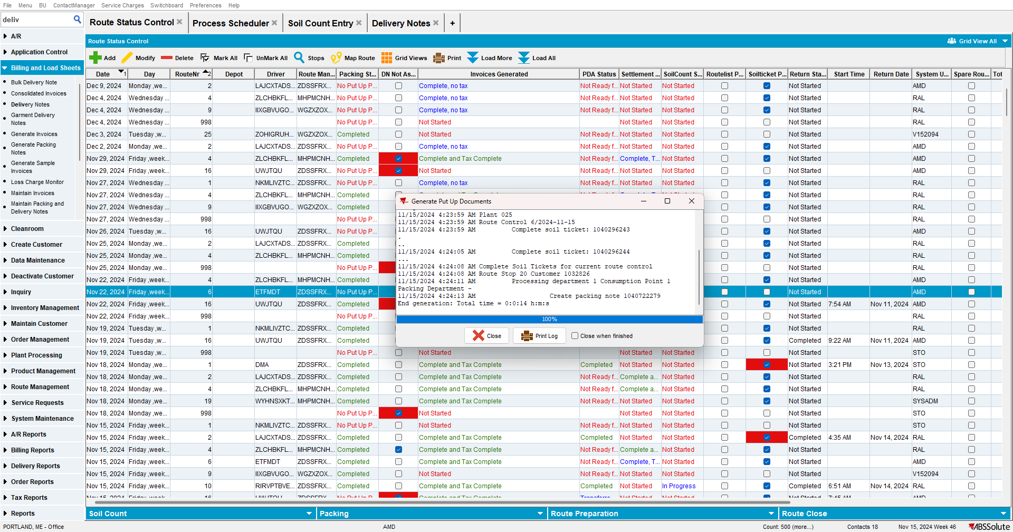
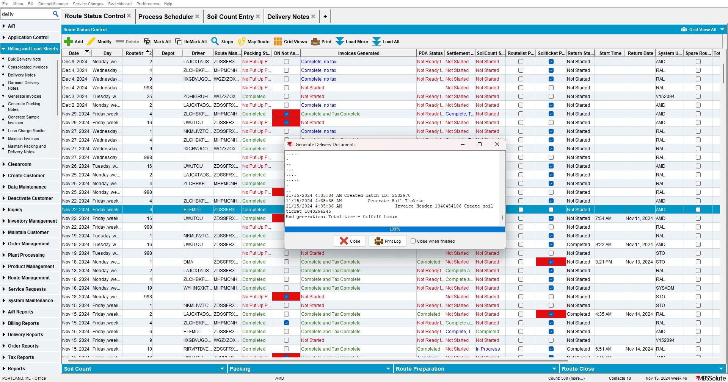

- Tax the invoices
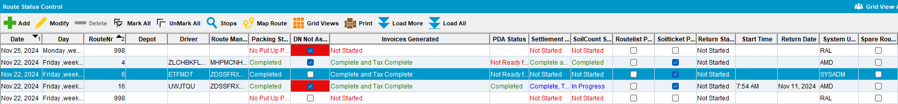
- Enter Soil Count DLG: Find a customer on the route from step 1 that has a soil ticket generated
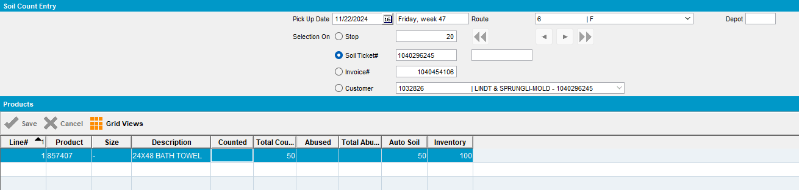
- Delivery Note DLG: Add a manual delivery note for the customer with a soil ticket.
- Delivery Note DLG: Set a delivery date that is in the future but before the driving date for the route control from step 1
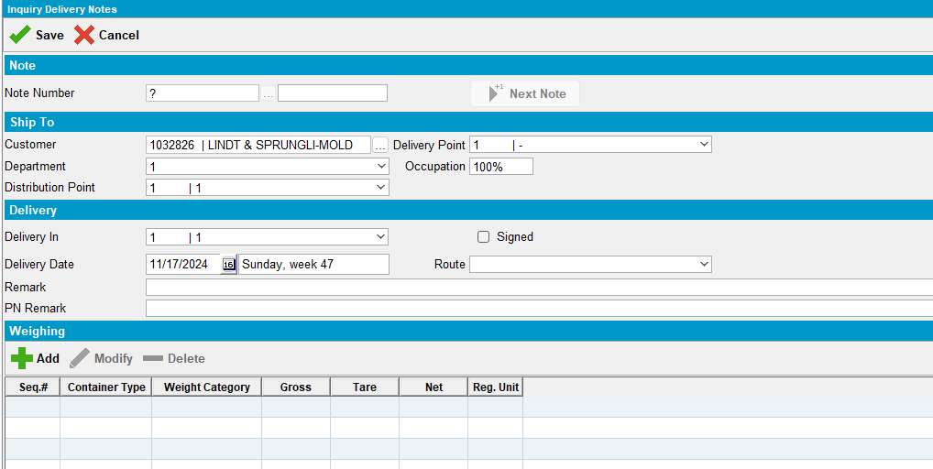
- Delivery Note DLG: Add any product with a quantity > 0 on the del note
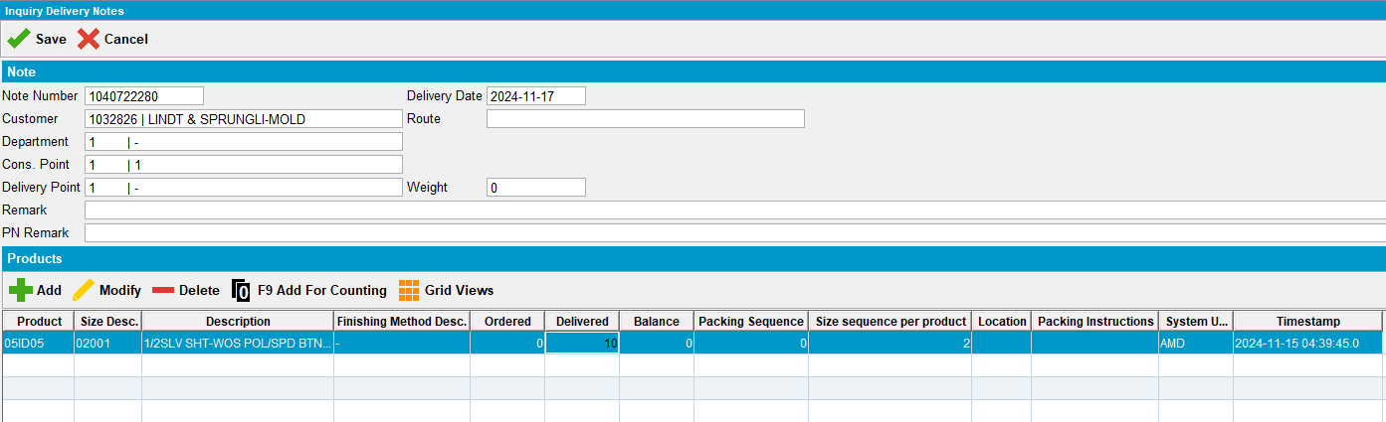
- RSC DLG: Check that the route control from step 1 now has the checkbox for PN not assigned
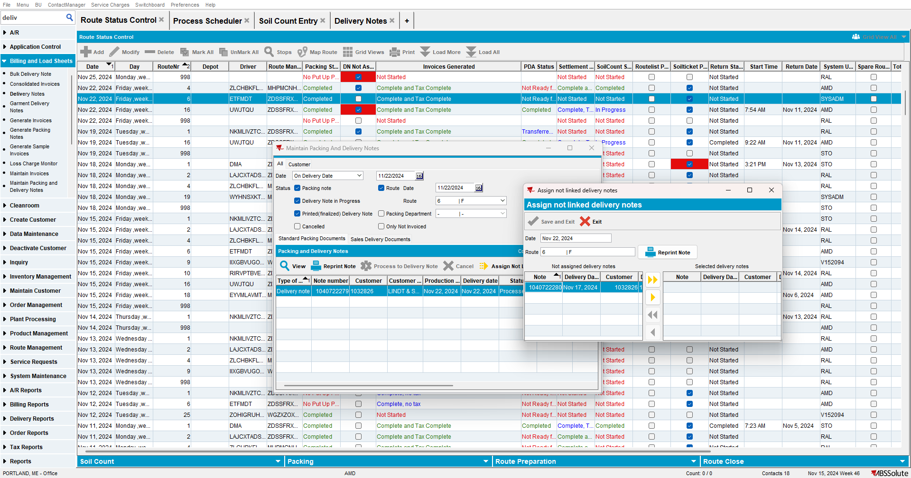
- Process Scheduler DLG: Run the Cancel and regenerate US direct invoices for late delivery notes
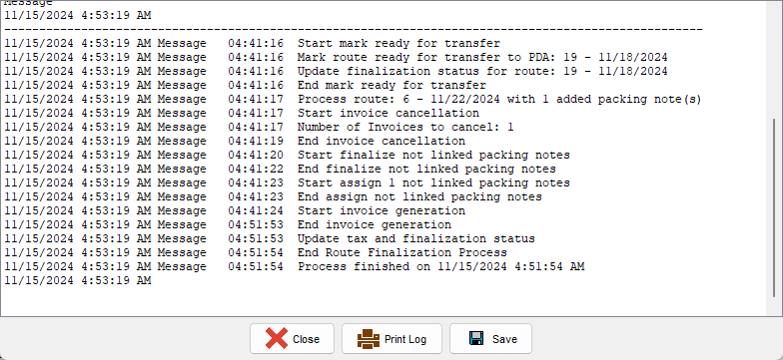
- View Process Log DLG: Check the GenerateInvoicesFromFinaliseRoutesProcess log check if there is a soil ticket generated at the end
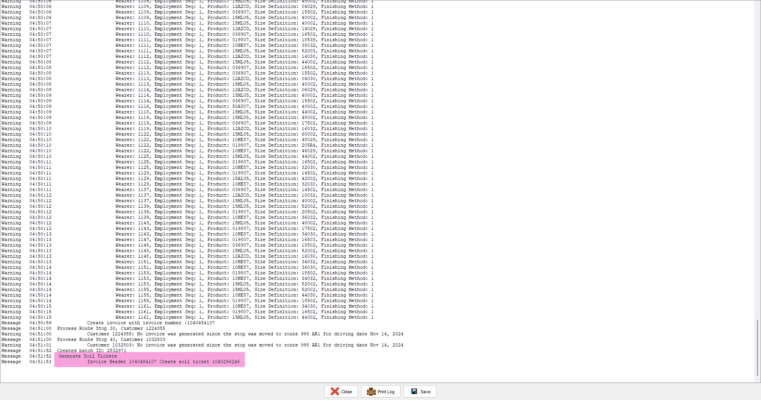

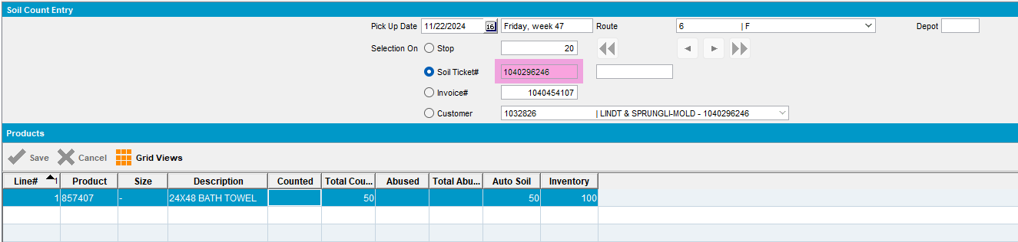
TESTED OK. 💚

