ABS-171065 - Improve logging for Vertex BCI processing
Environment | Prerequisites
Version: 9.07.00.UNF18  DBServerName= abs-srv20.internal.abslbs.com  DBSID=CUST24  DBUser=UNFDEV  DBPassword= UNFDEV  Environment=Test | - Module:  - System setting

Contents
Reproducing before fix 1
Steps to reproduce 1
Current Behavior 3
Expected behavior 4
Retest after fix 4
Test Case 1 – Check the format of Vertex BCI Processing Log for Invoice and Batch Numbers 4

Reproducing before fix

Steps to reproduce
- RSC DLG: Create a new routecontrol for a route
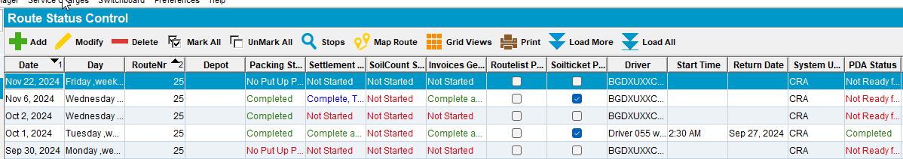
- Generate invoices
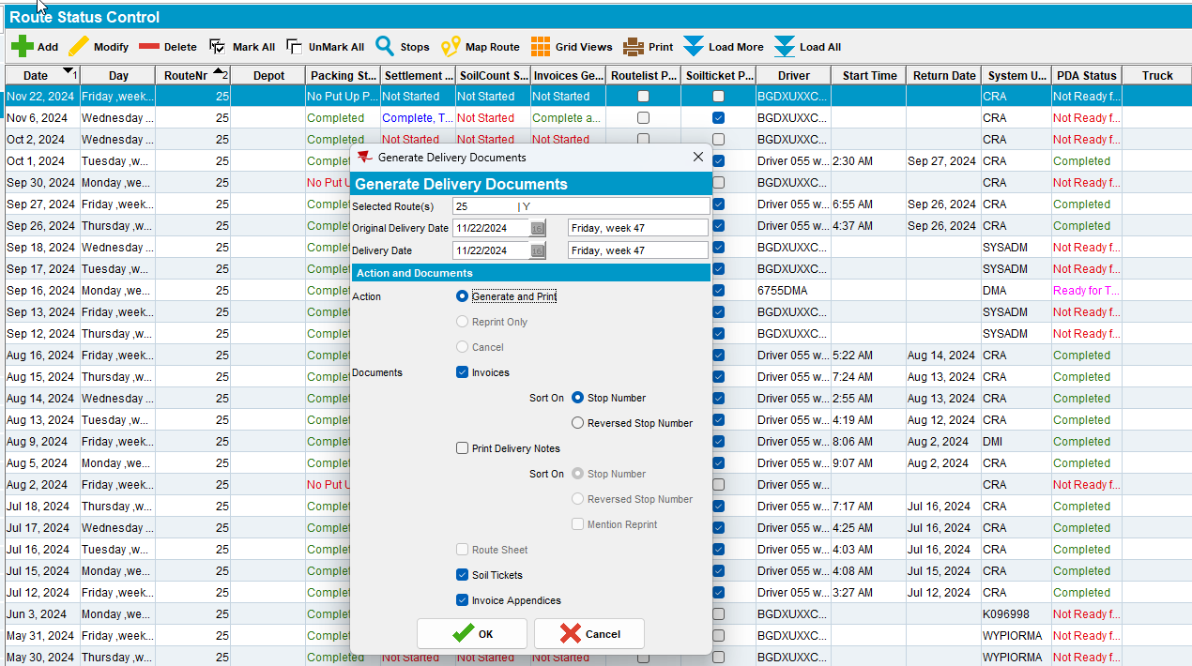
- Script taxes using SQL script
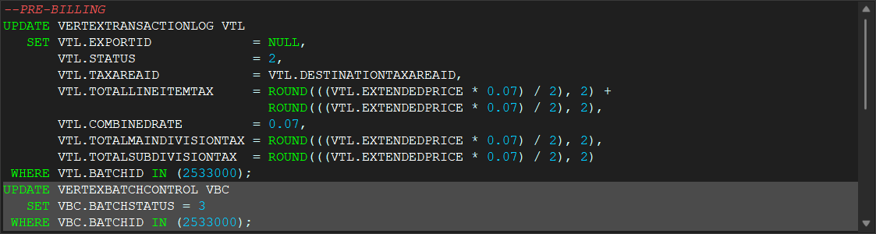
- Process Scheduler DLG: Run Import Vertex BCI Tax Response
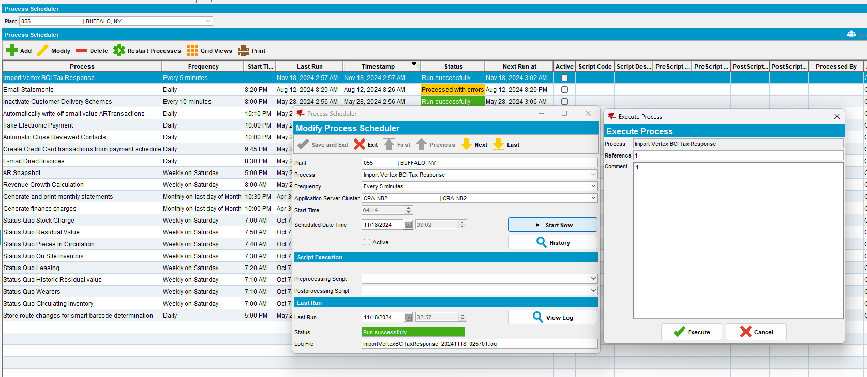
- View Process Log DLG: select Scheduled Process and Import Vertex BCI Tax Response
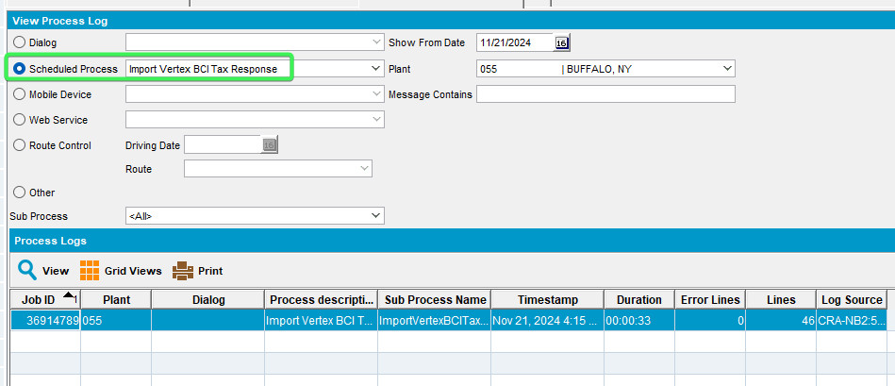
- View Vertex BCI Process Log, notice the Invoice number and Vertex Batch Control format
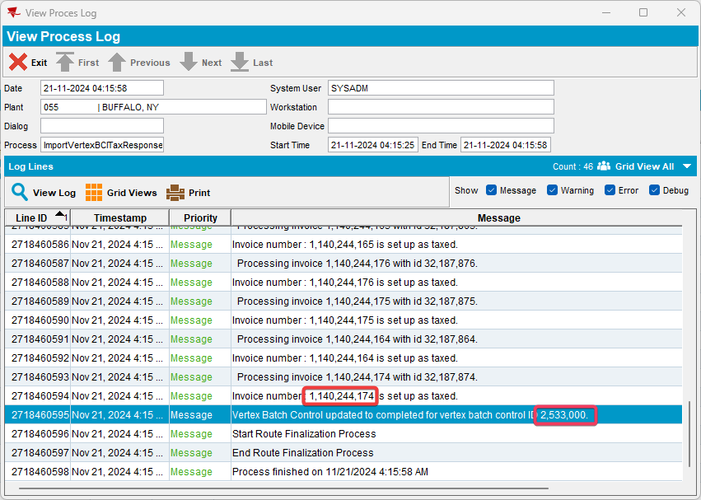
REPRODUCED OK.

Current Behavior
The Vertex BCI processing log shows batch id and invoice numbers in a number format using commas, Ex: 123,456,789

Expected behavior
The number should be shown as a whole Ex:123456789

Retest after fix

Test Case 1 – Check the format of Vertex BCI Processing Log for Invoice and Batch Numbers
Hash: 413ad78ec90
- RSC DLG: Create a new routecontrol for a route
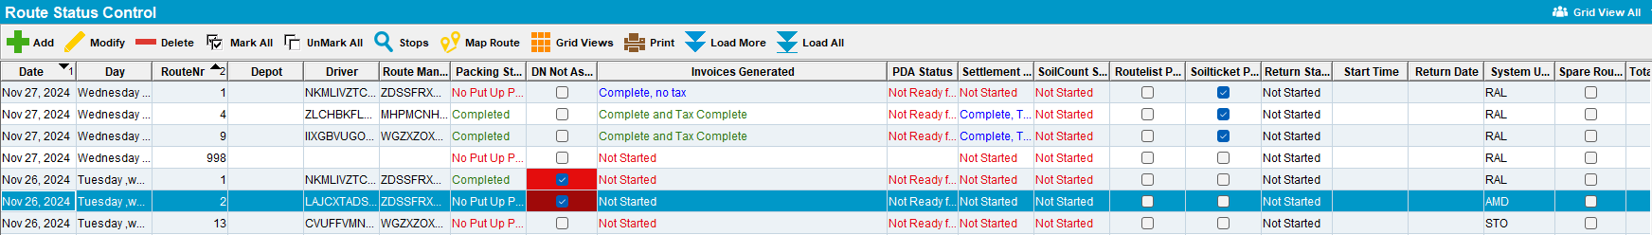
- Generate invoices
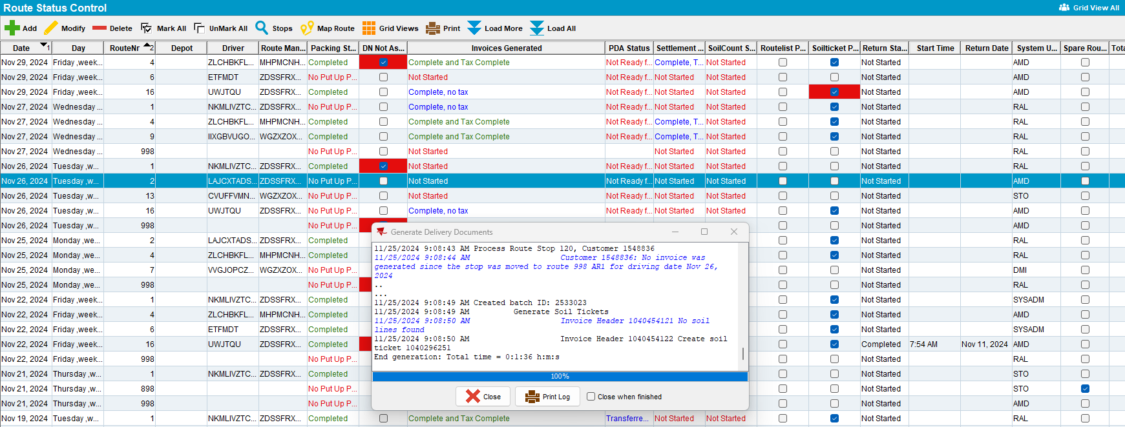
- Script taxes using SQL script
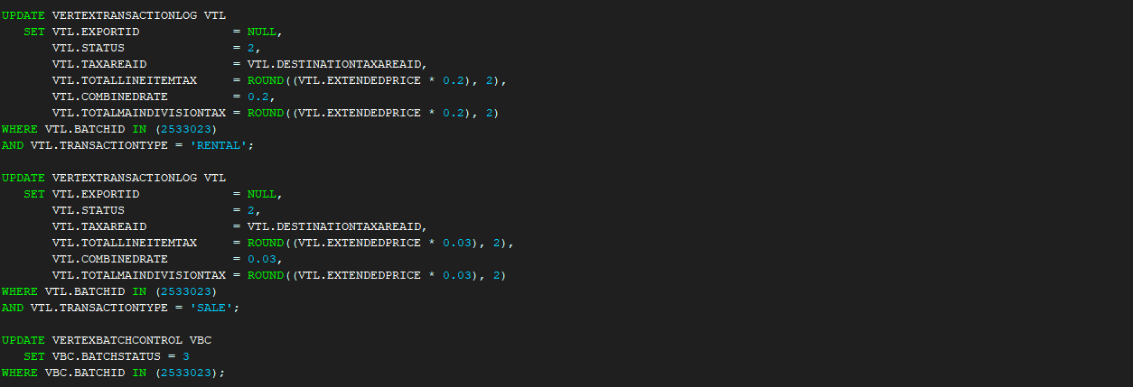

- Process Scheduler DLG: Run Import Vertex BCI Tax Response
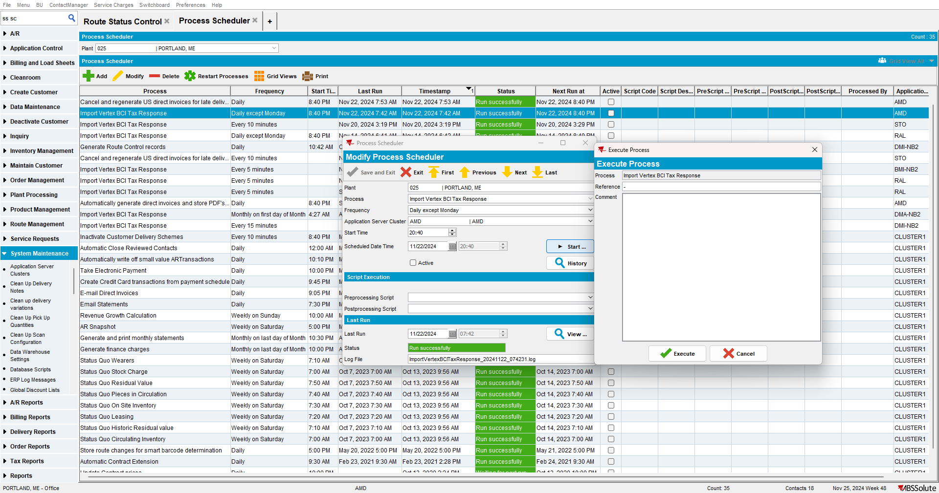
- View Process Log DLG: select Scheduled Process and Import Vertex BCI Tax Response
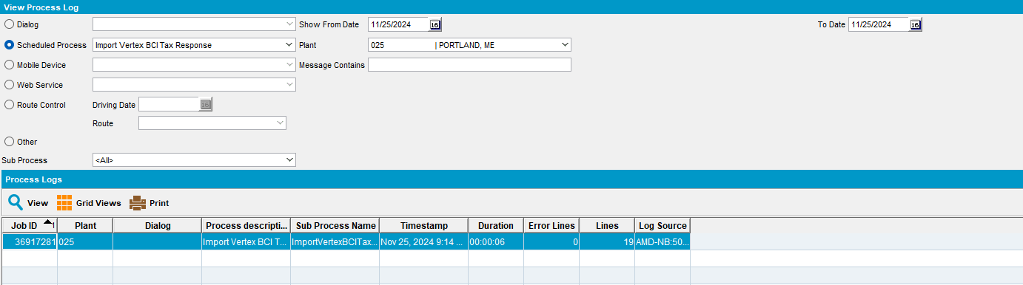

- View Vertex BCI Process Log, notice the Invoice number and Vertex Batch Control format
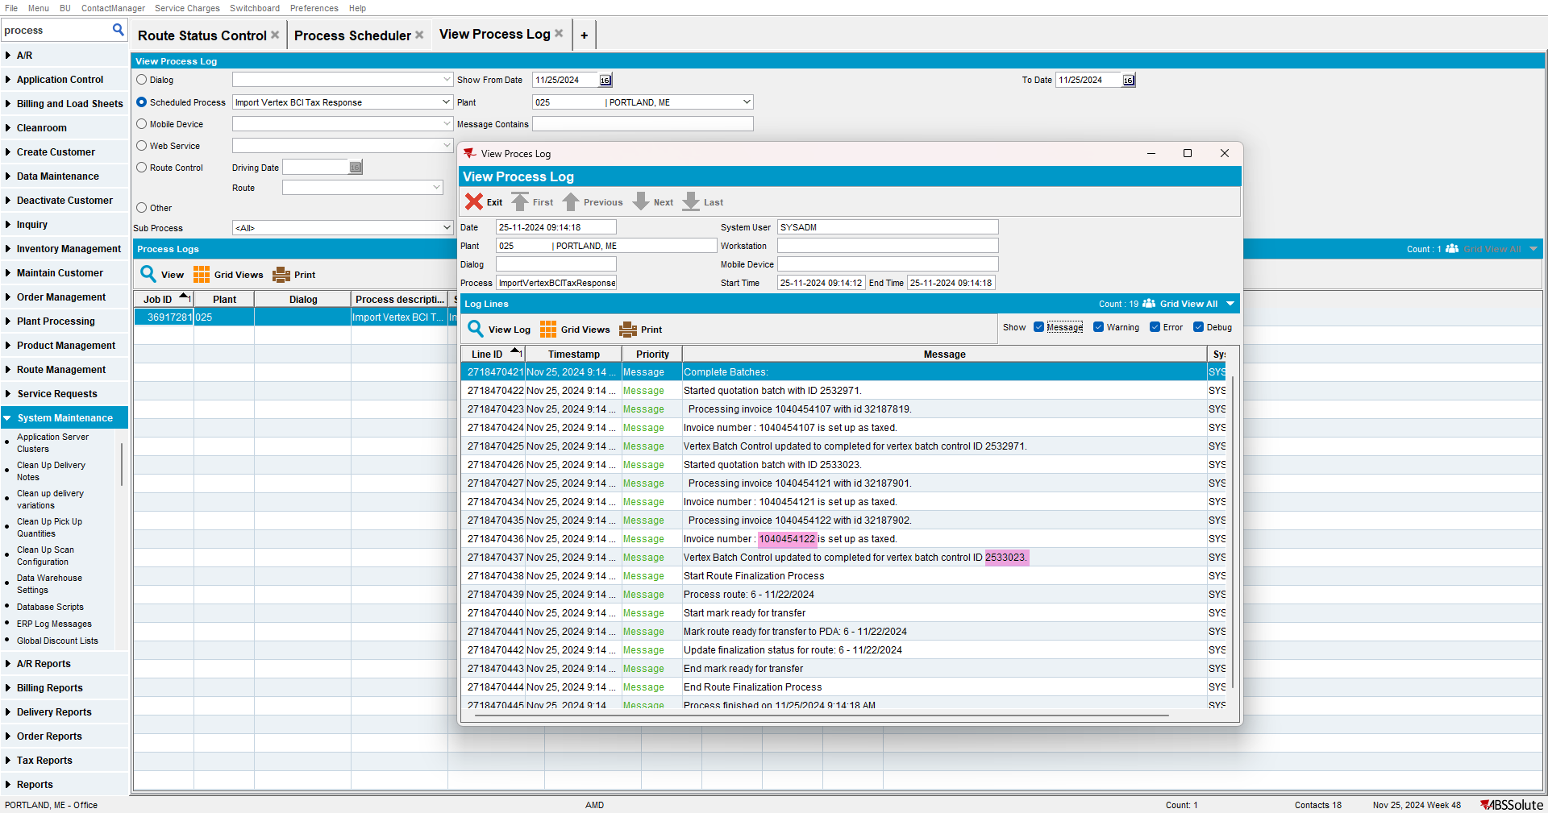
- RSC DLG: Settle the route
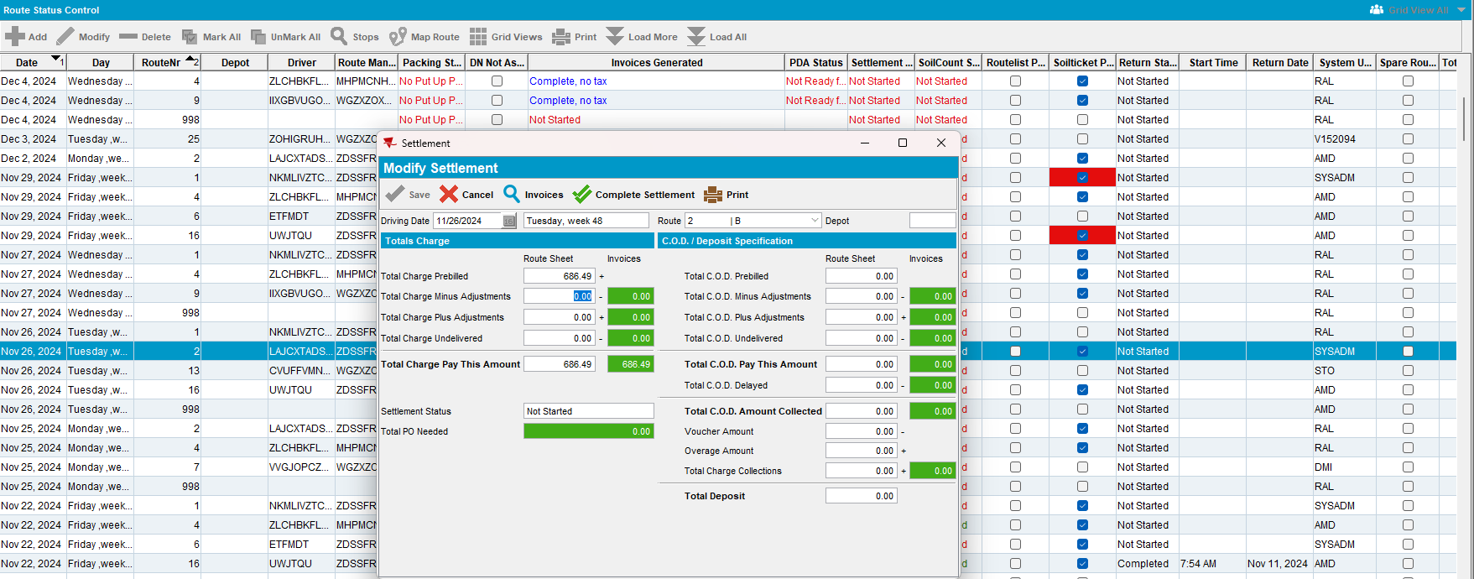

- Script Settlement taxes in SQL
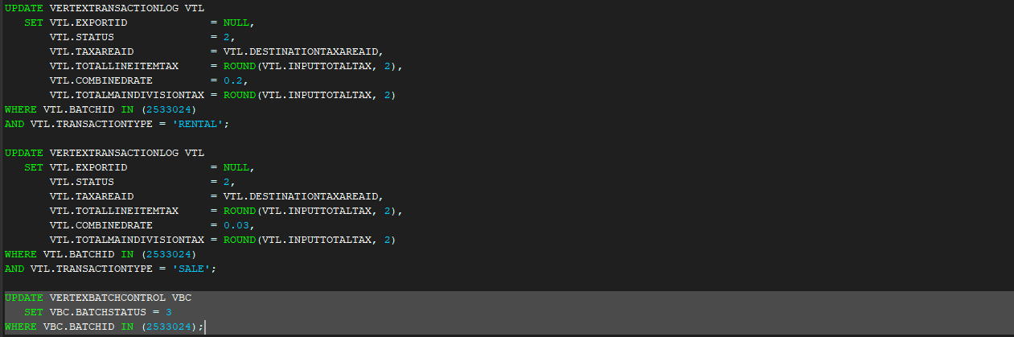
- Process Scheduler DLG: Run Import Vertex BCI Tax Response
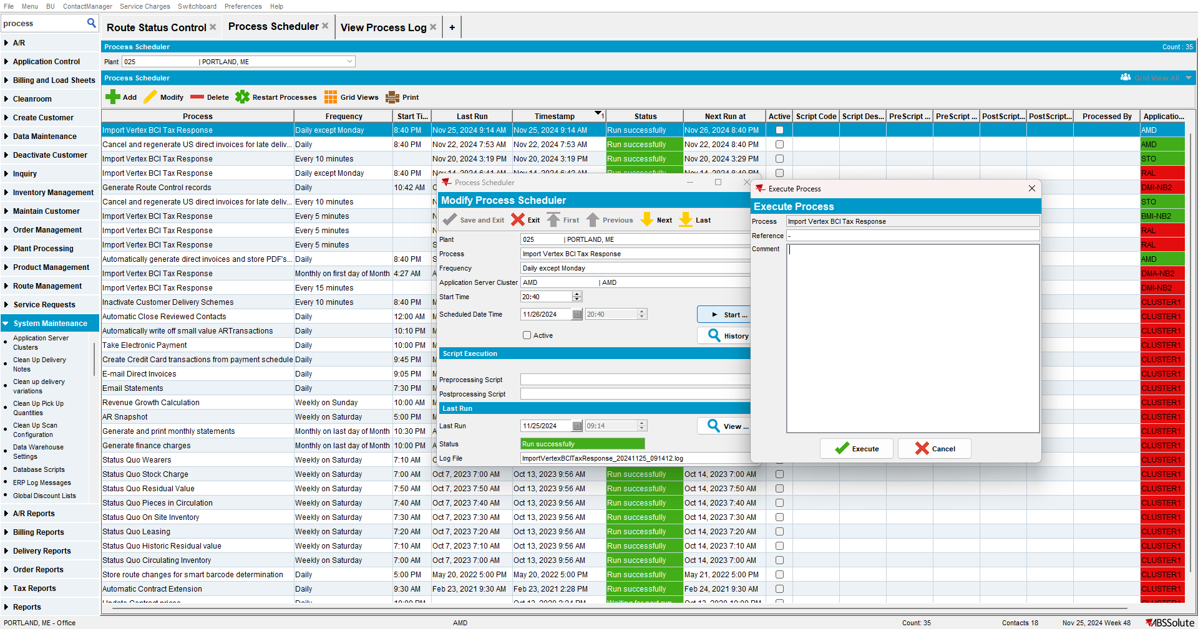
- View Process Log DLG: select Scheduled Process and Import Vertex BCI Tax Response
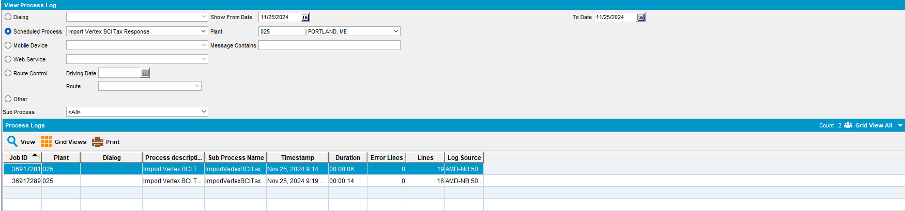

- View Vertex BCI Process Log, notice the Invoice number and Vertex Batch Control format
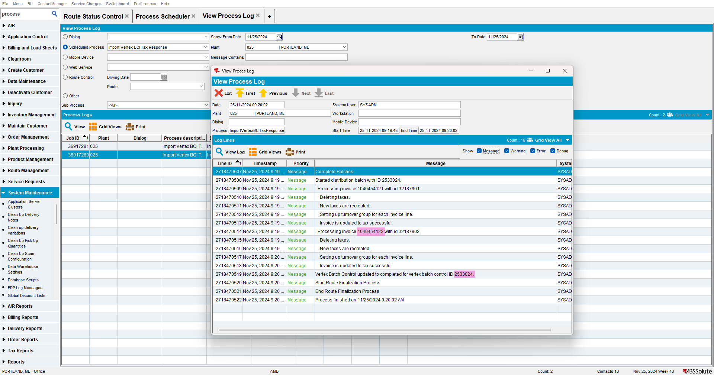
Tested OK

