ABS-171064 - Improve logging for Settlement
Environment | Prerequisites
Version: 9.09.00.RC1  DBServerName= abs-srv20.internal.abslbs.com  DBSID=CUST24  DBUser=UNFA  DBPassword= UNFA  Environment=Test | - Module:  - System setting

Contents
Reproducing before fix 1
Steps to reproduce 1
Current Behavior 2
Expected behavior 2
Retest after fix 2
Test Case 1 – Complete Settlement from Route Status Control 2
Test Case 2 – Complete Settlement from Route Check In 4
Test Case 3 – Complete Settlement from WebX 6
Test Case 4 – Complete Settlement from Settlement DLG 10

Reproducing before fix

Steps to reproduce
- RSC: Create a new routecontrol for a route
- RSC: Generate invoices
- Script taxes
- RSC: Settle the route
- Notice the settlement log
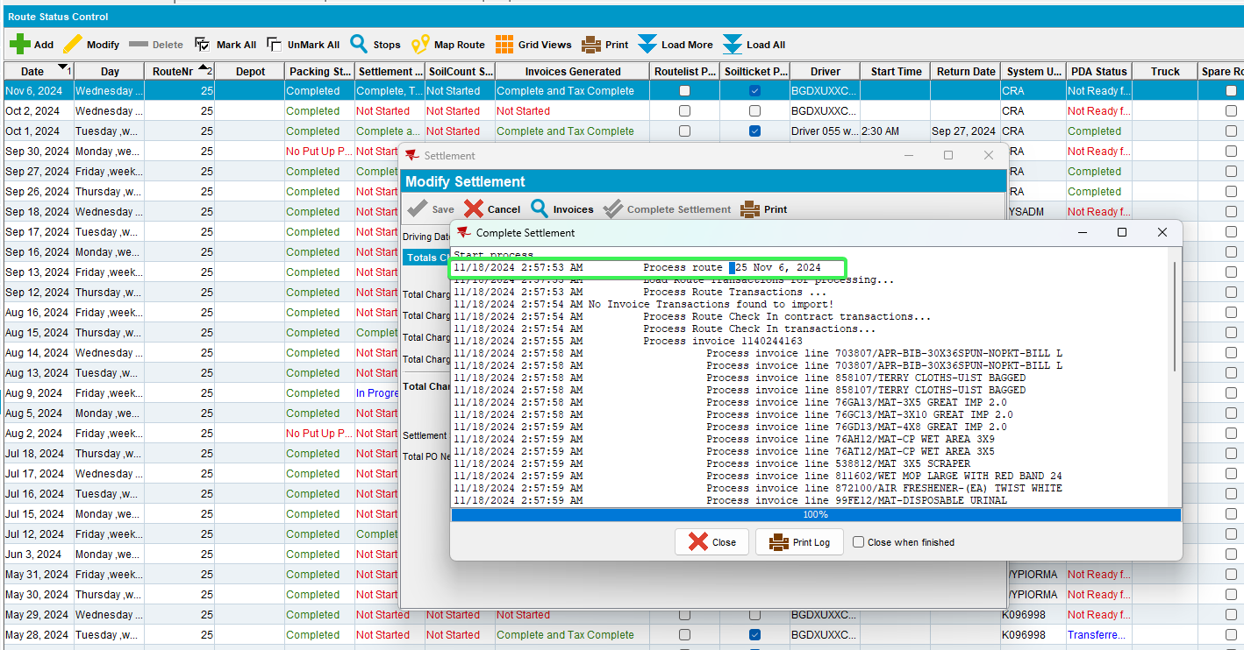
REPRODUCED OK.

Current Behavior
Currently, the Settlement process log shows route number and date but the format is not the same as for Packing Note and Invoice generation. Also, there is an extra space between "Route" and the actual route number which is impacting searches in the log.

Expected behavior
Settlement process log should have the same format as for Packing Note and Invoice generation, also remove the double spacing between "Route" and the actual route number.

Retest after fix

Test Case 1 – Complete Settlement from Route Status Control
Hash: 413ad78ec90
- RSC: Create a new routecontrol for a route
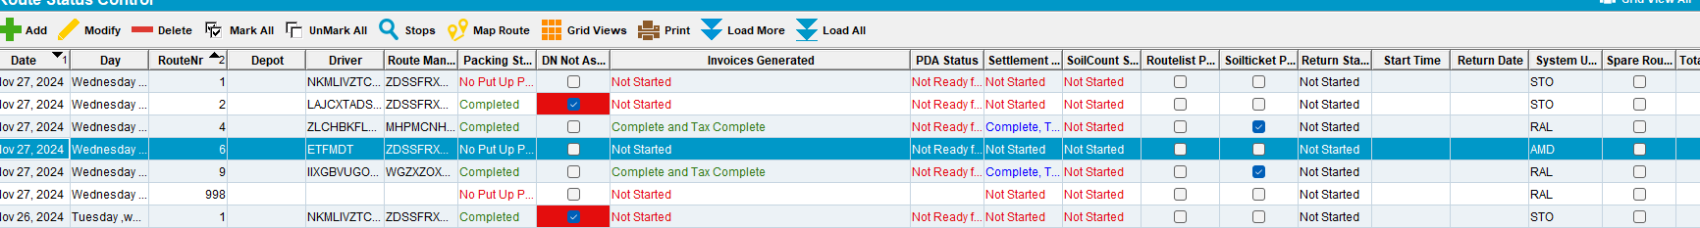

- RSC: Generate invoices
- Script taxes
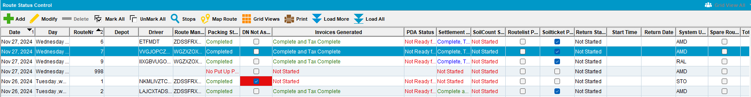
- RSC: Settle the route
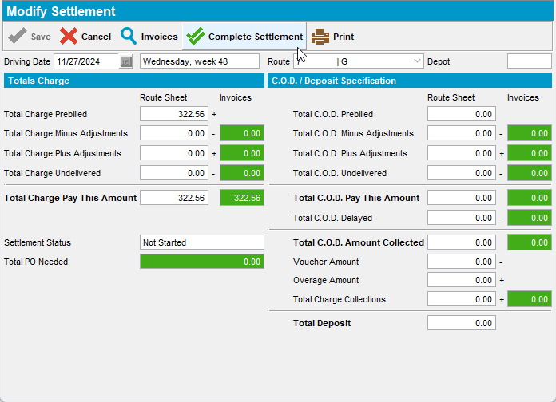
- Check the settlement log
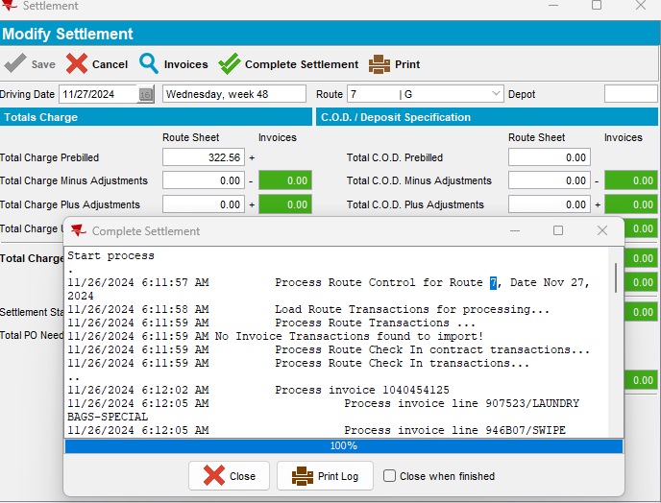
Tested OK

Test Case 2 – Complete Settlement from Route Check In
Hash: 413ad78ec90
- RSC: Create a new routecontrol for a route
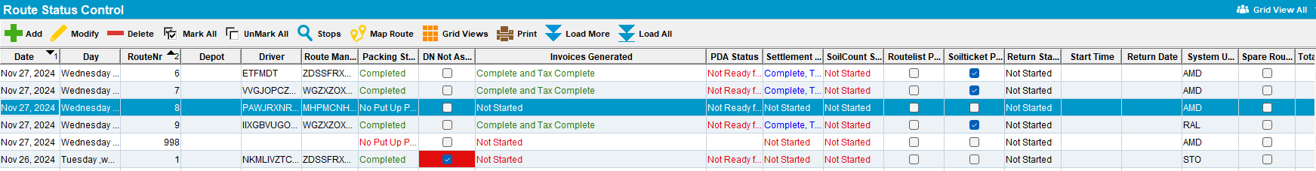
- RSC: Generate invoices
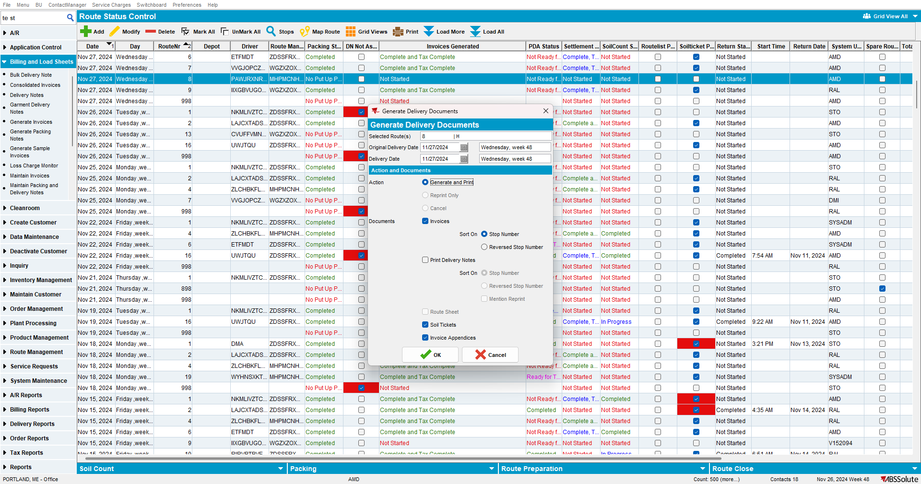
- Script taxes
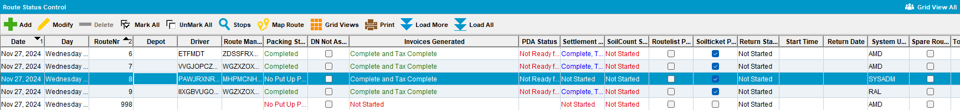
- RSC: Send the route to RA
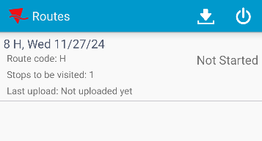
- RA: Settle the route and upload the data
- Route Check In DLG: Settle the route
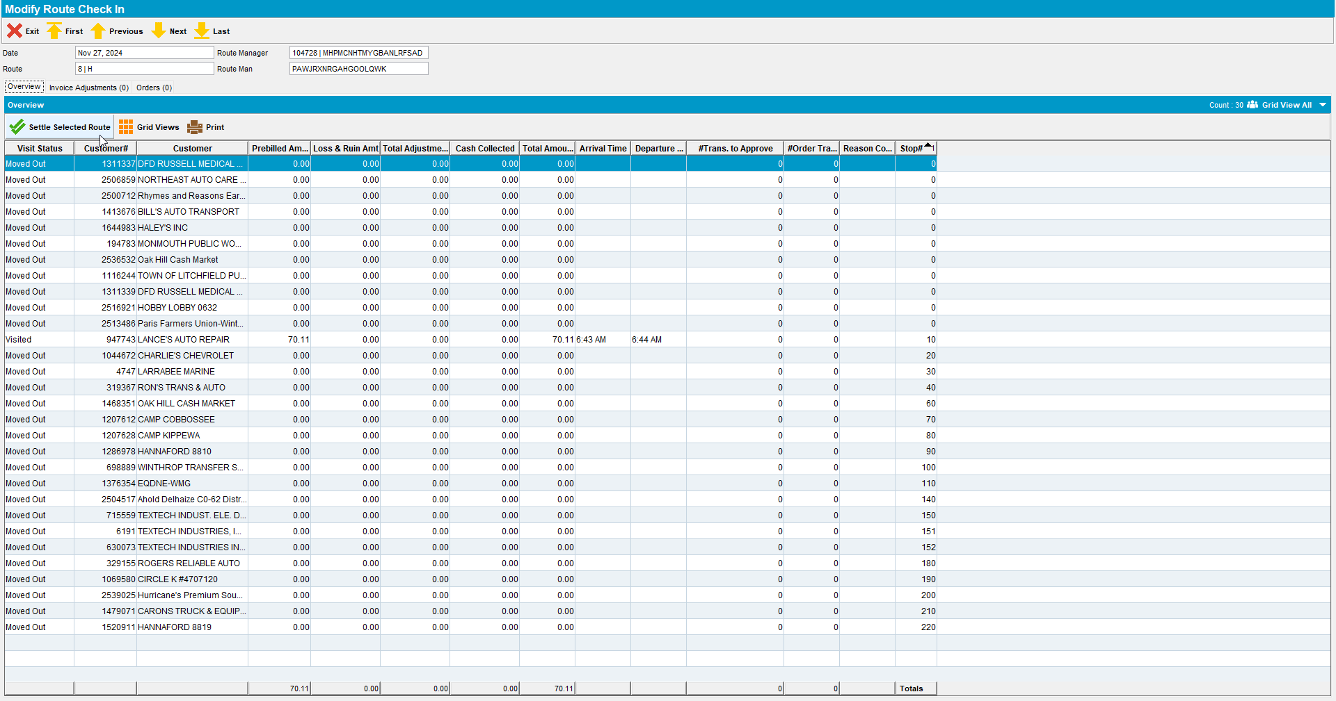
- Check the settlement log
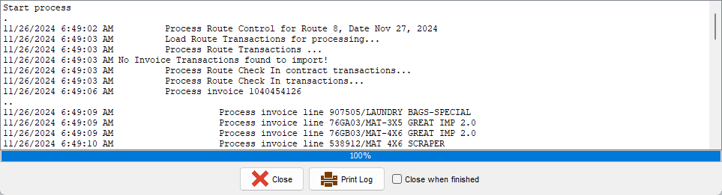
Tested OK

Test Case 3 – Complete Settlement from WebX
Hash: 413ad78ec90
- RSC: Create a new routecontrol for a route
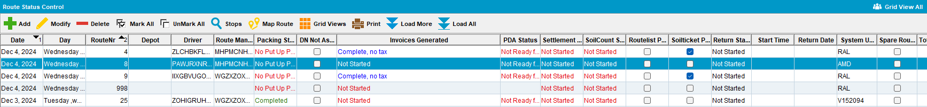

- RSC: Generate invoices
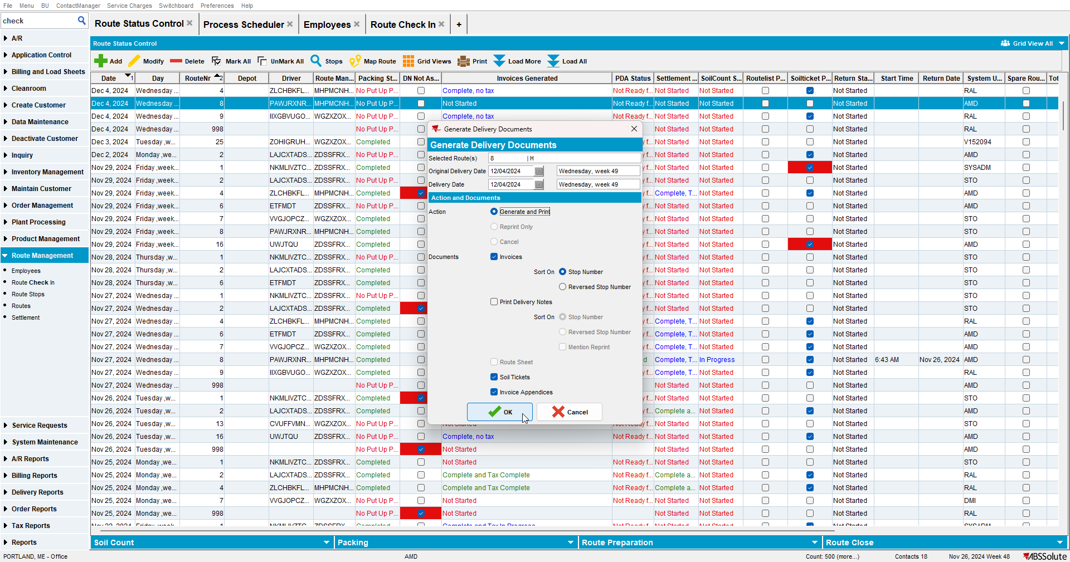
- Script taxes
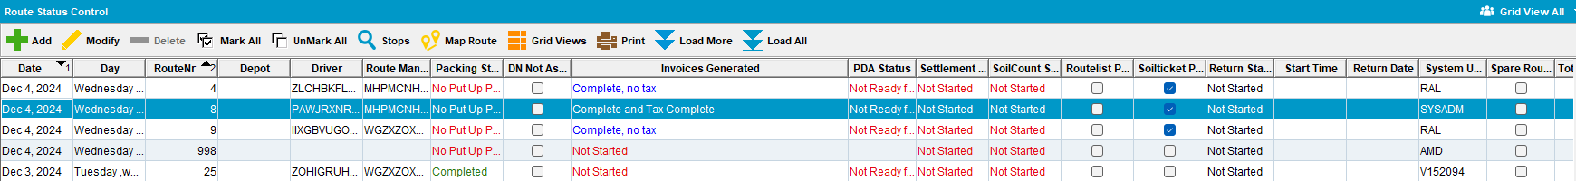
- RSC: Send the route to RA
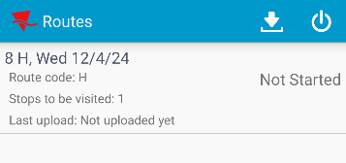

- RA: Settle the route and upload the data
- WebX: Complete Start my day
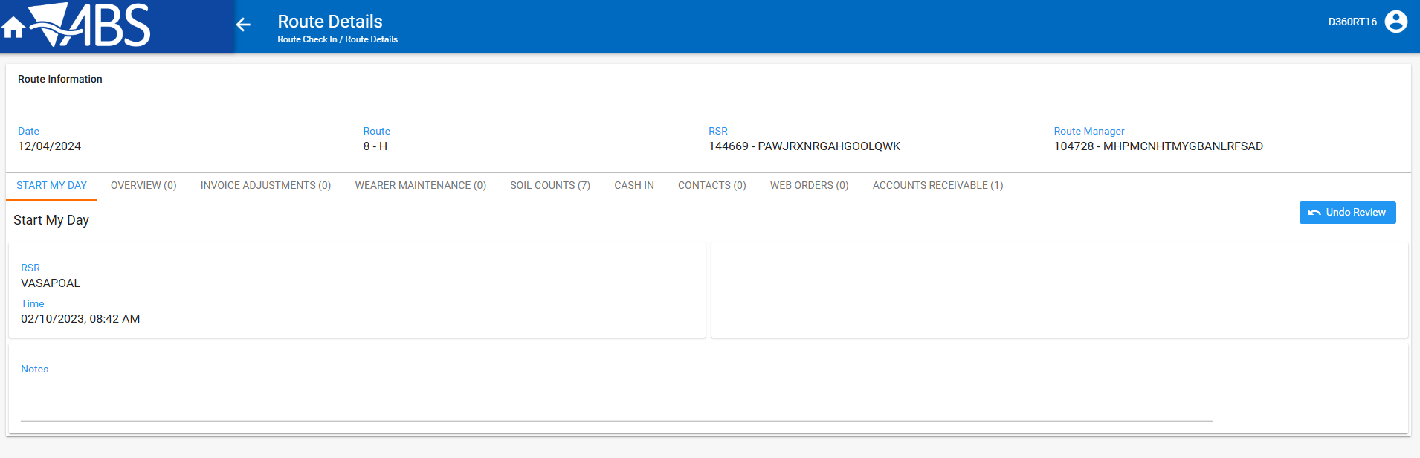
- WebX: Review all tabs
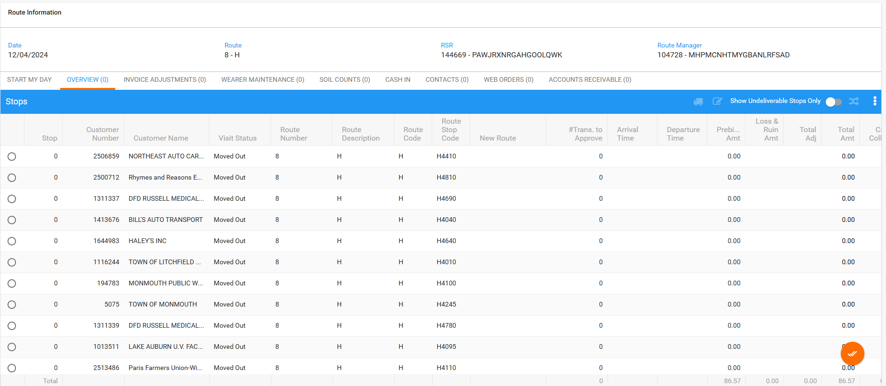

- WebX: Settle the route
- WebX: Check the settlement log
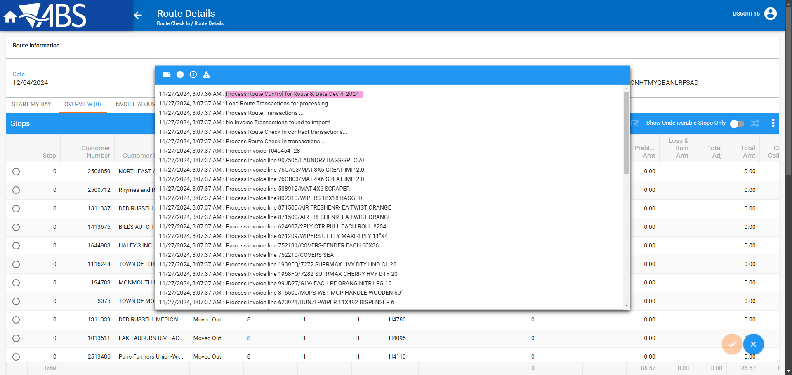
Tested OK

Test Case 4 – Complete Settlement from Settlement DLG
Hash: 413ad78ec90
- RSC: Create a new routecontrol for a route
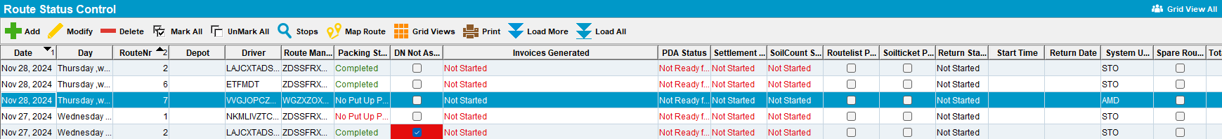

- RSC: Generate invoices
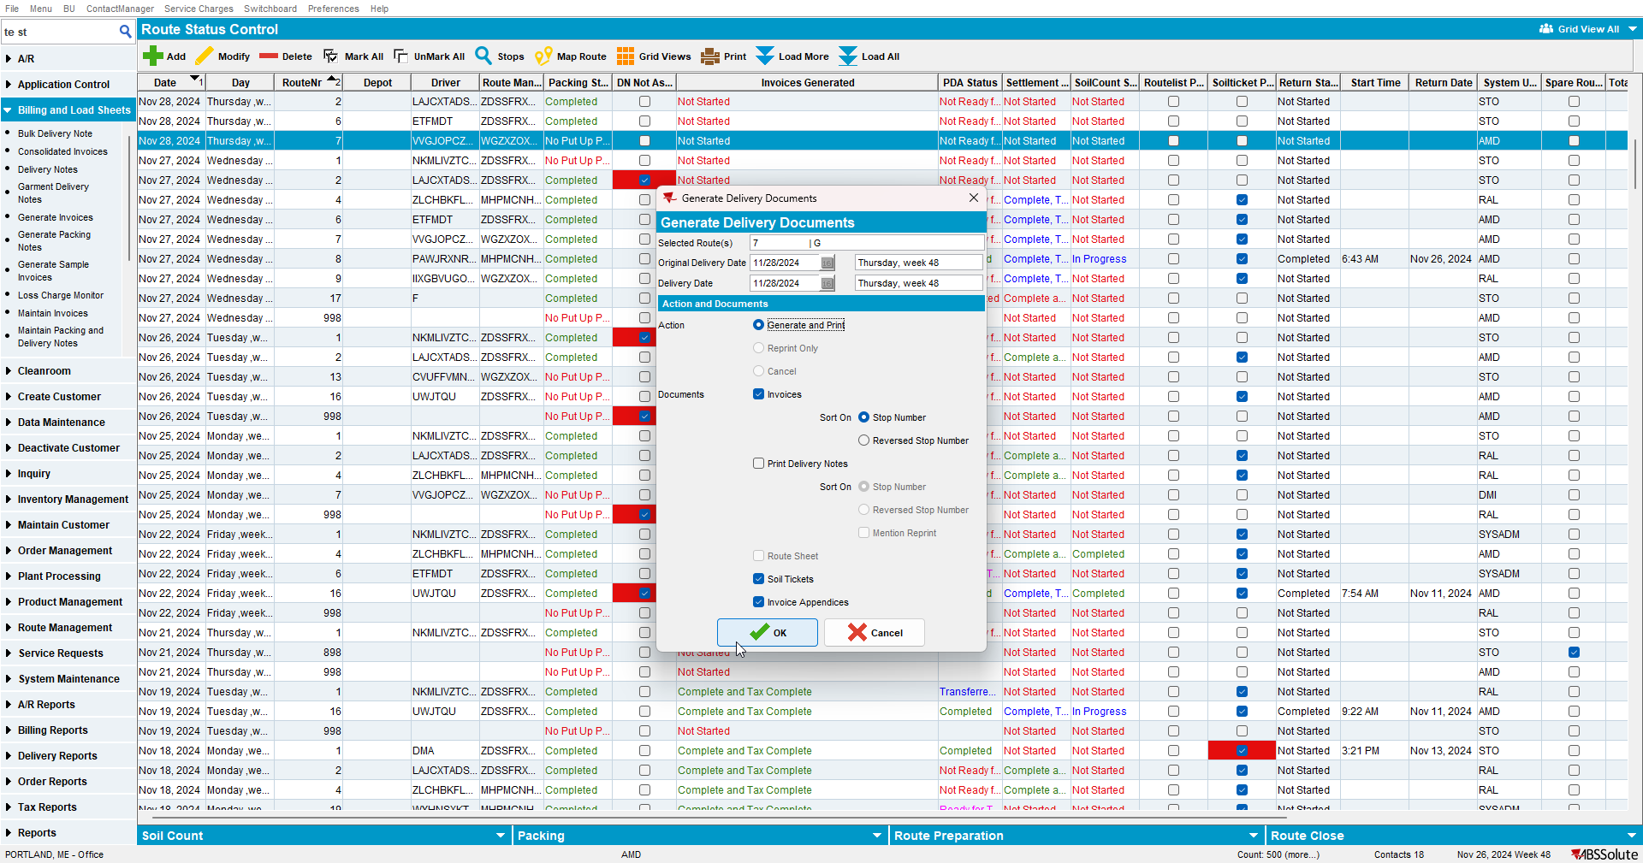
- Script taxes
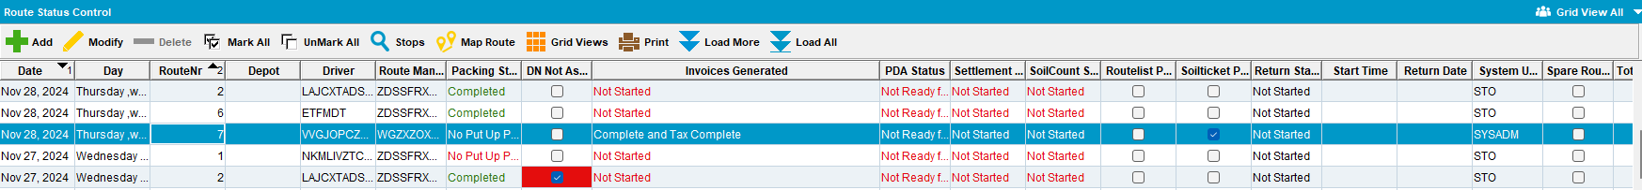
- Settlement DLG: Settle the route
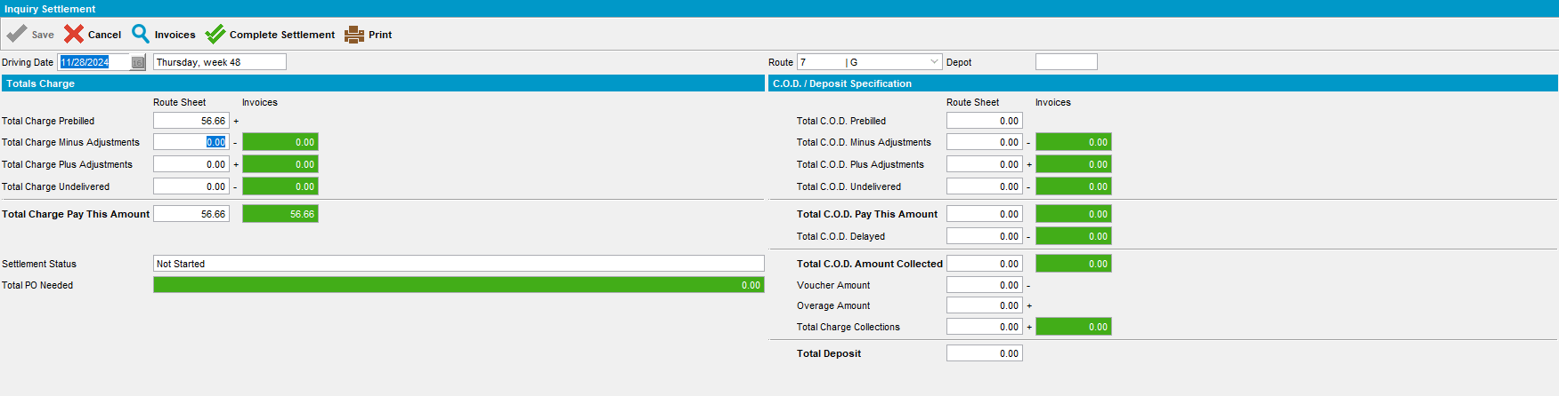
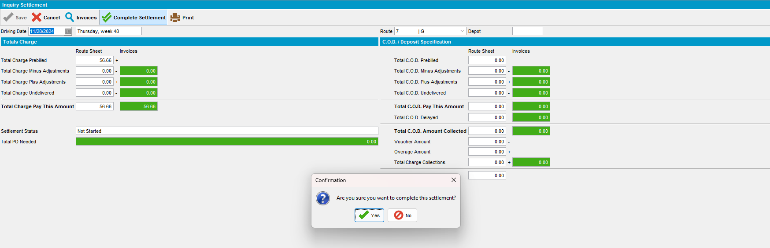
- WebX: Check the settlement log
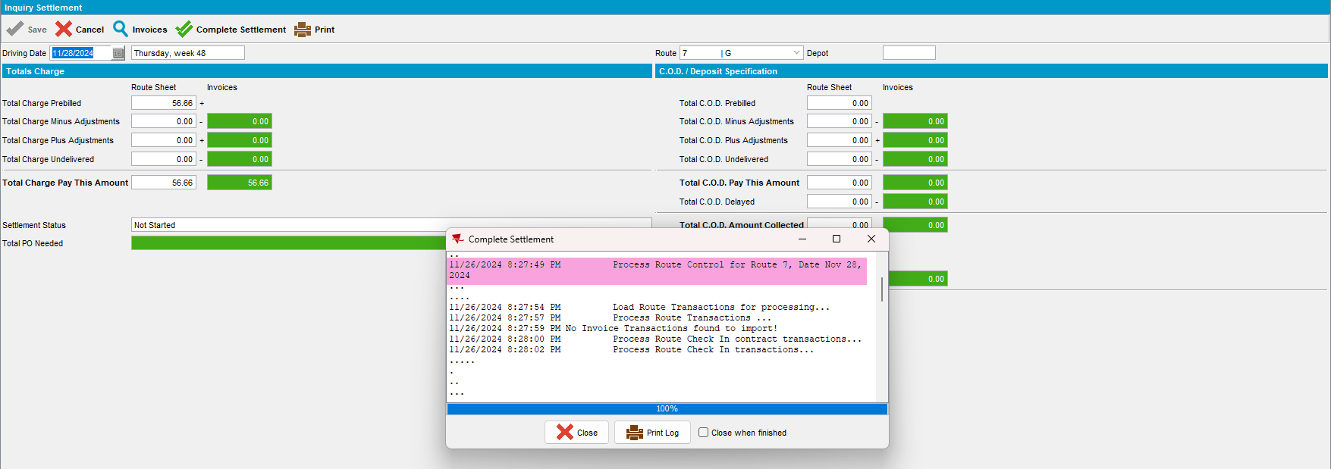
Tested OK

