ABS-170150 D_UBS_2560 Using Bill Loss Now on the RA after keying an exchange does not rag the garments from circulation
Environment | Prerequisites
Version:9.08.02  DBServerName=abs-srv20.internal.abslbs.com  DBSID= CUST24  DBUser= UNFA  DBPassword= UNFA  Environment=Production | - Module:  - System setting

Contents
Reproducing before fix 1
Steps to reproduce 1
Expected behavior 4
Retest after fix 5
Steps to reproduce 5

Reproducing before fix

UNFA@CUST22
9.09.00.RC1 hash: 411339d4b573 + RouteAssistant_v12.35.INTERNAL_TEST_ONLY.efcdb1640.apk
BU: 052
Route: 1
Date: 01.11.2024

Steps to reproduce
- RSC dlg: Create a new route with at least one customer with garment delivery days.
- RSC dlg: Generate put up docs and invoices, send the route to PDA.
- RA: Download the route and arrive at the customer.
- RA: Make a size exchange inventory
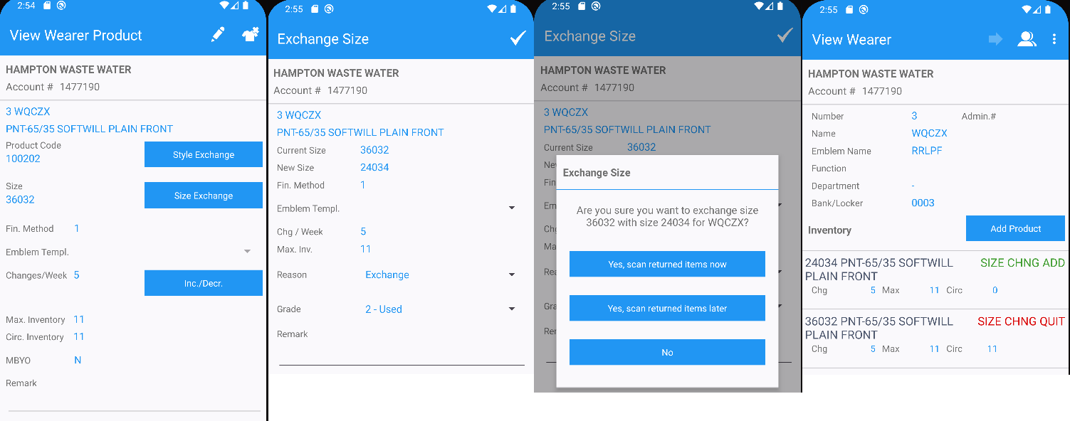
- RA: For another wearer make a style exchange inventory.
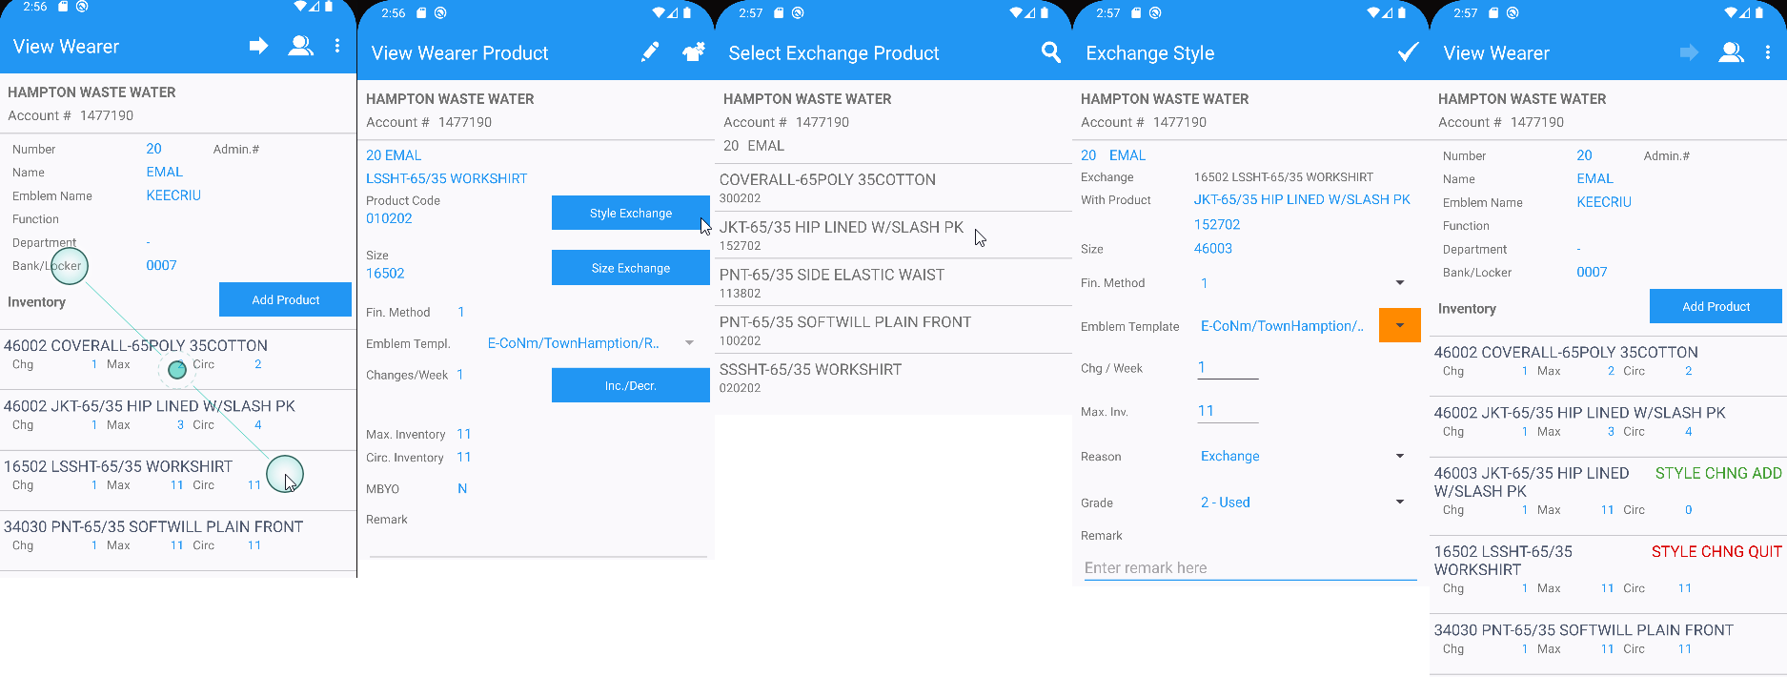
- RA: Bill all for loss now.
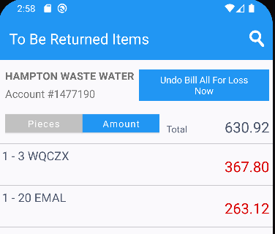
- RA: Settle the route and upload it.
- WebX: Settle the route.
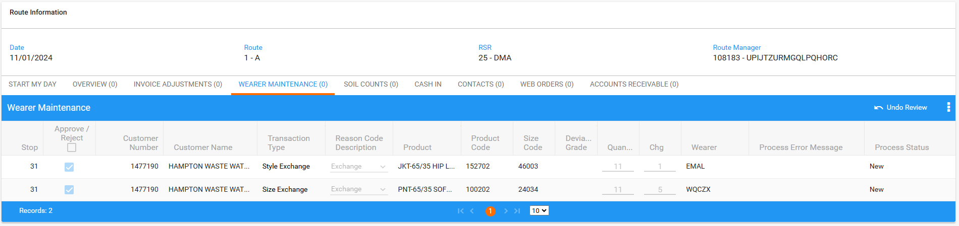
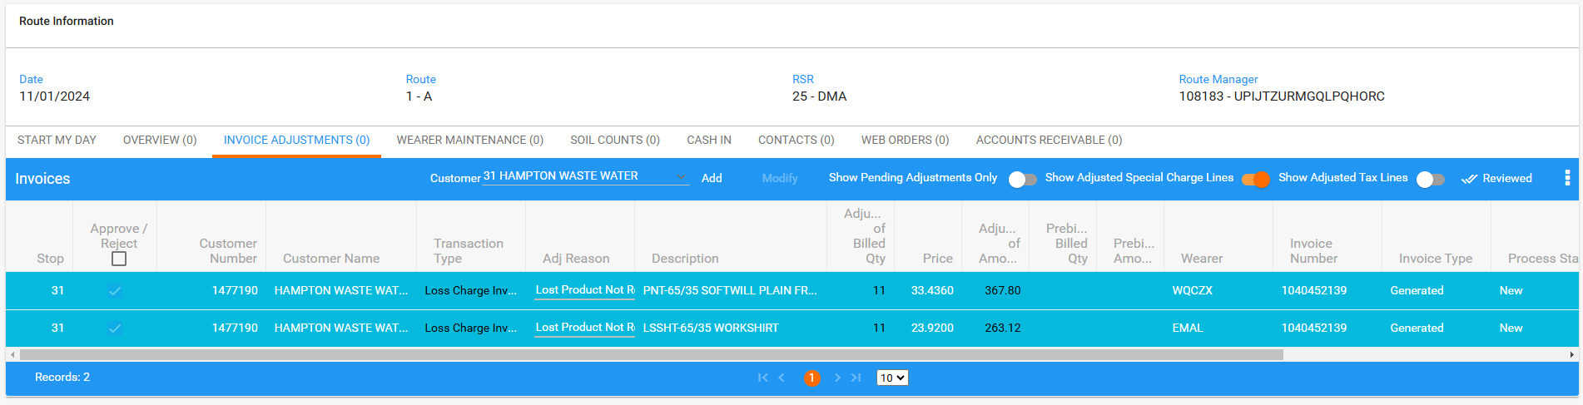
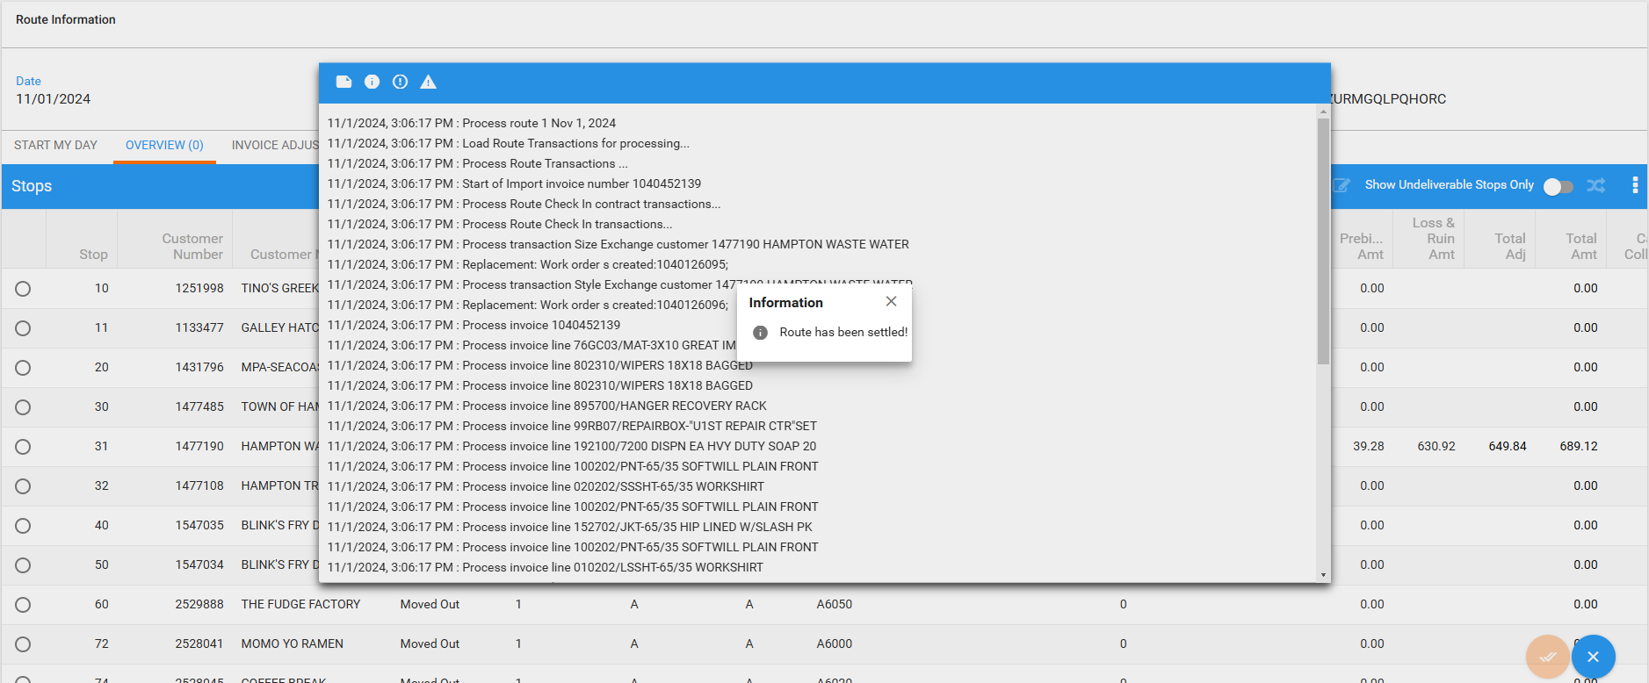
- Maintain Invoices dlg: Check the invoice.
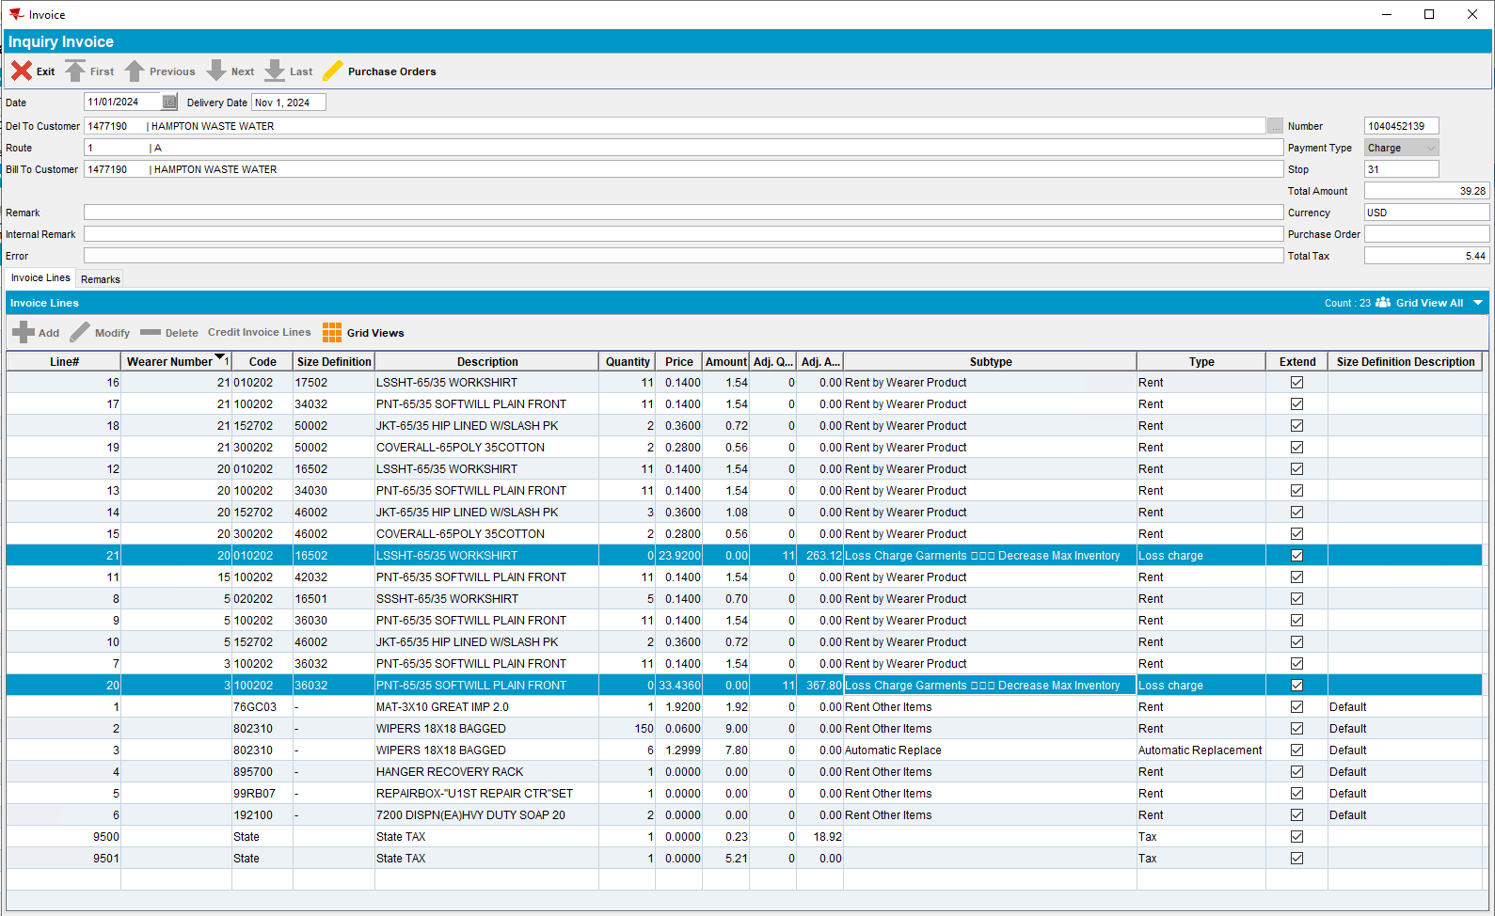

REPRODUCED OK.

Expected behavior
The subtype of the size exchange and style exchange is wrong

Retest after fix

UNFDEV@CUST24
9.07.00.UNF18 hash: 80689830f576 + RouteAssistant_v12.35.apk
BU: 025
Route: 1
Date: 01.11.2024

Steps to reproduce
- RSC dlg: Create a new route with at least one customer with garment delivery days.
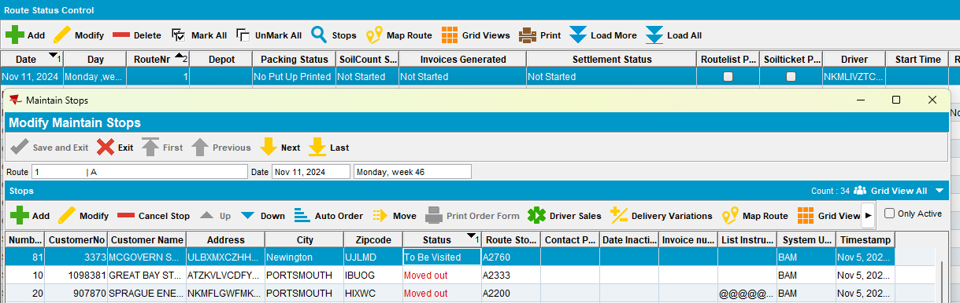
- RSC dlg: Generate put up docs and invoices, send the route to PDA.
- RA: Download the route and arrive at the customer.
- RA: Make a size exchange inventory
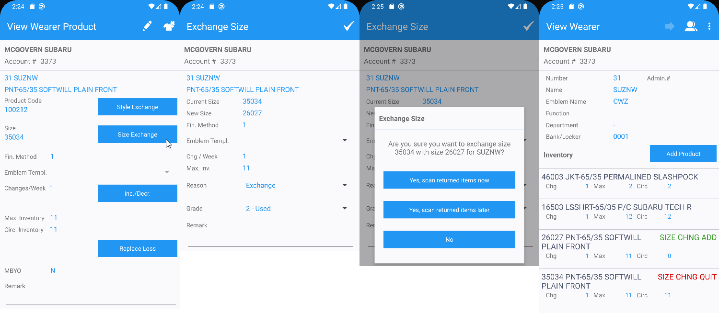
- RA: For another wearer make a style exchange inventory.
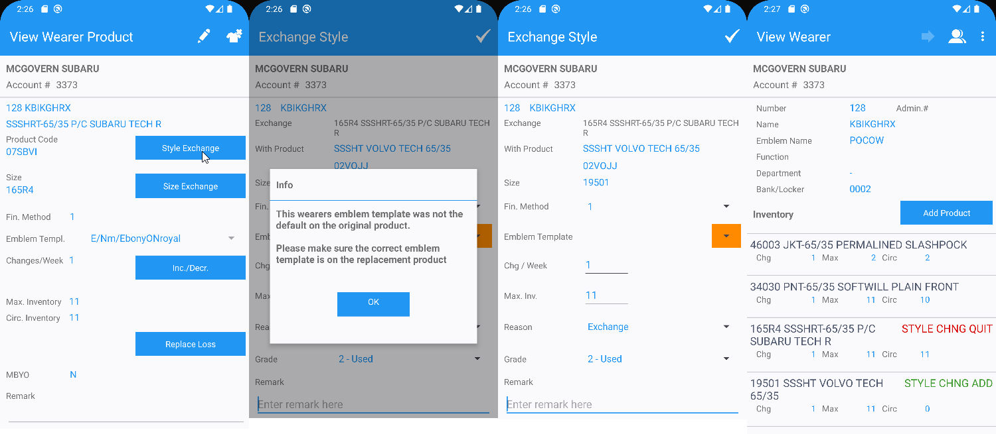
- RA: Bill all for loss now.
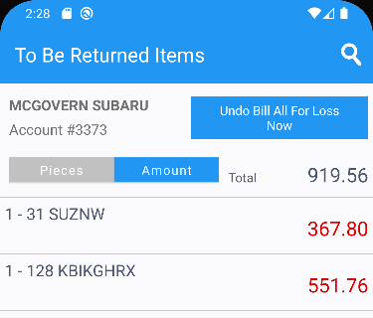
- RA: Settle the route and upload it.
- WebX: Settle the route.
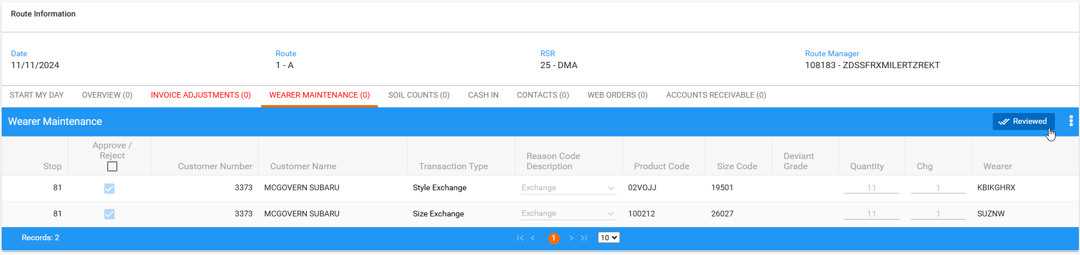

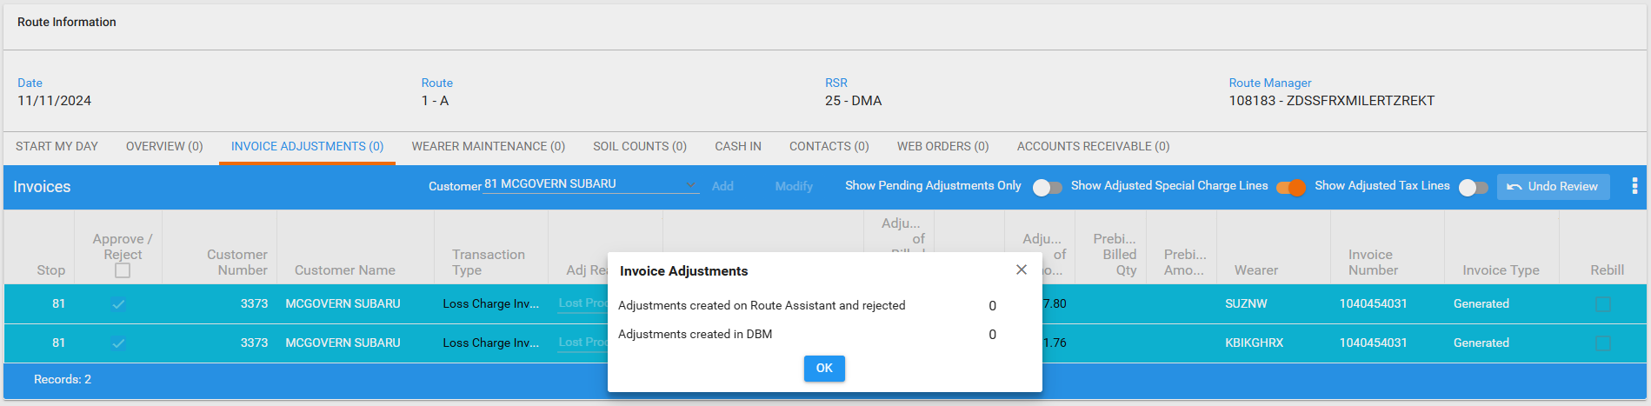
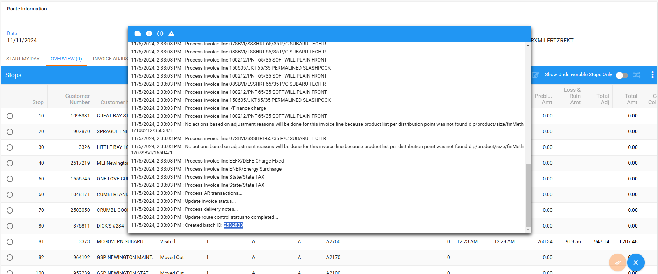

- Maintain Invoices dlg: Check the invoice.
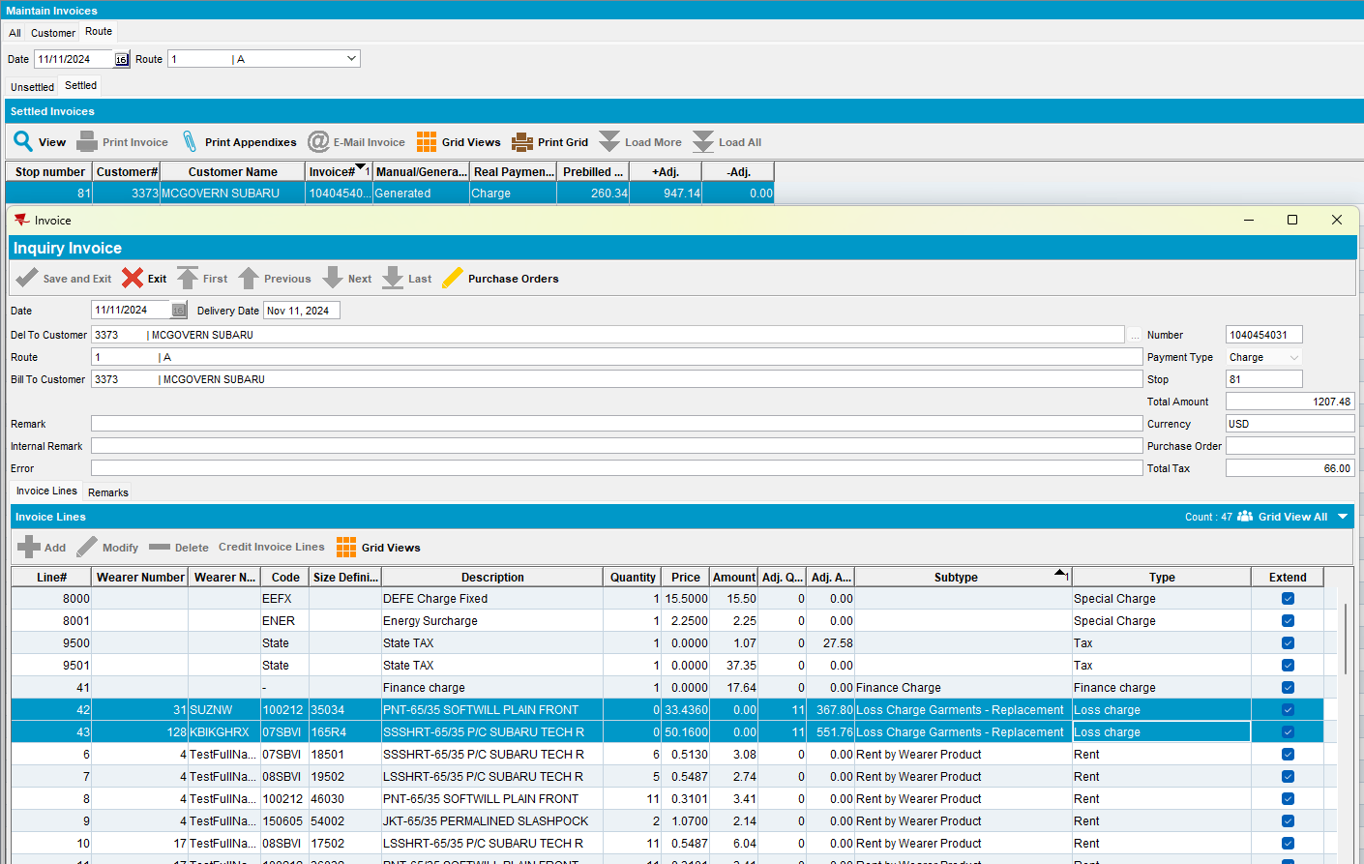

The subtype replacement is correct
Tested OK

