ABS-169902 - D_UBS_2554 Link Special size charge and Size surcharge pricing in contract compliancy enforce
Environment | Prerequisites
Version: 9.07.00.UNF17.p.01  DBServerName= abs-srv20.internal.abslbs.com  DBSID=CUST24  DBUser=UNFDEV  DBPassword= UNFDEV  Environment=Test | - Module:  - System setting

Contents
Retest after fix 1
Test Case 1 – Link Special size charge and Size surcharge pricing in contract compliancy enforce 1
Current Behavior 4
Expected behavior 4

Retest after fix

Test Case 1 – Link Special size charge and Size surcharge pricing in contract compliancy enforce
Hash: e61988f3883
- Contract DLG: Components > Product Settings
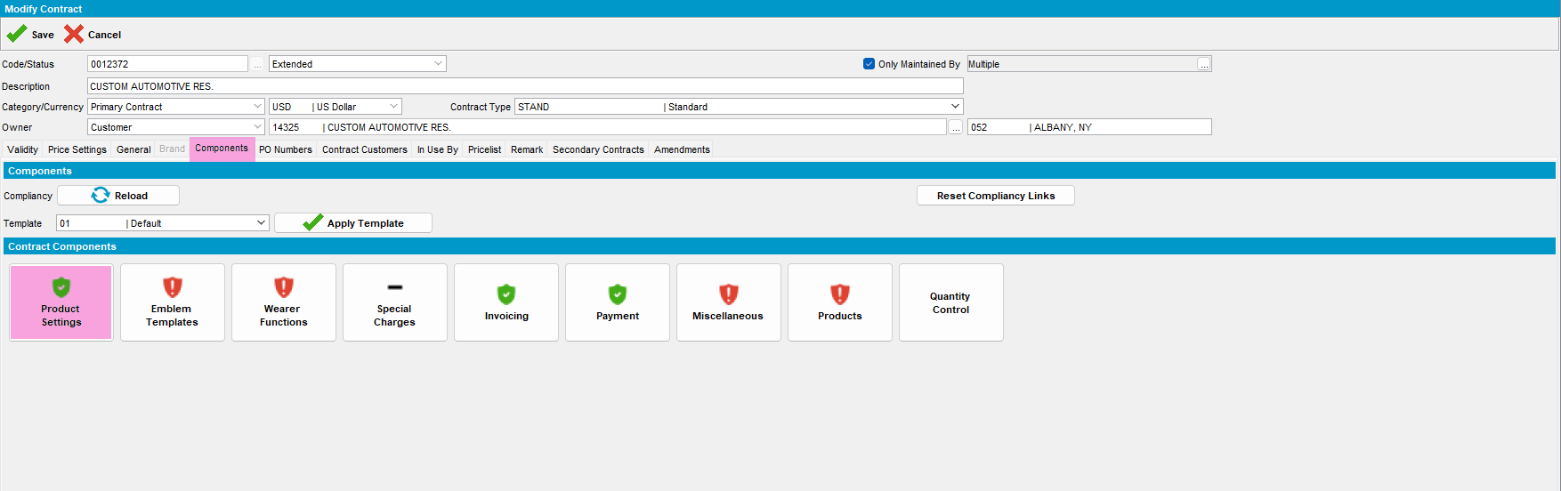

- Contract DLG: See the status of Special Size Charging and Size Surcharge Pricing
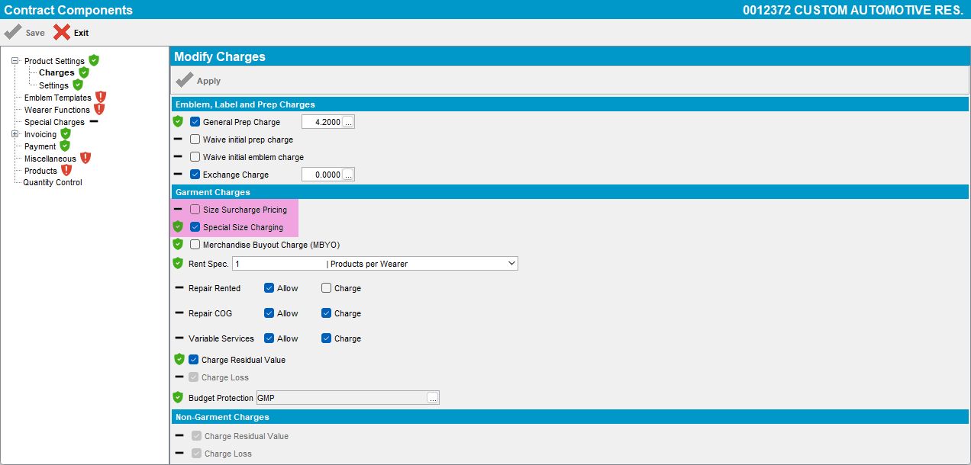

- Check that both are compliant
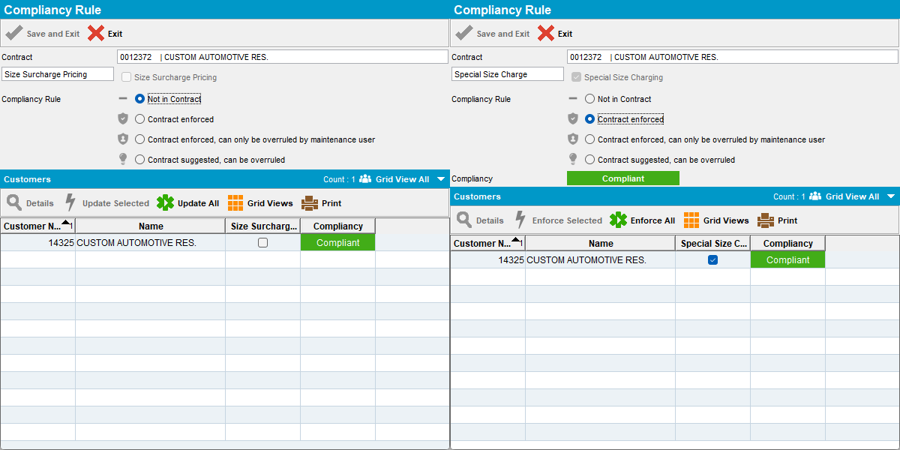

- Customers DLG: Garment Charges check that both “Product/Size Surcharge Pricing” and “Product Special Size Charging” are as set-up in the contract at step 3
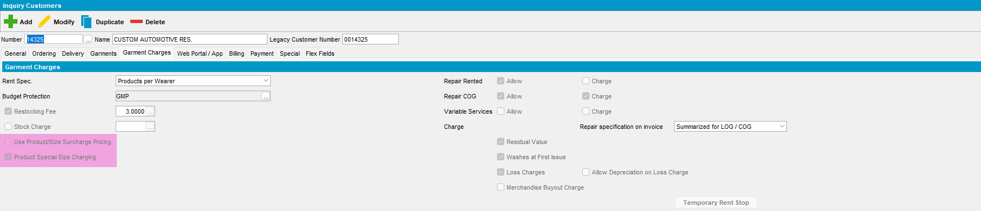

- Contract DLG: Change one option to another ex: from Special Size Charging active to Size Surcharge Pricing active (both cannot be active at the same time)
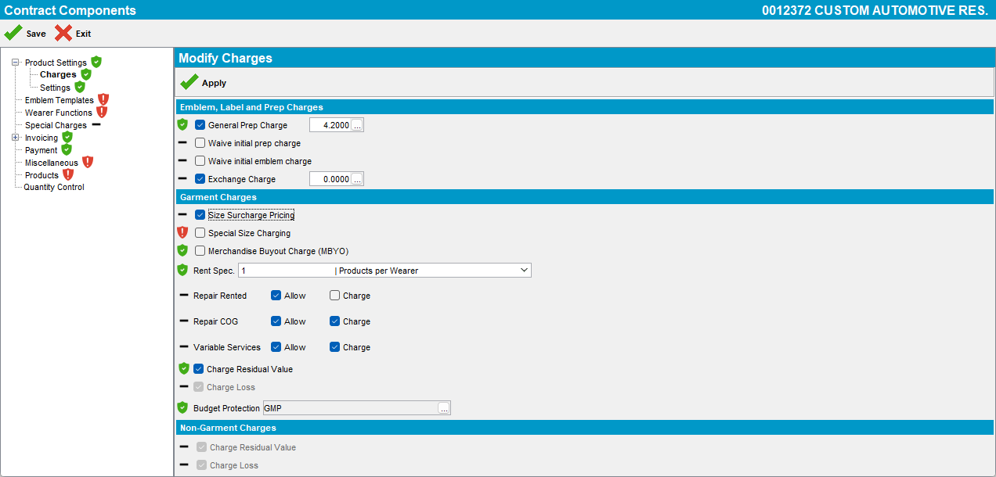

- Change the compliancy of Size Surcharge Pricing to compliant
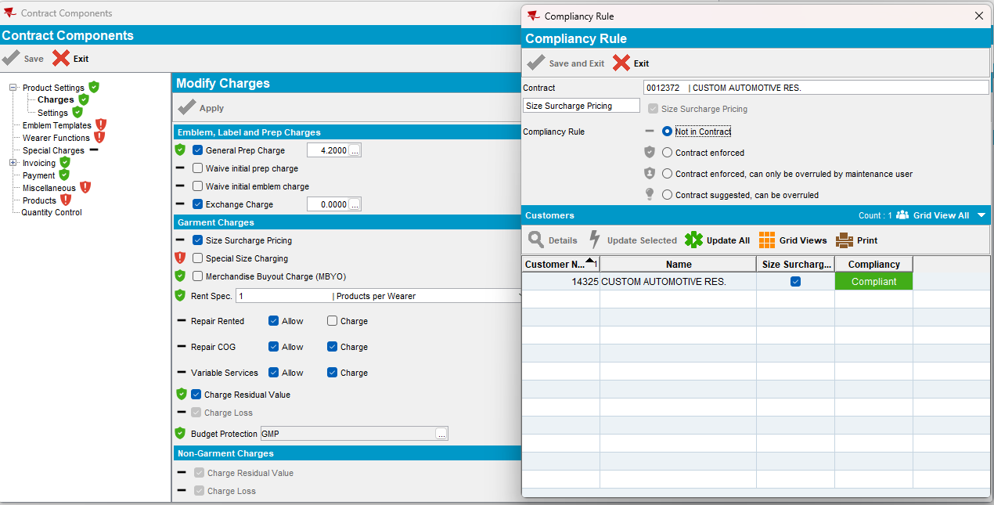

- Customer DLG: Check the status of the “Product/Size Surcharge Pricing” and “Product Special Size Charging”
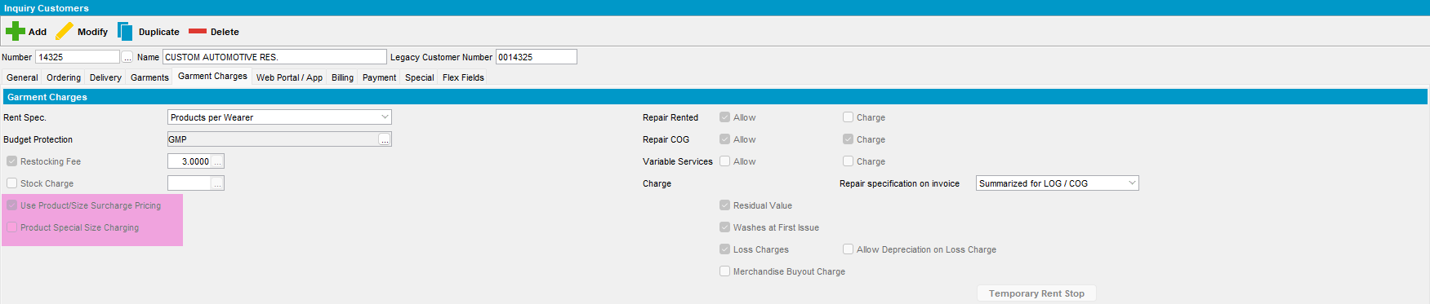
Tested OK

Current Behavior
As the 2 fields Special Size Charge and Size Surcharge Pricing are mutually exclusive, enforcing compliancy on one of them should enforce compliancy on the other.

Expected behavior
As the 2 fields Special Size Charge and Size Surcharge Pricing are mutually exclusive, enforcing compliancy on one of them should enforce compliancy on the other.

