ABS-169858 - D_UBS_2015 Contract Compliancy - Compliancy should mark ETLs as inactive when used on WOs
Environment | Prerequisites
Version: 9.07.00.UNF18  DBServerName= abs-srv20.internal.abslbs.com  DBSID=CUST24  DBUser=UNFDEV  DBPassword= UNFDEV  Environment=Test | - Module:  - System setting

Contents
Reproducing before fix 1
Steps to reproduce 1
Retest after fix 5
Test Case 1 – Enforce compliancy for an ETL not linked to contract that has a new WorkOrder 5
Test Case 2 – Enforce compliancy for an ETL not linked to contract that has no workorders 9
Test Case 3 – Enforce compliancy for an ETL not linked to contract that has a WorkOrder that was already issued and is complete 12
Test Case 4 – Enforce compliancy for an ETL not linked to contract that has a WorkOrder that was partially issued and is in progress 17

Reproducing before fix

Steps to reproduce
- Find a customer that has linked Emblem Templets with the following select:
SELECT C.CUSTOMERNUMBER FROM CUSTOMER C
WHERE EXISTS (SELECT 1 FROM EMBLEMTEMPLATE ET
WHERE ET.CUSTOMER_ID = C.CUSTOMER_ID)
AND C.DEFAULTBUSINESSUNIT_ID = (SELECT BU.BUSINESSUNIT_ID FROM BUSINESSUNIT BU WHERE BU.CODE = '055')
AND C.DATEINACTIVE > SYSDATE
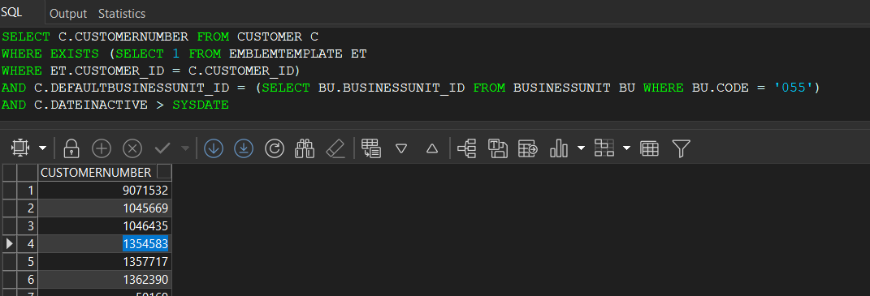
- Emblem templates DLG: Open an emblem template that is linked to a contract and add a new template
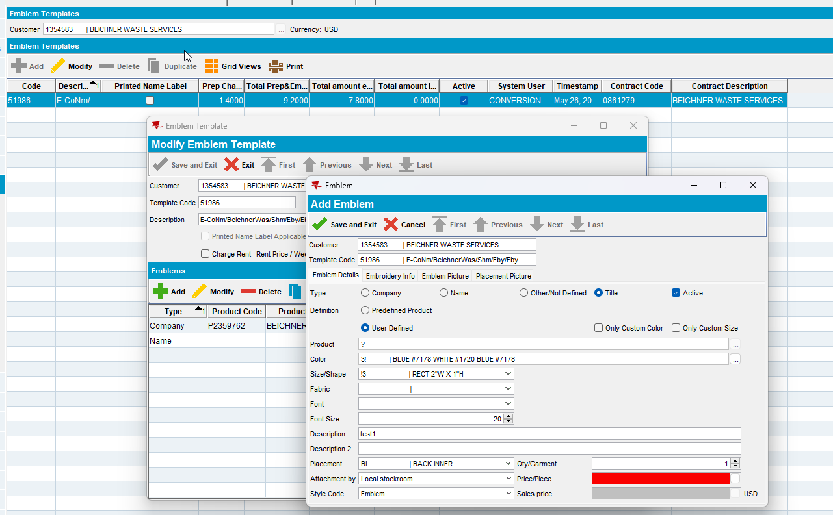
- Contract DLG: Components > Emblem Templates set the Compliancy to Not in Contract
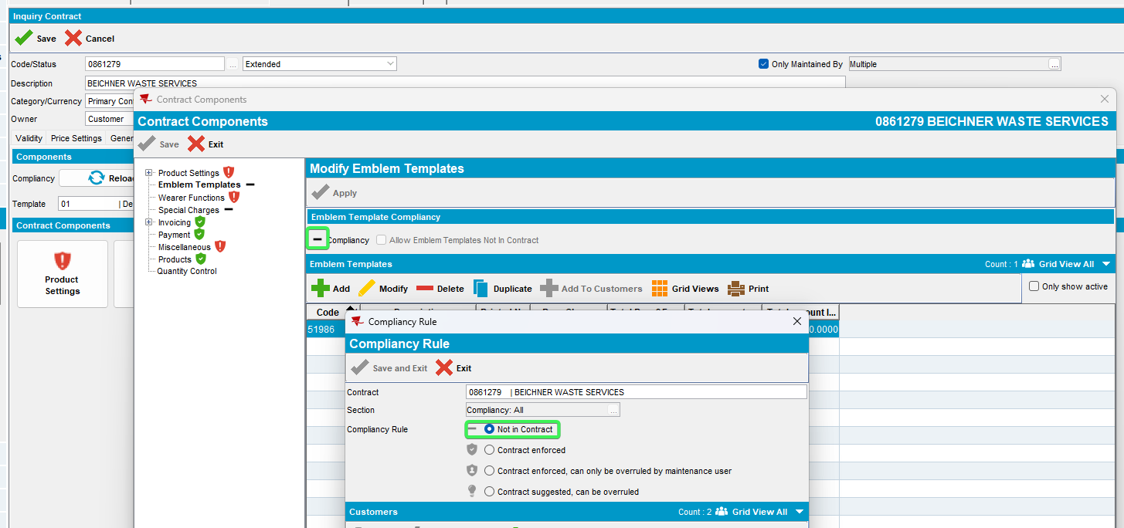
- Wearer DLG: Add a new wearer inventory with that emblem template 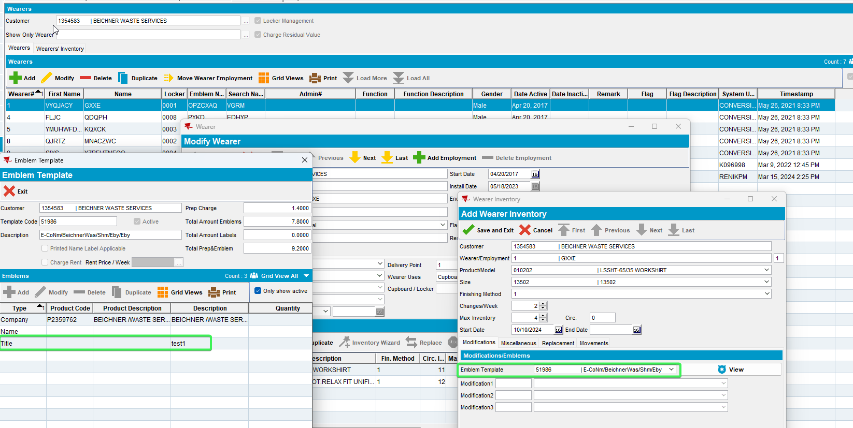
- Generate the Work order for the added WI
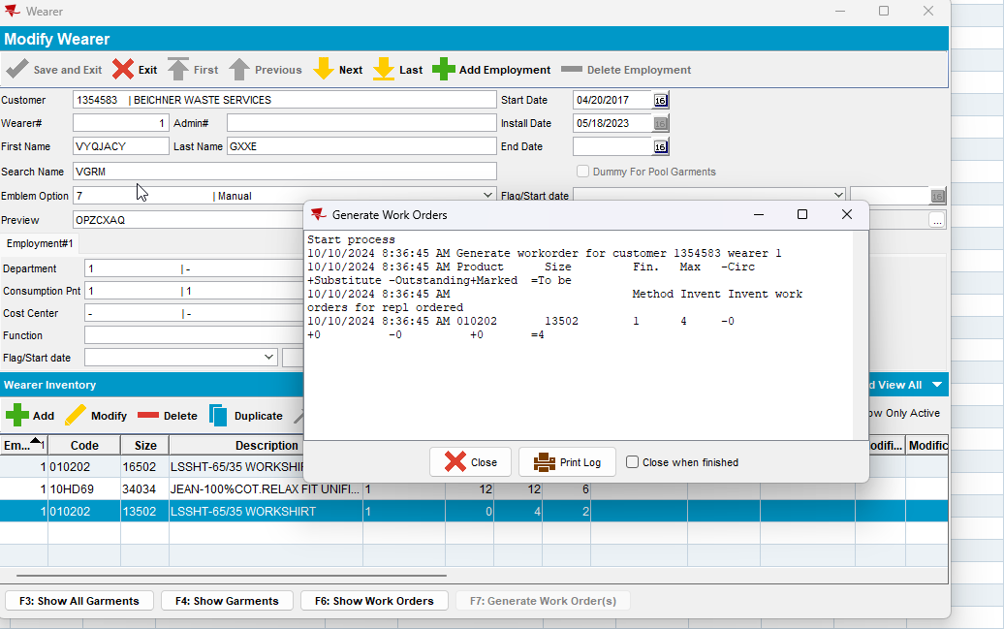
- Contract DLG: Components > Emblem Template enforce compliancy to your customer
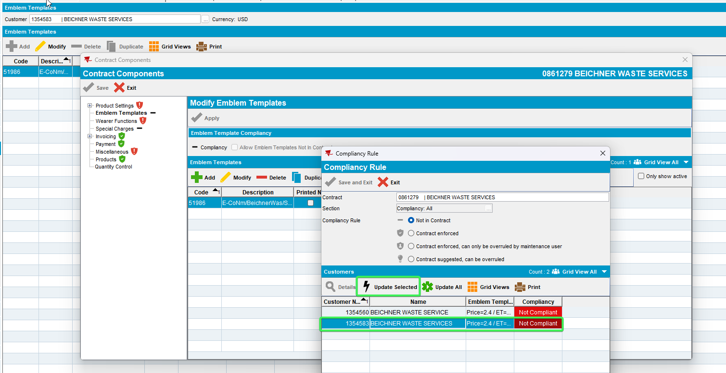
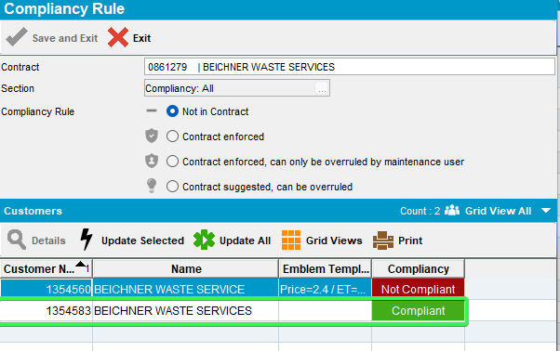
- Issue Work Order: Issue the work Order for the WI added previously
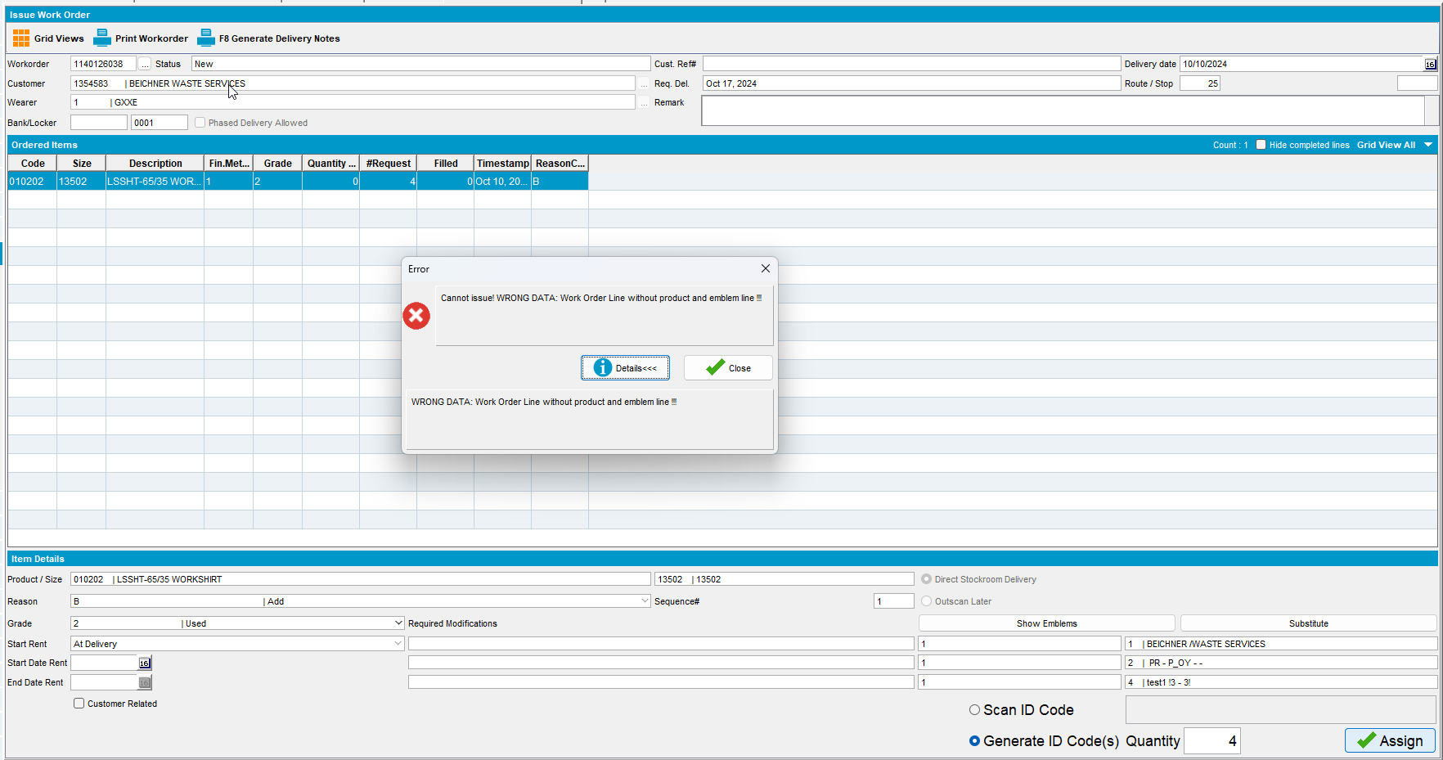
REPRODUCED OK.

Retest after fix

Test Case 1 – Enforce compliancy for an ETL not linked to contract that has a new WorkOrder
Hash: 80689830f576
Expected behavior: ETL is not deleted but instead is made Active = 'N'. The Workorder can still be issued.
- Find a customer that has linked Emblem Templets with the following select:
SELECT C.CUSTOMERNUMBER FROM CUSTOMER C
WHERE EXISTS (SELECT 1 FROM EMBLEMTEMPLATE ET
WHERE ET.CUSTOMER_ID = C.CUSTOMER_ID)
AND C.DEFAULTBUSINESSUNIT_ID = (SELECT BU.BUSINESSUNIT_ID FROM BUSINESSUNIT BU WHERE BU.CODE = '055')
AND C.DATEINACTIVE > SYSDATE
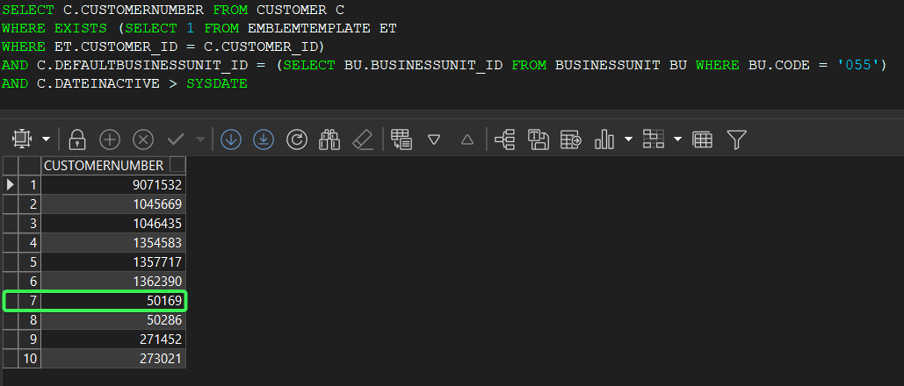
- Contract DLG: Components > Emblem Templates set the Compliancy to Not in Contract
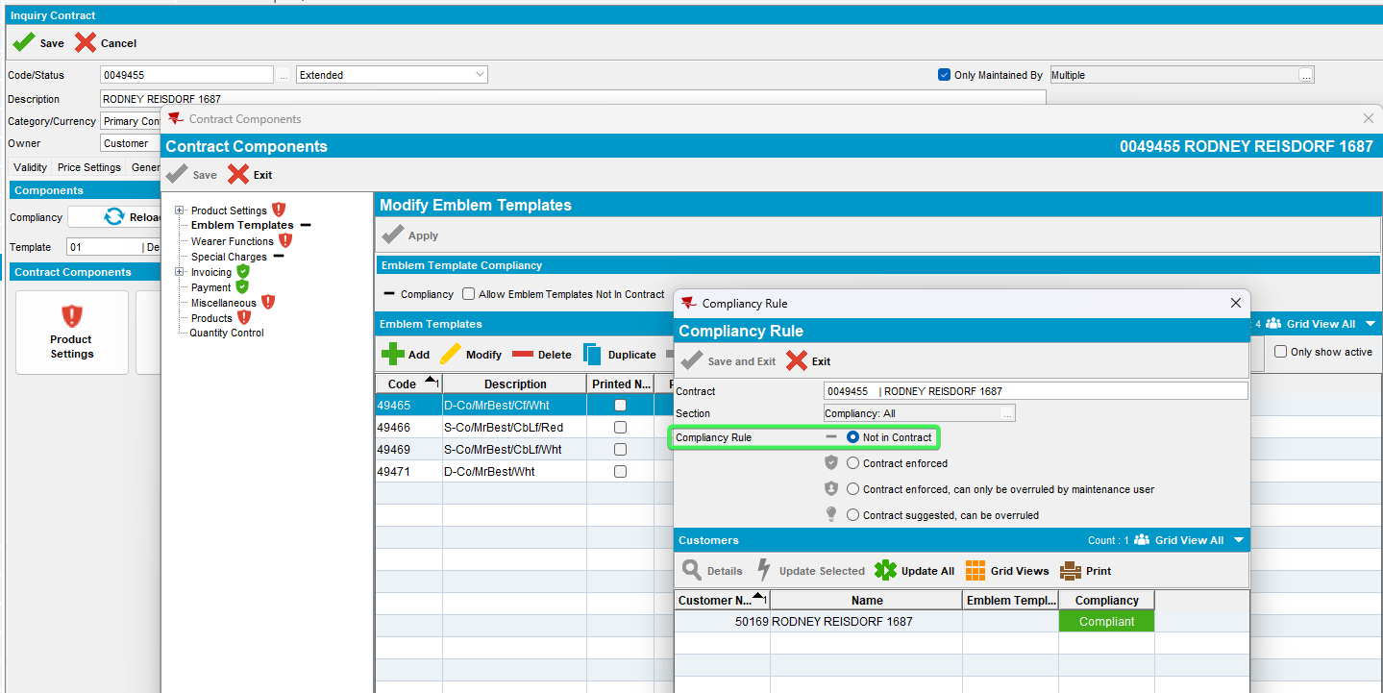
- Emblem templates DLG: Open an emblem template that is linked to a contract and add a new template
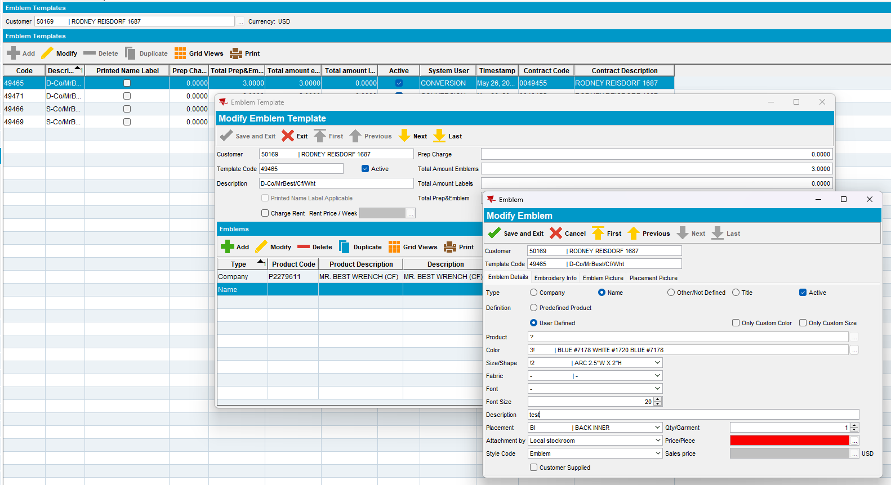
- Wearer DLG: Add a new wearer inventory with that emblem template
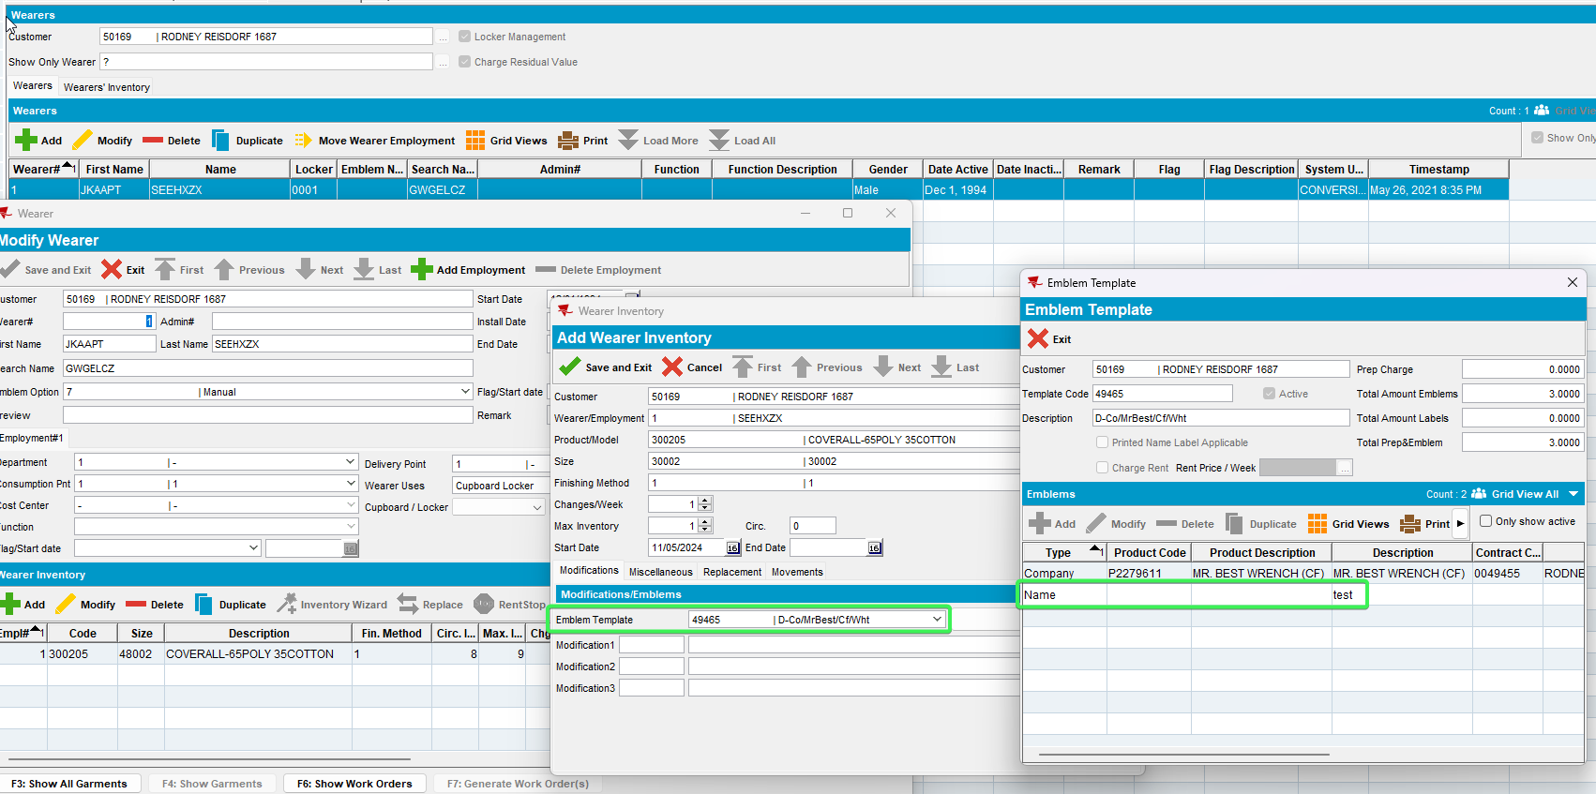
- Generate the Work order for the added WI
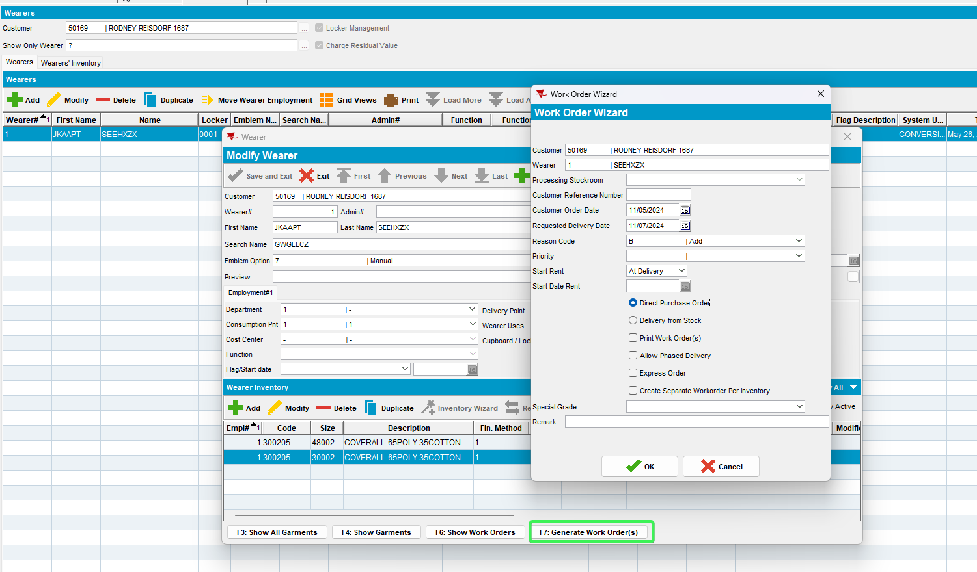
- Contract DLG: Components > Emblem Template enforce compliancy to your customer
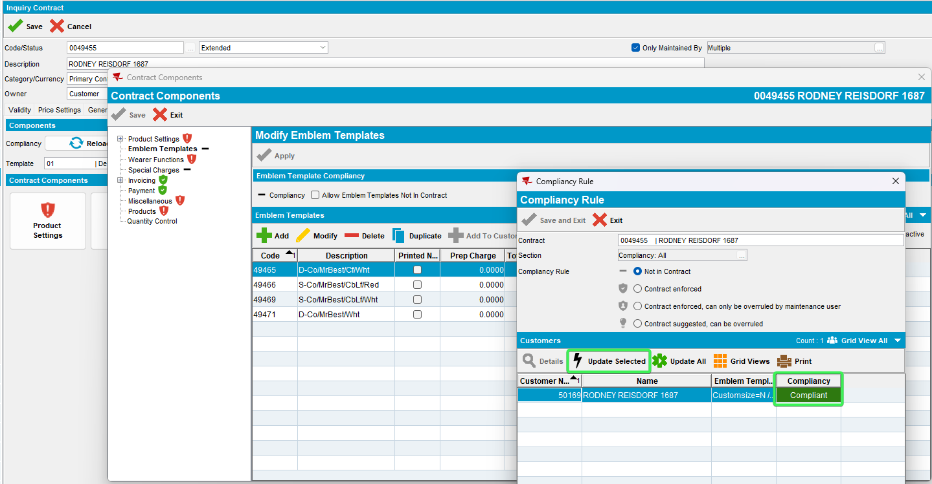
- Issue Work Order: Issue the work Order for the WI added previously
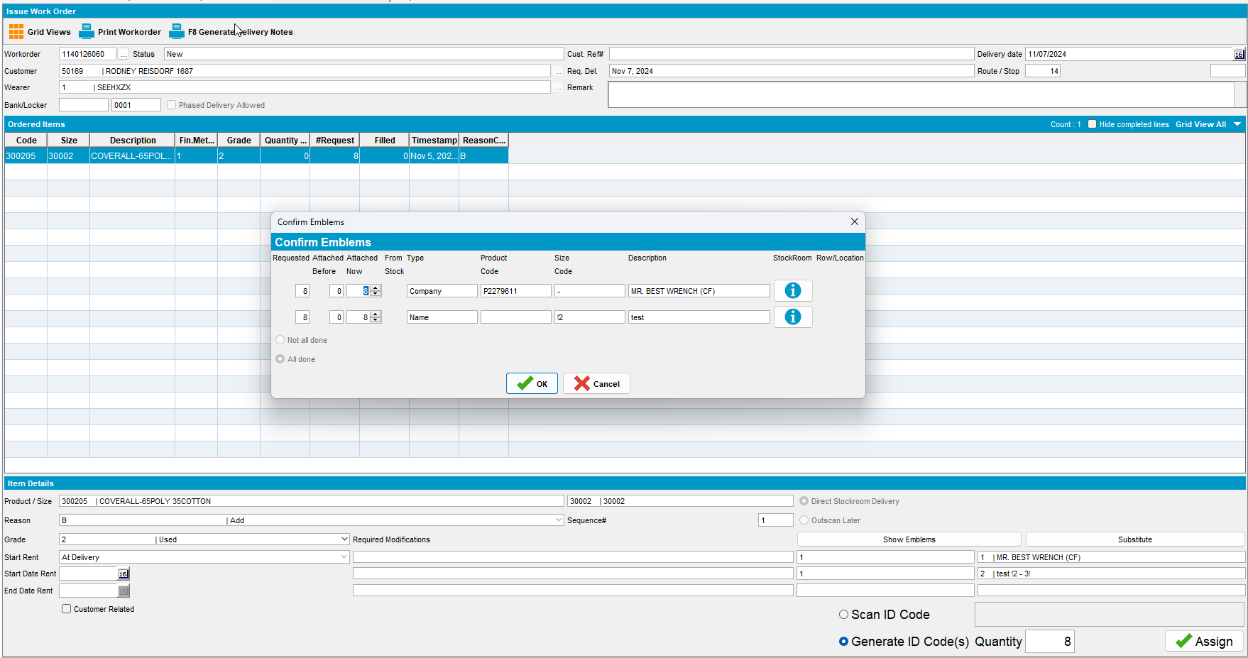
- Emblem Template DLG: See that the added emblem is now Active =N
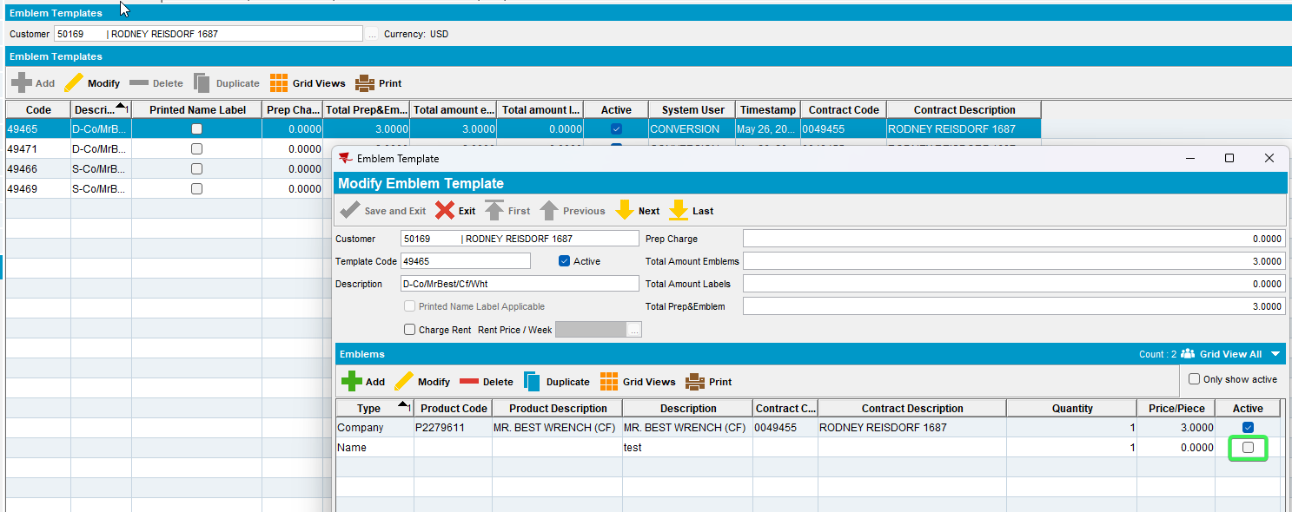
Tested OK

Test Case 2 – Enforce compliancy for an ETL not linked to contract that has no workorders
Hash: 80689830f576
Expected behavior: ETL is deleted.
- Find a customer that has linked Emblem Templets with the following select:
SELECT C.CUSTOMERNUMBER FROM CUSTOMER C
WHERE EXISTS (SELECT 1 FROM EMBLEMTEMPLATE ET
WHERE ET.CUSTOMER_ID = C.CUSTOMER_ID)
AND C.DEFAULTBUSINESSUNIT_ID = (SELECT BU.BUSINESSUNIT_ID FROM BUSINESSUNIT BU WHERE BU.CODE = '055')
AND C.DATEINACTIVE > SYSDATE
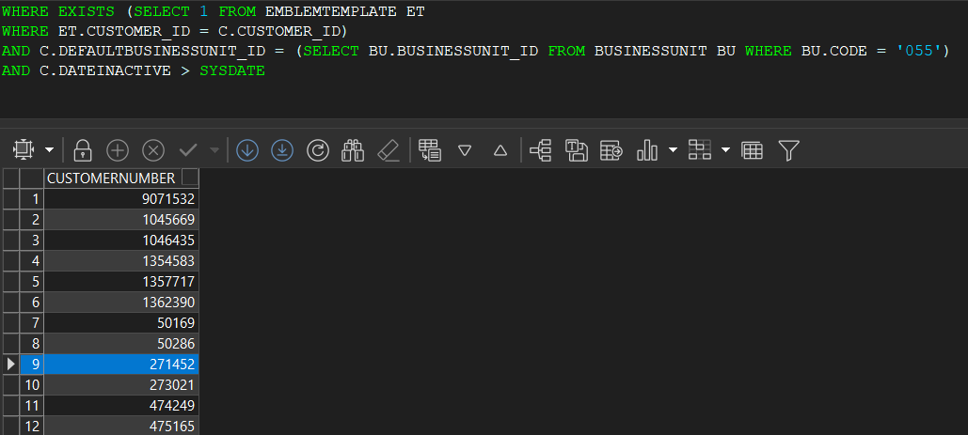
- Contract DLG: Components > Emblem Templates set the Compliancy to Not in Contract
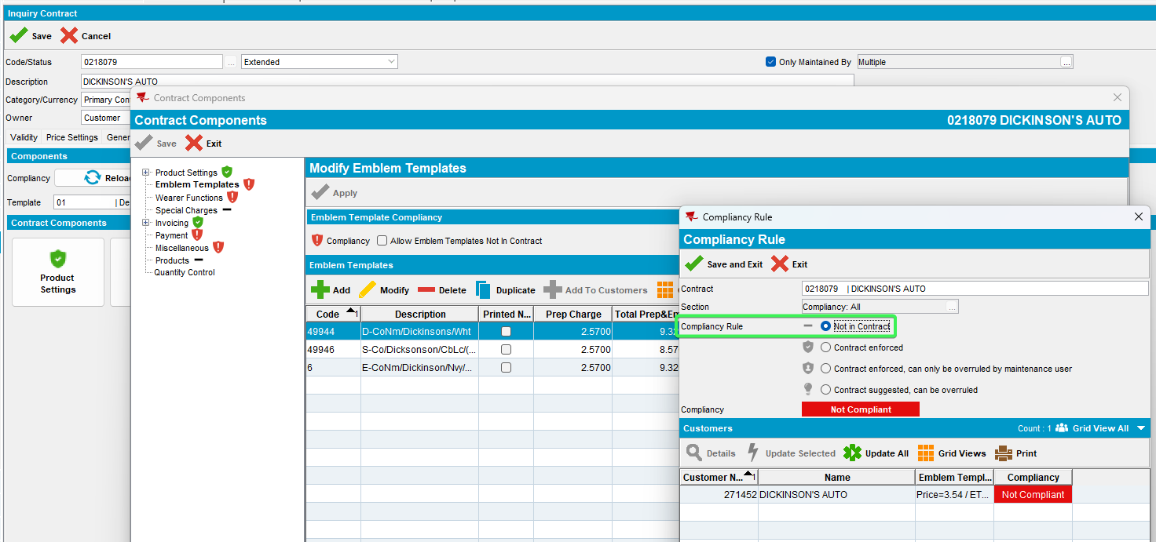
- Emblem templates DLG: Open an emblem template that is linked to a contract and add a new template
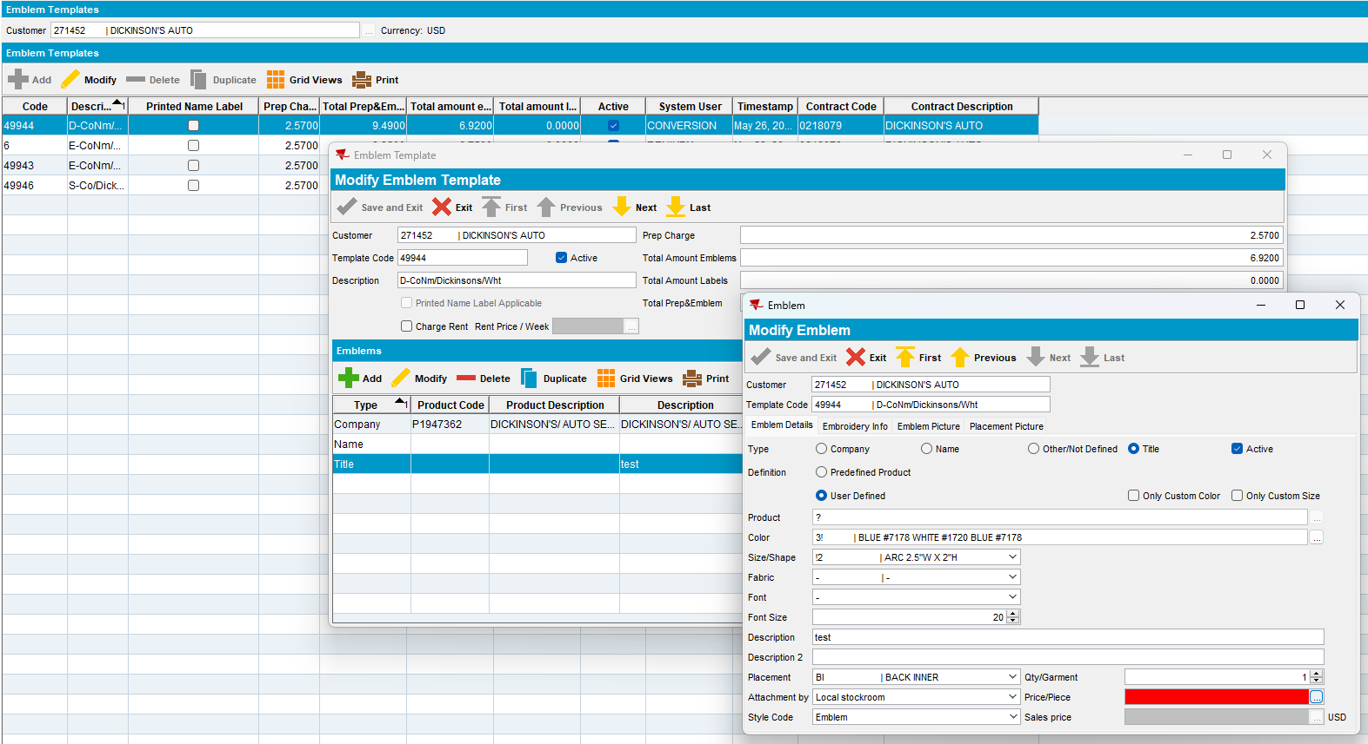
- Wearer DLG: Add a new wearer inventory with that emblem template
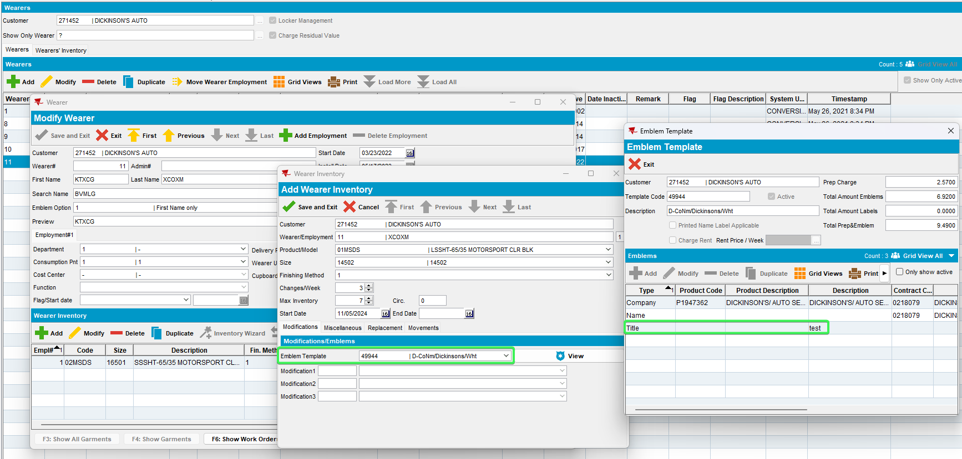
- Contract DLG: Components > Emblem Template enforce compliancy to your customer without creating the work order for the added WI
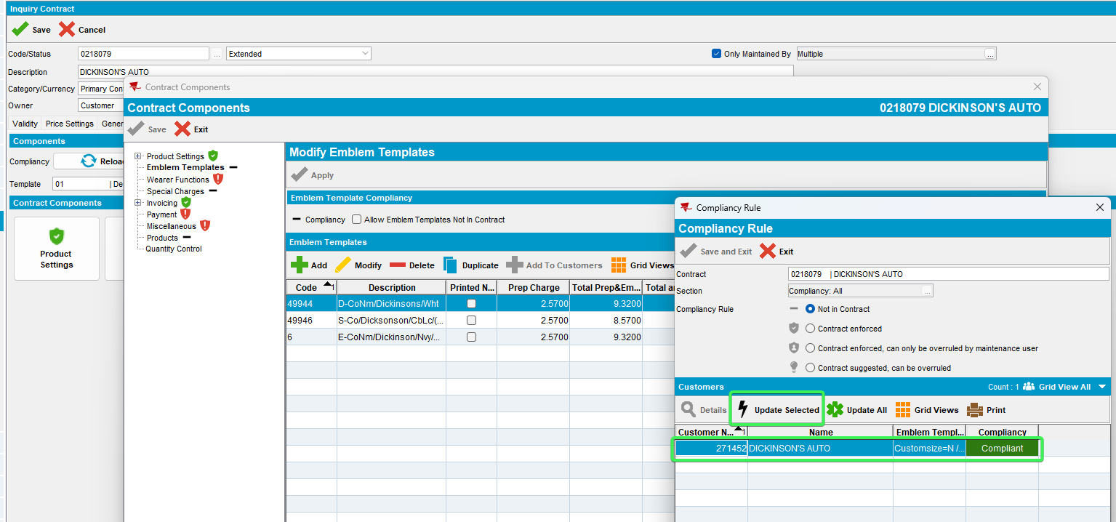
- Emblem Template DLG: see that the added emblem was deleted
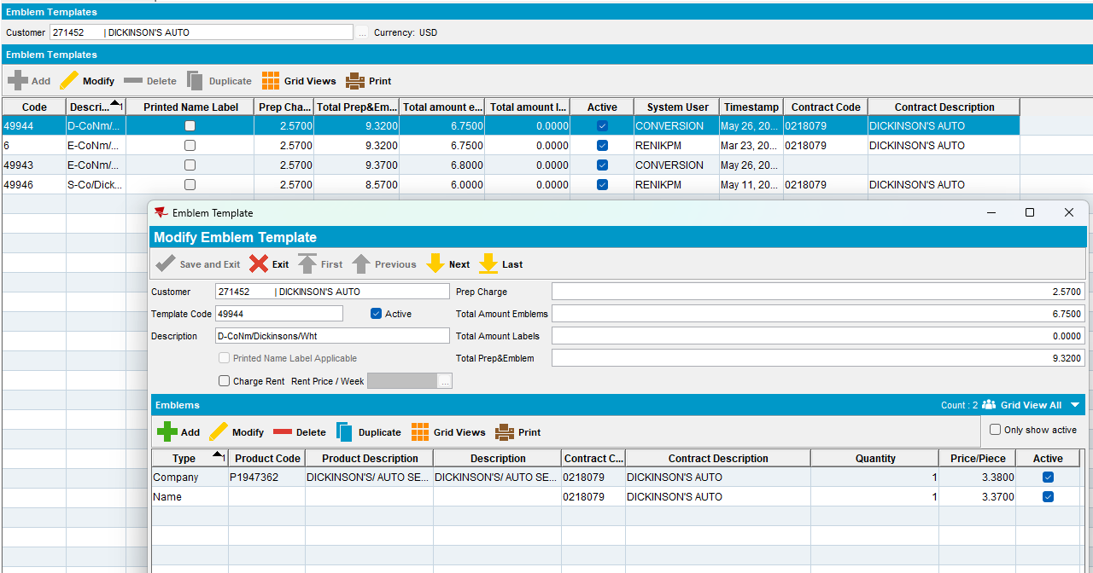
Tested OK

Test Case 3 – Enforce compliancy for an ETL not linked to contract that has a WorkOrder that was already issued and is complete
Hash: 80689830f576
Expected behavior: ETL is not deleted but instead is made Active = 'N'.
- Find a customer that has linked Emblem Templets with the following select:
SELECT C.CUSTOMERNUMBER FROM CUSTOMER C
WHERE EXISTS (SELECT 1 FROM EMBLEMTEMPLATE ET
WHERE ET.CUSTOMER_ID = C.CUSTOMER_ID)
AND C.DEFAULTBUSINESSUNIT_ID = (SELECT BU.BUSINESSUNIT_ID FROM BUSINESSUNIT BU WHERE BU.CODE = '055')
AND C.DATEINACTIVE > SYSDATE
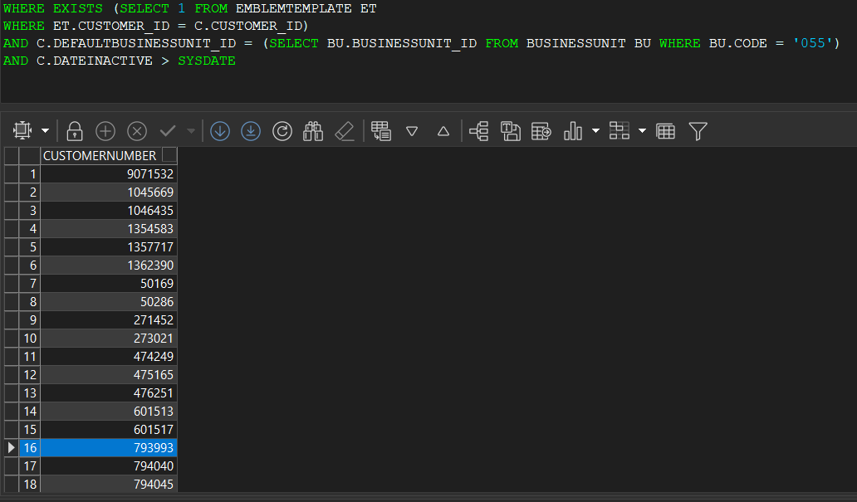
- Contract DLG: Components > Emblem Templates set the Compliancy to Not in Contract
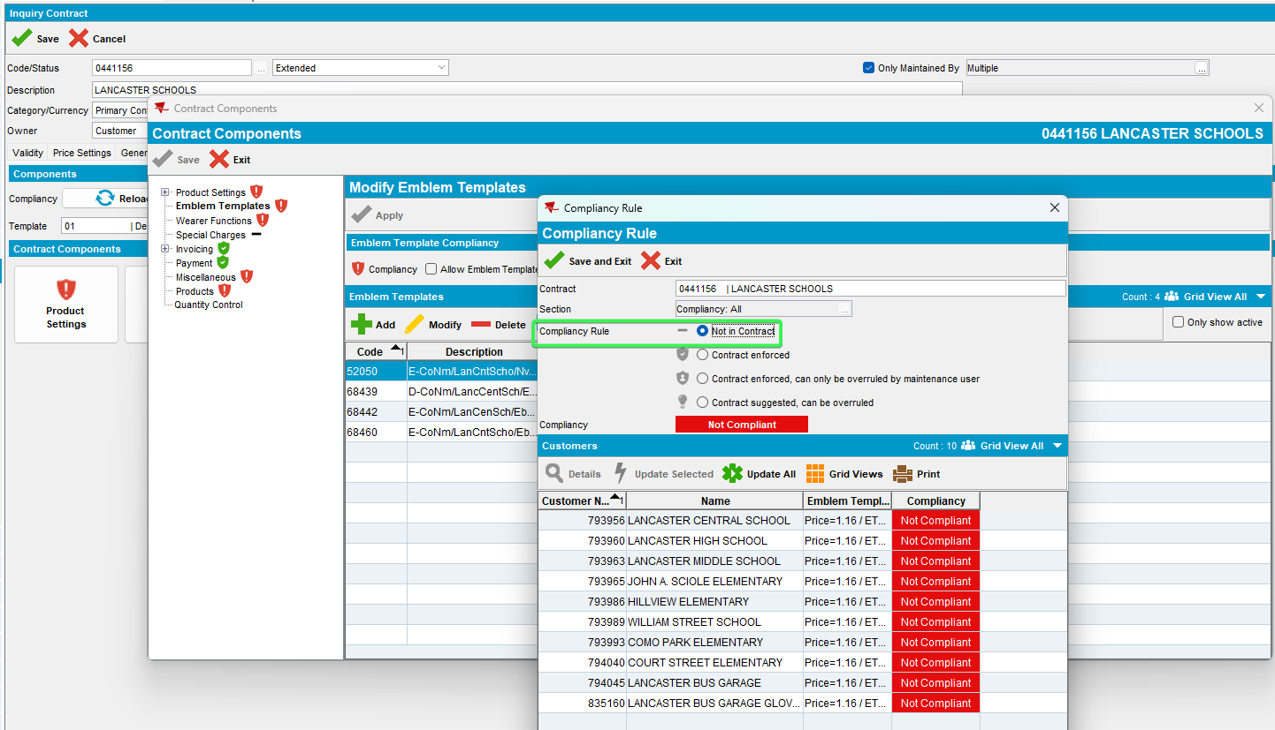
- Emblem templates DLG: Open an emblem template that is linked to a contract and add a new template
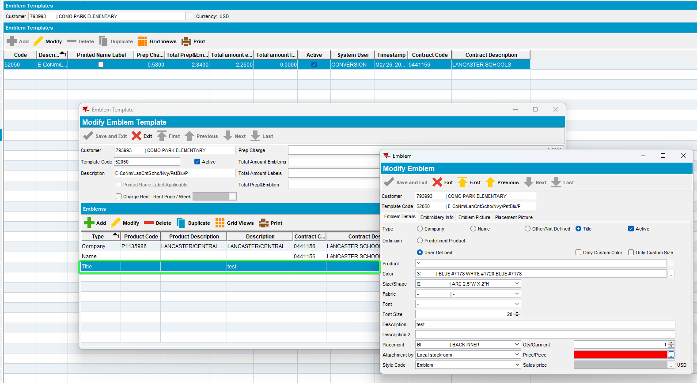
- Wearer DLG: Add a new wearer inventory with that emblem template
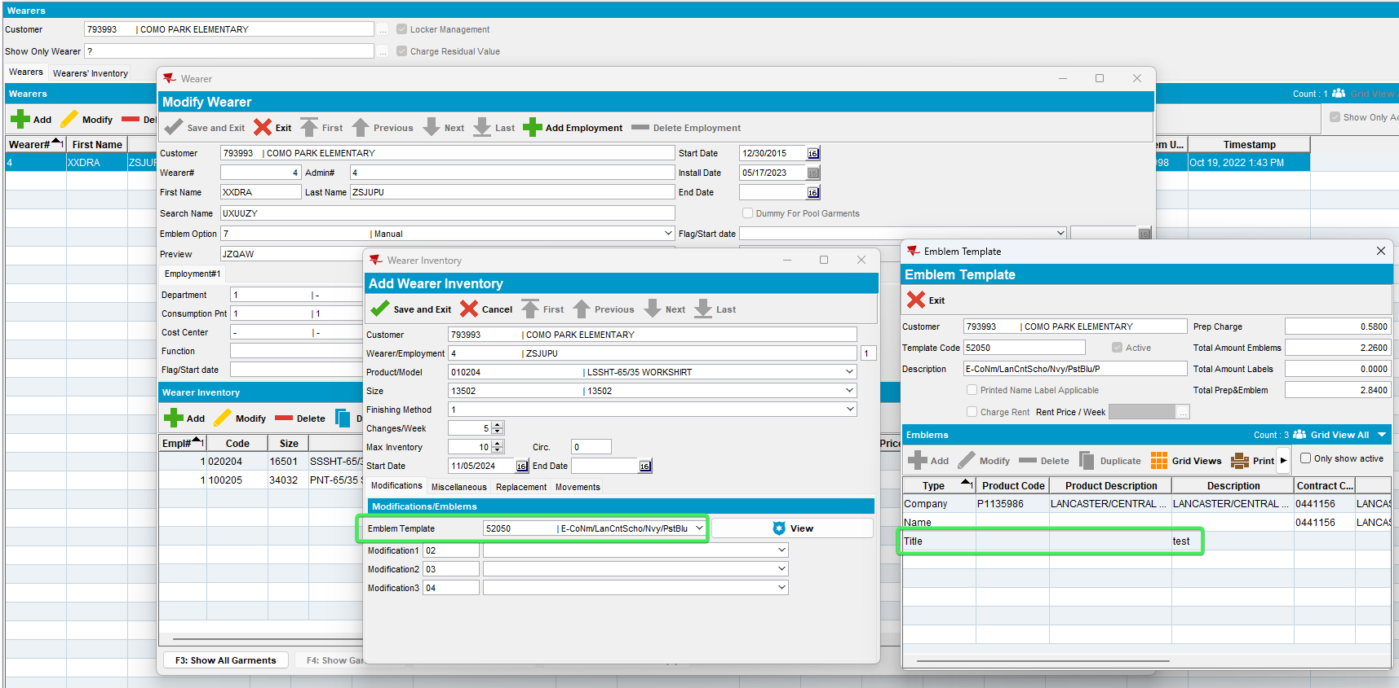
- Generate the Work order for the added WI
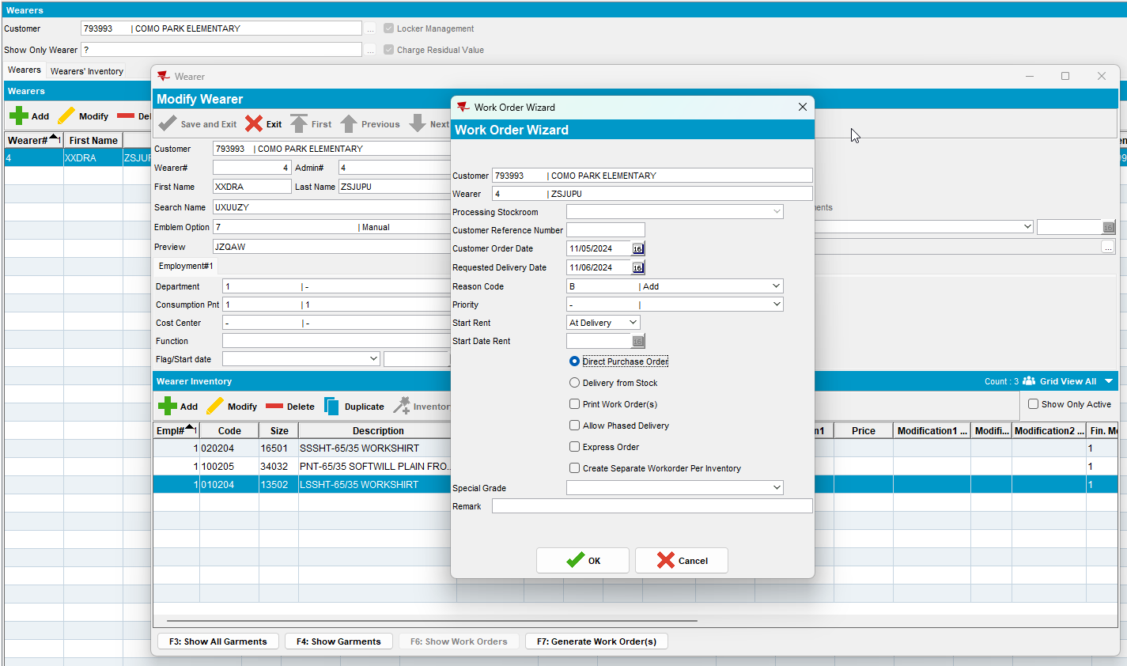
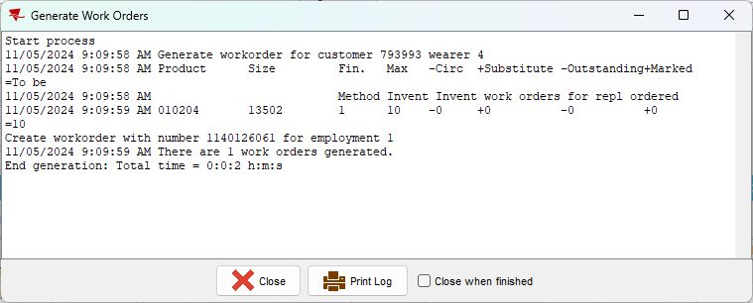
- Issue Work Order: Issue the work Order for the WI added previously
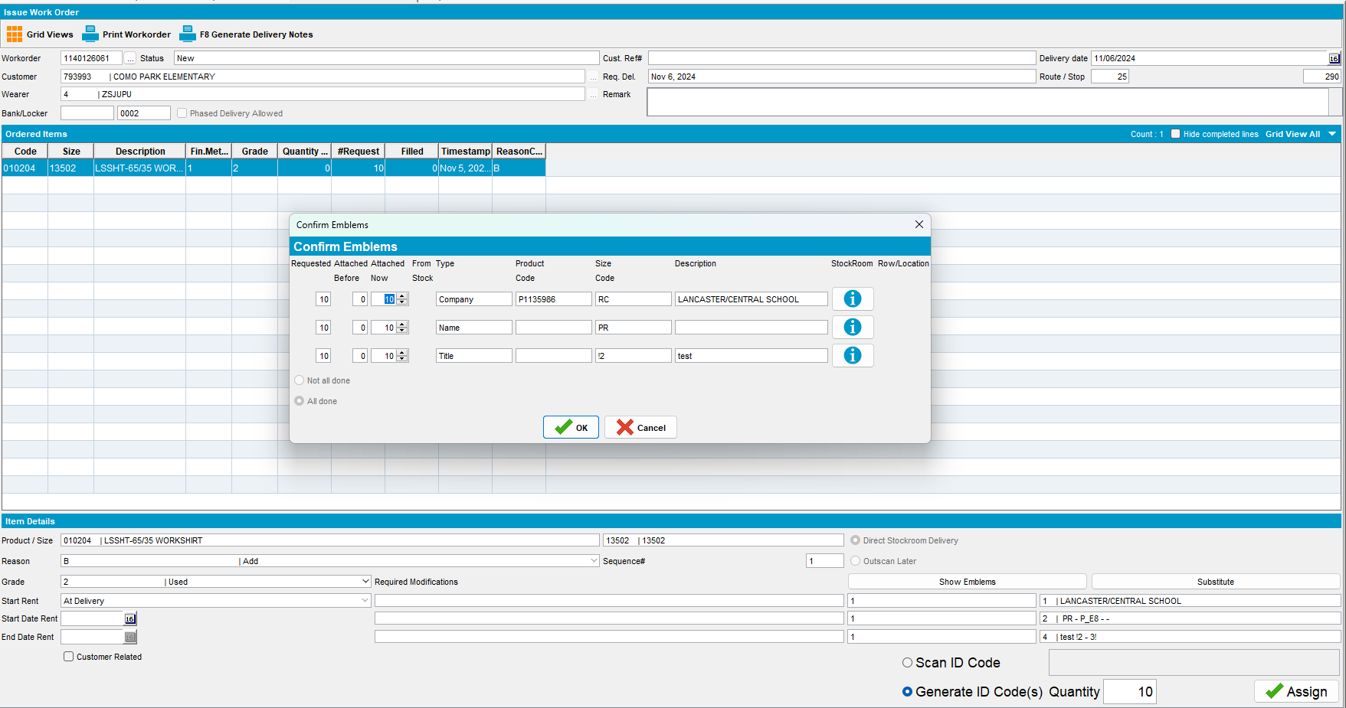
- Contract DLG: Components > Emblem Template enforce compliancy to your customer
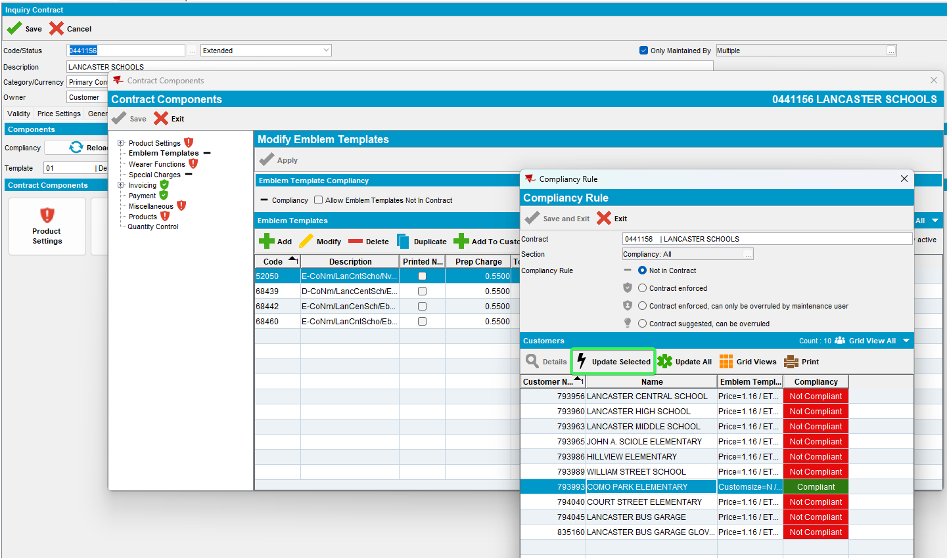
- Emblem Template DLG: Check the added emblem that is now Active=N
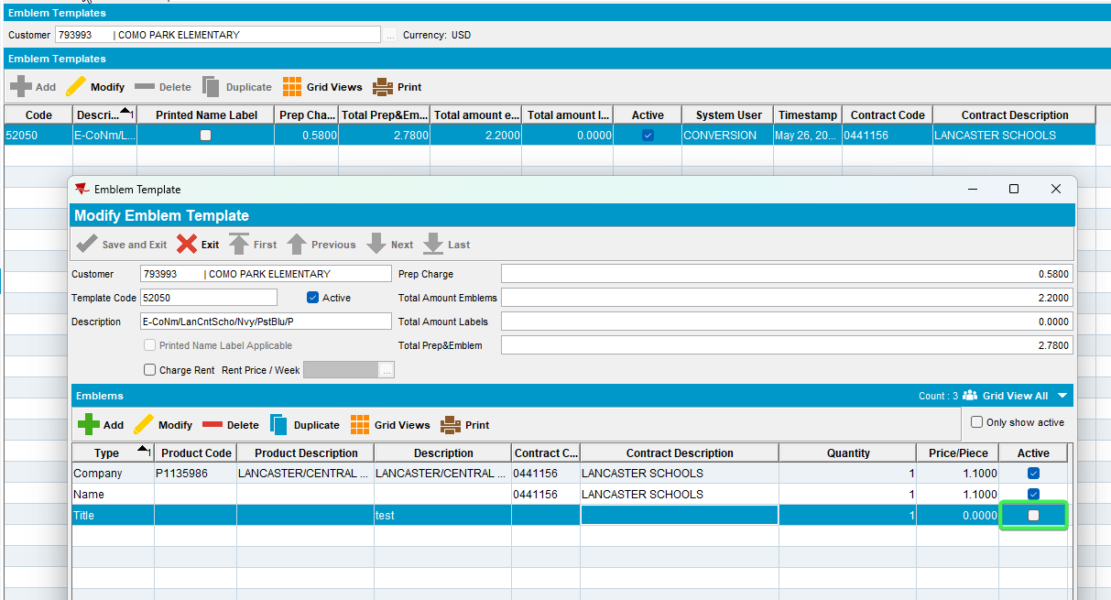
Tested OK

Test Case 4 – Enforce compliancy for an ETL not linked to contract that has a WorkOrder that was partially issued and is in progress
Hash: 80689830f576
Expected behavior: ETL is not deleted but instead is made Active = 'N'. The Workorder can still be issued fully.
- Find a customer that has linked Emblem Templets with the following select:
SELECT C.CUSTOMERNUMBER FROM CUSTOMER C
WHERE EXISTS (SELECT 1 FROM EMBLEMTEMPLATE ET
WHERE ET.CUSTOMER_ID = C.CUSTOMER_ID)
AND C.DEFAULTBUSINESSUNIT_ID = (SELECT BU.BUSINESSUNIT_ID FROM BUSINESSUNIT BU WHERE BU.CODE = '055')
AND C.DATEINACTIVE > SYSDATE
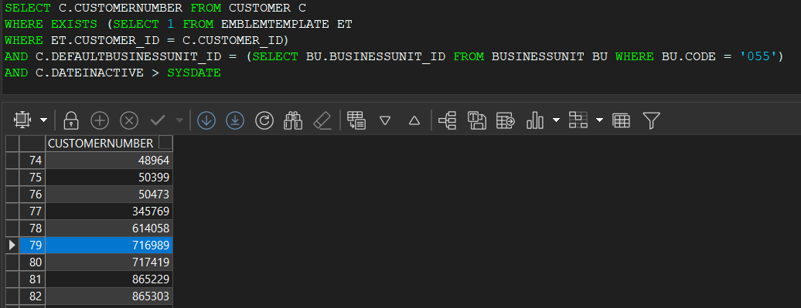
- Contract DLG: Components > Emblem Templates set the Compliancy to Not in Contract
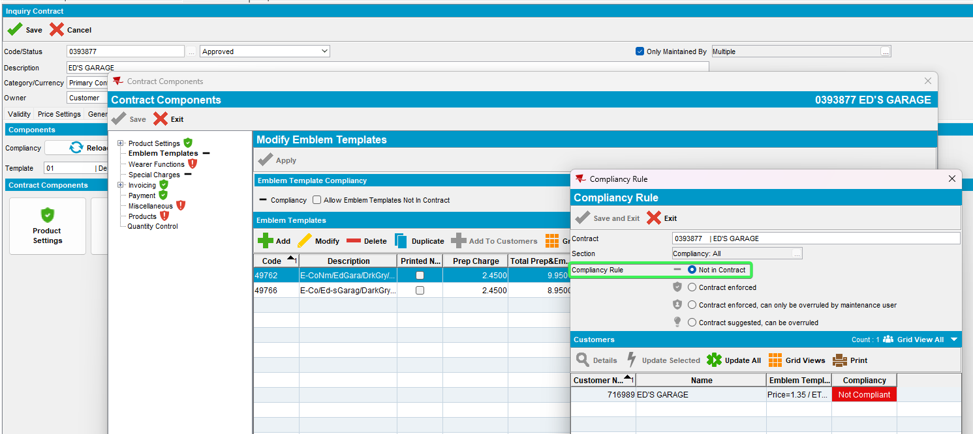
- Emblem templates DLG: Open an emblem template that is linked to a contract and add a new template
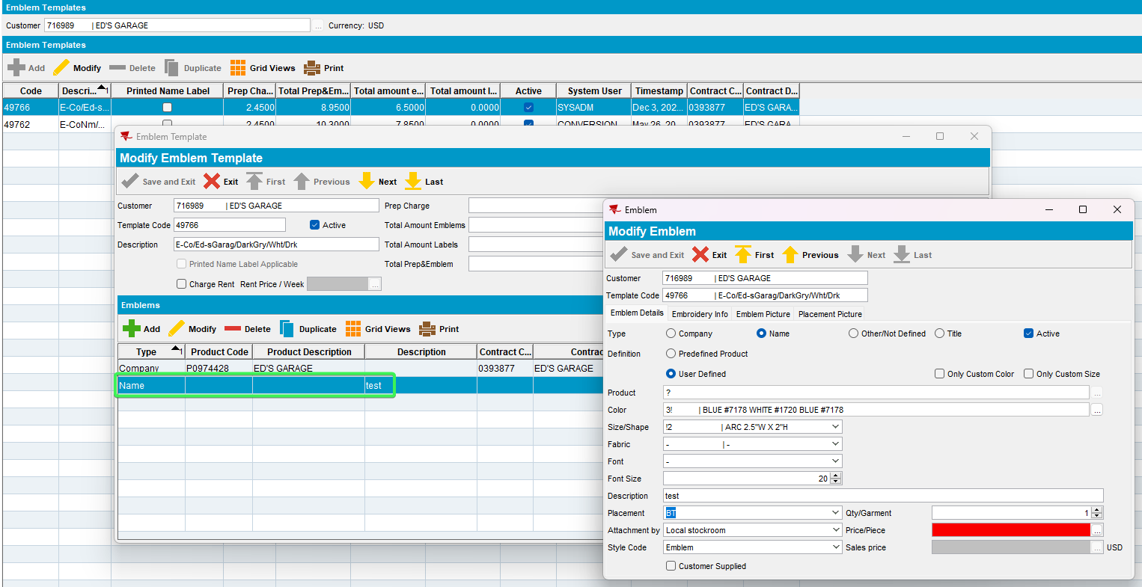
- Wearer DLG: Add a new wearer inventory with that emblem template
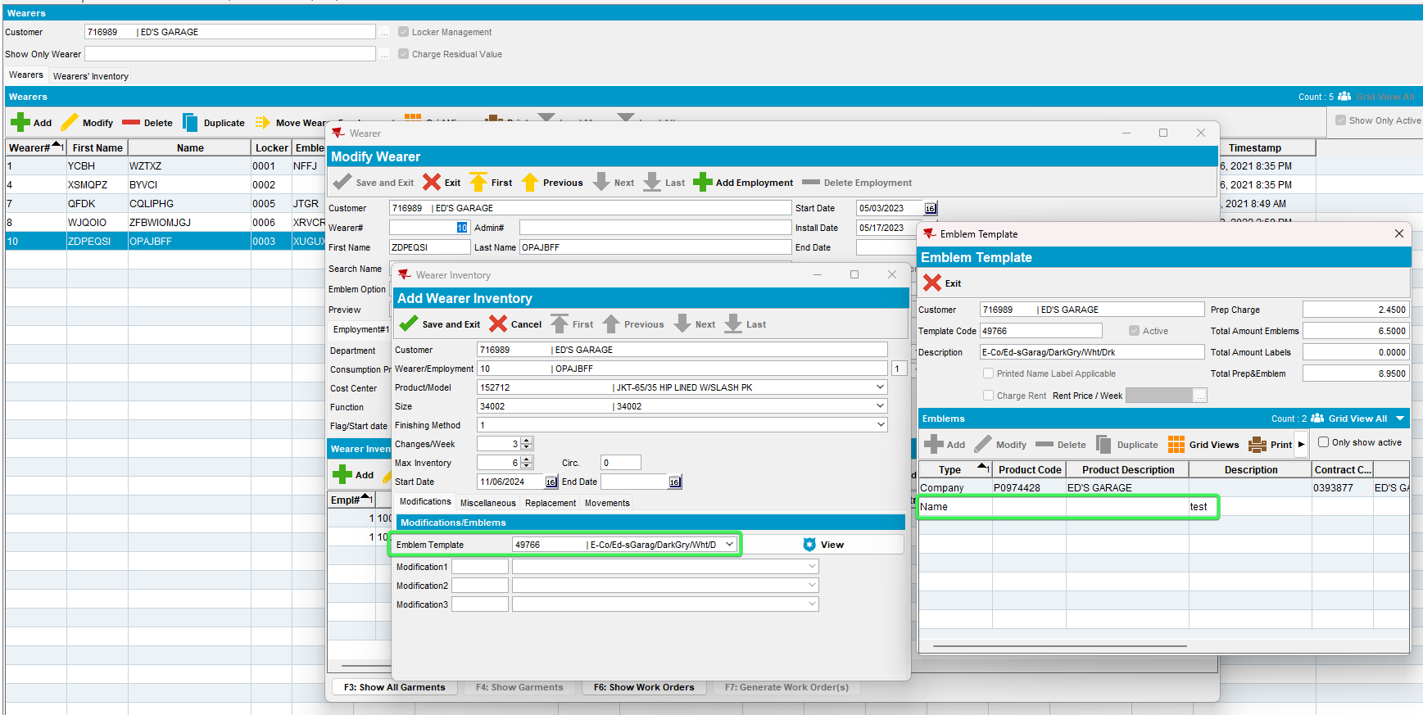
- Generate the Work order for the added WI
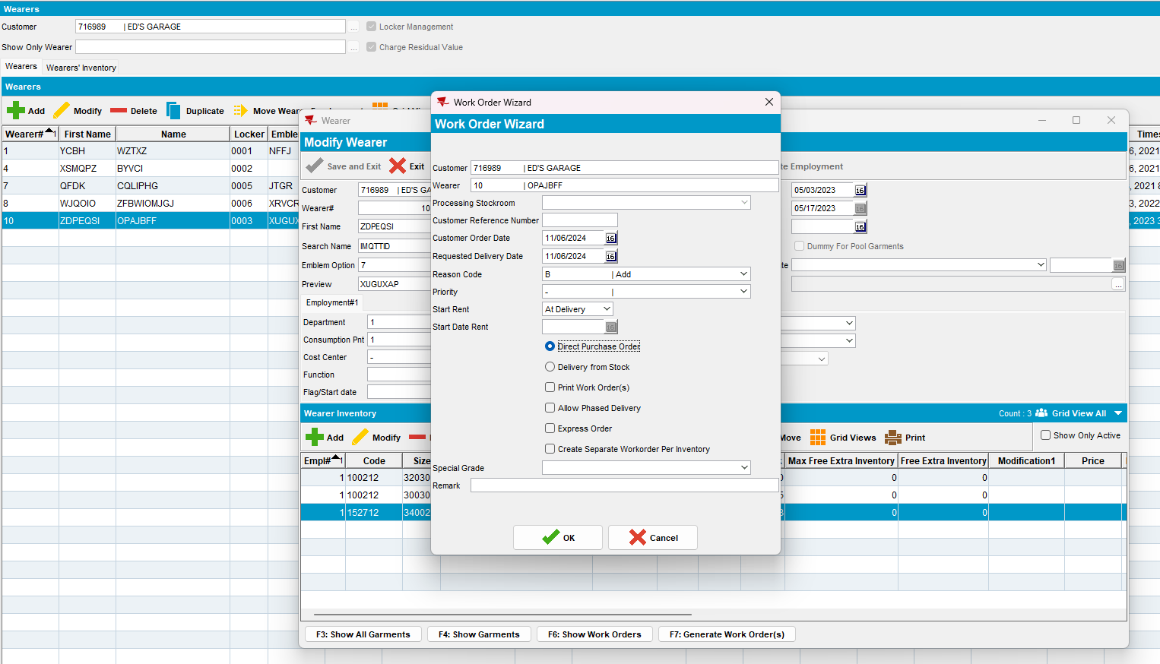

- Issue Work Order: Issue half of the items
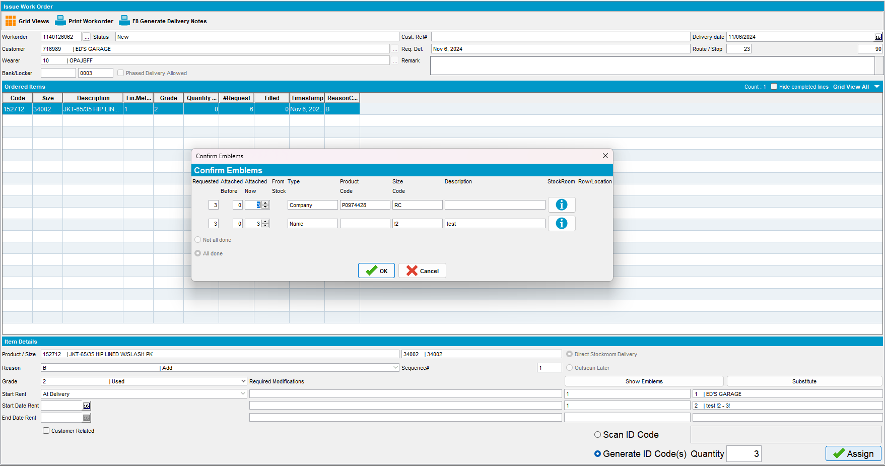

- Contract DLG: Components > Emblem Template enforce compliancy to your customer
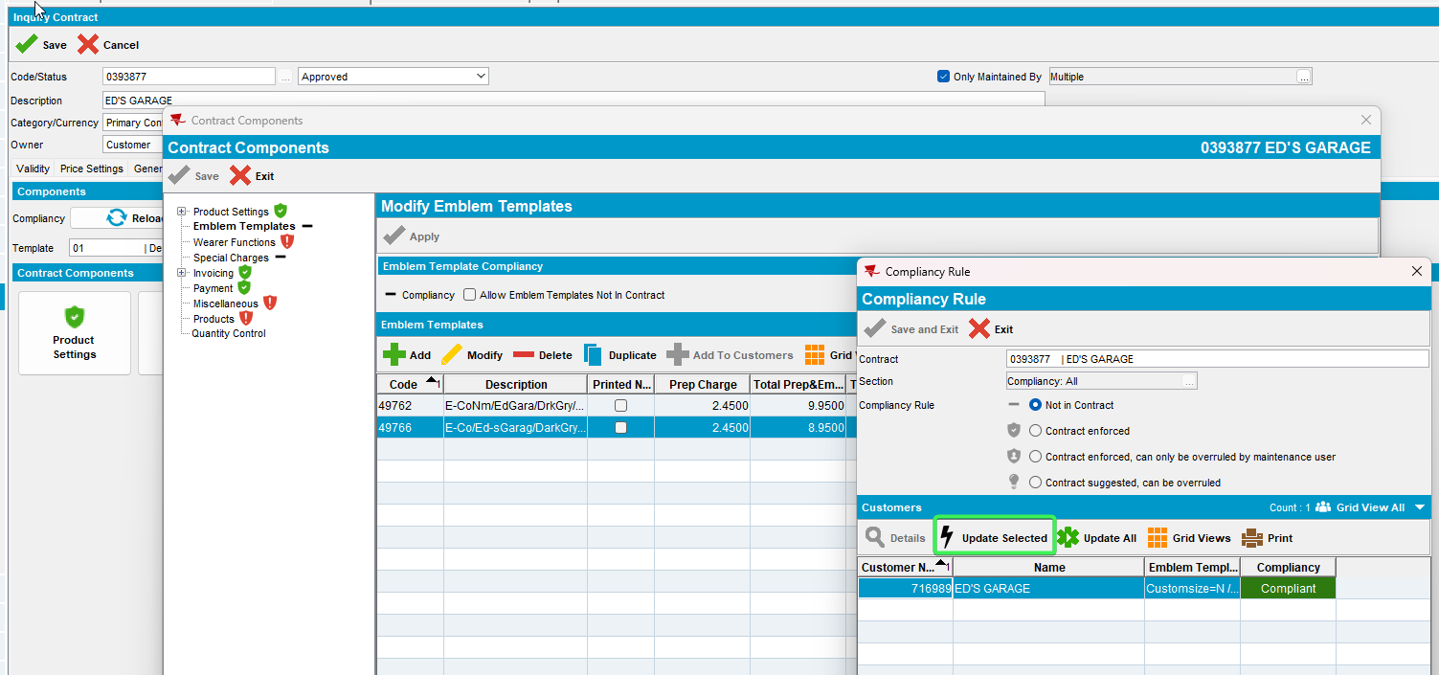
- Emblem Template DLG: Check the added emblem that is now Active=N
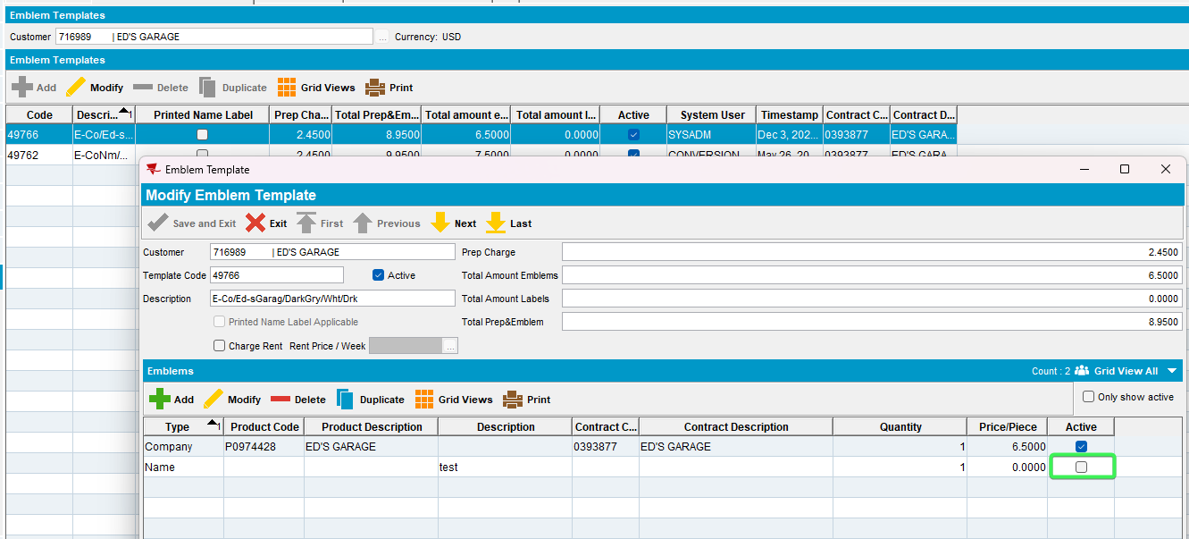
Tested OK

