ABS-169093 Calculation of the quantity for a work order has problem with route returned garmented
Environment | Prerequisites
Version:9.07.00  DBServerName=abs-SRV20.internal.abslbs.com  DBSID=CUST24  DBUser=UNFDEV  DBPassword=UNFDEV  Environment=Test | - Module:  - System setting

Contents
Test after fix 1
Test Case 1 – Change formula for deciding if we can create a new workorder– Tested OK 1
Test Case 2 – Change formula for the number of items on a new workorder line– Tested OK 4
Test Case 3 – Route Returns to remove replacement flag when setting item on status Route Returned to Stock– Tested OK 8

Test after fix

Test Case 1 – Change formula for deciding if we can create a new workorder– Tested OK
Expected behavior: Generate Work Order button is disabled for wearer inventories that have extra garments attached to the WI with a replacement flag and status_id = 121.
Hash: 74876eb
- Check that SS MAKECIRC=MAXONCHANGEMAX is set to 0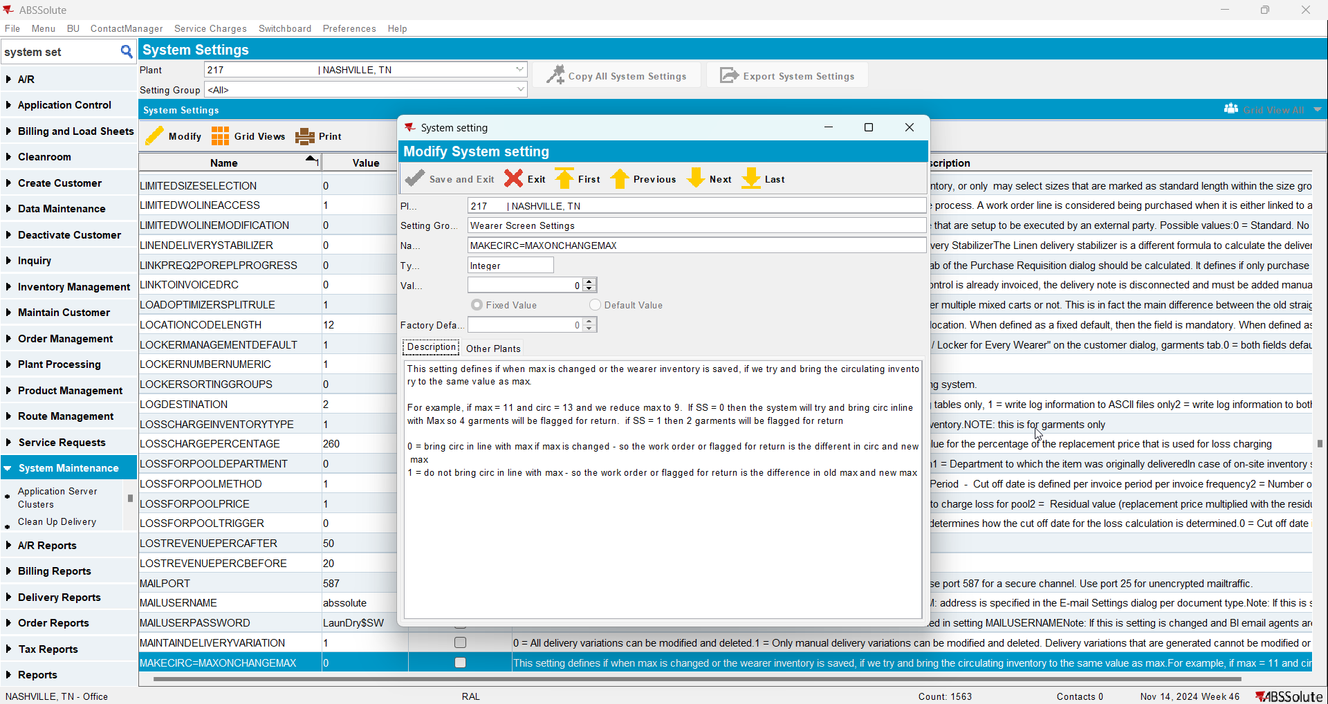
- Use the below select to find data
select c.customernumber,
w.wearernumber,
p.code,
wi.maxinventory,
wi.circinventory, u.primaryid
from uniqueitem u
join uniqueitemflag uf
on u.uniqueitem_id = uf.uniqueitem_id
join uniqueitemnonpool unp
on unp.uniqueitem_id = u.uniqueitem_id
join wearerinventory wi
on wi.wearerinventory_id = unp.wearerinventory_id
join weareremployment we
on wi.weareremployment_id = we.weareremployment_id
join wearer w
on w.wearer_id = we.wearer_id
join customer c
on c.customer_id = w.customer_id
join product p
on p.product_id = wi.product_id
where u.status_id = 121
and uf.flag_id = 41
and wi.circinventory = wi.maxinventory
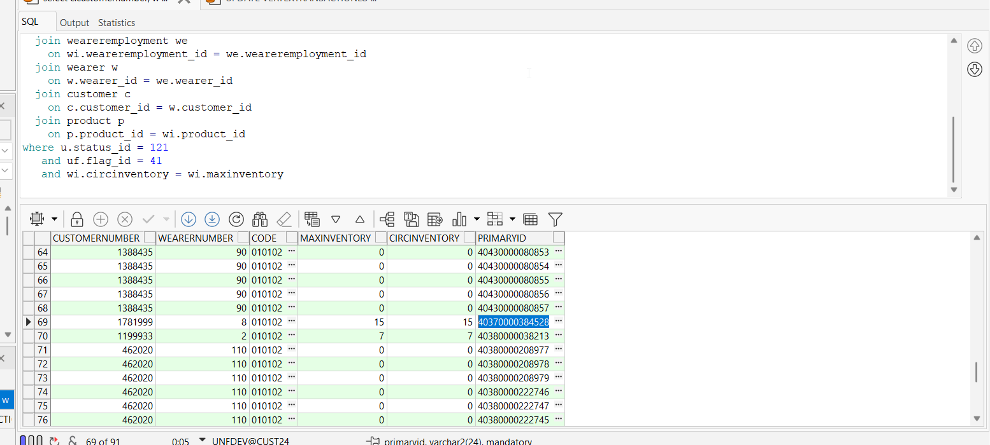
- Check that the unique item has the replacement flag and returned flag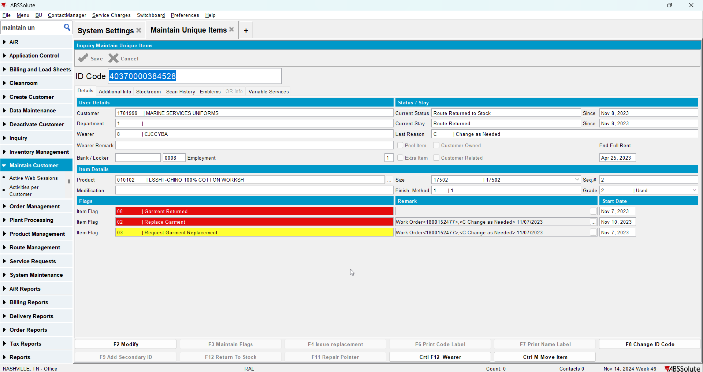
- Go to Wearers dlg, load your customer and select your wearer
- Select the WI and see that the Generate Work Order button is disabled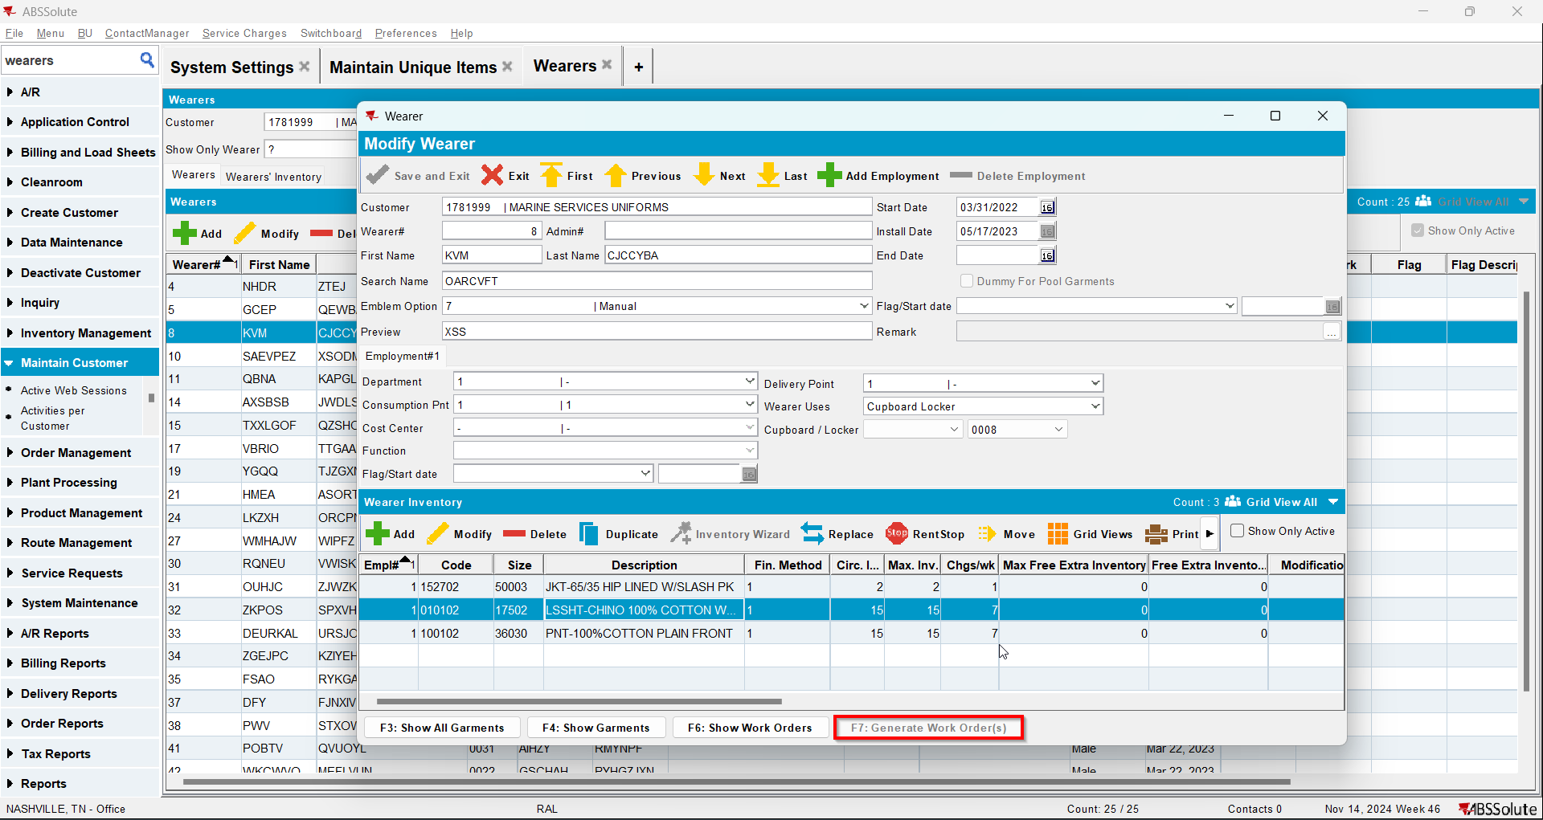

Test Case 2 – Change formula for the number of items on a new workorder line– Tested OK
Expected behavior: When generating a work order for a wearer inventory that has garments with status_id = 121 and replacement flag active the work order line quantity calculation for this wearer inventory will NOT take these garments into account.
Hash: 74876eb
- Check that SS MAKECIRC=MAXONCHANGEMAX is set to 0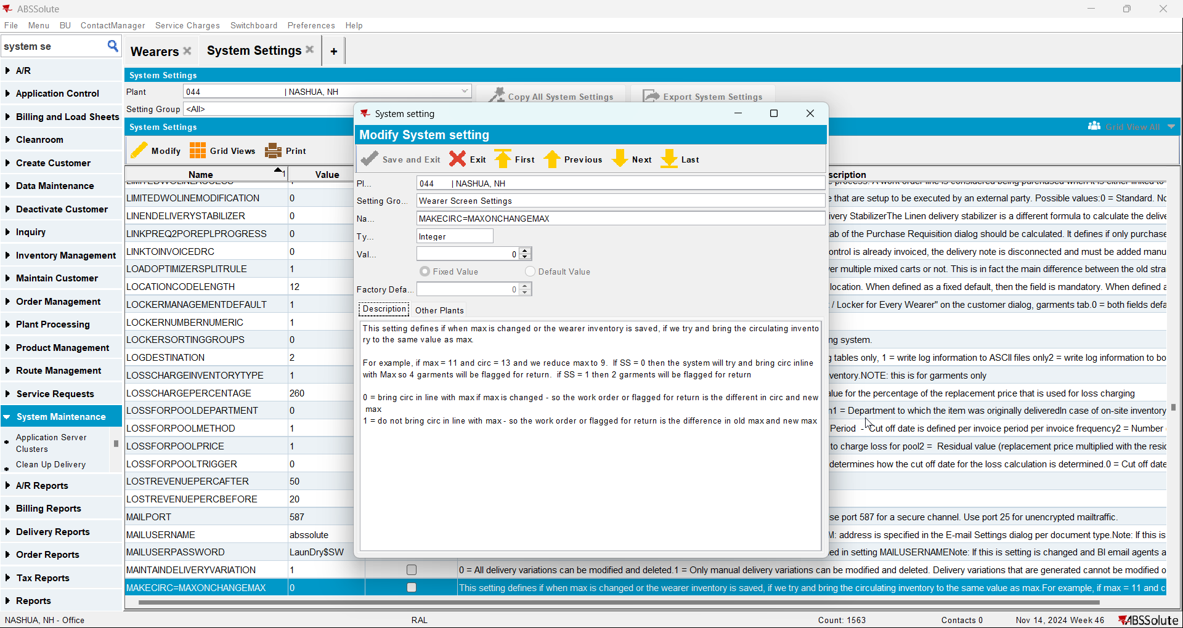
- Use the below select to find data
select c.customernumber,
w.wearernumber,
p.code,
wi.maxinventory,
wi.circinventory, u.primaryid
from uniqueitem u
join uniqueitemflag uf
on u.uniqueitem_id = uf.uniqueitem_id
join uniqueitemnonpool unp
on unp.uniqueitem_id = u.uniqueitem_id
join wearerinventory wi
on wi.wearerinventory_id = unp.wearerinventory_id
join weareremployment we
on wi.weareremployment_id = we.weareremployment_id
join wearer w
on w.wearer_id = we.wearer_id
join customer c
on c.customer_id = w.customer_id
join product p
on p.product_id = wi.product_id
where u.status_id = 121
and uf.flag_id = 41
and wi.circinventory <> wi.maxinventory
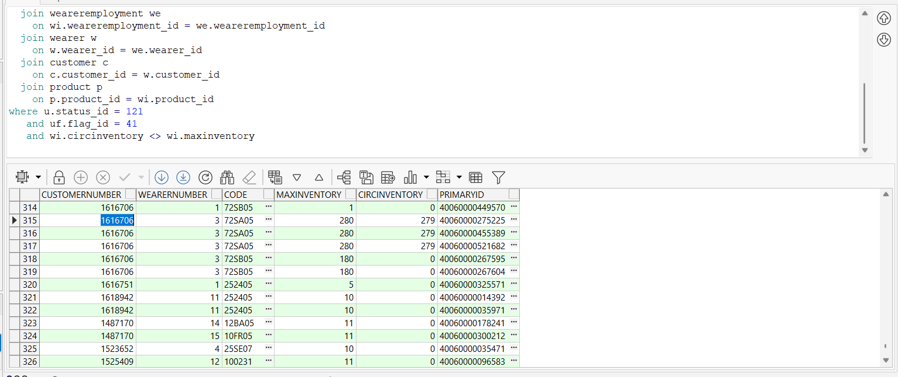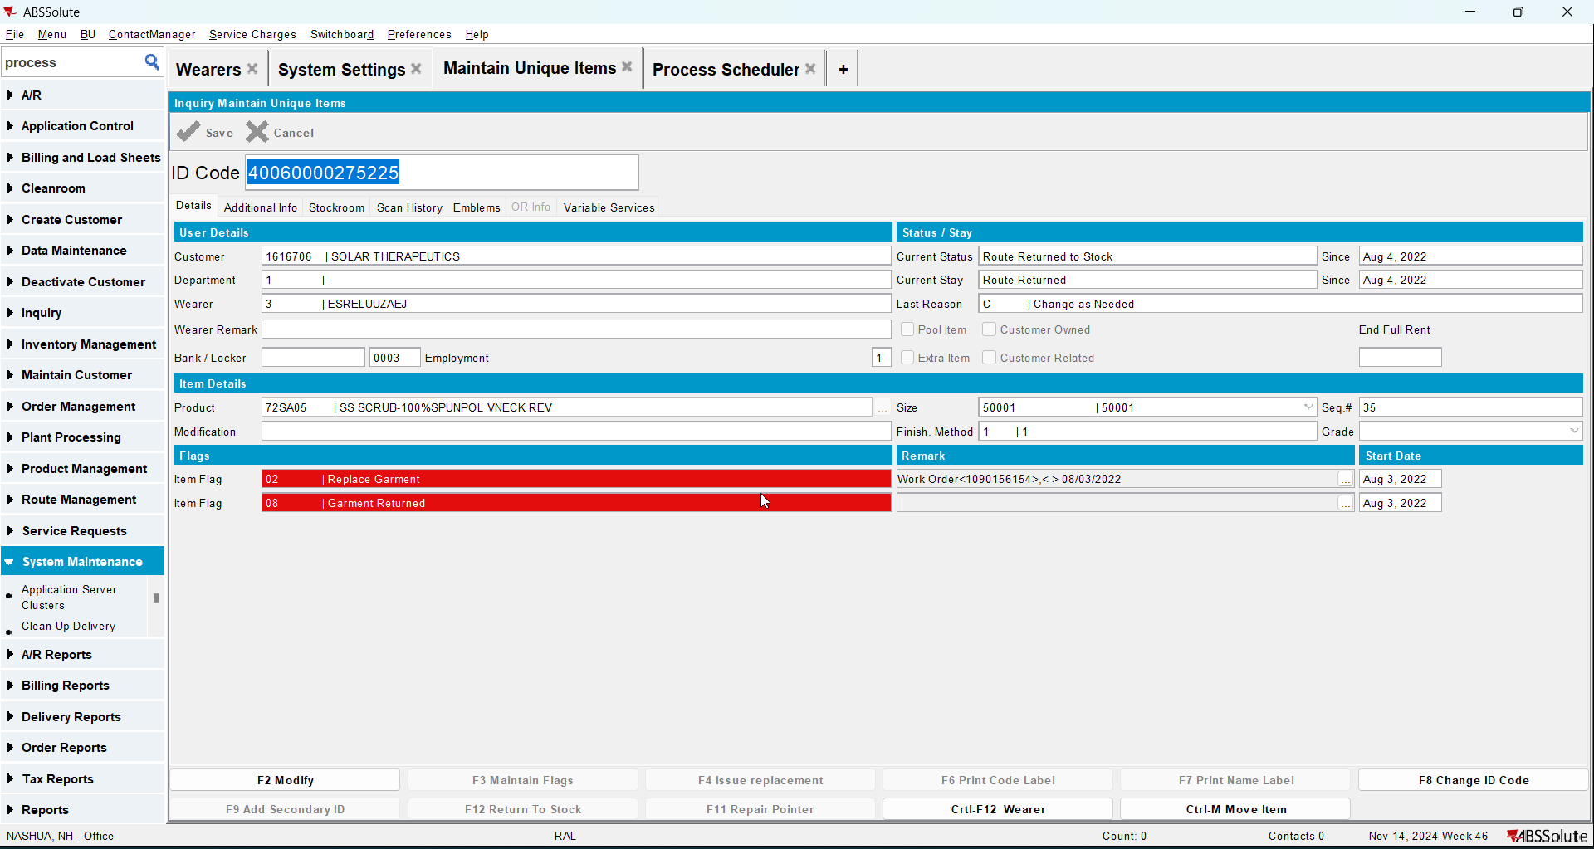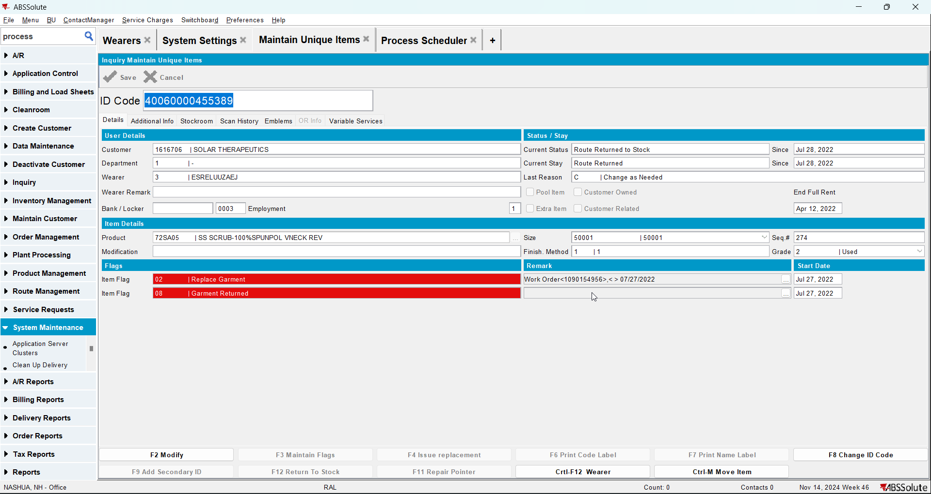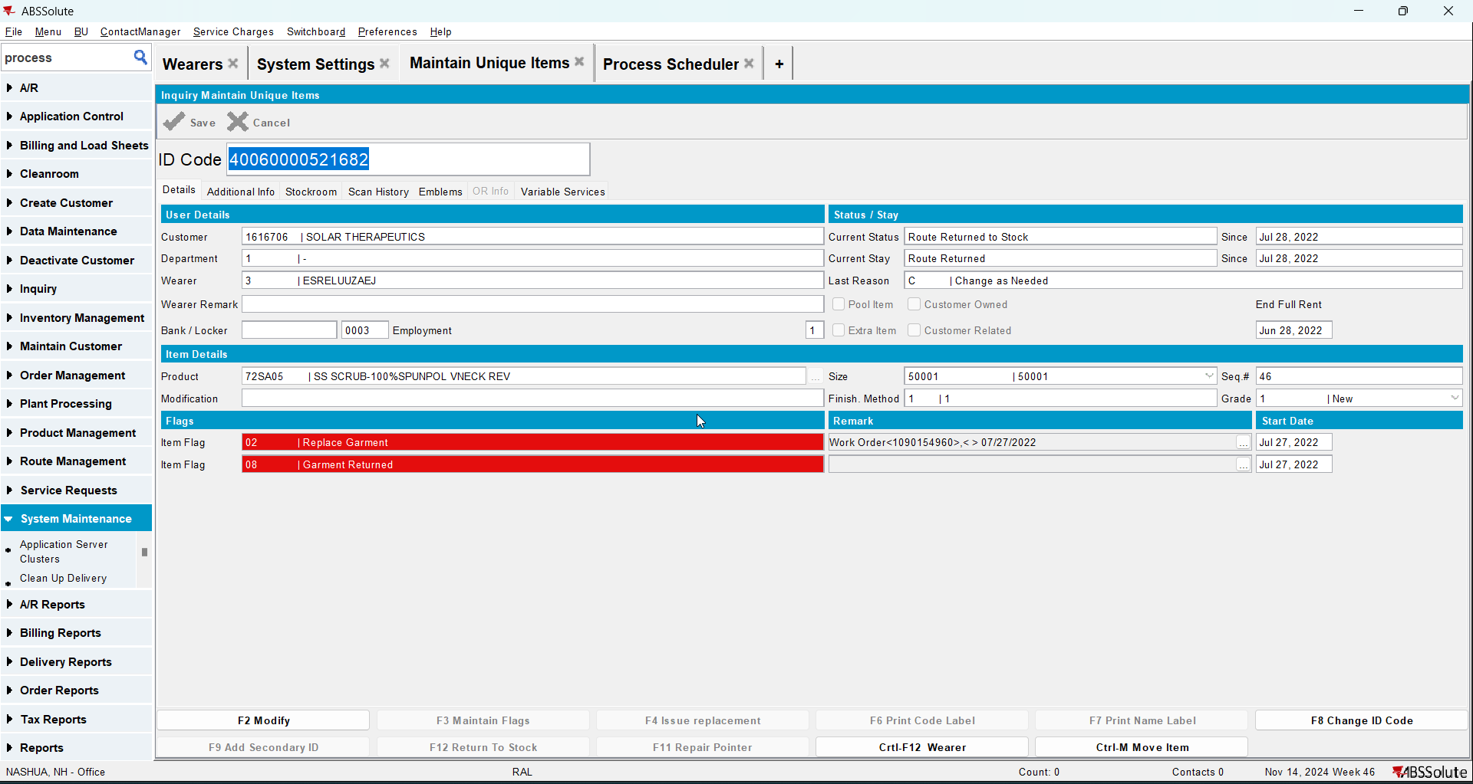
- Go to Wearers dlg, load your customer and select your wearer
- Select the WI and see that the Generate Work Order button is enabled. Generate workorder and make sure the calculation is right and does not take the items found in the above SQL into calculation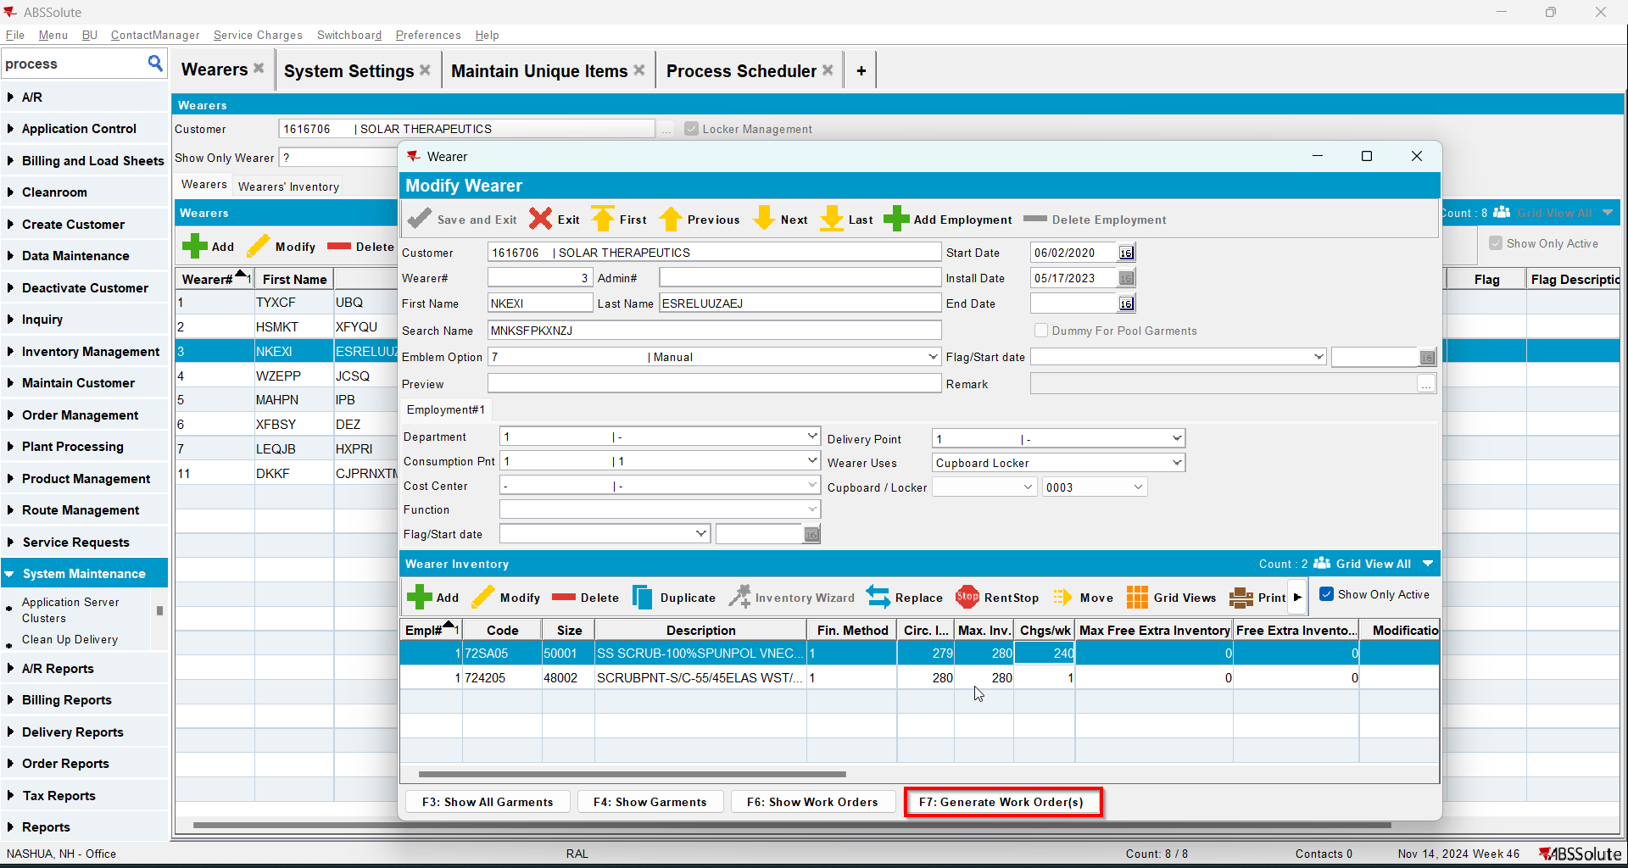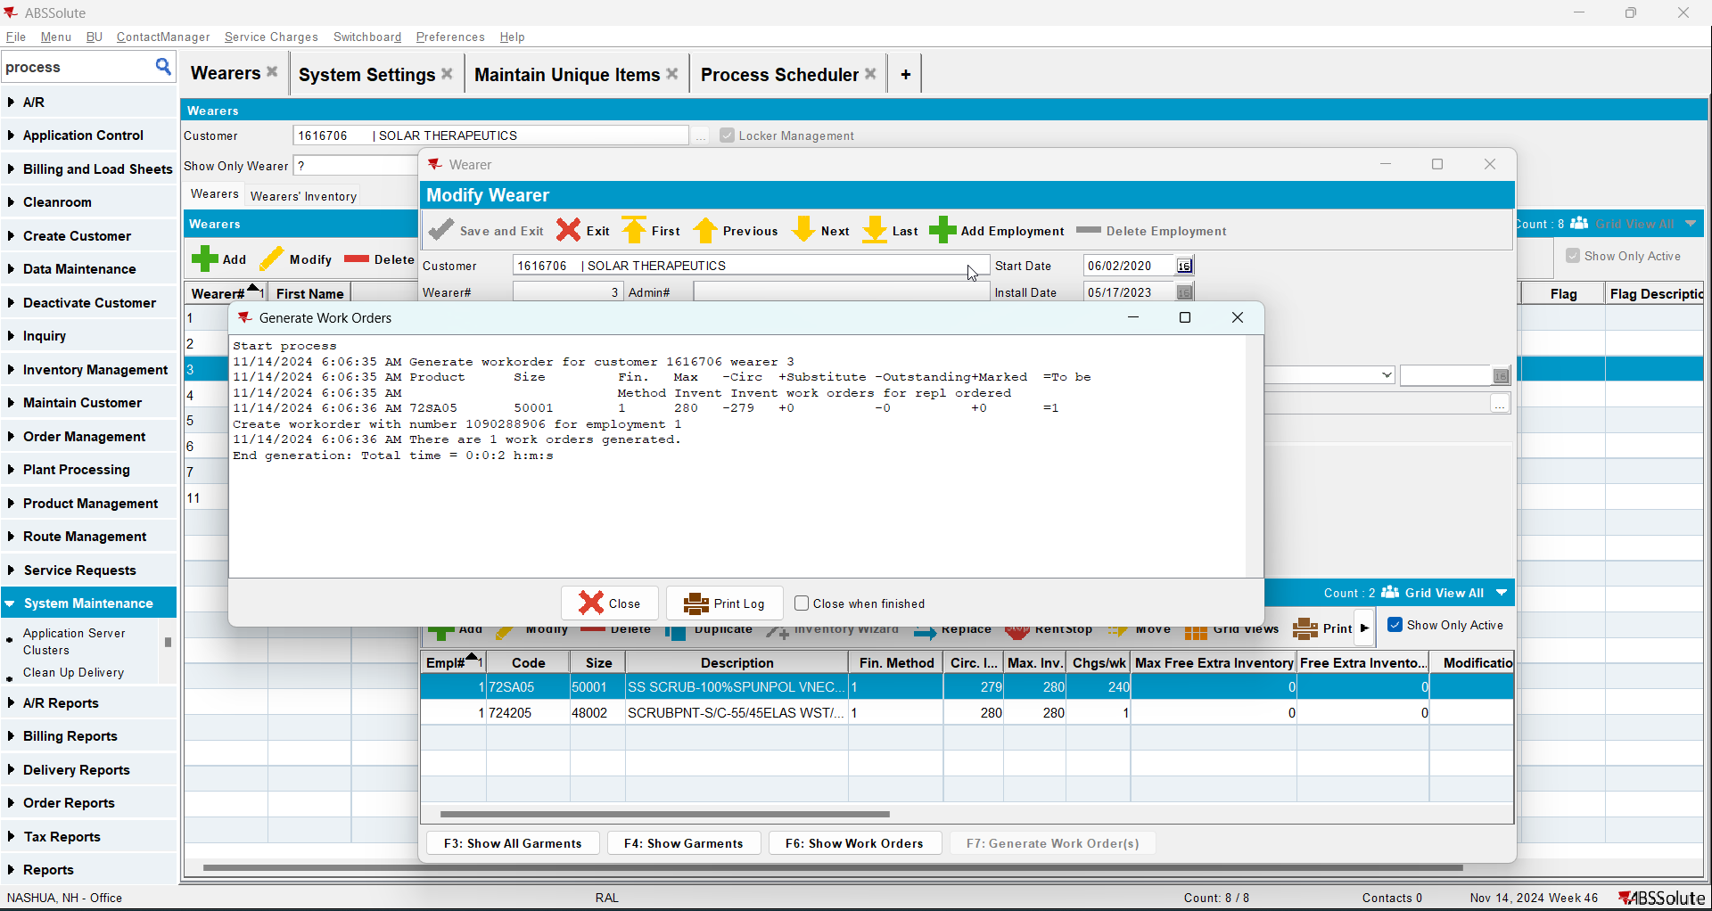

Test Case 3 – Route Returns to remove replacement flag when setting item on status Route Returned to Stock– Tested OK
Expected behavior: When returning garments in route return that had replacement flags the replacement flags are removed from the UniqueItem – check in maintain unique item.

Hash: 74876eb
- Check that SS MAKECIRC=MAXONCHANGEMAX is set to 0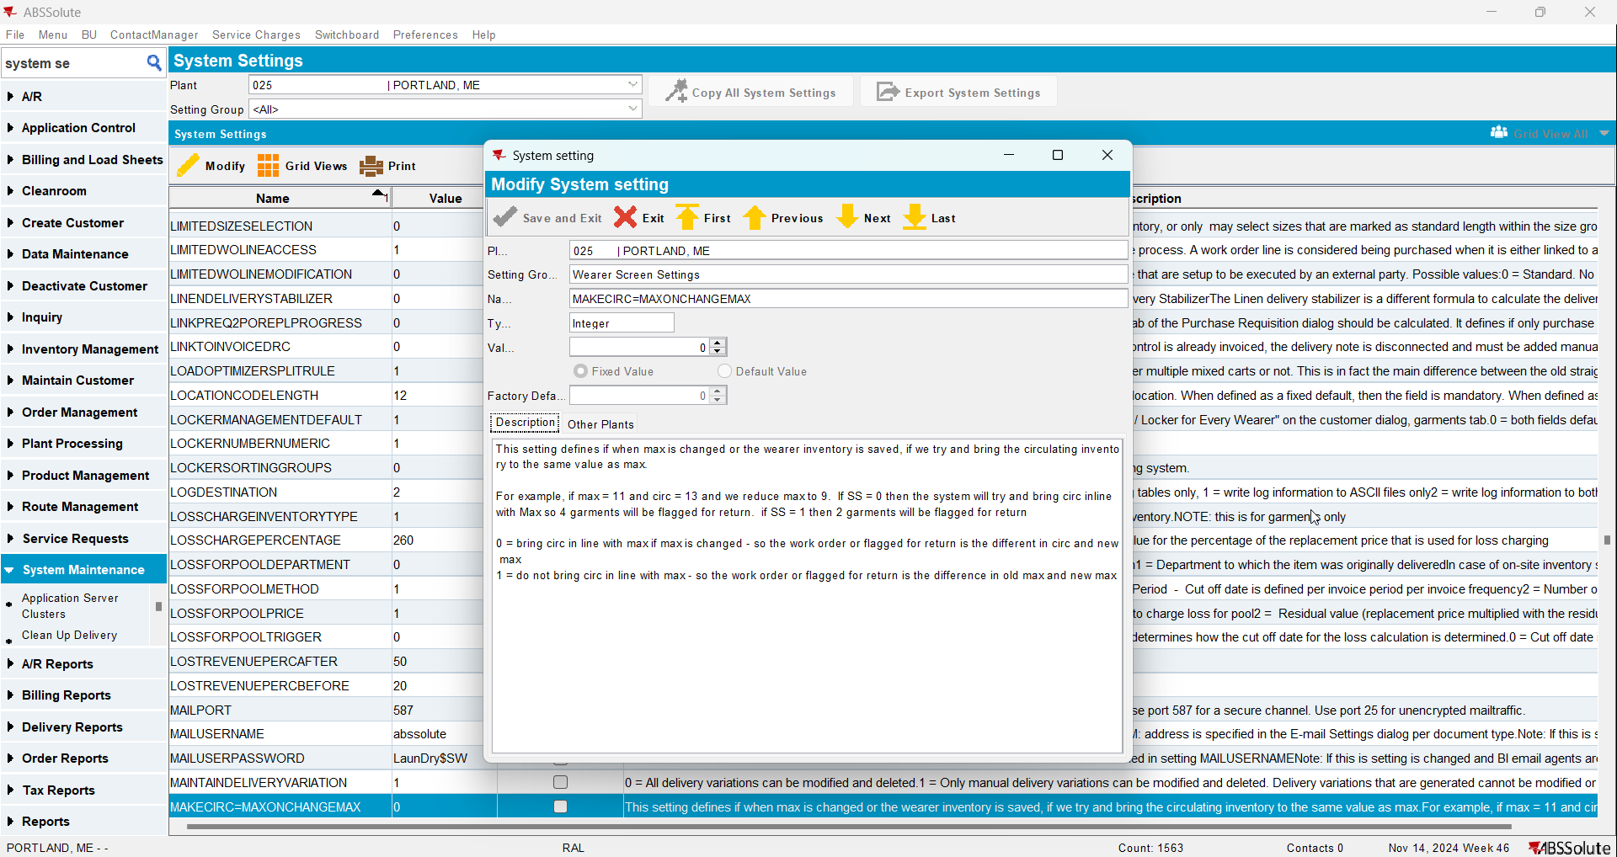
- Have a WI with unique items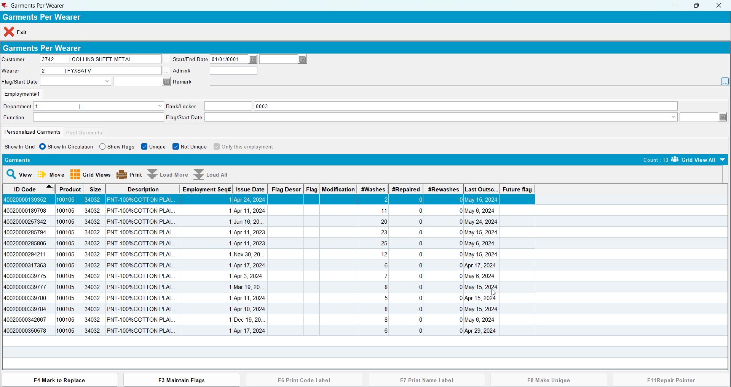
- Do a partial replace changing only the size 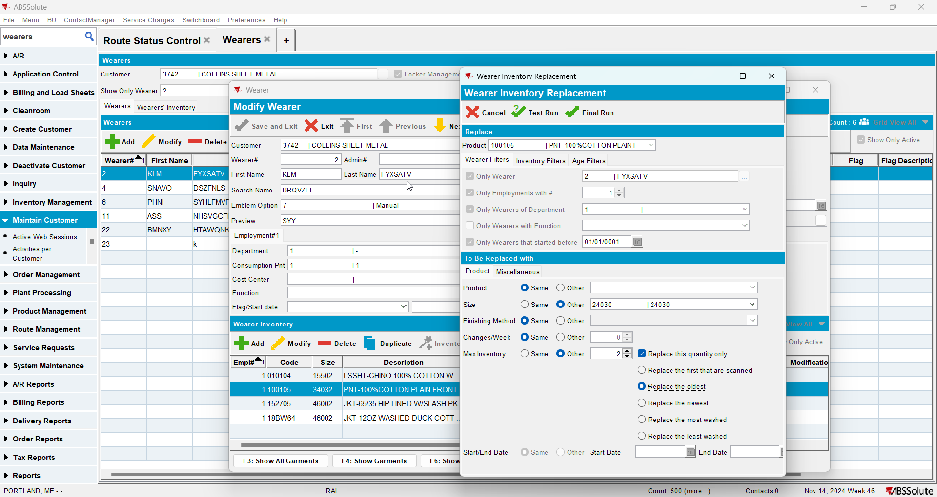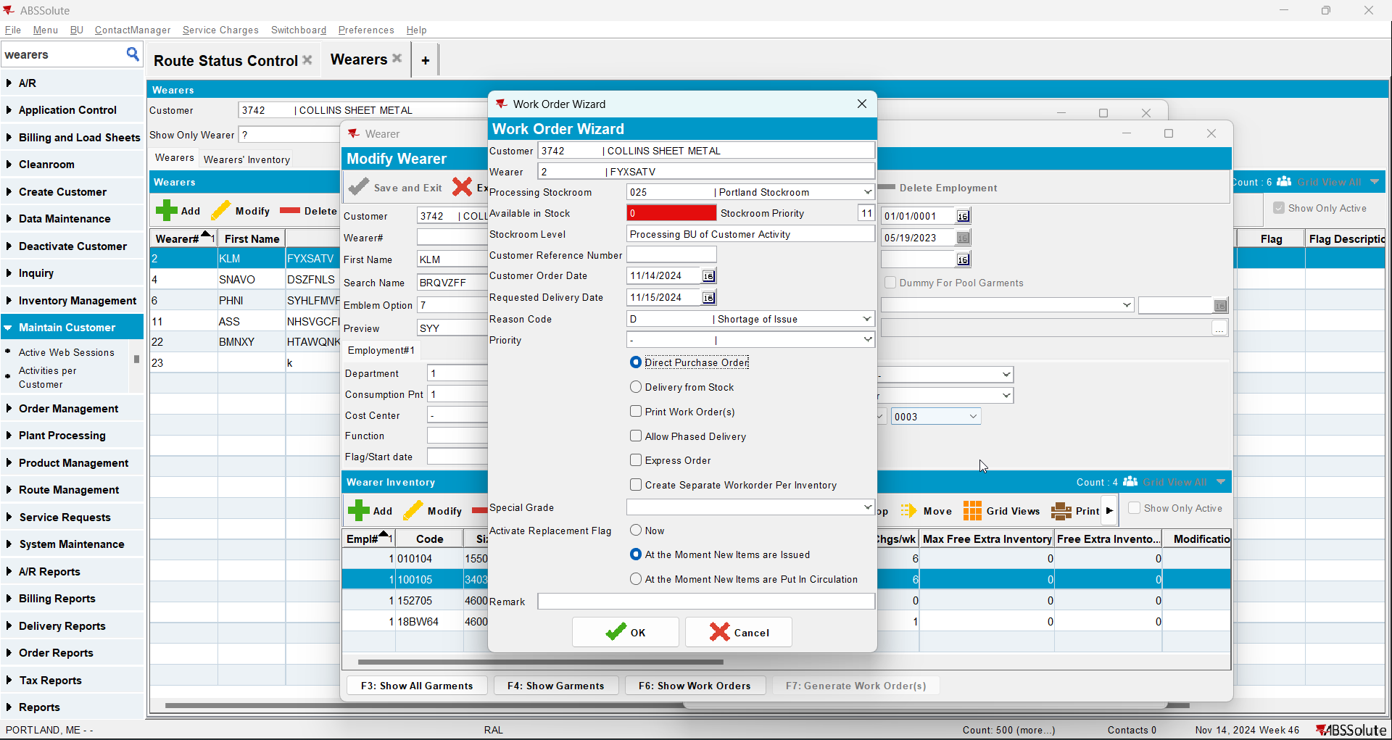
- Issue the WO and generate delivery notes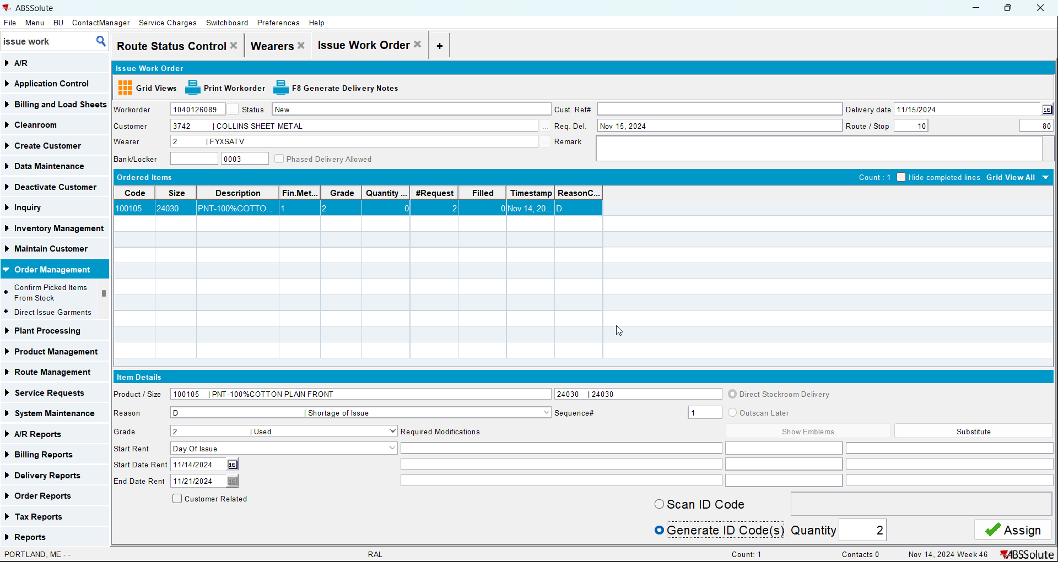
- Check that the items that you issue have replacement flag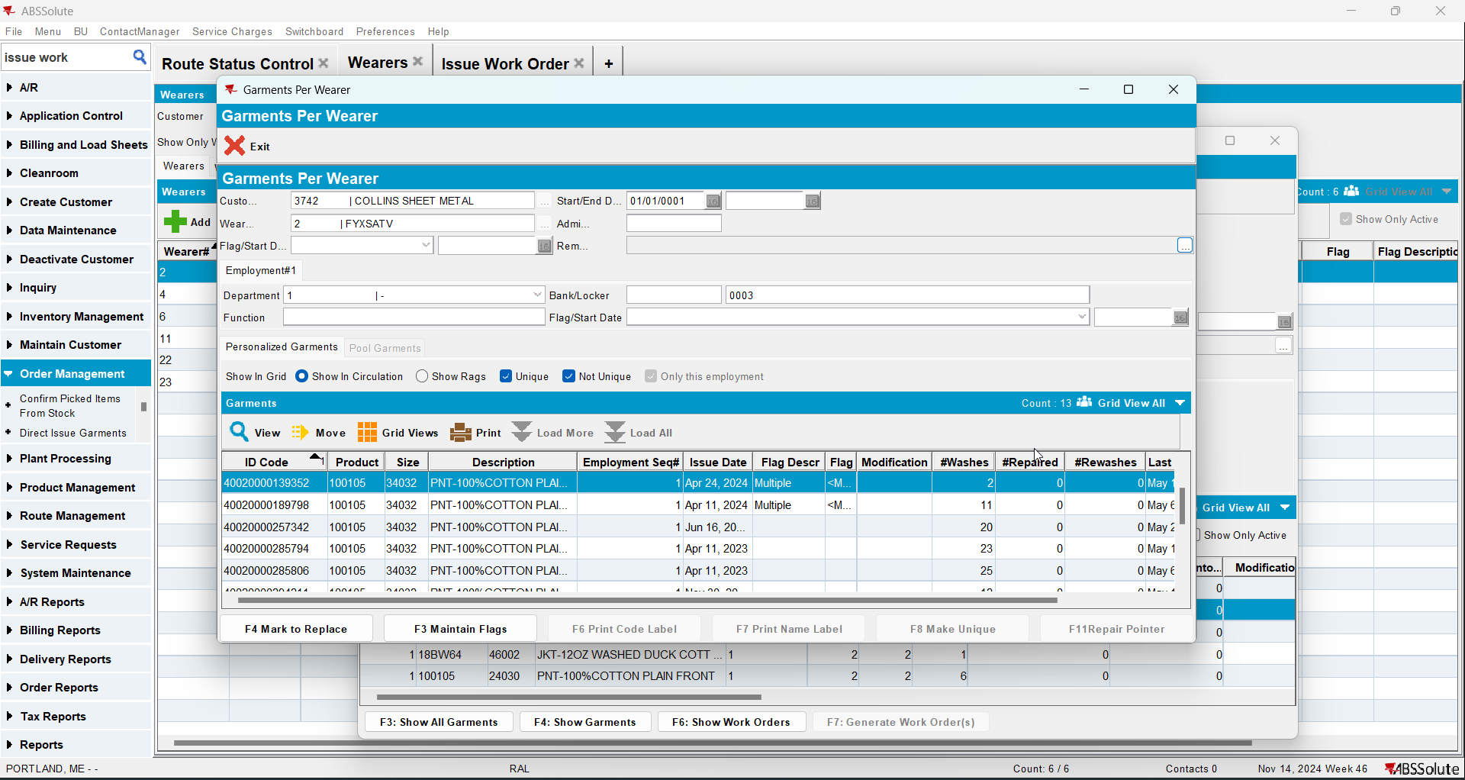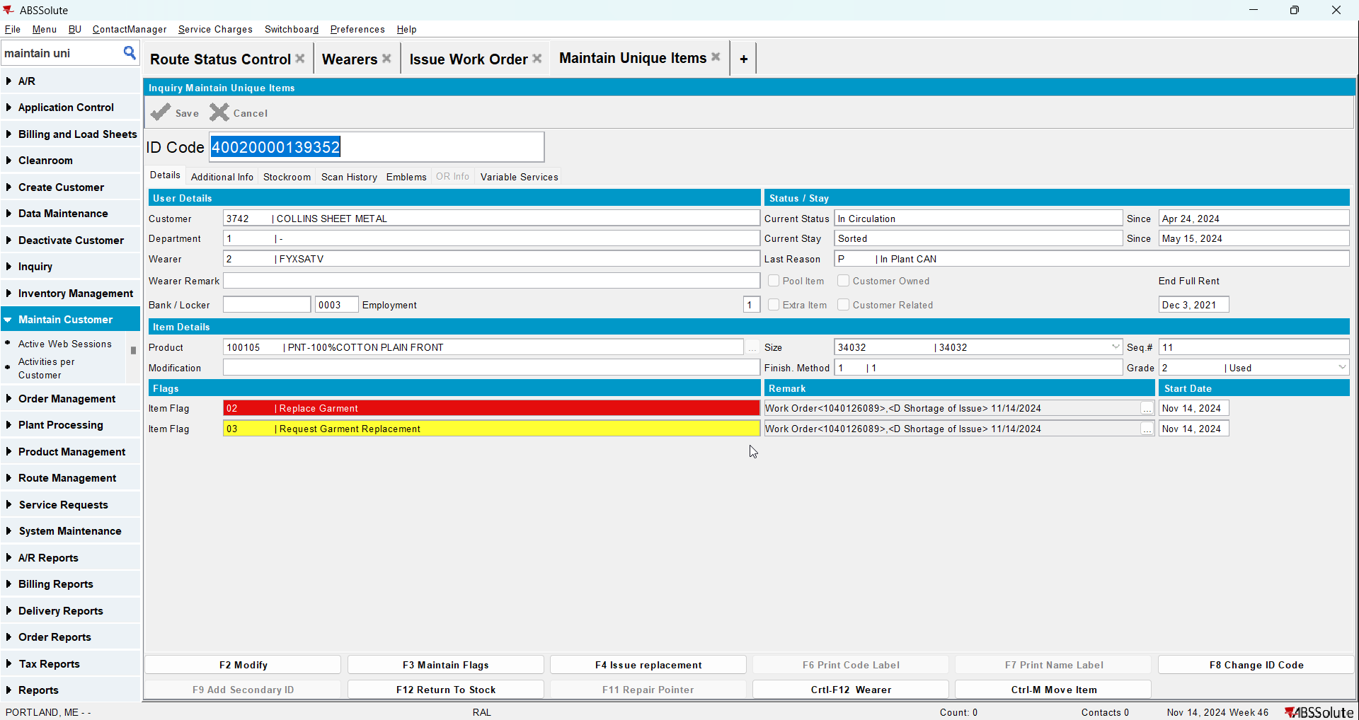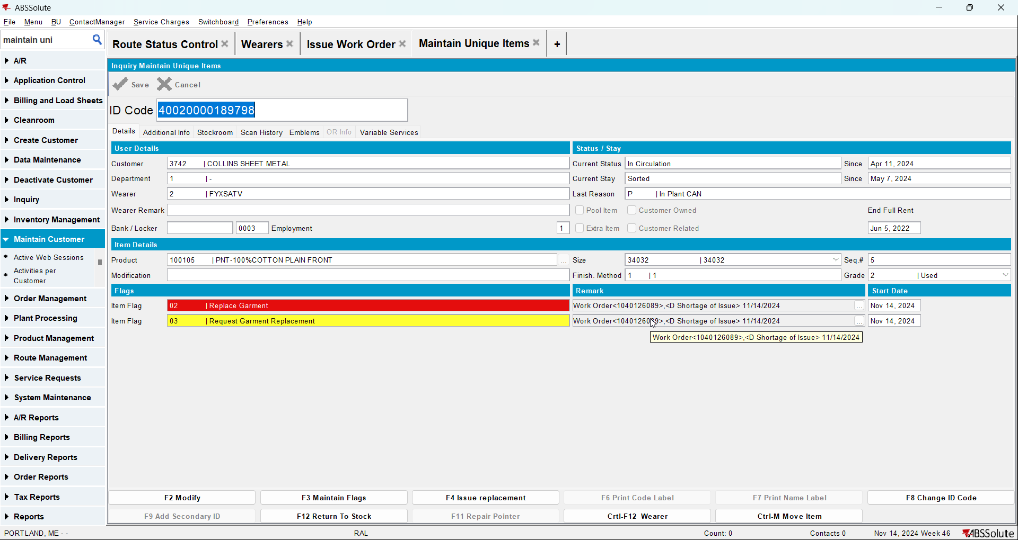
- Generate invoices and mark the route ready for transfer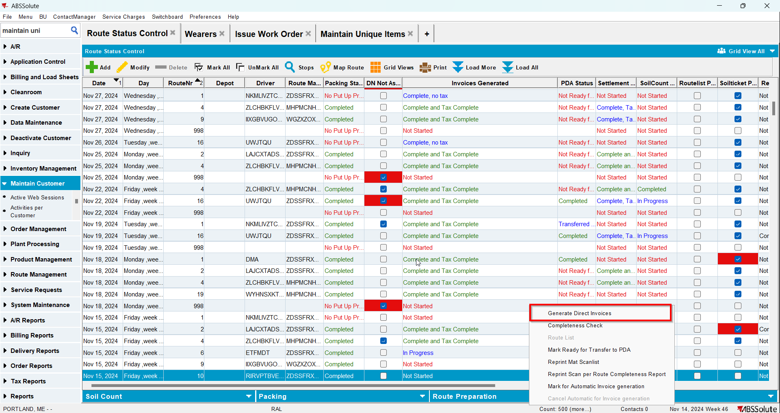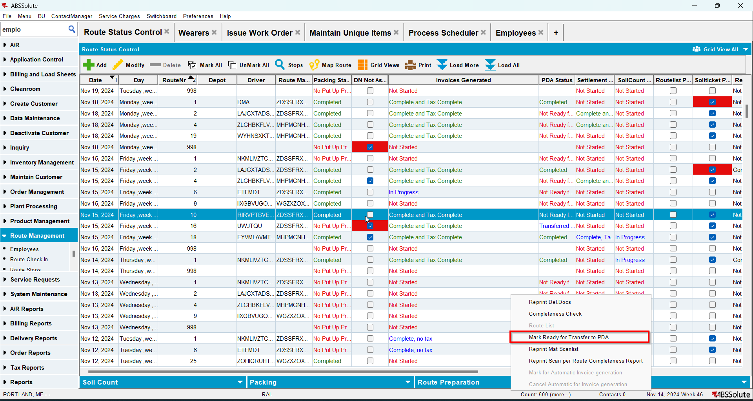
- On RA scan the items for return
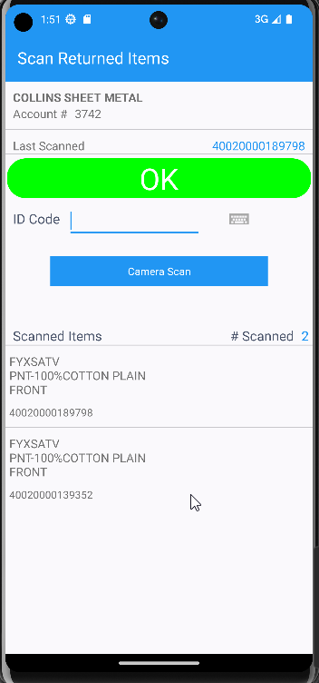
- Settle the route and finish it
- On Route Returns scan the items to stock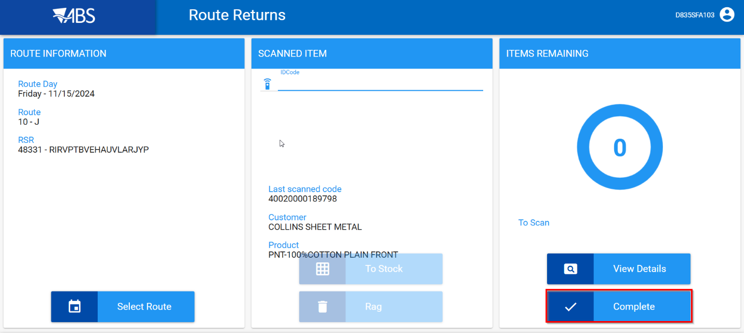
- Check that the items do not have the replace flag