ABS-169078 WebX route check in changing tabs with save active
Environment | Prerequisites
Version:9.07.00  DBServerName=abs-SRV20.internal.abslbs.com  DBSID=CUST24  DBUser=UNFDEV  DBPassword=UNFDEV  Environment=Test | - Module:  - System setting

Contents
Test after fix 1
Test Case 1 – In WebX modify something in a tab without saving then change to another tab – Tested OK 1

Test after fix

Test Case 1 – In WebX modify something in a tab without saving then change to another tab – Tested OK
Expected behavior: When making a change in a tab without saving and trying to go to another tab a pop-up appears that warns the users there are changes in their page
Hash: 3fa65b8
- Go to Wearers dlg and add a new WI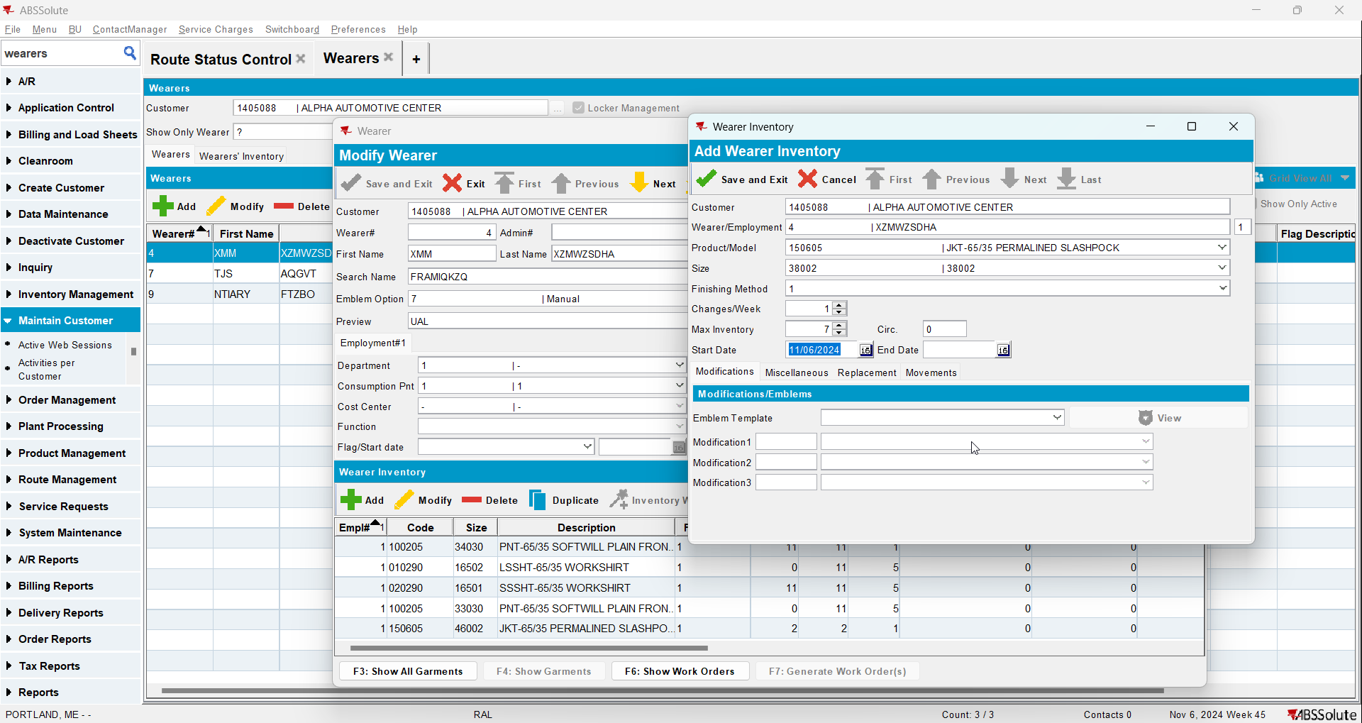
- Generate WO and issue the items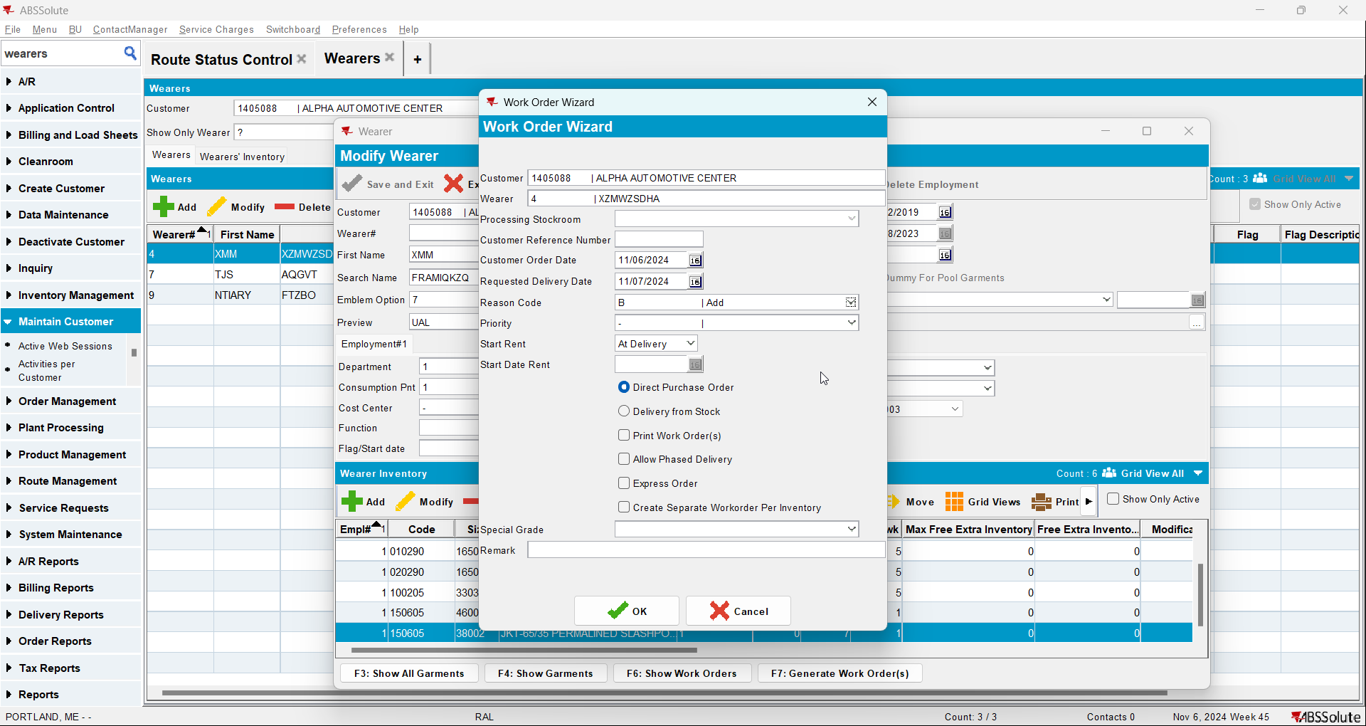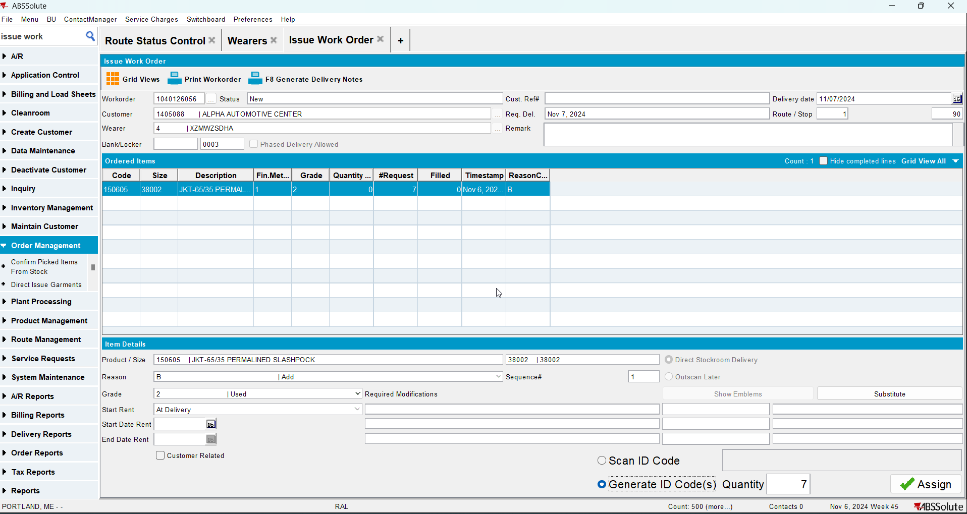
- In database update that WO changing status_id to 18 and origin to 3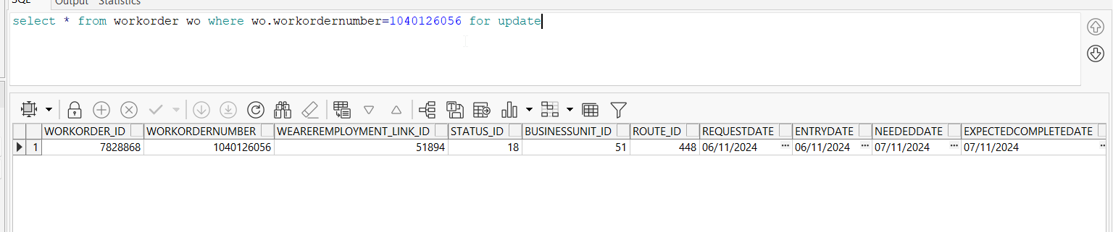
- Generate delivery notes for your route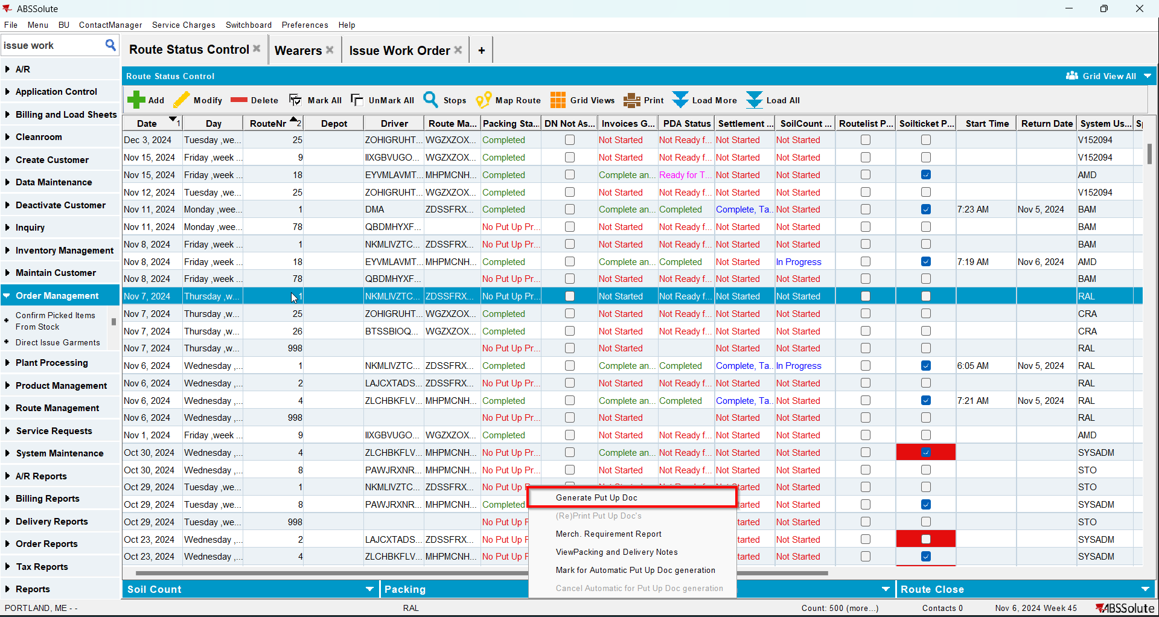
- Generate invoices for your route and mark the route ready for transfer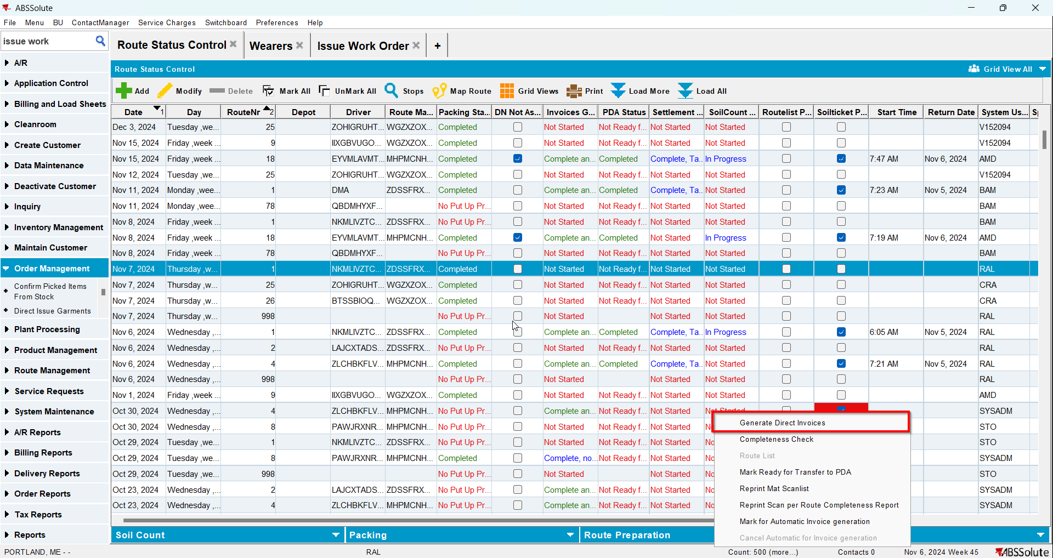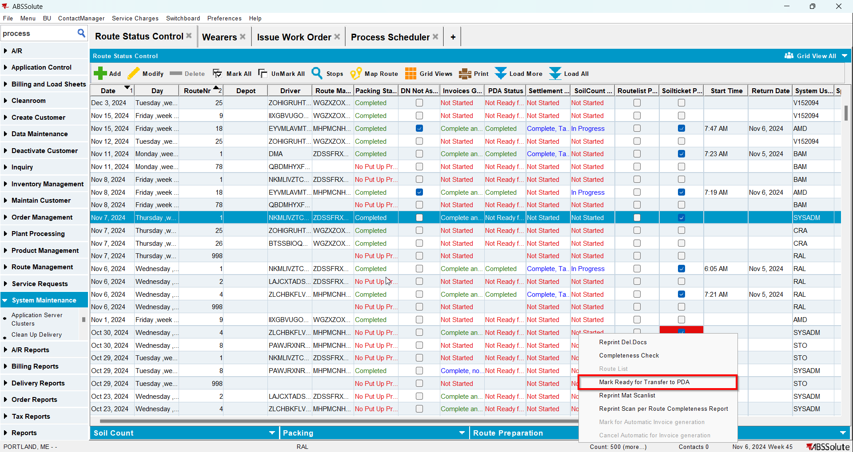
- On RA make an adjustment and change the size of a product
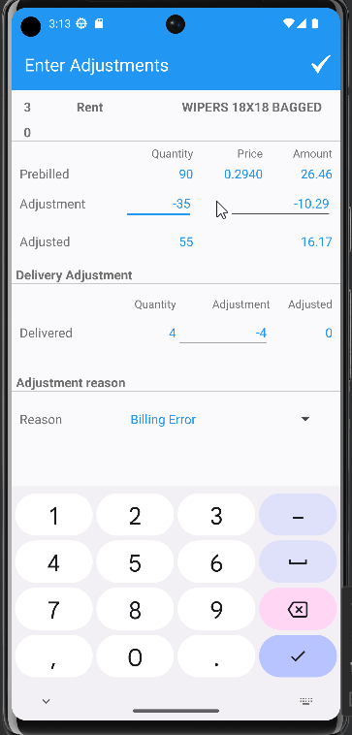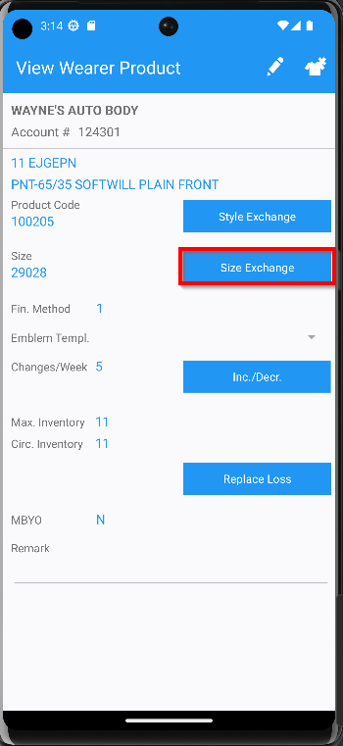
- On WebX go through every tab and make a change without saving. Click on another tab