ABS-169076 Allow contract dialog to remove special charge from a customer
Environment | Prerequisites
Version: 9.07.00.UNF18 hash: e4fbef51f864  DBServerName= abs-srv20.internal.abslbs.com  DBSID=CUST24  DBUser=UNFDEV  DBPassword=UNFDEV  Environment=PRODUCTION | - Module:  - System setting:

Contents
Test Case 1 – Add a special charge to a customer already linked to the contract and remove the special charge 1
Test Case 2 – Add special charges to a customer when linking to the contract, remove the special charge from customer dlg and re-add from contract add/remove button 5
Test Case 3 – Add special charges to a customer when linking to the contract, remove the special charge from customer dlg and re-add from contract add/remove button 8

Test Case 1 – Add a special charge to a customer already linked to the contract and remove the special charge

- Contract dlg: Load a contract, eg: 0905455
- Contract dlg: Add a special charge to the contract.
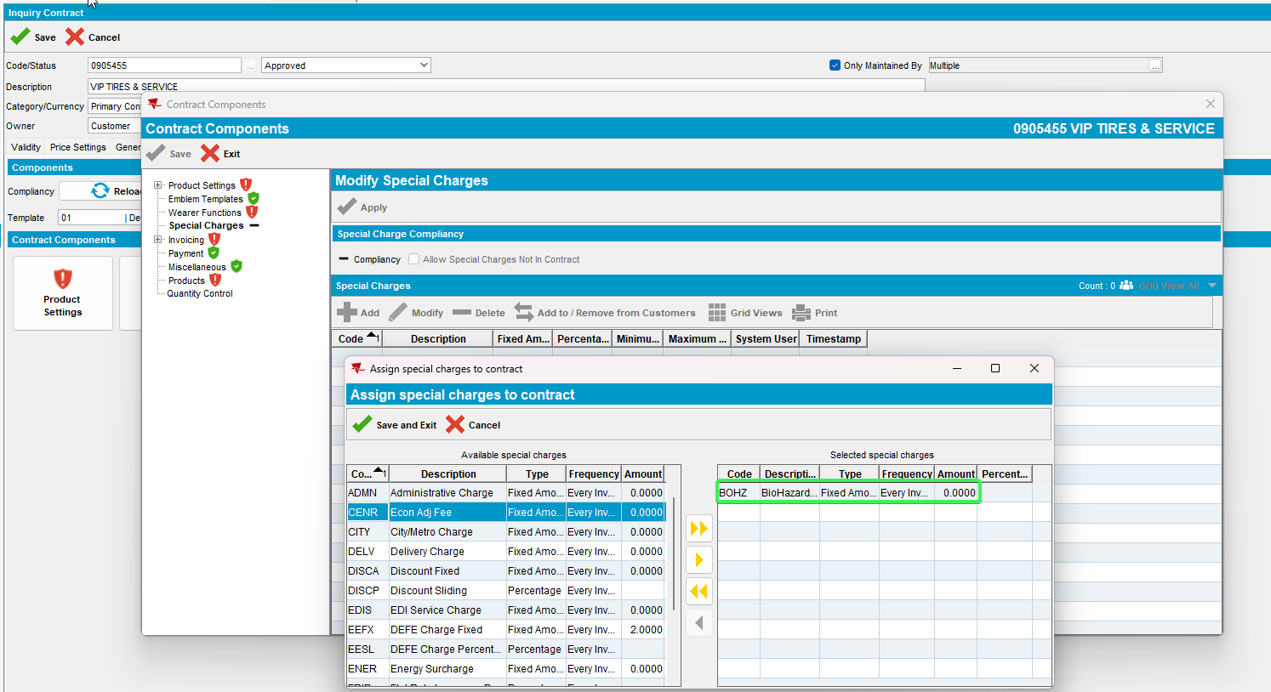
- Contract dlg: Add the special charge to the customer that is already linked to the contract. Save and exit.
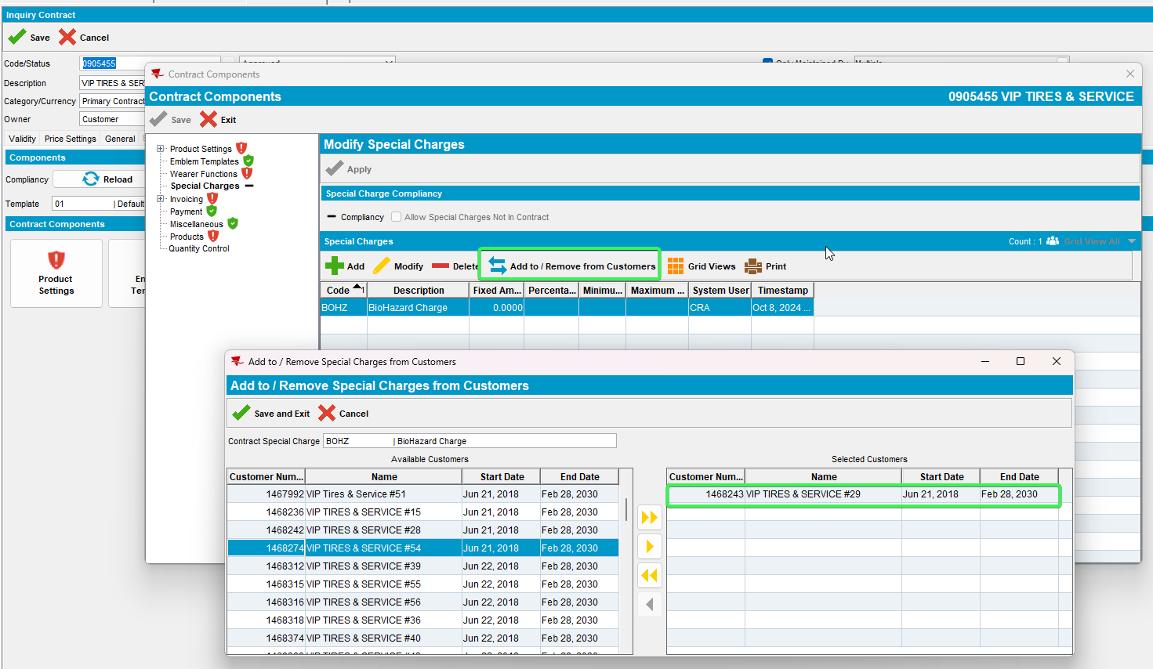
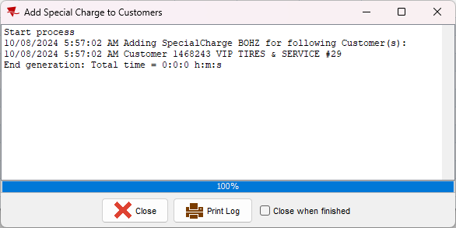
- Customers dlg: Load the customer 1468243 and check the special charges has been added.
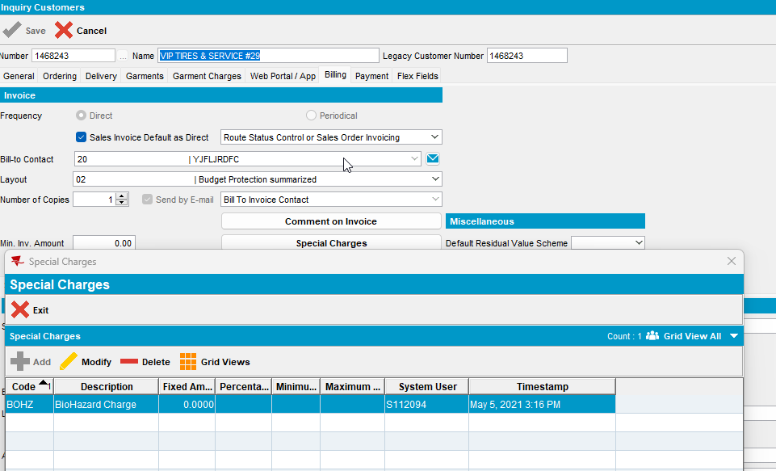
- System Settings dlg: Change NOTINCONTRACTALLOWED
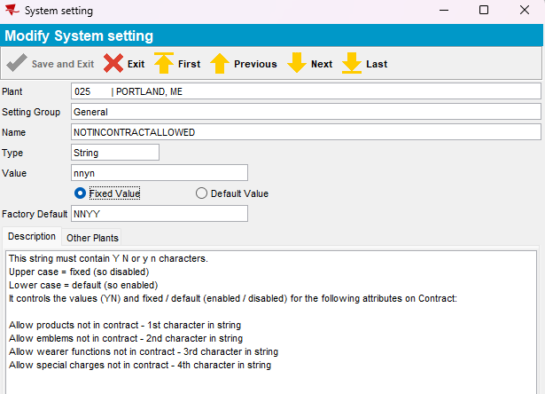
- Contract dlg: Re-load the contract dlg and check the option allow special charges not in contract
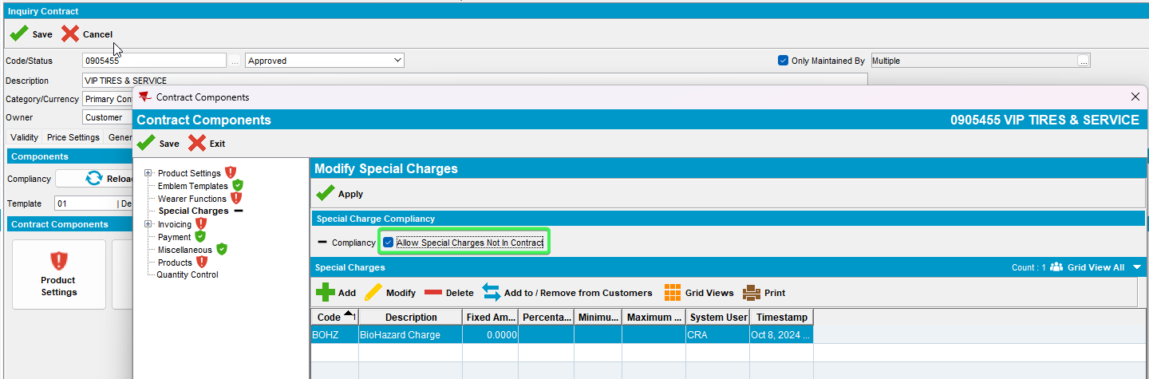
- Customers dlg: For the customer 1468243, enter special charges and delete the special charge added from the contract.
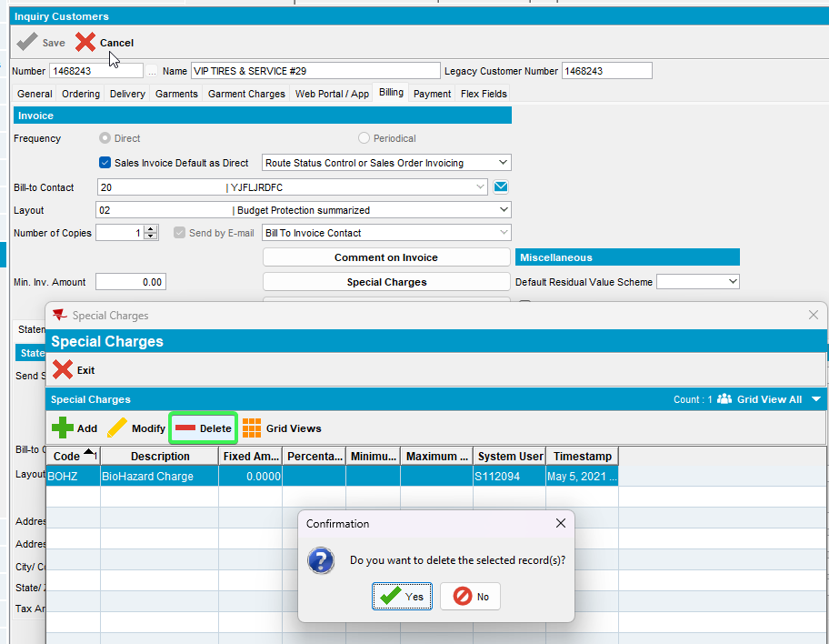
- Contract dlg: Click on Add to / Remove from Customers and check that the special charge can be re-added.
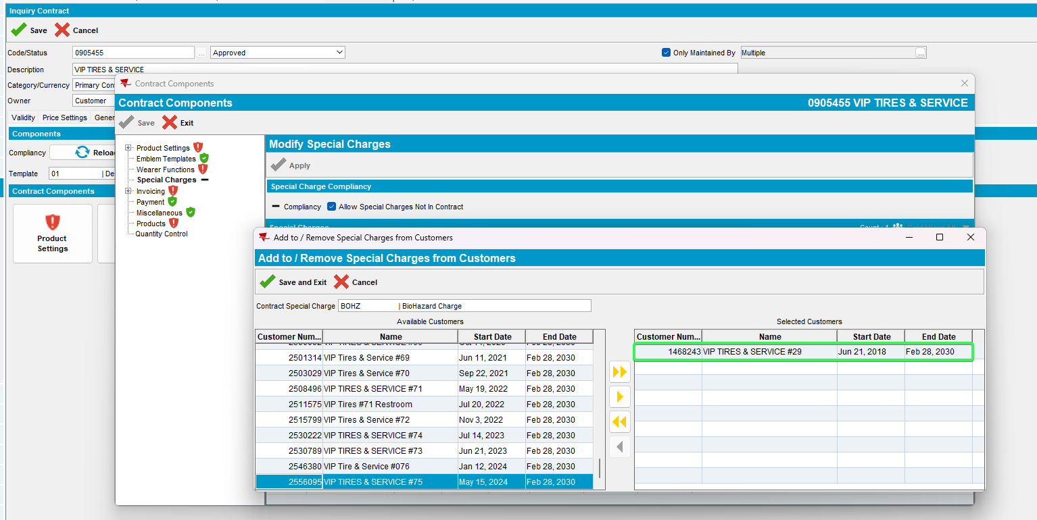
Tested OK

Test Case 2 – Add special charges to a customer when linking to the contract, remove the special charge from customer dlg and re-add from contract add/remove button

- Customers dlg: Duplicate the customer, create 3 new customers.
2556811, 2556812, 2556813
- Contract dlg: Add some more special charges
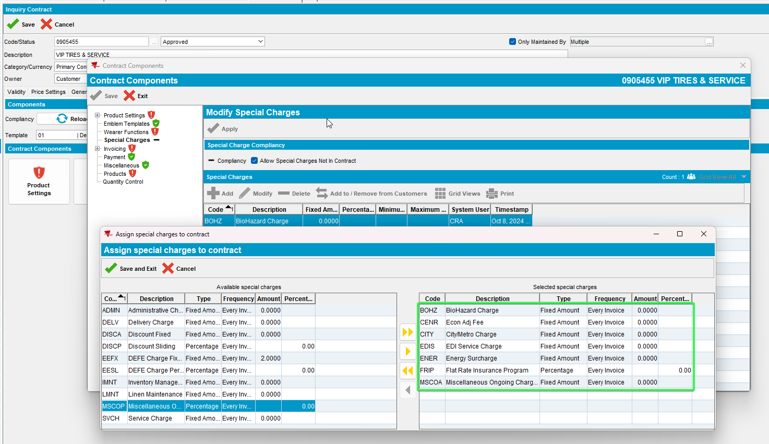
- Contract dlg: Add some prices.
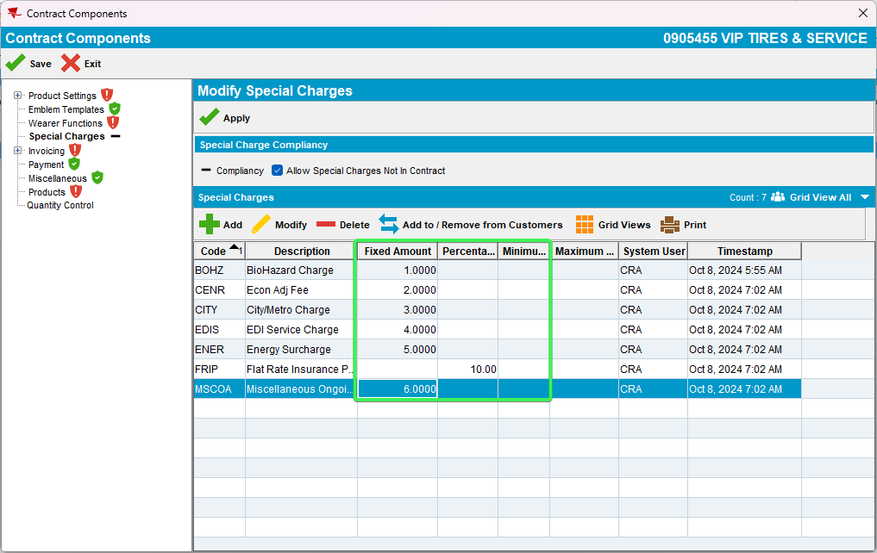
- Contract dlg: Add one of the customers to the contract with the option all for special charges.
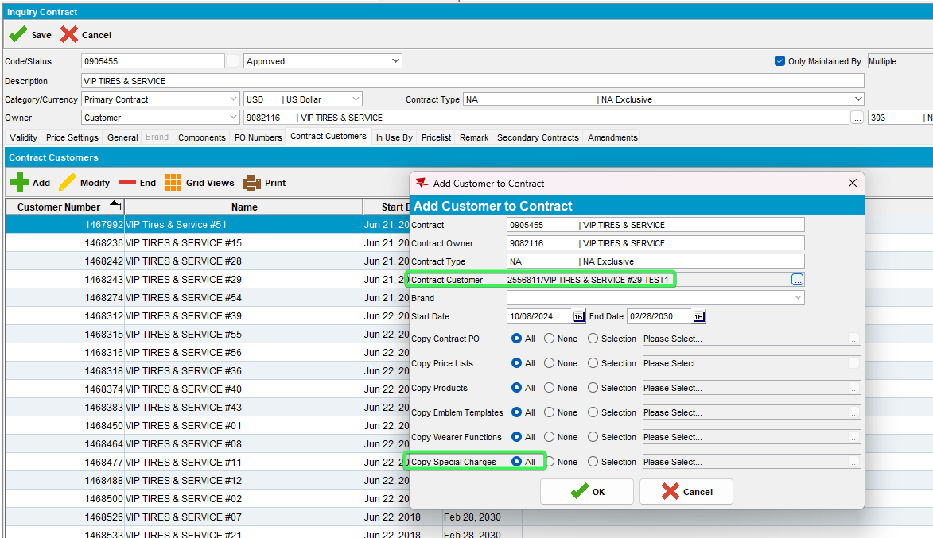
- Customers dlg: Delete some of the special charges.
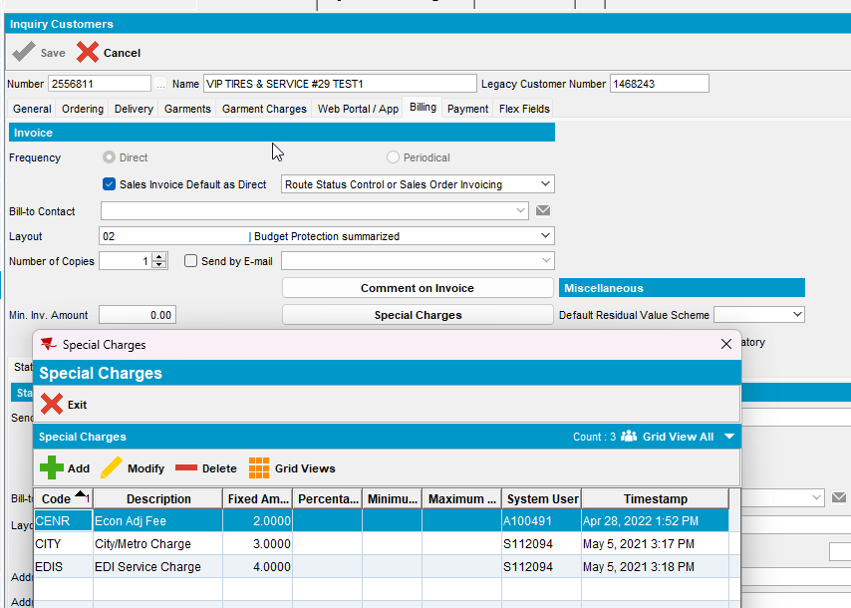
- Contract dlg: Re-add the charges
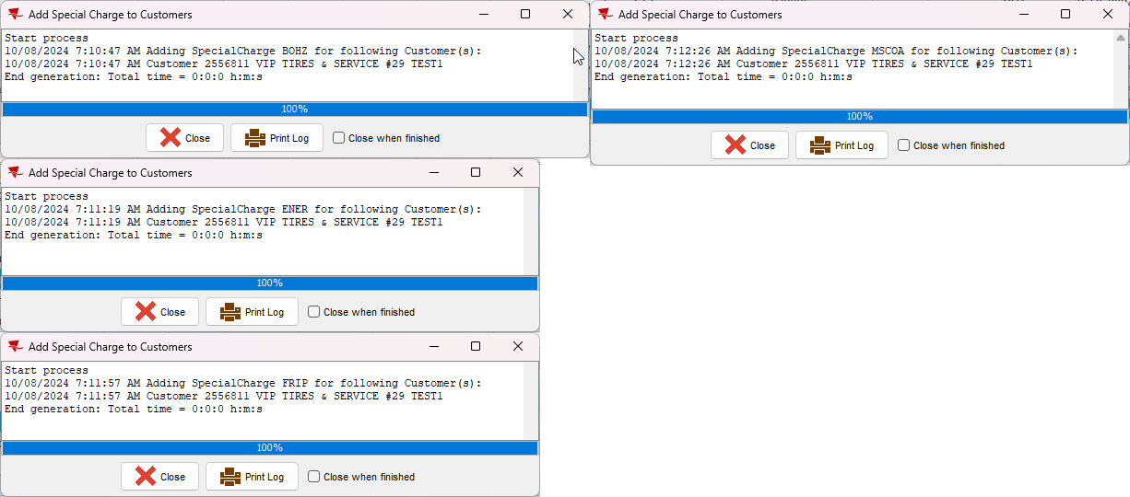
- Customers dlg: Re-check the special charge.
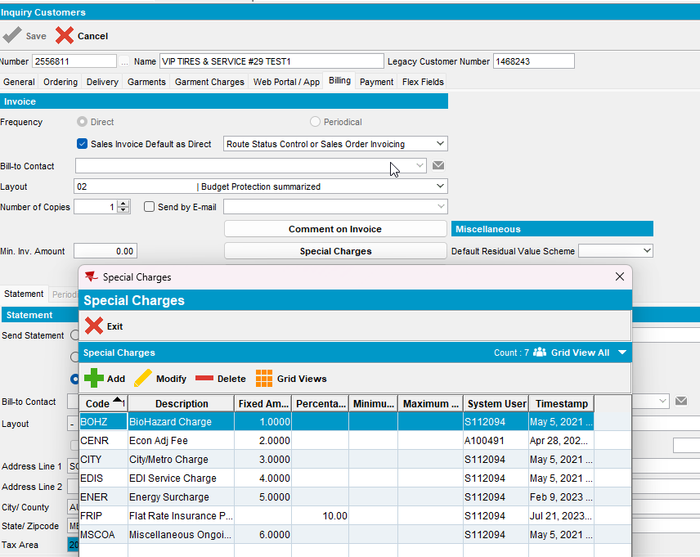
Tested OK

Test Case 3 – Add special charges to a customer when linking to the contract, remove the special charge from customer dlg and re-add from contract add/remove button

- Customers dlg: Add a custom price for the special charge on the customer
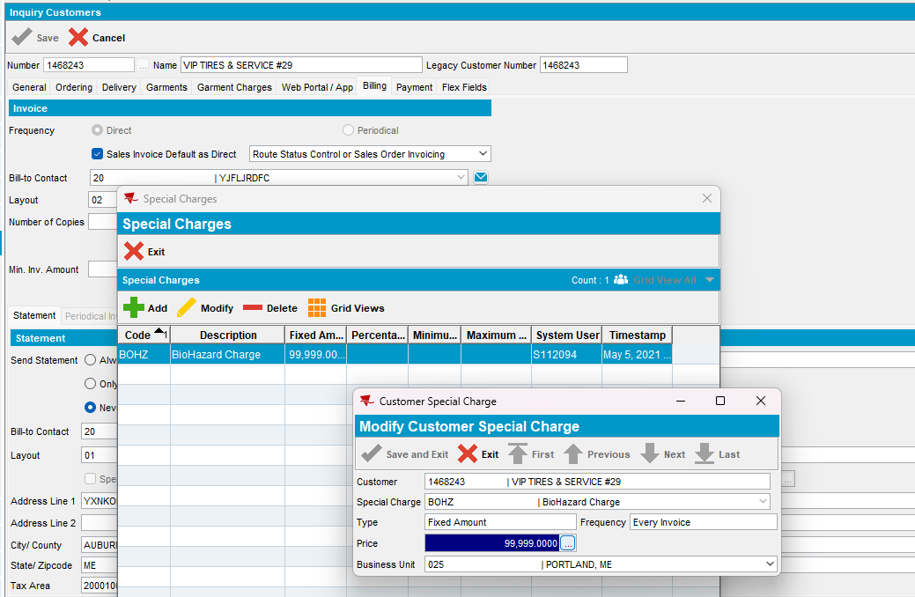
- Price lists per Customer dlg: Check the Special Charge tab for the customer specific price.
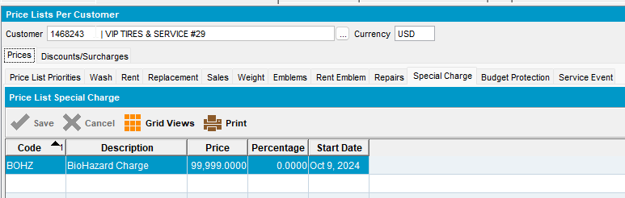
- Contract dlg: Go back to the contract and remove that special charge.
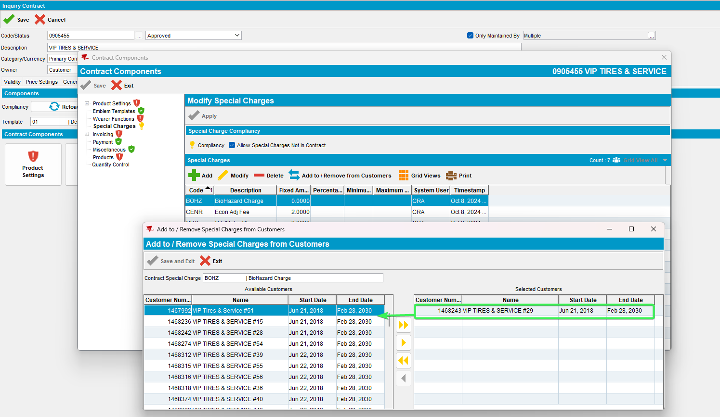
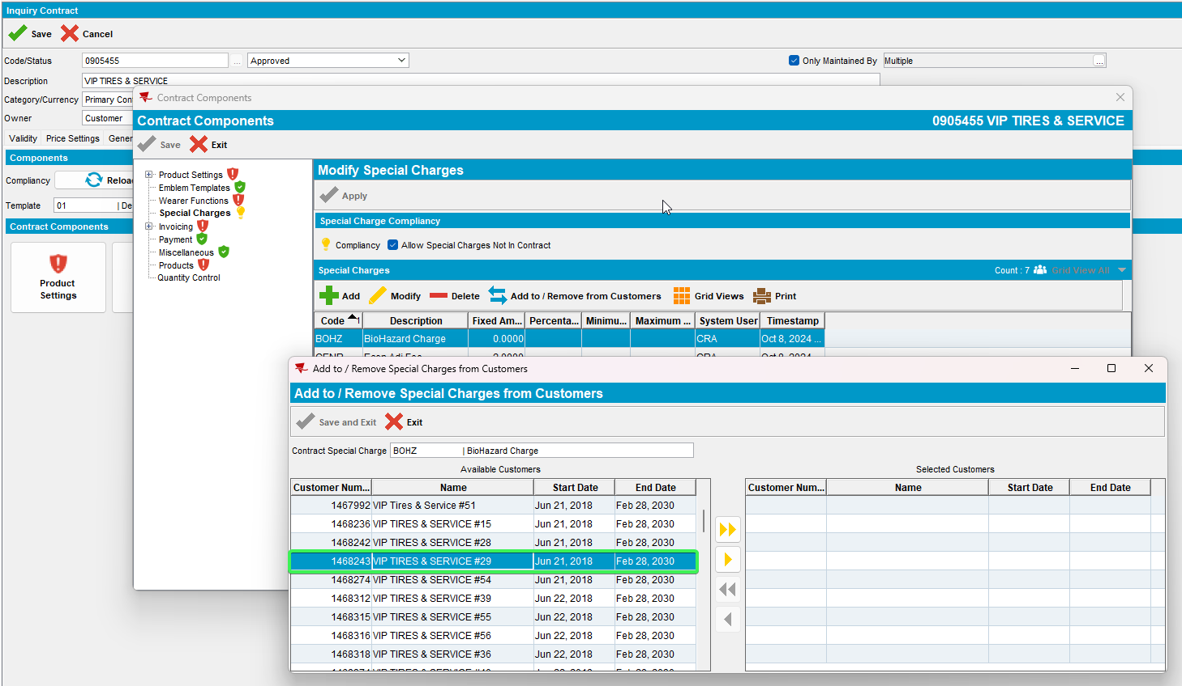
- Customers dlg: Check the special charge was removed from customer
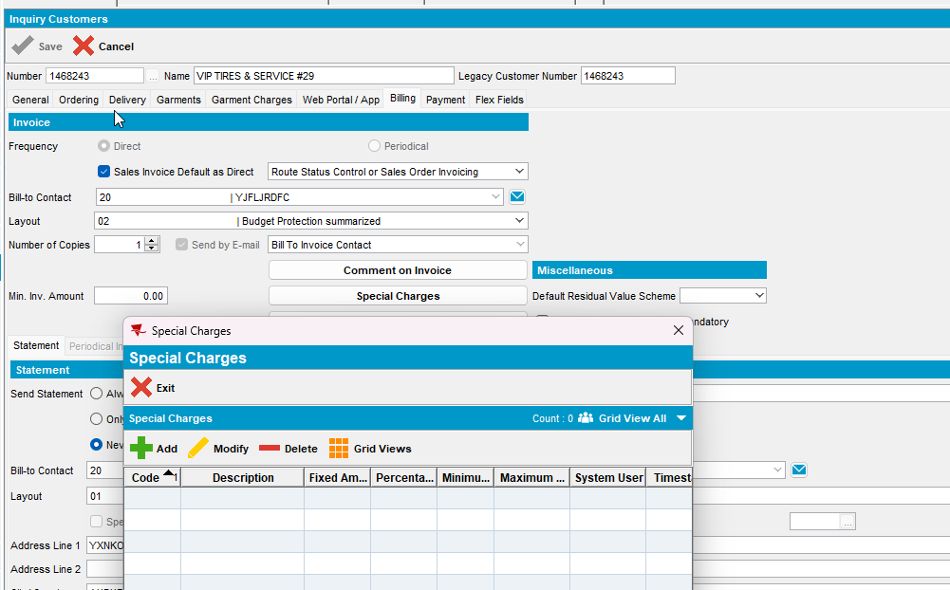
- Price Lists Per Customer dlg: Check that the customer specific price was removed after it was removed from contract button.
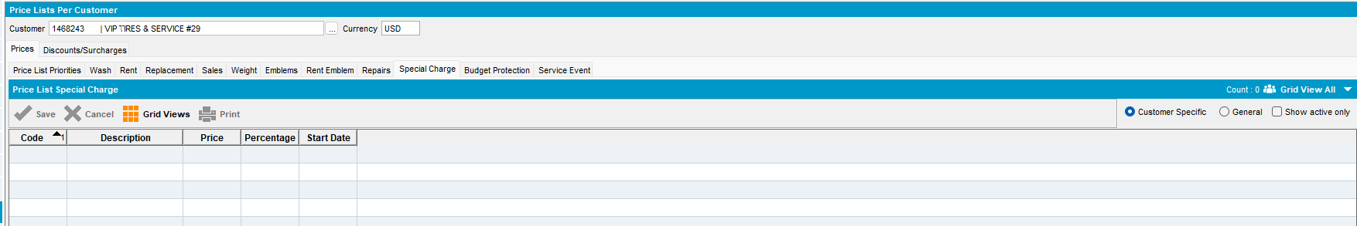
Tested OK

