ABS-168532 - D_UBS_2533 Control deletion of size billing group price
Environment | Prerequisites
Version: 9.07.00.UNF18  DBServerName= abs-srv20.internal.abslbs.com  DBSID=CUST24  DBUser=UNFDEV  DBPassword= UNFDEV  Environment=Test | - Module:  - System setting

Contents
Retest after fix 1
Data preparation 1
Test Case 1 – PRICECONTROLACCES = 1 & SIZEBILLINGGROUPPRICECTL = 1 & NULL Billing Group for rent 9
Test Case 2 – PRICECONTROLACCES = 1 & SIZEBILLINGGROUPPRICECTL = 0 for Rent 16
Test Case 3 – PRICECONTROLACCES = 0 & SIZEBILLINGGROUPPRICECTL = 1 for Rent 23
Test Case 4 – PRICECONTROLACCES = 1 & SIZEBILLINGGROUPPRICECTL = 1 & NULL Billing Group for Sale 29
Test Case 5 – PRICECONTROLACCES = 1 & SIZEBILLINGGROUPPRICECTL = 1 & NULL Billing Group for Replace 34
Test Case 6 – PRICECONTROLACCES = 1 & SIZEBILLINGGROUPPRICECTL = 1 & Specific Billing Group for rent 40

Retest after fix

Data preparation
NULL Billing Group for rent
- Have SS SIZESPECIALCHARGEOPTIONS =7
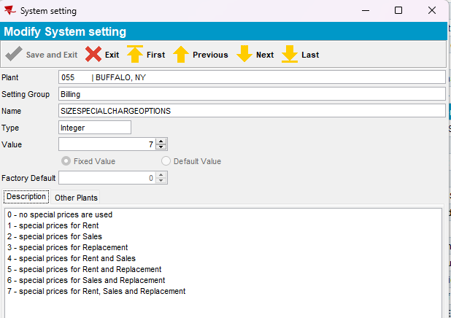
- Products DLG: Pick a product that you want to use like 010104, note the product group of this product (ex: Cotton Goods)
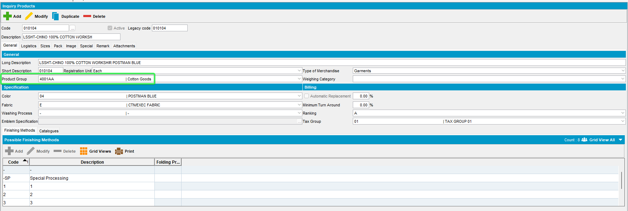
- Products DLG> Sizes: Find one of the sizes used by this product 010104 like 13502
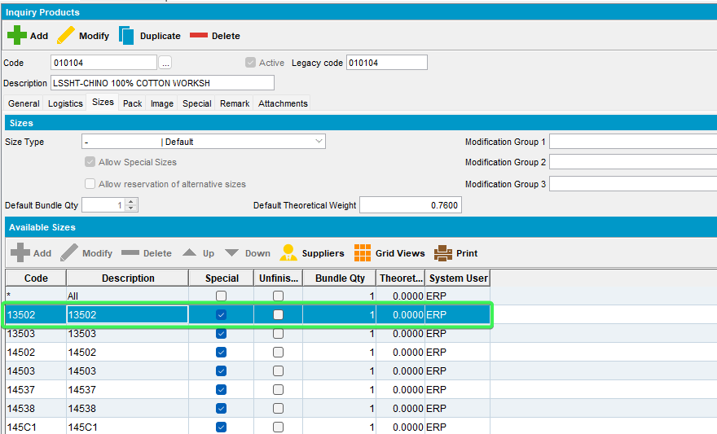
- SIZES DLG: Find the size you picked and modify it, and add Size Billing Group “Charge”
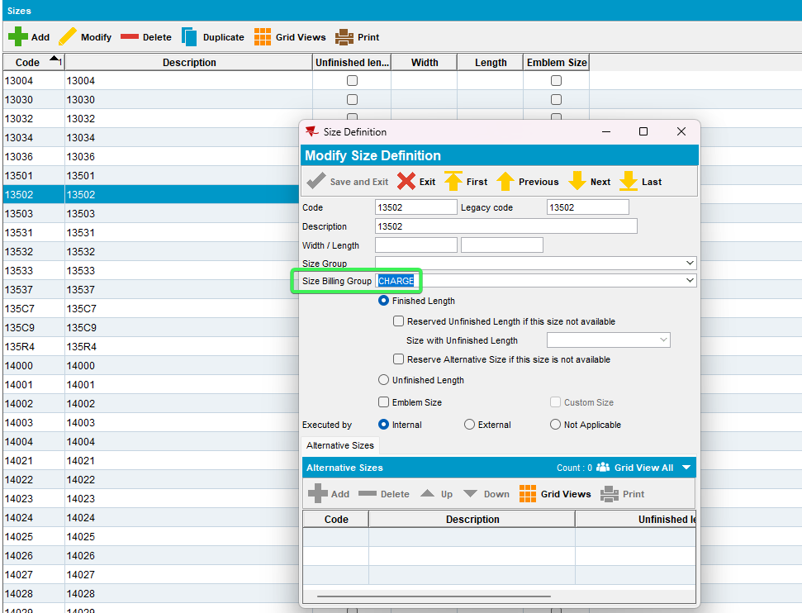
- Product Group DLG: Find your product group (Cotton Goods) and modify it
- Product Group DLG > Size Billing Groups: Add the “Charge” size billing group with a percentage of 10%
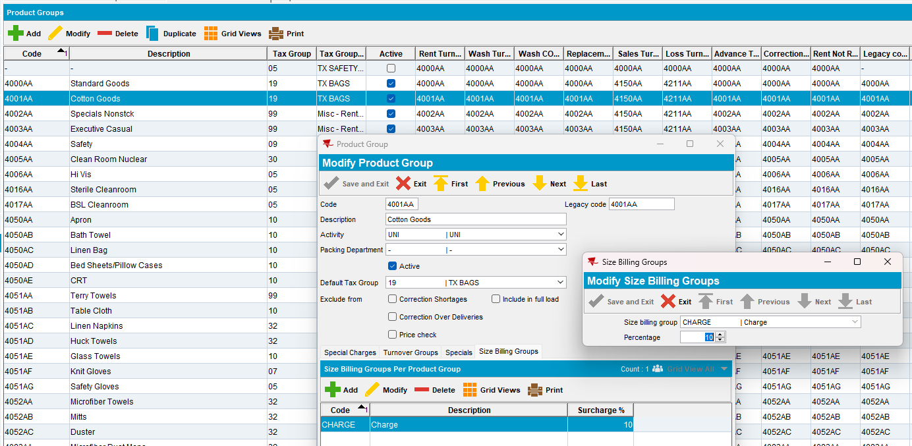
- Contract DLG> Components> Product Settings> Set checkbox "Size Surcharge Pricing" and save
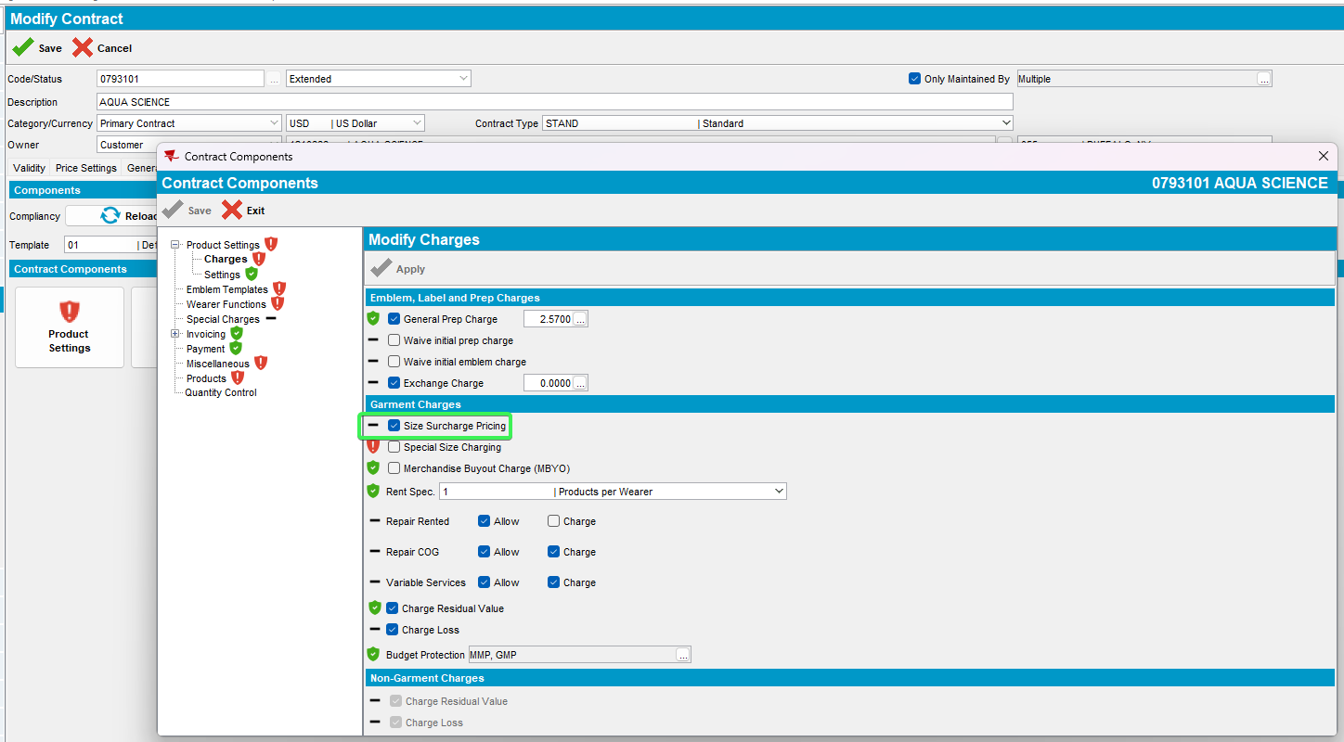
- Contract DLG> Components> Products> Add the product with the CHARGE billing group (ex: 010104) with size *
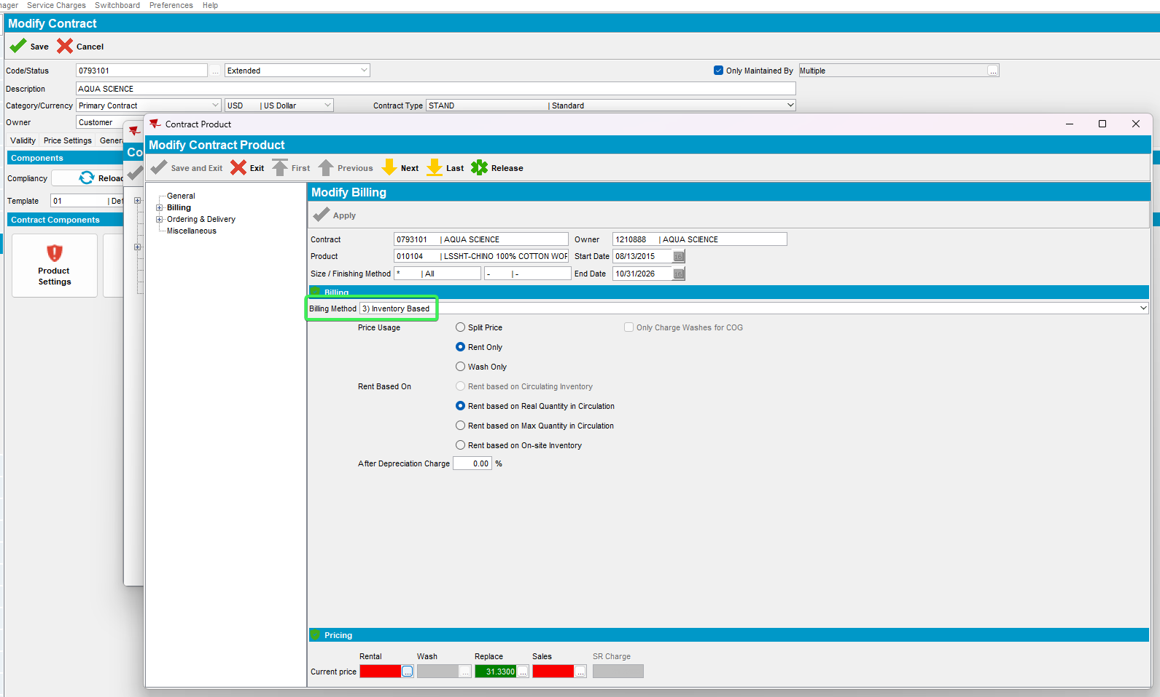
- Contract DLG> Components> Products> Add new product dlg set billing method 3 and add a new rent price
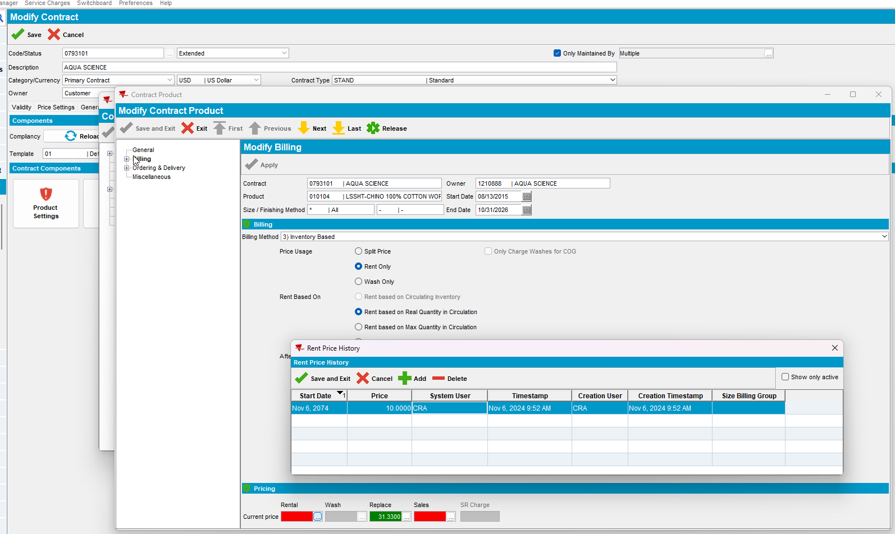
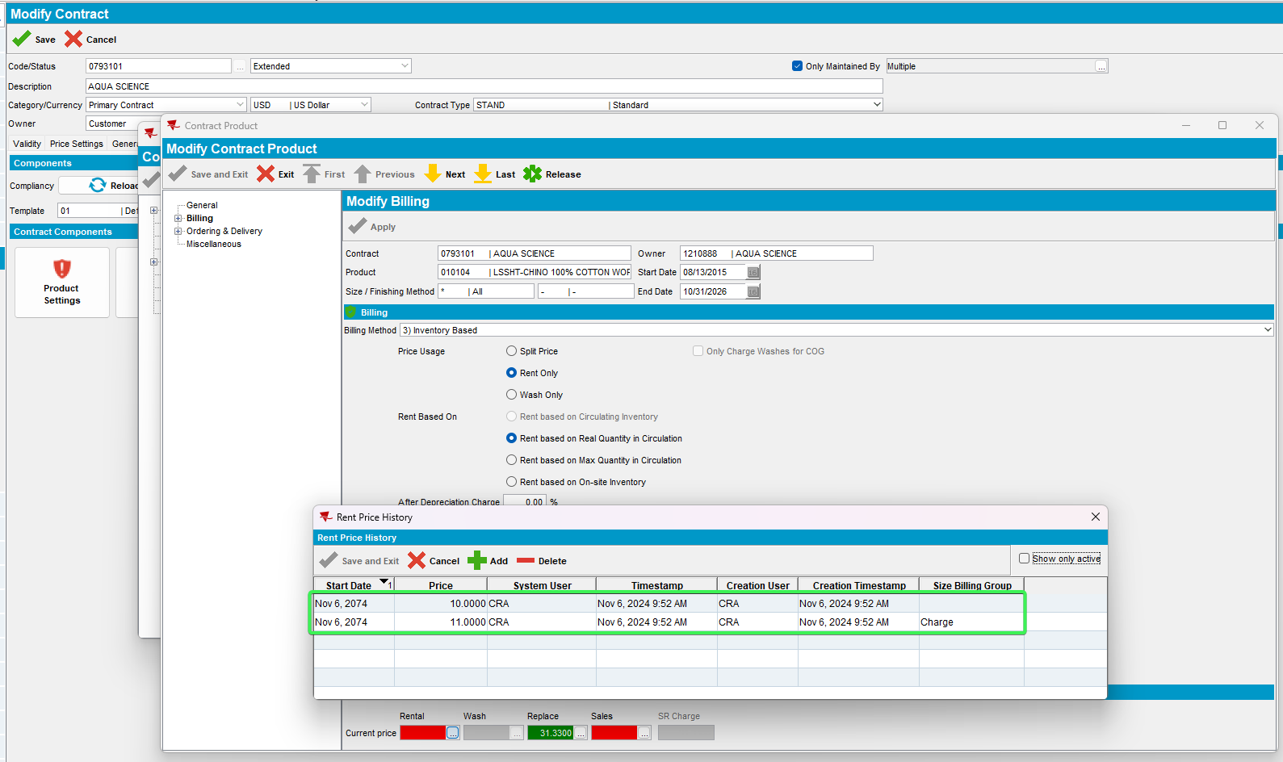
Product Lists per Customer DLG (Customer Specific Prices)
- CONTRACT DLG: Release the product to an active contract customer
- PRICE LISTS PER CUSTOMER: Add a customer price list for the customer of type RENT with priority 1
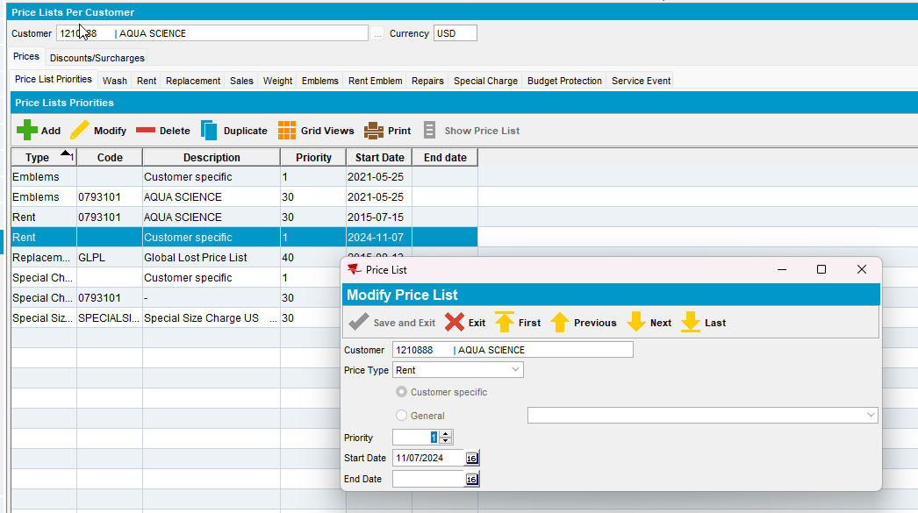

Add Size Billing Group from menu application
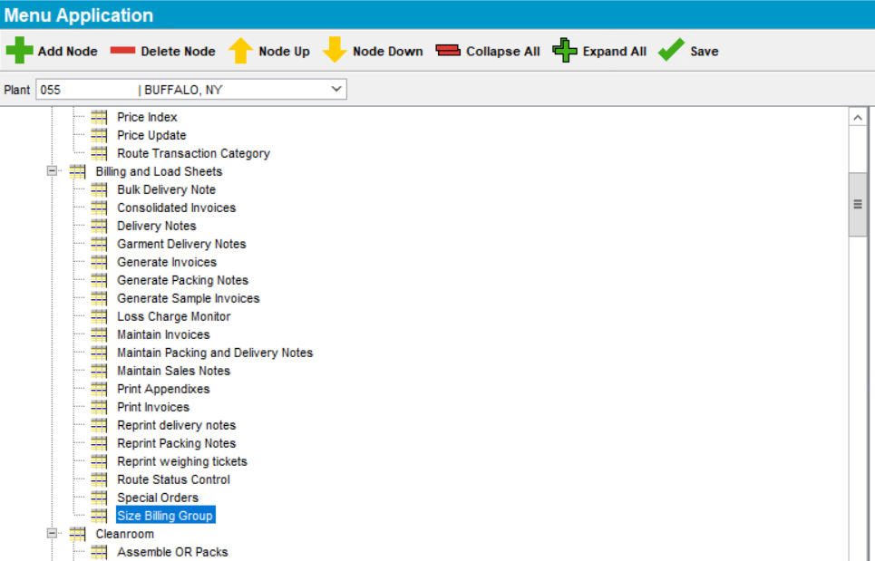
- Size Billing Group add a standard billing group with description RENT check the Standard checkbox
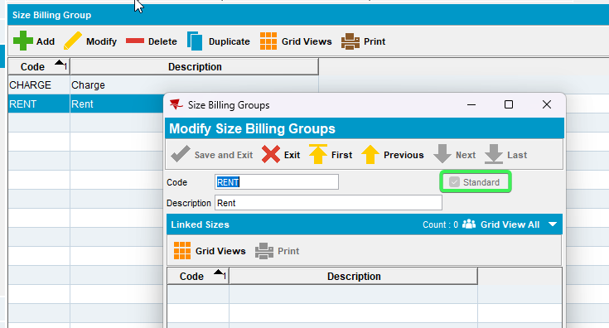
- Sizes Add the Billing Group to another size used by the same product
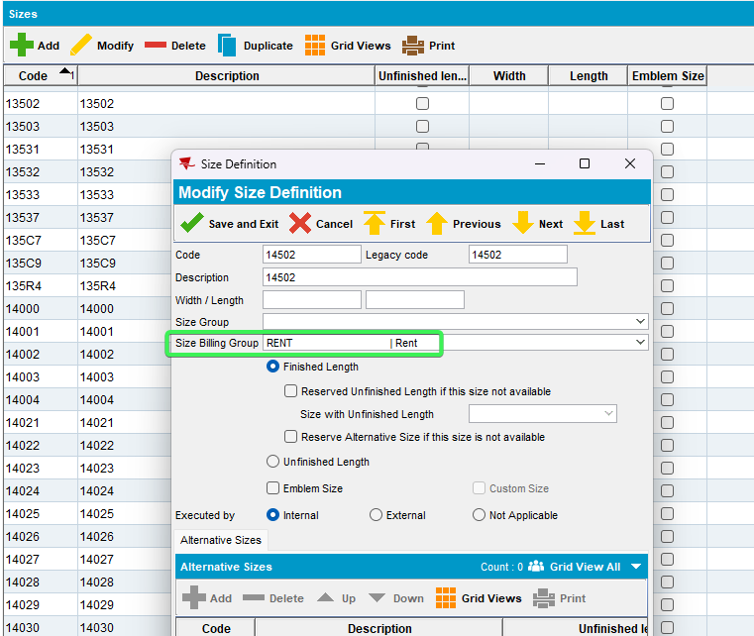

Test Case 1 – PRICECONTROLACCES = 1 & SIZEBILLINGGROUPPRICECTL = 1 & NULL Billing Group for rent
Hash: 3fa65b8b1696
System Settings DLG: Set PRICECONTROLACCES = 1 & SIZEBILLINGGROUPPRICECTL = 1
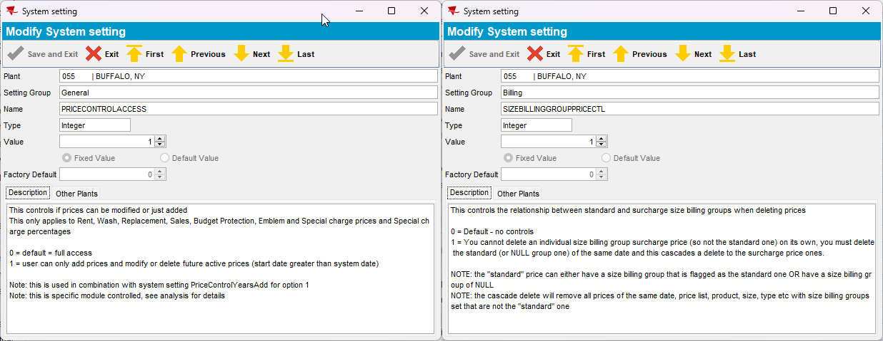
- Contract DLG
a. Delete the Rent surcharge price -> error message is shown
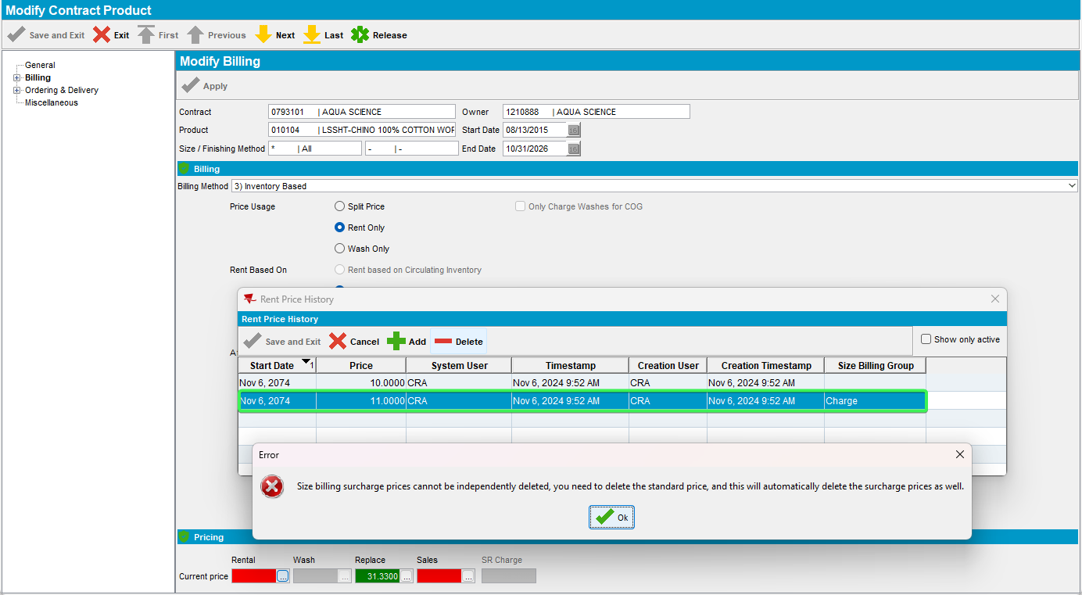
b. Delete the rent price -> deletes both rent and surcharge price
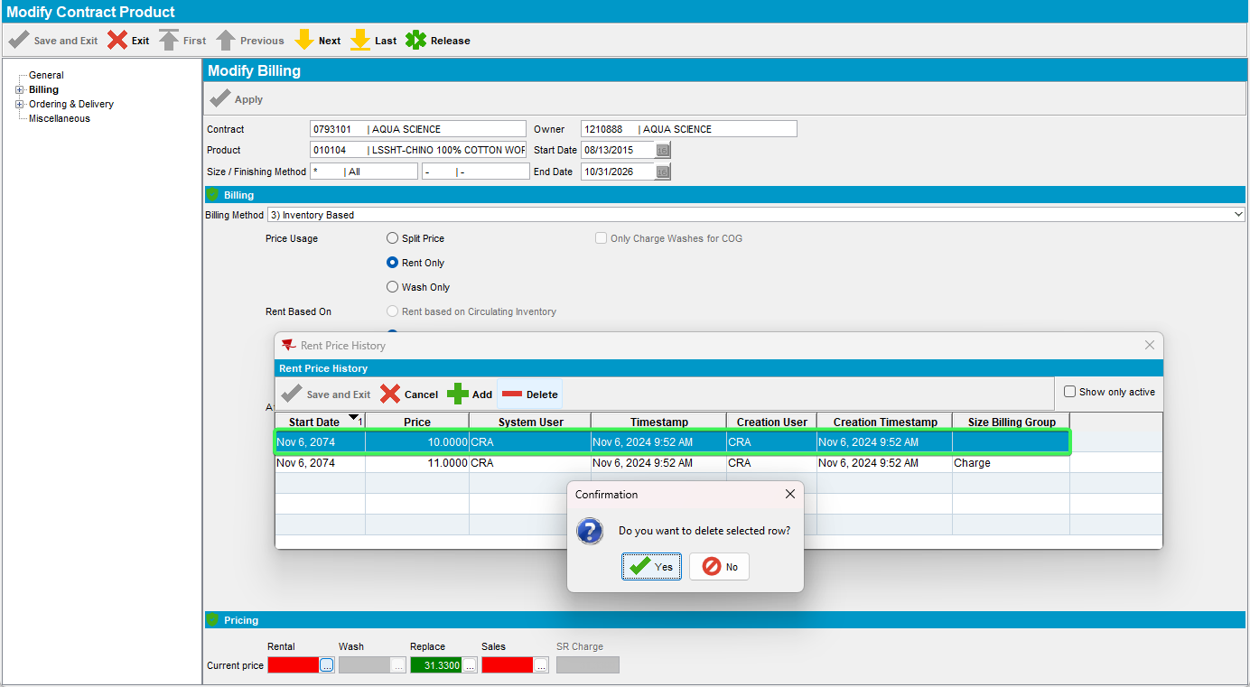
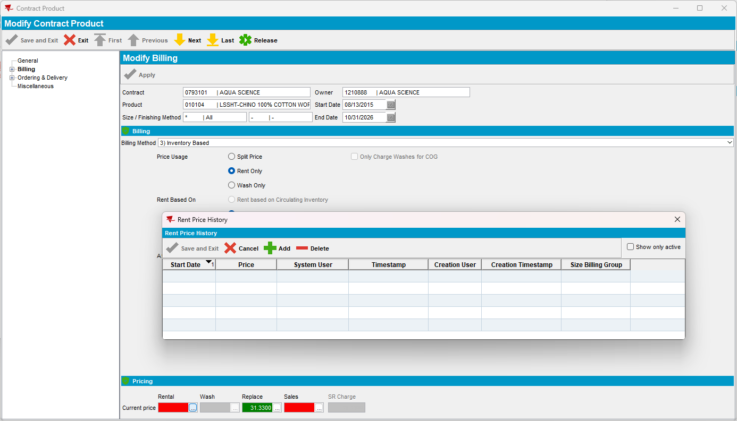
- General Price List DLG
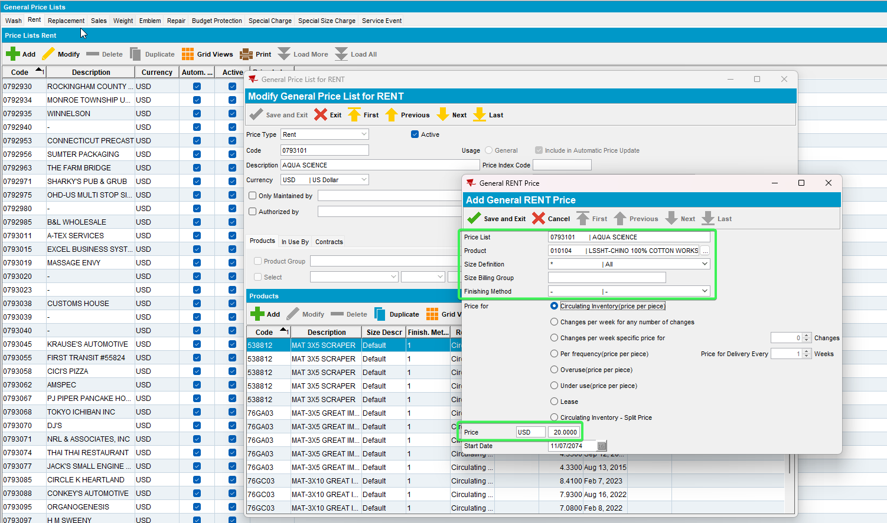
- Delete the Rent surcharge price -> error message is shown
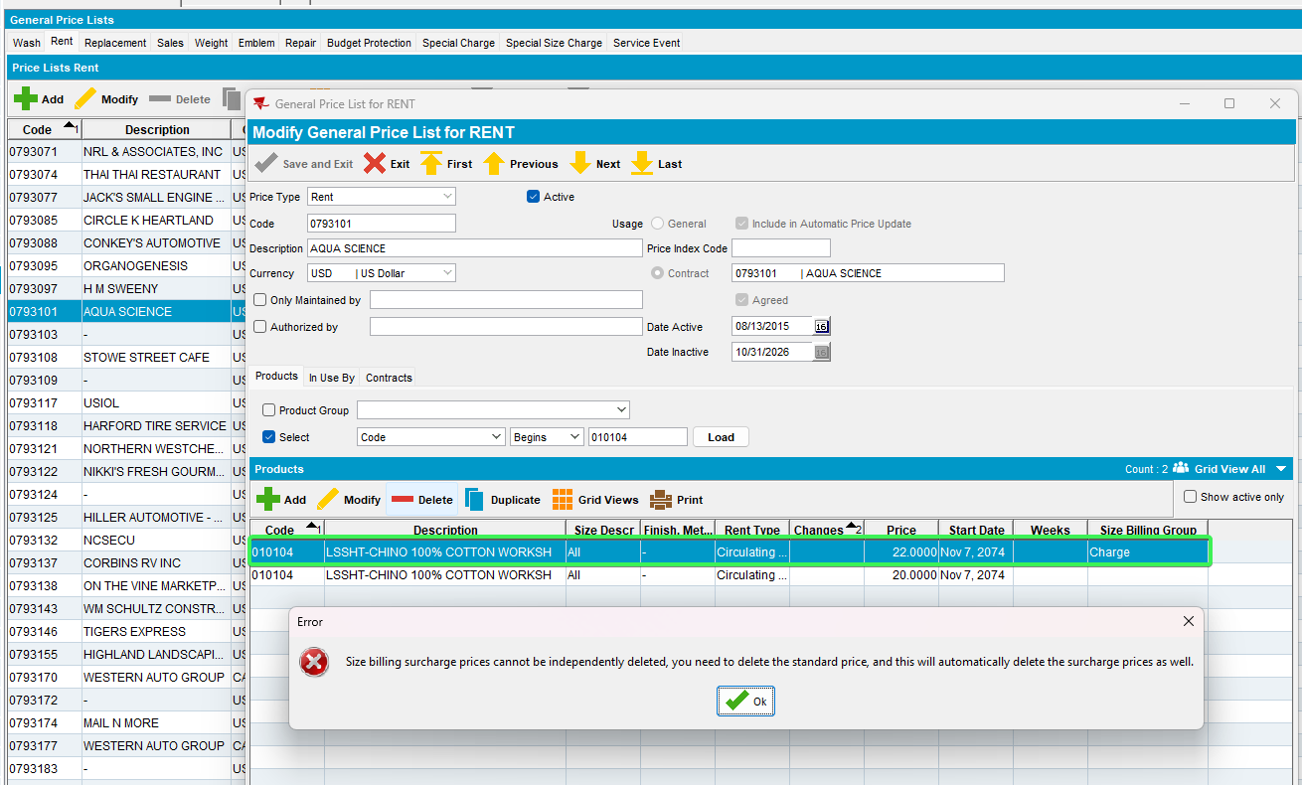
- Delete the rent price -> deletes both rent and surcharge price
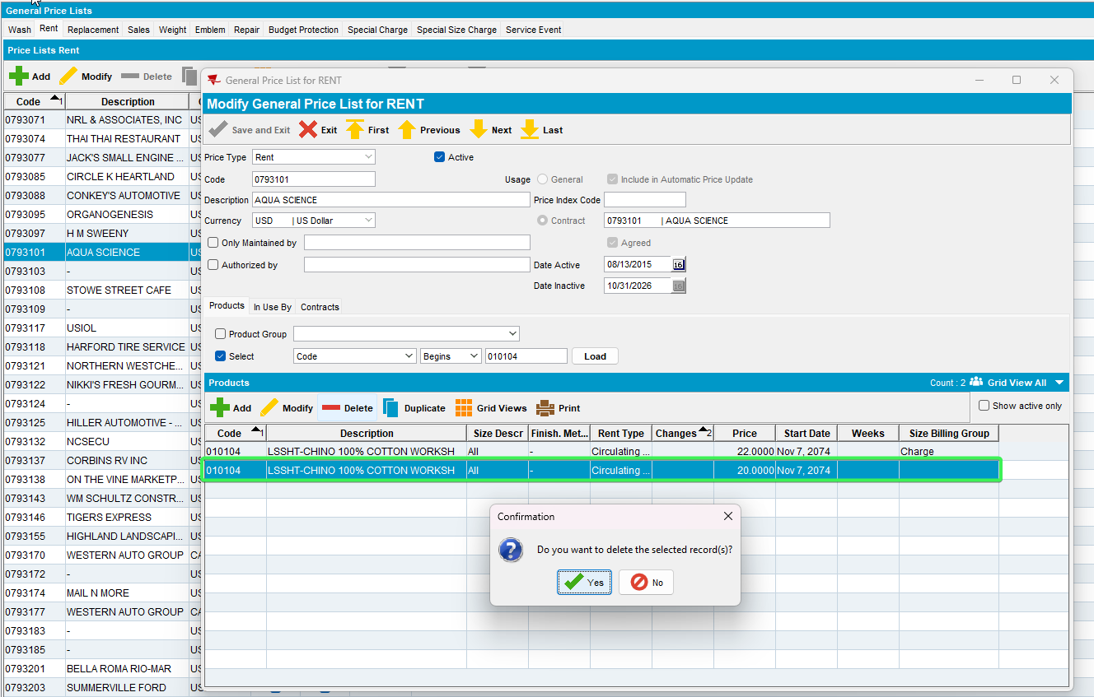
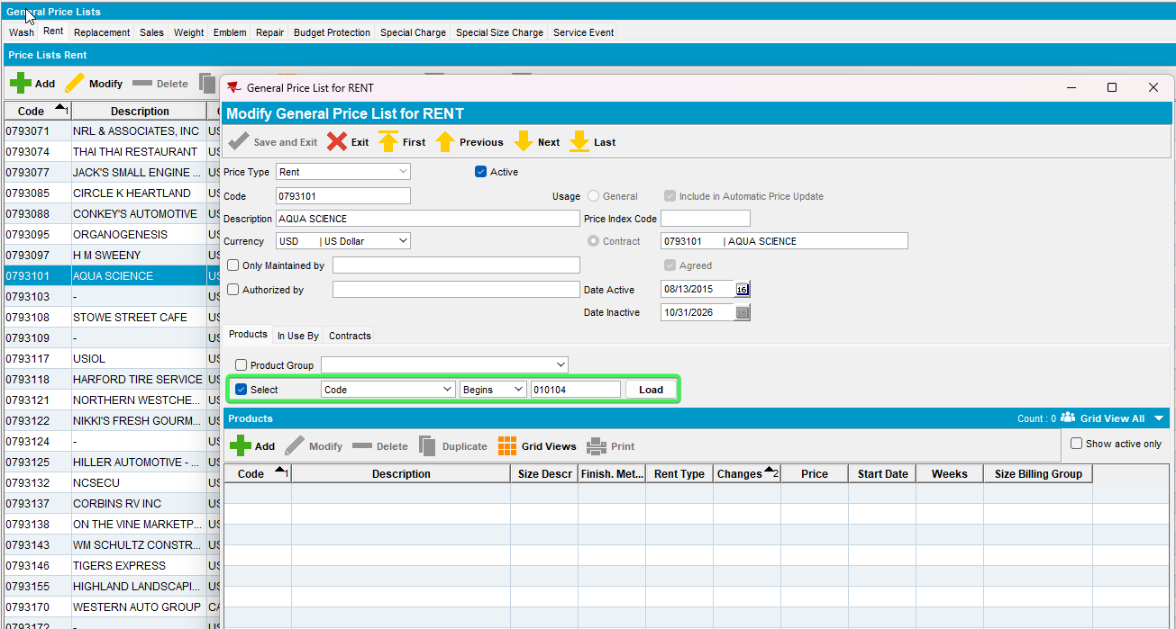
- Product Lists per Customer DLG (Customer Specific Prices)
a. Delete the Rent surcharge price -> error message is shown
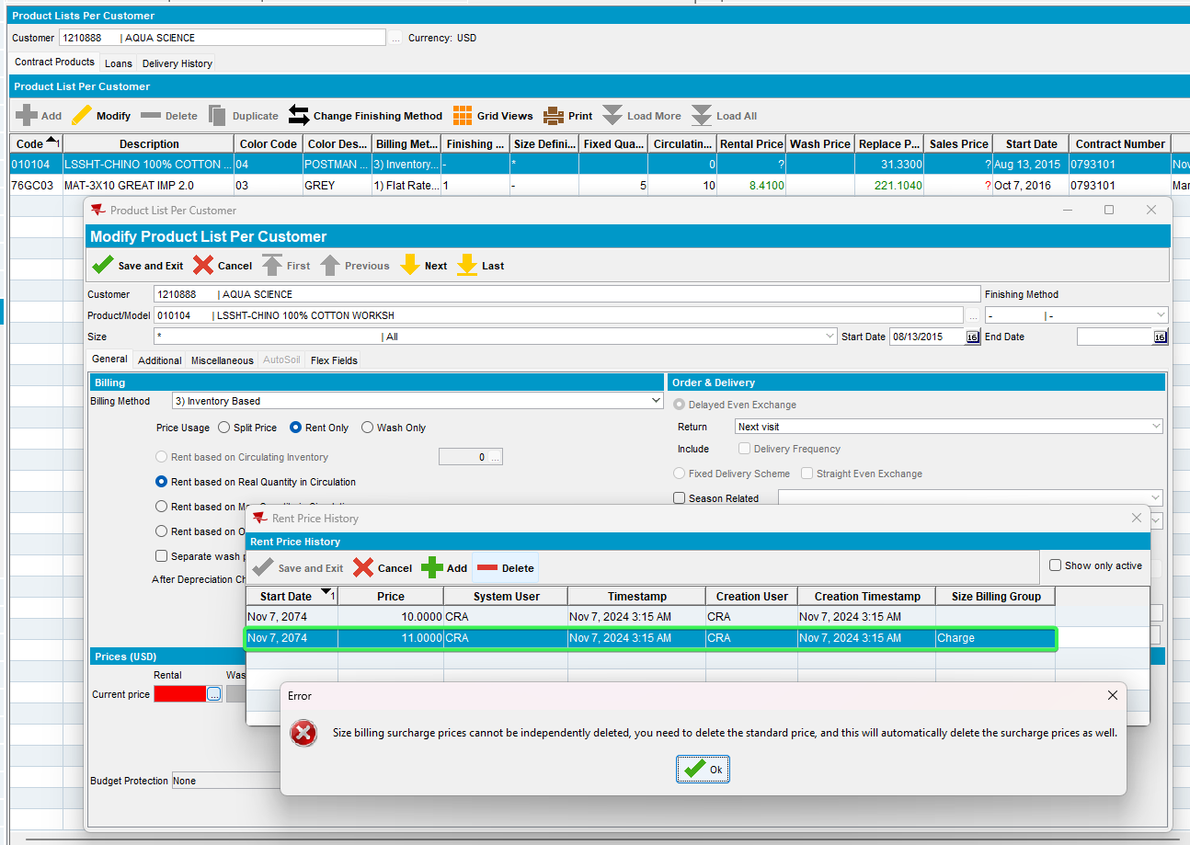
- Delete the rent price -> deletes both rent and surcharge price
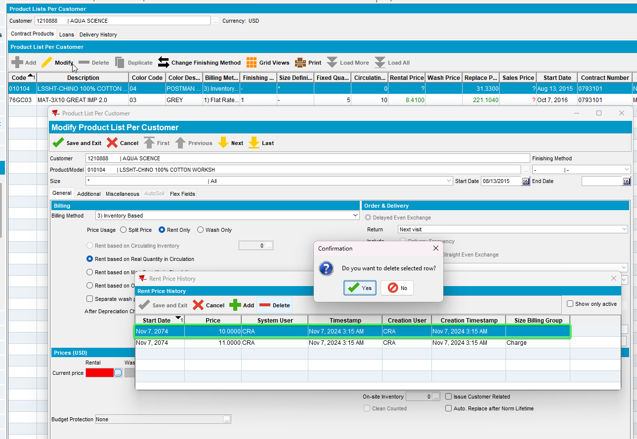
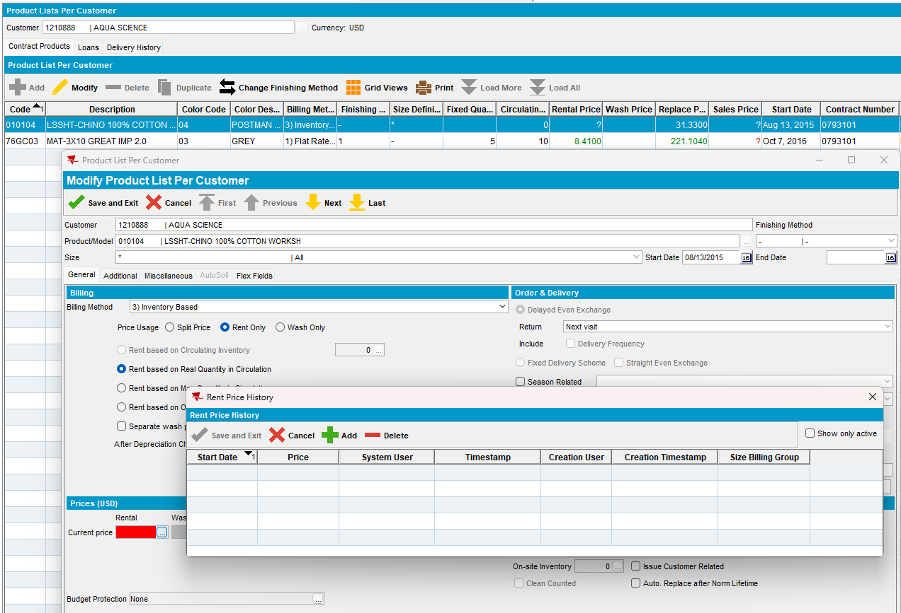
Tested OK

Test Case 2 – PRICECONTROLACCES = 1 & SIZEBILLINGGROUPPRICECTL = 0 for Rent
Hash: 3fa65b8b1696
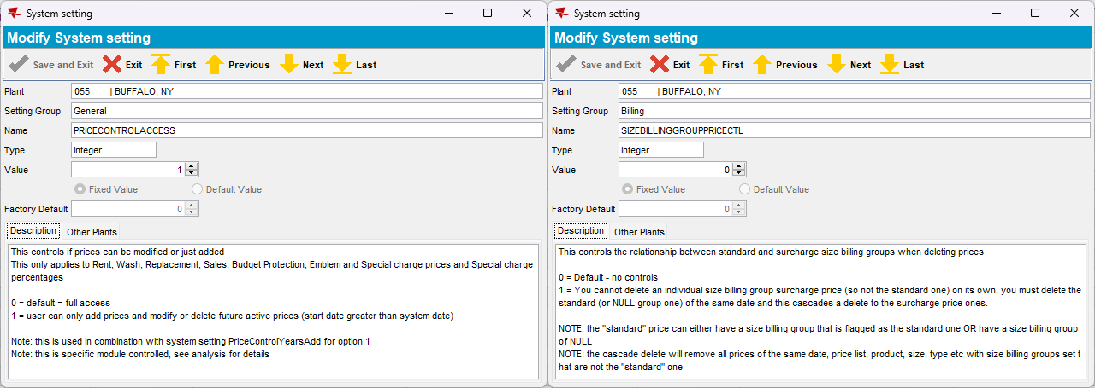
- Contract DLG
a. Delete the Rent surcharge price -> no error message is shown, price is deleted
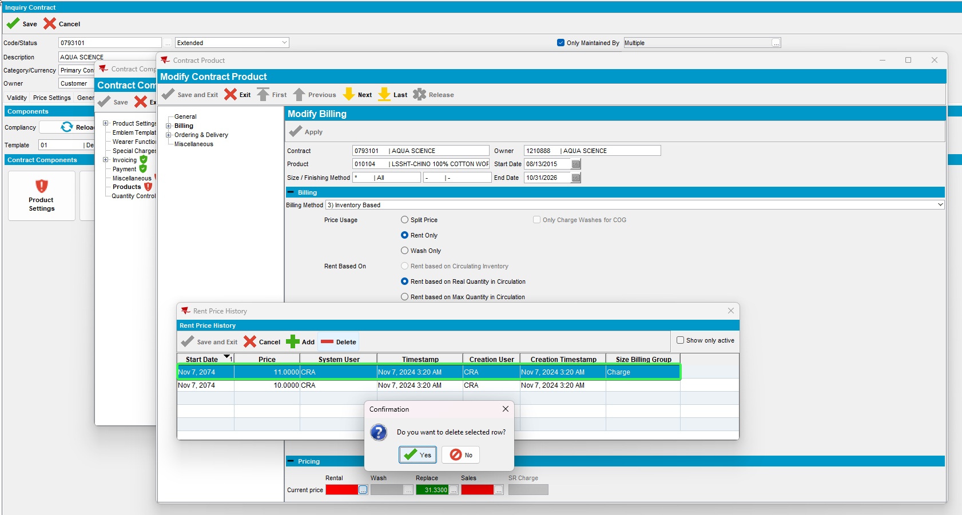
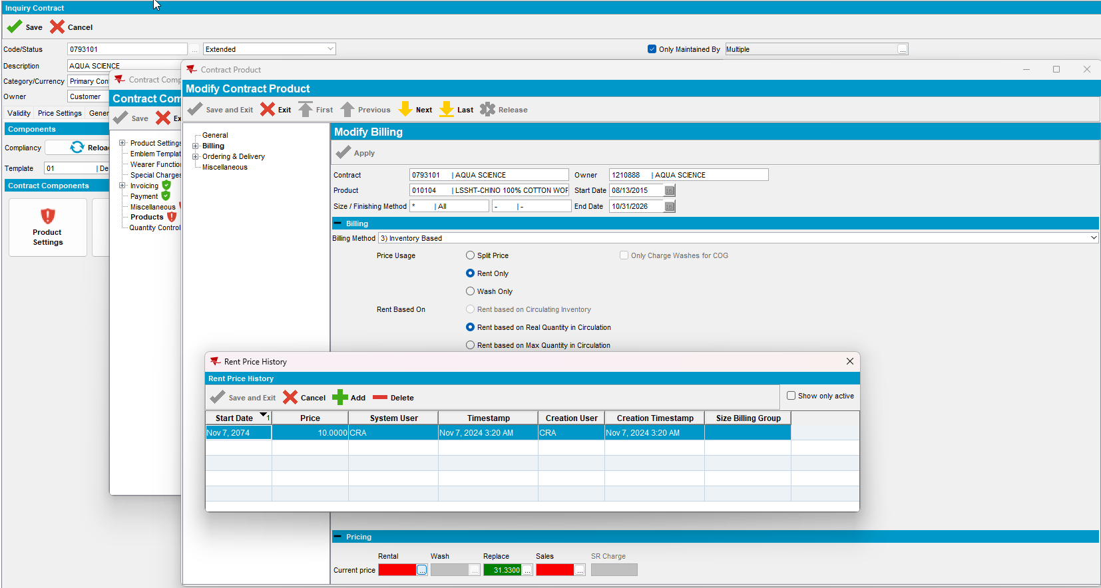
b. Delete the rent price -> delete rent price only
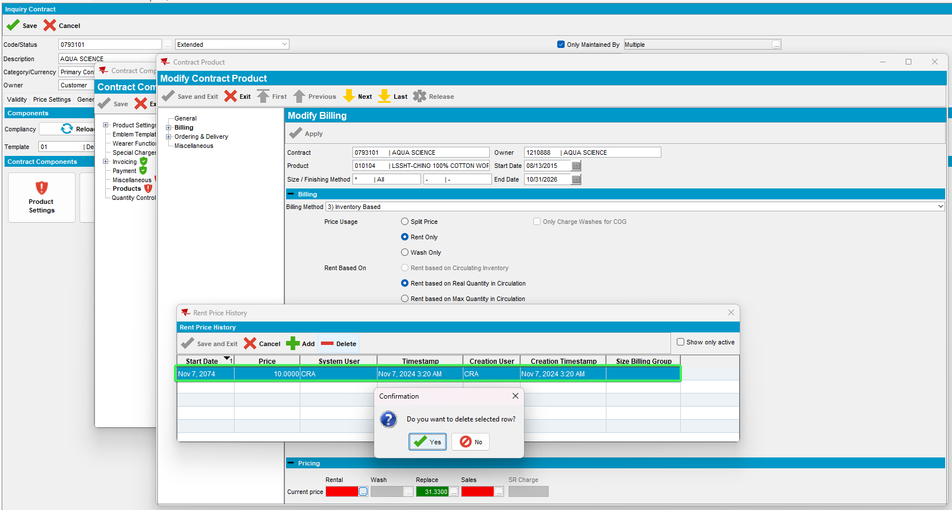
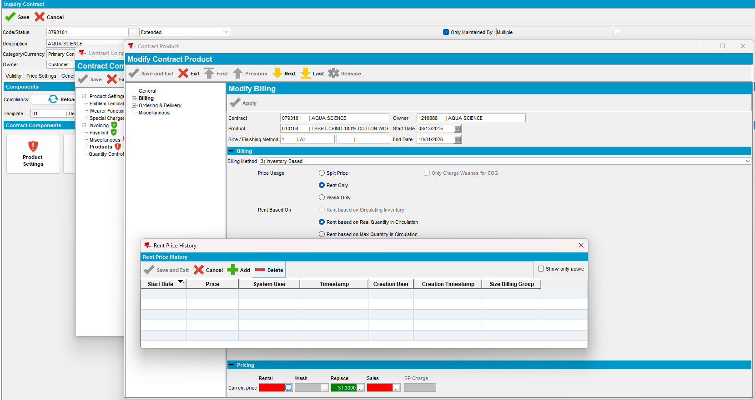
- General Price List DLG
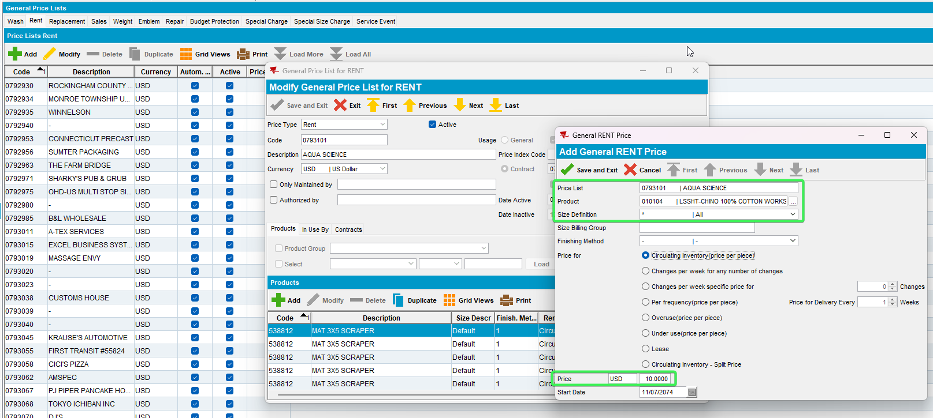
a. Delete the Rent surcharge price -> no error message is shown, price is deleted
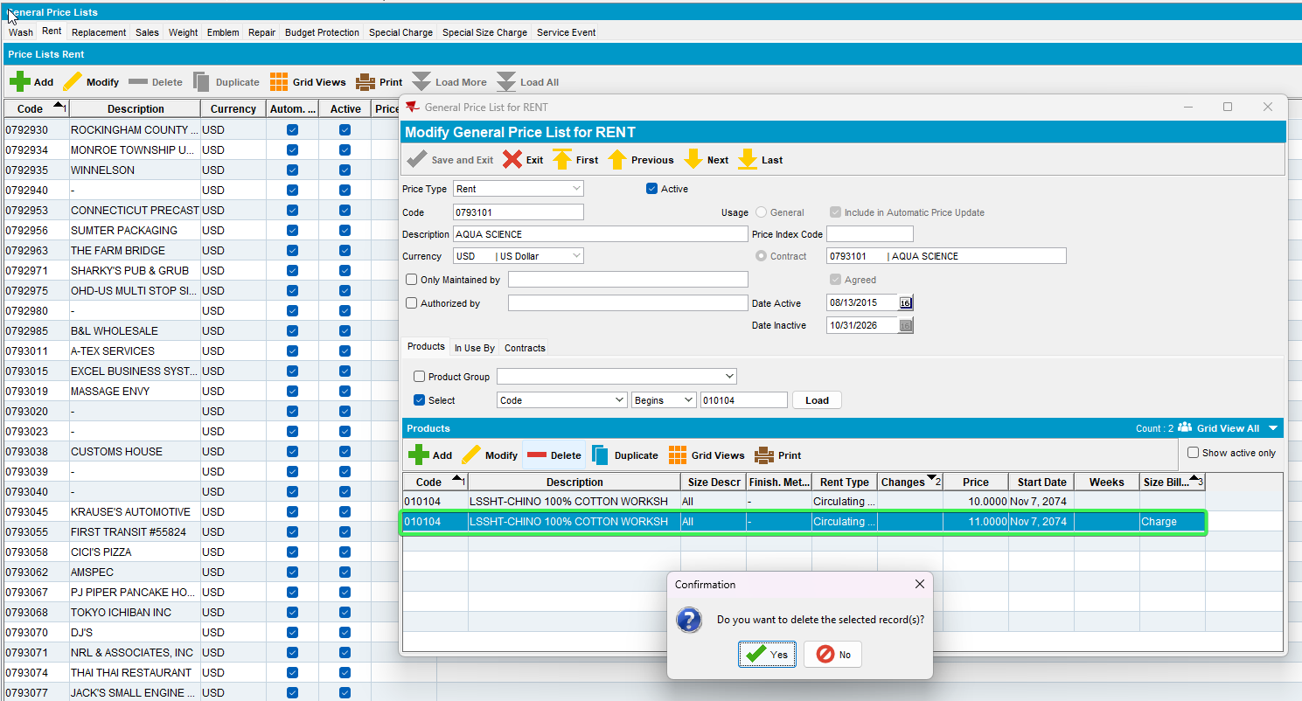
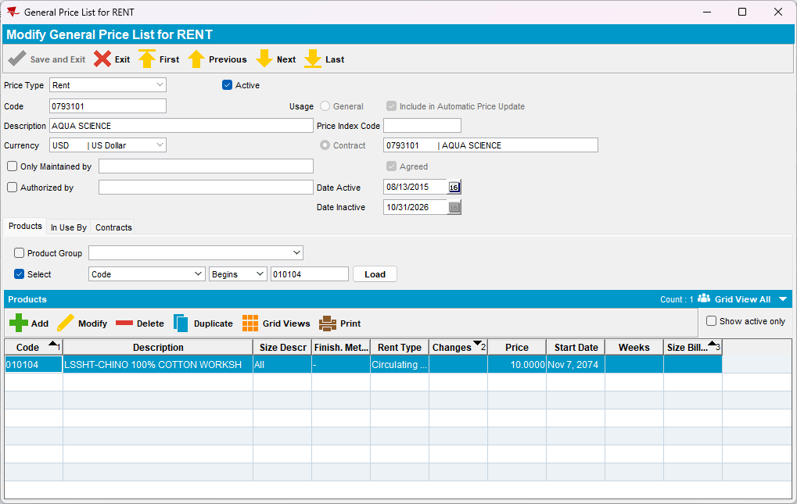
b. Delete the rent price -> delete rent price only
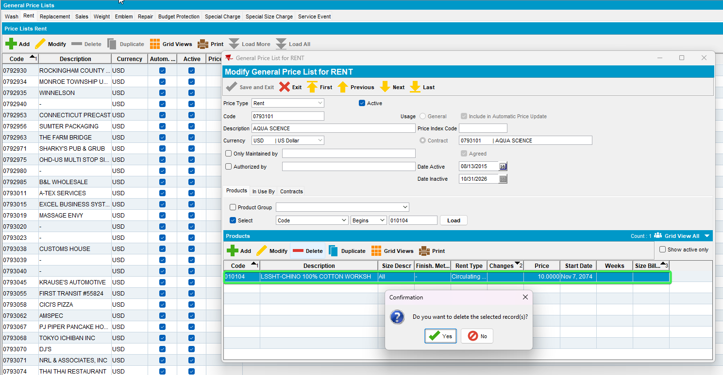
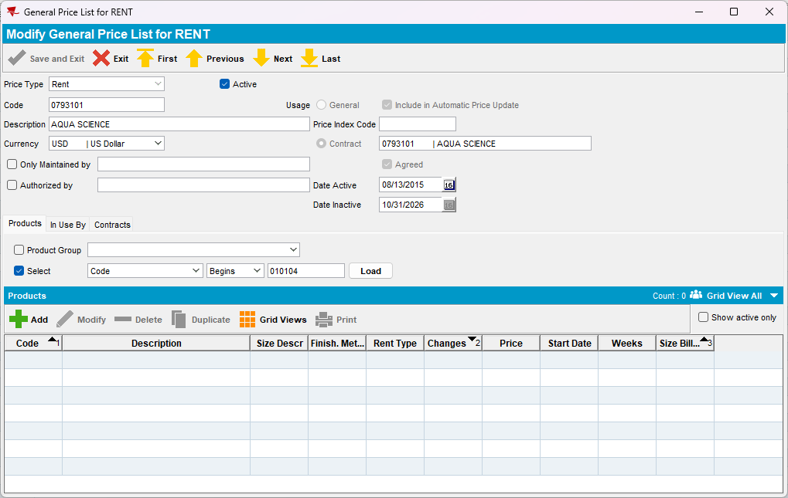
- Product Lists per Customer DLG (Customer Specific Prices)
a. Delete the Rent surcharge price -> no error message is shown, price is deleted
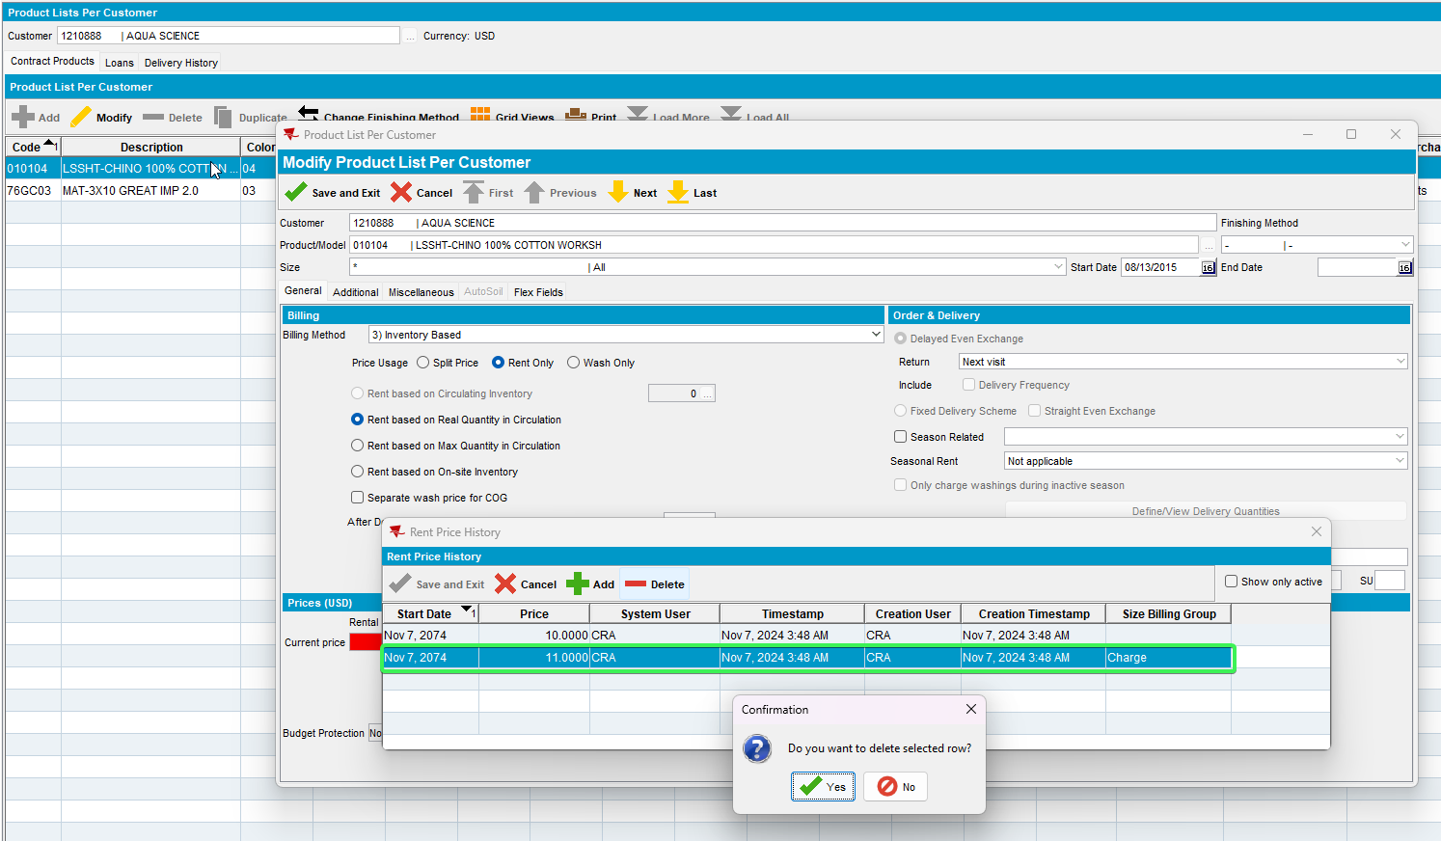
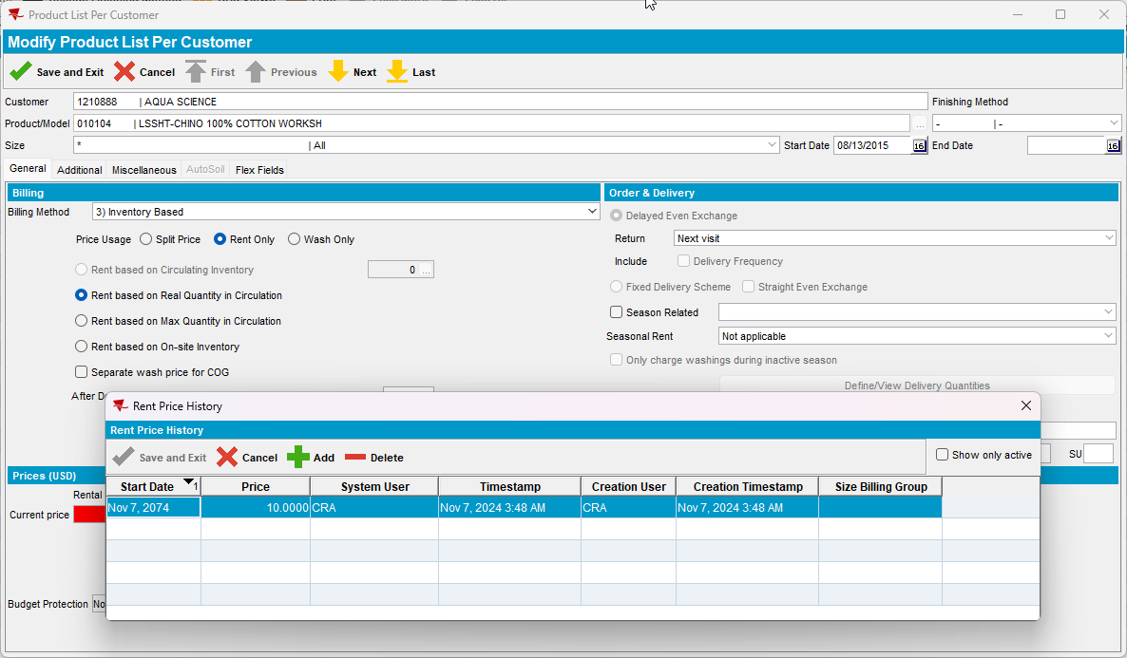
b. Delete the rent price -> delete rent price only
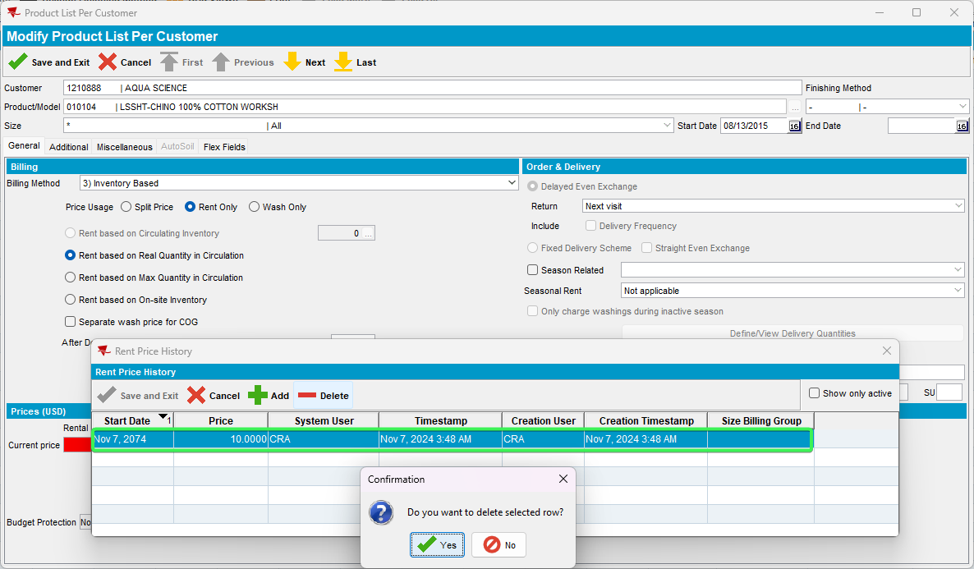
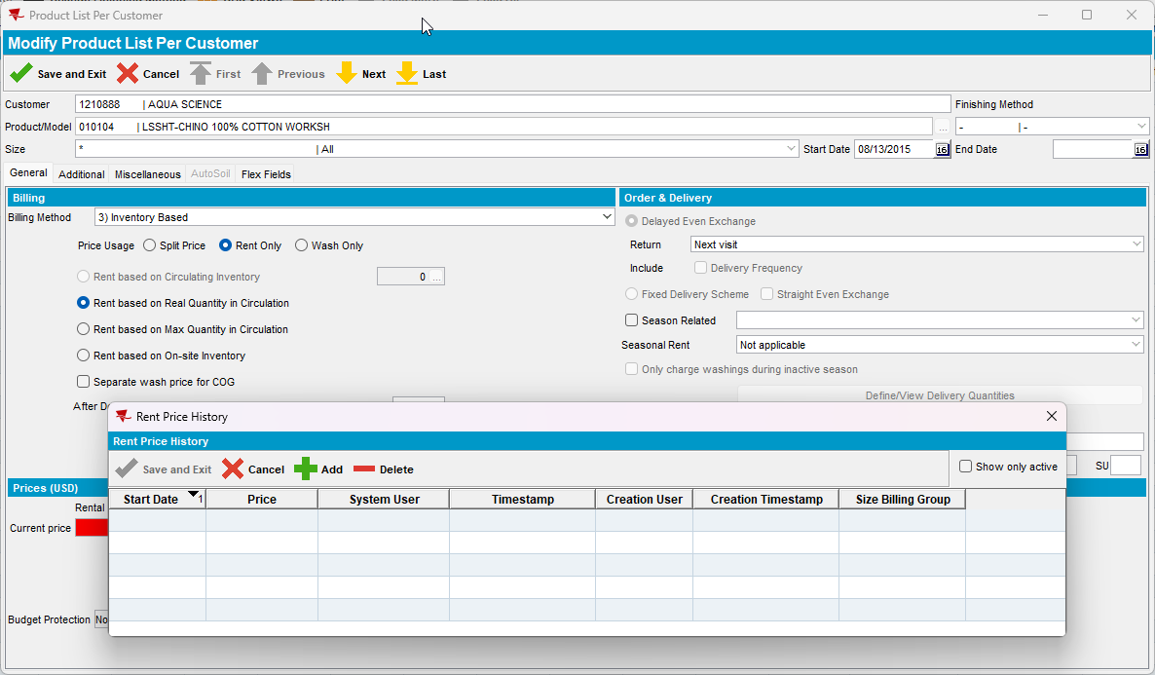

Test Case 3 – PRICECONTROLACCES = 0 & SIZEBILLINGGROUPPRICECTL = 1 for Rent
Hash: 3fa65b8b1696
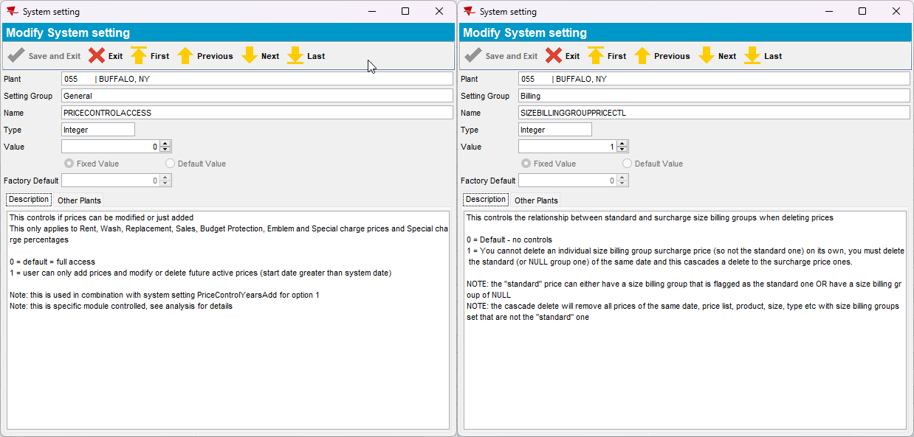
- Contract DLG
a. Delete the Rent surcharge price -> error message is shown
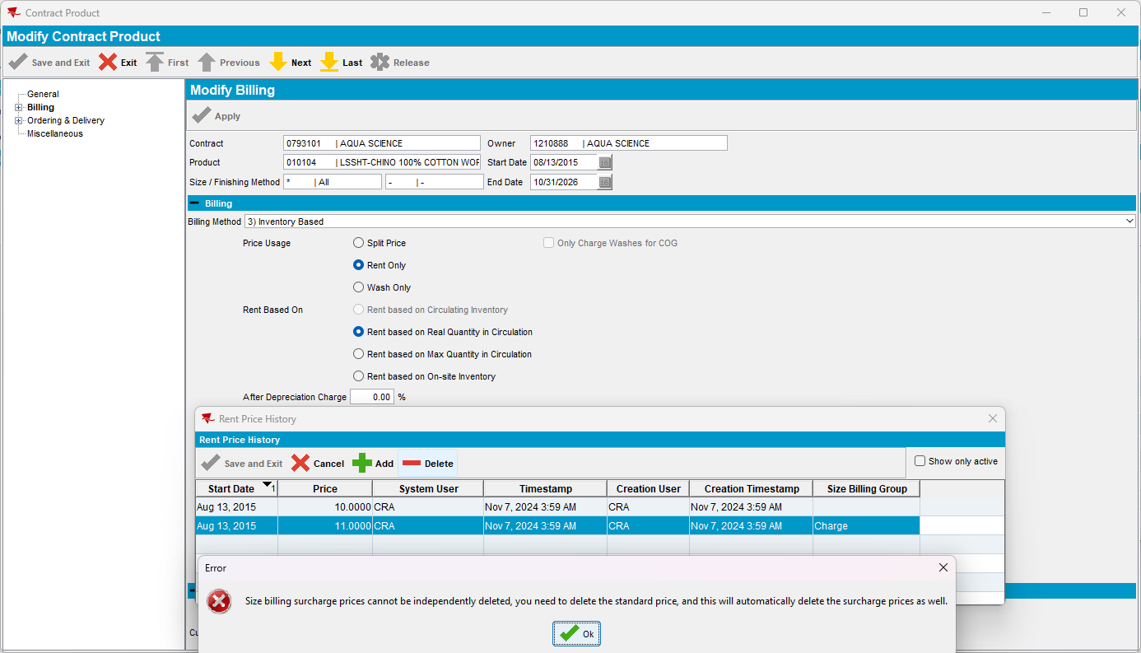
b. Delete the rent price -> deletes both rent and surcharge price
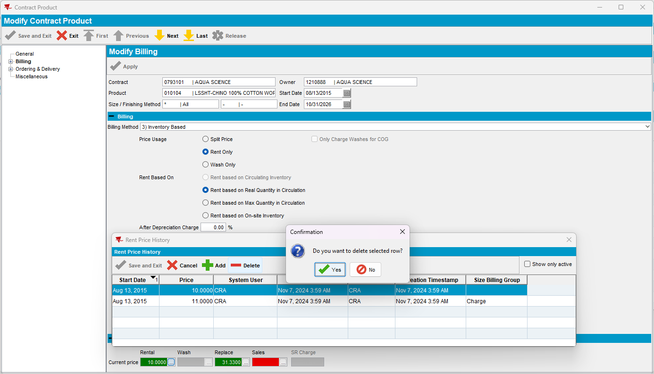
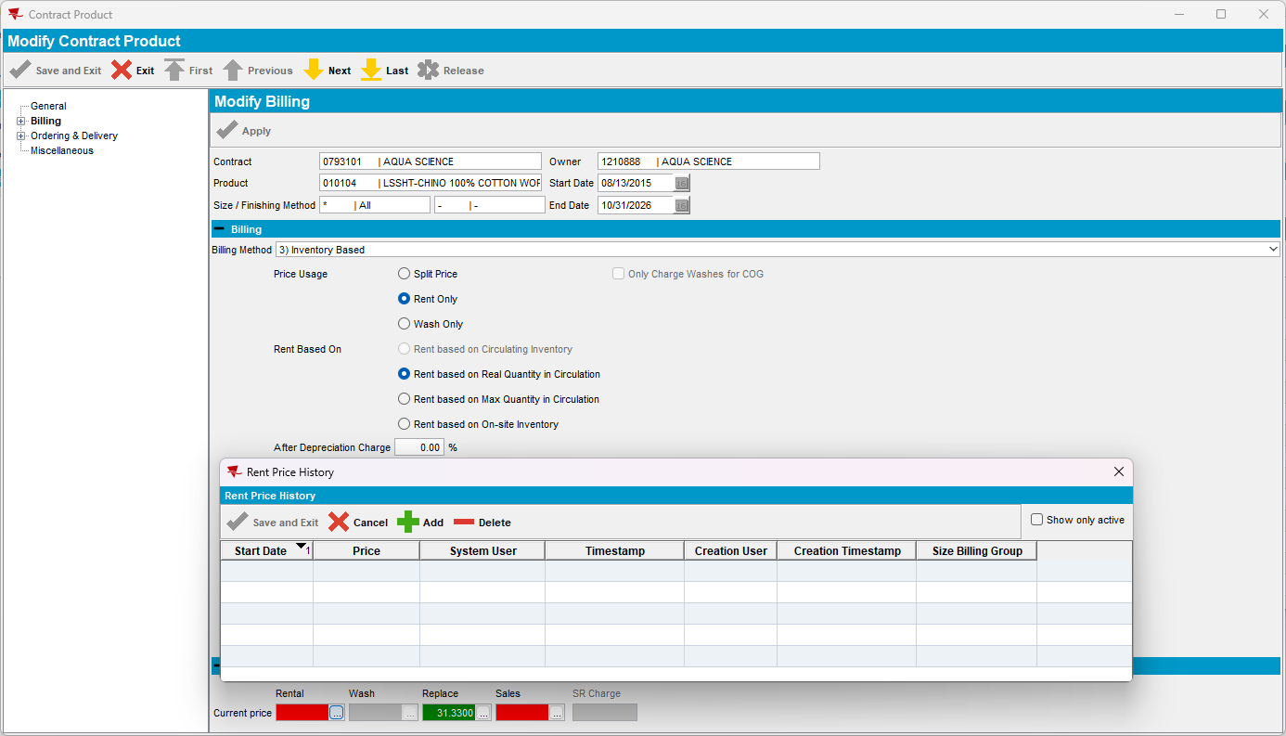
- General Price List DLG
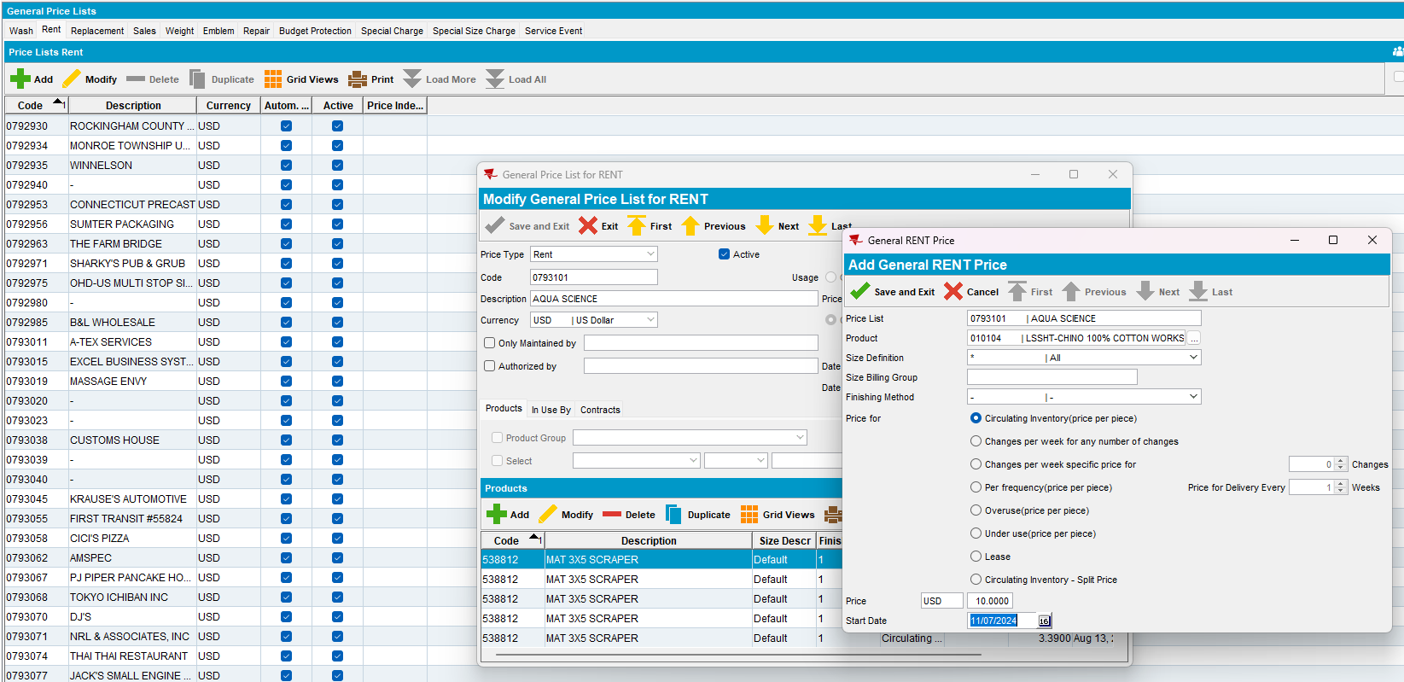
- Delete the Rent surcharge price -> error message is shown
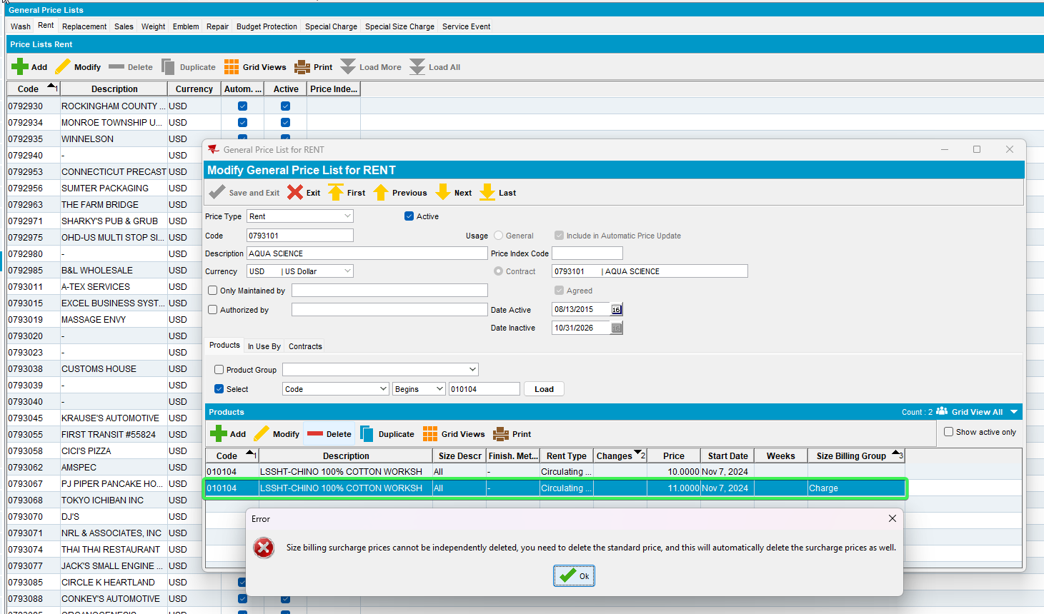
- Delete the rent price -> deletes both rent and surcharge price
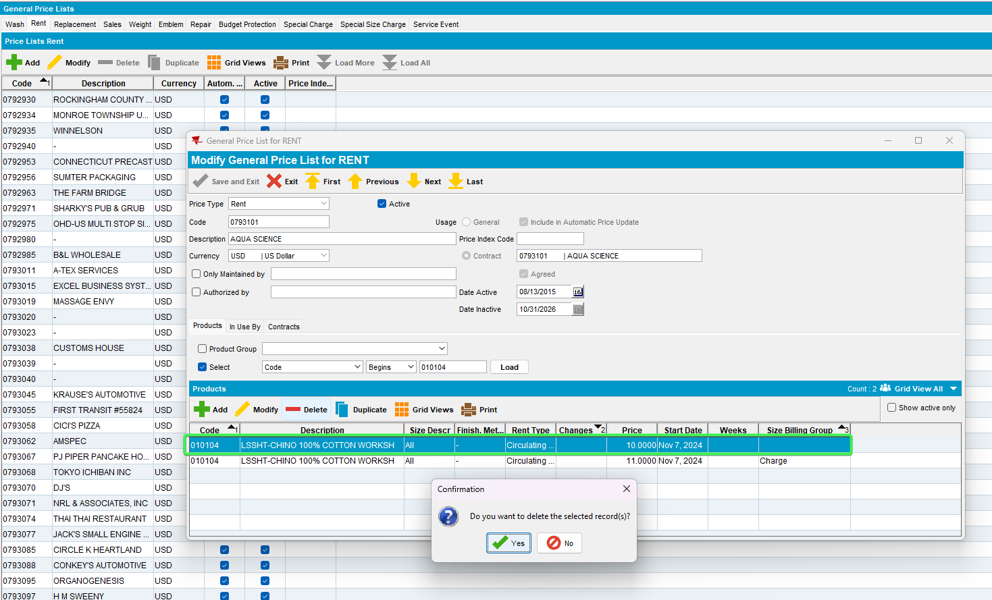
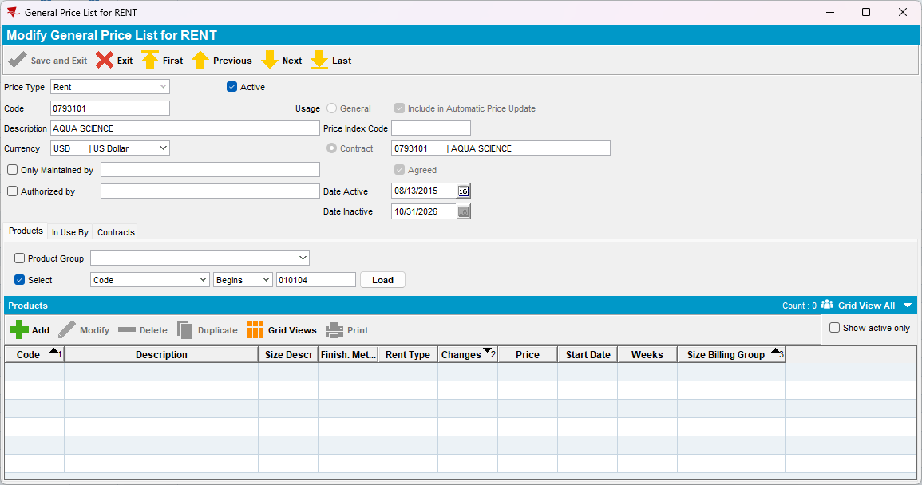
- Product Lists per Customer DLG (Customer Specific Prices)
- Delete the Rent surcharge price -> error message is shown
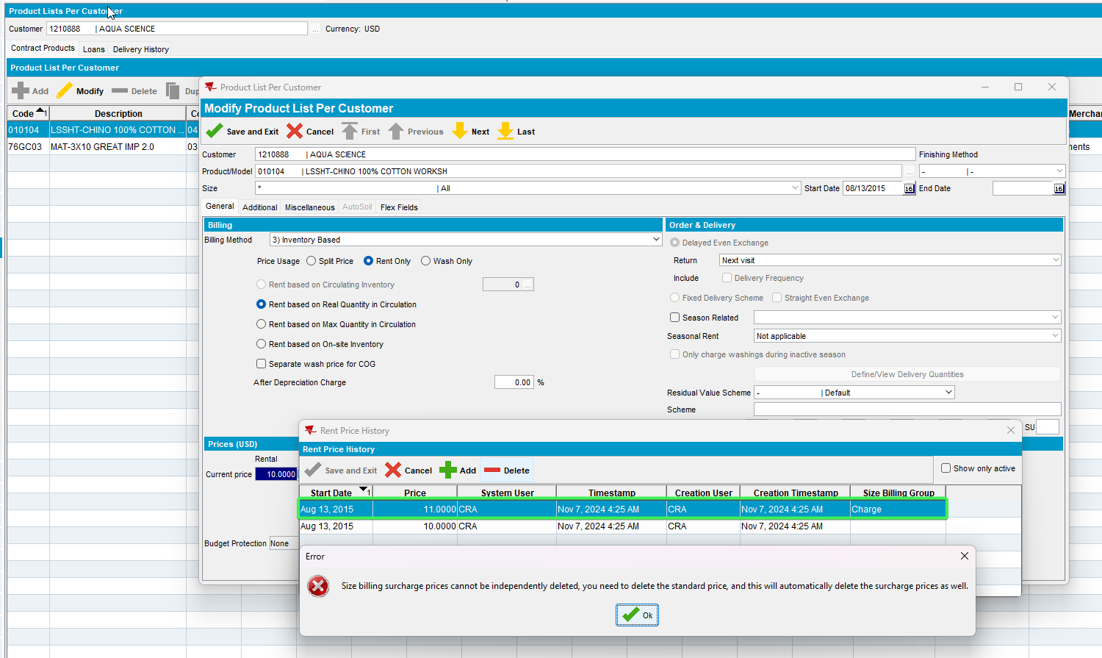
- Delete the rent price -> deletes both rent and surcharge price
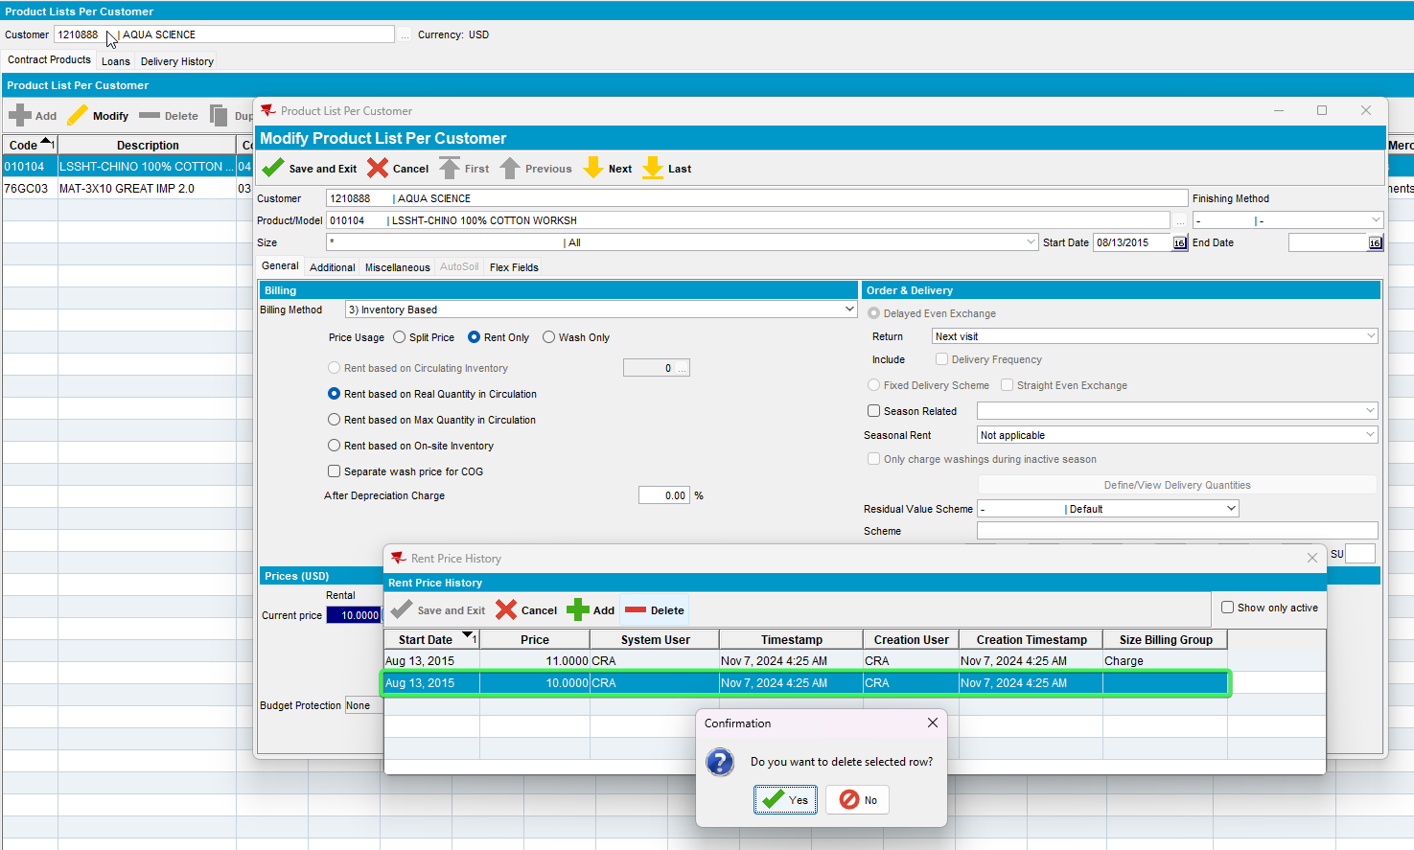
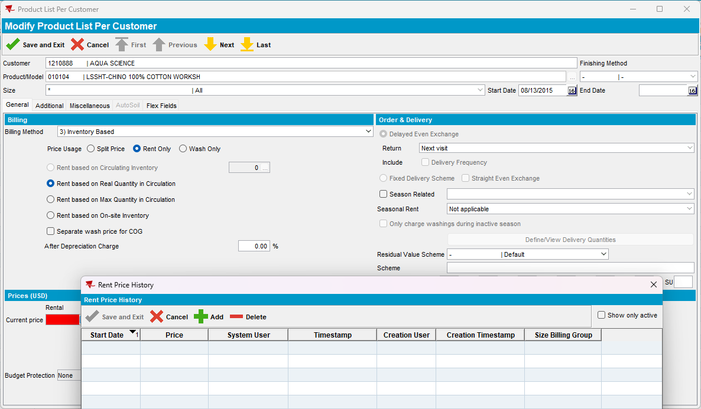
Tested OK

Test Case 4 – PRICECONTROLACCES = 1 & SIZEBILLINGGROUPPRICECTL = 1 & NULL Billing Group for Sale
Hash: 3fa65b8b1696
- Contract DLG
a. Delete the Sale surcharge price -> error message is shown
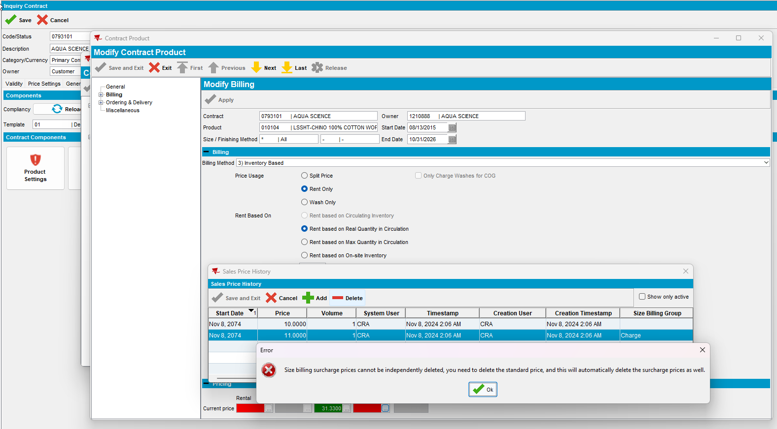
- Delete the Sale price -> deletes both sale and surcharge price
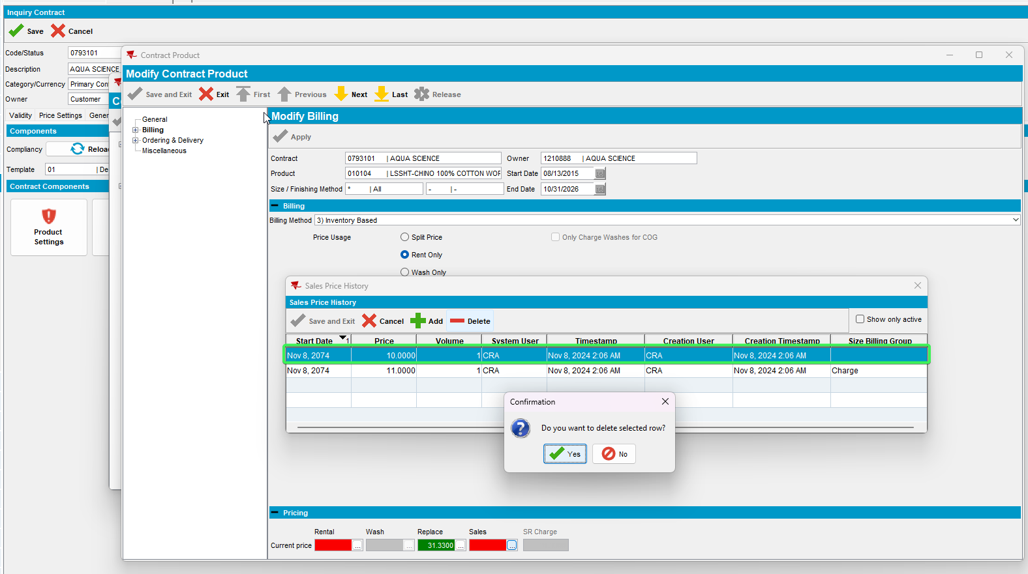
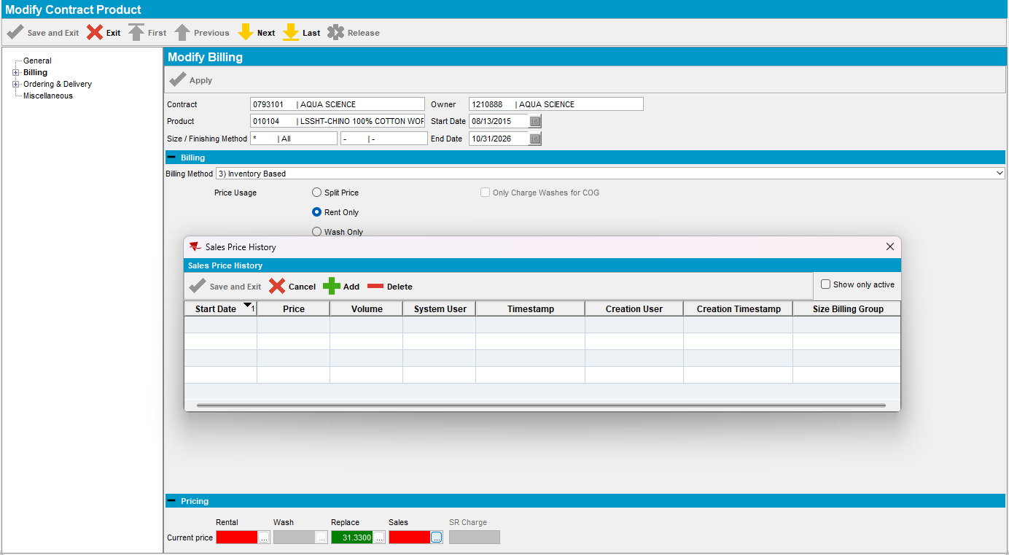
- General Price List DLG
- Delete the Sale surcharge price -> error message is shown
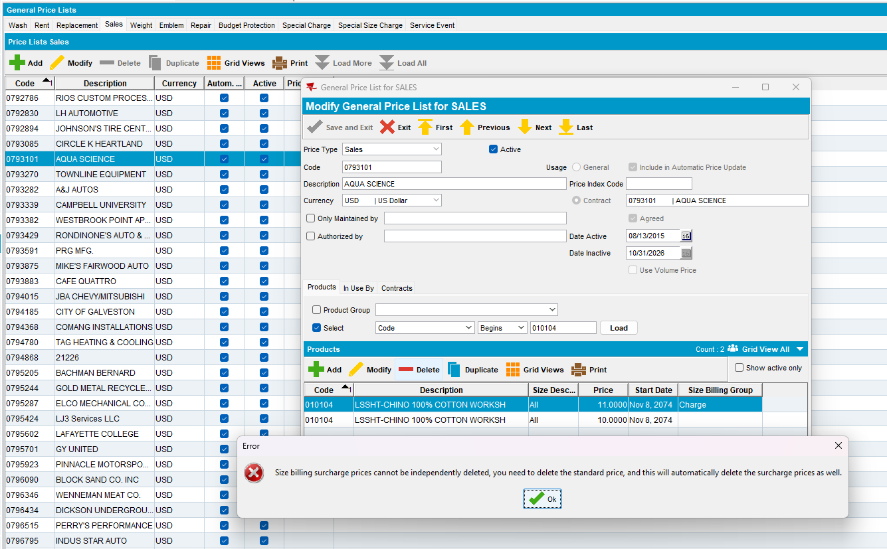
- Delete the Sale price -> deletes both sale and surcharge price
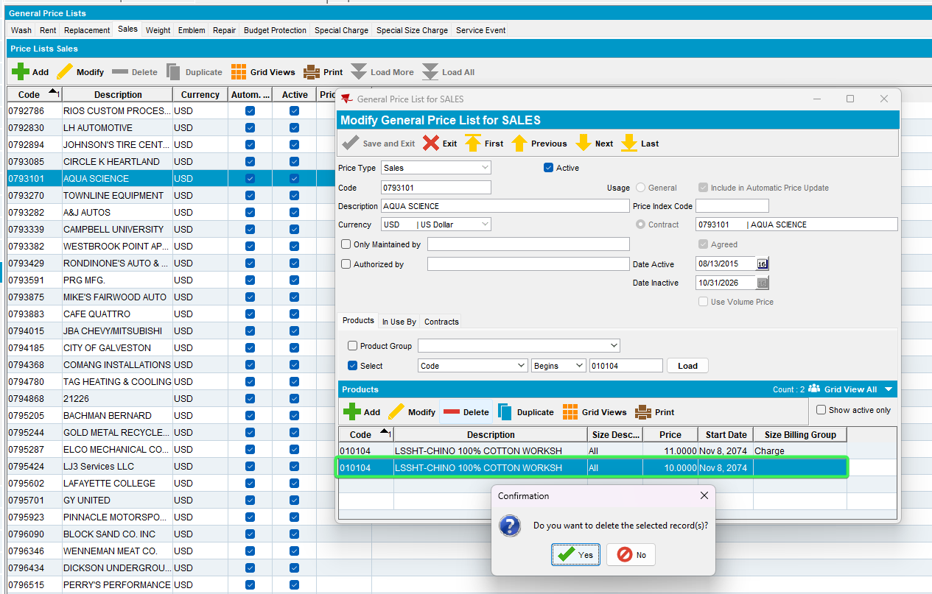
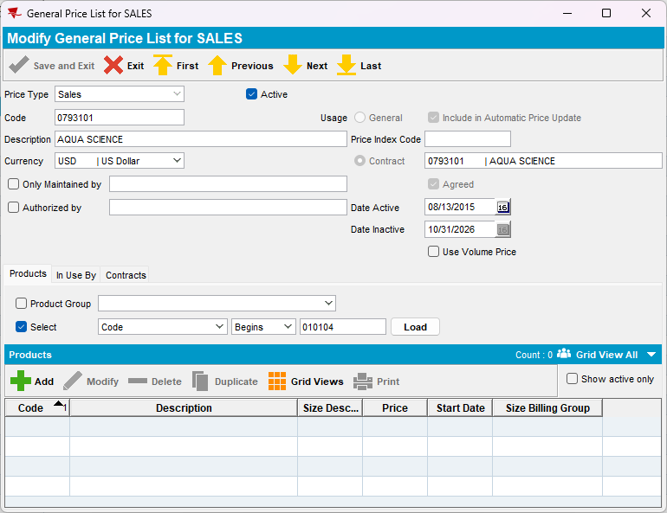
- Product Lists per Customer DLG (Customer Specific Prices)
a. Delete the Sale surcharge price -> error message is shown
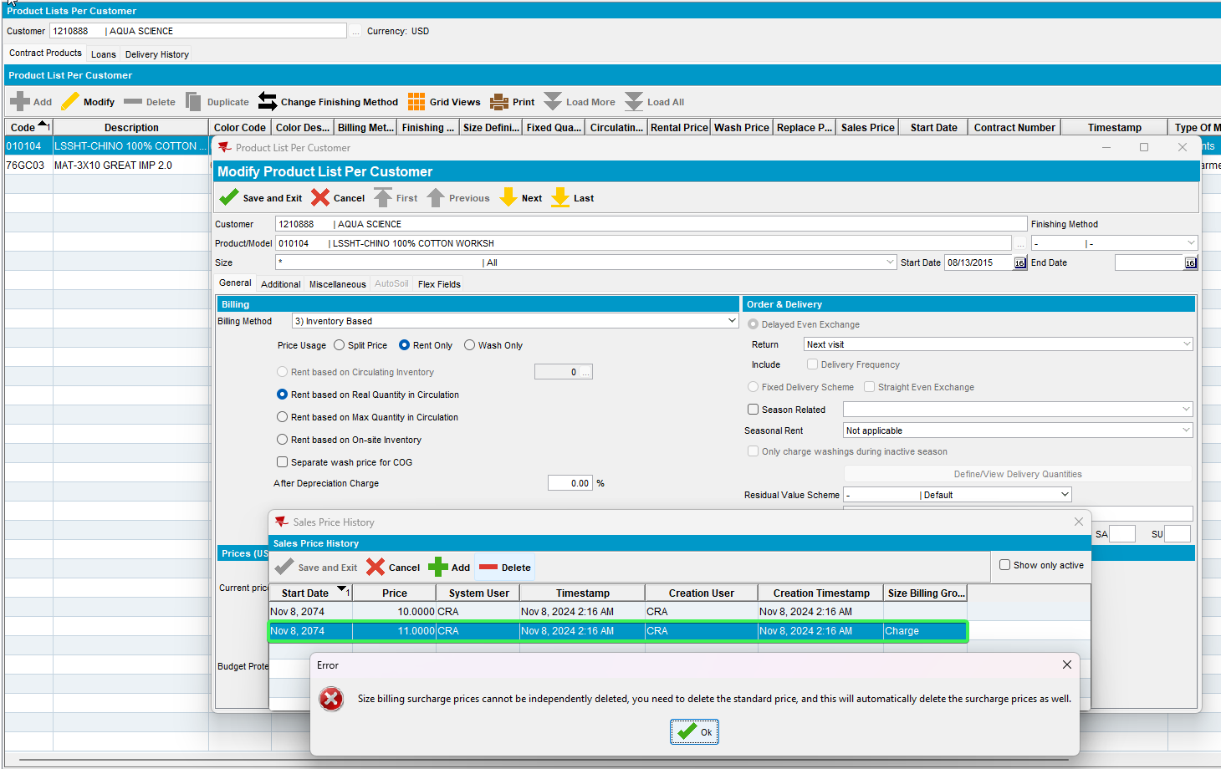
- Delete the Sale price -> deletes both sale and surcharge price
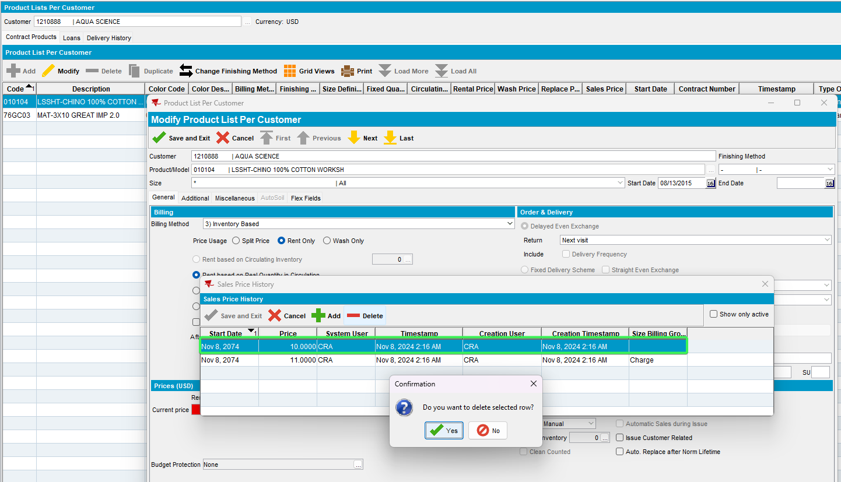
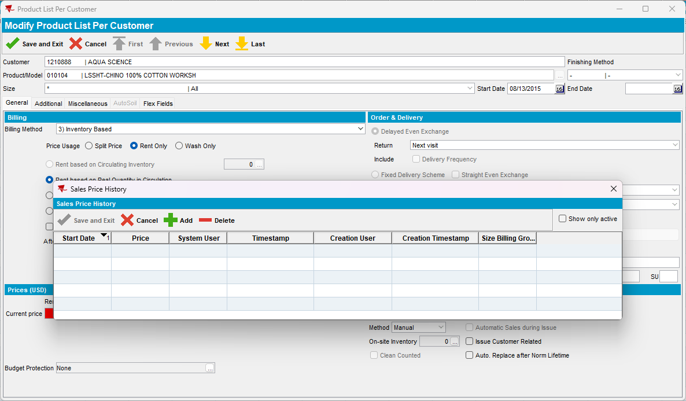
Tested OK

Test Case 5 – PRICECONTROLACCES = 1 & SIZEBILLINGGROUPPRICECTL = 1 & NULL Billing Group for Replace
Hash: 3fa65b8b1696
- Contract DLG
a. Delete the Replace surcharge price -> error message is shown
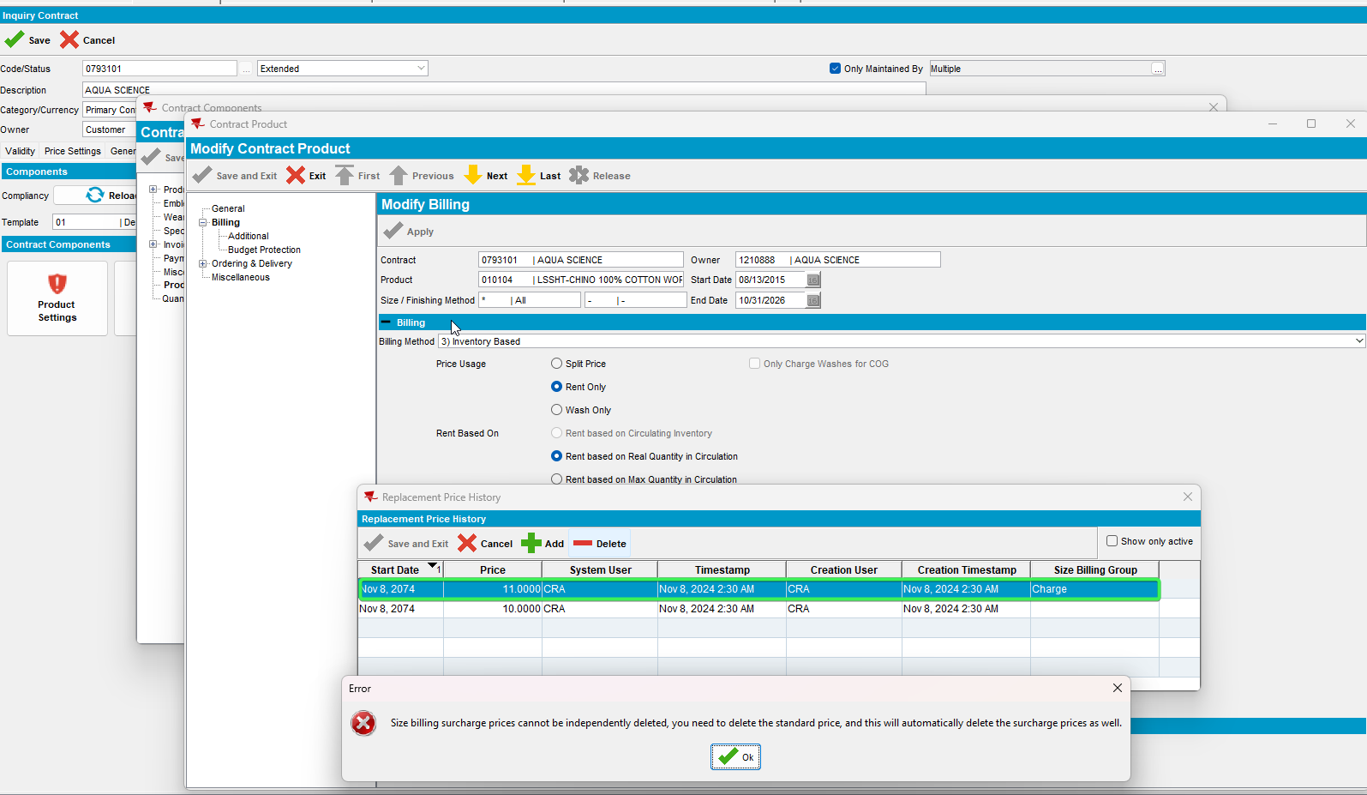
- Delete the Replace price -> deletes both replace and surcharge price
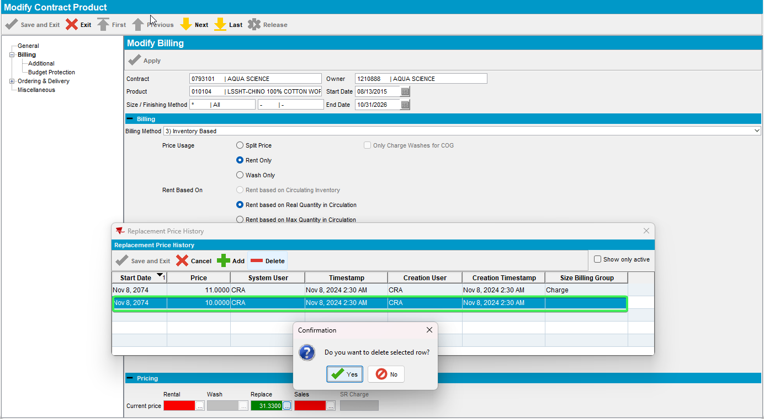
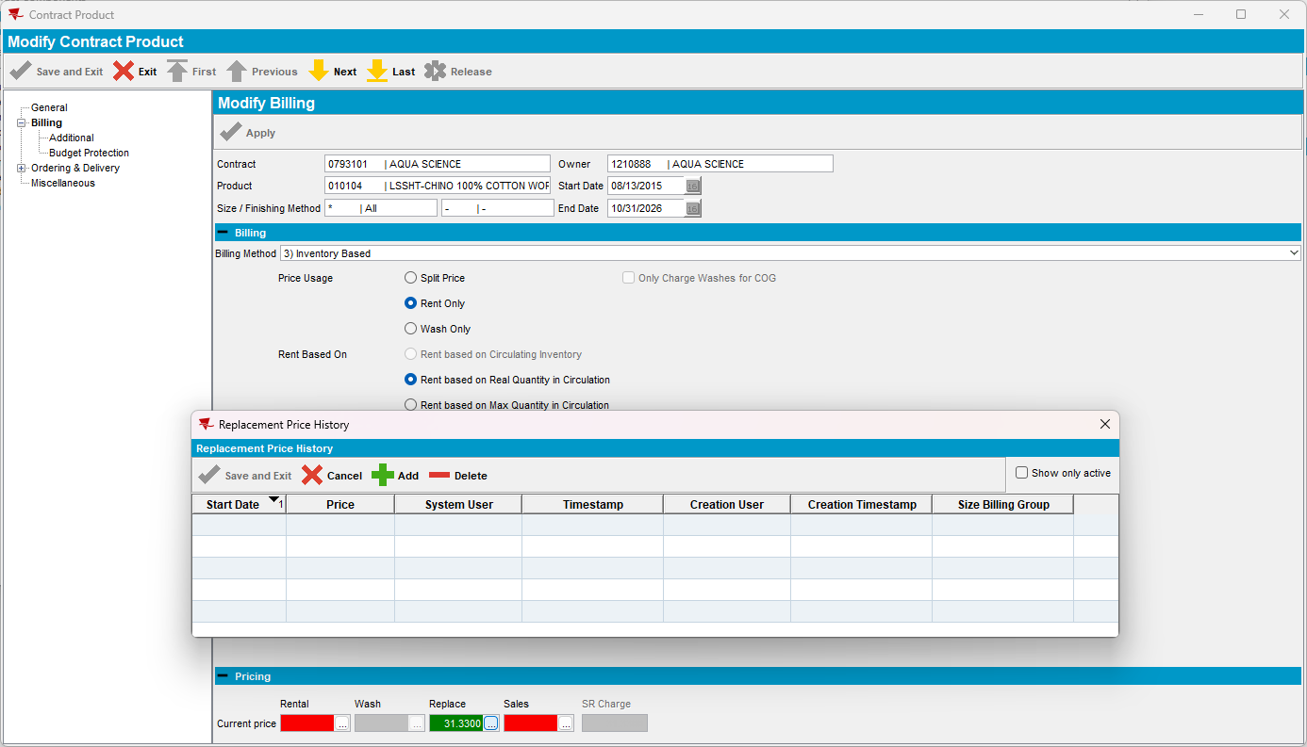
- General Price List DLG

a. Delete the Replace surcharge price -> error message is shown
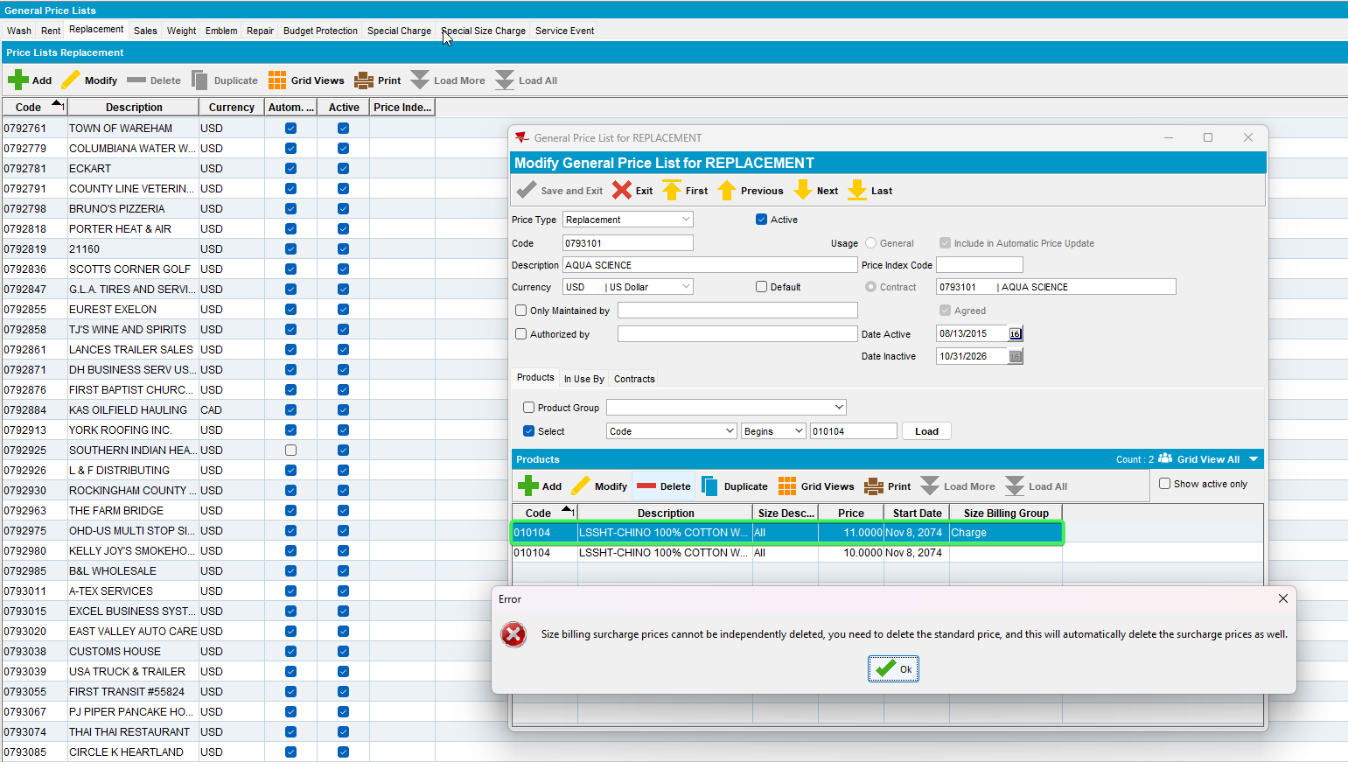
- Delete the Replace price -> deletes both replace and surcharge price
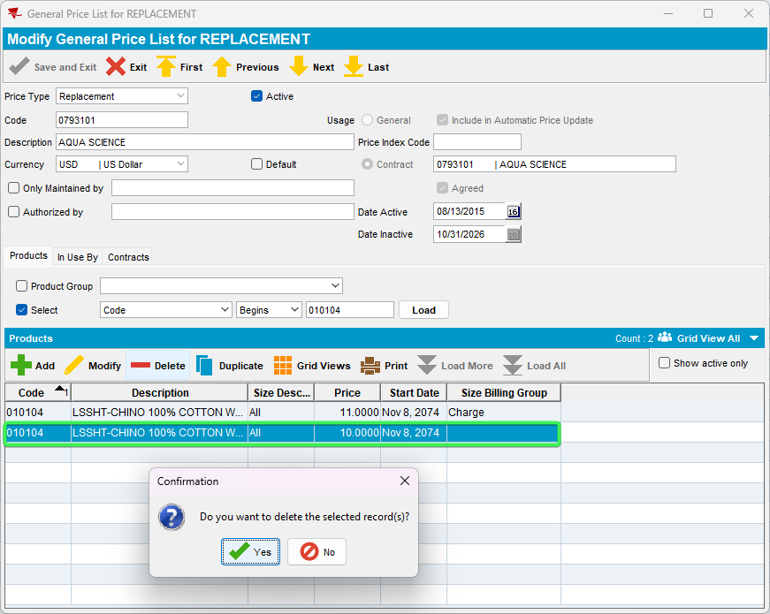
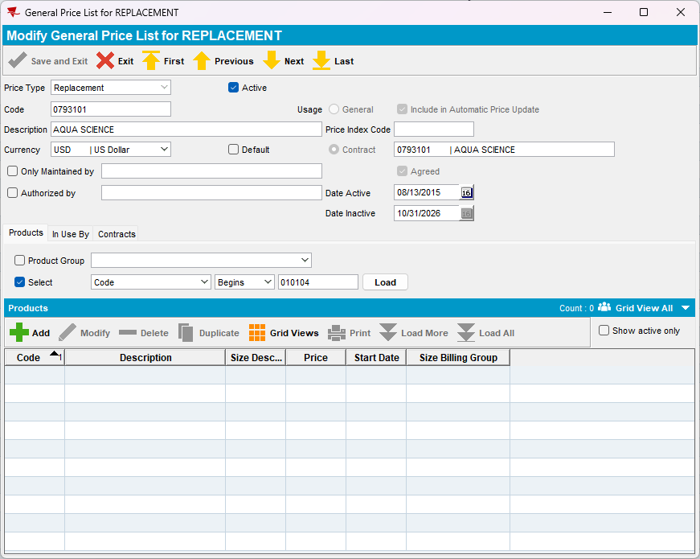
- Product Lists per Customer DLG (Customer Specific Prices)
a. Delete the Replace surcharge price -> error message is shown
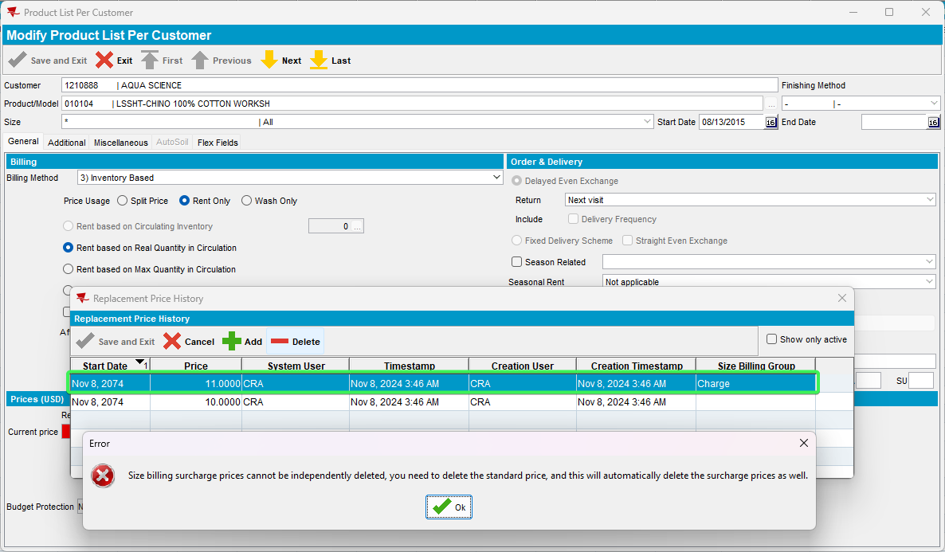
b. Delete the Replace price -> deletes both replace and surcharge price
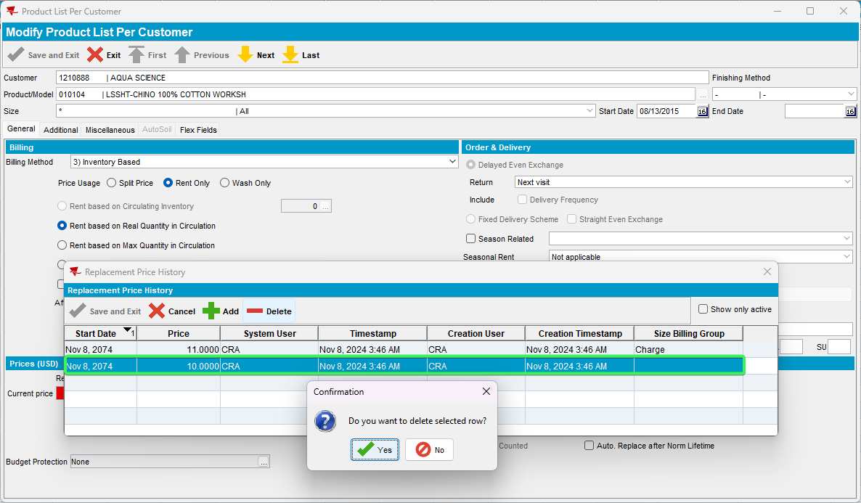
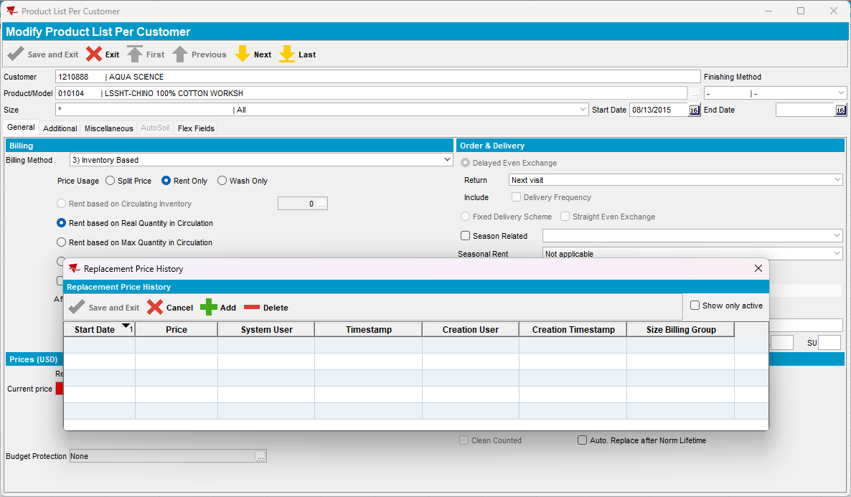
Tested OK

Test Case 6 – PRICECONTROLACCES = 1 & SIZEBILLINGGROUPPRICECTL = 1 & Specific Billing Group for rent
Hash: 3fa65b8b1696
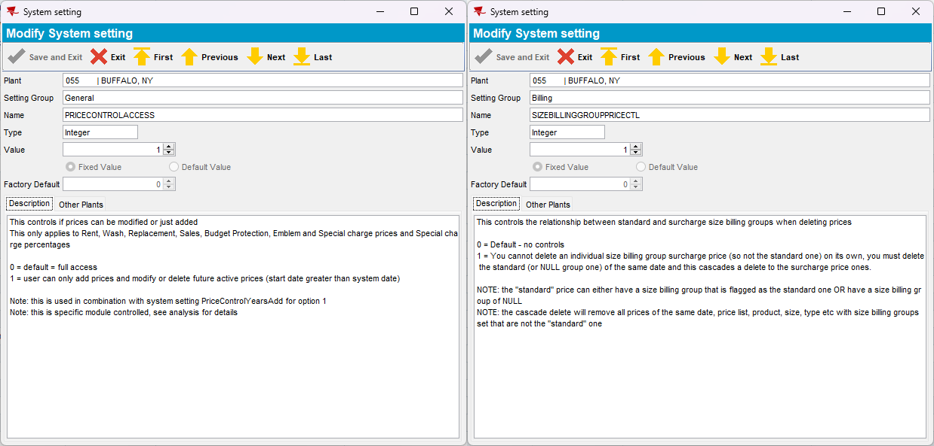
- Contract DLG
a. Delete the Rent surcharge price -> error message is shown
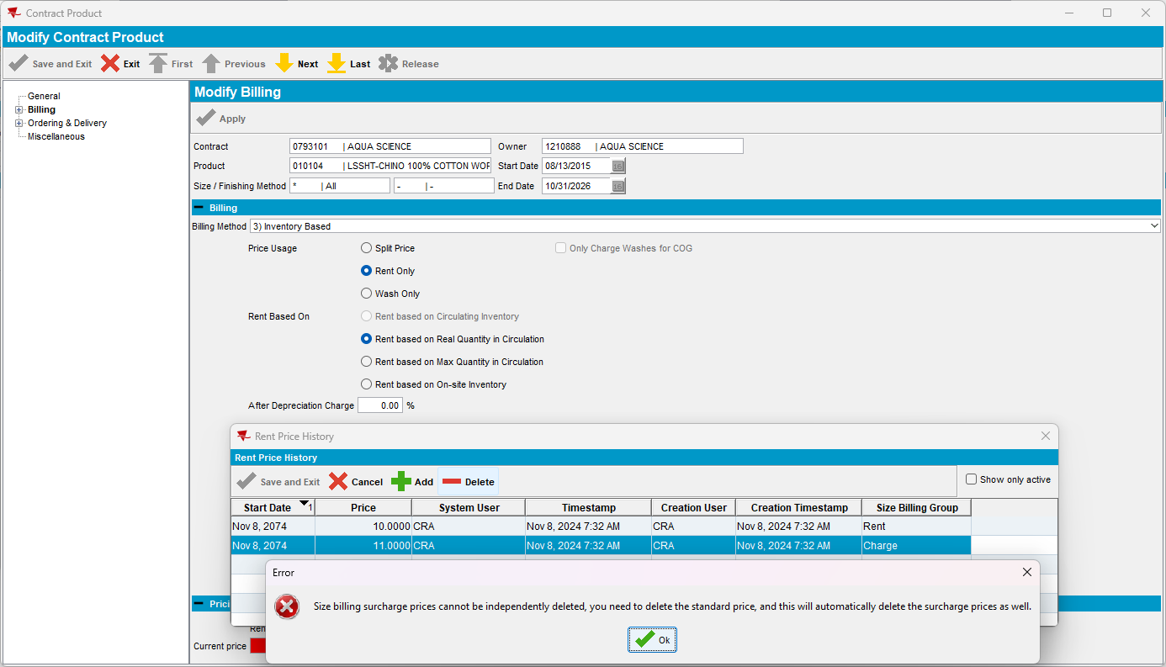
- Delete the rent price -> deletes both rent and surcharge price
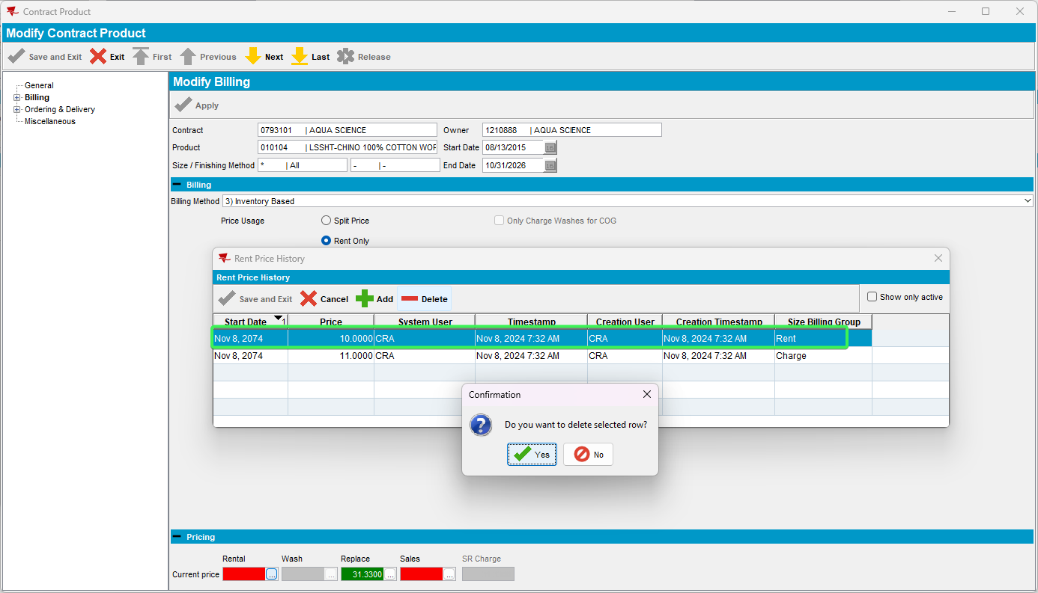
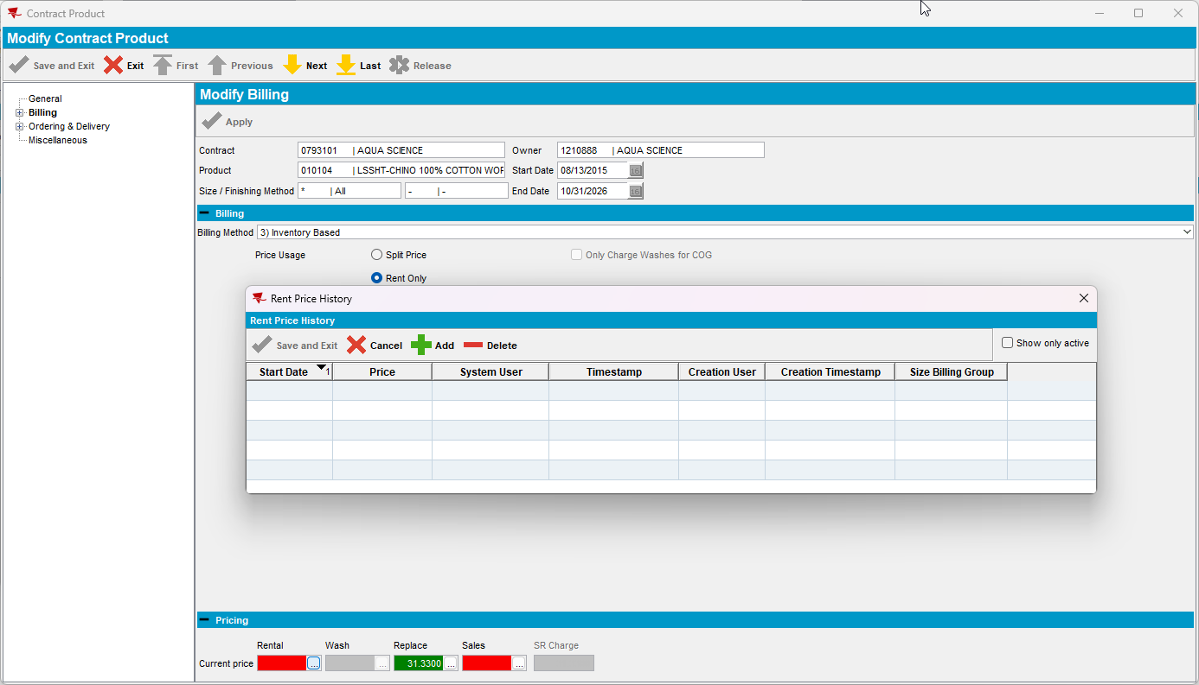
- General Price List DLG
a. Delete the Rent surcharge price -> error message is shown
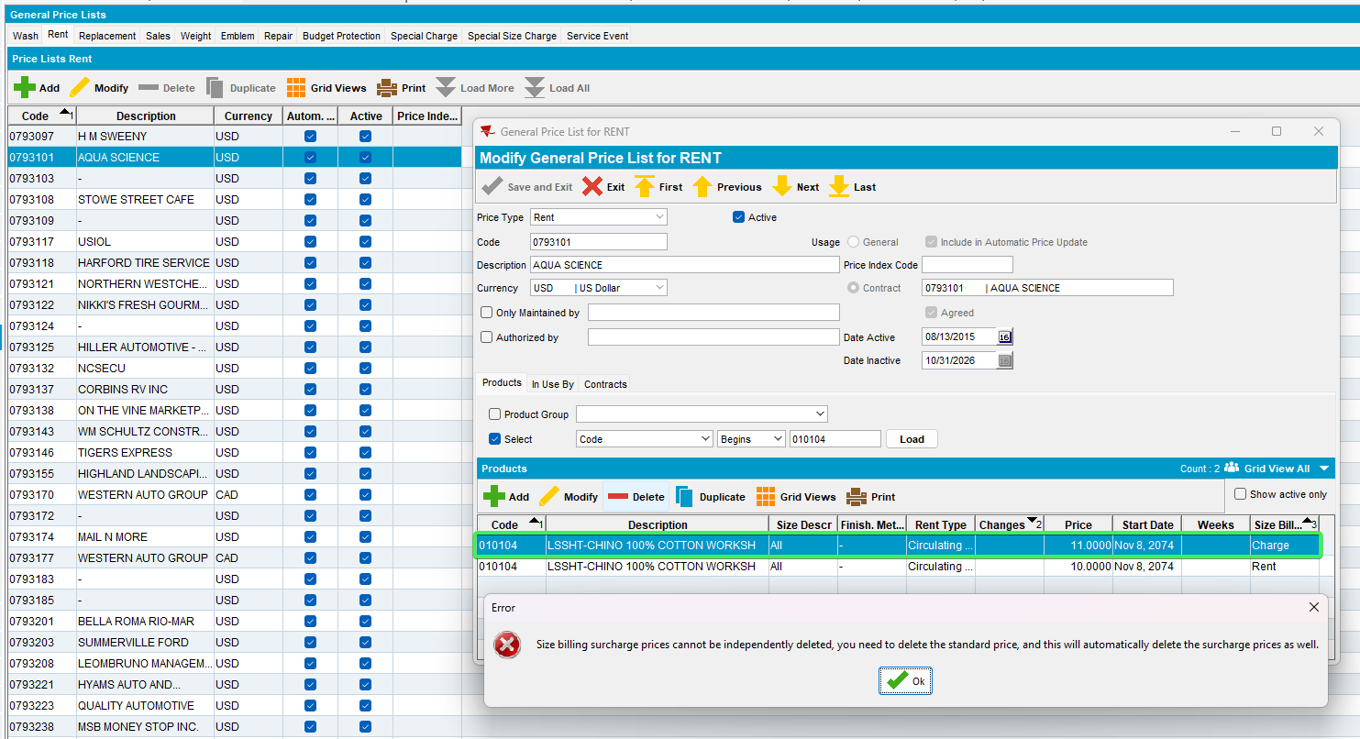
- Delete the rent price -> deletes both rent and surcharge price
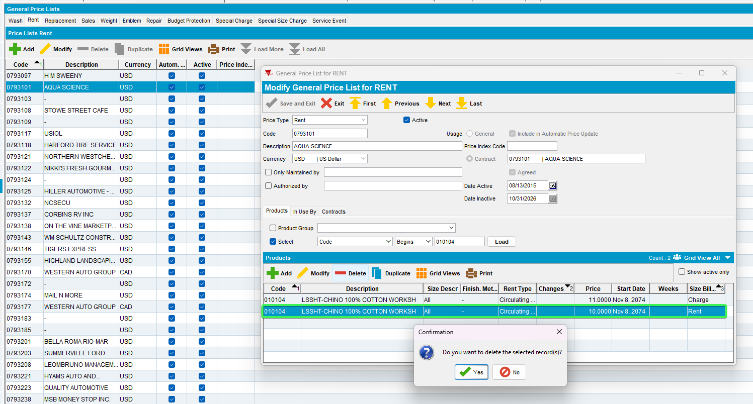
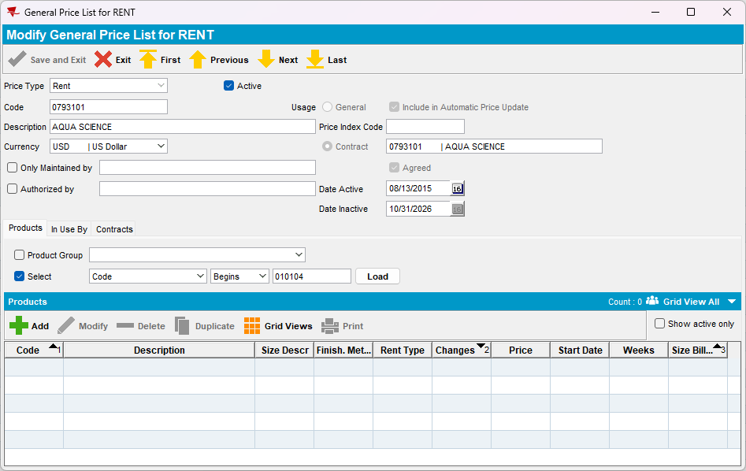
- Product Lists per Customer DLG (Customer Specific Prices)
a. Delete the Rent surcharge price -> error message is shown
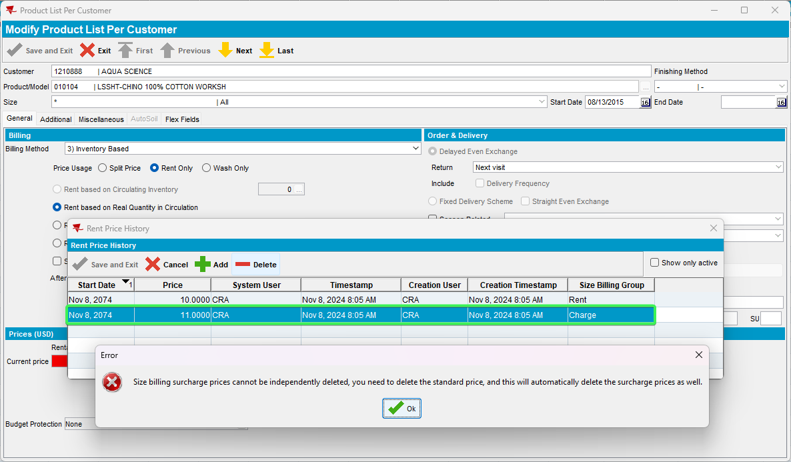
b. Delete the rent price -> deletes both rent and surcharge price
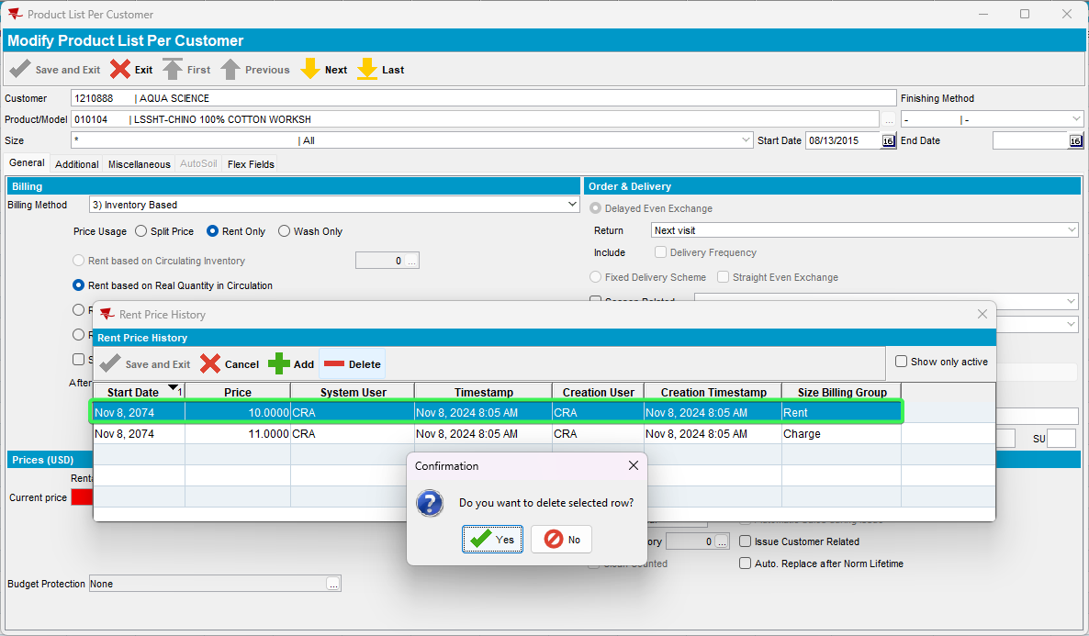
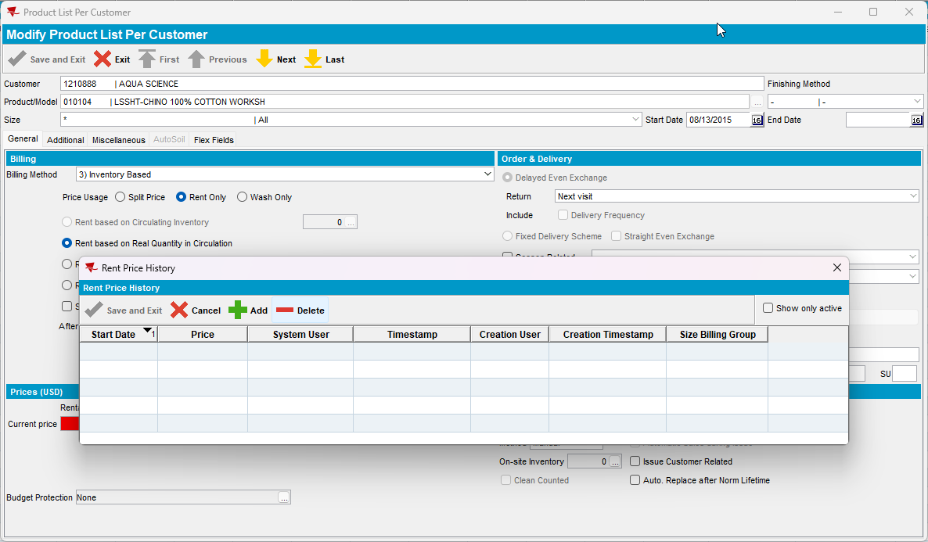
Tested OK

