ABS-167618 The client freezes when trying to credit the first invoice for a customer
Environment | Prerequisites
Version:9.07.00  DBServerName=abs-SRV20.internal.abslbs.com  DBSID=CUST24  DBUser=UNFDEV  DBPassword=UNFDEV  Environment=Test | - Module:  - System setting

Contents
Test after fix 1
Test Case 1 – Credit an invoice for a newly added customer – Tested OK 1

Test after fix

Test Case 1 – Credit an invoice for a newly added customer – Tested OK
Expected behavior: The client should not freeze and the invoice should be credited
Hash: 3fa65b8
- Add a new customer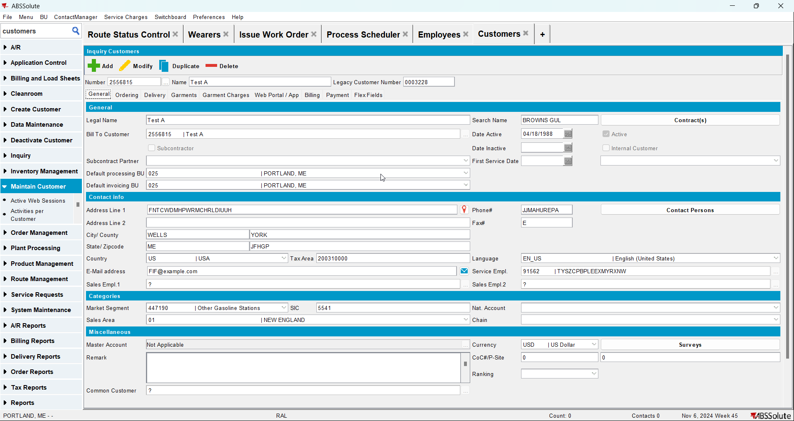
- Add the customer to a contract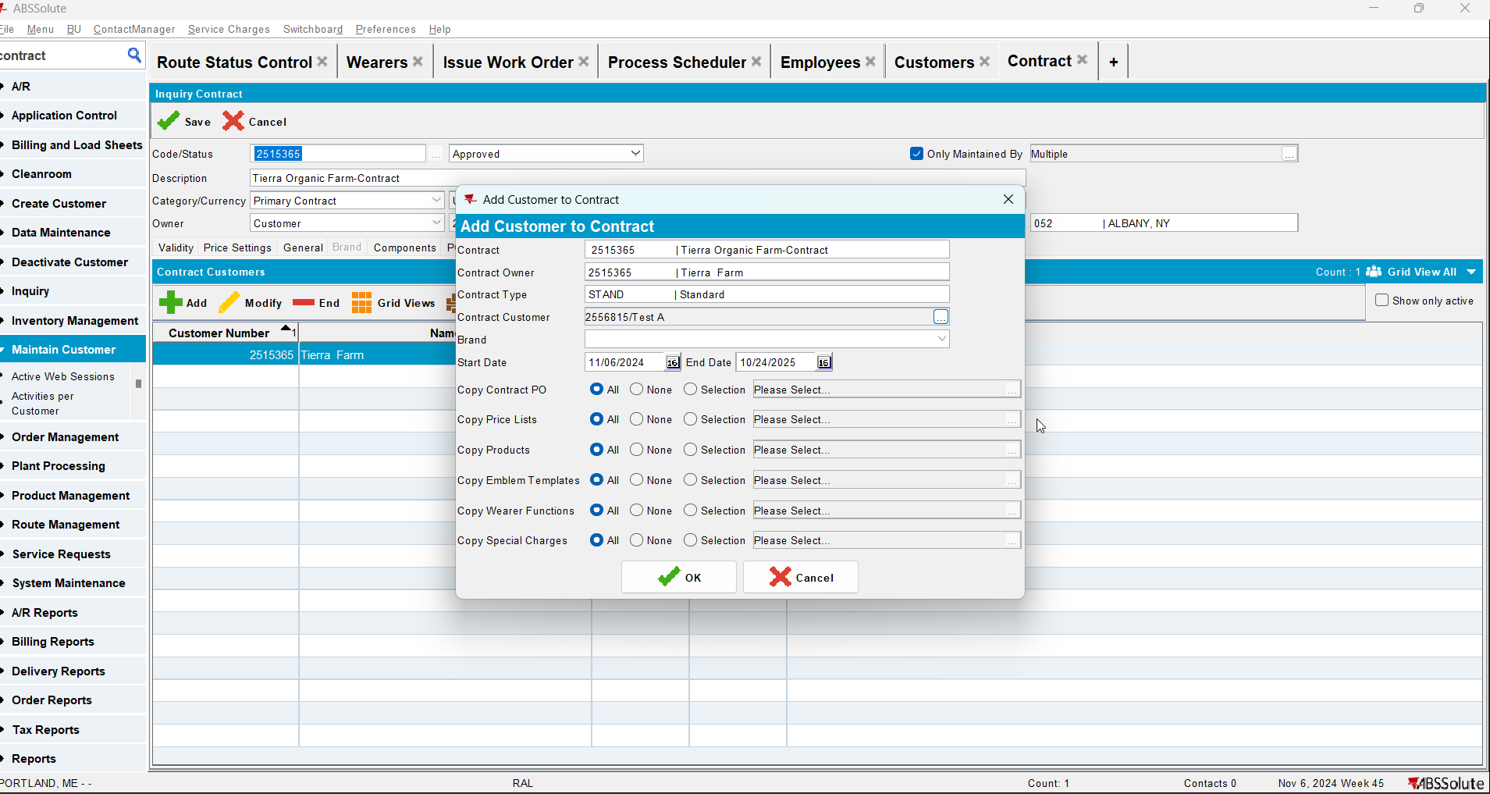
- Go to Banks and Lockers dlg and add lockers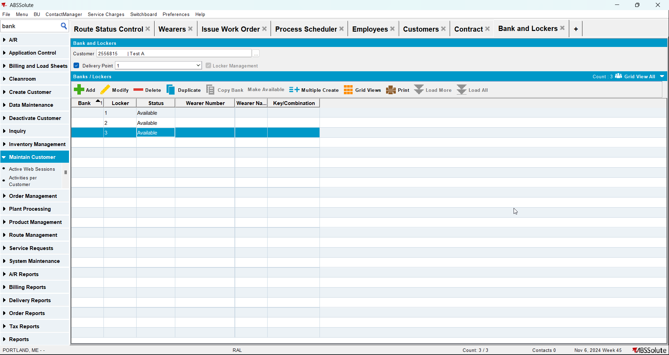
- Add wearers with wearer inventories for that customer. Generate the WO, issue them and generate delivery note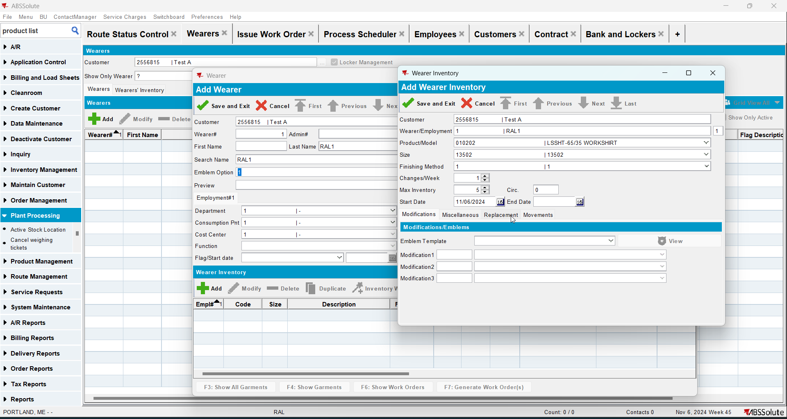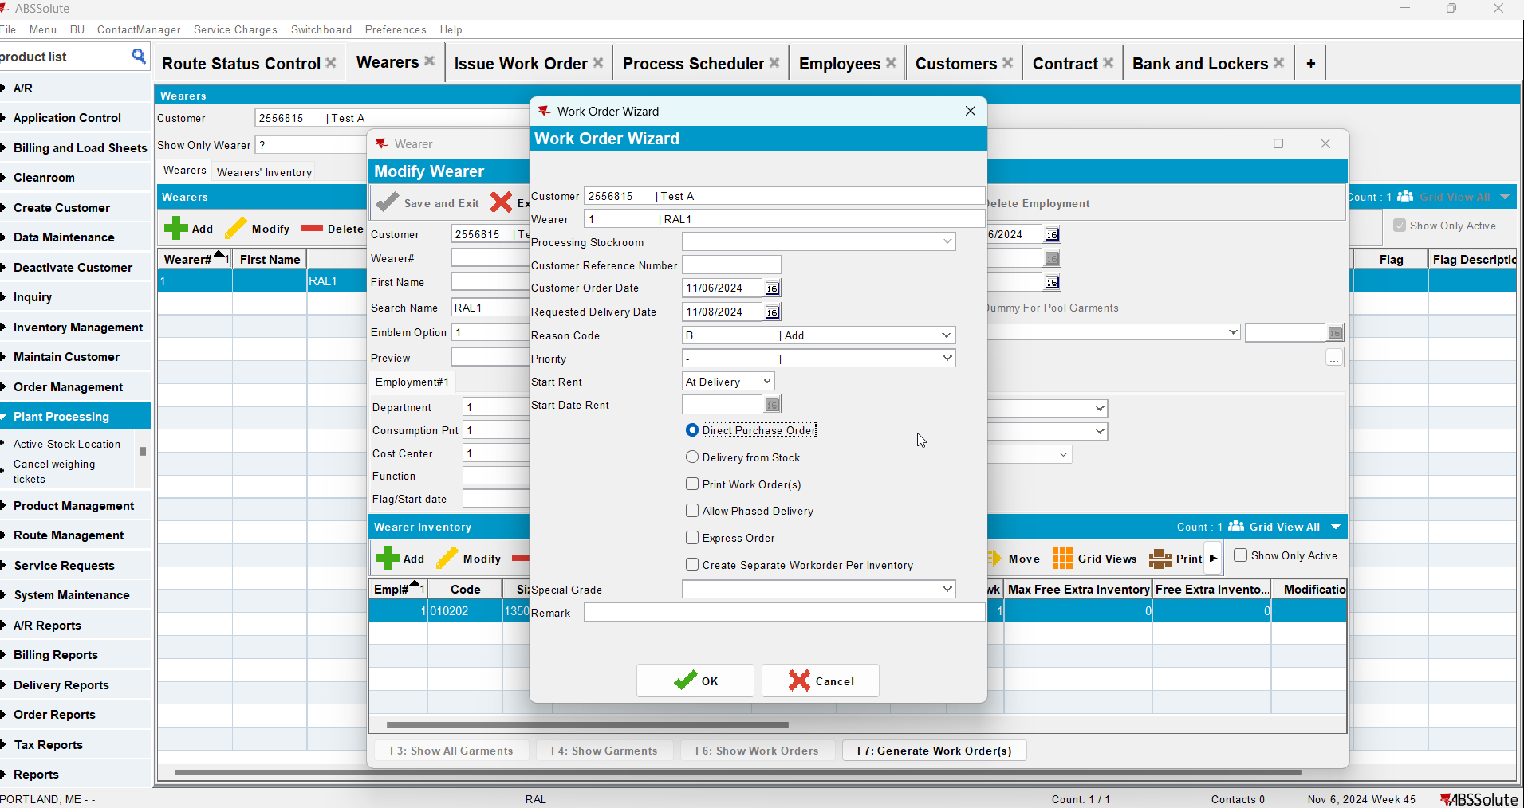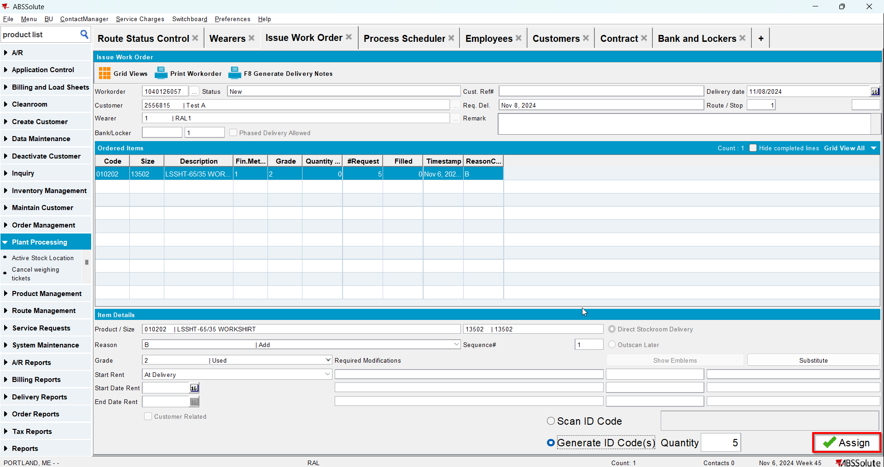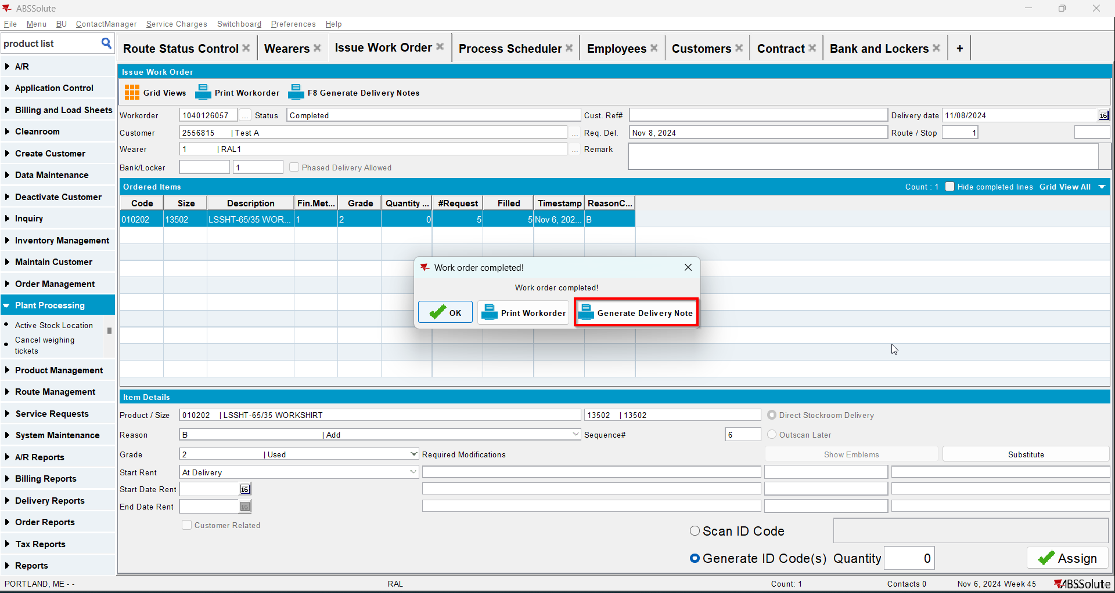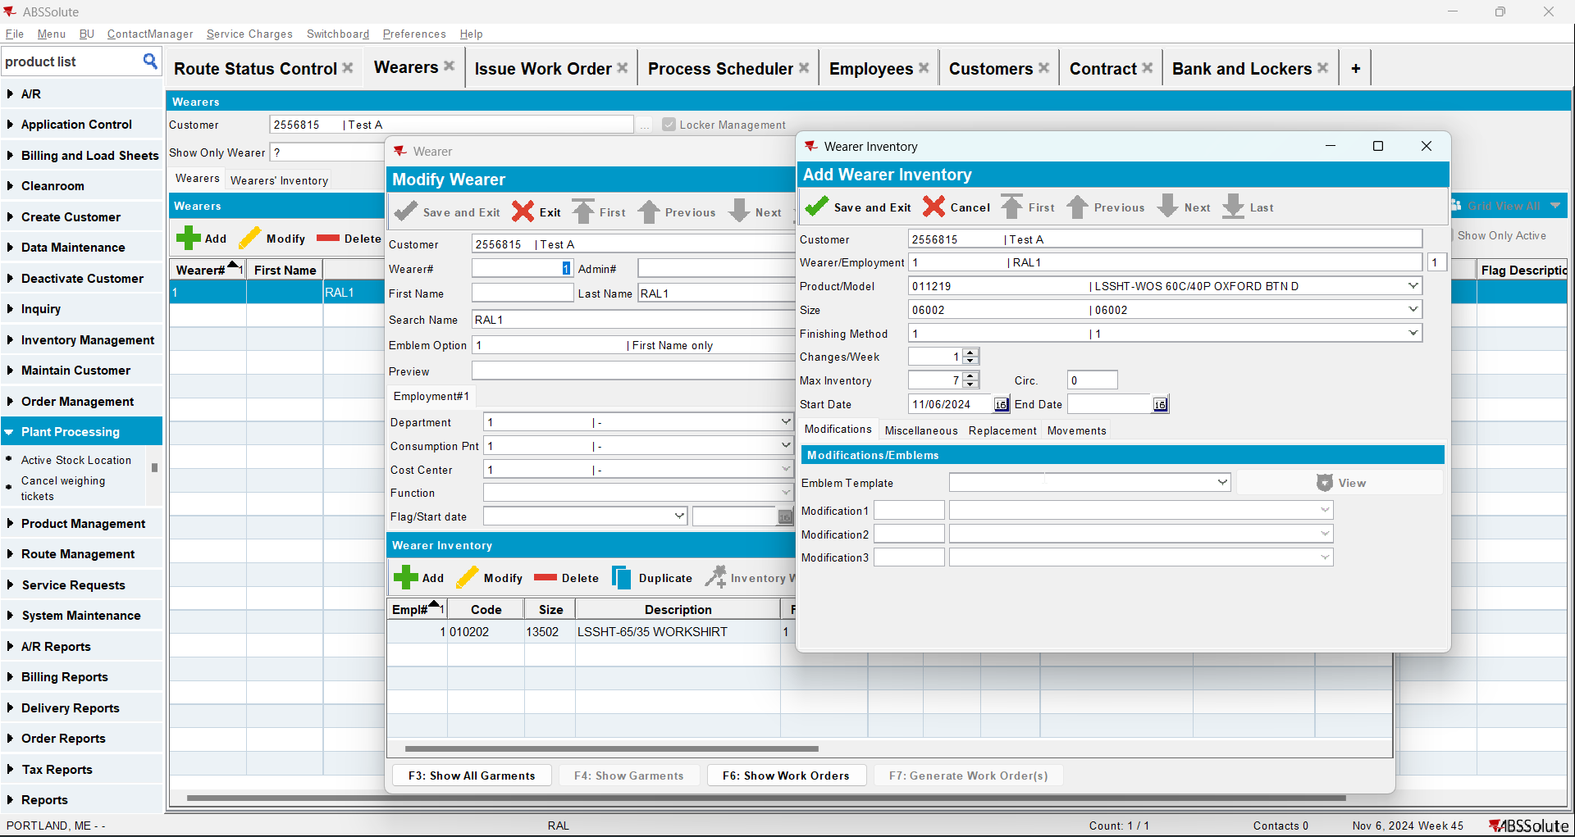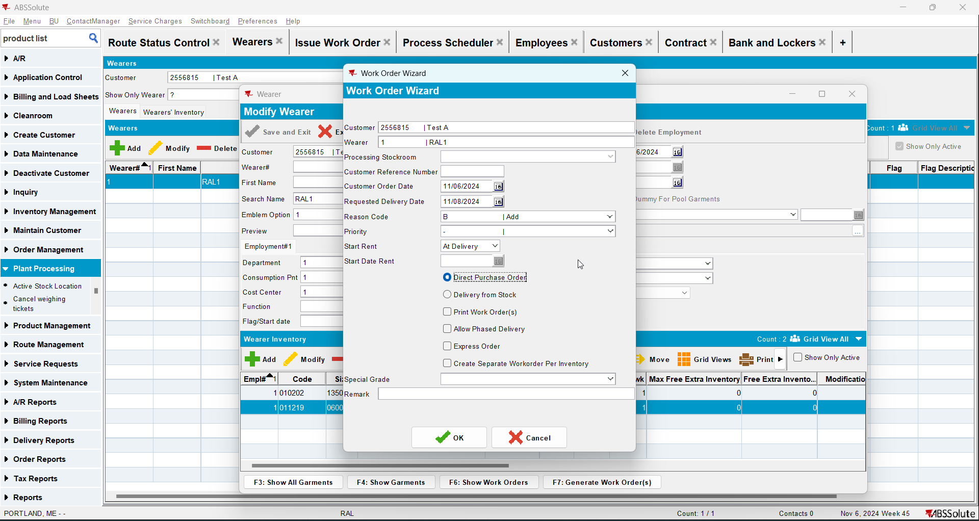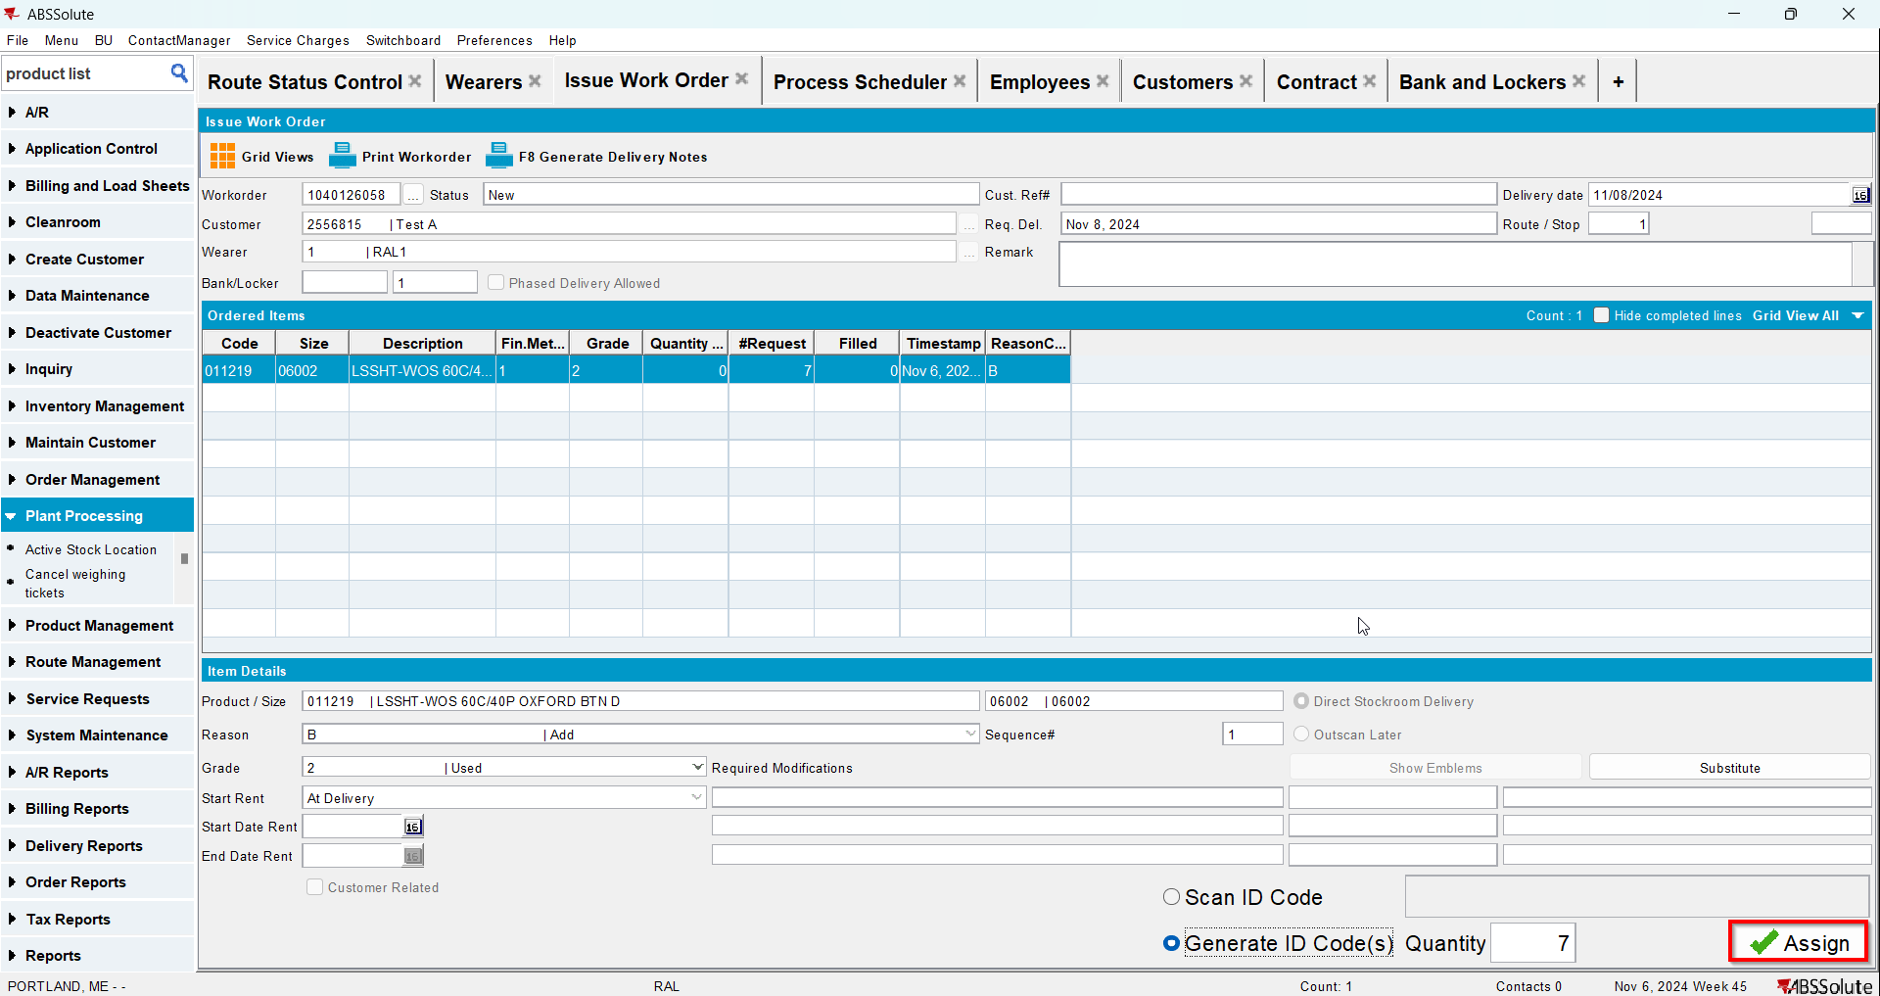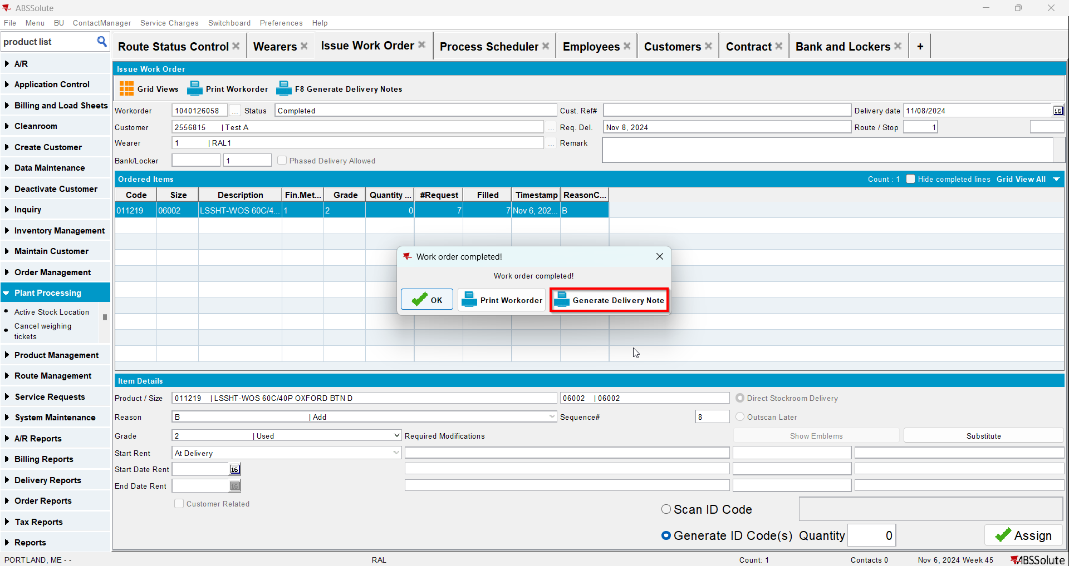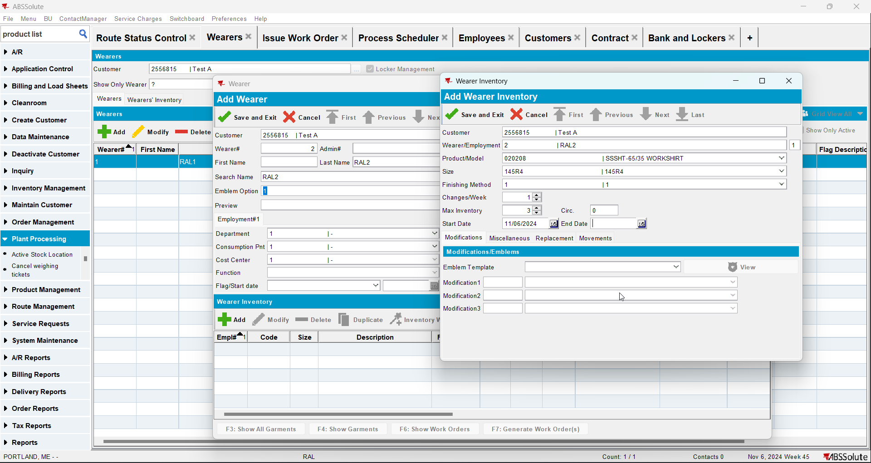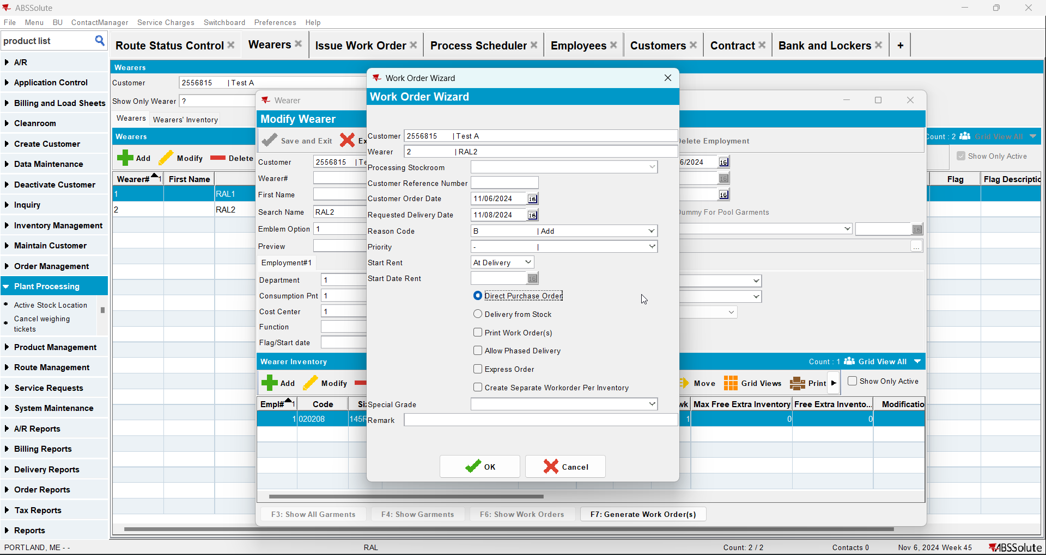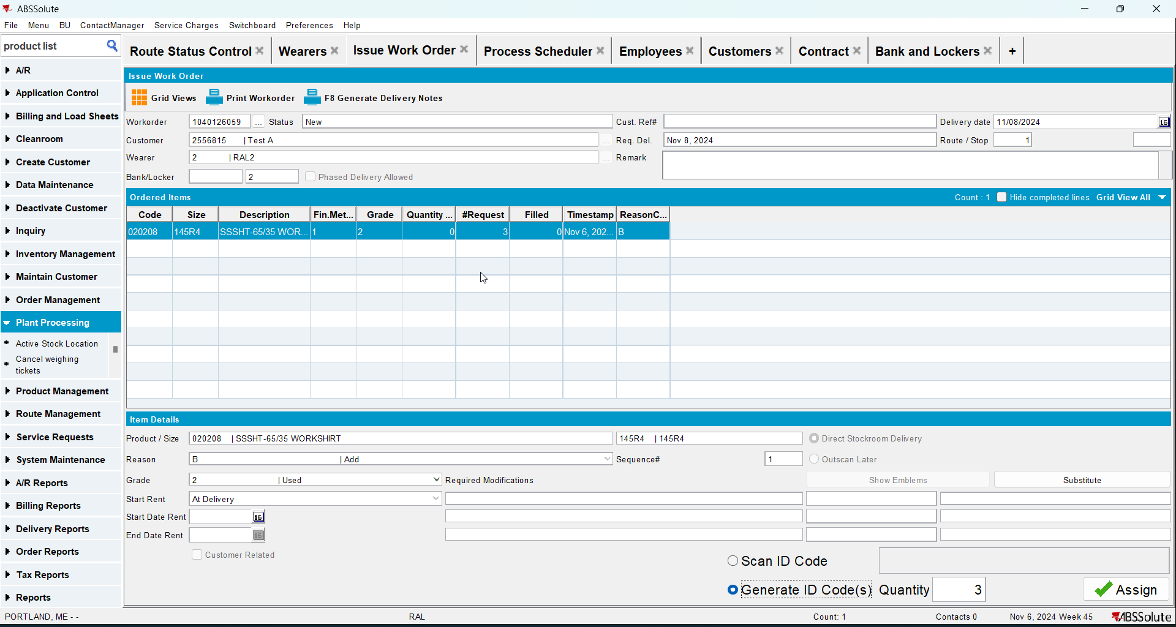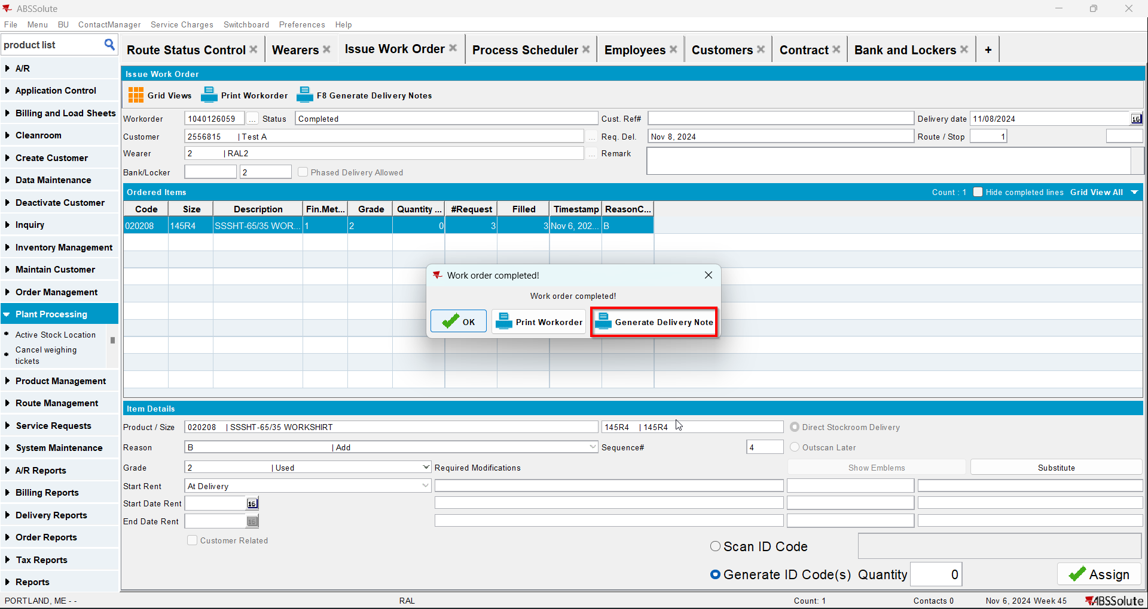
- Generate the invoices from RSC for your customer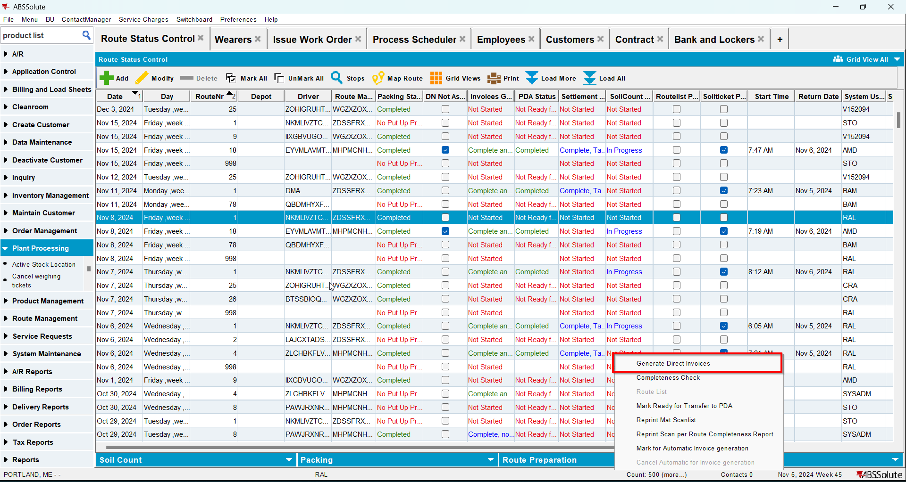
- Settle the route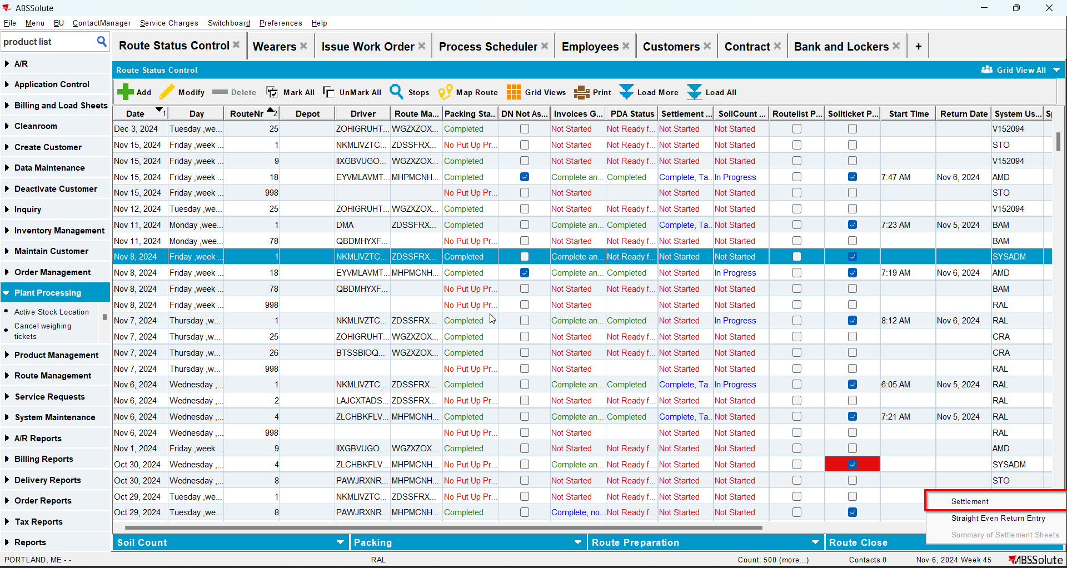
- Go to Maintain Invoices dlg to Customer tab and Settled tab
- Credit the invoice