ABS-167455 Maintain Garment Charges, Garment Sales records for emblems sold on a sales note have status FOC
Environment | Prerequisites
Version: 9.07.00.UNF17  DBServerName= abs-srv20.internal.abslbs.com  DBSID=CUST24  DBUser=UNFDEV  DBPassword=UNFDEV  Environment=Production | - Module:

Contents
Retest after fix 1

Retest after fix
Hash: 80689830f57

- Create a sales note then generate the invoices.
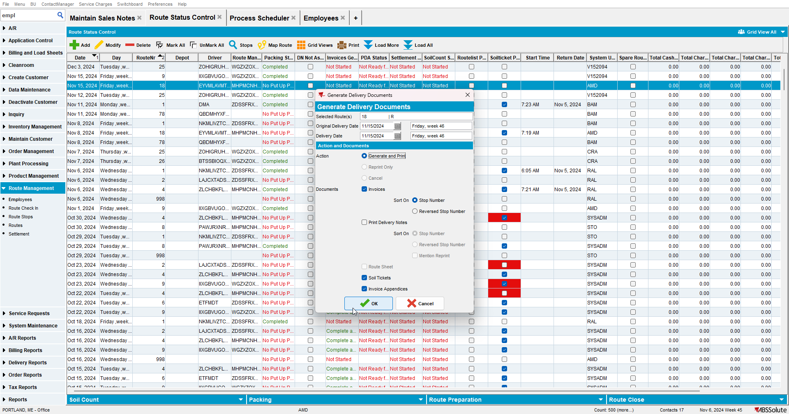

- Upload the route to RA and make some adjustments.
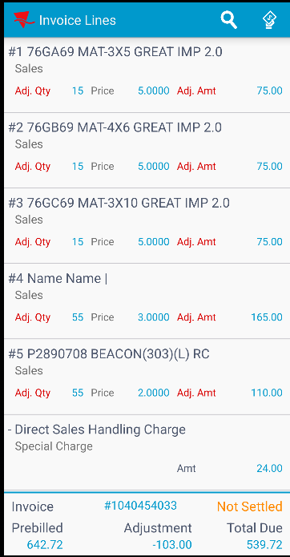

- Settle the route.
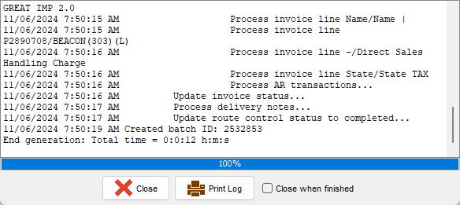
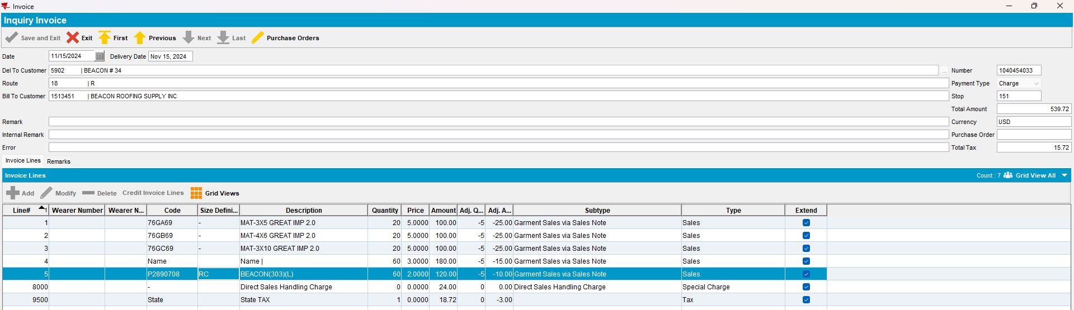

- Check the Maintain Garment Charges dlg.
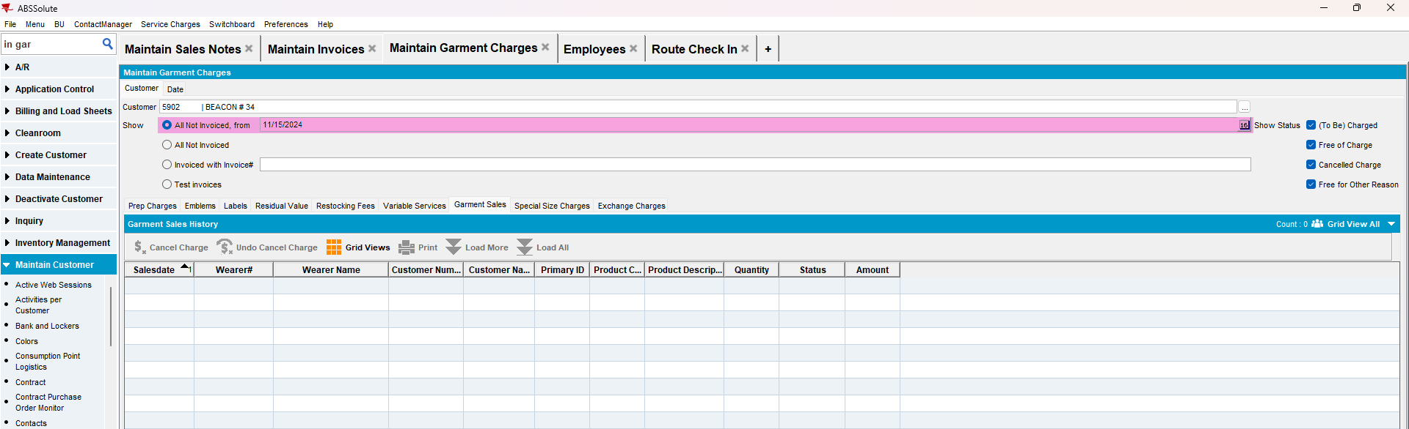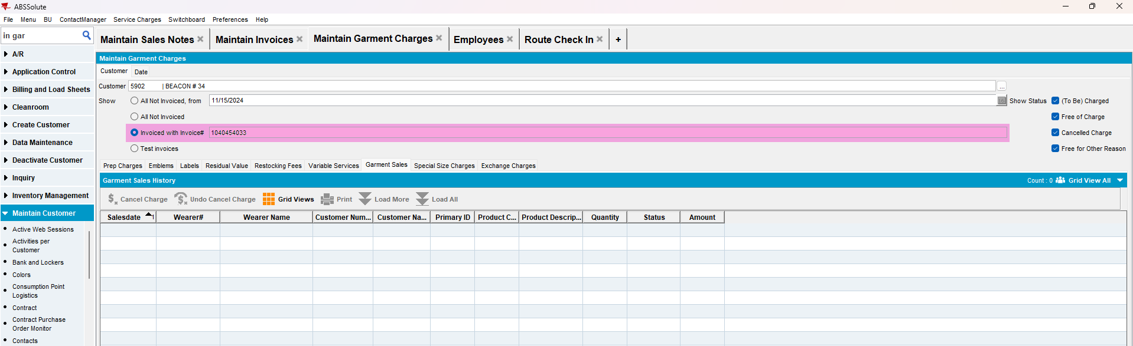
The records for emblems sold on a sales note doesn’t appear in the “Garment Sales” tab in the “Maintain Garment Charges” dlg.
TESTED OK.

