ABS-167385 Error in log after adding a new Plant - java.lang.NullPointerException - at absgroup.bl.session.RestAppServerCache.lambda$getPlantIDsFromBuMap$0
Environment | Prerequisites
Version:9.07.00  DBServerName=abs-SRV20.internal.abslbs.com  DBSID= CUST24  DBUser= UNFDEV  DBPassword= UNFDEV  Environment=Production | - Module:  - System setting

Contents
Reproducing before fix 1
Steps to reproduce 1
Current Behavior 2
Expected behavior 3
Retest after fix 3
Steps to reproduce 3

Reproducing before fix
9.08.02.RC1 hash: 7c765861b101

Steps to reproduce

- Add a new plant in the license file.
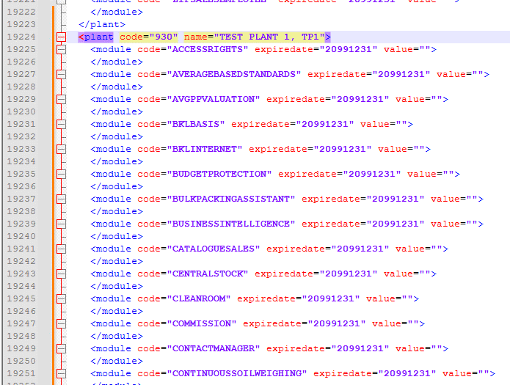
- Start the server with that license.
- Go to Plants dialog and add a new plant.
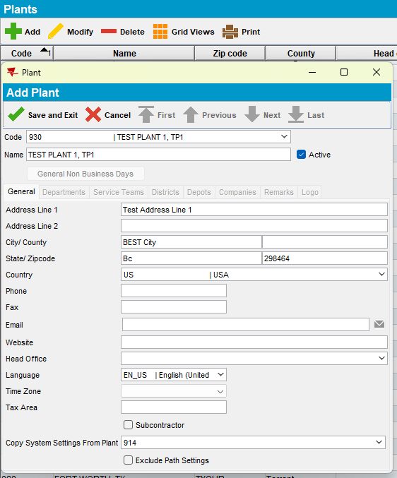
- Go to Business Units dialog and add at least one new business unit on the plant added at step 3.
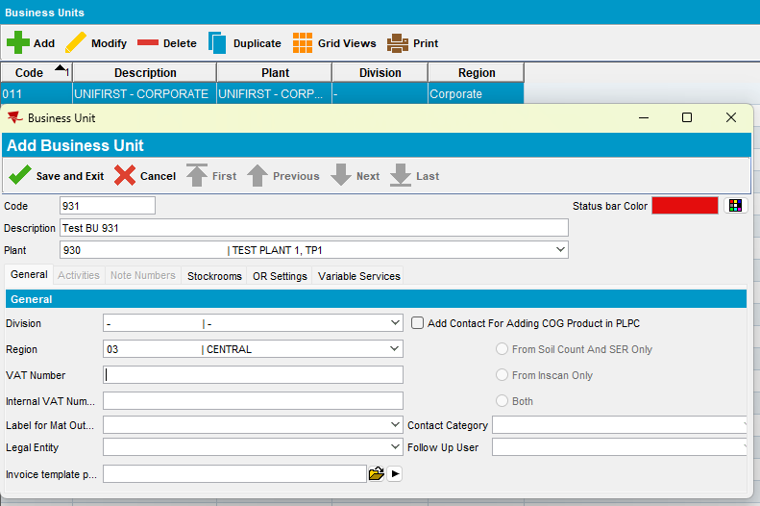

REPRODUCED OK.

Current Behavior
Every 5 minutes there should be a NullPointerException as seen in the description of the ticket. This is visible only in the ServerErrorLog file.
2024-08-28 10:18:07.682 *----> ABSSolute exception occurred <----*
When: Wed Aug 28 10:18:07 EDT 2024
User: system
Error message: An unexpected exception occurred.
Additional error message: Cannot invoke "absgroup.bl.plant.Plant.getID()" because the return value of "absgroup.bl.plant.BusinessUnit.getPlant()" is null
Stack trace: java.lang.NullPointerException: Cannot invoke "absgroup.bl.plant.Plant.getID()" because the return value of "absgroup.bl.plant.BusinessUnit.getPlant()" is null
at absgroup.bl.session.RestAppServerCache.lambda$getPlantIDsFromBuMap$0(RestAppServerCache.java:69)
at java.base/java.util.stream.ReferencePipeline$3$1.accept(Unknown Source)
at java.base/java.util.stream.ReferencePipeline$3$1.accept(Unknown Source)
at java.base/java.util.concurrent.ConcurrentHashMap$EntrySpliterator.forEachRemaining(Unknown Source)
at java.base/java.util.stream.AbstractPipeline.copyInto(Unknown Source)
at java.base/java.util.stream.AbstractPipeline.wrapAndCopyInto(Unknown Source)
at java.base/java.util.stream.ReduceOps$ReduceOp.evaluateSequential(Unknown Source)
at java.base/java.util.stream.AbstractPipeline.evaluate(Unknown Source)
at java.base/java.util.stream.ReferencePipeline.collect(Unknown Source)
at absgroup.bl.session.RestAppServerCache.getPlantIDsFromBuMap(RestAppServerCache.java:69)
at absgroup.bl.session.RestAppServerCache.setPlantsFromBusinessUnitMap(RestAppServerCache.java:123)
at java.base/jdk.internal.reflect.NativeMethodAccessorImpl.invoke0(Native Method)
at java.base/jdk.internal.reflect.NativeMethodAccessorImpl.invoke(Unknown Source)
at java.base/jdk.internal.reflect.DelegatingMethodAccessorImpl.invoke(Unknown Source)
at java.base/java.lang.reflect.Method.invoke(Unknown Source)
at org.springframework.aop.support.AopUtils.invokeJoinpointUsingReflection(AopUtils.java:343)
at org.springframework.aop.framework.ReflectiveMethodInvocation.invokeJoinpoint(ReflectiveMethodInvocation.java:196)
at org.springframework.aop.framework.ReflectiveMethodInvocation.proceed(ReflectiveMethodInvocation.java:163)
at org.springframework.aop.framework.CglibAopProxy$CglibMethodInvocation.proceed(CglibAopProxy.java:751)
at org.springframework.aop.framework.ReflectiveMethodInvocation.proceed(ReflectiveMethodInvocation.java:178)
at org.springframework.aop.framework.CglibAopProxy$CglibMethodInvocation.proceed(CglibAopProxy.java:751)
at org.springframework.aop.framework.CglibAopProxy$DynamicAdvisedInterceptor.intercept(CglibAopProxy.java:703)
at absgroup.bl.session.RestAppServerCache$$SpringCGLIB$$0.setPlantsFromBusinessUnitMap(<generated>)
at absgroup.bl.session.ServerScheduledActions.buildPlantList(ServerScheduledActions.java:224)
at absgroup.bl.session.ServerScheduledActions.refreshServerCacheFromDatabase(ServerScheduledActions.java:393)
at absgroup.bl.session.ServerScheduledActions$TaskUpdateServerCache.updateServerCacheAndProcess(ServerScheduledActions.java:333)
at absgroup.bl.session.ServerScheduledActions$TaskUpdateServerCache.run(ServerScheduledActions.java:303)
at java.base/java.util.concurrent.Executors$RunnableAdapter.call(Unknown Source)
at java.base/java.util.concurrent.FutureTask.runAndReset(Unknown Source)
at java.base/java.util.concurrent.ScheduledThreadPoolExecutor$ScheduledFutureTask.run(Unknown Source)
at java.base/java.util.concurrent.ThreadPoolExecutor.runWorker(Unknown Source)
at java.base/java.util.concurrent.ThreadPoolExecutor$Worker.run(Unknown Source)
at java.base/java.lang.Thread.run(Unknown Source)

Expected behavior
No errors in log.

Retest after fix
Hash: 9.07.00 hash: 413ad78

Steps to reproduce
- Add a new plant in the license file.
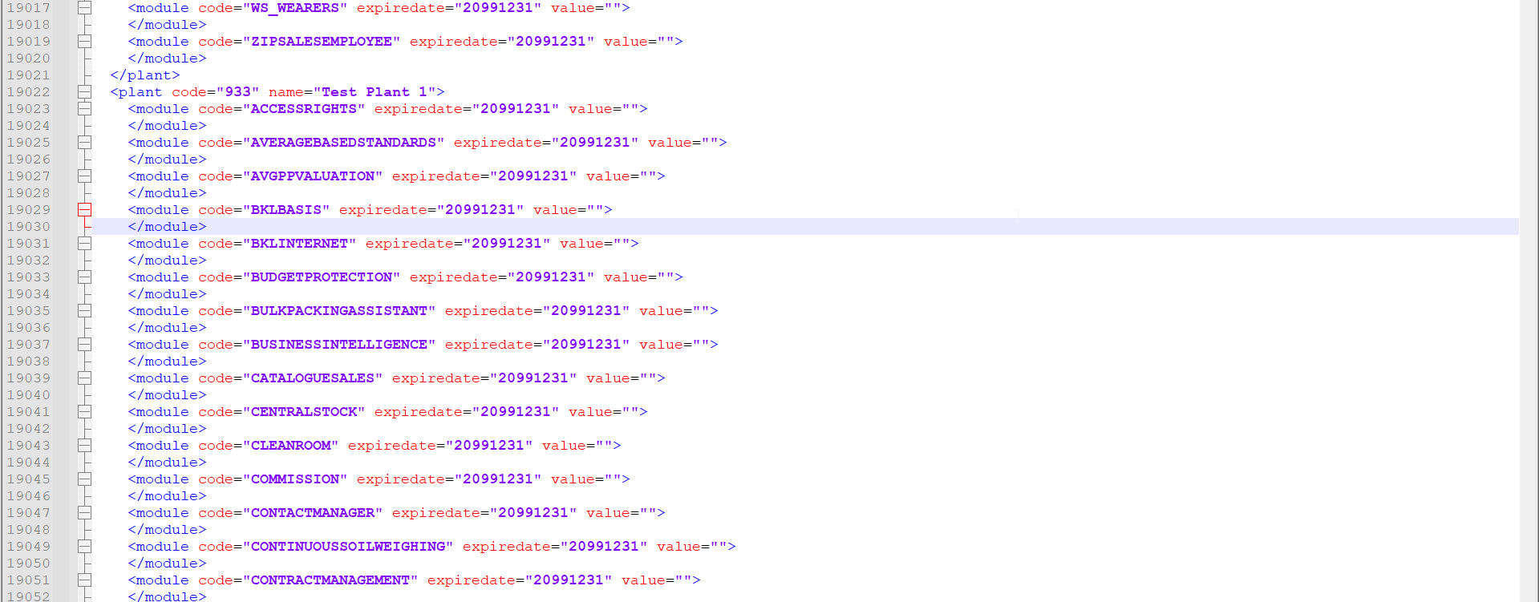
- Start the server with that license.
- Go to Plants dialog and add a new plant.
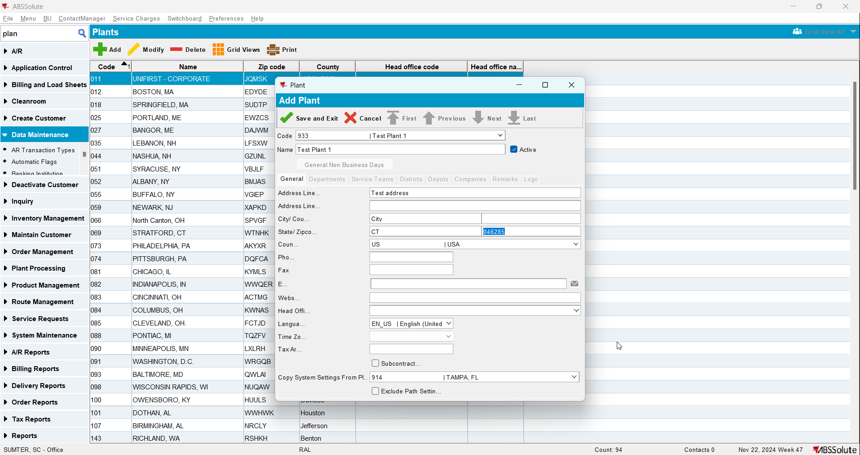
- Go to Business Units dialog and add at least one new business unit on the plant added at step 3.
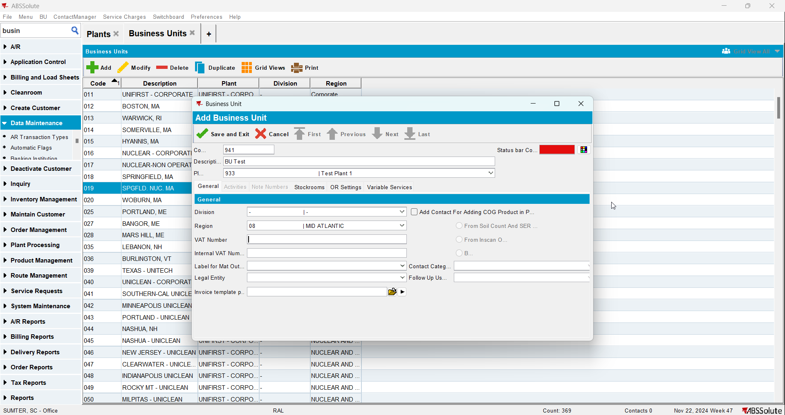
- Wait for at least 5 minutes. Check the ServerError.Log file
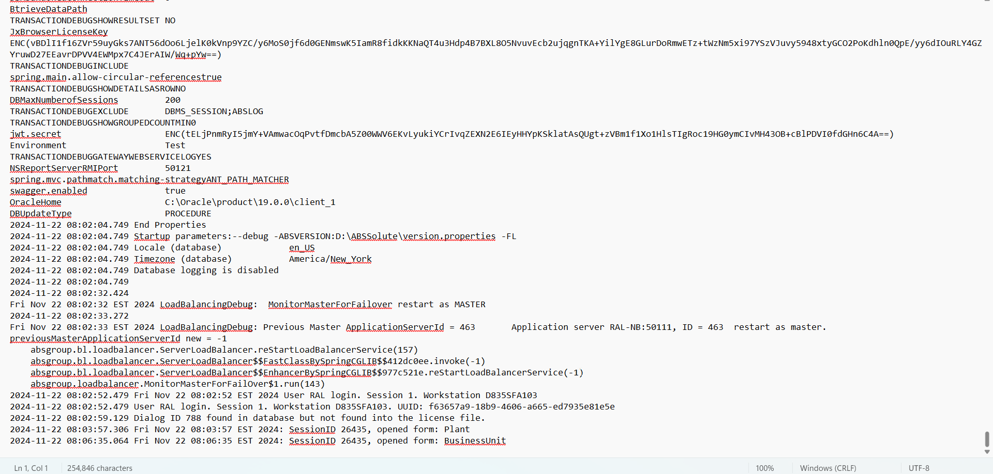
Tested OK
No errors in log.

