ABS-167334 Restocking fee per wearer on invoice – Rework 2
Environment | Prerequisites
Version: 9.07.00  DBServerName= abs-srv20.internal.abslbs.com  DBSID=CUST24  DBUser=UNFDEV  DBPassword=UNFDEV  Environment=Production | - Module:

Contents
Test Case 1 – Check if the Price and the Amount appears in Maintain Garment Charges dialog 1

Test Case 1 – Check if the Price and the Amount appears in Maintain Garment Charges dialog
Hash: 80689830f57
Test Steps:
- Find or create a customer
- Make sure the customer has a price for Restocking Fee set at 5$
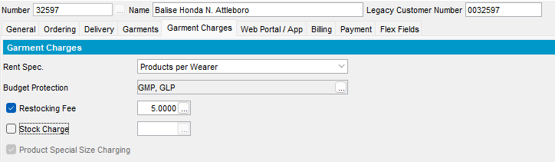

- Wearers DLG: Find at least 3 unique garments from 3 different wearers
- Take Items out of Circulations DLG: Return 2 garment to stock for Wearer 1 – Wearer Inventory 1 – use a Reason Code that has “Charging Restocking Fee” checkbox checked
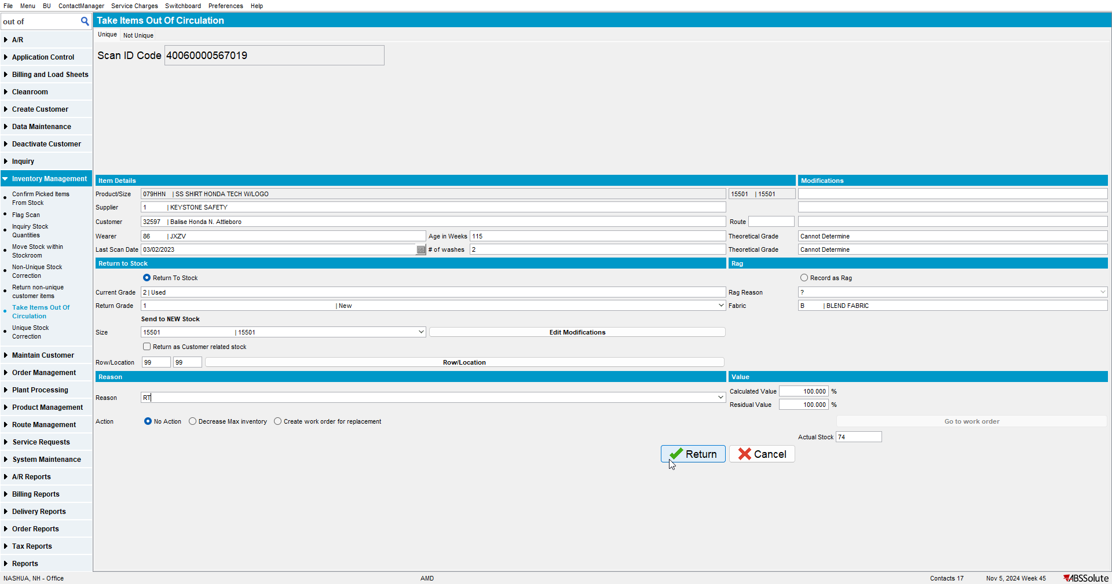
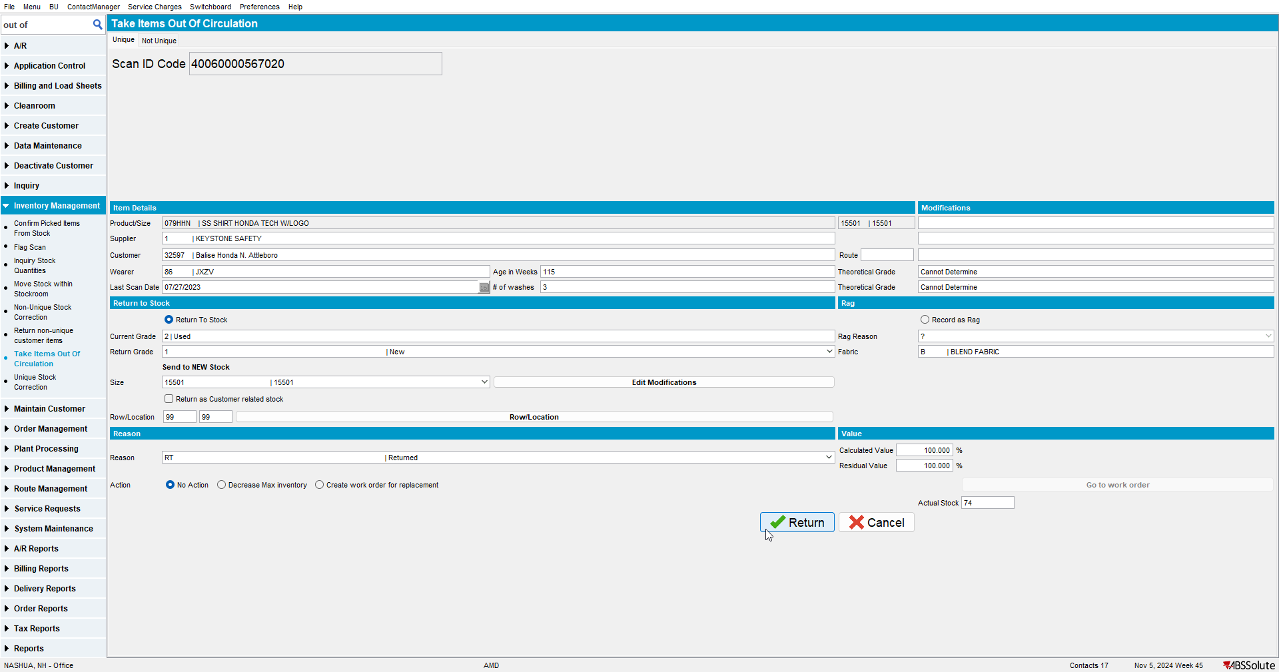

- Take Items out of Circulations DLG: Return 2 garments to stock for Wearer 2 – use a Reason Code that has “Charging Restocking Fee” checkbox checked
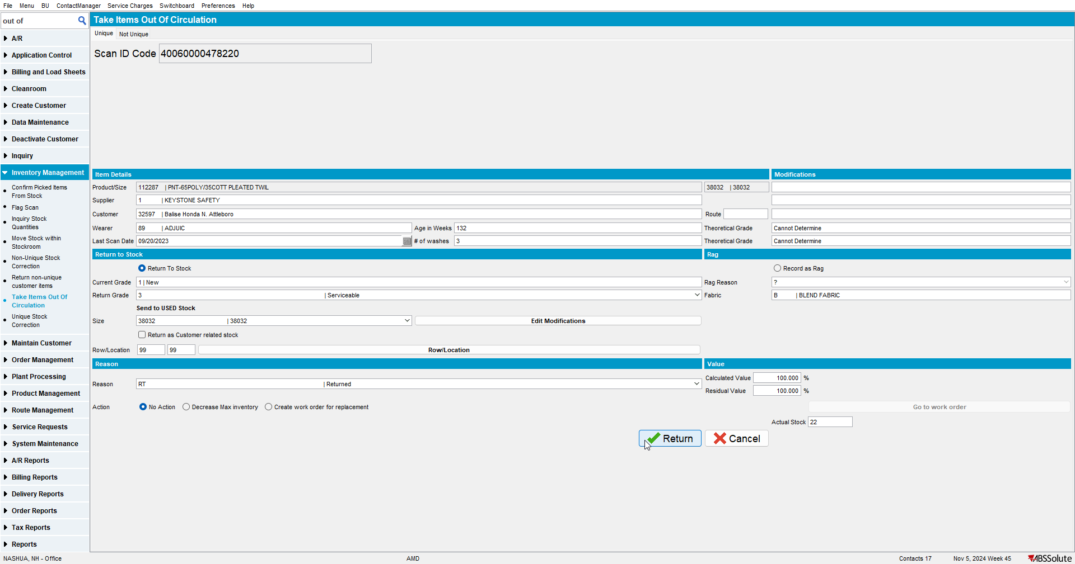
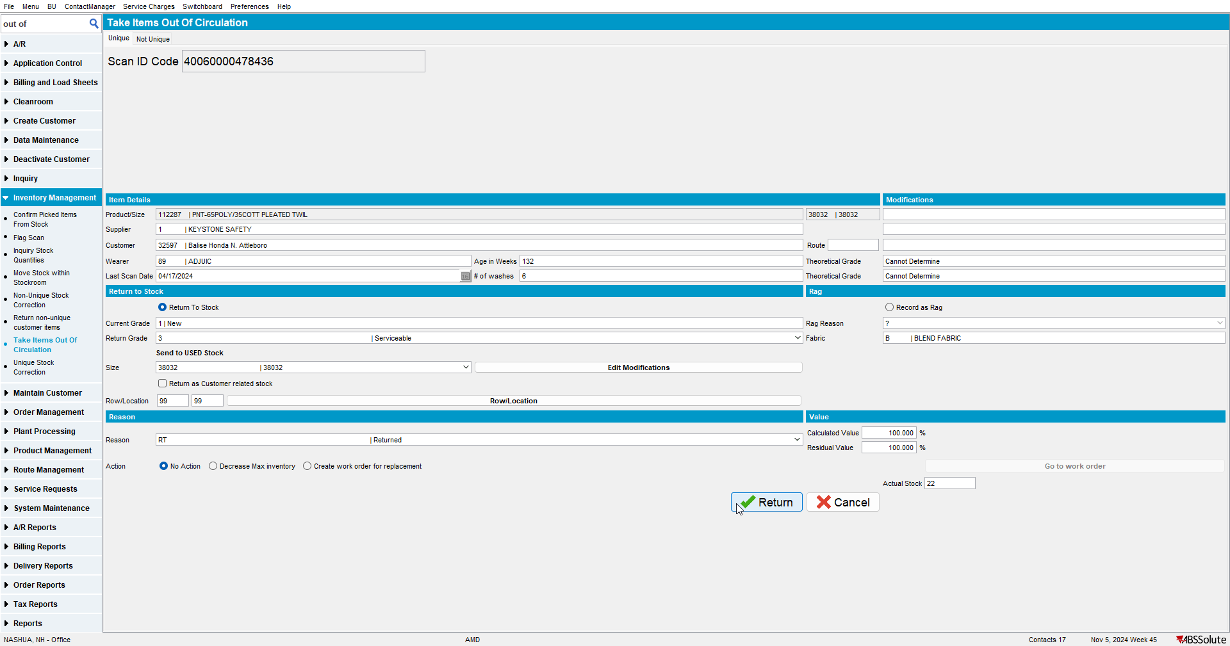

- Take Items out of Circulations DLG: Return 2 garments to stock for Wearer 3 – use a Reason Code that has “Charging Restocking Fee” checkbox checked
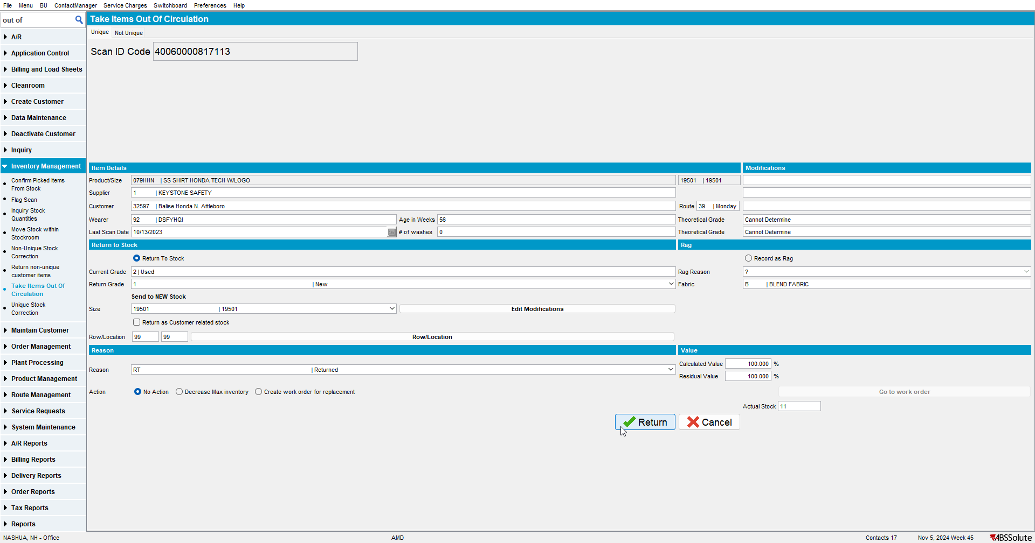
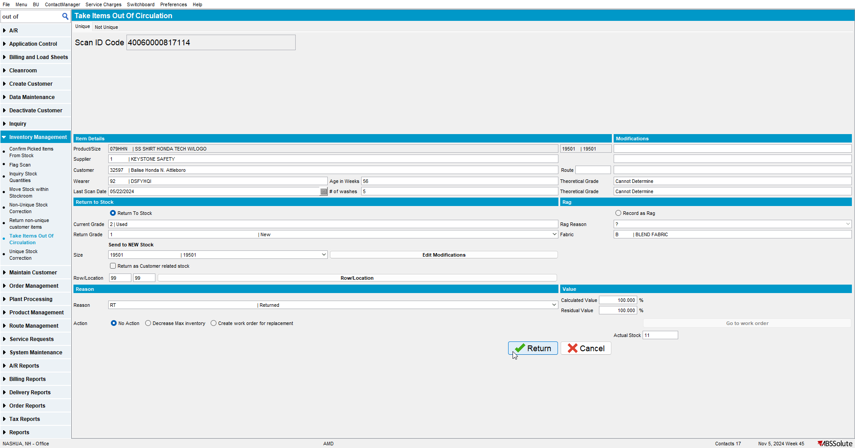

- Route Status Control DLG: Add a route control for the next billing day and generate the invoices
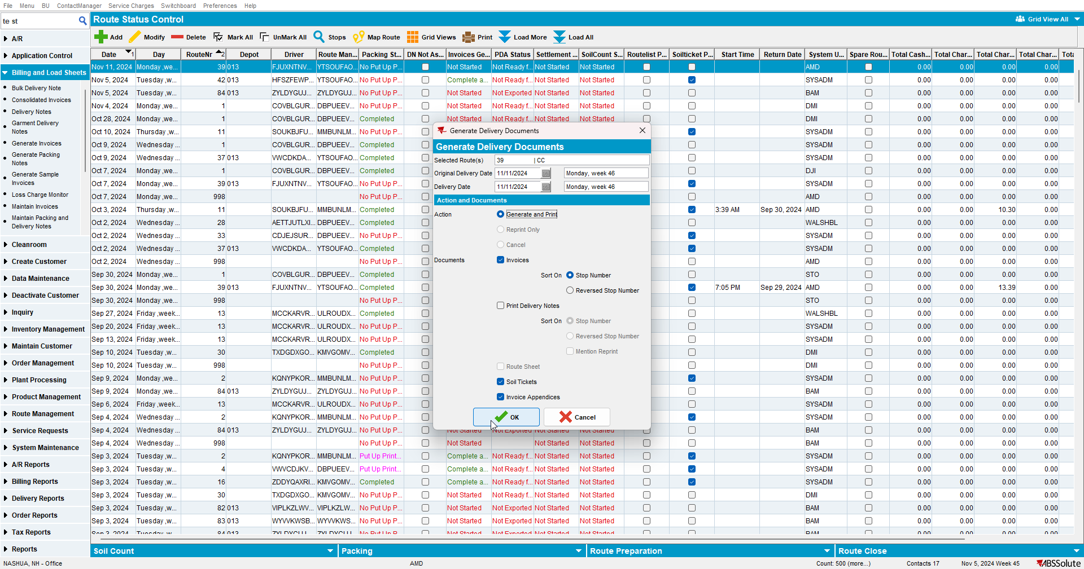

- Maintain Invoices DLG: Check that the invoice has:
  - one restocking fee invoiceline for Wearer 1 with a quantity of 2
  - one restocking fee invoiceline for Wearer 2 with a quantity of 2
  - one restocking fee invoiceline for Wearer 3 with a quantity of 2
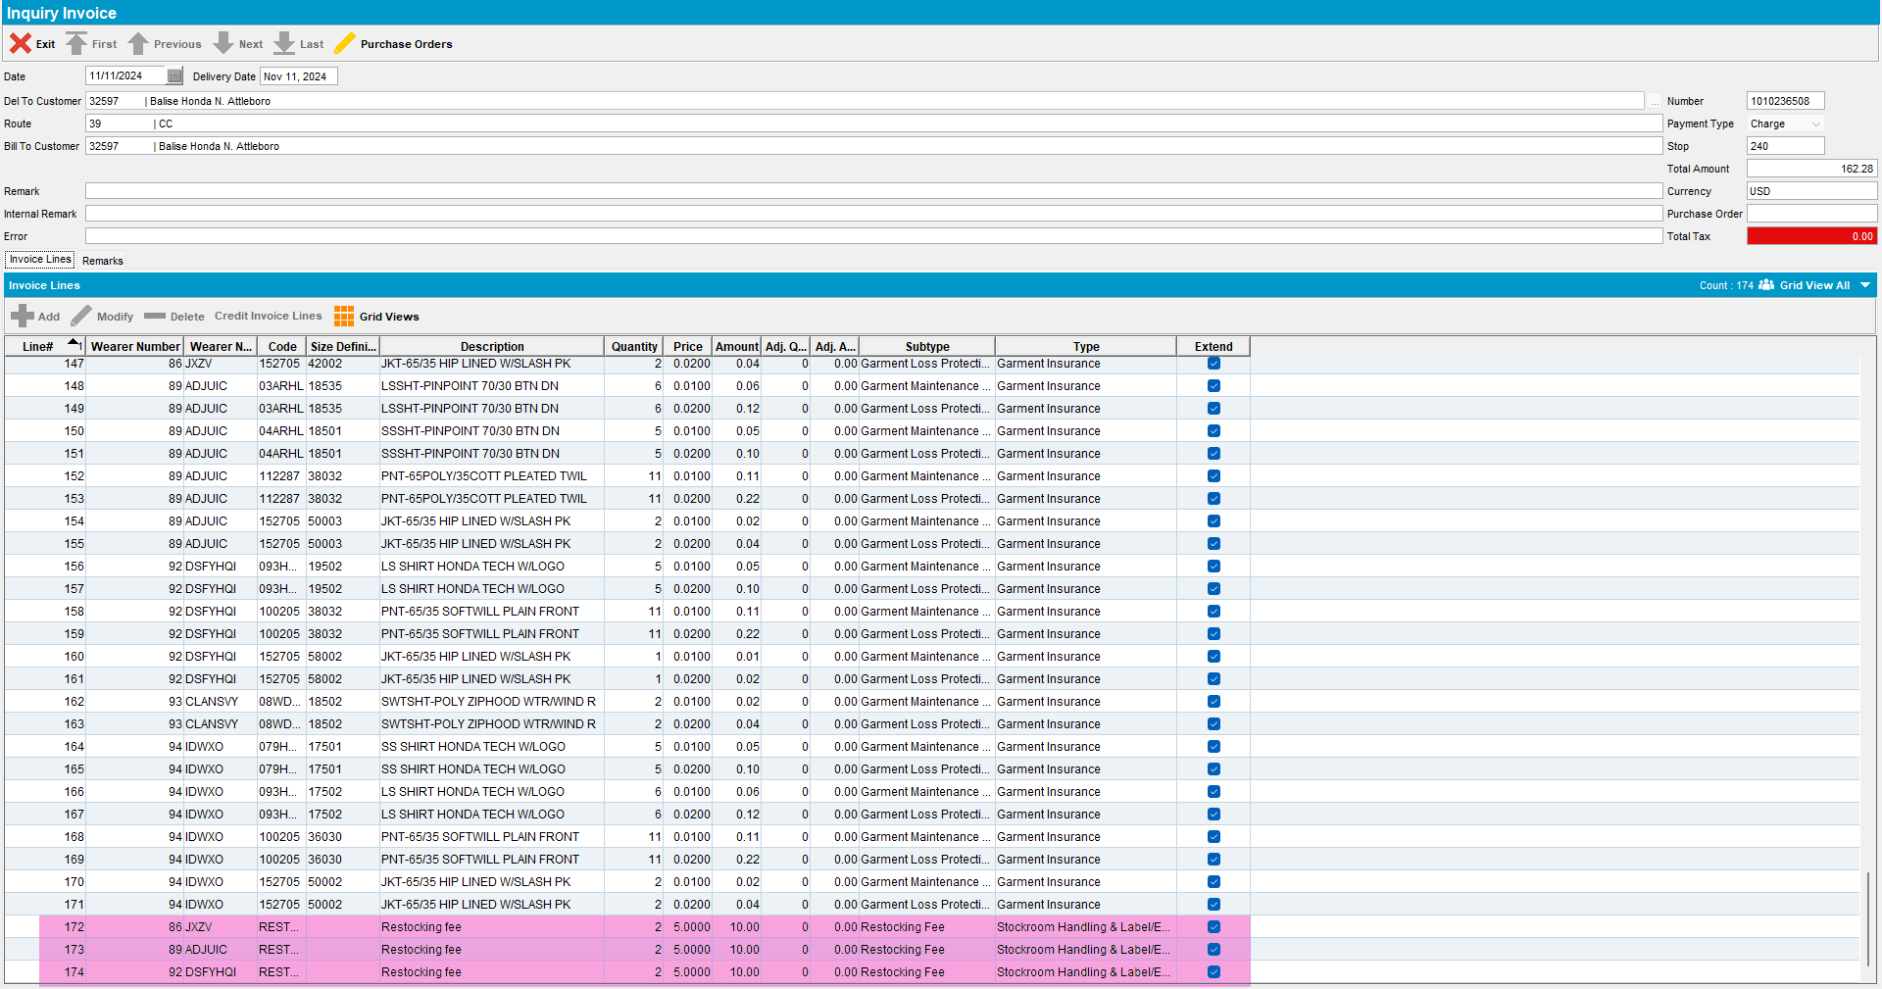

- Check the price and the amount in Maintain Garment Charges dialog.
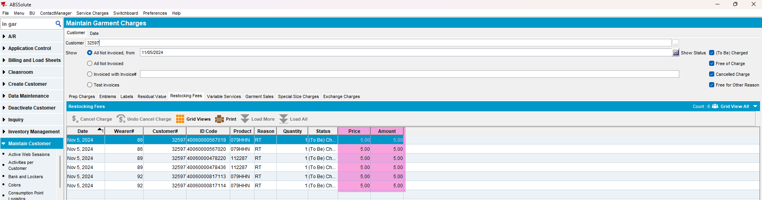

TESTED OK.

