ABS-166473 GeocodingService requires Billing on the Google Cloud Project
DataBase | Preconditions
Version:9.07.00.UNF18  DBServerName= abs-srv20.internal.abslbs.com  DBSID=CUST24  DBUser=UNFDEV  Env: Production | - Module:  - System setting:  - Other applications versions (if is applicable)  - Device used for mobile applications (if is applicable: Memo, physical device, Nox)
Contents
Expected Behaviour: 1
Summary: Retest after fix 2
Test Case 1: Google API Key –OK 2
Test Case 2: Modify Existing DP with customer address set – GPS coordinates copied from address - OK 4
Test Case 3: Modify Existing DP with customer address set – manual coordinates - OK 12
Test Case 4: Modify Existing DP with specific address set – GPS coordinates copied from address - OK 18
Test Case 5: Modify Existing DP with specific address set – manual coordinates – OK 26
Test Case 6: Switching back from manual coordinates to GPS coordinates copied from address - OK 34
Test Case 7: Adding new DP - OK 38
Test Case 8: Inquiring mode - OK 43
Test Case 9: Map route from RSC – OK 44

Expected Behaviour:
- Google API key check can be done from client application (system information) when a valid license key is available, otherwise, request should be denied.
- The number of calls to Geocoding services should be reduced.
- Customerdlg analysis updated as it follows:
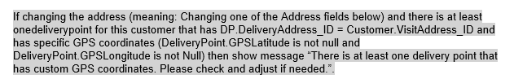
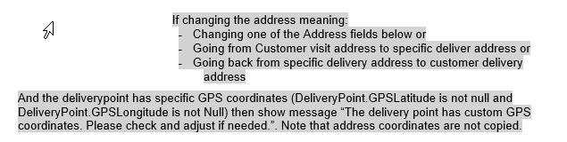
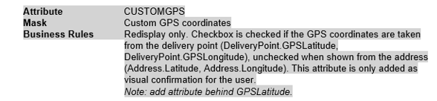

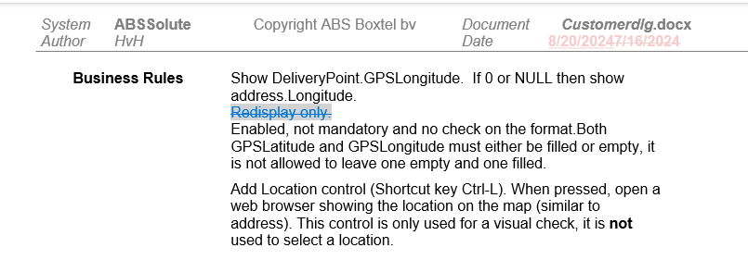

Summary: Retest after fix
Preconditions: 9.07.00.RELEASE.(p29) hash: d9287fec9d75

Test Case 1: Google API Key –OK
Step 1) Open System information: notice new field is added for Google API Key.
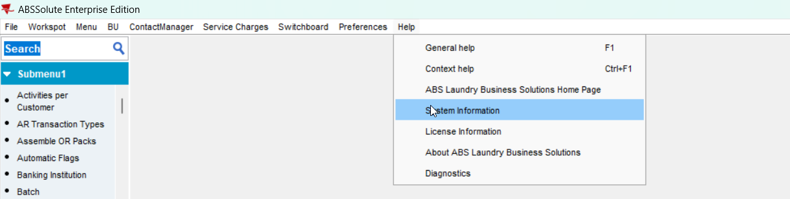
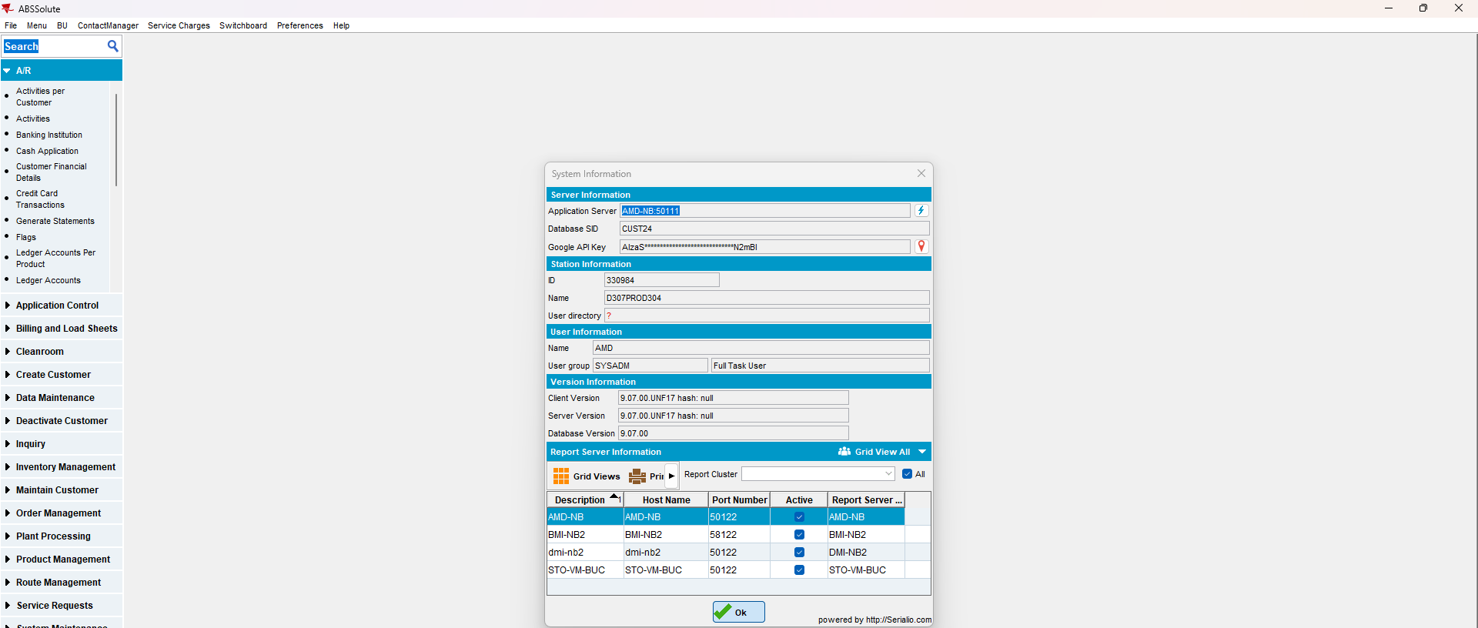
Step 2) If you press the location icon to trigger a response status from Google, the answer will be “Request Denied” if the key is not a valid one: this is correct
Step 3) Add a valid Google API Key in the application.properties file, restart server + client and try again: this time the request is valid
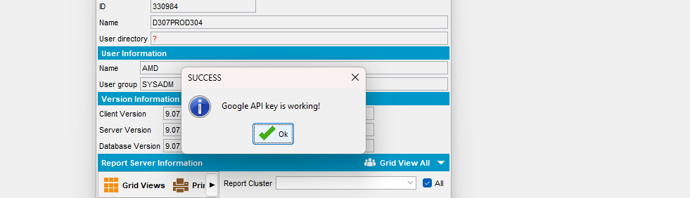
RETEST OK

Test Case 2: Modify Existing DP with customer address set – GPS coordinates copied from address - OK
Step 1) Open customer in modify mode.
This is the address set on customer level:
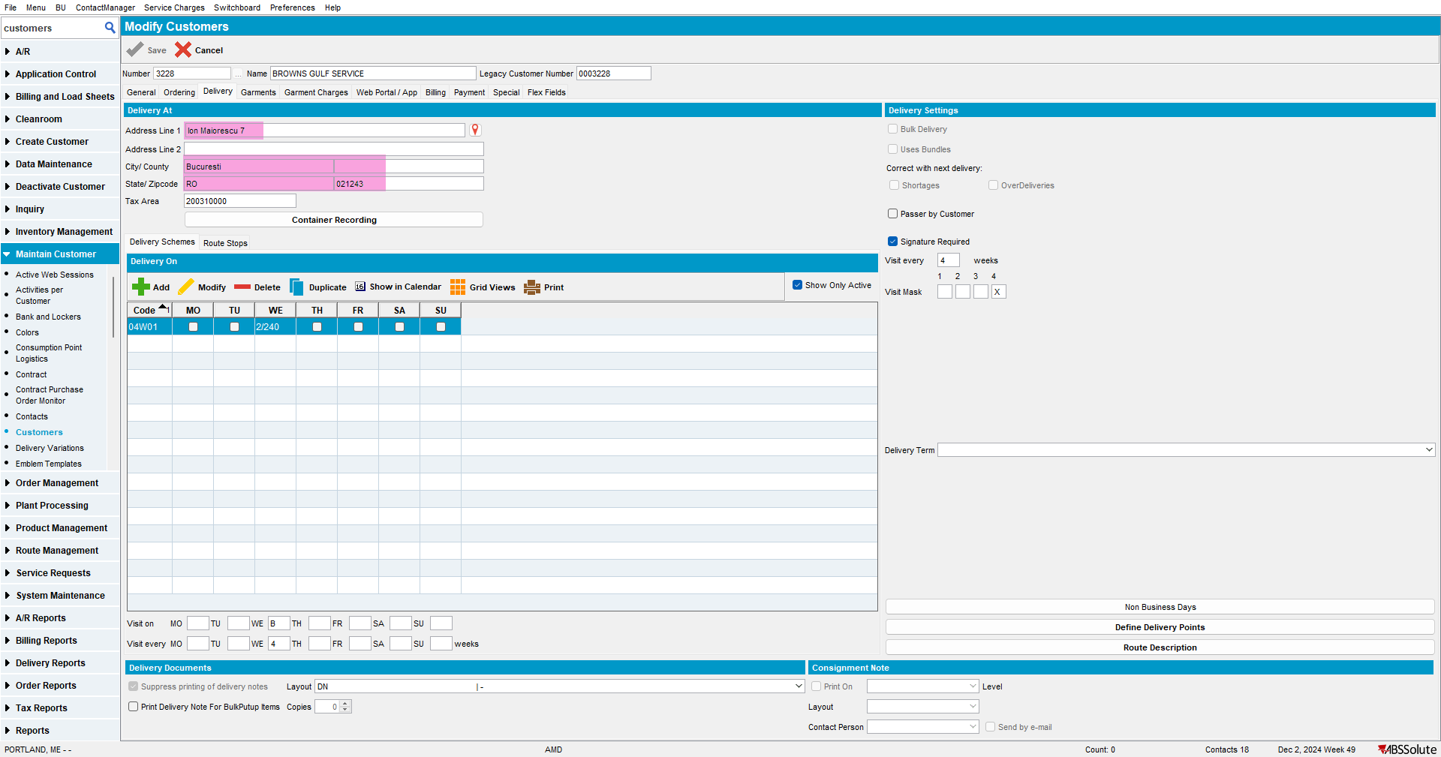
Step 2) This is an existing DP having the address of customer set and coordinates taken from customer address: notice there is a new checkbox for “GPS coordinates copied from address” that is checked.
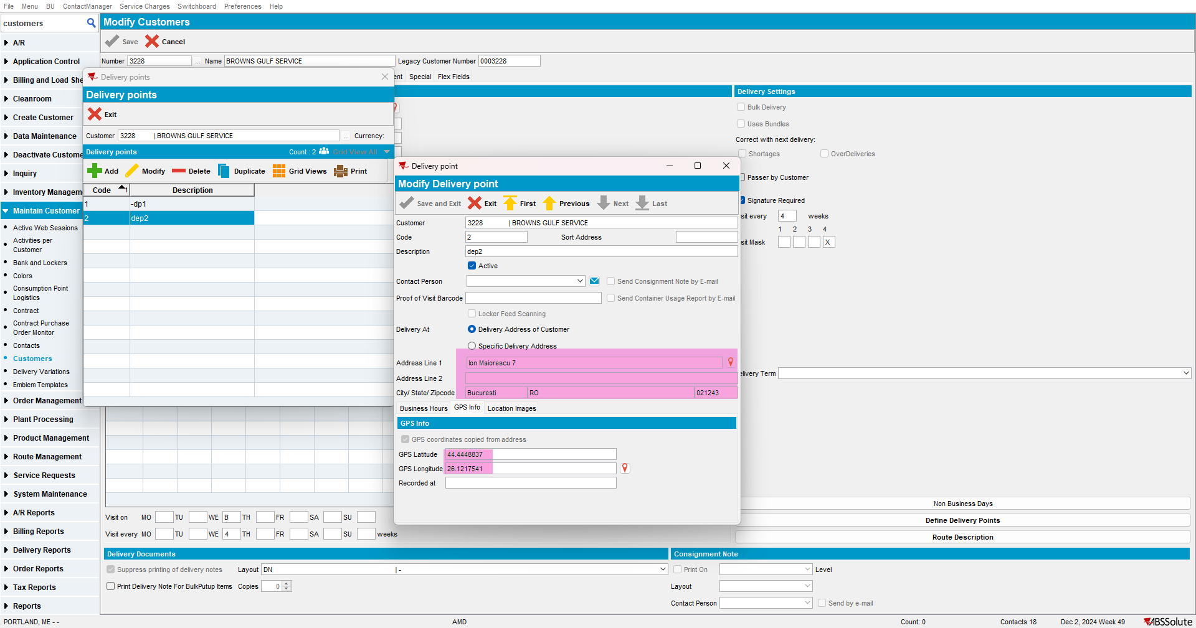
Database: Delivery Point Table (notice the latitude, longitude and timestamp are not filled. This is correct):
select dp.customer_id,
dp.deliverypoint_id,
dp.code,
dp.description,
dp.deliveryaddress_id,
dp.gpslatitude,
dp.gpslongitude,
dp.gpstimestamp
from deliverypoint DP
where dp.customer_id = 34155

Database: Address Table:
Select ad.address_id,
ad.street,
ad.zipcode,
ad.city,
ad.latitude,
ad.longitude
from address AD
where ad.address_id = 104432
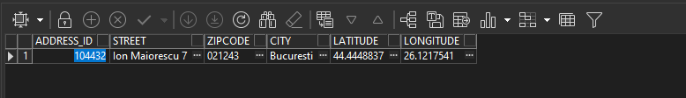
Step 3) Modify DP by changing something unrelated to the address or coordinates, for example, the description:
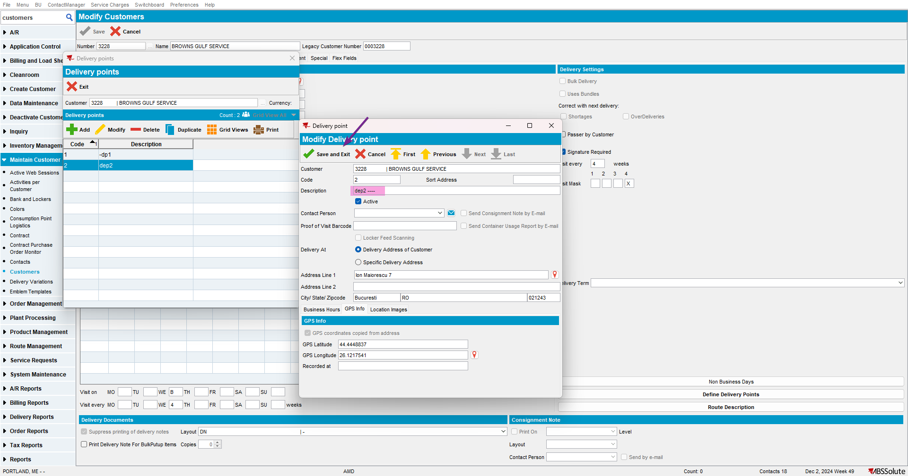
- No call is made to the geocoding service: this is correct
- No update is made on coordinates or address: this is correct

Step 4) Change the coordinates on the DP: notice the checkbox is now unchecked. This is correct:
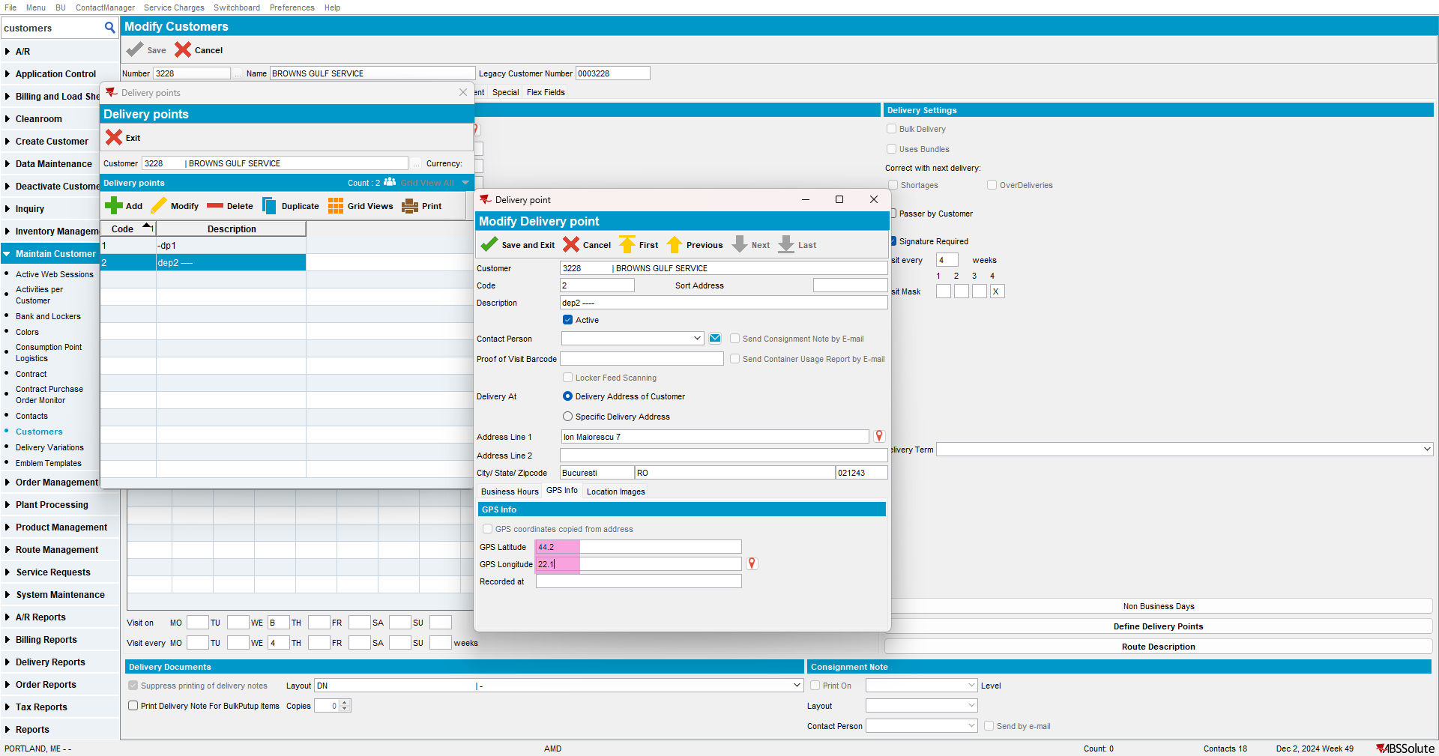
- No call is made to the geocoding service: this is correct
- No change is made on address table: this is correct
- The manual coordinates are set in the DP table: this is correct
- No warning message: this is correct
Step 5) Change the address on customer level: notice warning occurs, because there is at least one DP set already that use the address of the customer and it has custom coordinates set. This is correct:

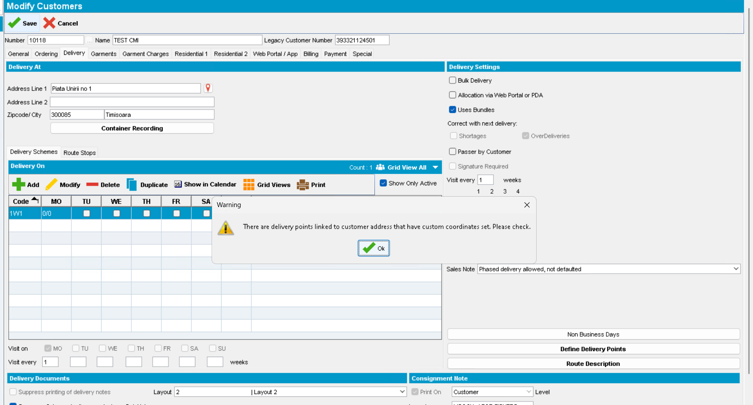
- Call to geocoding service is made: this is correct
- Address is changed in the Address table: this is correct
- No change in the DP table, it is still using the manual coordinates, only the address has changed: this is correct
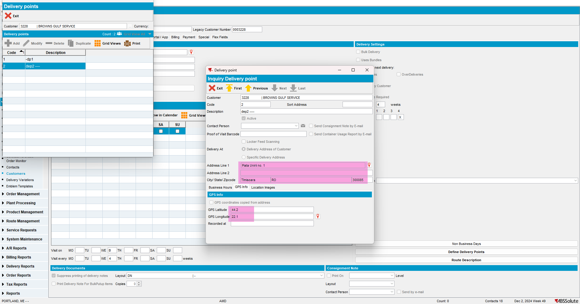
Note: if there is a DP set to use customer address and the coordinates are taken from that address (so the checkbox is checked) then if the user changes the address on customer level, the warning message won’t appear and the new address and coordinates will automatically update that DP.
Ex: customer 3233
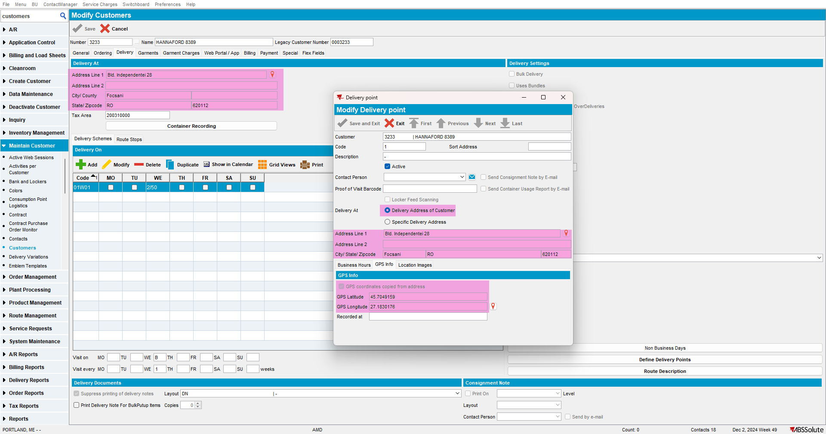
Change address: no warning message occurs, and DP is updated:
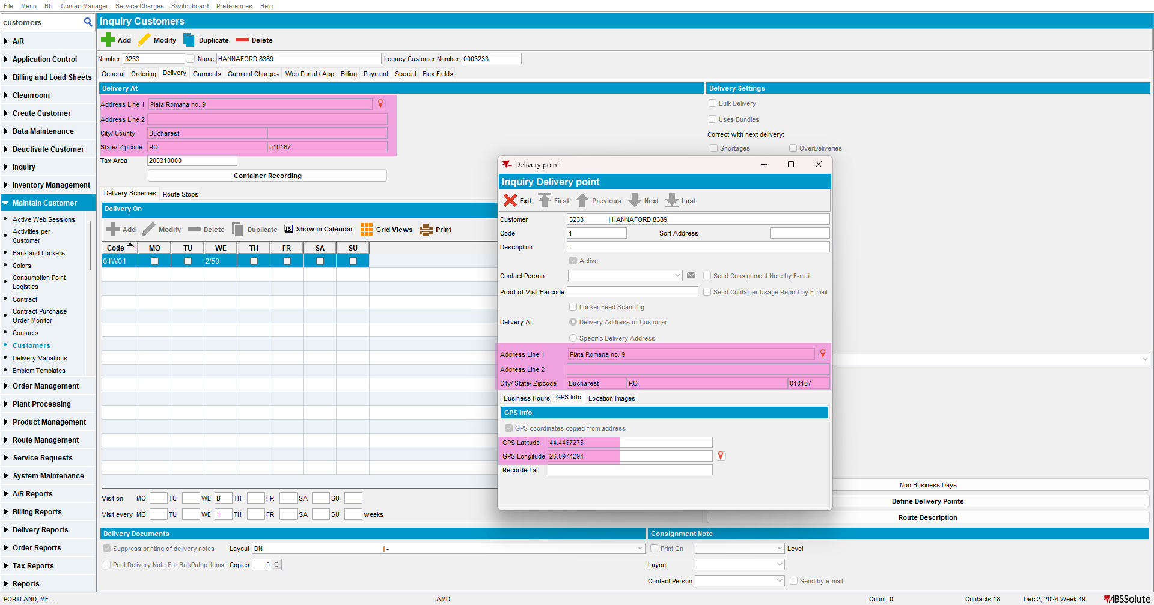
Step 6) Take a DP that uses the address of customer (automatic coordinates) and turn it into a specific one:
Initial DP:
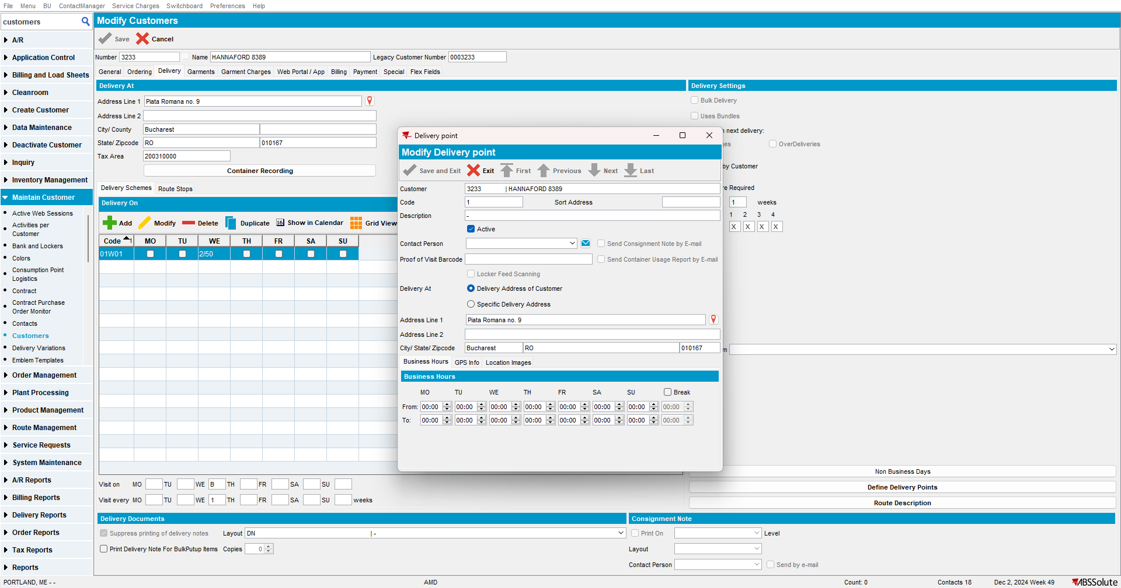
Change to specific: notice the checkbox is automatically checked (so the coordinates will be taken from the specific address once it is saved)
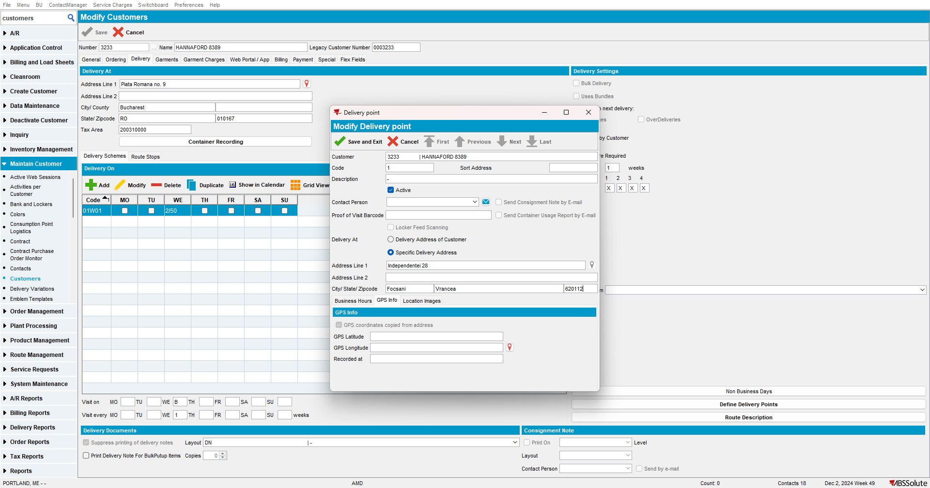
After Save: automatic coordinates are filled
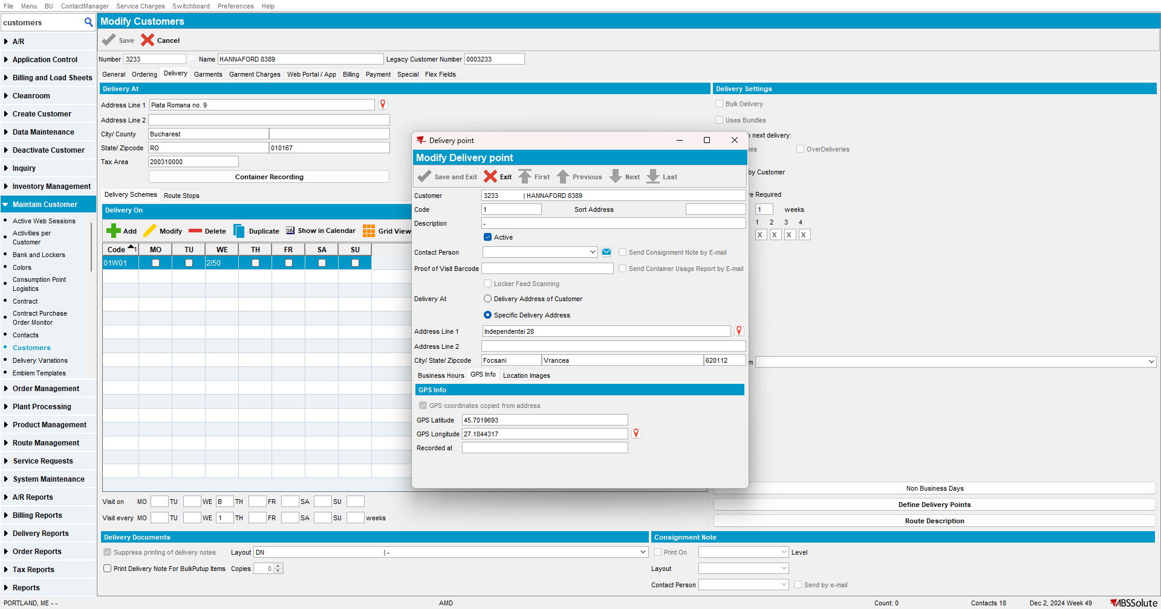
- Latitude and Longitude are empty in the DP table: this is correct
- Information is filled in the Address table:
- Call to geocoding service is made for this new address: this is correct

Note: User may change these coordinates as well with manual ones:
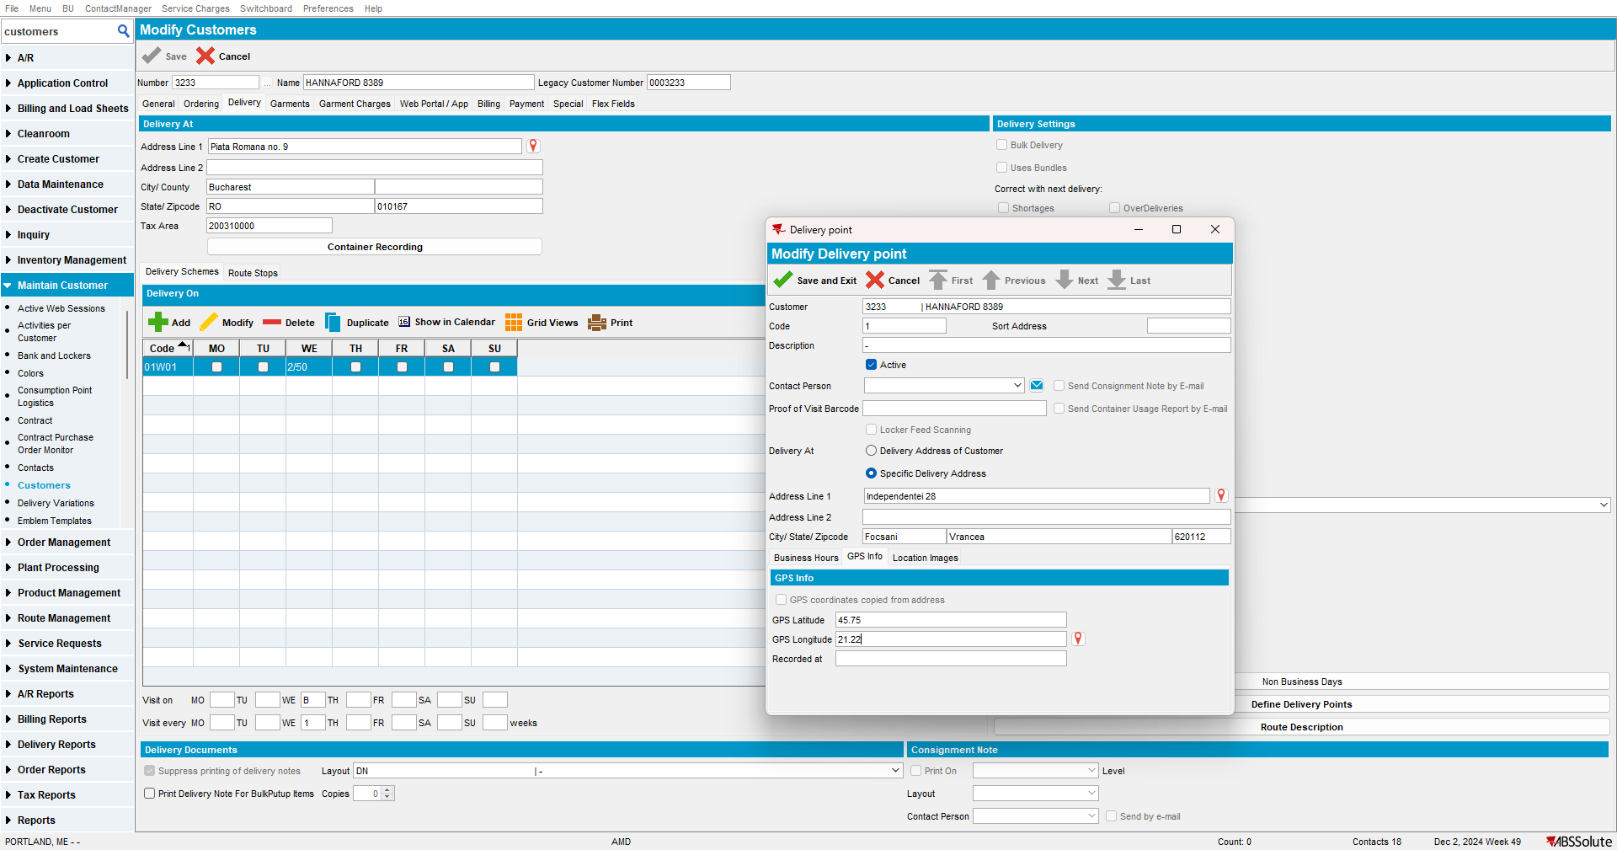
In this case:
- Call to geocoding service is not done: this is correct
- No change is done to the address table: this is correct
- Manual coordinates are entered in the DP table: this is correct
RETEST OK

Test Case 3: Modify Existing DP with customer address set – manual coordinates - OK
Step 1) Open customer in modify mode.
This is the address set on customer level:
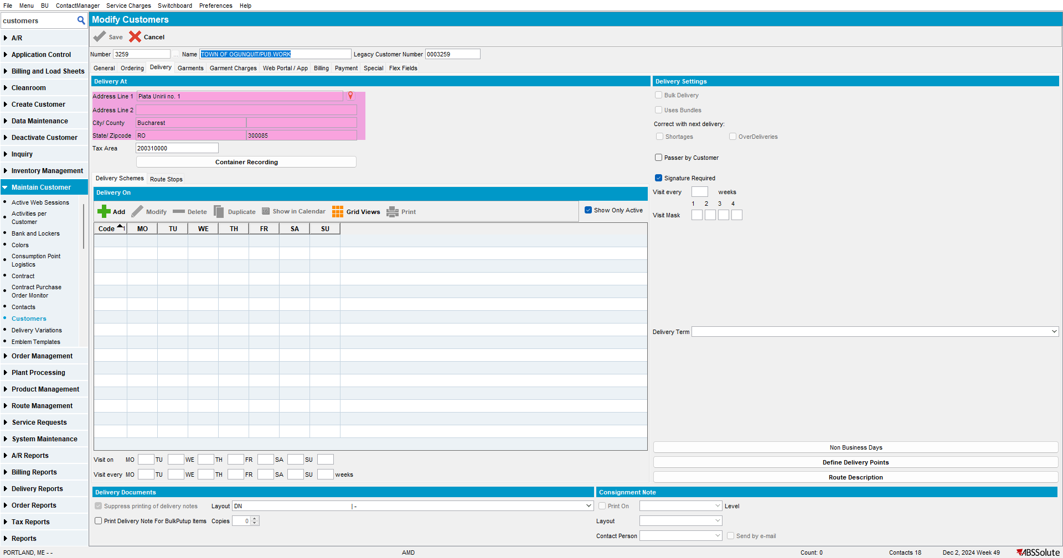
These are the coordinates:
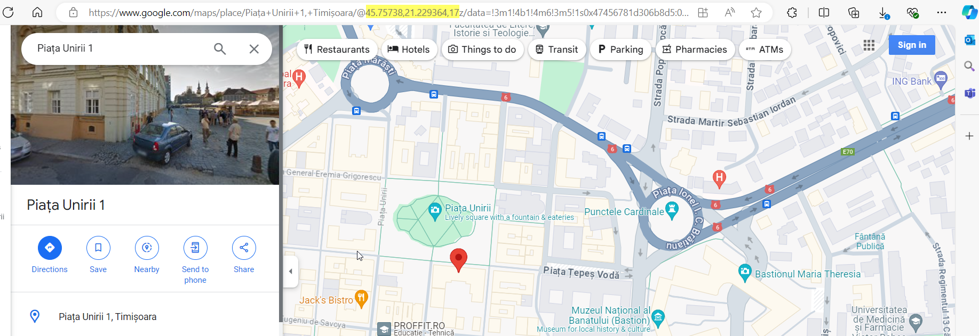
Step 2) This is an existing DP having the address of customer set but the coordinates are manually set (notice there is a new checkbox for “GPS coordinates copied from address” that is unchecked):
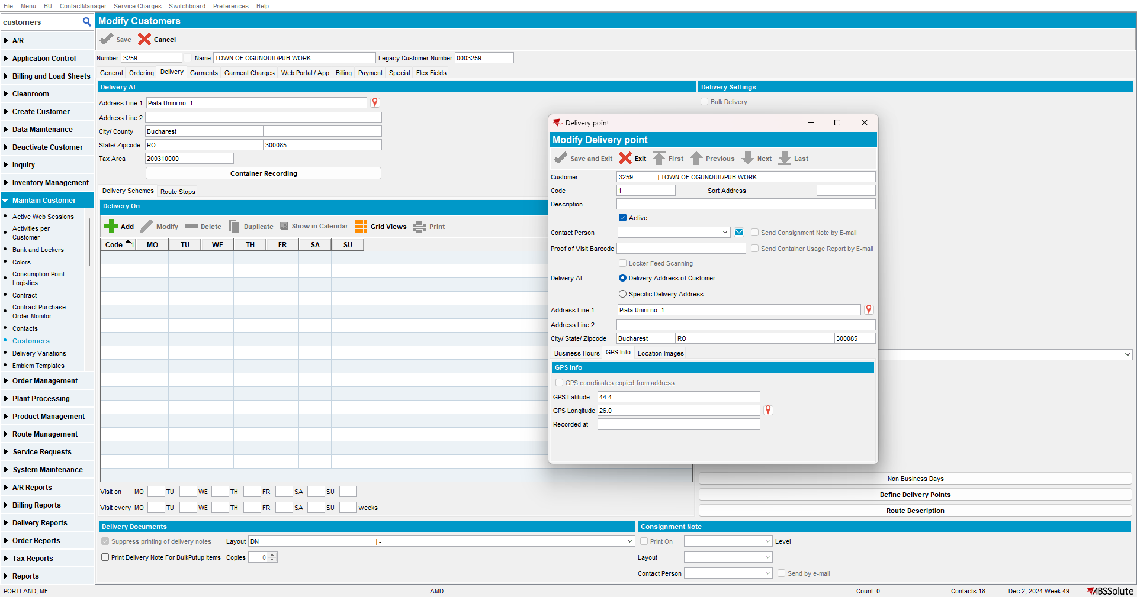
Database: Delivery Point Table (notice the latitude, longitude are filled. This is correct):
select dp.customer_id,
dp.deliverypoint_id,
dp.code,
dp.description,
dp.deliveryaddress_id,
dp.gpslatitude,
dp.gpslongitude,
dp.gpstimestamp
from deliverypoint DP
where dp.customer_id = 38951

Database: Address Table:
Select ad.address_id,
ad.street,
ad.zipcode,
ad.city,
ad.latitude,
ad.longitude
from address AD
where ad.address_id = 118820

Step 3) Modify DP by changing something unrelated to the address or coordinates, for example, the description:
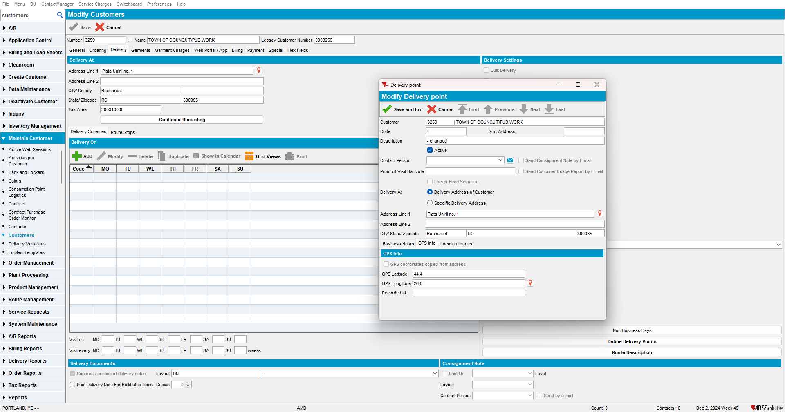
- No call is made to the geocoding service: this is correct
- No update is made on coordinates on DP table or address table: this is correct

Step 4) Take a DP that uses the address of customer (manual coordinates) and turn it into a specific one:
Initial DP:
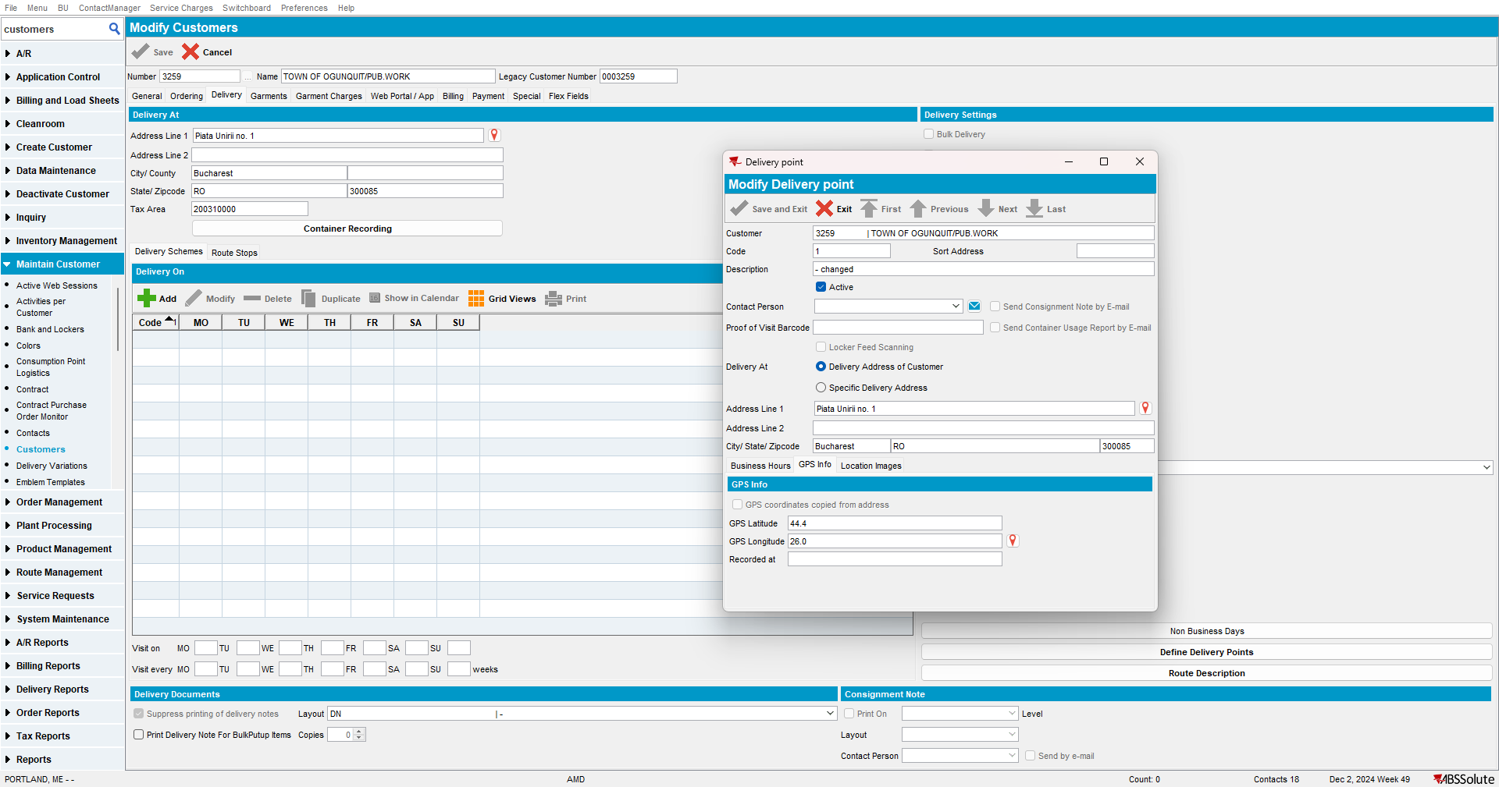
Change to specific: notice the checkbox is not automatically checked (it is displaying the manual coordinates still)
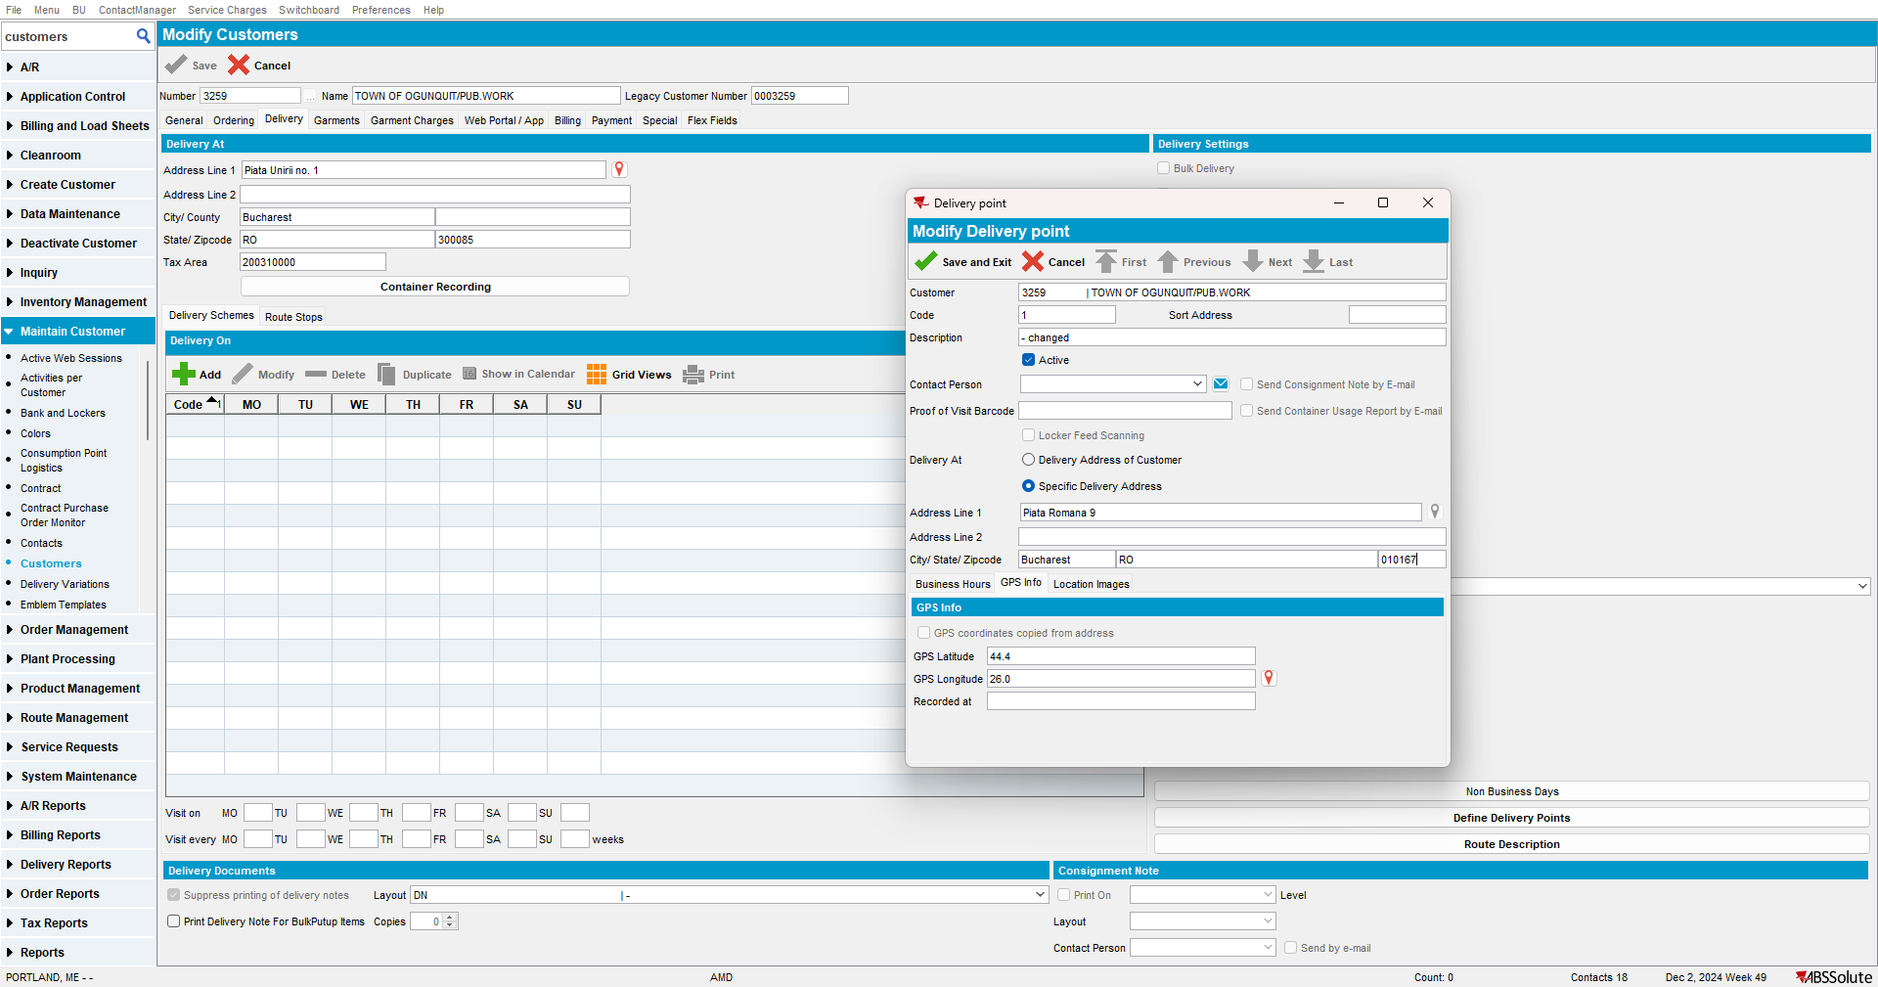
Notice warning message occurs correctly:
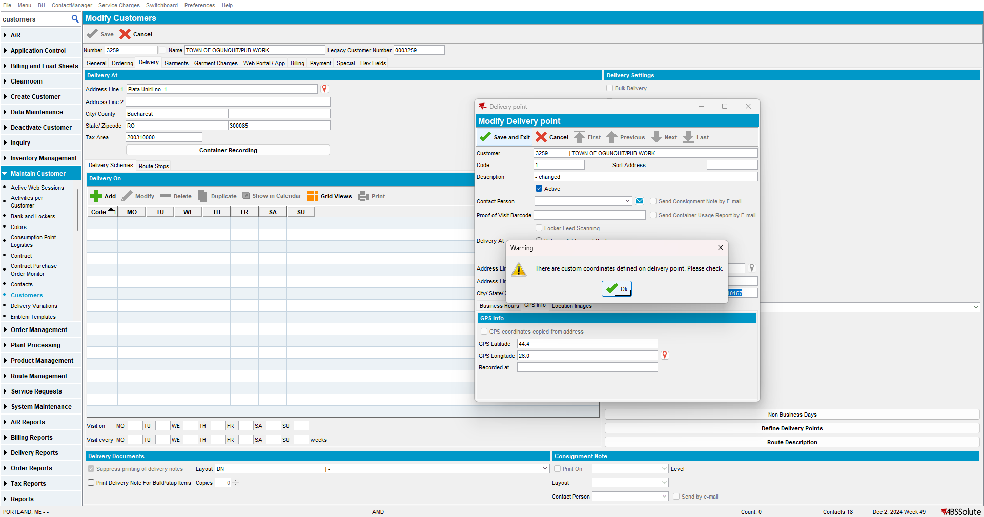
After Save: manual coordinates remain, since these have the highest priority
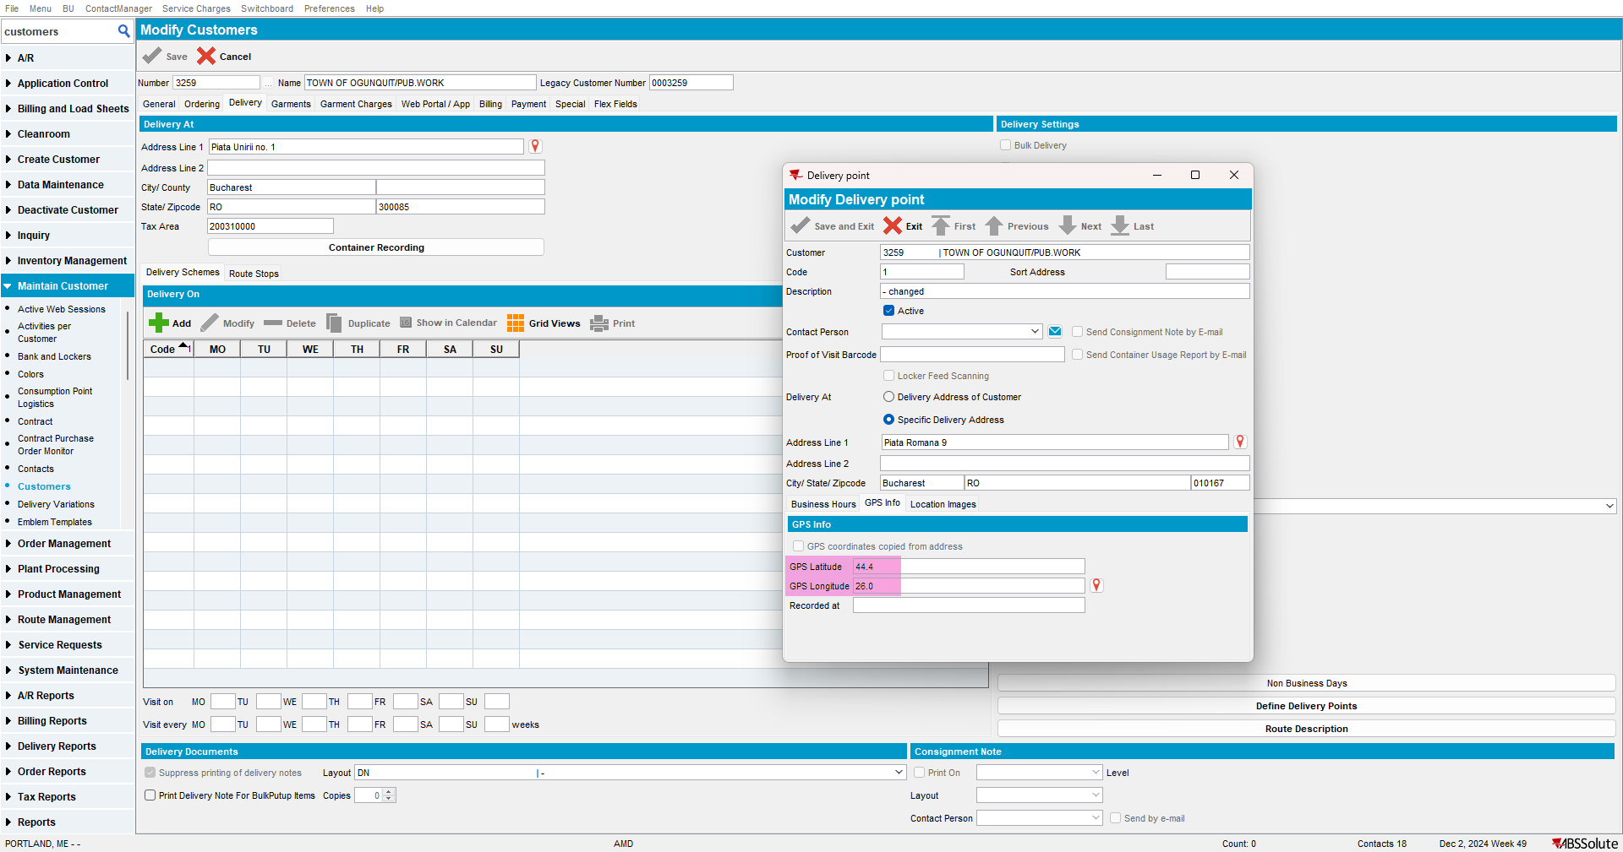
- Latitude and Longitude remain in the DP table: this is correct
- Information is filled in the Address table with new entry: this is correct
- Call to geocoding service is made for this new address: this is correct
Step 5) If you change the address on Customer level, this can be done without any warning since both DP are using specific addresses at this point.
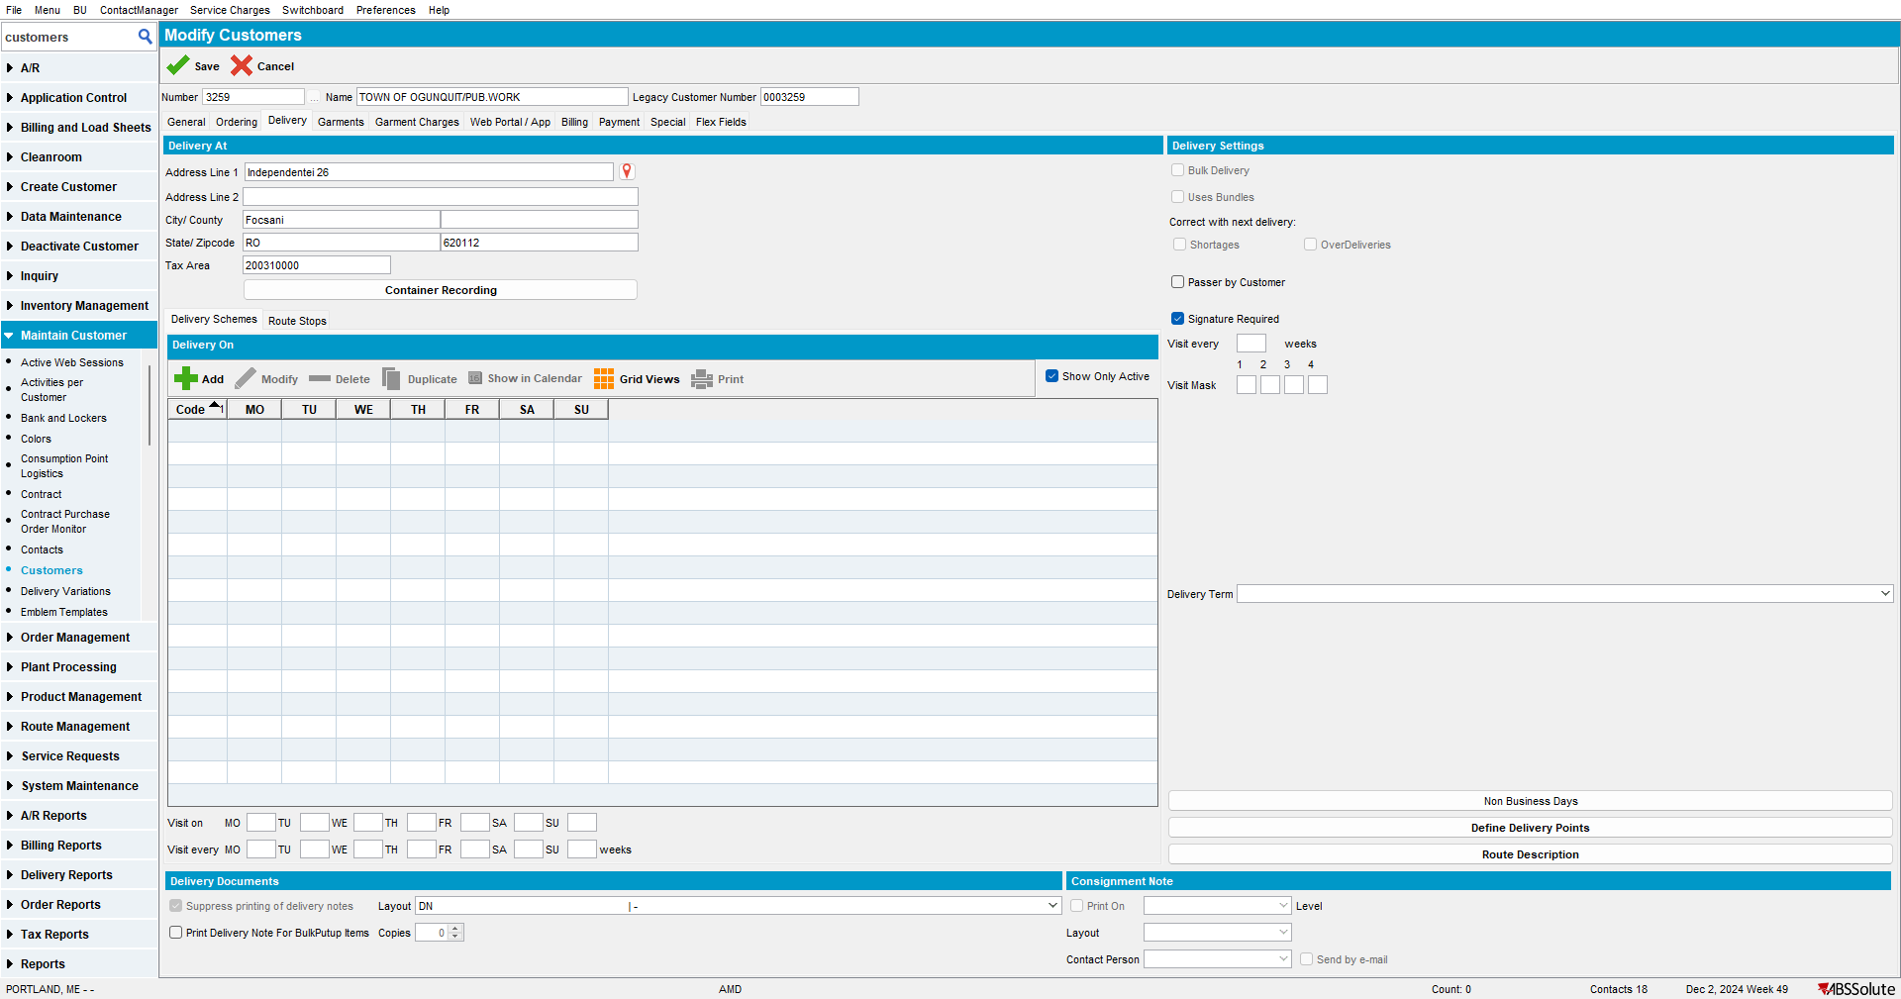
- There is only one call to geocoding service made for this new address: this is correct
- There is no change in the DP table: this is correct
- Address is updated in the Address table: this is correct
RETEST OK

Test Case 4: Modify Existing DP with specific address set – GPS coordinates copied from address - OK
Step 1) Open customer in modify mode.
This is the address set on customer level:
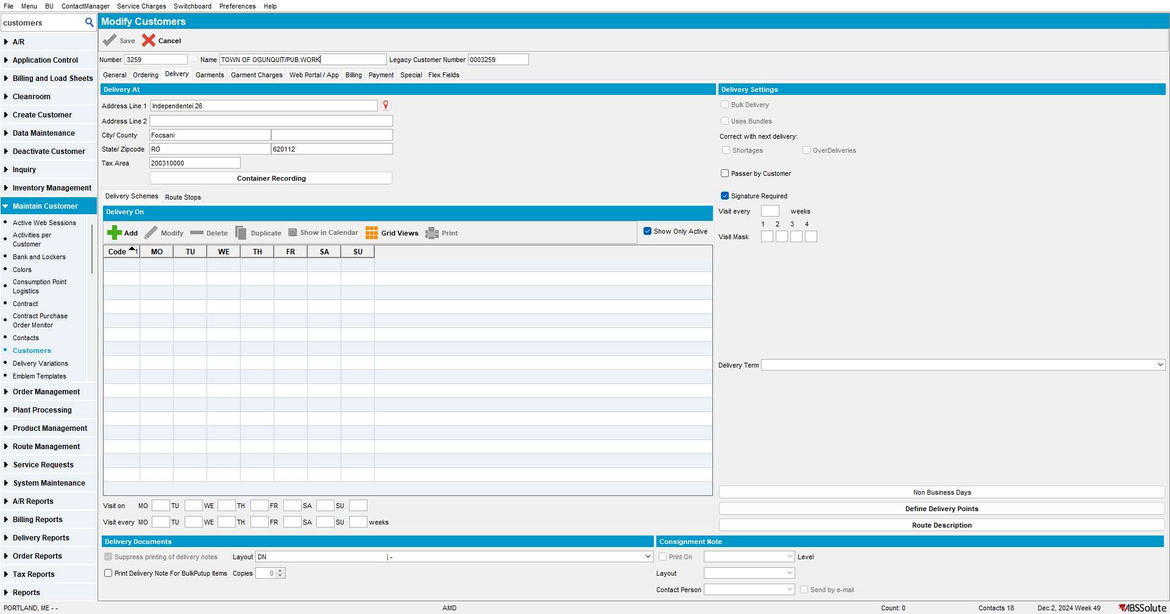

Step 2) This is an existing DP having specific address set and coordinates taken from address: notice there is a new checkbox for “GPS coordinates copied from address” that is checked.
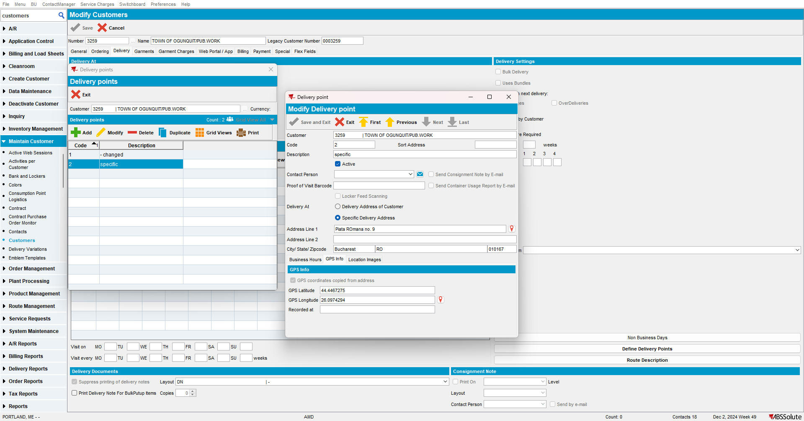
Database: Delivery Point Table (notice the latitude, longitude are not filled. This is correct):
select dp.customer_id,
dp.deliverypoint_id,
dp.code,
dp.description,
dp.deliveryaddress_id,
dp.gpslatitude,
dp.gpslongitude,
dp.gpstimestamp
from deliverypoint DP
where dp.customer_id = 38951



Database: Address Table:
Select ad.address_id,
ad.street,
ad.zipcode,
ad.city,
ad.latitude,
ad.longitude
from address AD
order by ad.address_id desc

Step 3) Modify DP by changing something unrelated to the address or coordinates, for example, the description:
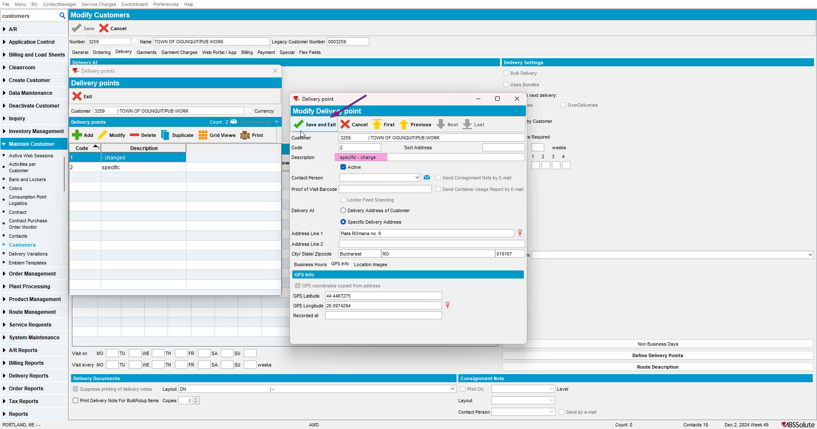
- No call is made to the geocoding service: this is correct
- No update is made on coordinates or address: this is correct

Step 4) Change the coordinates on the DP: notice the checkbox is now unchecked. This is correct:
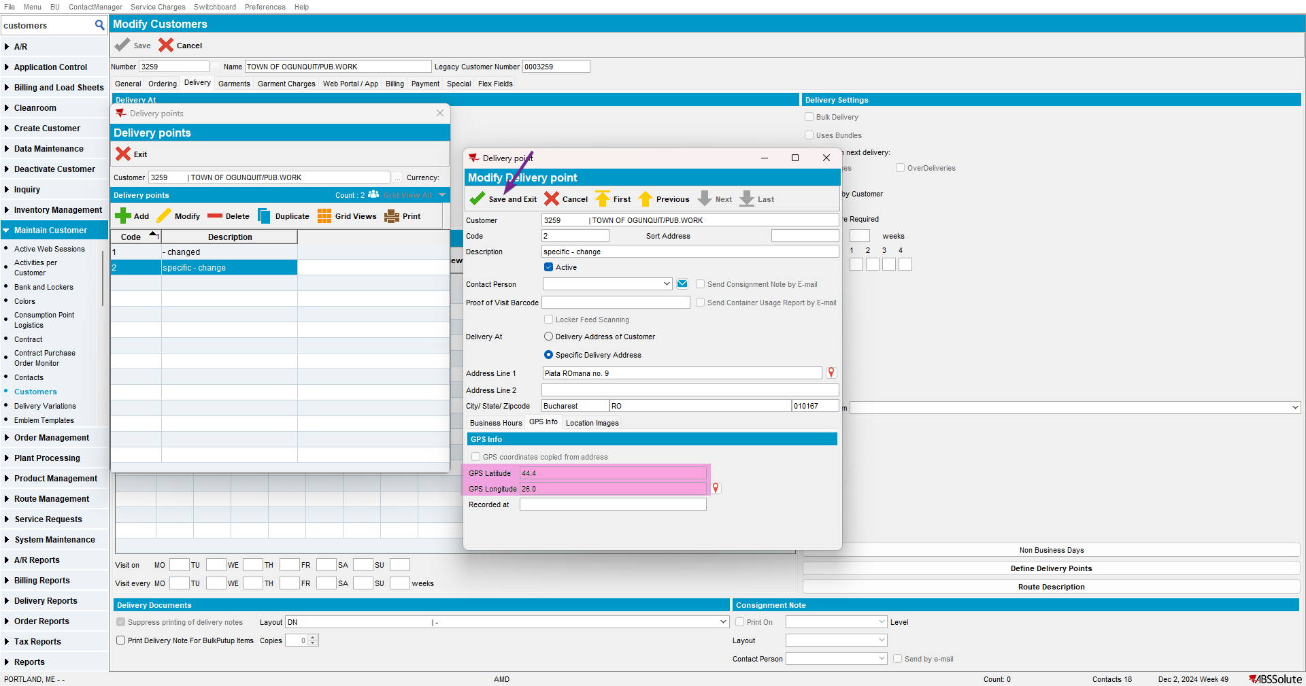
- No call is made to the geocoding service: this is correct
- No change is made on address table: this is correct
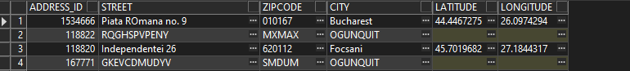
- The manual coordinates are set in the DP table: this is correct
- No warning message: this is correct

Step 5) Change the address on customer level: notice no warning occurs, because there is no DP set that uses the address of the customer with custom coordinate (there are only DP with specific addresses). This is correct:
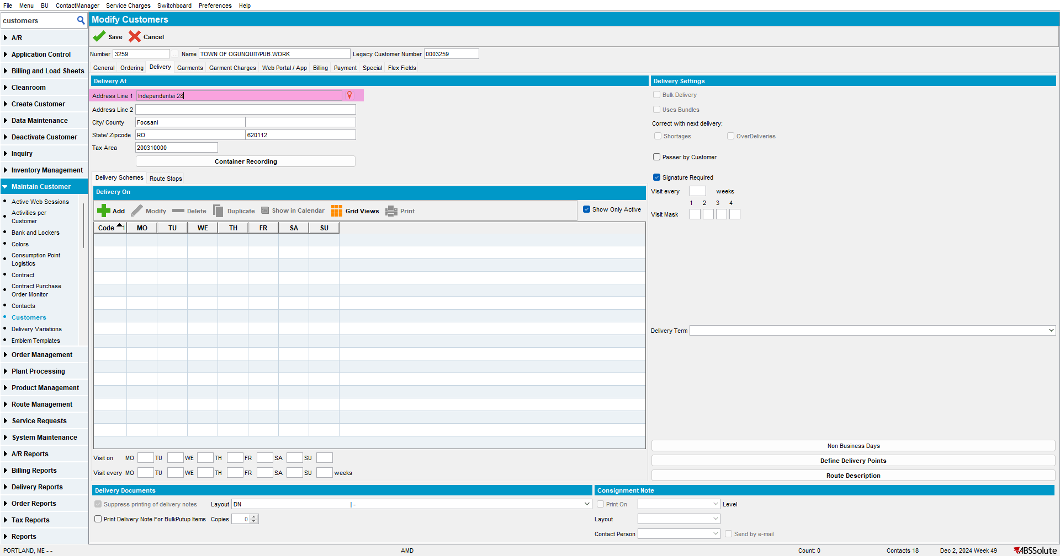
- Call to geocoding service is made for the new address: this is correct
- Address is changed in the Address table: this is correct
- No change in the DP table, it is still using the specific address and its manual coordinates: this is correct
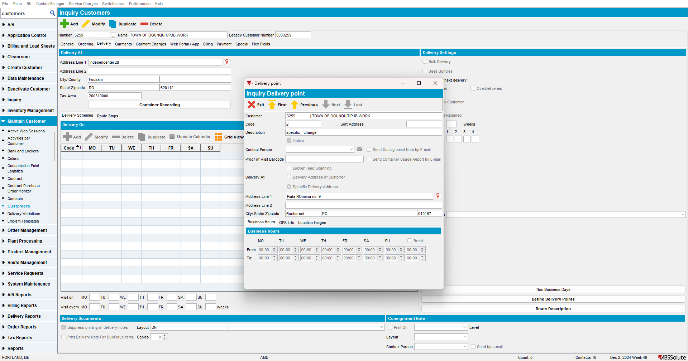
Step 6) Take a DP that uses the specific address (automatic coordinates) and turn it into a customer one:
Initial DP:
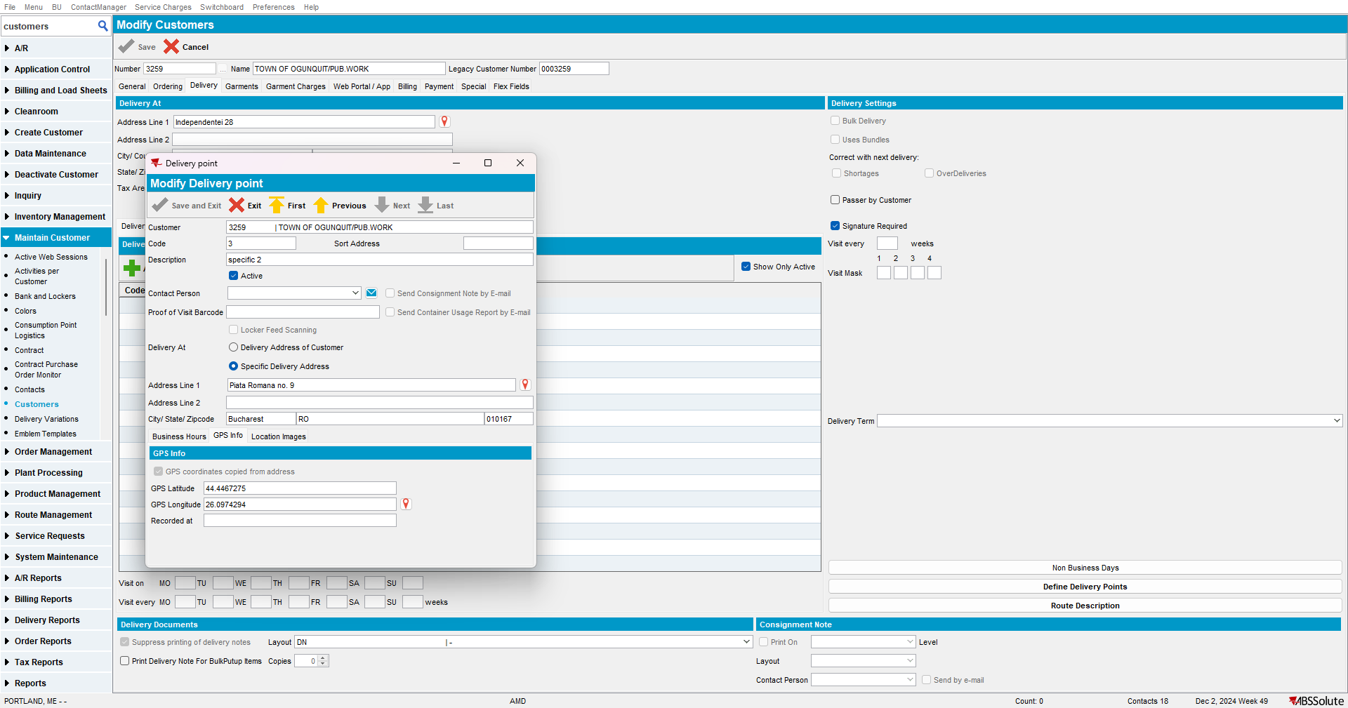
Change to customer address: notice the checkbox is automatically checked (so the coordinates will be taken from the customer address once it is saved)
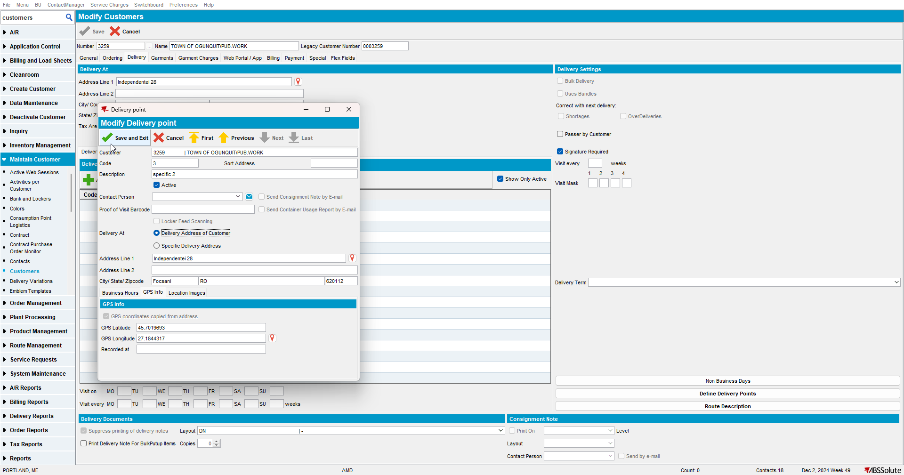
After Save: automatic coordinates are filled
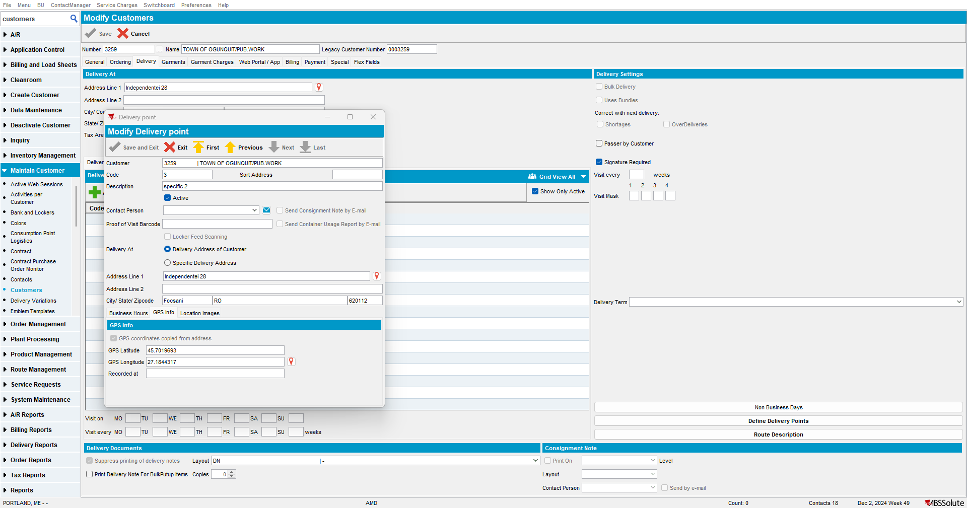
- Latitude and Longitude are empty in the DP table: this is correct
- Information is in the Address table:
- No call to geocoding service is made: this is correct
Step 7) Take a DP that uses the specific address (automatic coordinates) and change the specific address:
Initial DP:
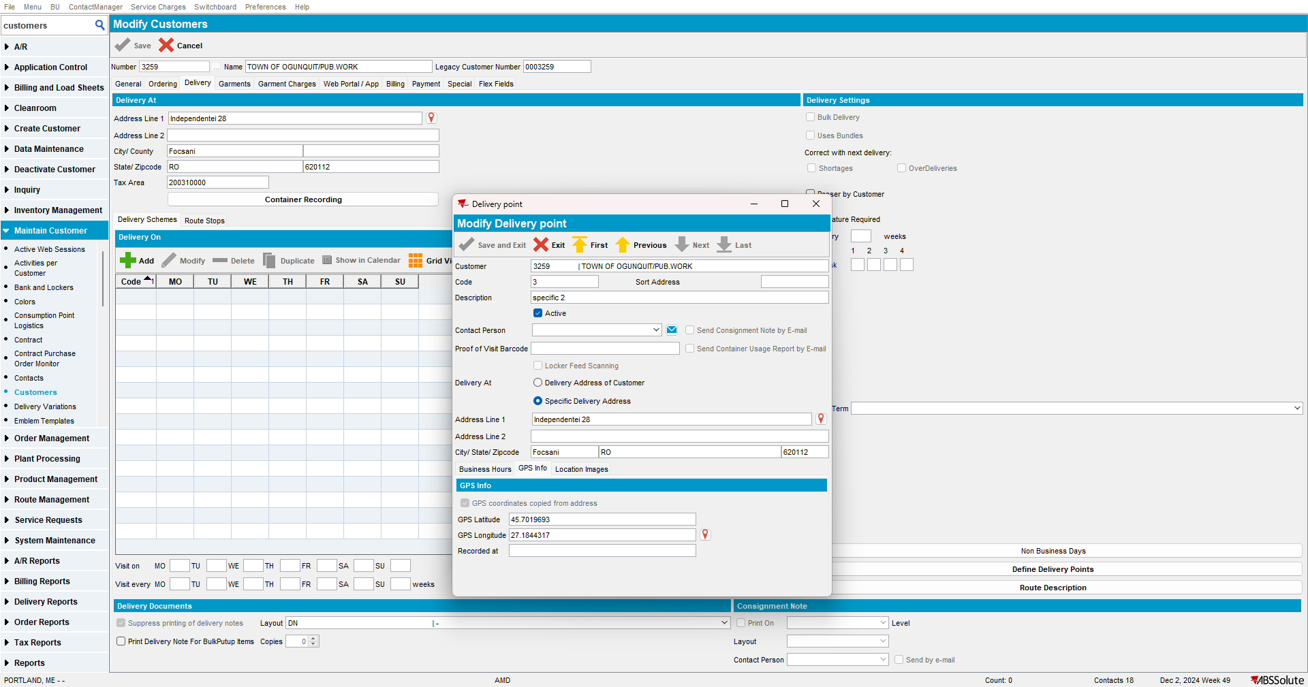
Change the specific address: notice the checkbox is automatically checked (so the coordinates will be taken from the new specific address once it is saved)
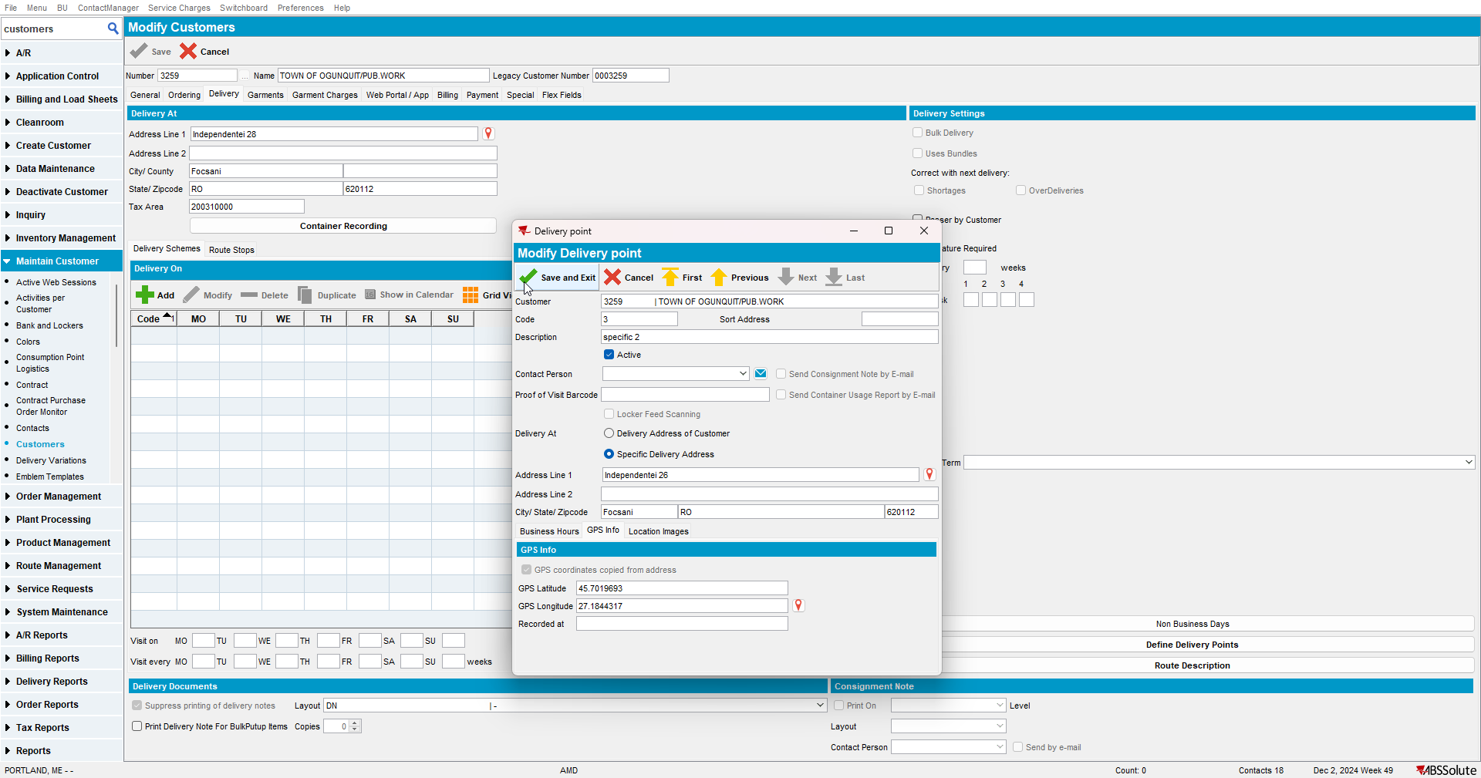
After Save: automatic coordinates are filled
- Latitude and Longitude are empty in the DP table: this is correct

- Information is added in the Address table:
- Call to geocoding service is made for the new address entry: this is correct
RETEST OK

Test Case 5: Modify Existing DP with specific address set – manual coordinates – OK
Step 1) Open customer in modify mode.
This is the address set on customer level:
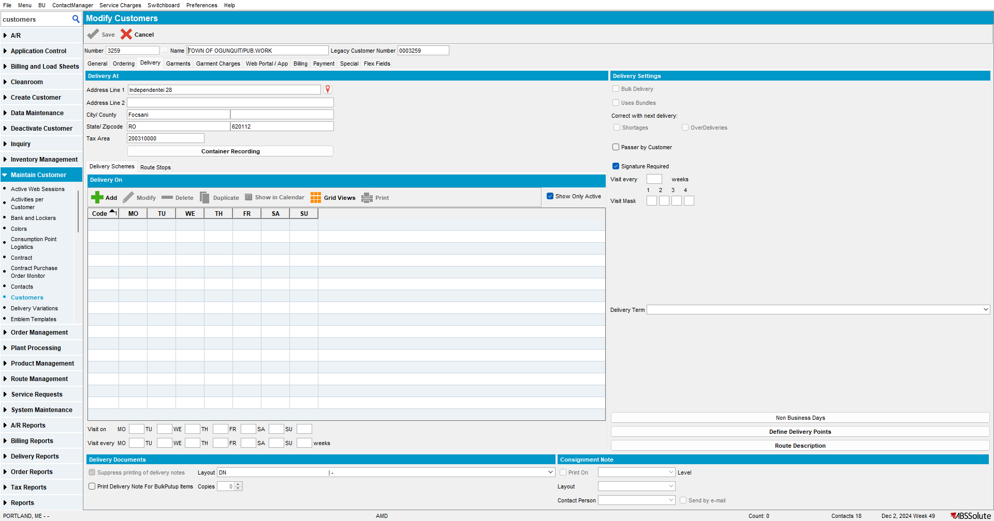

Step 2) This is an existing DP having specific address set and manual coordinates: notice there is a new checkbox for “GPS coordinates copied from address” that is unchecked.
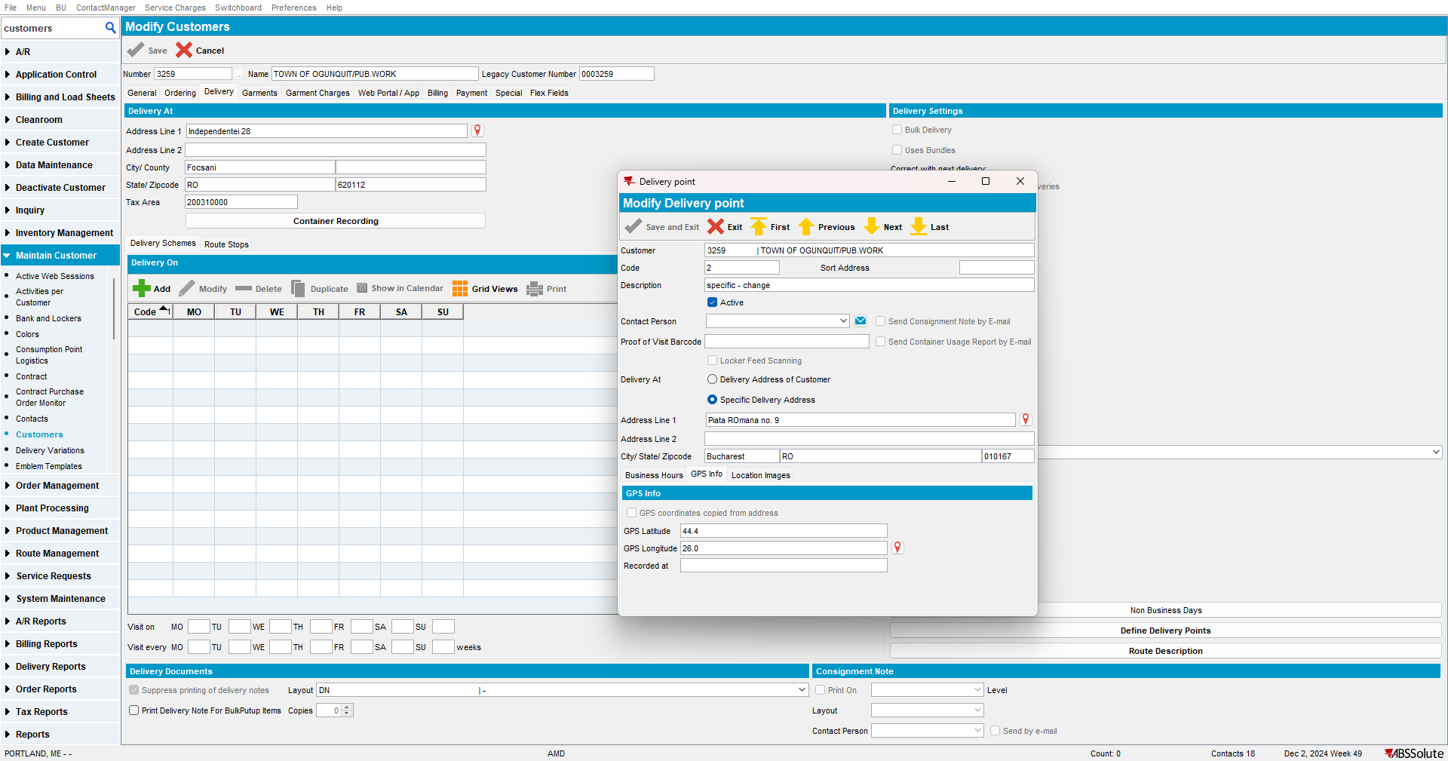
Database: Delivery Point Table (notice the latitude, longitude are filled. This is correct):
select dp.customer_id,
dp.deliverypoint_id,
dp.code,
dp.description,
dp.deliveryaddress_id,
dp.gpslatitude,
dp.gpslongitude,
dp.gpstimestamp
from deliverypoint DP
where dp.customer_id = 38951

Database: Address Table:
Select ad.address_id,
ad.street,
ad.zipcode,
ad.city,
ad.latitude,
ad.longitude
from address AD
order by ad.address_id desc



Step 3) Modify DP by changing something unrelated to the address or coordinates, for example, the description:
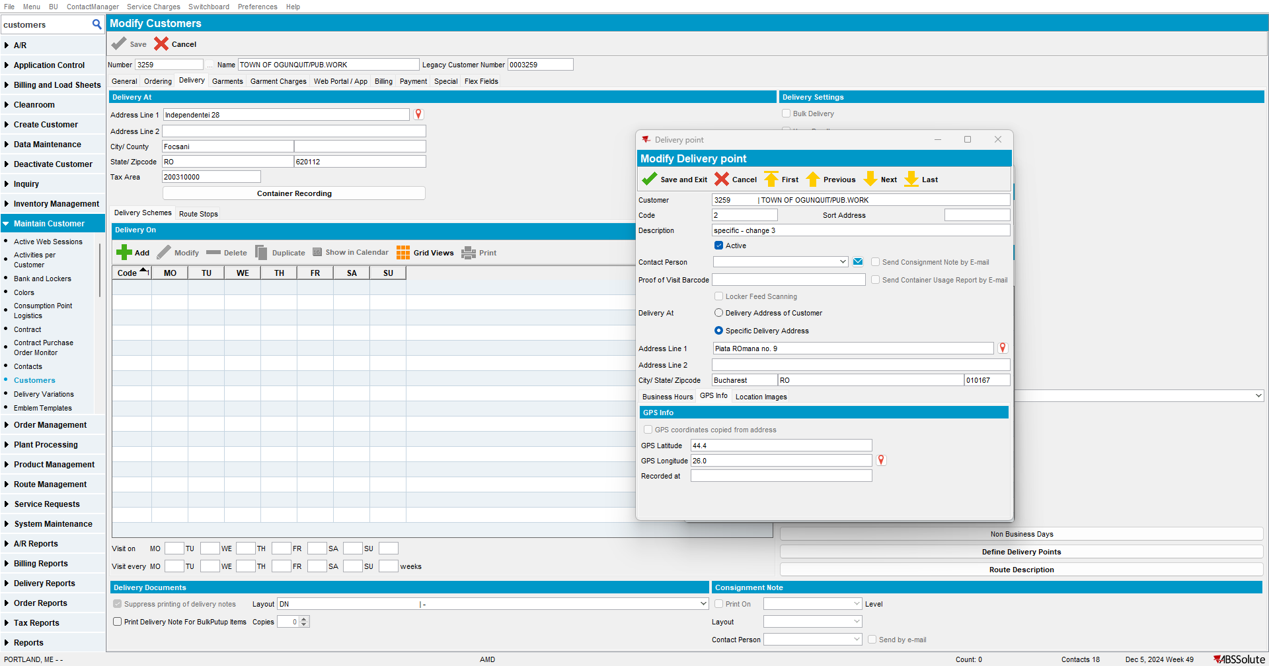
- No call is made to the geocoding service: this is correct
- No update is made on coordinates or address: this is correct

Step 4) Change the coordinates on the DP: notice the checkbox is remains unchecked. This is correct:
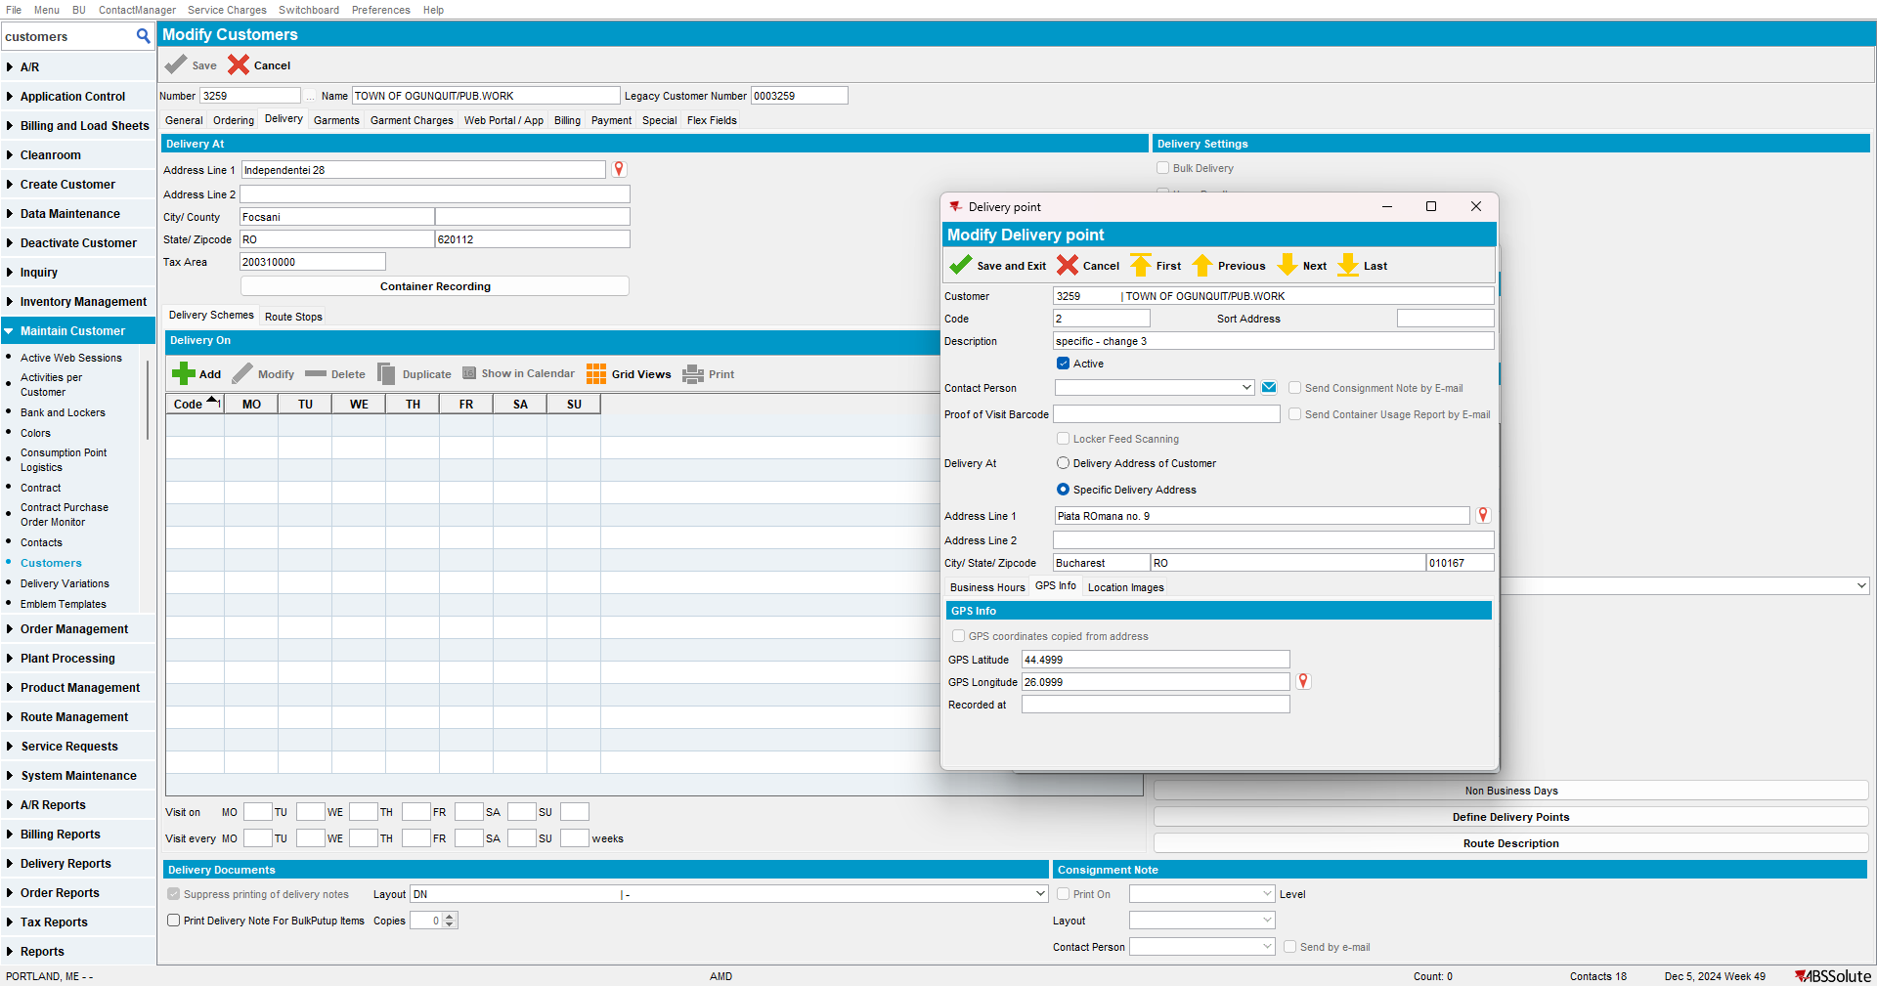
- No call is made to the geocoding service: this is correct
- No change is made on address table: this is correct

- The manual coordinates are set in the DP table: this is correct

- No warning message: this is correct

Step 5) Take a DP that uses the specific address (manual coordinates) and turn it into a customer one:
Initial DP:
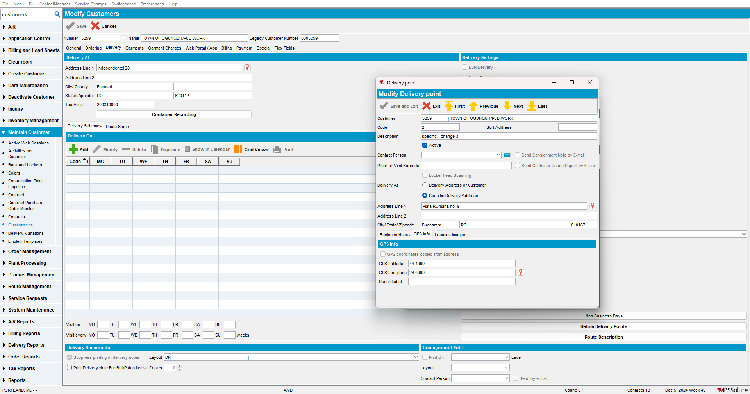
Change to customer address: notice the checkbox is not automatically checked (so the coordinates will not be taken from the customer address once it is saved)
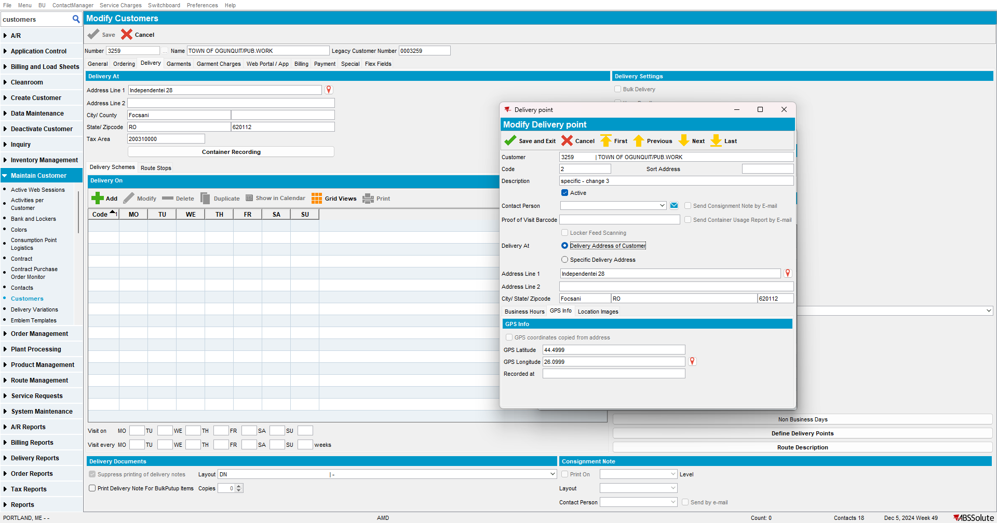
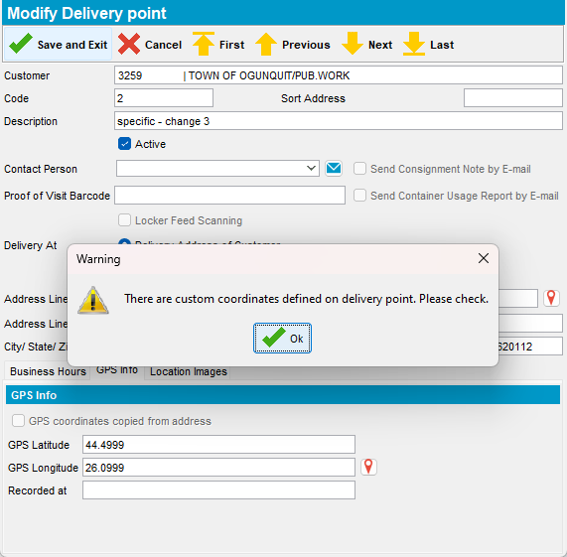
After Save: old manual coordinates remain in DP since manual coordinates have higher priority. This is correct:
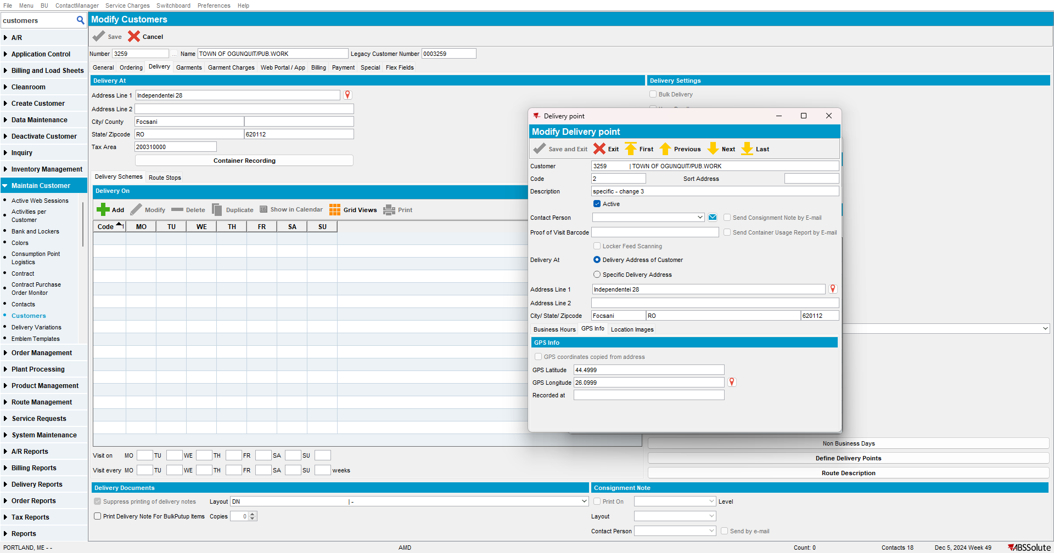
- Latitude and Longitude are not empty in the DP table: this is correct
- Information is in the Address table
- No call to geocoding service is made: this is correct
Step 6) Take a DP that uses the specific address (manual coordinates) and change the specific address:
Initial DP:
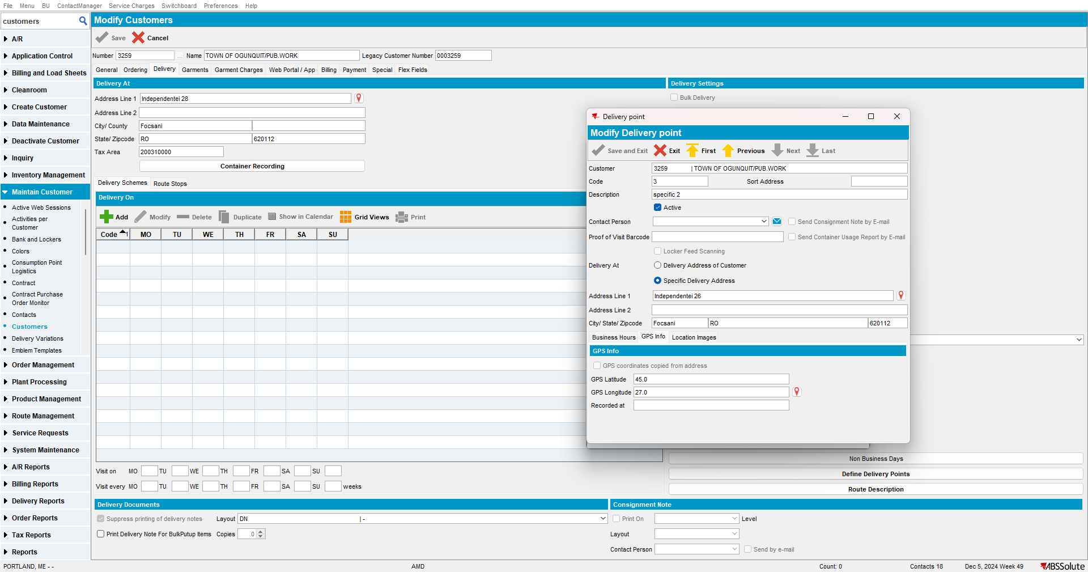

Change the specific address: notice the checkbox is not automatically checked (so the coordinates will not be taken from the new specific address once it is saved)
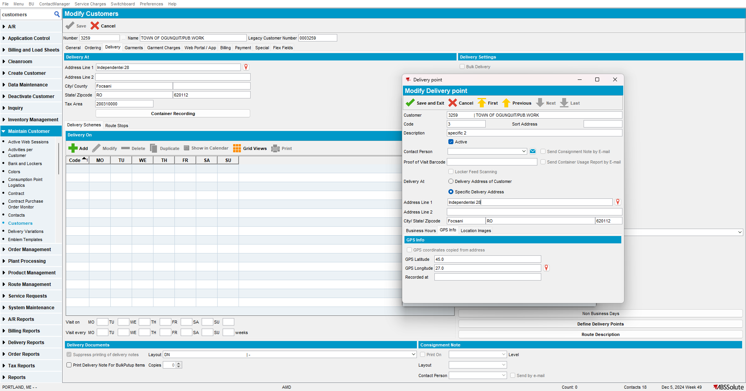
Notice warning correctly occurs:
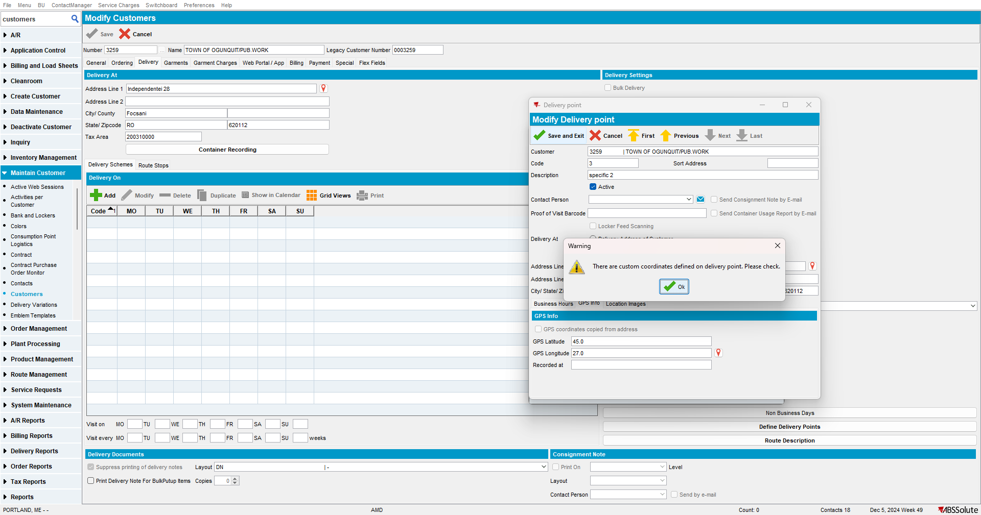
After Save: manual coordinates remain and are not updated to the specific address ones, because manual coordinates have higher priority. This is correct:
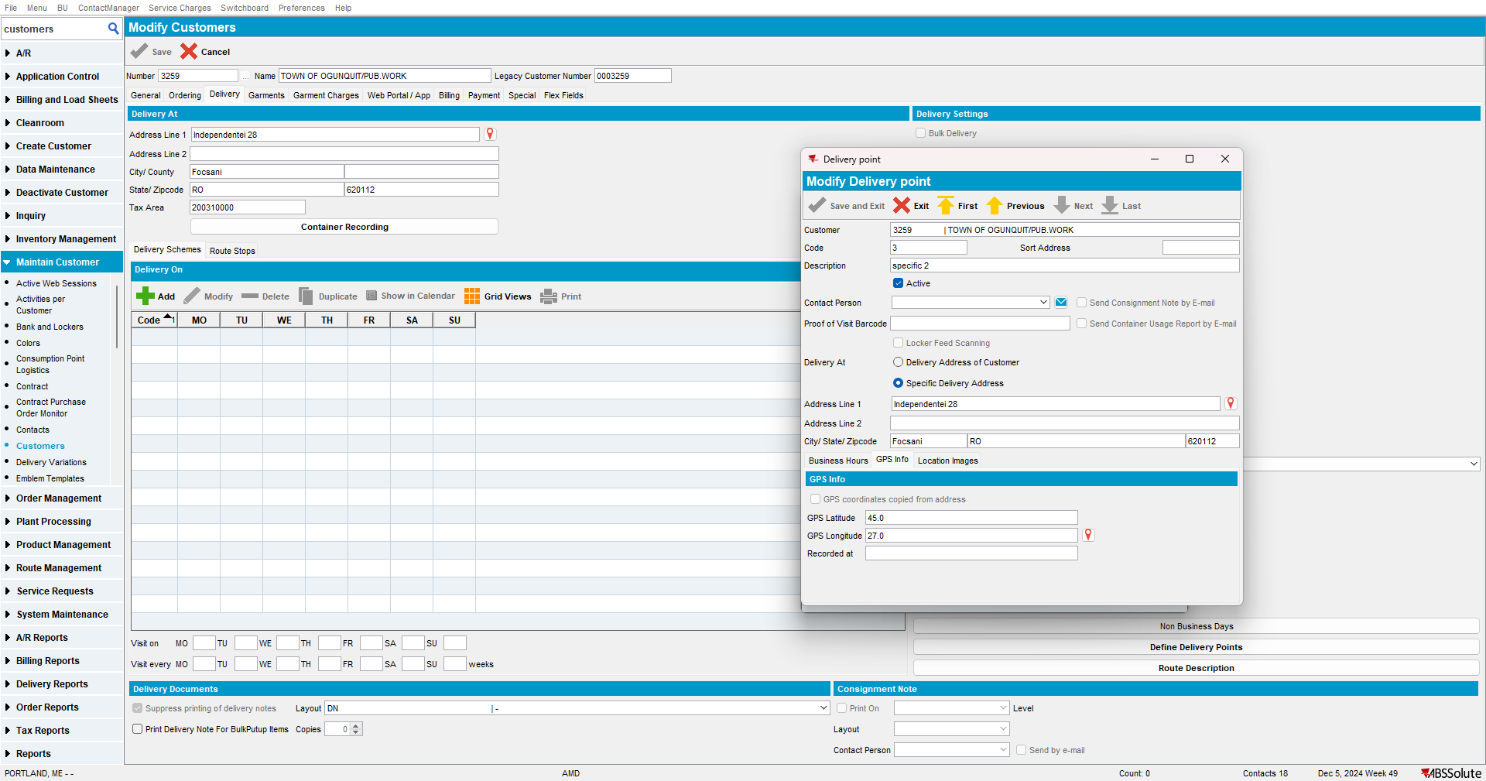
- Latitude and Longitude are not empty in the DP table: this is correct
- Information is added in the Address table:
- Call to geocoding service is made for the new address entry: this is correct
RETEST OK

Test Case 6: Switching back from manual coordinates to GPS coordinates copied from address - OK
Step 1) Select a DP that is using a specific address (having manual coordinates set)
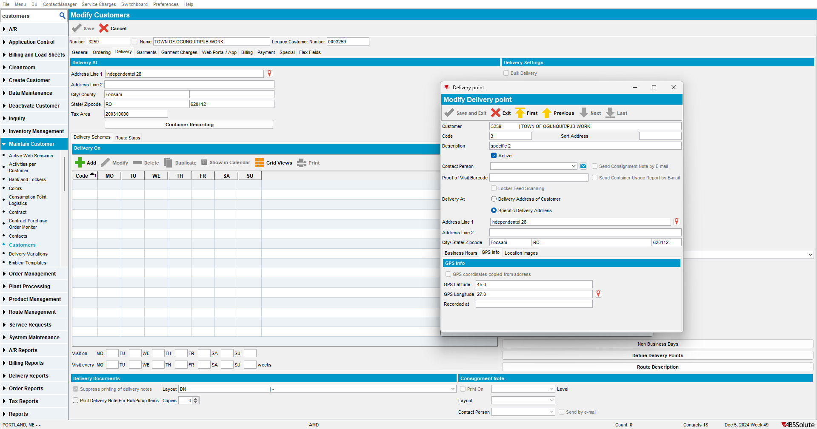
Step 2) Delete the existing coordinates and save:
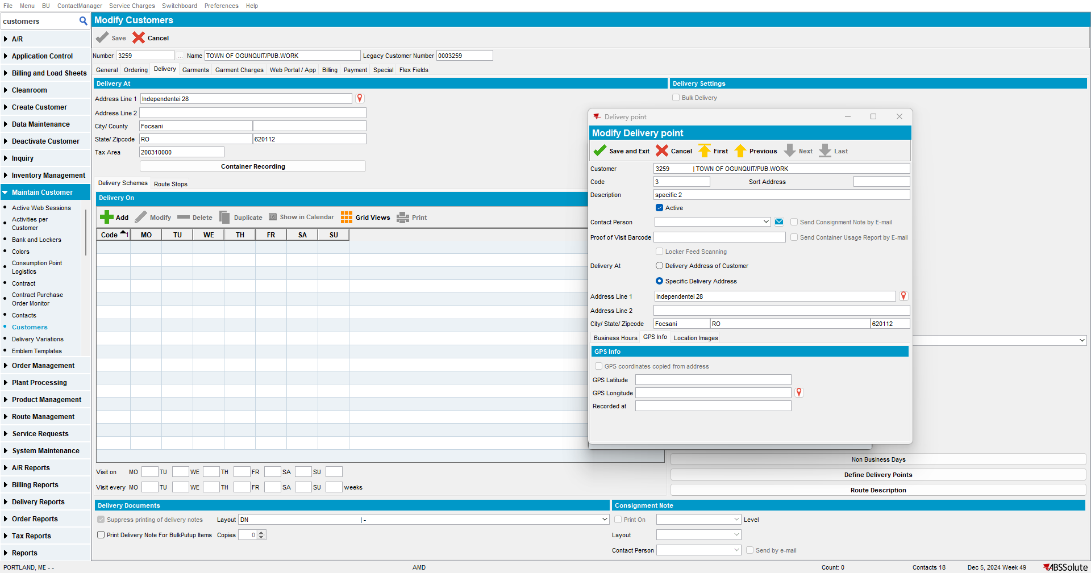
Notice the coordinates are automatically filled for the specific address:
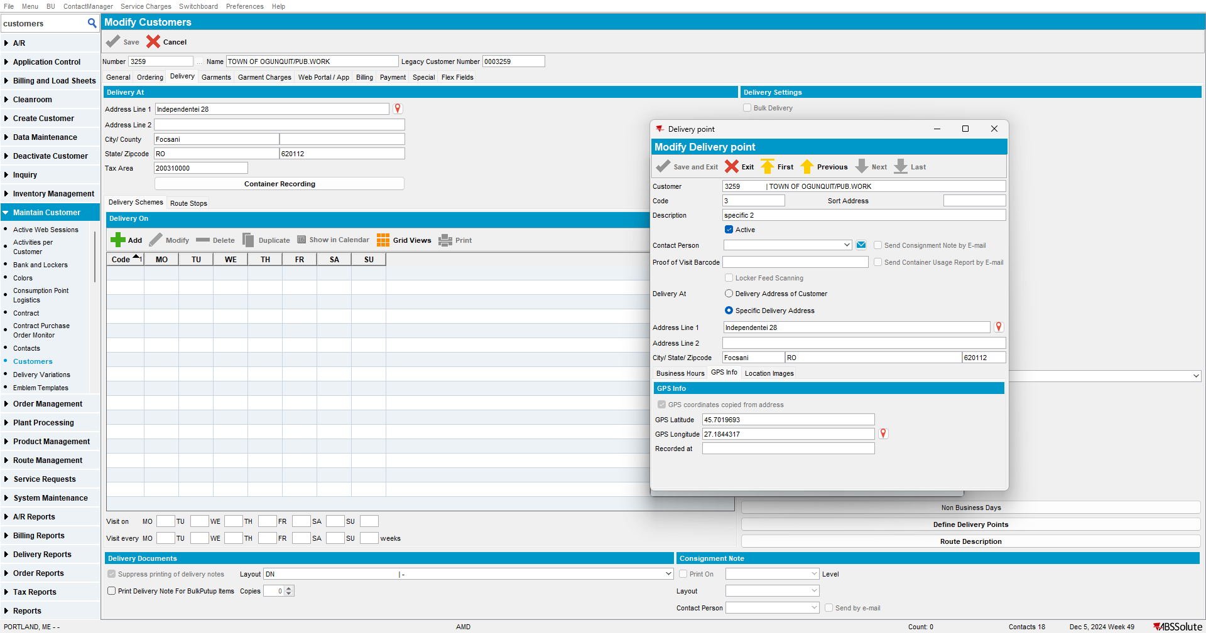
- There is no call to geocoding service made: this is correct
- Latitude and longitude are removed from the DP table: this is correct

- No change to the address table (the coordinates are taken from here according to the address_ID): this is correct
Step 3) Select a DP that is using a customer address (having manual coordinates set)
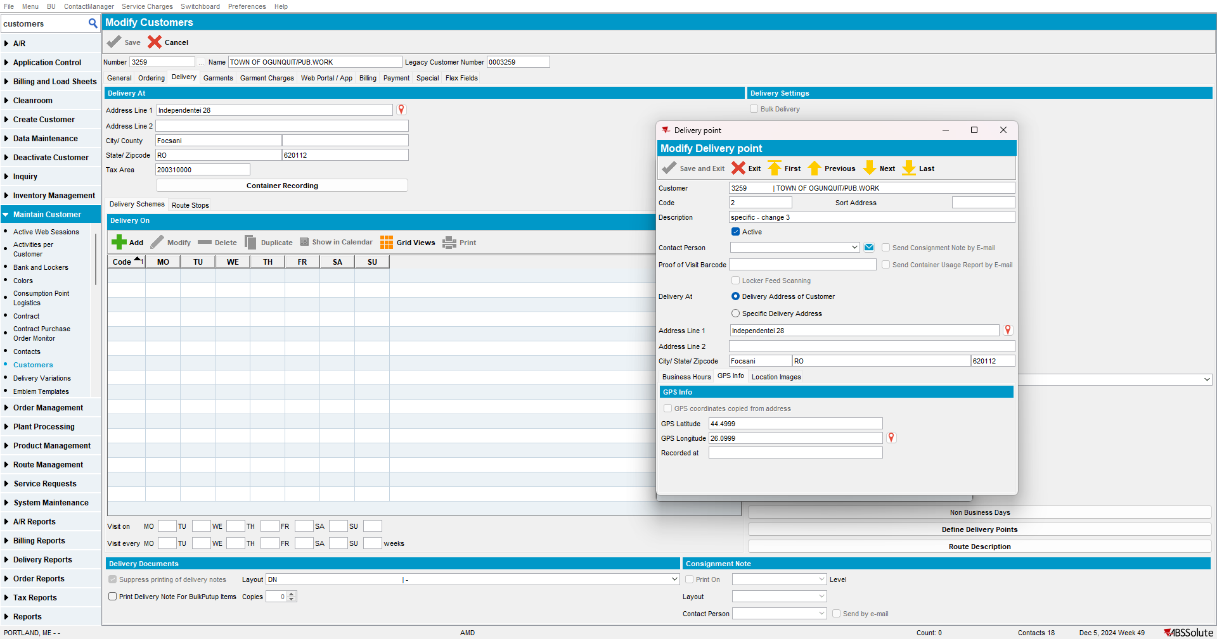
Step 4) Delete the existing coordinates and save:
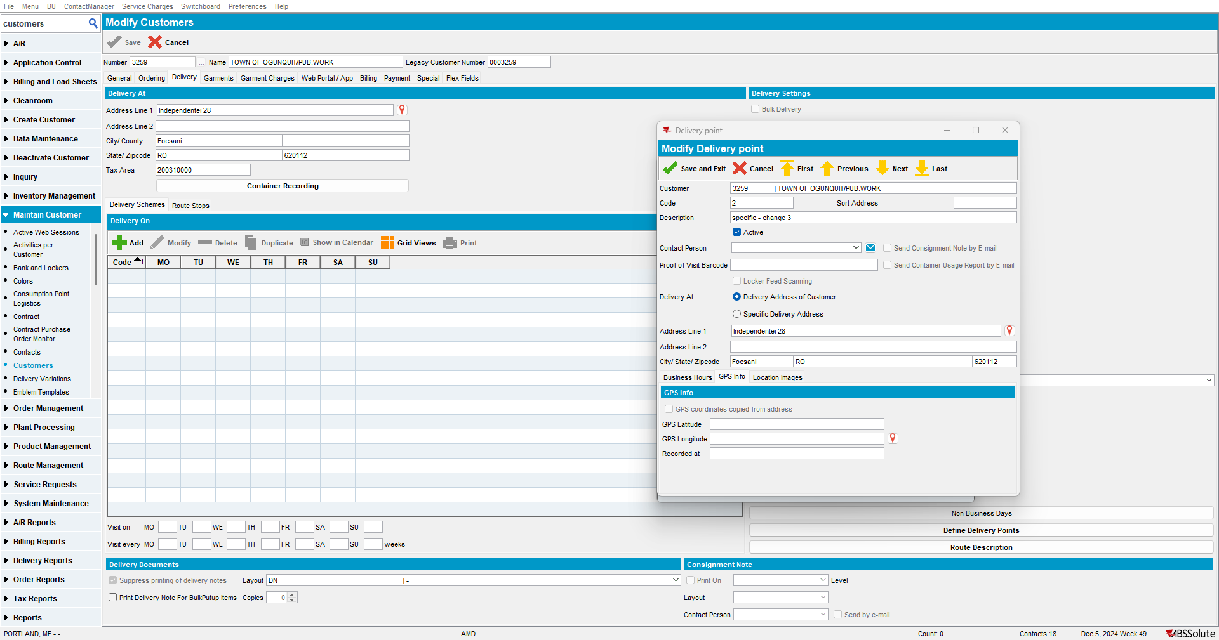
Notice the coordinates are automatically filled for the customer address:
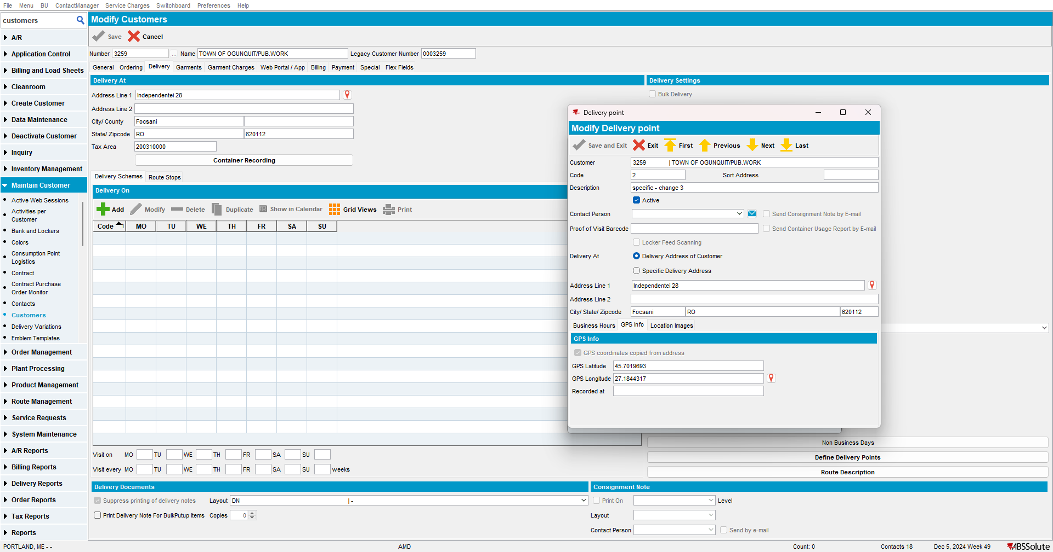
- There is no call to geocoding service made: this is correct
- Latitude and longitude are removed from the DP table: this is correct
- No change to the address table (the coordinates are taken from here according to the address_ID): this is correct
RETEST OK

Test Case 7: Adding new DP - OK
Step 1) This is the address on customer level:
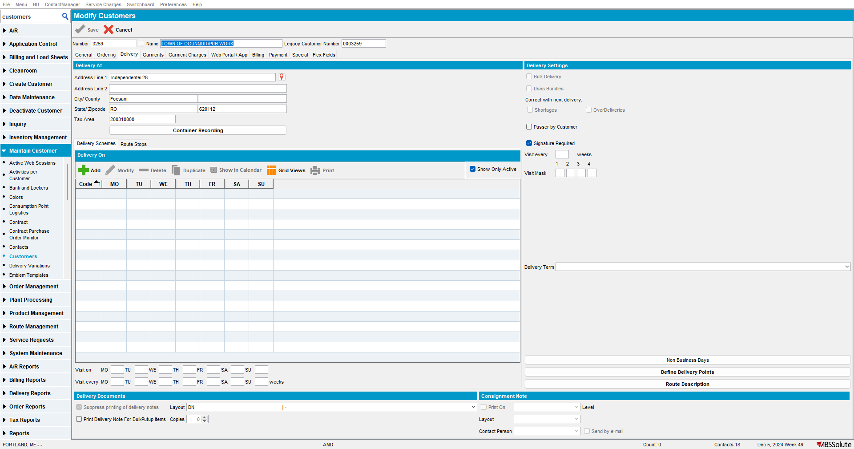
Step 2) Add a new DP that uses customer address and its coordinates: when selecting the option, the checkbox for GPS coordinates is automatically checked:
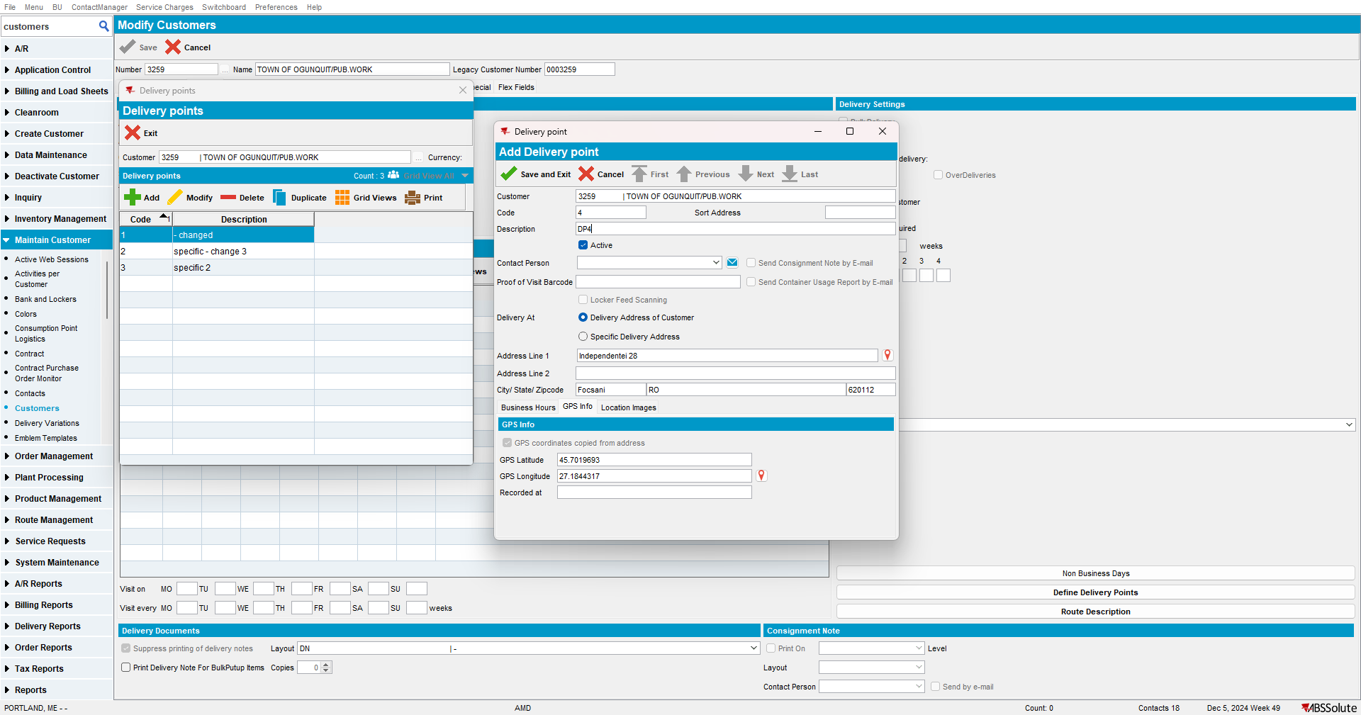
Notice DP is added correctly:
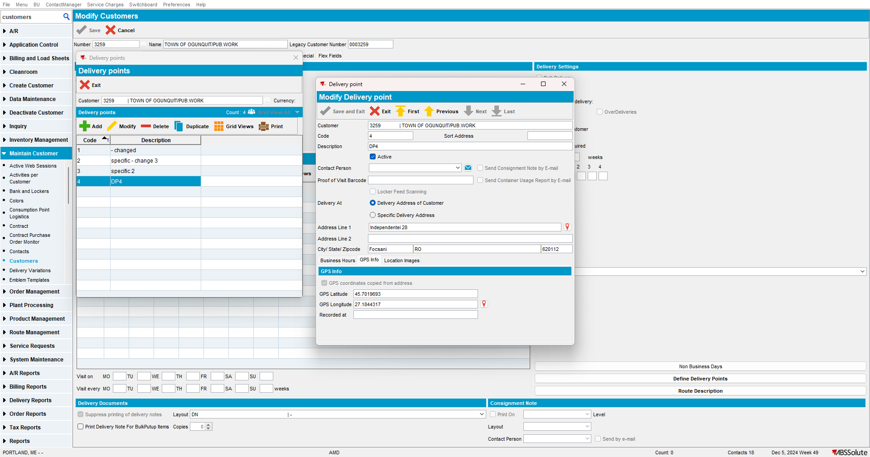
Added in DP table without Latitude and Longitude:
Address exists in Address table:

No geocoding service call.
Step 3) Add a new DP that uses customer address and manual coordinates:
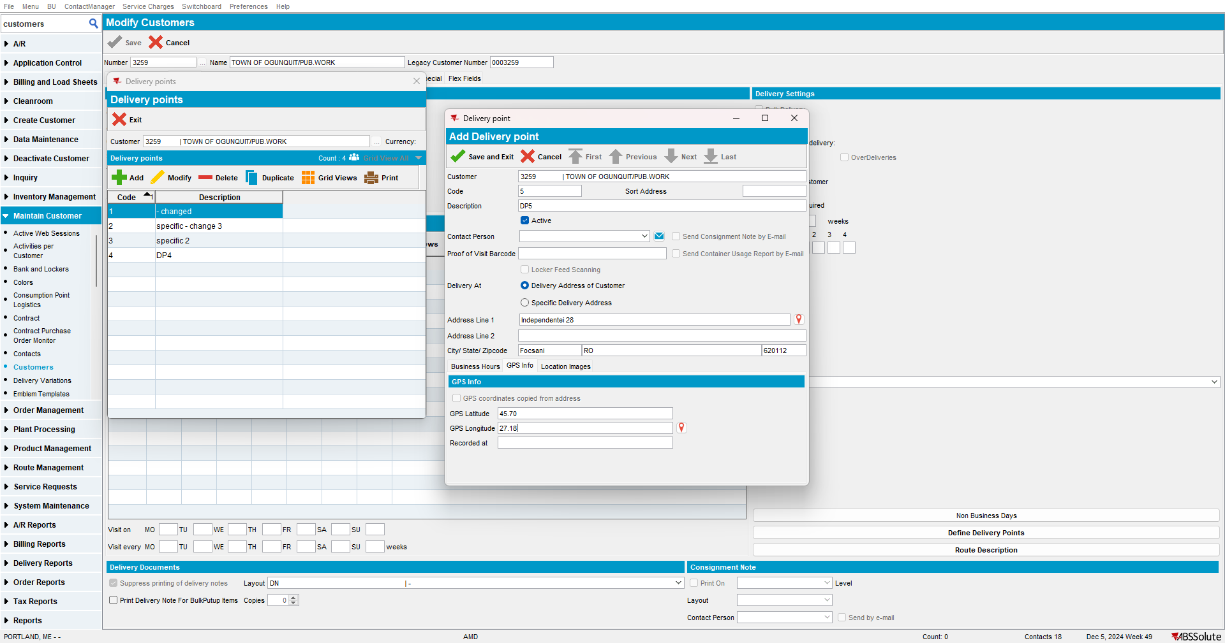
Notice DP is added correctly:
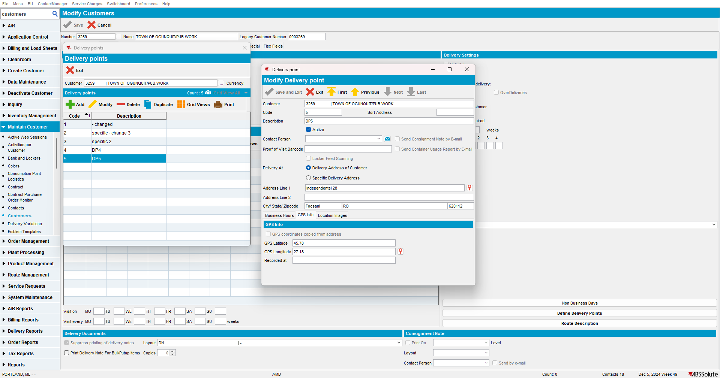
Added in DP table with Latitude and Longitude:

Address exists in Address table:

No geocoding service call.
Step 4) Add a new DP that uses specific address and its coordinates (checkbox is automatically checked):
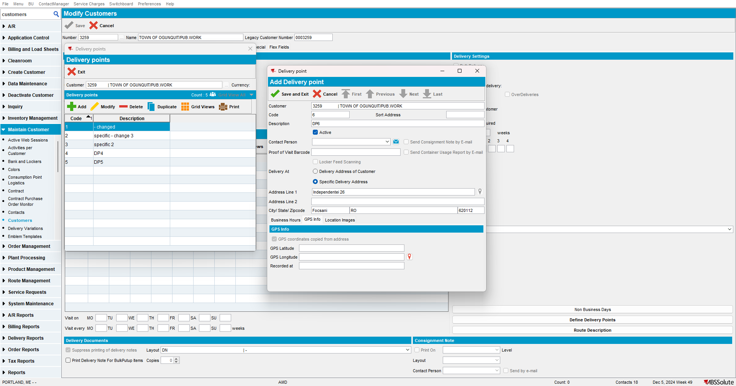
Notice DP is added correctly:
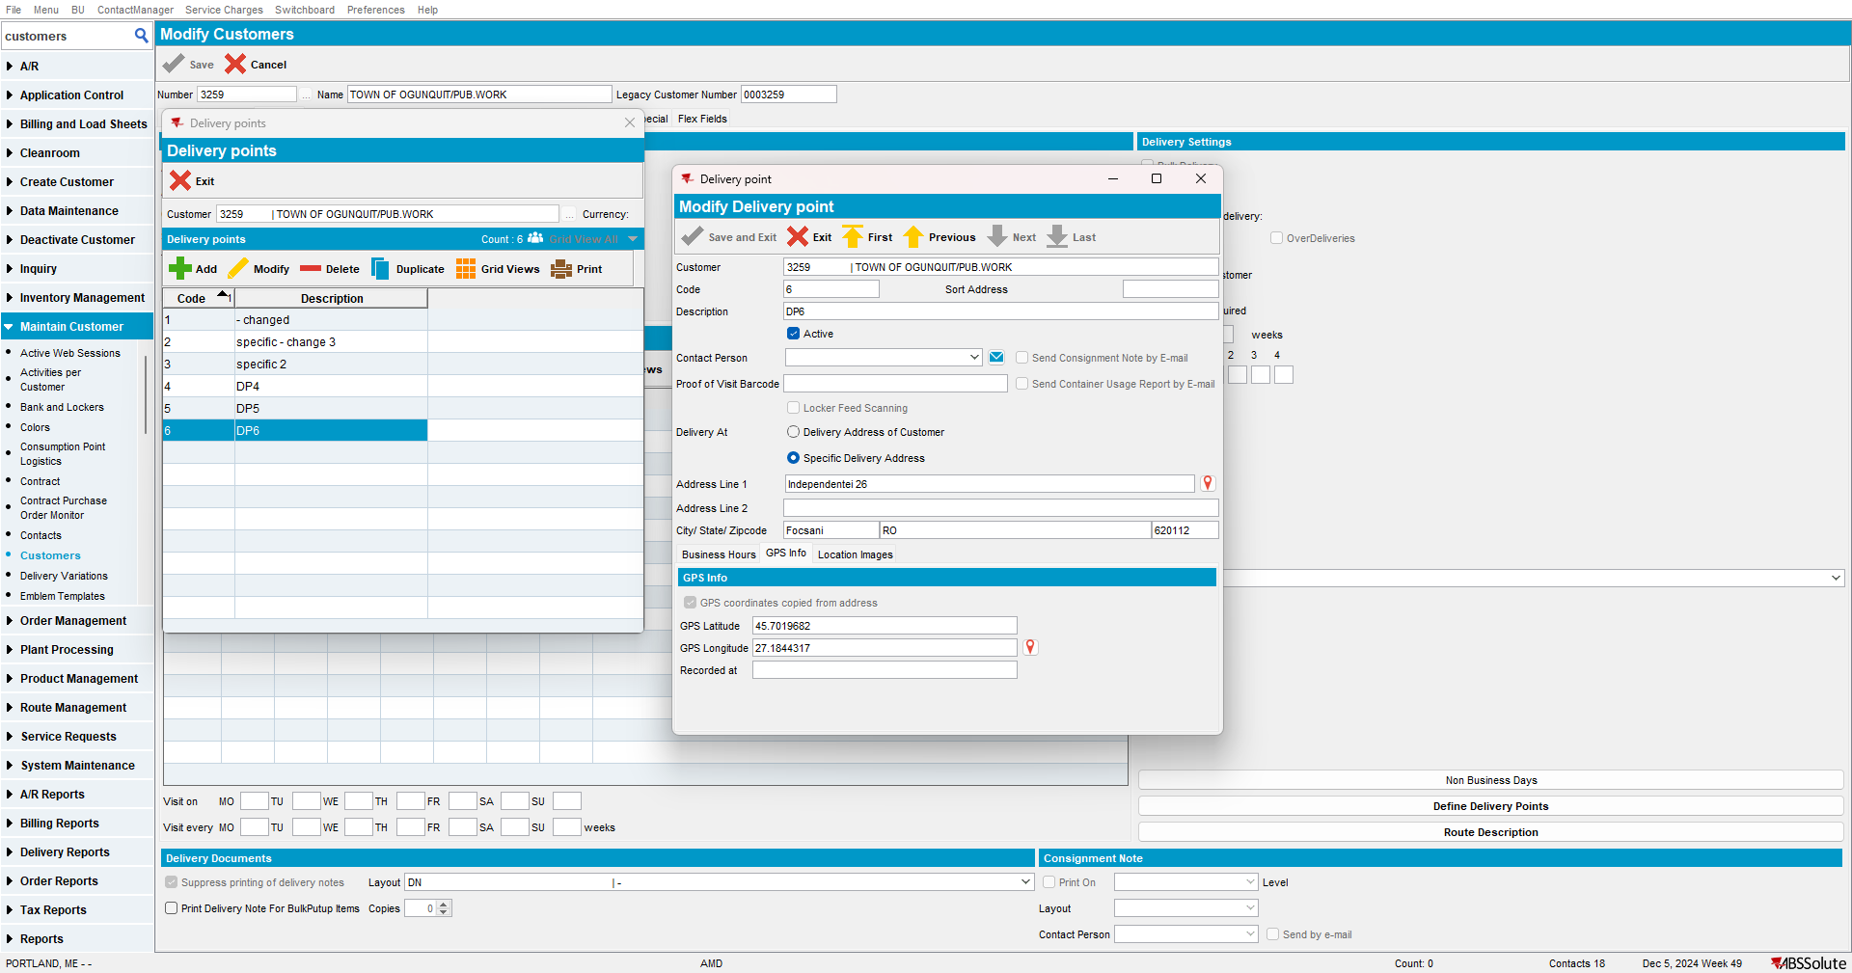
Added in DP table without Latitude and Longitude:

Address is added in Address table:
A geocoding service call is made for the new address:
Step 5) Add a new DP that uses specific address and manual coordinates (checkbox is automatically checked but user may entry manual coordinates and box will uncheck by itself):
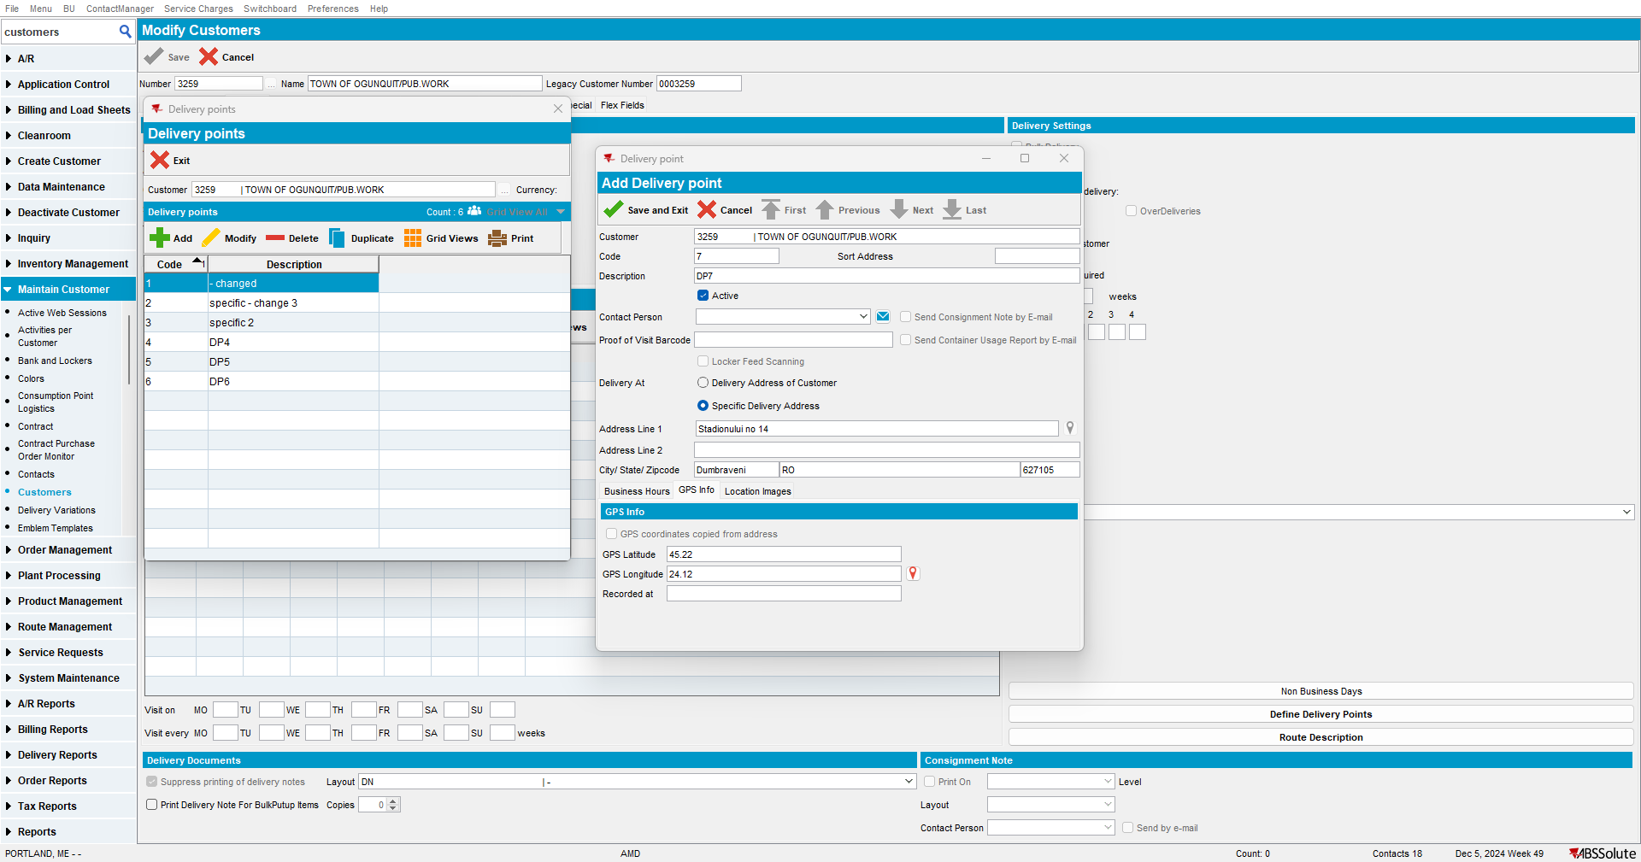
Notice DP is added correctly:
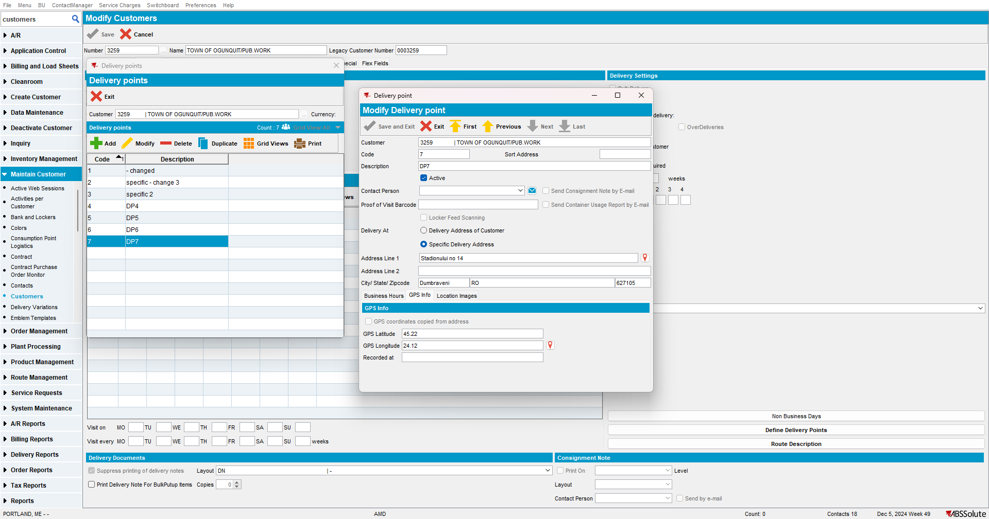
Added in DP table with Latitude and Longitude:
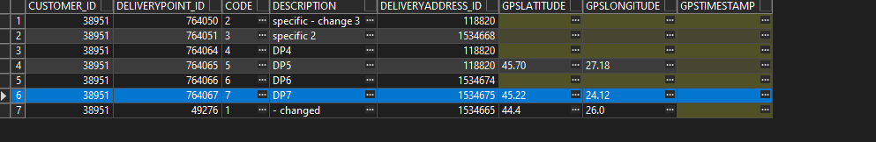
Address is added in Address table:
A geocoding service call is made for the new address:
RETEST OK

Test Case 8: Inquiring mode - OK
Step 1) Load customer and do not open it in modify mode.
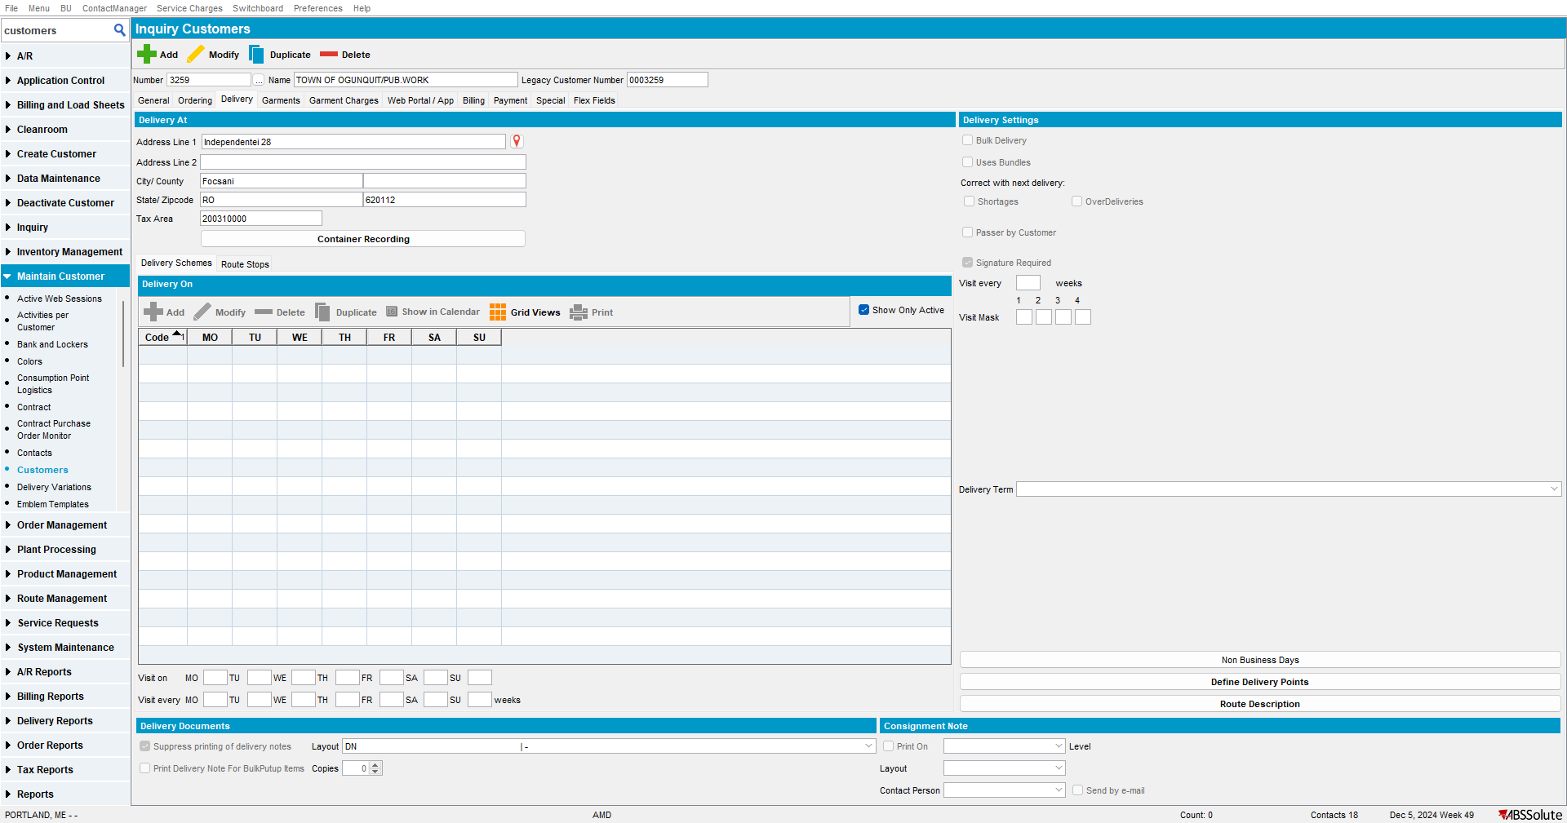
Step 2) Open delivery points. No calls to geocoding service are made. This is correct:
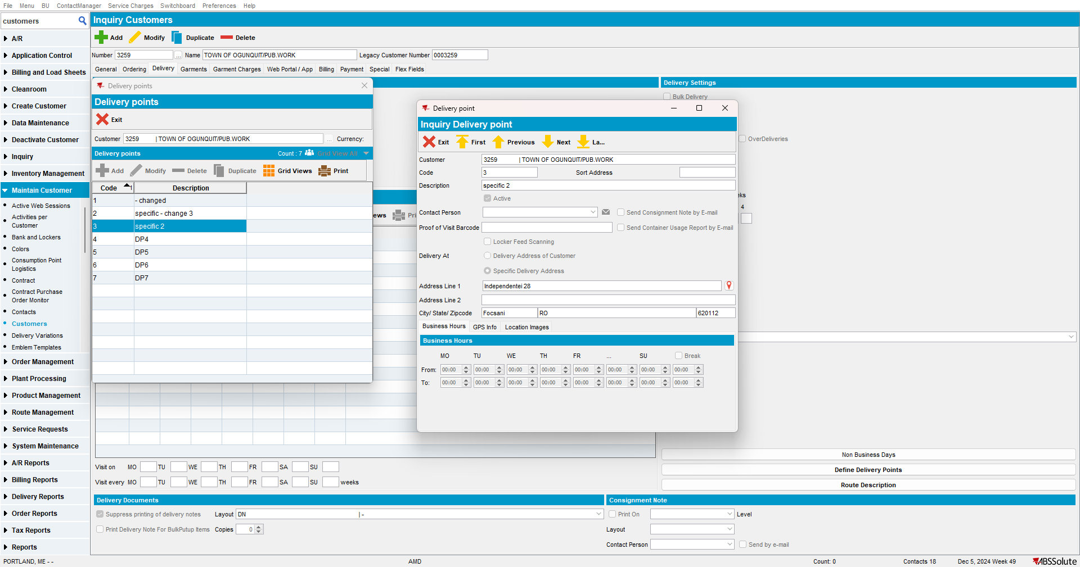
RETEST OK

Test Case 9: Map route from RSC – OK
Step 1) Go to Route Status Control and add a route. Make sure customer 1052868 is a stop to be visited.
Step 2) Map route:
This is the address on the DP which is being used:
Step 3) Delete the coordinates for this DP:
Step 4) Map route again:
Coordinates are filled:

Step 5) Set the DP to Delivery Address of Customer

Step 6) Add the route and map: works OK
Step 7) Remove the GPS from the address:
Step 8) Map route again: notice the coordinates were filled and geocoding service call was made:
Step 9) Set the route to use a DP that has a specific address – but manual coordinates (these coordinates should have the priority):
This is the DP: it has specific address in Bucharest, but the coordinates are for Timisoara:
Add the route and map it: notice the location is in Timisoara (so the manual coordinates have priority). This is correct:
RETEST OK
Note: calls to Geocoding service are not done when using next/previous buttons, not even when changes are done on DP and user saves the changes, if the changes are not related to the address or coordinates. The call will be made if the user changes something on a DP that is missing coordinates for it’s address. This is correct.

