ABS-165737 D_UBS_2460 Using Bill Loss Now on garments with a $0.00 Replace price does not rag the garments

Environment | Prerequisites
Version:9.07.00  DBServerName=abs-SRV20.internal.abslbs.com  DBSID=CUST24  DBUser=UNFDEV  DBPassword=UNFDEV  Environment=Test | - Module:  - System setting

Contents
ABS-165737 D_UBS_2460 Using Bill Loss Now on garments with a $0.00 Replace price does not rag the garments 1
Test after fix 1
Test Case 1 – PROCESSLOSSINSETTLEMENT = 1 – Tested OK 1
Test Case 2 – PROCESSLOSSINSETTLEMENT = 0 – Tested OK 10

Test after fix

Test Case 1 – PROCESSLOSSINSETTLEMENT = 1 – Tested OK
Expected behavior: Wearer 1 and Wearer 2 garments SHOULD get ragged by settlement when replacement price is 0$ after the loss charges were either added or transitioned from Extended = 'N' to 'Y' with Bill Loss now transactions on RA
Hash: 3ca895a
- Set SS PROCESSLOSSINSETTLEMENT=1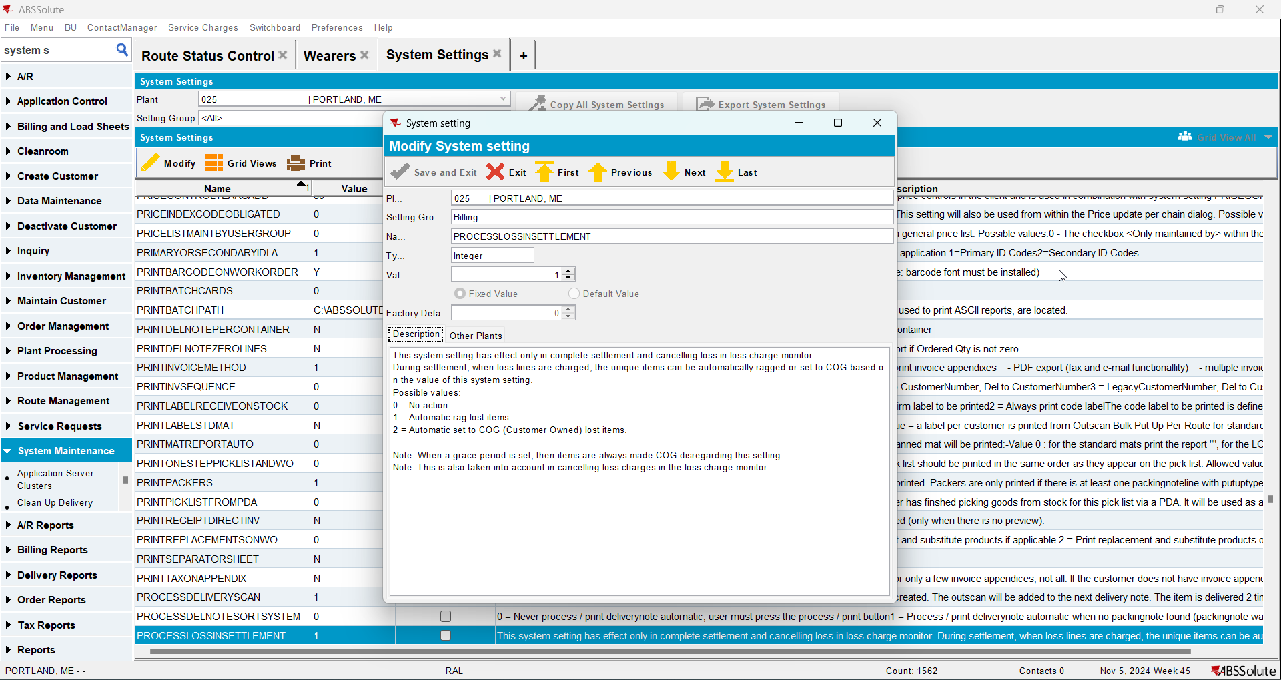
- Find a customer with wearers
- Wearers DLG: Find 2 active wearers inventory with equal circ/max using the same product (Wearer 1 and Wearer 2)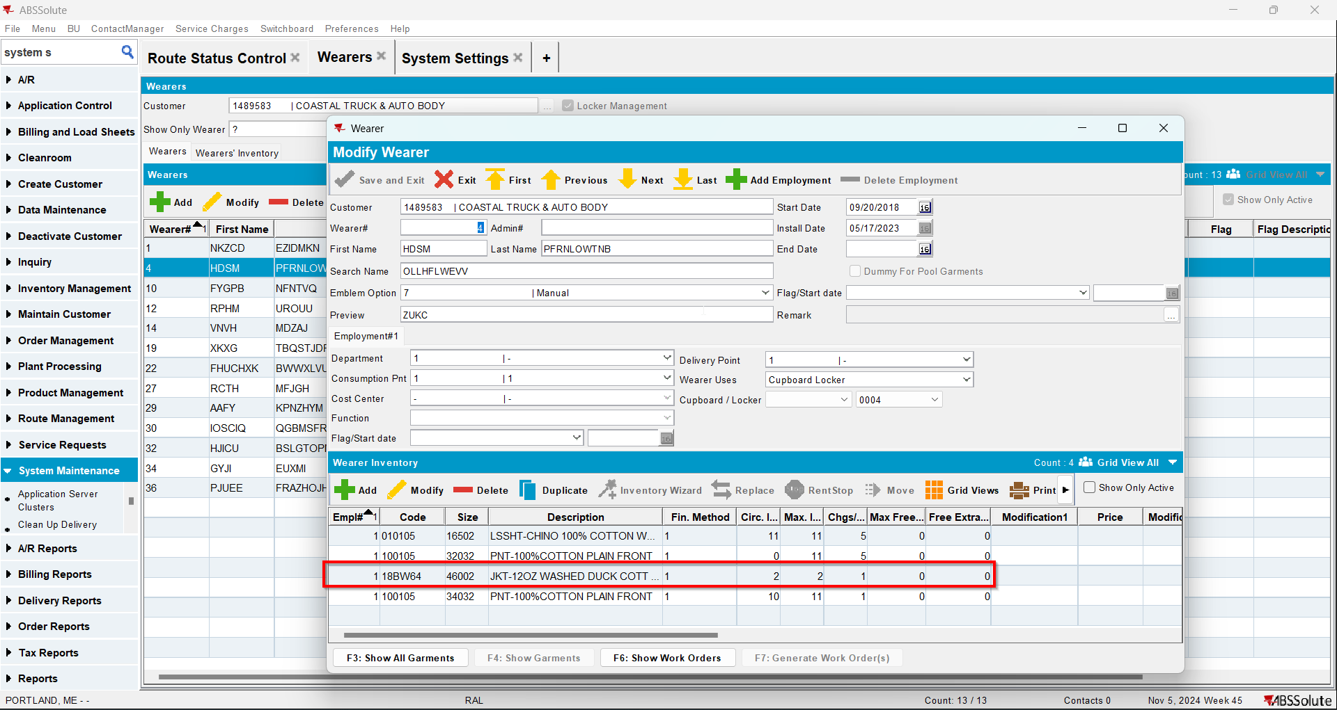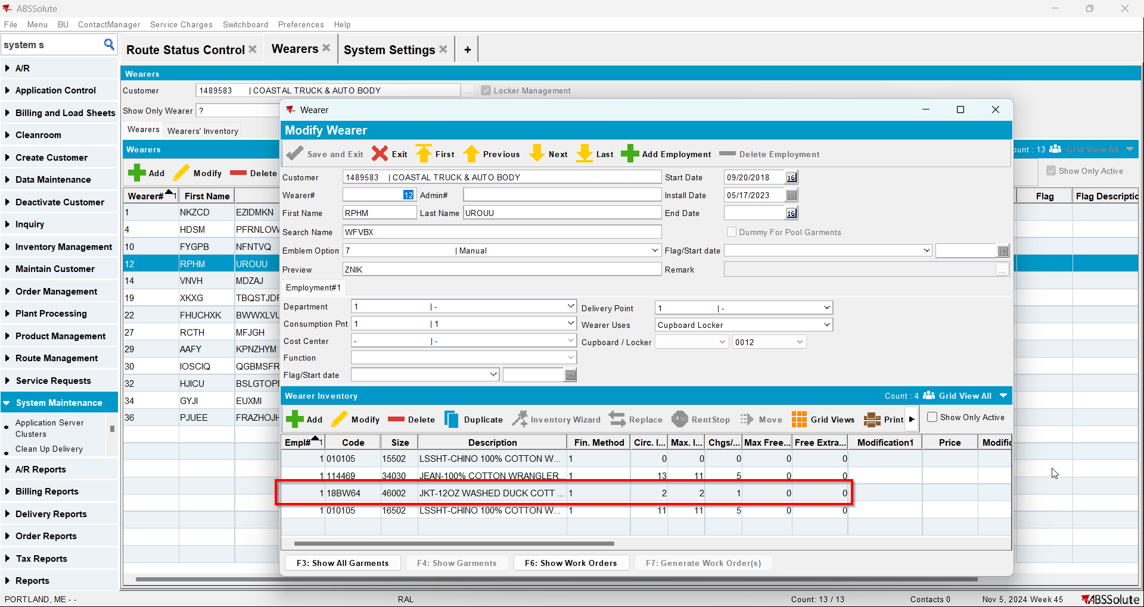Contract DLG: Load the contract for your customer
- Contract DLG: Find the product your wearer inventory(s) use and add a new replacement price to 0$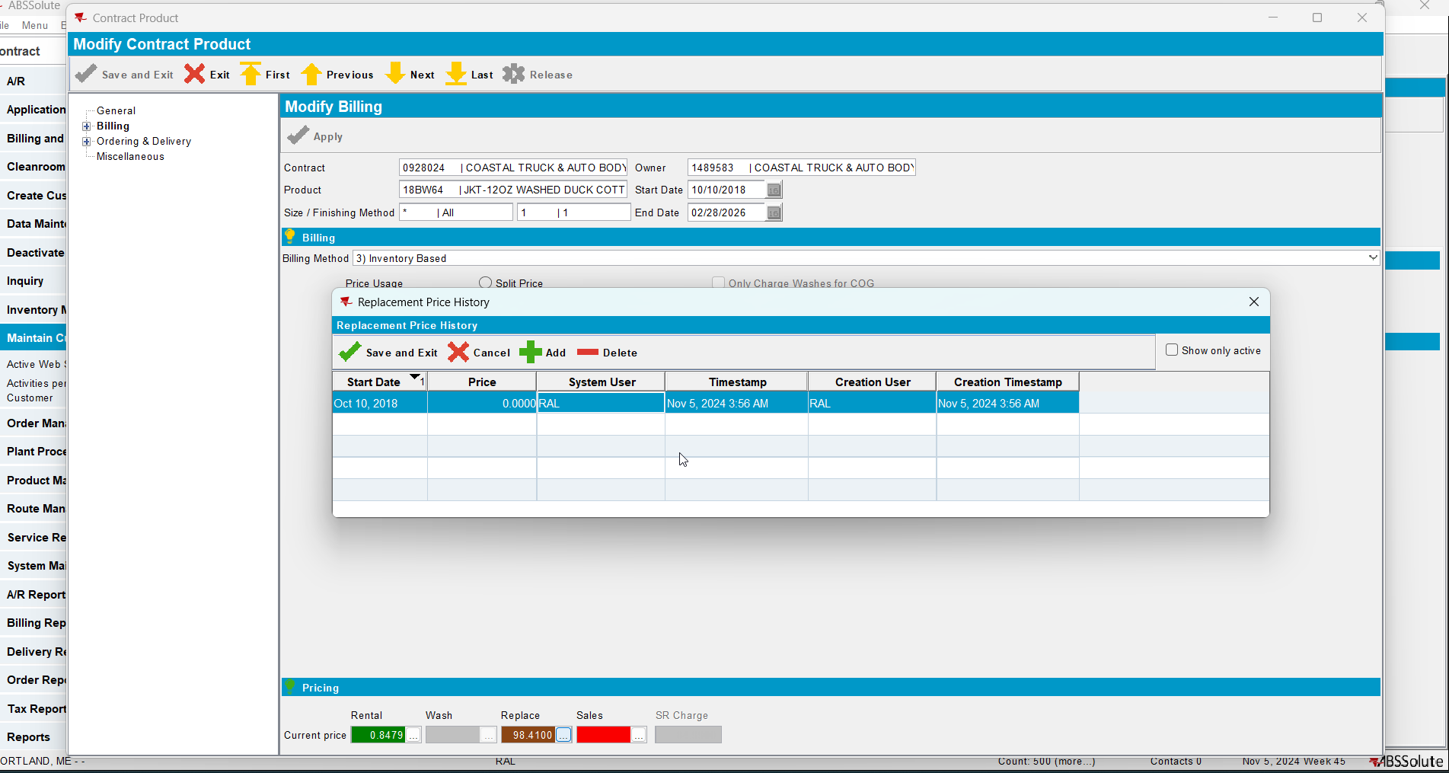
- Contract DLG: Click Update Customer and select your customer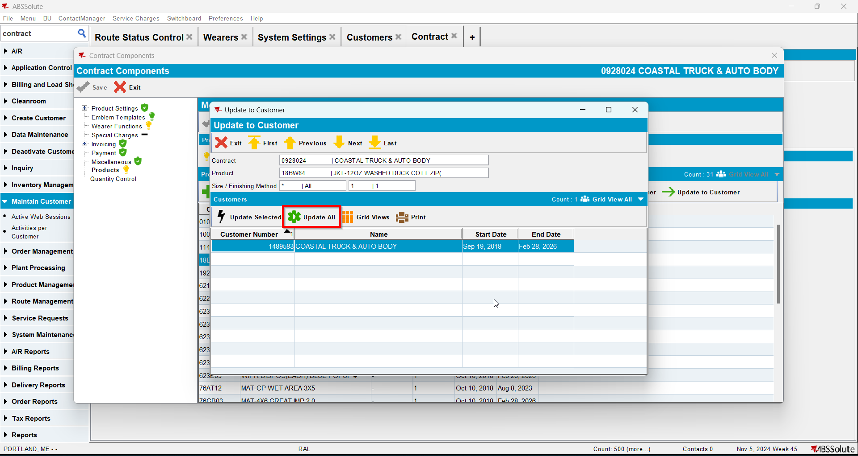
- PLPC DLG: Go to the product you just updated and make sure it is 0$ price for replacement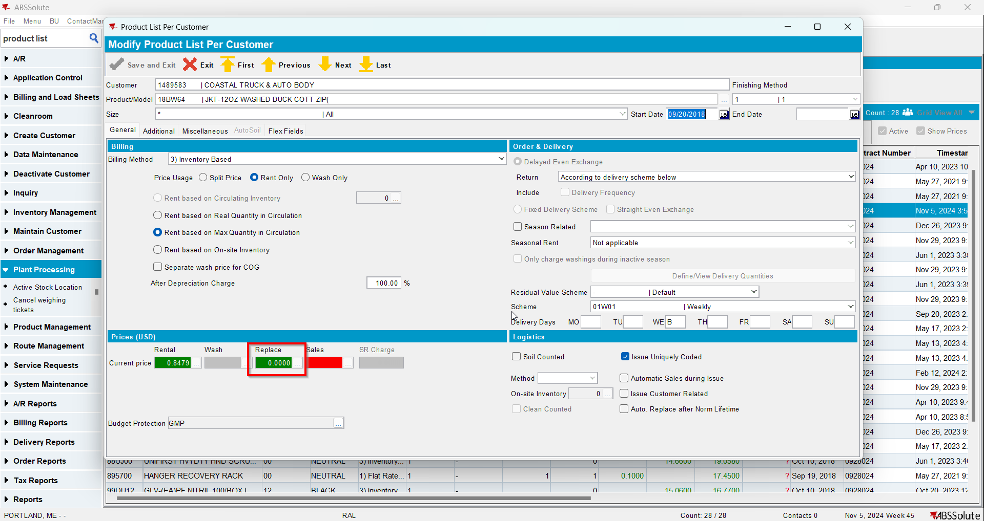
- Wearers DLG: Quit Wearer Inventory for Wearer 1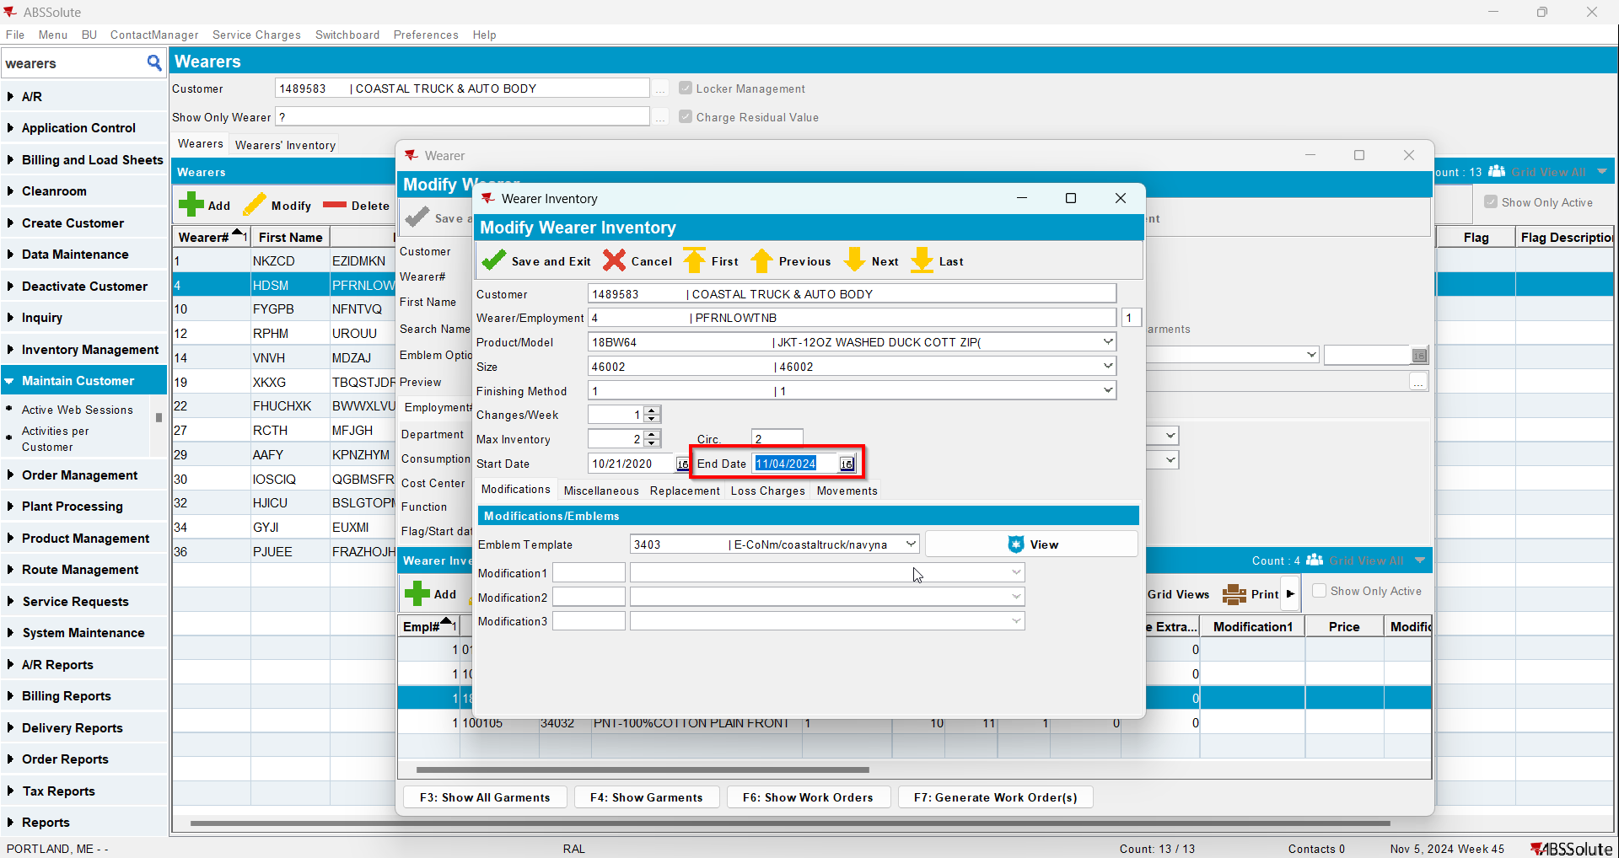
- RSC DLG: Generate invoices for a route with the customer for the current week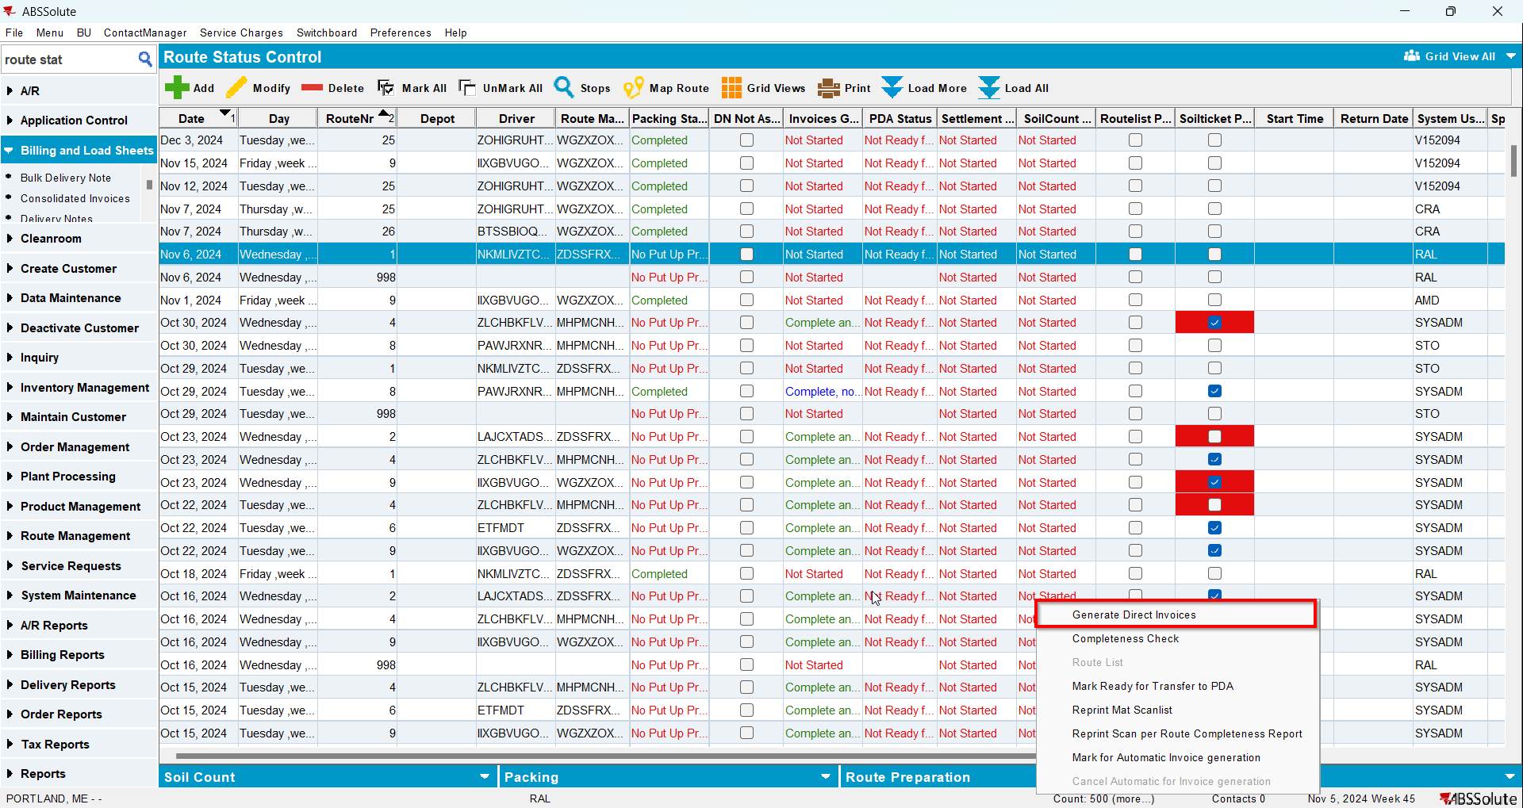
- Maintain Invoices DLG: Check that there is a Loss Charge for Wearer 1 with Extend = 'N'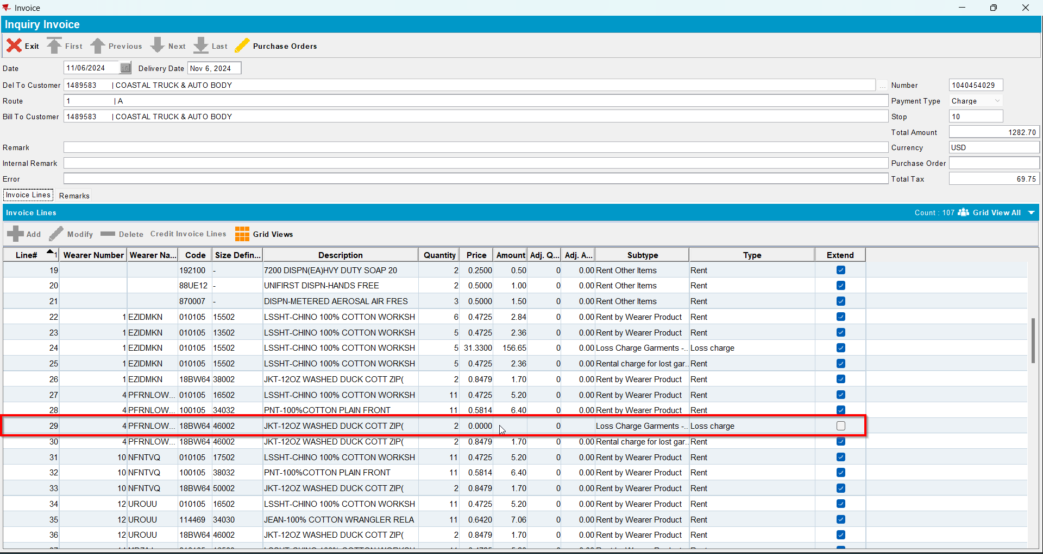
- Send the route to RA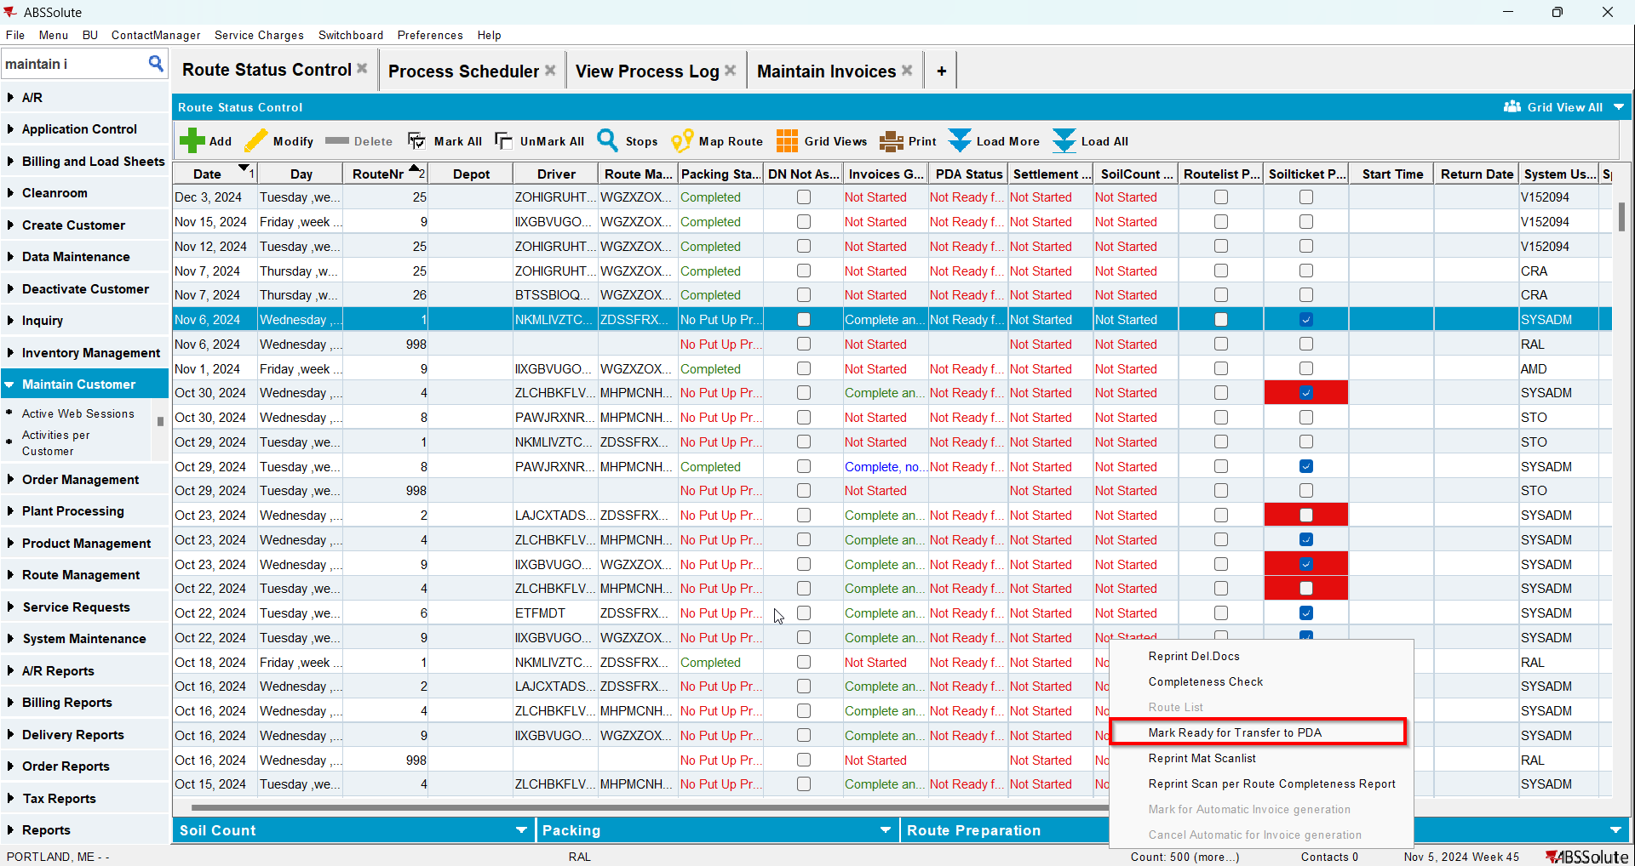
- RA: Download the route
- RA: Quit Wearer Inventory for Wearer 2
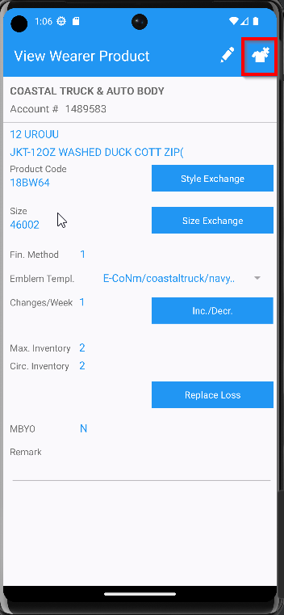
- RA: Return items> Bill Loss Now for garments from Wearer 1 and Wearer 2
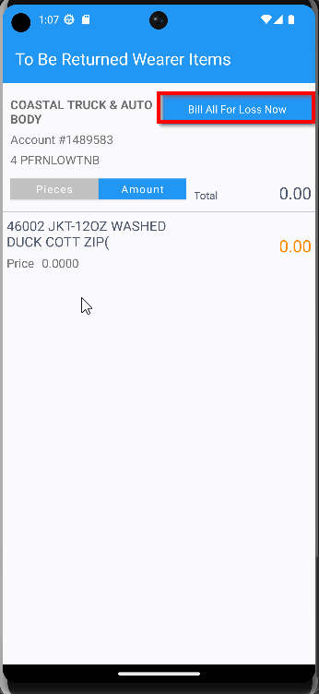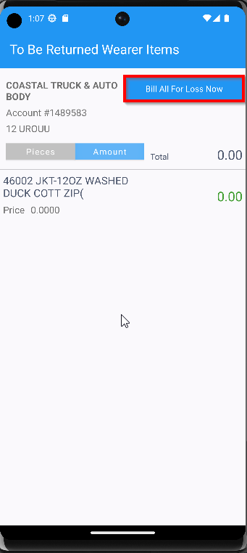
- Settle and upload the route
- WebX: Approve the invoice like adjustments
- WebX: Settle the route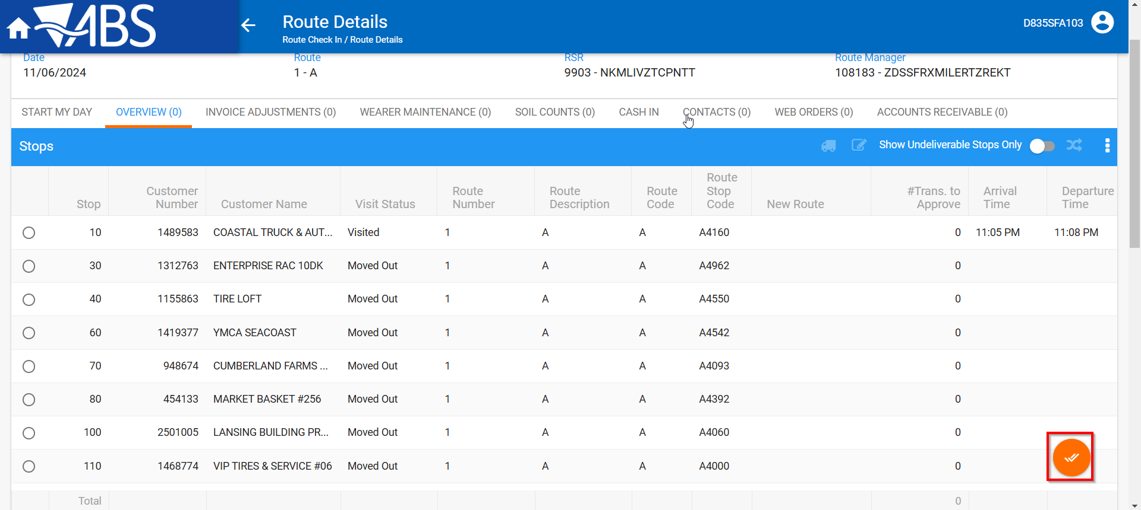
- Maintain Invoices DLG: Open the invoice and make sure you have two Loss Charge lines one is for Wearer 1 and the other for Wearer 2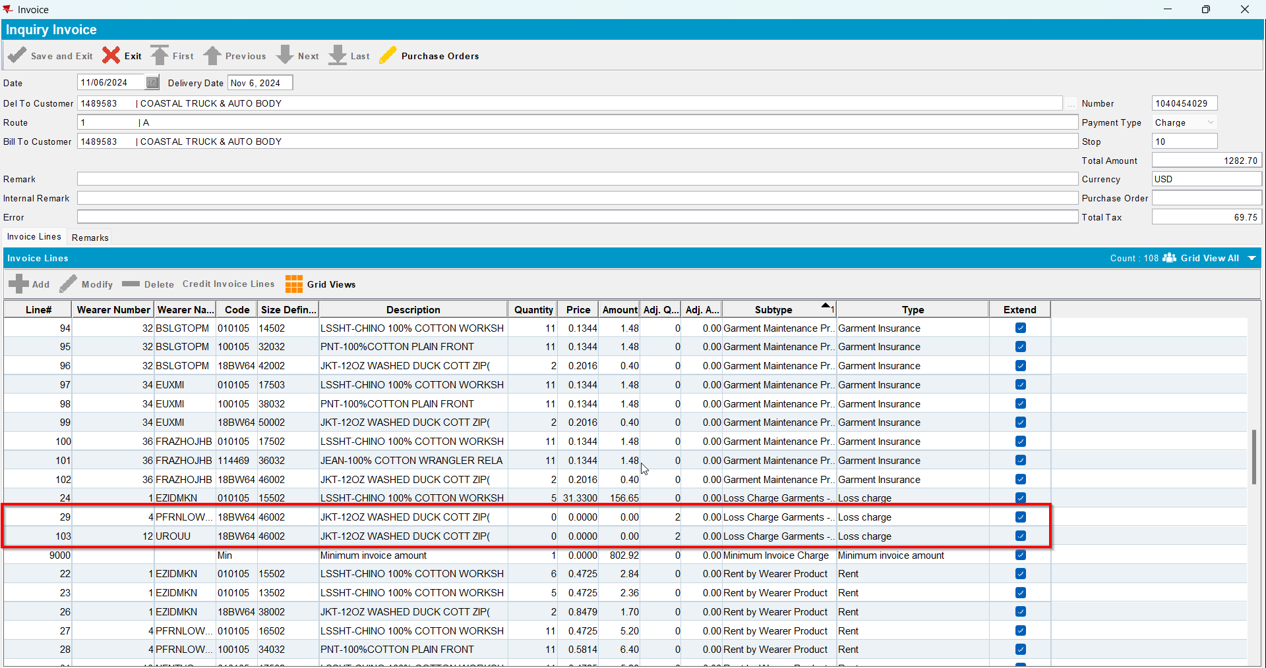
- Wearers DLG: Check Wearer 1 Garments to see if they were ragged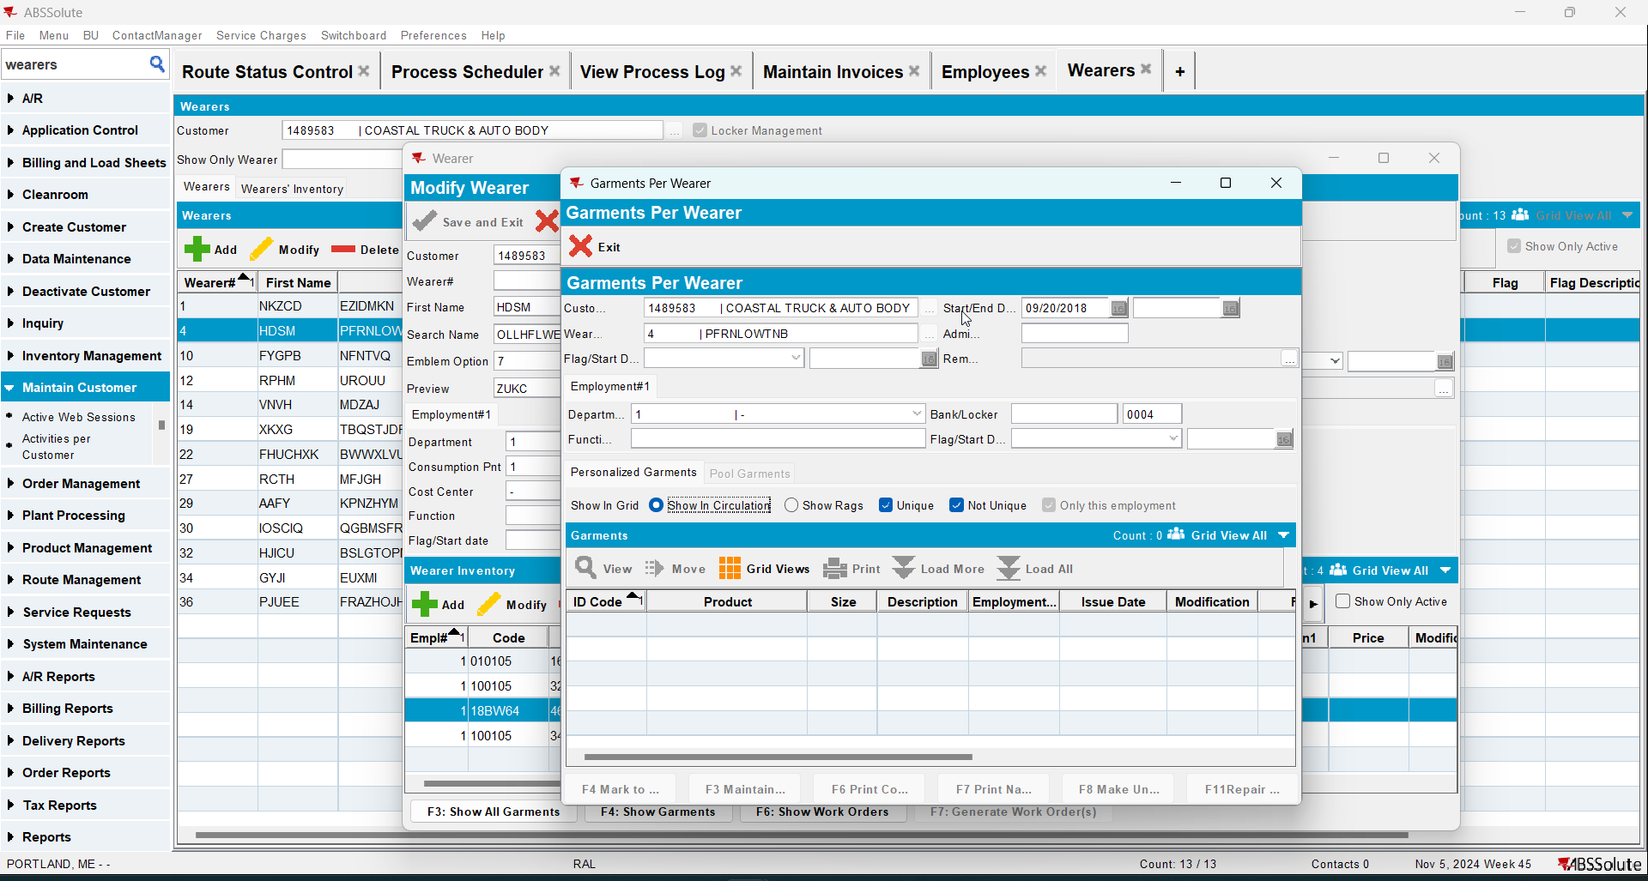
- Wearers DLG: Check Wearer 2 Garments to see if they were ragged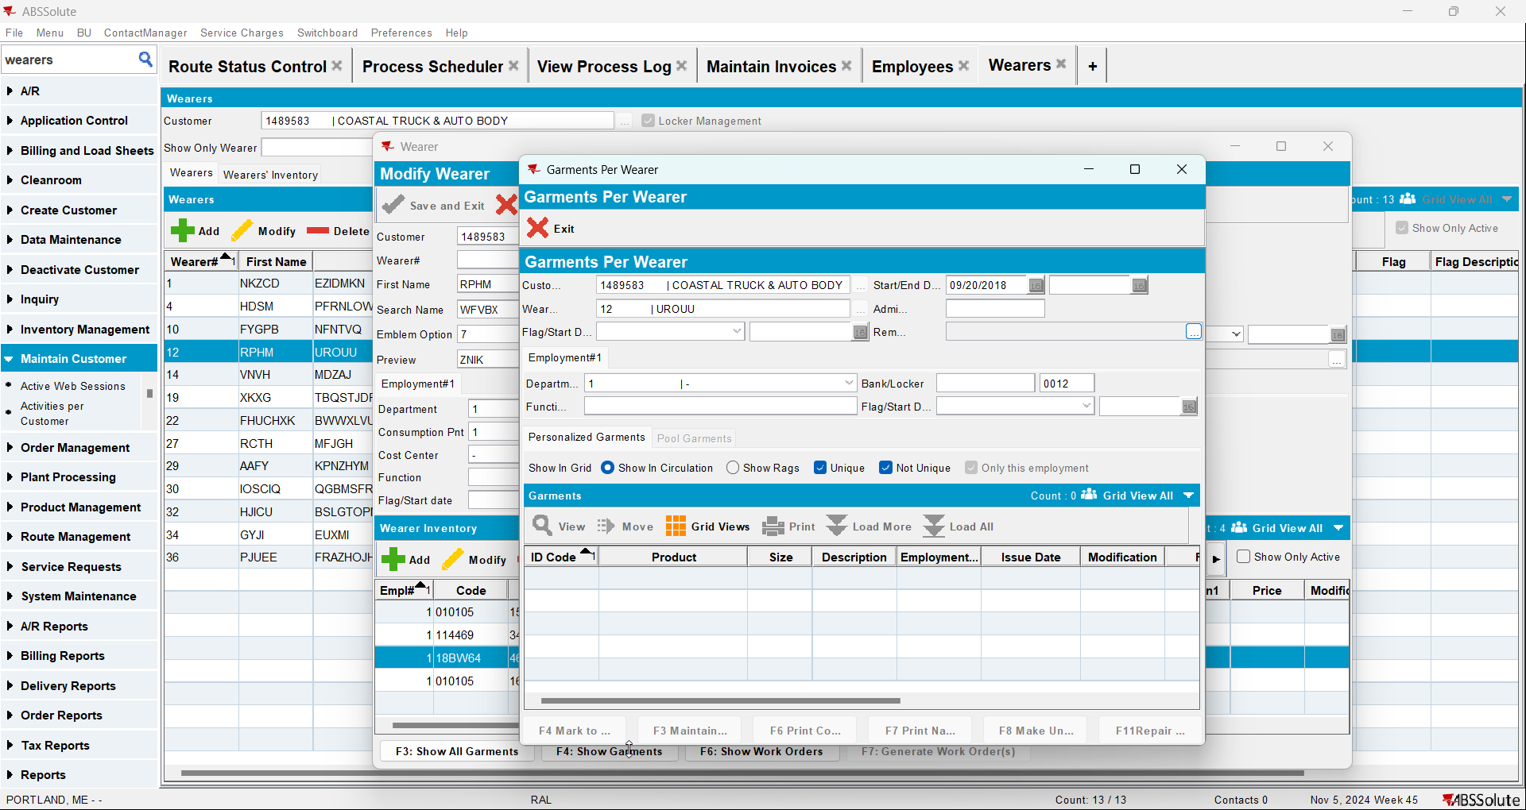

Test Case 2 – PROCESSLOSSINSETTLEMENT = 0 – Tested OK
Expected behavior: Wearer 1 and Wearer 2 garments SHOULD NOT get ragged by settlement when replacement price is 0$ after the loss charges were either added or transitioned from Extended = 'N' to 'Y' with Bill Loss now transactions on RA
Hash: 3ca895a
- Set SS PROCESSLOSSINSETTLEMENT=0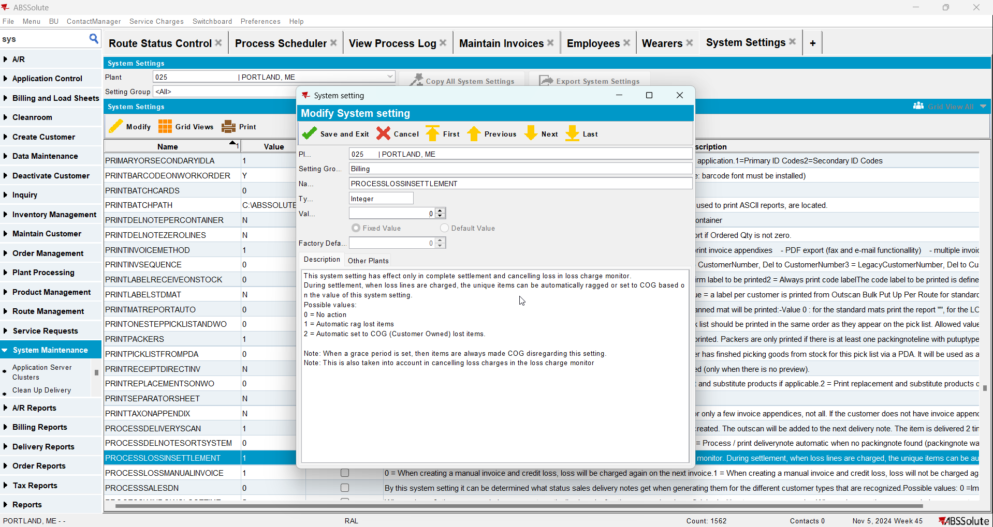
- Find a customer with wearers
- Wearers DLG: Find 2 active wearers inventory with equal circ/max using the same product (Wearer 1 and Wearer 2)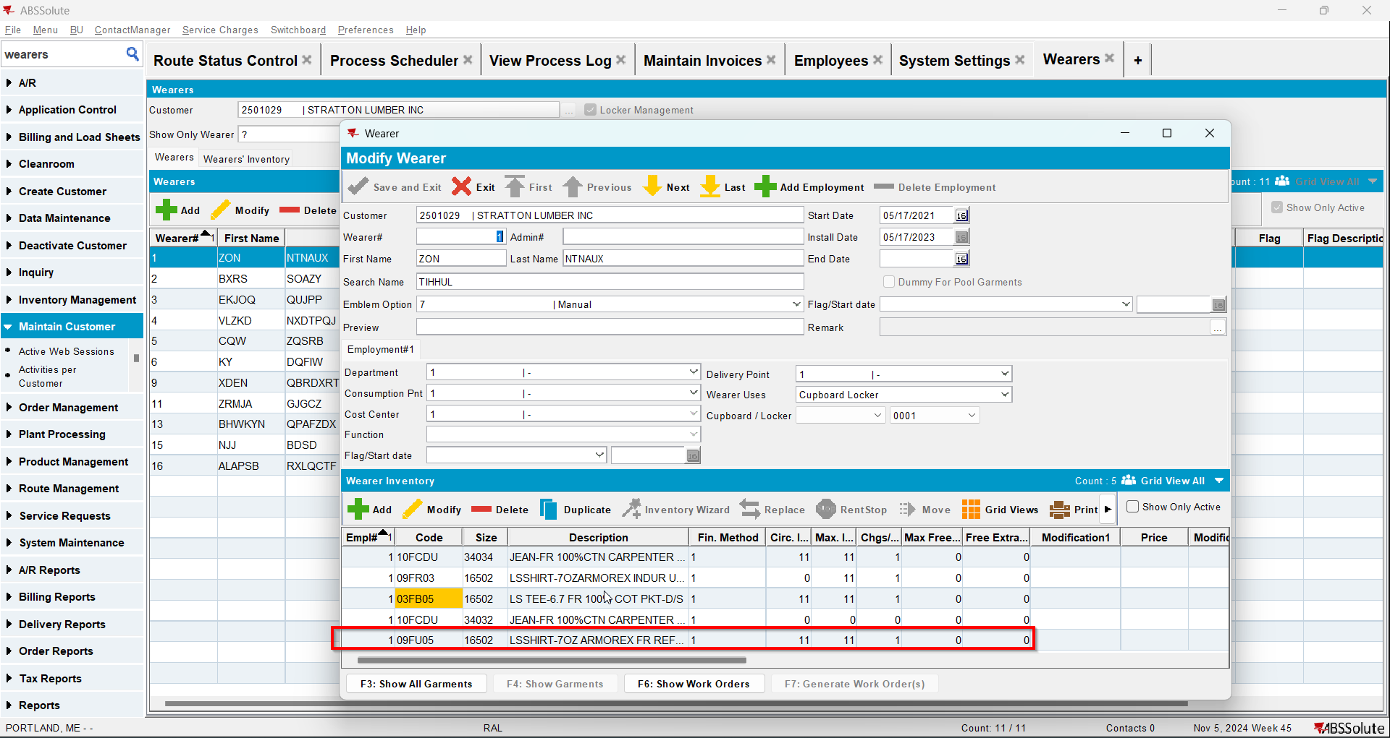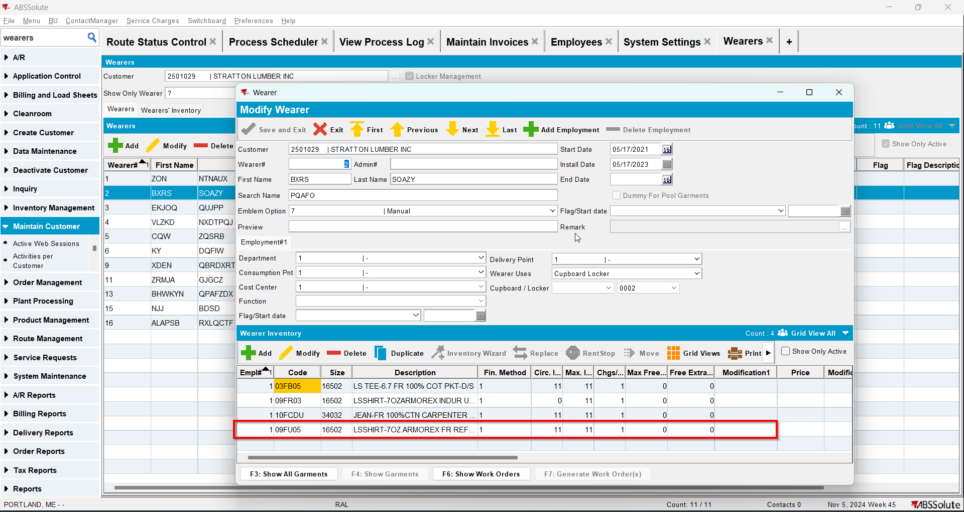
- Contract DLG: Load the contract for your customer
- Contract DLG: Find the product your wearer inventory(s) use and add a new replacement price to 0$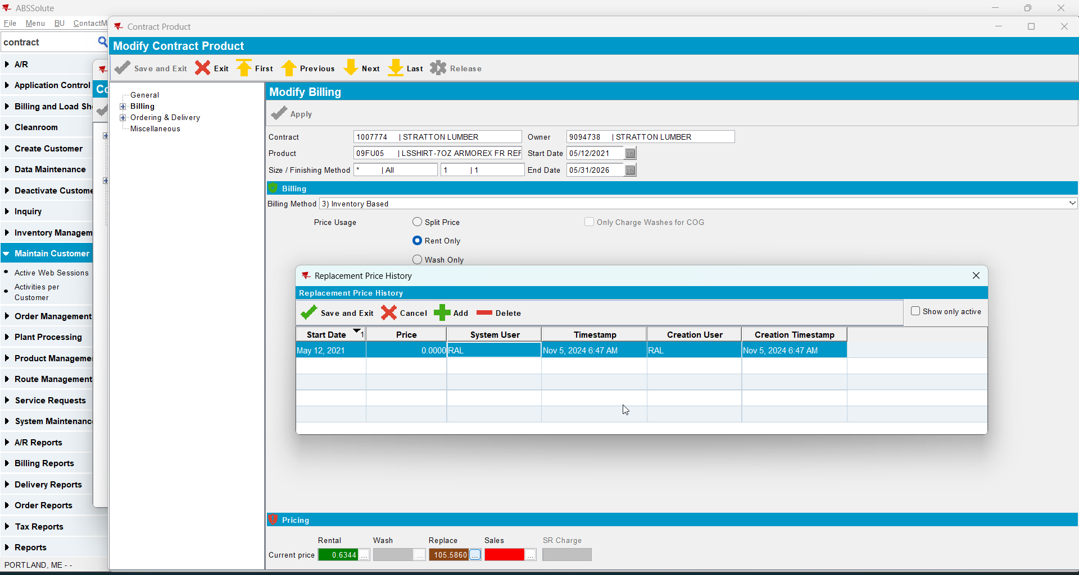
- Contract DLG: Click Update Customer and select your customer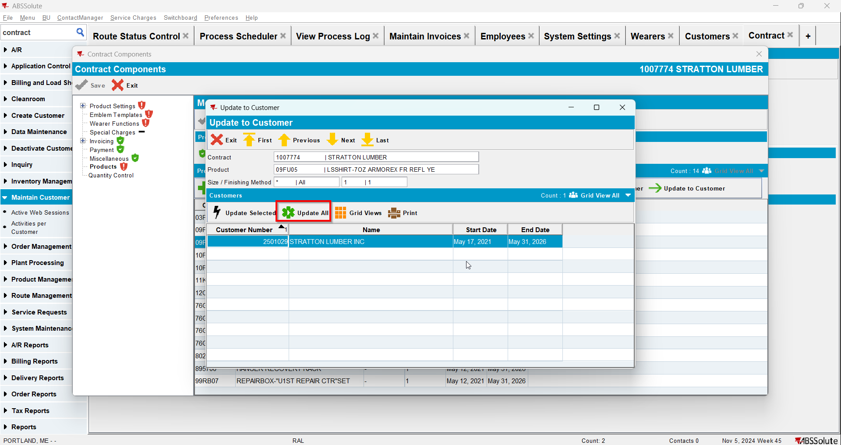
- PLPC DLG: Go to the product you just updated and make sure it is 0$ price for replacement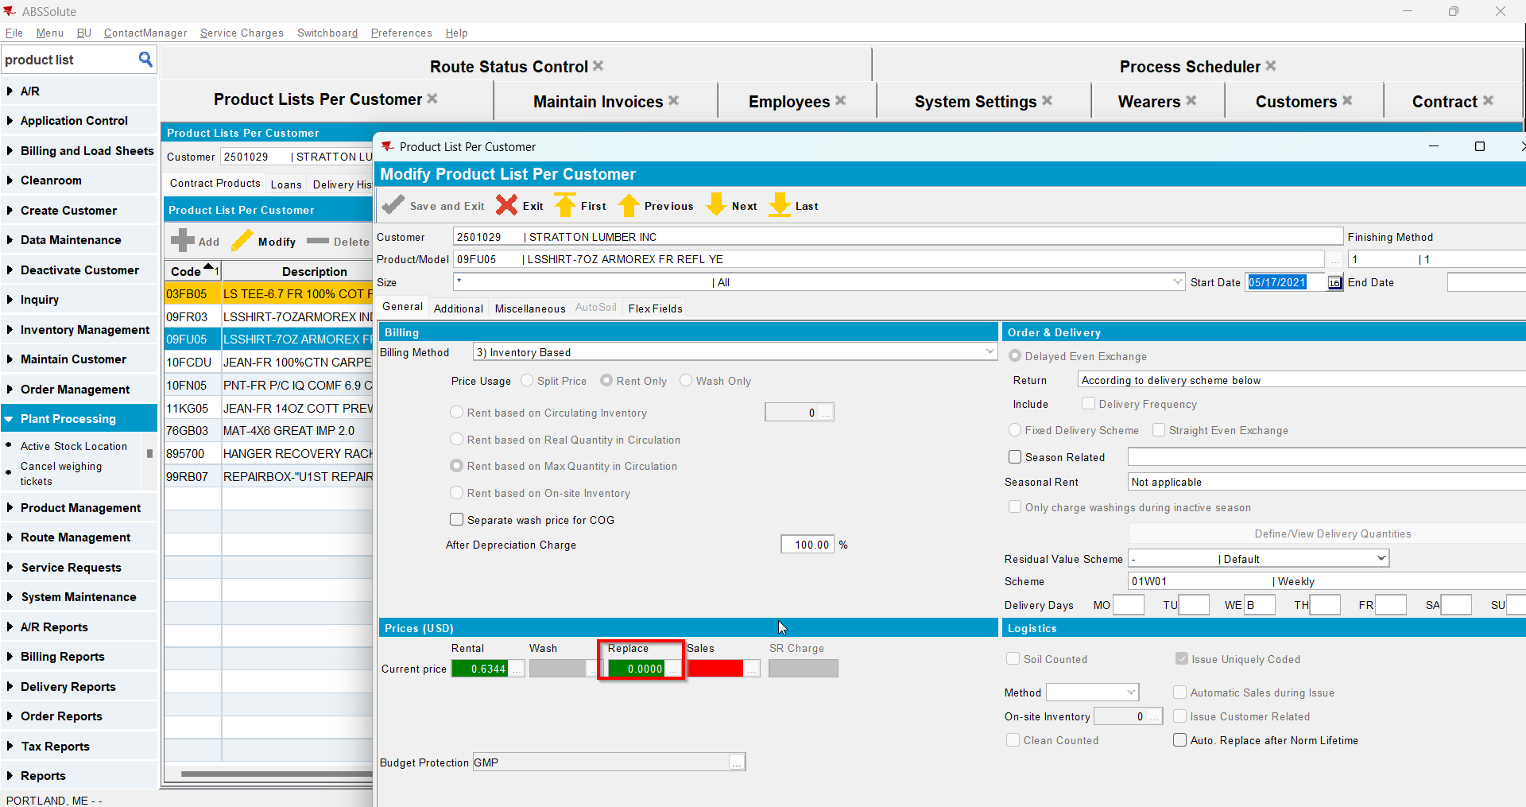
- Wearers DLG: Quit Wearer Inventory for Wearer 1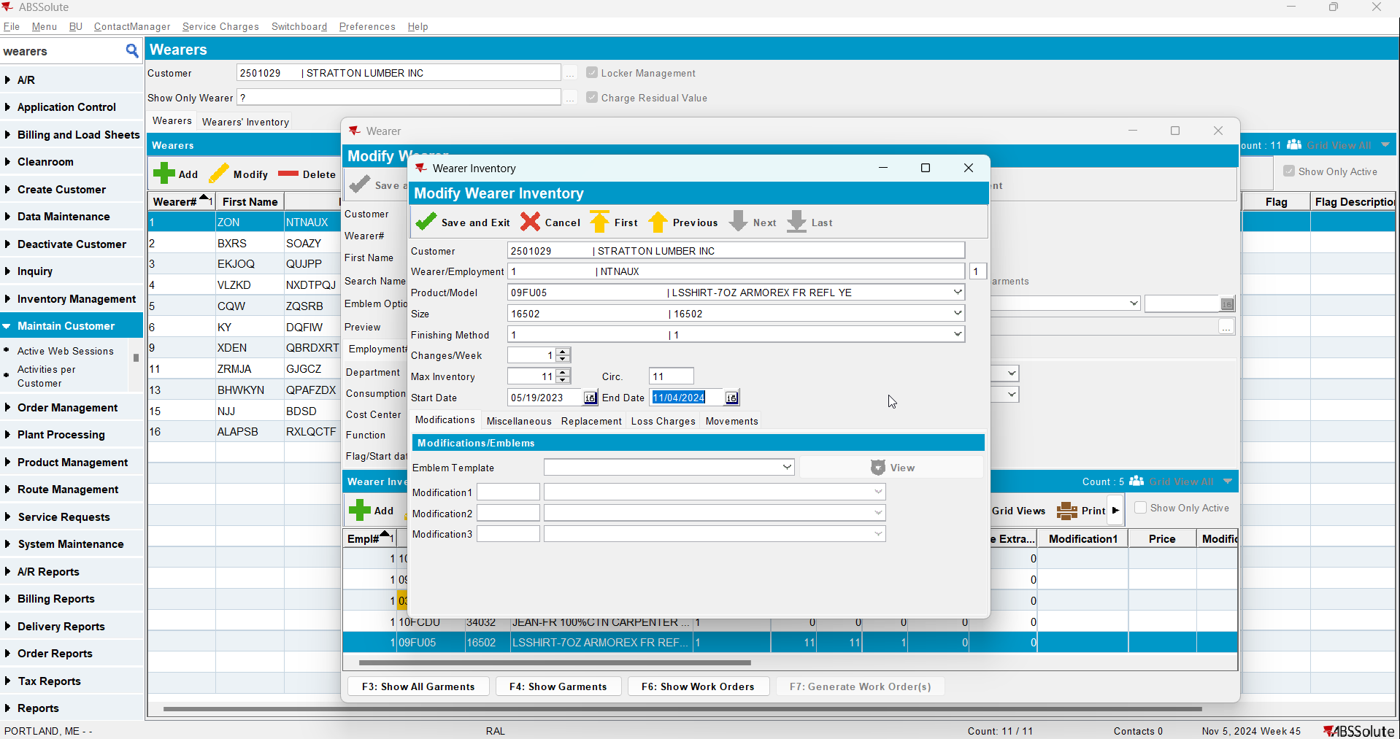
- RSC DLG: Generate invoices for a route with the customer for the current week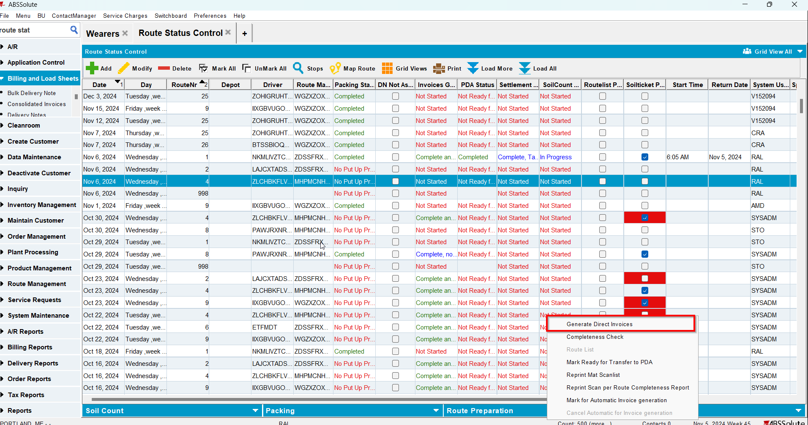
- Maintain Invoices DLG: Check that there is a Loss Charge for Wearer 1 with Extend = 'N'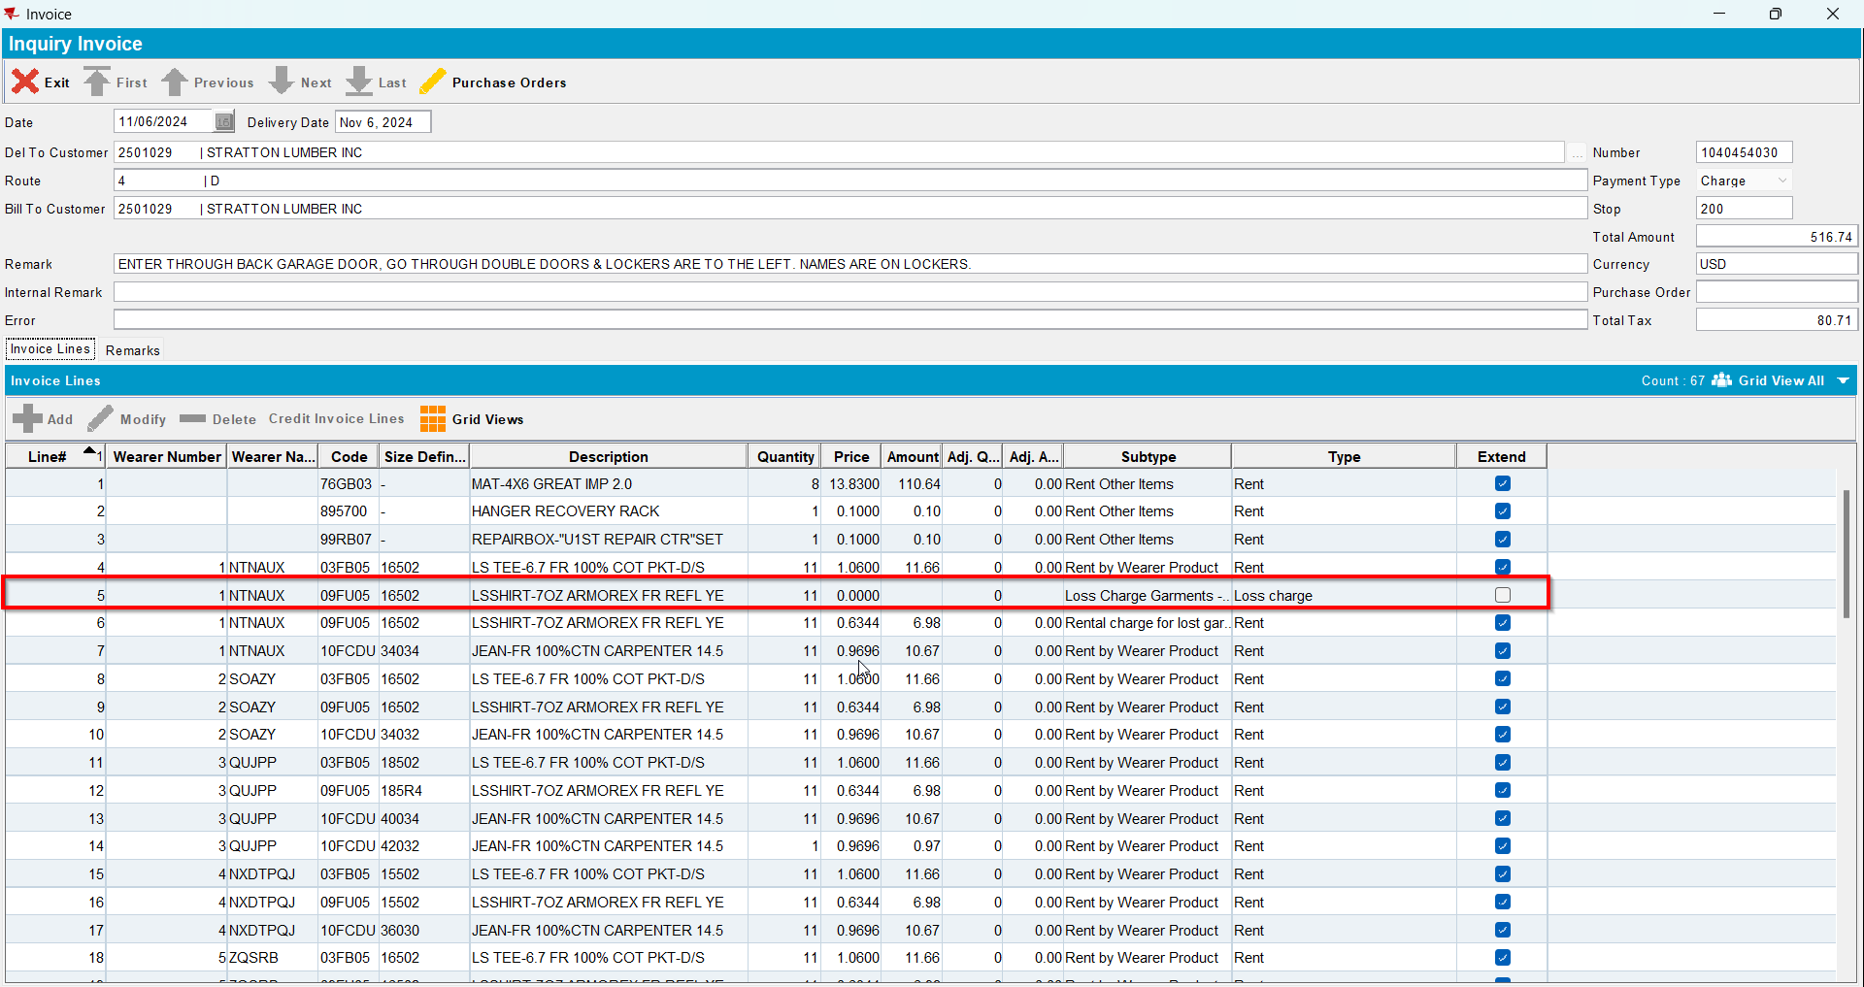
- Send the route to RA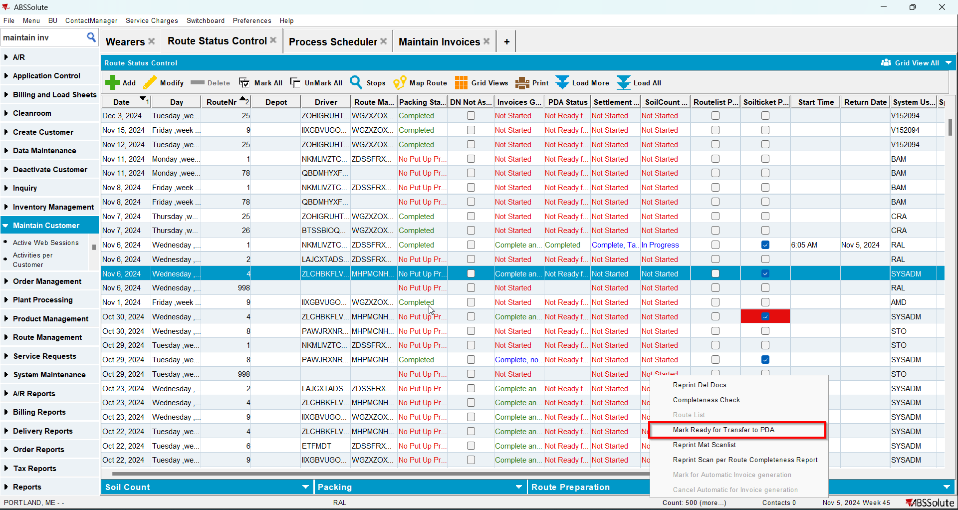
- RA: Download the route
- RA: Quit Wearer Inventory for Wearer 2
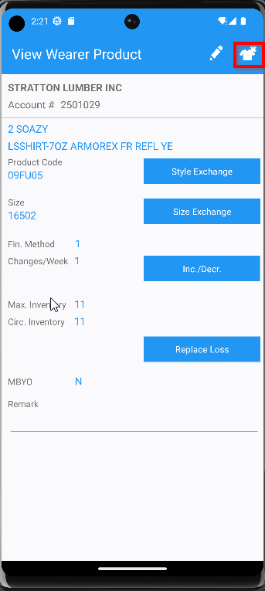
- RA: Return items> Bill Loss Now for garments from Wearer 1 and Wearer 2
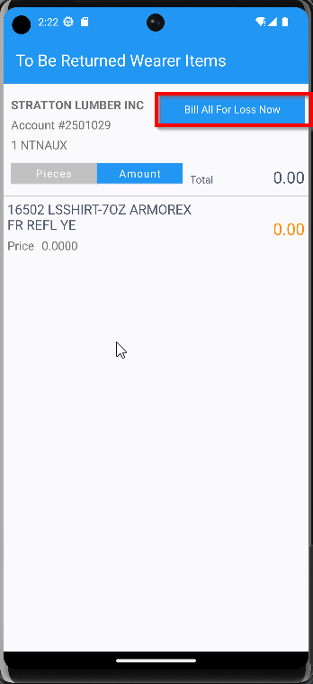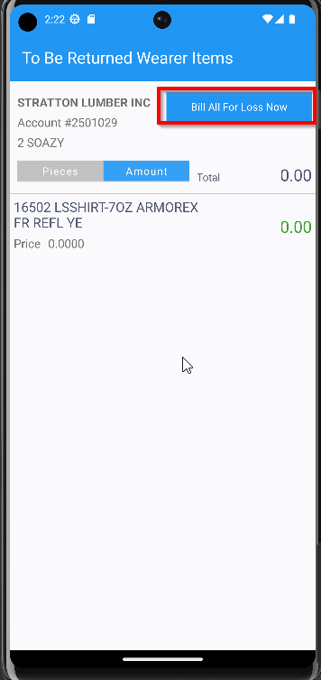
- Settle and upload the route
- WebX: Approve the invoice like adjustments
- WebX: Settle the route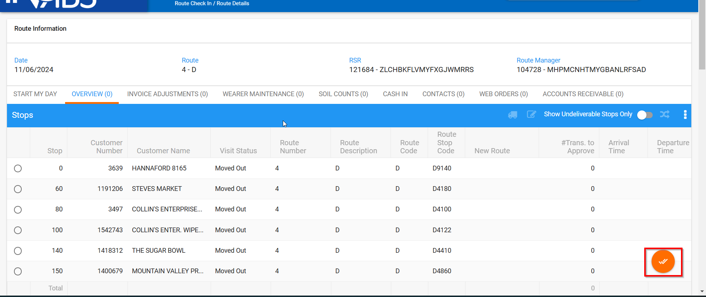
- Maintain Invoices DLG: Open the invoice and make sure you have two Loss Charge lines one is for Wearer 1 and the other for Wearer 2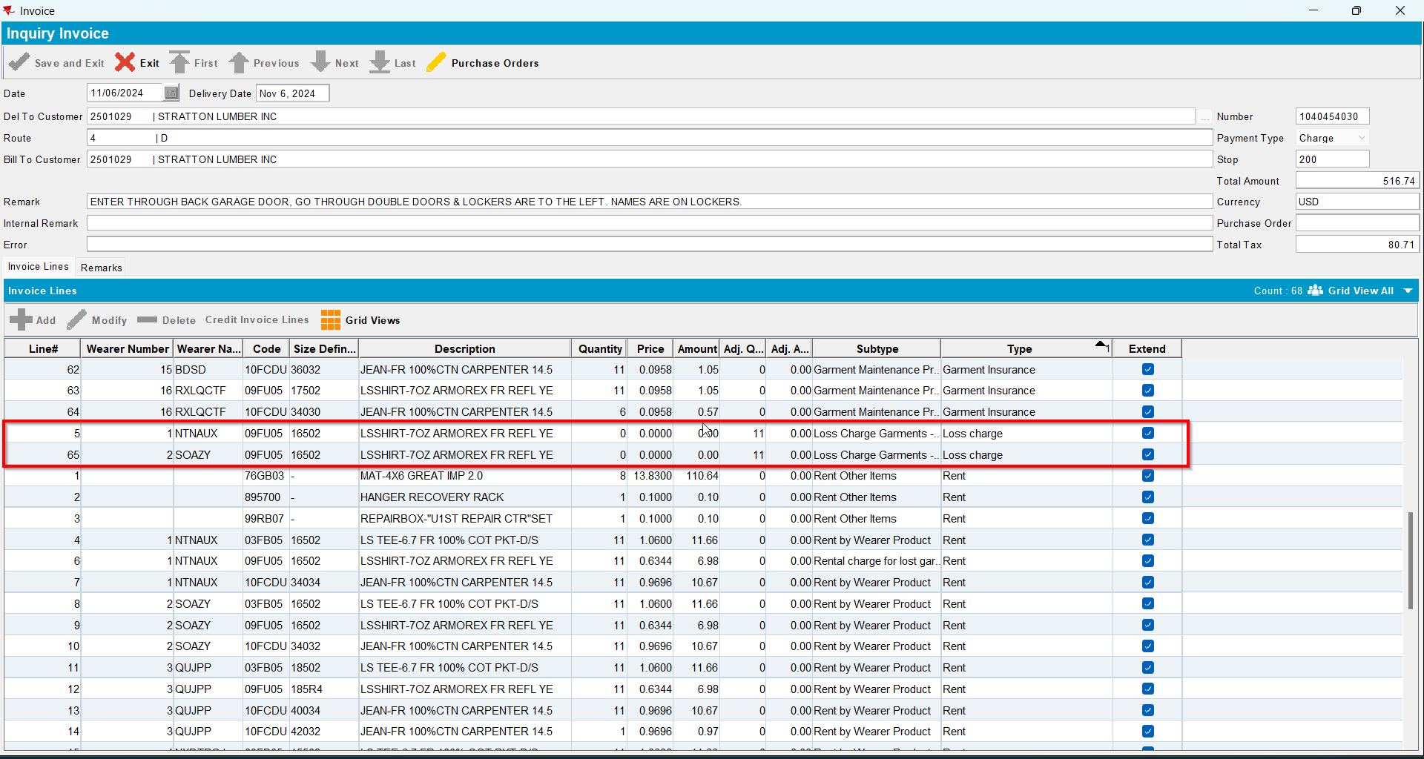
- Wearers DLG: Check Wearer 1 Garments to see if they were ragged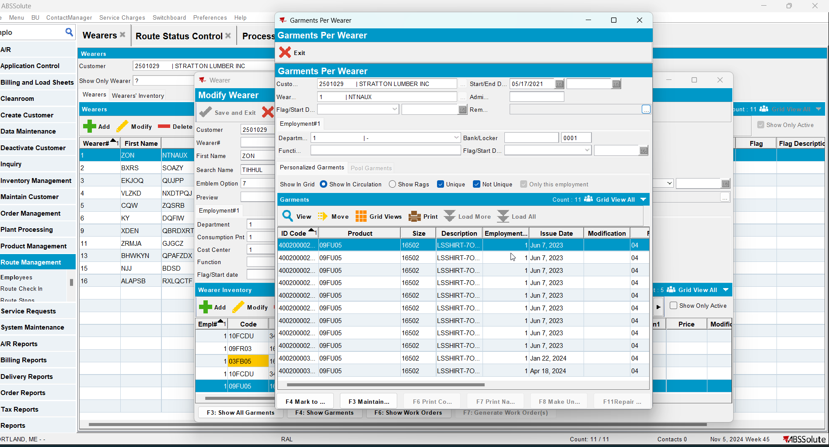
- Wearers DLG: Check Wearer 2 Garments to see if they were ragged