ABS-165072 D_UBS_2345 Invoice Reprint Order
Environment | Prerequisites
Version: 9.07.00.UNF18  DBServerName= abs-srv20.internal.abslbs.com  DBSID=CUST24  DBUser=UNFDEV  DBPassword=UNFDEV  Environment=Production | - Module:  - System setting

Contents
Test after fix 1
Test Case 1 - Print invoices from Maintain Invoices> All Tab with UNFCUSTOM in the license 1
Test Case 2 - Print invoices from Customer Financial Details> Invoices/Charges Tab with UNFCUSTOM in the license for a big BillToCustomer 5

Test after fix
Hash: 4954e3cd5c7

Test Case 1 - Print invoices from Maintain Invoices> All Tab with UNFCUSTOM in the license
Expected behavior:
The order in which invoices are printed is ordered by Route / Stop / Customer / Invoice Number
Test steps:
1. Maintain Invoices DLG>All Tab>Settled subtab
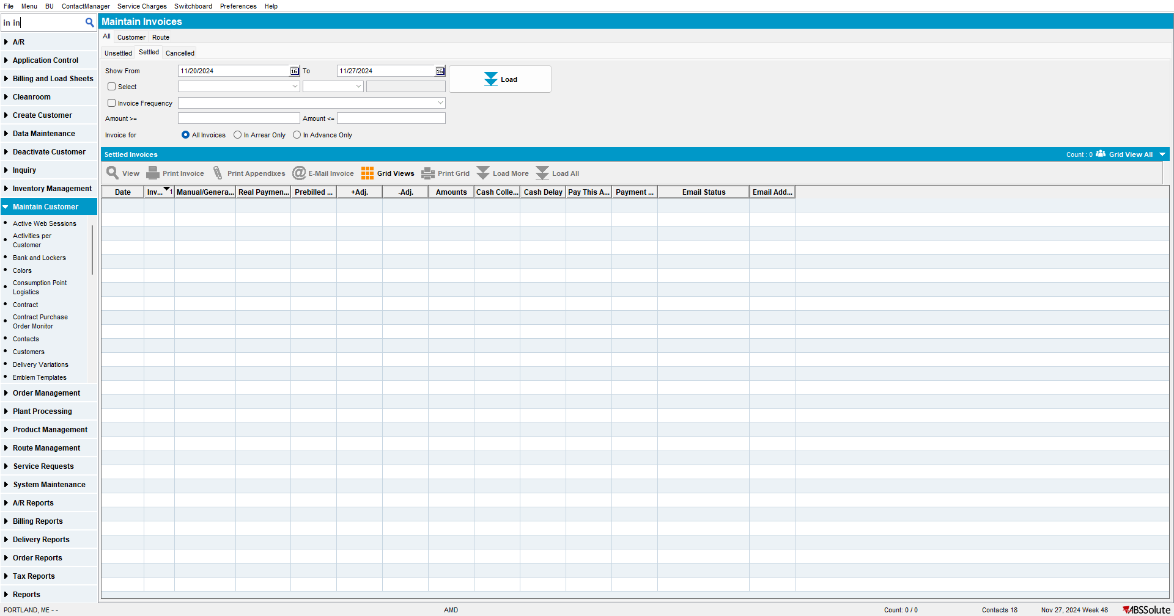
2. Load a month’s worth of invoices.
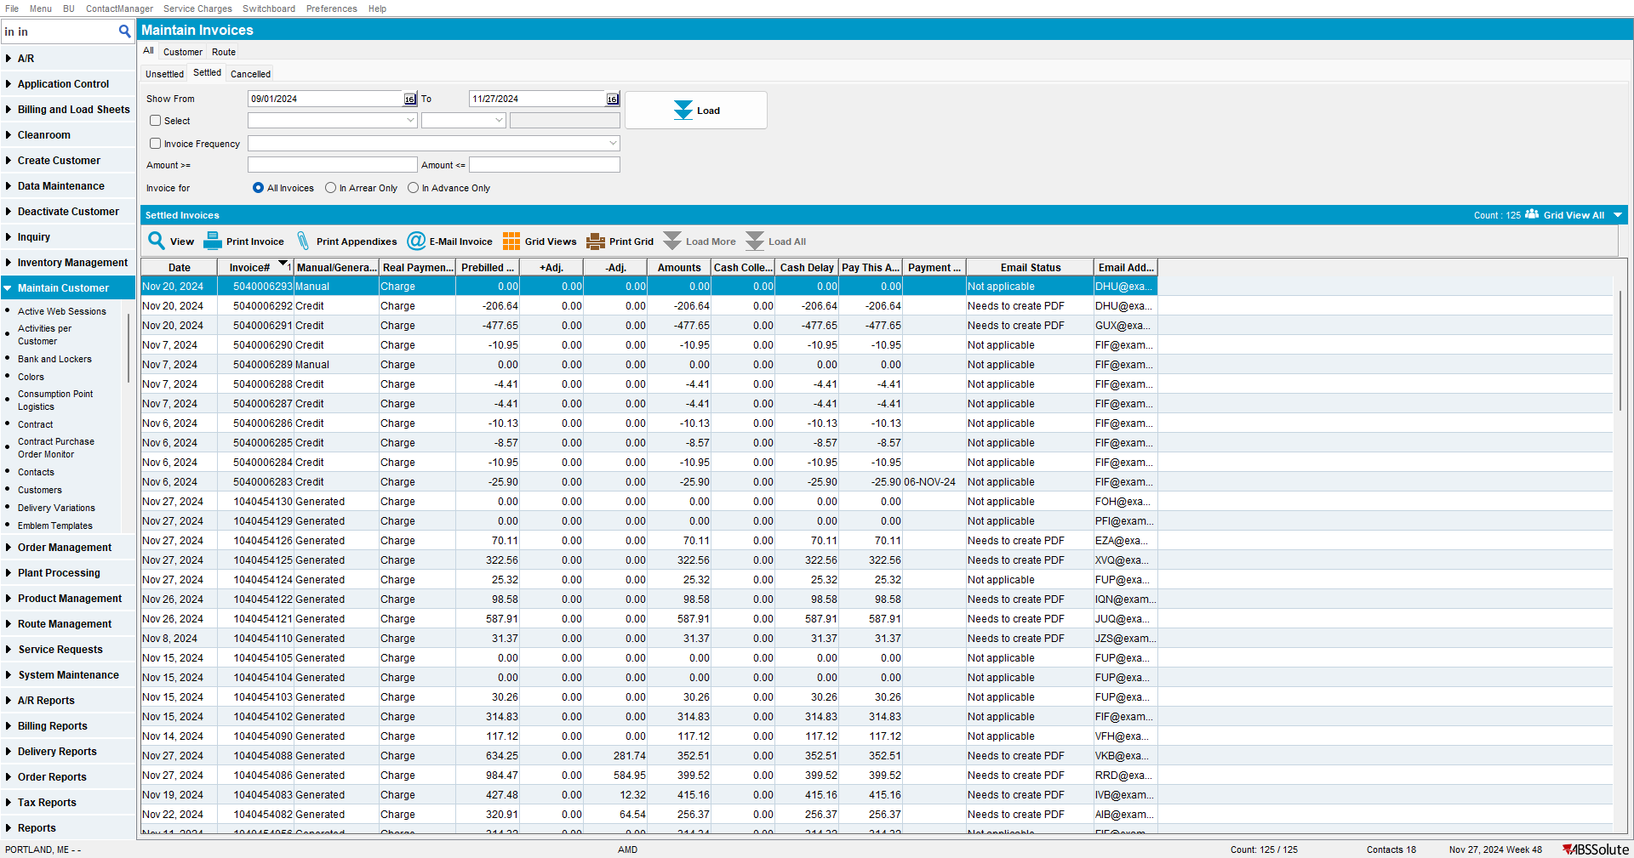

3. Add Route and Stop Number columns and order first by route then by Stop number
4. Multiselect in the grid invoices from multiple routes
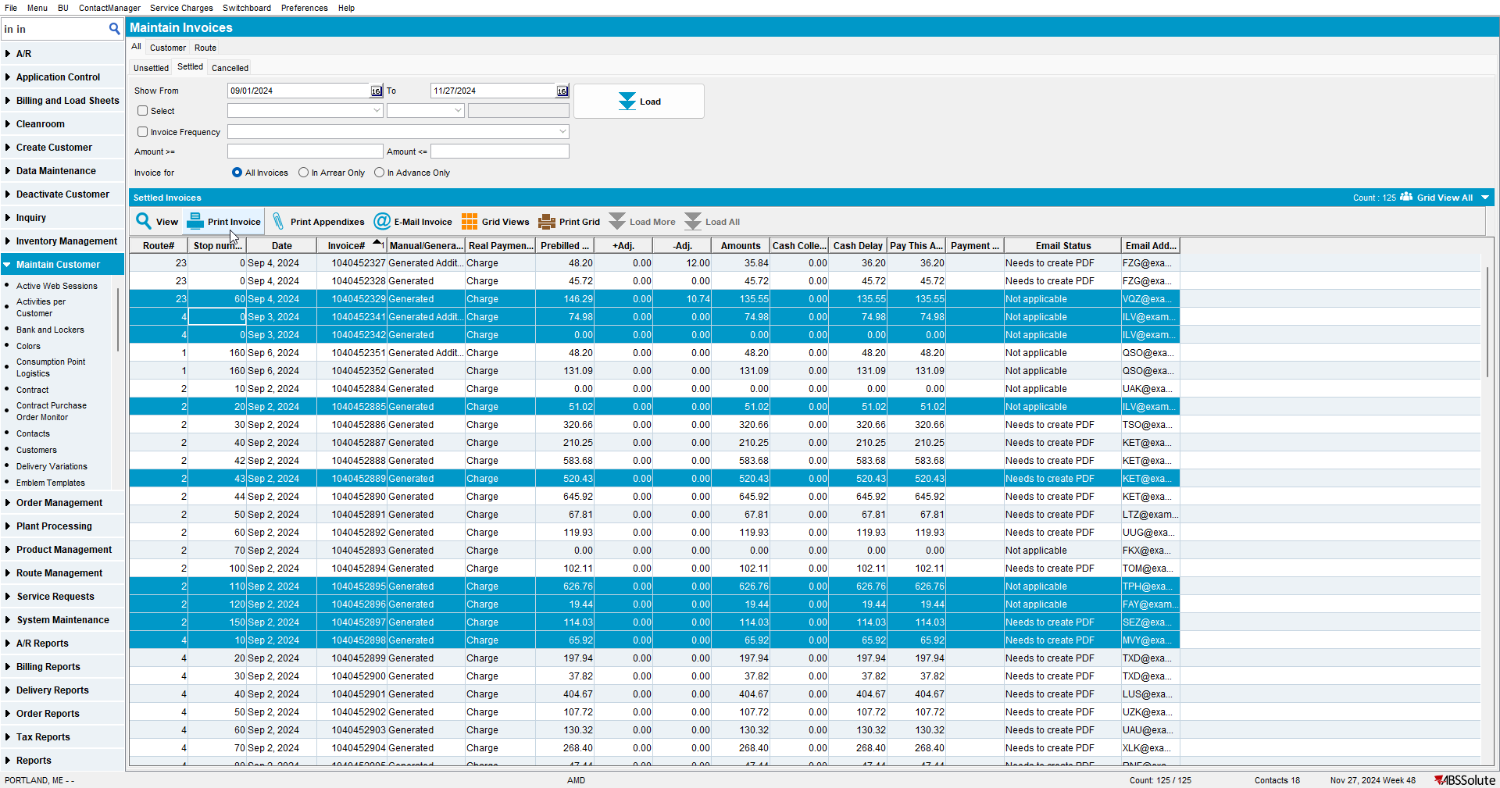
5. Press Print
6. Check to see that invoices are printed in the order of route / stop
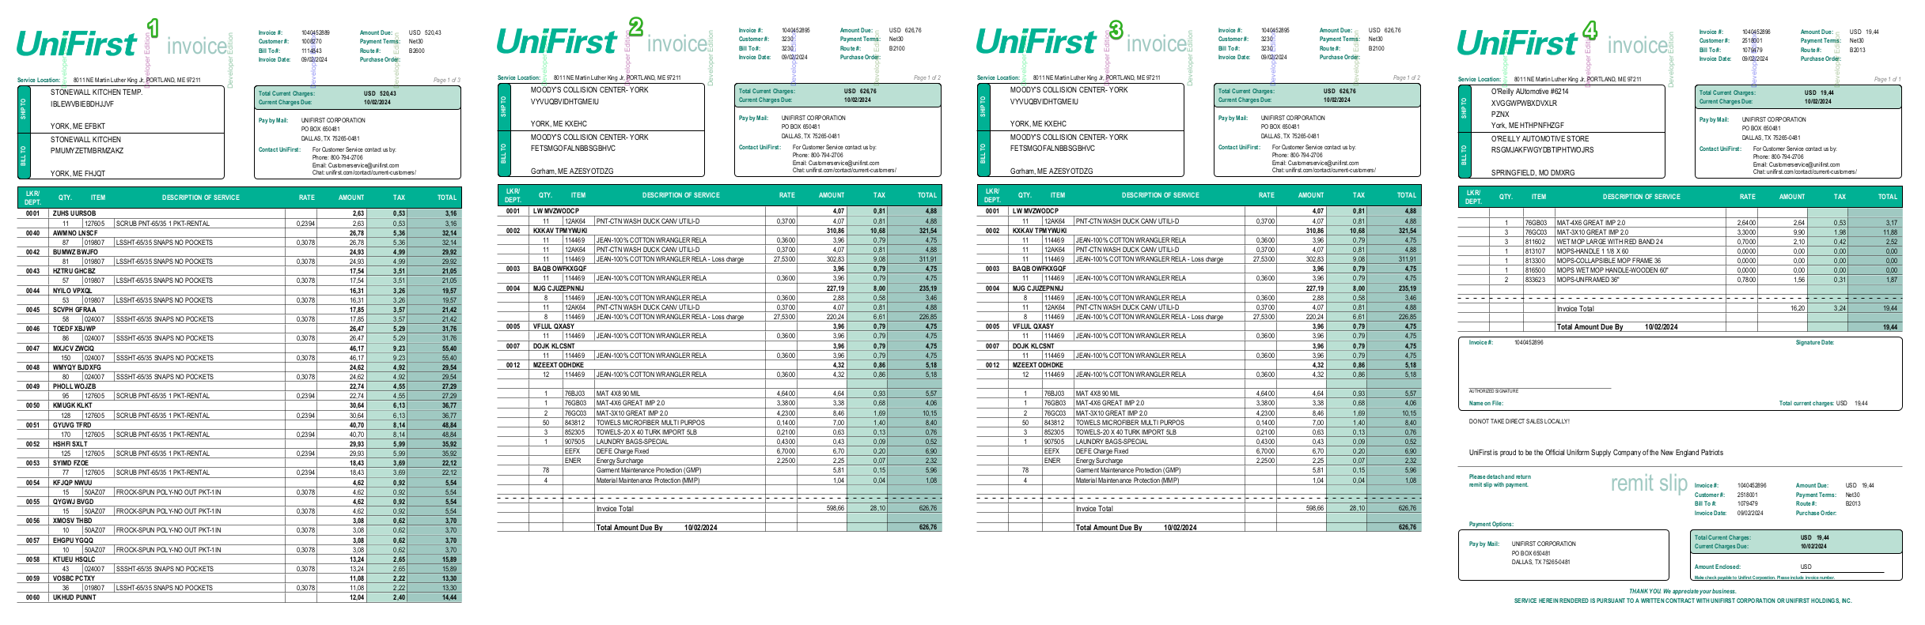
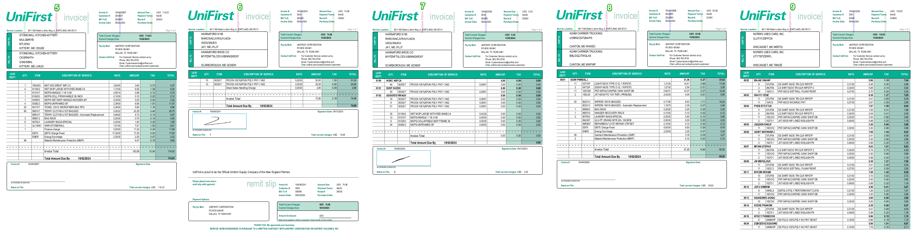
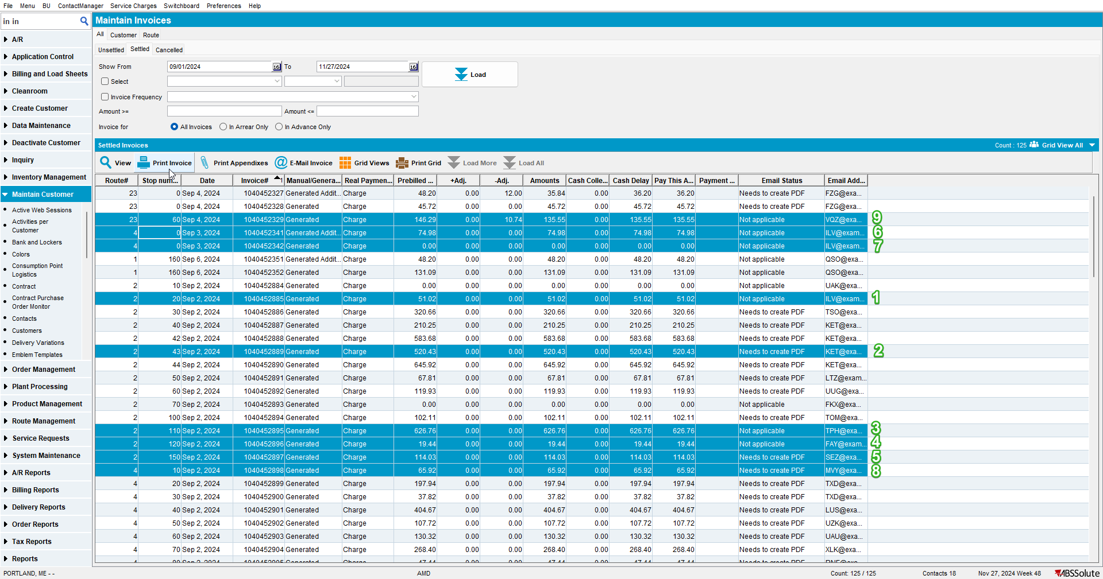
TESTED OK 💚

Test Case 2 - Print invoices from Customer Financial Details> Invoices/Charges Tab with UNFCUSTOM in the license for a big BillToCustomer
Expected behavior:
The order in which invoices are printed is ordered by Invoice Date / Customer
Test steps:
1. Customer Financial Details> Invoices/Charges Tab
2. Pick one of the bigger bill-to-customers from BU 011 like 382660
3. Load at least a month’s worth of invoices
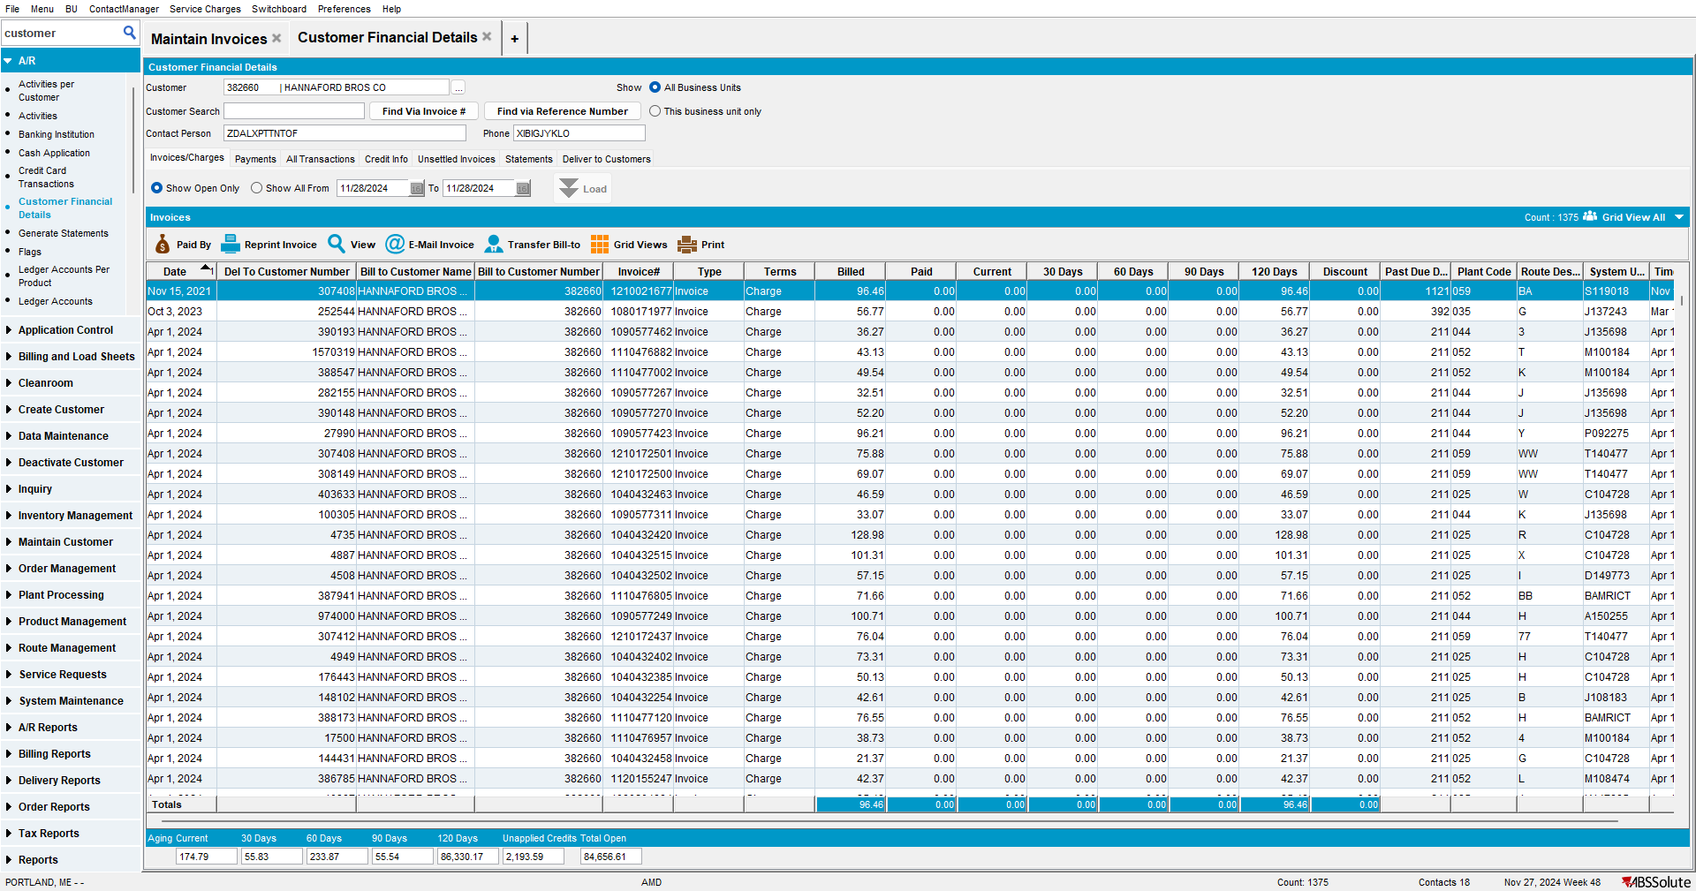
4. Select multiple invoices from different customers and click on Reprint Invoice
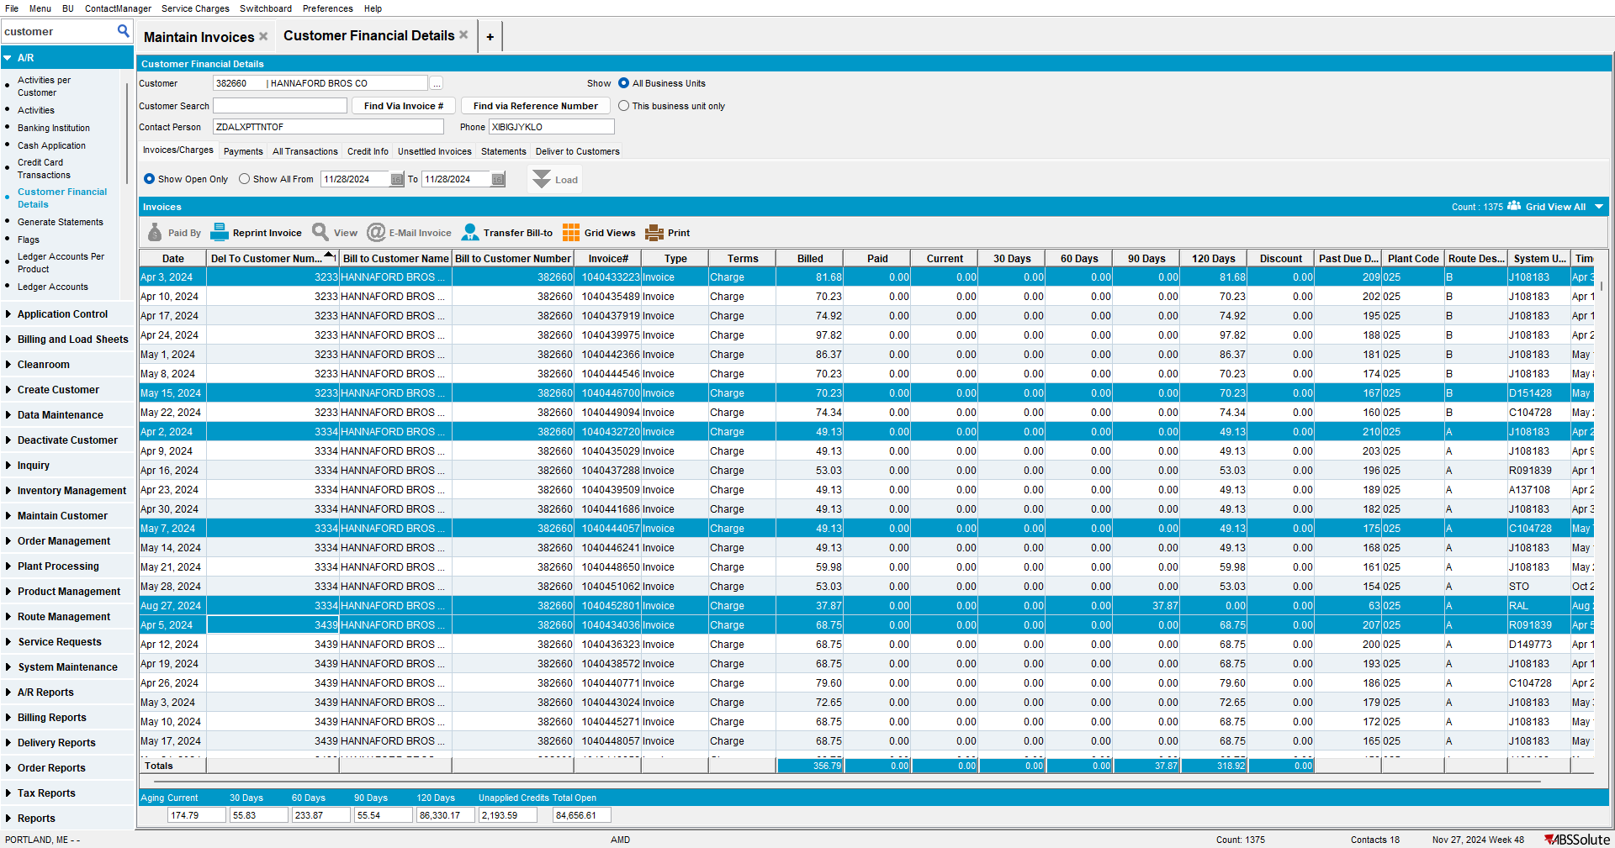
5. Check that the invoices are printed by Invoice Date / Customer.
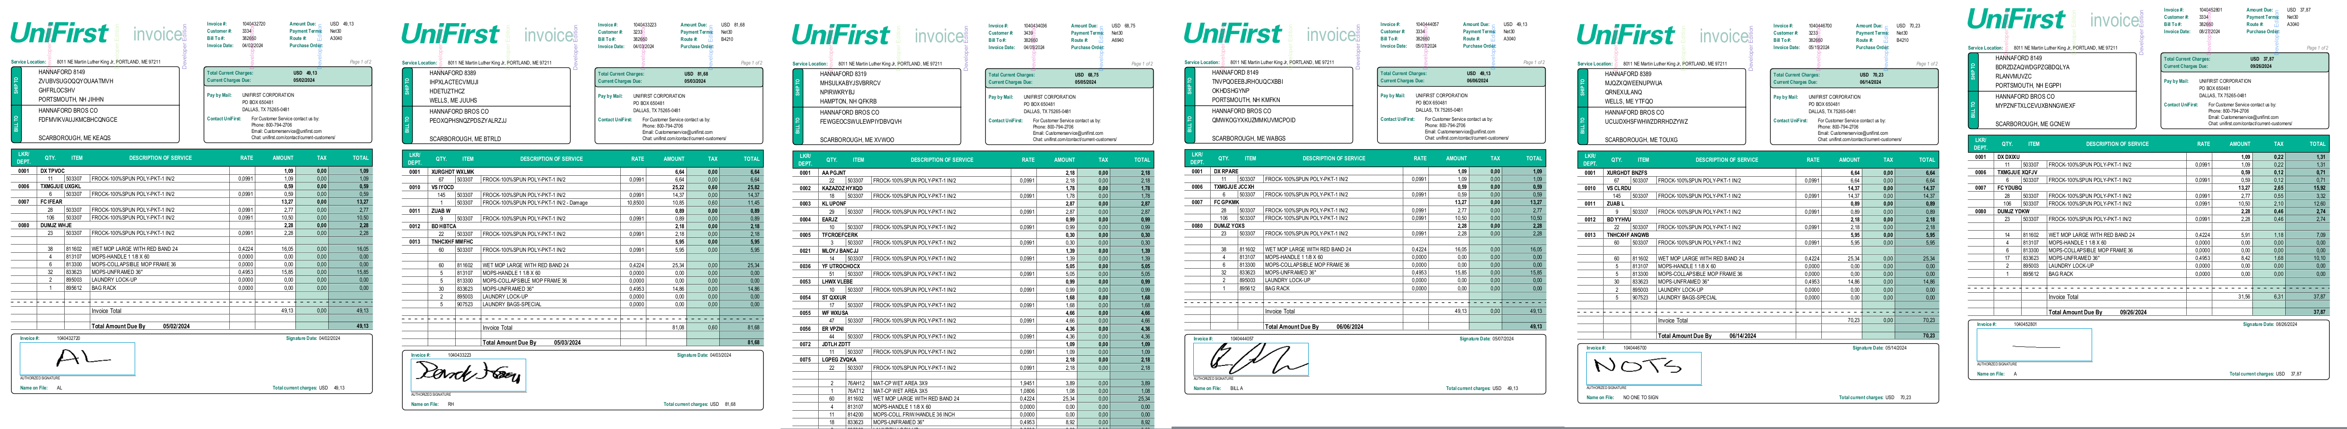
TESTED OK 💚

