ABS-164048 D_UBS_2428 Partial credit of invoice is updating first service and contract install dates
Environment | Prerequisites
Version:9.07.00  DBServerName=abs-SRV20.internal.abslbs.com  DBSID=CUST24  DBUser=UNFDEV  DBPassword=UNFDEV  Environment=Test | - Module:  - System setting

Contents
Test after fix 1
Test Case 1 – Full Credit when this is the first invoice for the customer and there are no more invoices for this customer– Tested OK 1
Test Case 2 – Full Credit when this is the first invoice for the customer and there are 2 more invoices for this customer– Tested OK 12
Test Case 3 – Manually Credit all lines besides special charge, min inv amount and tax when this is the first invoice for the customer and there are no more invoices for this customer– Tested OK 23
Test Case 4 – Manually Credit all lines besides special charge, min inv amount and tax when this is the first invoice for the customer and there are 2 more invoices for this customer; then repeat for second week’s invoice– Tested OK 34
Test Case 5 - Manually Credit only one line from the first invoice for the customer and there are 2 more invoices for this customer – Tested OK 49
Test Case 6 – Manually Credit all rent/sales/wash lines and one fixed special charge when this is the first invoice for the customer and there are no more invoices for this customer– Tested OK 64

Test after fix

Test Case 1 – Full Credit when this is the first invoice for the customer and there are no more invoices for this customer– Tested OK
Expected behavior: Install date and first service date should be NULL
Hash: 3fa65b8
- Add a new customer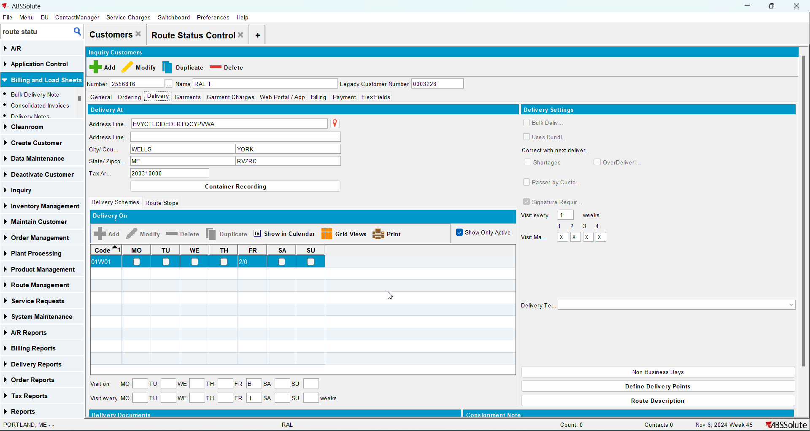
- Check that the First Service Date is null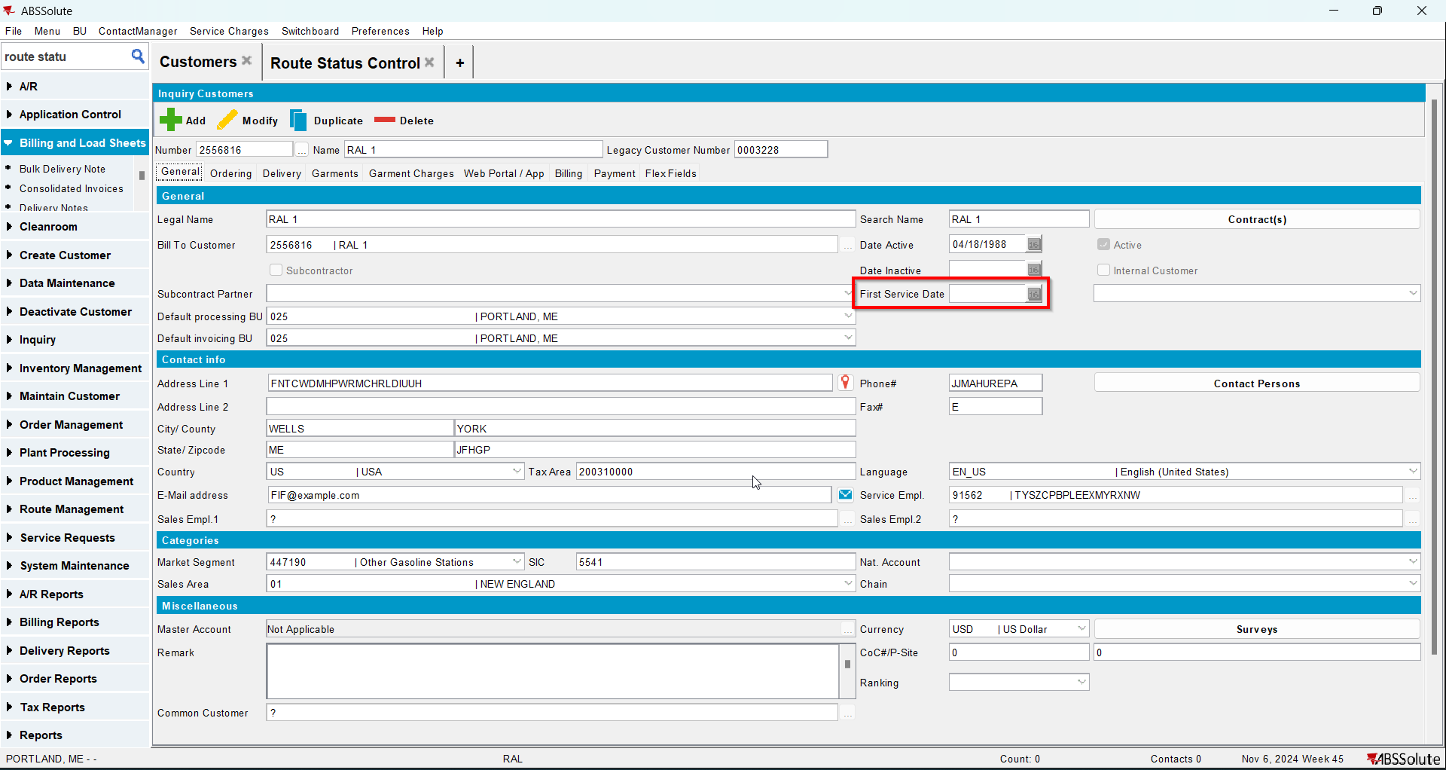
- Go to Bank and Lockers dlg and add lockers for your customer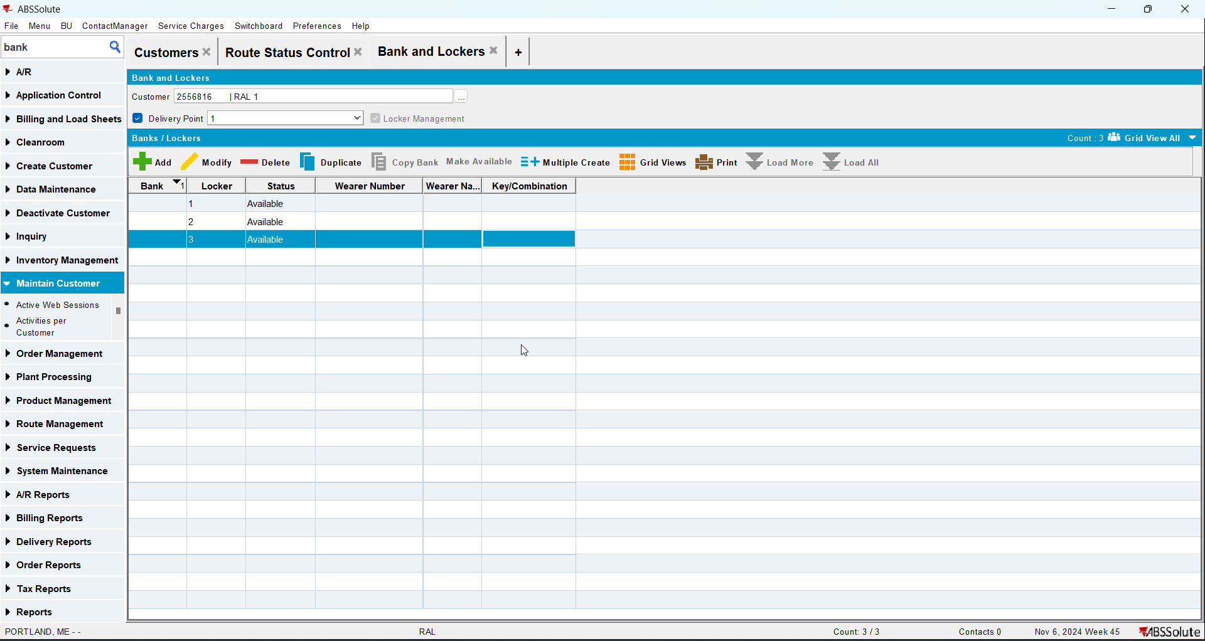
- Go to Contract dlg and add your customer to a contract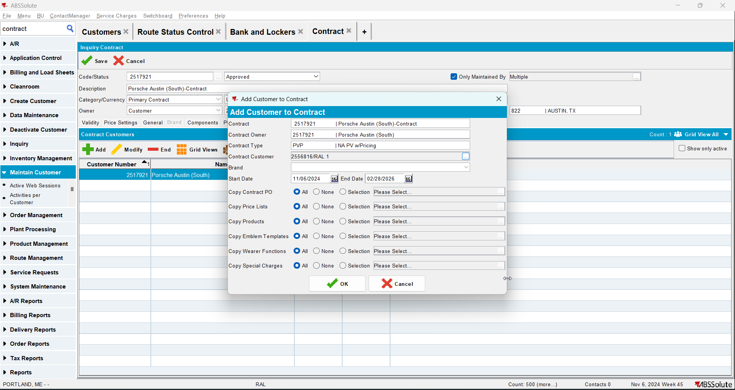
- Check that Install Date is null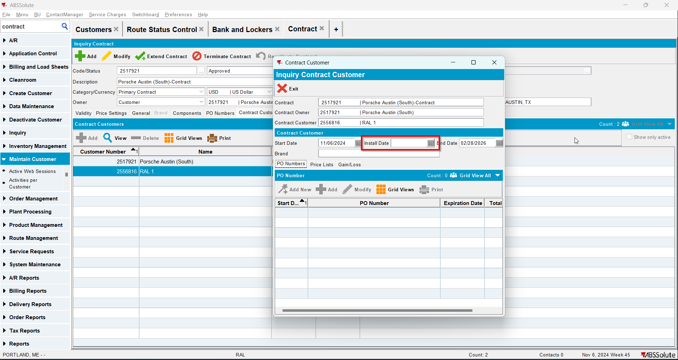
- Go to Wearers dlg and add wearers for your customer. Generate WO and after that issue the WO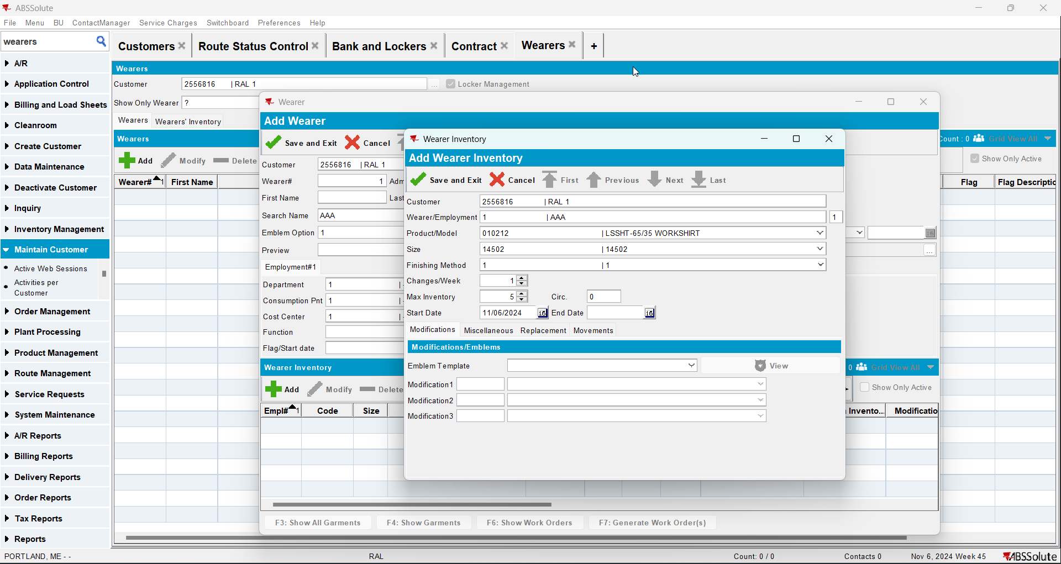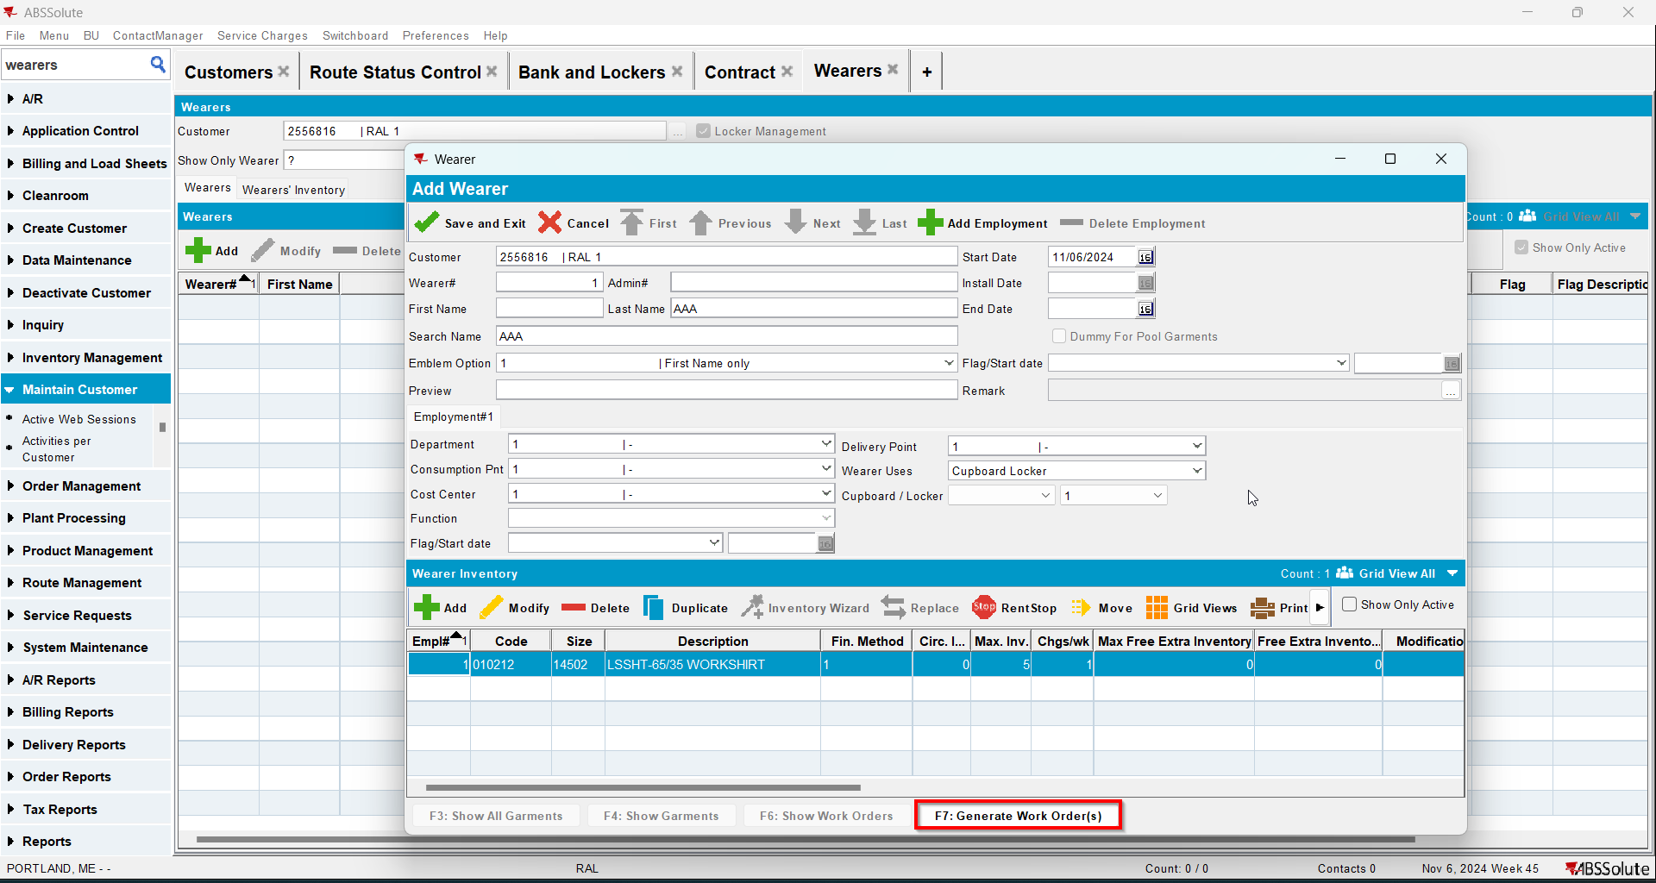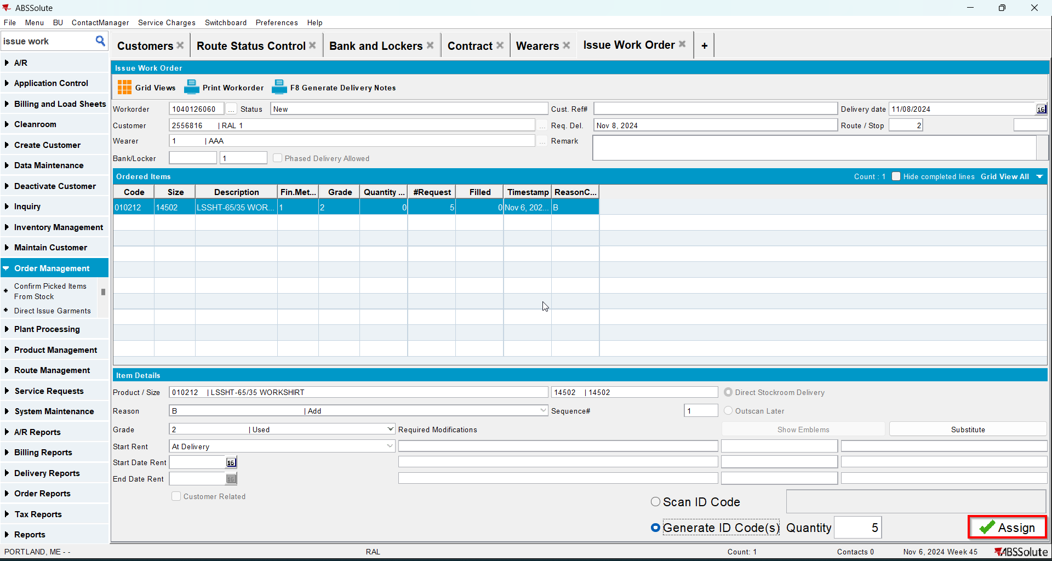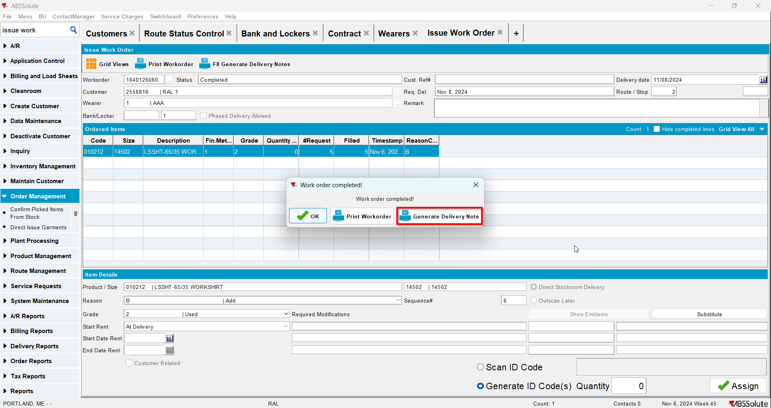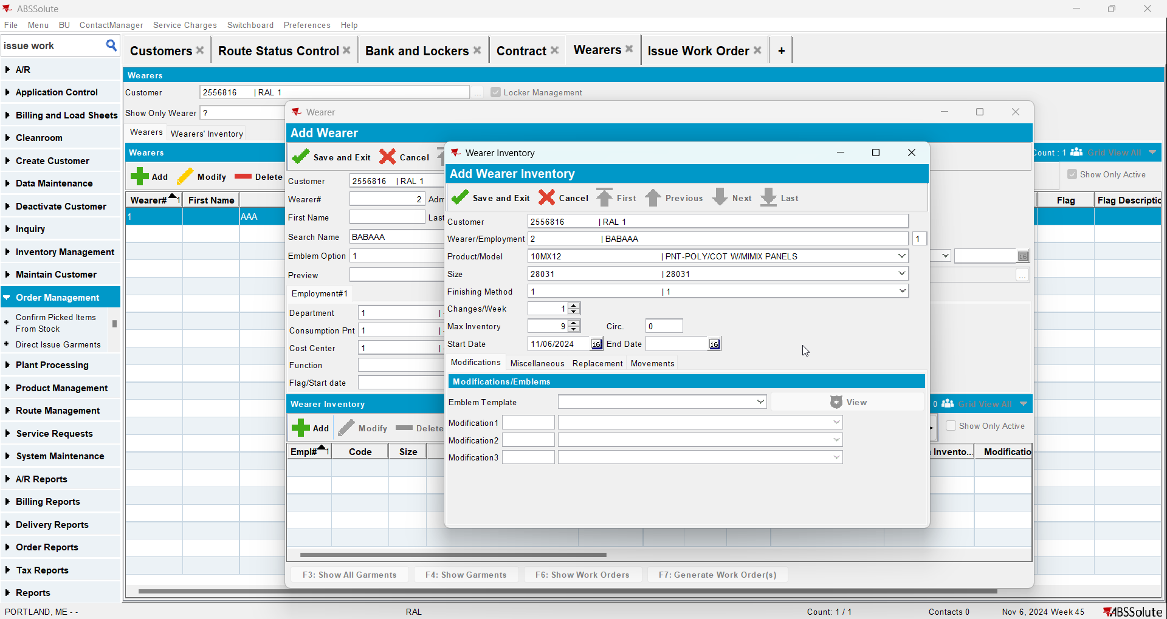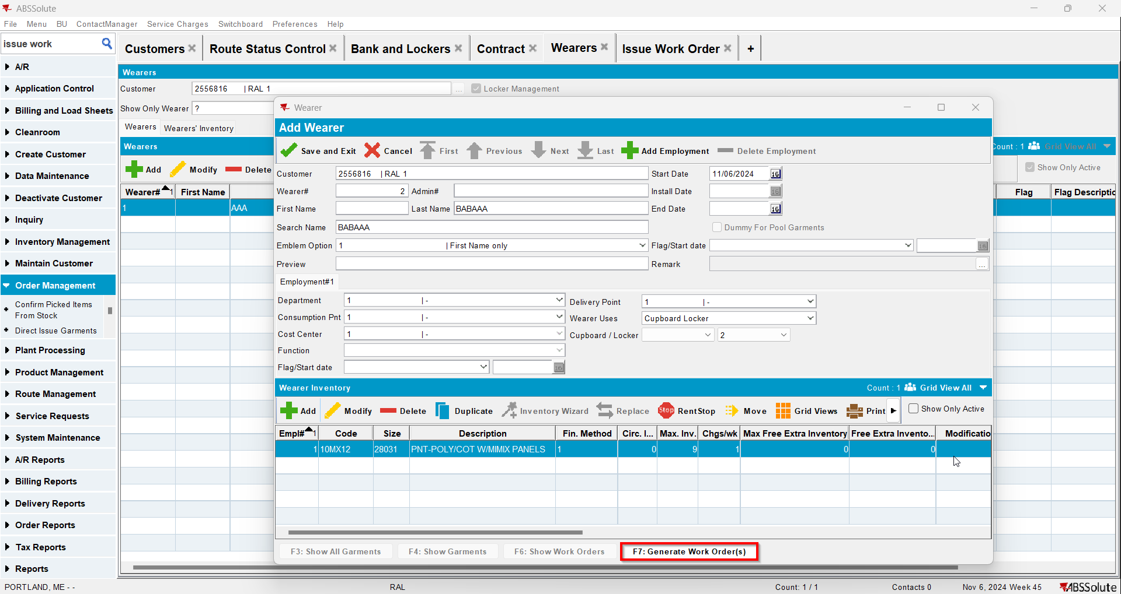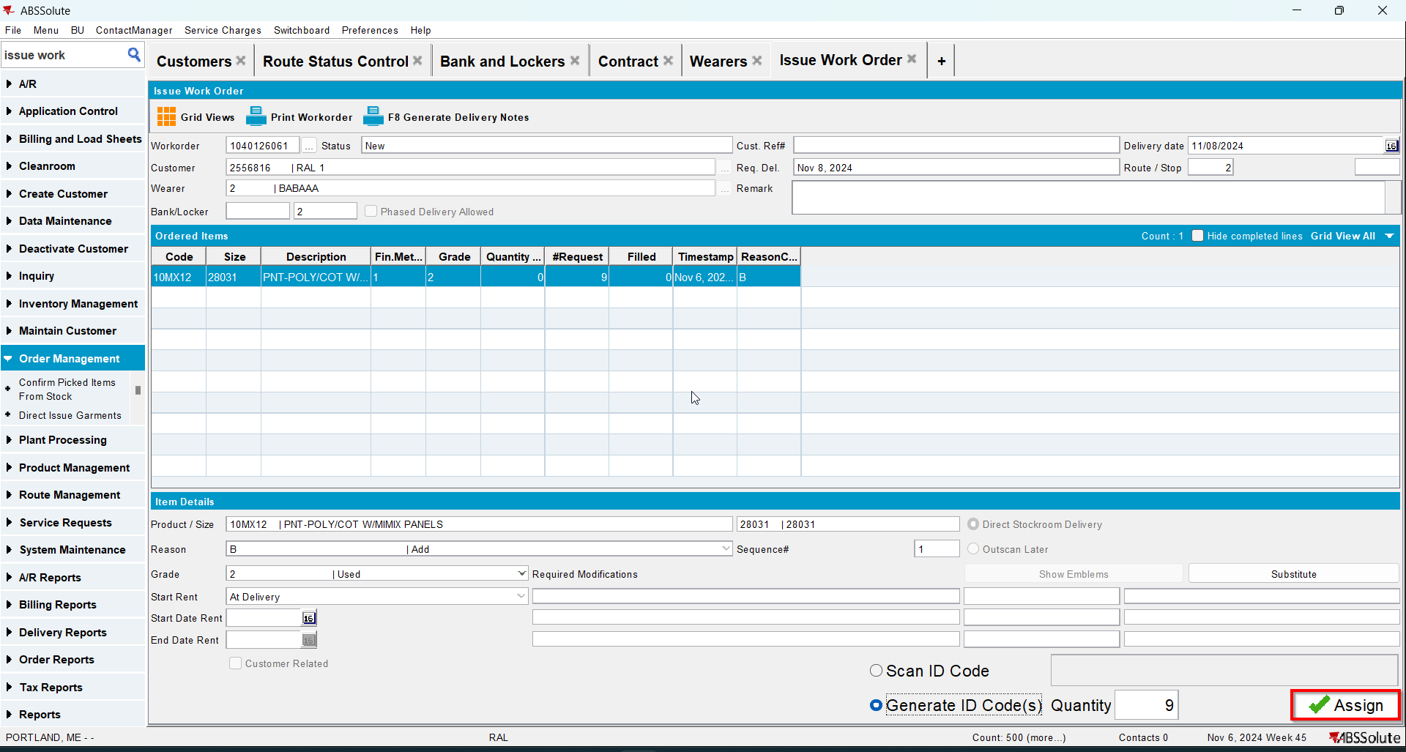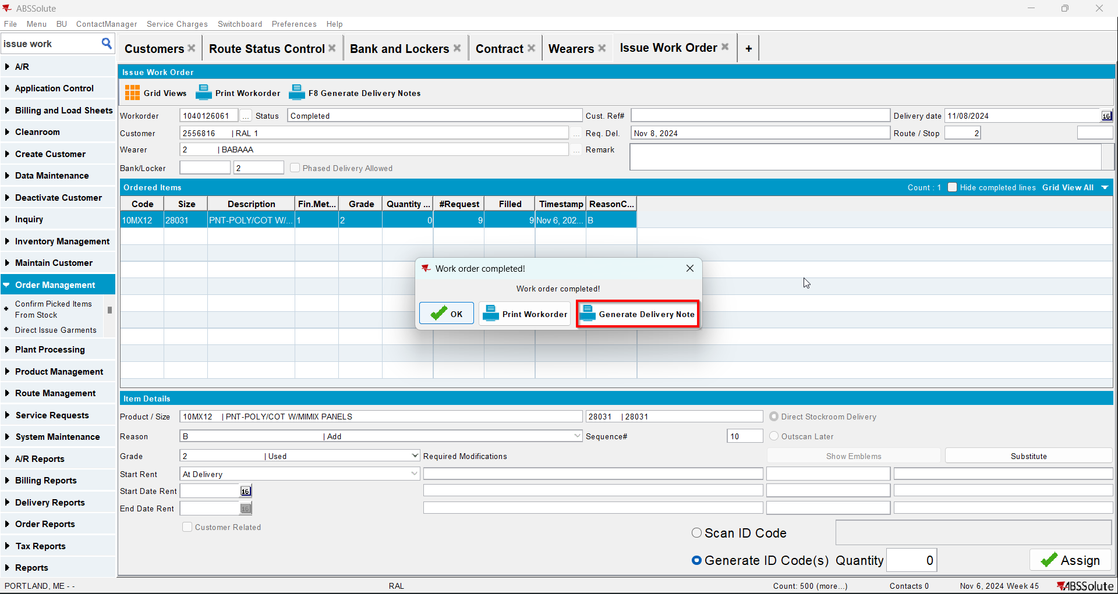
- Go to Route Status Control dlg and generate invoices for your route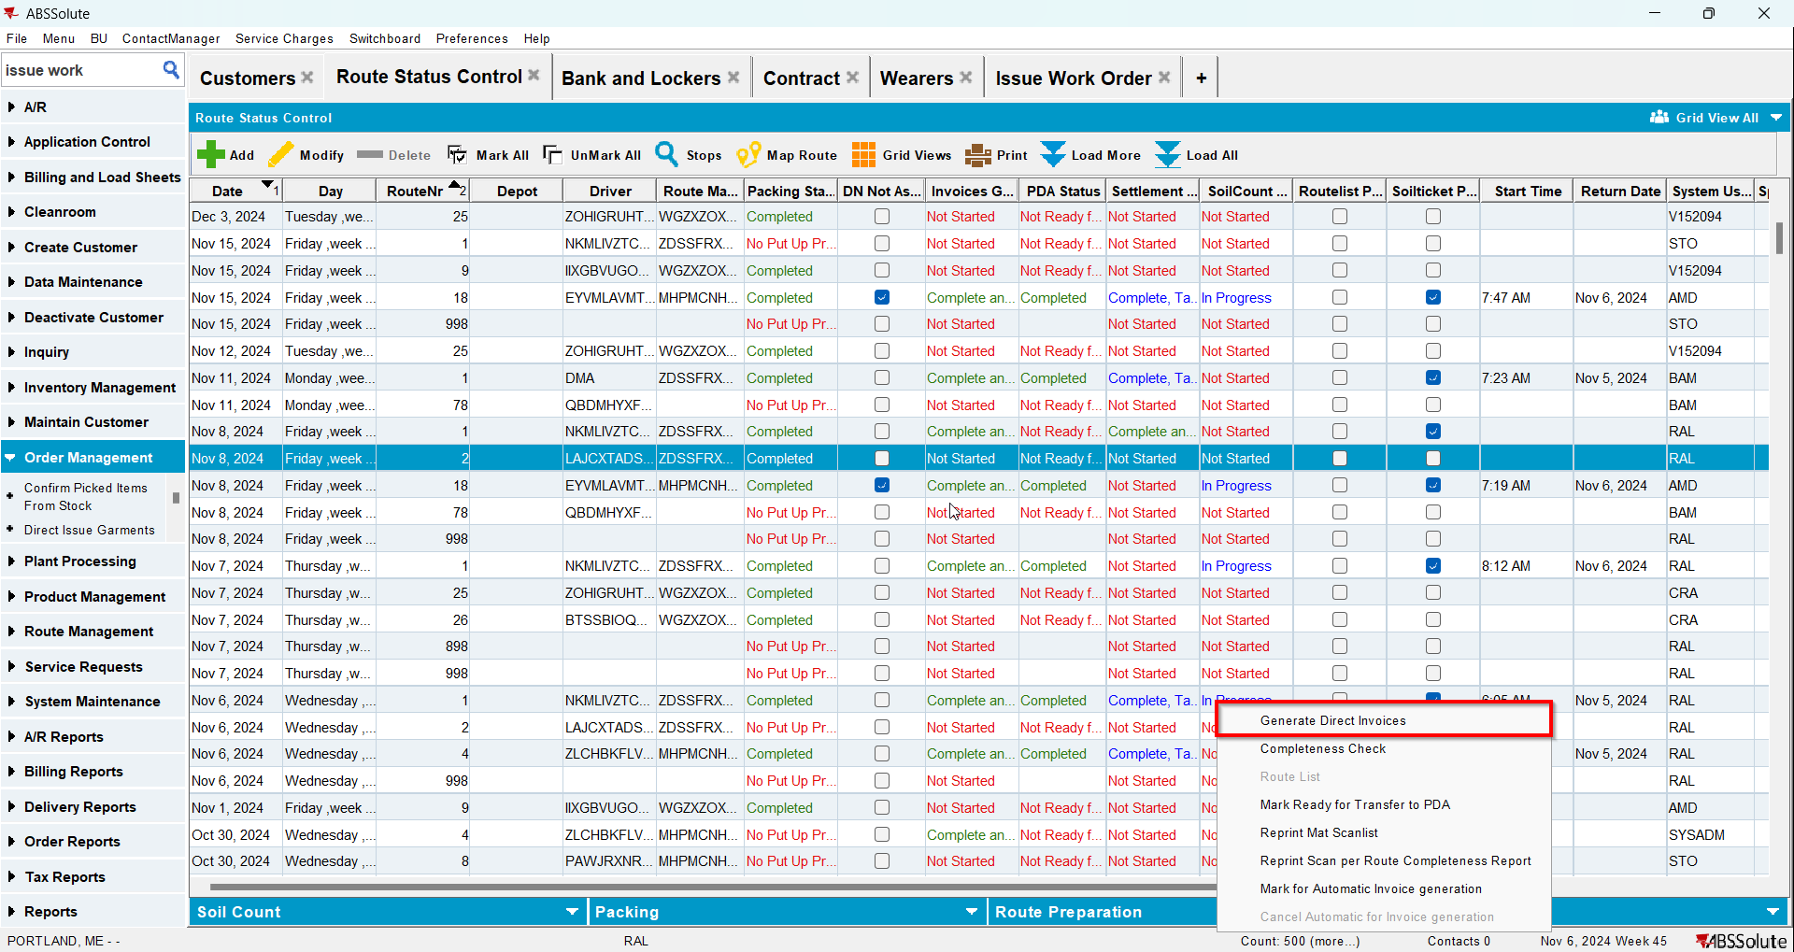
- Settle the route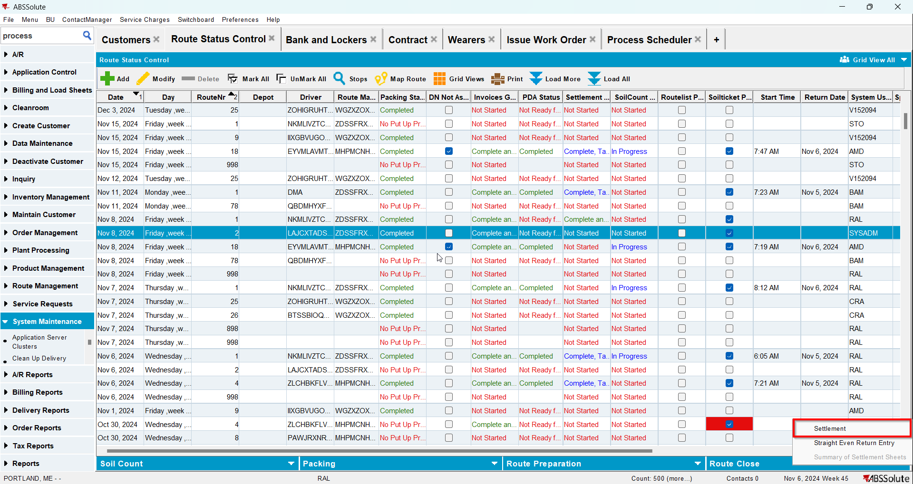
- Check that the Install Date and First Service Date have the date of the invoice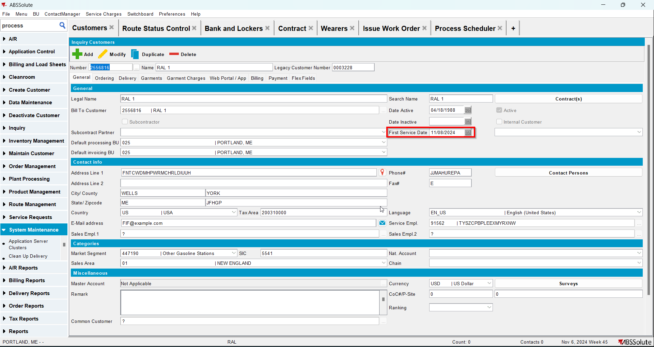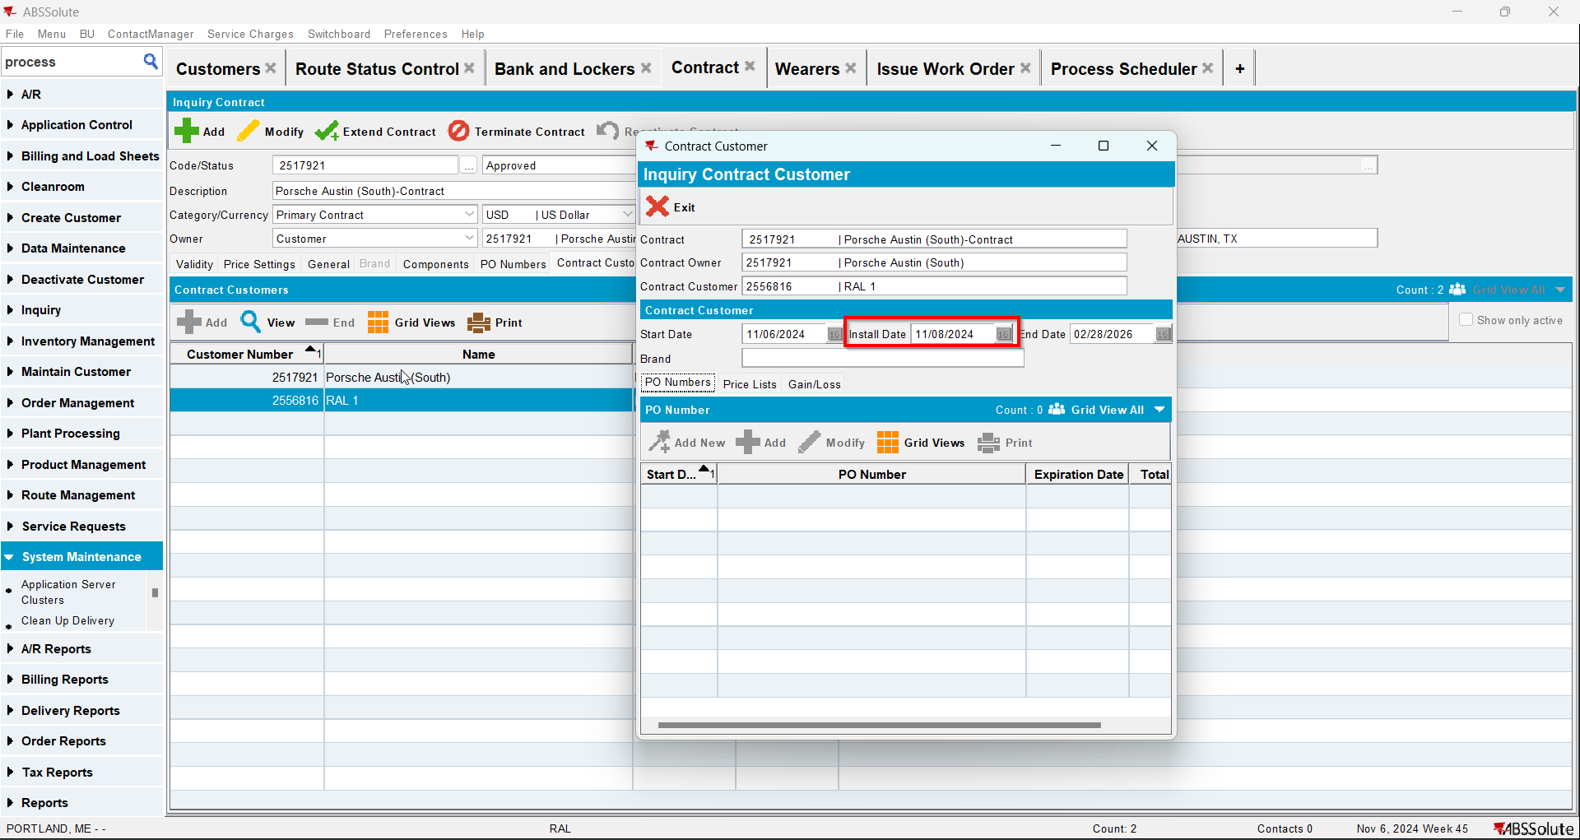
- Go to Maintain Invoices dlg and full credit the invoice for your customer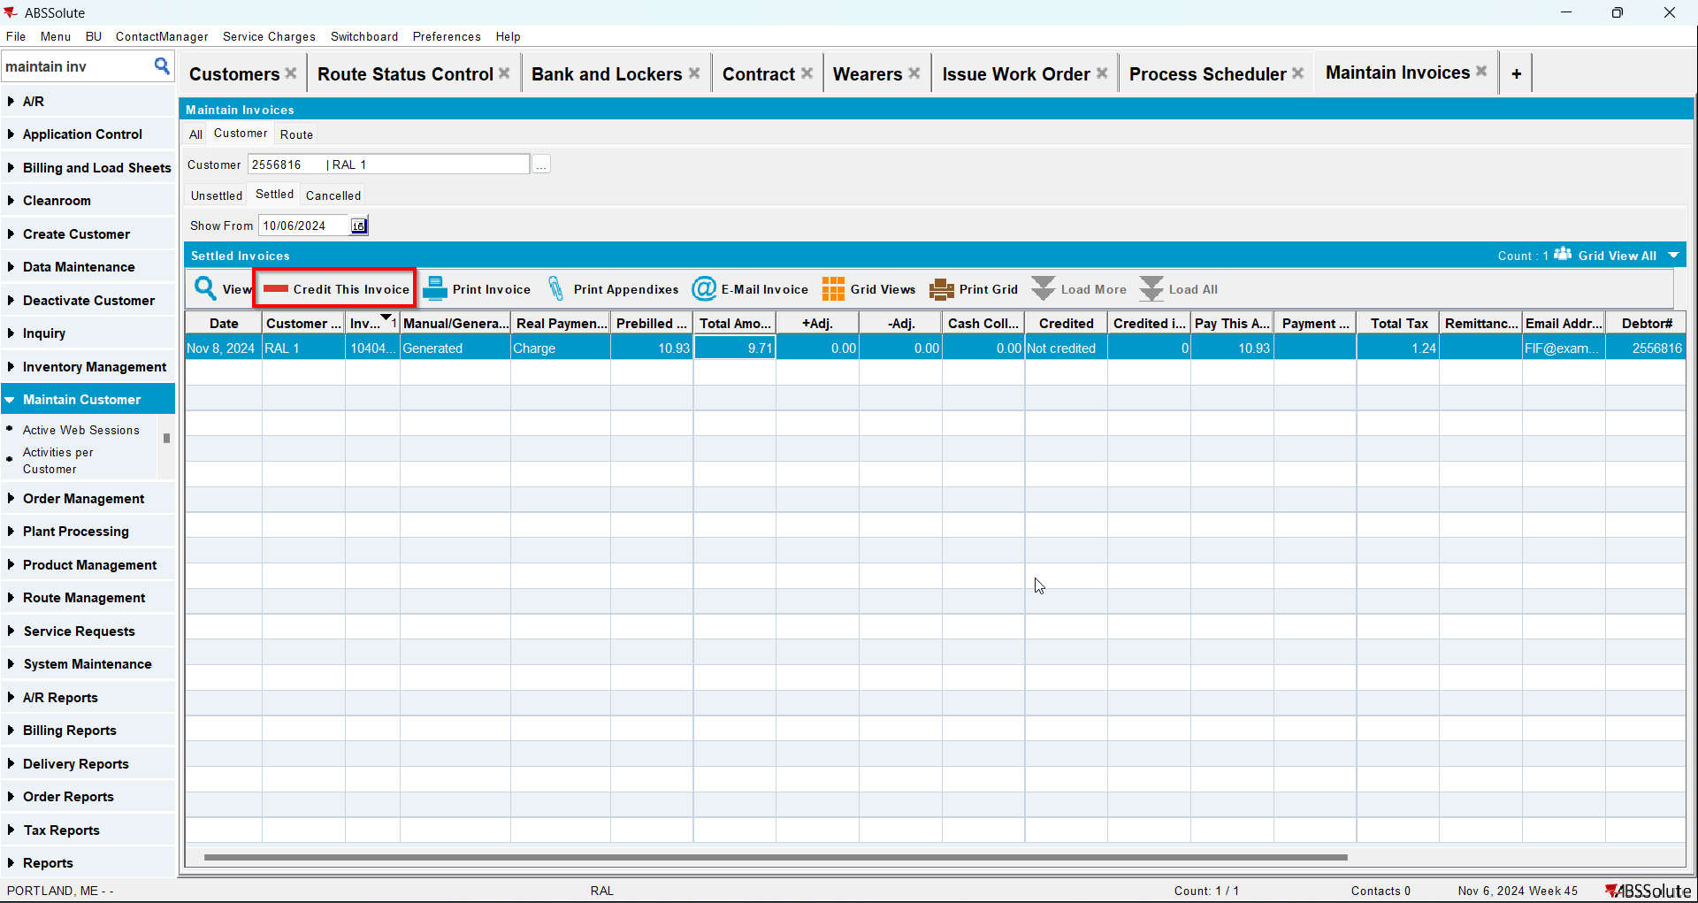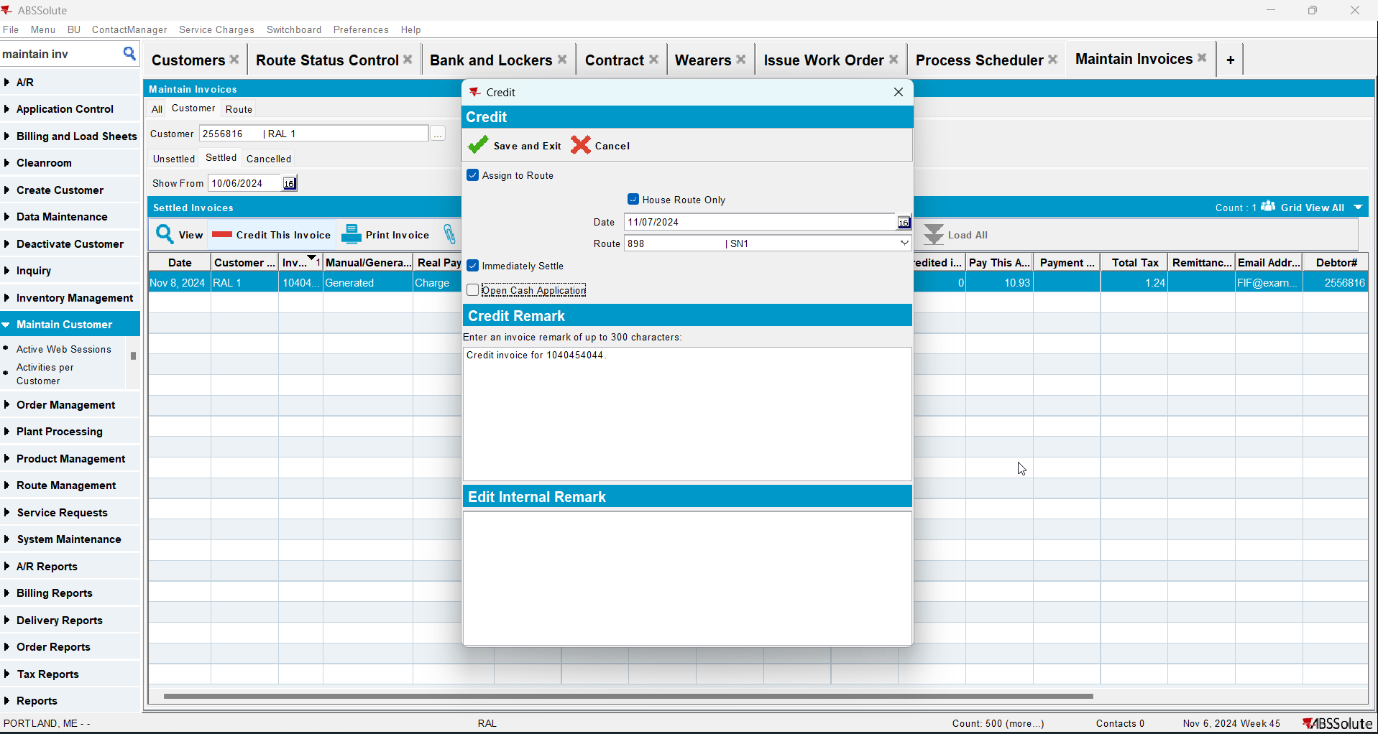
- Check that the Install Date and First Service Date are null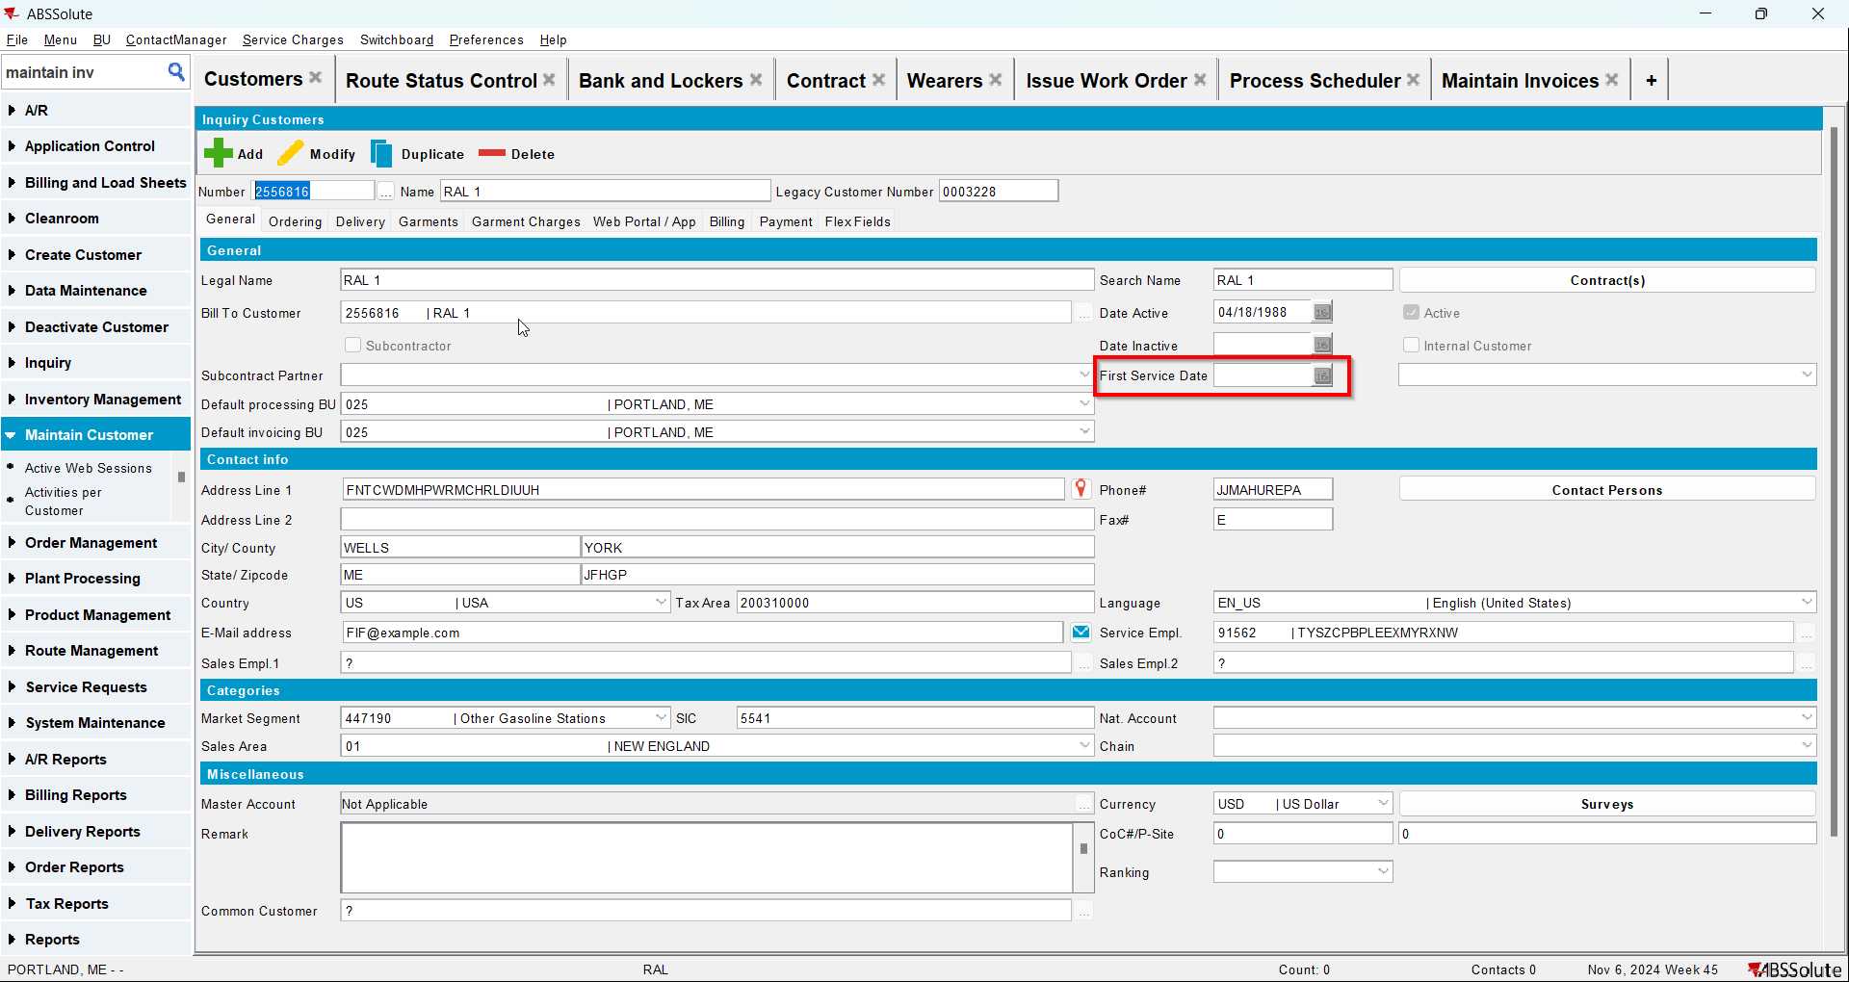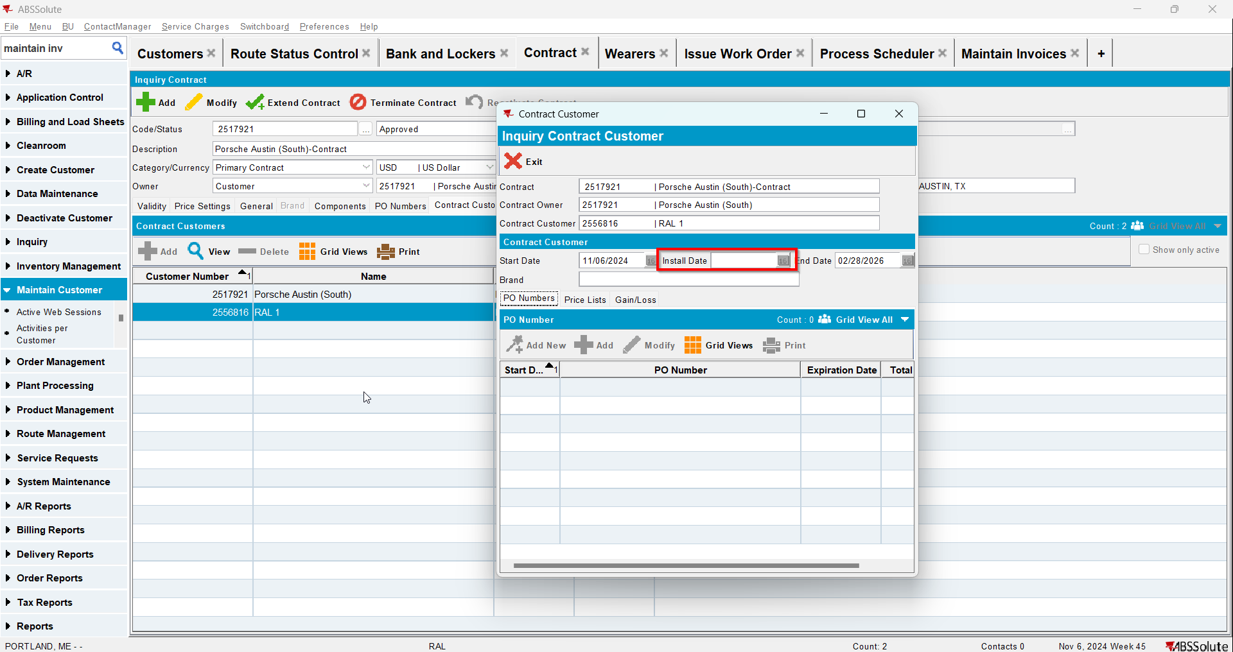

Test Case 2 – Full Credit when this is the first invoice for the customer and there are 2 more invoices for this customer– Tested OK
Expected behavior: Install date and first service date should be updated to the oldest invoice date
Hash: 3fa65b8
- Add a new customer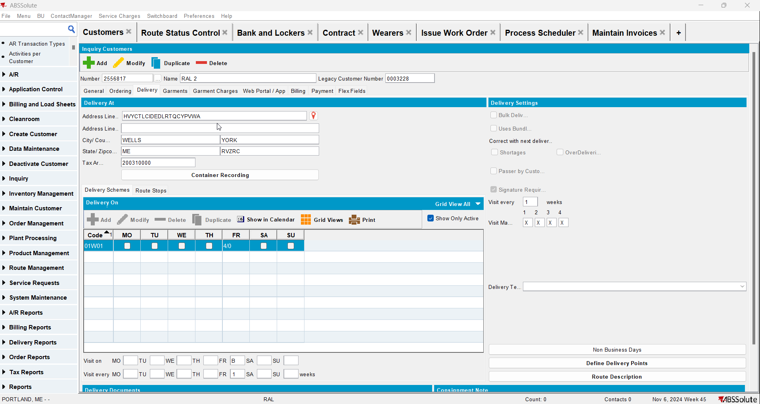
- Check that the First Service Date is null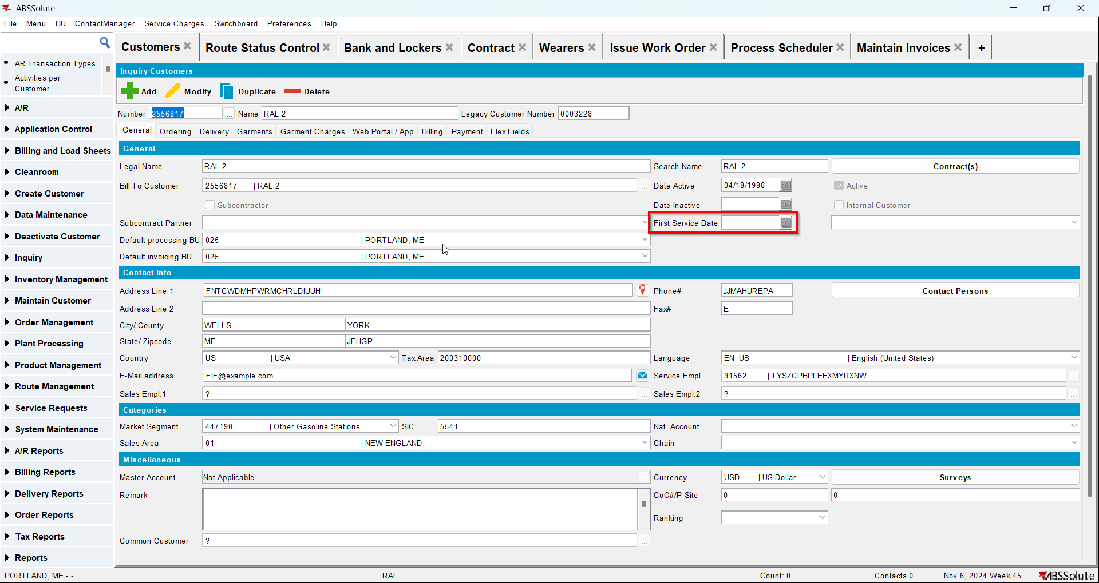
- Go to Bank and Lockers dlg and add lockers for your customer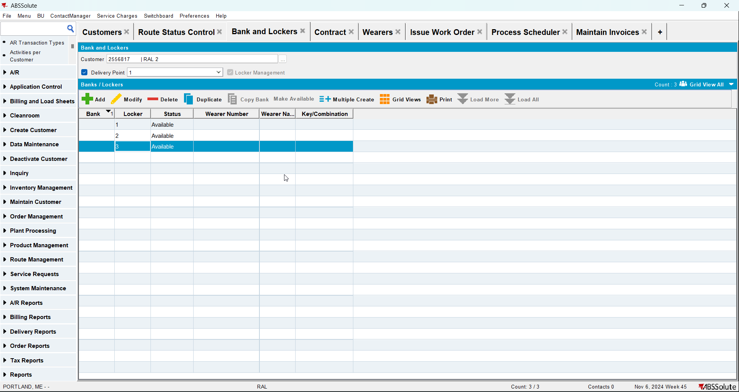
- Go to Contract dlg and add your customer to a contract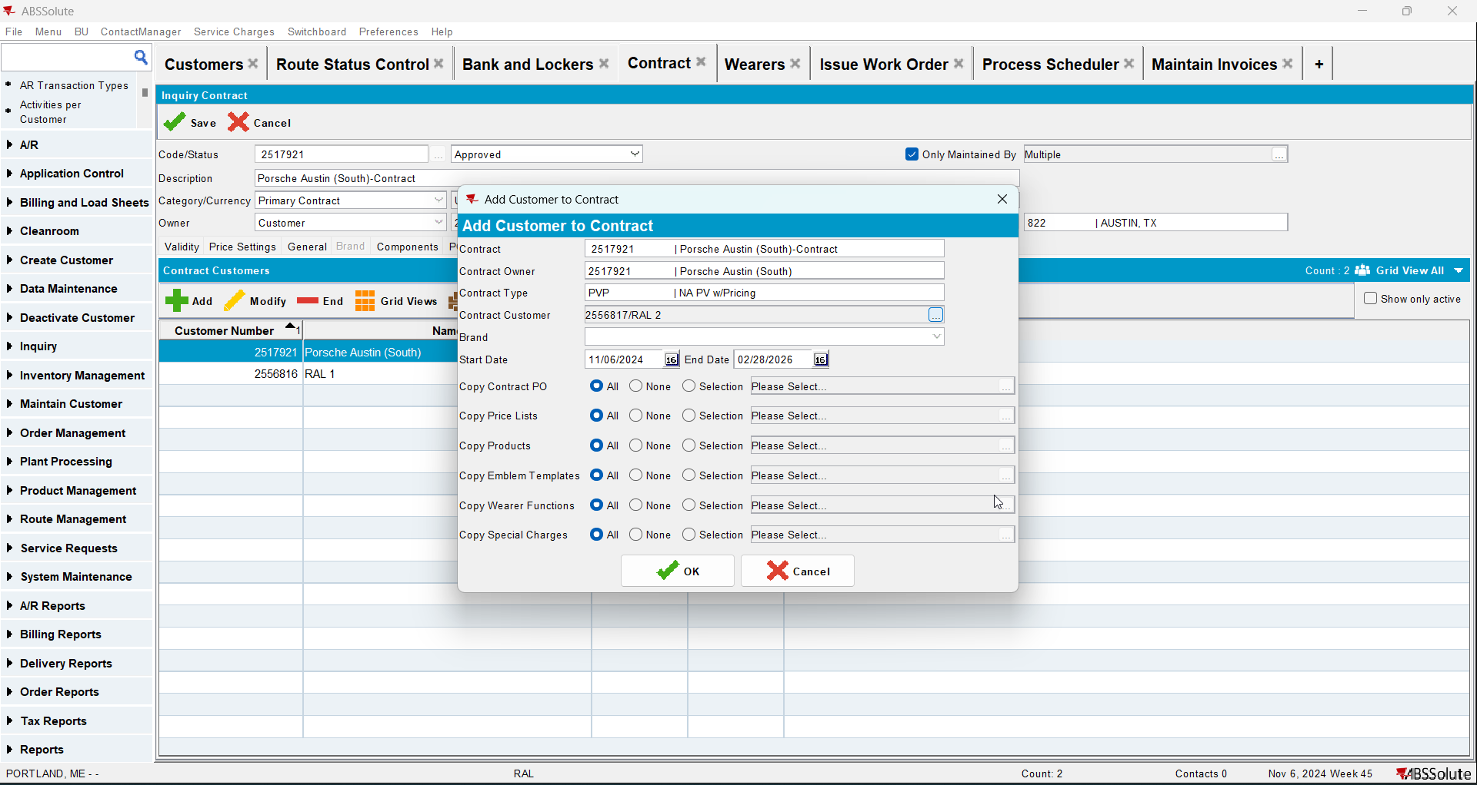
- Check that Install Date is null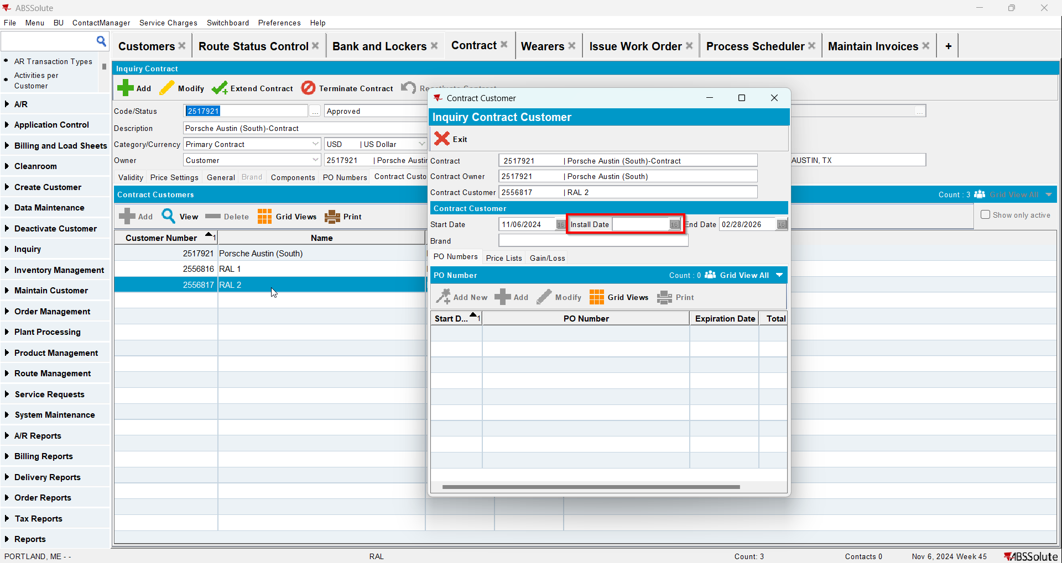
- Go to Wearers dlg and add wearers for your customer. Generate WO and after that issue the WO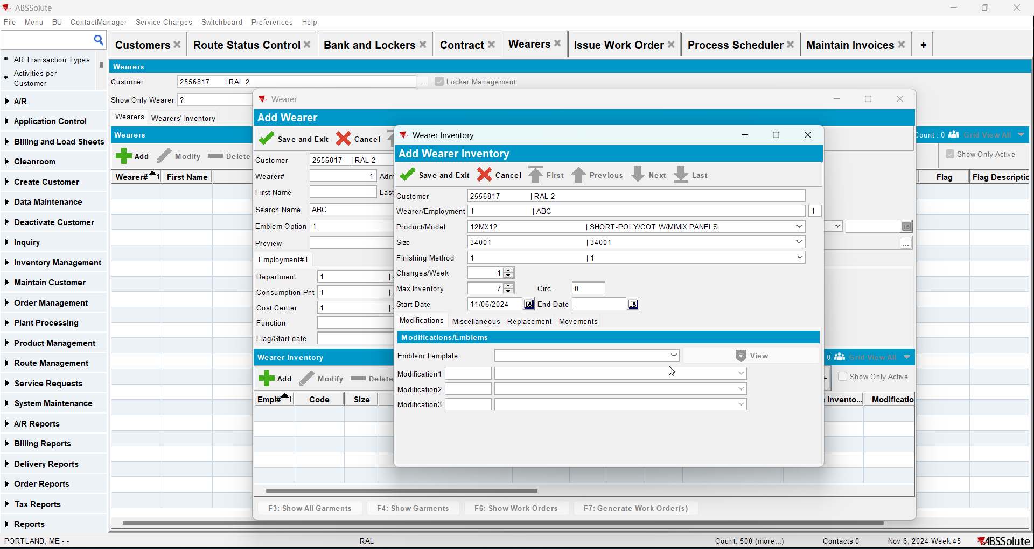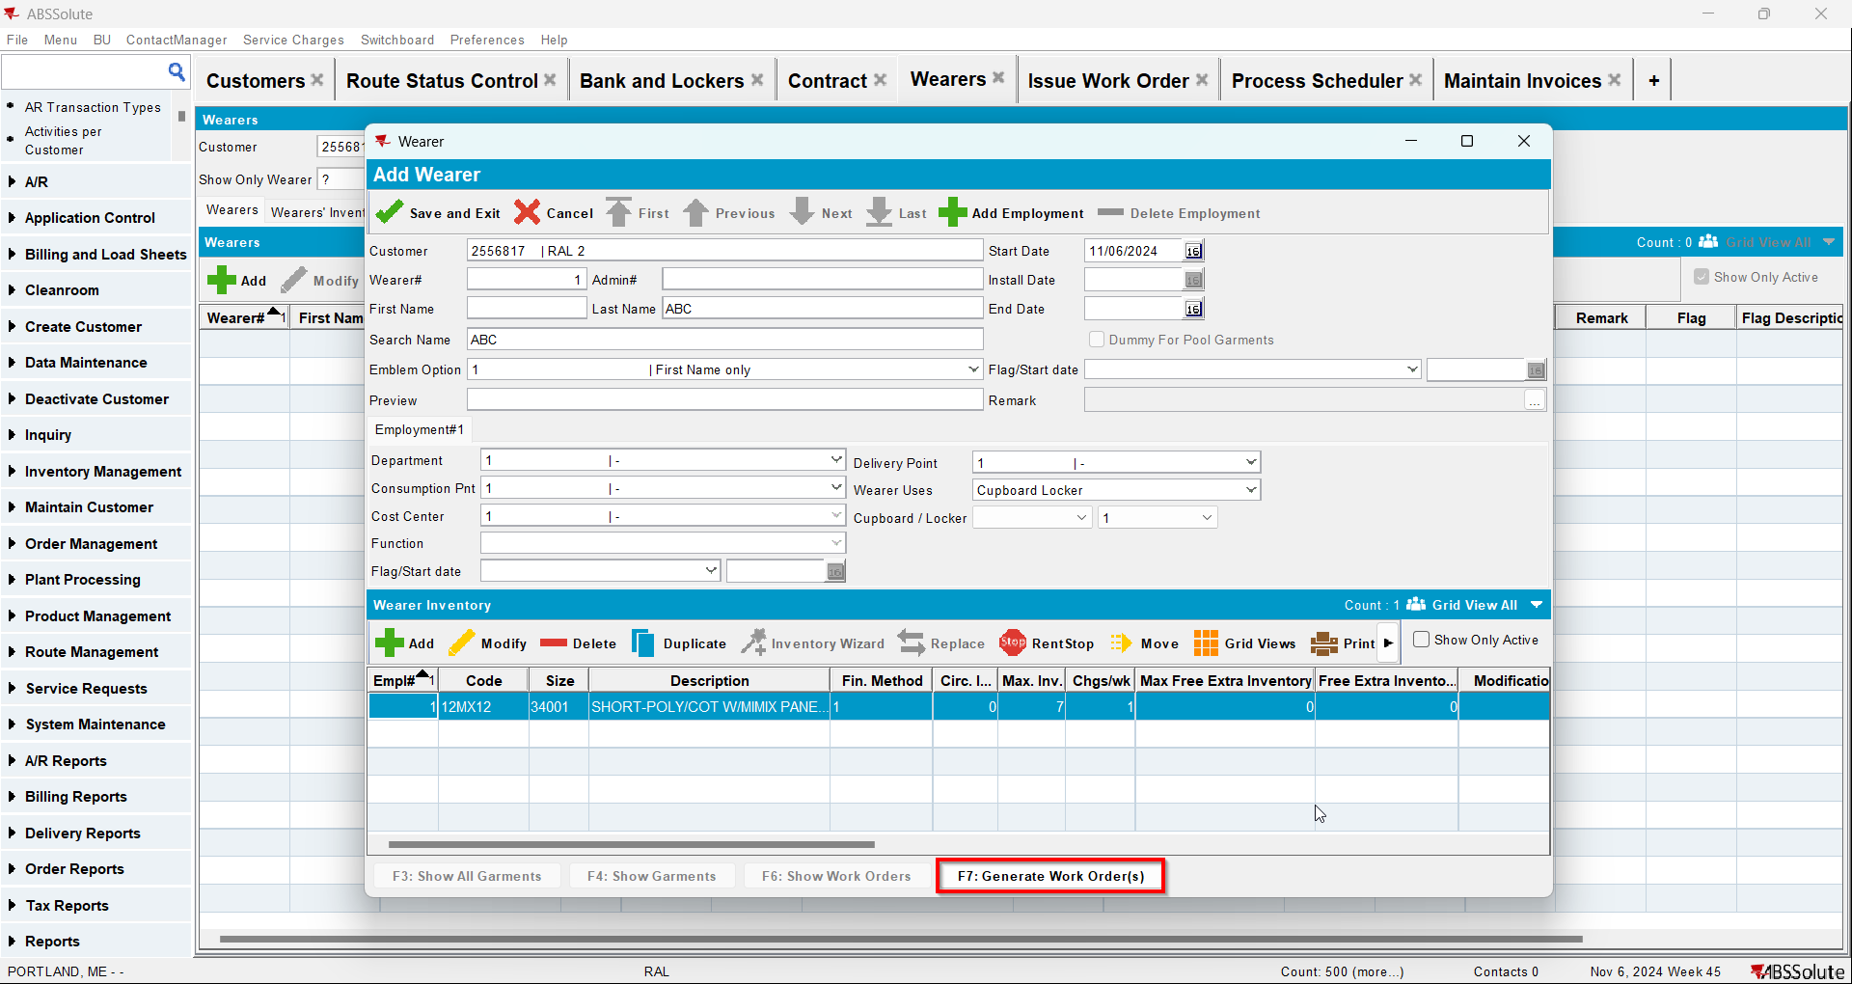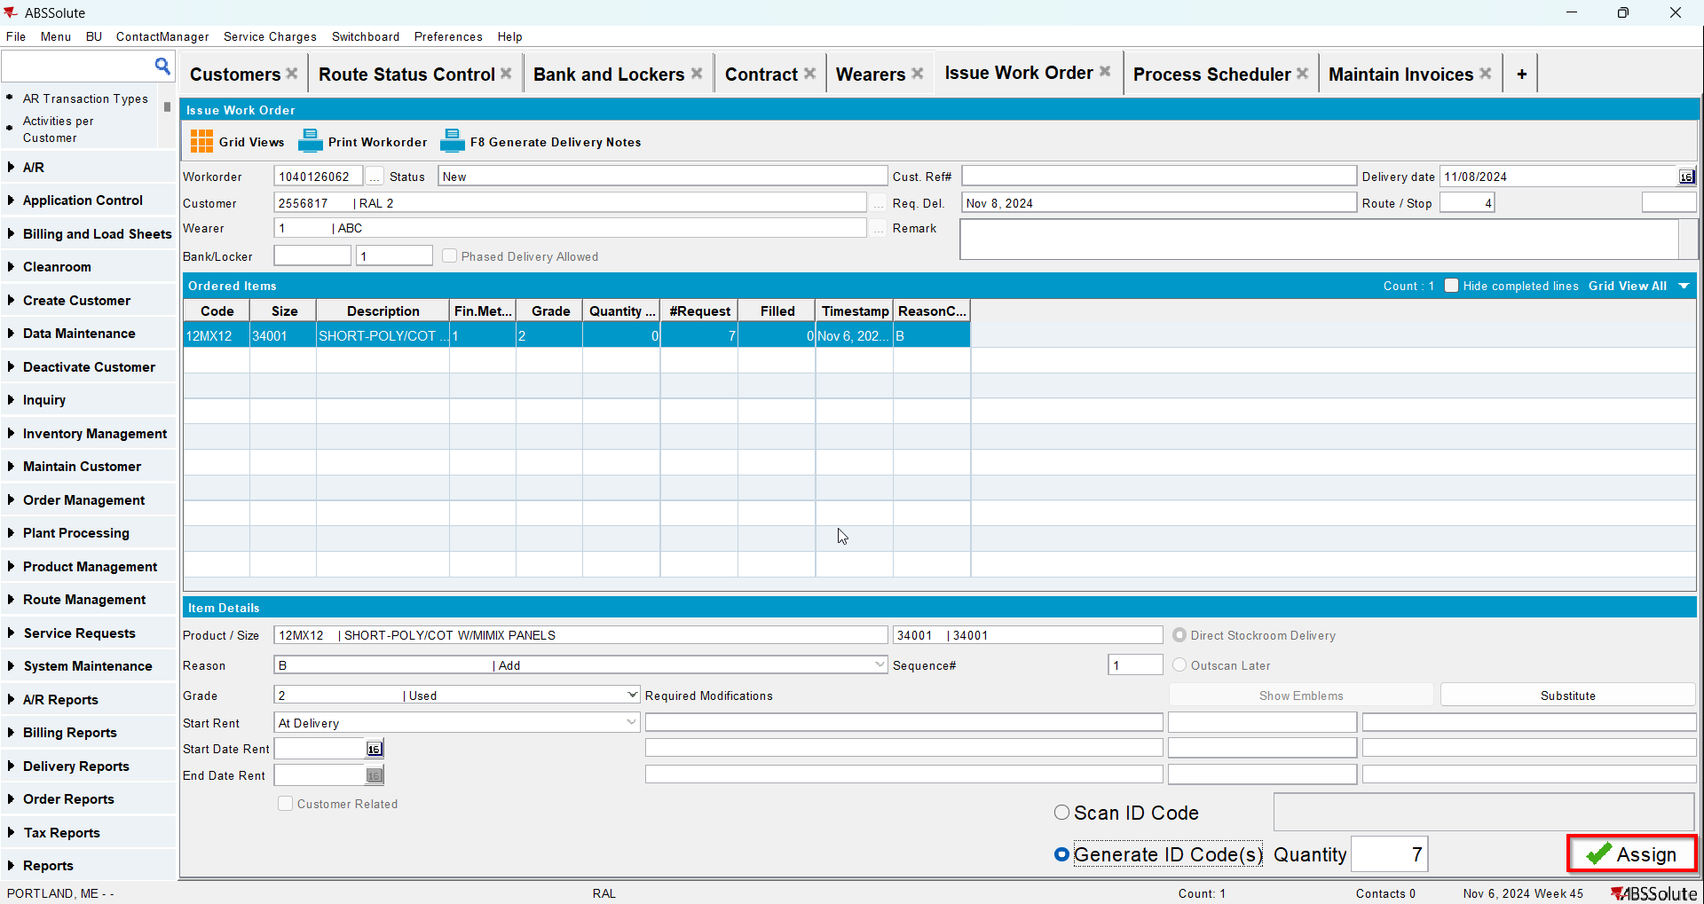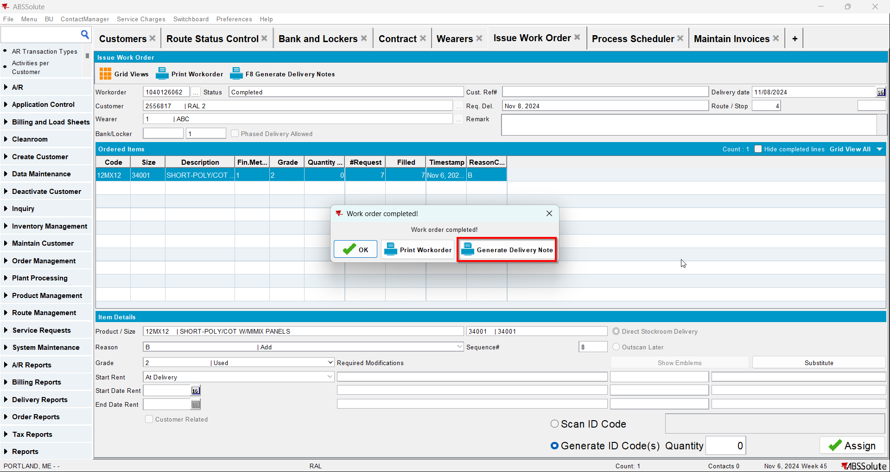
- Go to Route Status Control dlg and generate invoices for your route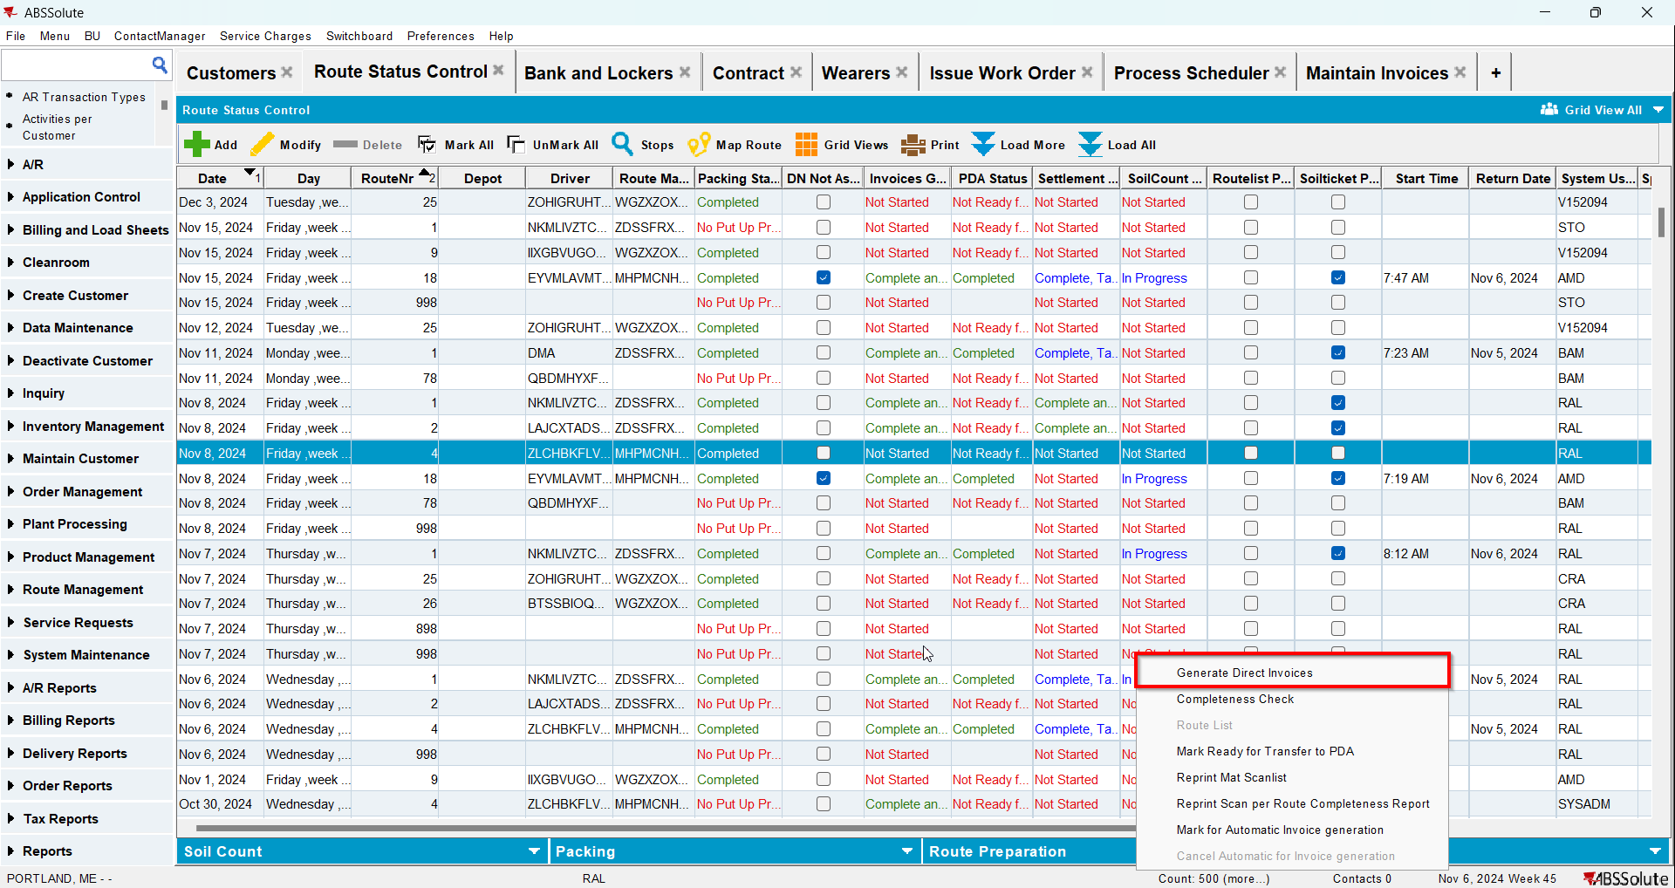
- Settle the route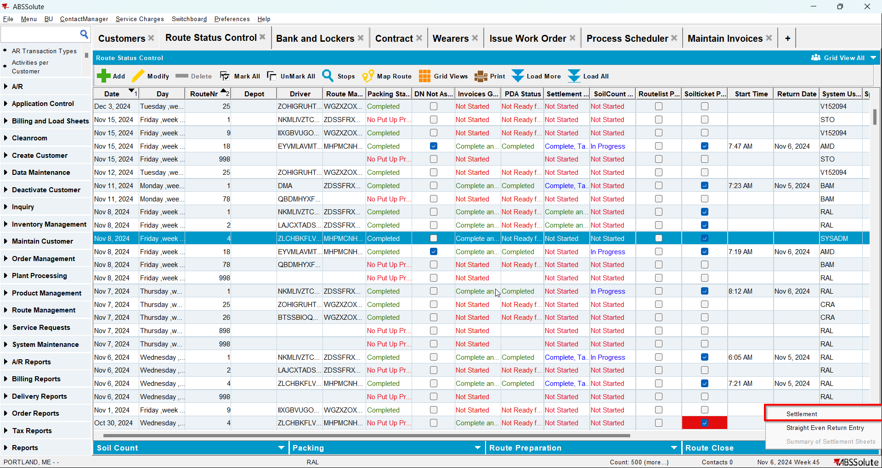
- Check that the Install Date and First Service Date have the date of the invoice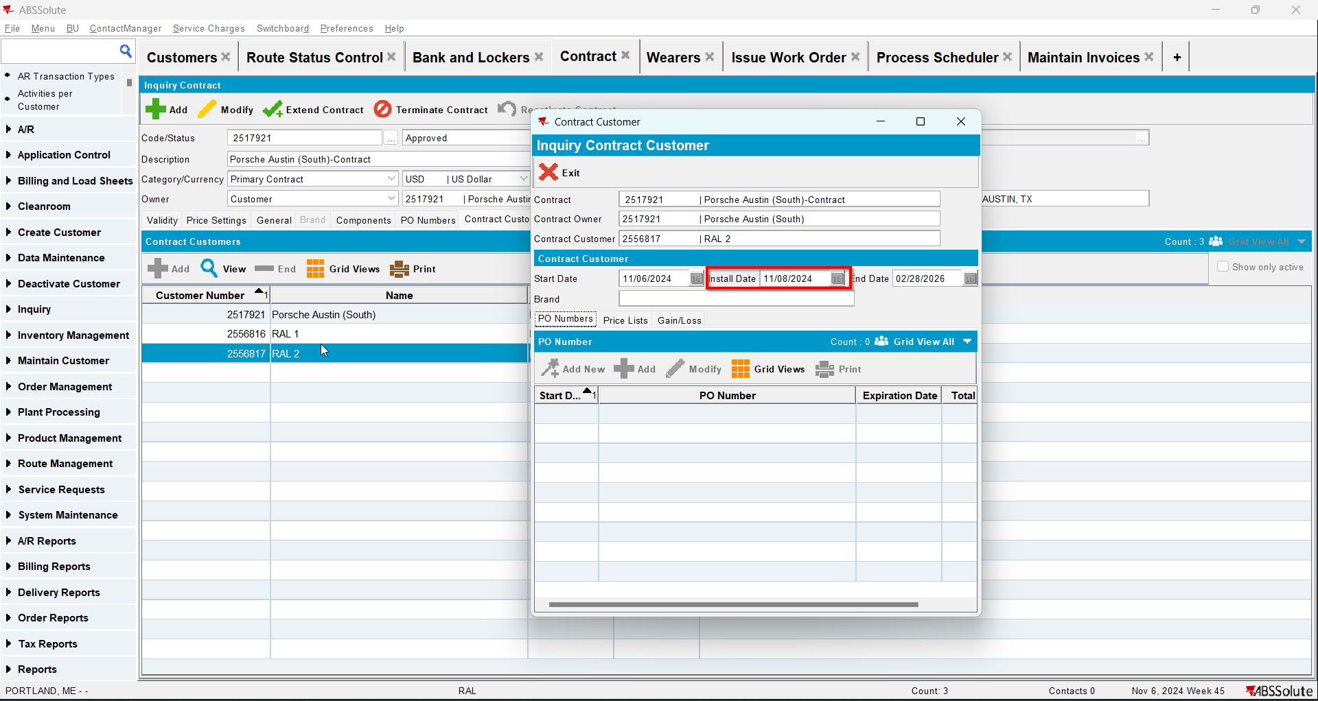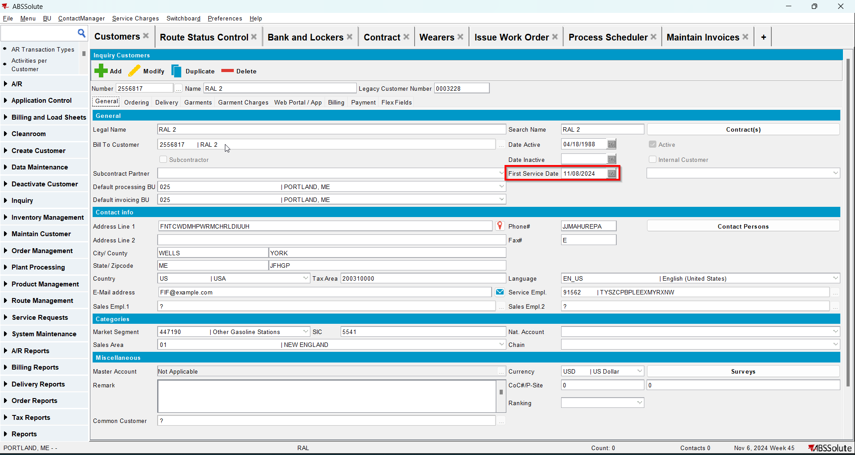
- Generate invoices for the next 2 weeks and settle the routes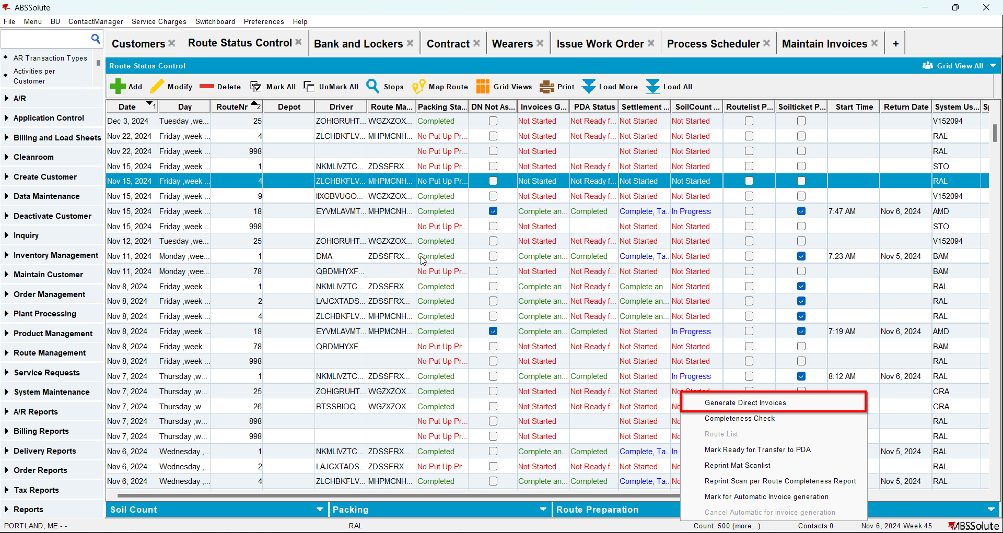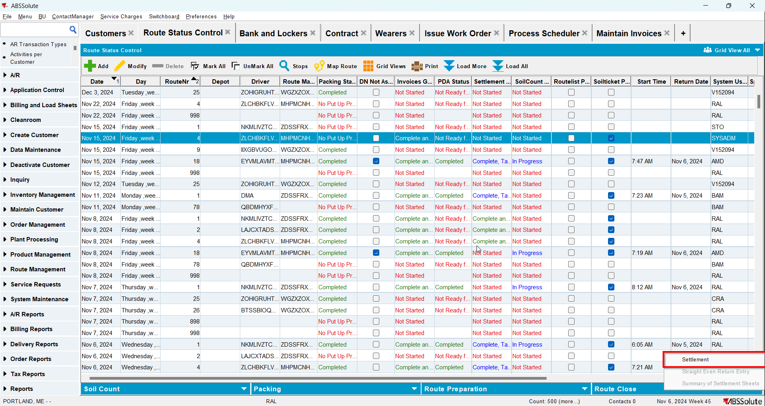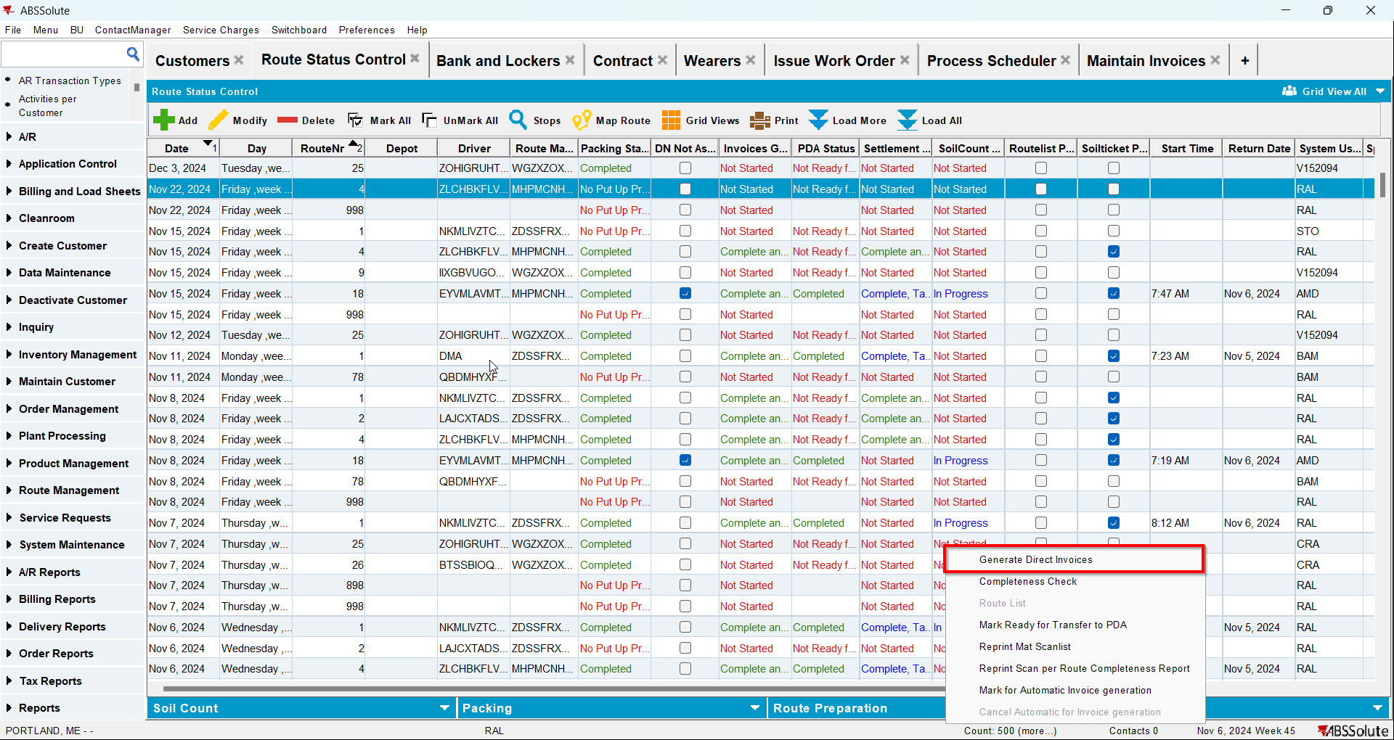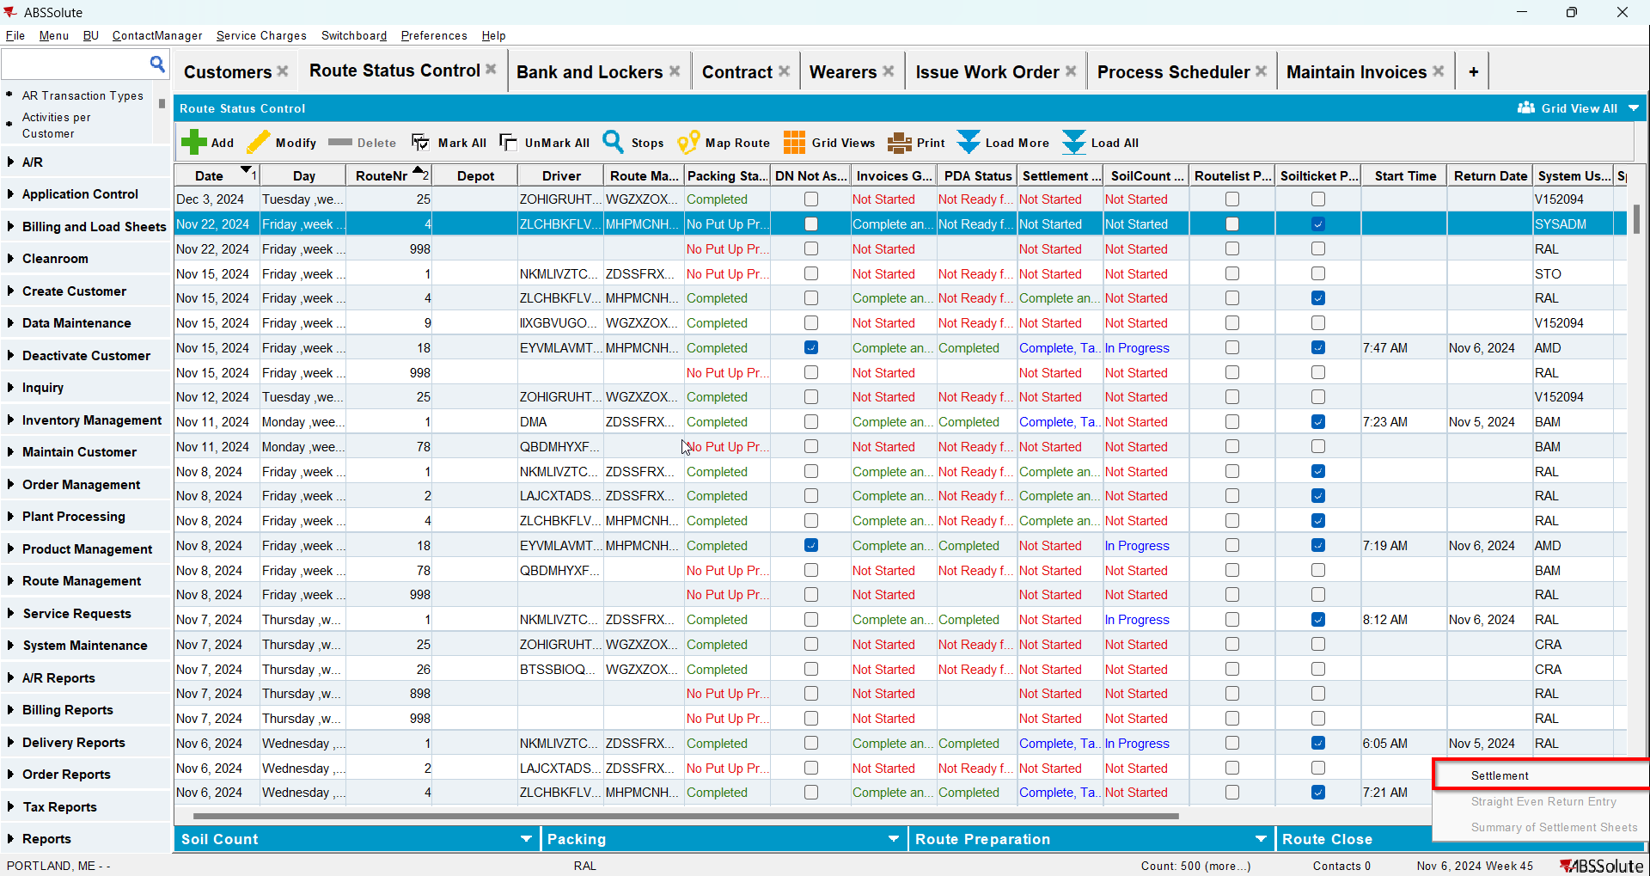
- Go to Maintain Invoices dlg and full credit the first invoice for your customer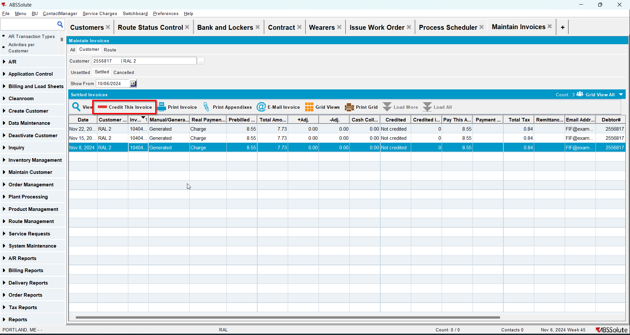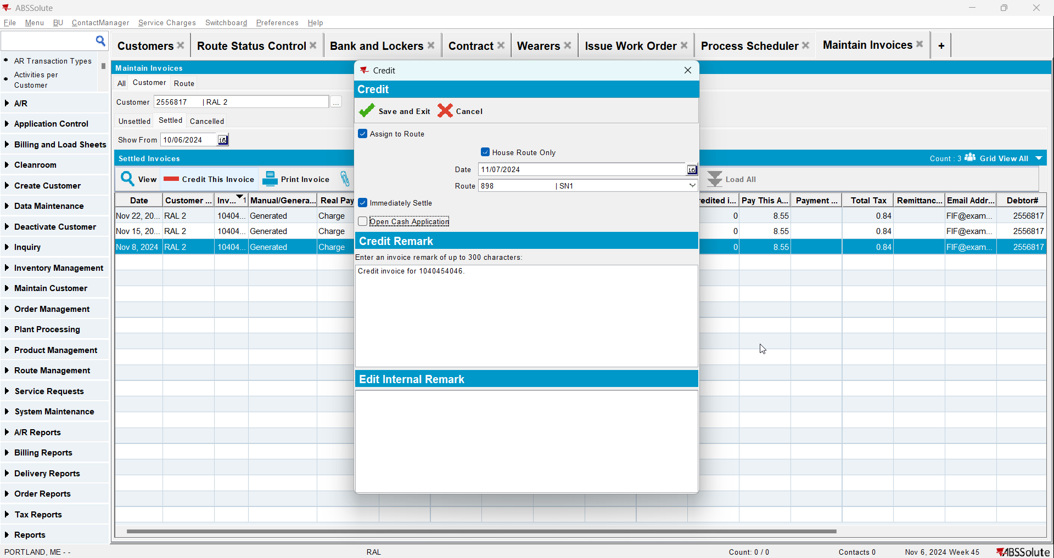
- Check that the Install Date and First Service Date are updated to the oldest invoice date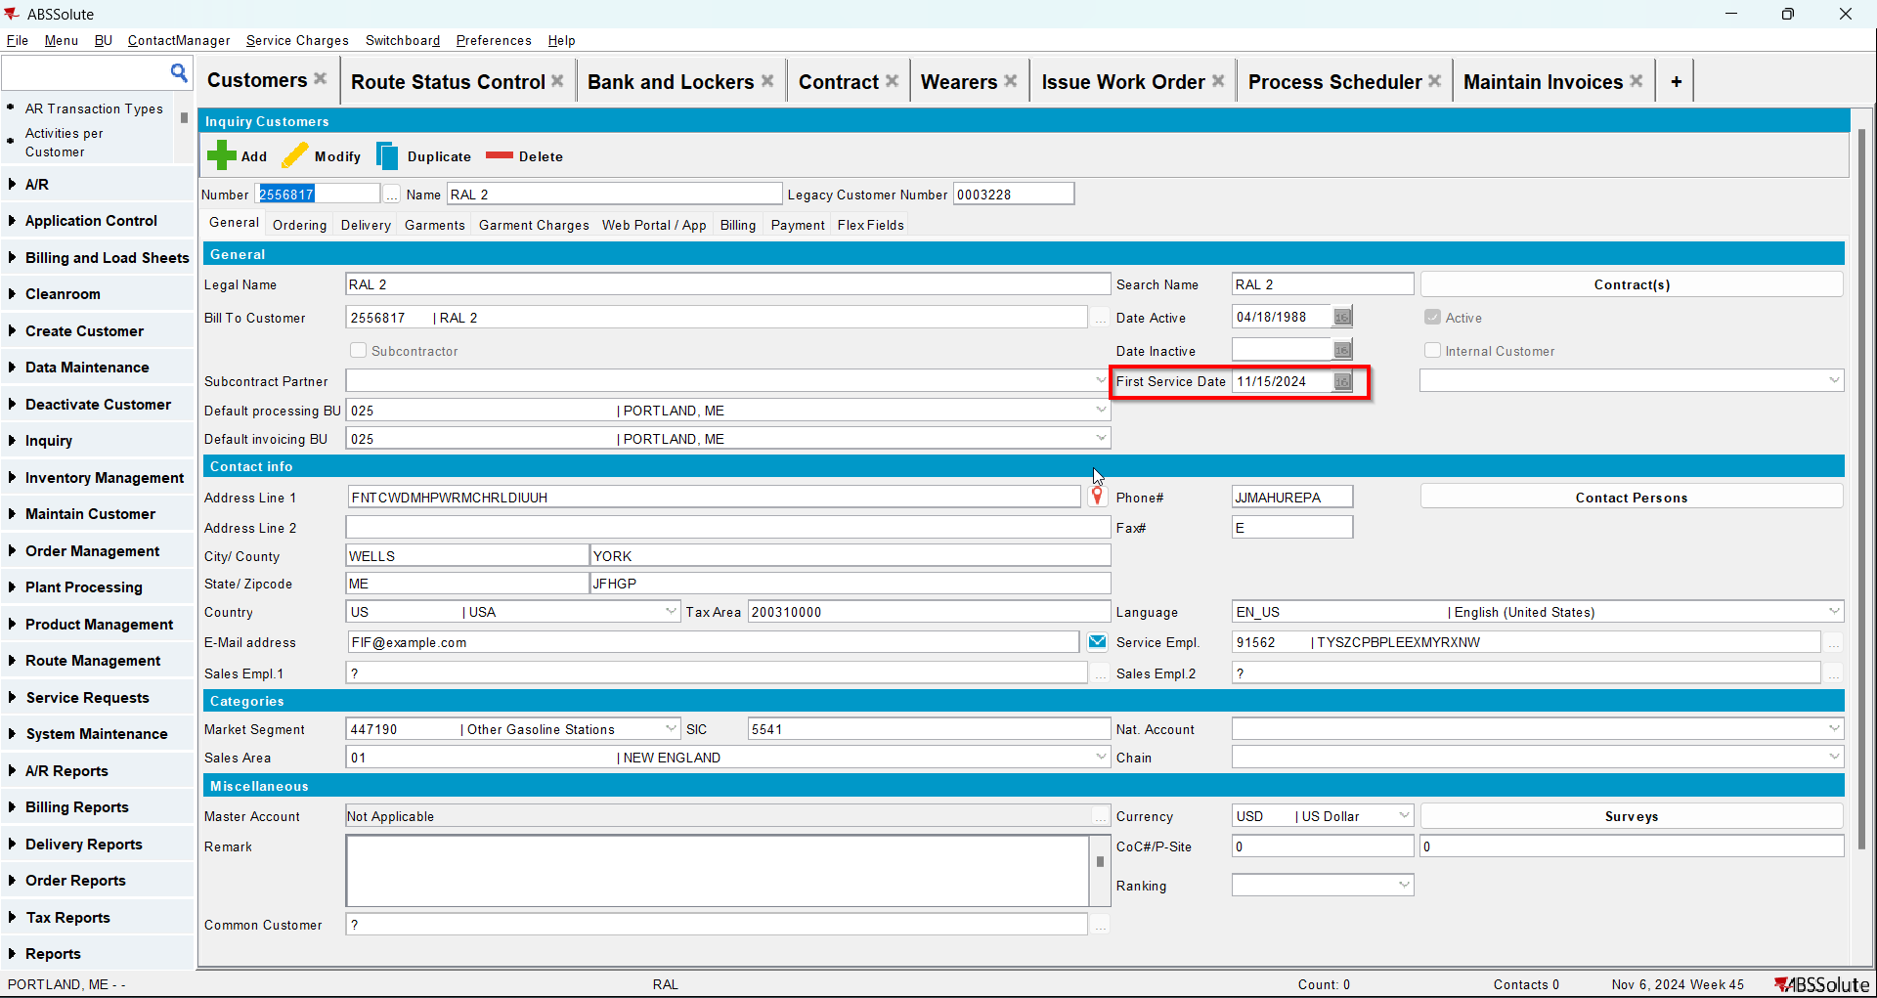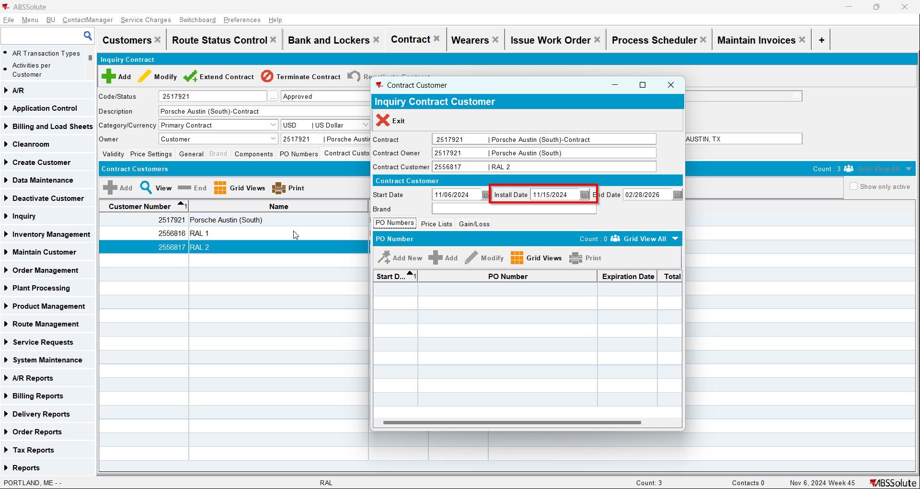

Test Case 3 – Manually Credit all lines besides special charge, min inv amount and tax when this is the first invoice for the customer and there are no more invoices for this customer– Tested OK
Expected behavior: Install date and first service date should be NULL
Hash: 3fa65b8
- Add a new customer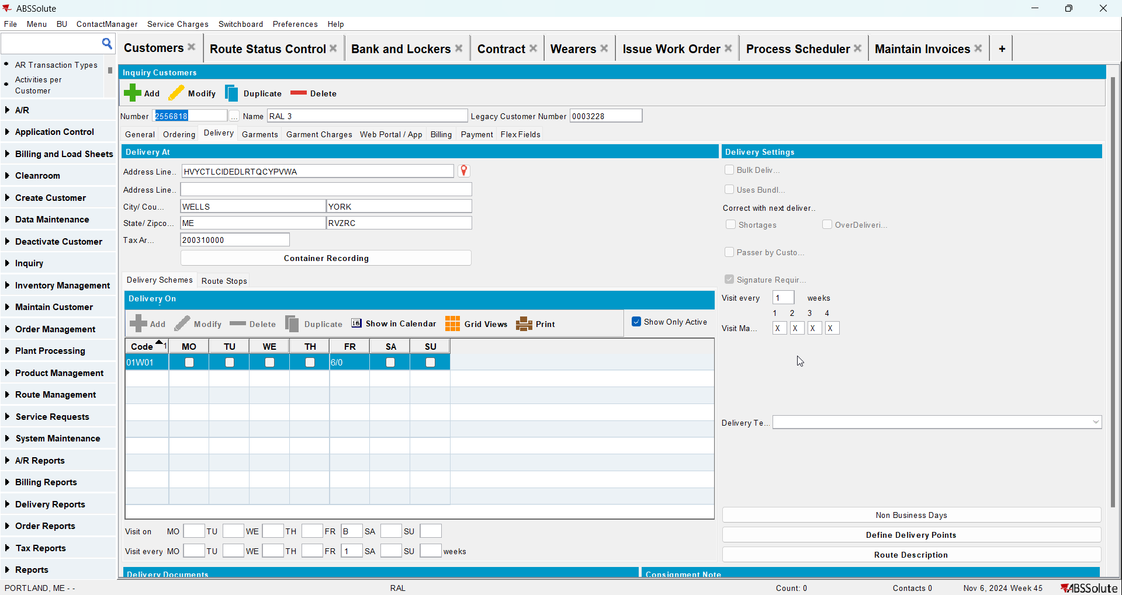
- Check that the First Service Date is null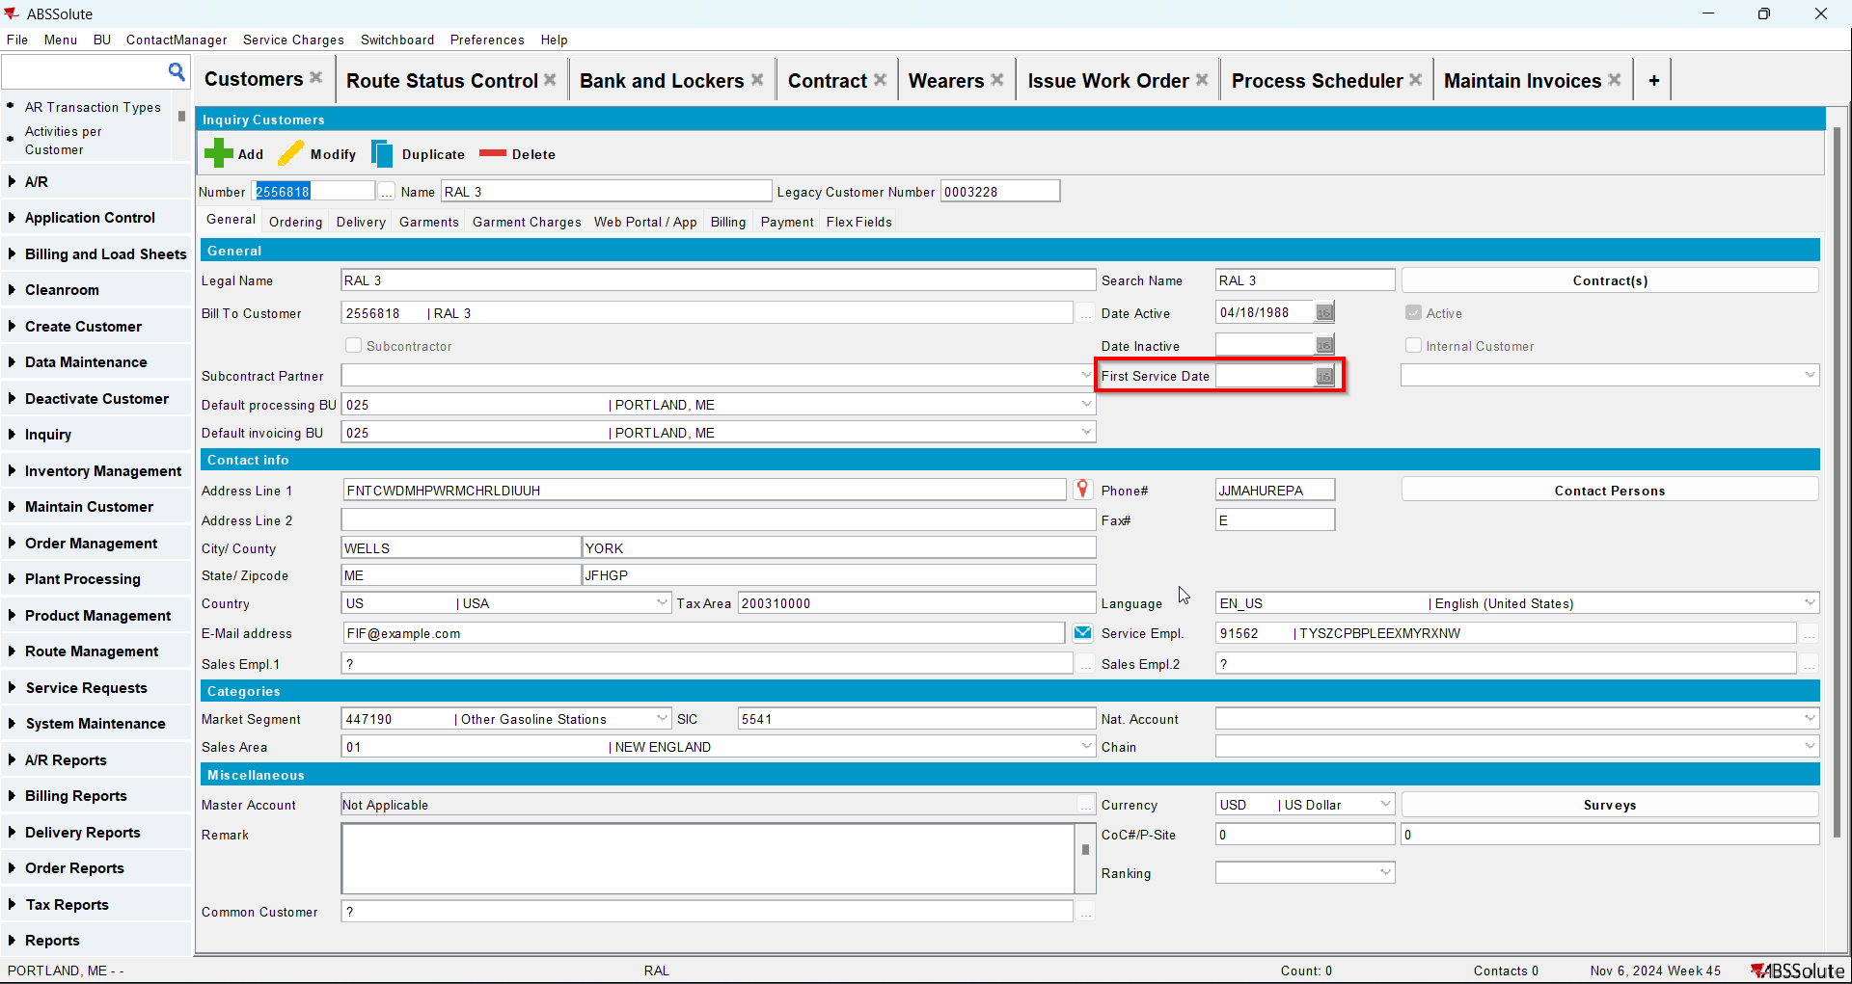
- Go to Bank and Lockers dlg and add lockers for your customer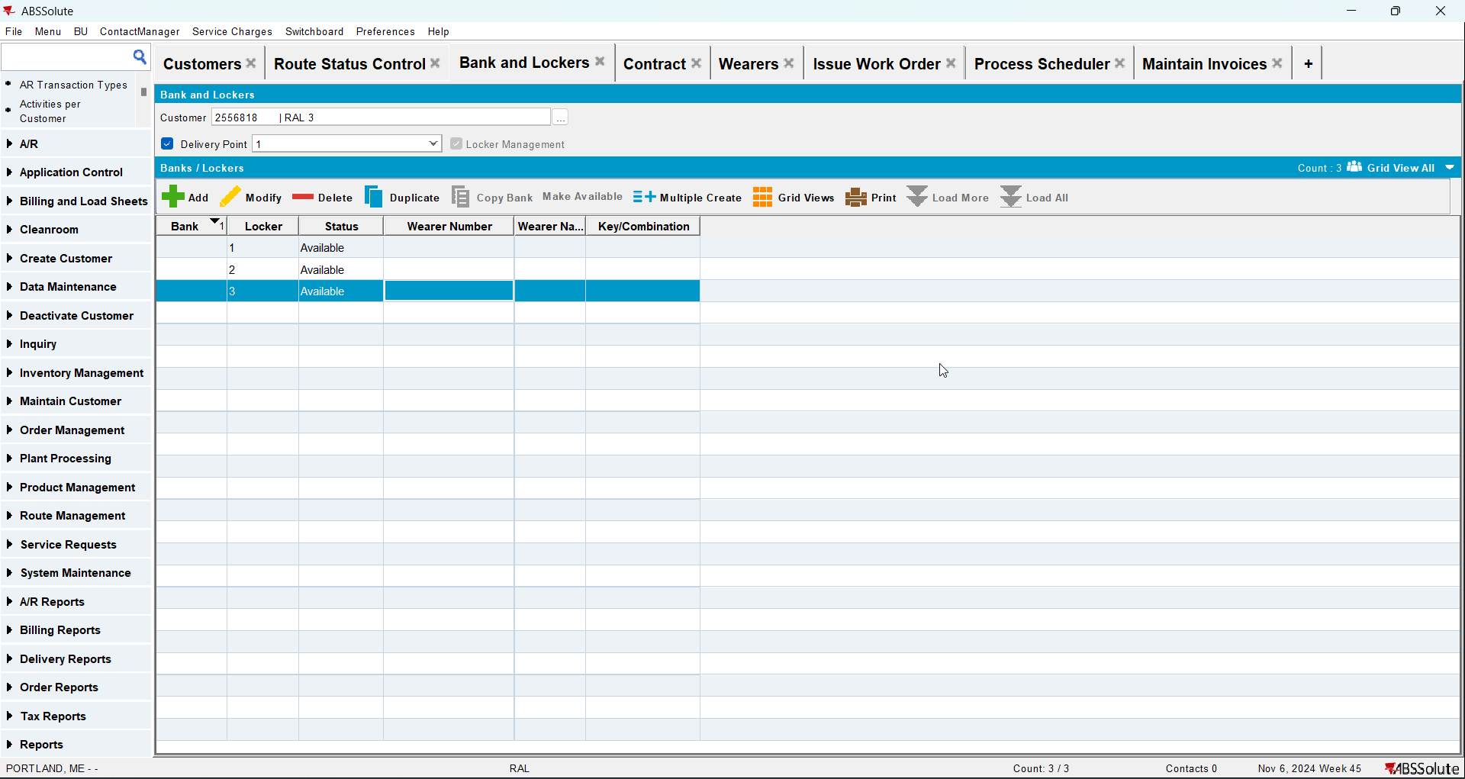
- Go to Contract dlg and add your customer to a contract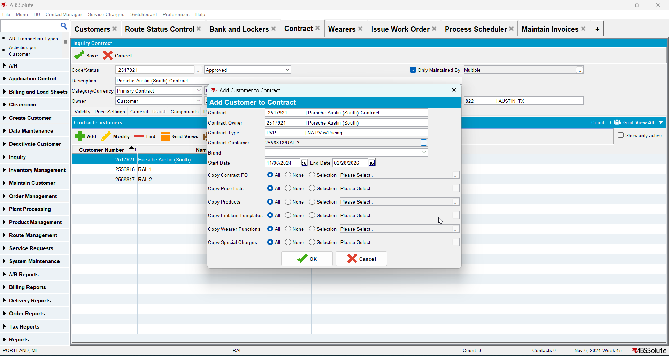
- Check that Install Date is null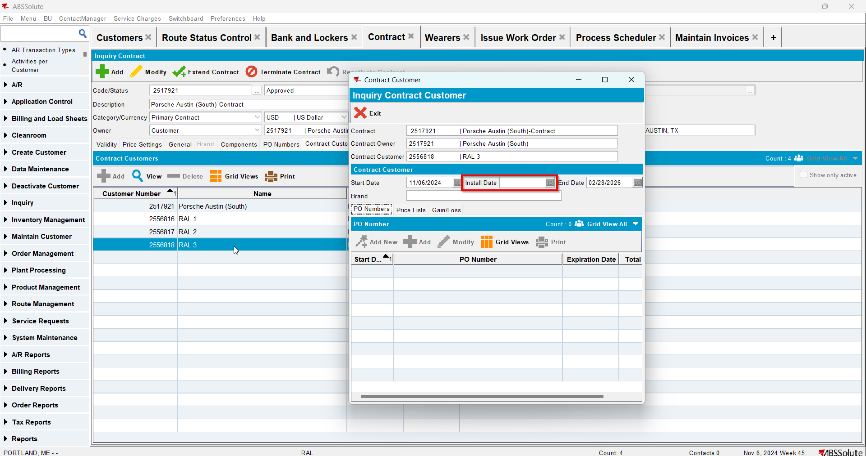
- Go to Wearers dlg and add wearers for your customer. Generate WO and after that issue the WO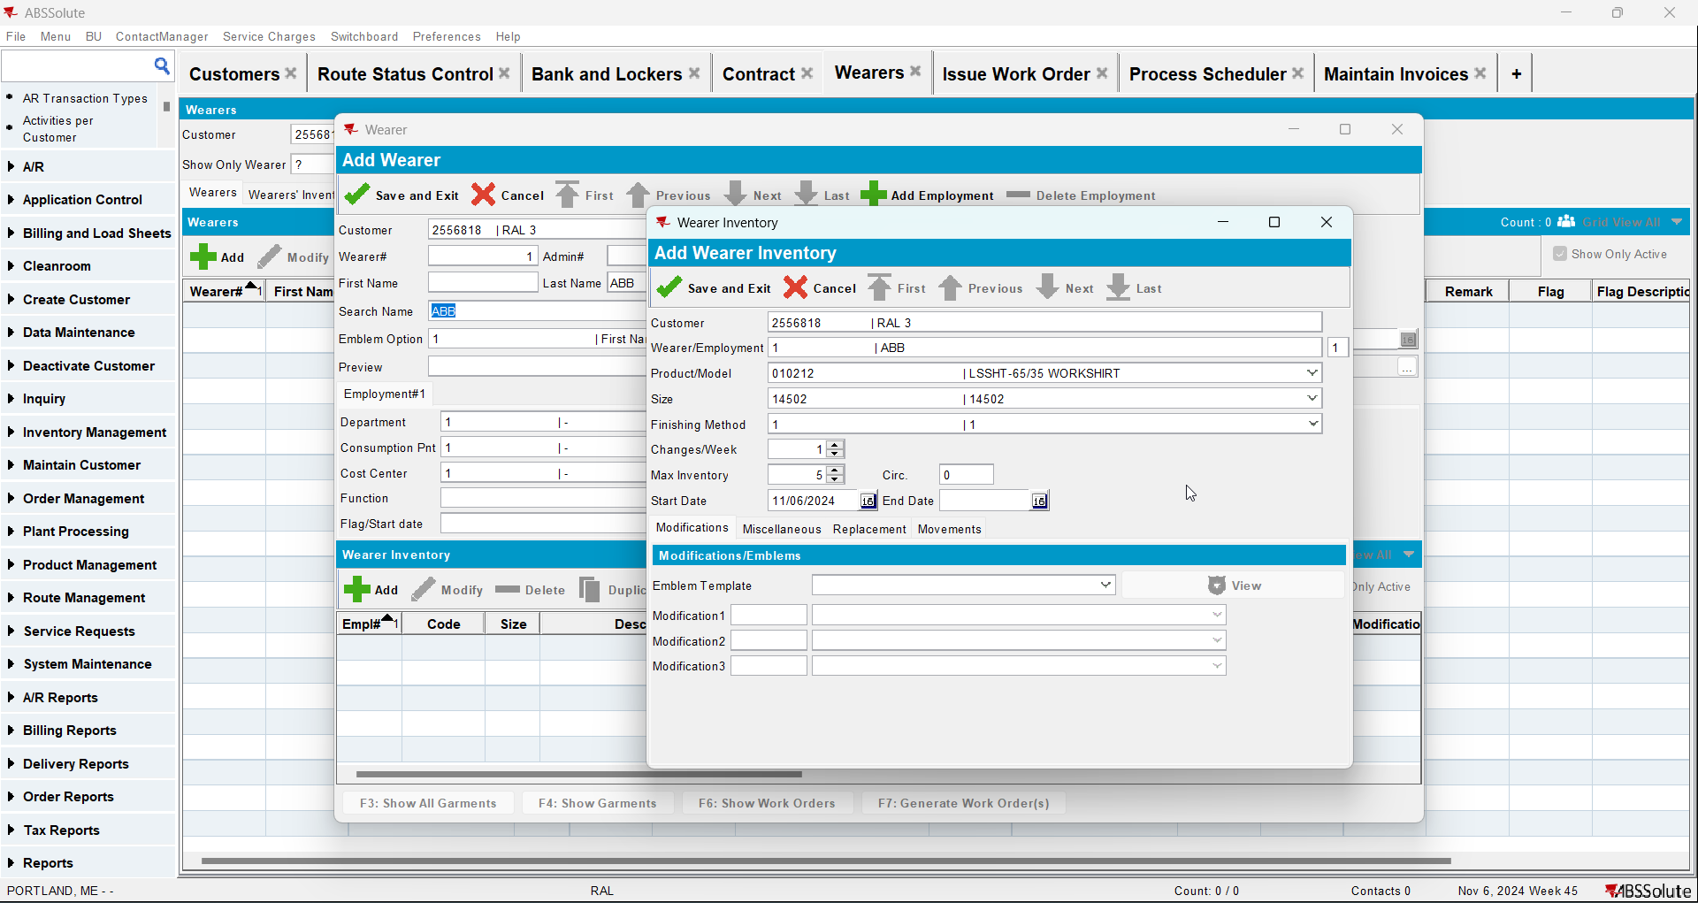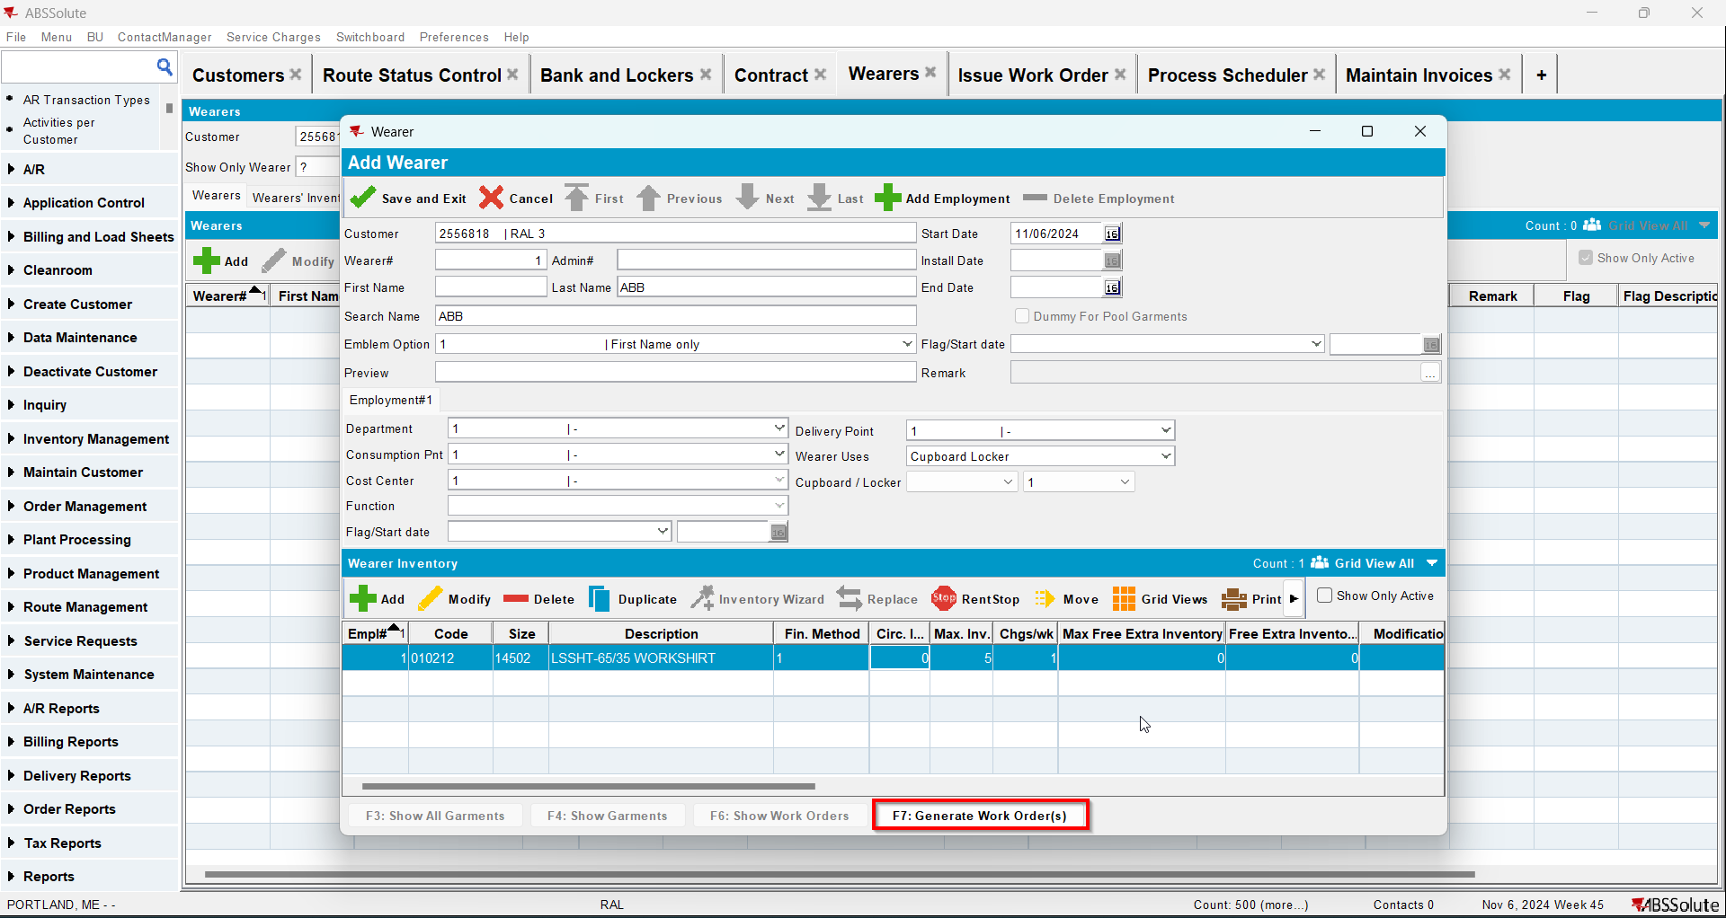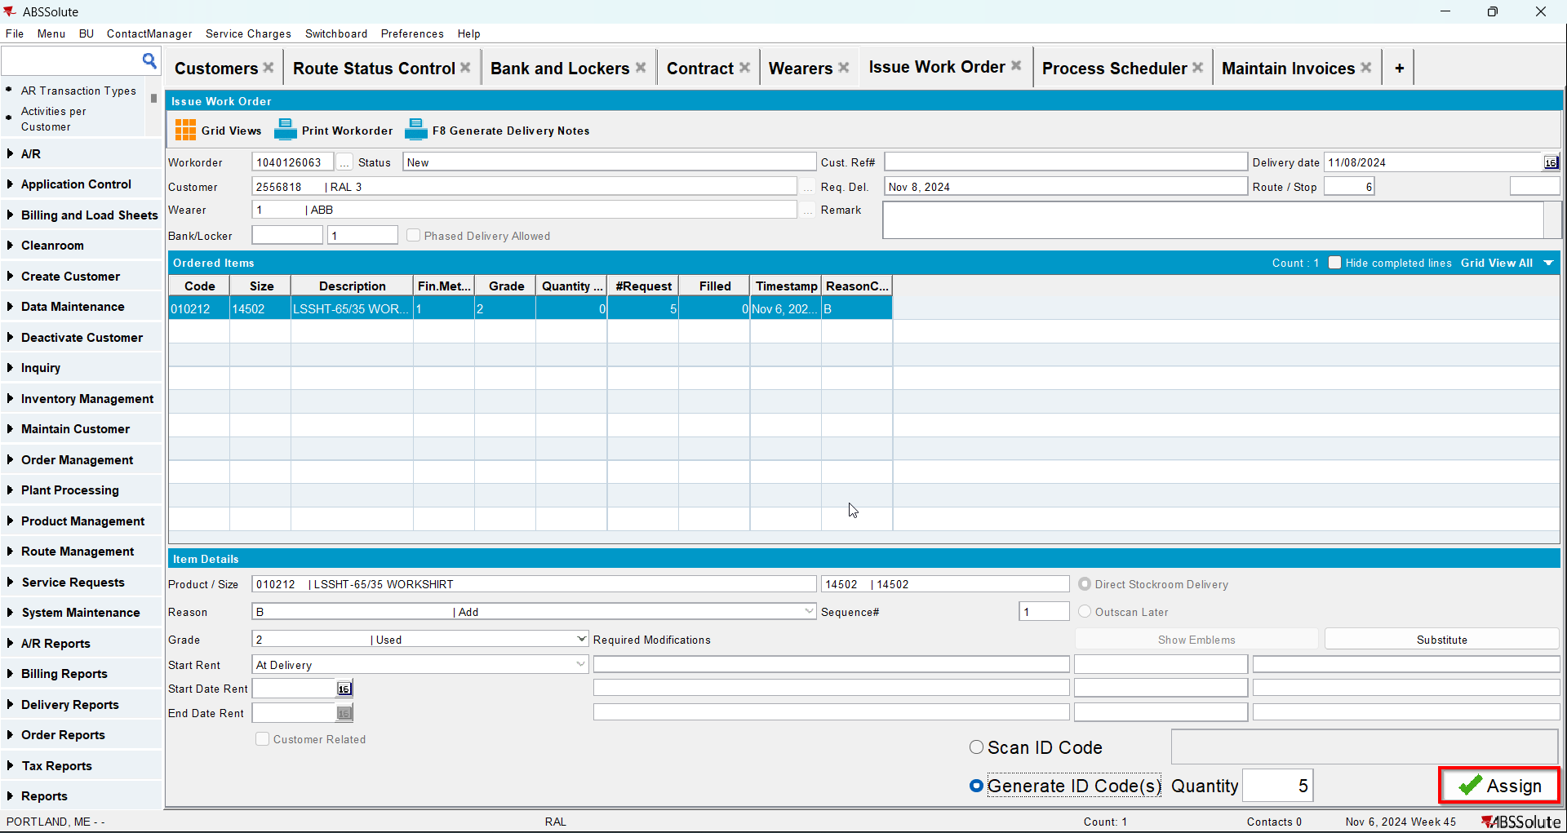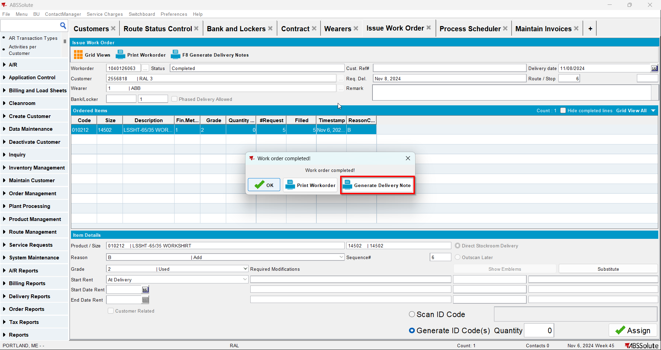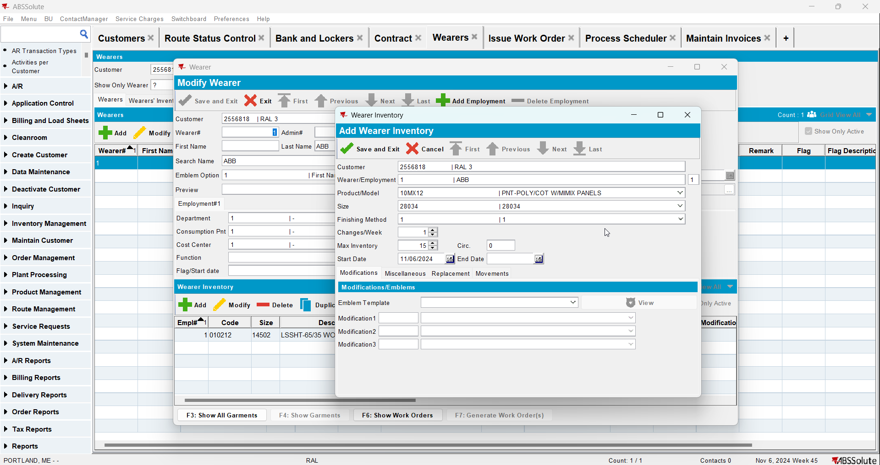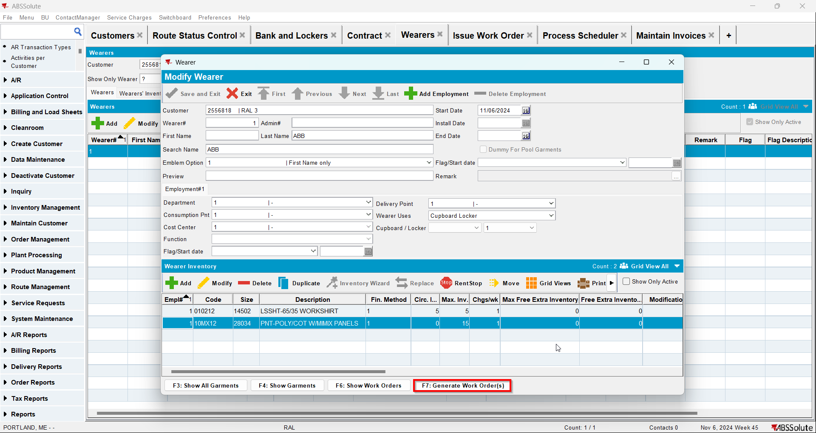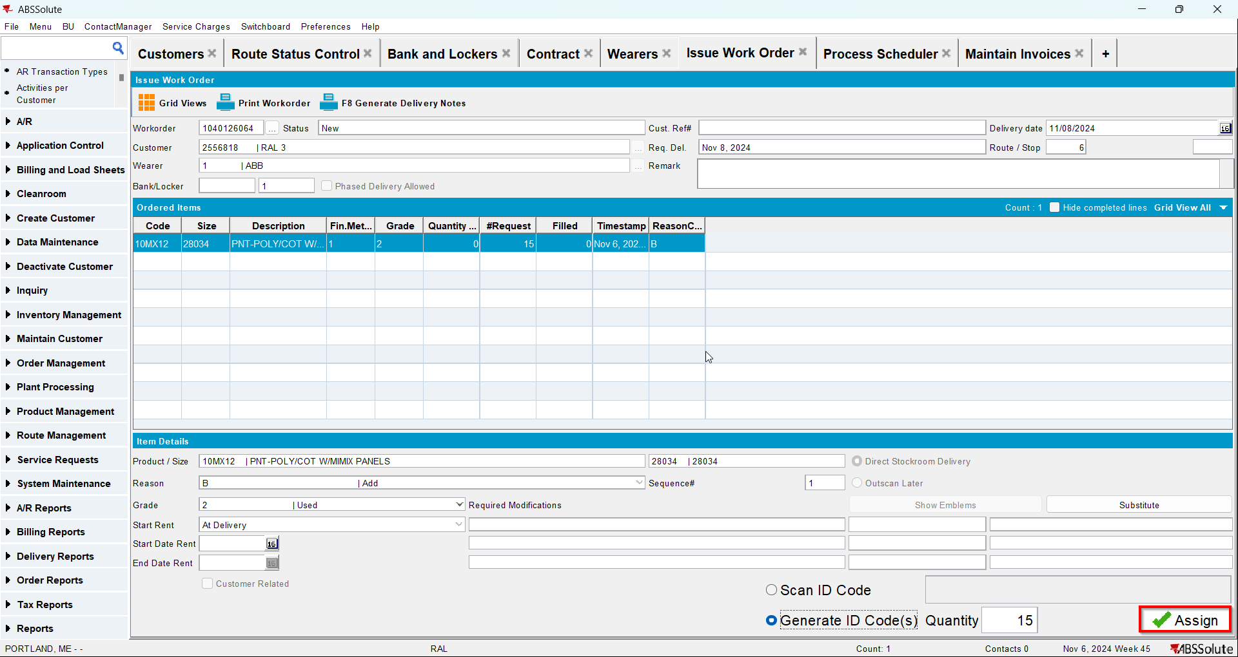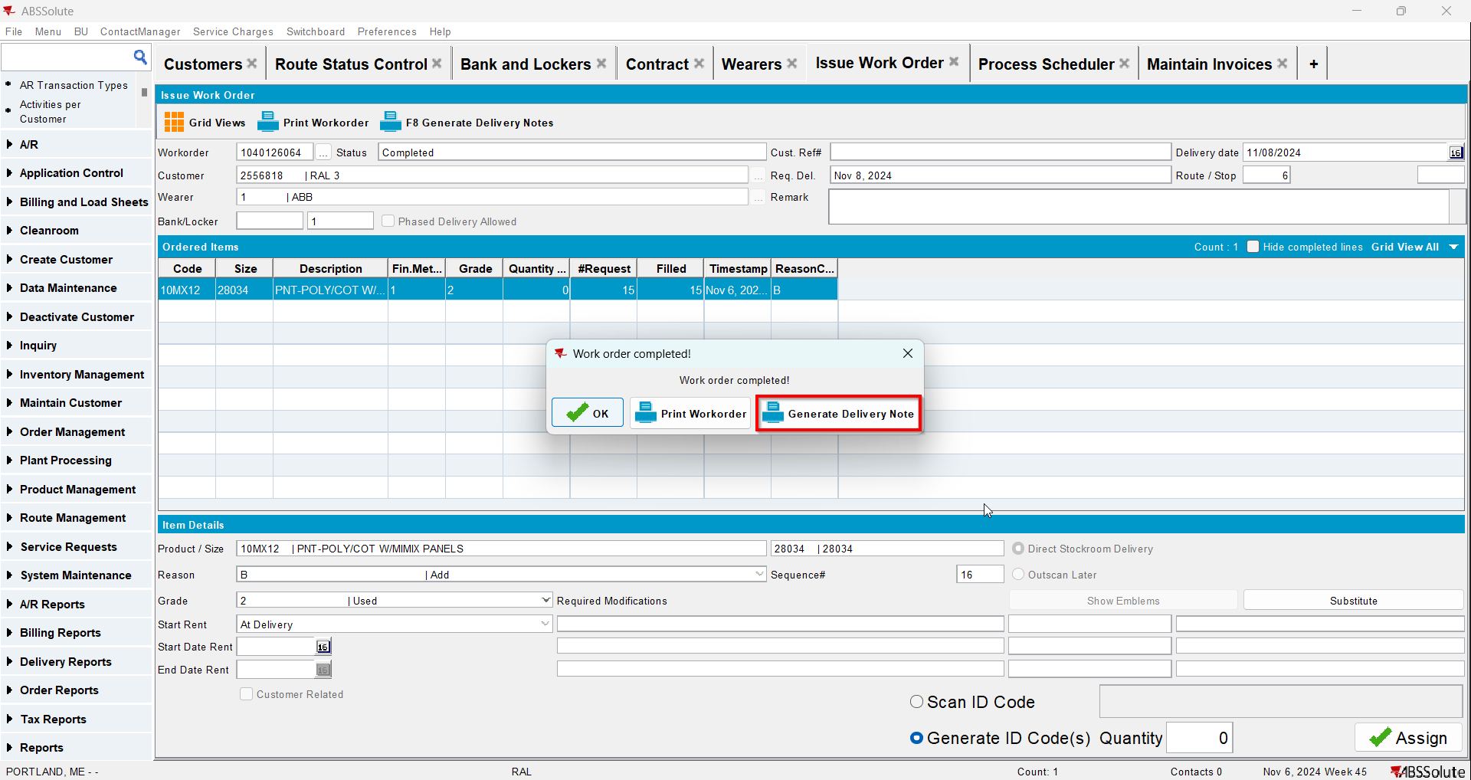
- Make sure your customer has a minimum invoice amount and special charges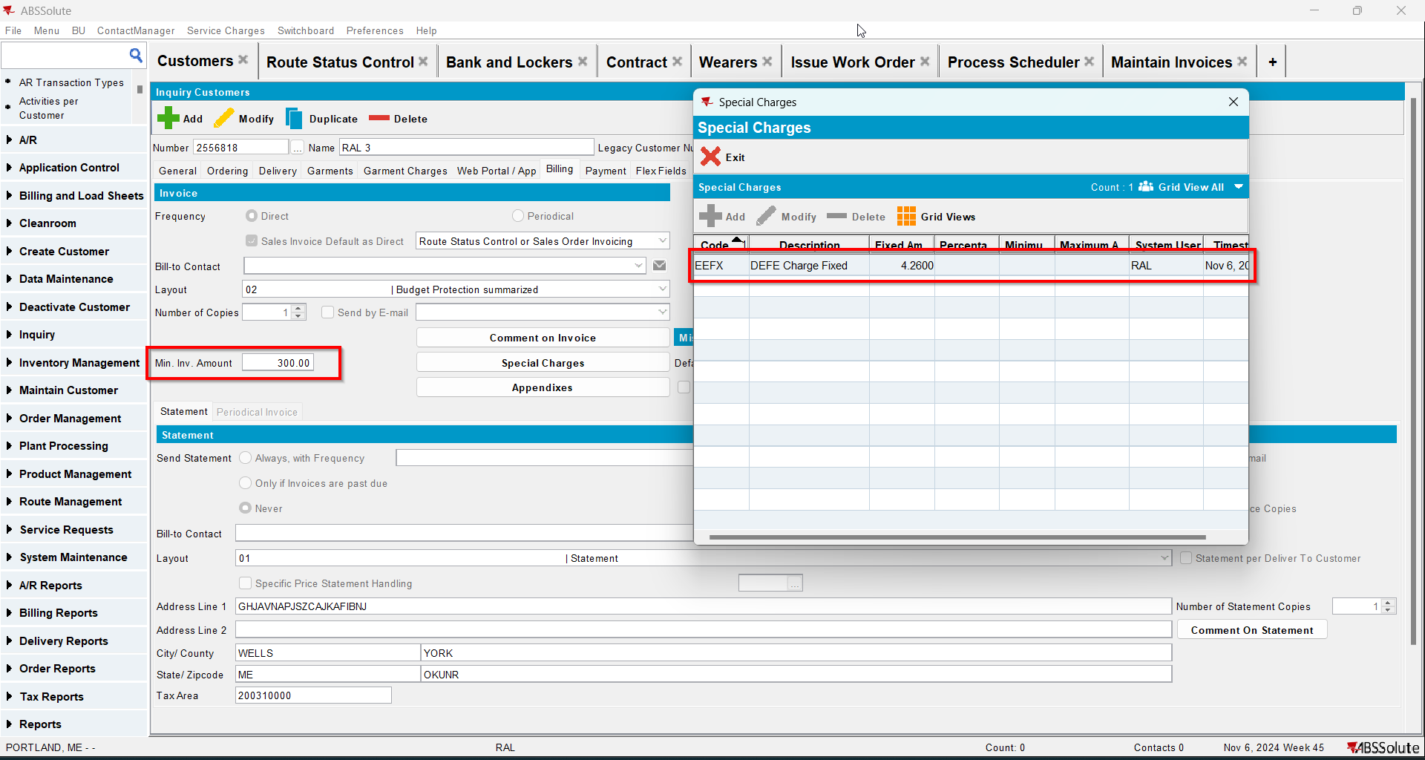
- Go to Route Status Control dlg and generate invoices for your route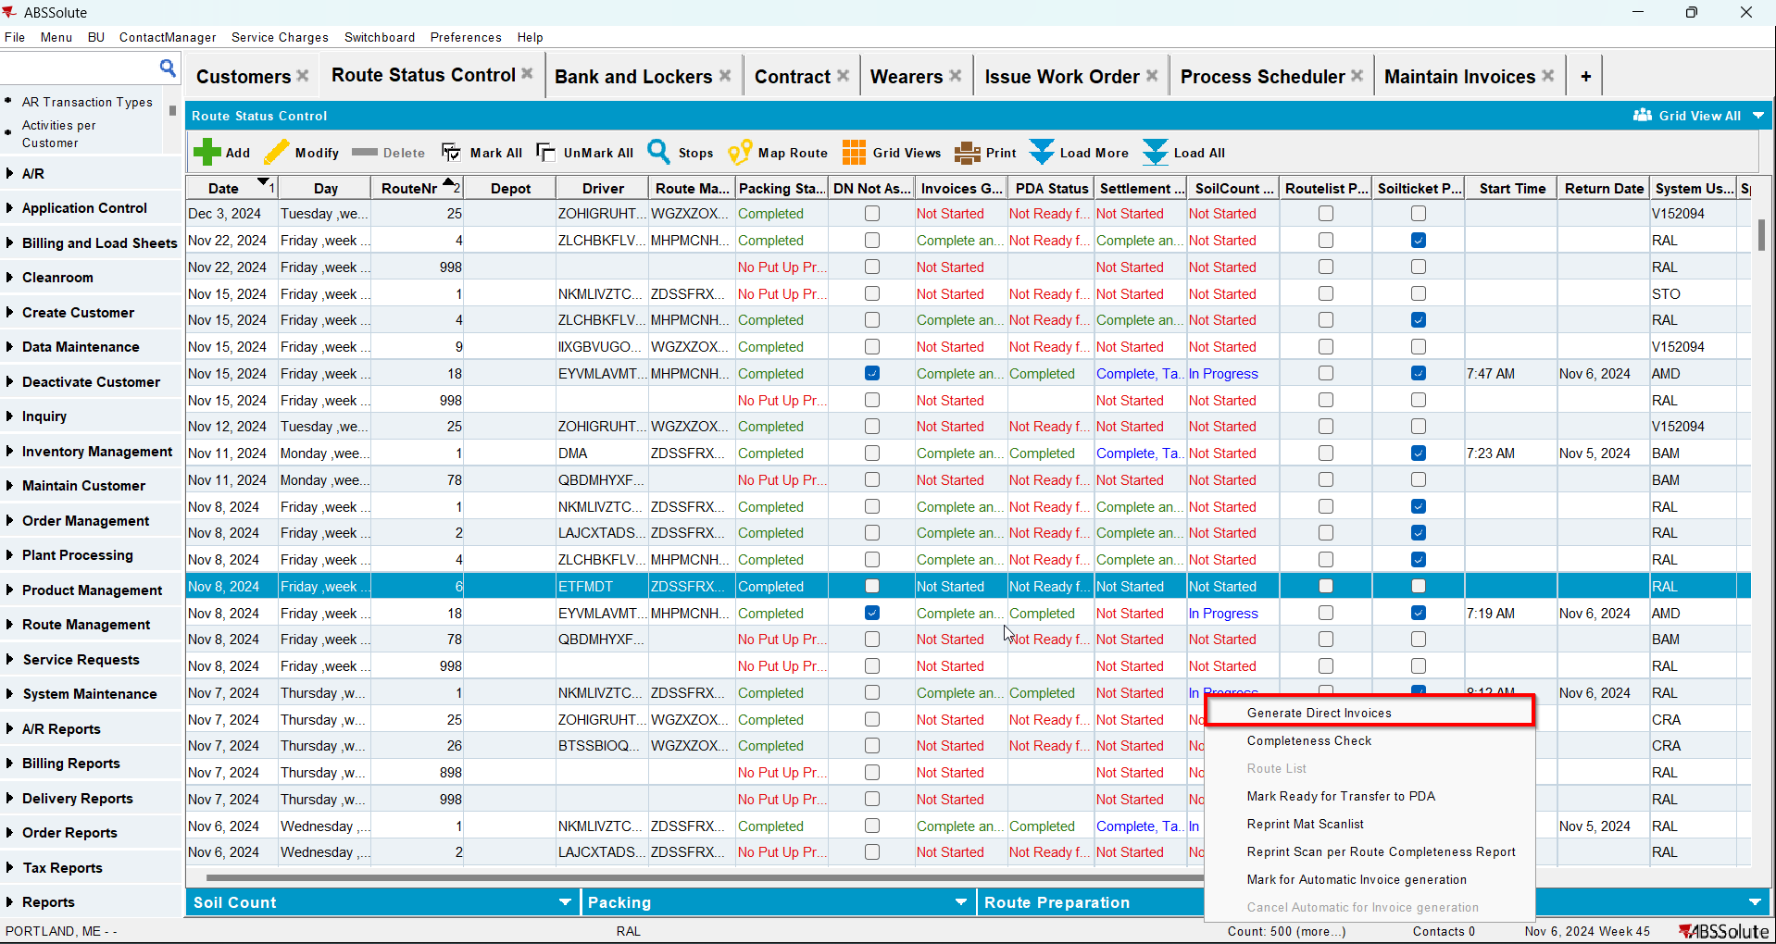
- Settle the route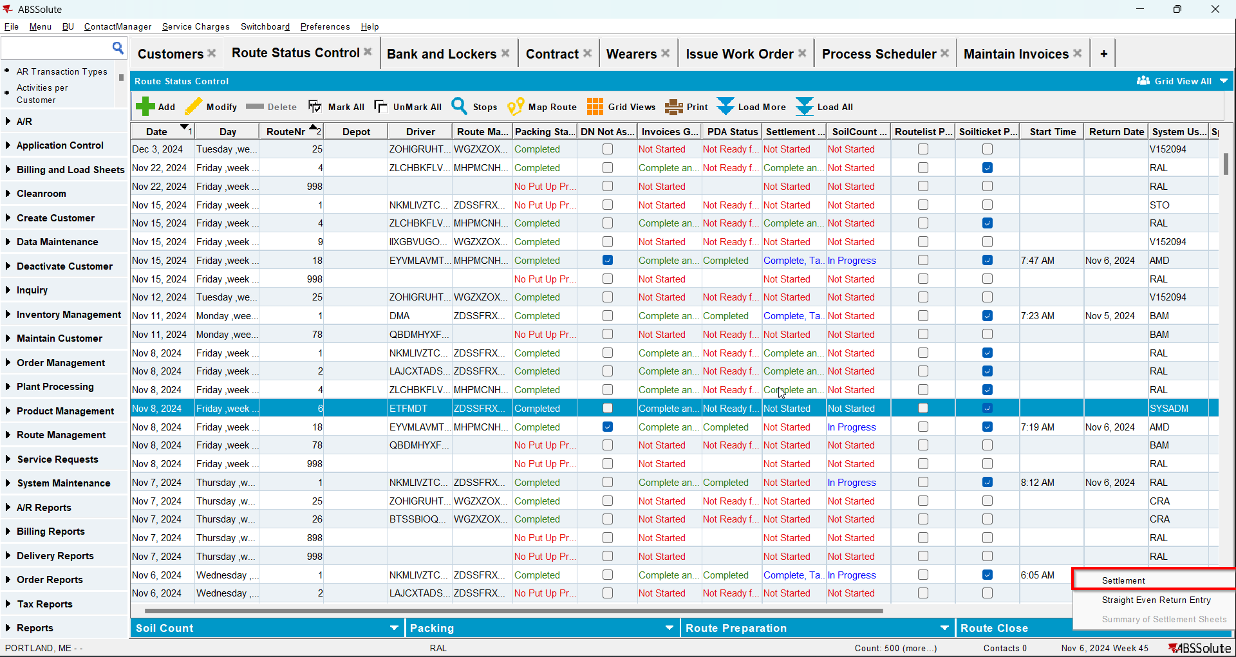
- Check that the Install Date and First Service Date have the date of the invoice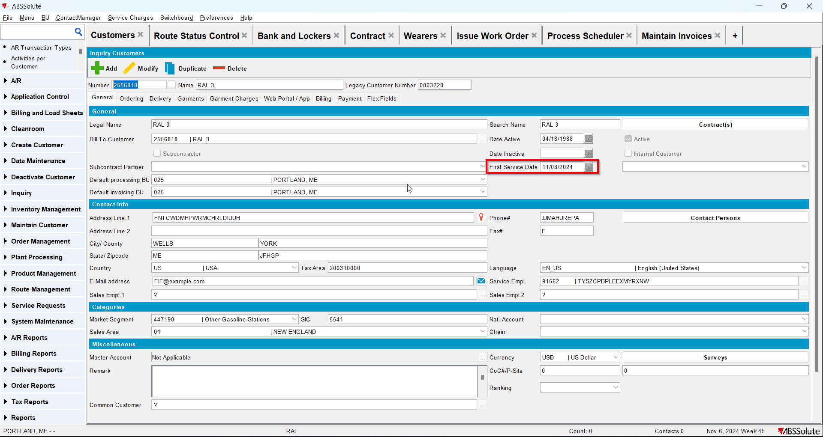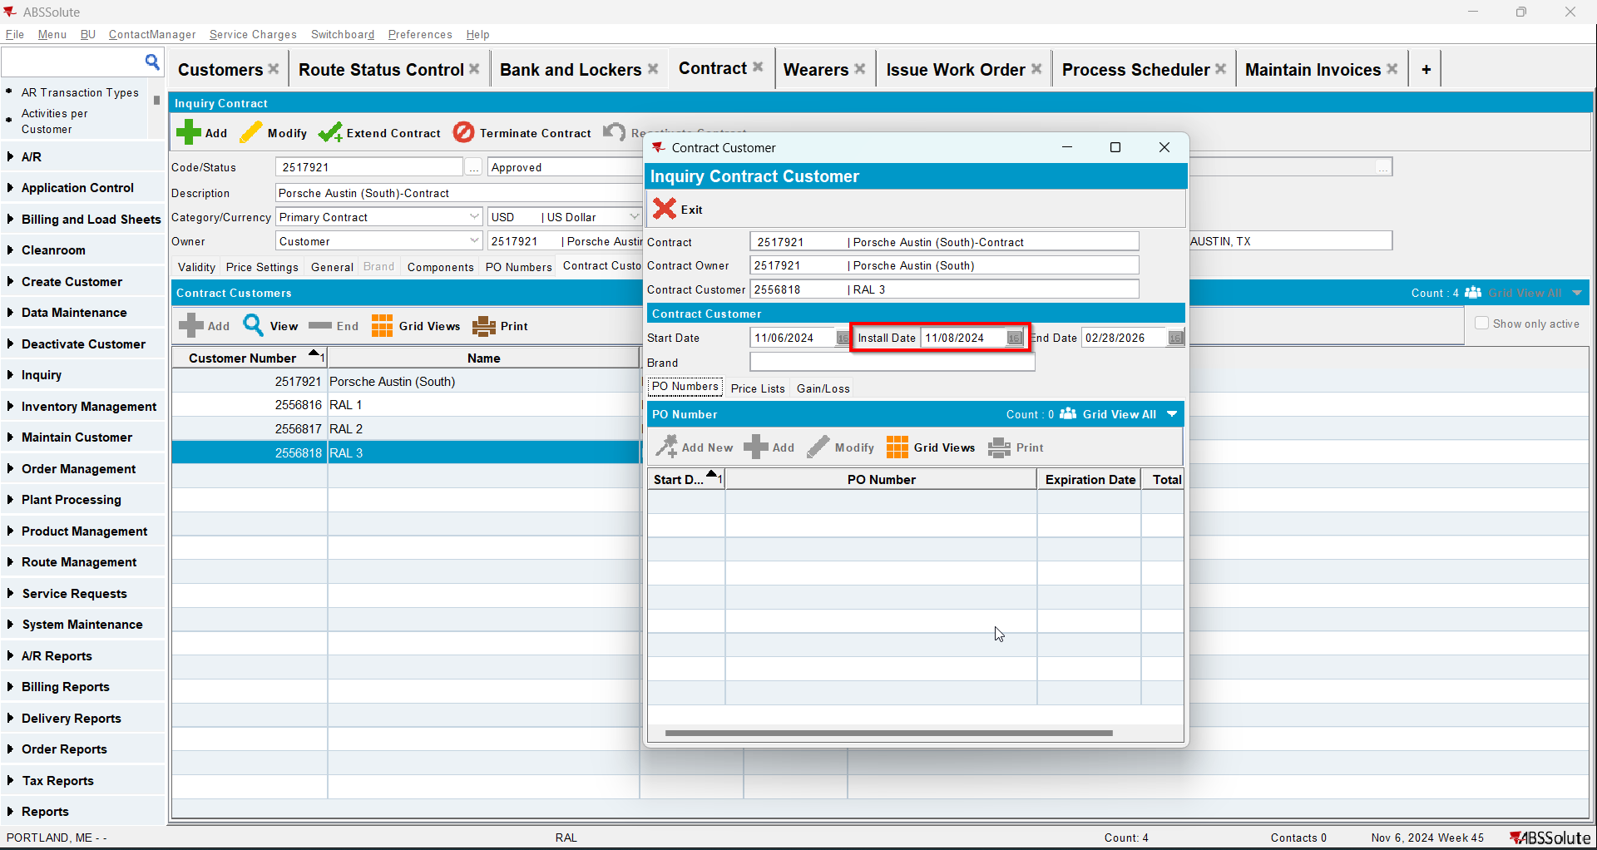
- Go to Maintain Invoices dlg and manually credit all lines beside special charges, minimum and tax 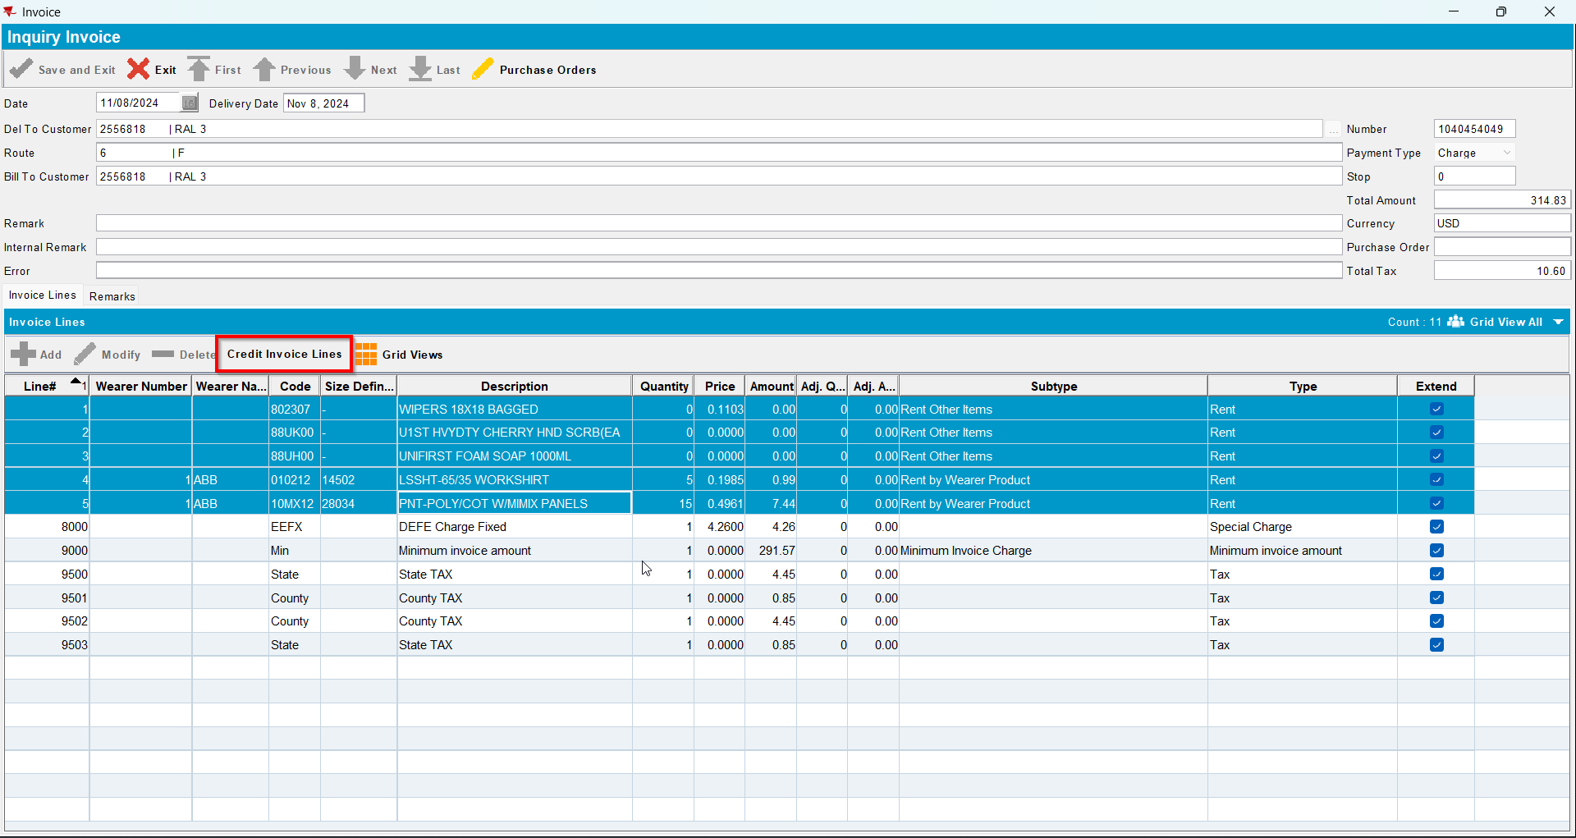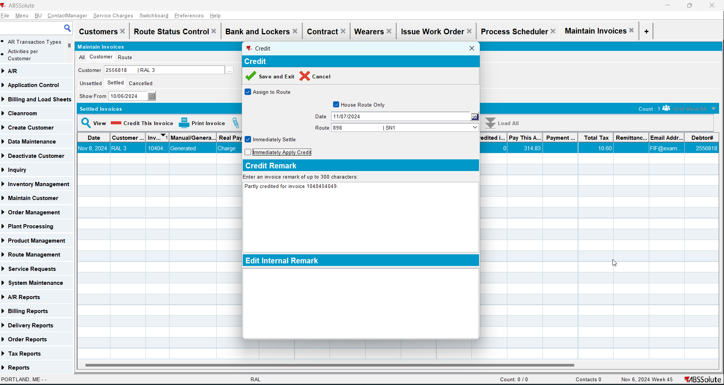
- Check that the Install Date and First Service Date are null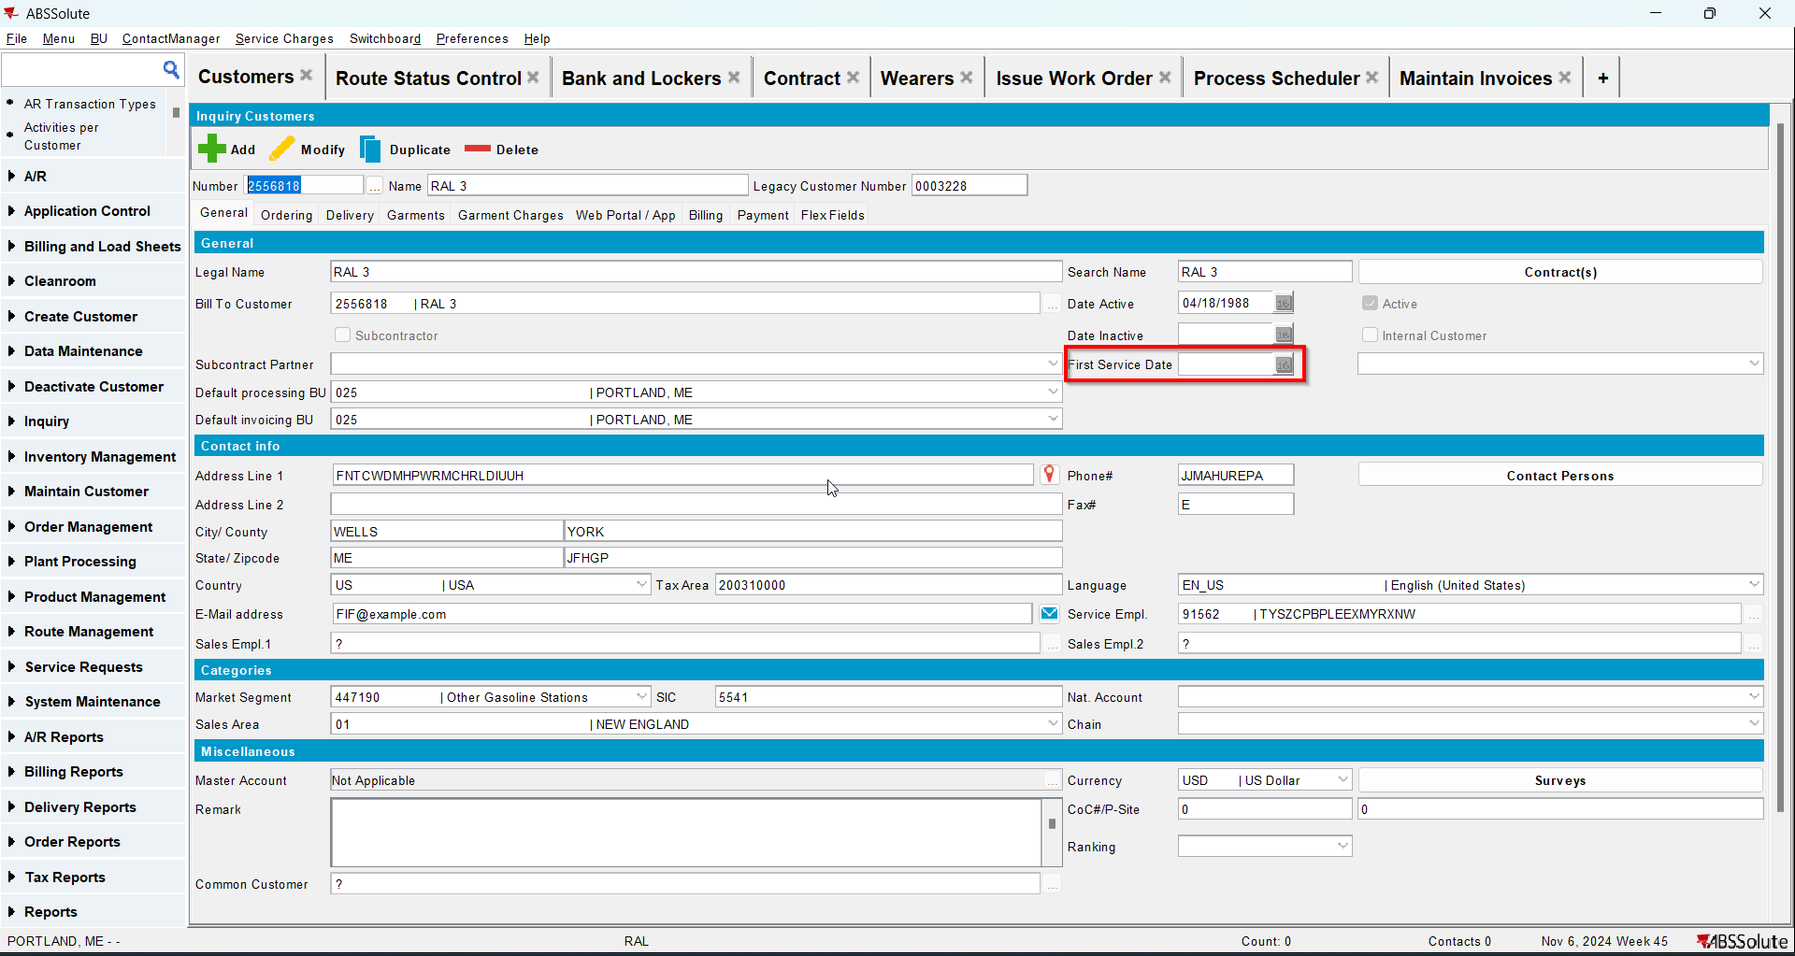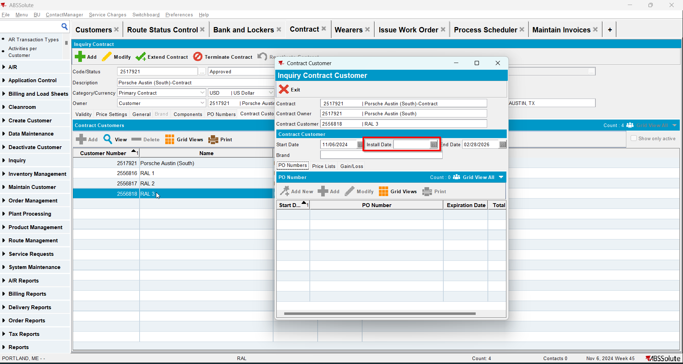

Test Case 4 – Manually Credit all lines besides special charge, min inv amount and tax when this is the first invoice for the customer and there are 2 more invoices for this customer; then repeat for second week’s invoice– Tested OK
Expected behavior: Install date and first service date should be updated to the oldest invoice date after the first credit. Then after the second credit update again.
Hash: 3fa65b8
- Add a new customer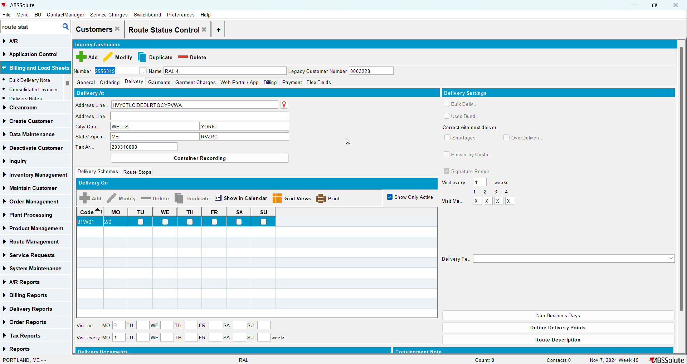
- Check that the First Service Date is null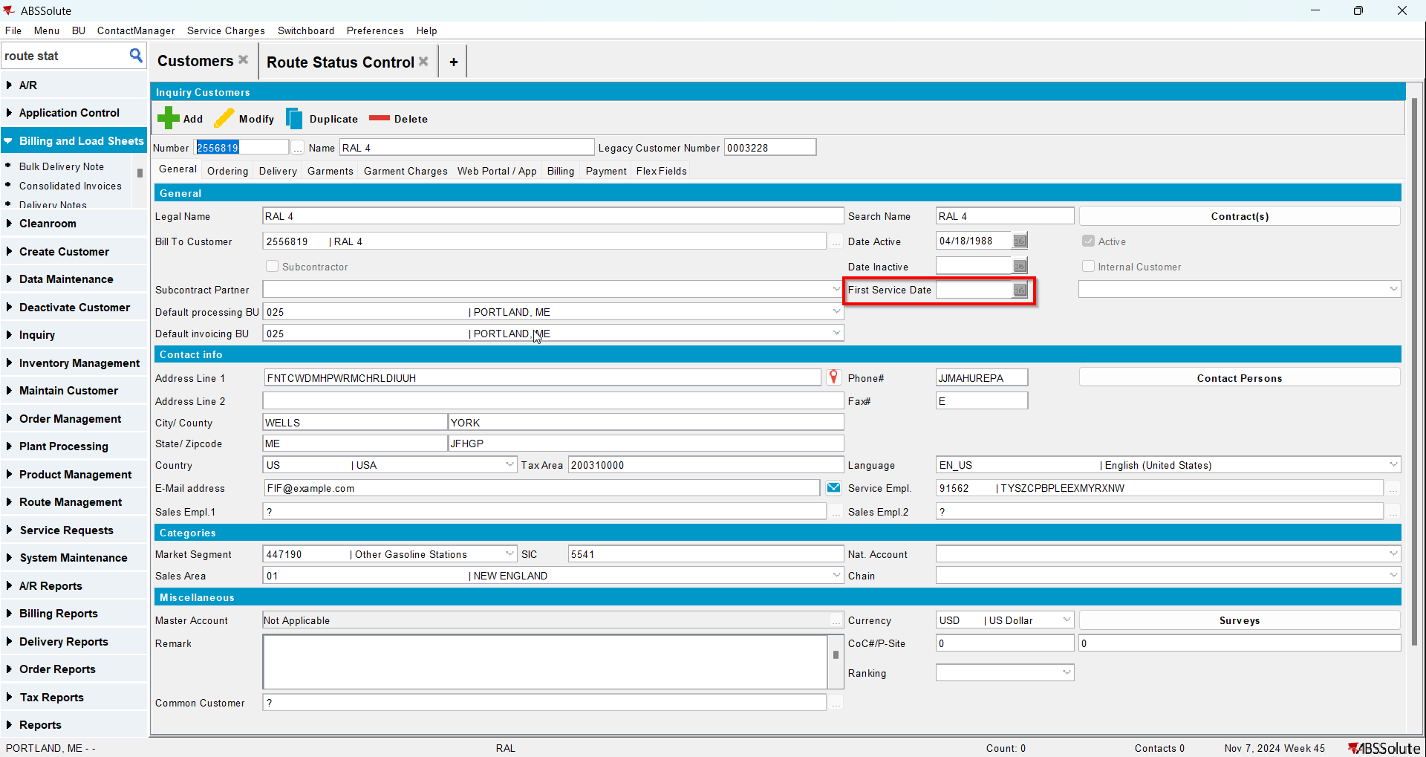
- Go to Bank and Lockers dlg and add lockers for your customer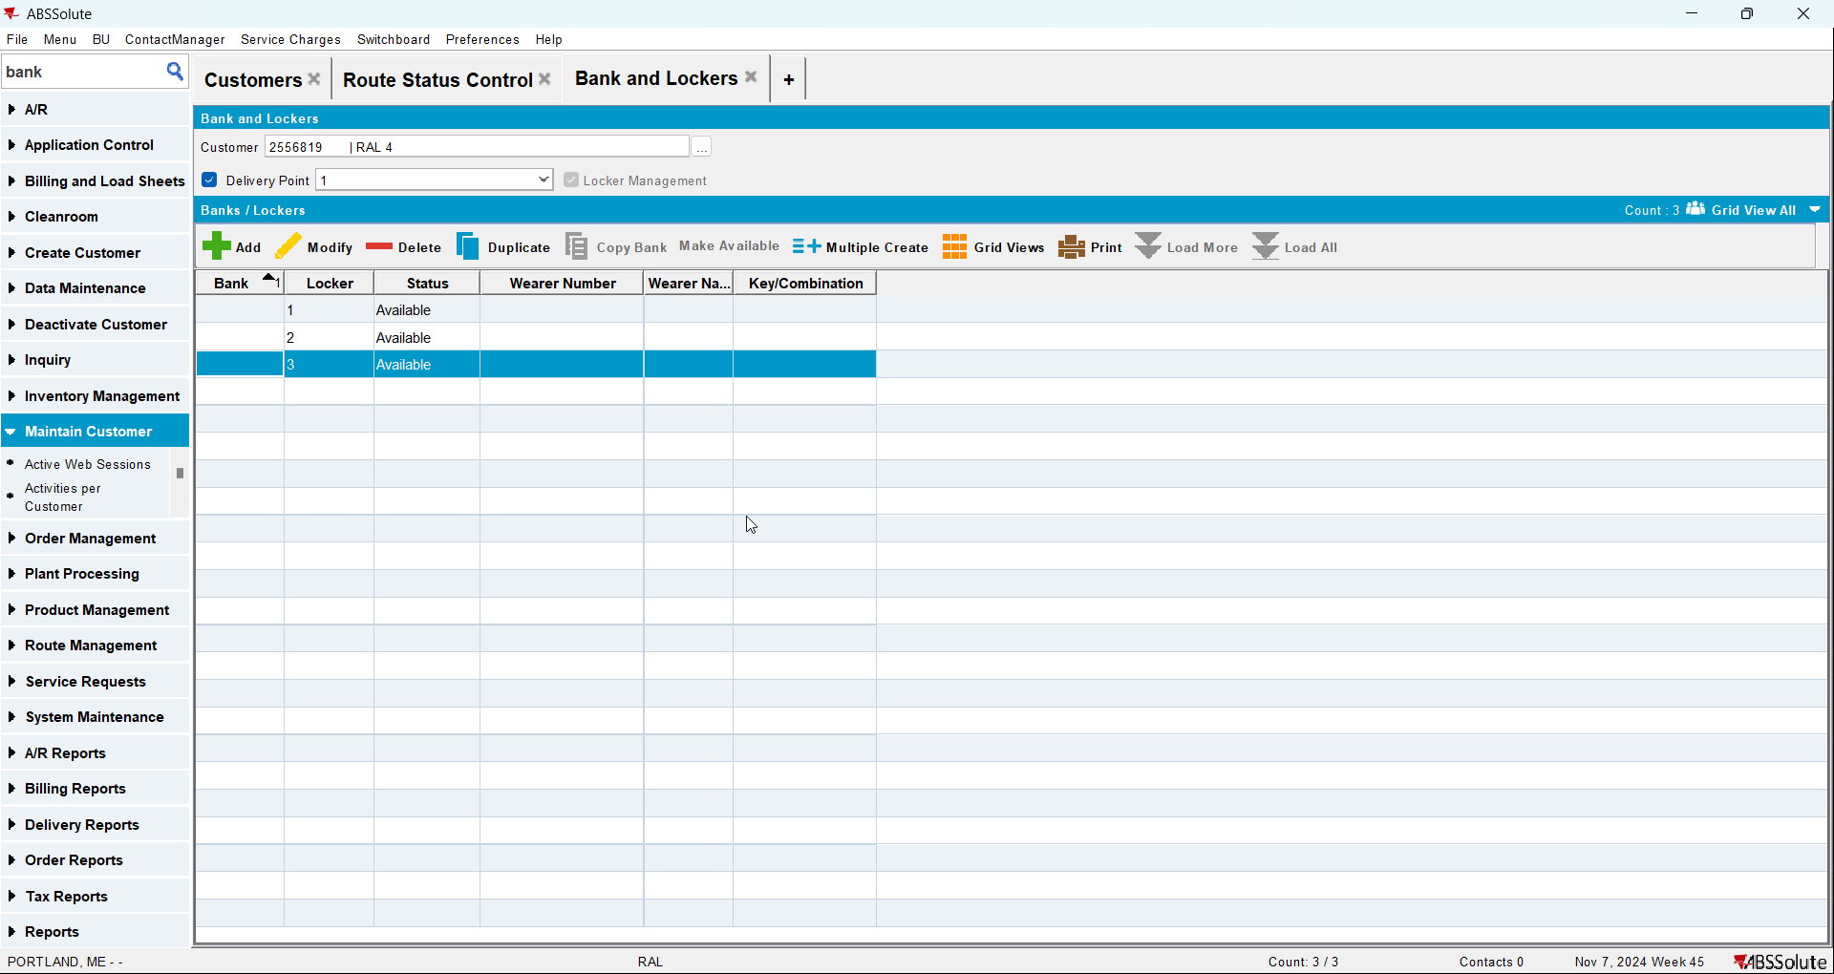
- Go to Contract dlg and add your customer to a contract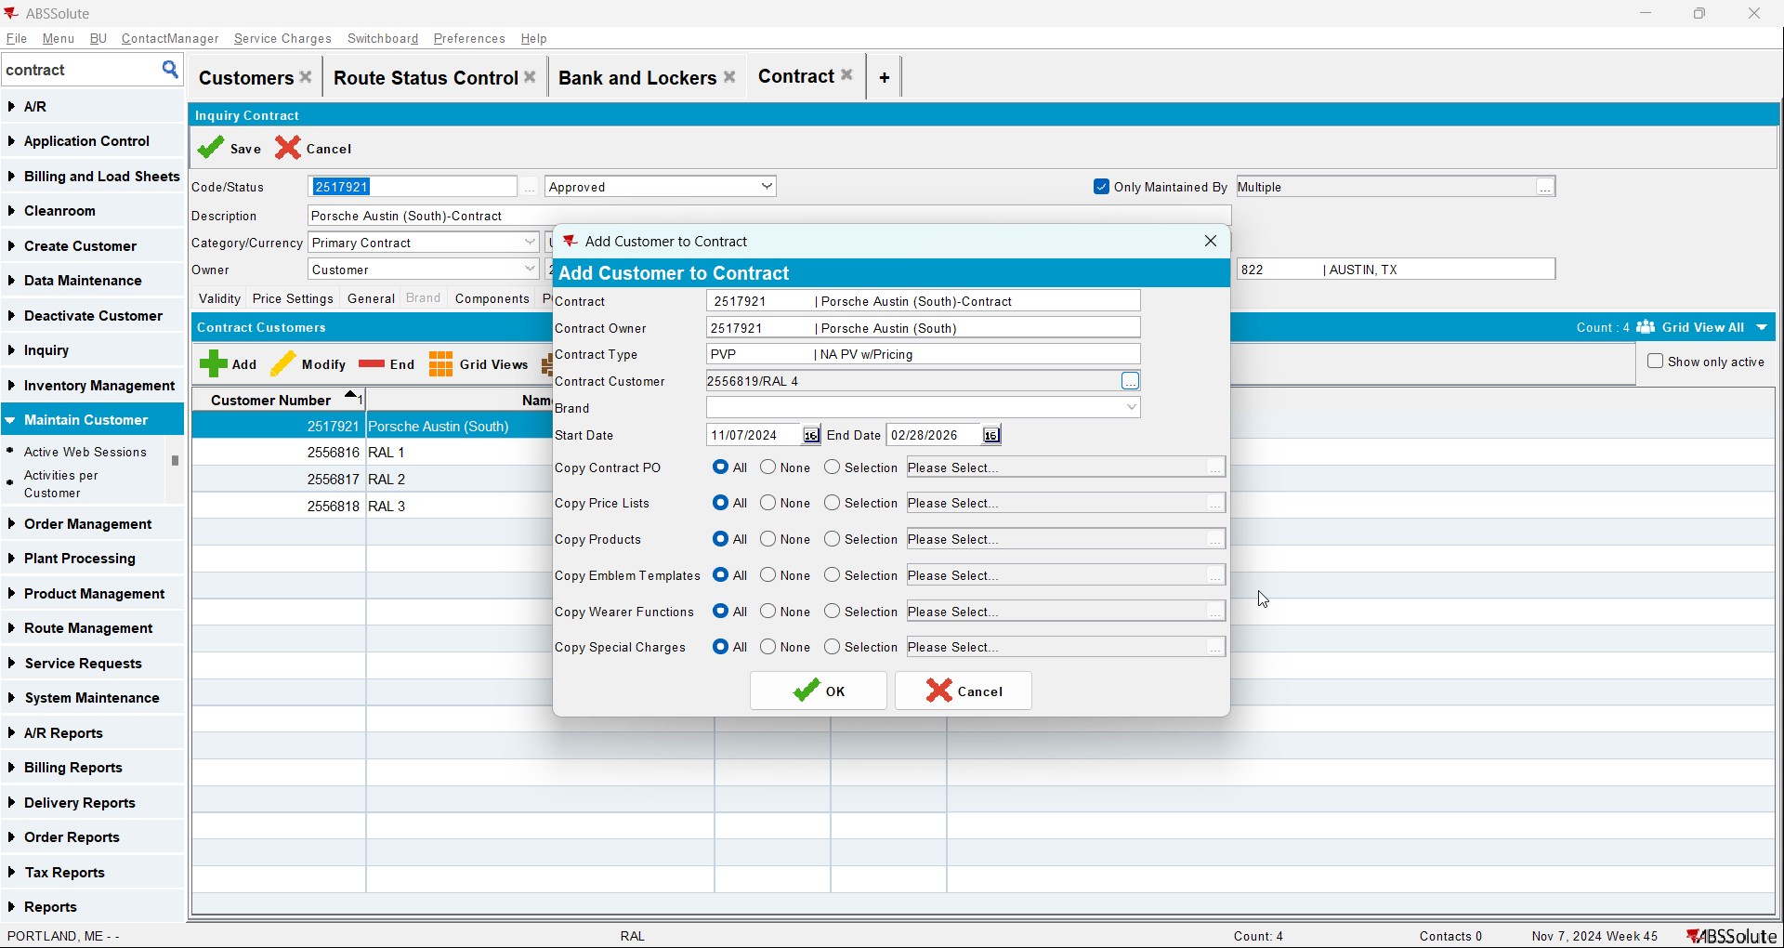
- Check that Install Date is null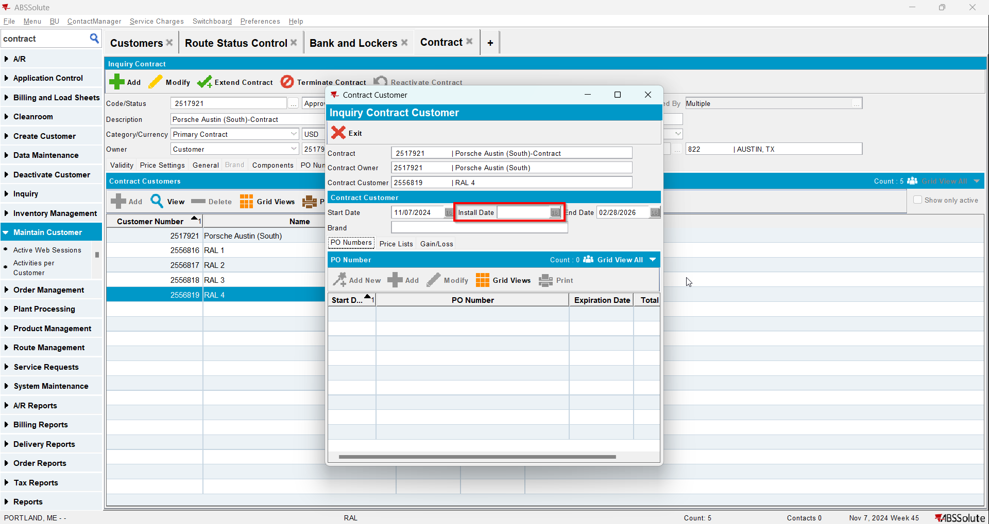
- Go to Wearers dlg and add wearers for your customer. Generate WO and after that issue the WO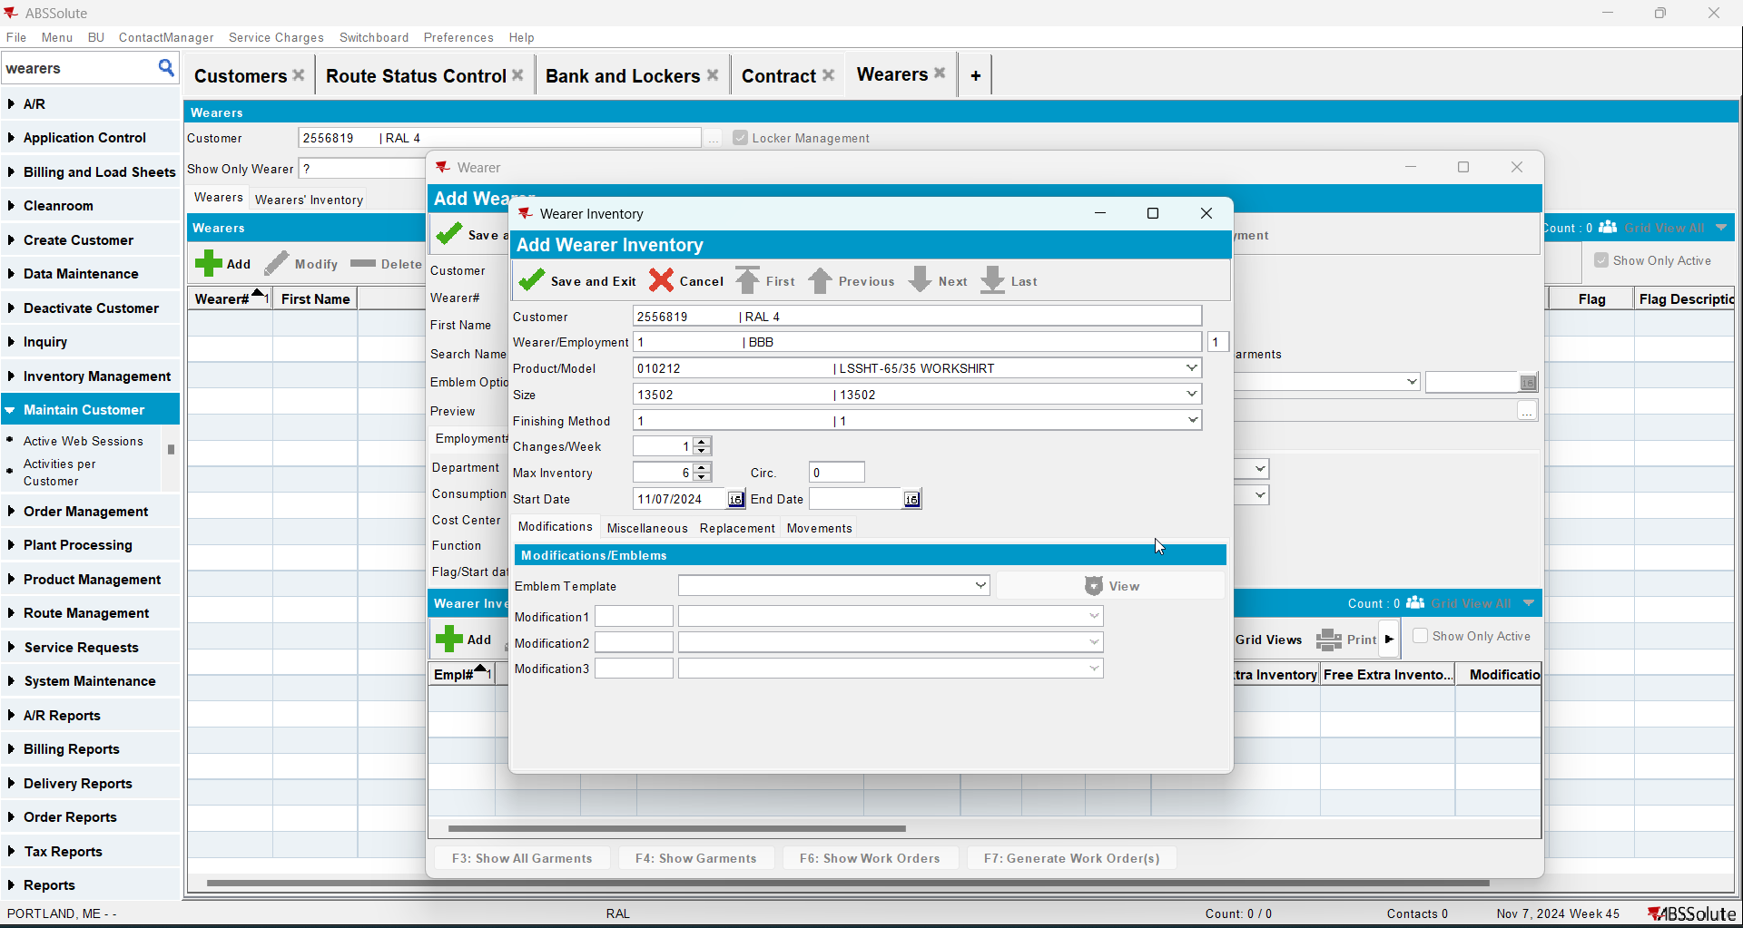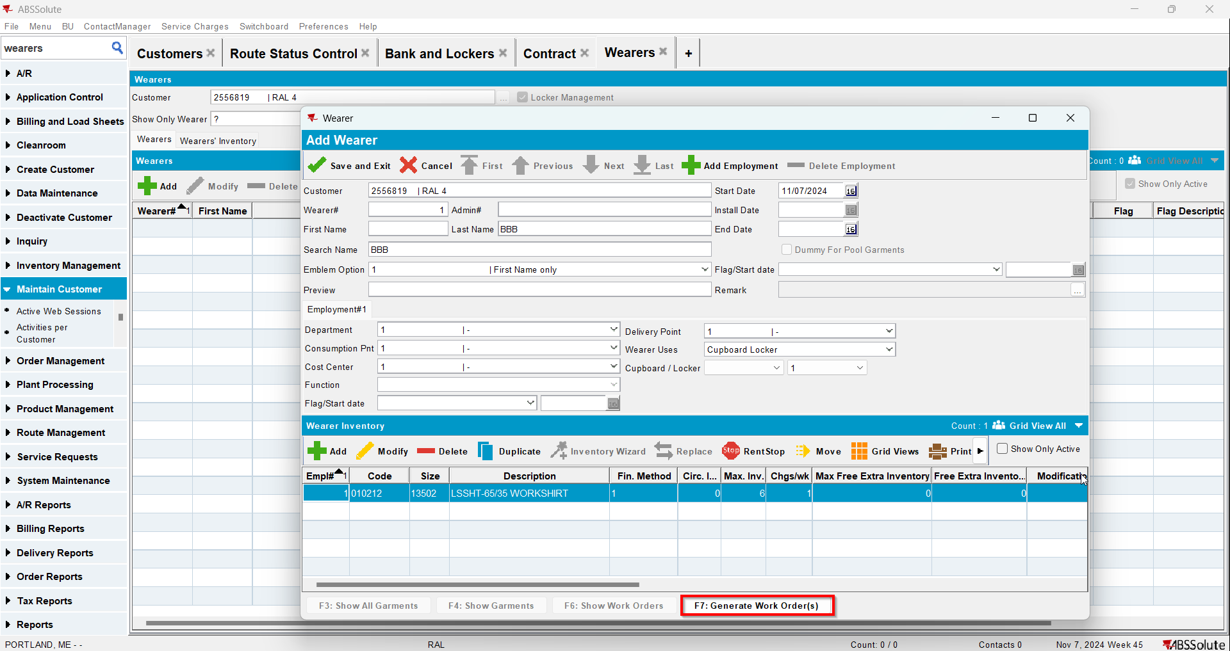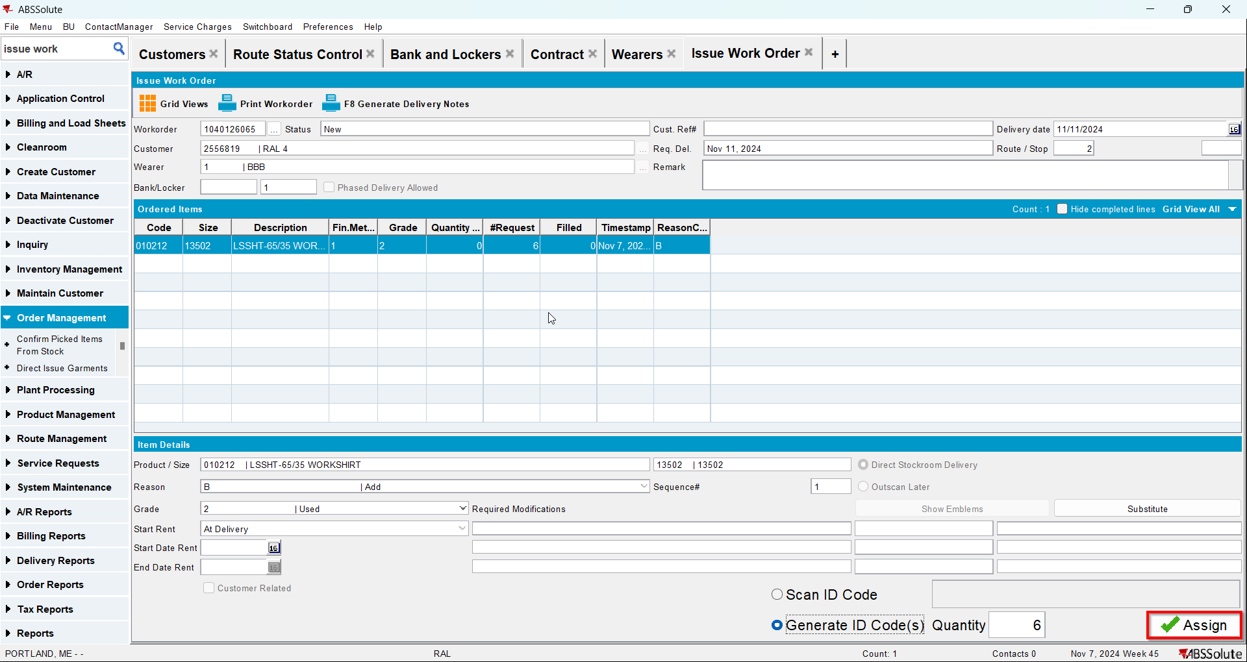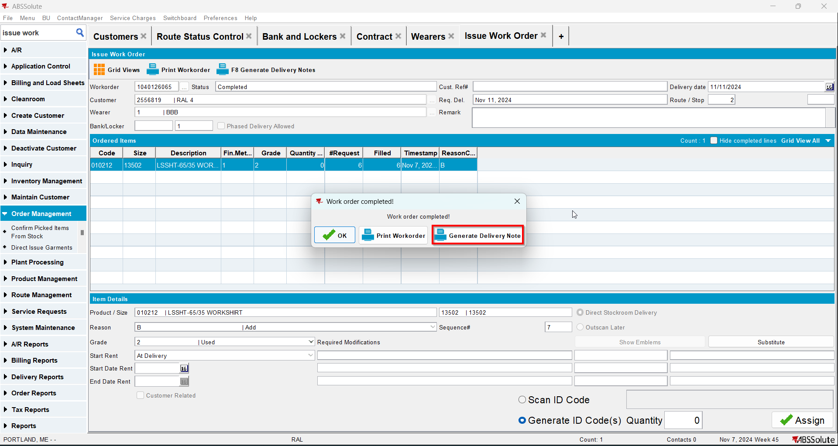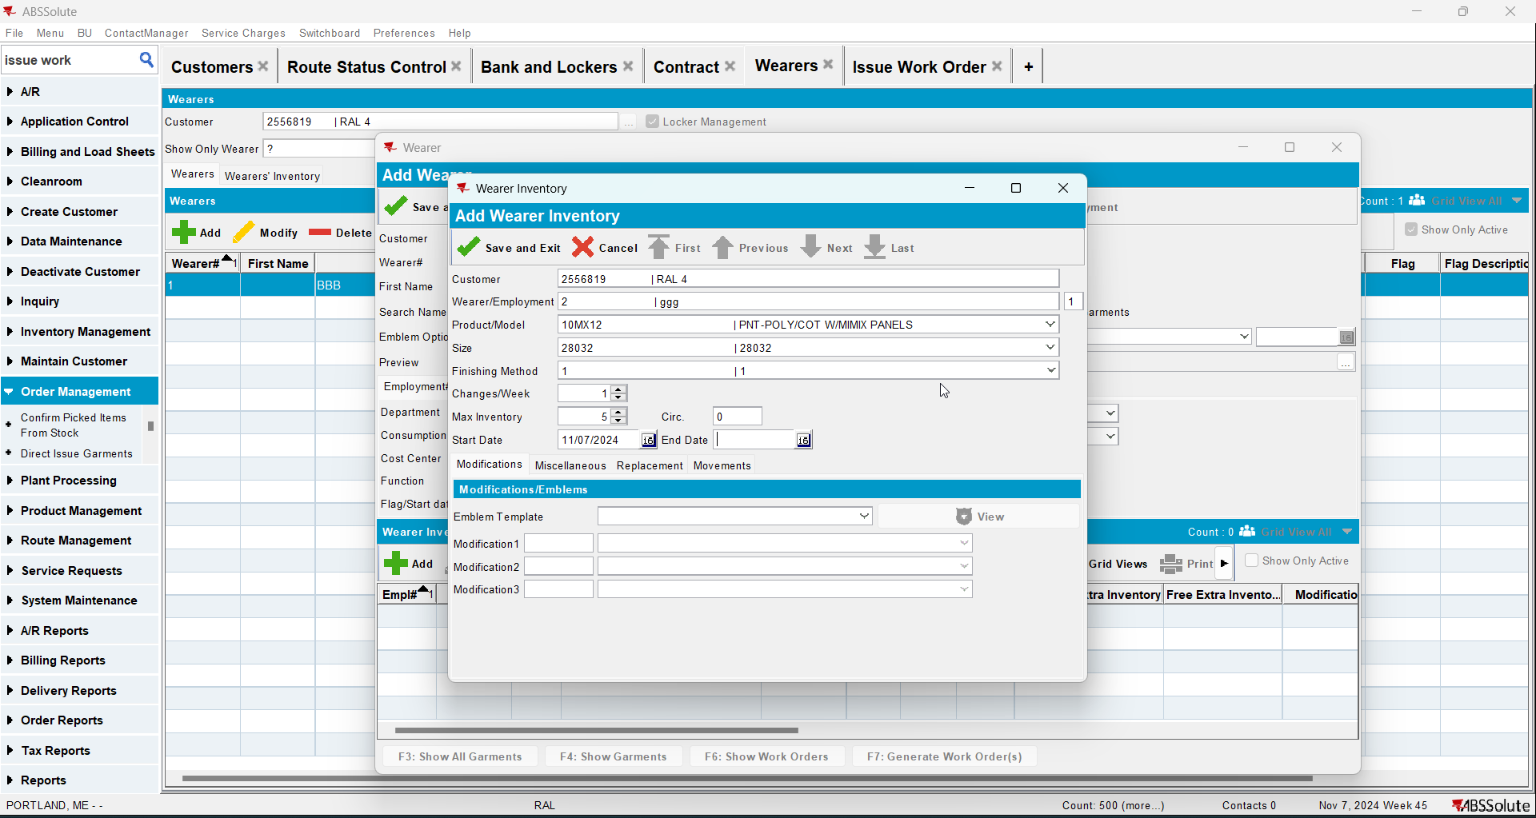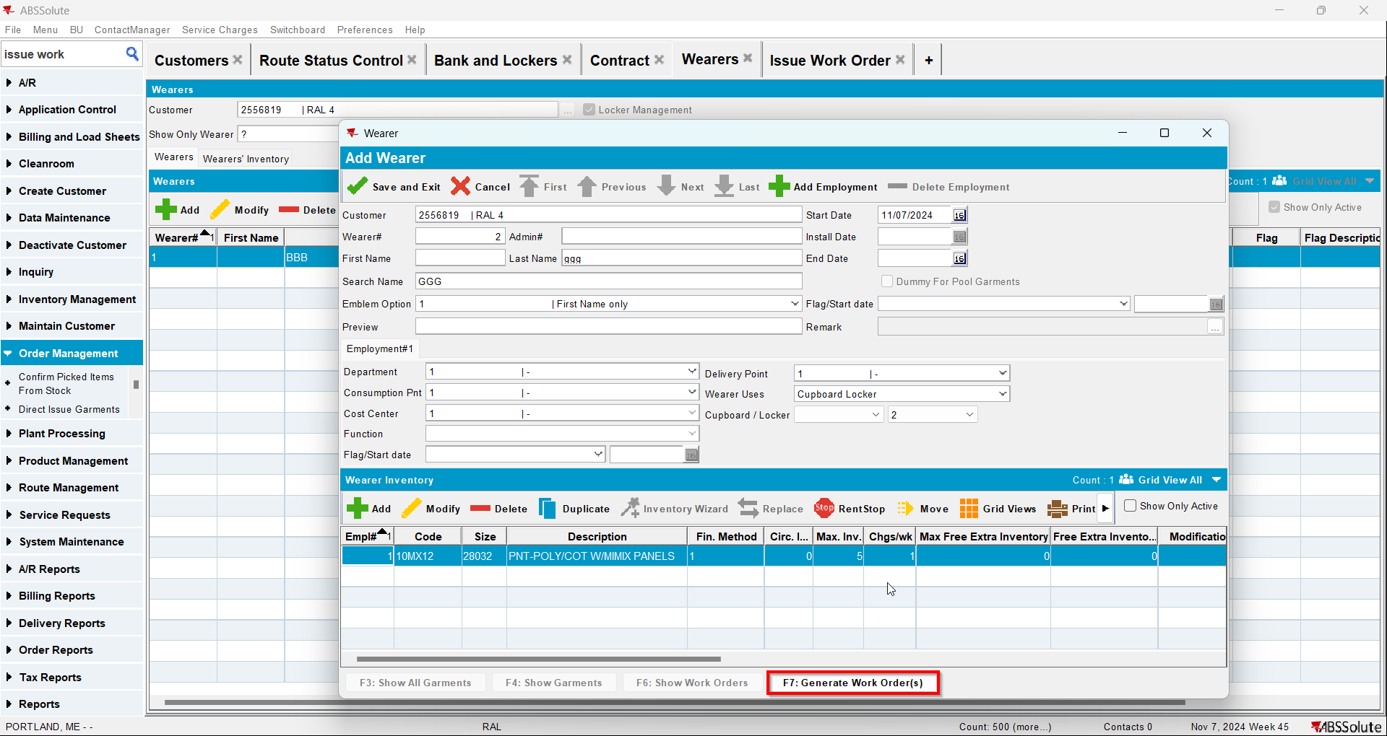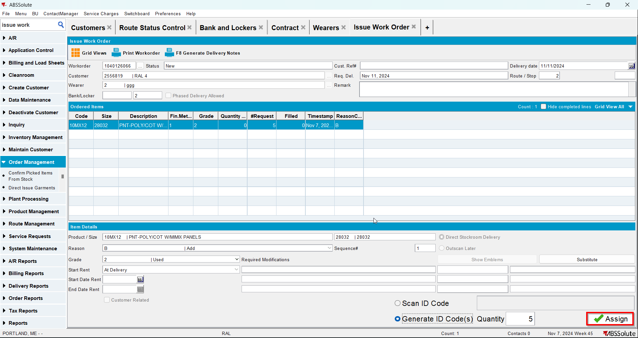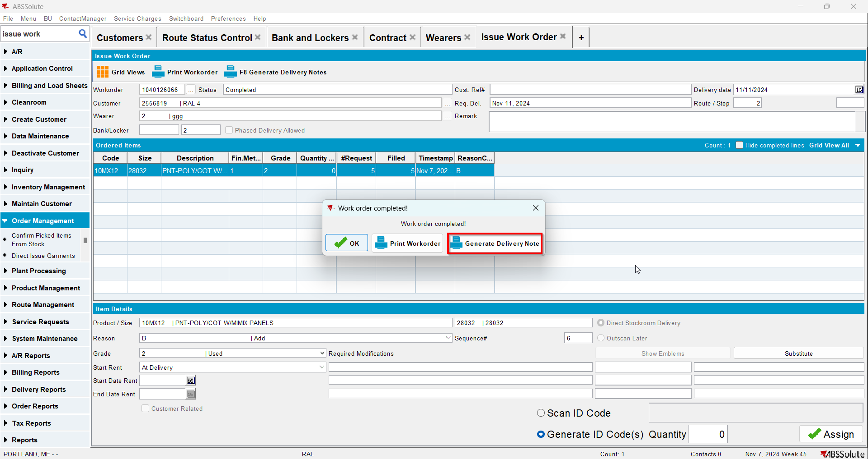
- Go to Route Status Control dlg and generate invoices for your route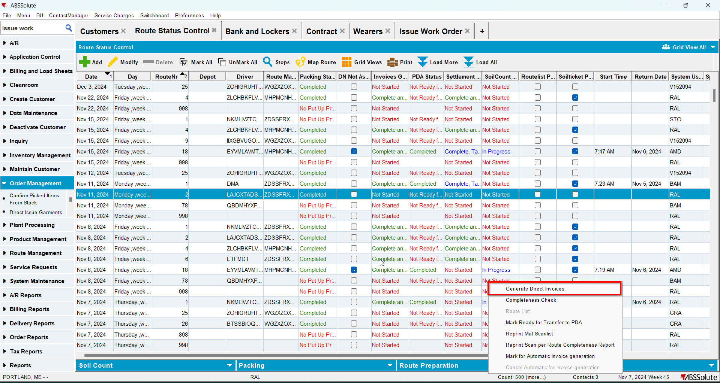
- Settle the route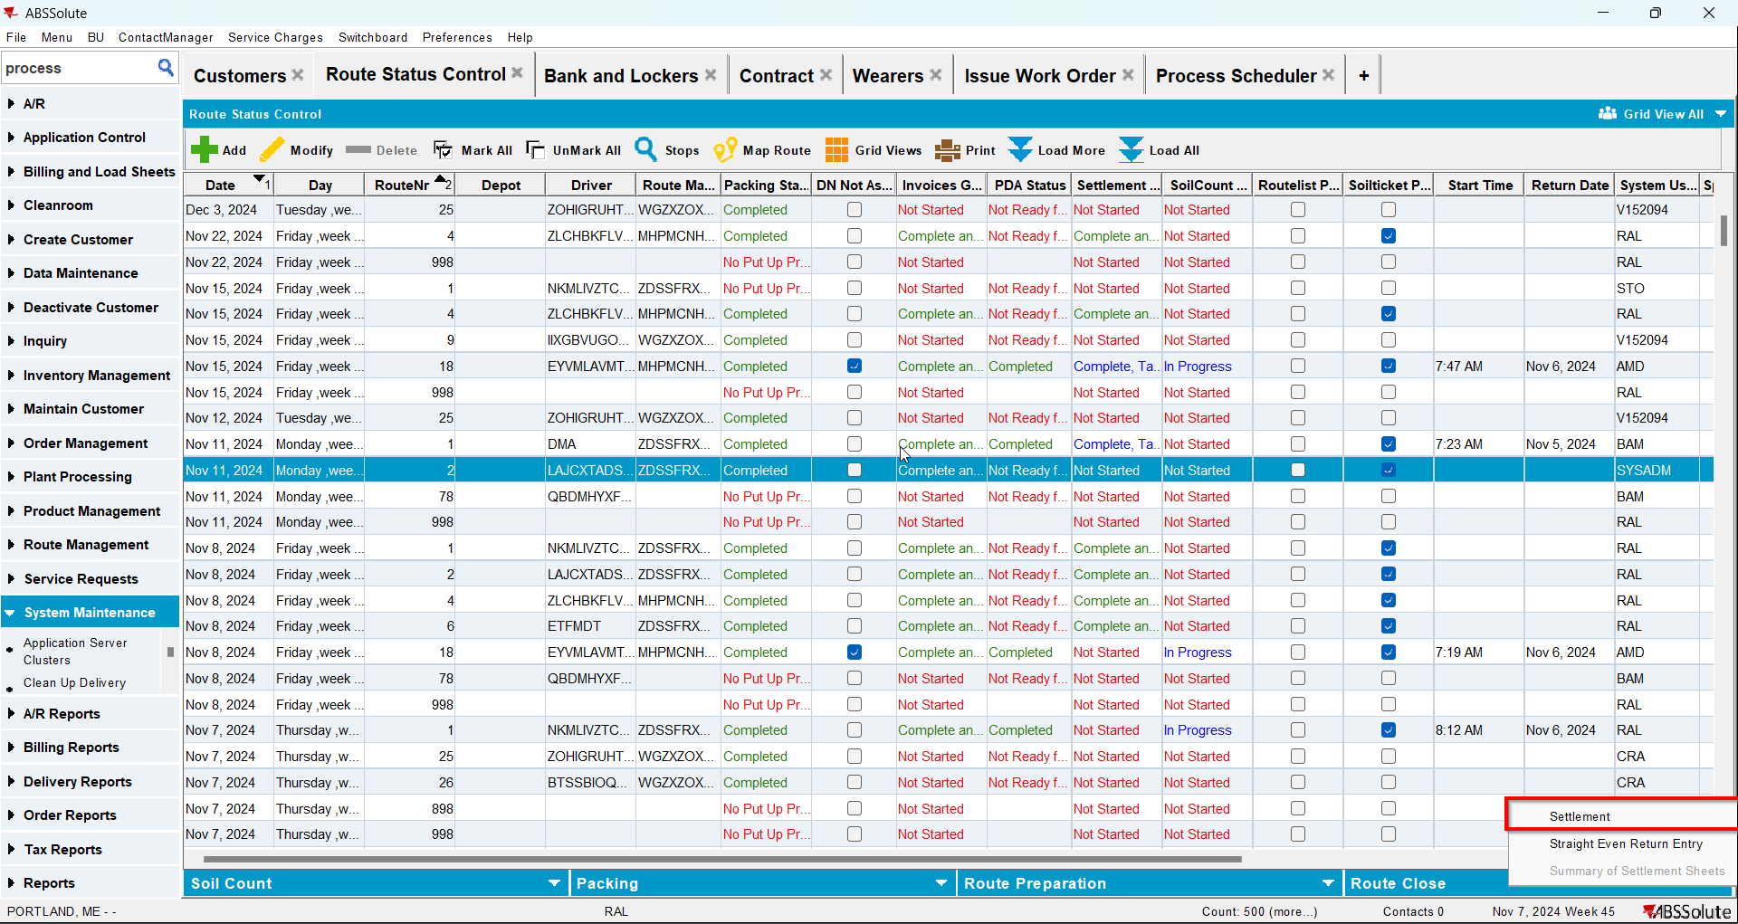
- Check that the Install Date and First Service Date have the date of the invoice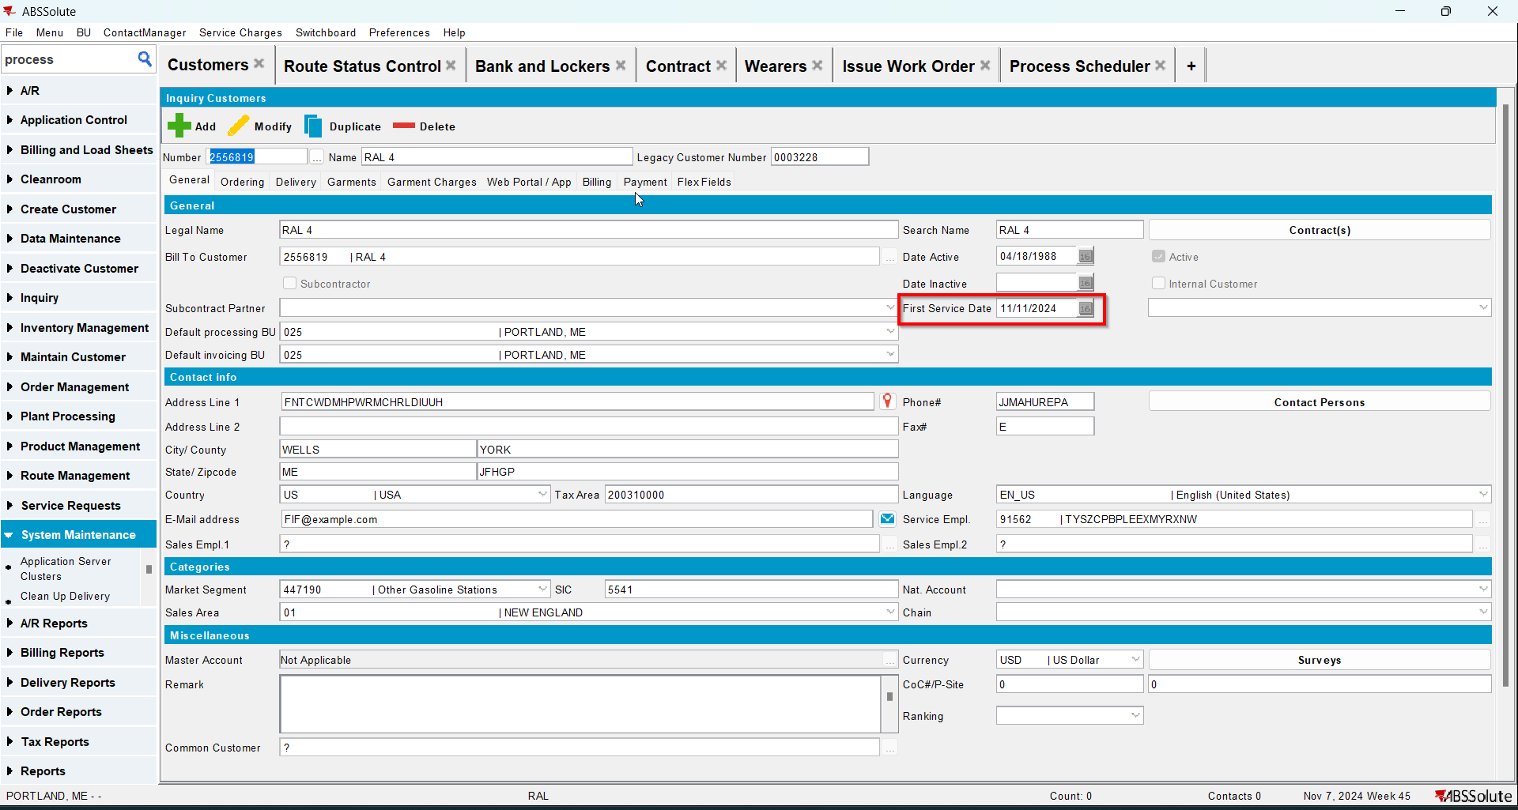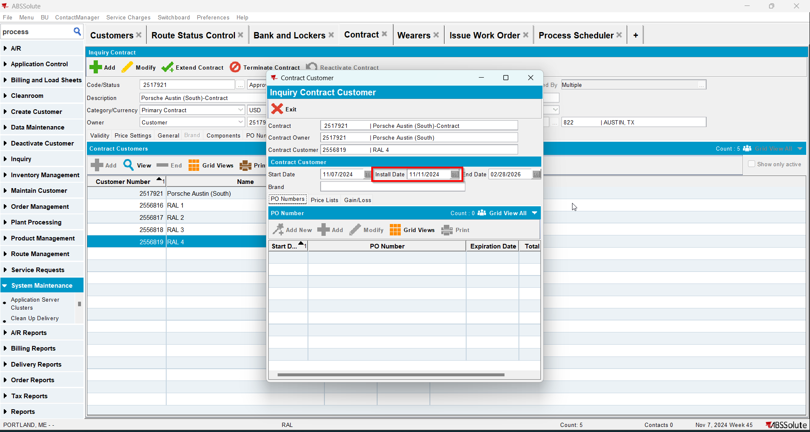
- Generate invoices for the next 2 weeks and settle the routes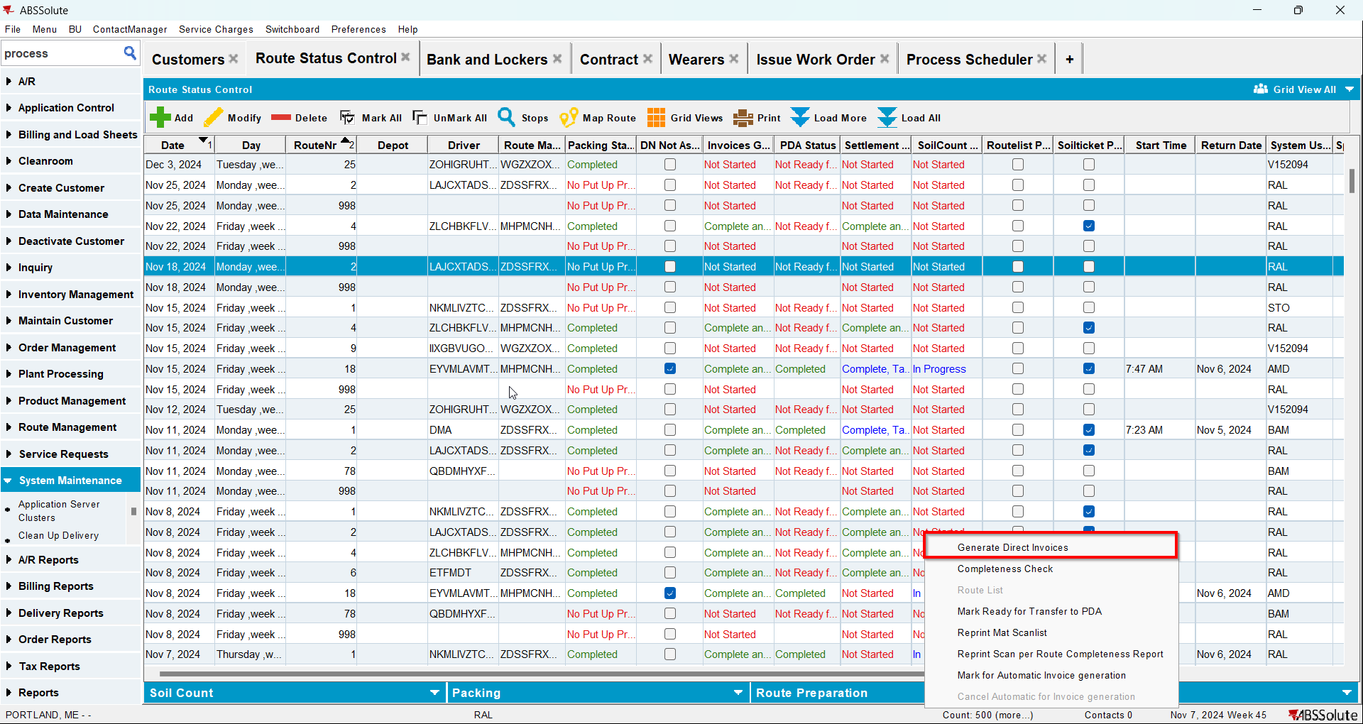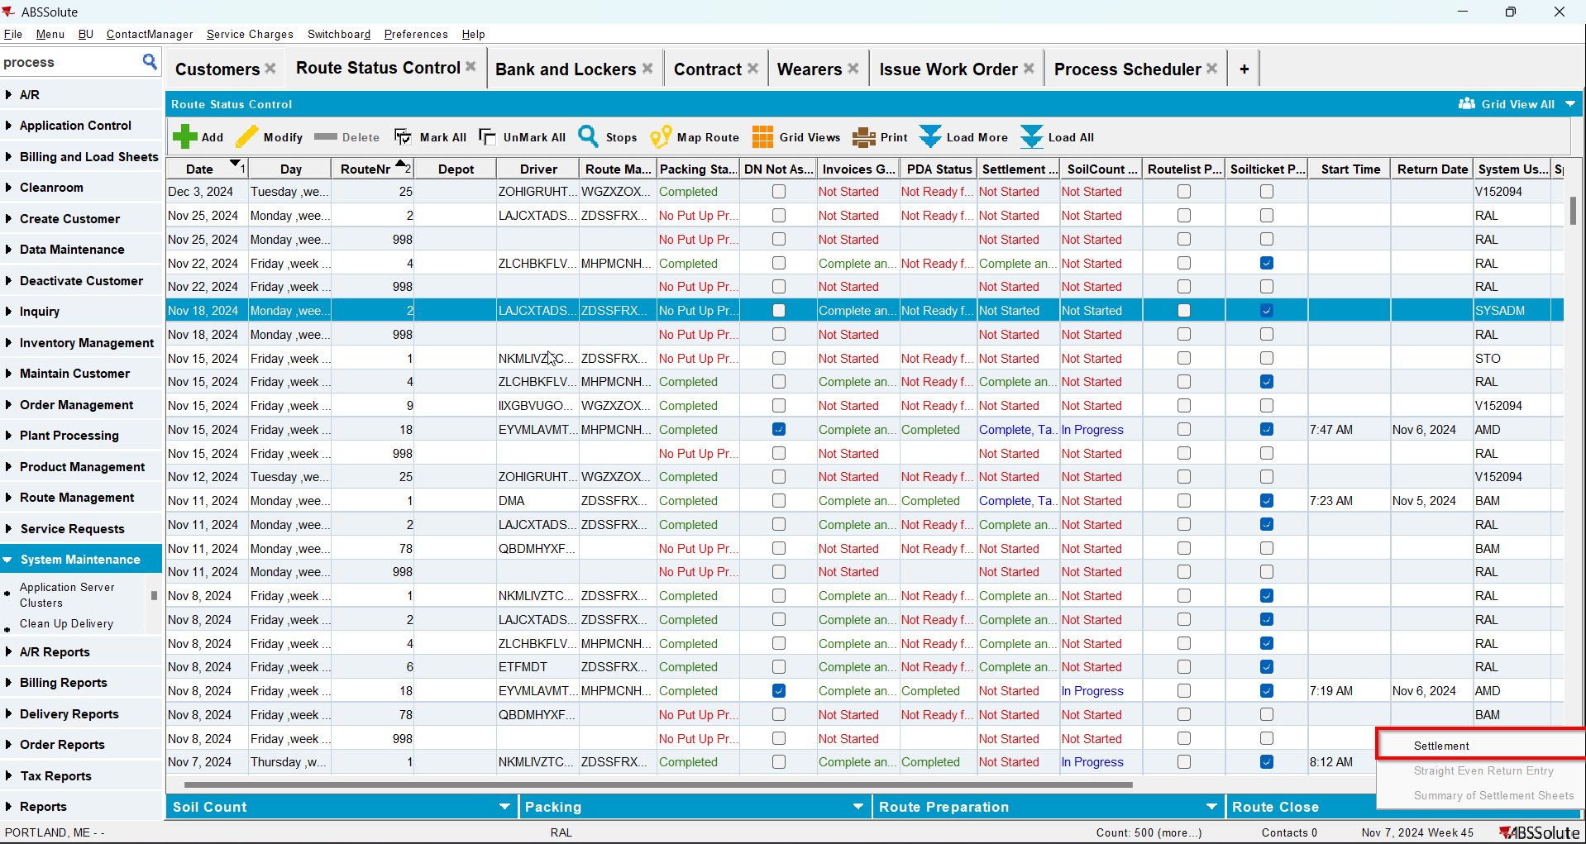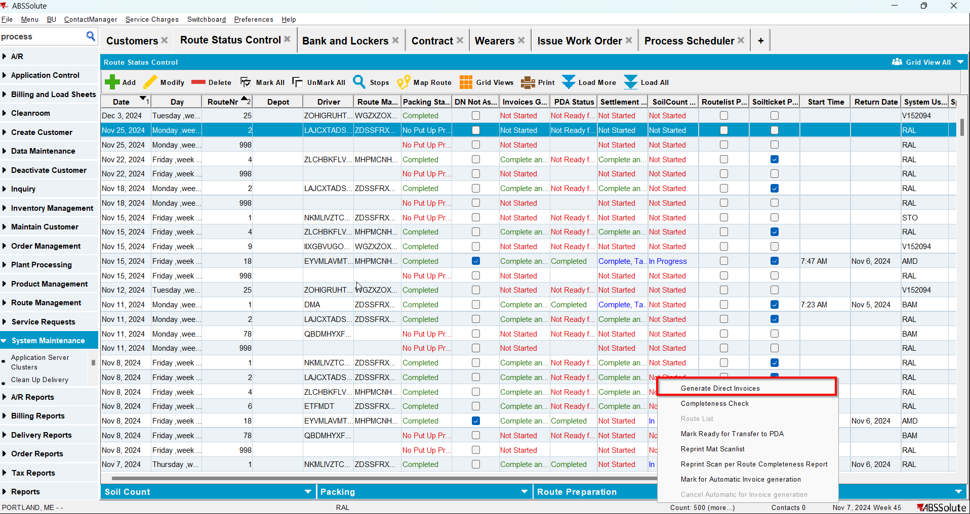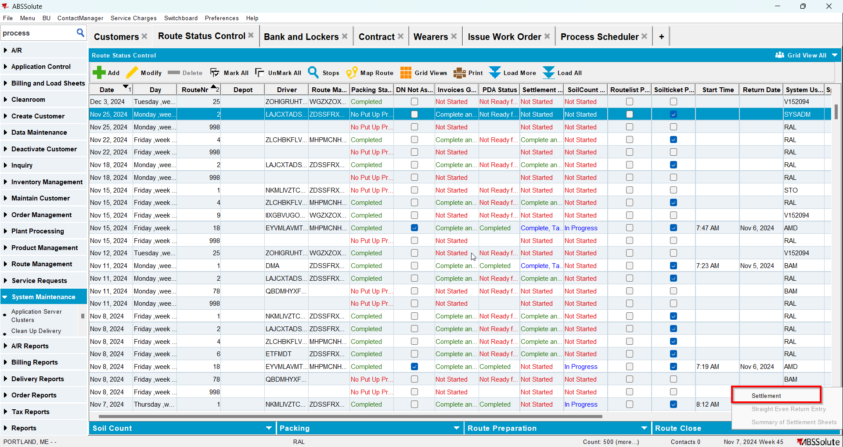
- Go to Maintain Invoices dlg and manually credit all lines beside special charges, minimum and tax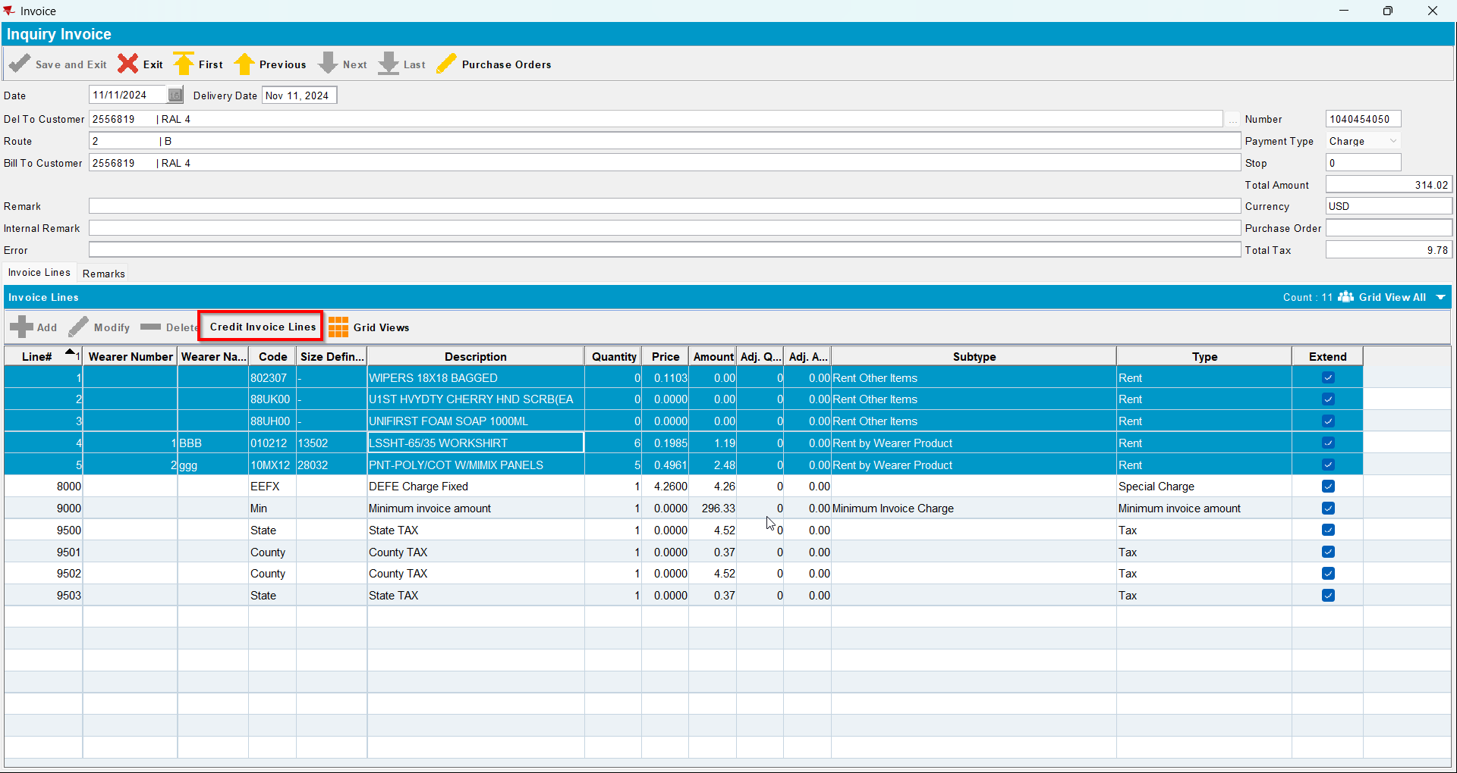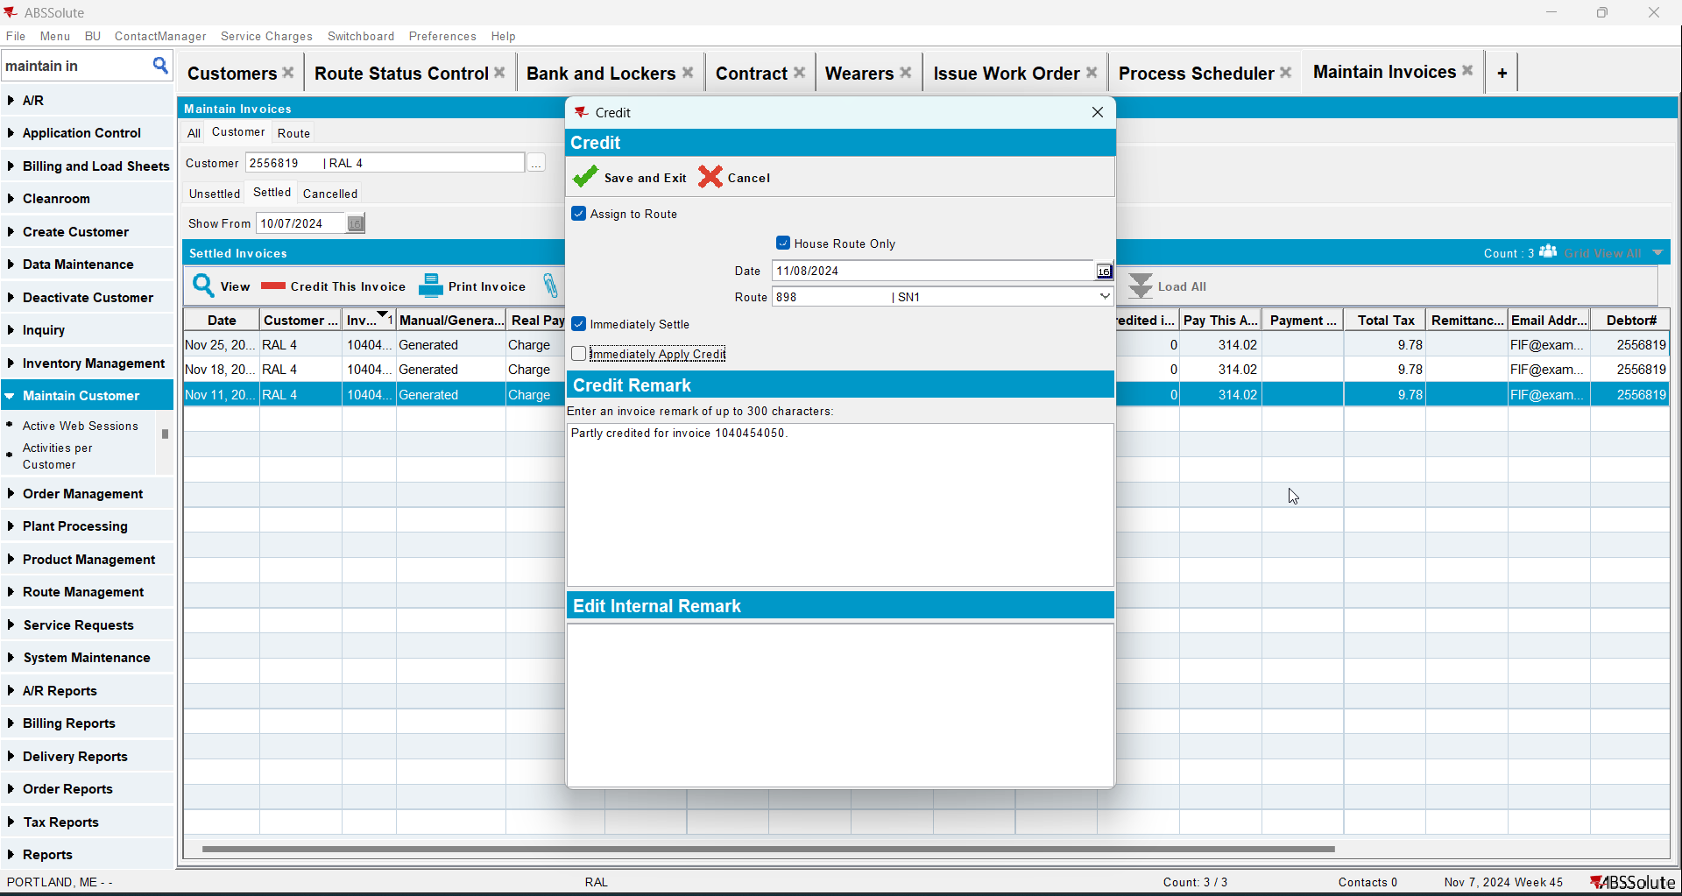
- Check that the Install Date and First Service Date are update to the oldest invoice date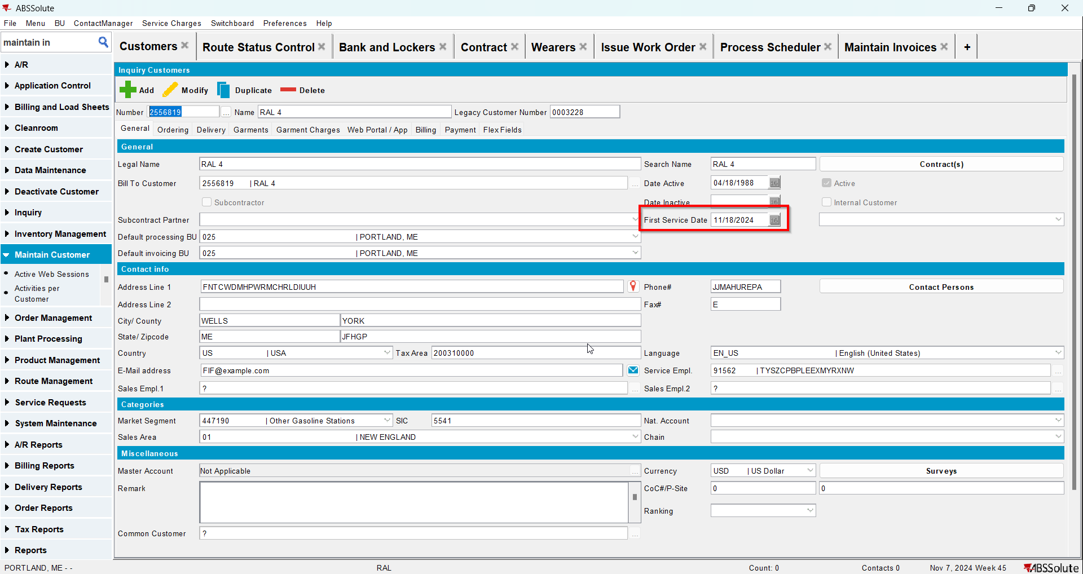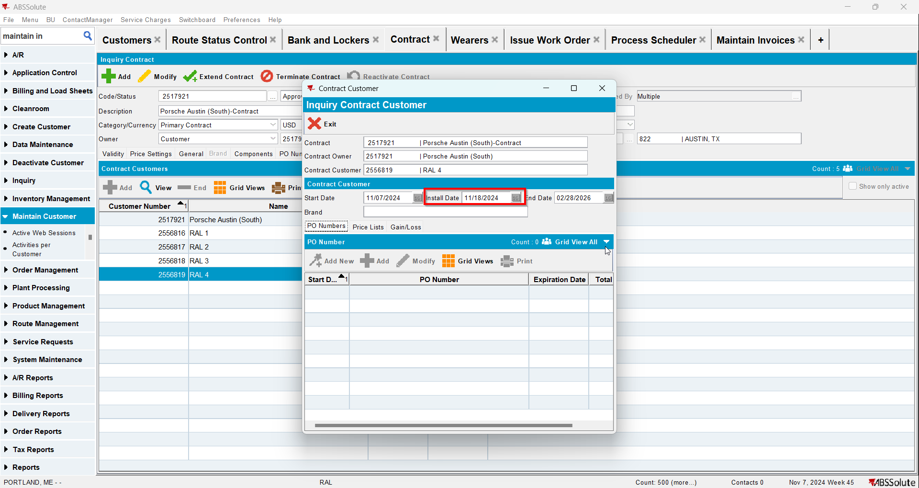
- Go to Maintain Invoices dlg and manually credit all lines beside special charges, minimum and tax of the second invoice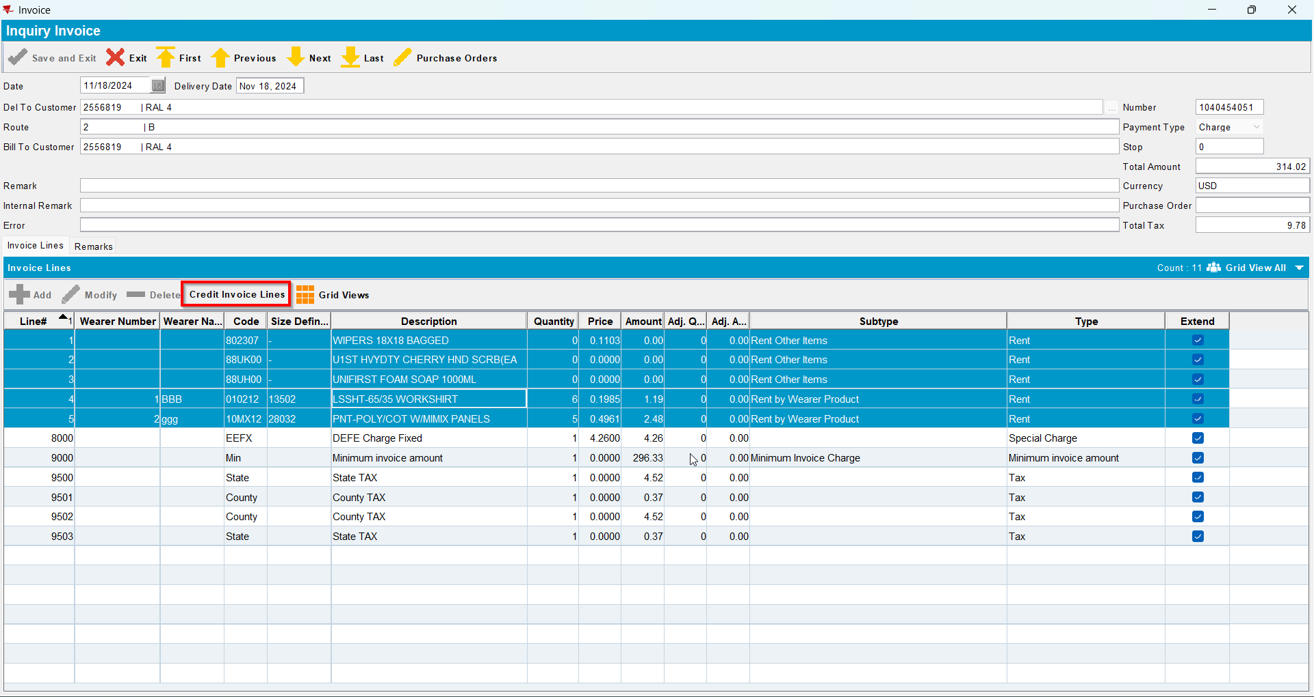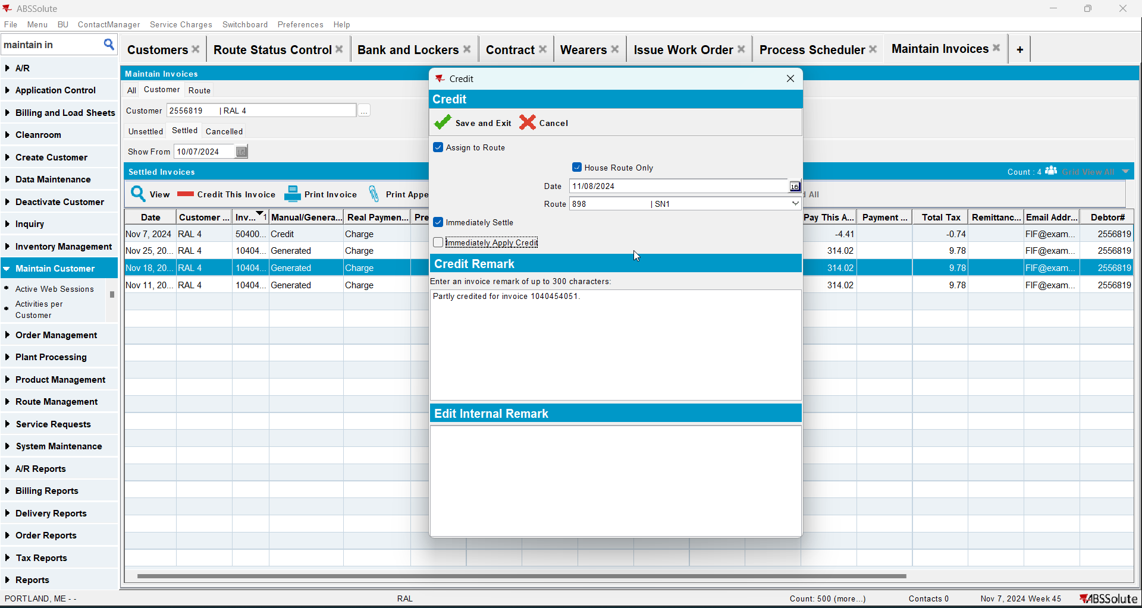
- Check that the Install Date and First Service Date are update to the oldest invoice date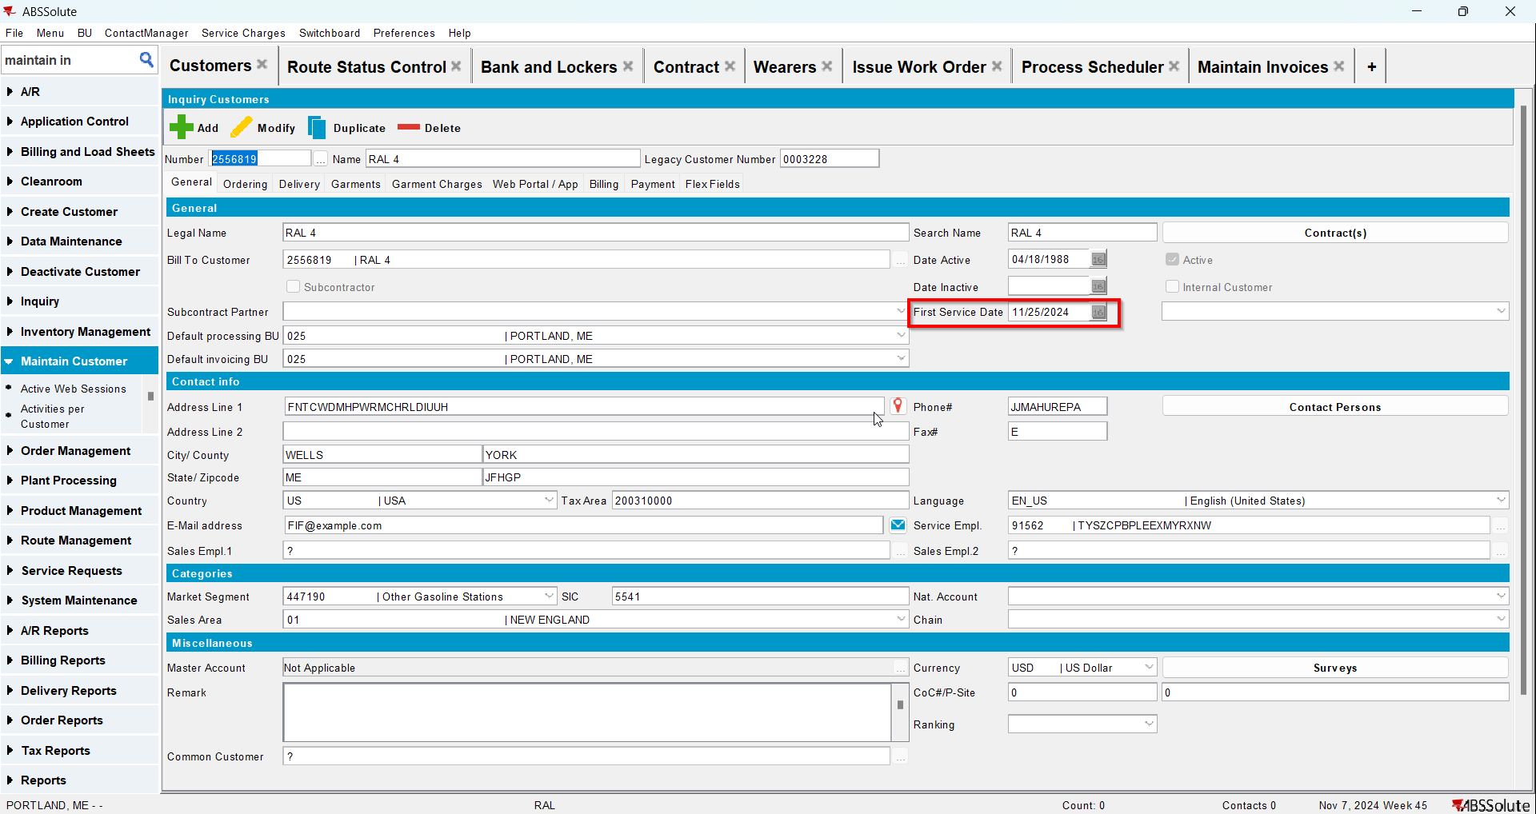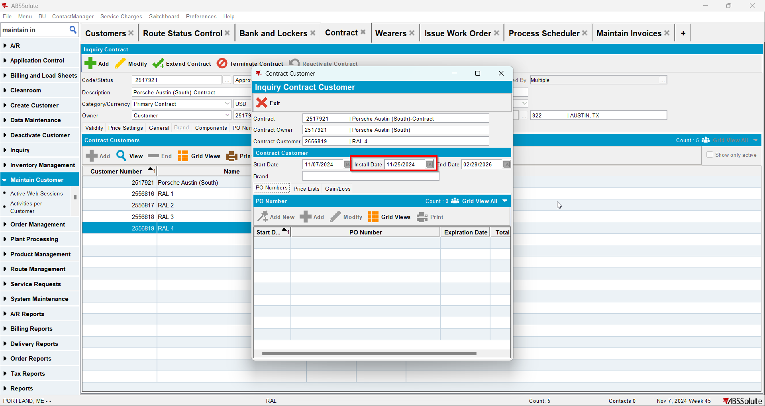

Test Case 5 - Manually Credit only one line from the first invoice for the customer and there are 2 more invoices for this customer – Tested OK
Expected behavior: Install date and first service date should NOT be updated to the oldest invoice date
Hash: 3fa65b8
- Add a new customer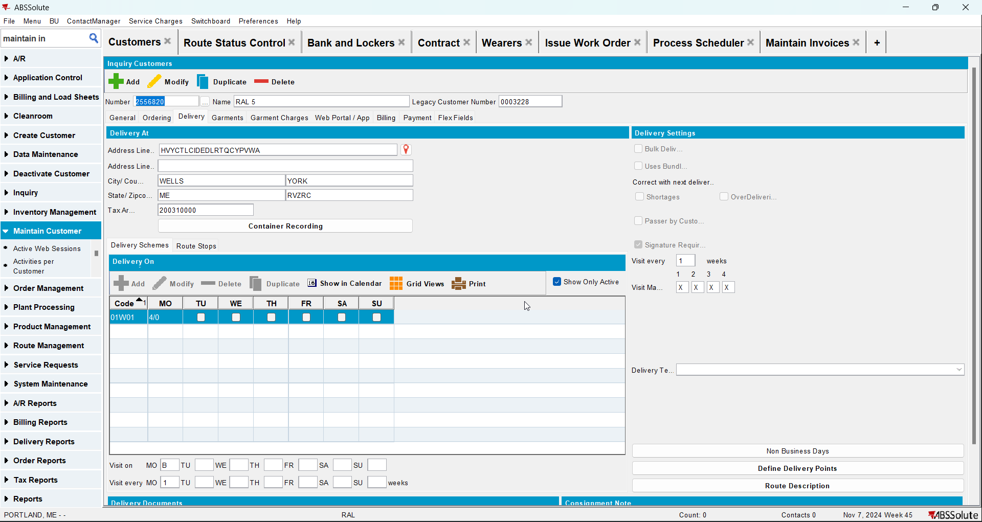
- Check that the First Service Date is null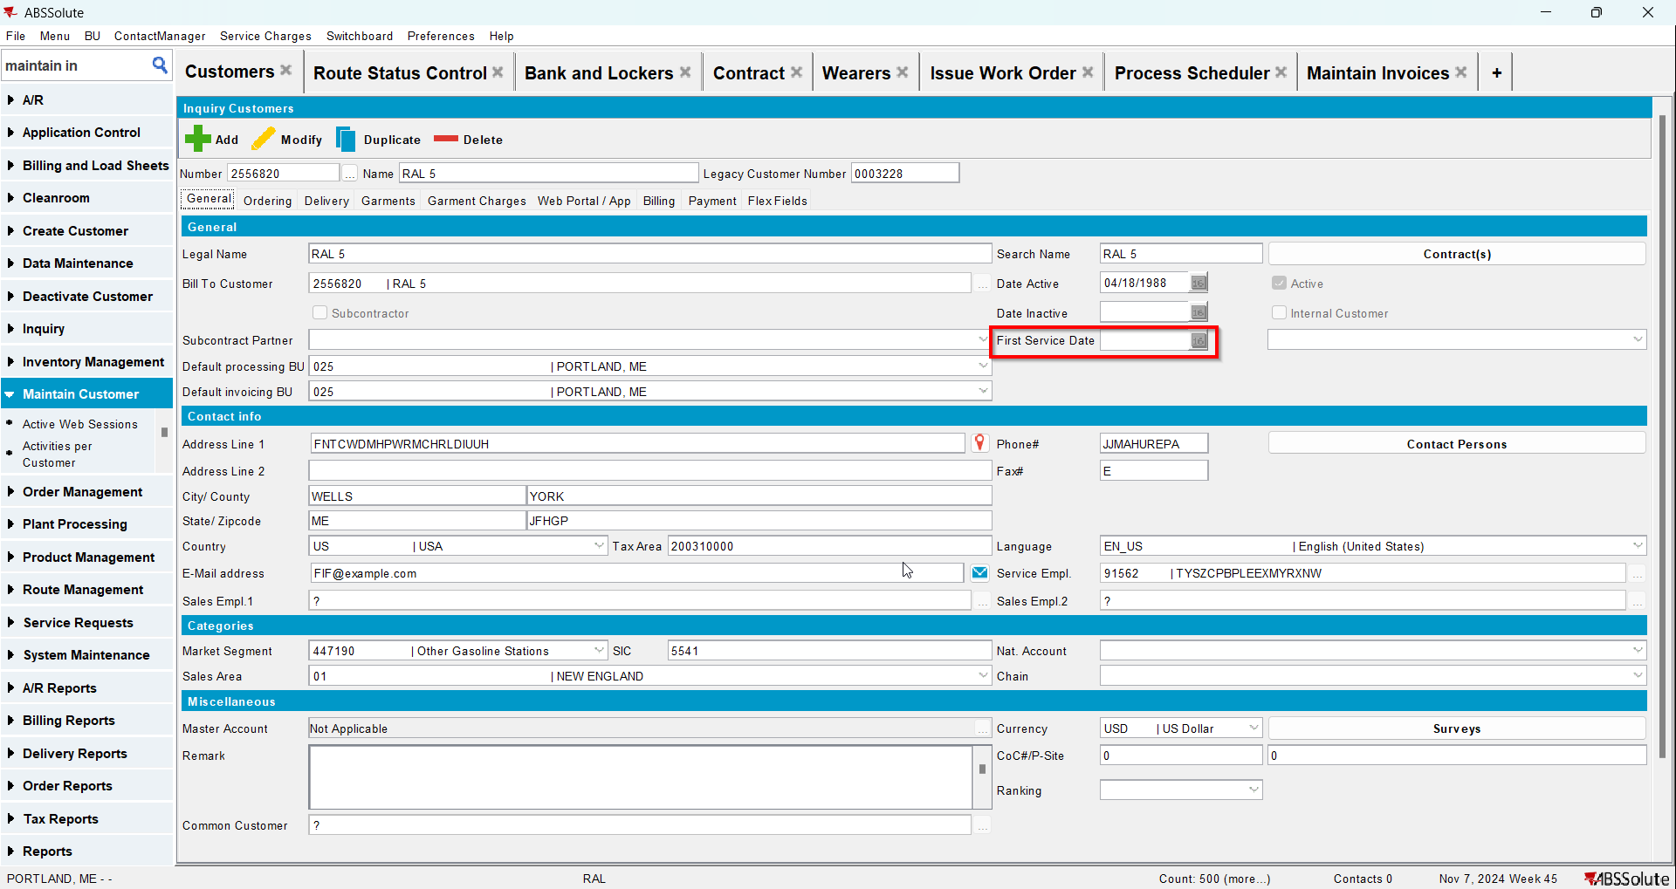
- Go to Bank and Lockers dlg and add lockers for your customer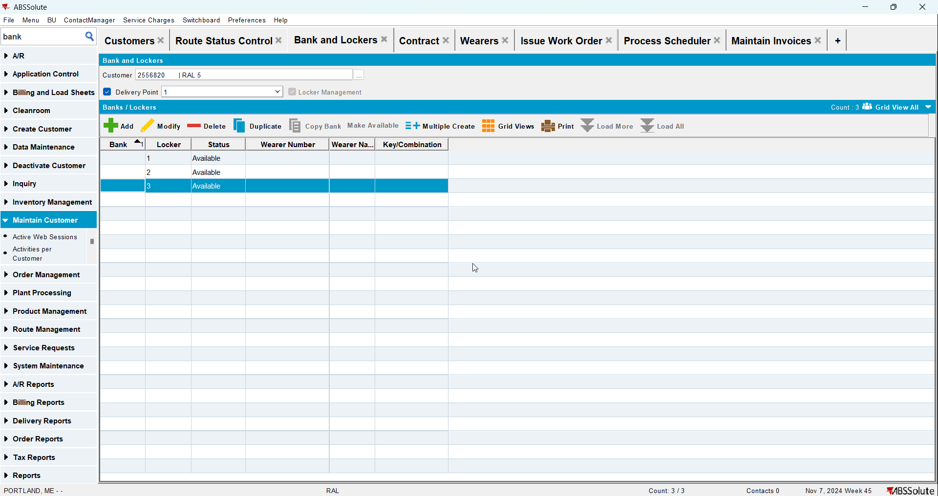
- Go to Contract dlg and add your customer to a contract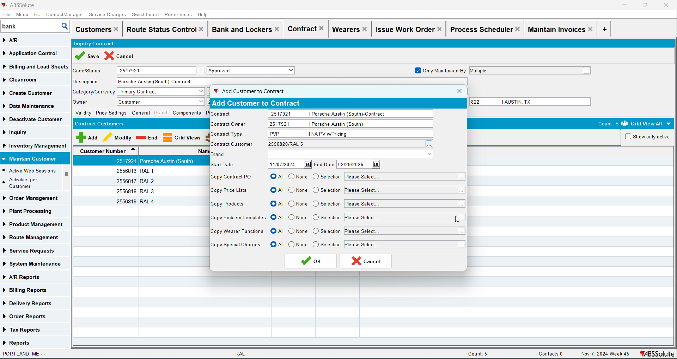
- Check that Install Date is null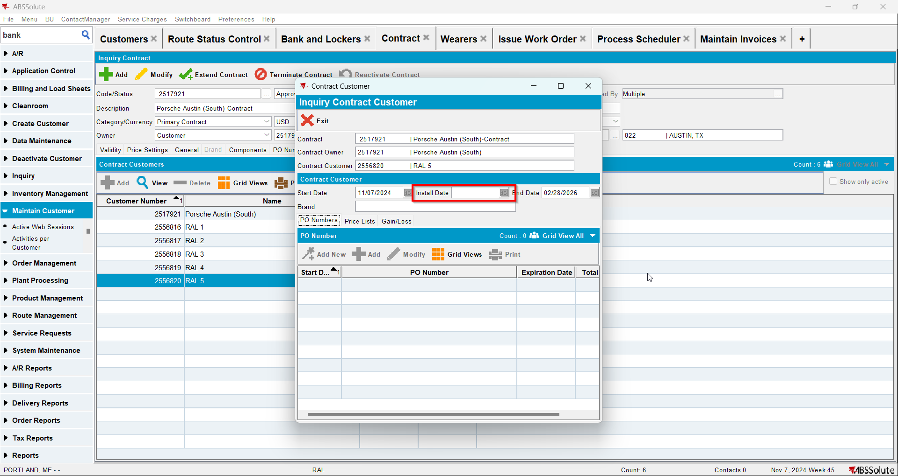
- Go to Wearers dlg and add wearers for your customer. Generate WO and after that issue the WO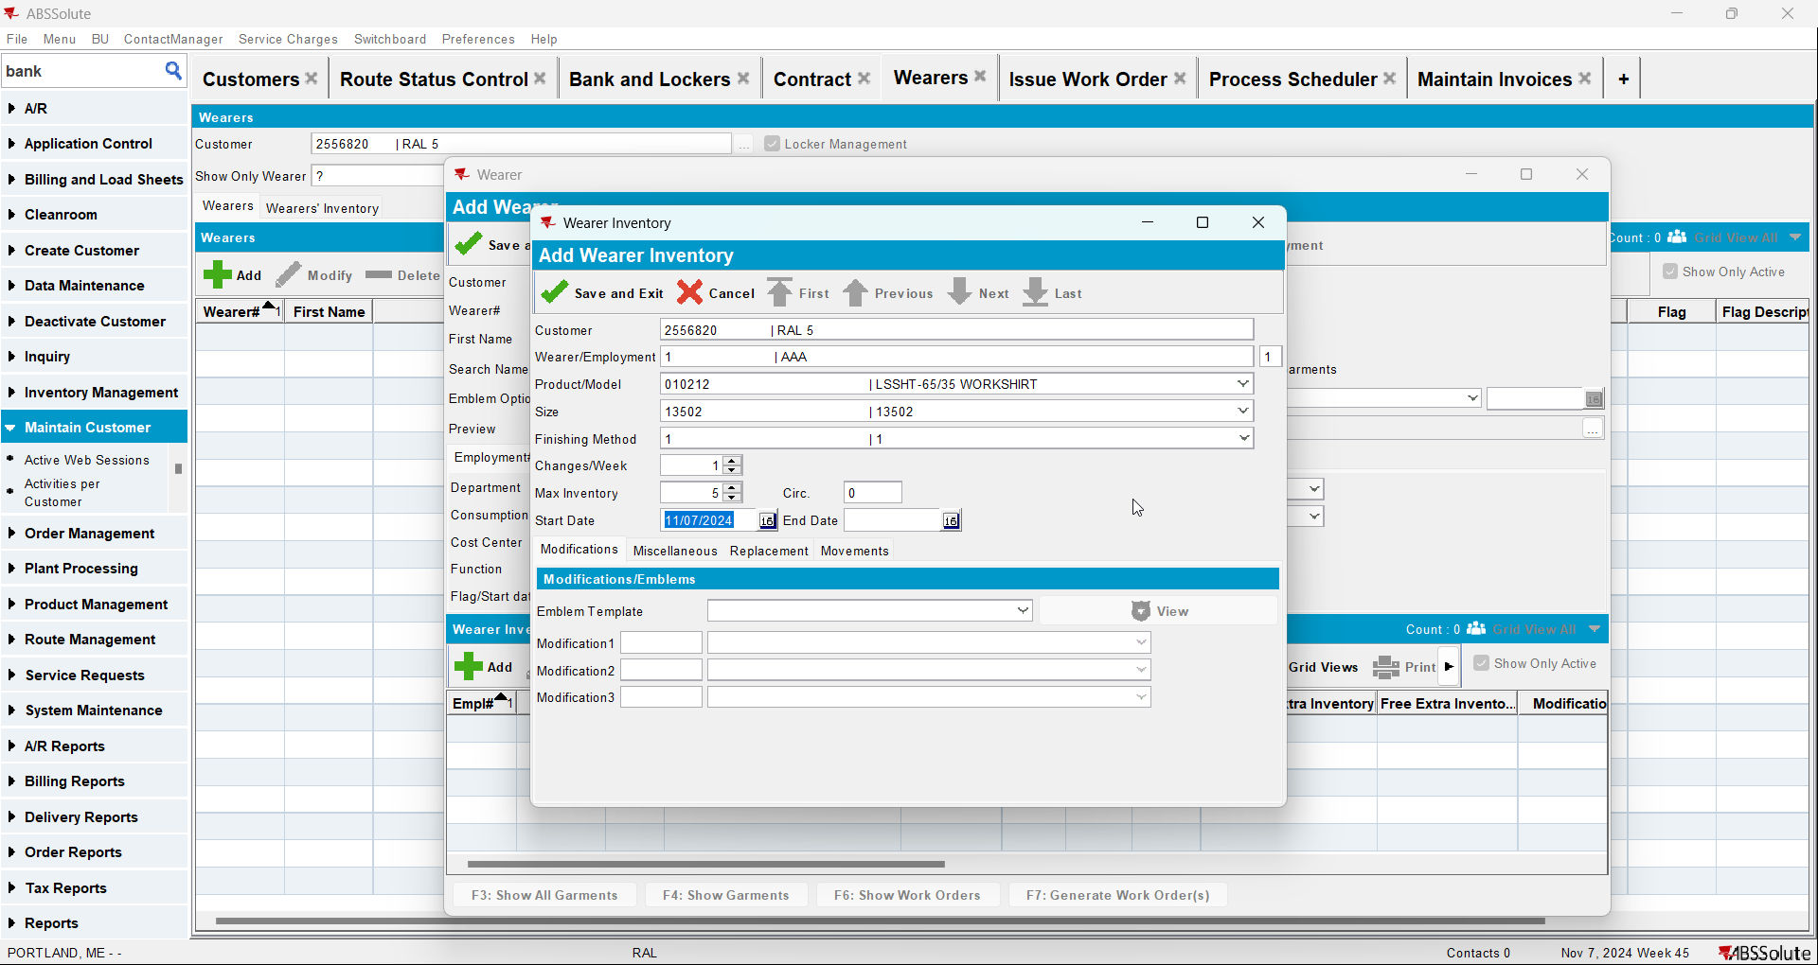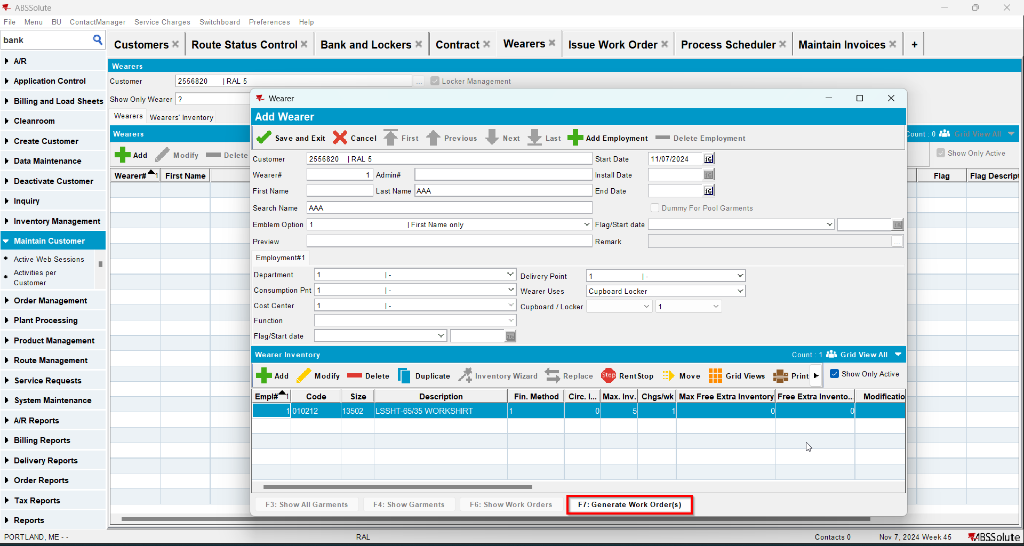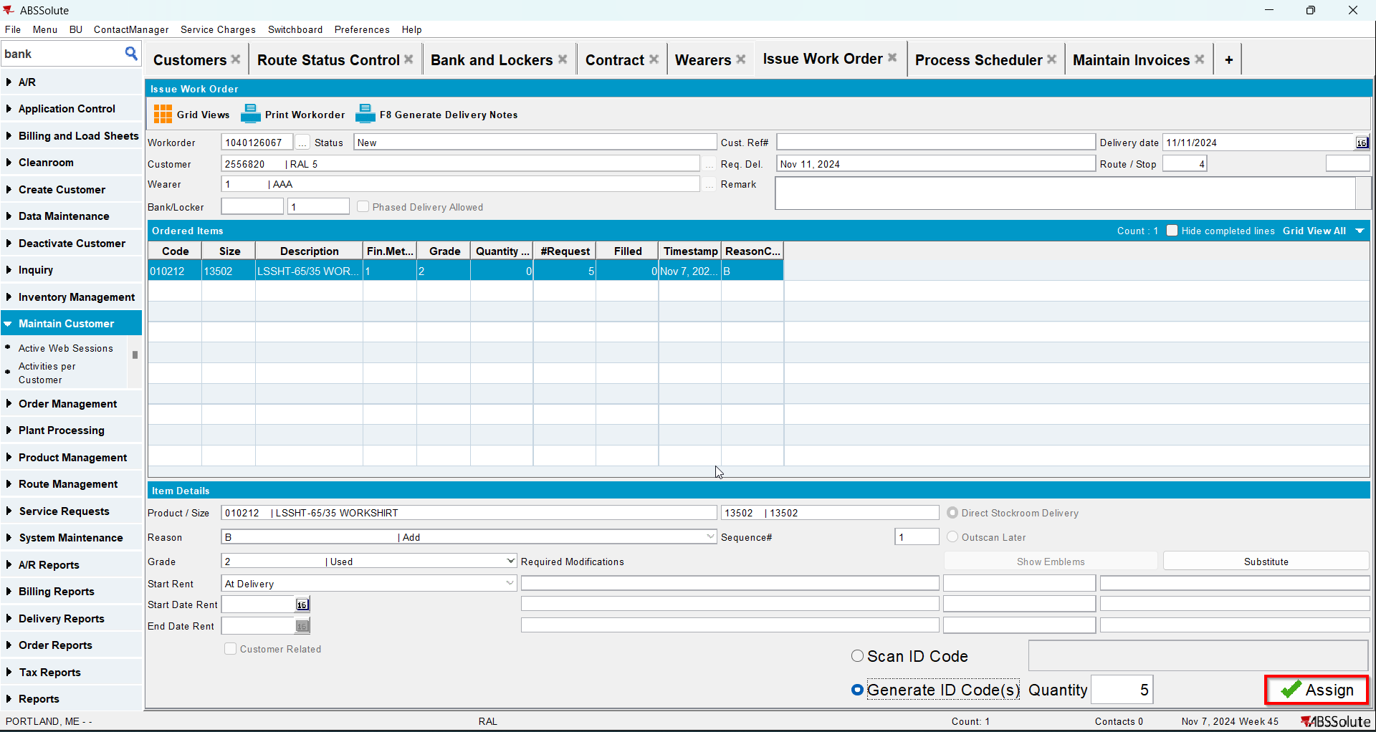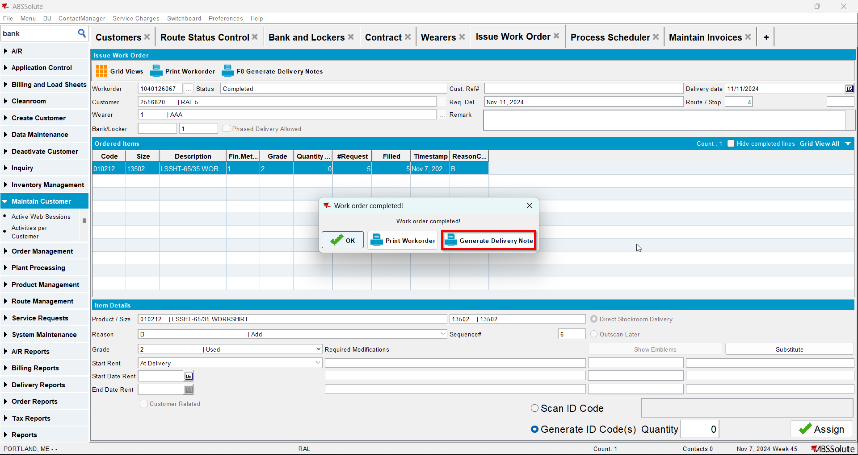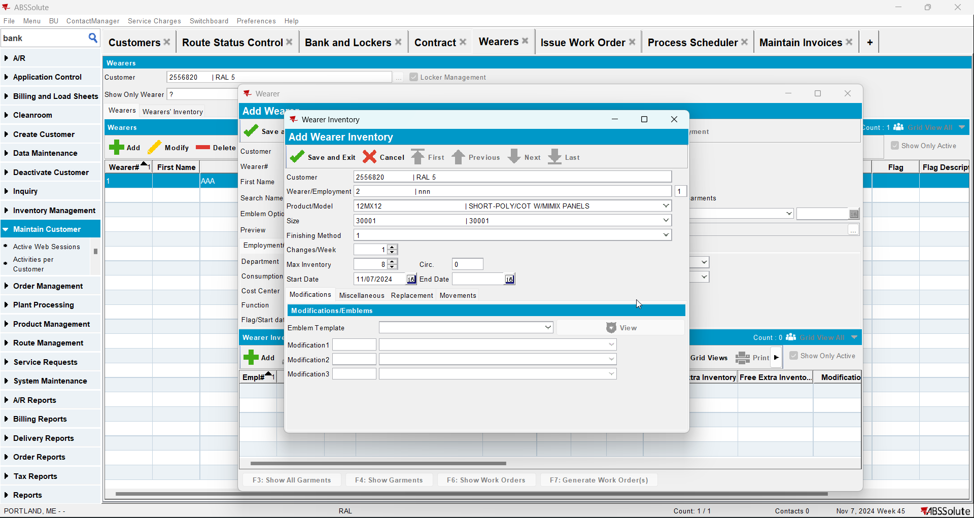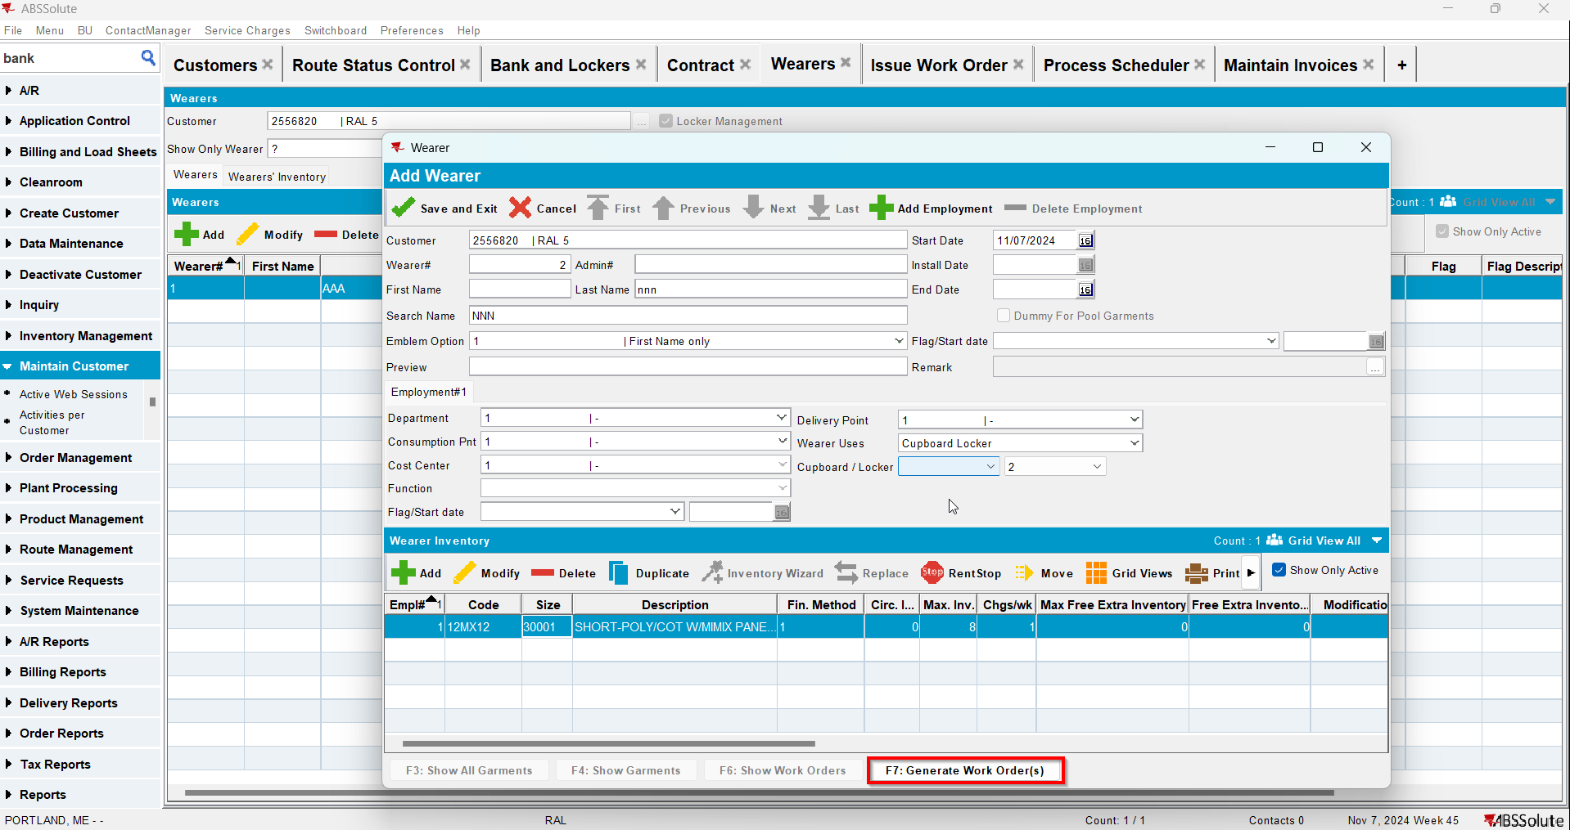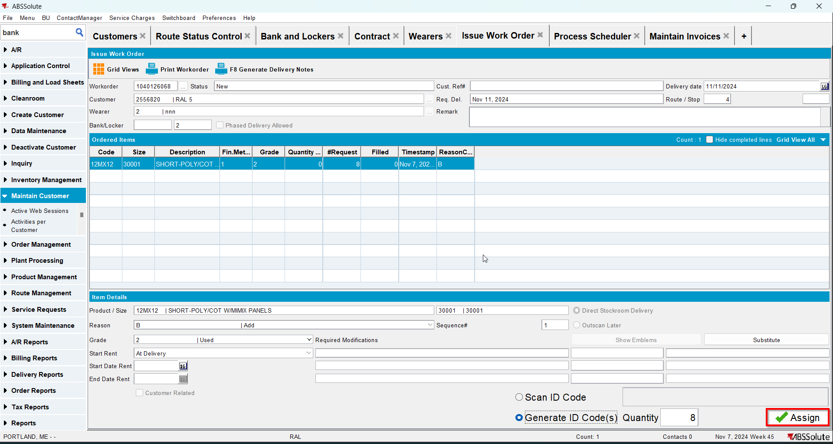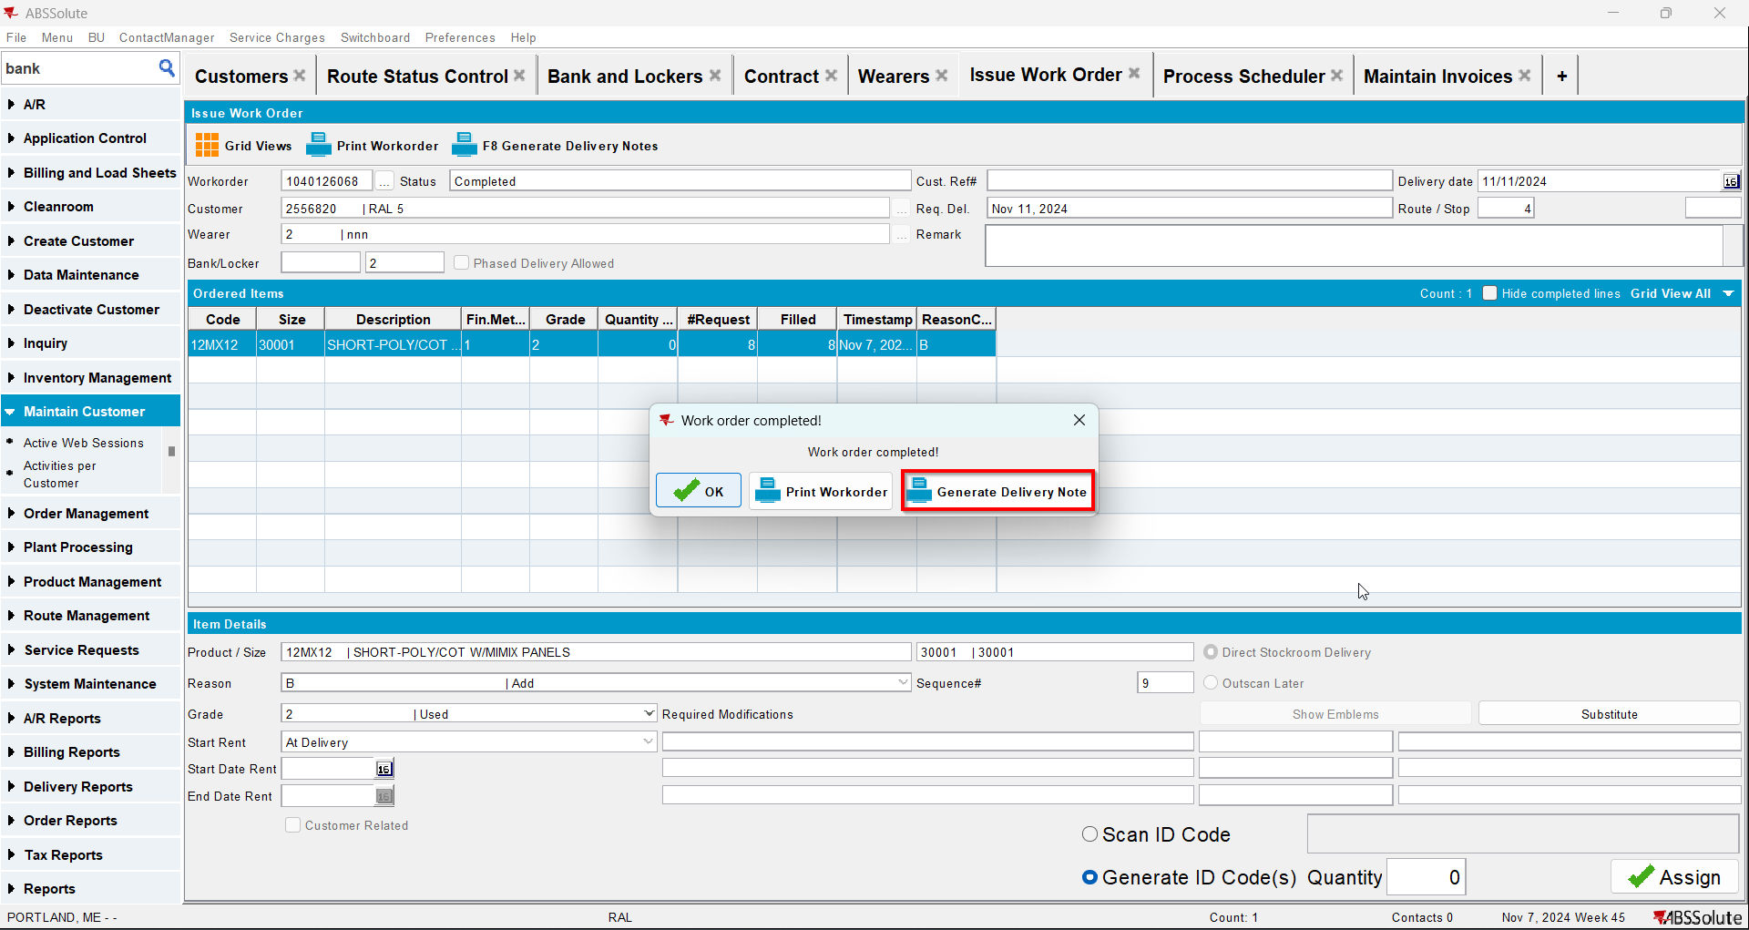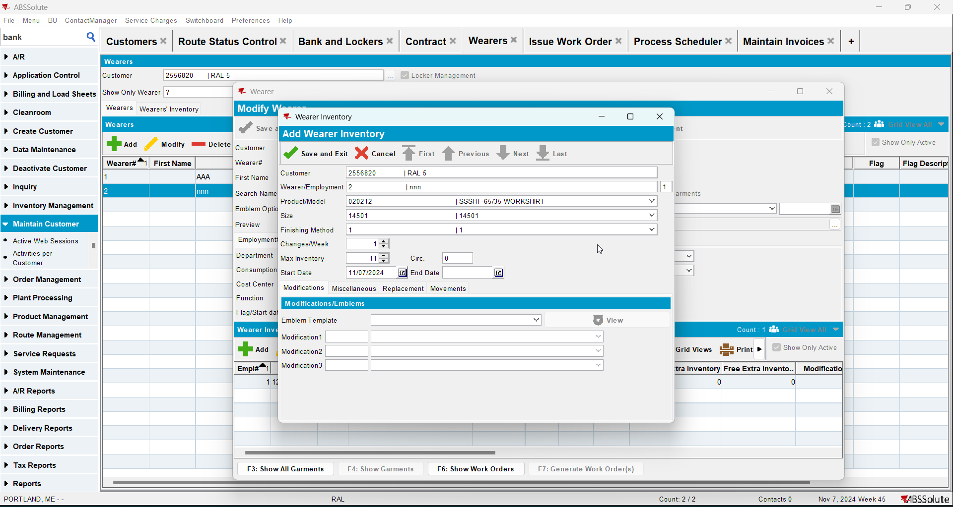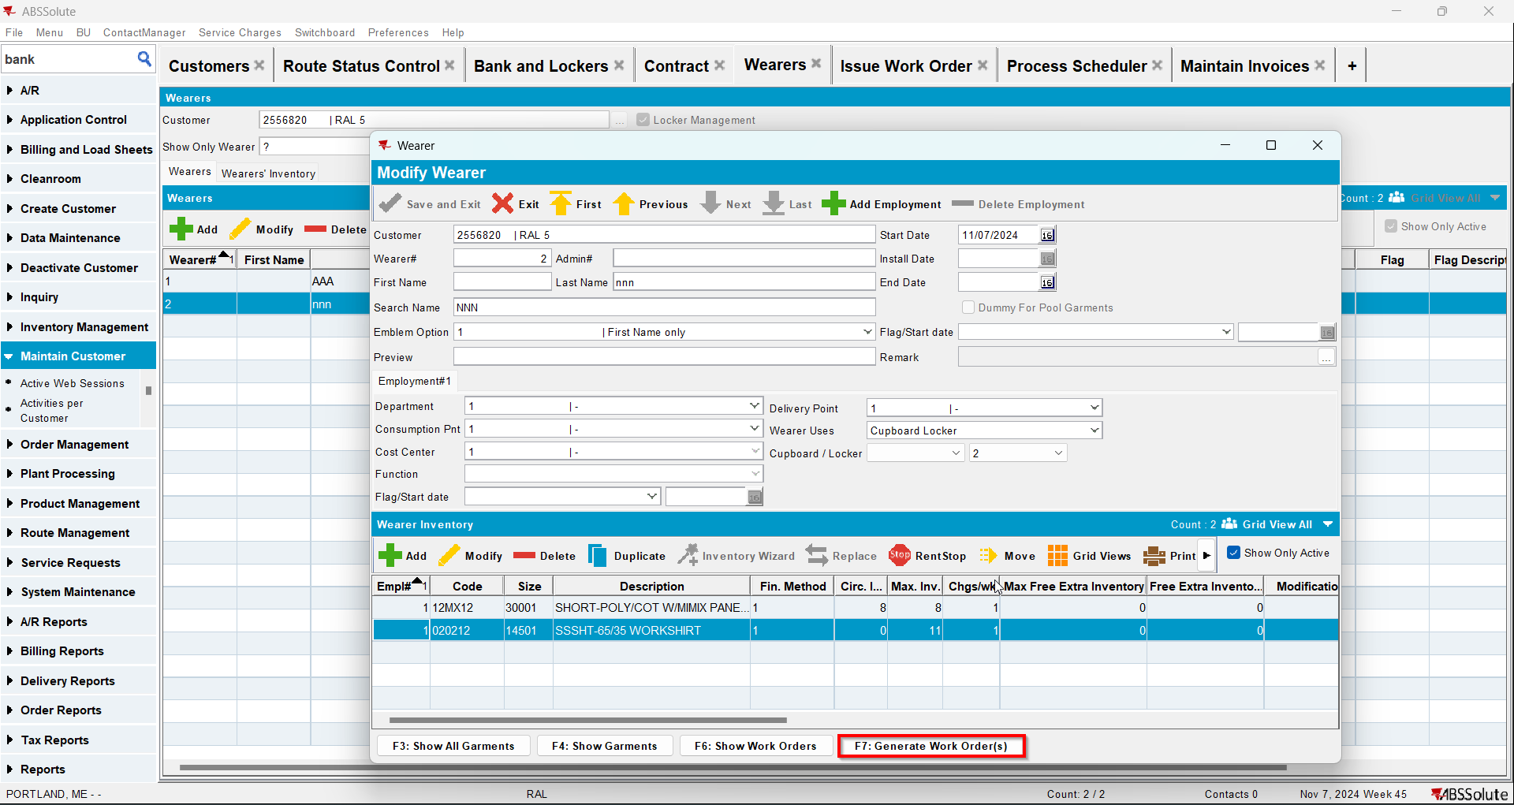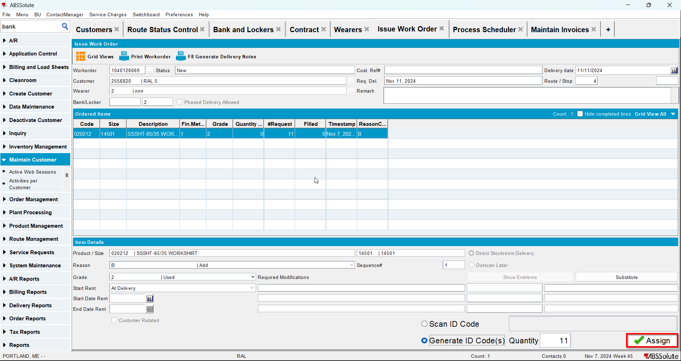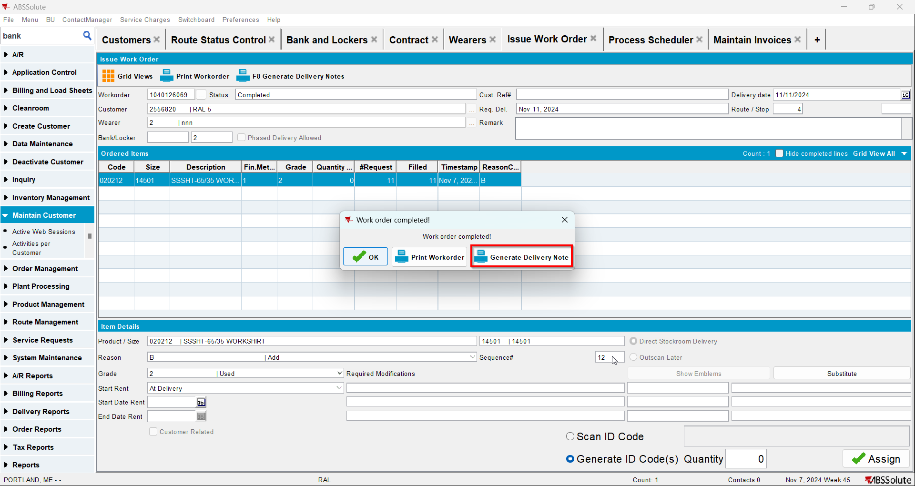
- Go to Route Status Control dlg and generate invoices for your route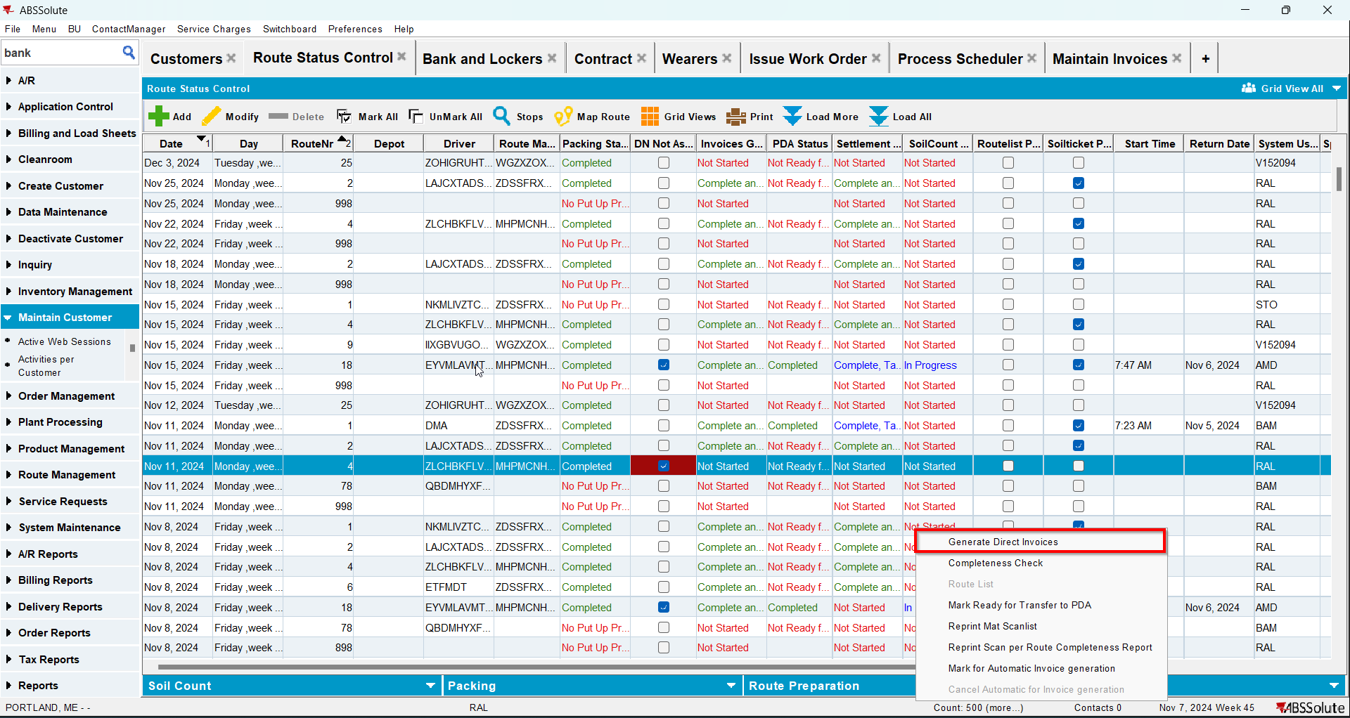
- Settle the route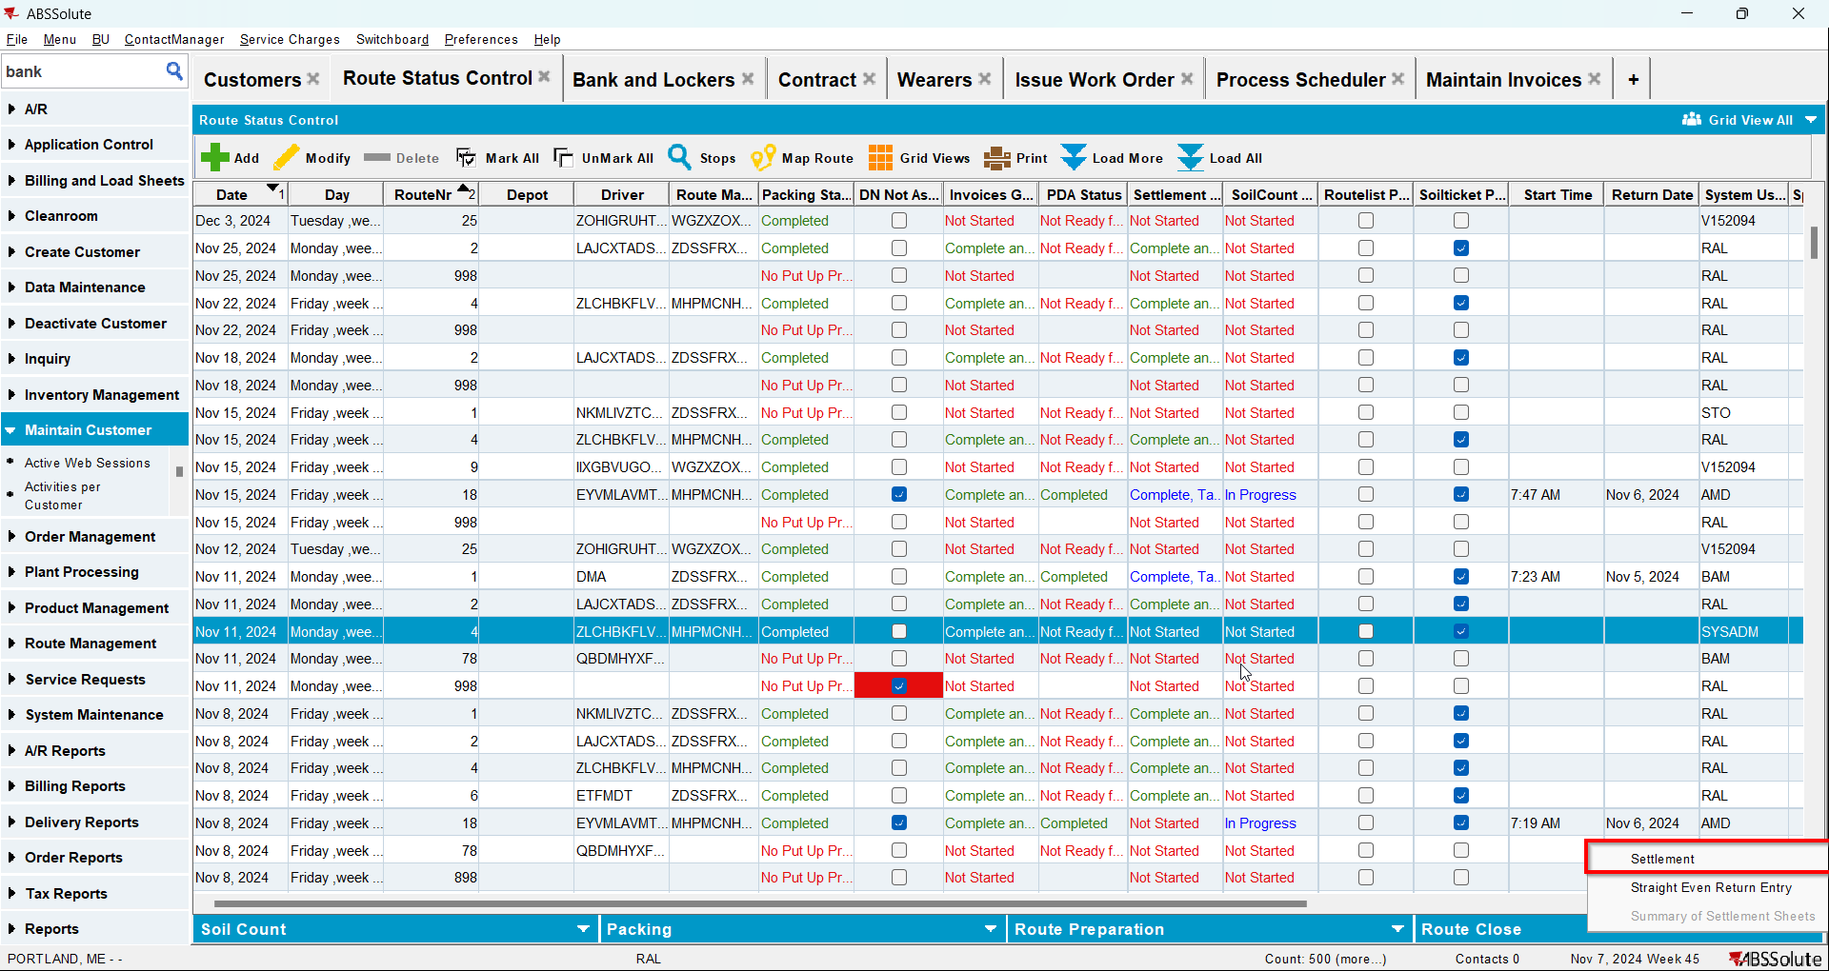
- Check that the Install Date and First Service Date have the date of the invoice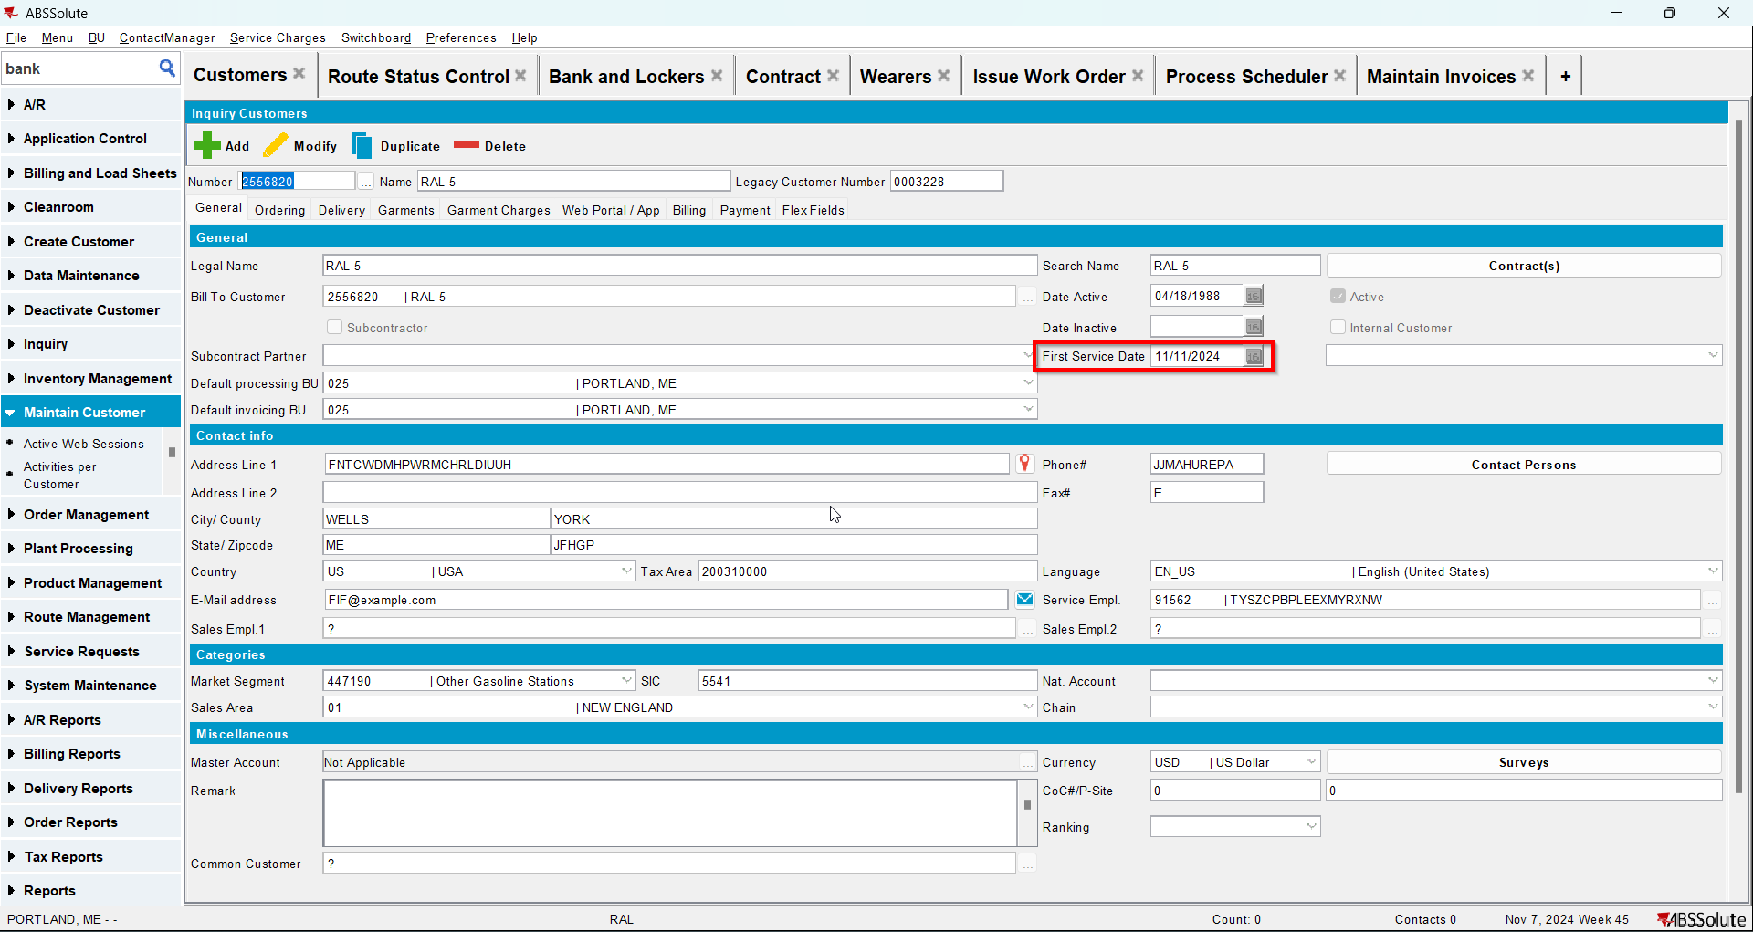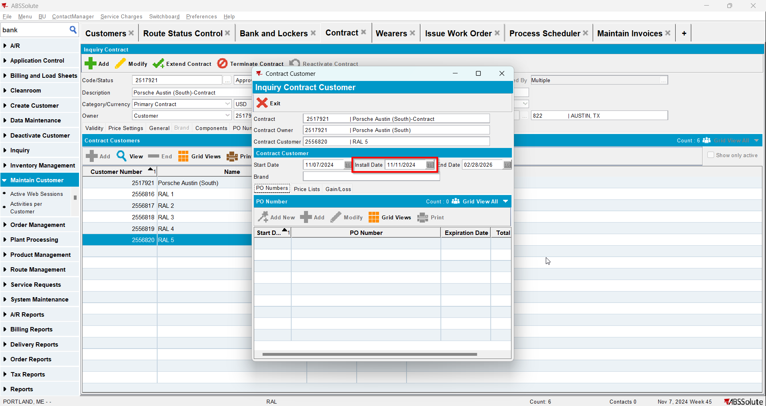
- Generate invoices for the next 2 weeks and settle the routes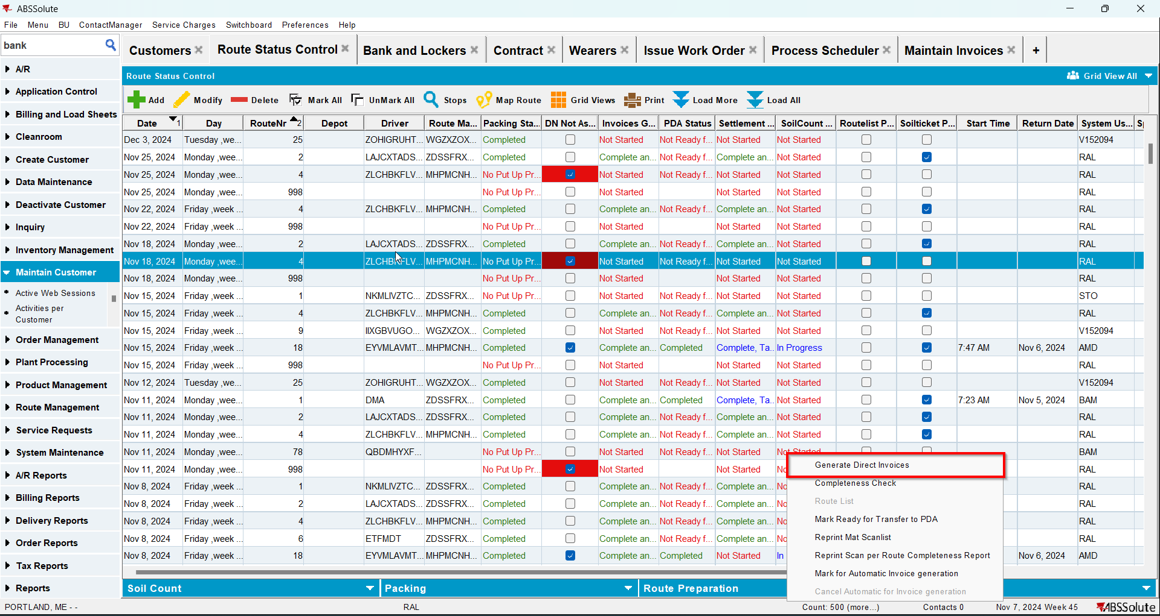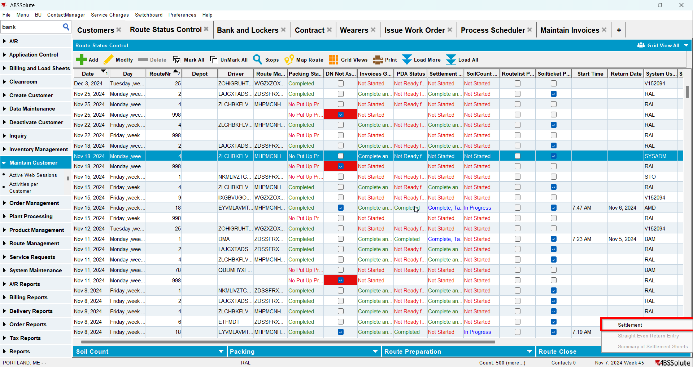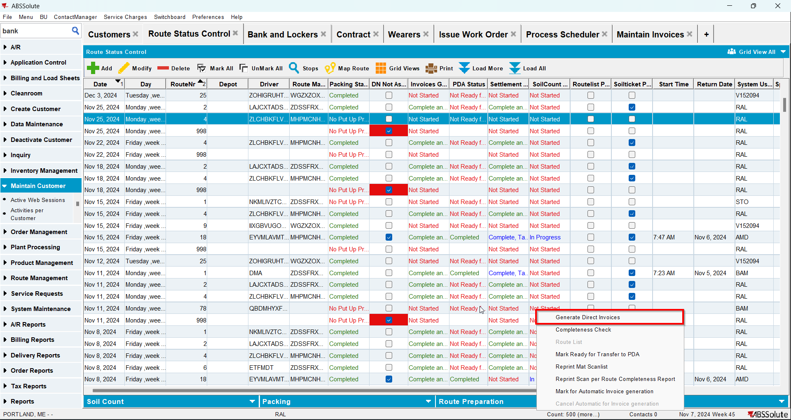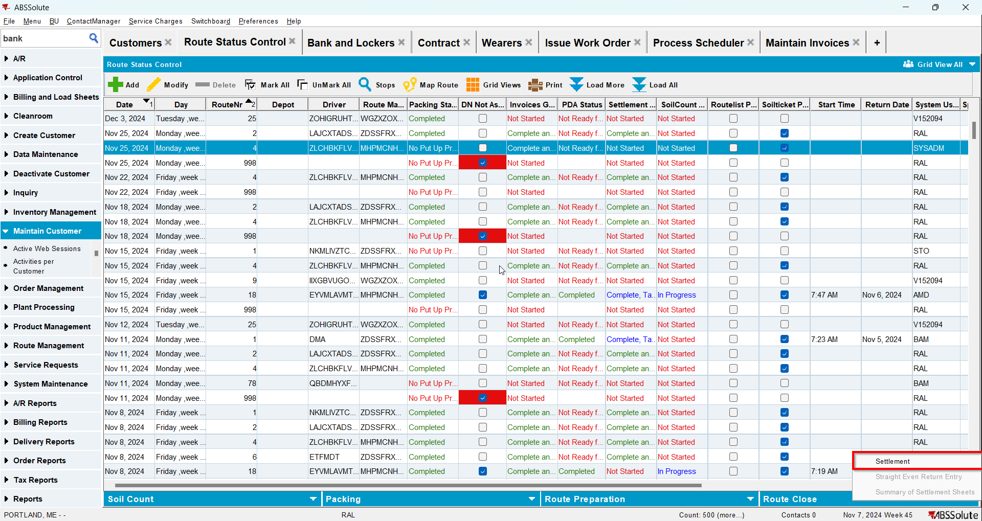
- Go to Maintain Invoices dlg and manually credit just 1 line from the first invoices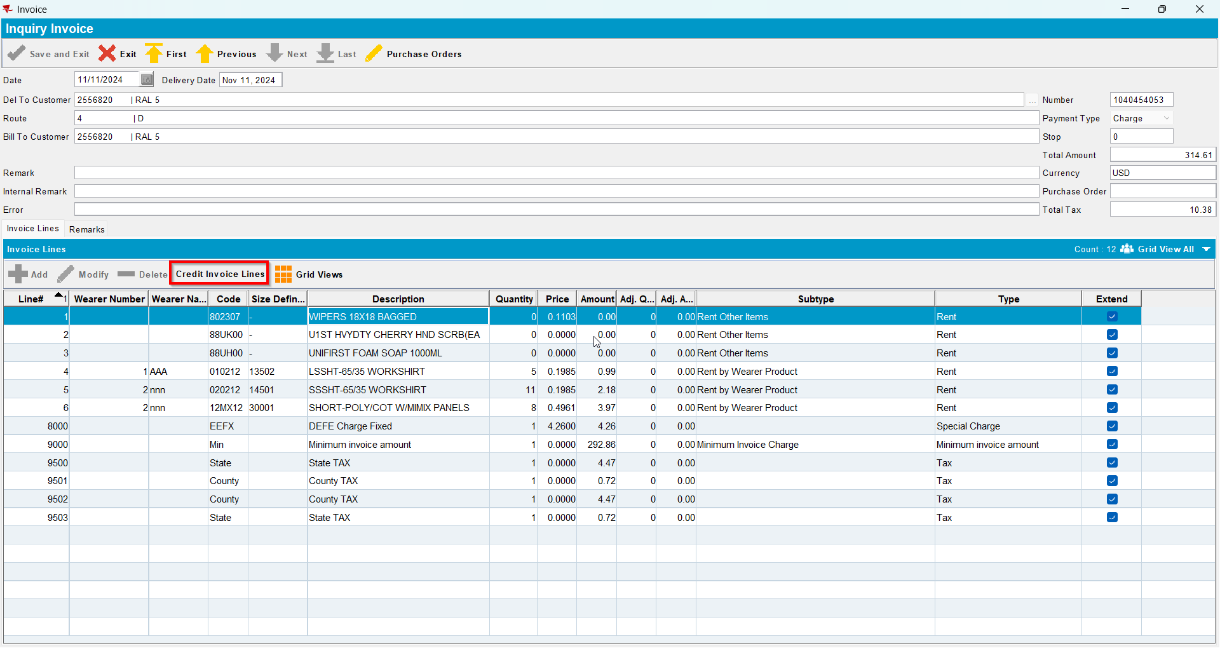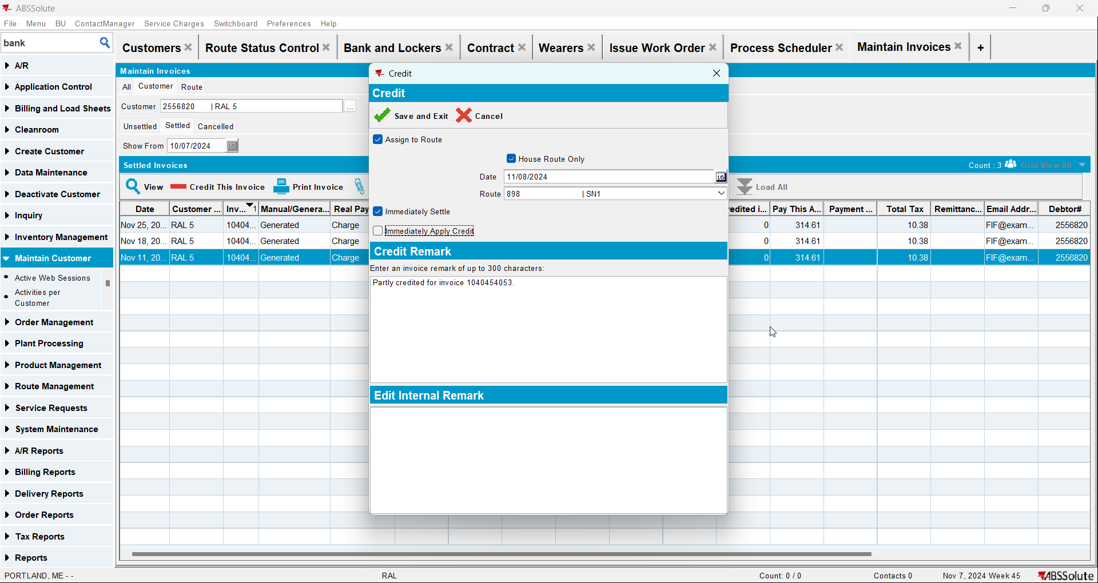
- Check that the Install Date and First Service Date have the date of the first invoice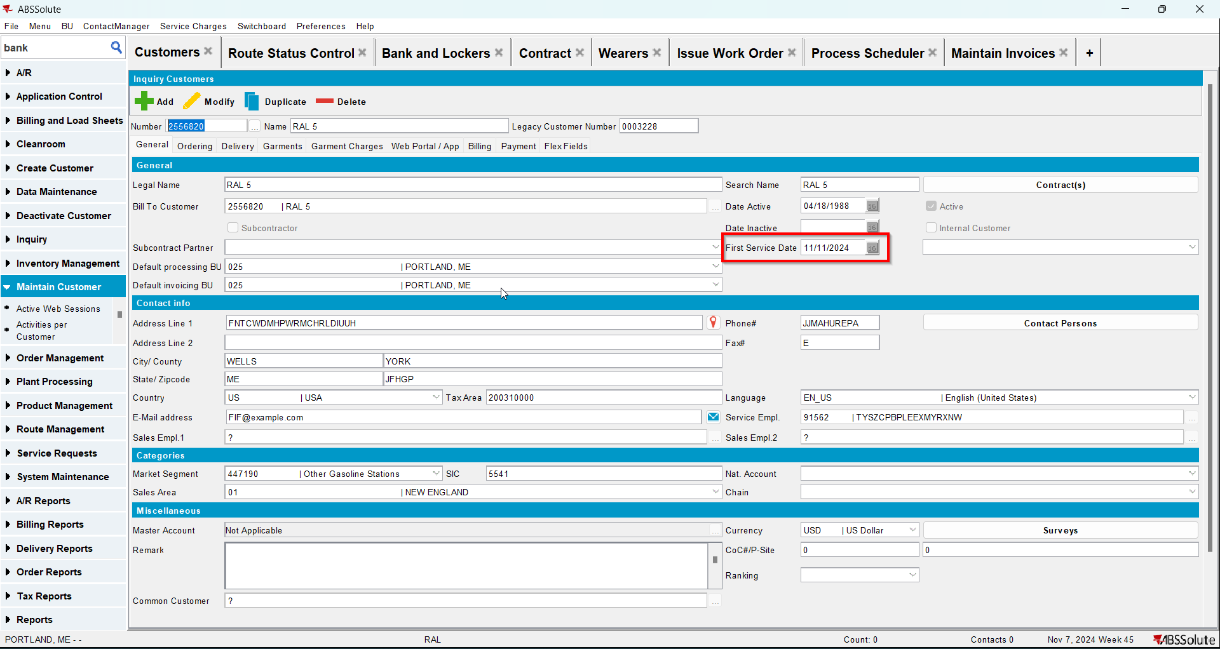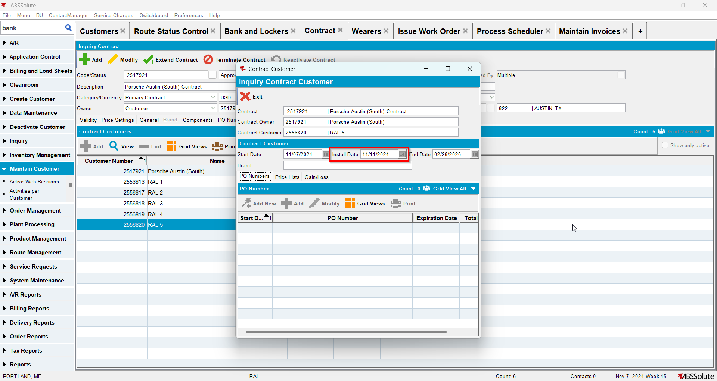

Test Case 6 – Manually Credit all rent/sales/wash lines and one fixed special charge when this is the first invoice for the customer and there are no more invoices for this customer– Tested OK
Expected behavior: Install date and first service date should be NULL
Hash: 3fa65b8
- Add a new customer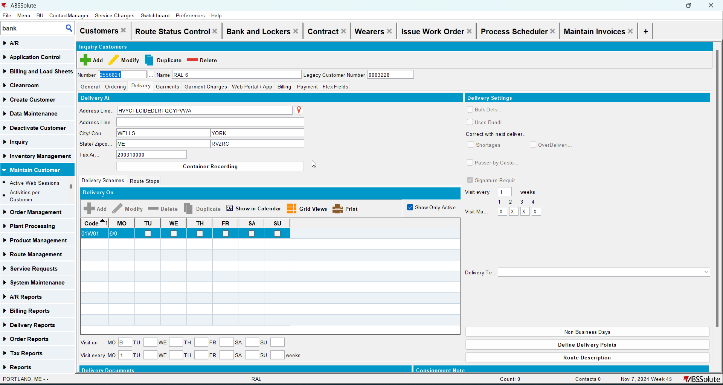
- Check that the First Service Date is null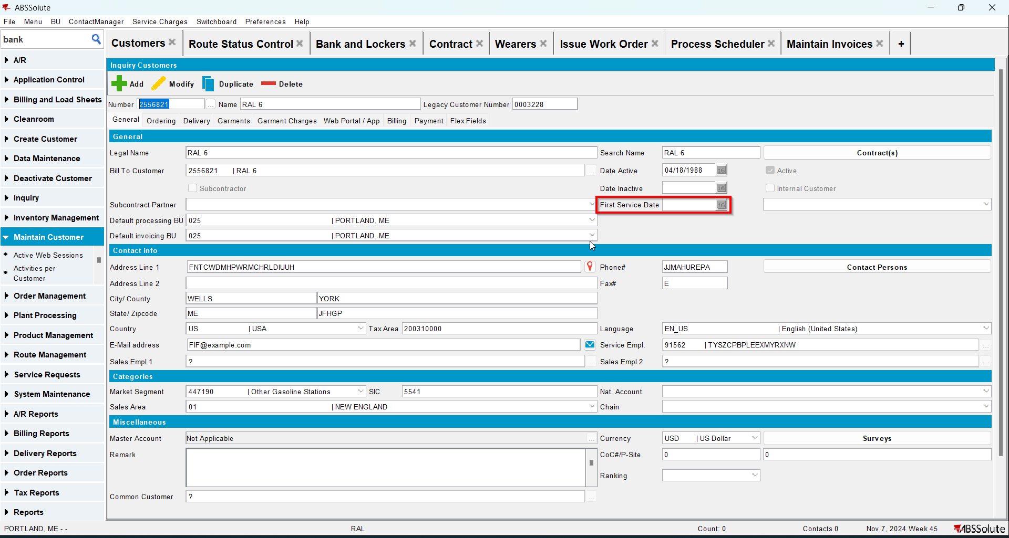
- Go to Bank and Lockers dlg and add lockers for your customer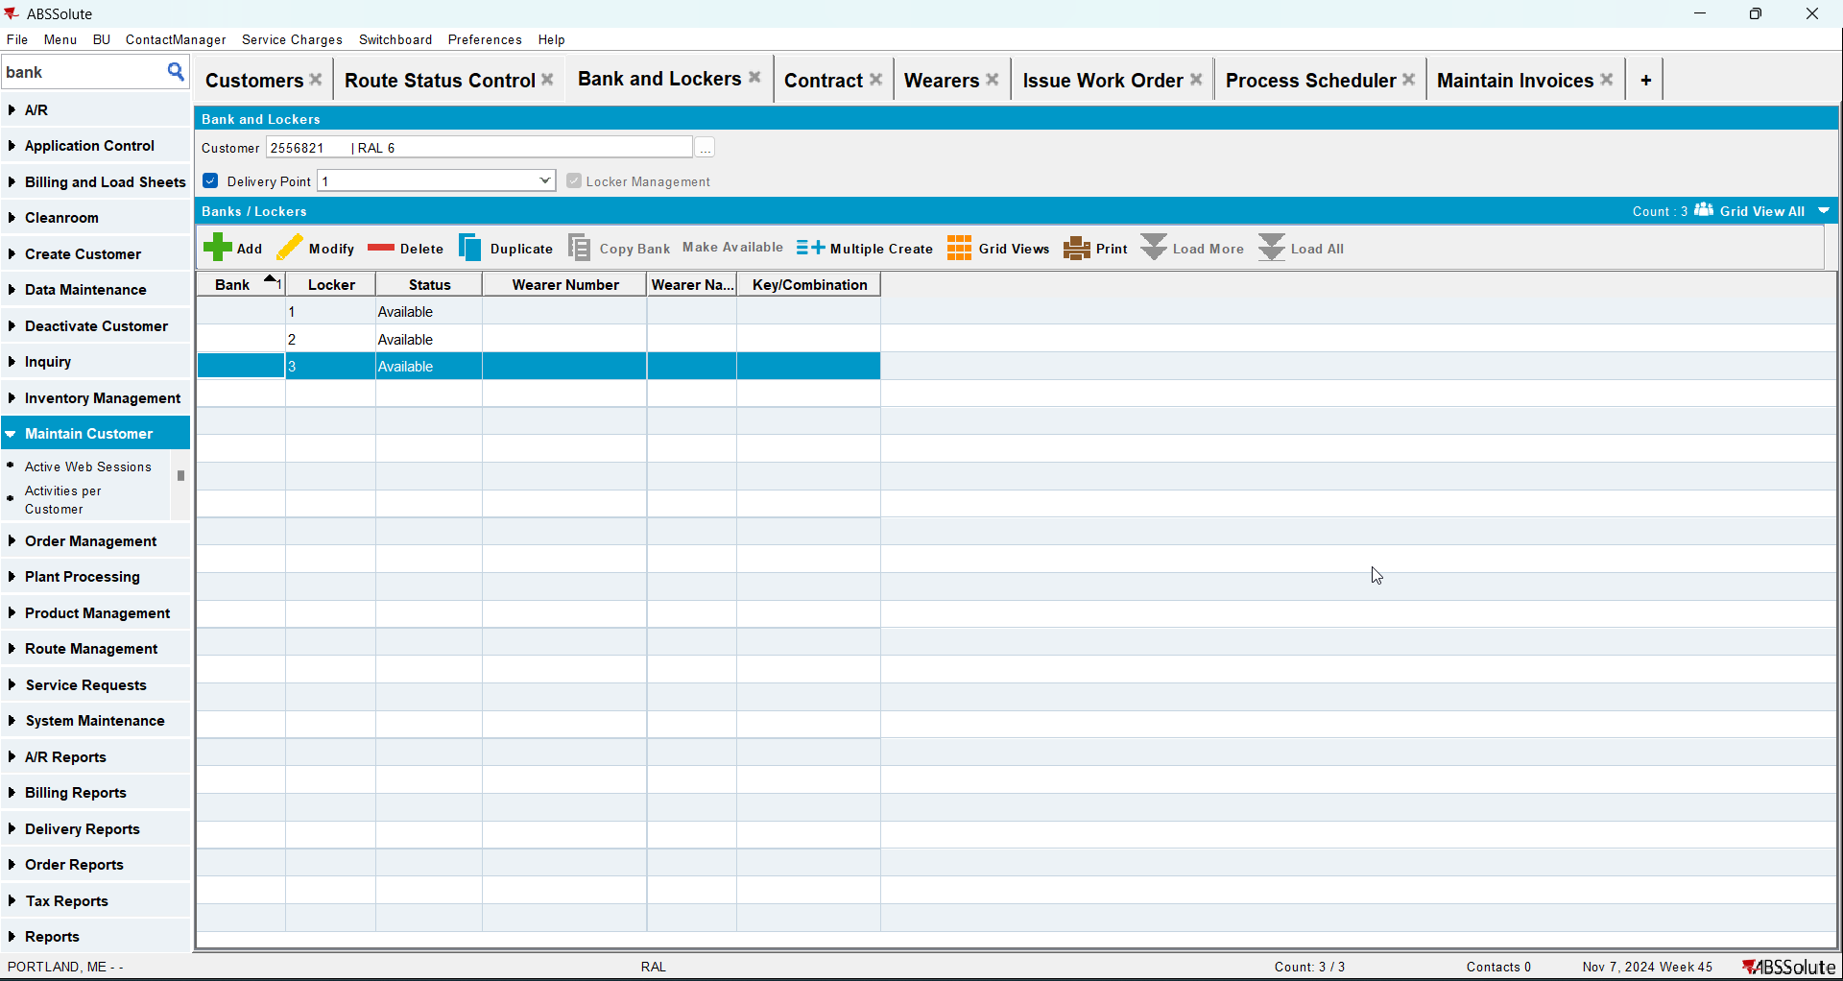
- Go to Contract dlg and add your customer to a contract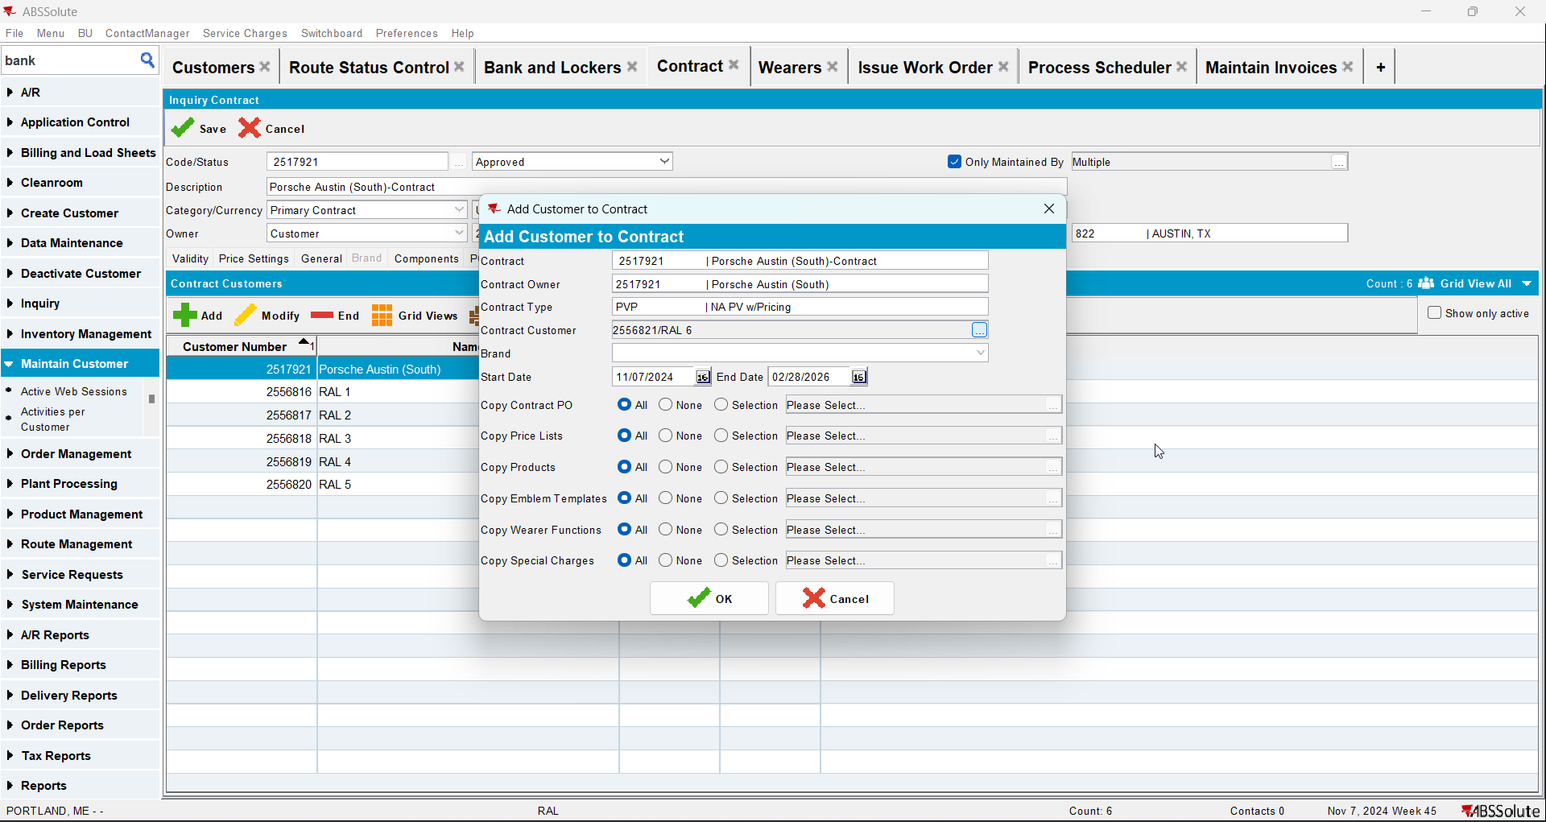
- Check that Install Date is null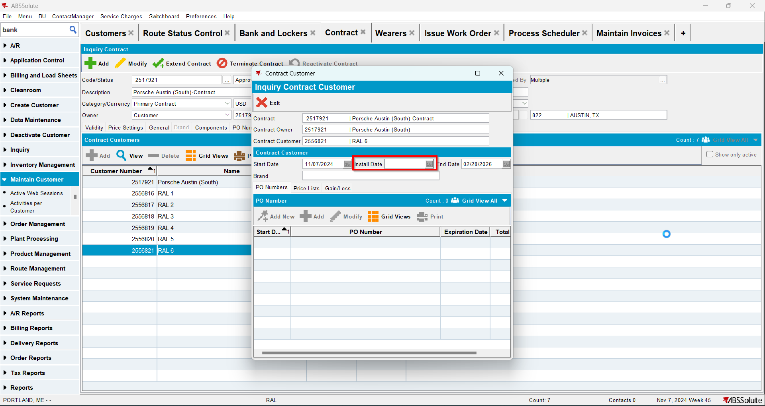
- Go to Wearers dlg and add wearers for your customer. Generate WO and after that issue the WO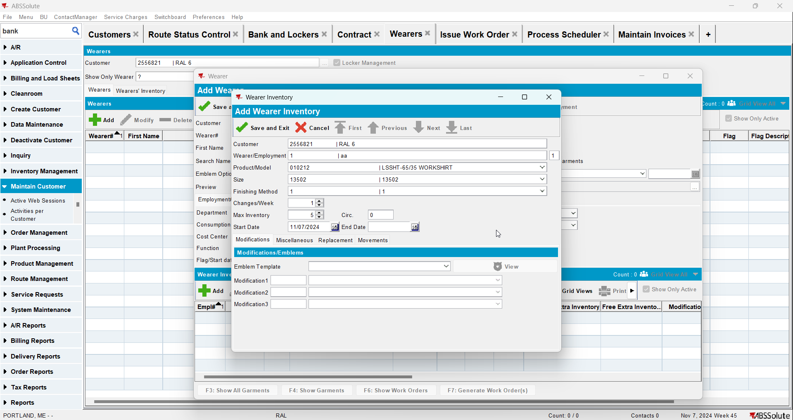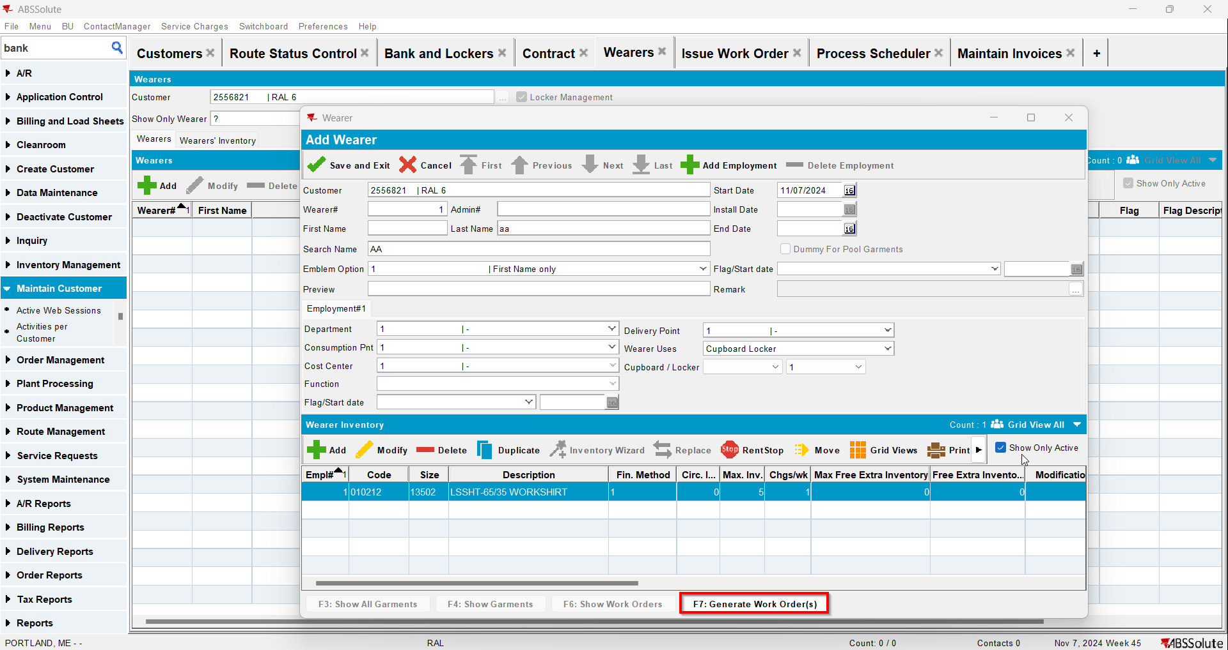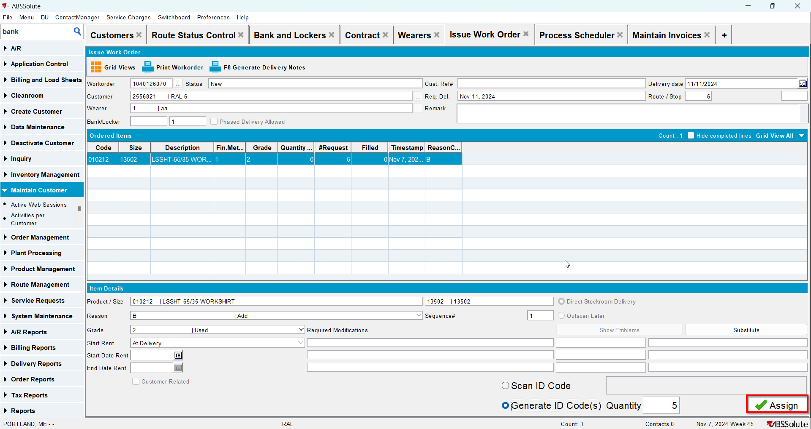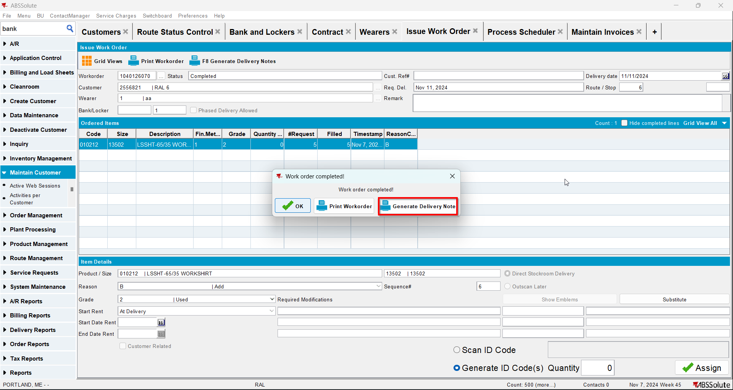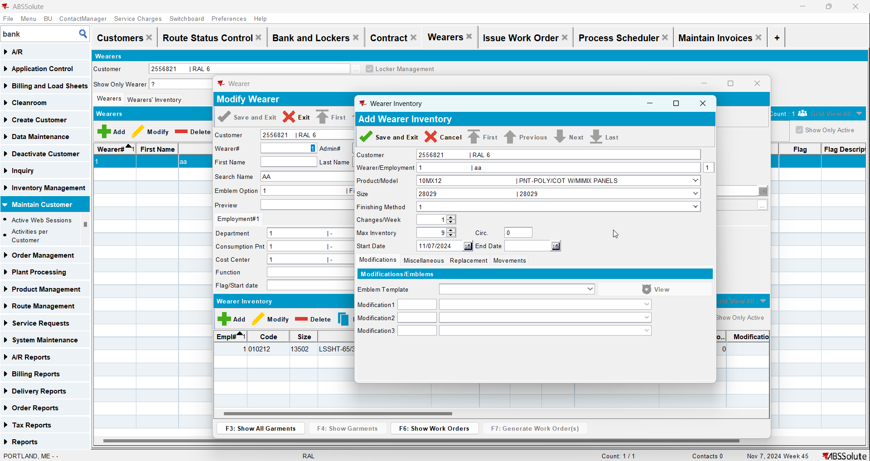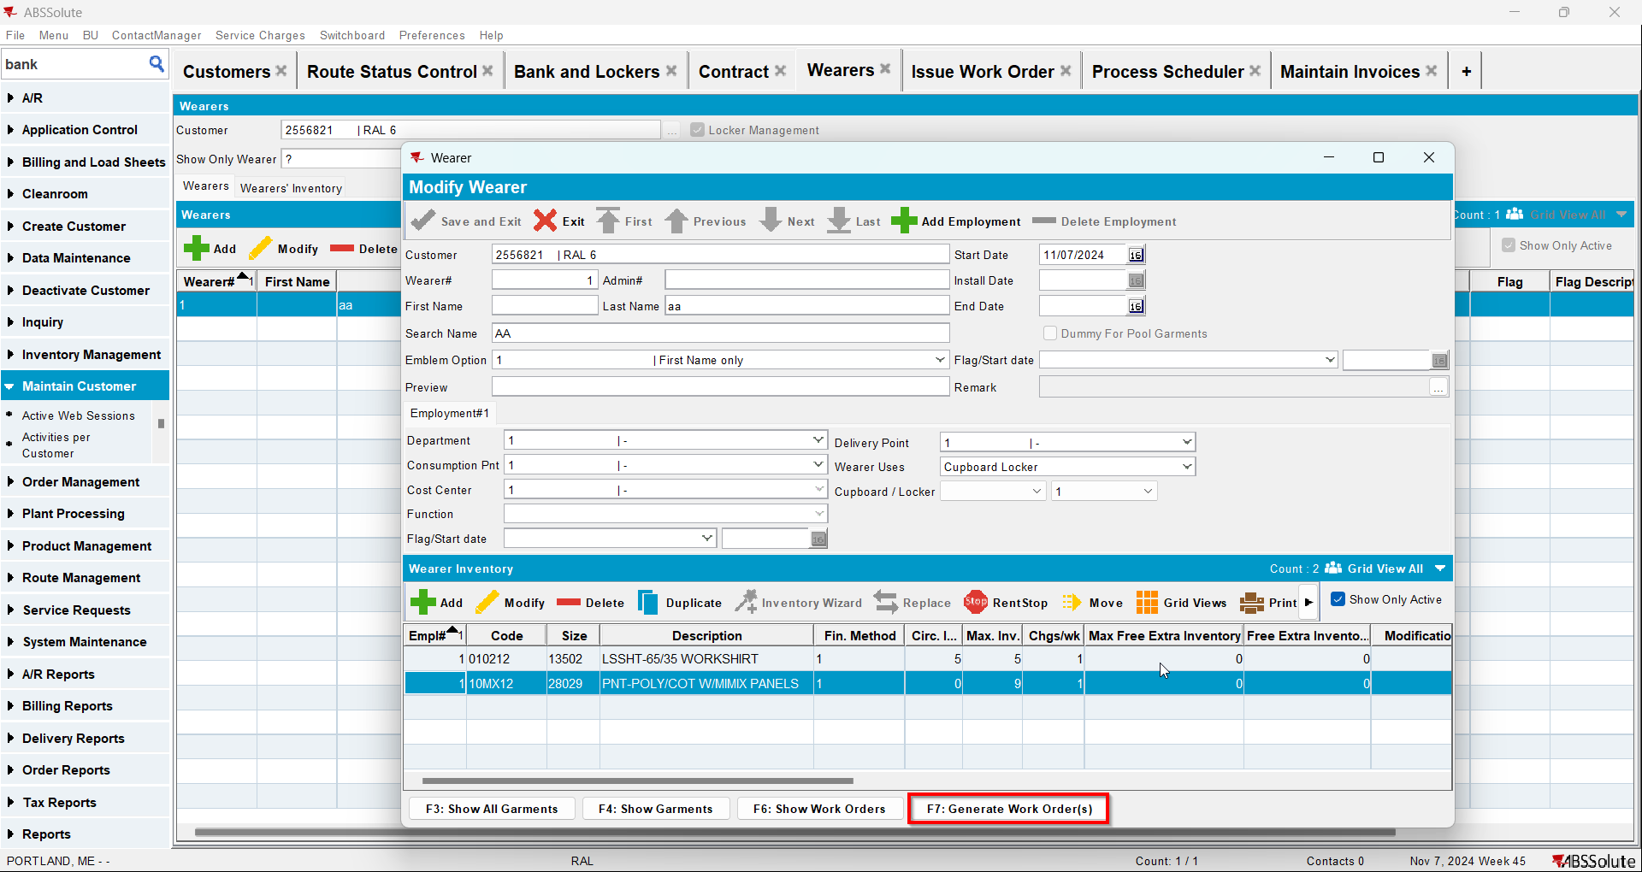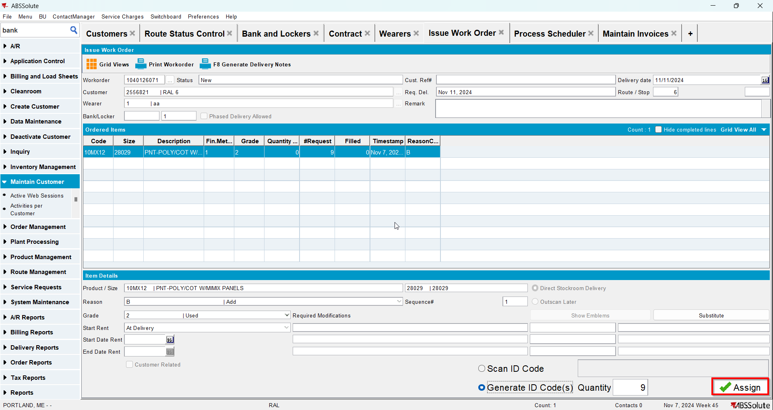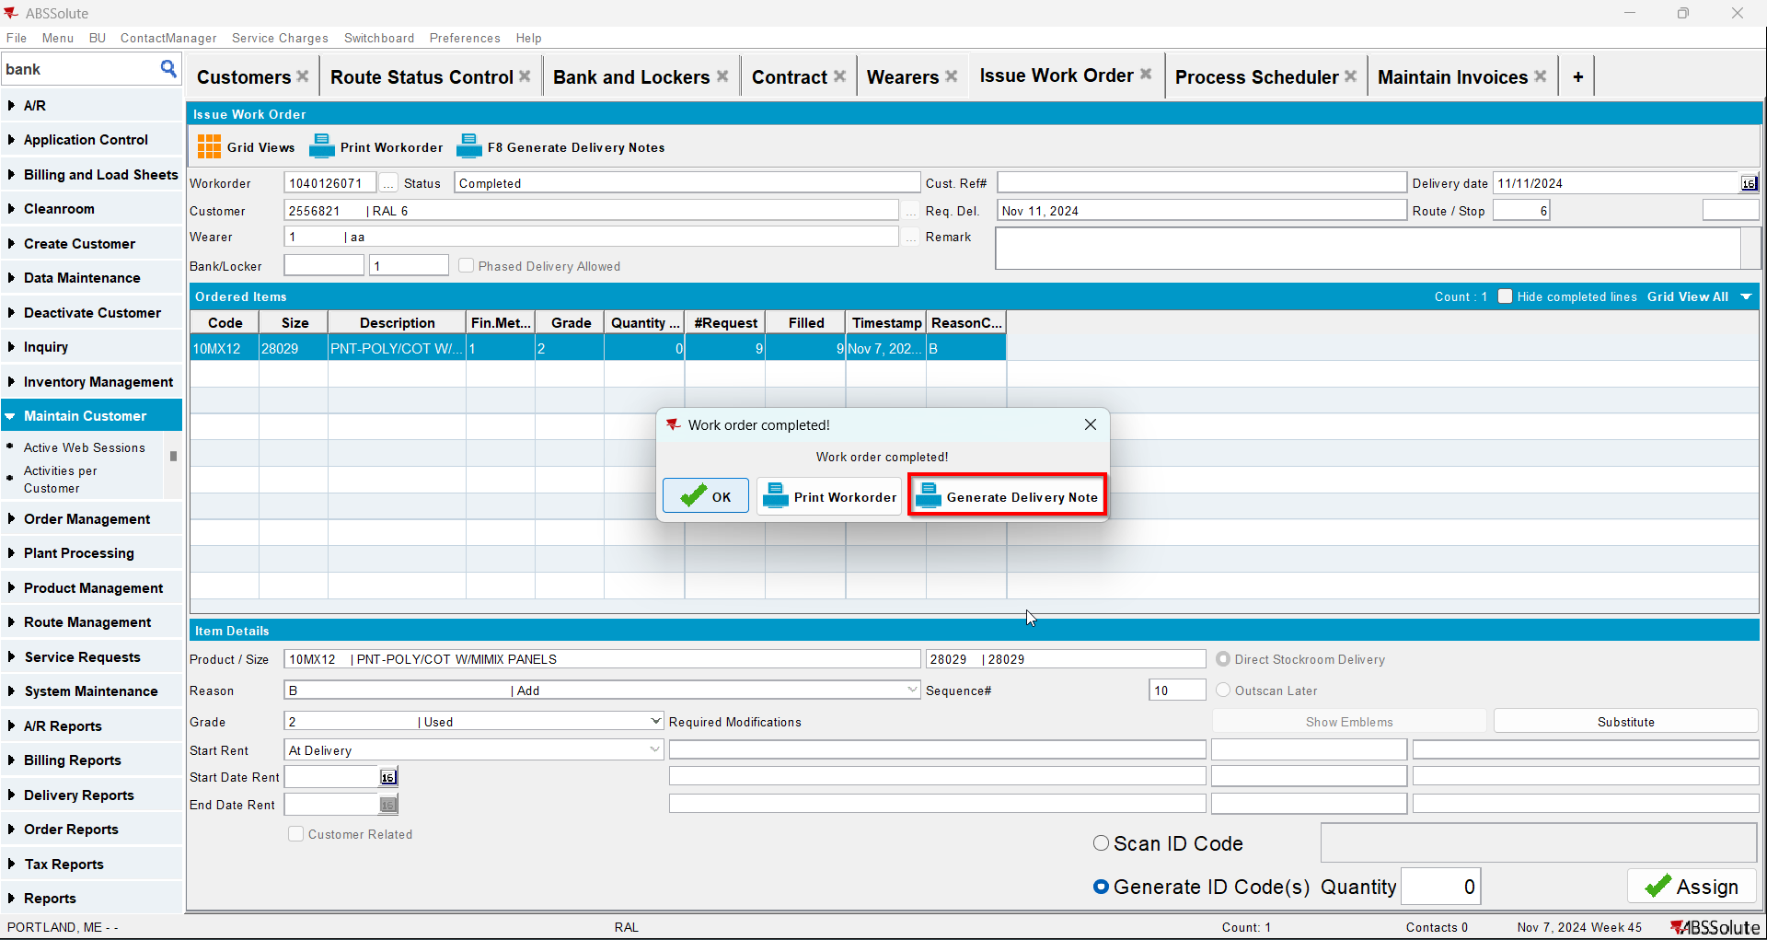
- Go to Route Status Control dlg and generate invoices for your route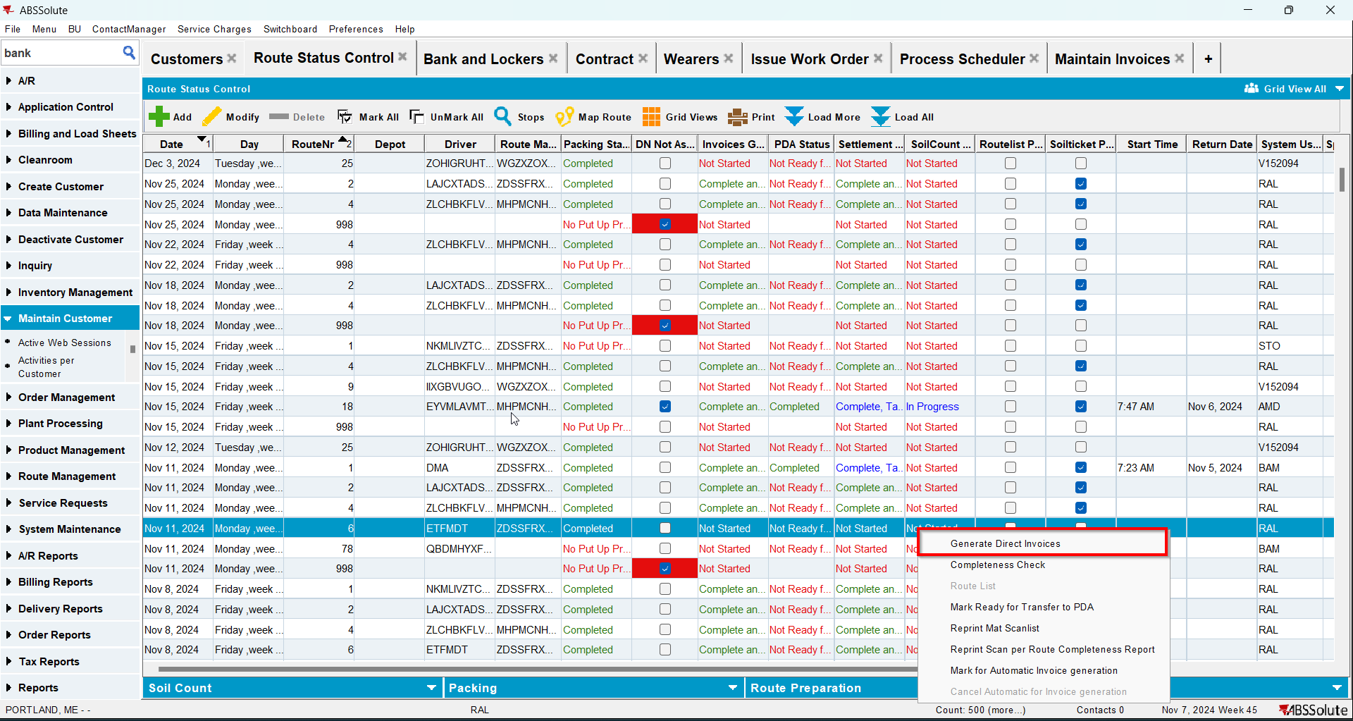
- Settle the route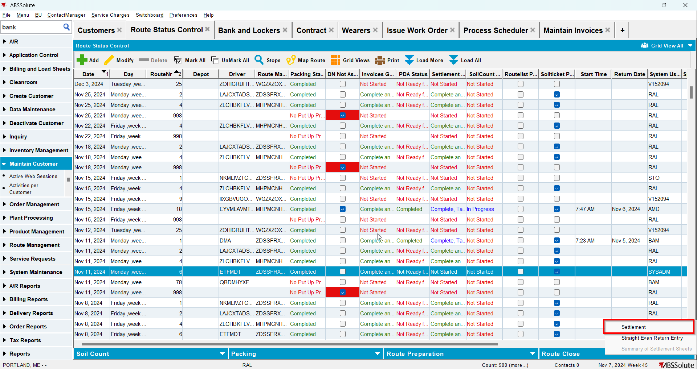
- Check that the Install Date and First Service Date have the date of the invoice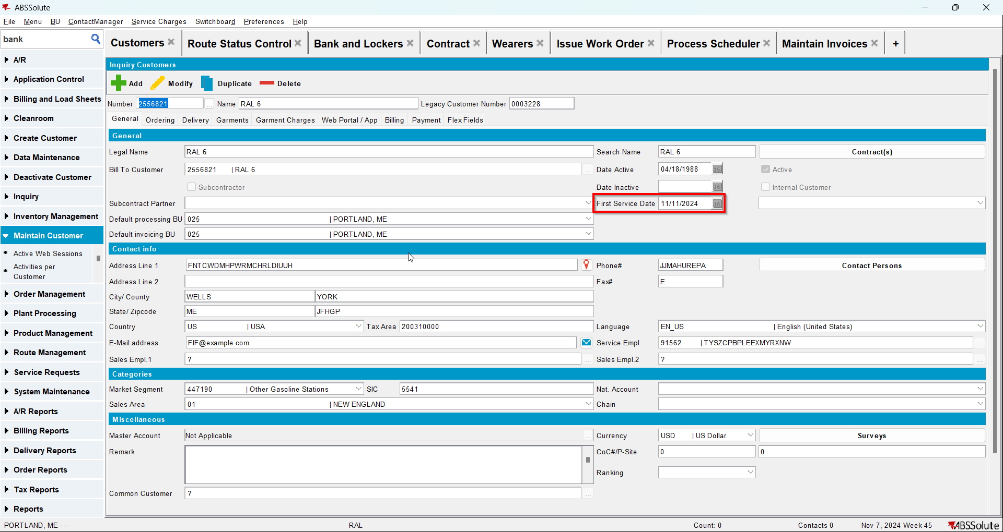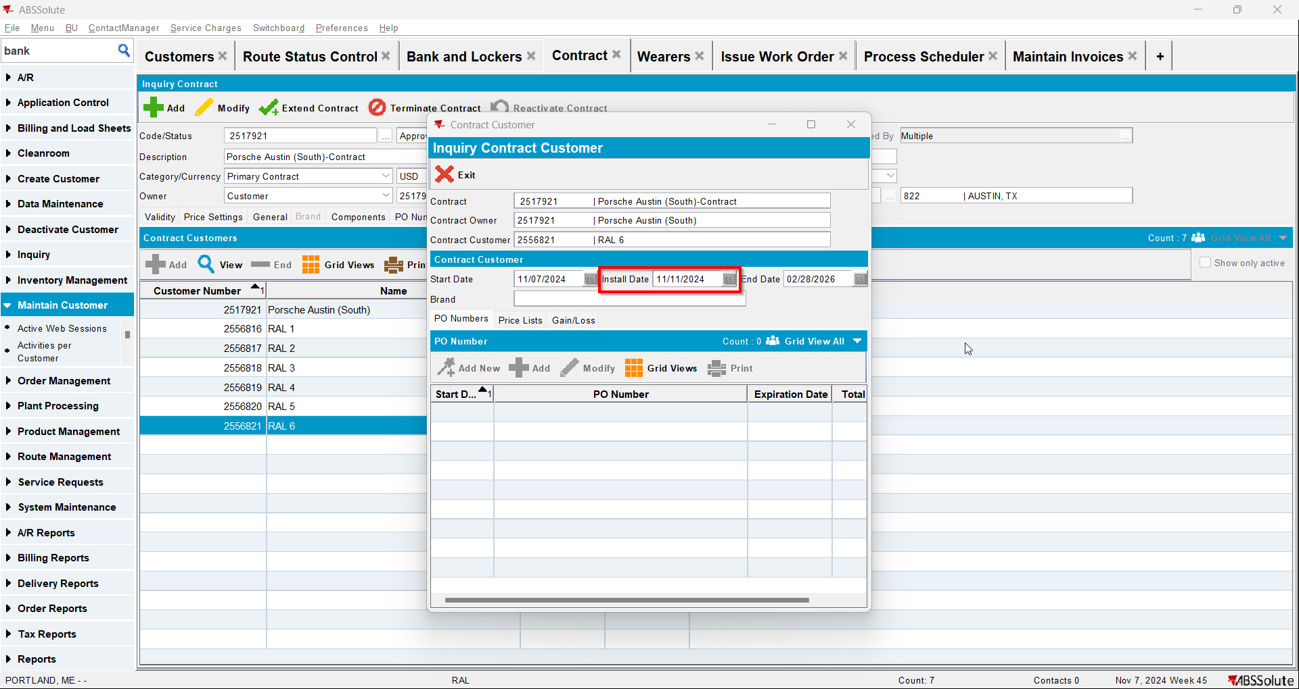
- Go to Maintain Invoices dlg and manually credit all sales/rent/wash lines and 1 fixed special charge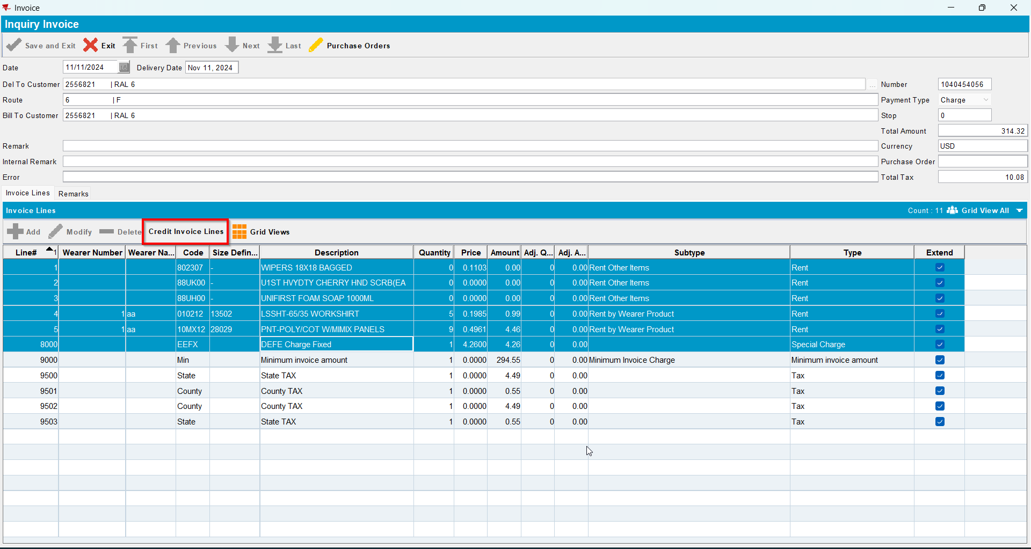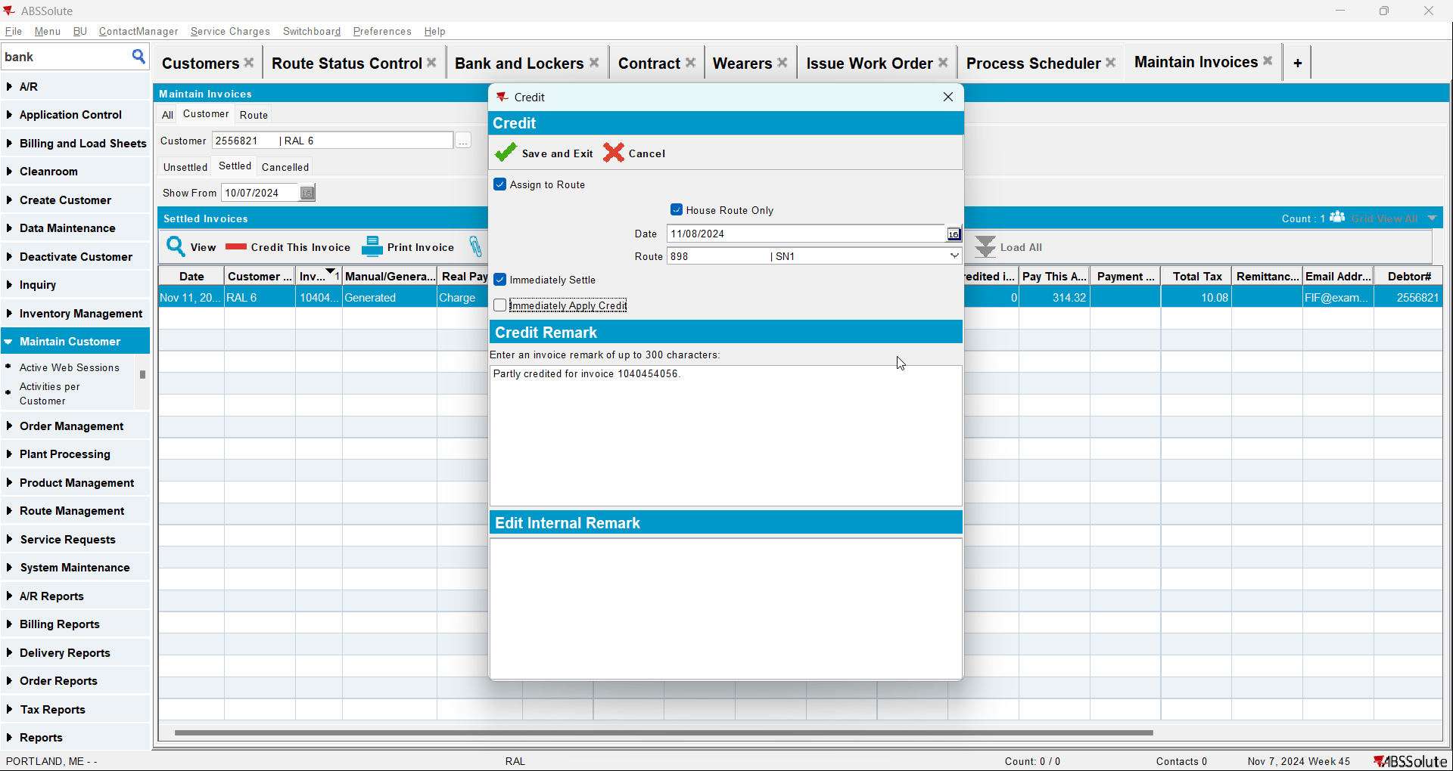
- Check that the Install Date and First Service Date are null