ABS-162902 System setting for garment and non garment loss fixed / default should apply to contract level
Environment | Prerequisites
Version:9.07.00  DBServerName=abs-srv20.internal.abslbs.com  DBSID=CUST24  DBUser=UNFDEV  DBPassword=UNFDEV  Environment=Test | - Module:  - System setting

Contents
Test after fix 1
Test Case 1 – Add new Contract with CHARGELOSSCHARGENONGRM =1 fixed and CHARGELOSSCHARGE = 1 fixed– Tested OK 1
Test Case 2 – Add new Contract with CHARGELOSSCHARGENONGRM =1 default and CHARGELOSSCHARGE = 1 default– Tested OK 4
Test Case 3 – Add new Contract with CHARGELOSSCHARGENONGRM =0 fixed and CHARGELOSSCHARGE = 0 fixed– Tested OK 6
Test Case 4 – Add new Contract with CHARGELOSSCHARGENONGRM =0 default and CHARGELOSSCHARGE = 0 default– Tested OK 8

Test after fix

Test Case 1 – Add new Contract with CHARGELOSSCHARGENONGRM =1 fixed and CHARGELOSSCHARGE = 1 fixed– Tested OK
Expected behavior: In Contract DLG Charge Loss for garments and Charge Loss for non-garments are checked and the fields are disabled.
Hash: 74876ebbc89
- Set the SS CHARGELOSSCHARGENONGRM=1 fixed and CHARGELOSSCHARGE=1 fixed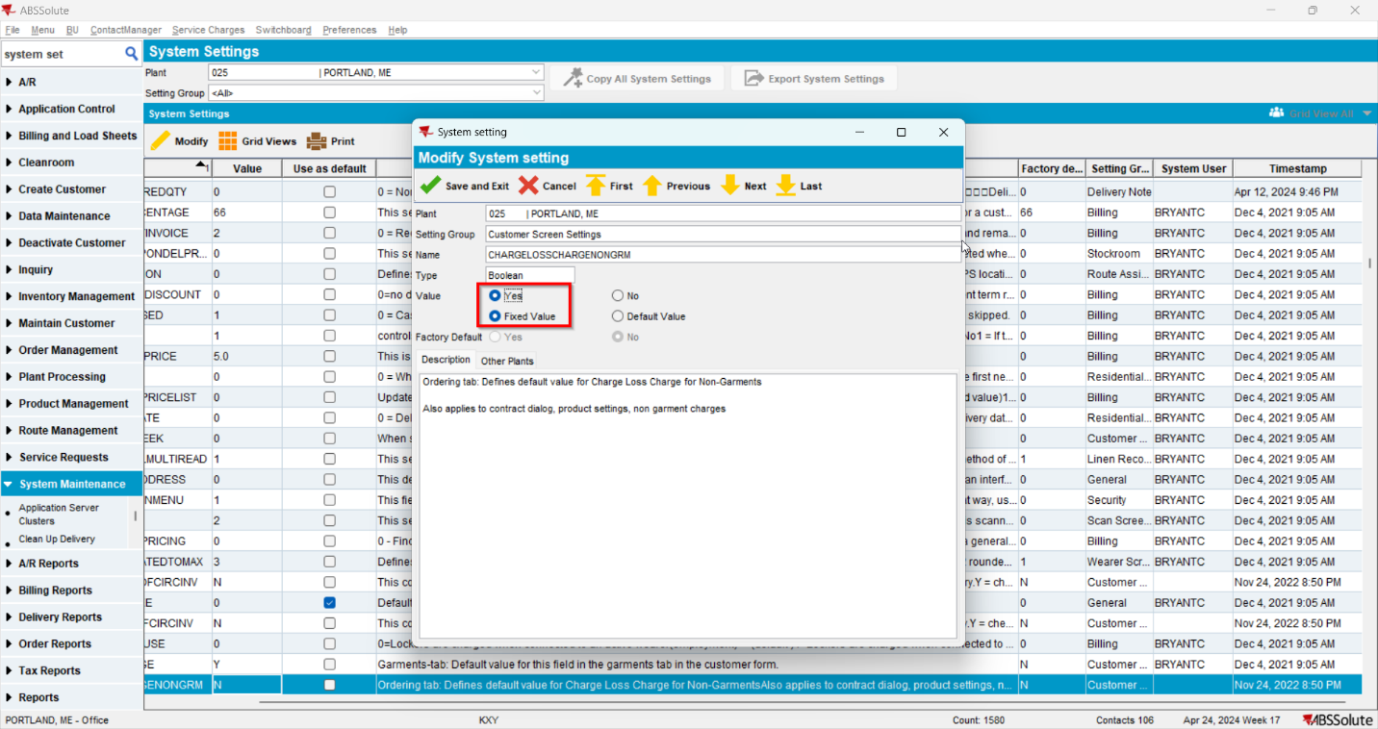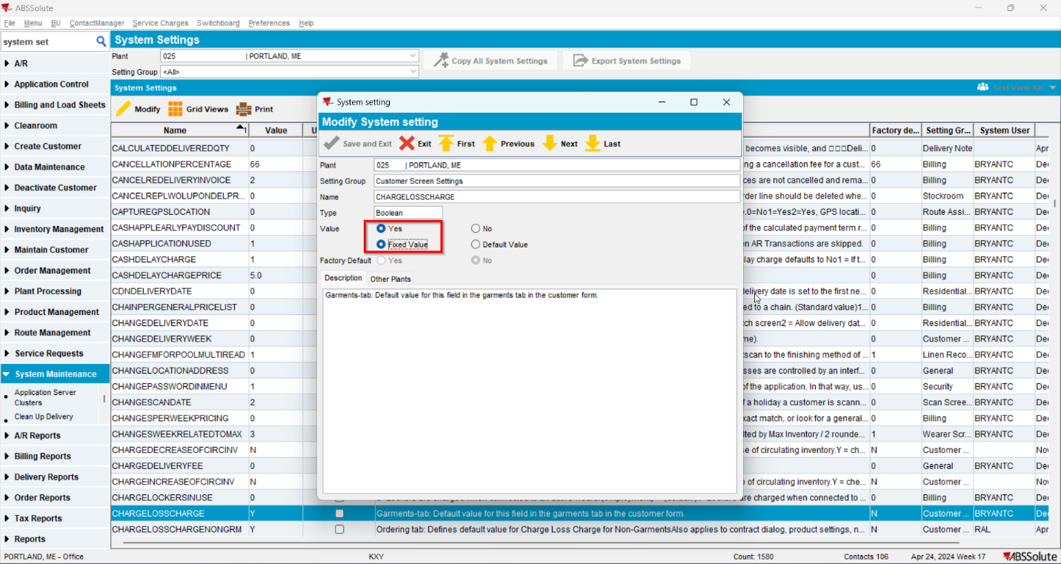

- Add a new contract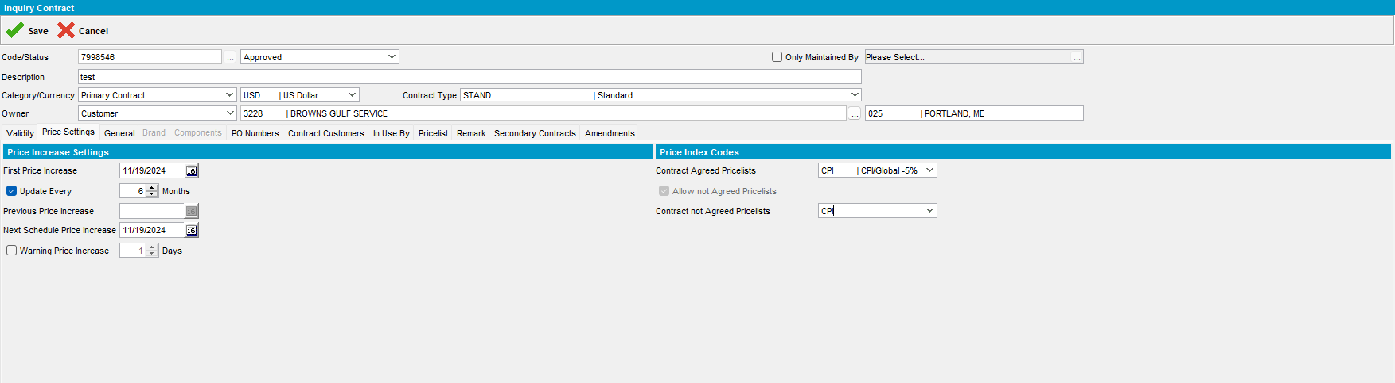

- In the contract go to Product Setting to Charges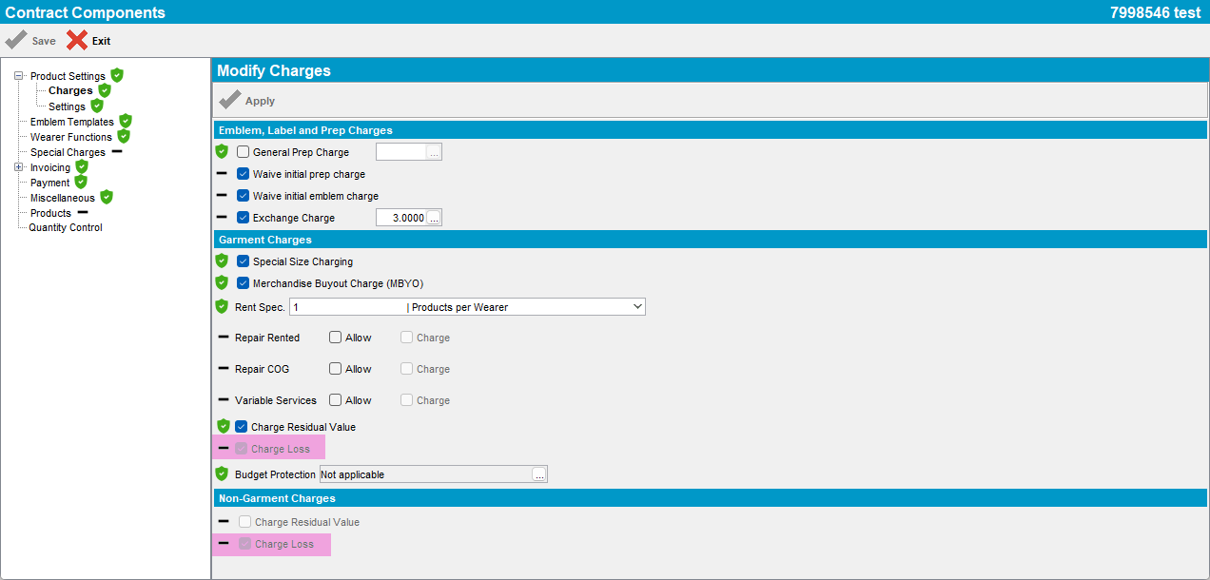

Test Case 2 – Add new Contract with CHARGELOSSCHARGENONGRM =1 default and CHARGELOSSCHARGE = 1 default– Tested OK
Expected behavior: In Contract DLG Charge Loss for garments and Charge Loss for non-garments are checked and the fields are enabled.
Hash: 74876ebbc89
- Set the SS CHARGELOSSCHARGENONGRM=1 default and CHARGELOSSCHARGE=1 default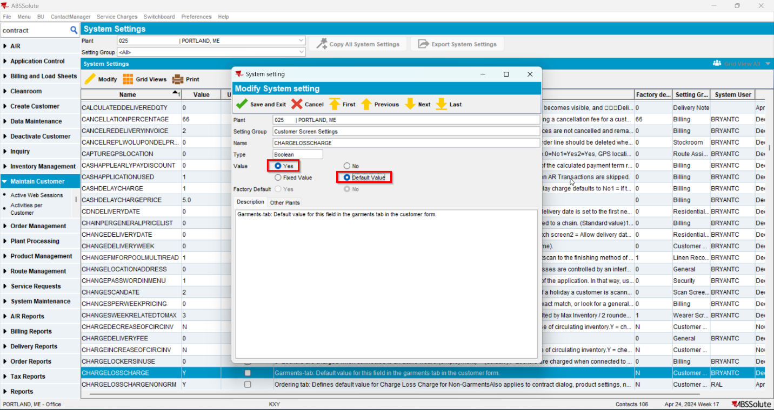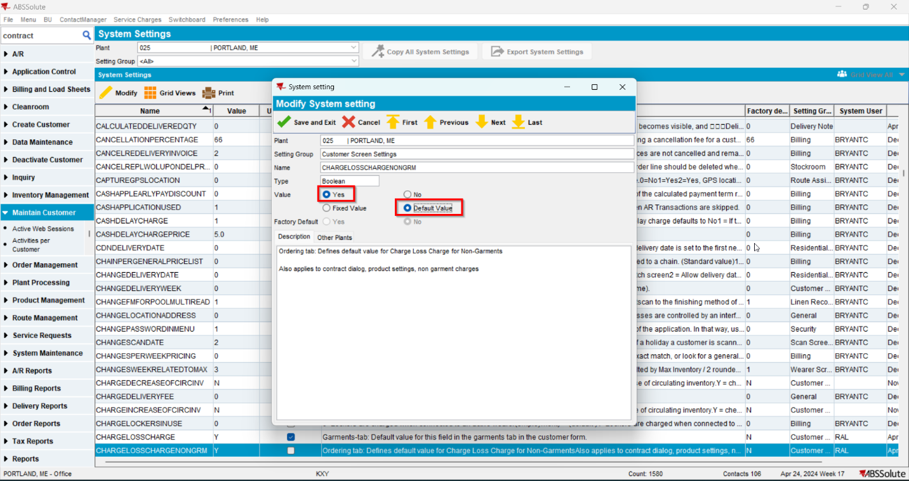
- Add a new contract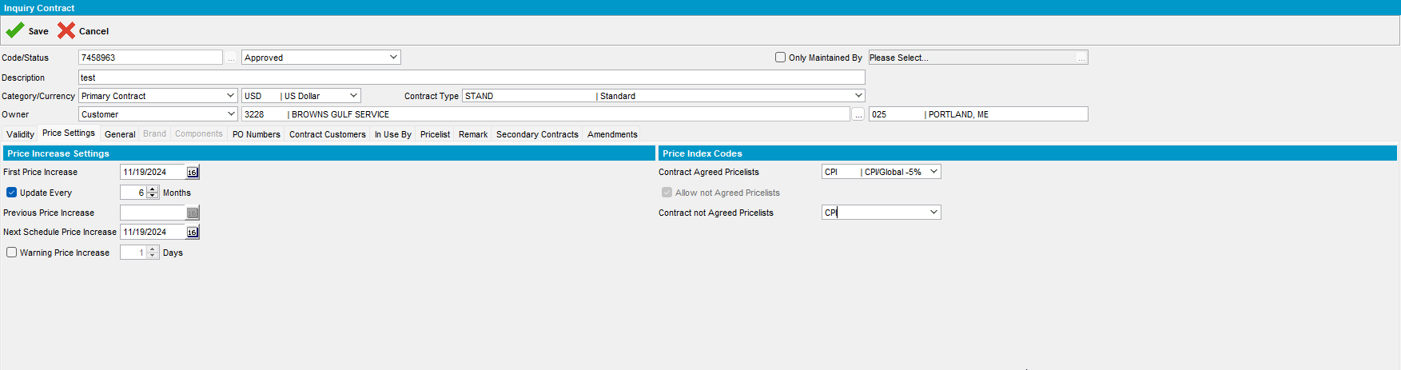

- In the contract go to Product Setting to Charges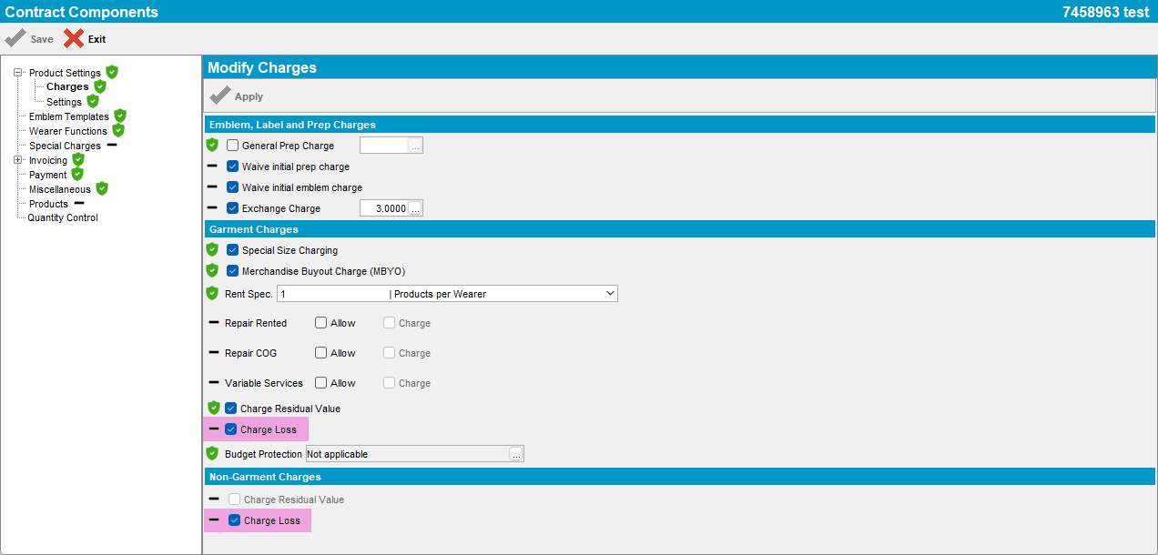

Test Case 3 – Add new Contract with CHARGELOSSCHARGENONGRM =0 fixed and CHARGELOSSCHARGE = 0 fixed– Tested OK
Expected behavior: In Contract DLG Charge Loss for garments and Charge Loss for non-garments are unchecked and the fields are disabled.
Hash: 74876ebbc89
- Set the SS CHARGELOSSCHARGENONGRM=0 fixed and CHARGELOSSCHARGE=0 fixed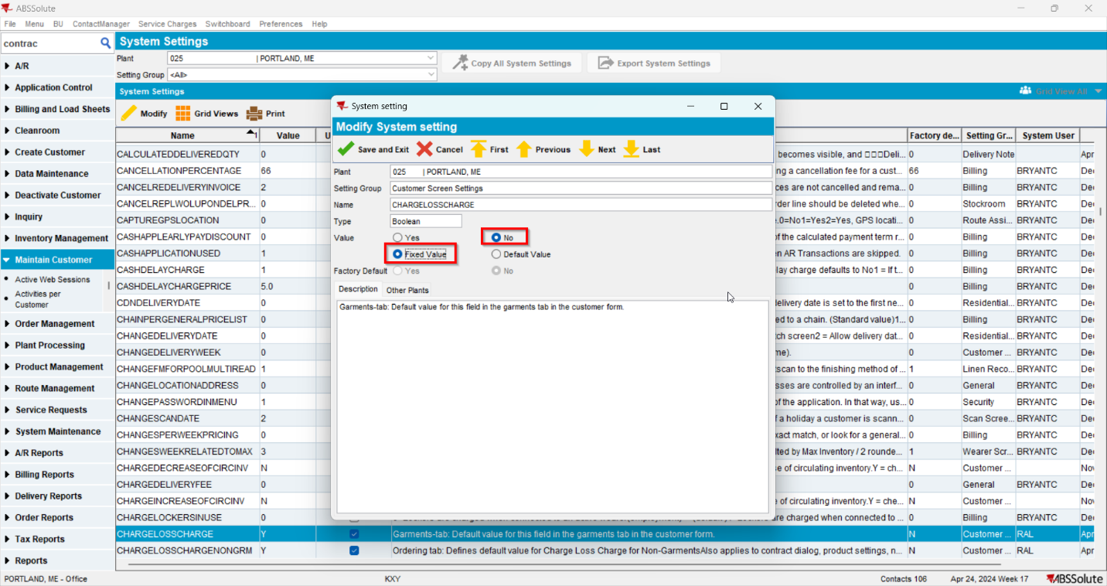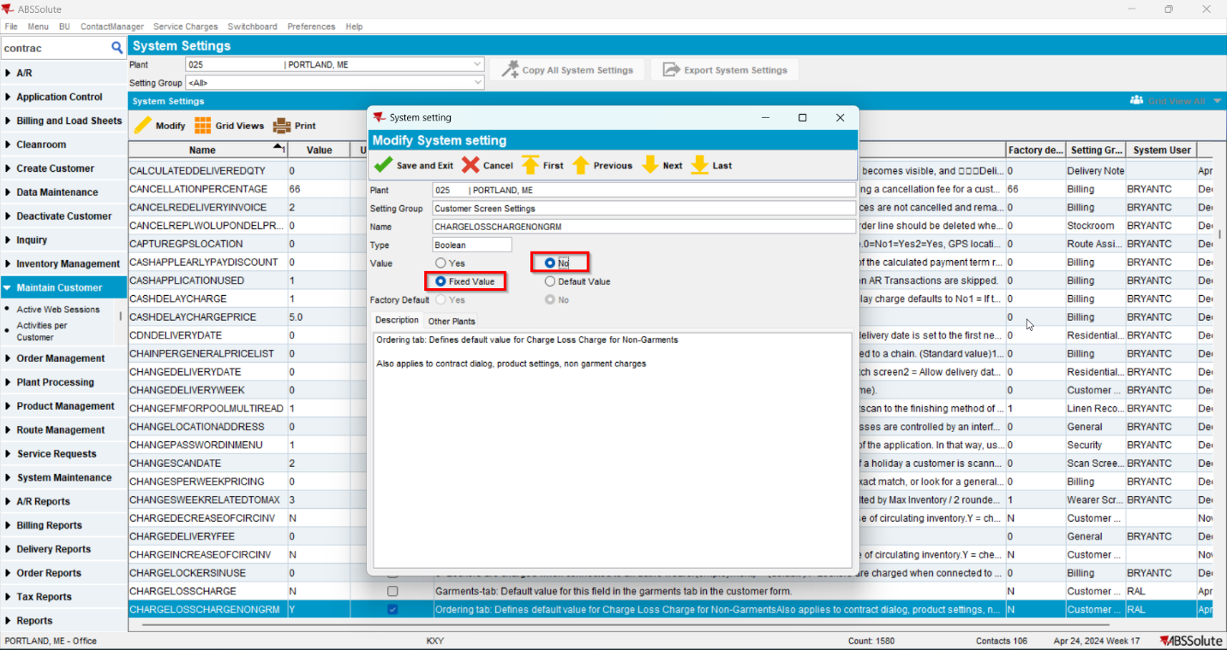
- Add a new contract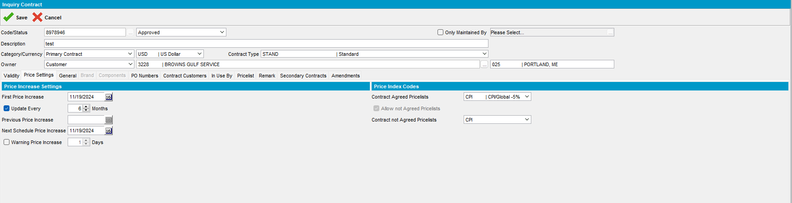

- In the contract go to Product Setting to Charges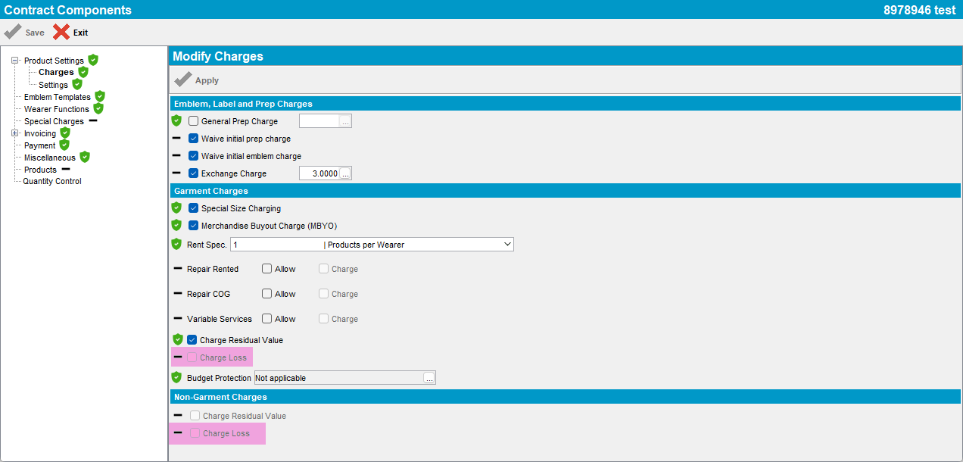

Test Case 4 – Add new Contract with CHARGELOSSCHARGENONGRM =0 default and CHARGELOSSCHARGE = 0 default– Tested OK
Expected behavior: In Contract DLG Charge Loss for garments and Charge Loss for non-garments are unchecked and the fields are enabled.
Hash: 74876ebbc89
- Set the SS CHARGELOSSCHARGENONGRM=0 default and CHARGELOSSCHARGE=0 default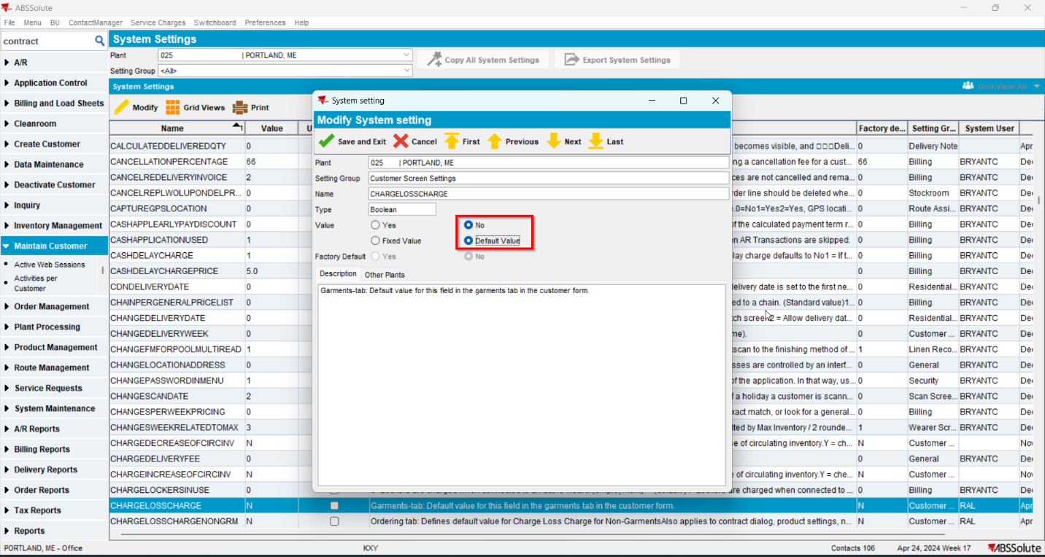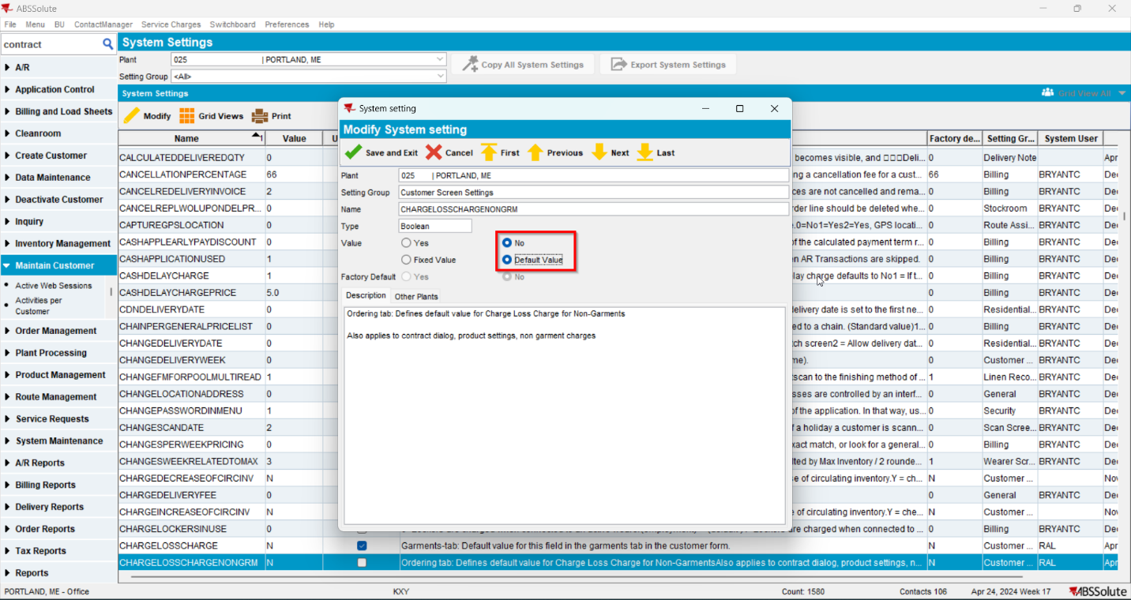
- Add a new contract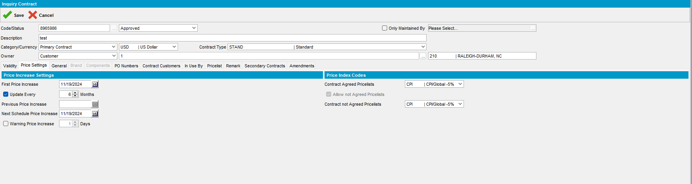

- In the contract go to Product Setting to Charges