ASD-60599 UNF D_UBS_2354 SR Charge showing non compliant while matching on contract and PLPC
Environment | Prerequisites
Version: 9.07.00  DBServerName= abs-srv20.internal.abslbs.com  DBSID=CUST24  DBUser=UNFDEV  DBPassword=UNFDEV  Environment=Production | - Module:  - System setting

Contents
Test before fix 1
Steps to reproduce: 1
Test after fix 2
Problem 1: Tested Ok 2
Steps to reproduce: 2
Problem 2: Tested OK 3
Steps to reproduce: 4
Problem 3: Tested OK 5
Steps to reproduce: 5

Test before fix
Hash: 9.08.02.RC1 hash: 428fece7d5b4

Steps to reproduce:
- Find a contract with a product that has an entry in plpcchargepercentage but not in contractproductpricing and in the contract compliancy screen it is shown as not compliant.
select c.code, cu.customernumber
from plpcchargepercentage z
join productlistpercustomer plpc on plpc.productlistpercustomer_id = z.productlistpercustomer_id
join CONTRACTPRODUCTPLPC cplpc on cplpc.productlistpercustomer_id = z.productlistpercustomer_id
join contractproduct cp on cp.contractproduct_id = cplpc.contractproduct_id
join contract c on cp.contract_id = c.contract_id
join customer cu on cu.customer_id = plpc.customer_id
where z.srchargepercentage > 0
and c.enddate > sysdate
and not exists (select 1 from contractproductpricing cpp
where cpp.contractproduct_id = cp.contractproduct_id);
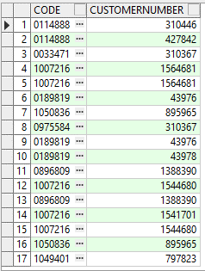
- Contracts dlg: Load contract 0114888 and check the Pricing compliancy for product 3104466
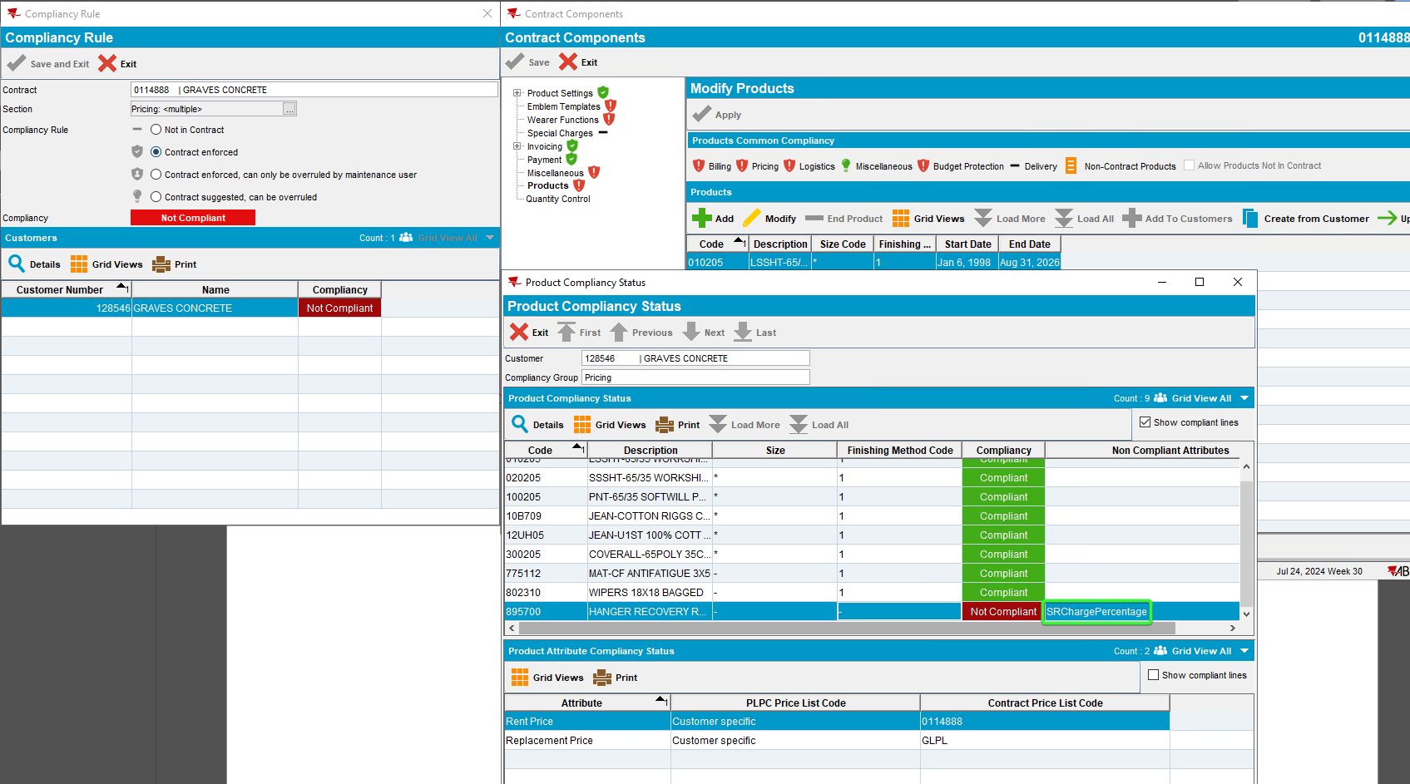
A product has an entry in plpcchargepercentage but not in contractproductpricing and in the contract compliancy screen it is shown as not compliant for SR Charge.

REPRODUCED OK.

Test after fix
Hash: 2206da5

Problem 1: Tested Ok
A product has an entry in plpcchargepercentage but not in contractproductpricing and in the contract compliancy screen it is shown as not compliant.
Expected behavior: It should be shown as compliant

Steps to reproduce:

- Find data in the database:
select c.code, cu.customernumber, p.code
from plpcchargepercentage z
join productlistpercustomer plpc on plpc.productlistpercustomer_id = z.productlistpercustomer_id
join CONTRACTPRODUCTPLPC cplpc on cplpc.productlistpercustomer_id = z.productlistpercustomer_id
join contractproduct cp on cp.contractproduct_id = cplpc.contractproduct_id
join contract c on cp.contract_id = c.contract_id
join customer cu on cu.customer_id = plpc.customer_id
join contractcustomer cc on cc.contract_id=c.contract_id and cu.customer_id = cc.customer_link_id
join product p on p.product_id = cp.product_id
where z.srchargepercentage =100
and c.enddate > sysdate
and not exists (select 1 from contractproductpricing cpp
where cpp.contractproduct_id = cp.contractproduct_id)
and z.losschargepercentage = 100
and cc.enddate >= sysdate;
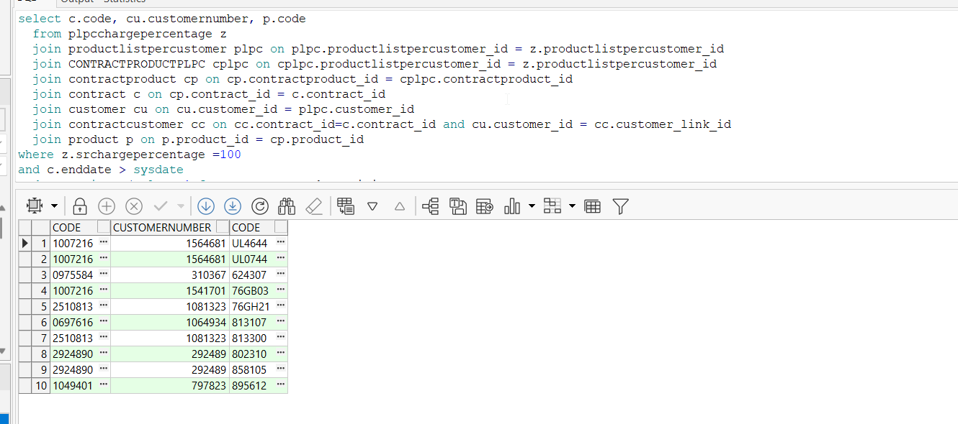

- Contract dlg: Load a contract from the list, eg: 1007216 and modify it.
- Contract dlg: Enter components, load compliancy and enter products. Click on the Pricing compliancy, customer 1564681 Details.
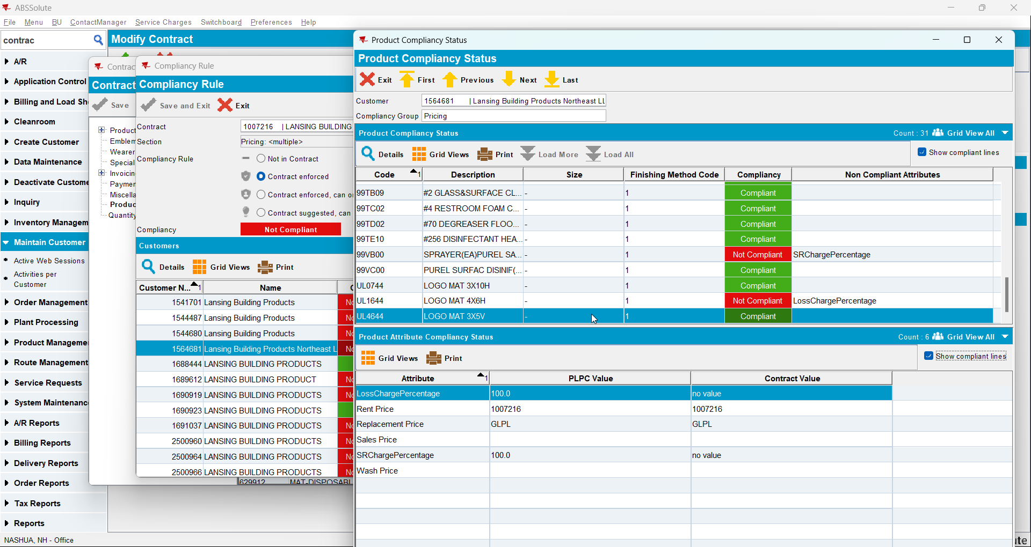

Tested OK

Problem 2: Tested OK
contractproductpricing.losschargepercentage = 100 and plpcchargepercentage.losschargepercentage = 0. This correctly shows up as non-compliant in the top part of the screen but this element does not show up in the Product Attribute Compliancy status.

Expected behavior:
The losschargepercentage should show up in the Product Attribute Compliancy status, bottom part of the screen.

Steps to reproduce:
- Find data in the database:

select c.code
from contractproductpricing x
join contractproduct cp on cp.contractproduct_id = x.contractproduct_id
join contract c on cp.contract_id = c.contract_id
join CONTRACTPRODUCTPLPC cplpc on cplpc.contractproduct_id = cp.contractproduct_id
join productlistpercustomer plpc on plpc.productlistpercustomer_id = cplpc.productlistpercustomer_id
join plpcchargepercentage z on z.productlistpercustomer_id = plpc.productlistpercustomer_id
where x.losschargepercentage = 100
and z.losschargepercentage = 0;
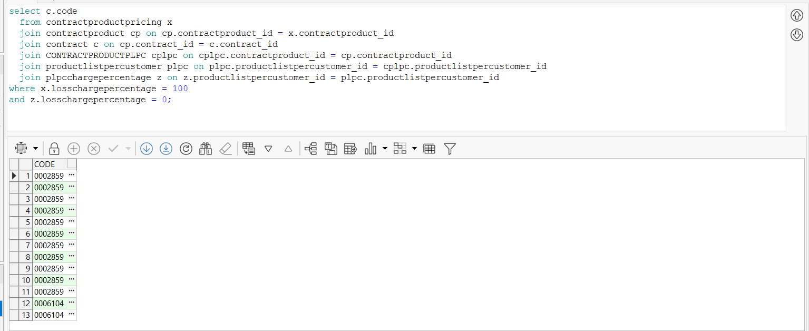

- Contract dlg: Load a contract from the list, eg: 0002859 and modify it.
- Contract dlg: Enter components, load compliancy and enter products. Click on the Pricing compliancy, customer 379458 Details.
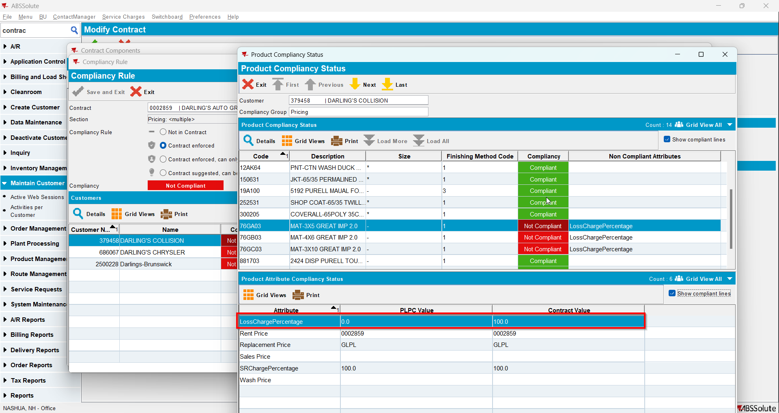
Tested OK

Problem 3: Tested OK
When there are NULL entries in contractproductpricing or plpcchargepercentage for either losschargepercentage or srchargepercentage we show blank for the value in the grid

Expected behavior:
instead of blank we show “no value”

Steps to reproduce:
- Contract dlg: Load a contract from the list, eg: 0114888 and modify it.
- Contract dlg: Enter components, load compliancy and enter products. Click on the Pricing compliancy, customer 128546 Details.
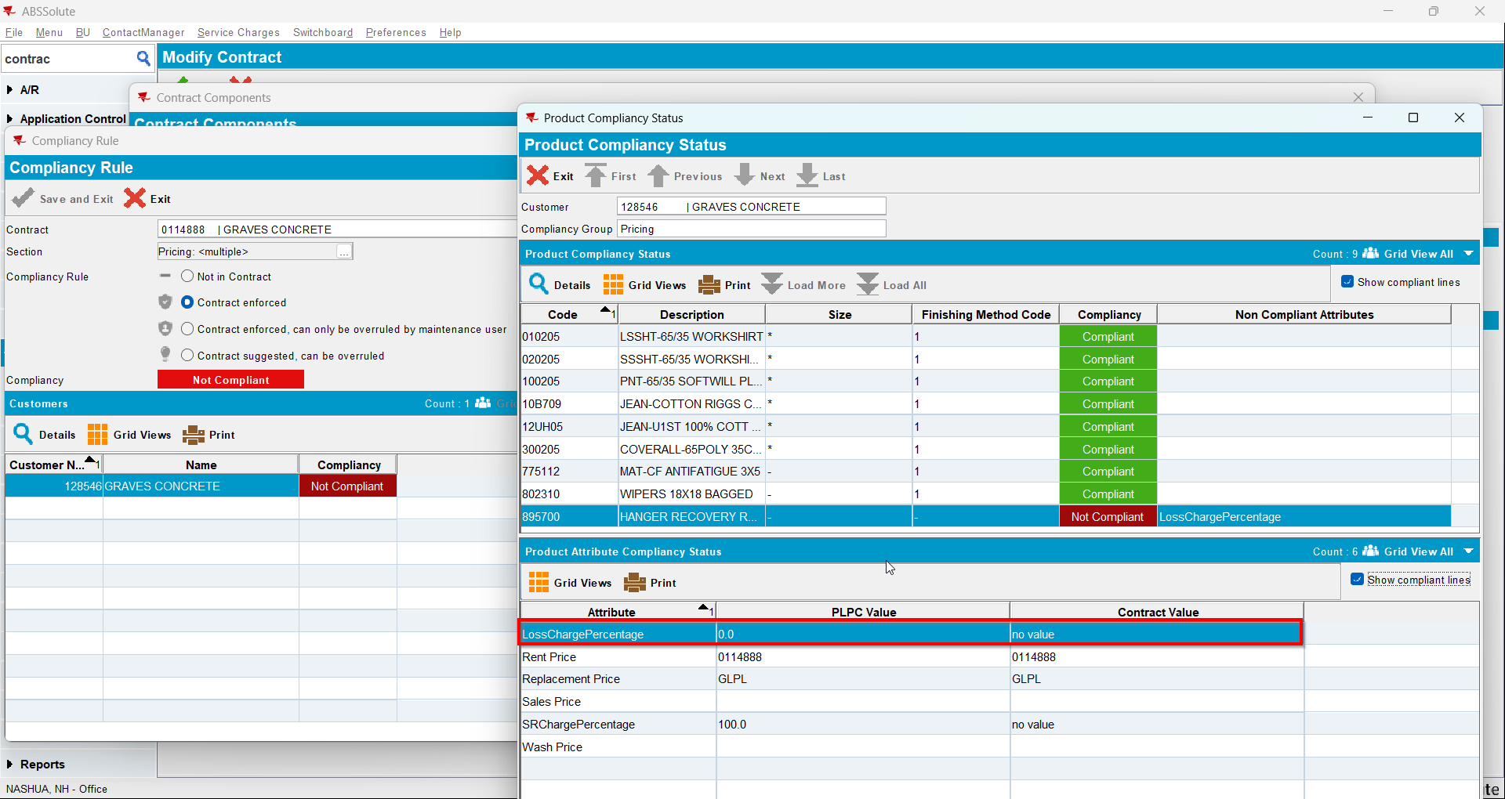
Tested OK

