ABS-153900 D_UBS_2216 Emblem Template column in compliancy improvement

Environment | Prerequisites
Version: 9.07.00.UNF18  DBServerName=abs-srv20.internal.abslbs.com  DBSID=CUST24  DBUser=UNFDEV  DBPassword=UNFDEV  Environment=Test | - Module:  - System setting

Contents
ABS-153900 D_UBS_2216 Emblem Template column in compliancy improvement 1
Test after fix 1
Test Case 1 – Modify Emblem Templates Lines – Tested OK 1
Test Case 2 – Add Emblem Template Line but don’t add it to customers – Tested OK 57
Test Case 3 – Modify Wearer functions – Tested NOT OK 59

Test after fix

Test Case 1 – Modify Emblem Templates Lines – Tested OK
Expected behavior: For non-compliant it won’t show database ids and will display EmblemTemplateLine.Type (label not number value) and EmblemTemplateLine.Product_ID.Product.Code (if there is one)
Hash: d276260ff389
- On the Contract dlg select a contract, go to Components tab and load compliancy
- Go to Emblem Templates
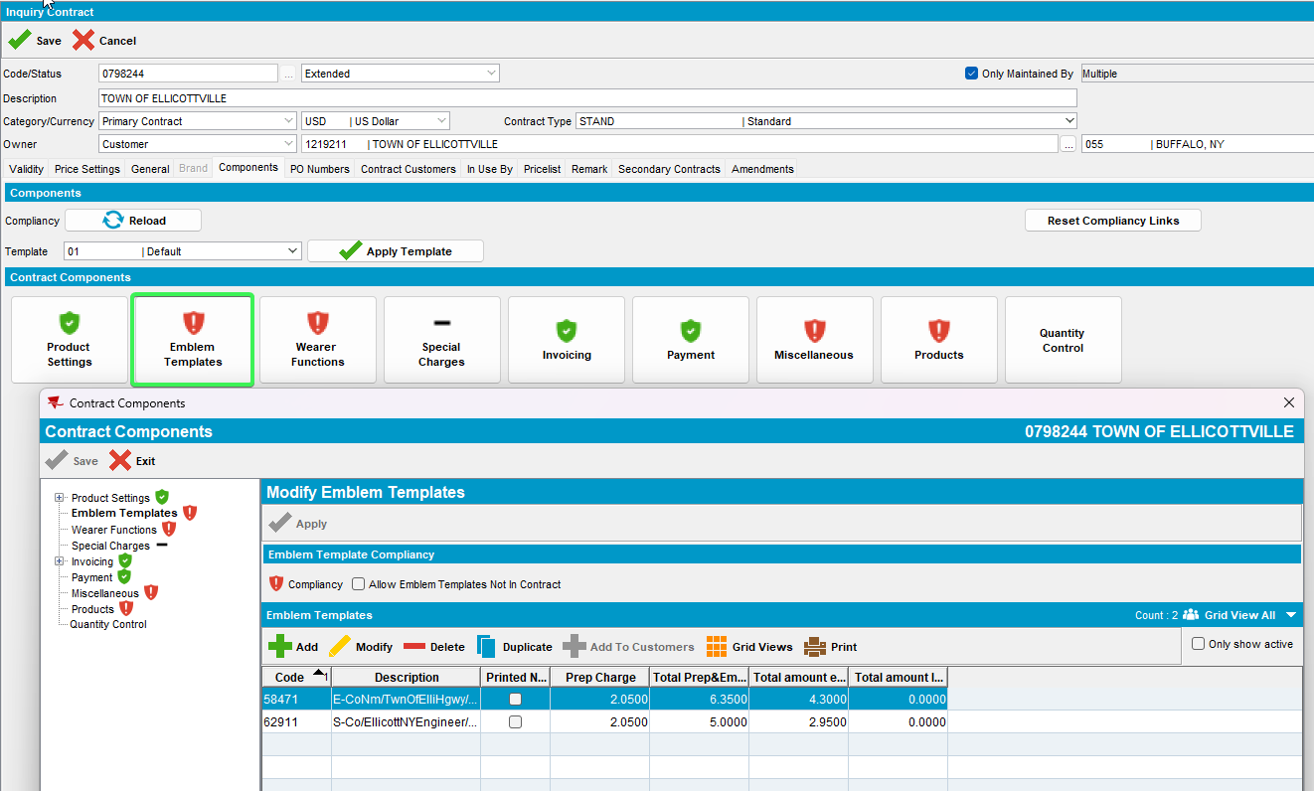
- Modify PRODUCT, reload the contract and load compliancy
Use the following select to find contractemptempline_id
select cet.code, cel.* from contractembtempline cel
join contractembtemp cet on cel.contractembtemp_id=cet.contractembtemp_id
join contract c on cet.contract_id=c.contract_id
where c.code = '0798244'
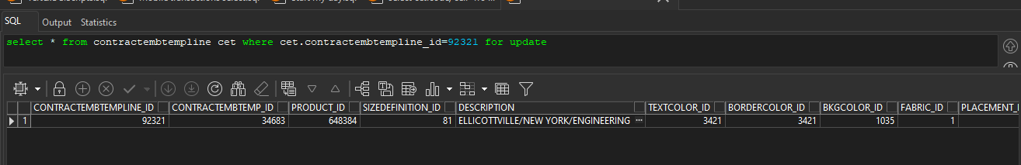
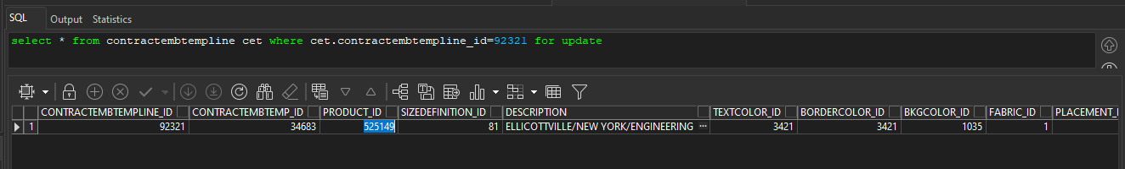
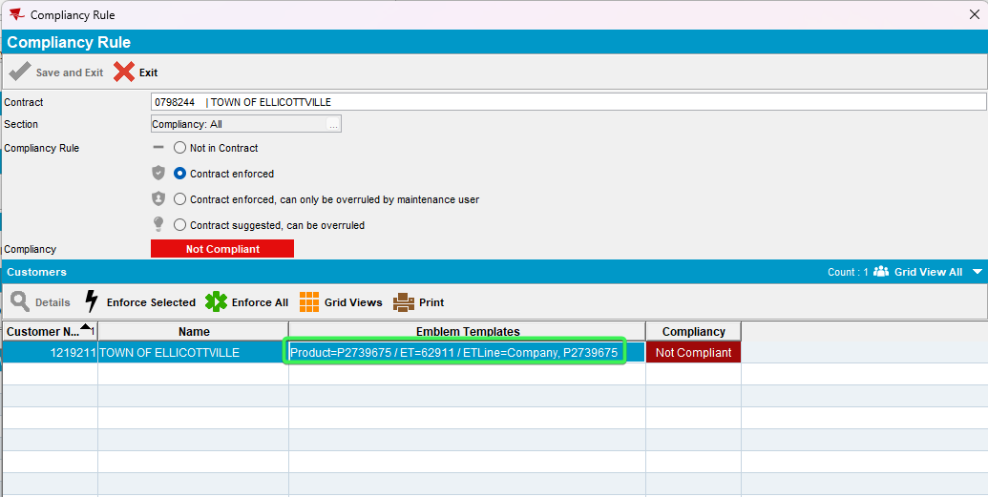
- Modify SIZEDEFINITION, reload the contract and load compliancy
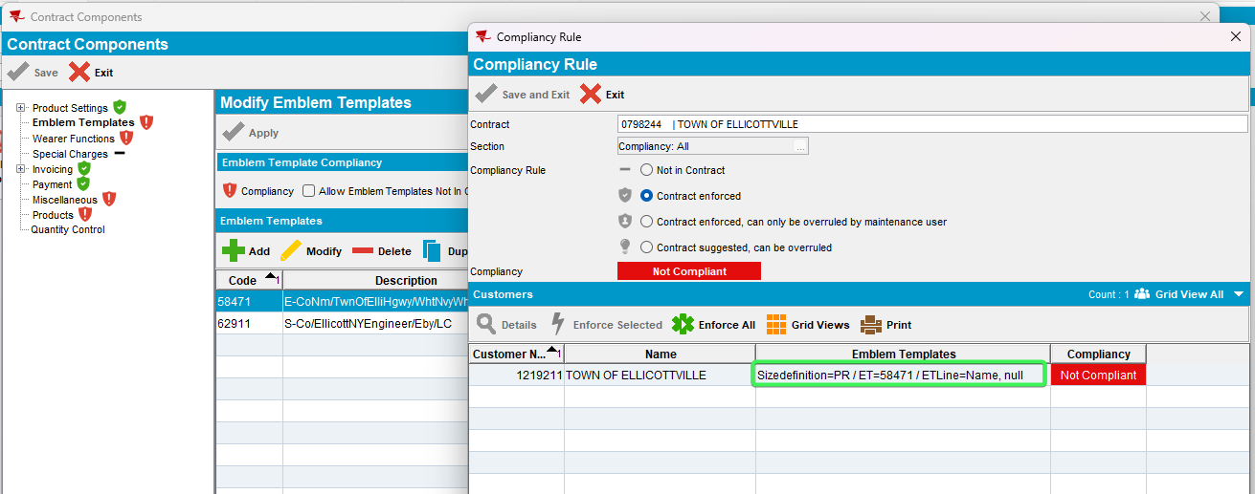
- Modify DESCRIPTION, reload the contract and load compliancy

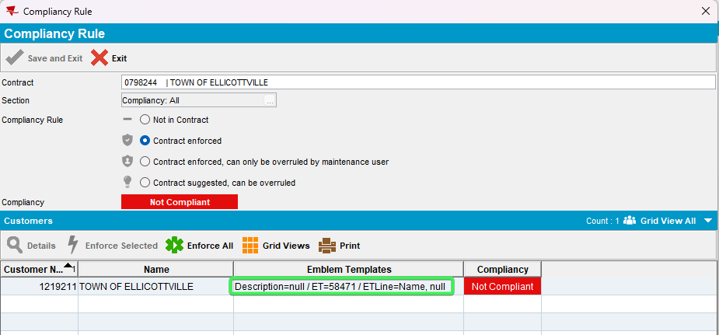
- Modify TEXTCOLOR, reload the contract and load compliancy
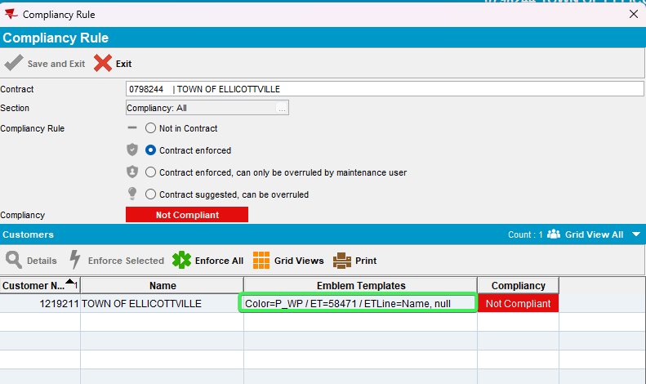
- Modify BORDERCOLOR, reload the contract and load compliancy
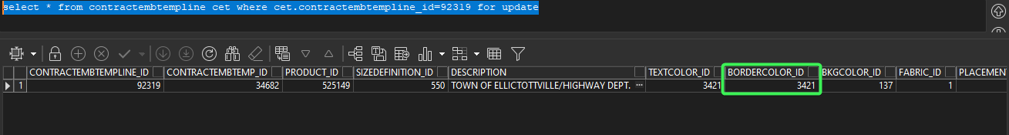
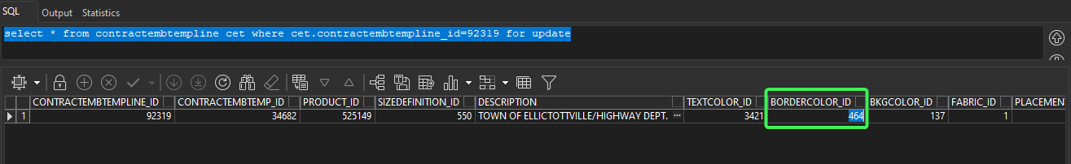
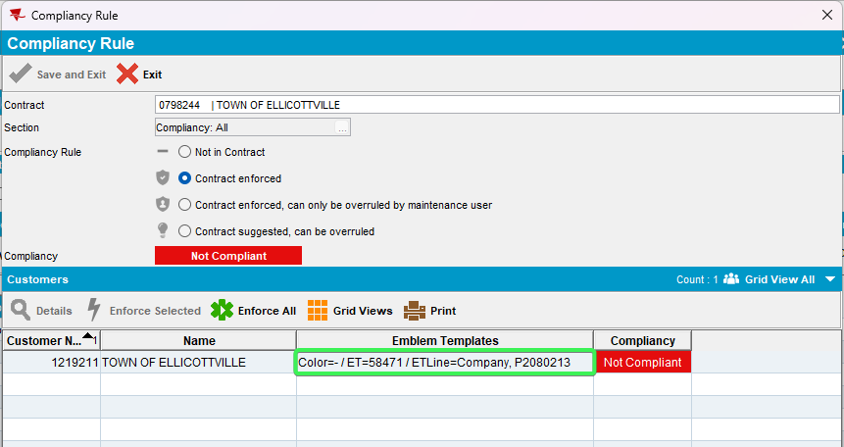
- Modify BKGCOLOR, reload the contract and load compliancy
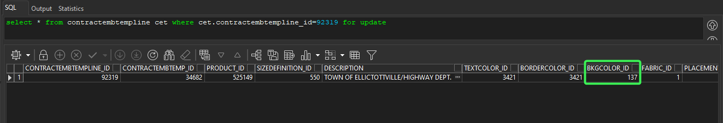
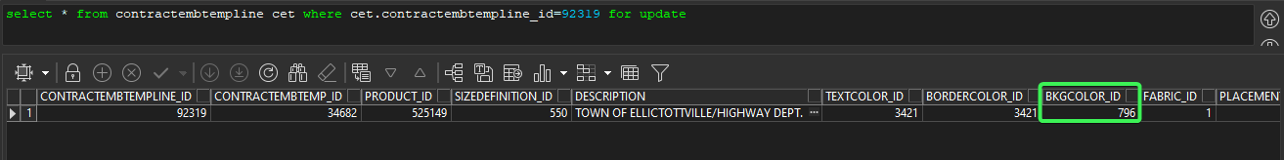
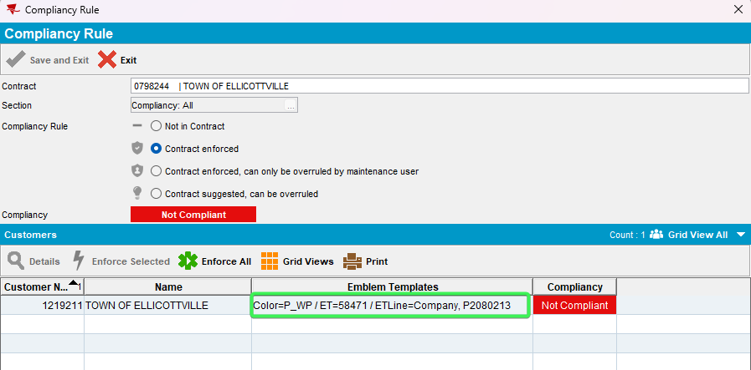

- Modify PLACEMENT, reload the contract and load compliancy
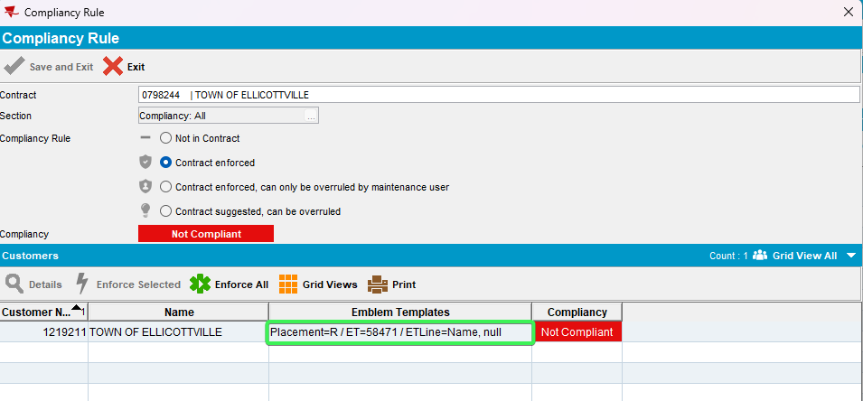
- Modify EMBLEMTYPE, reload the contract and load compliancy
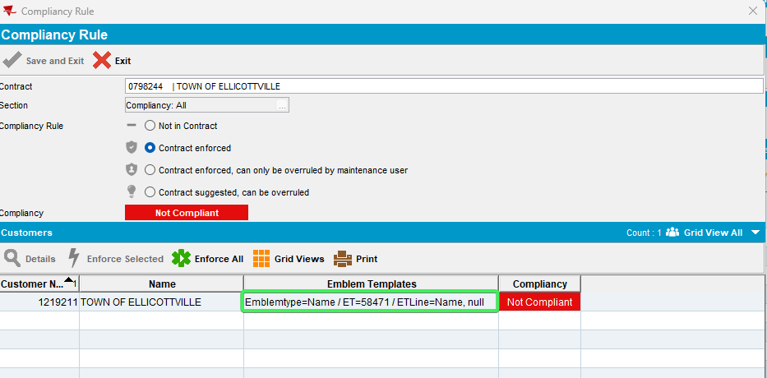
- Modify ATTACHMENTBY, reload the contract and load compliancy
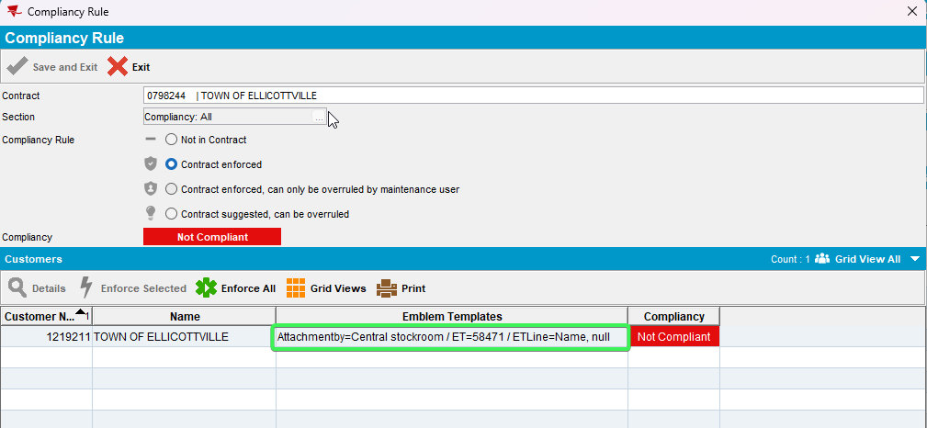
- Modify QTYPERGARMENT, reload the contract and load compliancy
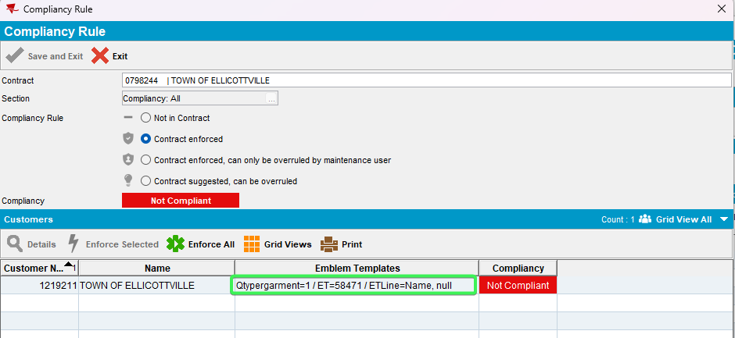
- Modify PLACEMENTIMAGE, reload the contract and load compliancy
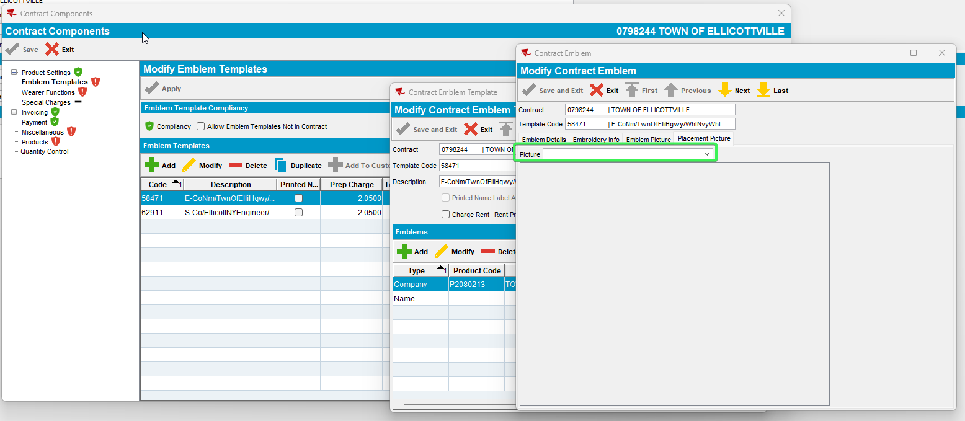
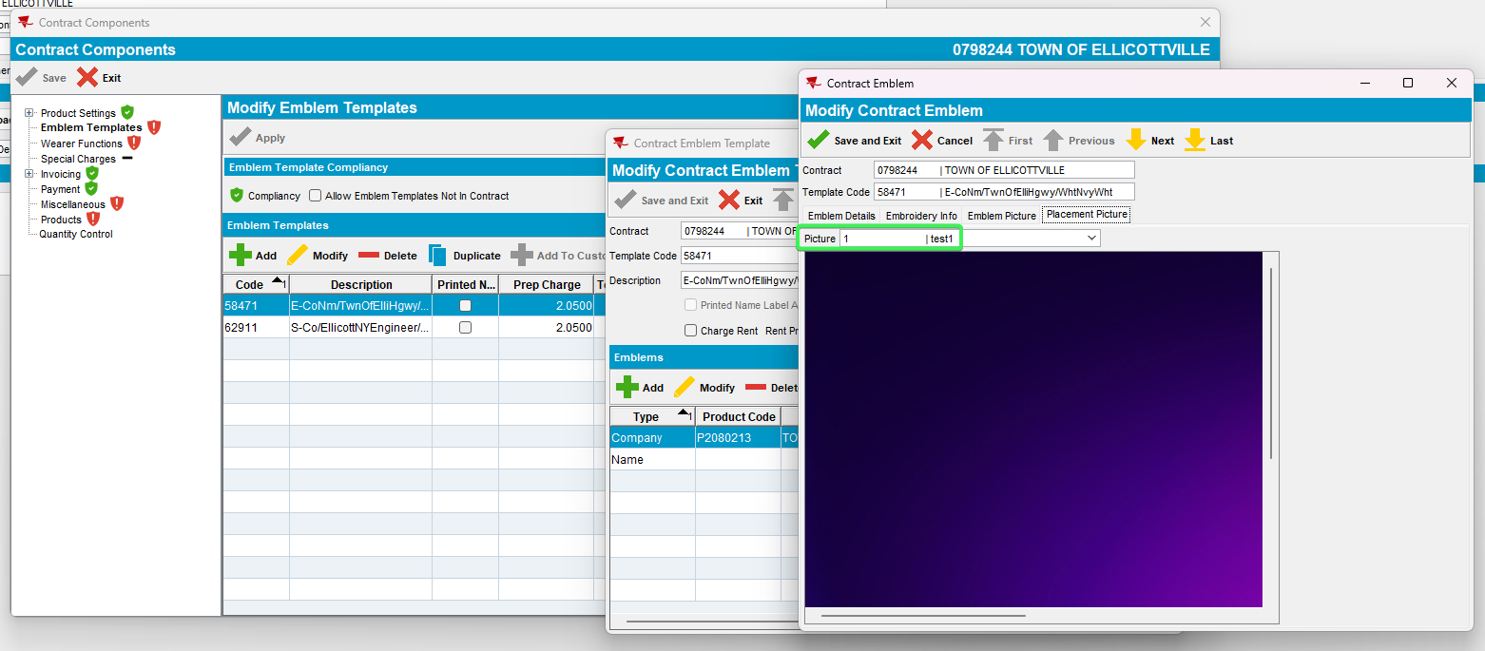
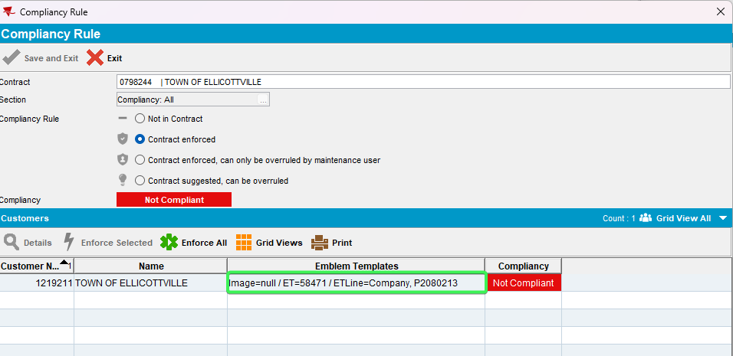
- Modify EMBLEMFONT, reload the contract and load compliancy
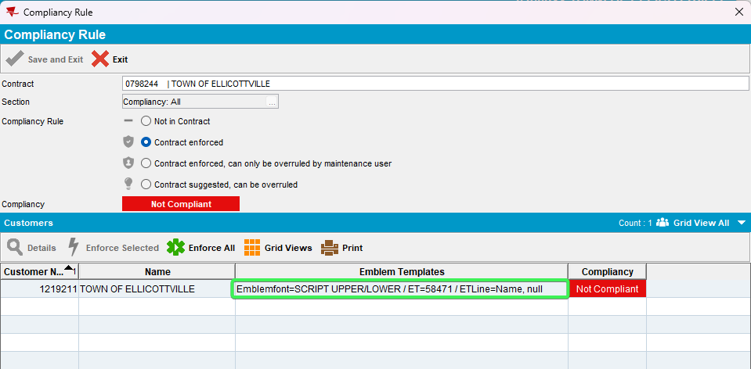
- Modify FONTSIZE, reload the contract and load compliancy
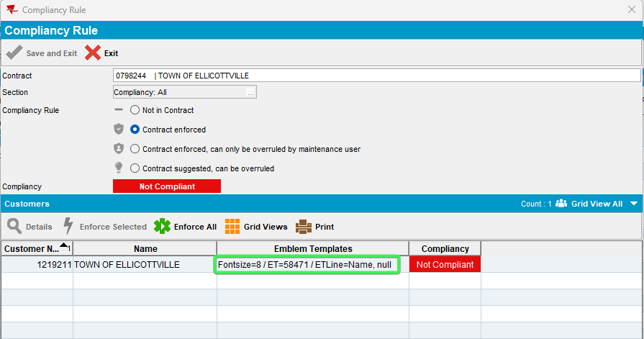
- Modify EMBROIDERYFILEPATHORIGINAL, reload the contract and load compliancy
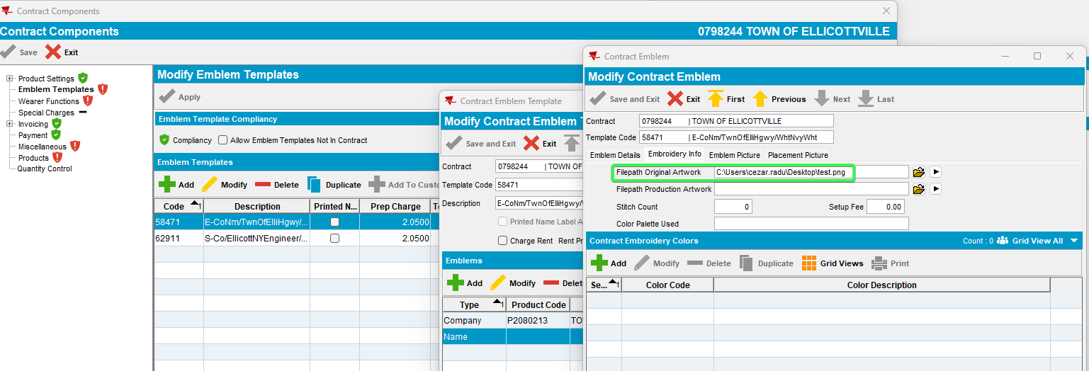
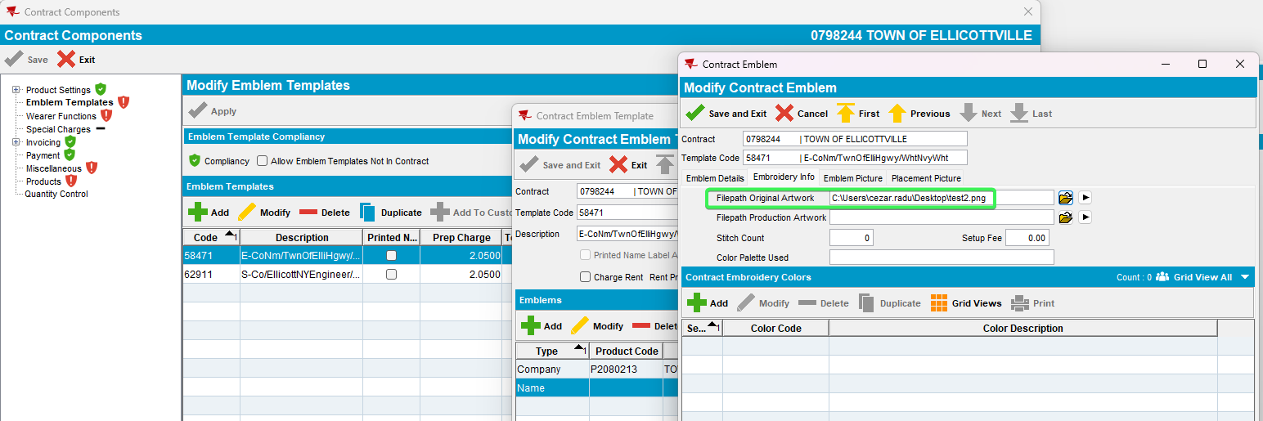
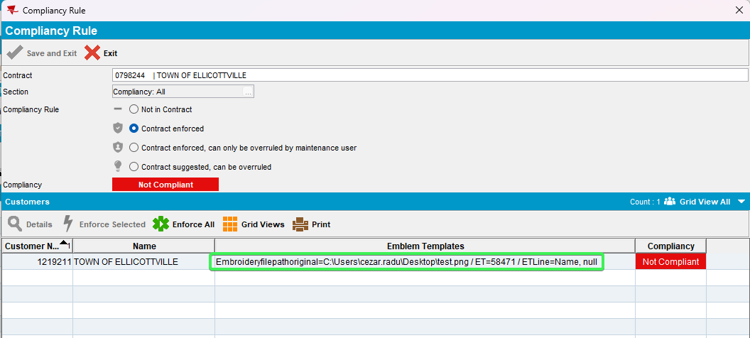
- Modify EMBROIDERYFILEPATHPRODUCTION, reload the contract and load compliancy

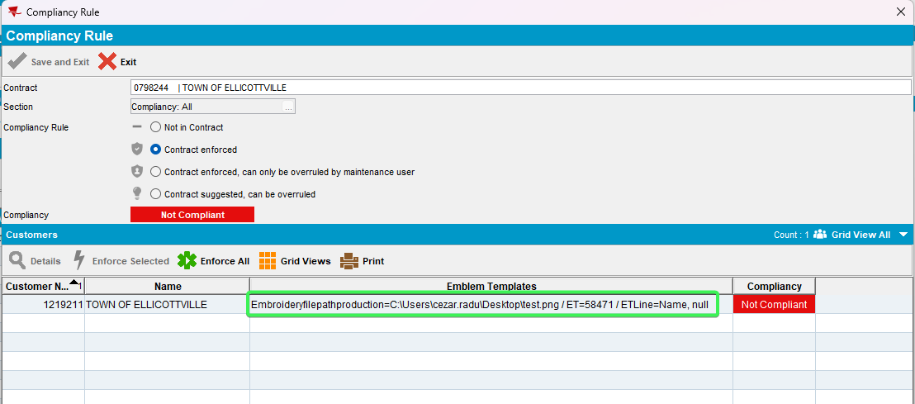
- Modify STITCHCOUNT, reload the contract and load compliancy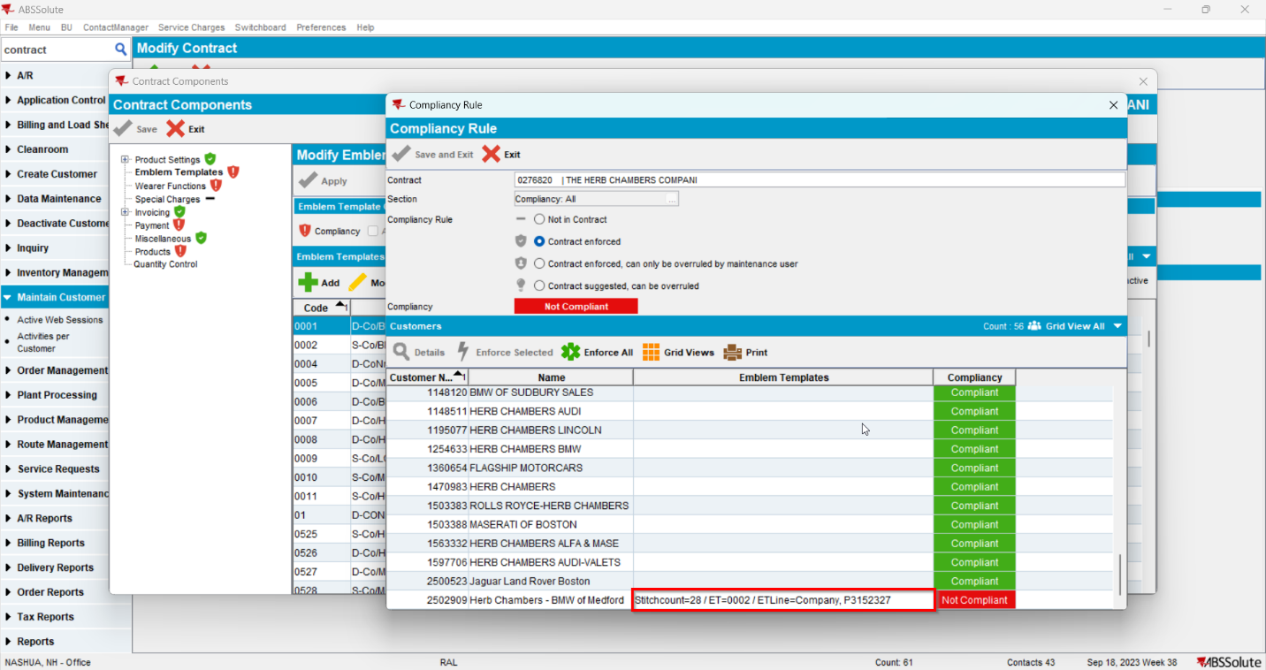
- Modify SETUPFEE, reload the contract and load compliancy
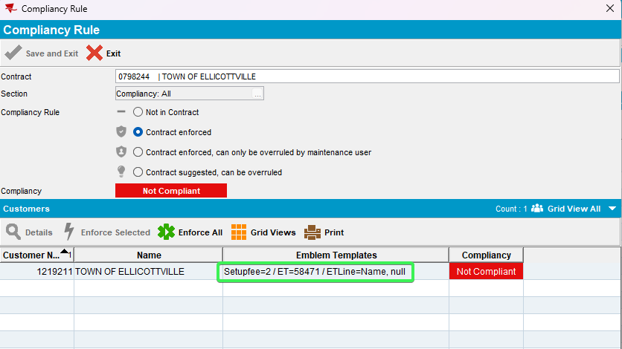
- Modify COLORPALETTE, reload the contract and load compliancy
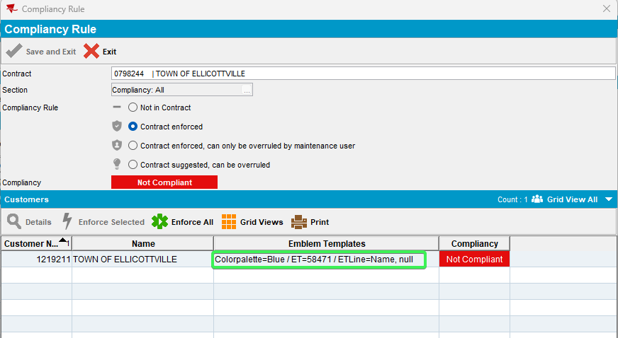
- Modify EMBROIDERYLETTERING, reload the contract and load compliancy
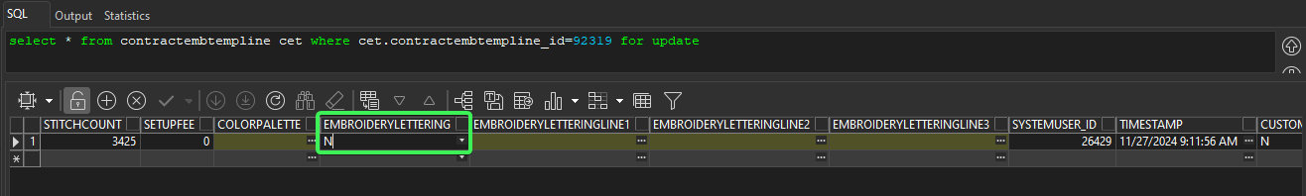
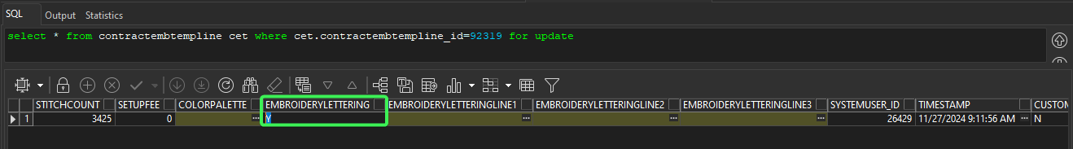
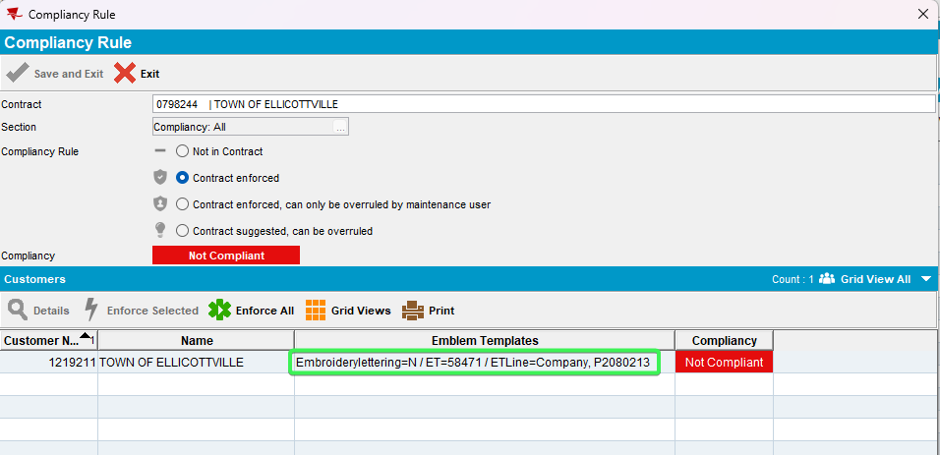
- Modify Price, reload the contract and load compliancy
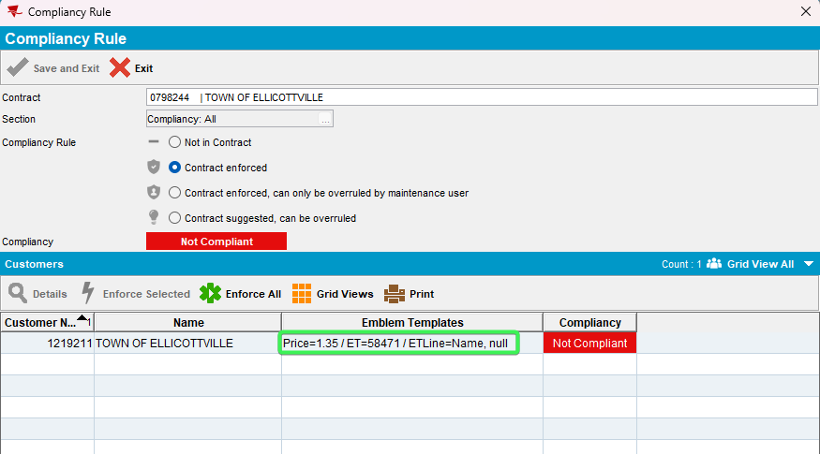
- Modify CustomColor, reload the contract and load compliancy
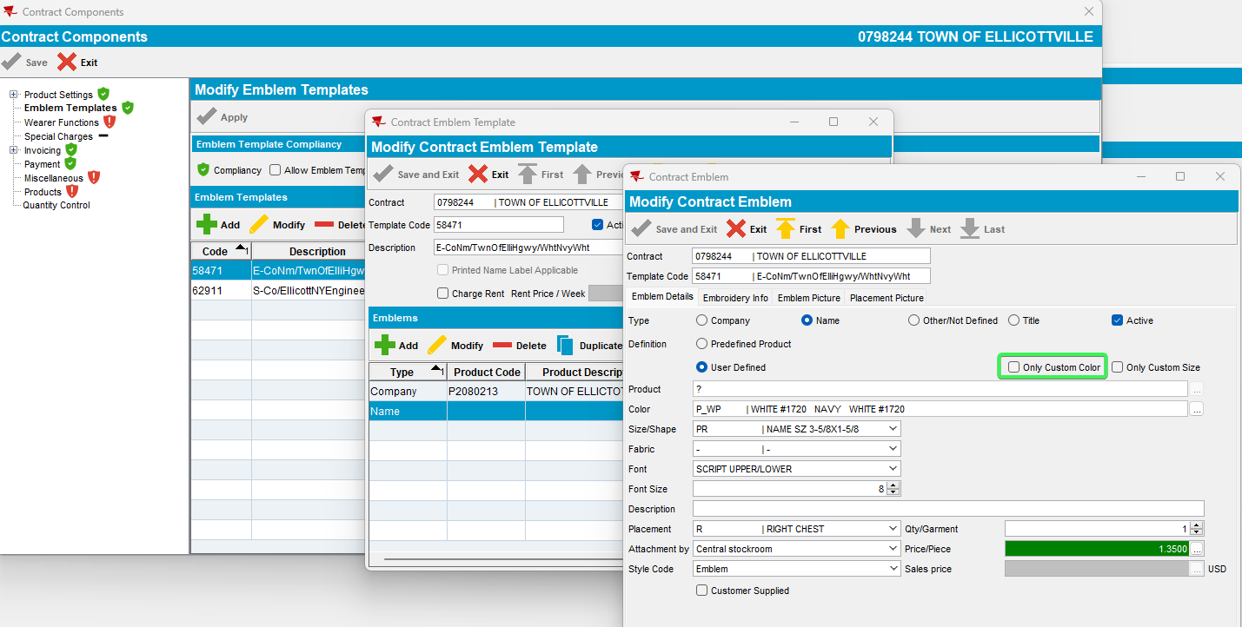
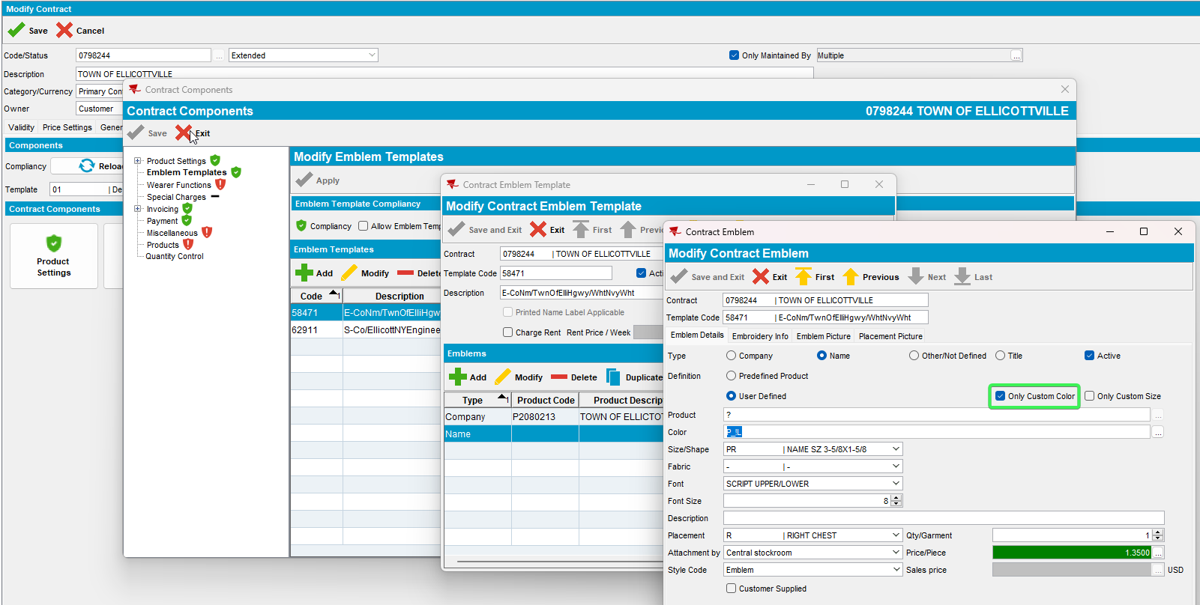
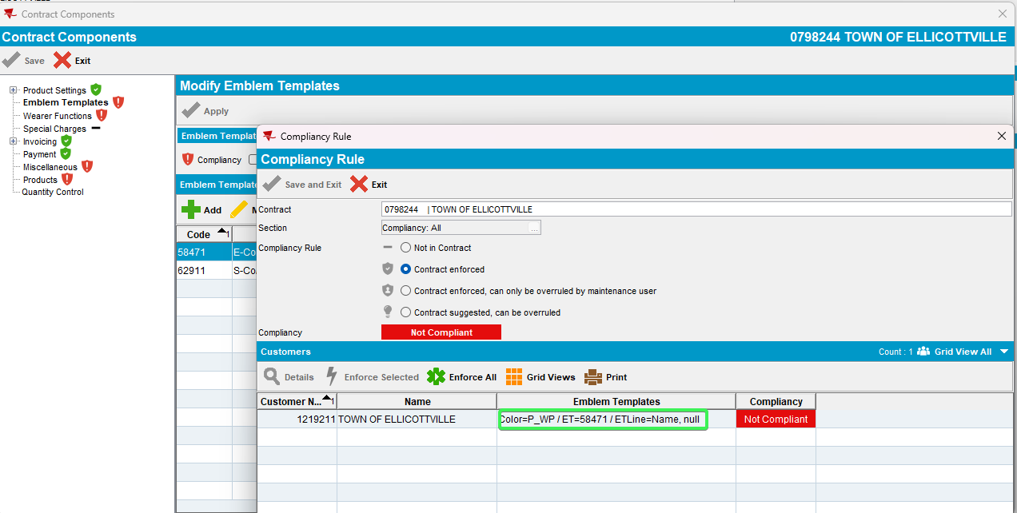
- Modify CustomSize, reload the contract and load compliancy
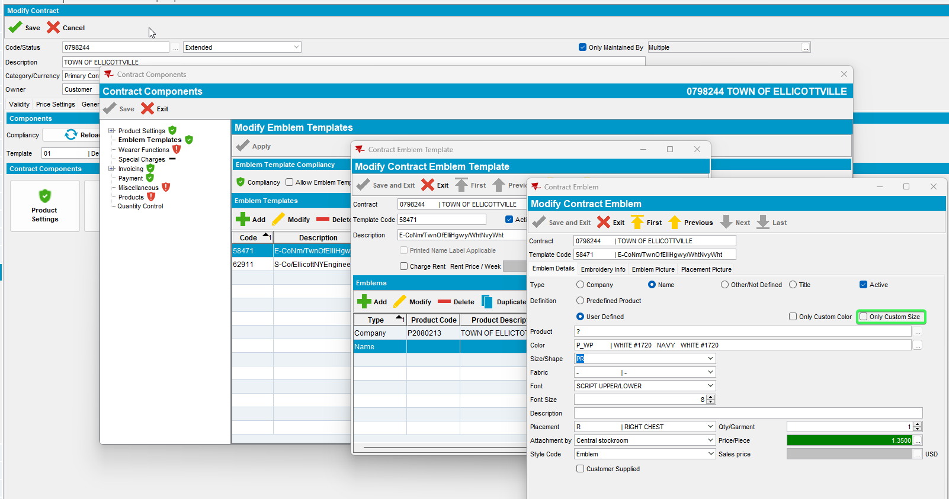
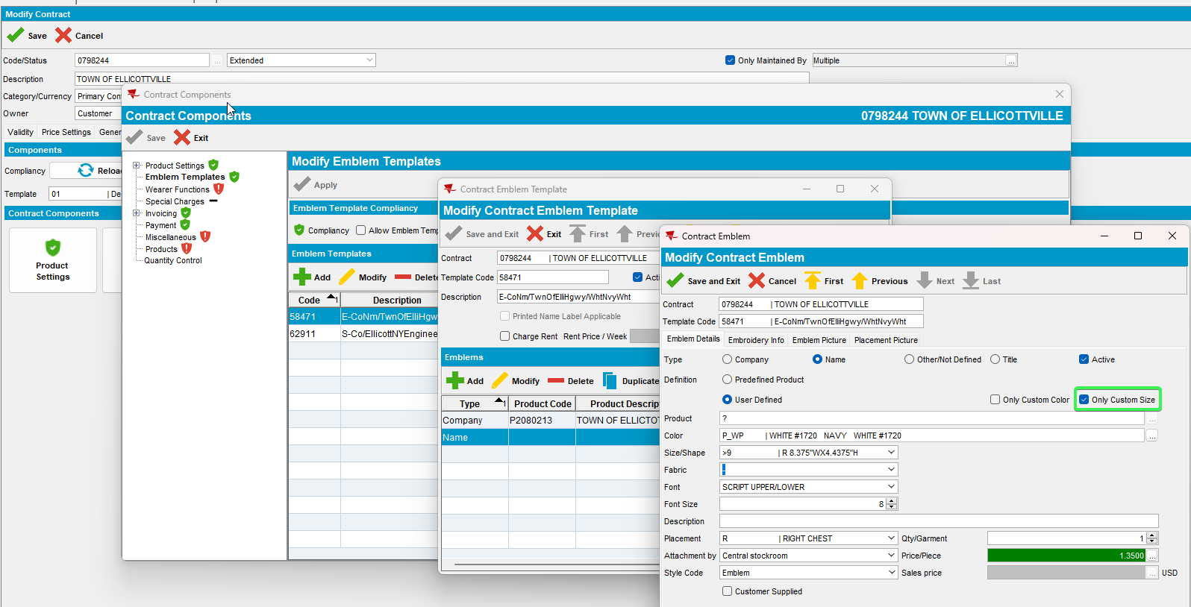
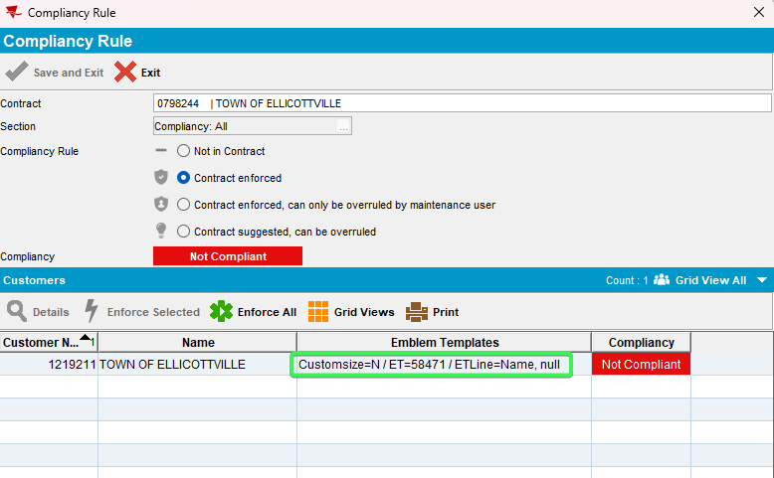
- Modify StyleCode, reload the contract and load compliancy
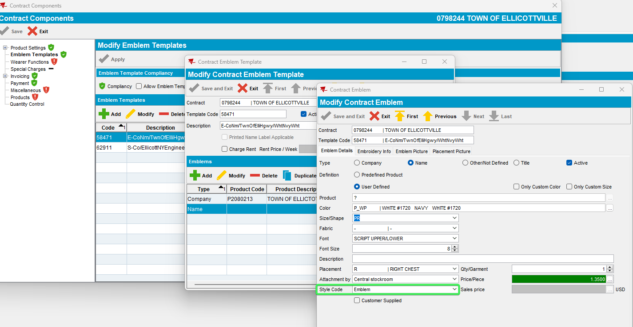
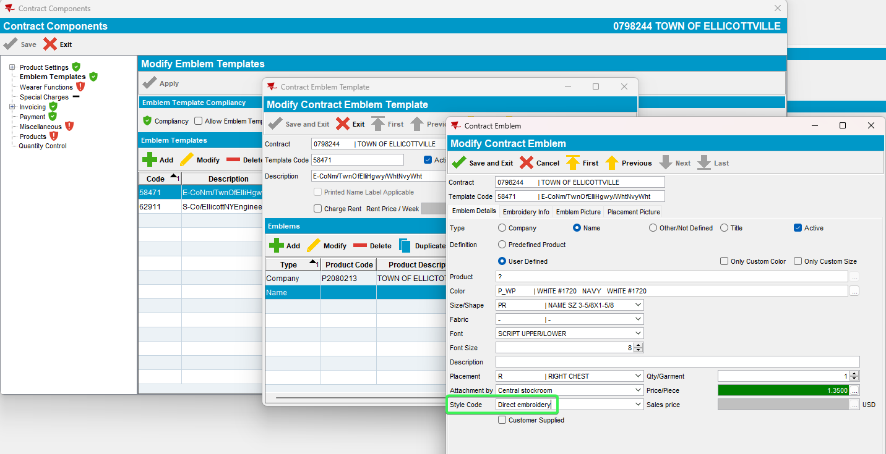
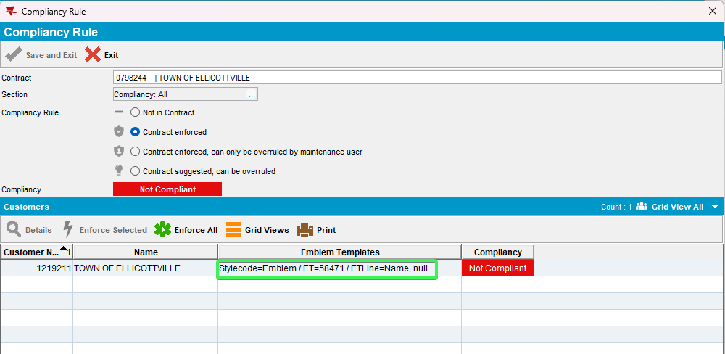
- Modify Description2, reload the contract and load compliancy
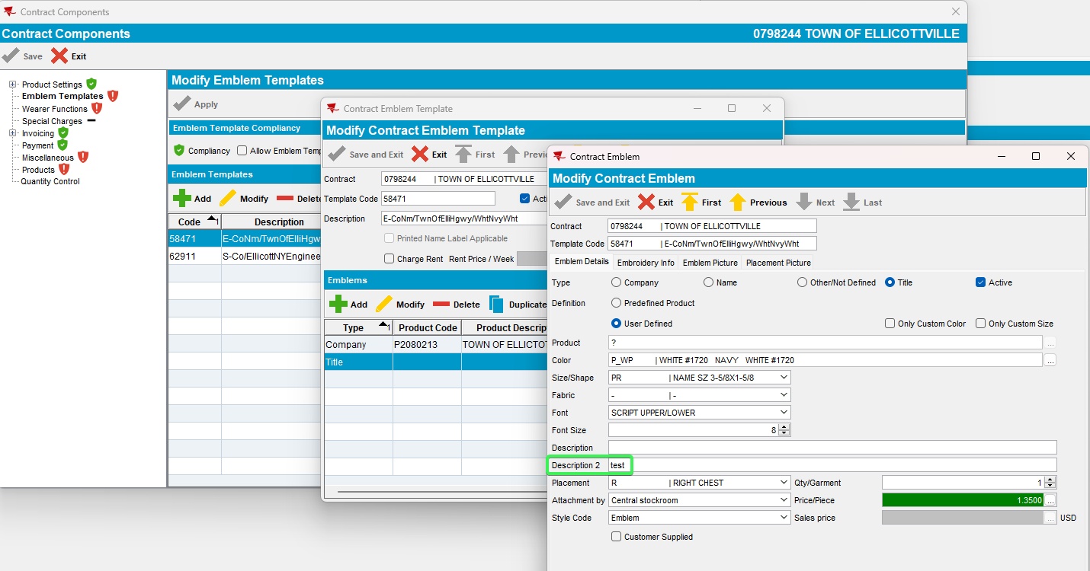
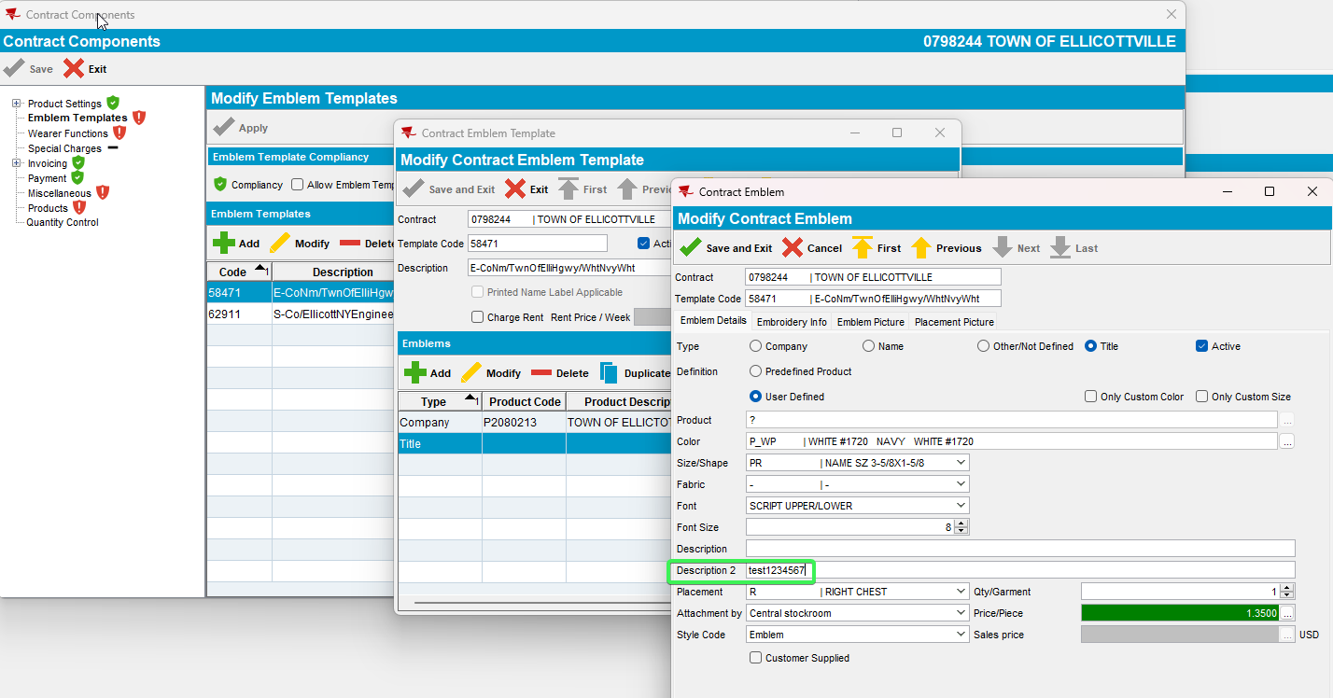
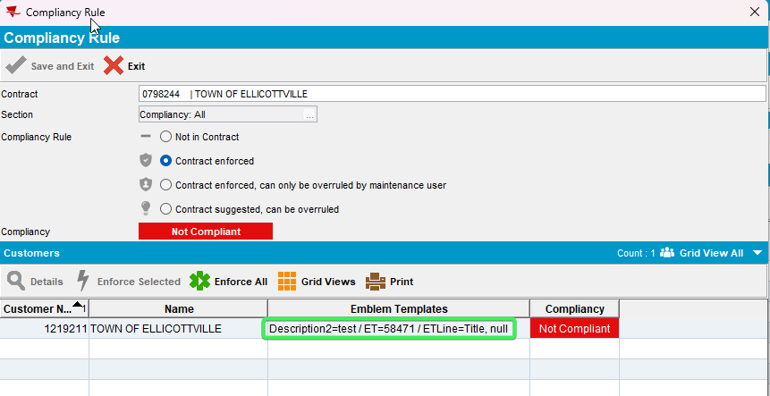
- Modify CustomerSupplied, reload the contract and load compliancy
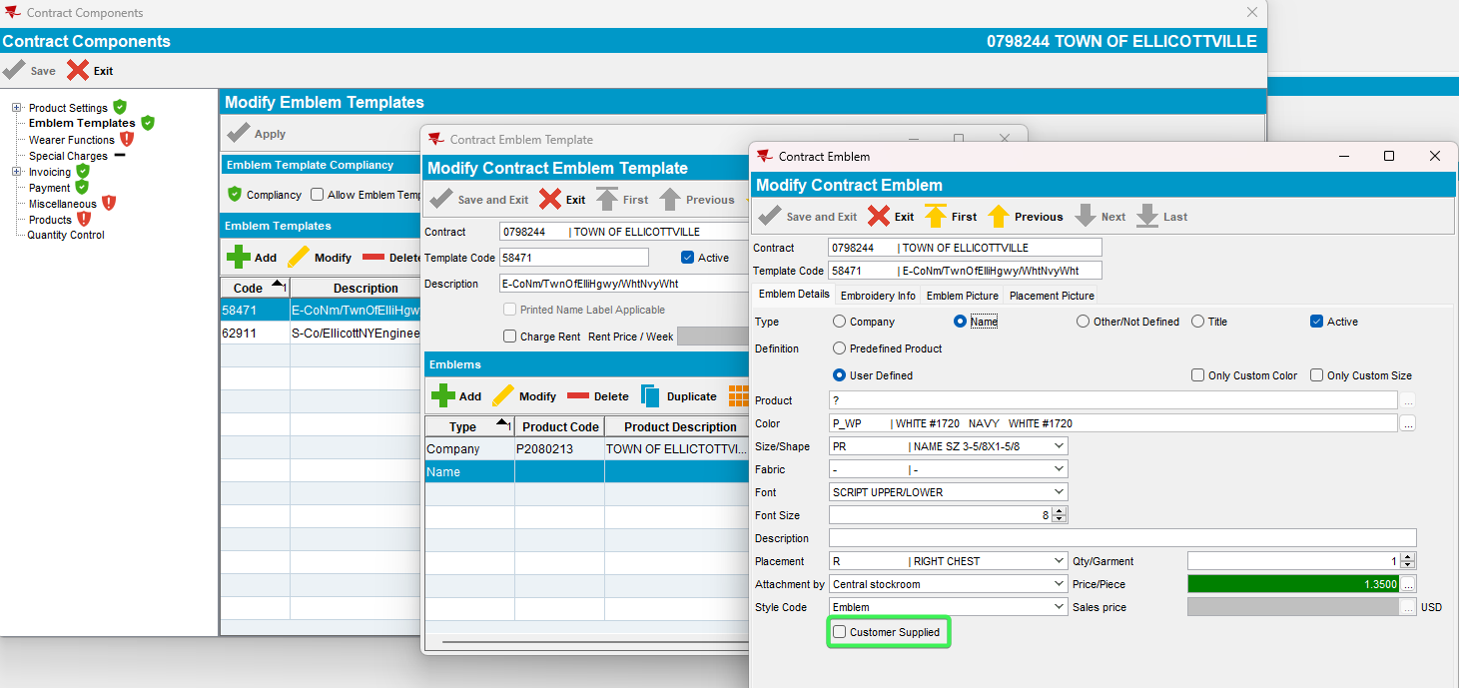
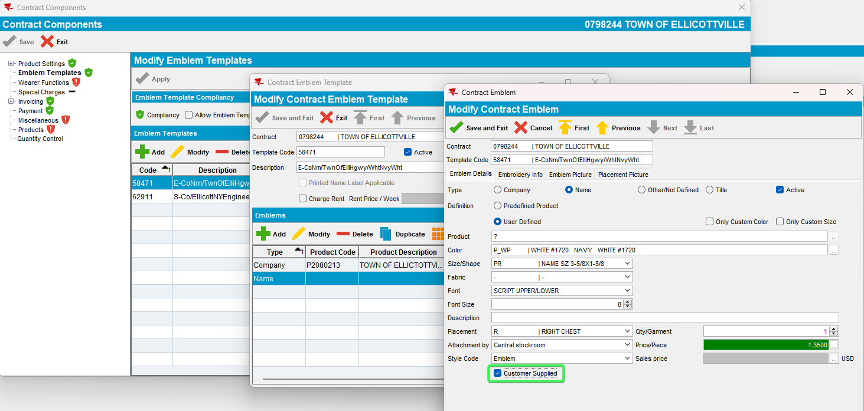
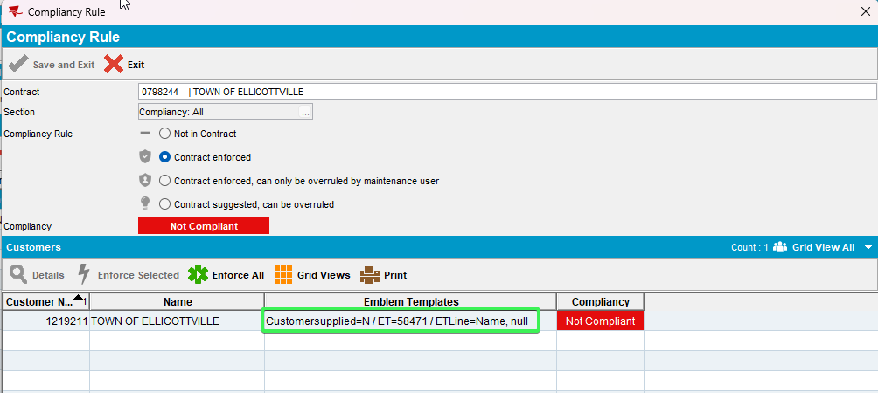
- Modify Active, reload the contract and load compliancy
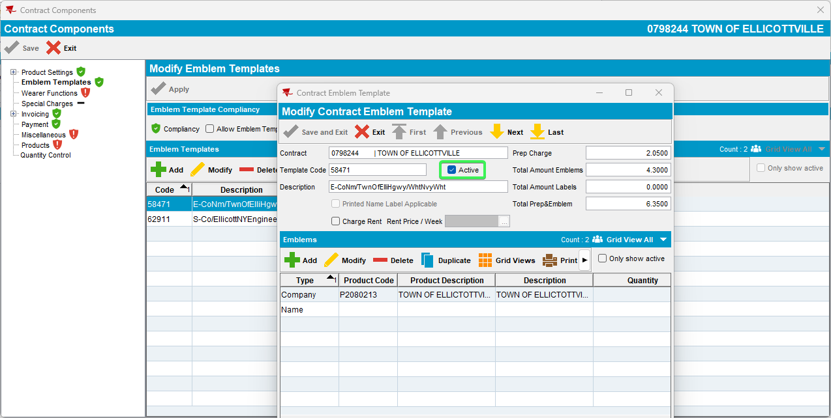
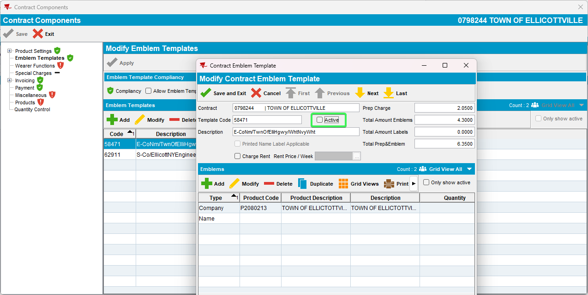
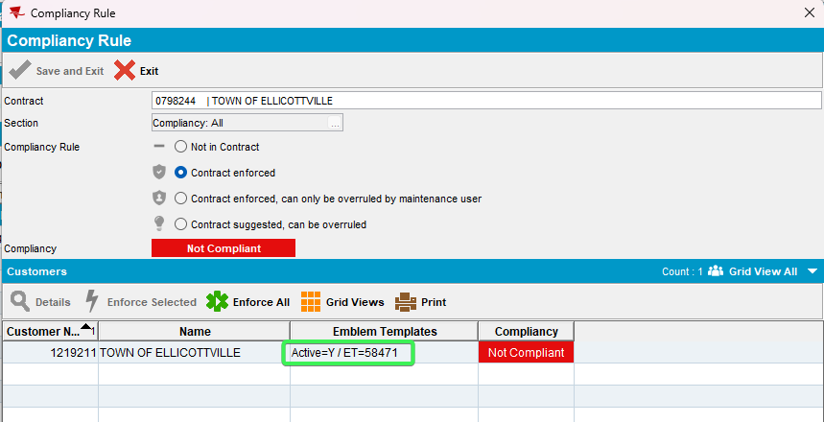
Tested OK

Test Case 2 – Add Emblem Template Line but don’t add it to customers – Tested OK
Expected behavior: If we have a missing EmblemTemplateLine (so the check returns ETL.EmblemtemplateLine_id = -1) we don't display any particular EmblemTemplateLine element that is missing (like placement or color) but instead display something like this: Missing + EmblemTemplateLine.Type (label not nubmer value) and EmblemtemplateLine.Product_ID.Product.Code (if there is one) + 'ET = <Emblemtemplate.Code>'
Hash: d276260ff389
- Go to Contract dlg and load a contract
- Go to Emblem Templates
- Select an emblem template and add an emblem template line
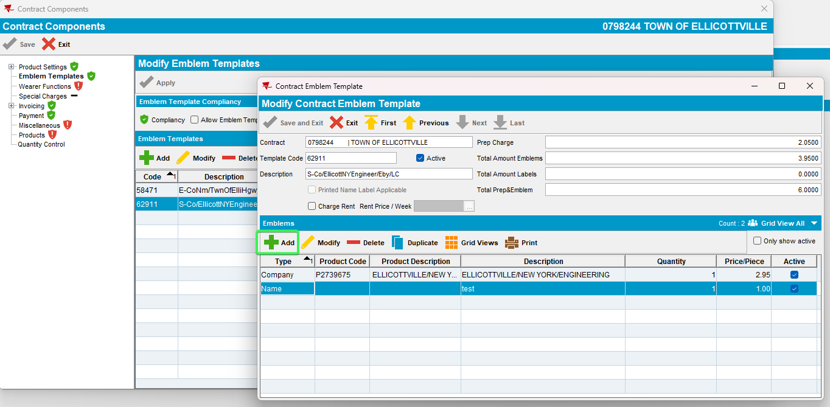
- Reload the contract and load compliancy
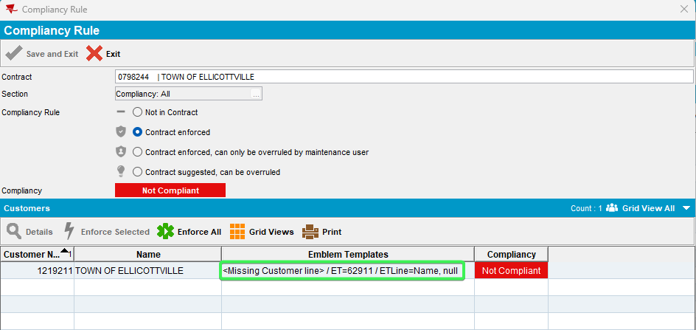
Tested OK

Test Case 3 – Modify Wearer functions – Tested NOT OK
Expected behavior: For non-compliant it won’t show database ids(will show code/descriptions)
Hash: d276260ff389
- On the Contract dlg select a contract, go to Components tab and load compliancy
- Go to Wearer functions
- Modify CODE, reload the contract and load compliancy
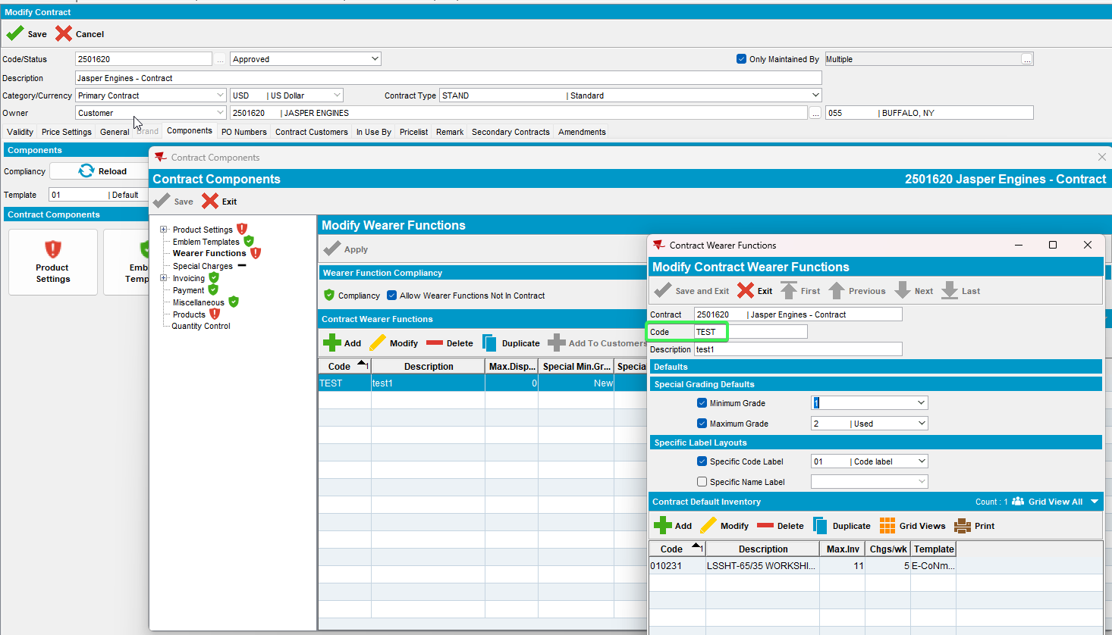
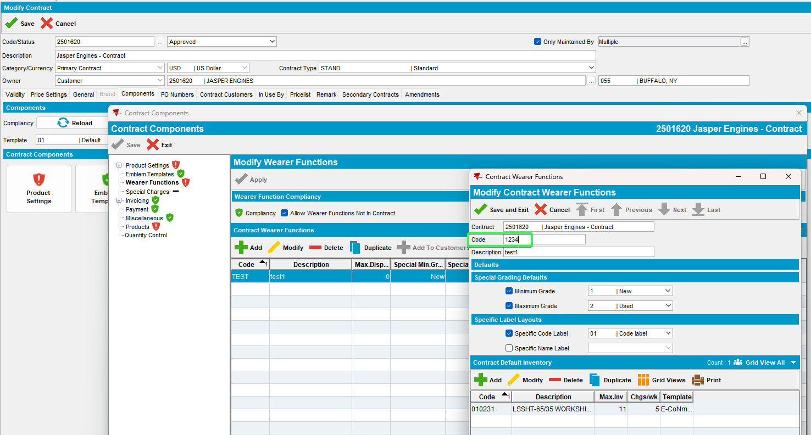
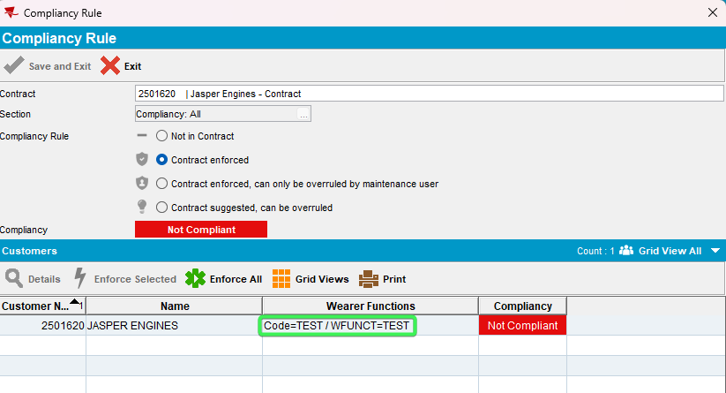
- Modify DESCRIPTION, reload the contract and load compliancy
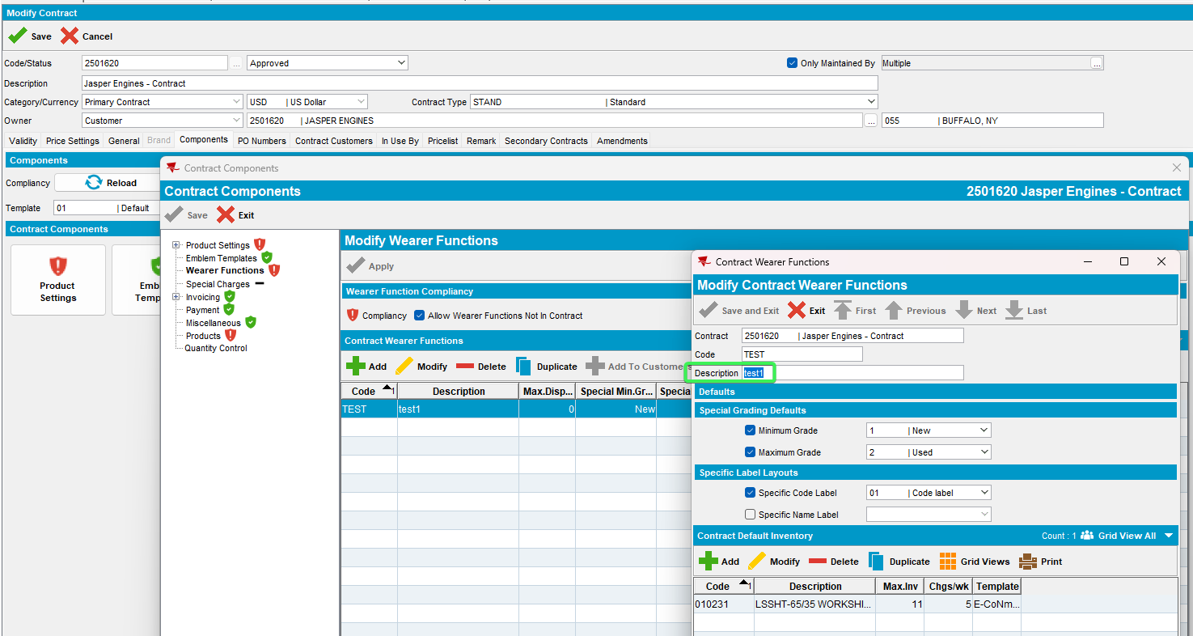
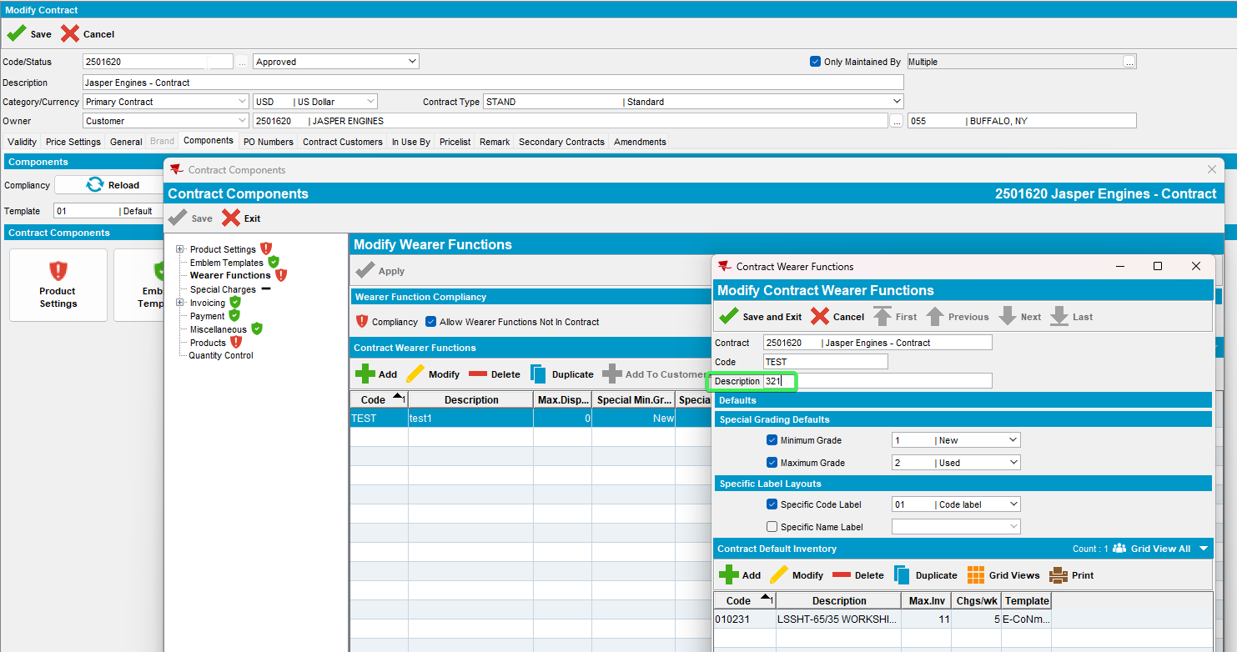
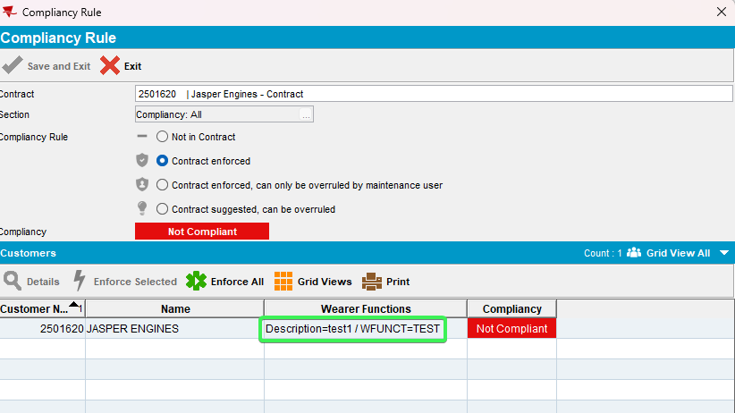
- Modify DEFAULTDISPENSECREDIT, reload the contract and load compliancy
Use the following select to find the contract ID
select * from contractwearerfunction cw
join contract c on cw.contract_id=c.contract_id
where c.code='2501620'
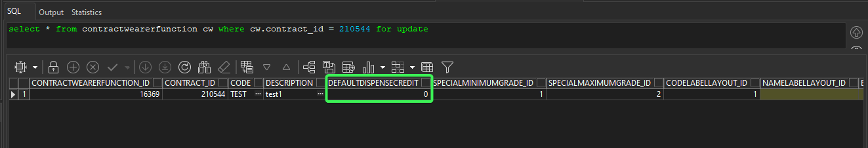
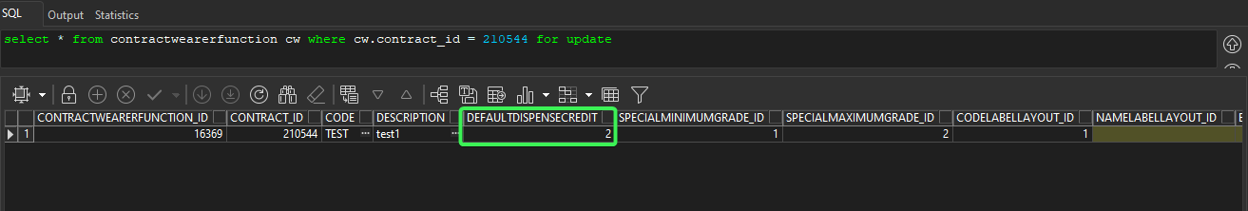
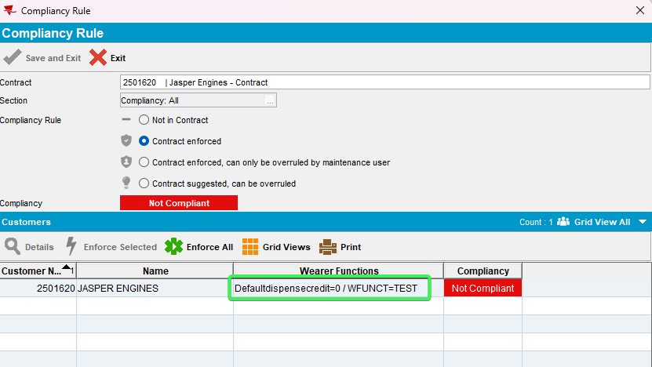
- Modify SPECIALMINIMUMGRADE, reload the contract and load compliancy
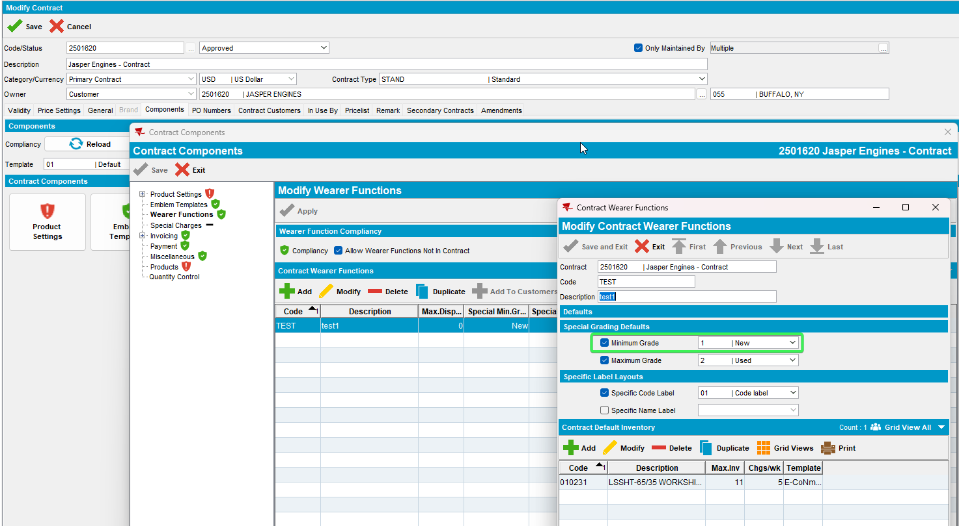
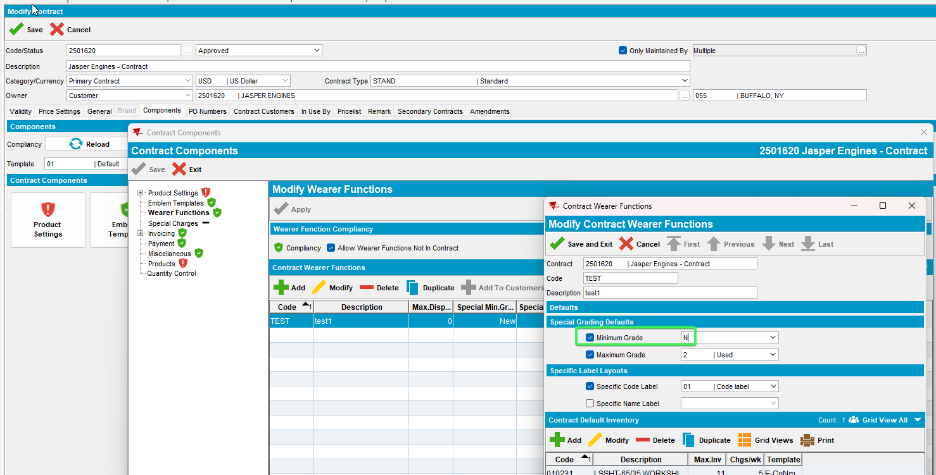
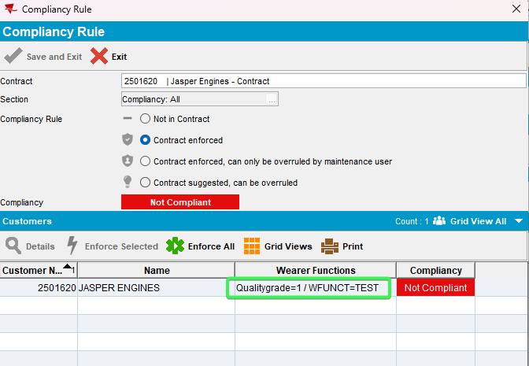
- Modify SPECIALMAXIMUMGRADE, reload the contract and load compliancy
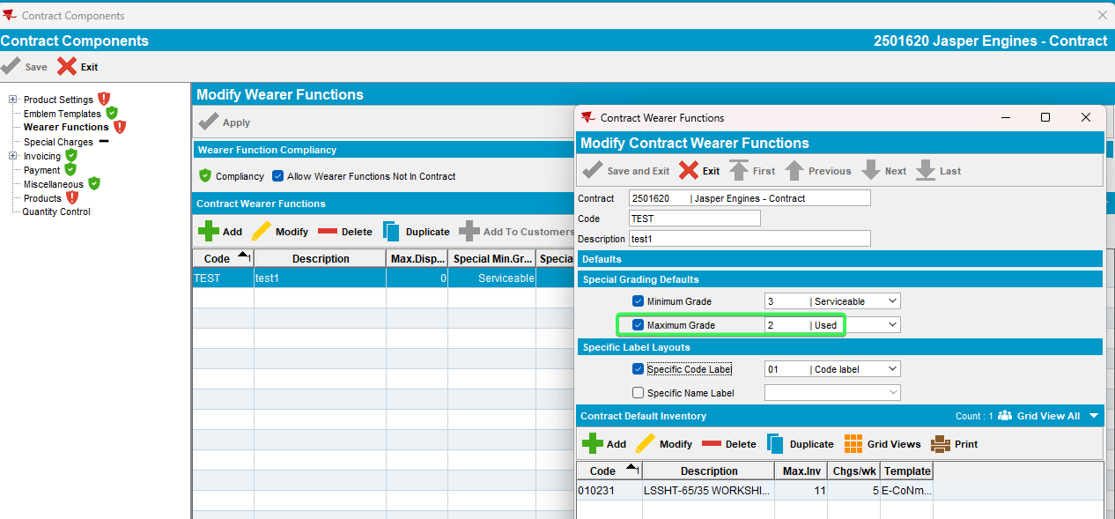

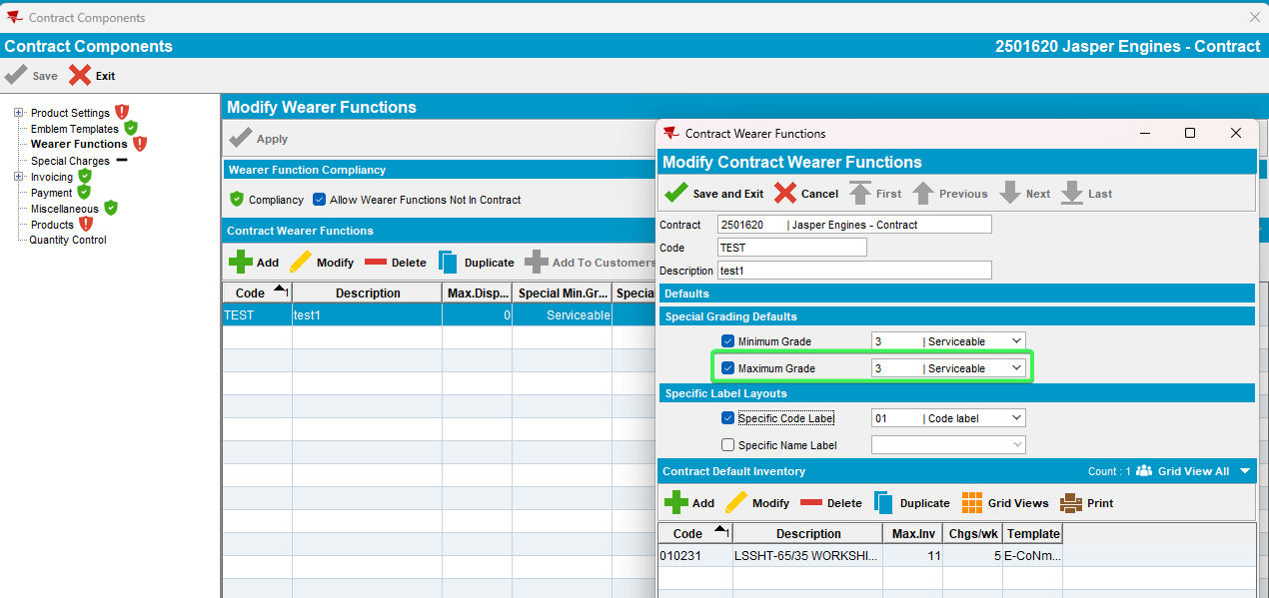
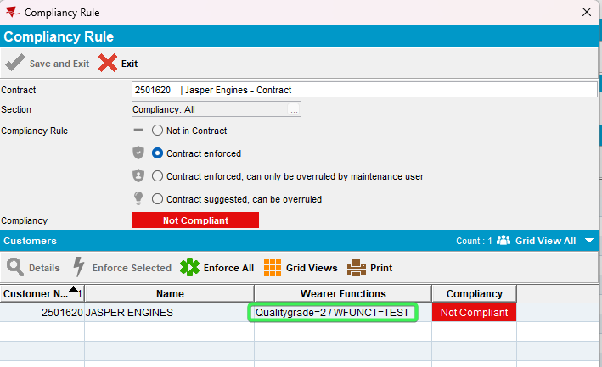
- Modify CODELABELLAYOUT, reload the contract and load compliancy
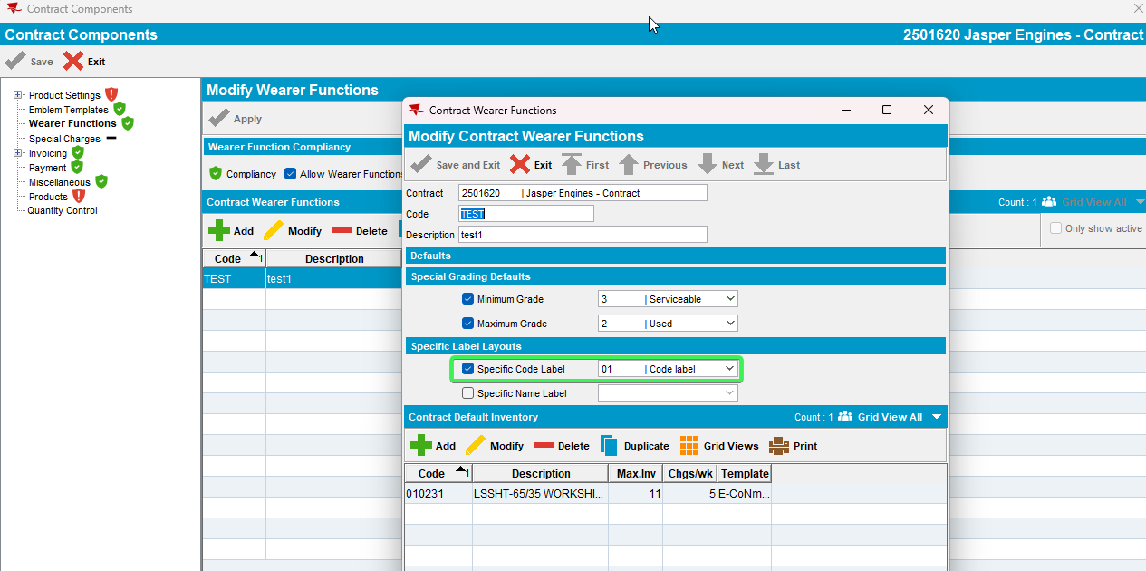
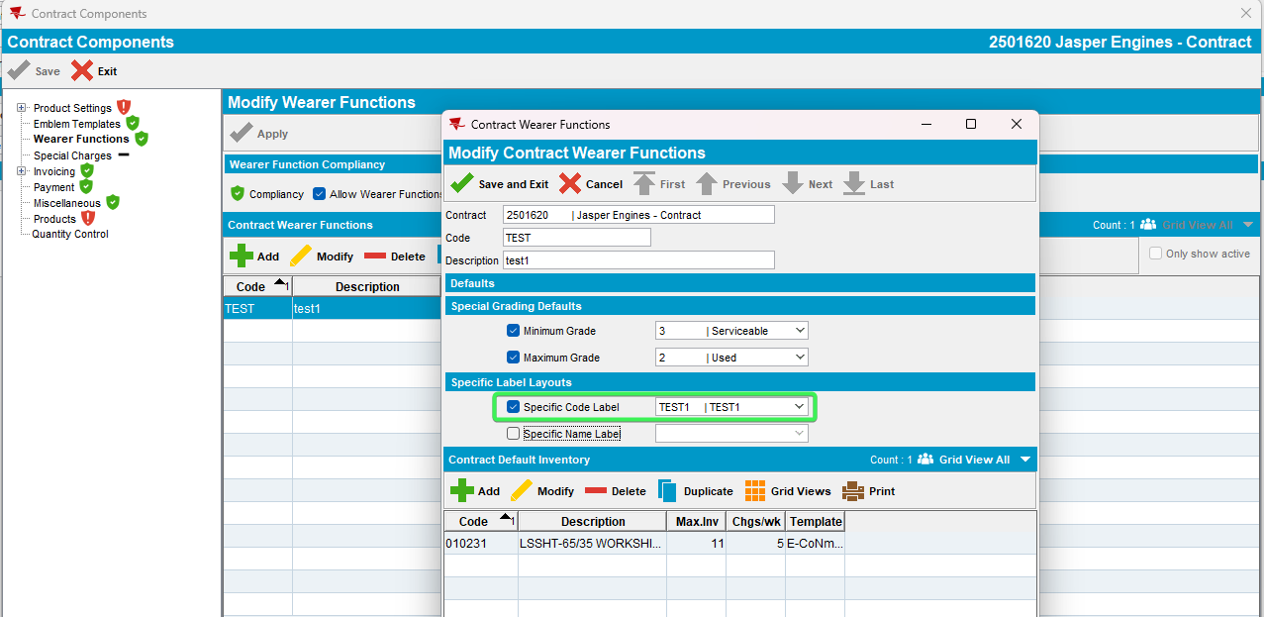
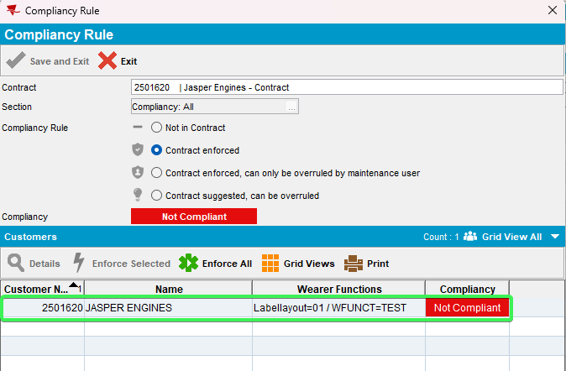
- Modify NAMELABELLAYOUT, reload the contract and load compliancy
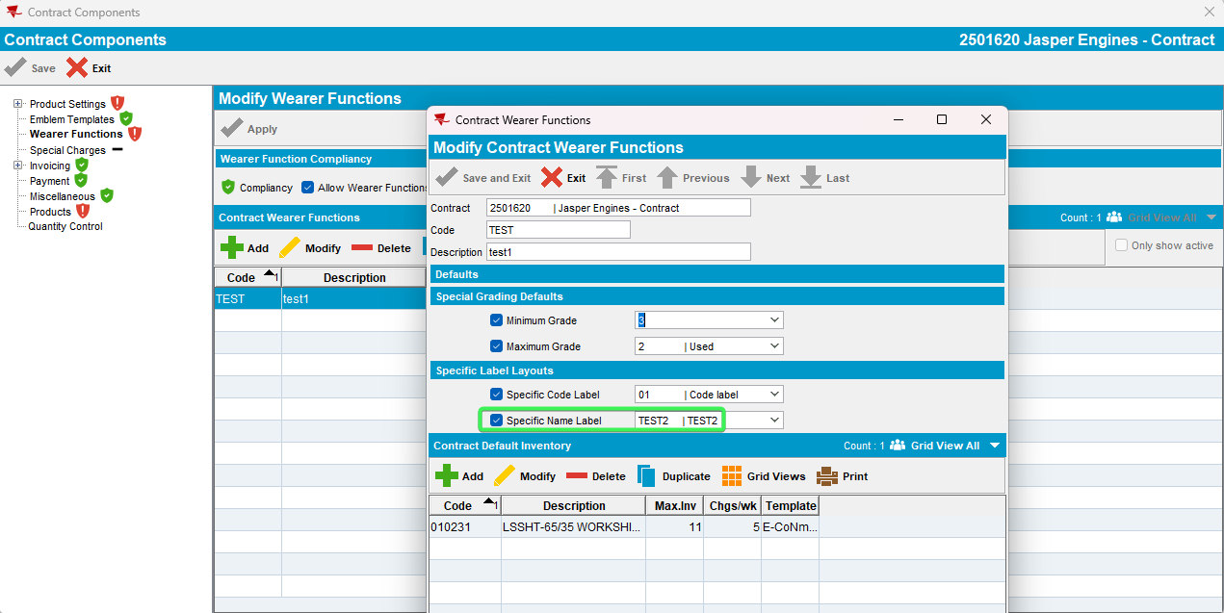
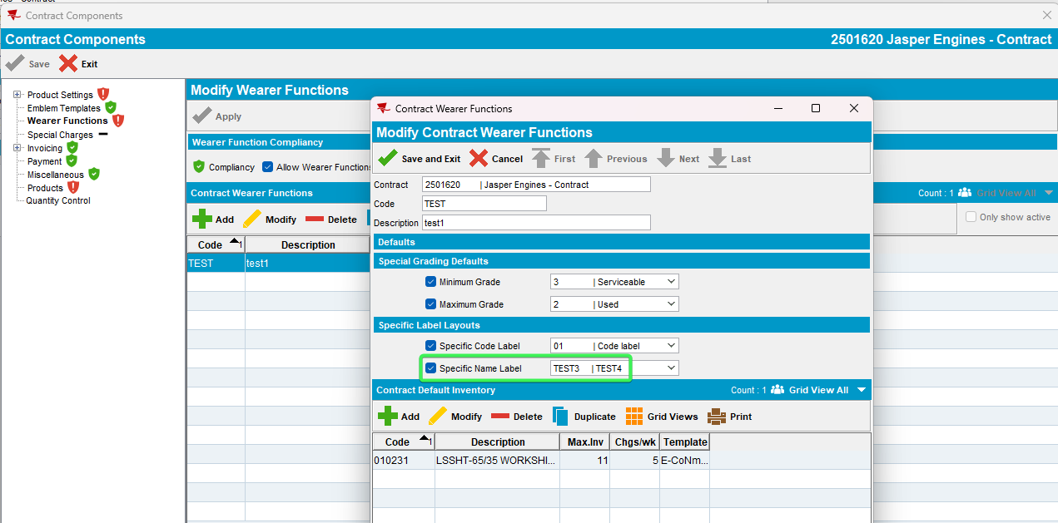
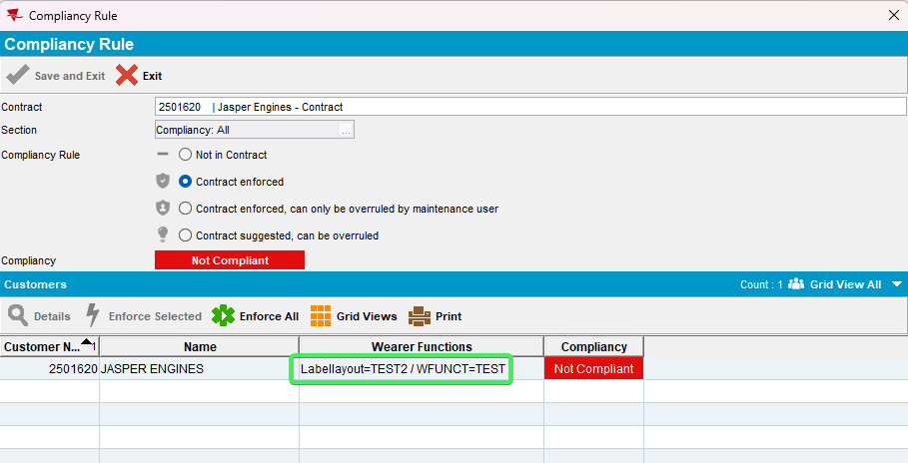
- Modify EXPORTGDCODE, reload the contract and load compliancy >>>>>>>>>>>>>>>>
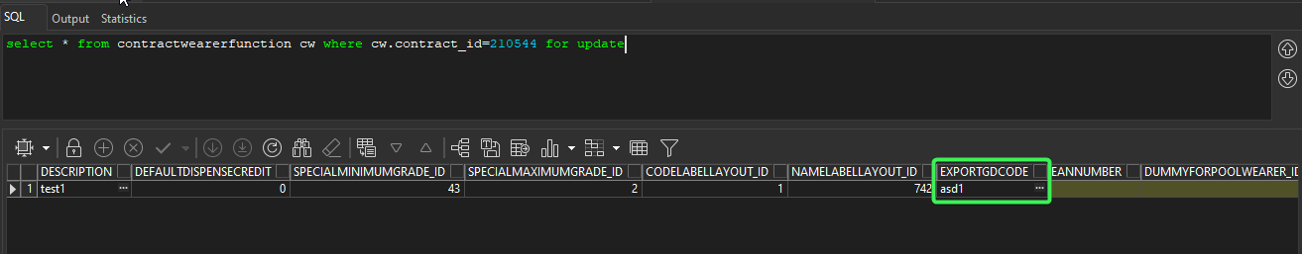
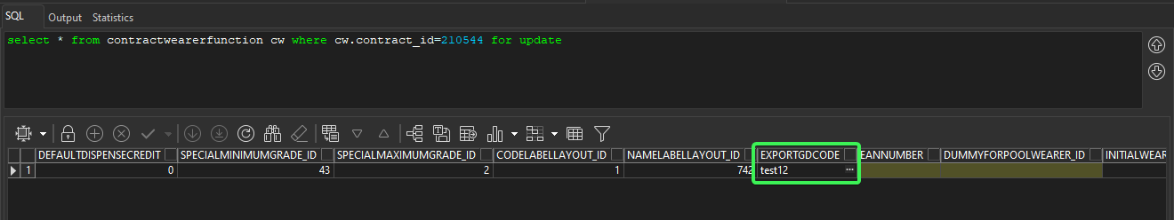
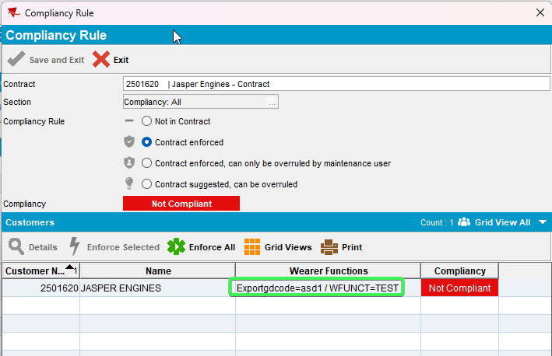
- Modify EANNUMBER, reload the contract and load compliancy
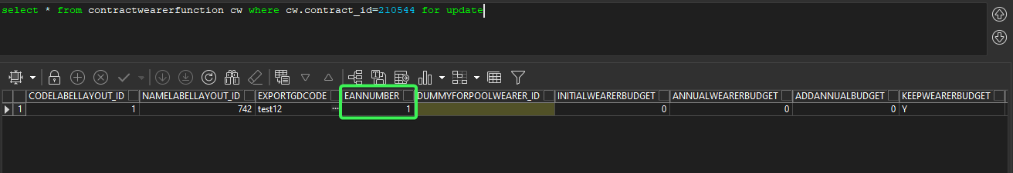
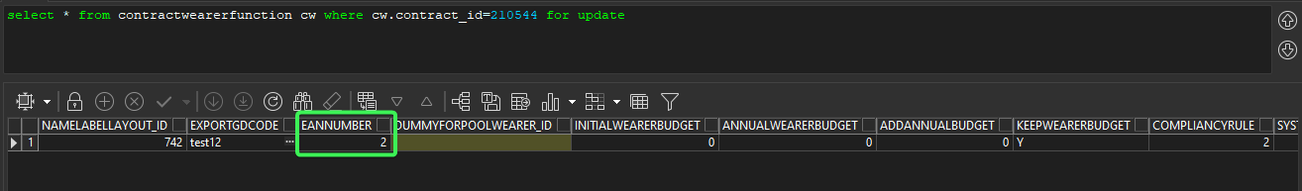
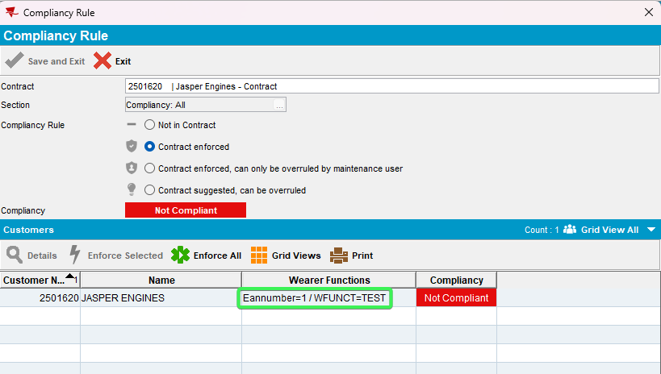
- Modify DUMMYFORPOOLWEARER, reload the contract and load compliancy
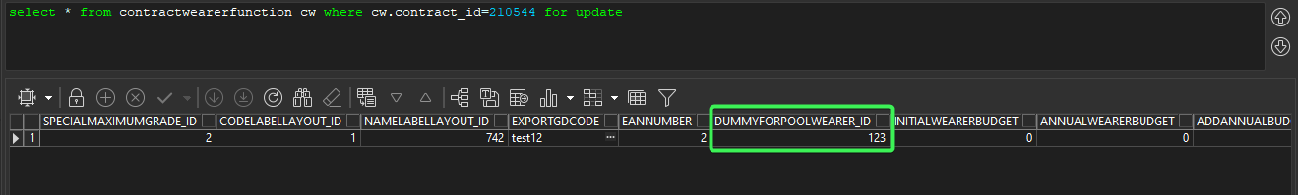
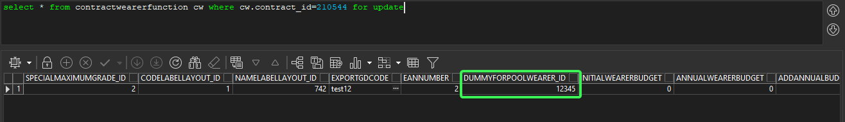
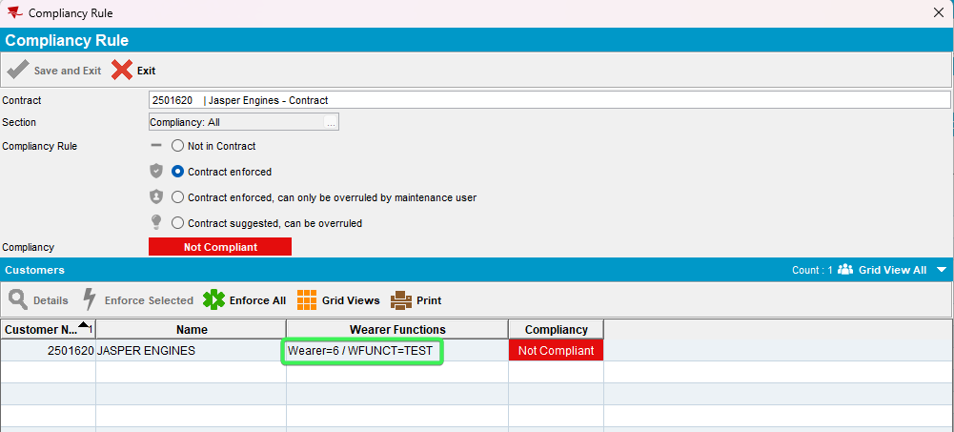
- Modify INITIALWEARERBUDGET, reload the contract and load compliancy
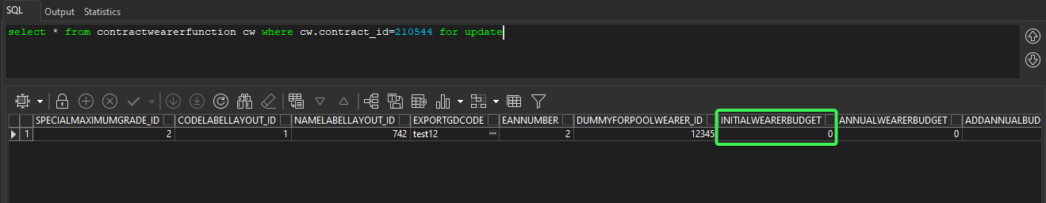
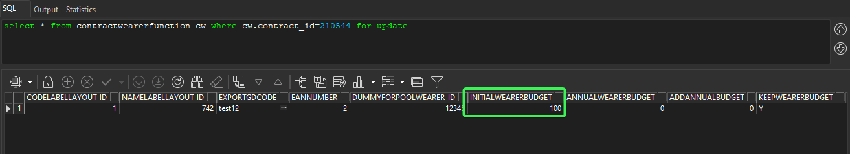
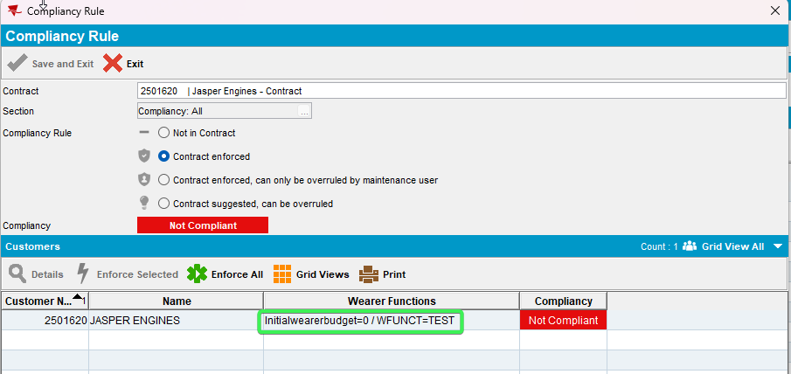
- Modify ANNUALWEARERBUDGET, reload the contract and load compliancy
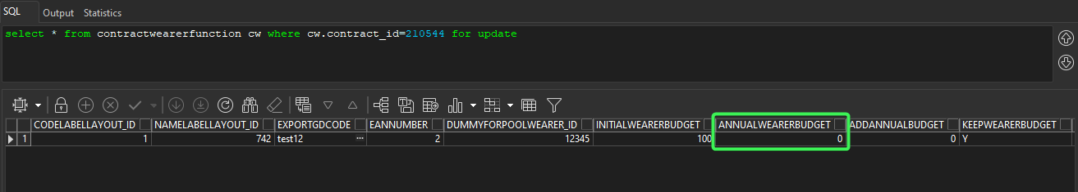
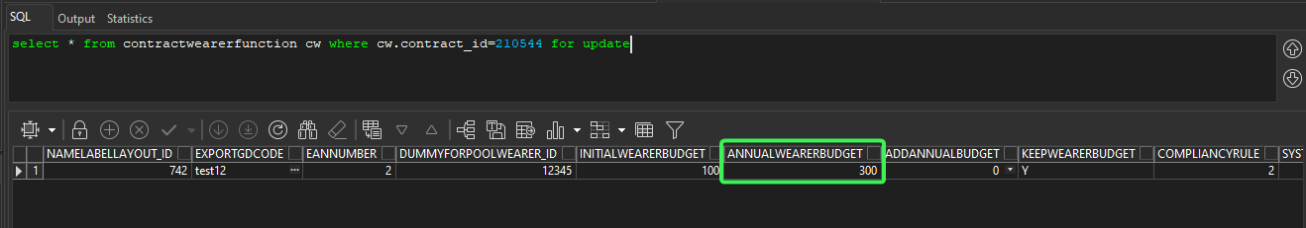
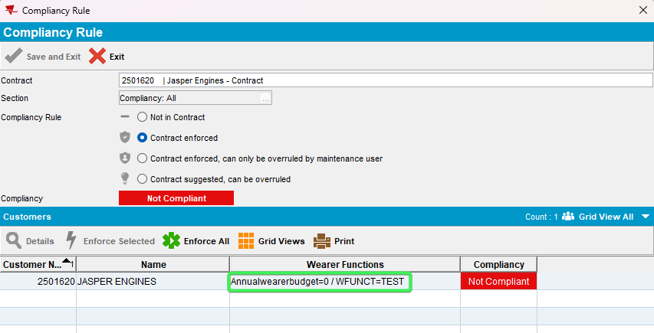
- Modify ADDANNUALBUDGET, reload the contract and load compliancy
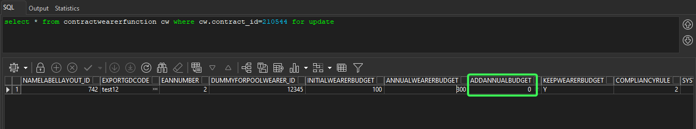
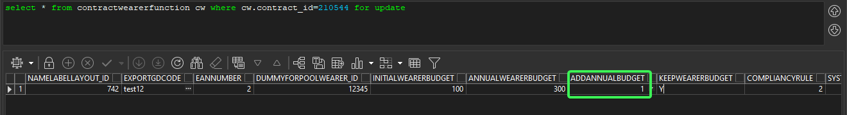
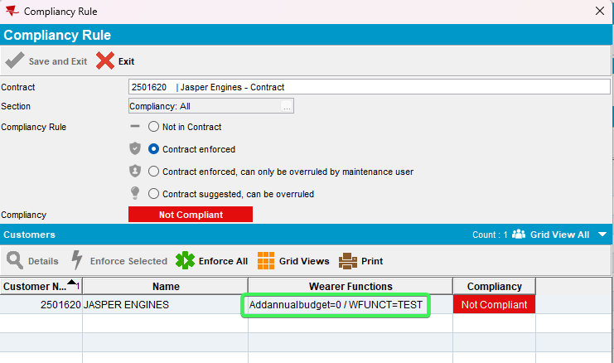
- Modify KEEPWEARERBUDGET, reload the contract and load compliancy
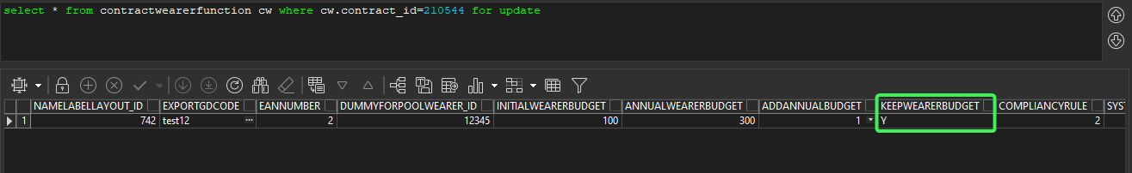
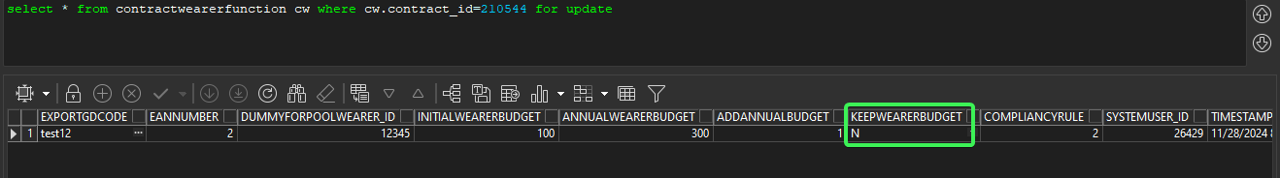
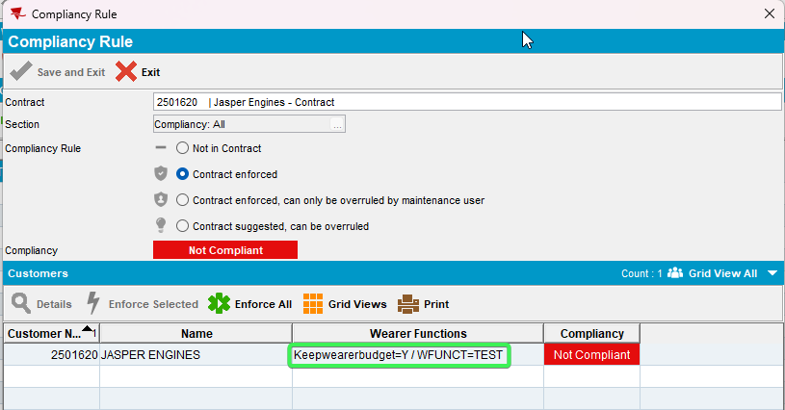
- Modify PRODUCT, reload the contract and load compliancy
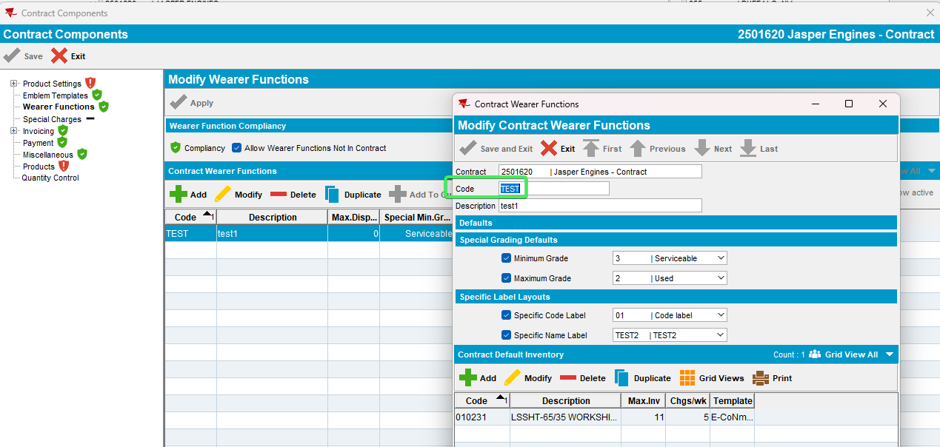
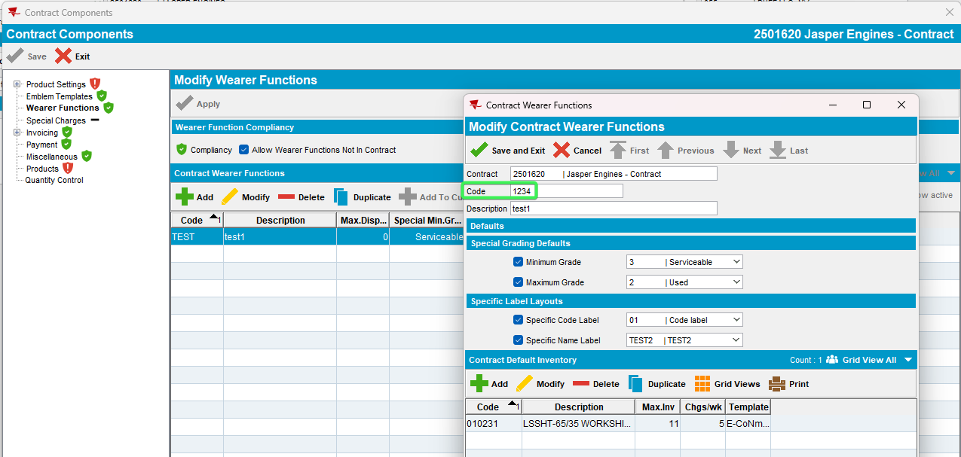
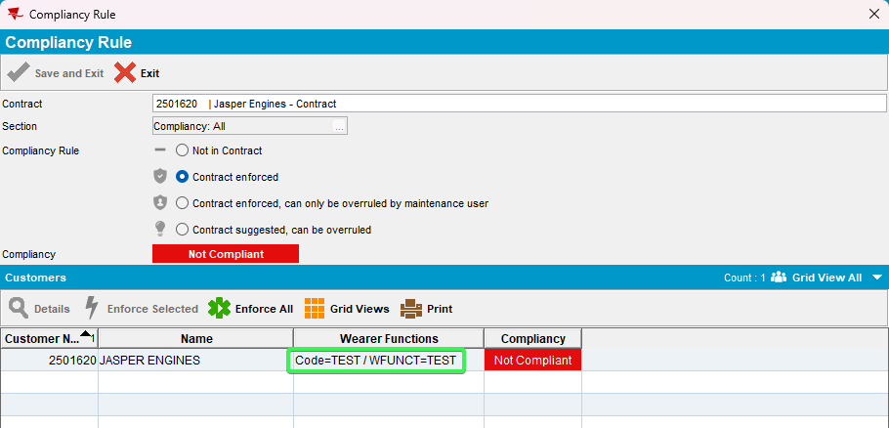
- Modify CONTRACTEMBTEMP, reload the contract and load compliancy
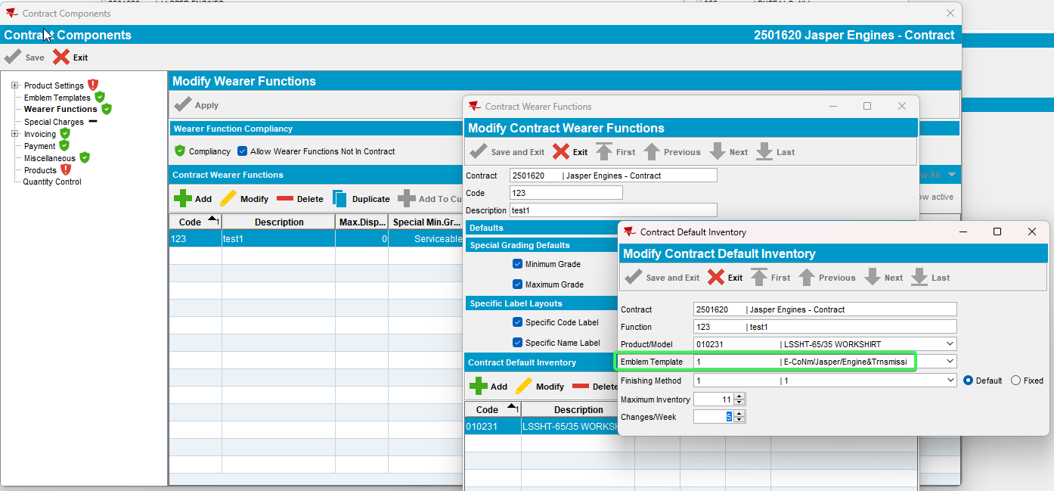
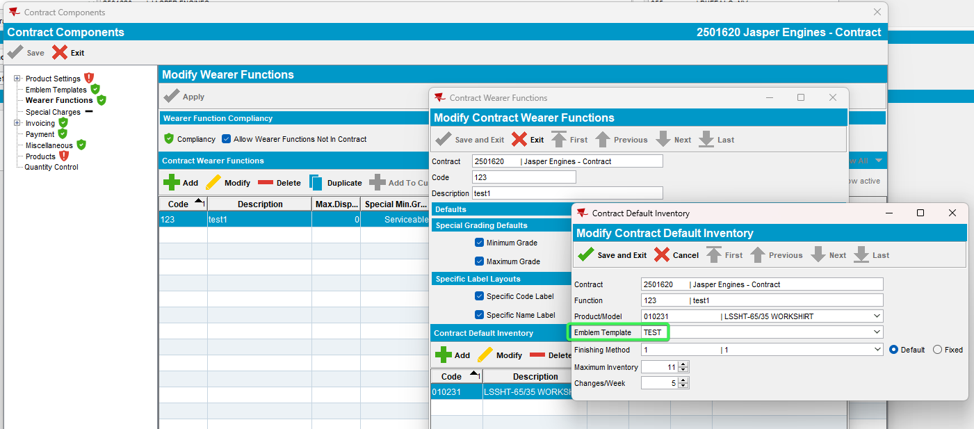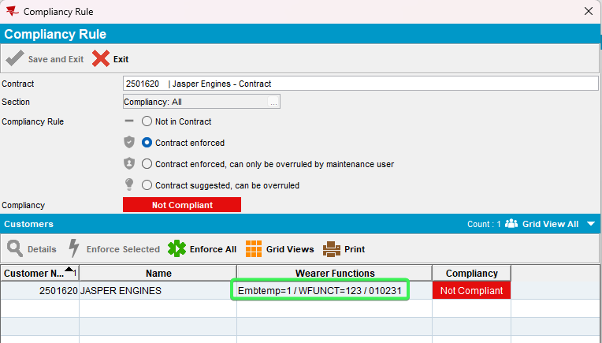
- Modify PUTINUSE, reload the contract and load compliancy
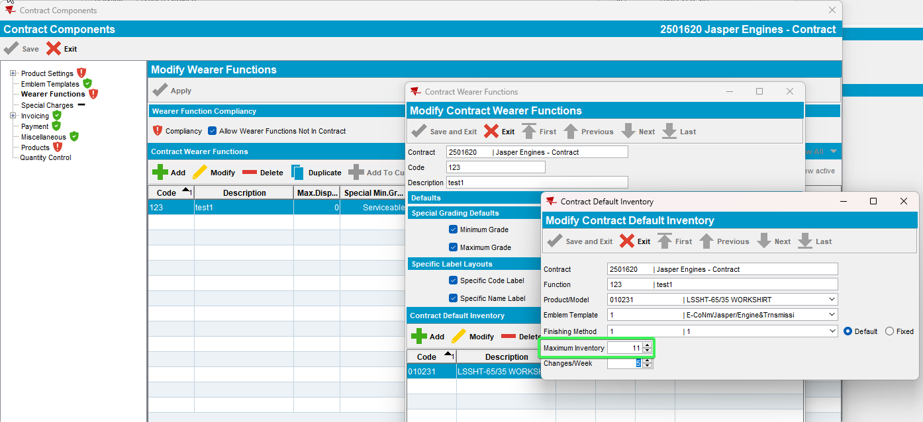
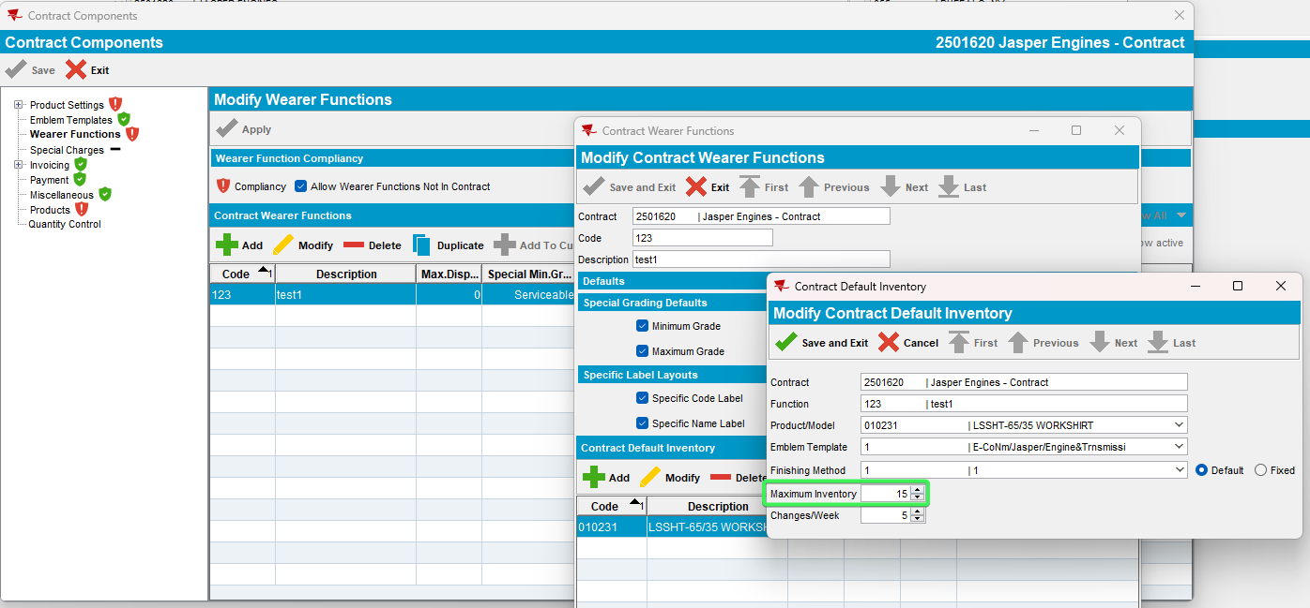
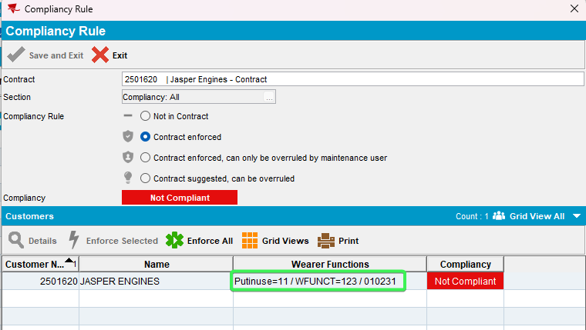
- Modify CHANGESPERWEEK, reload the contract and load compliancy
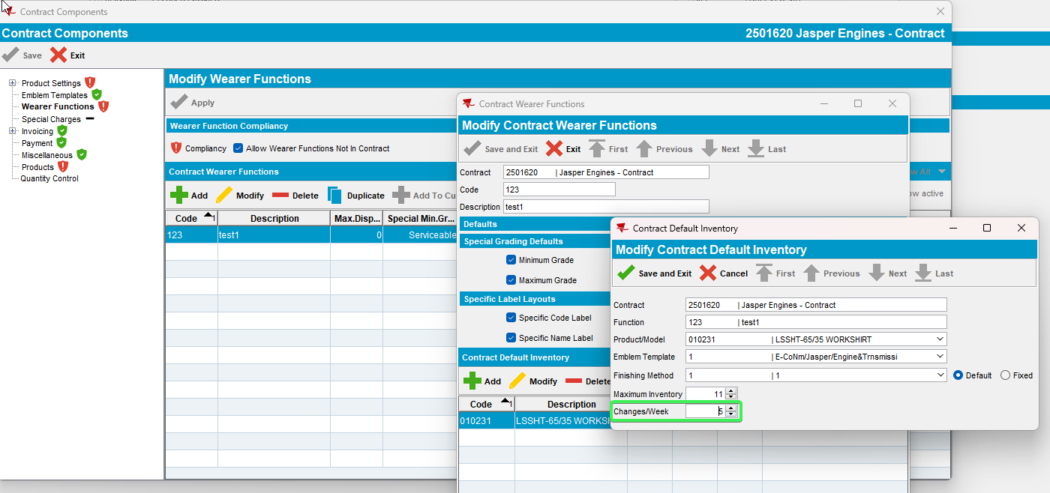
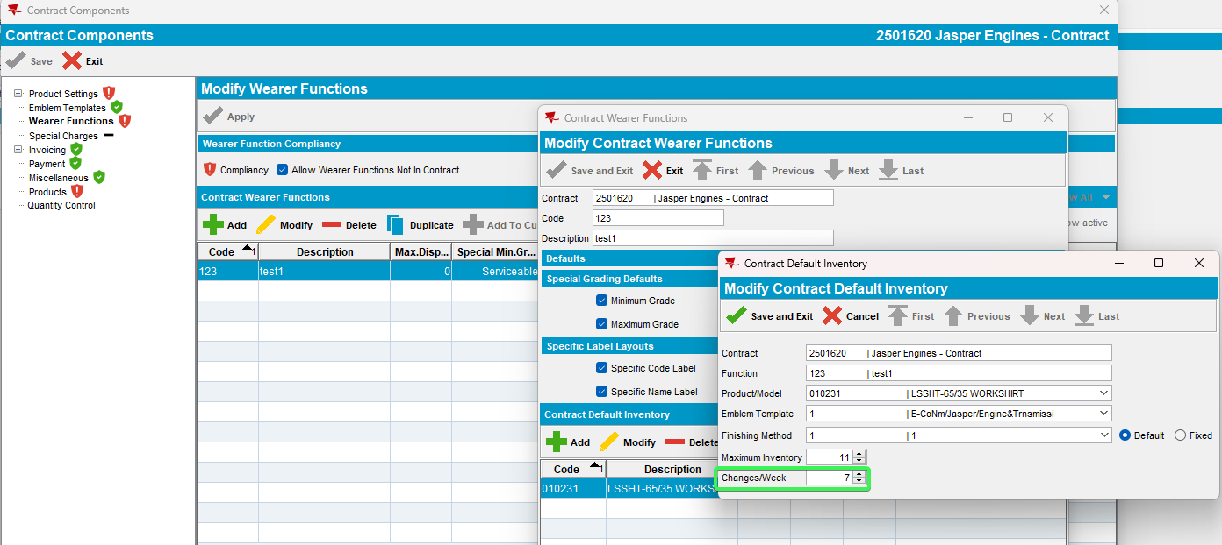
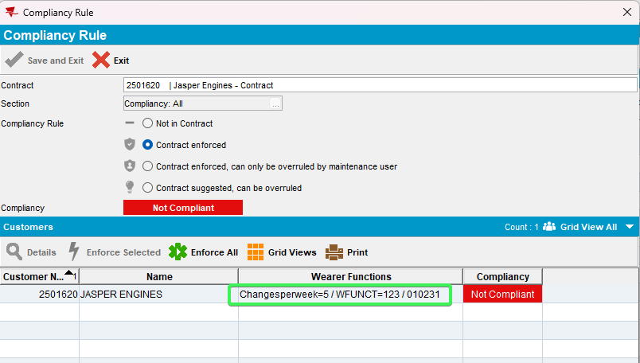
- Modify DISPENSECREDIT, reload the contract and load compliancy
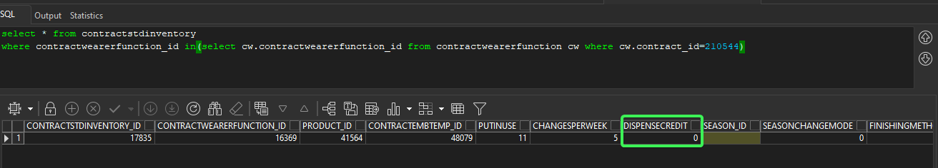
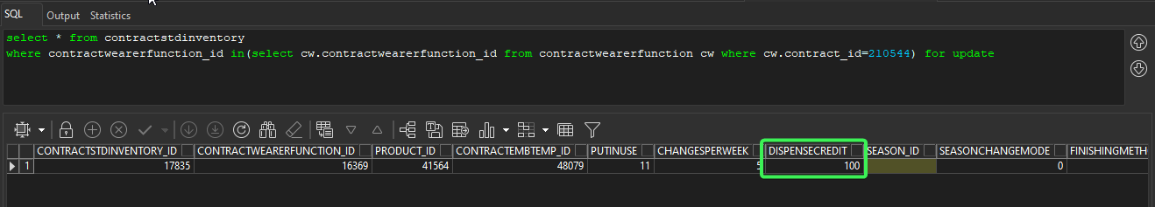
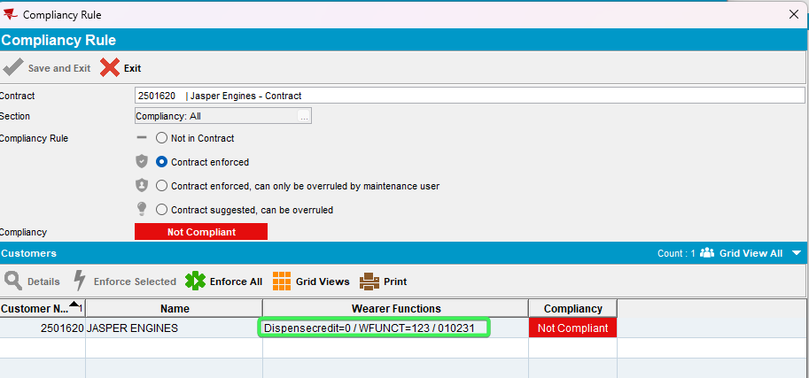
- Modify SEASONCHANGEMODE, reload the contract and load compliancy
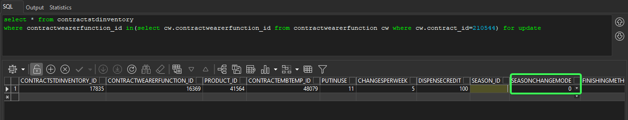
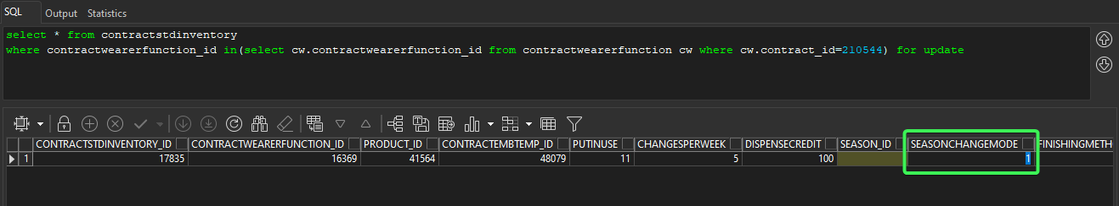
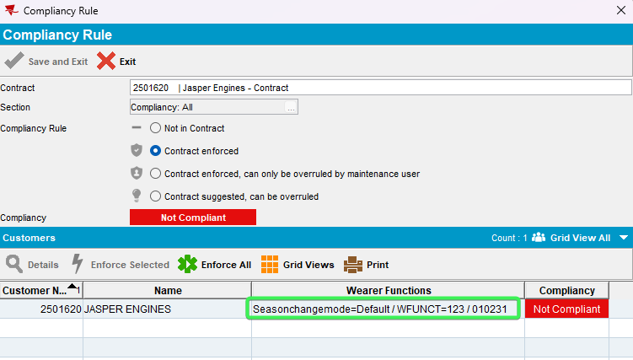
- Modify FINISHINGMETHOD, reload the contract and load compliancy
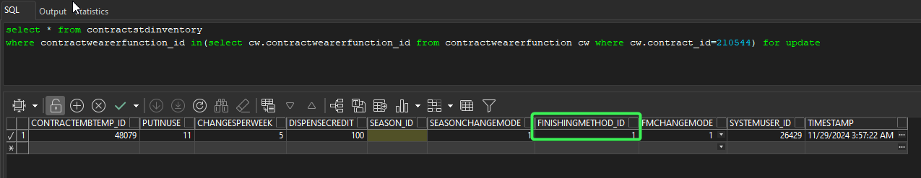
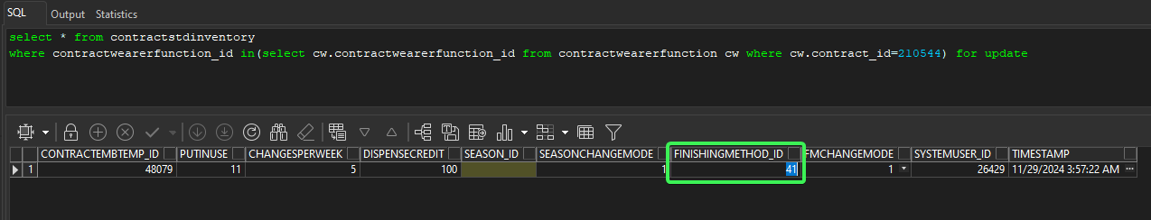
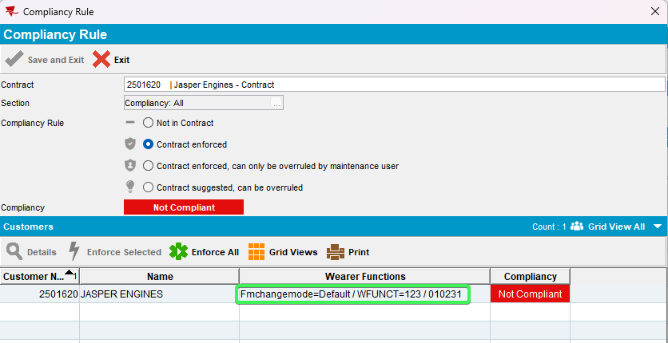
- Modify FMCHANGEMODE, reload the contract and load compliancy
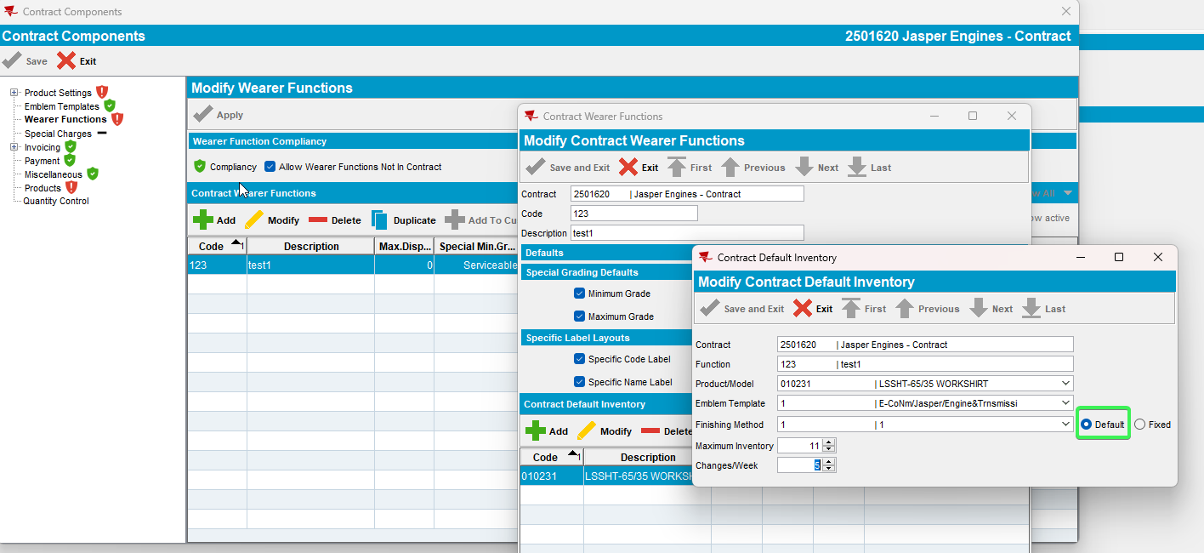
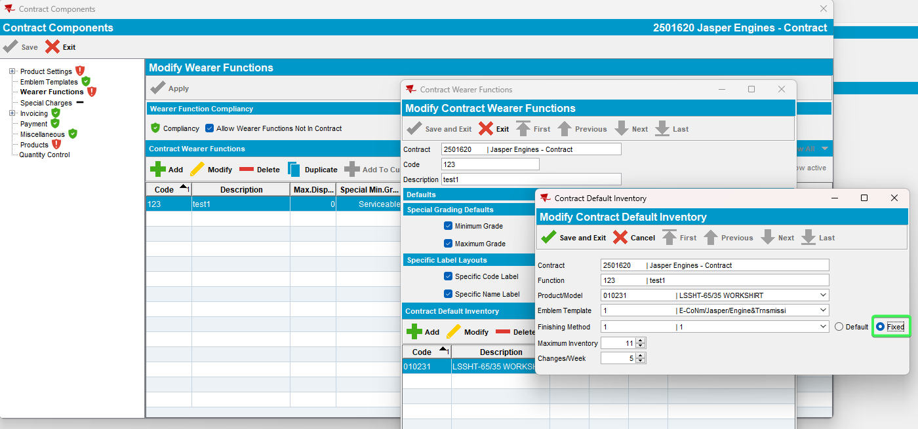
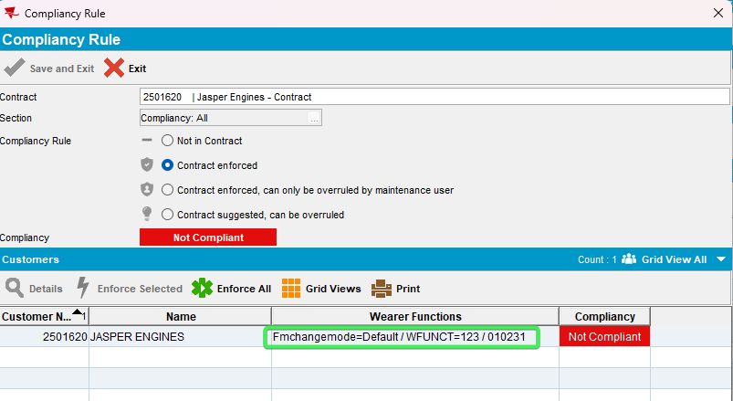

- Modify ContractDefWearerPrice.Price, reload the contract and load compliancy
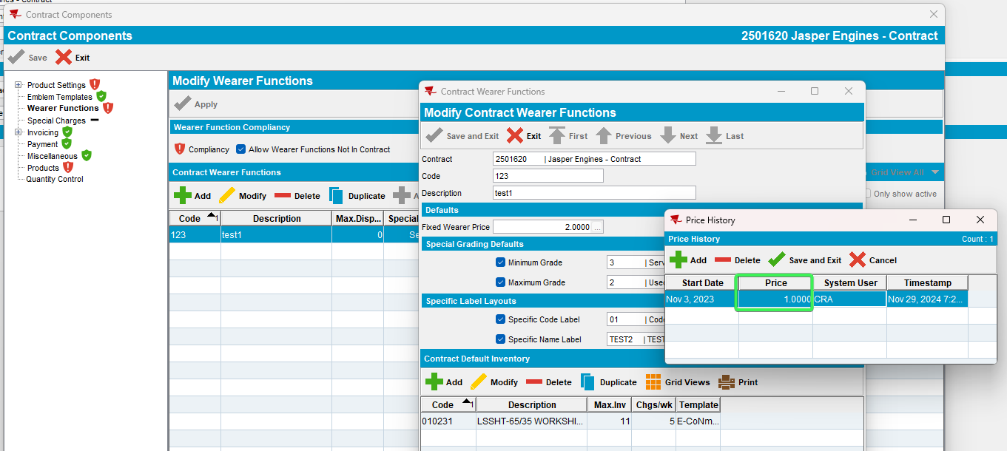
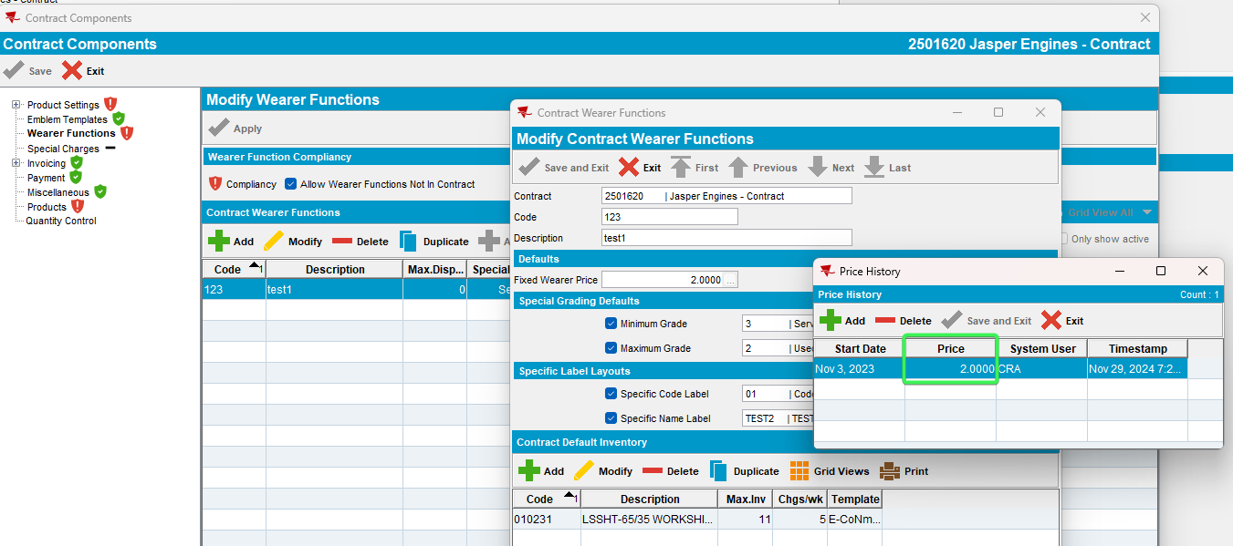
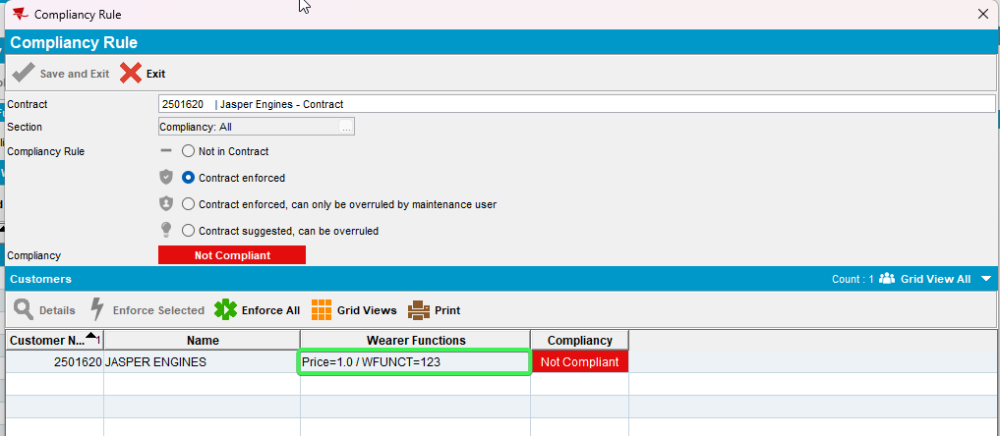
Tested OK

