ABS-152798 Loss Charge Monitor - Canceling a loss charge when there are multiple loss lines per wearer inventory

Environment | Prerequisites
Version:9.07.00  DBServerName=abs-SRV20.internal.abslbs.com  DBSID=CUST24  DBUser=UNFDEV  DBPassword=UNFDEV  Environment=Test | - Module:  - System setting

Contents
ABS-152798 Loss Charge Monitor - Canceling a loss charge when there are multiple loss lines per wearer inventory 1
Test after fix 1
Test Case 1 – Cancel the DOI charge– Tested OK 1
Test Case 2 – Cancel the Replacement charge– Tested OK 8

Test after fix

Test Case 1 – Cancel the DOI charge– Tested OK
Expected behavior: When we have 2 loss charges in the loss charge monitor for the same Wearer Inventory, canceling only one of the loss charges will still allow the other one to get billed on the next week's invoice.
Hash: 4f968a8
- Wearer dlg: Select a wearer inventory and make a reduction of the max inventory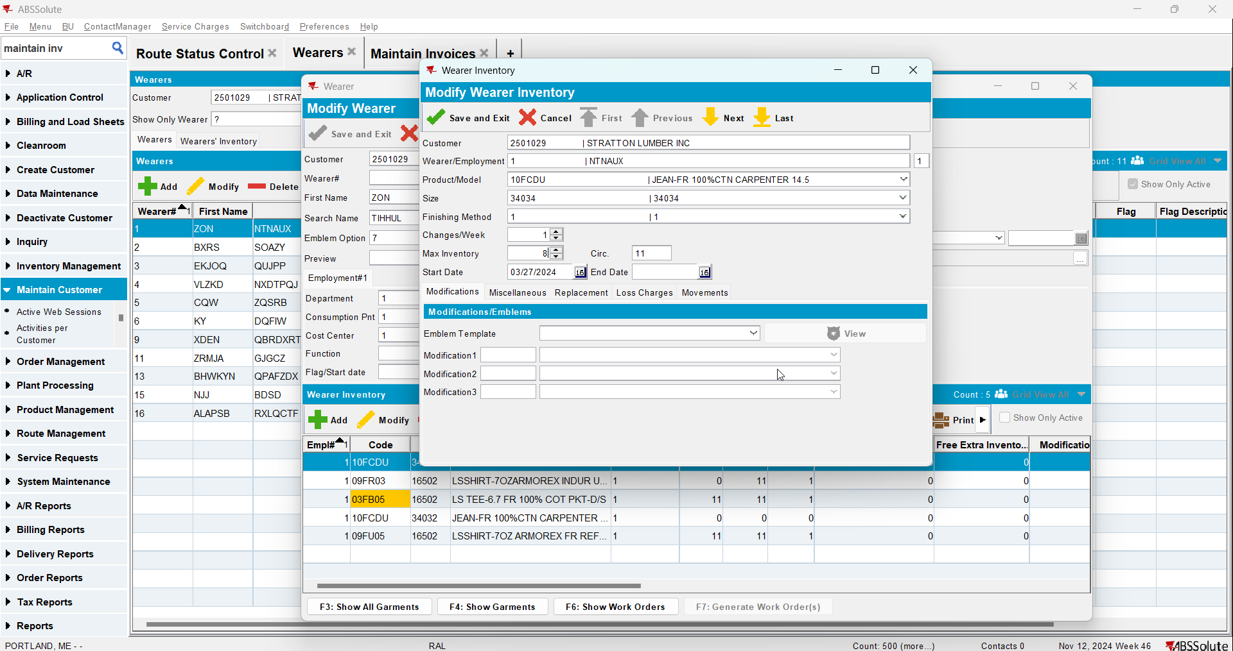
- Replace 2 garments from the same wearer inventory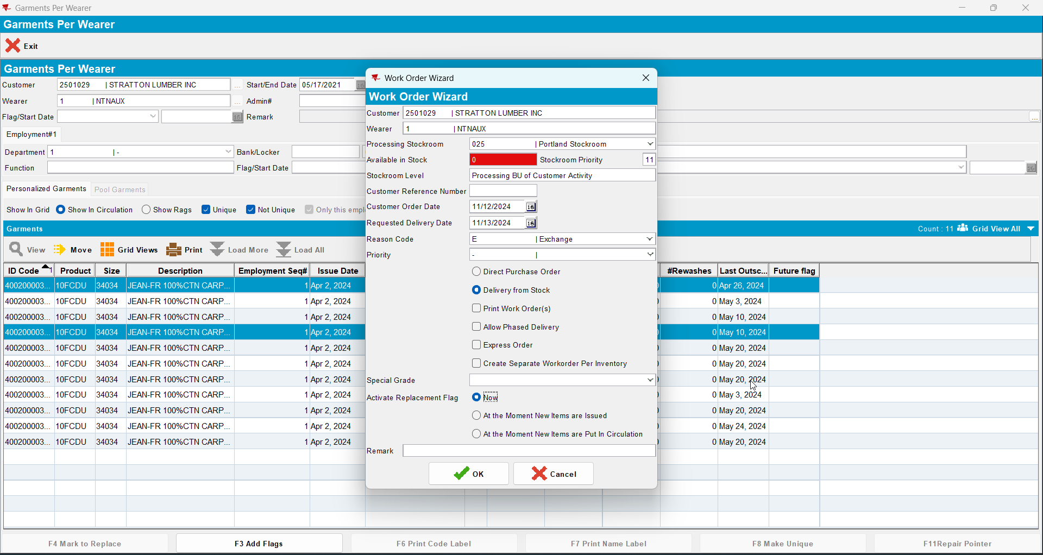
- RSC: Add a new route with a driving date 2 weeks after today's date and generate invoices for it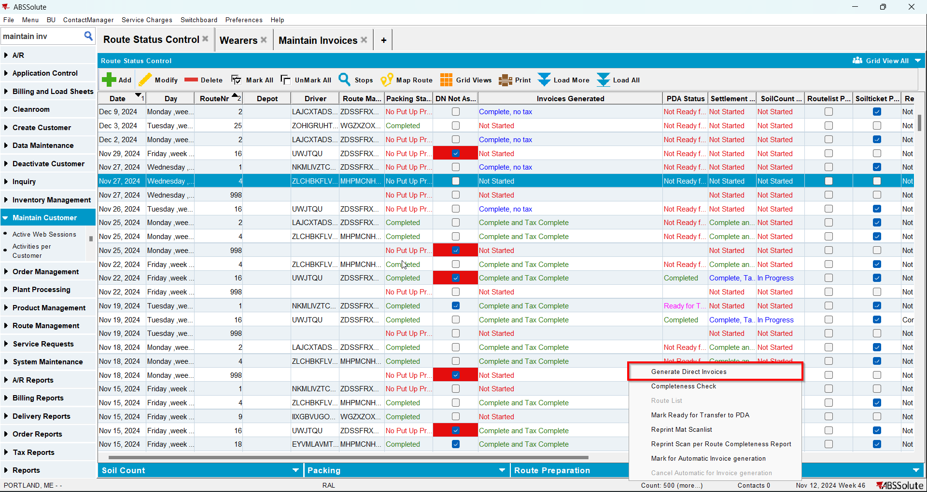
- Check the invoice to see if appear those two lines for loss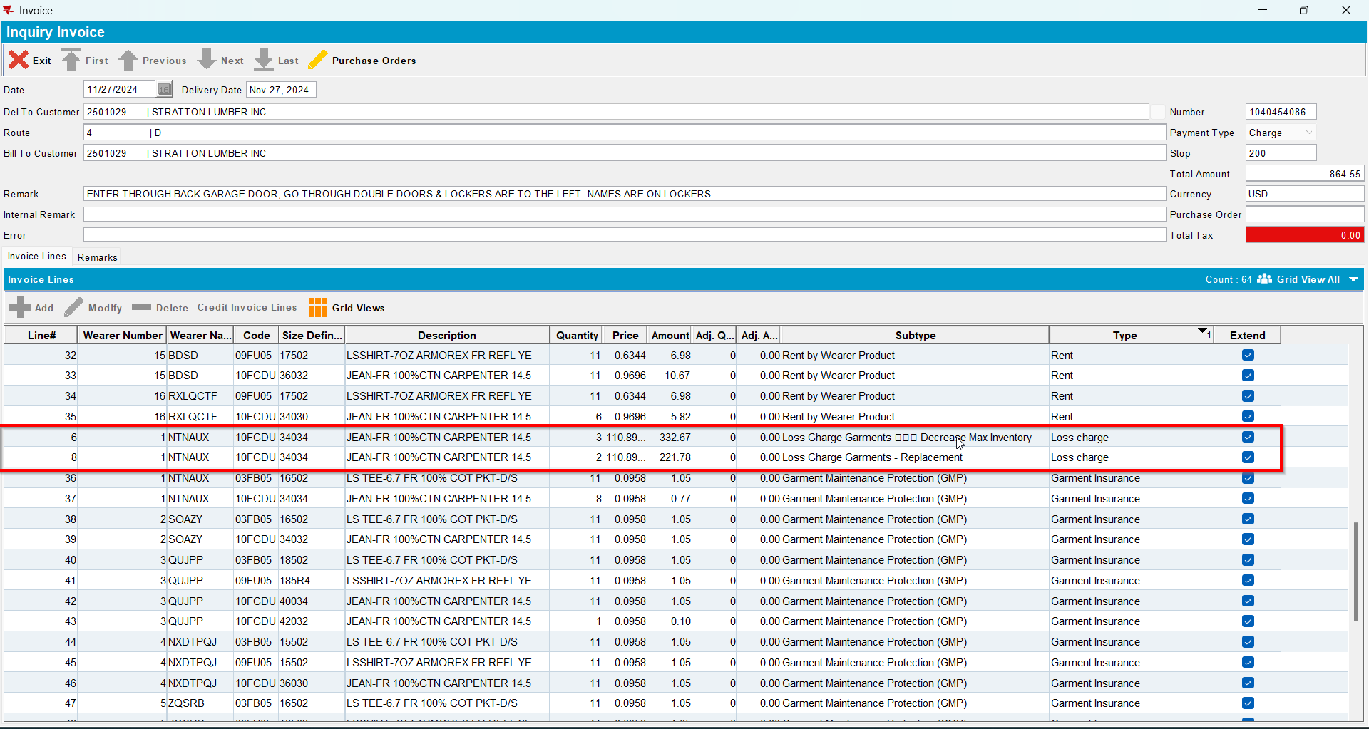
- RSC-> Settlement-> Adjust both loss lines to zero qty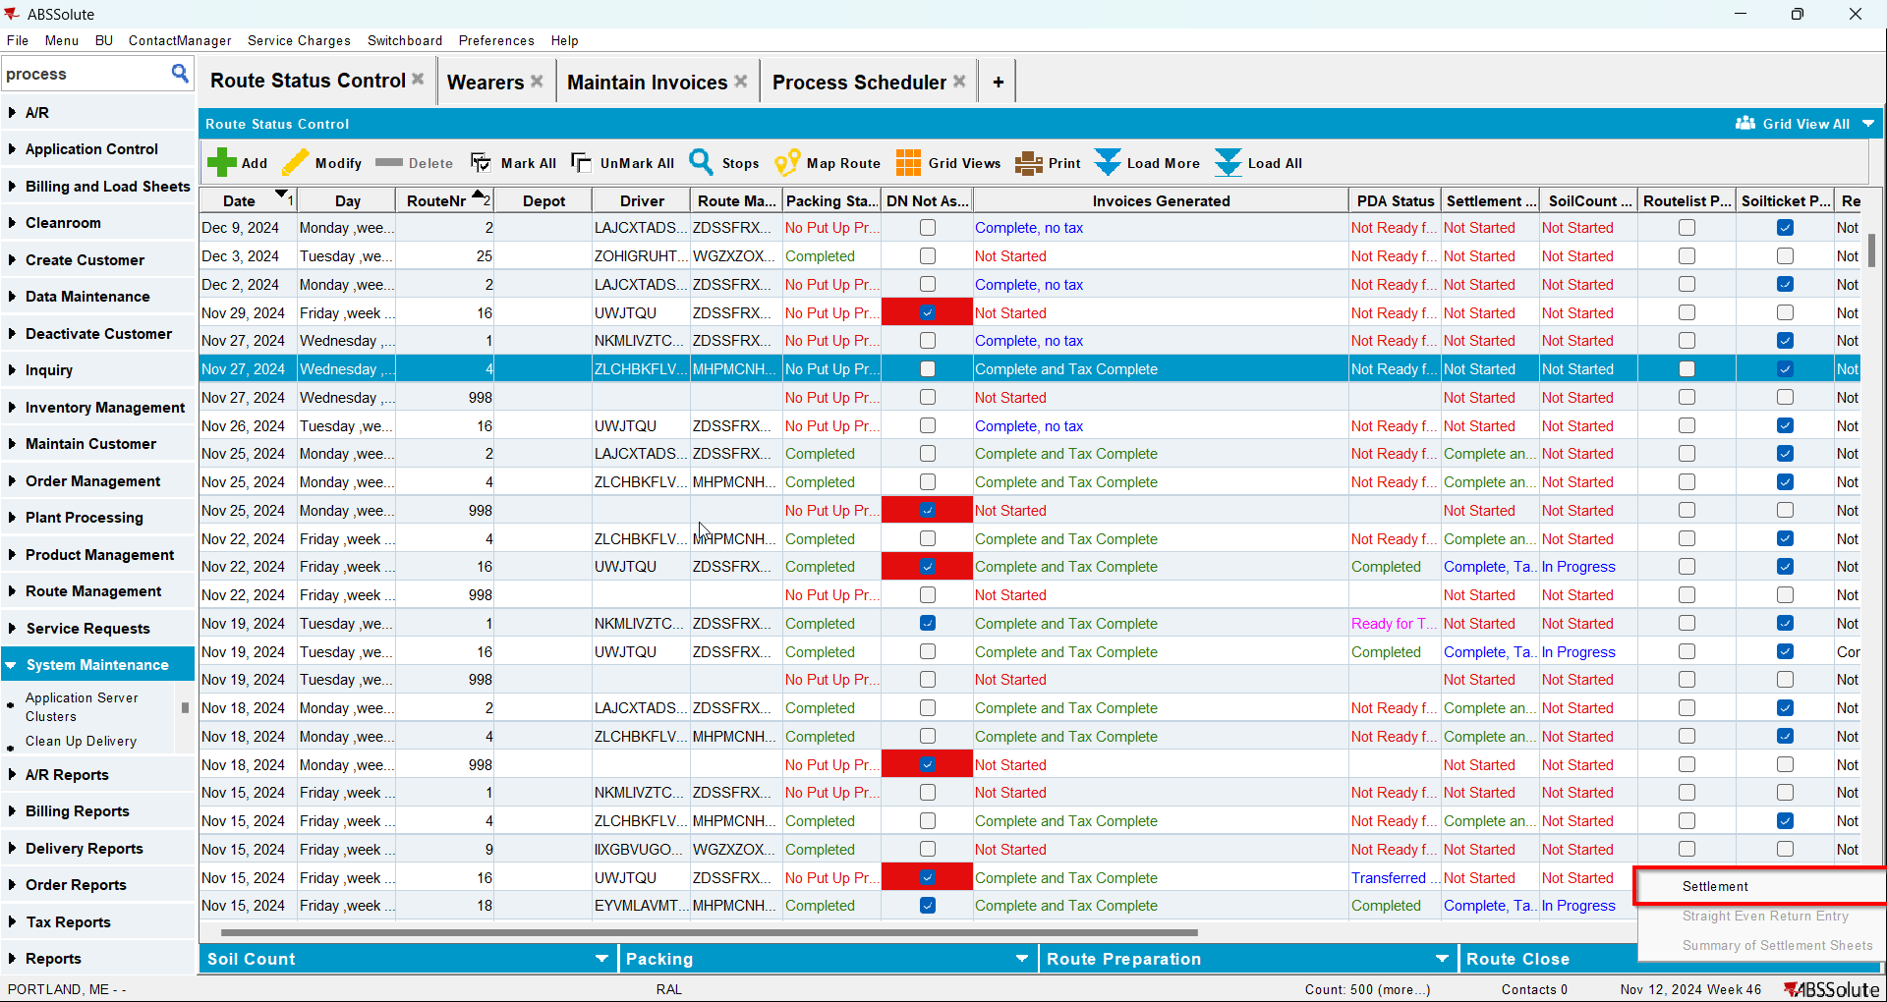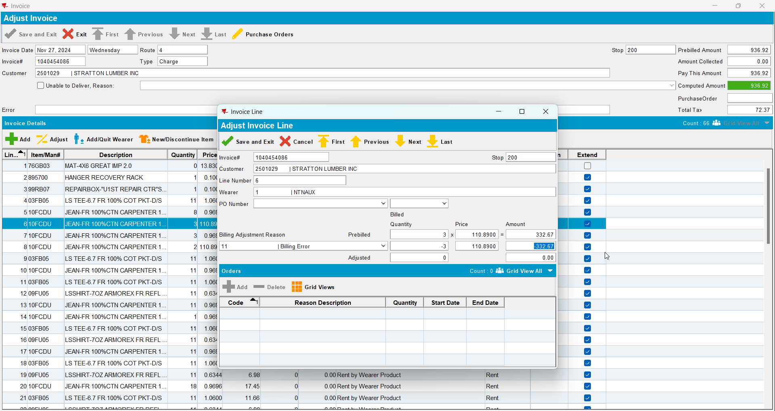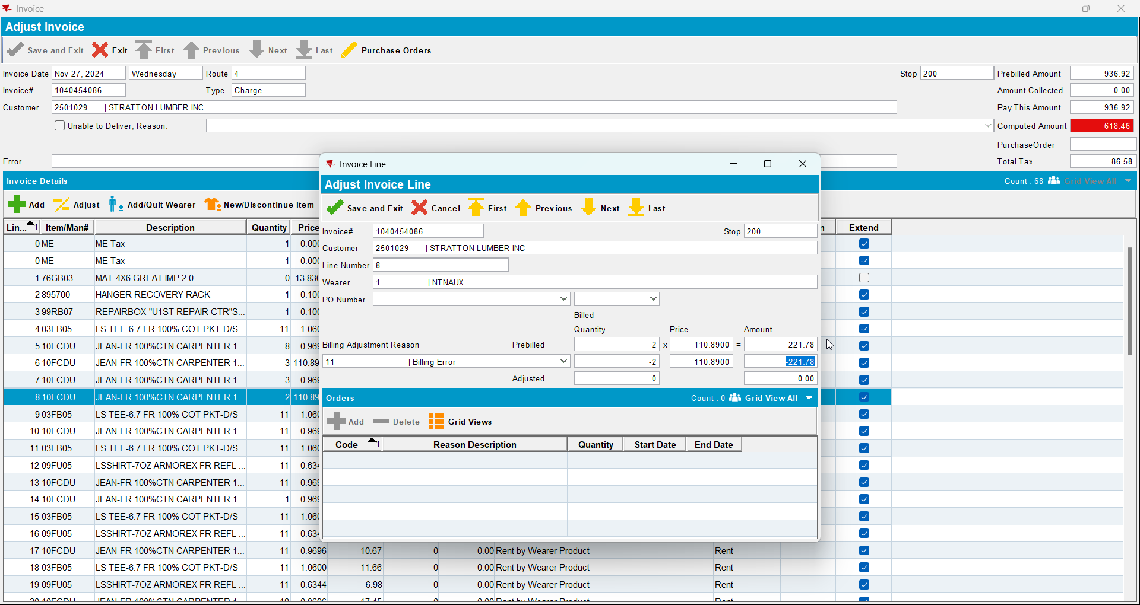
- Settle the route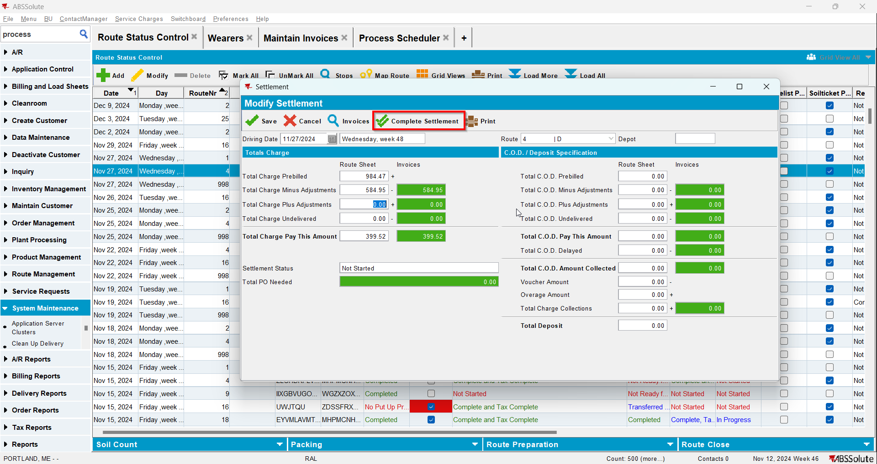
- Check data in Loss Charge Monitor - verify that now both lines appear for every loss charge type.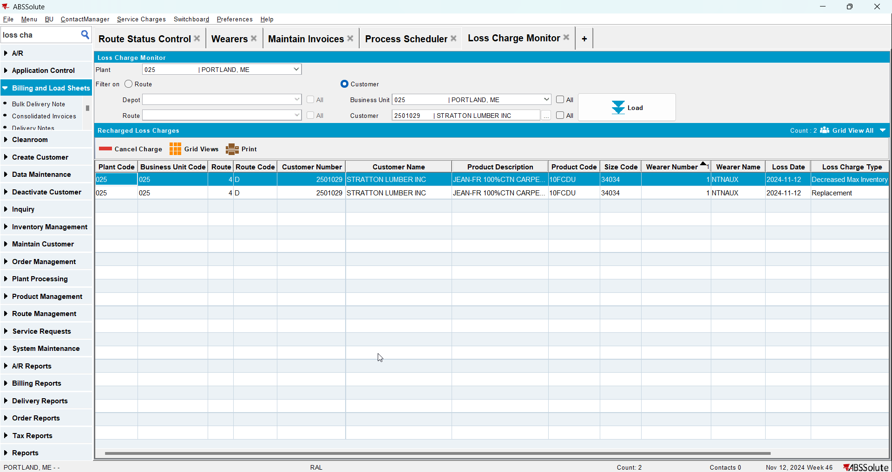
- Cancel the DOI Loss Charge but not the Replacement one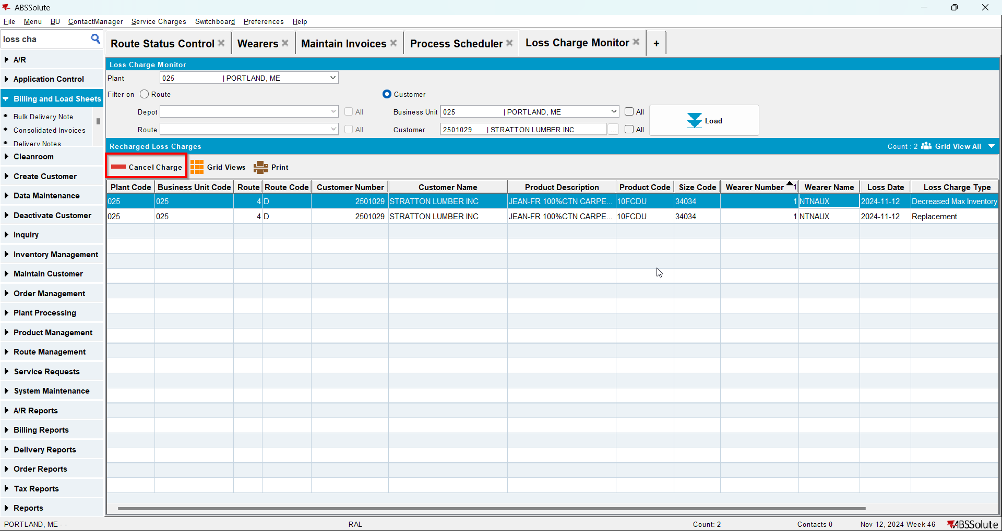
- RSC-> Add a new route for the same customer for the next week after the one from step 3
- RSC-> Generate invoices for said route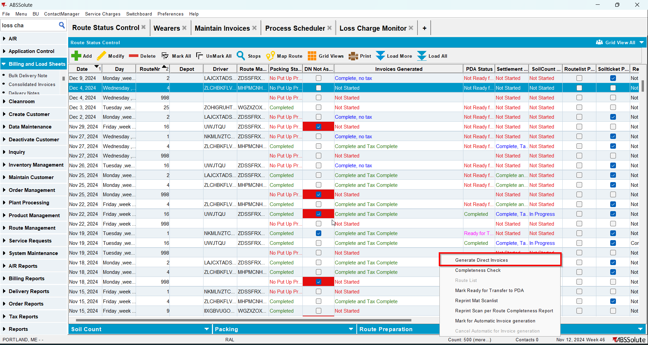
- Maintain Invoices DLG: Notice that the DOI loss charge does not appear on the invoice but the Replacement Loss charge does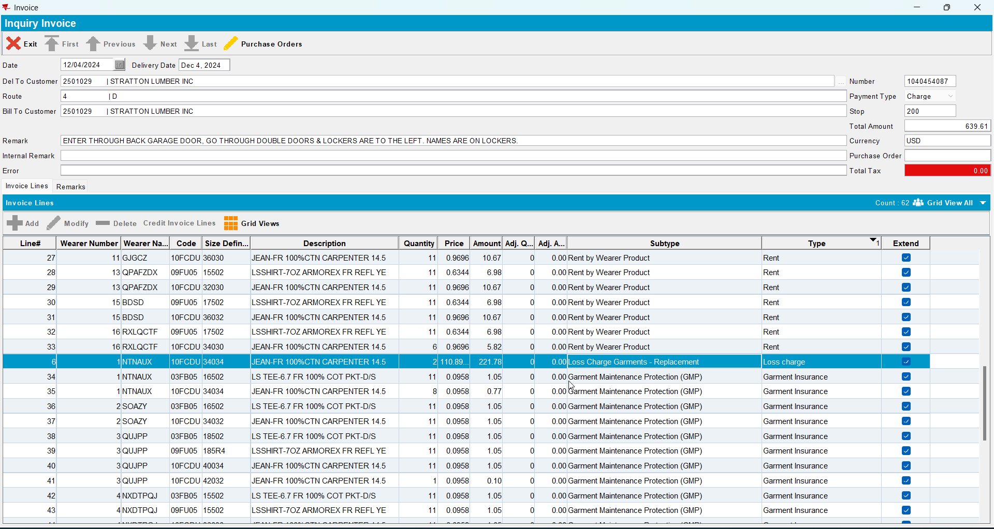

Test Case 2 – Cancel the Replacement charge– Tested OK
Expected behavior: When we have 2 loss charges in the loss charge monitor for the same Wearer Inventory, canceling only one of the loss charges will still allow the other one to get billed on the next week's invoice.
Hash: 4f968a8
- Wearer dlg: Select a wearer inventory and make a reduction of the max inventory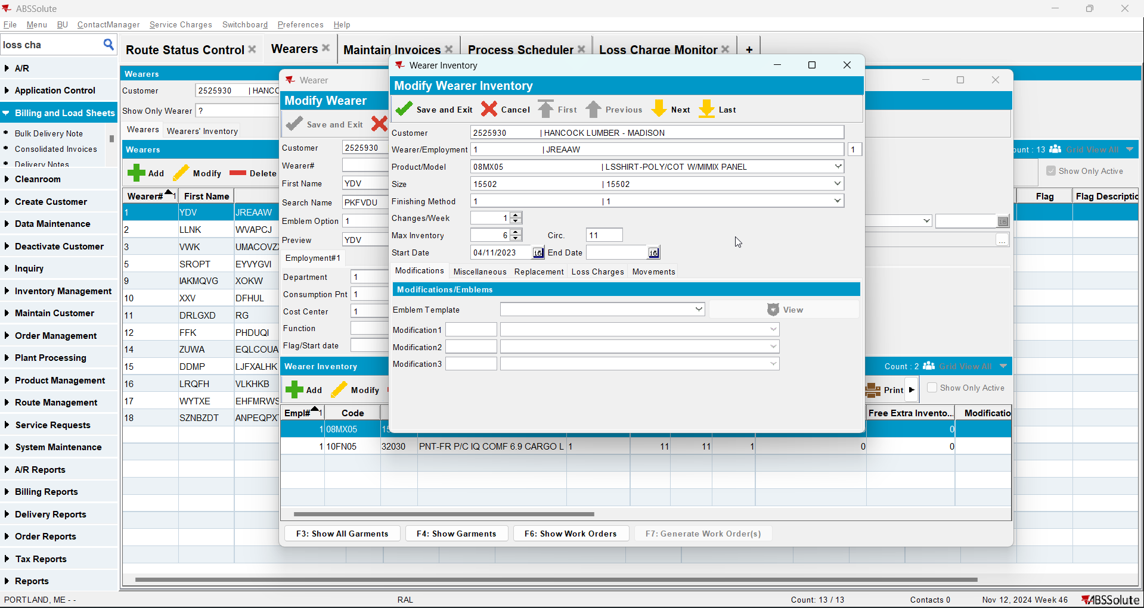
- Replace 2 garments from the same wearer inventory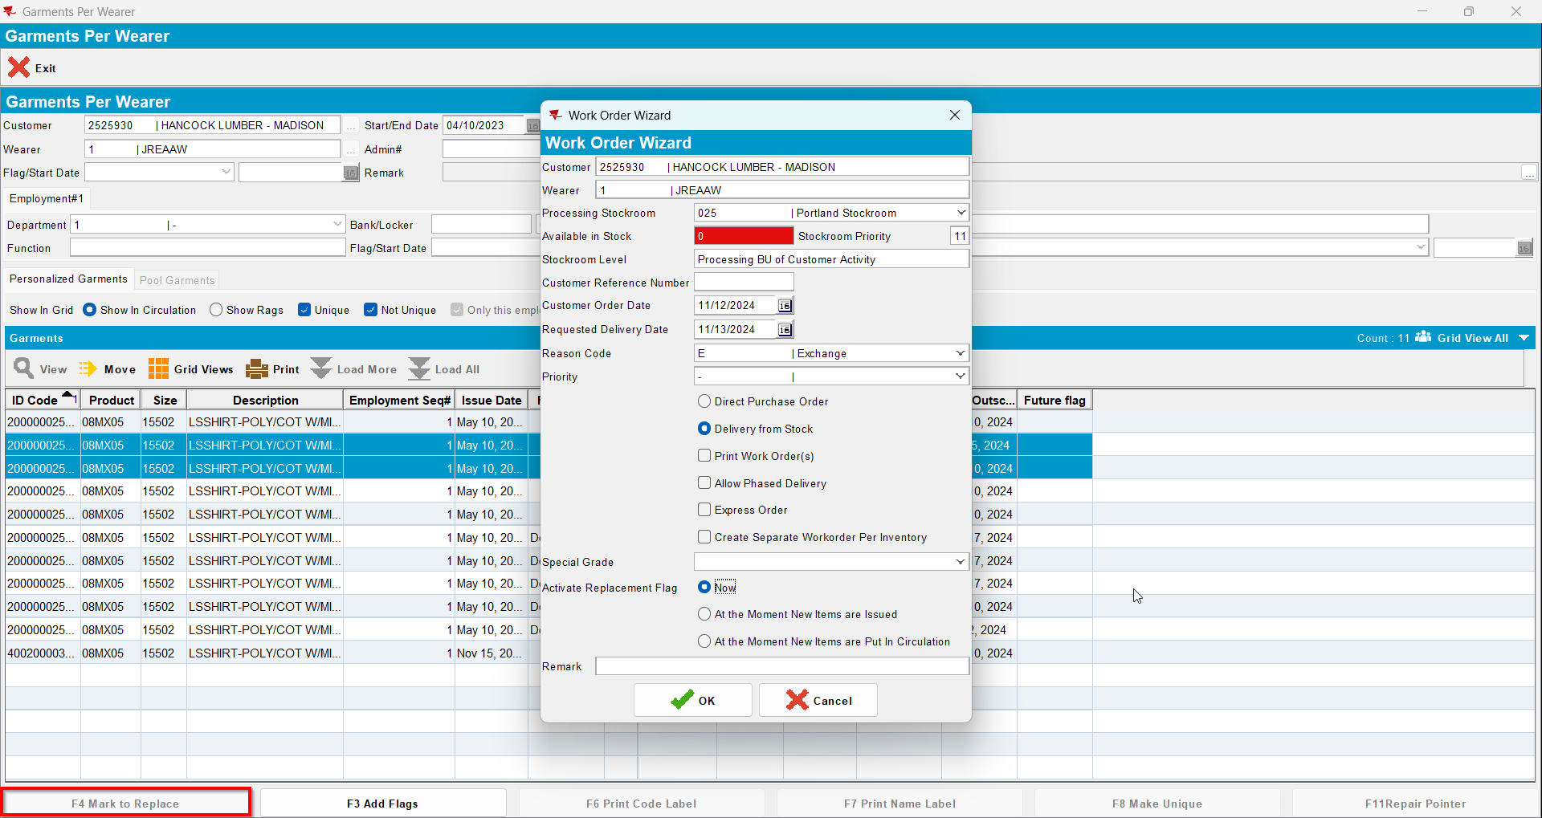
- RSC: Add a new route with a driving date 2 weeks after today's date and generate invoices for it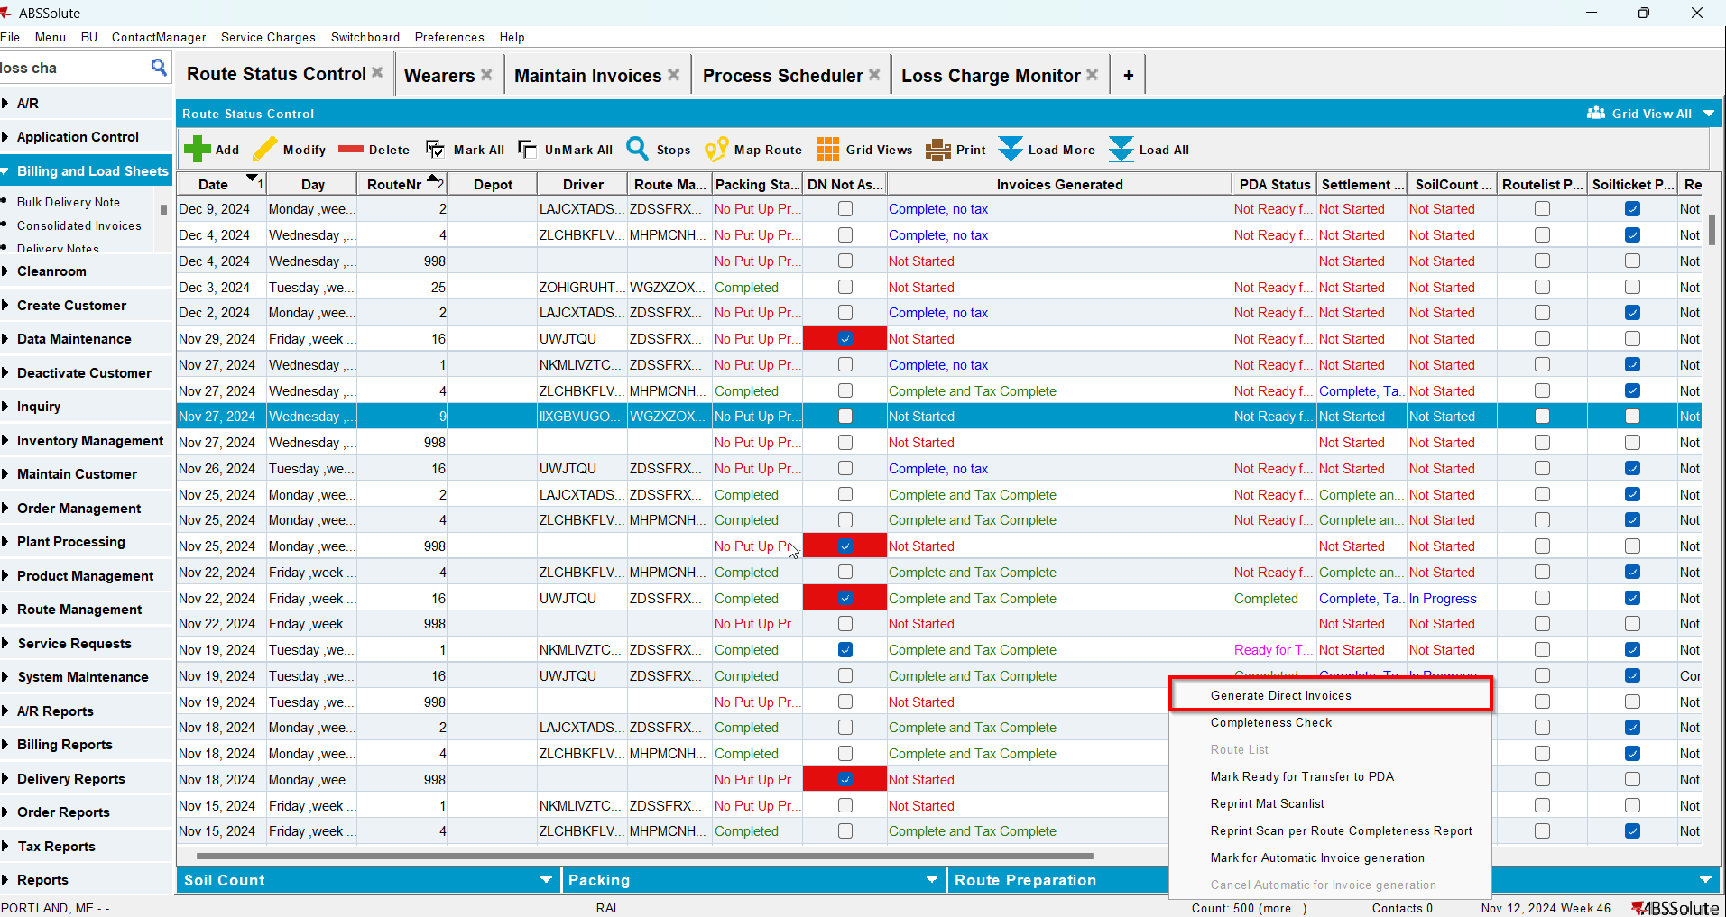
- Check the invoice to see if appear those two lines for loss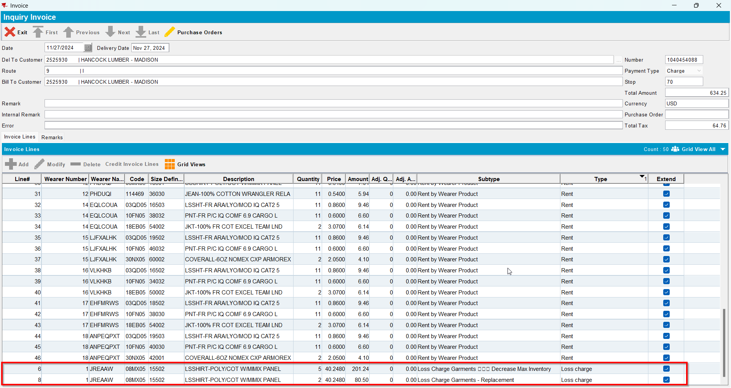
- RSC-> Settlement-> Adjust both loss lines to zero qty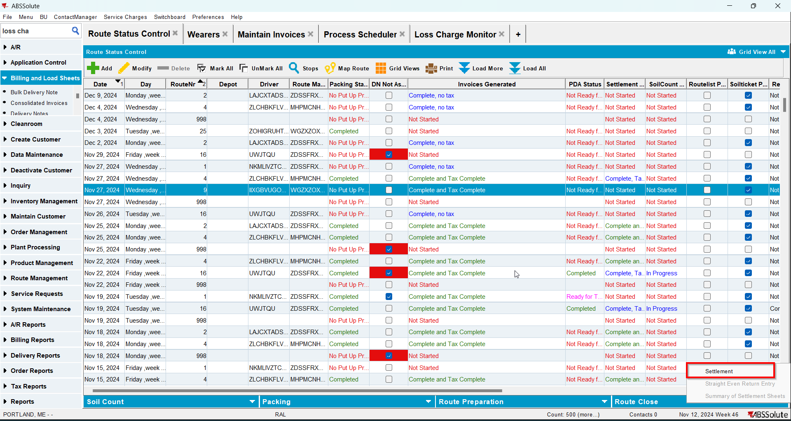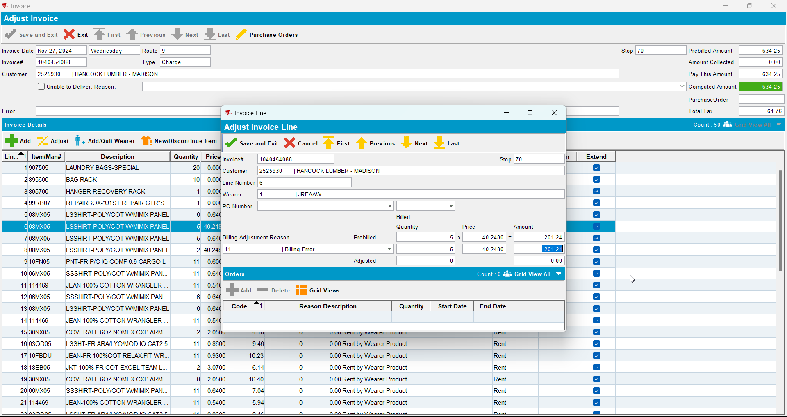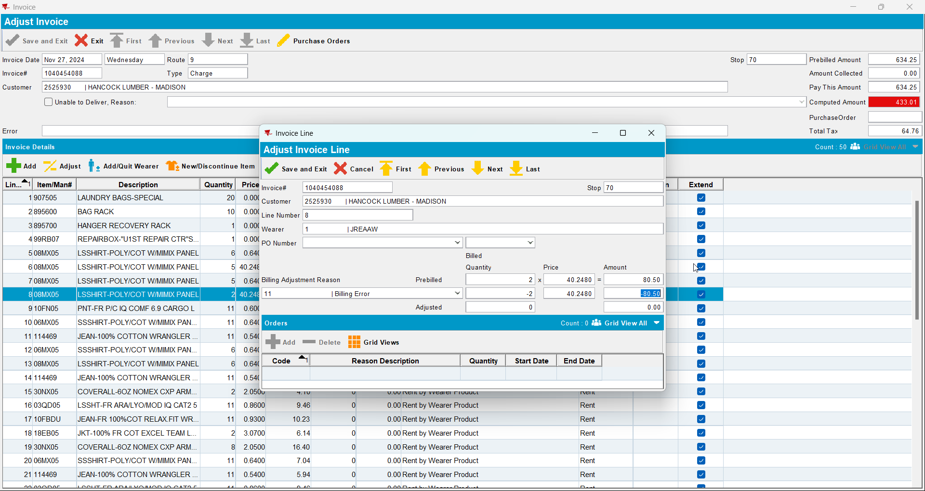
- Settle the route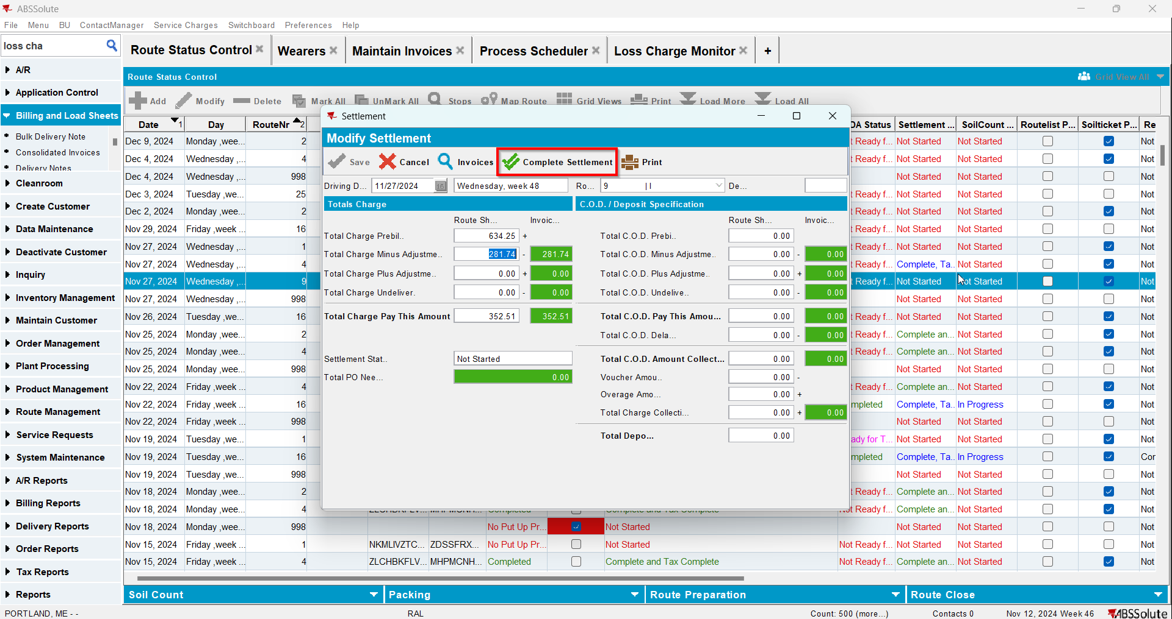
- Check data in Loss Charge Monitor - verify that now both lines appear for every loss charge type.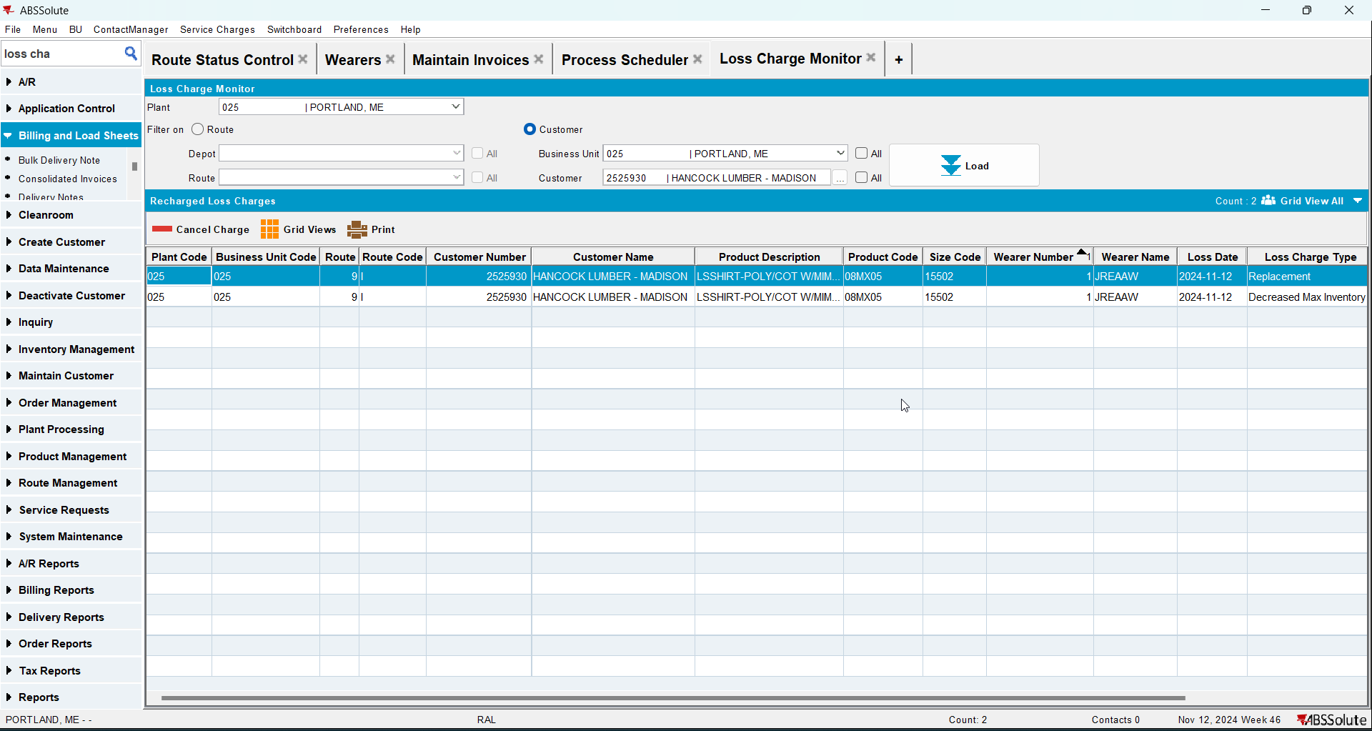
- Cancel the Replacement Loss Charge but not the DOI one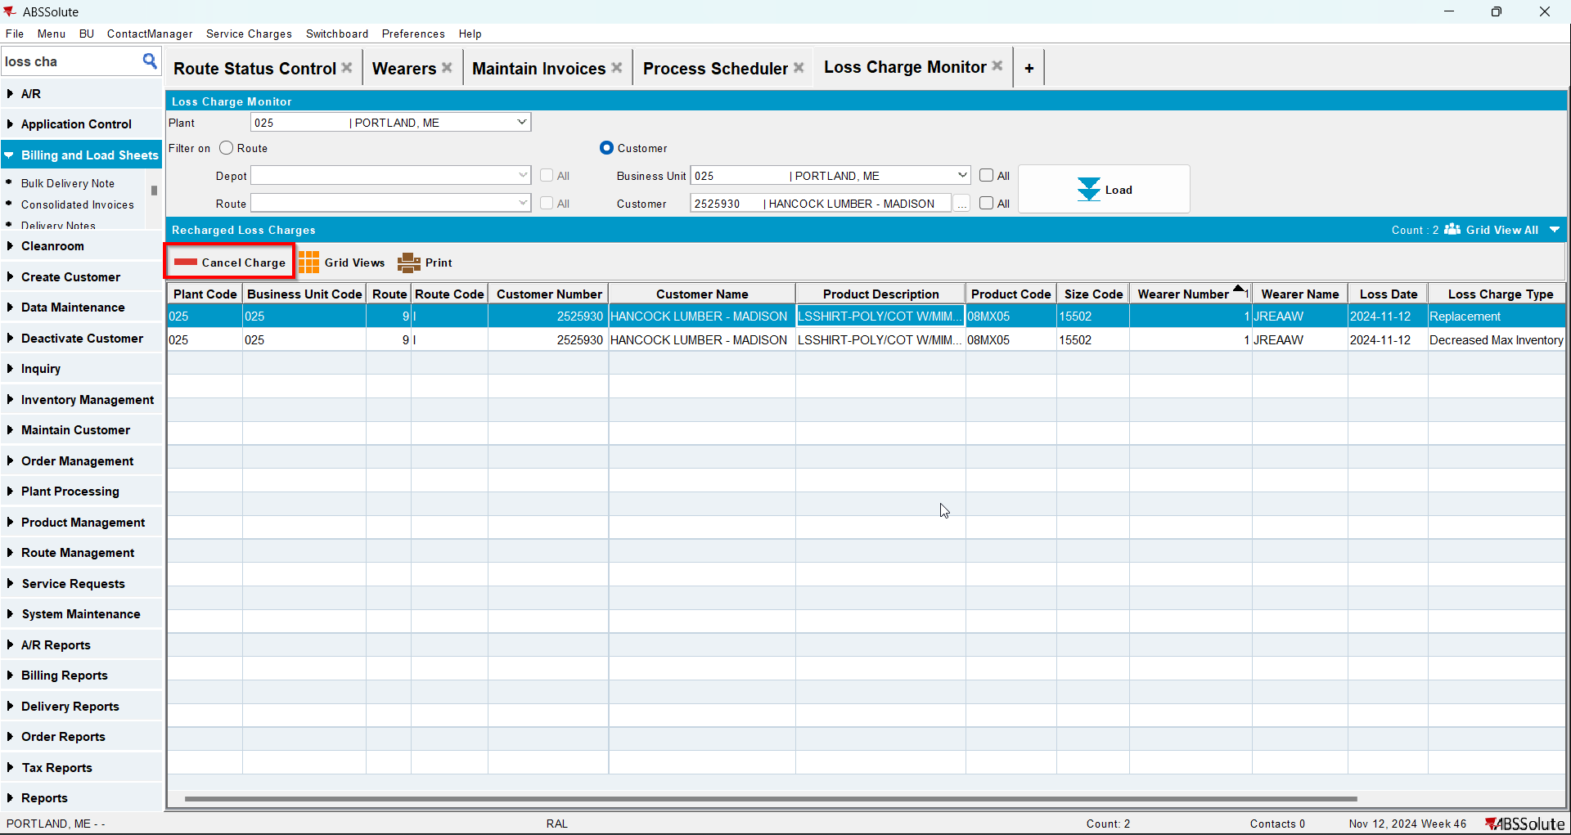
- RSC-> Add a new route for the same customer for the next week after the one from step 3
- RSC-> Generate invoices for said route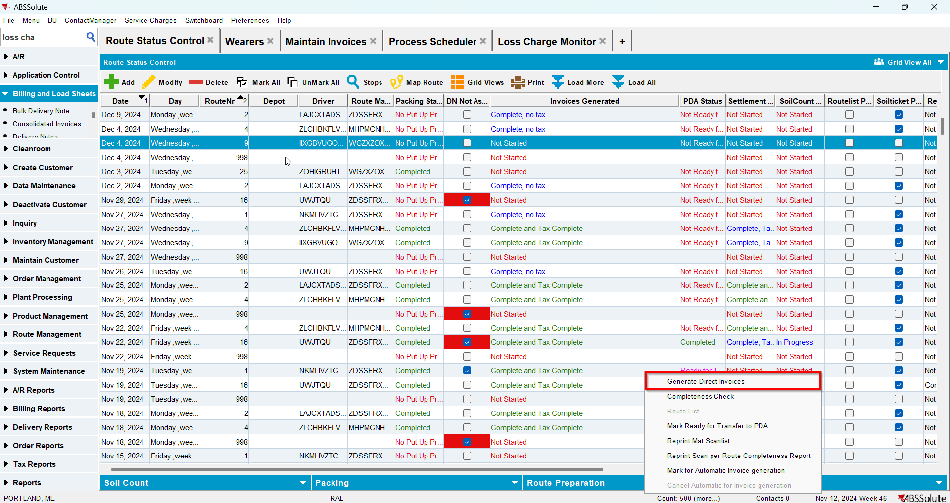
- Maintain Invoices DLG: Notice that the Replacement loss charge does not appear on the invoice but the DOI Loss charge does