ABS-151284 ORA-01407 cannot update (ABSSOLUTE.CUSTOMERBILLINGINFO.PAYMENTTERMS_ID) to NULL
Environment | Prerequisites
Version:9.07.00.UNF18  DBServerName= abs-srv20.internal.abslbs.com  DBSID=CUST22  DBUser=UNFDEV  DBPassword=UNFDEV  Environment=PRODUCTION | - Module:  - System setting:

Contents
Reproduction before fix 1
Test steps: 1
Current Behavior 6
Expected Behavior 6
Retest after fix 6
Expected Behavior: 6
Test steps: 6

Reproduction before fix
Bu: 025 Portland, ME
9.07.04.RC1 hash: ce157cfa51db

Steps to reproduce:
- Contract dlg: Load a contract which has Payment Terms blank.
- Contract dlg: Compliancy update the condition to a linked customer of the contract.
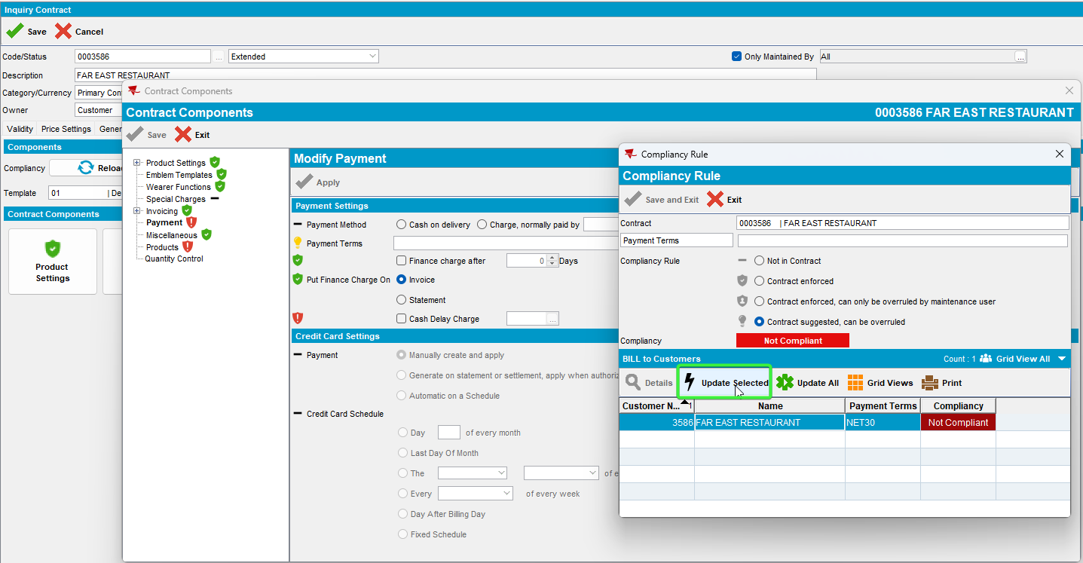

- Check the ServerErrorLog file.
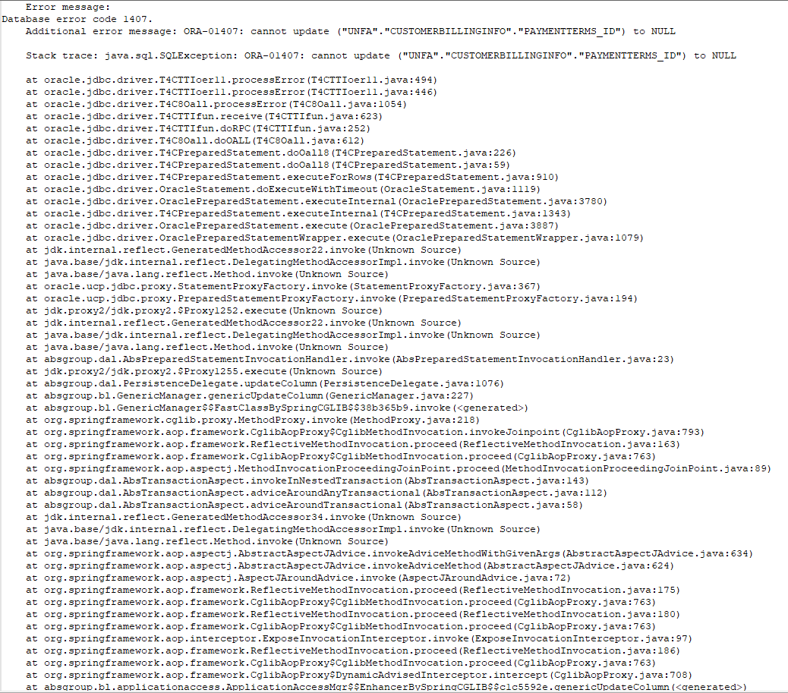

Current behavior:
Database error code 1407 will be logged in the ServerErrorLog file
Expected Behavior:
No database errors should be present.
REPRODUCED OK

Retest after fix
Bu: 025 PORTLAND, ME
9.07.00.UNF18 hash: 74876ebbc89f
Expected Behavior:
AUTOSOILQUANTITY should be re-calculated when the inactivedate of the SDL is changed to

Test steps:
- Contract dlg: Load a contract which has Payment Terms blank.
- Contract dlg: Compliancy update the condition to a linked customer of the contract.

- Check the ServerErrorLog file.
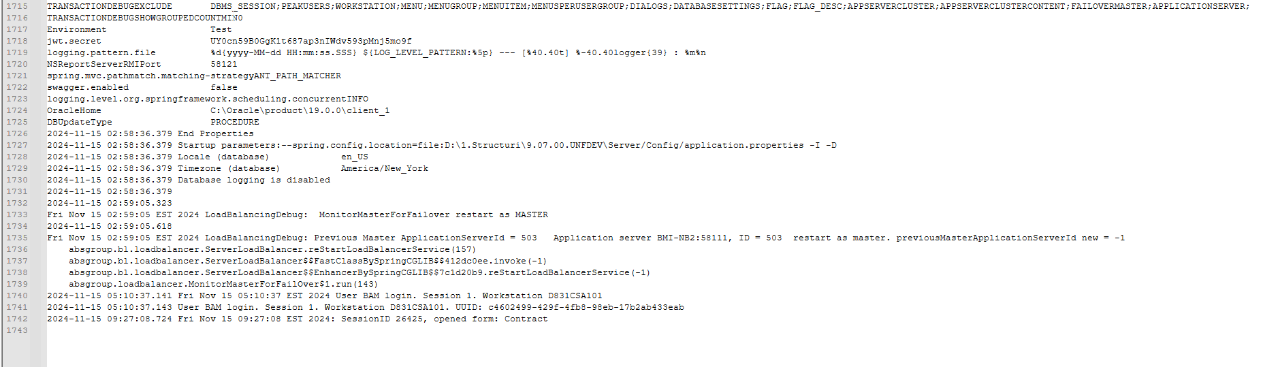
- Contract dlg: Click on Update all.
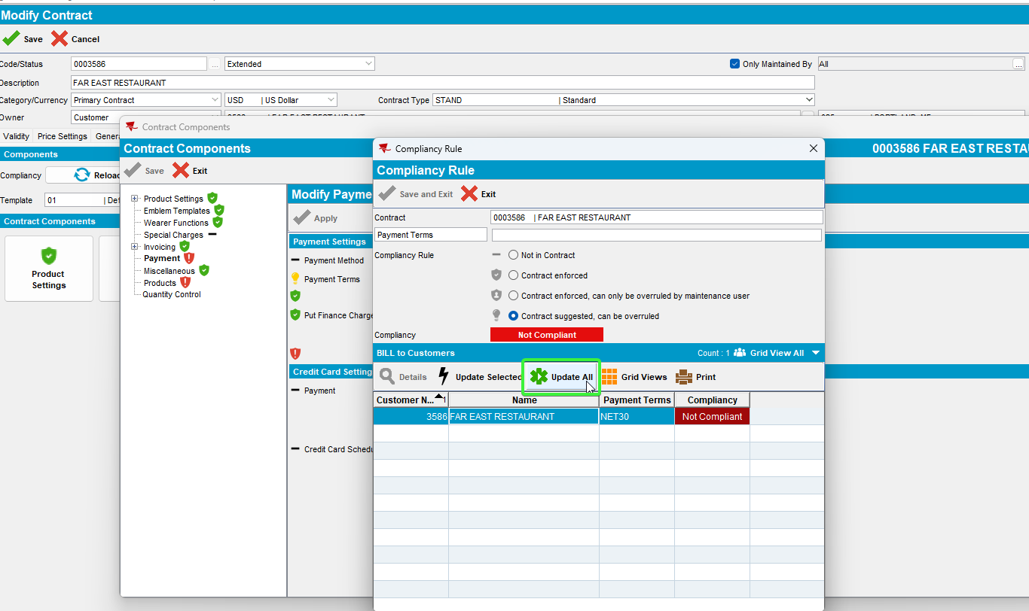
- Check the ServerErrorLog file.
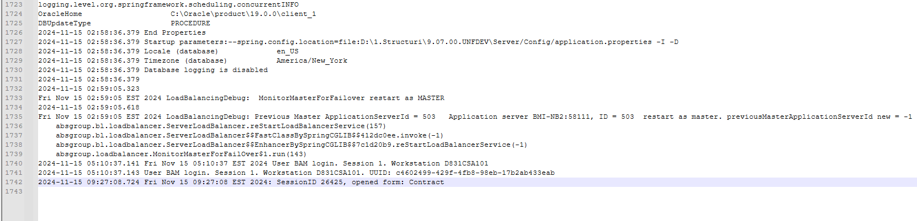
- Contract dlg: Select a payment term and update the compliancy on customer.
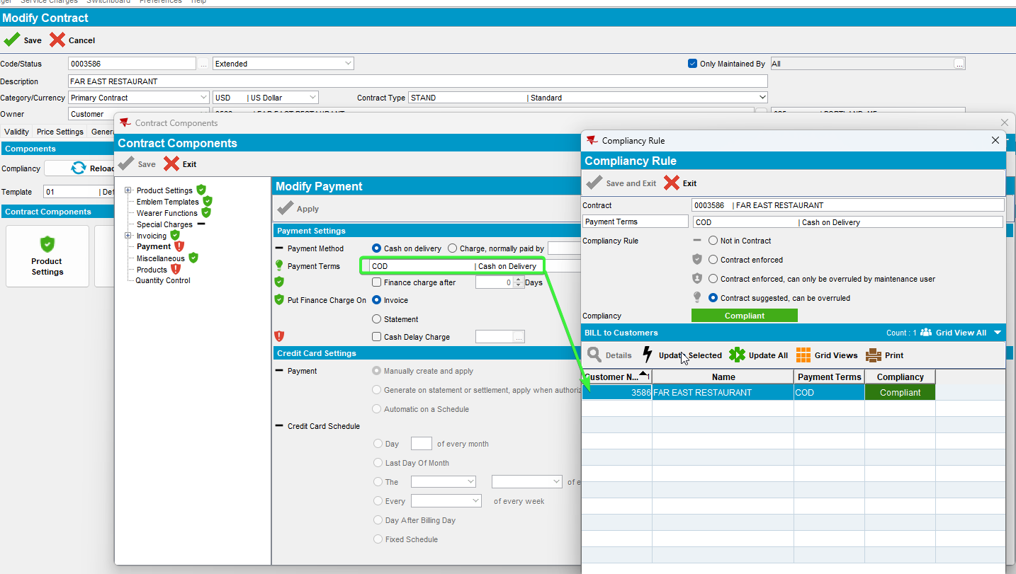
- Check the ServerErrorLog file.
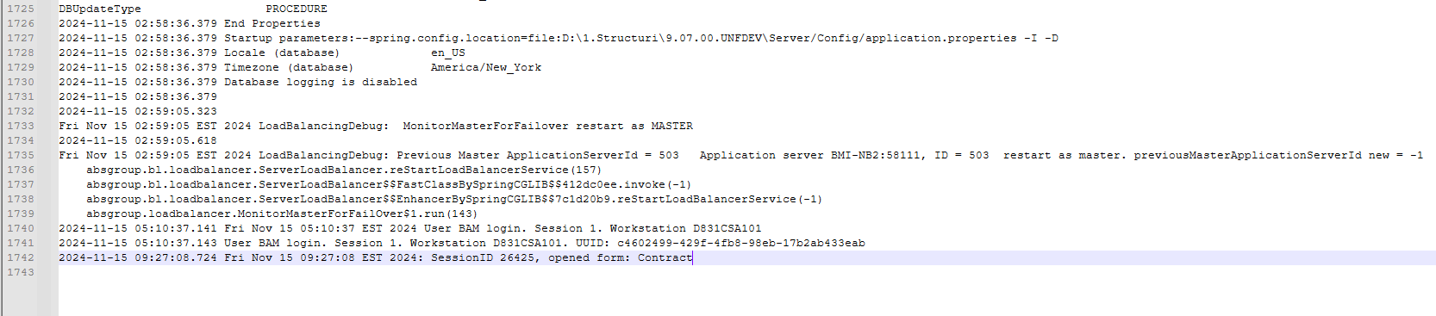
- Customer dlg: Load the customer linked to the contract and check that the payment term was updated.
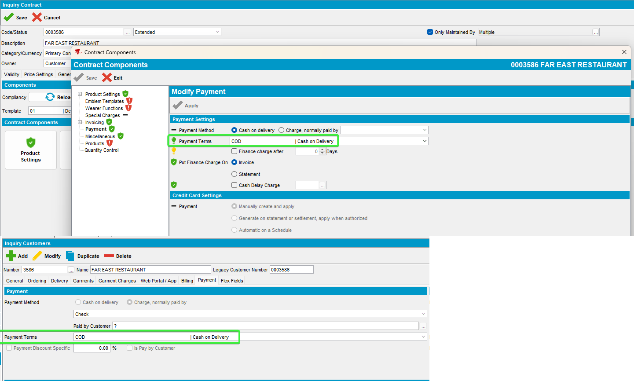
- Contract dlg: Change the payment term to a different option and update
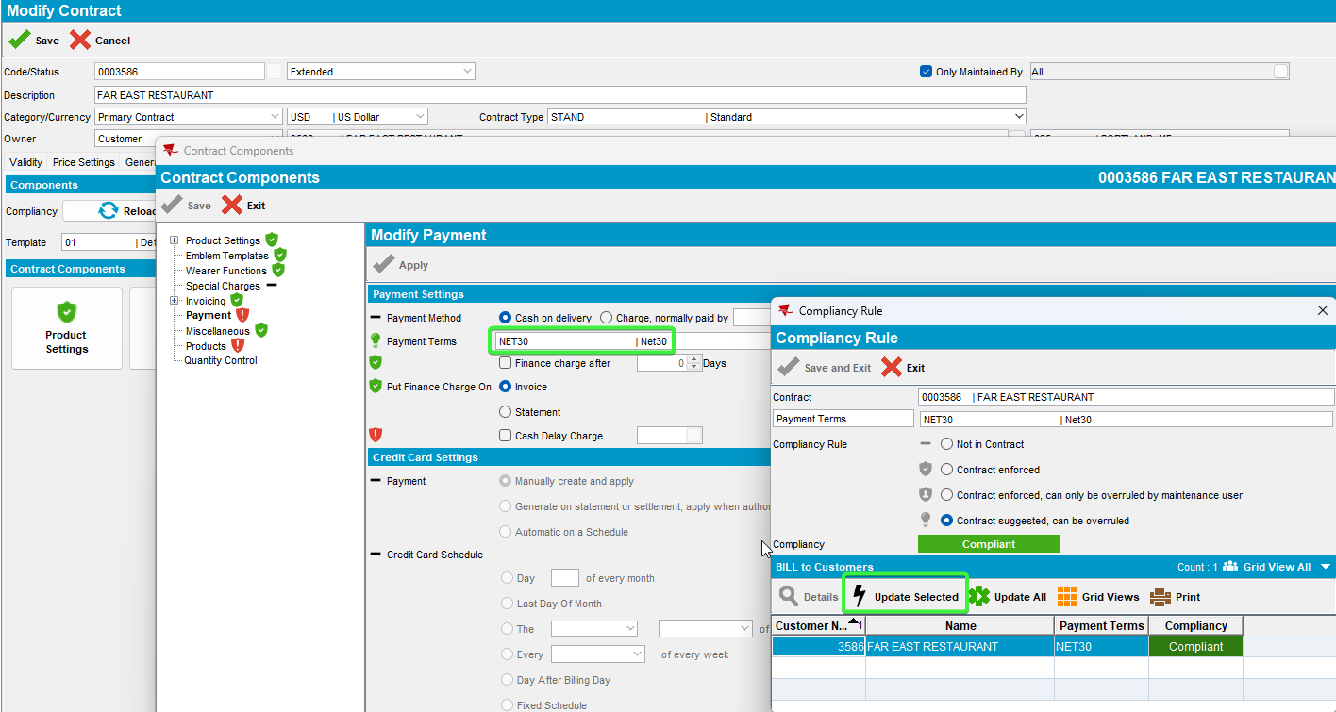
- Check the ServerErrorLog file.
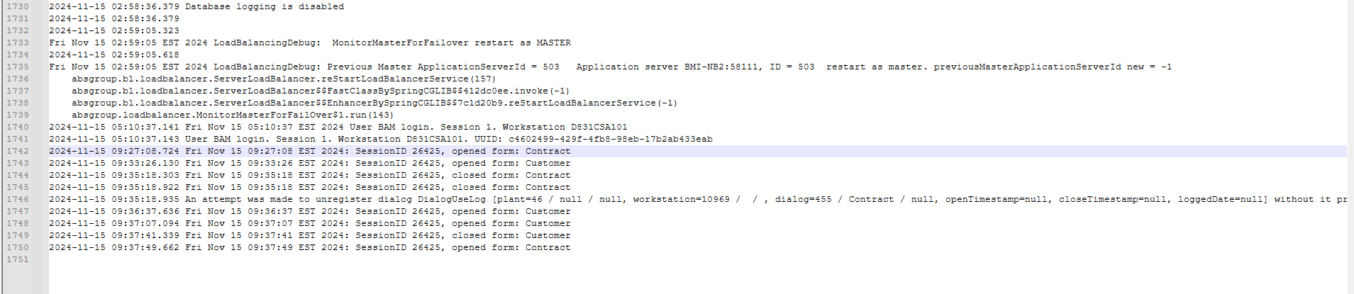

- Customer dlg: Load the customer linked to the contract and check that the payment term was updated.
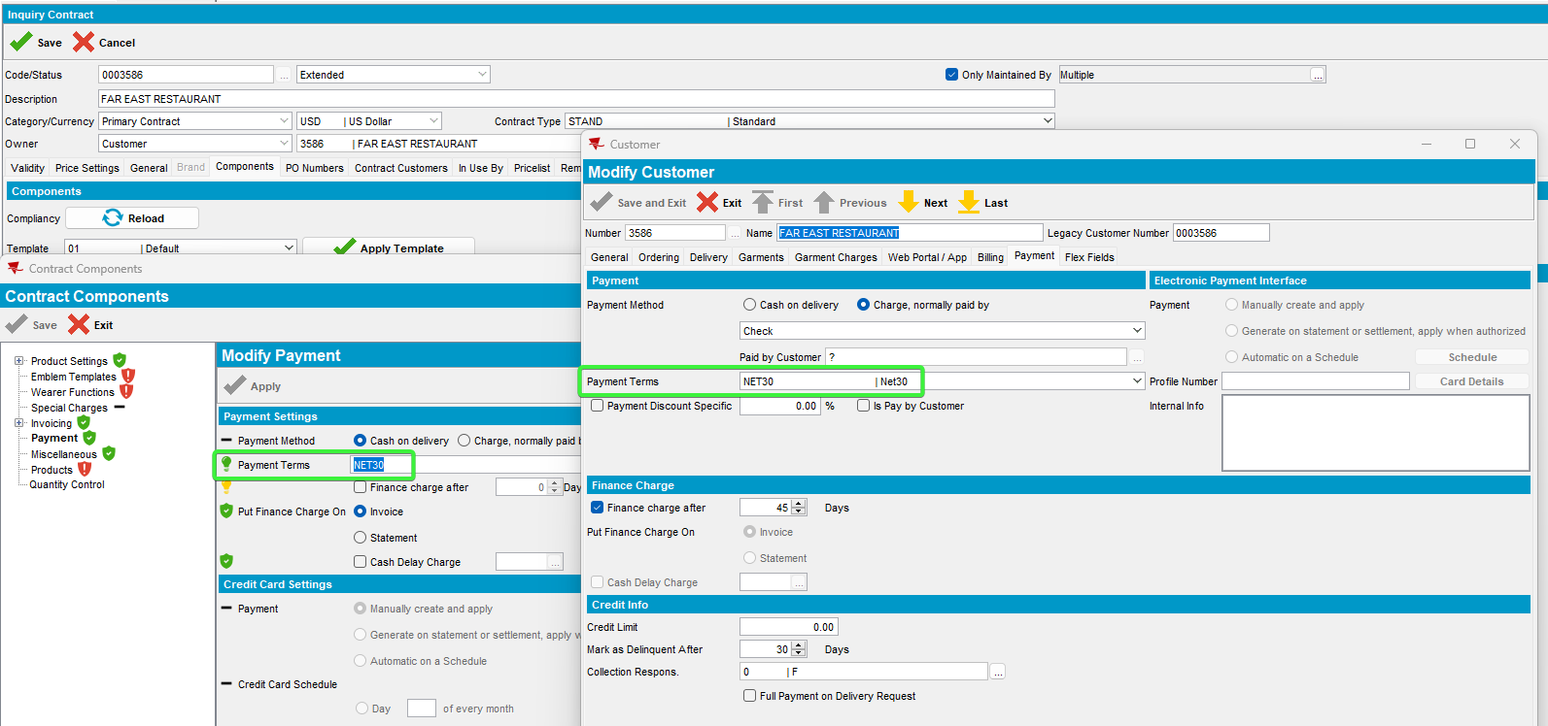
Tested OK

