ASD-54743 D_UBS_2058 Bill for loss now on extended N, DOI mixed inventory not ragging correctly and wrong flag
Environment | Prerequisites
Version:9.07.00.UNF18  DBServerName=abs-srv20.internal.abslbs.com  DBSID= CUST24  DBUser= UNFDEV  DBPassword= UNFDEV  Environment=Production | - Module:  - System setting

Contents
Reproducing before fix 1
Steps to reproduce 1
Expected behavior 4
Retest after fix 5
Test Case 1 - Bill for loss now on extended N, DOI mixed inventory 5
Steps to reproduce 5
Test Case 2 - Bill for loss now on extended N, DOI only unique inventory 10
Steps to reproduce 10
Test Case 3 - Bill for loss now on extended N, DOI only non-unique inventory 15
Steps to reproduce 15

Reproducing before fix
9.08.02.RC1 hash: 57c198fa0174
BU: 044

Steps to reproduce
- Wearers dlg: Find a customer with wearers that have mixed unique and non-unique garments on wi.
- Wearers dlg: Do a decrease of max for more than the non unique count (so unique and non unique get flagged DOI)
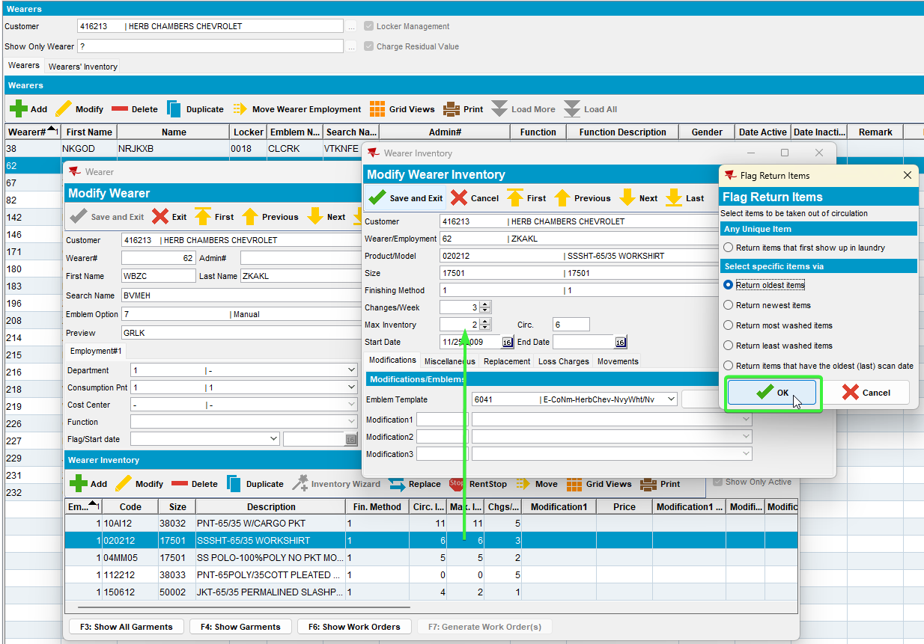
- RSC dlg: Generate the next week invoice with extended N for our customer.
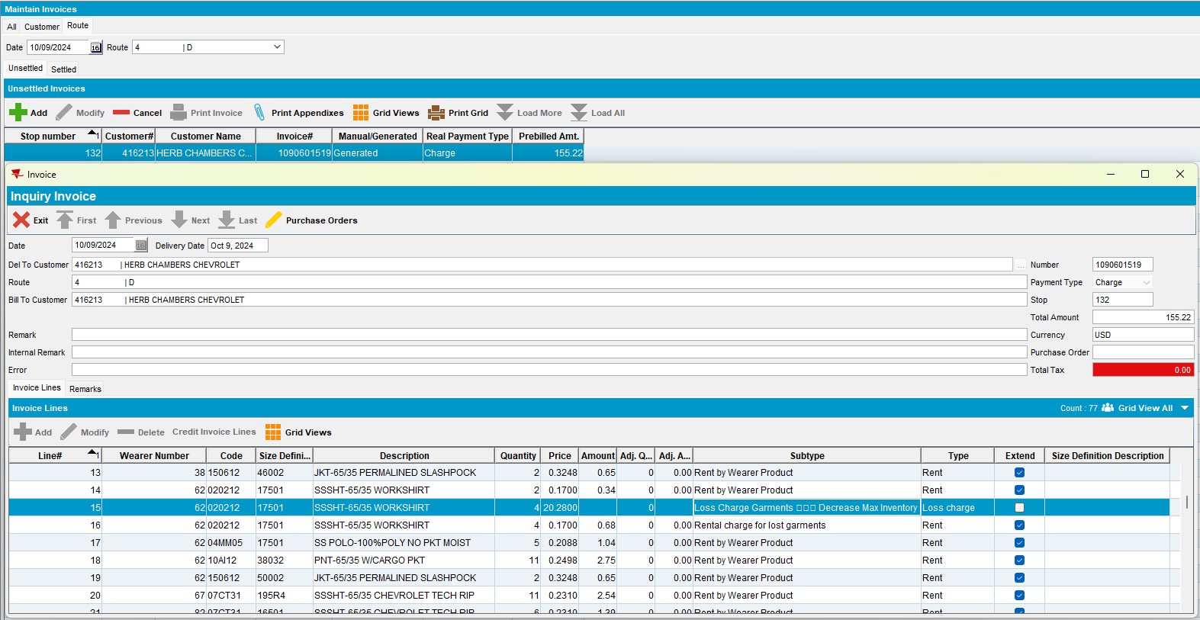
- RSC dlg: Mark ready for transfer on PDA.
- RA: Arrive at the customer and bill all for loss now
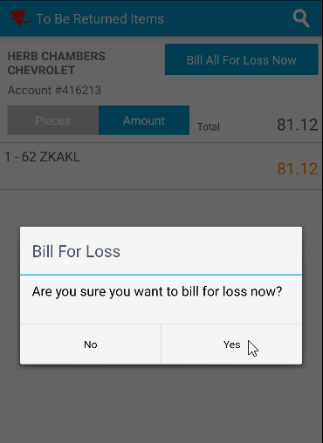
- RA: Settle, depart and upload the route.
- WebX: Approve the adjustment.
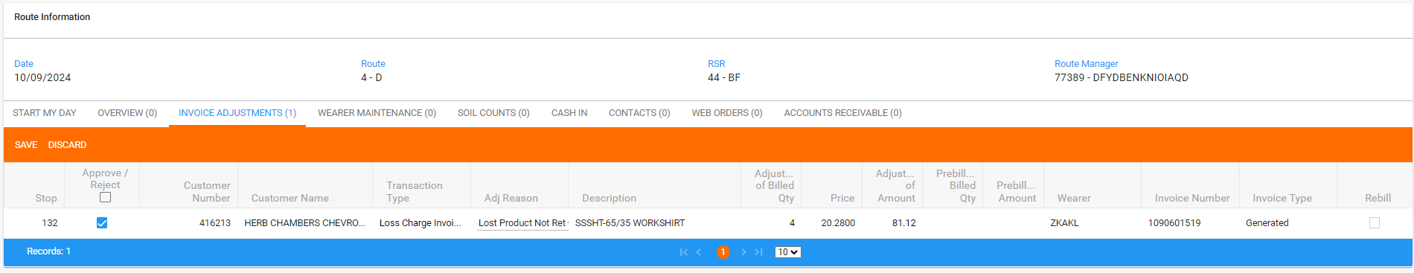
- WebX: Settle the route.
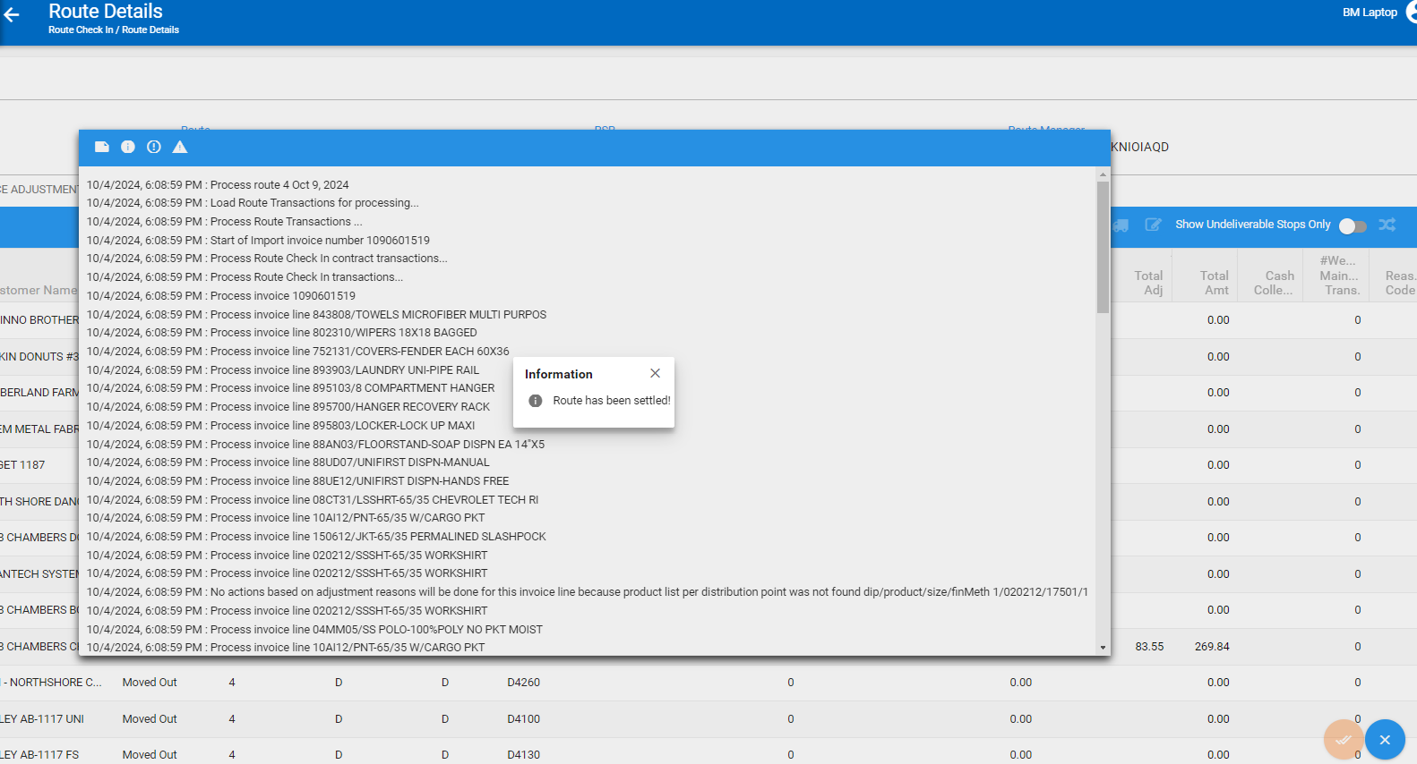
- Wearers dlg: Re-check the wearer.
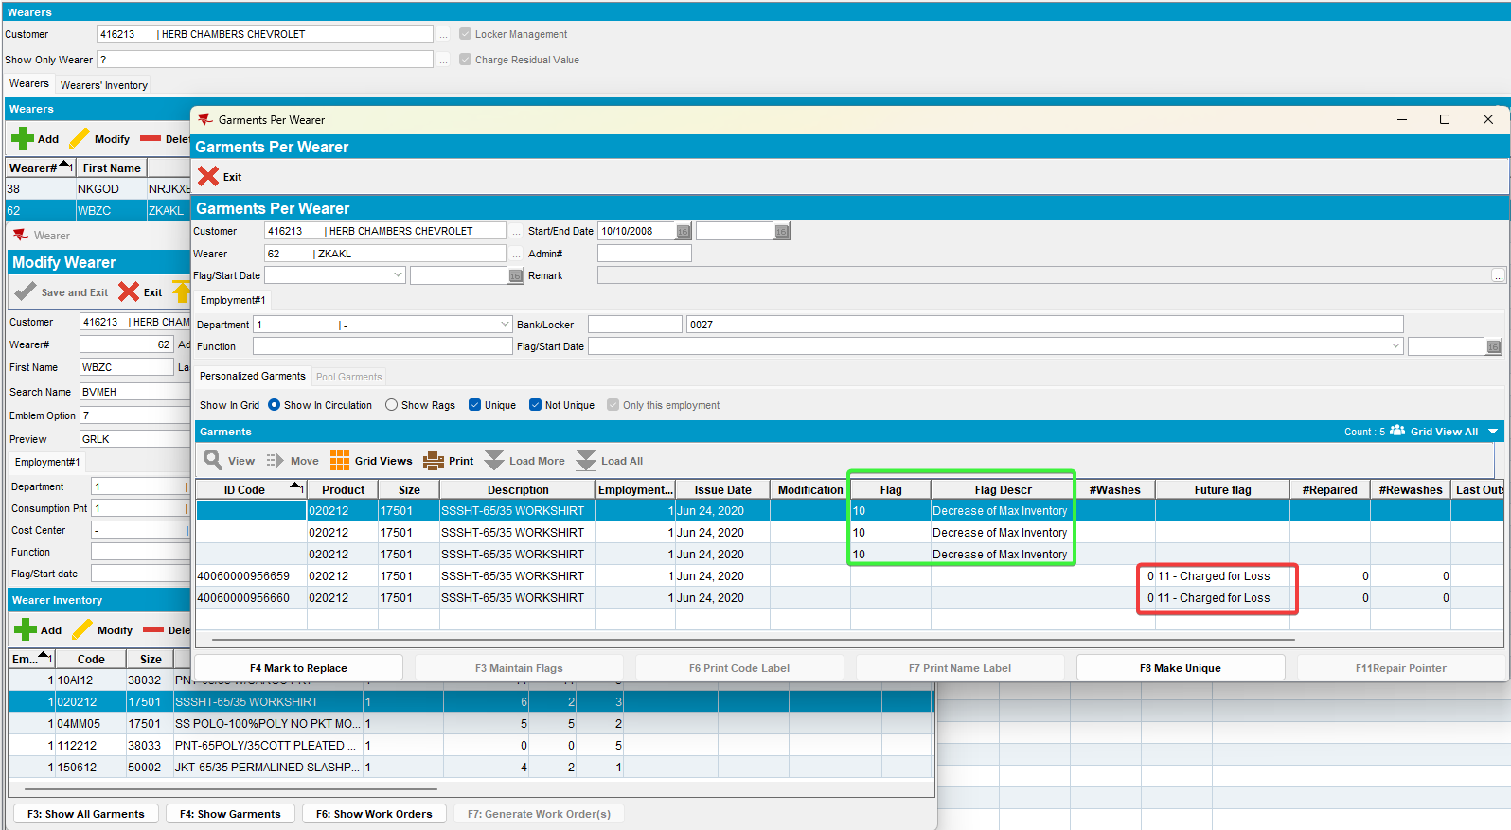
The remaining 2 unique garments are flagged with charge for loss

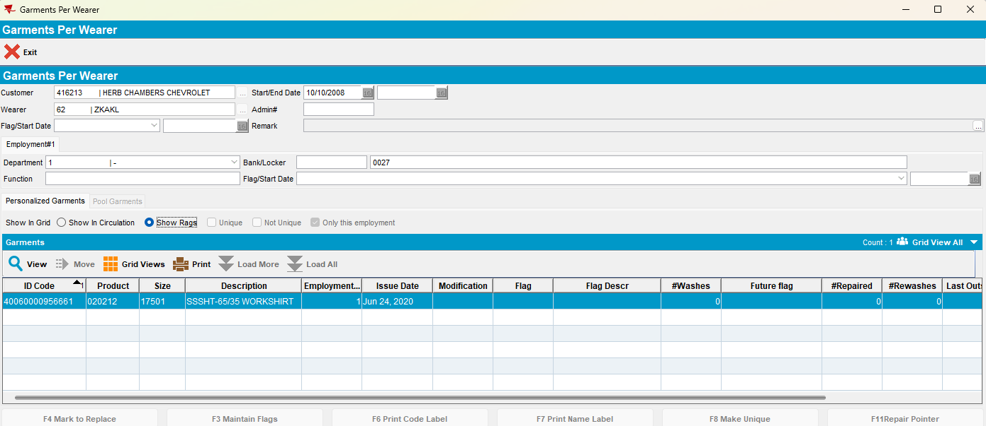
The unique are ragged but the non-unique are still there - they are charged for loss Y but should be ragged
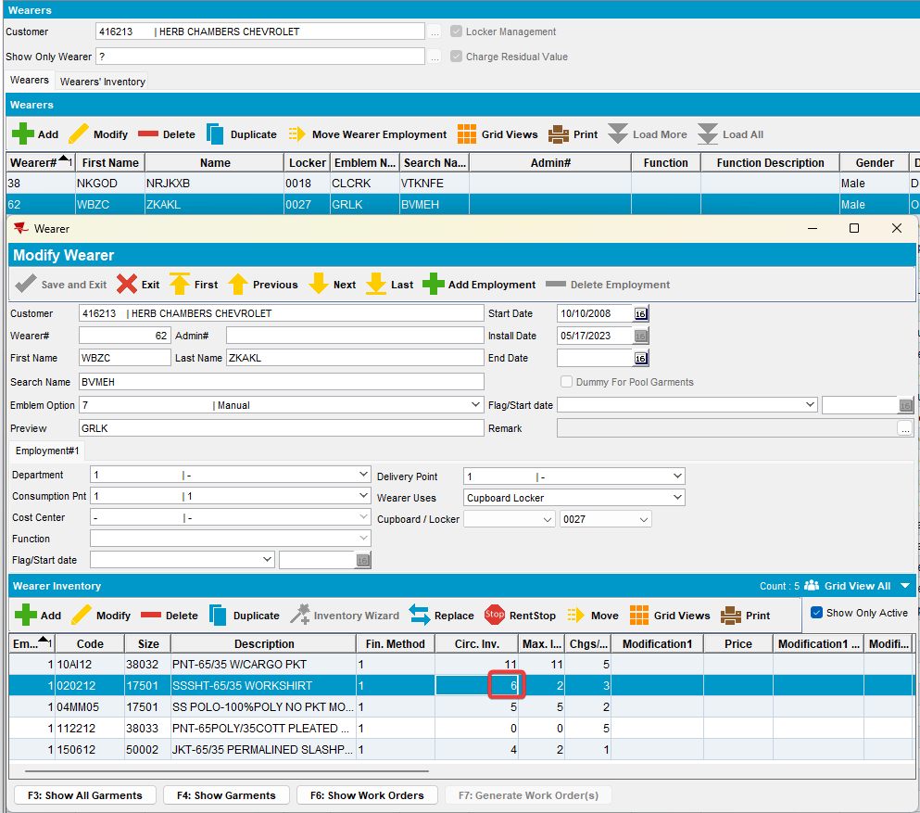
The remaining unique items have a weird flag on invoice date of "charged for loss" but are not

REPRODUCED OK.

Expected behavior
The remaining unique garments that were not flagged initially, after settlement should not be charged for loss.
The unique are ragged but also the non-unique should also be ragged.
The remaining unique items should not have a flag on invoice date of "charged for loss".

Retest after fix
Hash: 9.07.00.UNF18 hash: 74876ebbc89f
BU: 044

Test Case 1 - Bill for loss now on extended N, DOI mixed inventory

Steps to reproduce
- Wearers dlg: Find a customer with wearers that have mixed unique and non-unique garments on wi.
select c.customernumber, w.wearernumber, p.code from customer c
join wearer w on w.customer_id = c.customer_id
join weareremployment we on we.wearer_id = w.wearer_id
join wearerinventory wi on wi.weareremployment_id = we.weareremployment_id
join product p on p.product_id = wi.product_id
where wi.maxinventory > 0 and wi.circinventory >0
and exists (select 1 from nonuniqueitem nui where nui.wearerinventory_id = wi.wearerinventory_id and nui.flag_id is NULL)
and exists (select 1 from uniqueitemnonpool uinp where uinp.wearerinventory_id = wi.wearerinventory_id)
and wi.maxinventory = wi.circinventory;
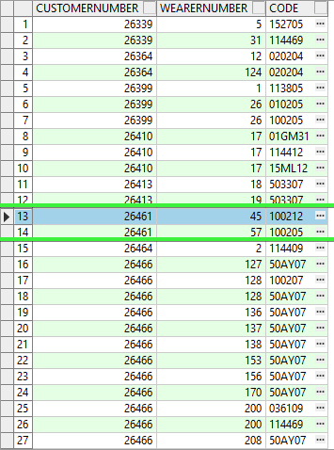
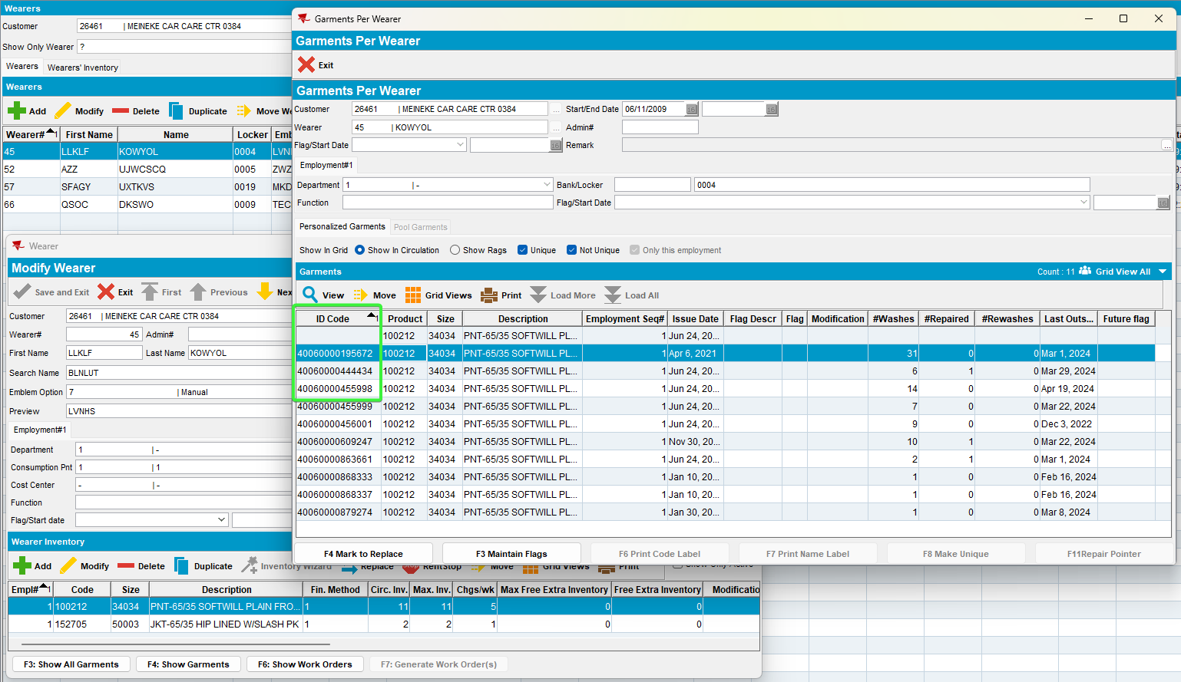
- Wearers dlg: Do a decrease of max for more than the non unique count (so unique and non unique get flagged DOI),
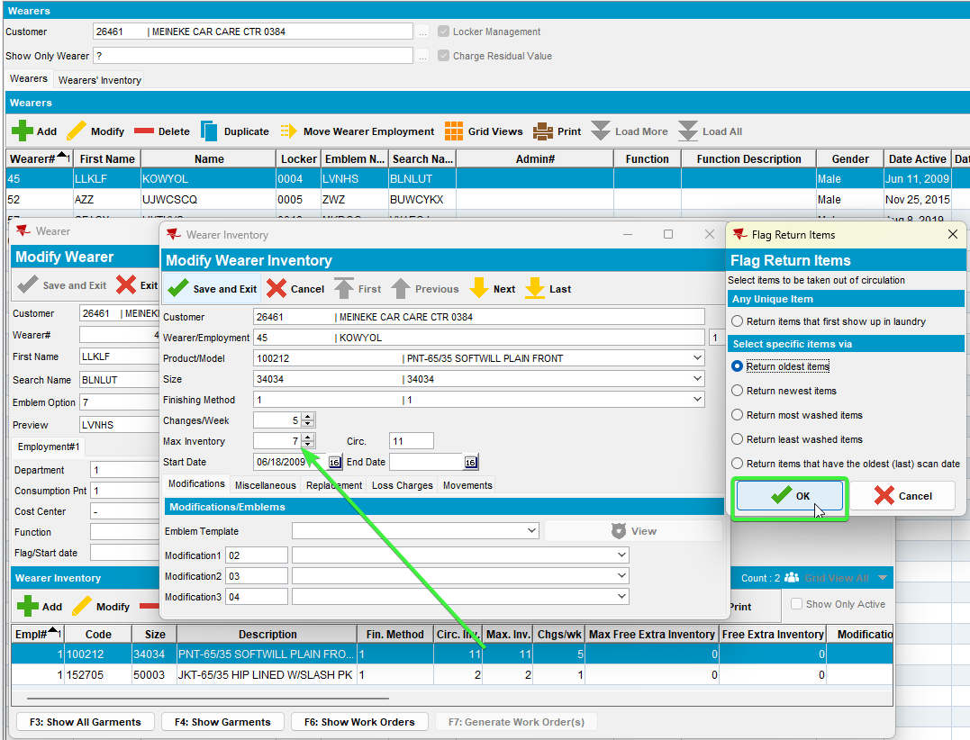
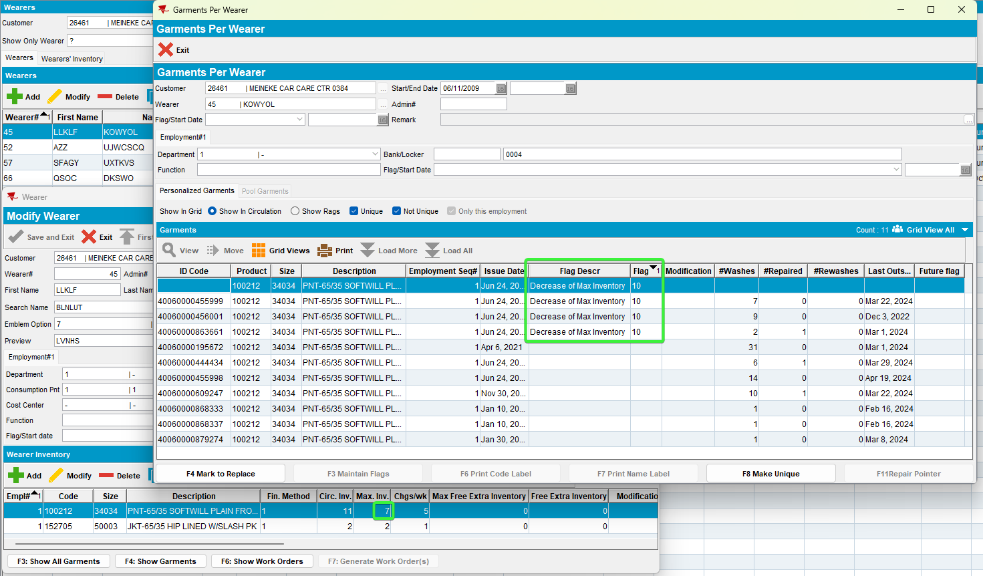
- RSC dlg: Generate the next week invoice with extended N for our customer.
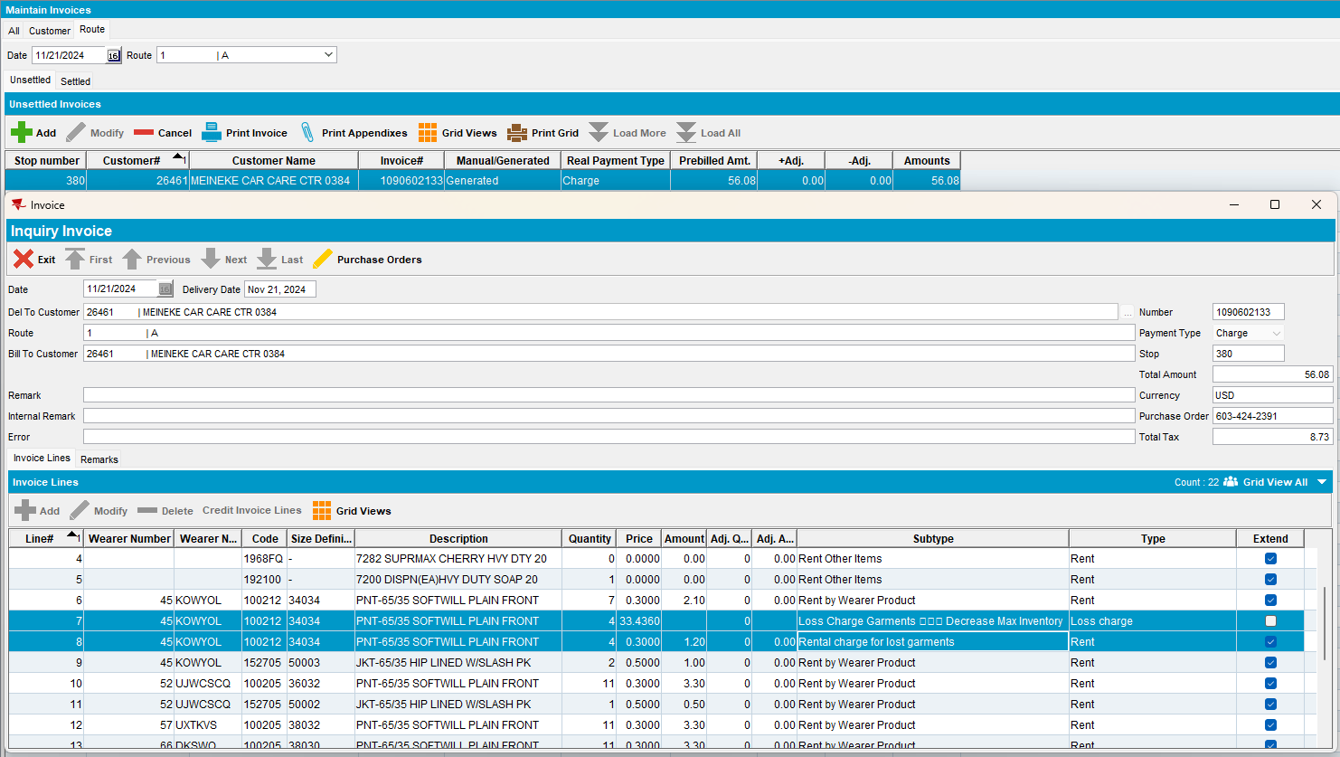
- RSC dlg: Mark ready for transfer on PDA.
- RA: Arrive at the customer and bill all for loss now
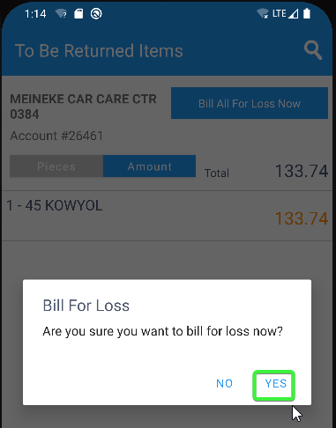
- RA: Settle, depart and upload the route.
- WebX: Approve the adjustment.
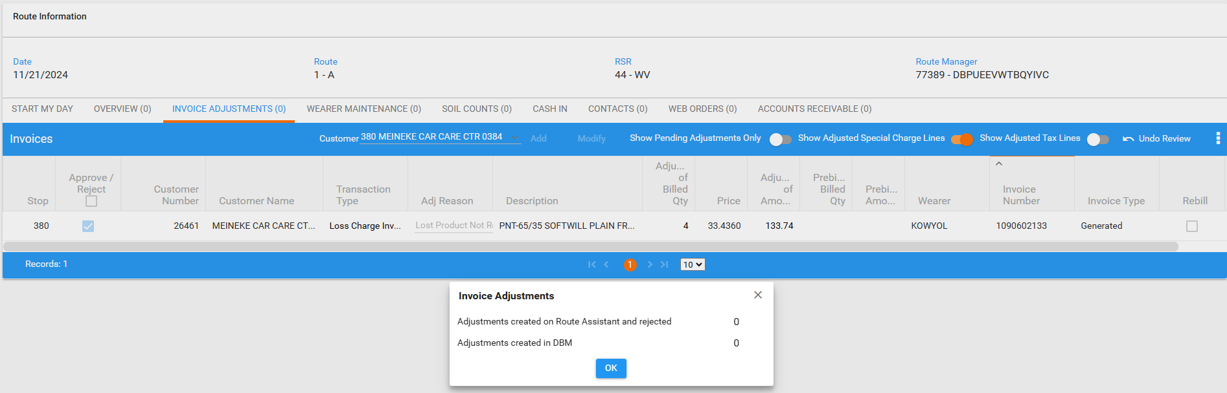
- WebX: Settle the route.
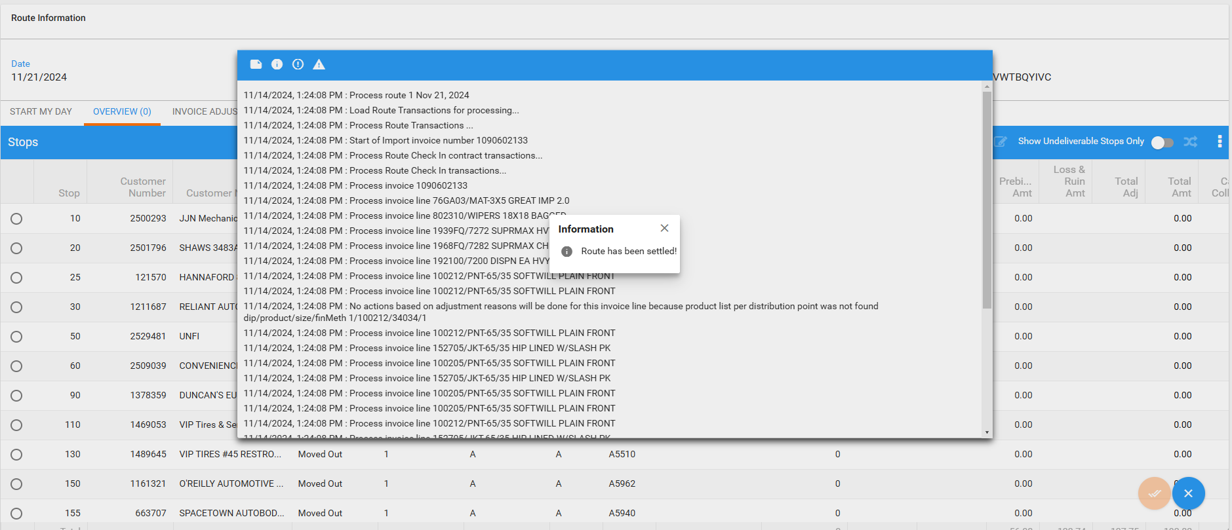
- Wearers dlg: Re-check the wearer.
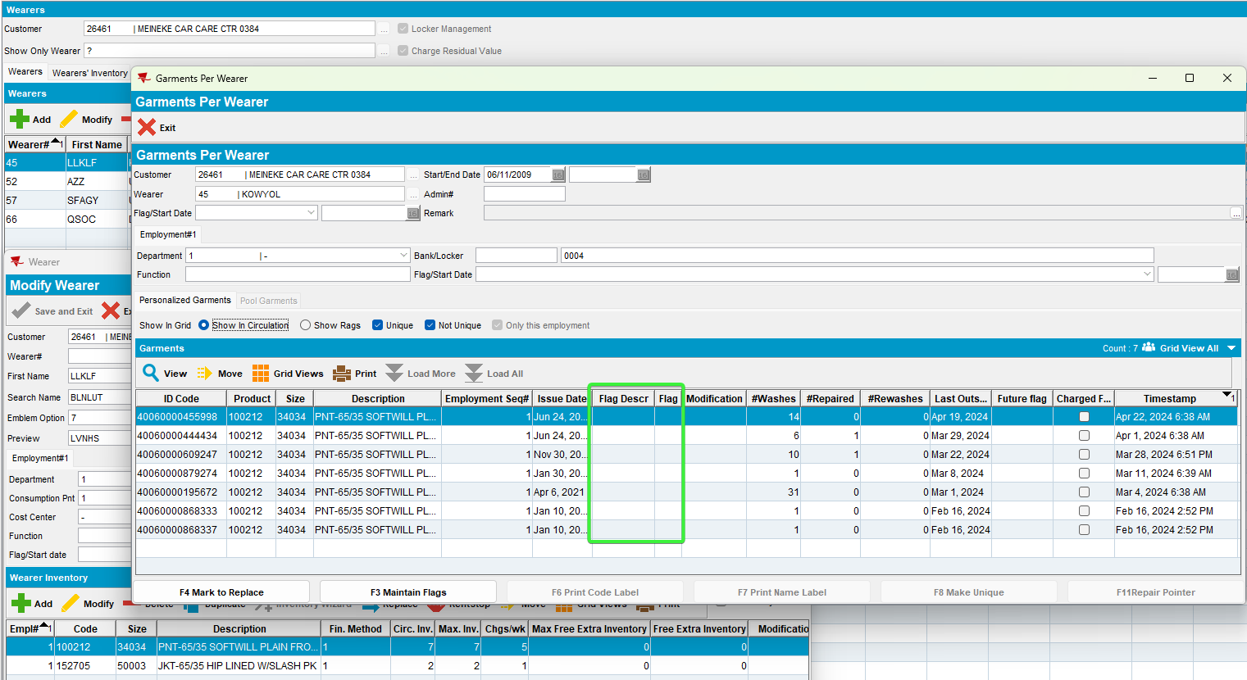
The remaining unique garment is not flagged with charge for loss
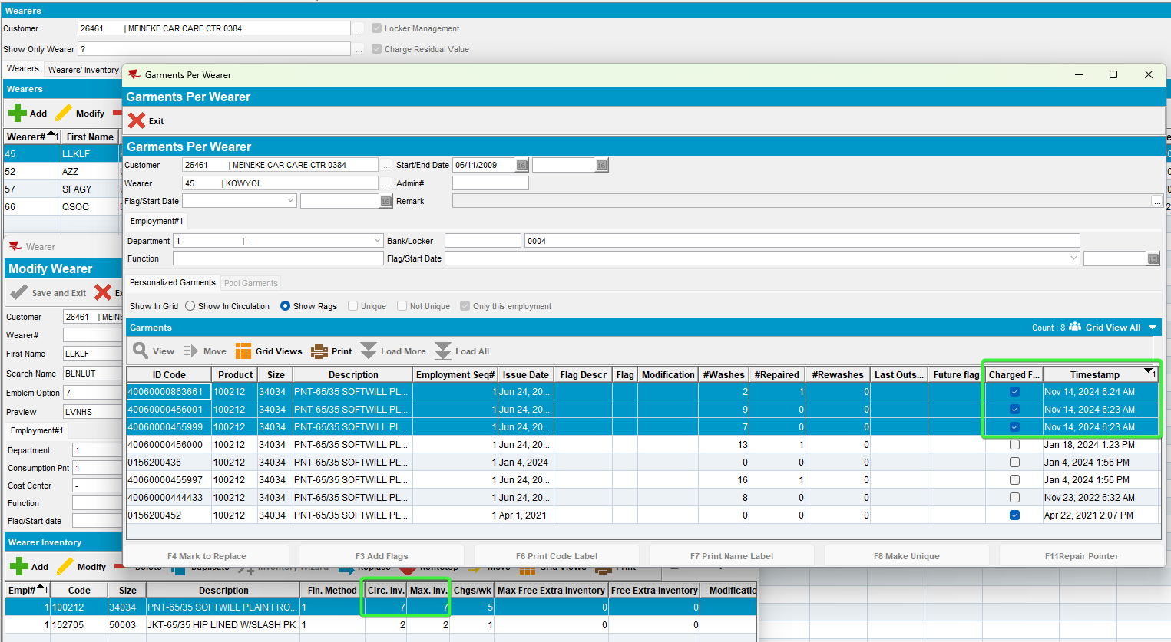
The 3 uniqued garments that were initially flagged after decrease are ragged and the non-uniques are deleted
The circulating inventory decreased and the max inventory decreased correctly

Test Case 2 - Bill for loss now on extended N, DOI only unique inventory

Steps to reproduce
- Wearers dlg: Find a customer with wearers that have unique garments on wi.
select c.customernumber, w.wearernumber, p.code from customer c
join wearer w on w.customer_id = c.customer_id
join weareremployment we on we.wearer_id = w.wearer_id
join wearerinventory wi on wi.weareremployment_id = we.weareremployment_id
join product p on p.product_id = wi.product_id
where wi.maxinventory > 0 and wi.circinventory >0
and not exists (select 1 from nonuniqueitem nui where nui.wearerinventory_id = wi.wearerinventory_id and nui.flag_id is NULL)
and exists (select 1 from uniqueitemnonpool uinp where uinp.wearerinventory_id = wi.wearerinventory_id)
and wi.maxinventory = wi.circinventory;
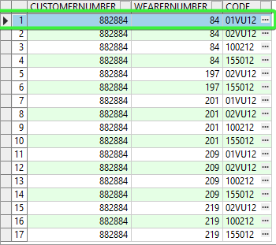
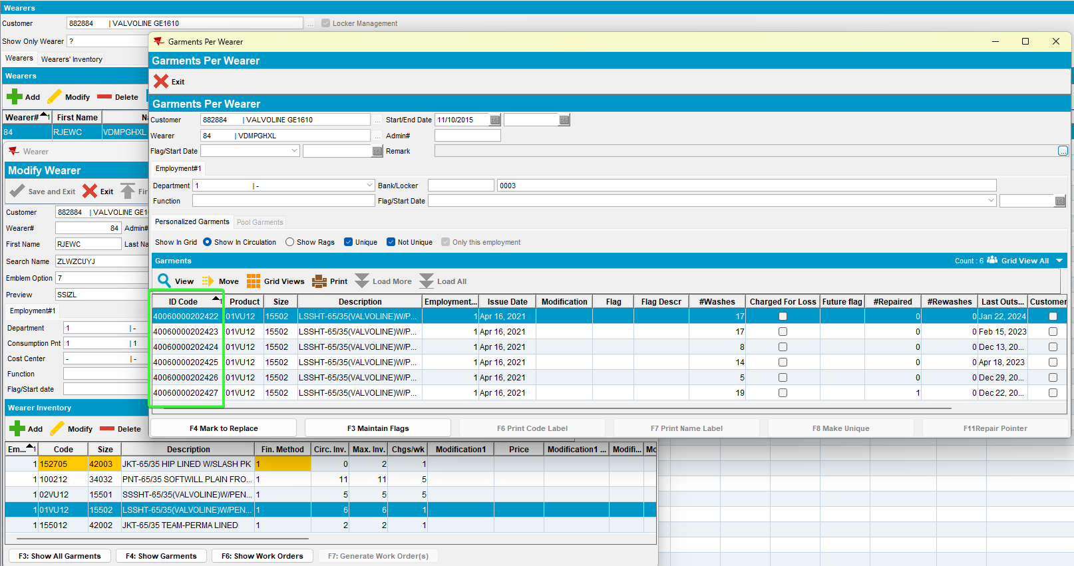
- Wearers dlg: Do a decrease of max
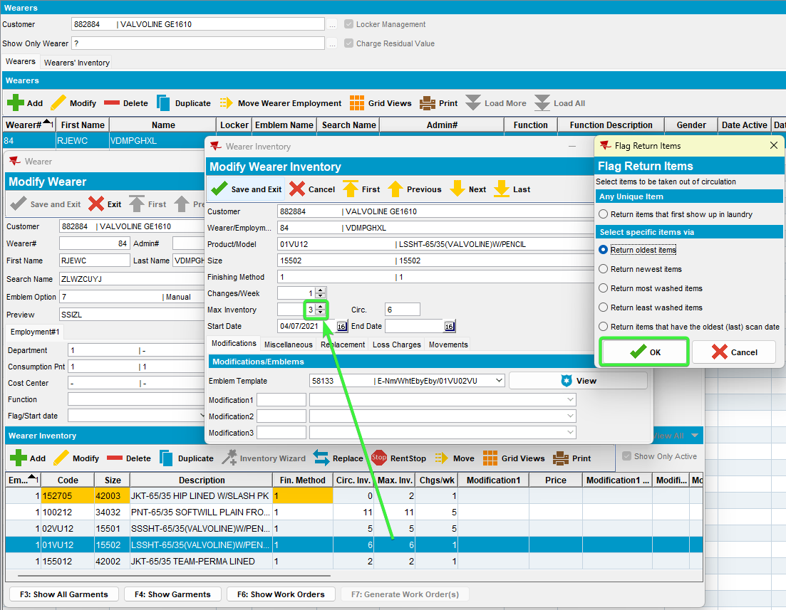

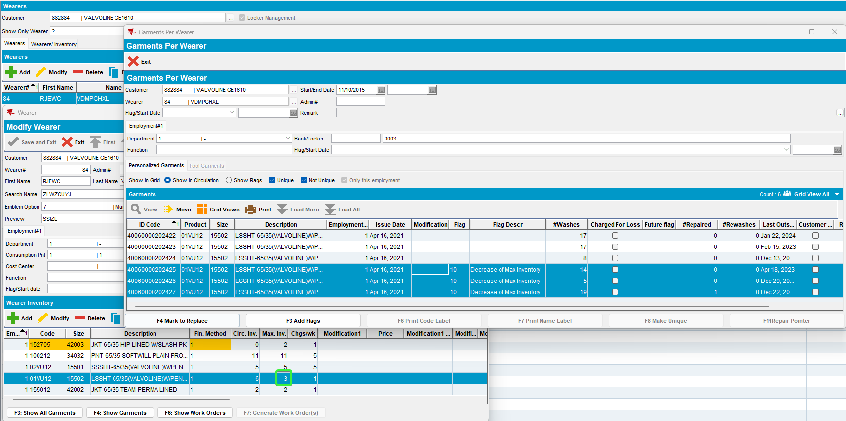
- RSC dlg: Generate the next week invoice with extended N for our customer.
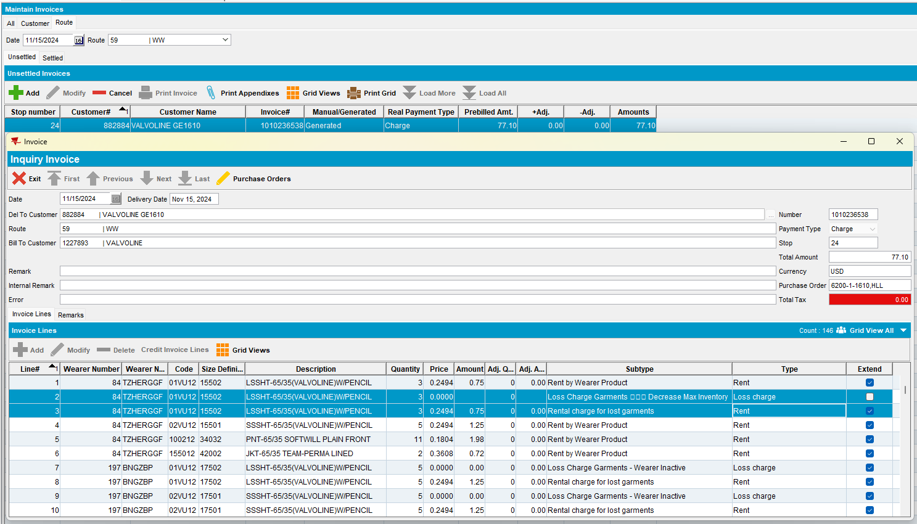
- RSC dlg: Mark ready for transfer on PDA.
- RA: Arrive at the customer and bill all for loss now
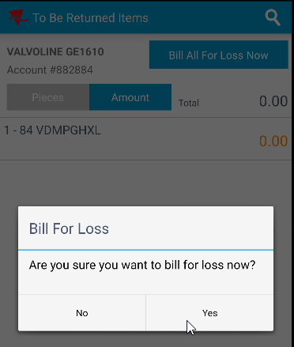
- RA: Settle, depart and upload the route.
- WebX: Approve the adjustment.
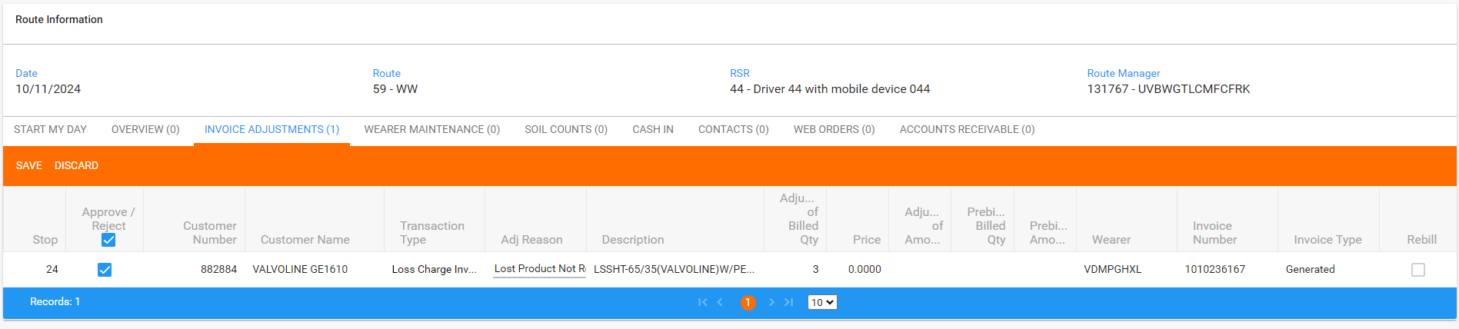
- WebX: Settle the route.
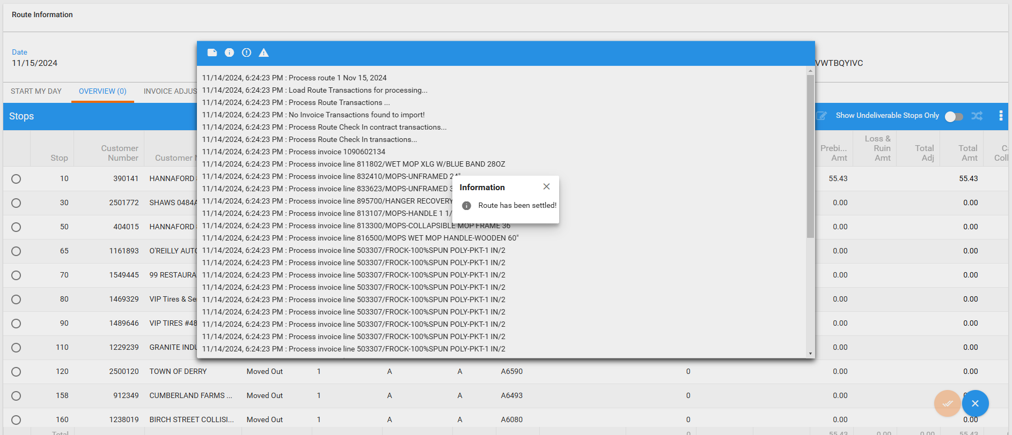
- Wearers dlg: Re-check the wearer.
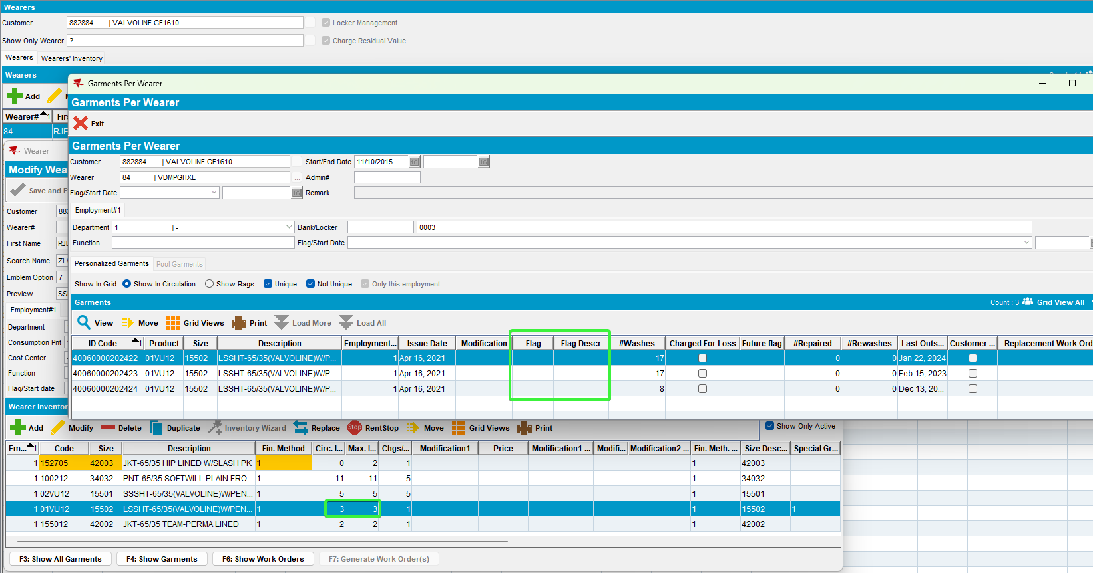
The remaining unique garment is not flagged with charge for loss and the circulating inventory also decreased

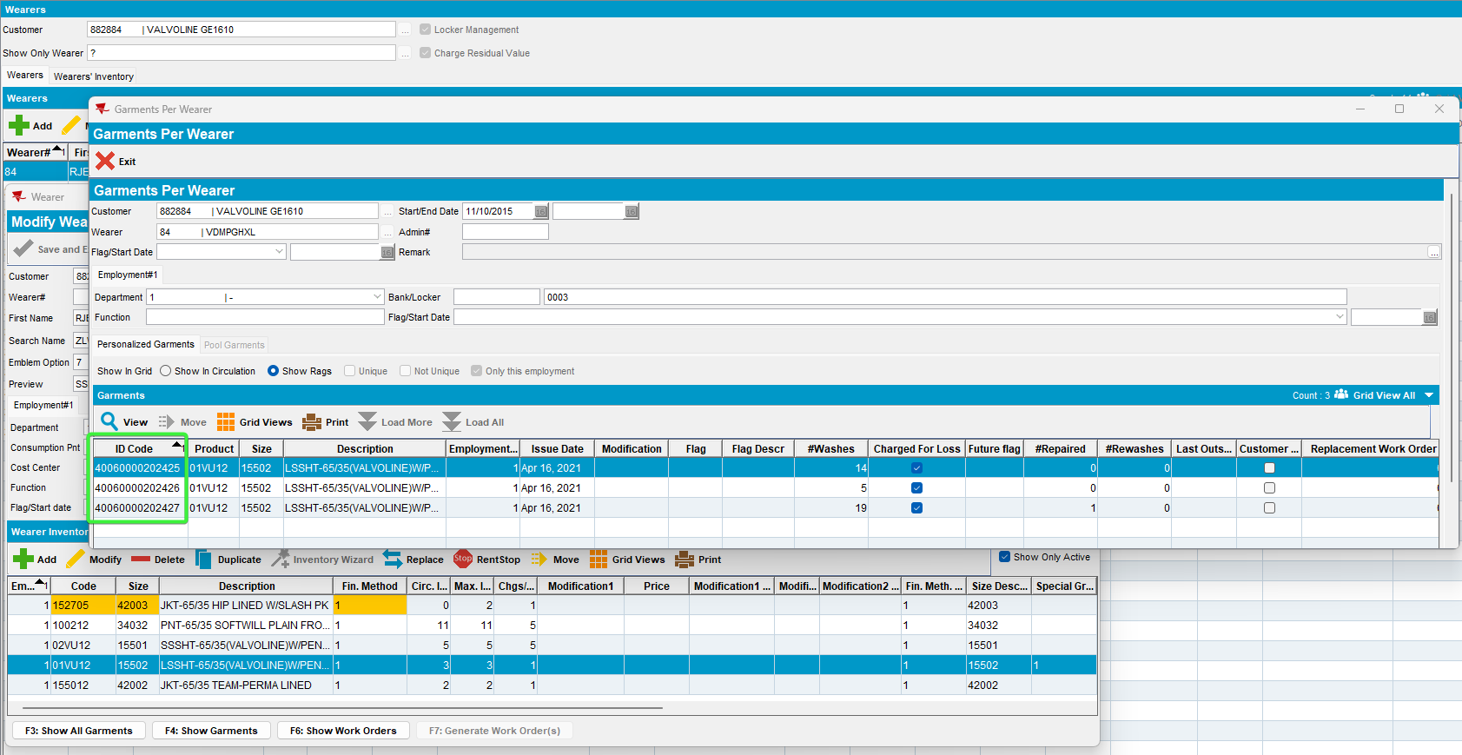
3 unique garments are ragged as there were 3 decreased

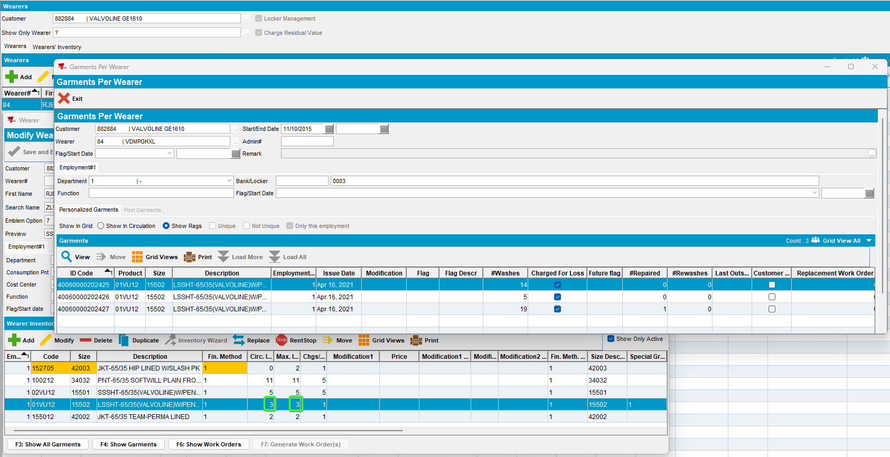
The circulating inventory decreased, the same as max inventory

Test Case 3 - Bill for loss now on extended N, DOI only non-unique inventory

Steps to reproduce
- Wearers dlg: Find a customer with wearers that have non-unique garments on wi.
select c.customernumber, w.wearernumber, p.code from customer c
join wearer w on w.customer_id = c.customer_id
join weareremployment we on we.wearer_id = w.wearer_id
join wearerinventory wi on wi.weareremployment_id = we.weareremployment_id
join product p on p.product_id = wi.product_id
where wi.maxinventory > 0 and wi.circinventory >0
and exists (select 1 from nonuniqueitem nui where nui.wearerinventory_id = wi.wearerinventory_id and nui.flag_id is NULL)
and not exists (select 1 from uniqueitemnonpool uinp where uinp.wearerinventory_id = wi.wearerinventory_id)
and wi.maxinventory = wi.circinventory;
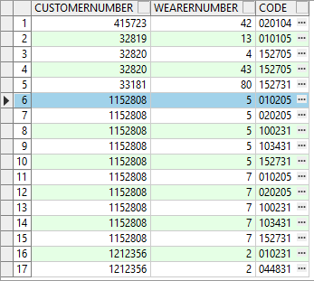
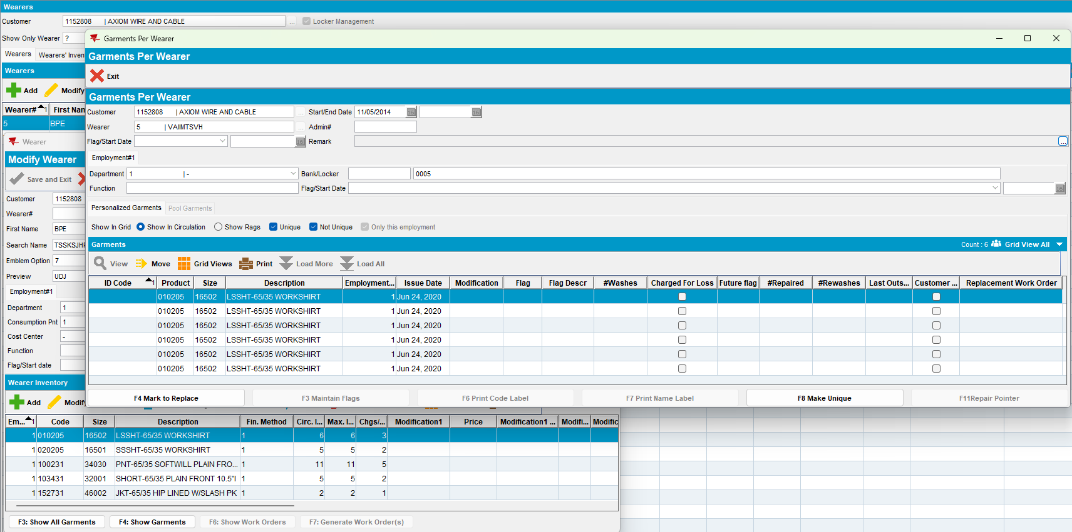
- Wearers dlg: Do a decrease of max
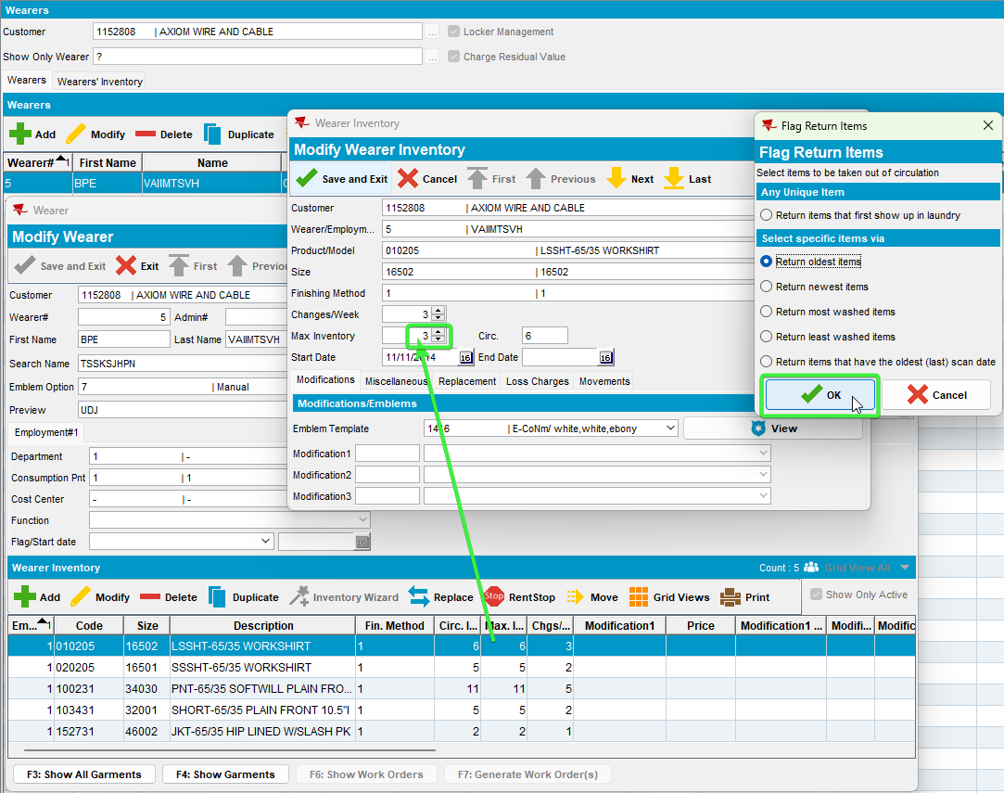

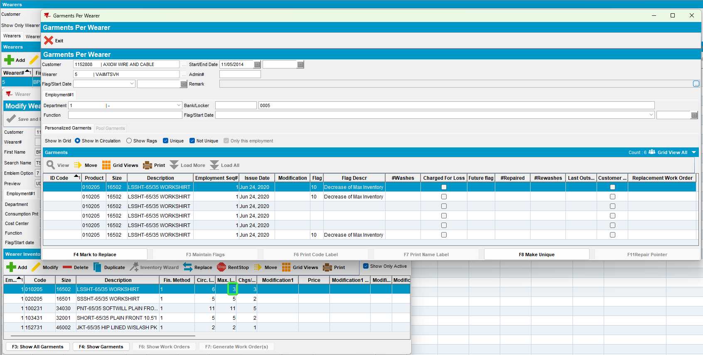
- RSC dlg: Generate the next week invoice with extended N for our customer.
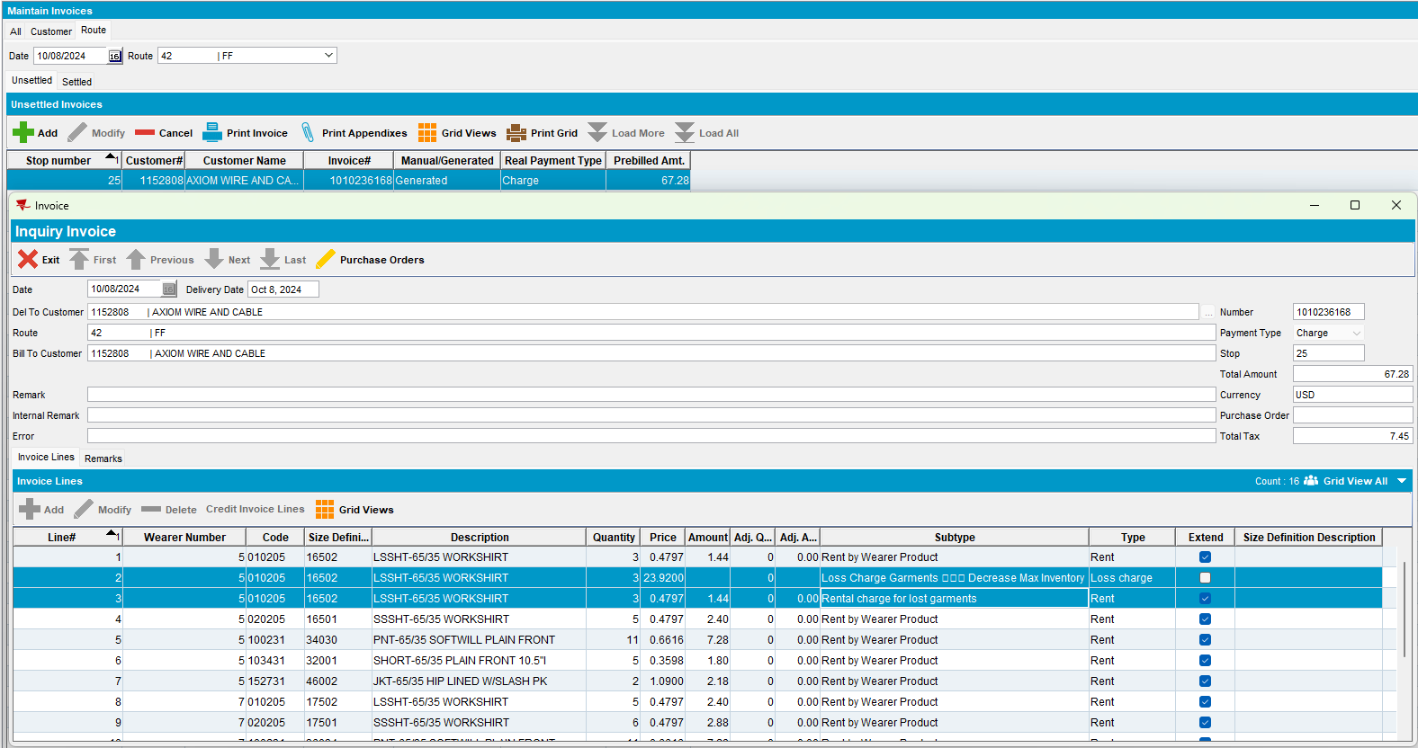
- RSC dlg: Mark ready for transfer on PDA.
- RA: Arrive at the customer and bill all for loss now
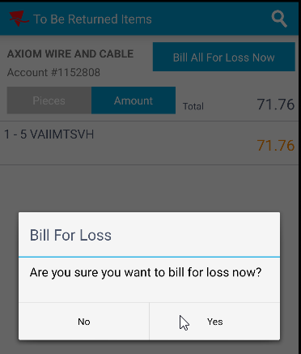
- RA: Settle, depart and upload the route.
- WebX: Approve the adjustment.
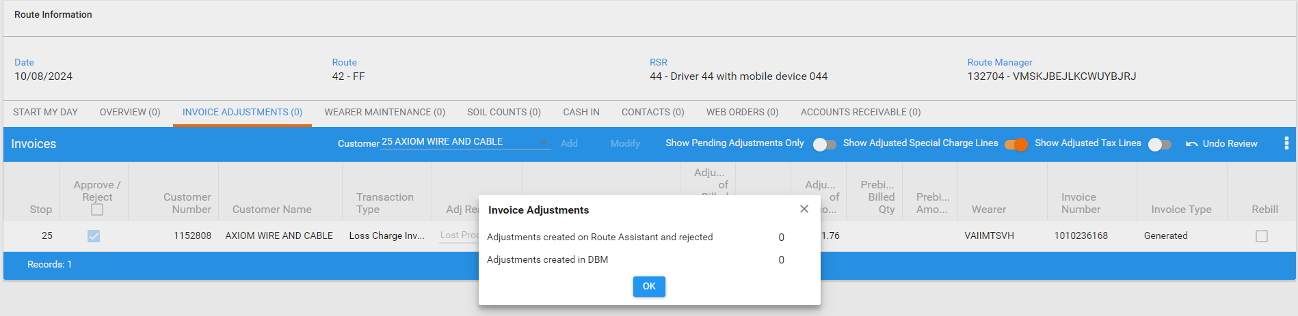
- WebX: Settle the route.
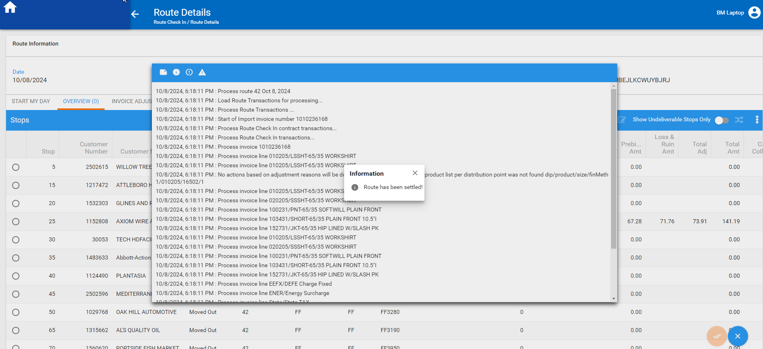
- Wearers dlg: Re-check the wearer.
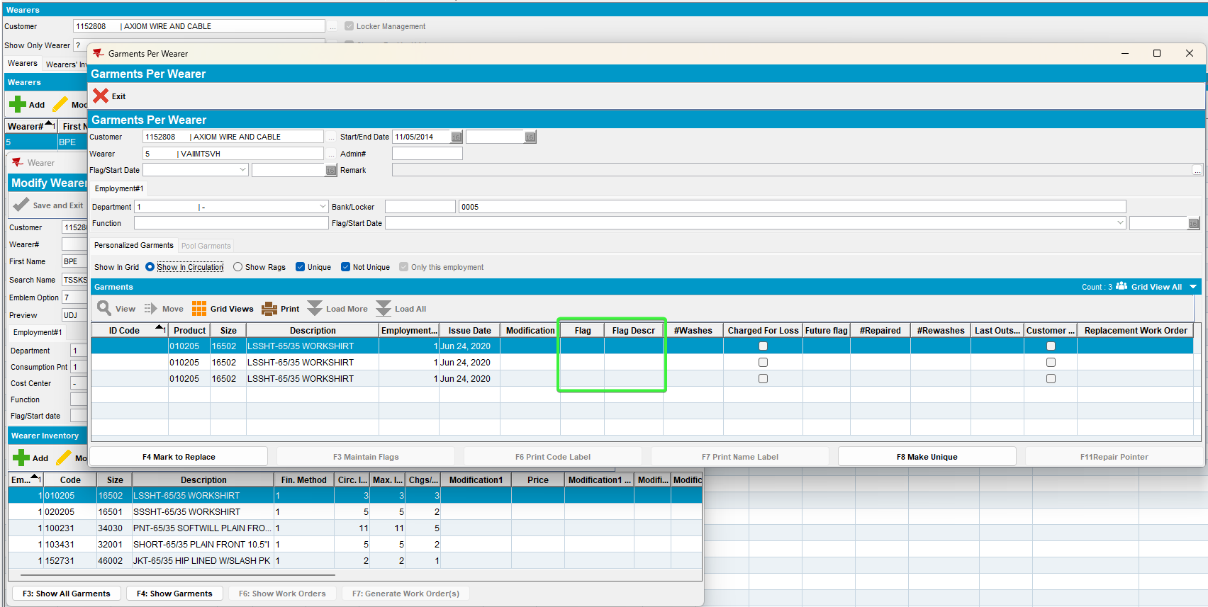
The remaining garments were not flagged with charge for loss and the circulating inventory also decreased

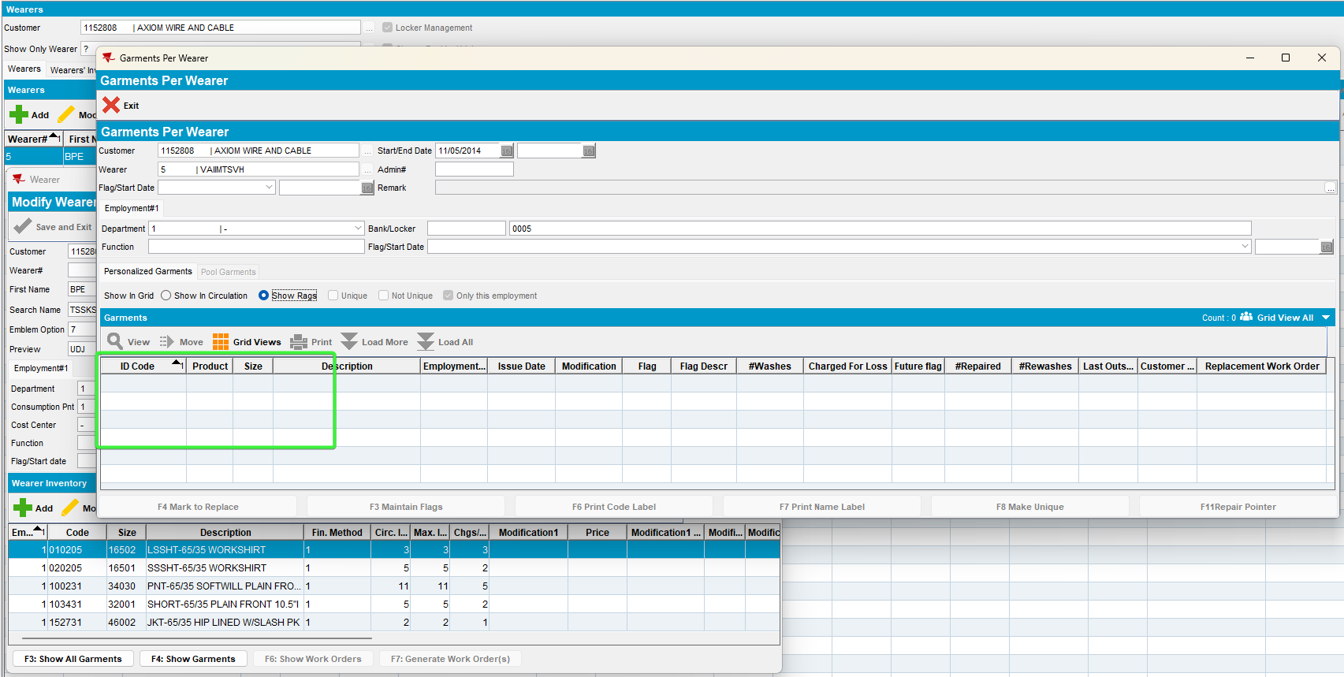
The non-unique garments were deleted

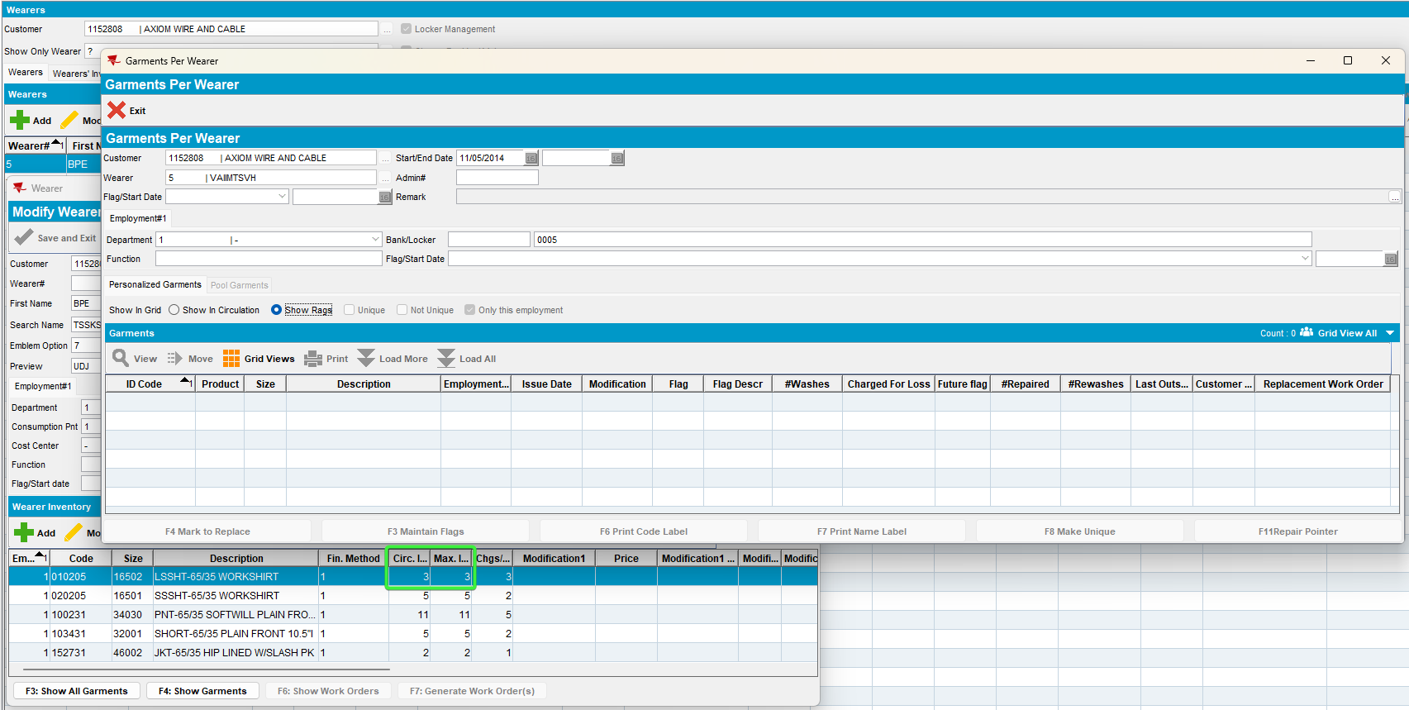
The circulating inventory decreased, the same as max inventory

