ABS-145411 Items marked for garment replacement are ragged after settlement even if the loss charge line is credited
Environment | Prerequisites
Version:9.07.00  DBServerName=abs-srv20.internal.abslbs.com  DBSID= CUST24  DBUser= UNFDEV  DBPassword= UNFDEV  Environment=Production | - Module:  - System setting

Contents
Retest after fix 1
Test Case 1 – Wearer Inventory with all non-unique garments with DOI and Replacement Loss Charges, adjust qty fully on loss charges before settlement 1
Expected behavior: Both loss charge line should appear on the invoice 1
Steps to reproduce 2
Test Case 2 – Wearer Inventory with all non-unique garments with DOI and Replacement Loss Charges, adjust qty partially on loss charges before settlement 6
Expected behavior: Both loss lines should appear with the adjusted qty 6
Steps to reproduce 6
Test Case 3 – Wearer Inventory with mixed garments with DOI and Replacement Loss Charges, adjust qty partially on loss charges before settlement 9
Expected behavior: Both loss lines should appear with the adjusted qty 9
Steps to reproduce 9
Test Case 4 – Wearer Inventory with mixed garments with DOI and Replacement Loss Charges, adjust qty fully on loss charges before settlement 13
Expected behavior: Both loss charge line should appear on the invoice 13
Steps to reproduce 13

Retest after fix

UNFDEV@CUST24
9.07.00.UNF18 hash: 4f968a8c3ffa
BU: 044

Test Case 1 – Wearer Inventory with all non-unique garments with DOI and Replacement Loss Charges, adjust qty fully on loss charges before settlement

Expected behavior: Both loss charge line should appear on the invoice

Steps to reproduce

- Find customers that have wearers with wearer inventories that are non-unique
--- Search wearer inventories with non-unique garments---
select c.customernumber, w.wearernumber, p.code from customer c
join wearer w on w.customer_id = c.customer_id
join weareremployment we on we.wearer_id = w.wearer_id
join wearerinventory wi on wi.weareremployment_id = we.weareremployment_id
join product p on p.product_id = wi.product_id
where wi.maxinventory > 0 and wi.circinventory >0
and exists (select 1 from nonuniqueitem nui where nui.wearerinventory_id = wi.wearerinventory_id and nui.flag_id is NULL)
and not exists (select 1 from uniqueitemnonpool uinp where uinp.wearerinventory_id = wi.wearerinventory_id)
and wi.maxinventory = wi.circinventory;
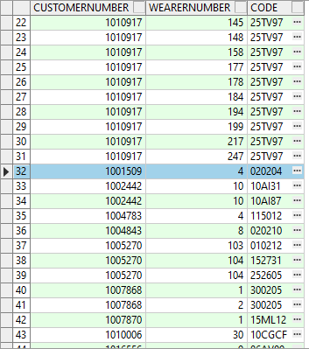
- Wearer dlg: Select a wearer inventory and make a reduction of the max inventory
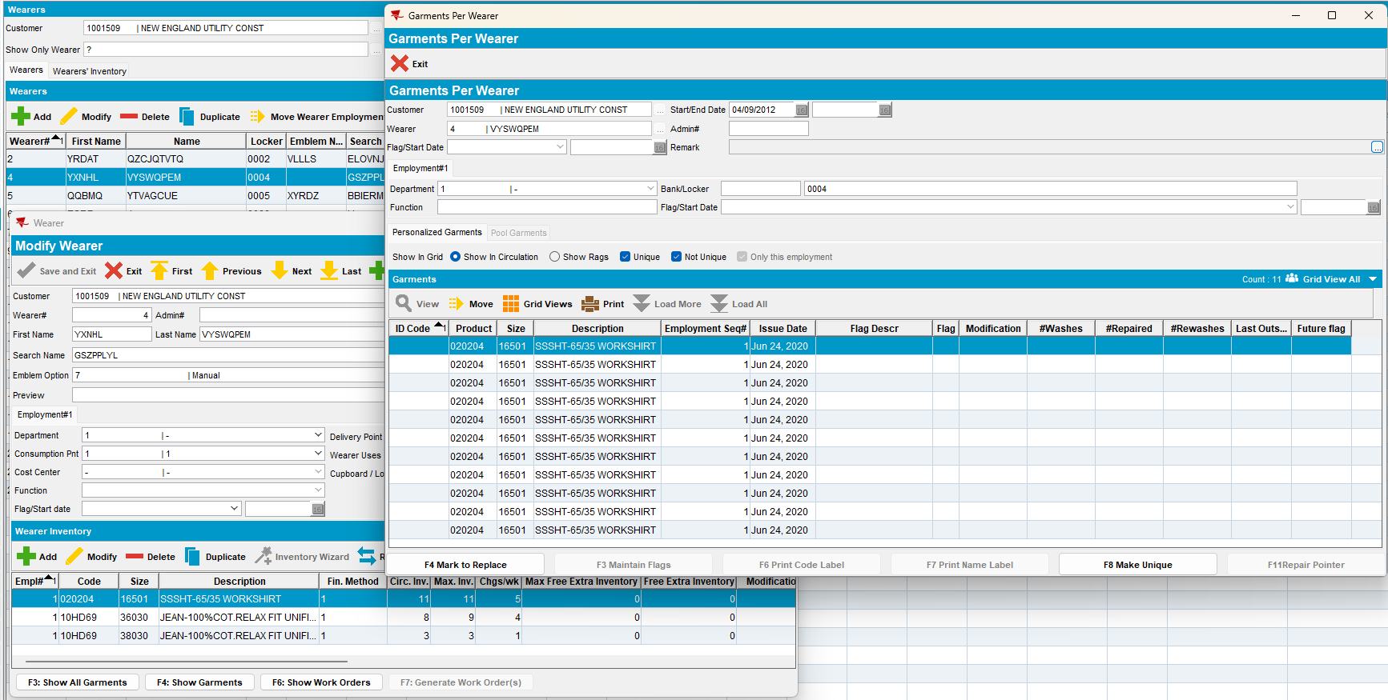
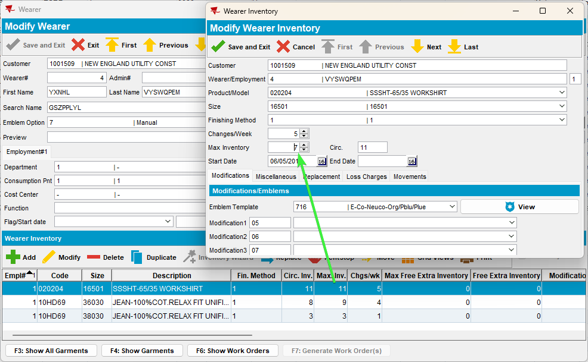
- Replace 3 garments from the same wearer inventory
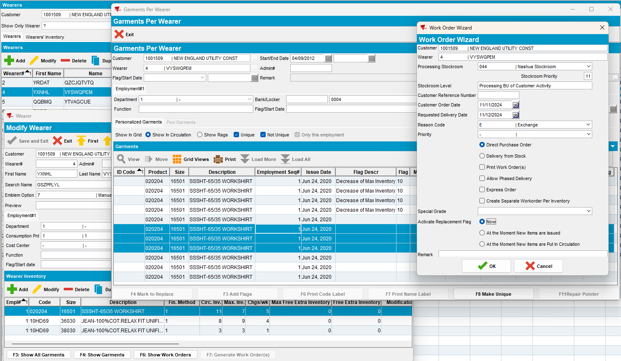
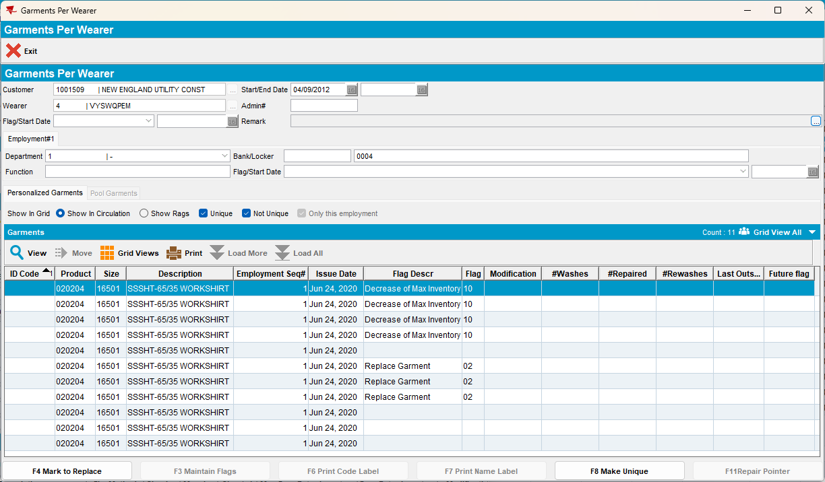
- RSC: Add a new route 2 weeks+ in the future and generate invoices for it
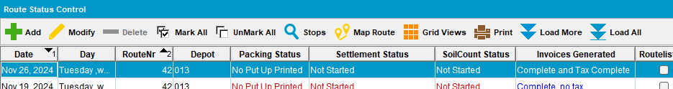
- Check the invoice to see if appear those two lines for loss
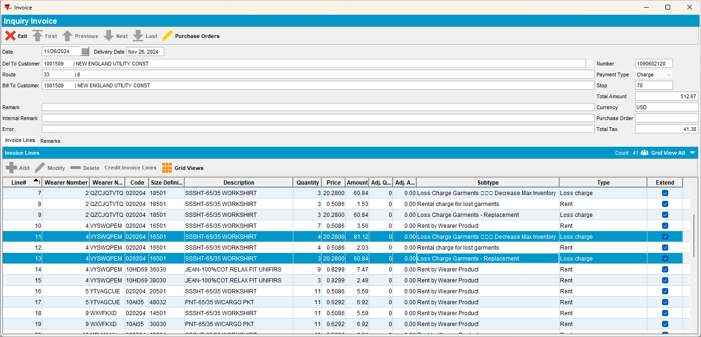
- RSC: Send the route to PDA.
- RA: Download the route and arrive at the customer. Enter adjust and adjust both loss lines to zero qty
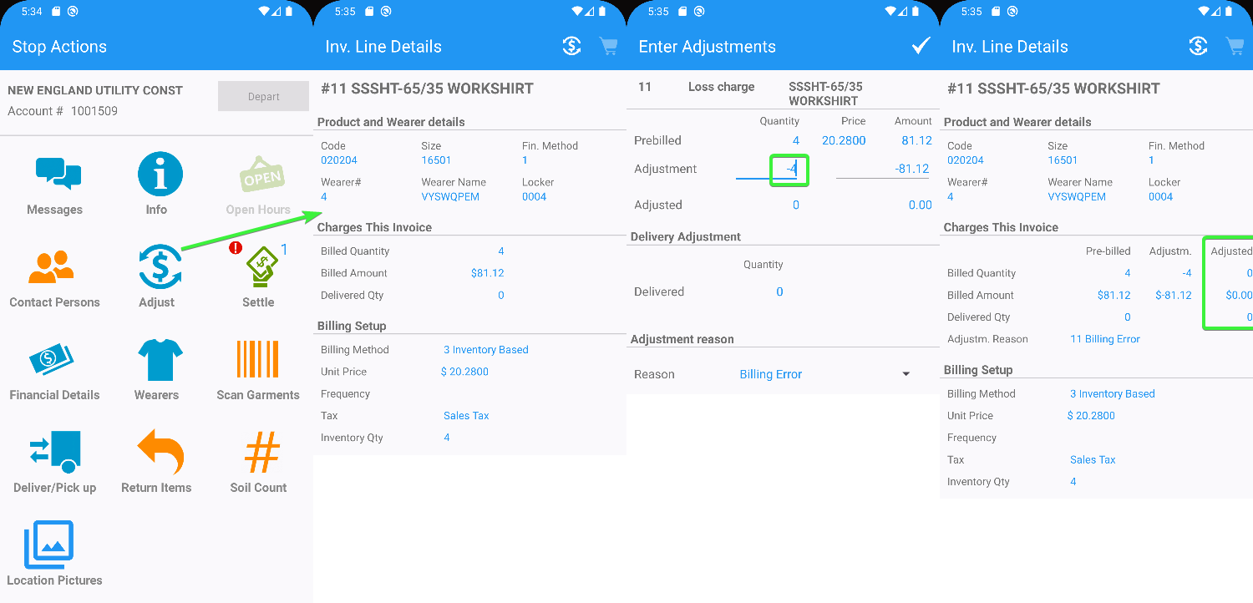
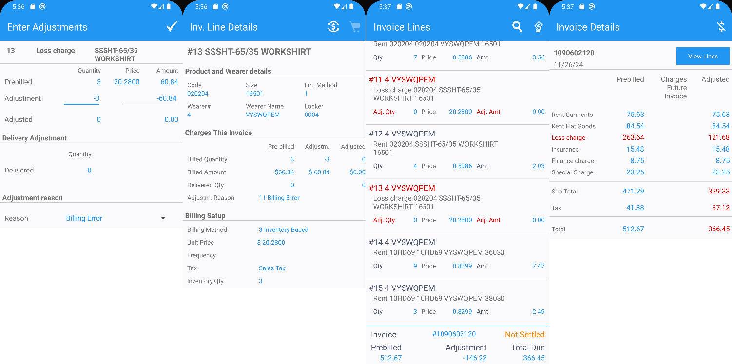
- RA: Settle, depart and upload the route.
- WebX: Approve and review everything, settle the route
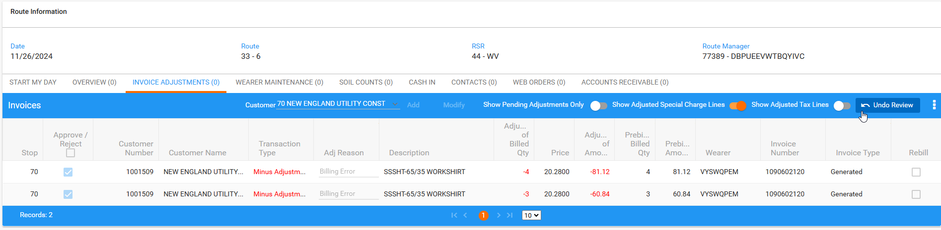
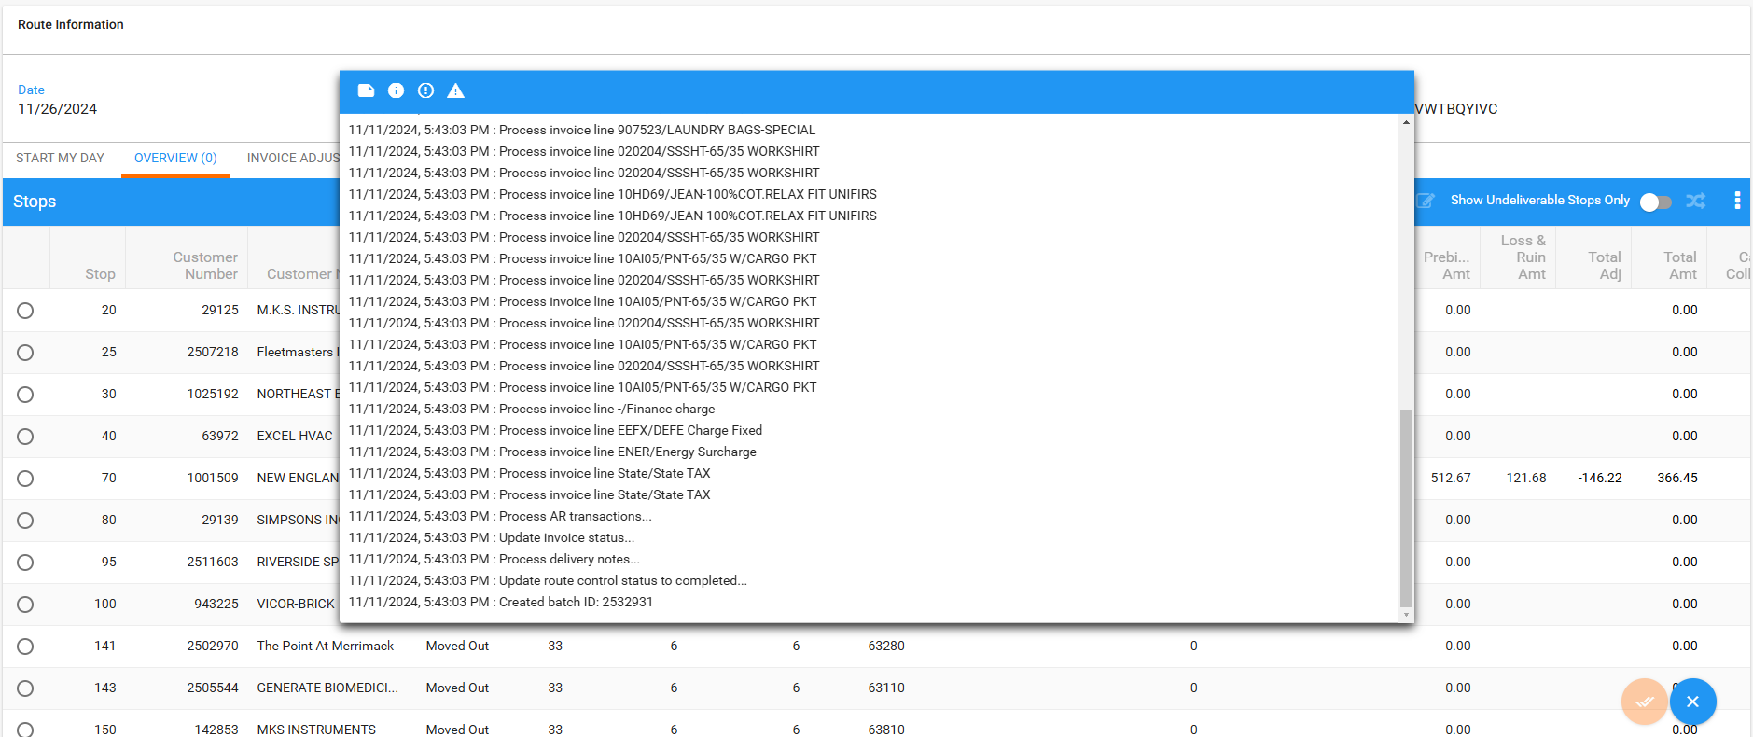
- Loss Charge Monitor dlg: Load the customer and check that the loss charges are present.
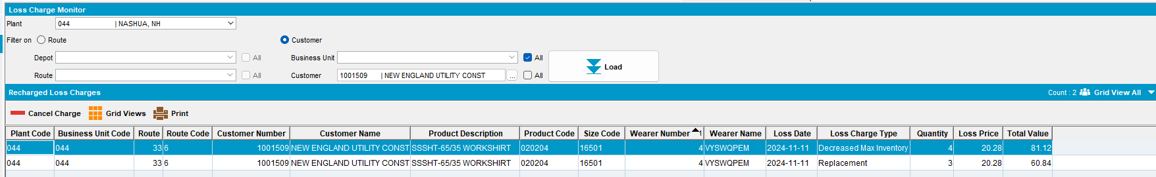
- Add a new route for the next delivery, generate invoices and check them
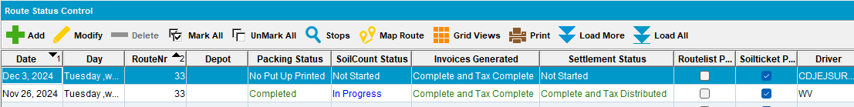
- Maintain Invoices dlg: Check the invoice.
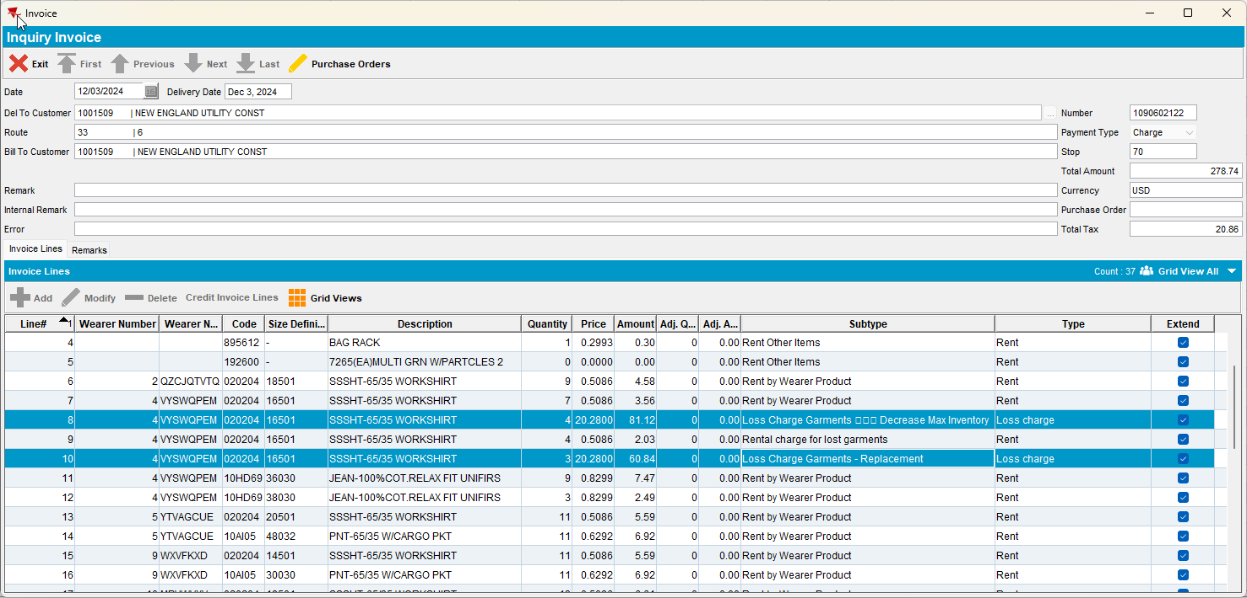
Both loss lines are present again
Tested ok.

Test Case 2 – Wearer Inventory with all non-unique garments with DOI and Replacement Loss Charges, adjust qty partially on loss charges before settlement

Expected behavior: Both loss lines should appear with the adjusted qty

Steps to reproduce
- Find customers that have wearers with wearer inventories that are non-unique
--- Search wearer inventories with non-unique garments---
select c.customernumber, w.wearernumber, p.code from customer c
join wearer w on w.customer_id = c.customer_id
join weareremployment we on we.wearer_id = w.wearer_id
join wearerinventory wi on wi.weareremployment_id = we.weareremployment_id
join product p on p.product_id = wi.product_id
where wi.maxinventory > 0 and wi.circinventory >0
and exists (select 1 from nonuniqueitem nui where nui.wearerinventory_id = wi.wearerinventory_id and nui.flag_id is NULL)
and not exists (select 1 from uniqueitemnonpool uinp where uinp.wearerinventory_id = wi.wearerinventory_id)
and wi.maxinventory = wi.circinventory;
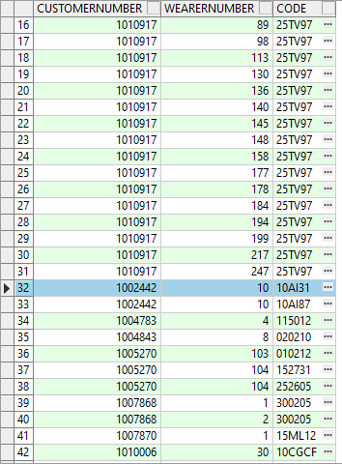
- Wearer dlg: Select a wearer inventory and make a reduction of the max inventory
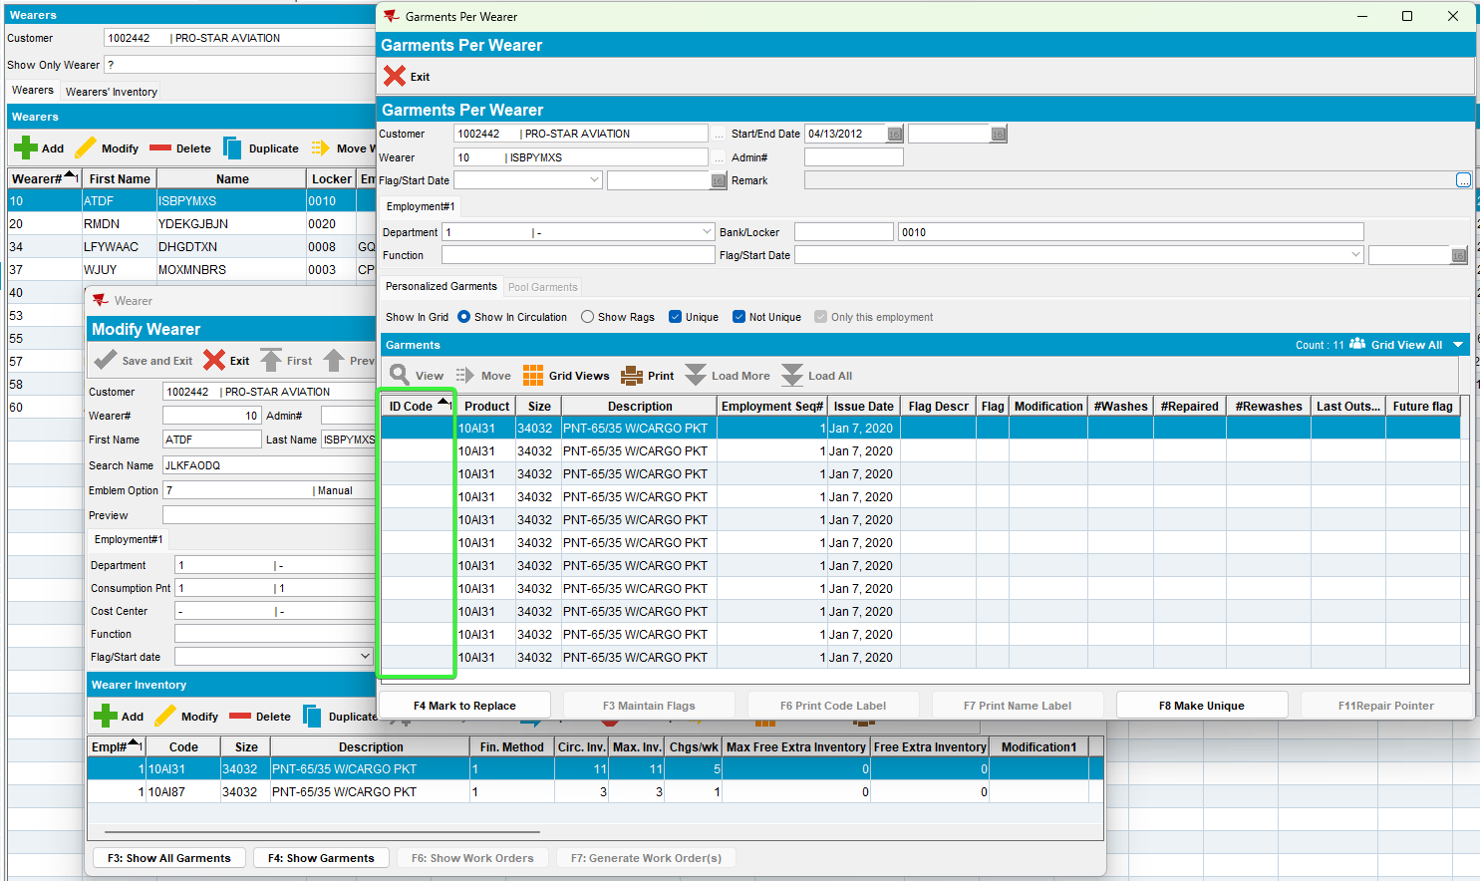
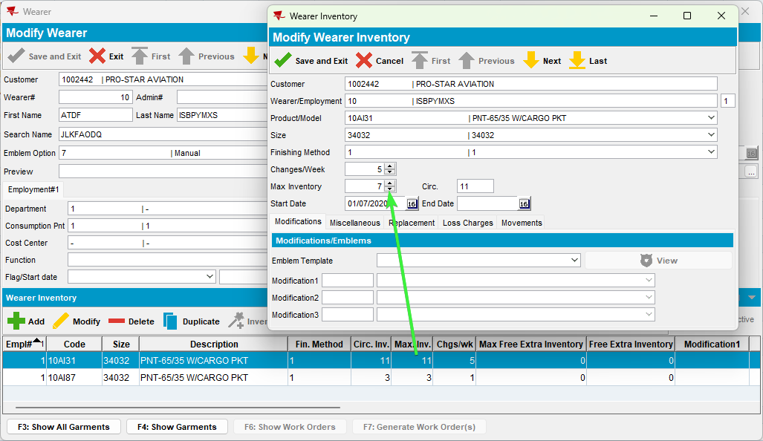
- Replace 3 garments from the same wearer inventory
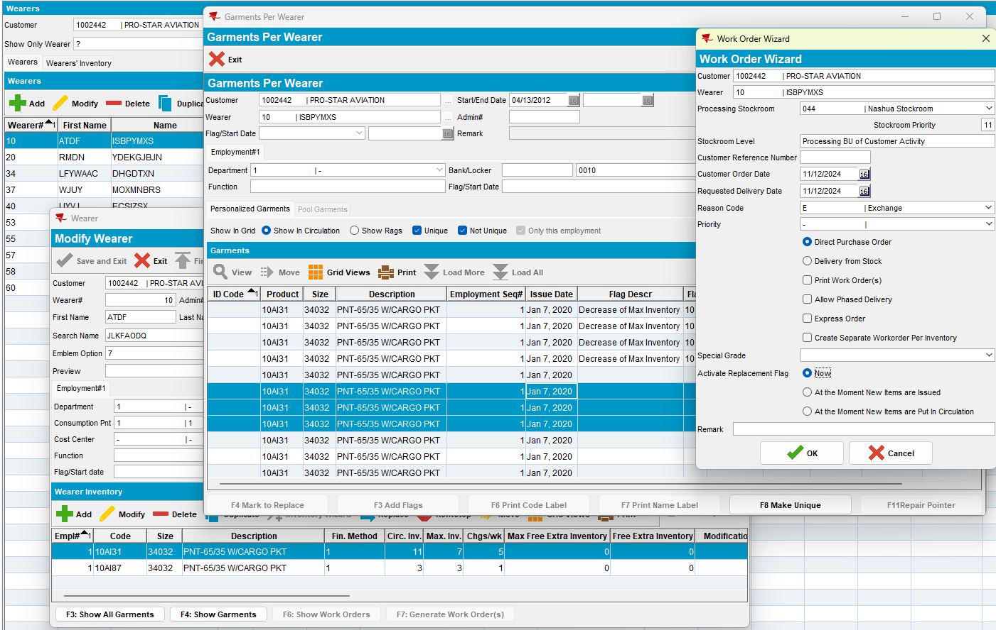
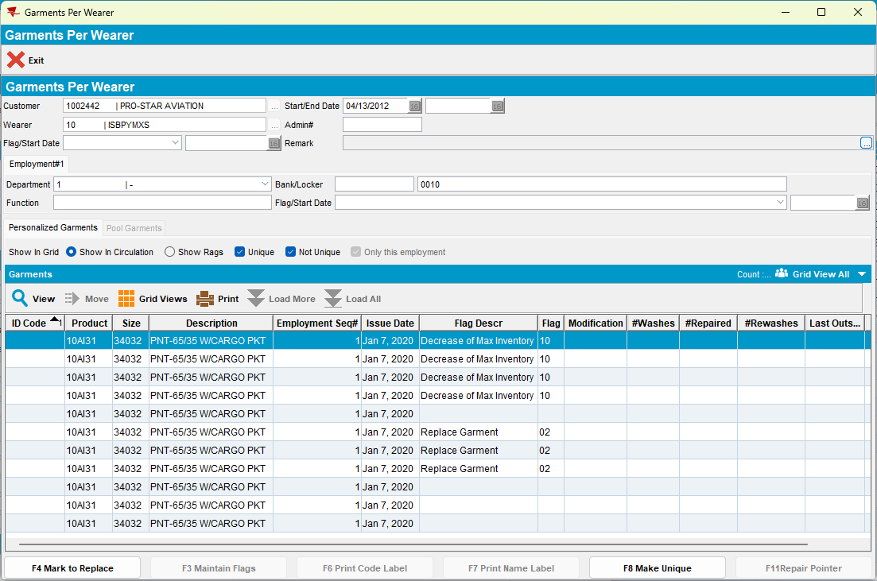
- RSC: Add a new route 2 weeks+ in the future and generate invoices for it
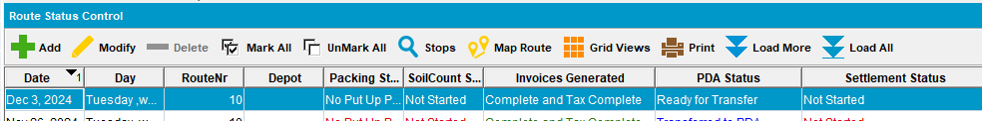
- Check the invoice to see if appear those two lines for loss
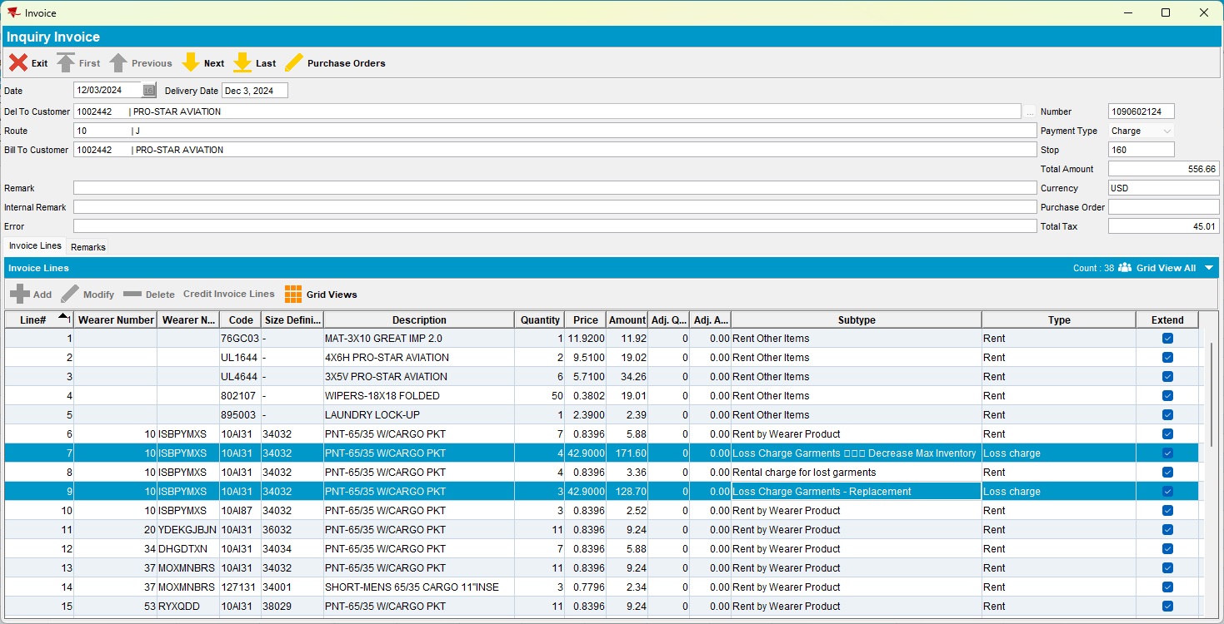
- RSC: Send the route to PDA.
- RA: Download the route and arrive at the customer. Settle, depart and upload the route.
- WebX: Adjust partially both loss lines
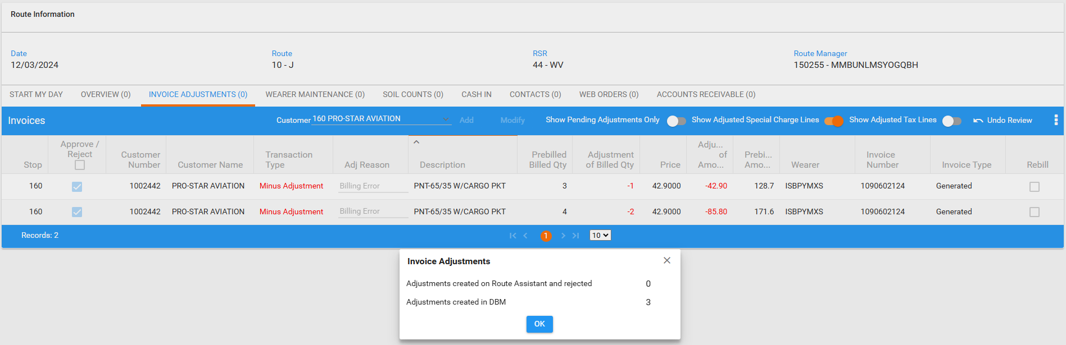
- Settle the route
- Loss Charge Monitor dlg: Check the existance of the loss charges.
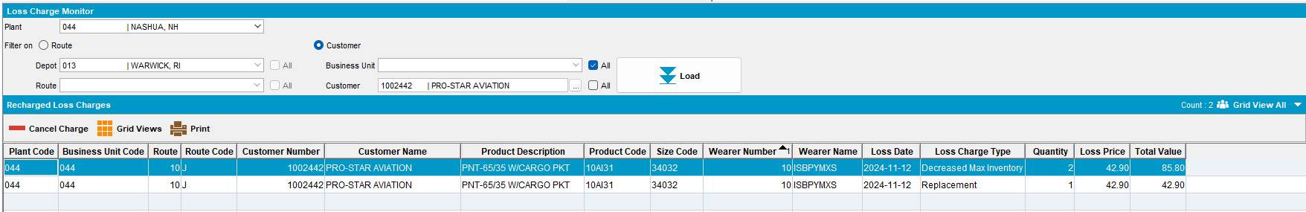
- Add a new route for the next delivery, generate invoices and check them
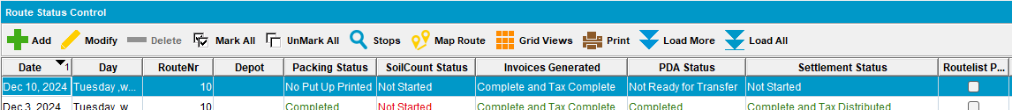
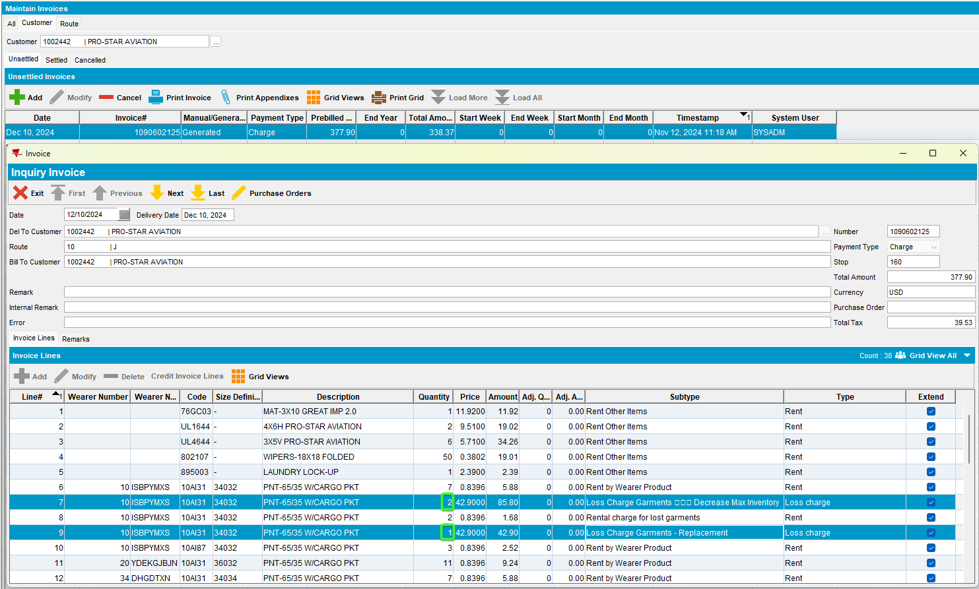

Both loss lines appear with the quantity that was previous adjusted, the rest was billed on the previous route. Tested ok.

Test Case 3 – Wearer Inventory with mixed garments with DOI and Replacement Loss Charges, adjust qty partially on loss charges before settlement

Expected behavior: Both loss lines should appear with the adjusted qty

Steps to reproduce
- Find customers that have wearers with wearer inventories mixed, non-unique and unique
--- Search wearer inventories with mixed non-unique and unique garments---
select c.customernumber, w.wearernumber, p.code from customer c
join wearer w on w.customer_id = c.customer_id
join weareremployment we on we.wearer_id = w.wearer_id
join wearerinventory wi on wi.weareremployment_id = we.weareremployment_id
join product p on p.product_id = wi.product_id
where wi.maxinventory > 0 and wi.circinventory >0
and exists (select 1 from nonuniqueitem nui where nui.wearerinventory_id = wi.wearerinventory_id and nui.flag_id is NULL)
and exists (select 1 from uniqueitemnonpool uinp where uinp.wearerinventory_id = wi.wearerinventory_id)
and wi.maxinventory = wi.circinventory;
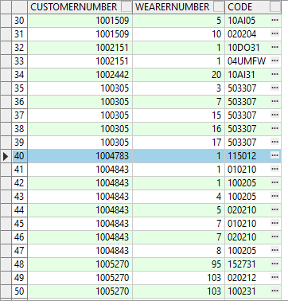
- Wearer dlg: Select a wearer inventory and make a reduction of the max inventory
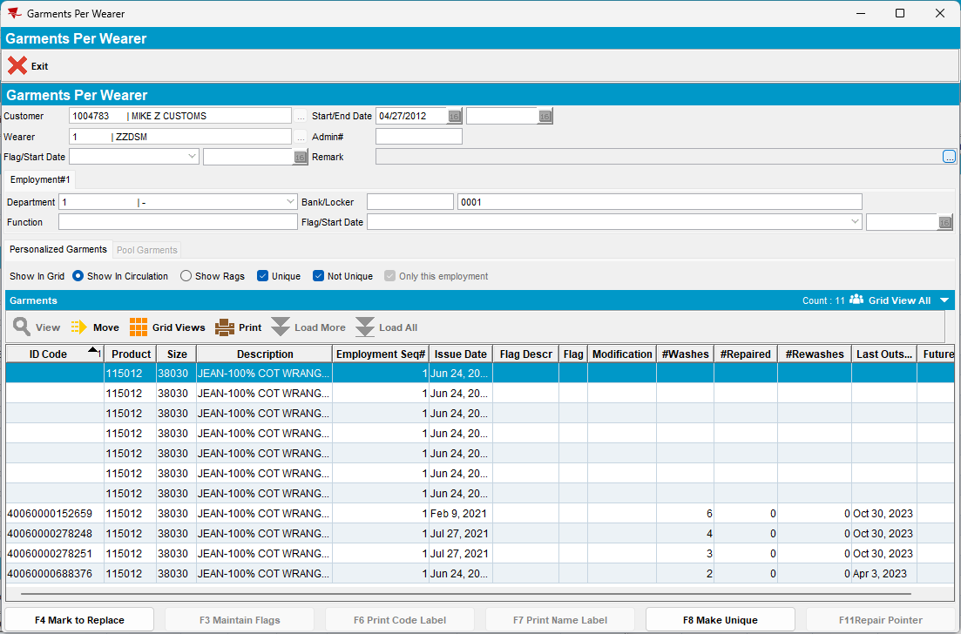
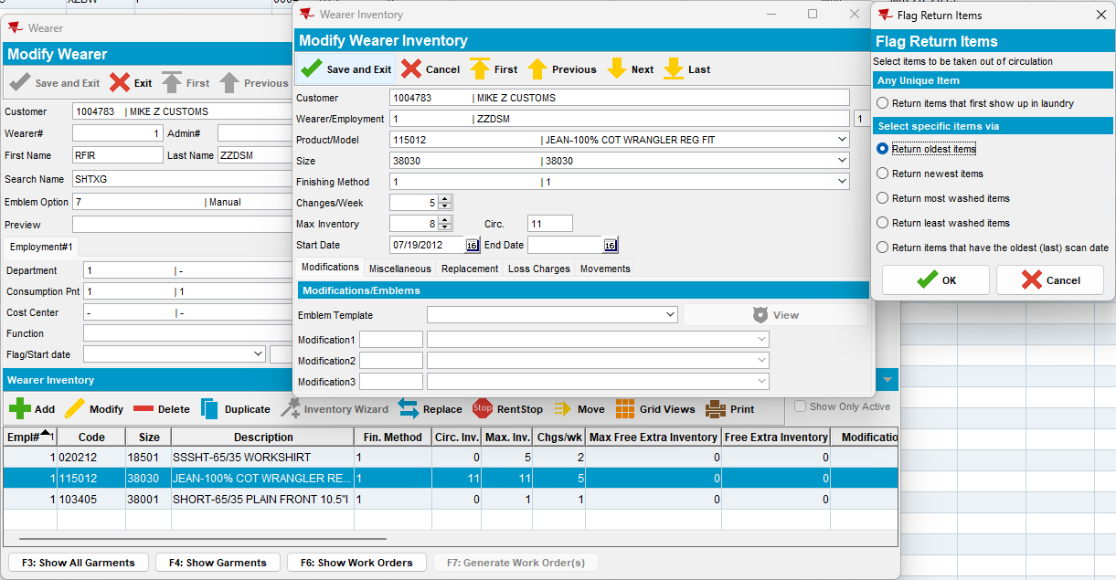
- Replace 2 garments from the same wearer inventory
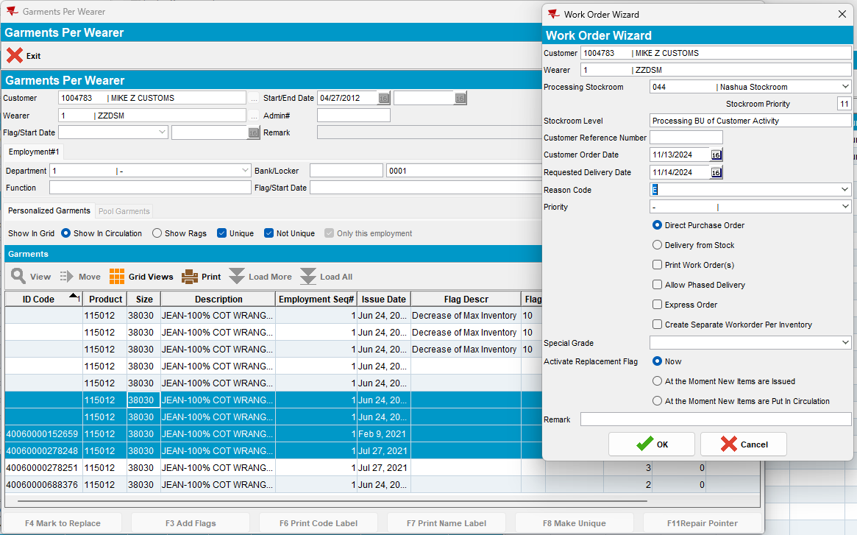
- RSC: Add a new route 2 weeks+ in the future and generate invoices for it
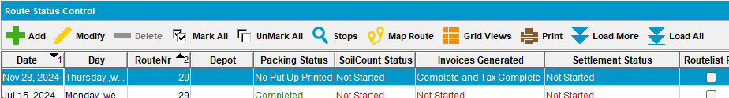
- Check the invoice to see if those two lines appear for loss
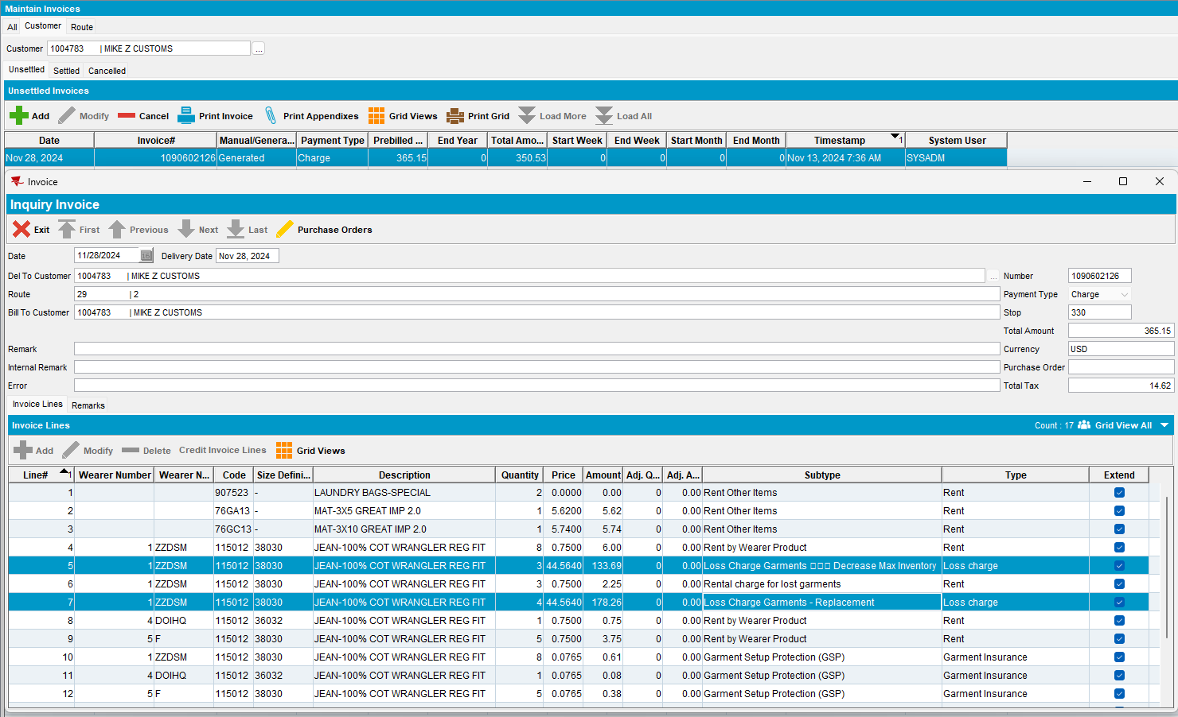
- RSC: Send the route to PDA.
- RA: Download the route and arrive at the customer.
- RA: Adjust partially just one loss charge.
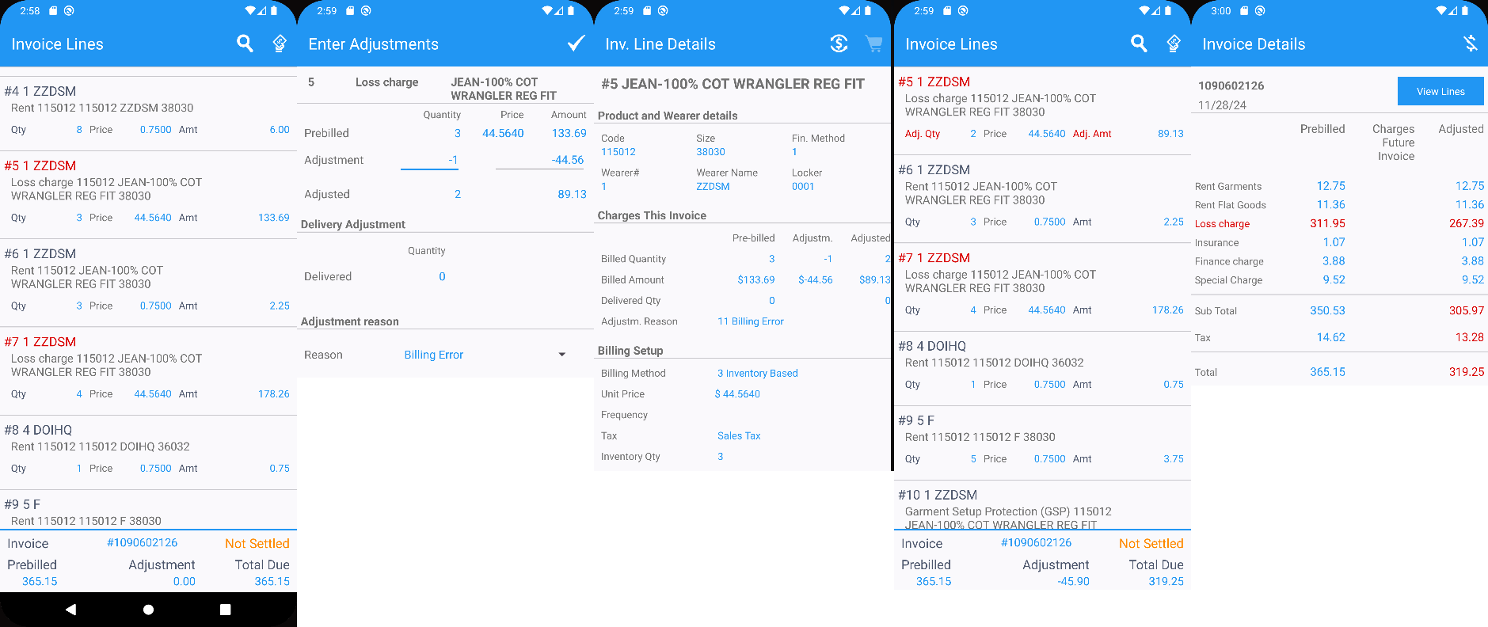
- Settle, depart and upload the route.
- WebX: Adjust partially the last loss line.
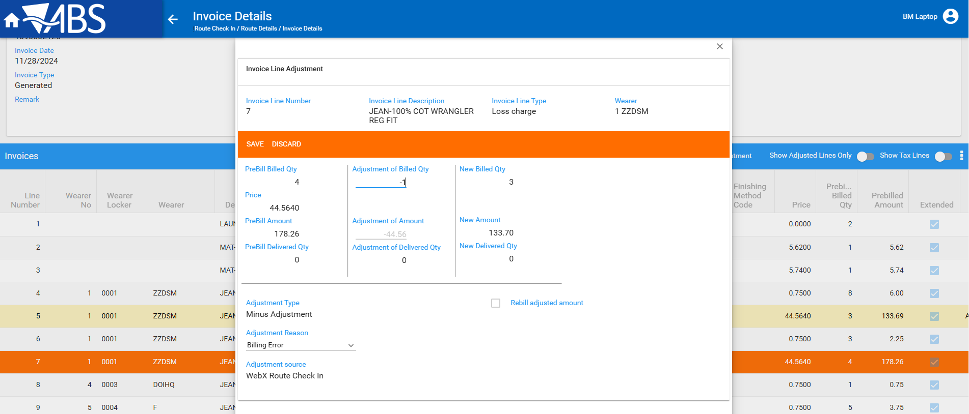
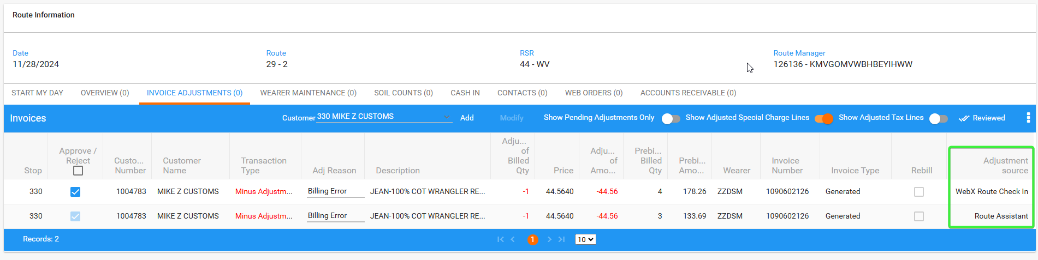
- WebX: Approve everything and settle the route
- Check data in Loss Charge Monitor
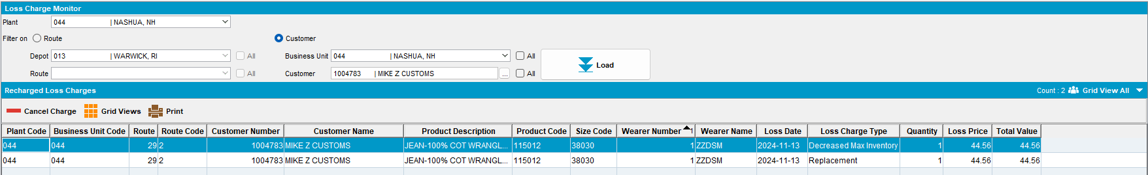
Both lines appear in LCM for every loss charge type.
- Add a new route for the next delivery, generate invoices and check them
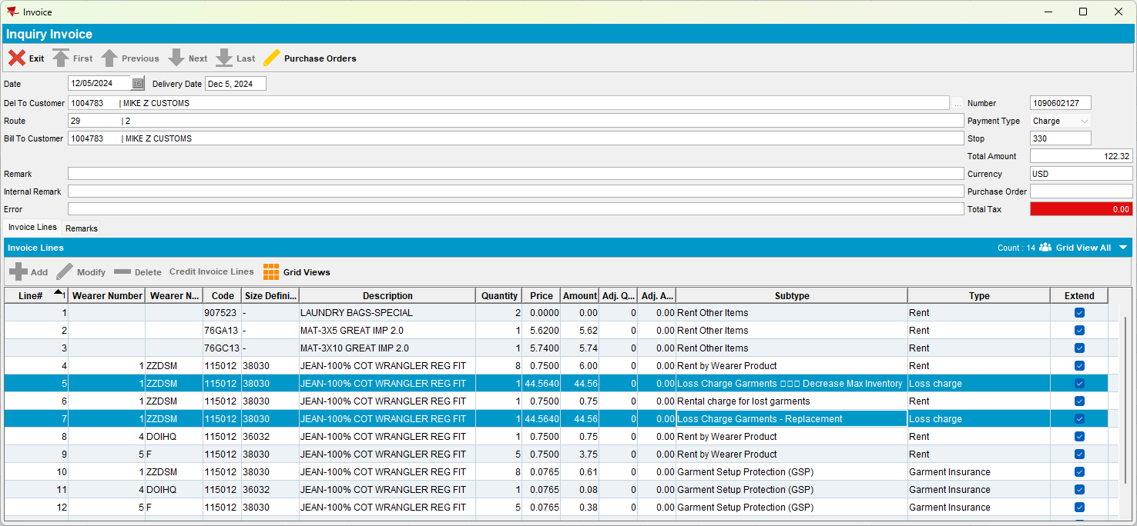
Both lines appear on the invoice with the right quantity.

Test Case 4 – Wearer Inventory with mixed garments with DOI and Replacement Loss Charges, adjust qty fully on loss charges before settlement

Expected behavior: Both loss charge line should appear on the invoice

Steps to reproduce
- Find customers that have wearers with wearer inventories mixed, non-unique and unique
--- Search wearer inventories with mixed non-unique and unique garments---
select c.customernumber, w.wearernumber, p.code from customer c
join wearer w on w.customer_id = c.customer_id
join weareremployment we on we.wearer_id = w.wearer_id
join wearerinventory wi on wi.weareremployment_id = we.weareremployment_id
join product p on p.product_id = wi.product_id
where wi.maxinventory > 0 and wi.circinventory >0
and exists (select 1 from nonuniqueitem nui where nui.wearerinventory_id = wi.wearerinventory_id and nui.flag_id is NULL)
and exists (select 1 from uniqueitemnonpool uinp where uinp.wearerinventory_id = wi.wearerinventory_id)
and wi.maxinventory = wi.circinventory;
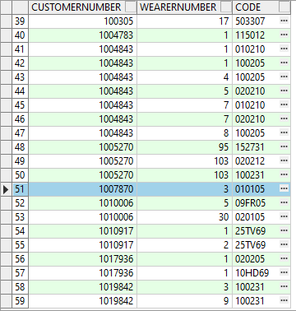
- Wearer dlg: Select a wearer inventory and make a reduction of the max inventory
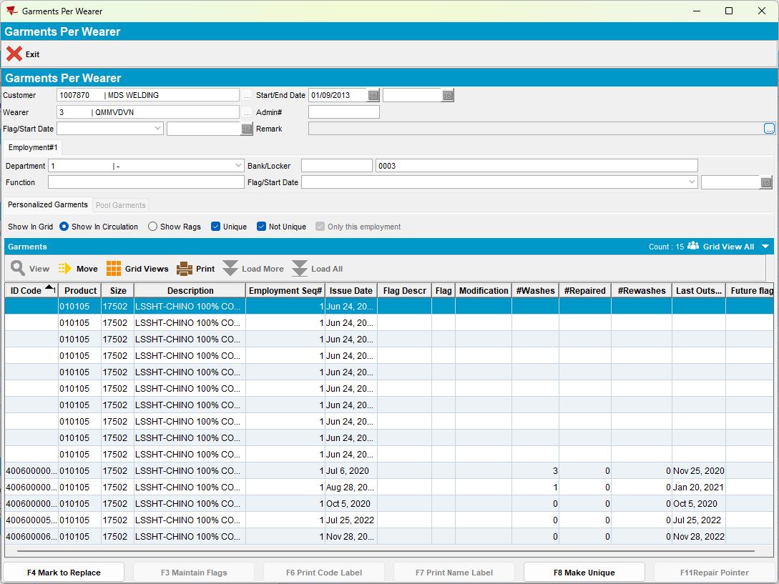
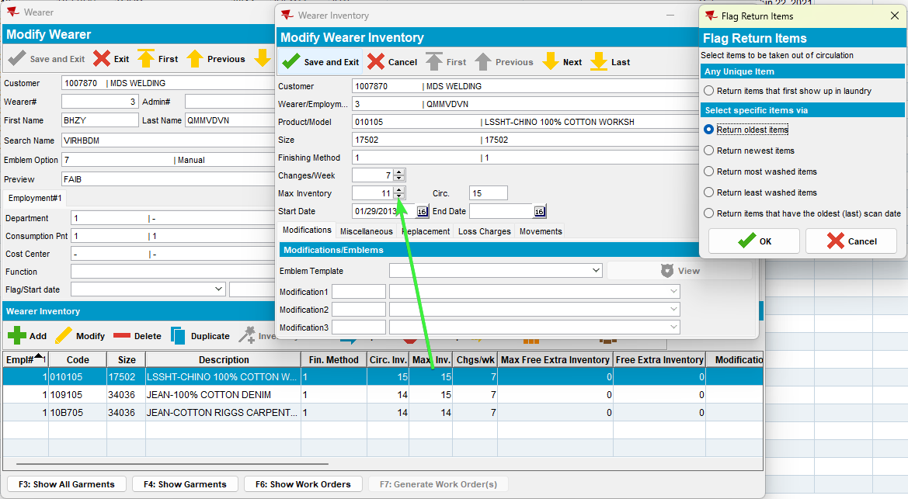
- Replace some garments from the same wearer inventory
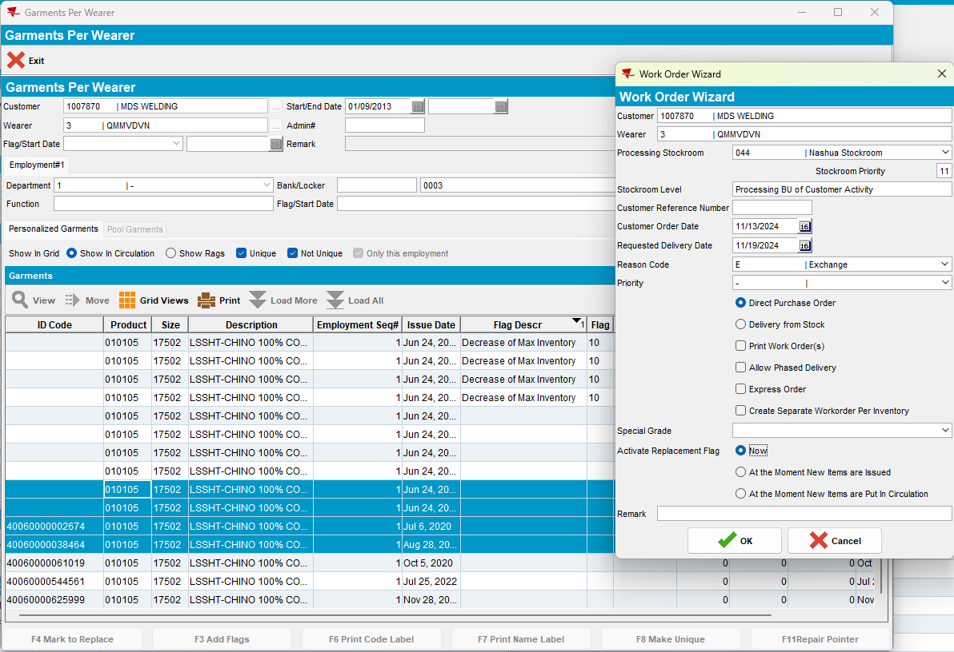
- RSC: Add a new route 2 weeks+ in the future and generate invoices for it
- Check the invoice to see if appear those two lines for loss
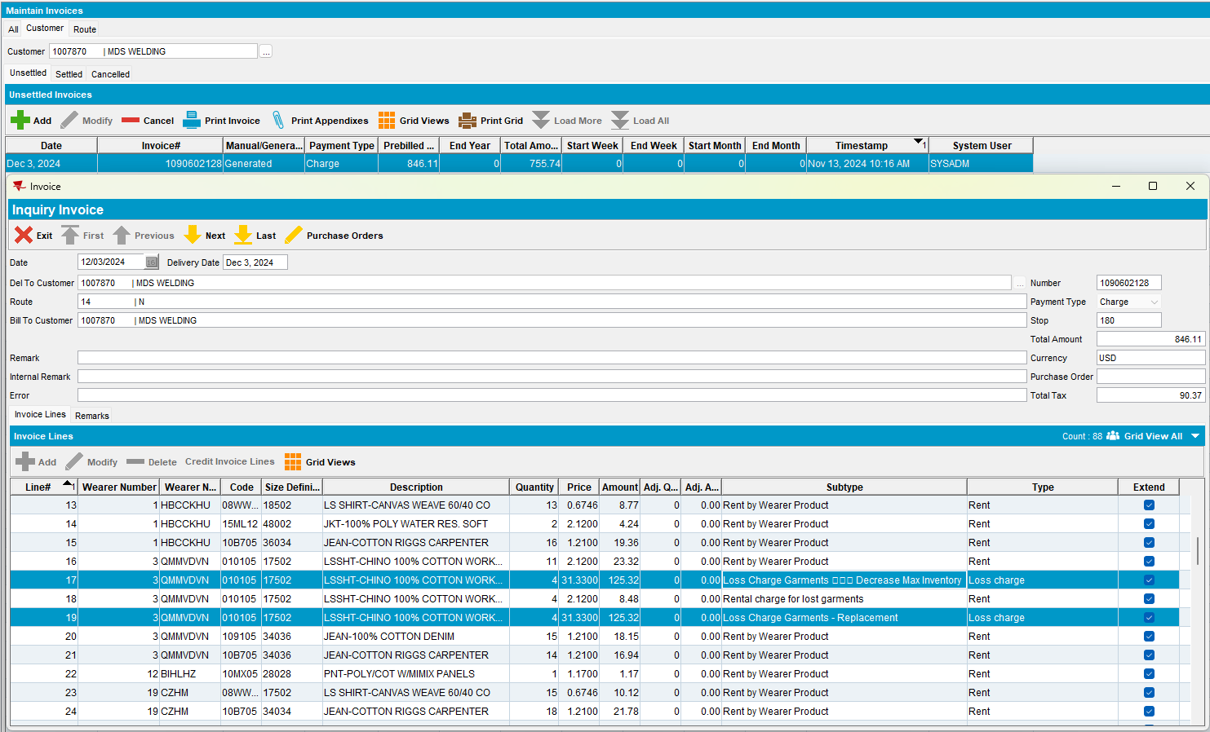
- RSC: Send the route to PDA.
- RA: Download the route and arrive at the customer.
- RA: Adjust fully just one loss charge.
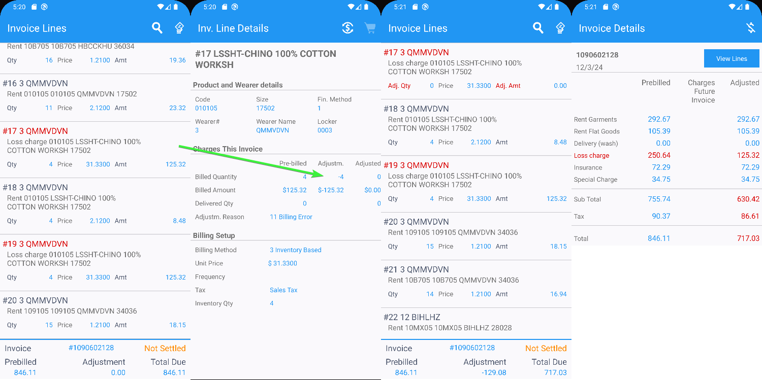
- RA: Settle, depart and upload the route.
- WebX: Adjust fully the second loss charge line.
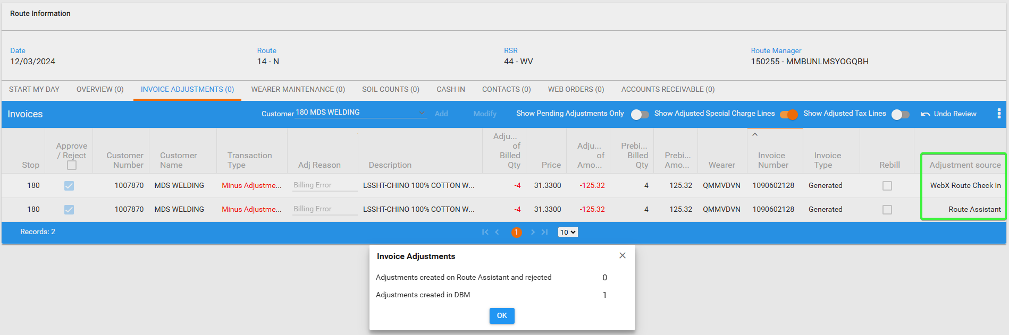
- WebX: Approve everything and settle the route
- Check data in Loss Charge Monitor
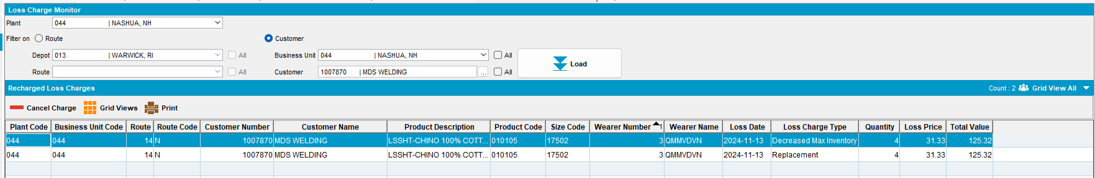
Both lines appear for every loss charge type.

- Add a new route for the next delivery, generate invoices and check them
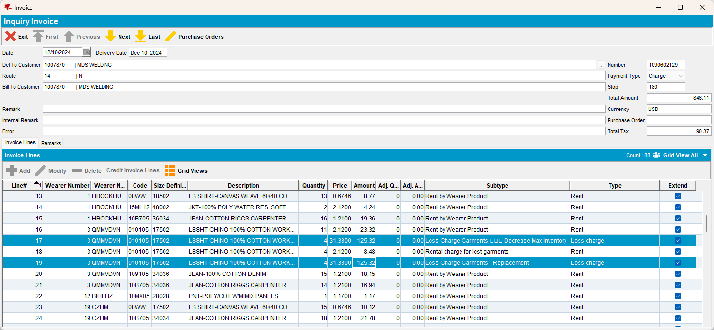
Both lines appear on the invoice with the right qty.
Tested ok.

Test Case 5 – Wearer Inventory with all unique garments with DOI and Replacement Loss Charges, adjust qty fully on loss charges before settlement

Expected behavior: Both loss charge line should appear on the invoice

Steps to reproduce
- Find customers that have wearers with wearer inventories mixed, non-unique and unique
--- Search wearer inventories with unique garments---
select c.customernumber, w.wearernumber, p.code from customer c
join wearer w on w.customer_id = c.customer_id
join weareremployment we on we.wearer_id = w.wearer_id
join wearerinventory wi on wi.weareremployment_id = we.weareremployment_id
join product p on p.product_id = wi.product_id
where wi.maxinventory > 0 and wi.circinventory >0
and not exists (select 1 from nonuniqueitem nui where nui.wearerinventory_id = wi.wearerinventory_id and nui.flag_id is NULL)
and exists (select 1 from uniqueitemnonpool uinp where uinp.wearerinventory_id = wi.wearerinventory_id)
and wi.maxinventory = wi.circinventory;
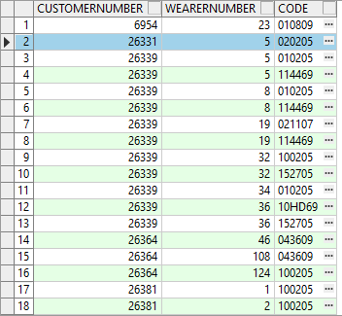

- Wearer dlg: Select a wearer inventory and make a reduction of the max inventory
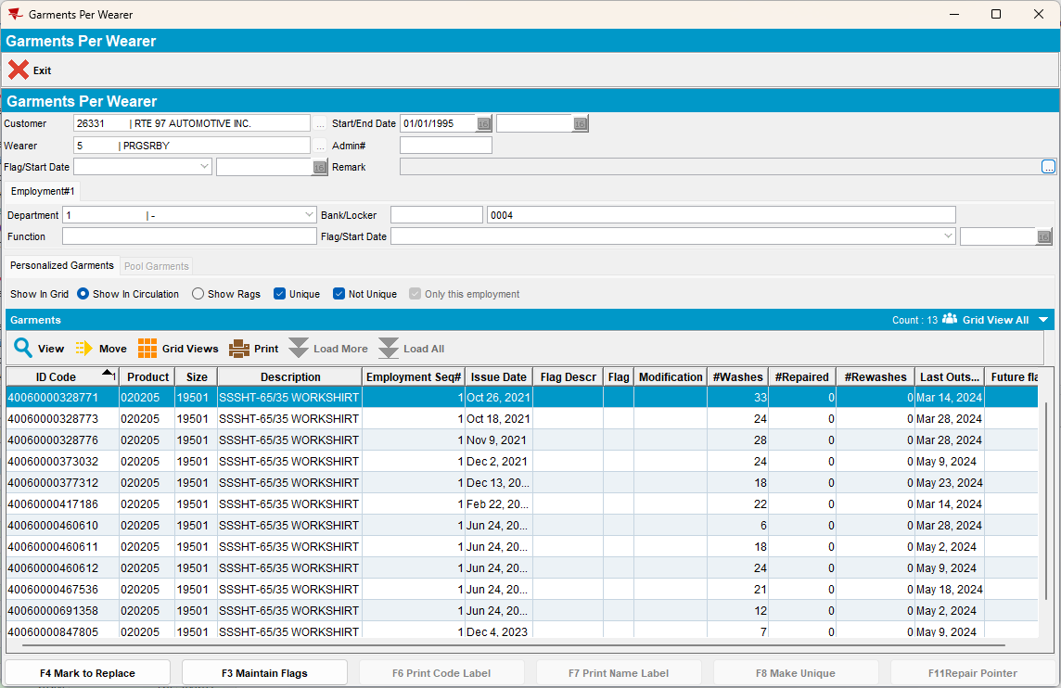

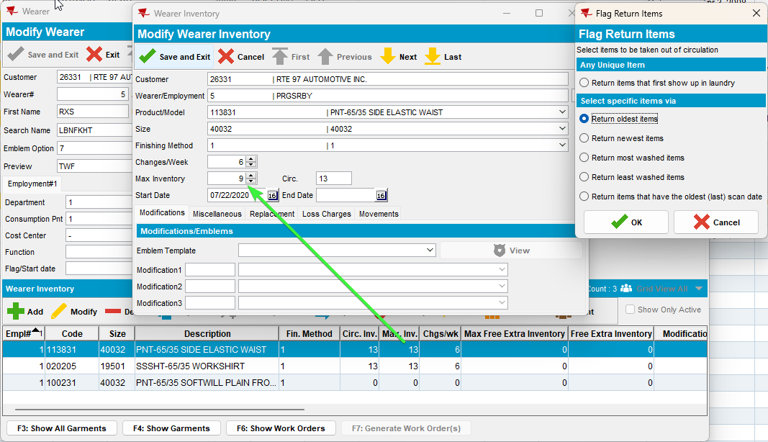
- Replace some garments from the same wearer inventory
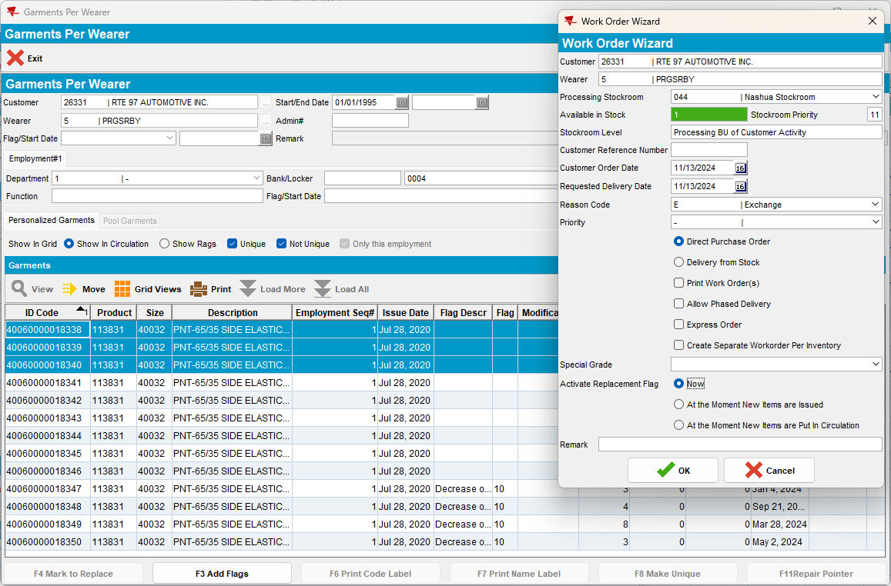
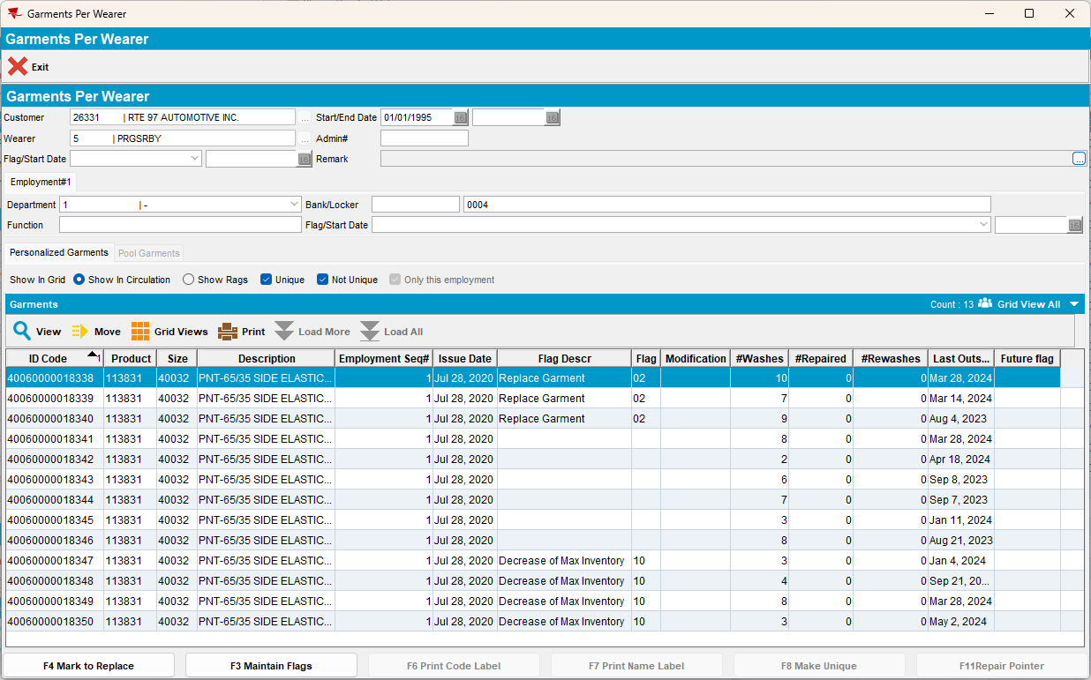
- RSC: Add a new route 2 weeks+ in the future and generate invoices for it
- Check the invoice to see if appear those two lines for loss
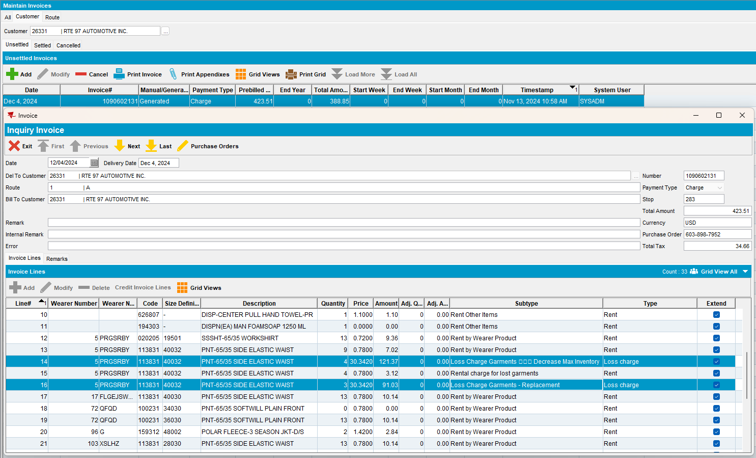
- RSC: Send the route to PDA.
- RA: Download the route and arrive at the customer.
- RA: Adjust fully just one loss charge.
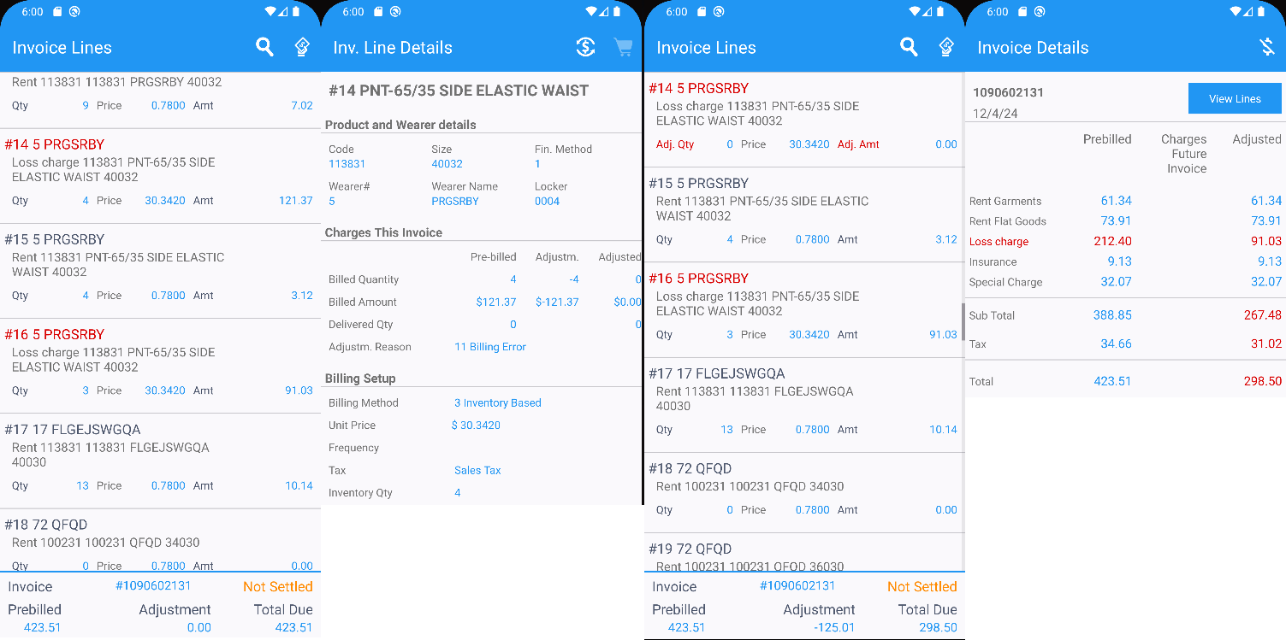
- RA: Settle, depart and upload the route.
- WebX: Adjust fully the second loss charge line.
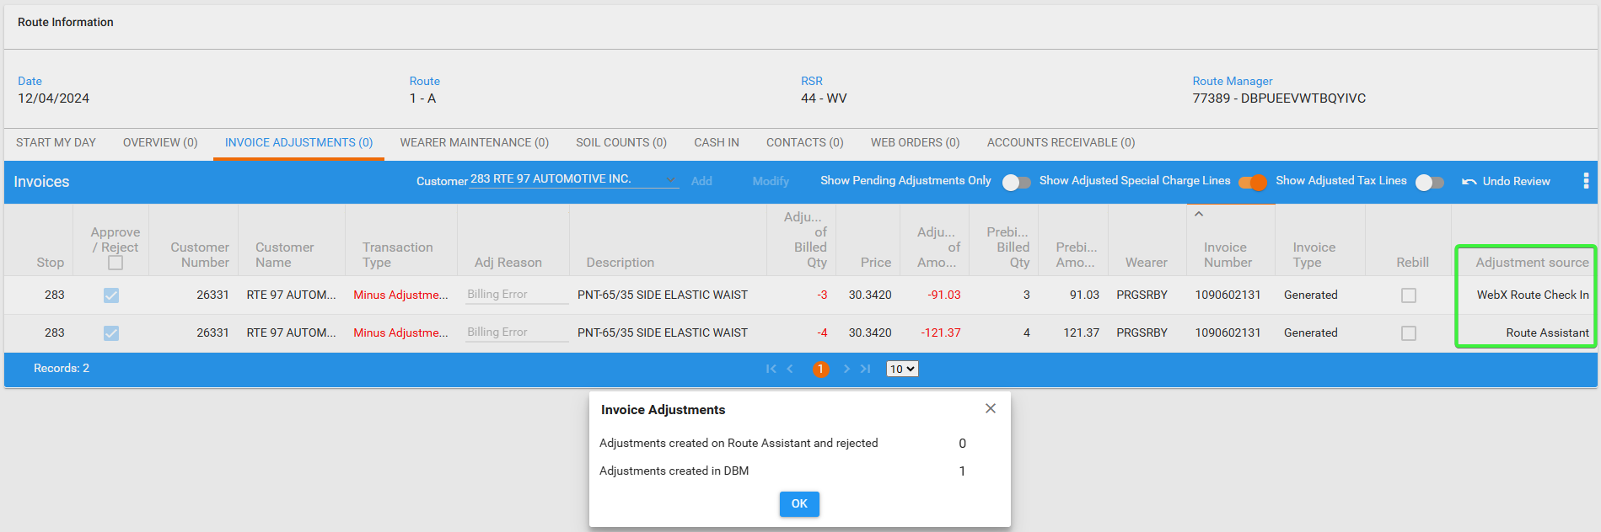
- WebX: Approve everything and settle the route
- Check data in Loss Charge Monitor
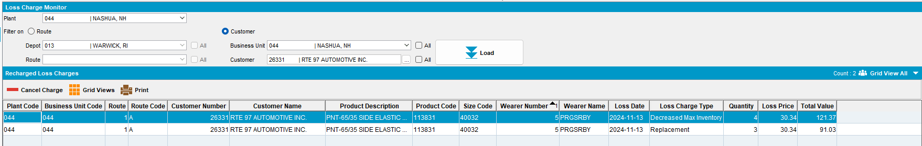
Both lines appear for every loss charge type.
- Add a new route for the next delivery, generate invoices and check them
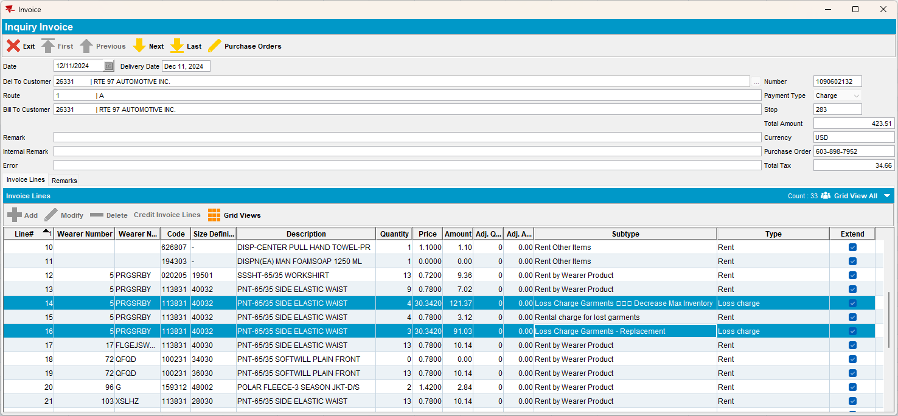
Both lines appear on the invoice with the right qty.
Tested ok.

