ABS-145186 With module smartbarcodes, i cannot release the locker when i quit a wearer
Environment | Prerequisites
Version: 9.09.00.RC1  DBServerName= abs-srv20.internal.abslbs.com  DBSID=CUST24  DBUser=UNFA  DBPassword=UNFA  Environment=Production | - Module:

Contents
Retest after fix 1
Test Case #1 – Release a locker with all unique items 1
Test Case #2 – Release a locker with bot unique an non unique items 3

Retest after fix
Hash: 6d6958b69da

Test Case #1 – Release a locker with all unique items
- Wearers: Select a wearer with only unique items
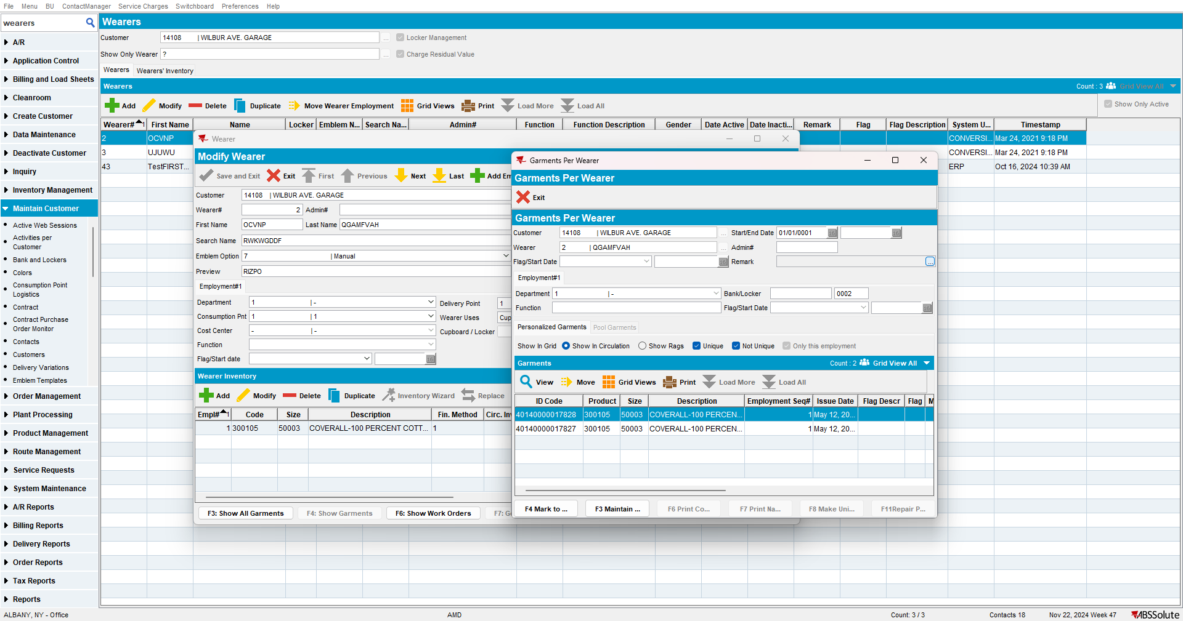

- Set the end date today.
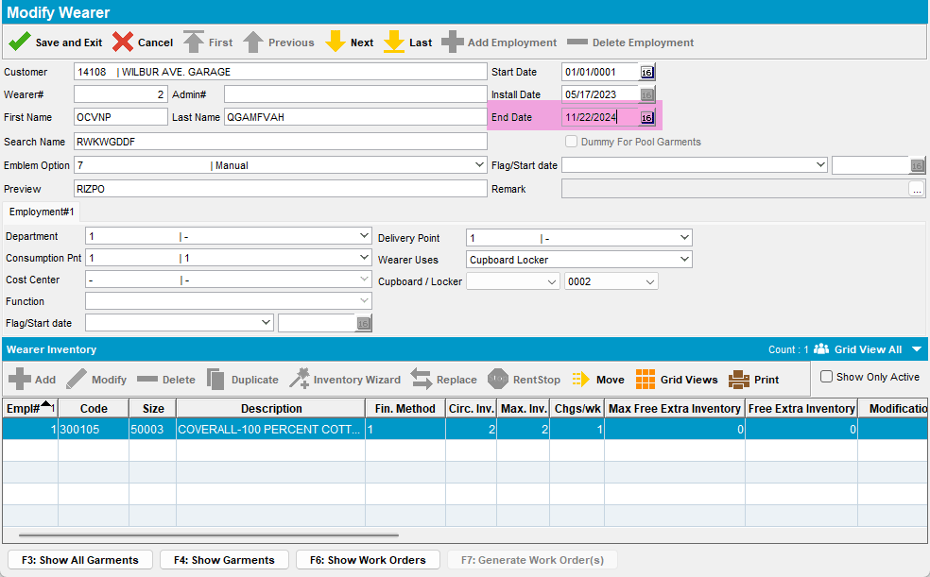

- Press Save and Exit then press Yes
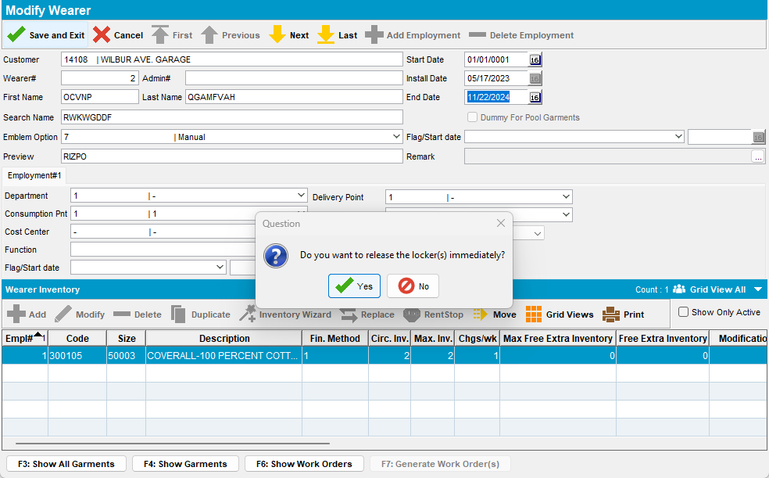
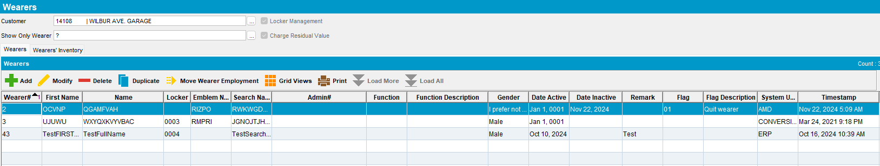
The locker was released.
TESTED OK. 💚

Test Case #2 – Release a locker with bot unique an non unique items

- Wearers: Select a wearer with only unique items
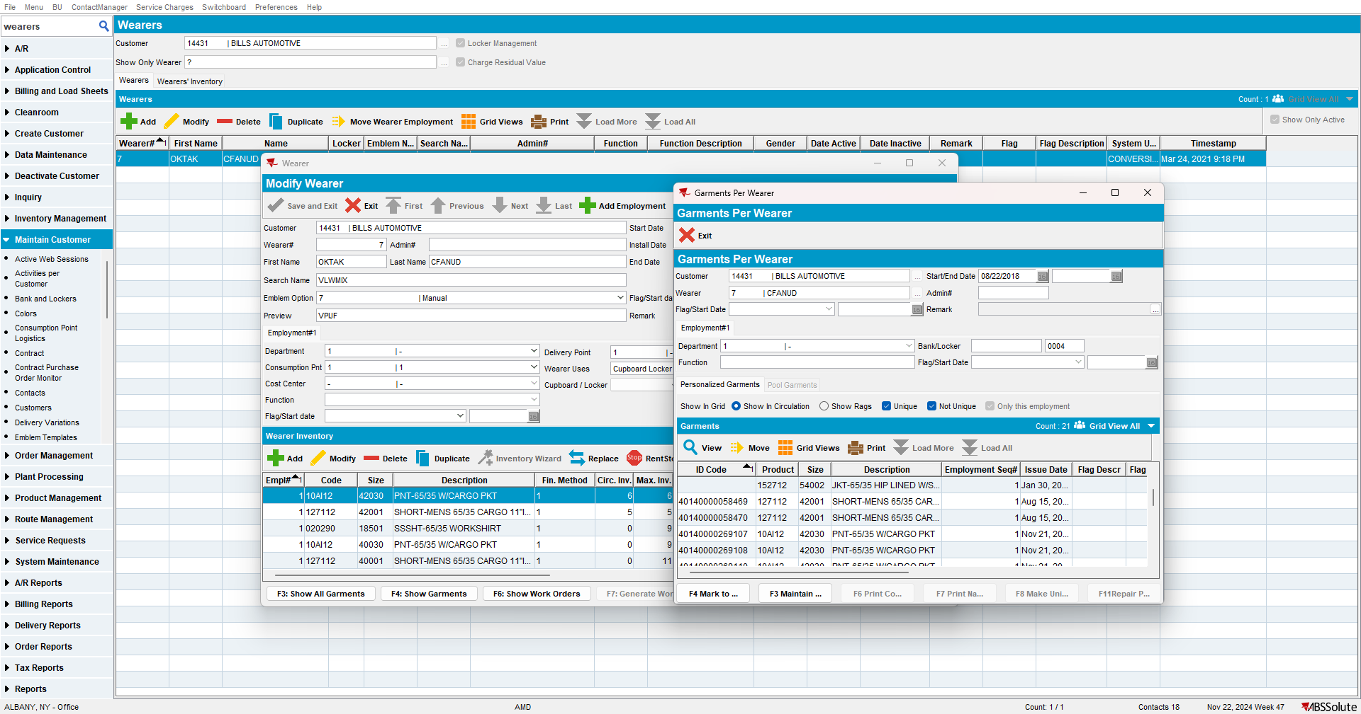

- Set the end date today.
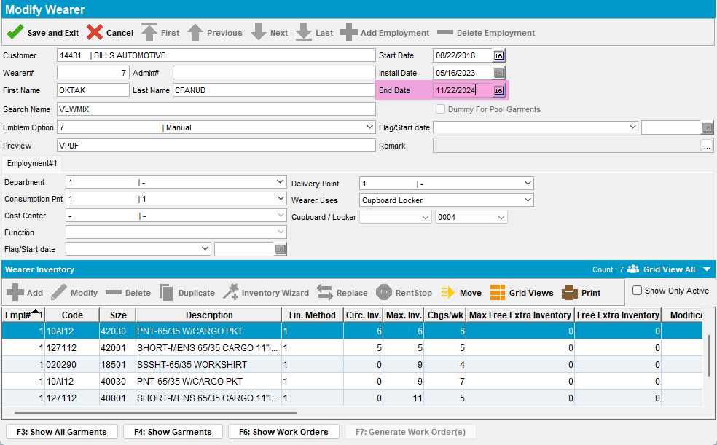

- Press Save and Exit then press Yes
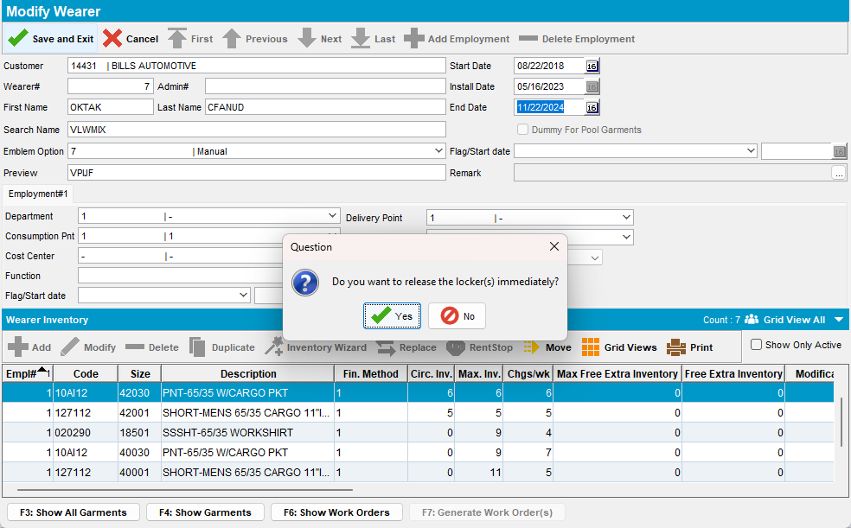
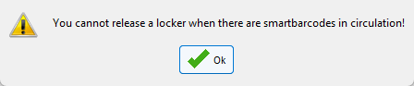
The locker can’t be released if there are non-unique items.
TESTED OK. 💚

