ABS-144784 Loss charge monitor with 2 different loss charge types on the same Wearer Inventory
Environment | Prerequisites
Version: 9.07.00  DBServerName= abs-srv20.internal.abslbs.com  DBSID=CUST24  DBUser=UNFDEV  DBPassword=UNFDEV  Environment=Production  Hash: 4f968a8c3ff | - Module:

Contents
Test after fix 1

Test after fix

- Wearer dlg: Select a wearer inventory and make a reduction of the max inventory.
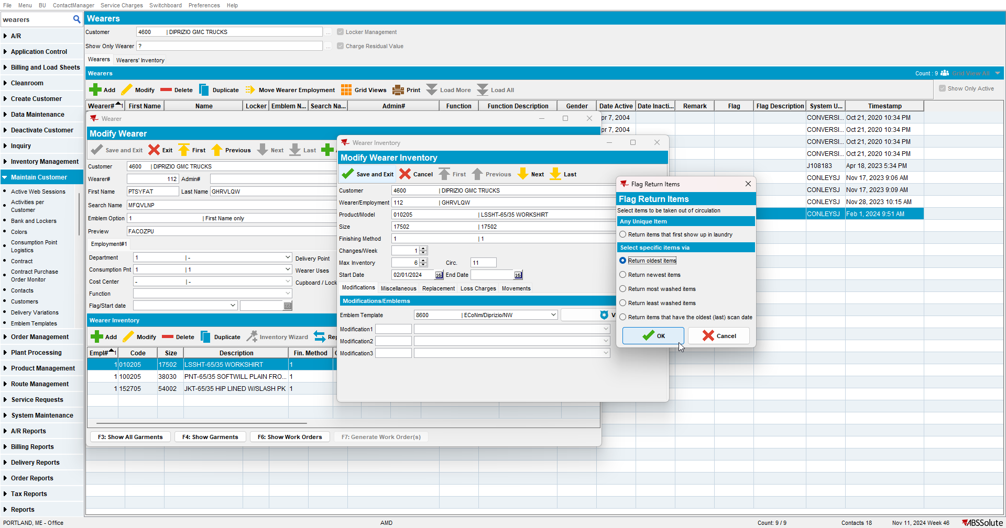

- Replace 2 garments from the same wearer inventory.
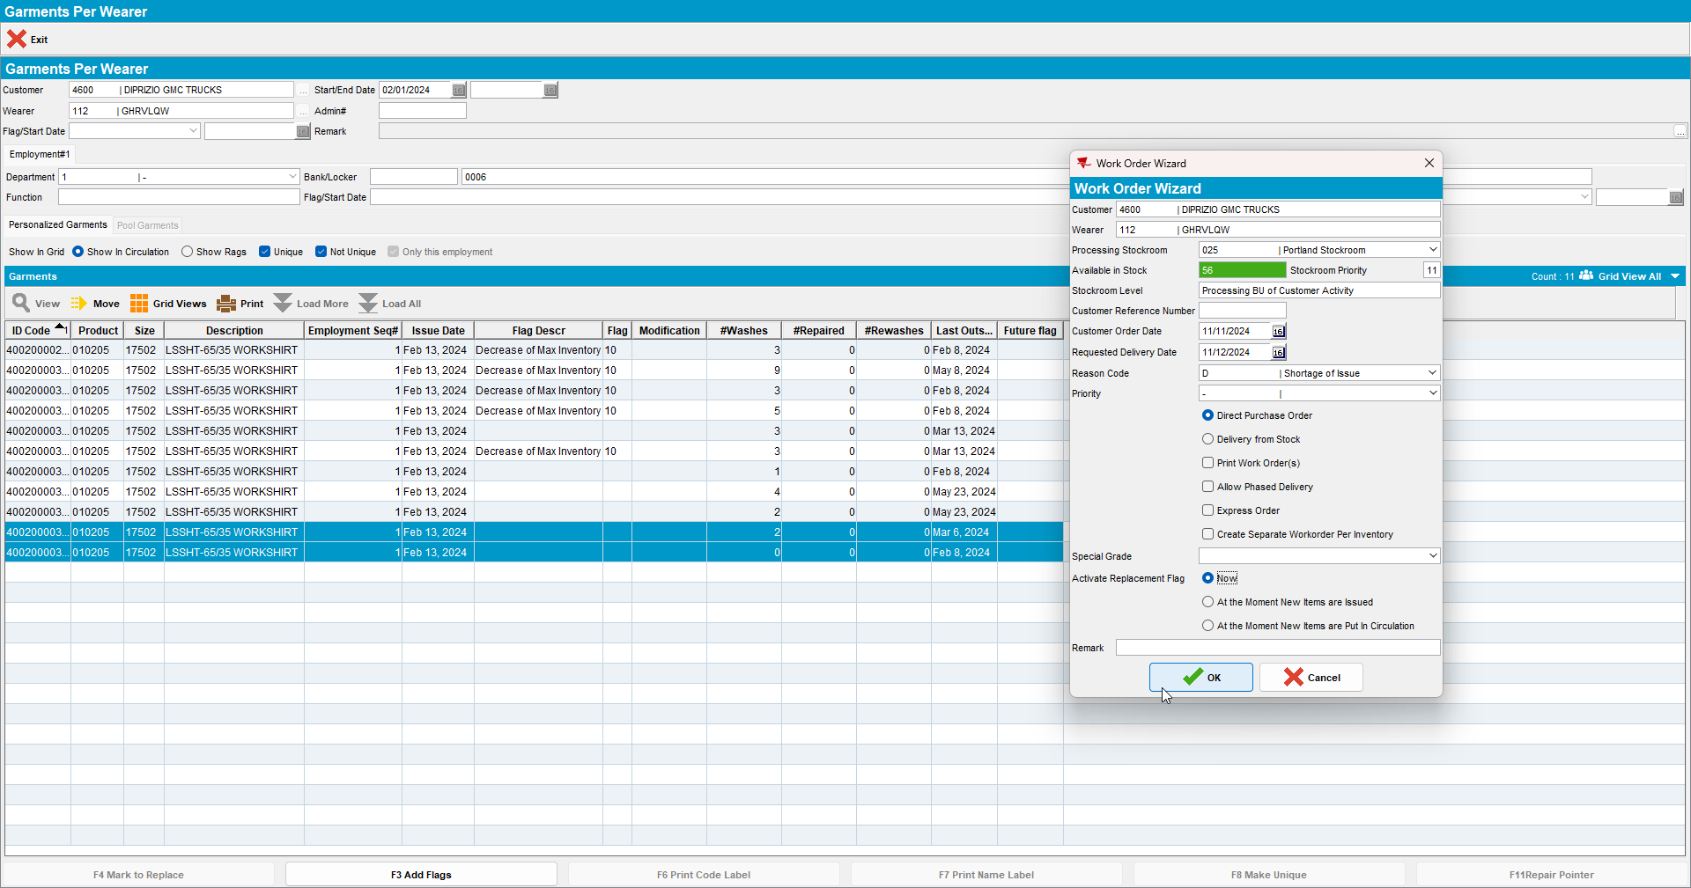

- RSC: Add a new route and generate invoices for it.
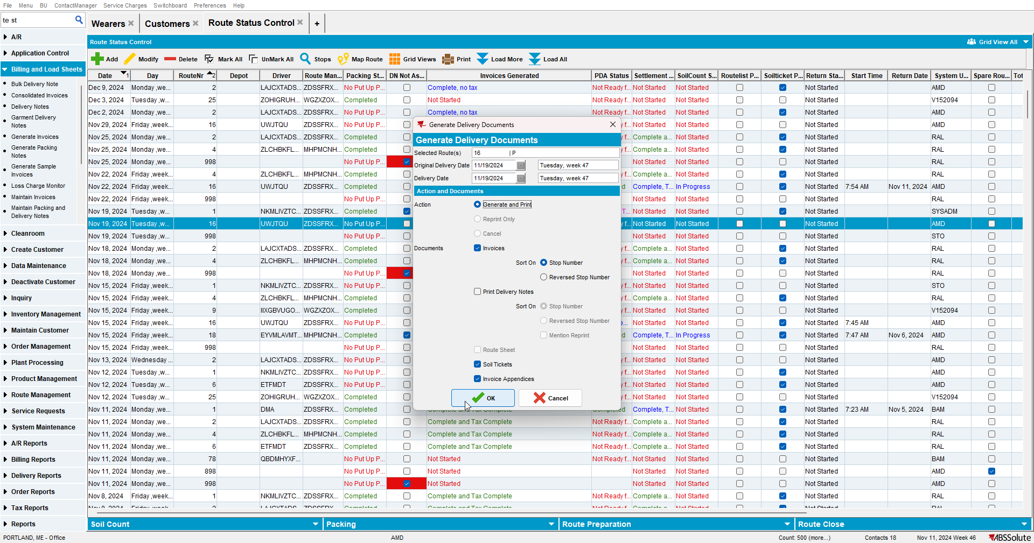

- Check the invoice to see if appear those two lines for loss.
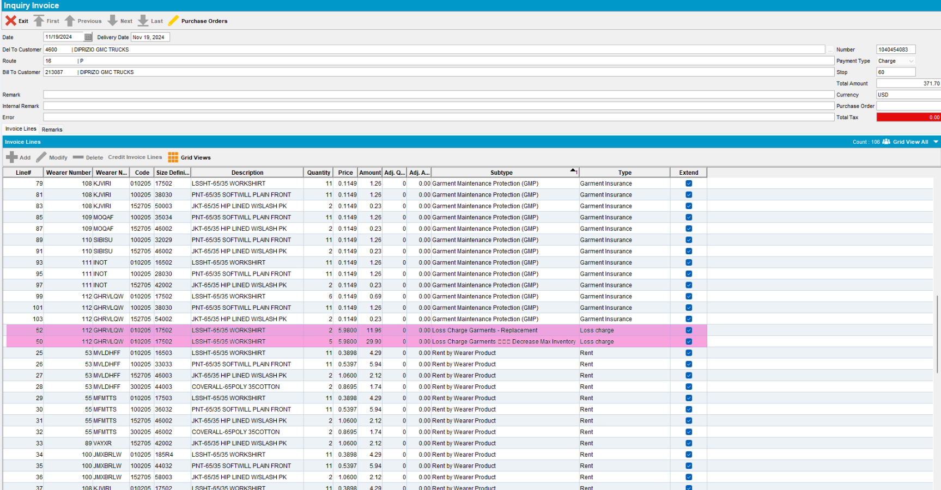

- RSC: Settlement-> Adjust partially both loss lines.
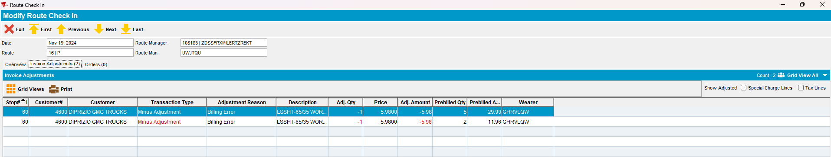

- Settle the route.
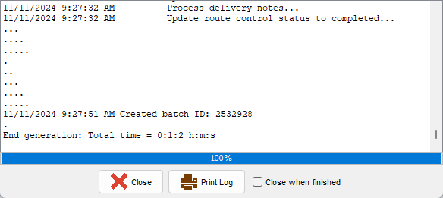

- Check data in Loss Charge Monitor.
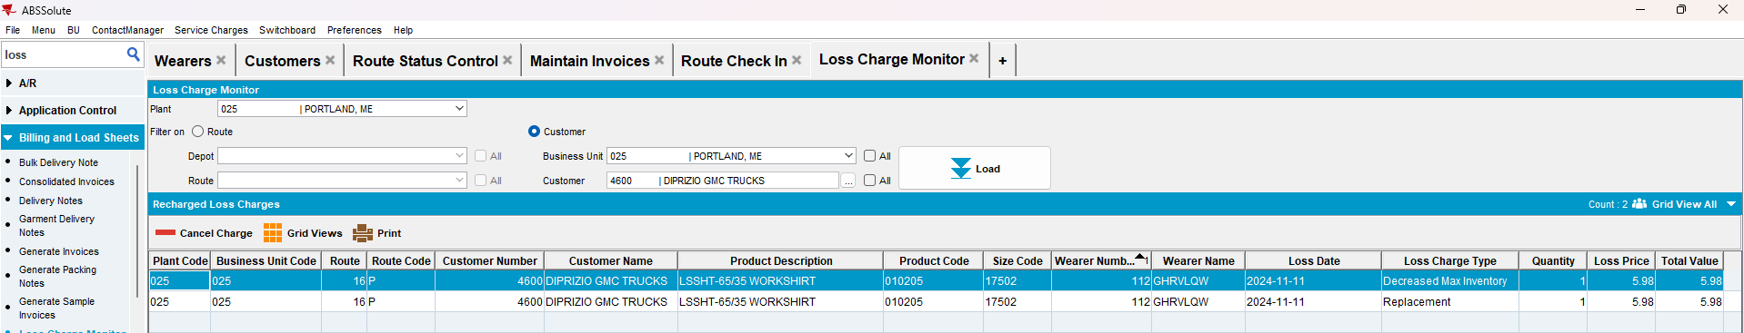

- Add a new route for the next delivery, generate invoices and check the invoice.
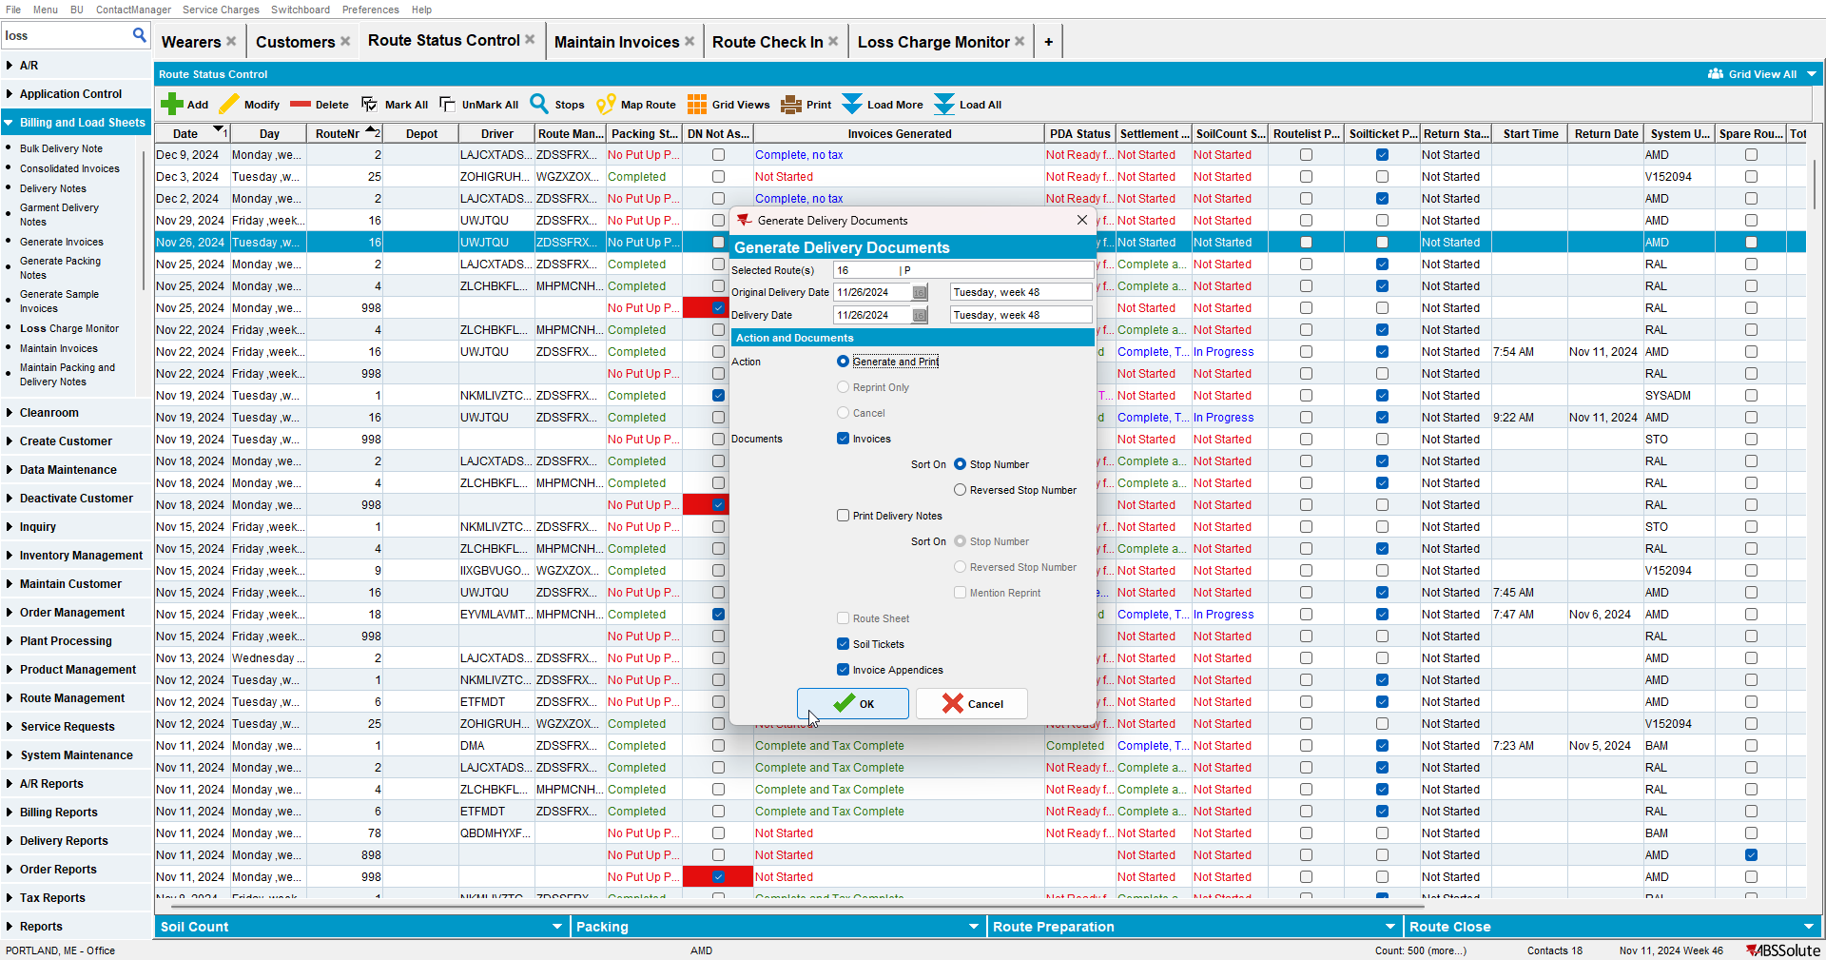
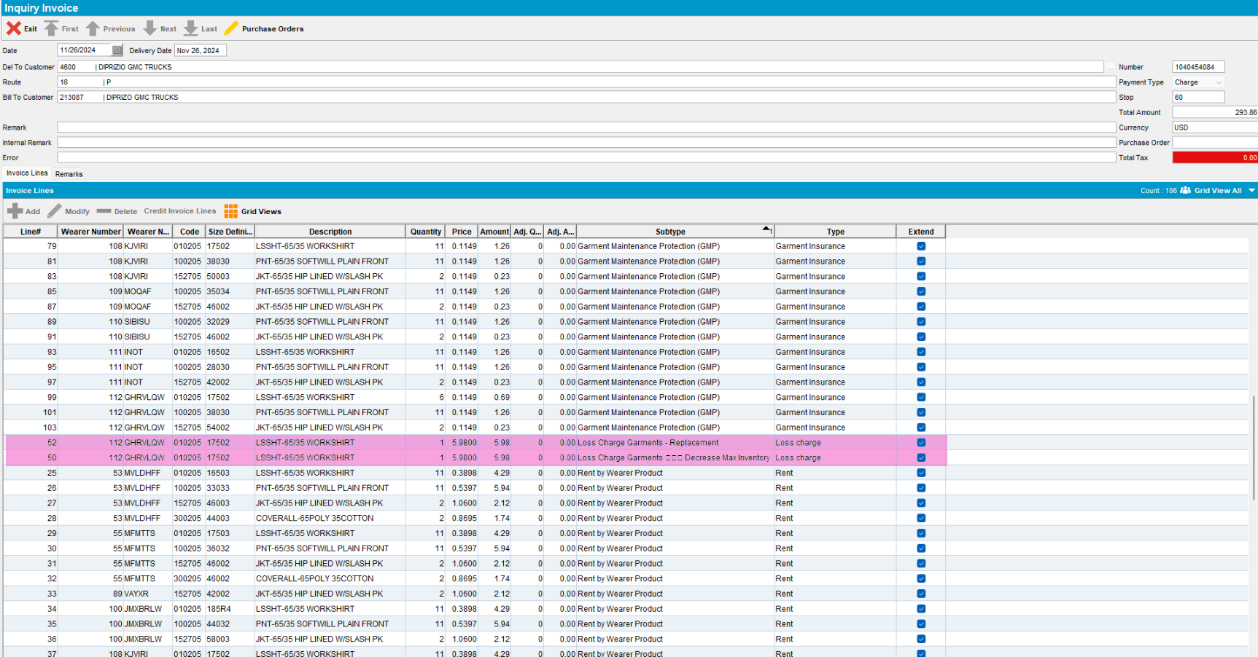
Both lines appear on the invoice.

TESTED OK. 💚

