ASD-36041 D_UBS_723 WEBWORKORDERRESERVATION system setting broken
Environment | Prerequisites
Version: 9.07.00.UNF18  DBServerName=abs-srv20.internal.abslbs.com  DBSID= CUST24  DBUser= UNFDEV  DBPassword= UNFDEV  Environment=Production | - Module:  - System setting

Contents
Reproducing before fix 1
Steps to reproduce 1
Expected behavior 4
Retest after fix 4
Expected behavior 4
Test Case 01 – ss WEBWORKORDERRESERVATION is on 2 5
Steps to reproduce 5
Test Case 02 – ss WEBWORKORDERRESERVATION is on 1 10
Steps to reproduce 10

Reproducing before fix
9.09.00.RC1 hash: 2fc52fa70387
BU: 088 PONTIAC

Steps to reproduce
- System Settings dlg: Make sure ss WEBWORKORDERRESERVATION is on 2.
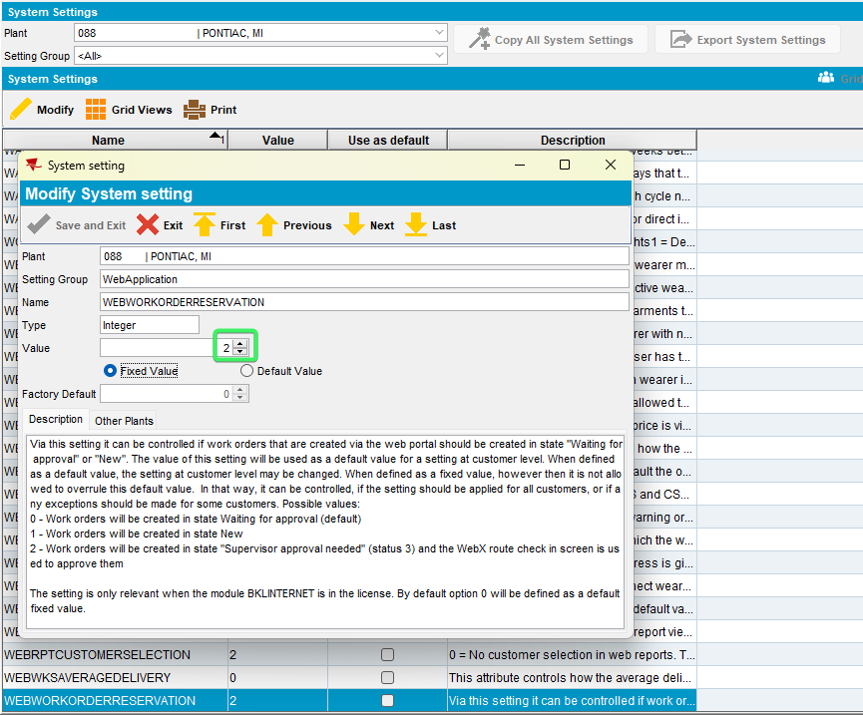
- Configure the abswebportal_9.09.00.RC1.war and make sure we add the correct server port, the correct system user and password and the correct workstation number.
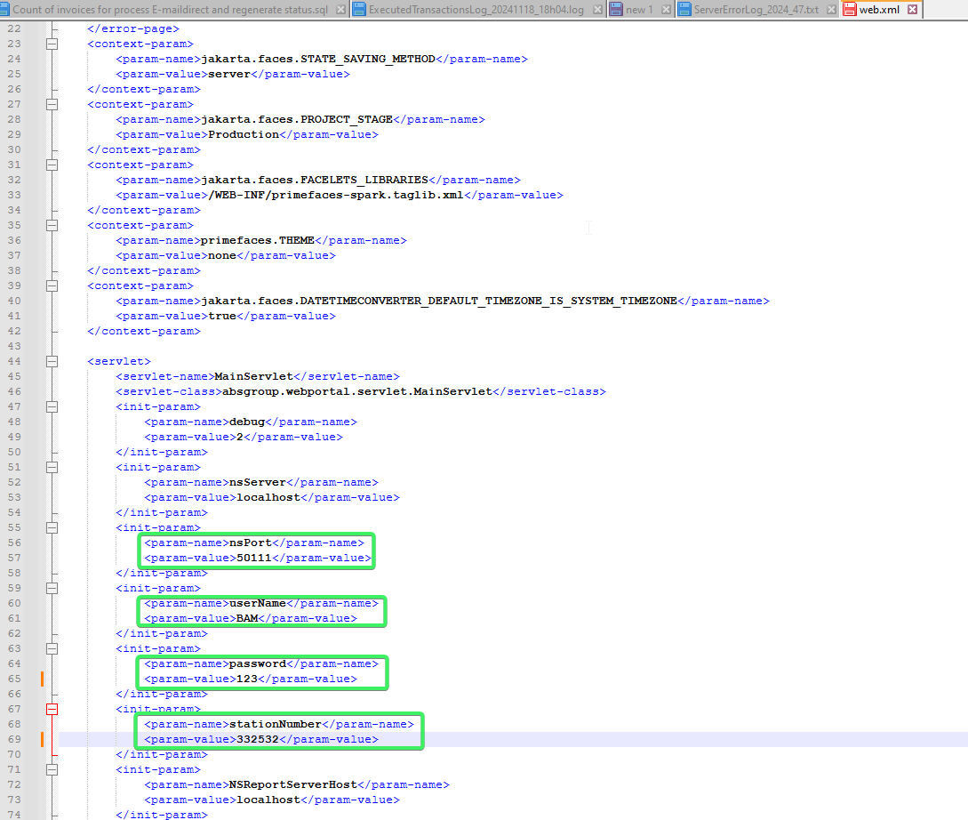
- WebPortal: Log in and select a configured customer.
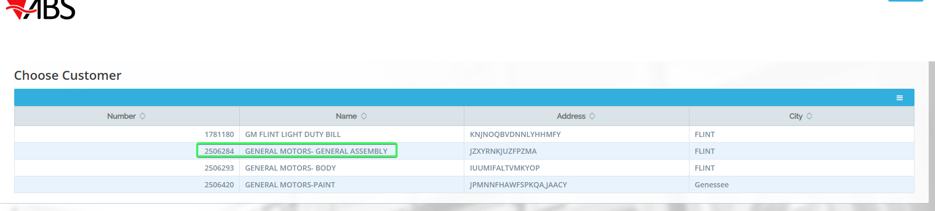
- WebPortal: Select Garment Wearers
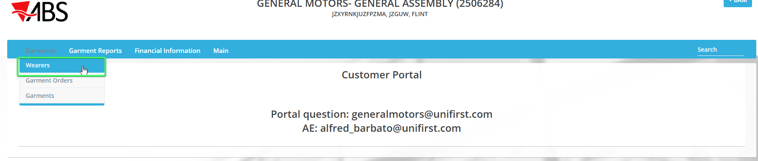
- WebPortal: Add wearer.
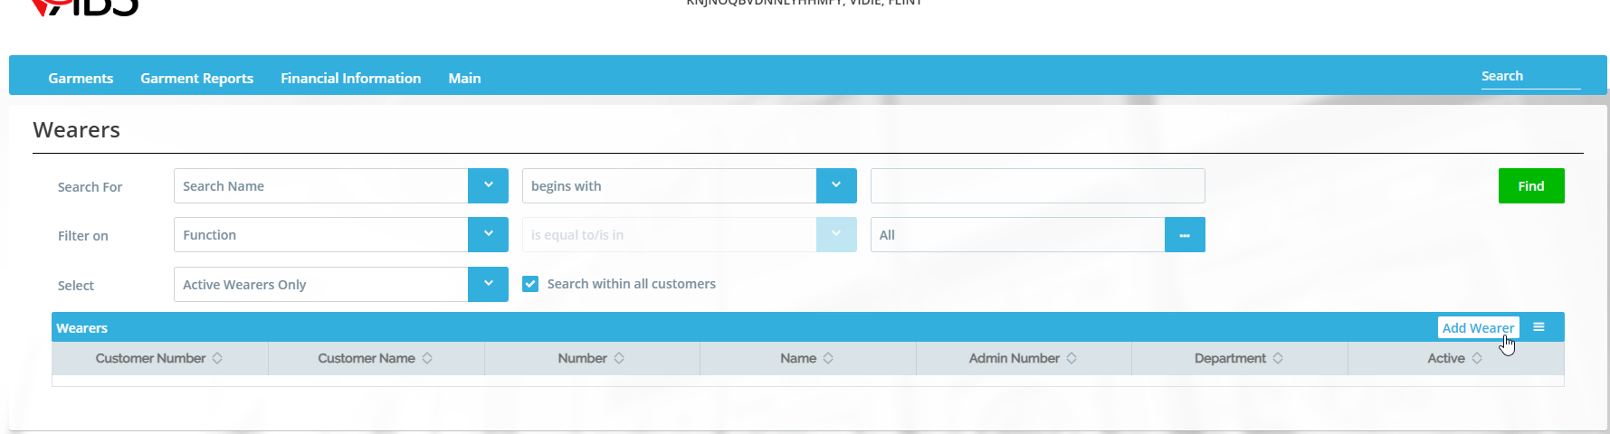
- WebPortal: Complete all the necessary fields
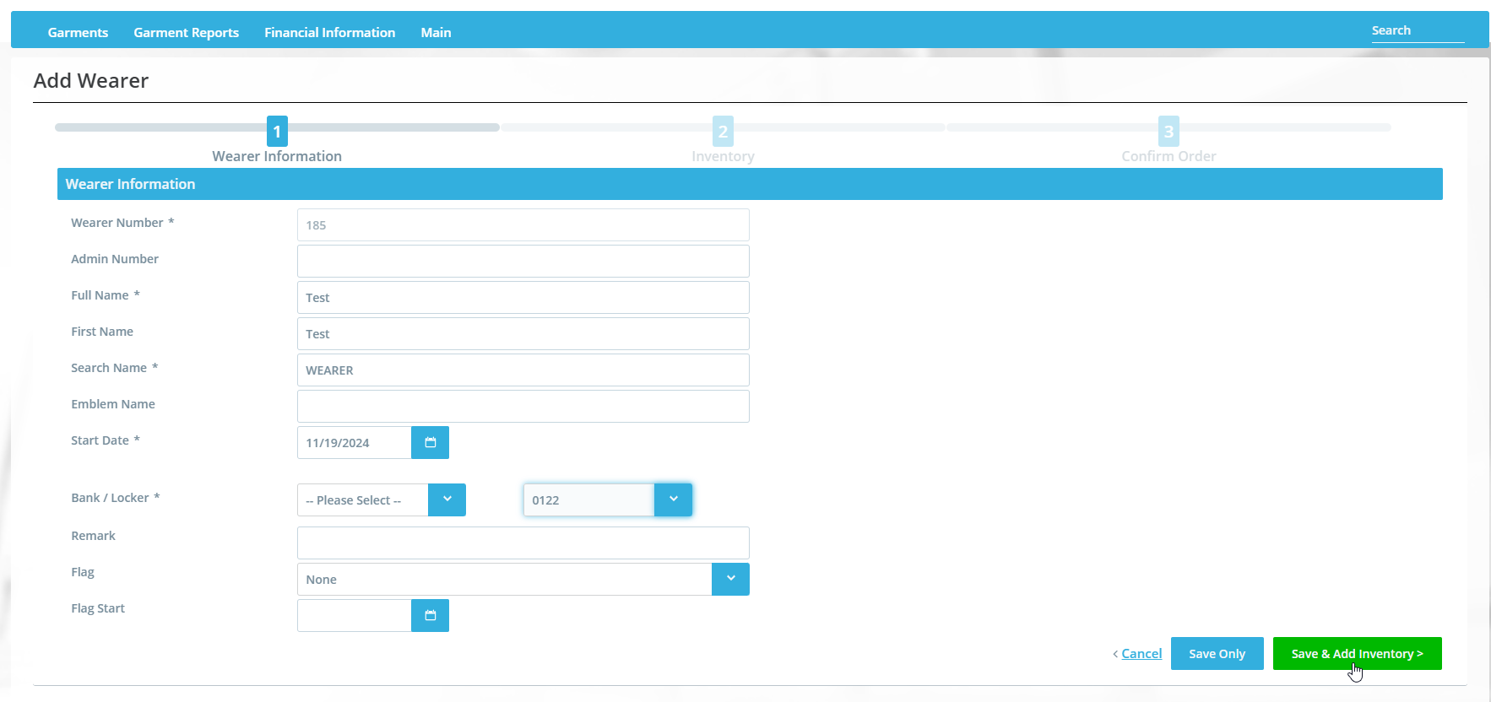
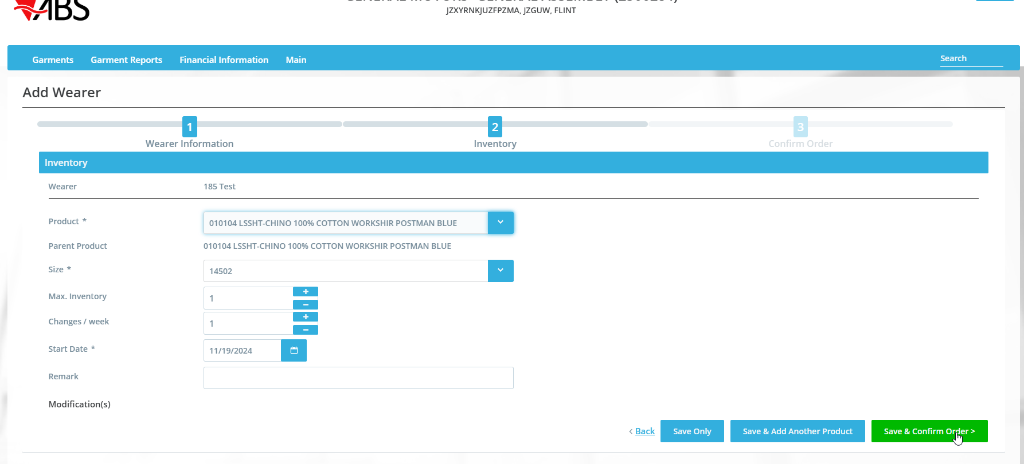
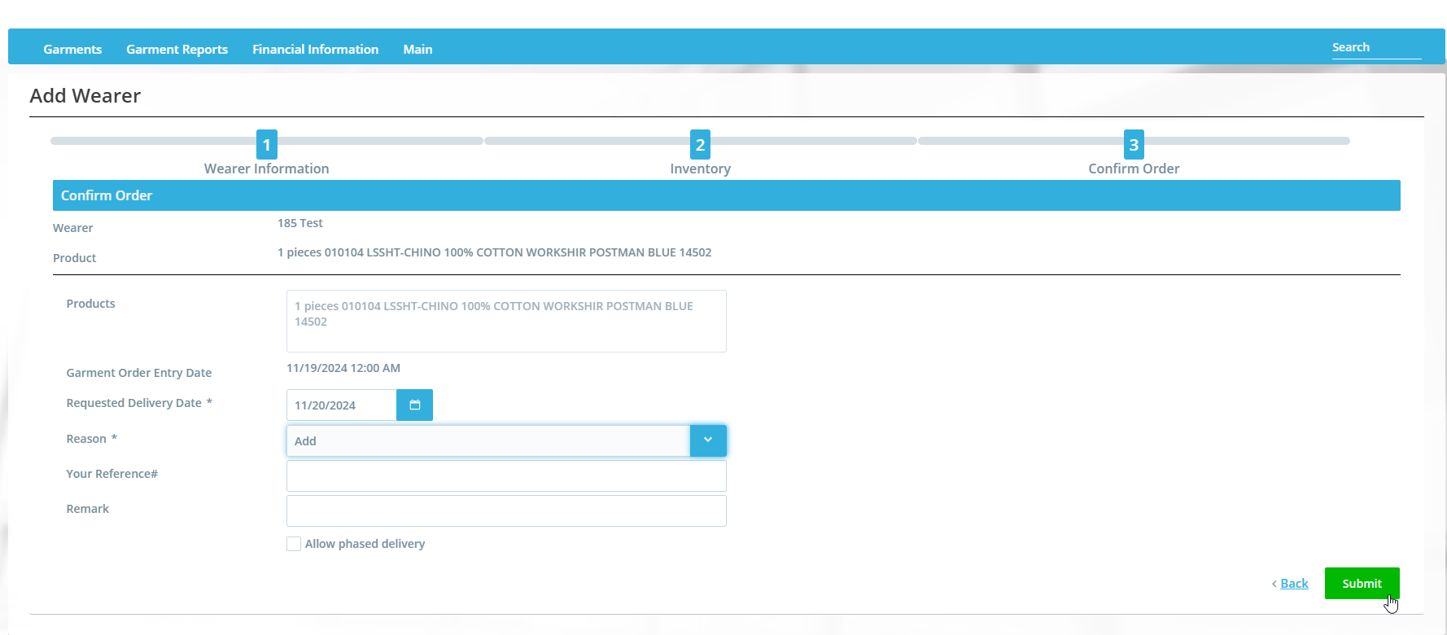
- WebPortal: Select Garments / Garment Orders and find the wo created.
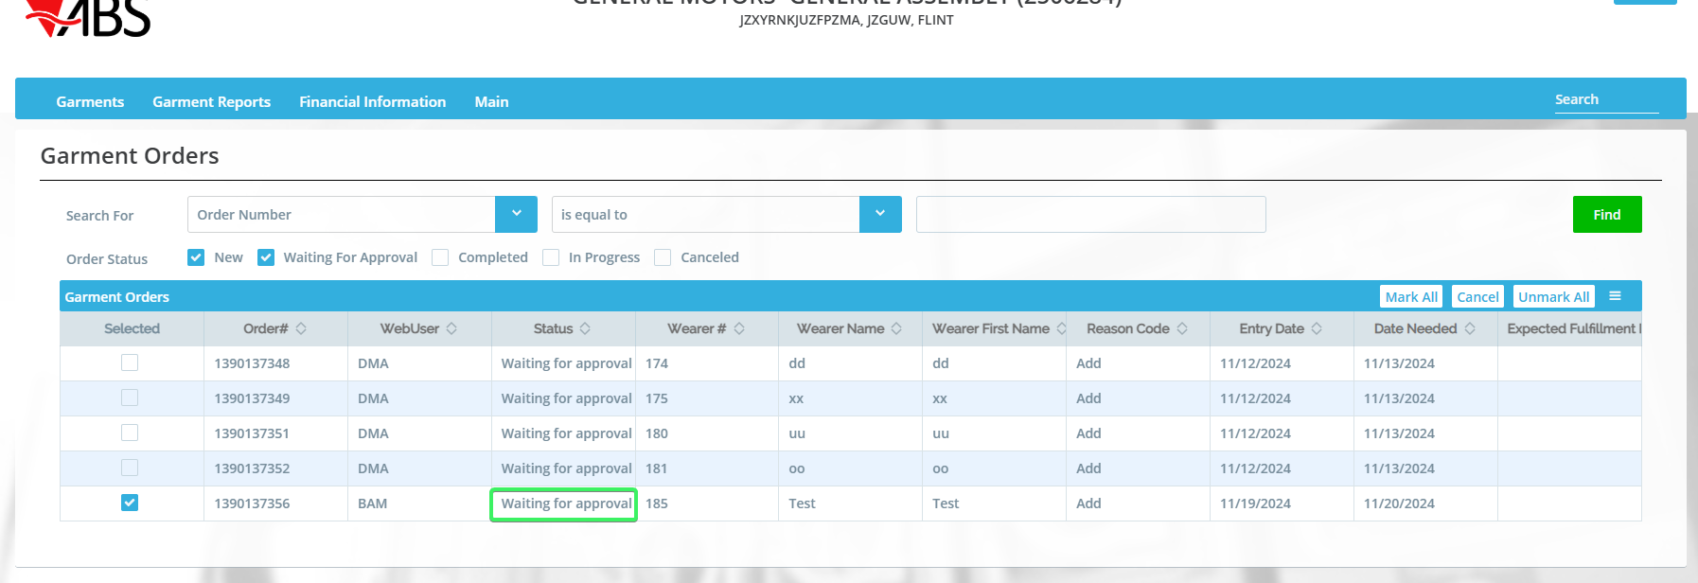
Observe the status
The ss value WEBWORKORDERRESERVATION is not taken into consideration.

REPRODUCED OK.

Expected behavior
The ss value WEBWORKORDERRESERVATION should be taken into consideration.

Retest after fix
Hash: 9.07.00.UNF18 hash: 972edf7b990b
BU: 088 Pontiac

Expected behavior
The ss value WEBWORKORDERRESERVATION should be taken into consideration.

Test Case 01 – ss WEBWORKORDERRESERVATION is on 2

Steps to reproduce
- System Settings dlg: Make sure ss WEBWORKORDERRESERVATION is on 2.
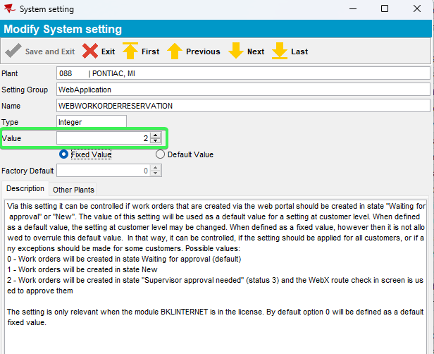
- Configure the abswebportal_9.07.00.UNF17 and make sure we add the correct server port, the correct system user and password and the correct workstation number.
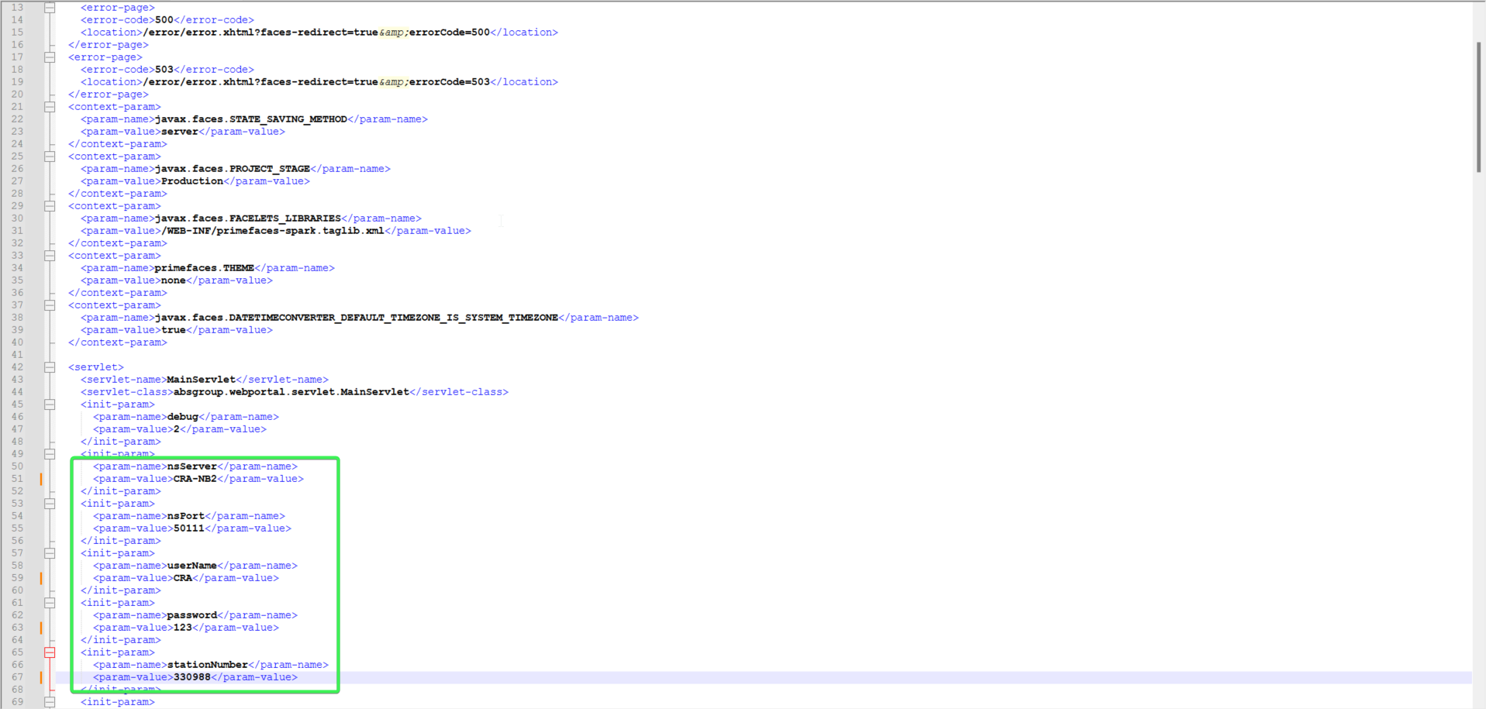
- WebPortal: Log in and select a configured customer.
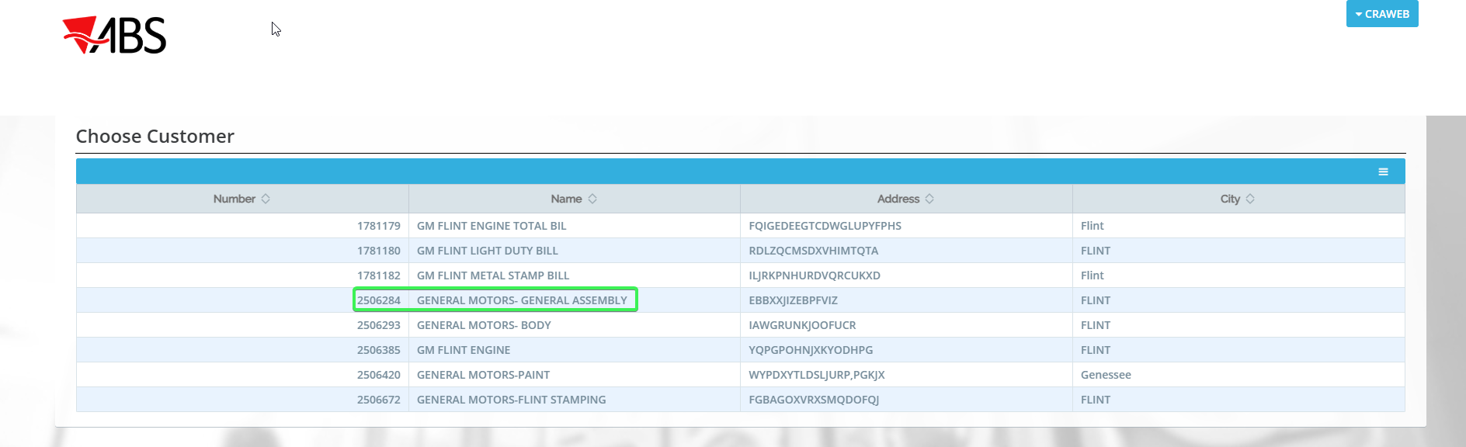
- WebPortal: Select Garment Wearers
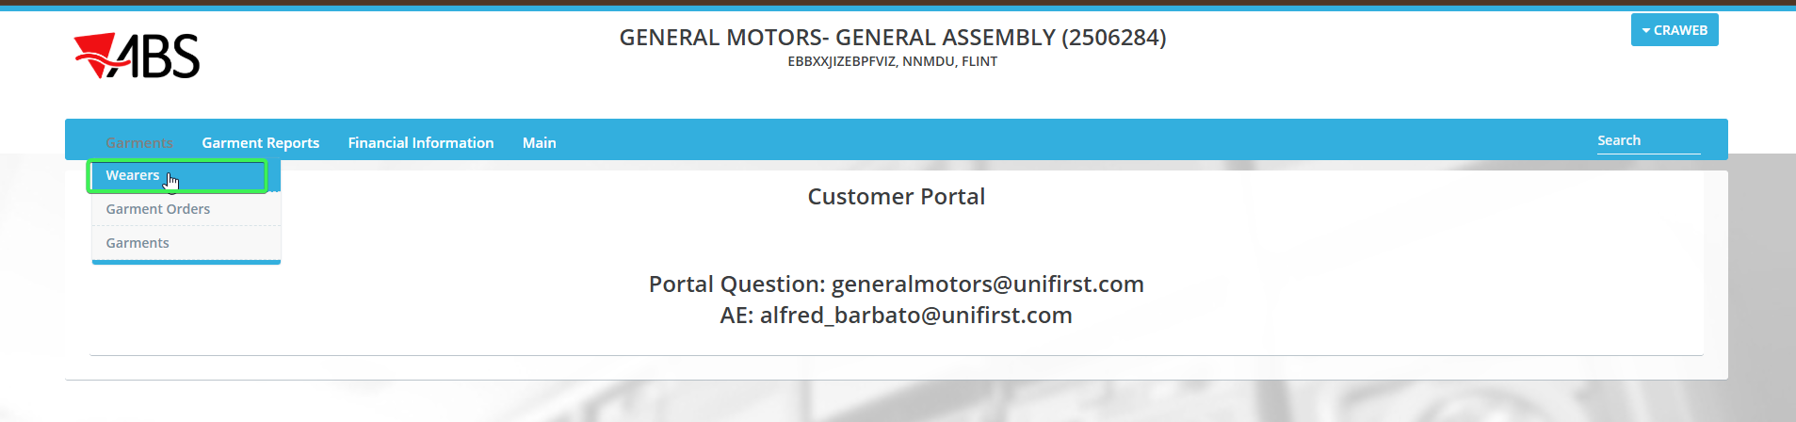
- WebPortal: Add wearer.
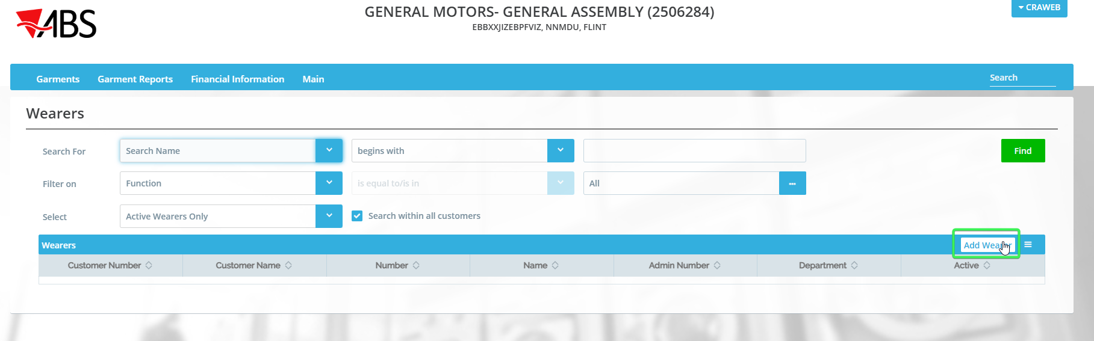
- WebPortal: Complete all the necessary fields
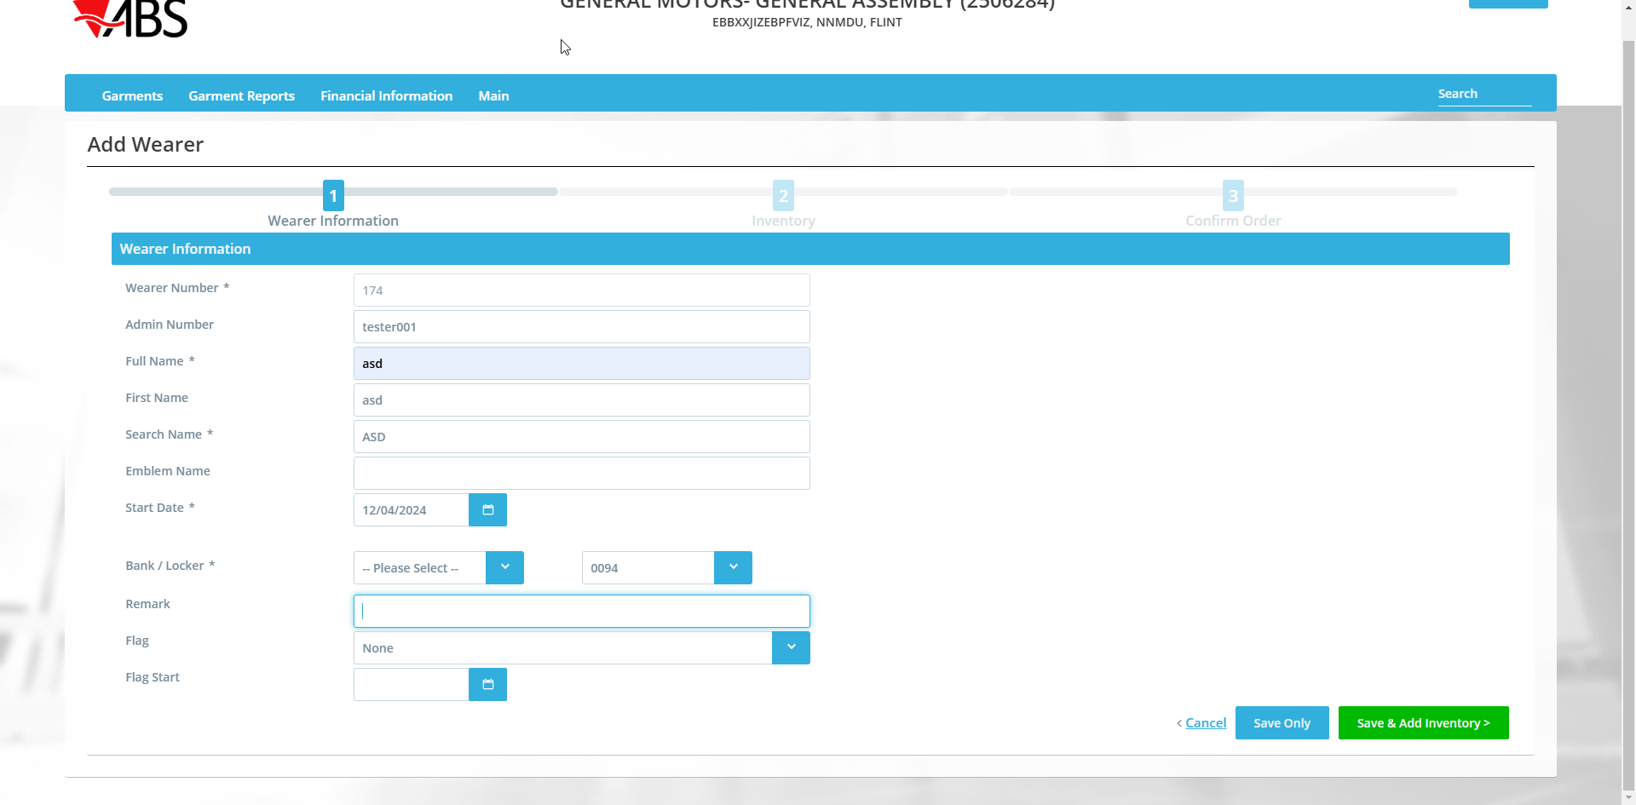
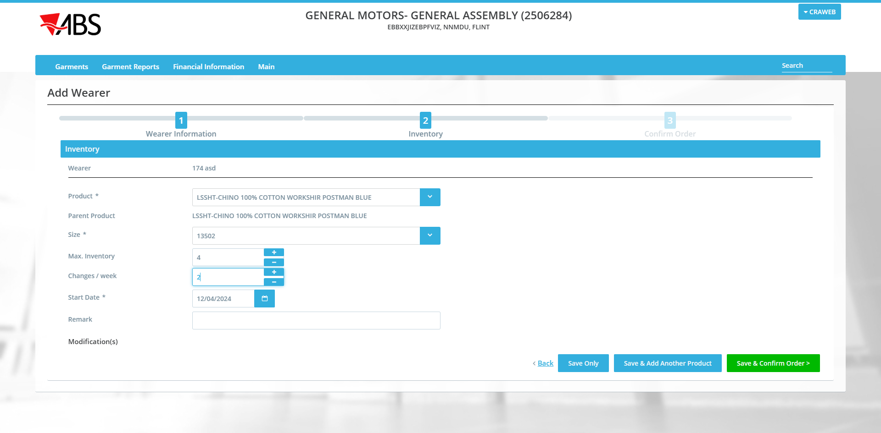
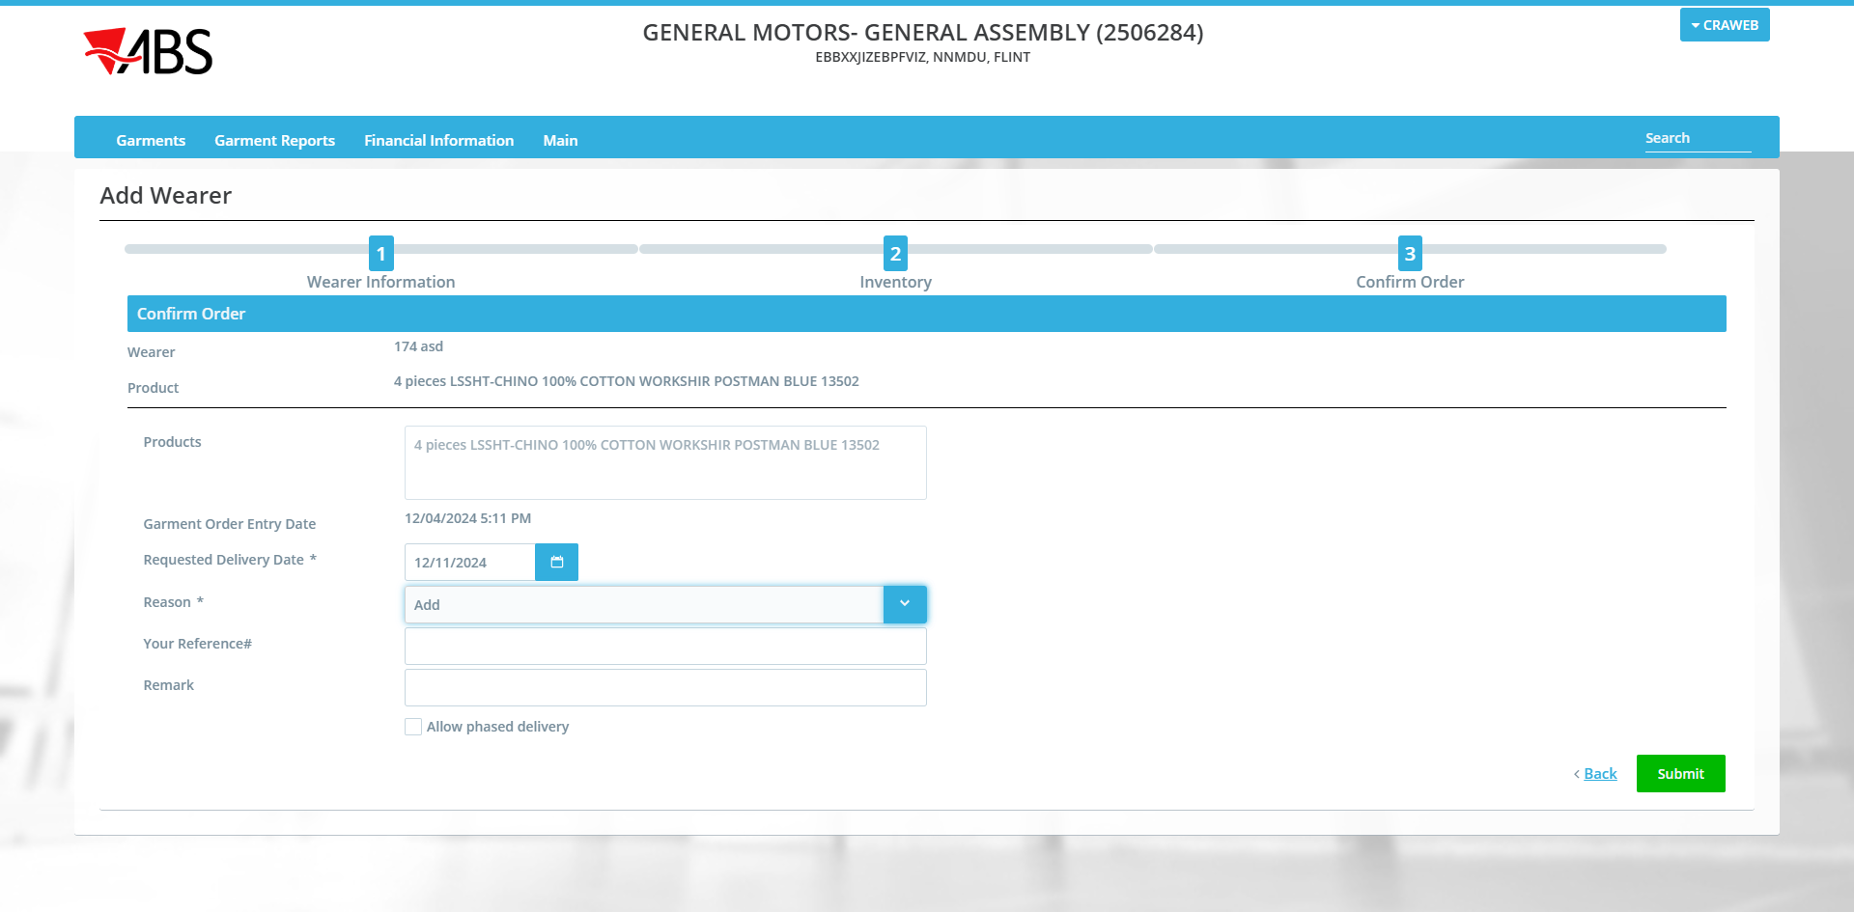
- WebPortal: Select Garments / Garment Orders and find the wo created.
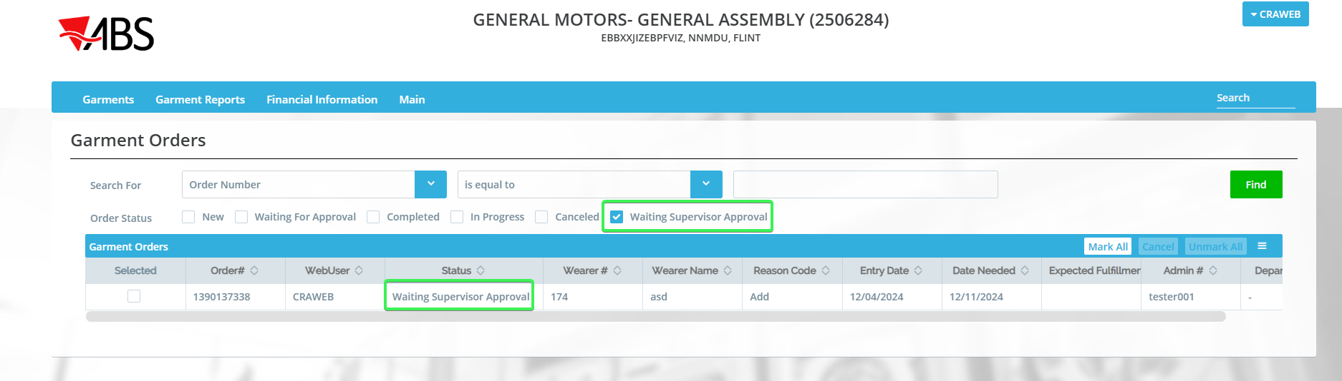
Observe that the filter option Waiting Supervisor Approval is present and that the new wo has the status Waiting Supervisor Approval
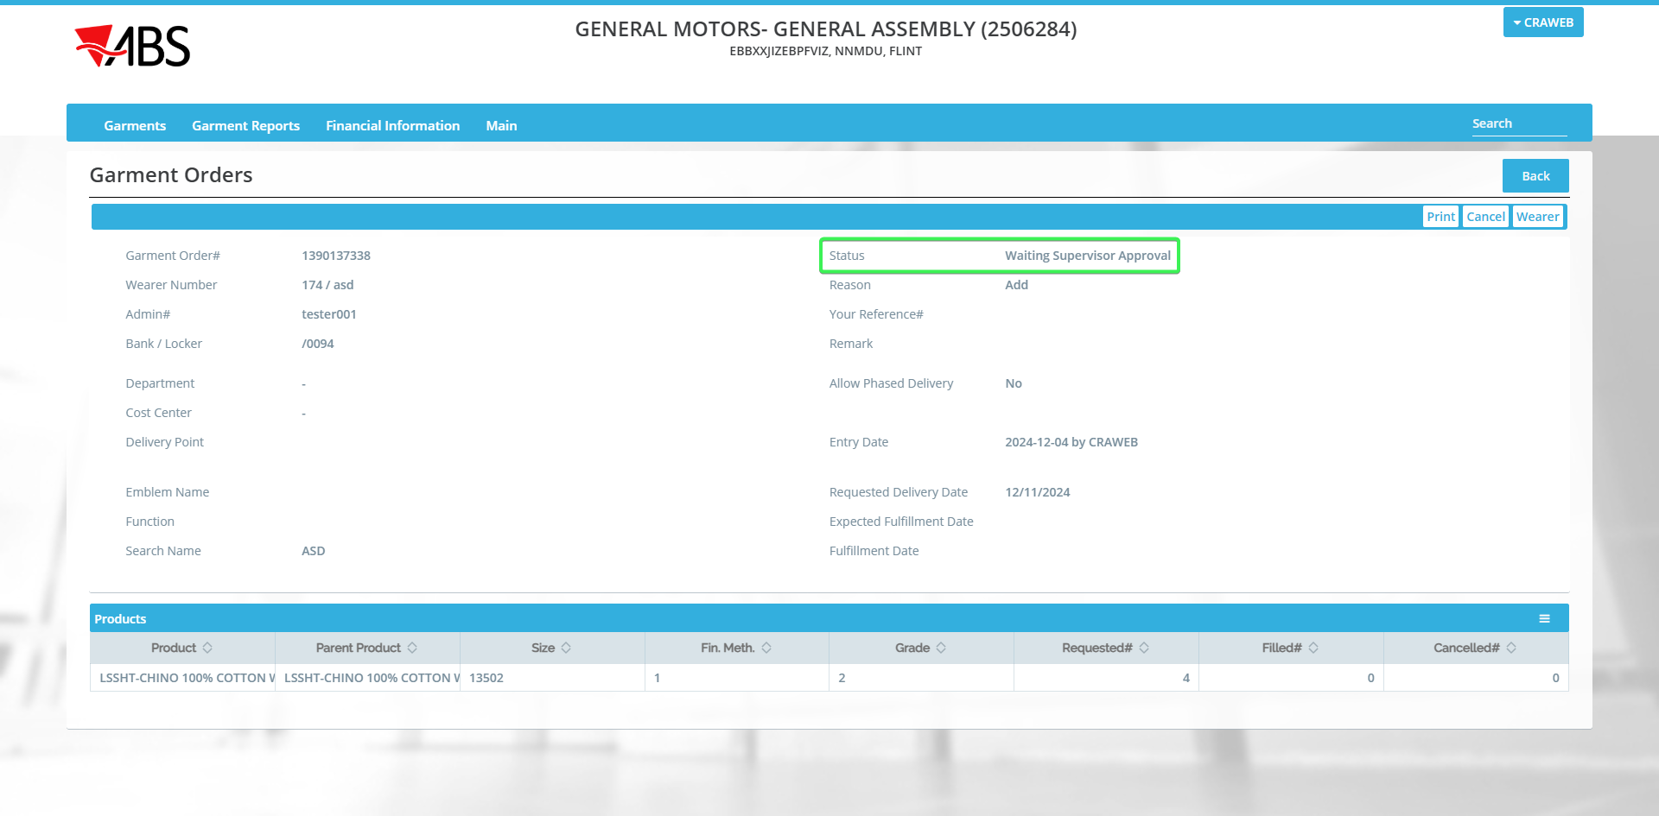
Check in DB the status of the wo.
select wo.status_id, wo.* from workorder wo
where wo.customer_link_id = (select c.customer_id from customer c where c.customernumber = 2506284)
order by wo.creationtimestamp desc;
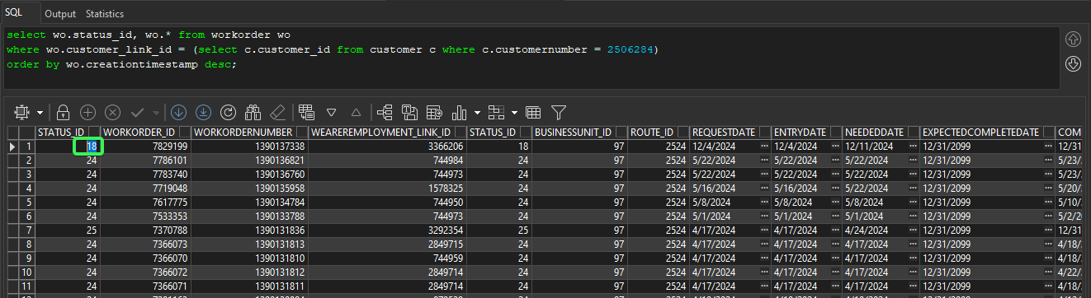
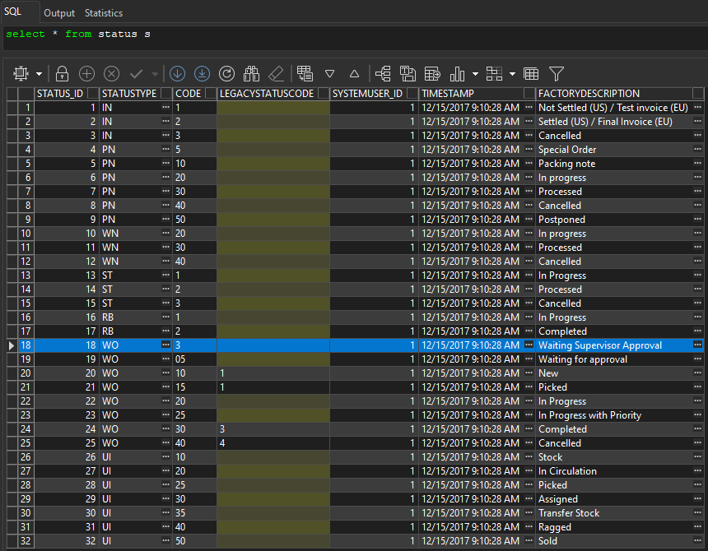
Tested OK

Test Case 02 – ss WEBWORKORDERRESERVATION is on 1

Steps to reproduce
- System Settings dlg: Make sure ss WEBWORKORDERRESERVATION is on 1. Restart server
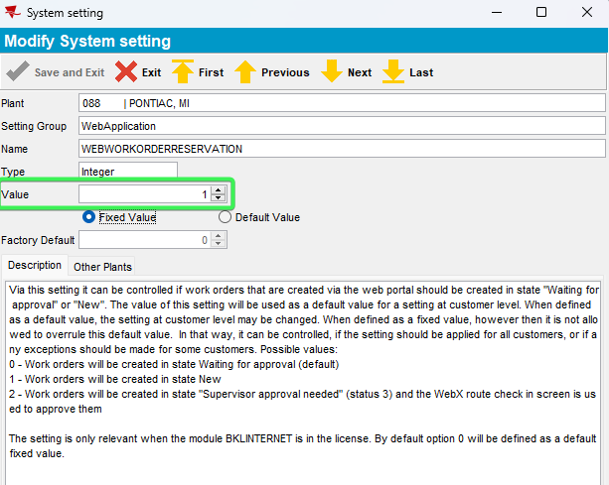
- WebPortal: Log in and select a configured customer.
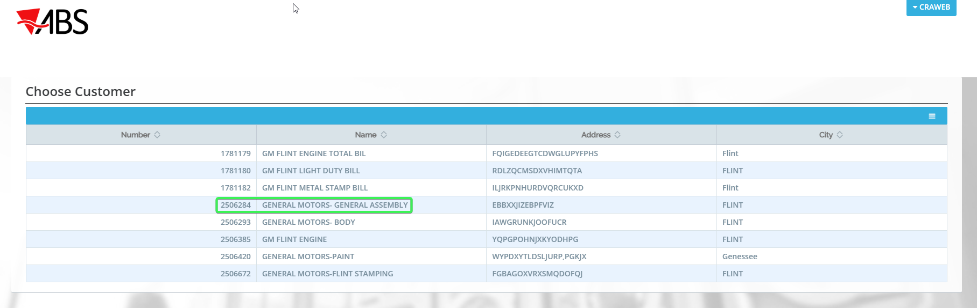
- WebPortal: Select Wearers
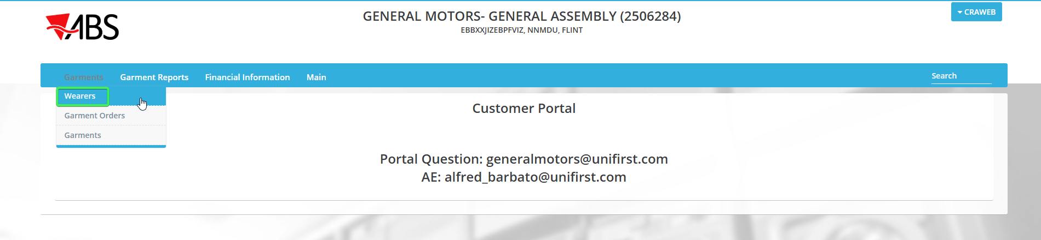
- WebPortal: Add wearer.
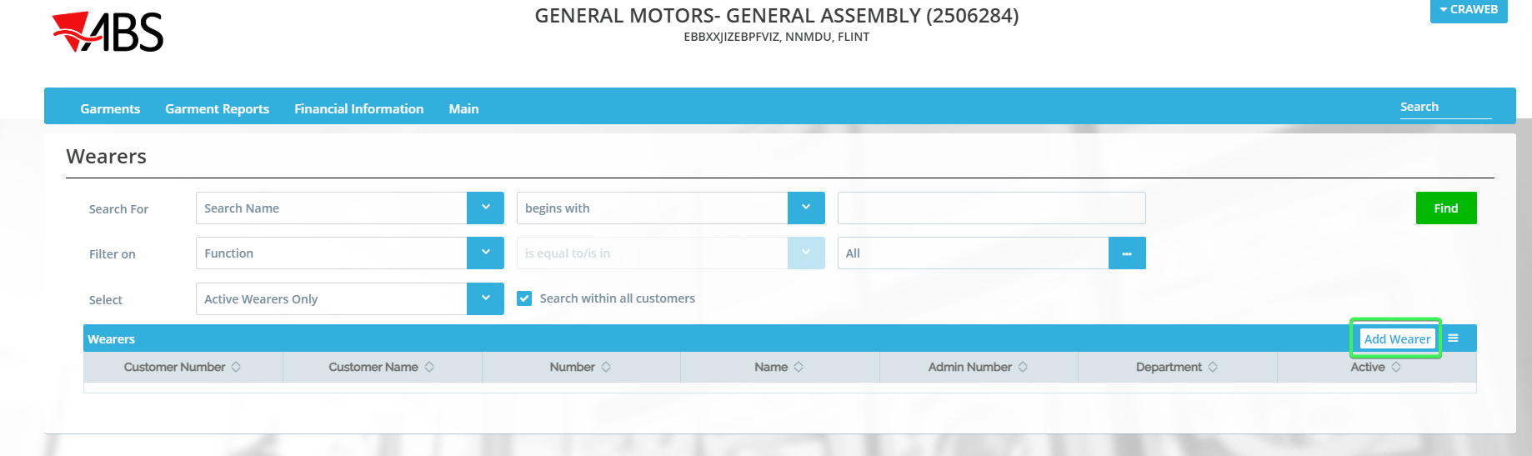
- WebPortal: Complete all the necessary fields
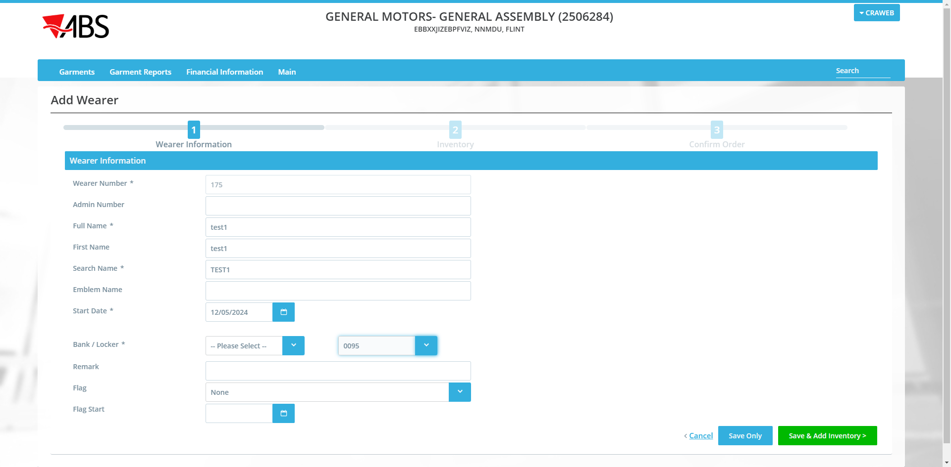
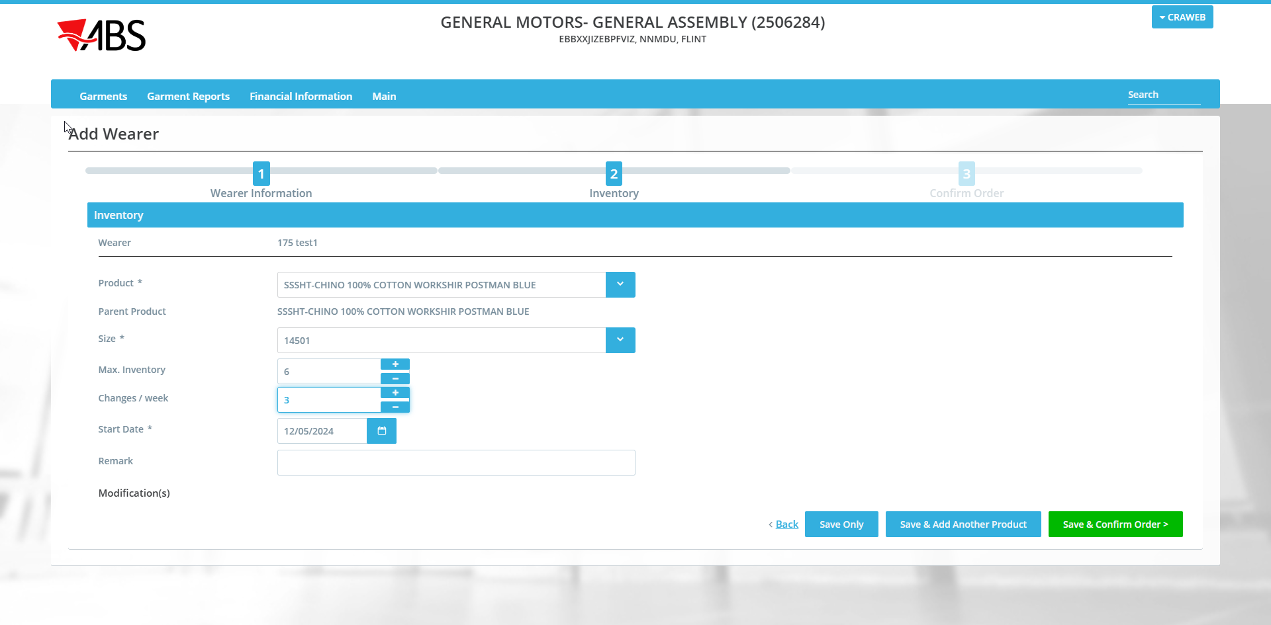
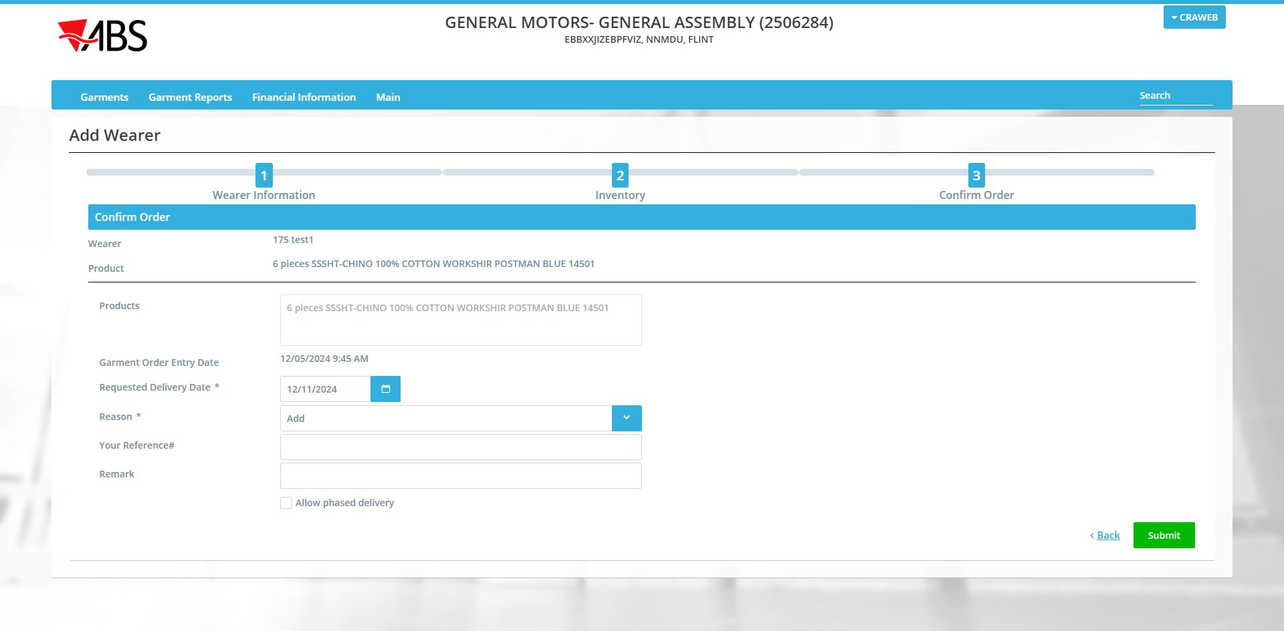
- WebPortal: Select Garments / Garment Orders and find the wo created.
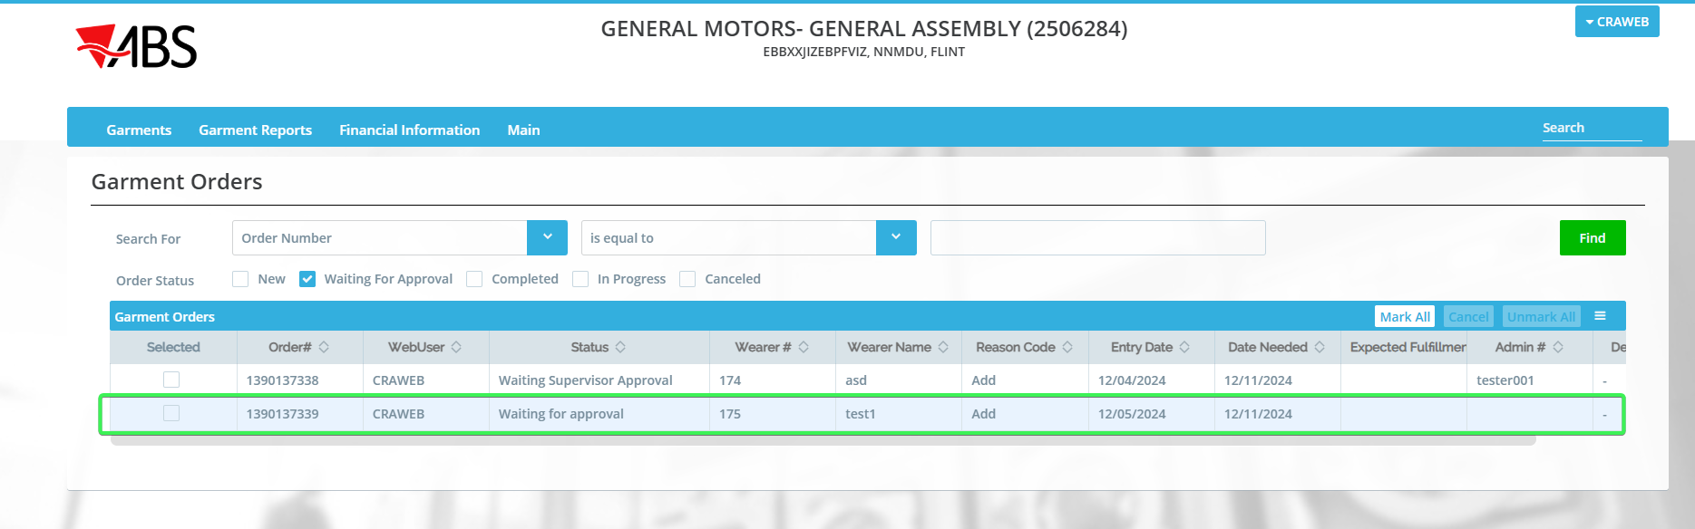
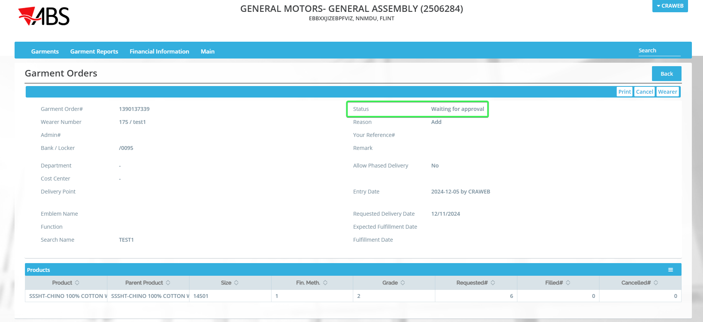
Observe that the filter option Waiting Supervisor Approval is not present anymore and that the new wo has the status Waiting for Approval
Check in DB the status of the wo.
select wo.status_id, wo.* from workorder wo
where wo.customer_link_id = (select c.customer_id from customer c where c.customernumber = 2506284)
order by wo.creationtimestamp desc;
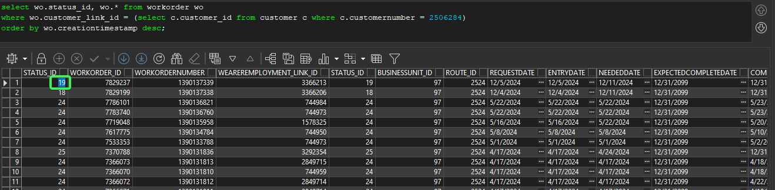
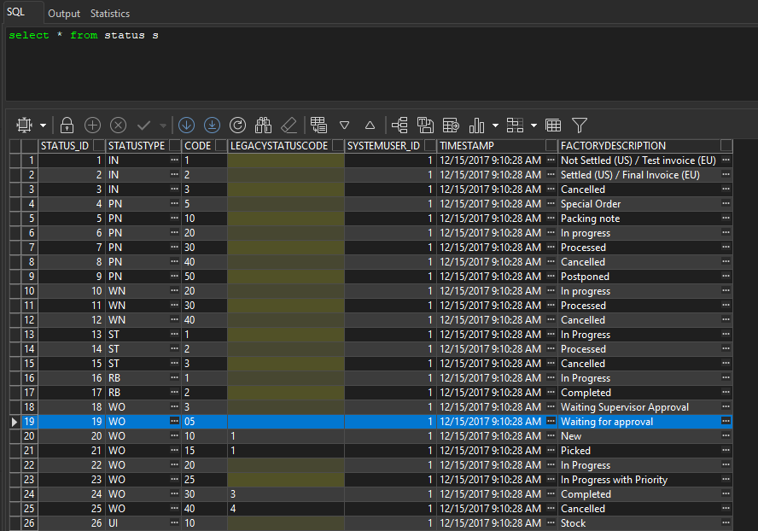
Tested OK

