RASAN-486 - Show the next delivery date of products on Route Assistant
Environment | Prerequisites
Version: 9.07.00.UNF17.p22 + RouteAssistant_v12.41  DBServerName= abs-srv20.internal.abslbs.com  DBSID=CUST24  DBUser=UNFDEV  Environment=Test | - Module:  - System setting

Contents
Data preparation 1
Test Cases 3
Test Case 1 – The customer has one regular delivery day per week, the product is delivered once every 4 weeks and the driving day IS a delivery day for the product 3
Test Case 2 – The customer has one regular delivery day per week, the product is delivered once every 4 weeks and the driving day IS NOT a delivery day for the product 9
Test Case 3 –Customer with weekly delivery day and the product is delivered once every 12 weeks and the driving day IS NOT a delivery day for the product 15

Data preparation
Use the following select to find customers and products that have 2 active PLPCs one with BM1 and another with BM3 from a product group that is 'Soap Dispenser' or 'Sanitizer'.

select c.customernumber, bu.code, p1.code, pdg.description
from customer c
join productlistpercustomer plpc1
on plpc1.customer_id = c.customer_id
join product p1
on p1.product_id = plpc1.product_id
join businessunit bu
on bu.businessunit_id = c.defaultbusinessunit_id
join productgroup_desc pdg
on pdg.productgroup_id = p1.productgroup_id
join standarddeliveryline sdl on sdl.productlistpercustomer_id = plpc1.productlistpercustomer_id
where p1.typeofmerchandise <> 2
and c.dateinactive > sysdate
and plpc1.dateinactive > sysdate
and plpc1.billingmethod = 1
and plpc1.soilcountmethod = 1
and sdl.deliveryscheme_id <> 1
/* and p1.productgroup_id in
(select pgd.productgroup_id
from productgroup_desc pgd
where pgd.description in ('Soap Dispenser',
'Sanitizer',
'Hand Towels',
'Tissue Paper',
'Heavy Duty',
'Hand/Anti Soap')
and pgd.language_id = 1) */
and exists (select 1
from productlistpercustomer plpc2
join product p2
on p2.product_id = plpc2.product_id
where plpc2.customer_id = c.customer_id
and p1.product_id = p2.product_id
and plpc2.billingmethod = 3
and plpc2.dateinactive > sysdate)
and exists (select 1
from customerdeliveryscheme cds
where cds.deliveryscheme_id = 1
and cds.customer_id = c.customer_id)
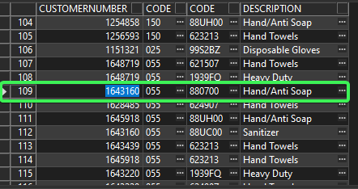

BM1 product needs to have PLPC > Fixed delivery scheme and no Soil Count
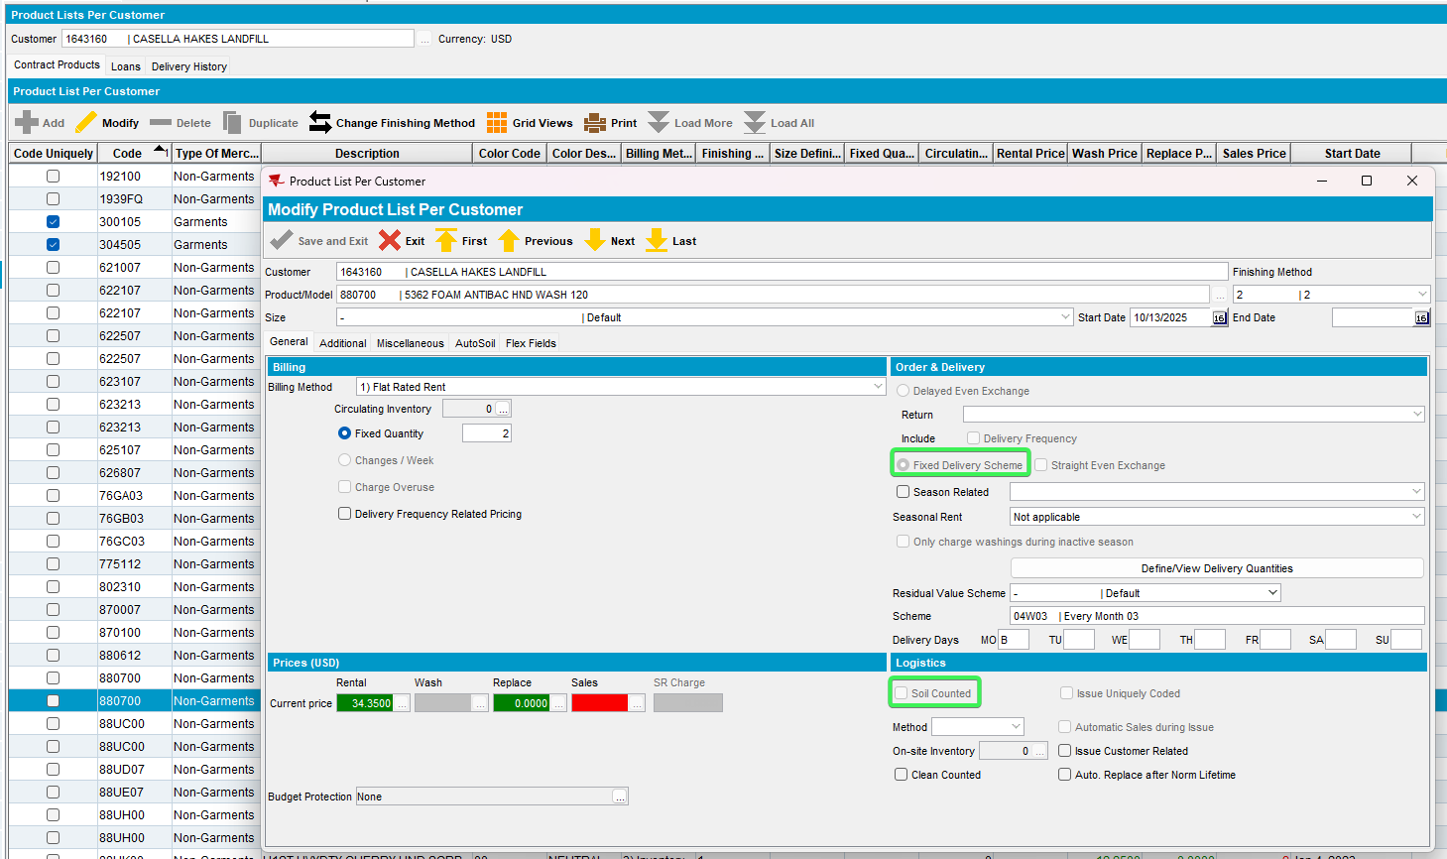
Can be changed from contract
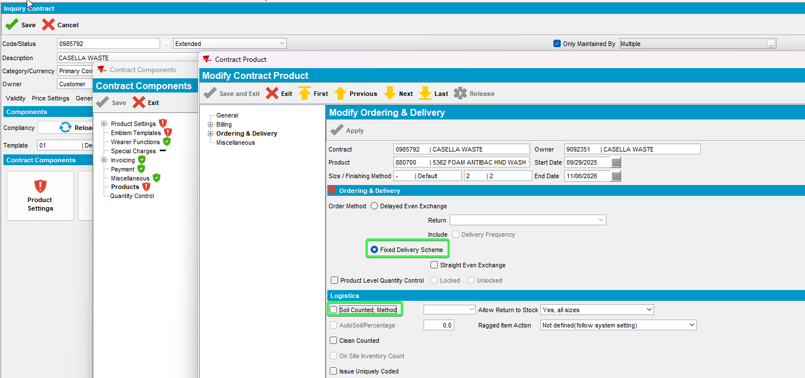

Test Cases

Test Case 1 – The customer has one regular delivery day per week, the product is delivered once every 4 weeks and the driving day IS a delivery day for the product
Hash: 9.07.00.UNF17.p22 hash: 42373e493540 + RouteAssistant_v12.41.INTERNAL_TEST_ONLY.ad0c94838
Expected behavior:
The next delivery date for the BM1 product should have the next delivery date set as the one, after 4 weeks.

Steps
- Customers DLG: Delivery tab see that the customer has a 1/week delivery scheme (01W01) and scheme that has a frequency higher than 1/week like 04W03
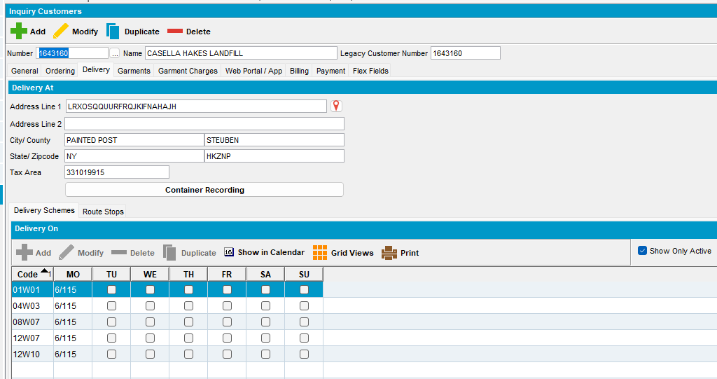
- PLPC: Find the PLPC entry for the BM1 product from the select.
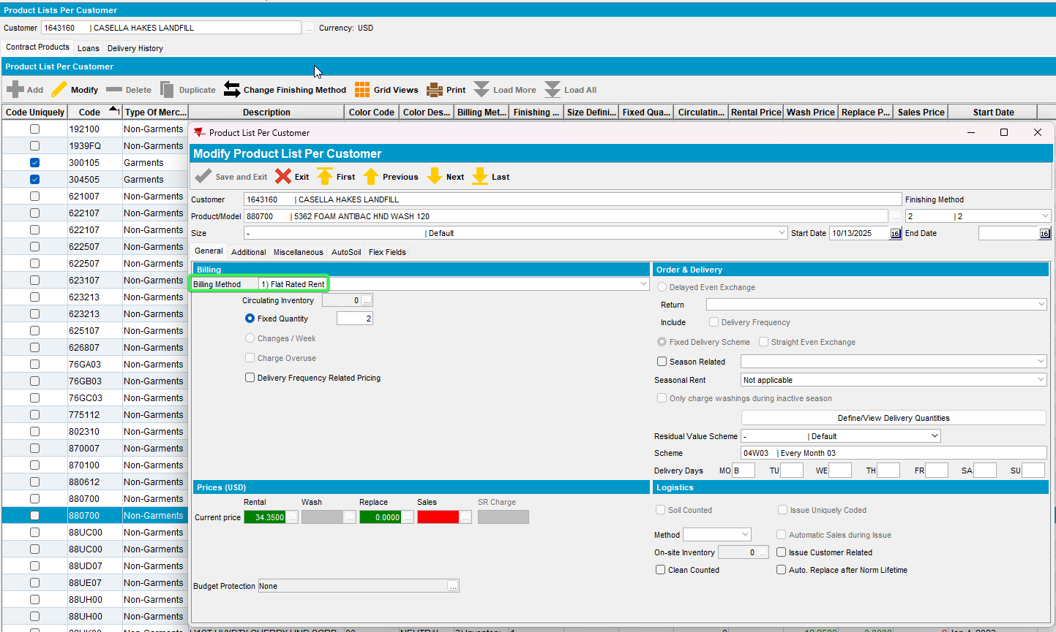
- PLPC: Click on the PLPC and go to CPL (Delivery scheme) and check that the BM1 product is set to be delivered once every 4 weeks and view the delivery days.
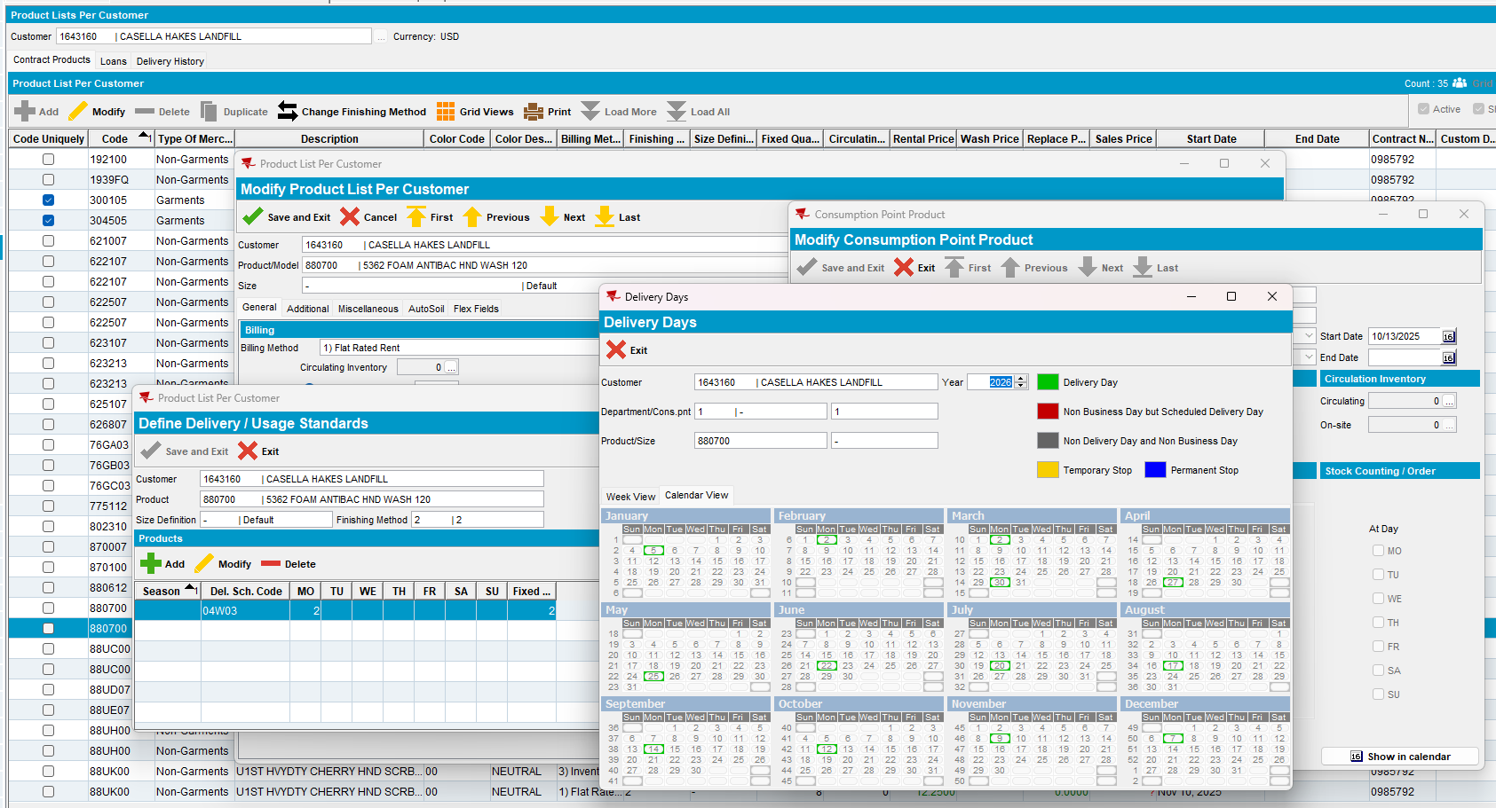
- Route Status Control DLG: Add a new route for the customer that is on the next delivery day of the product, which is 30th March.
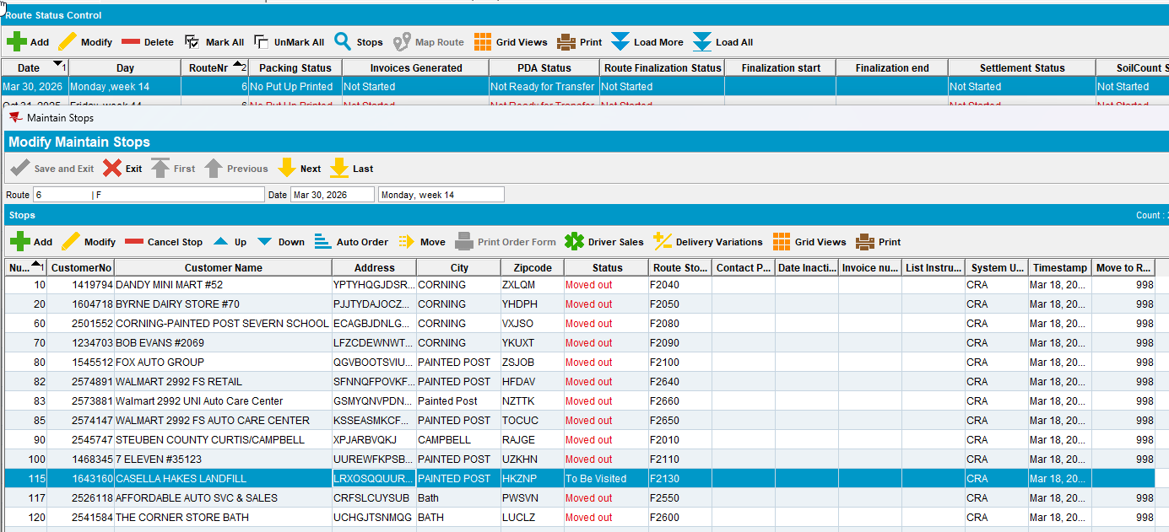
- Route Status Control DLG: Generate Packing Notes and finalize them.
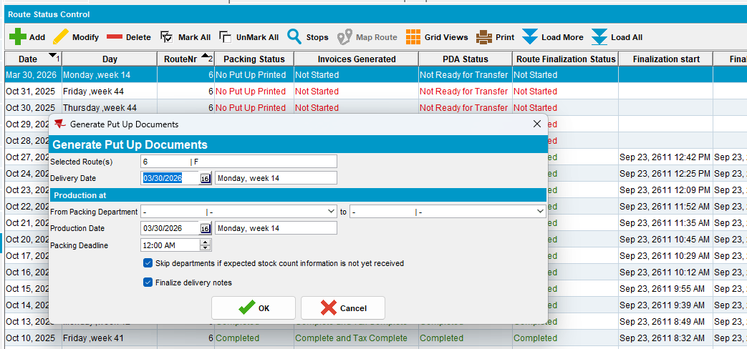
- Route Status Control DLG: Generate invoices with soil tickets and finalize them.
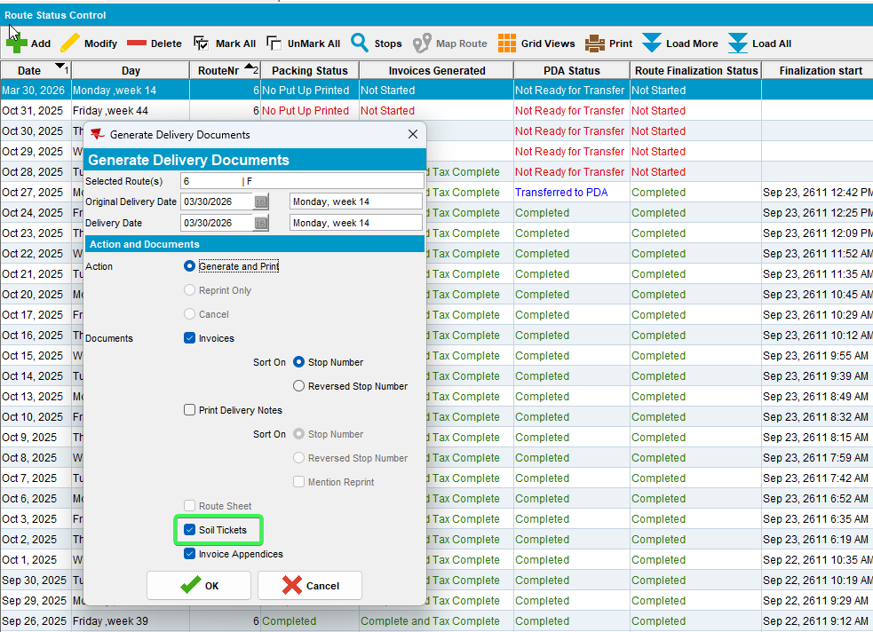
- Soil Count DLG: Select the route you just generated invoices for and check that there is a soil ticket line for your BM1 product.
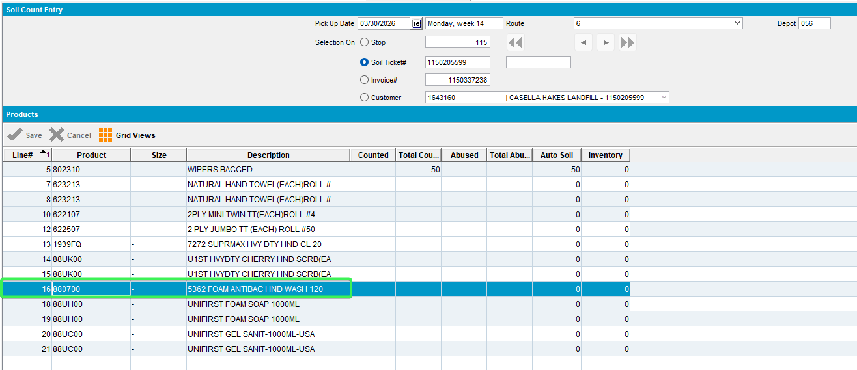
- Route Status Control DLG: Mark the route ready for transfer
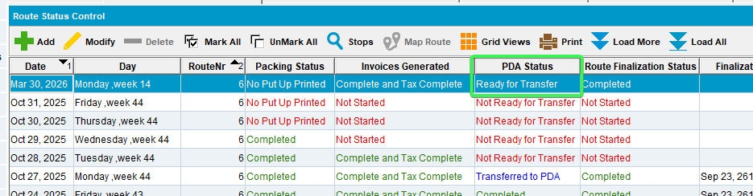
- RA: Download it and arrive at the customer
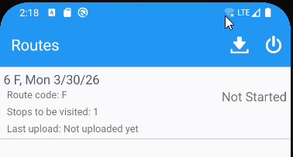
- RA: Go to Soil menu
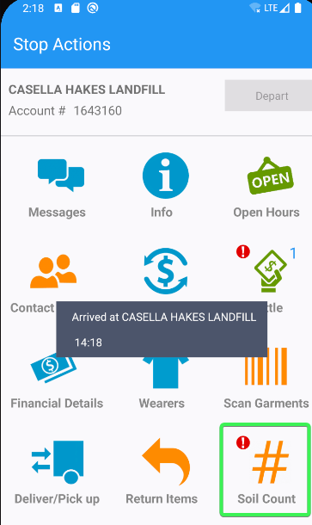
- RA: Check the dates on the soil count product and soil count entry screens
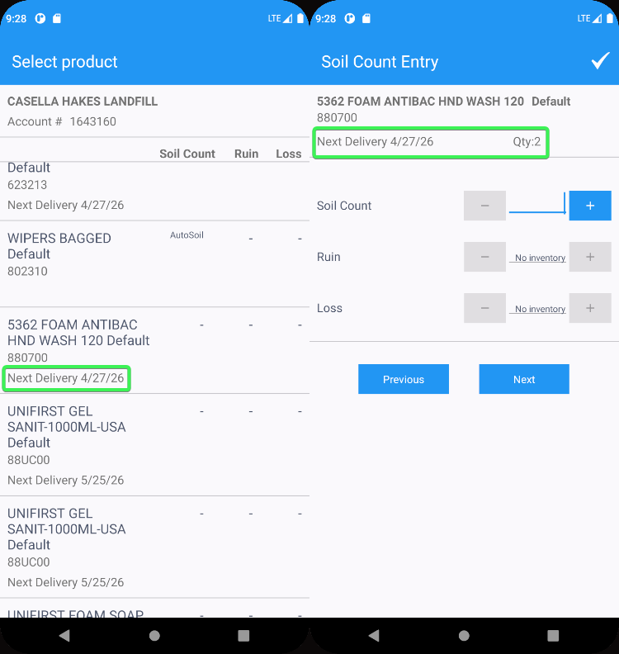
Tested OK

Test Case 2 – The customer has one regular delivery day per week, the product is delivered once every 4 weeks and the driving day IS NOT a delivery day for the product
Hash: 9.07.00.UNF17.p22 hash: 42373e493540 + RouteAssistant_v12.41.INTERNAL_TEST_ONLY.ad0c94838
Expected behavior:
Date for the next delivery date and QTY should be displayed in the soil count tab

Steps
- Customers DLG: Delivery tab see that the customer has a 1/week delivery scheme (01W01) and scheme that has a frequency higher than 1/week like 04W03
- PLPC: Find the PLPC entry for the BM1 product from the select.
- PLPC: Click on the PLPC and go to CPL (Delivery scheme) and check that the BM1 product is set to be delivered once every 4 weeks and view the delivery days.
- Route Status Control DLG: Add a new route for the customer that is on the next available delivery not the delivery date of the BM1 product
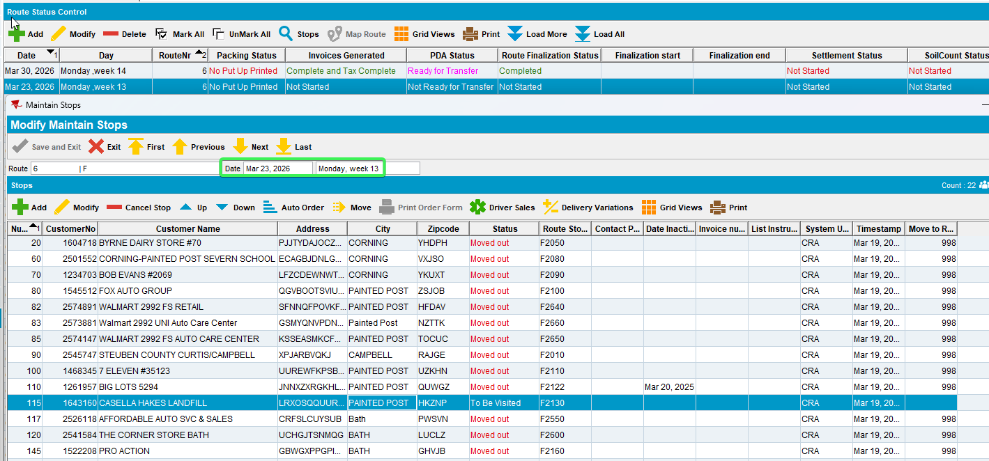
- Route Status Control DLG: Generate Packing Notes and finalize them
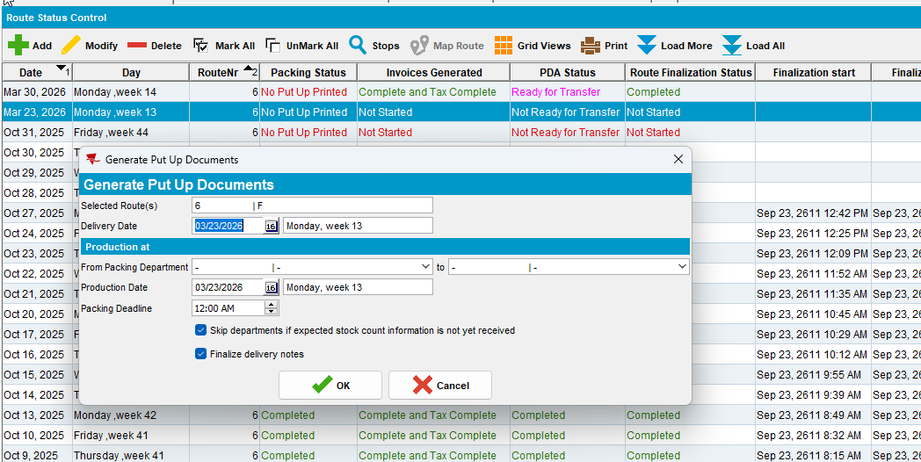
- Route Status Control DLG: Generate invoices with soil tickets and finalize them.
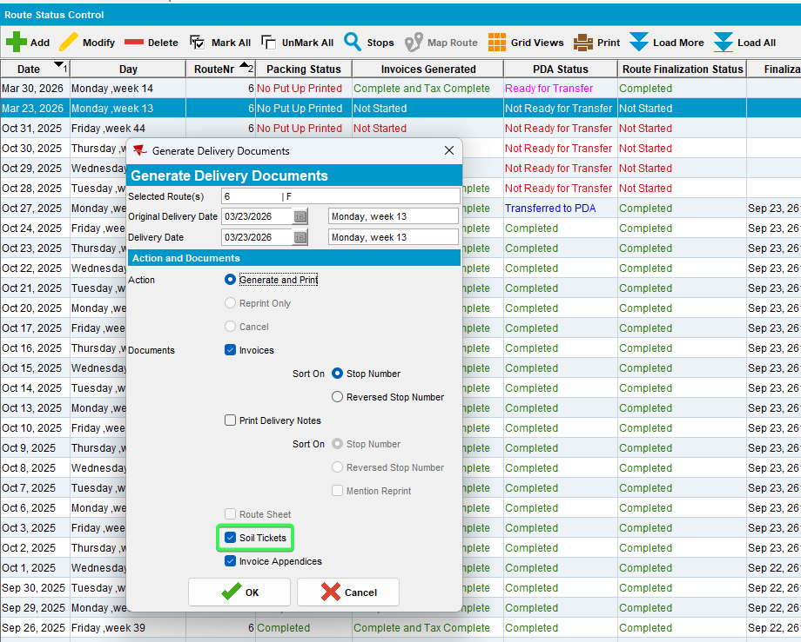
- Soil Count DLG: Select the route you just generated invoices for and check that there is a soil ticket line for your BM1 product.
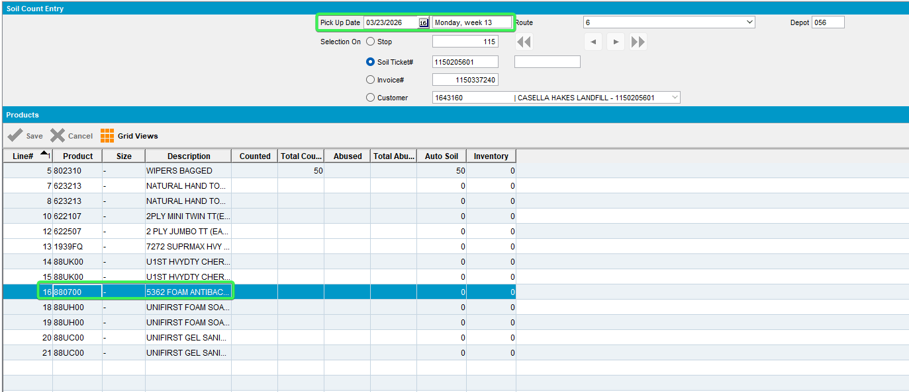
- Route Status Control DLG: Mark the route ready for transfer
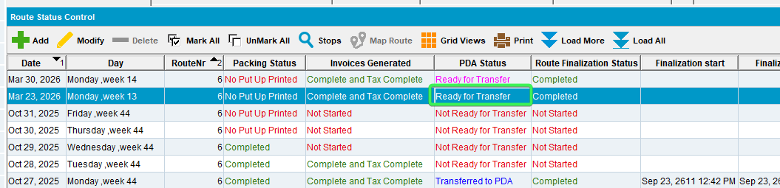
- RA: Download it and arrive at the customer
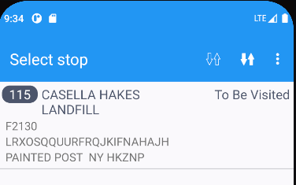
- RA: Go to Soil menu
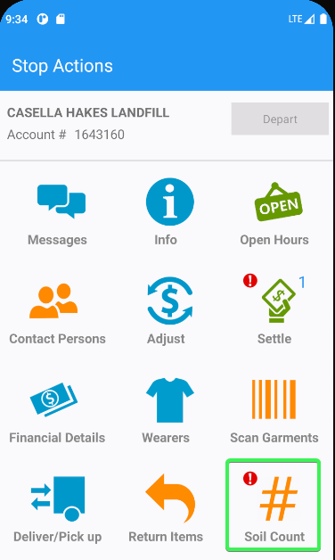
- RA: Check the dates on the soil count product and soil count entry screens are the ones from BM1 Product
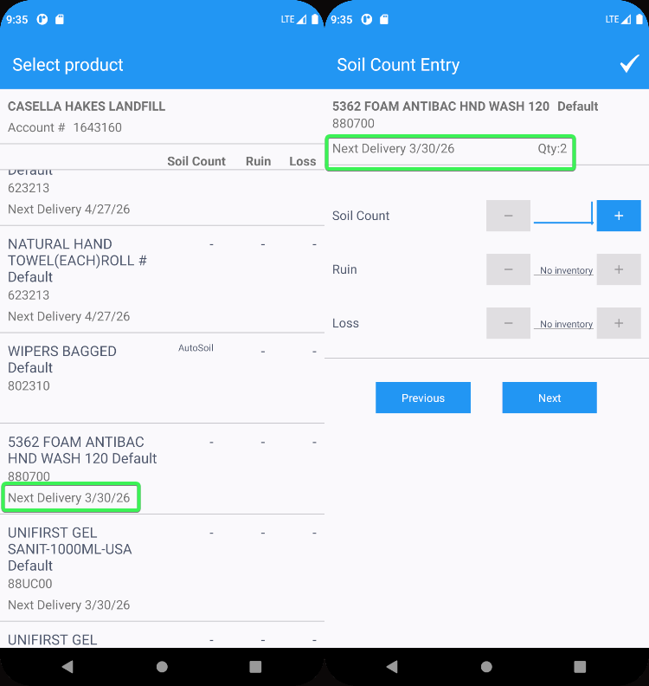
Tested OK

Test Case 3 –Customer with weekly delivery day and the product is delivered once every 12 weeks and the driving day IS NOT a delivery day for the product
Hash: 9.07.00.UNF17.p22 hash: 42373e493540 + RouteAssistant_v12.41.INTERNAL_TEST_ONLY.ad0c94838
Expected behavior:
Date for the next delivery date of the BM1 product and QTY should be displayed in the soil count tab

Steps:
- Customers DLG: Delivery tab see that the customer has a 1/week delivery scheme (01W01) and scheme that has a frequency higher than 1/week like 12W03
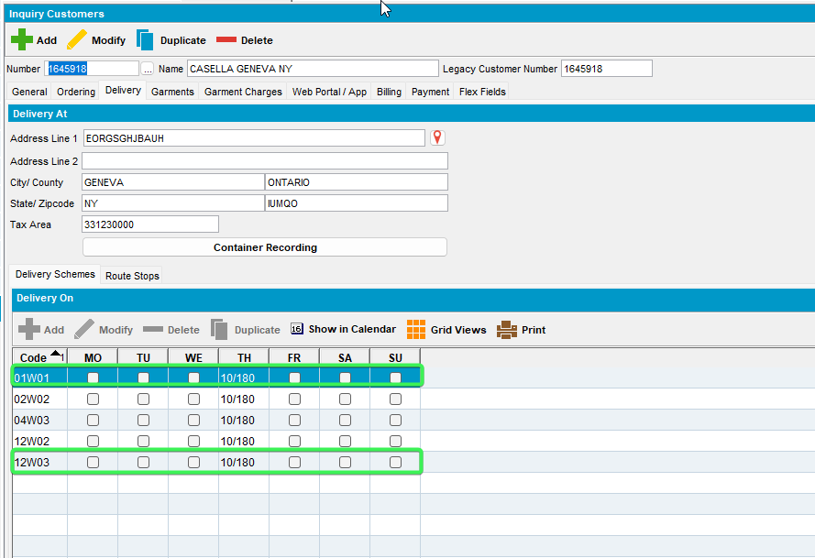
- PLPC: Find the PLPC entry for the BM1 product from the select.
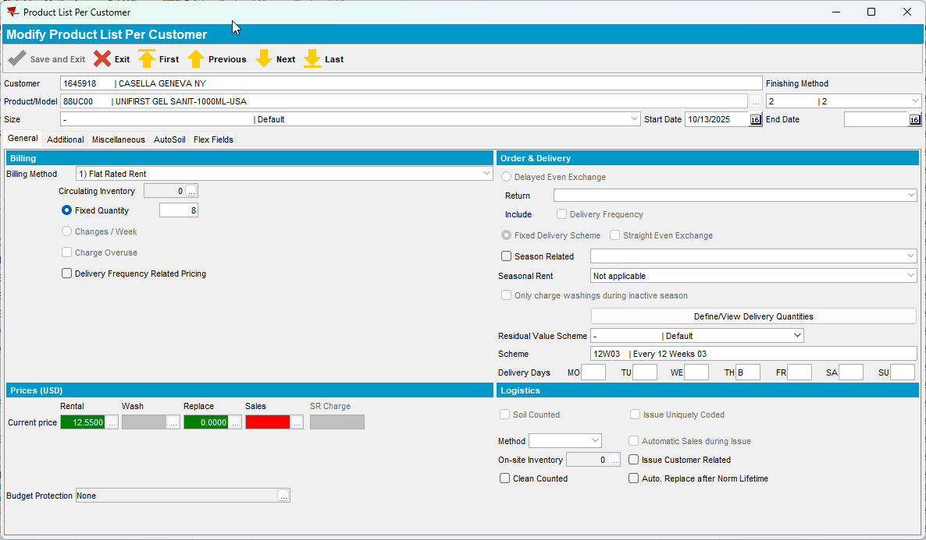
- PLPC: Click on the PLPC and go to CPL (Delivery scheme) and check that the BM1 product is set to be delivered once every 12 weeks and view the delivery days.
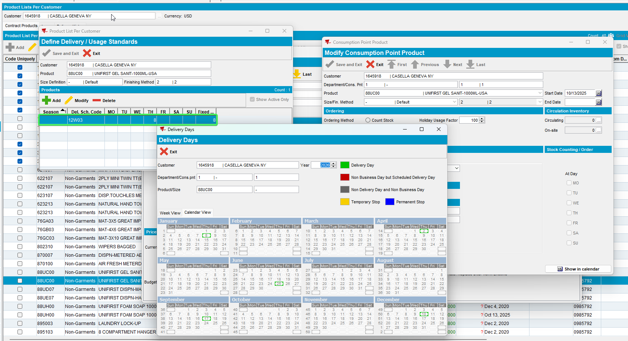
- Route Status Control DLG: Add a new route for the customer next available delivery (next week) 26th march.
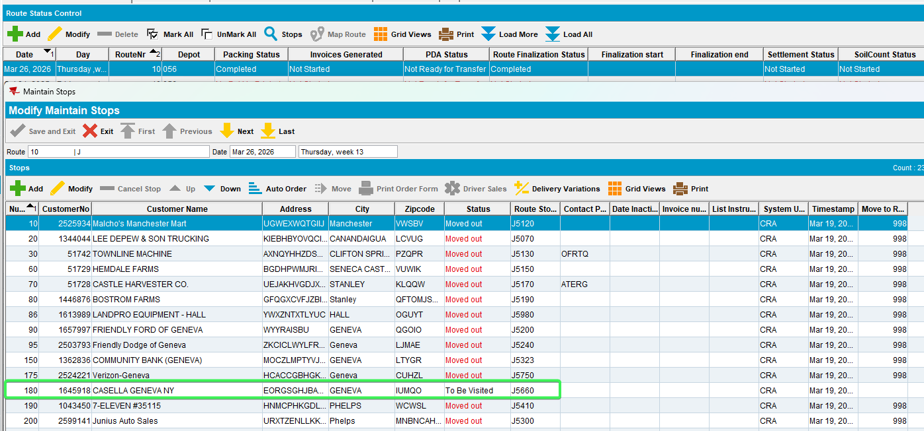
- Route Status Control DLG: Generate Packing Notes and finalize them.
- Route Status Control DLG: Generate invoices with soil tickets and finalize them.
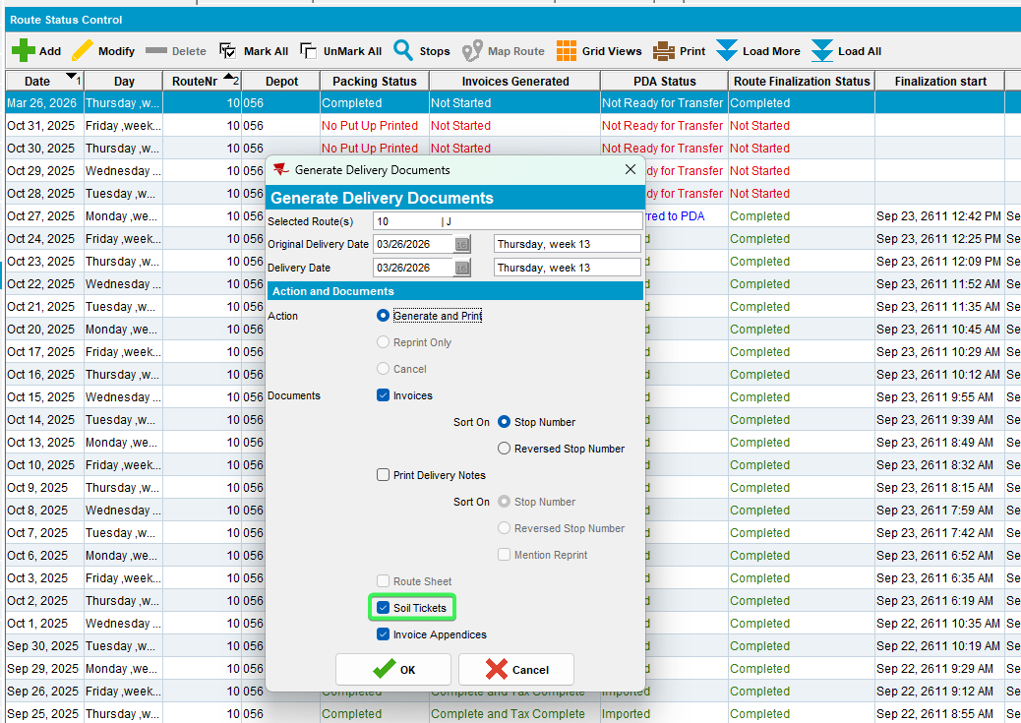
- Soil Count DLG: Select the route you just generated invoices for and check that there is a soil ticket line for your BM1 product.
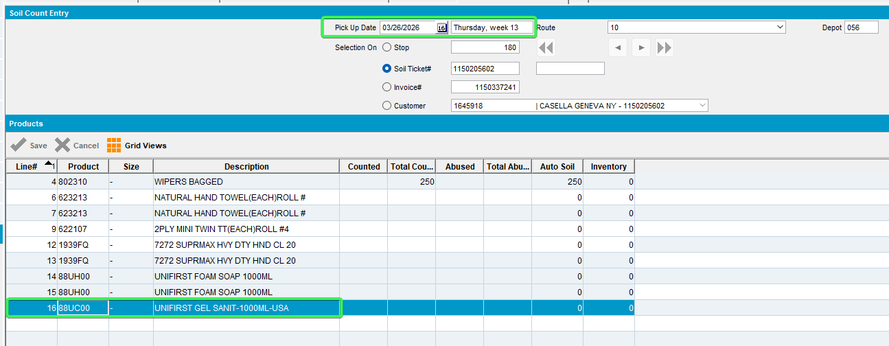
- Route Status Control DLG: Mark the route ready for transfer
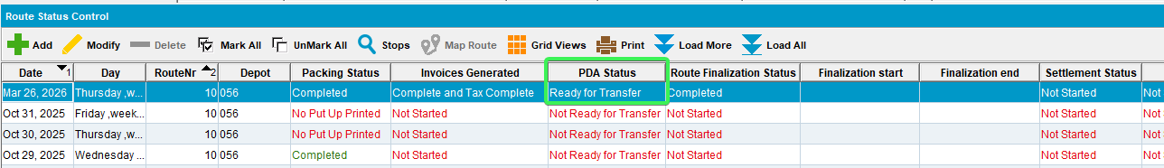
- RA: Download it and arrive at the customer
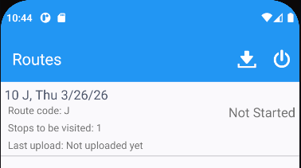
- RA: Go to Soil menu
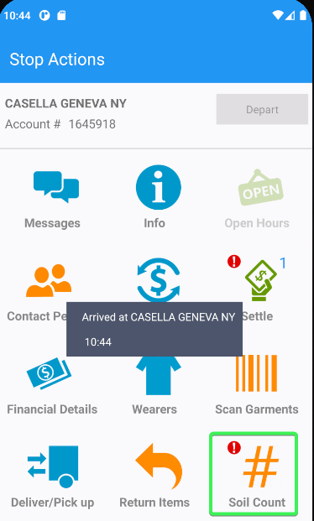
- RA: Check the dates on the soil count product and soil count entry screens
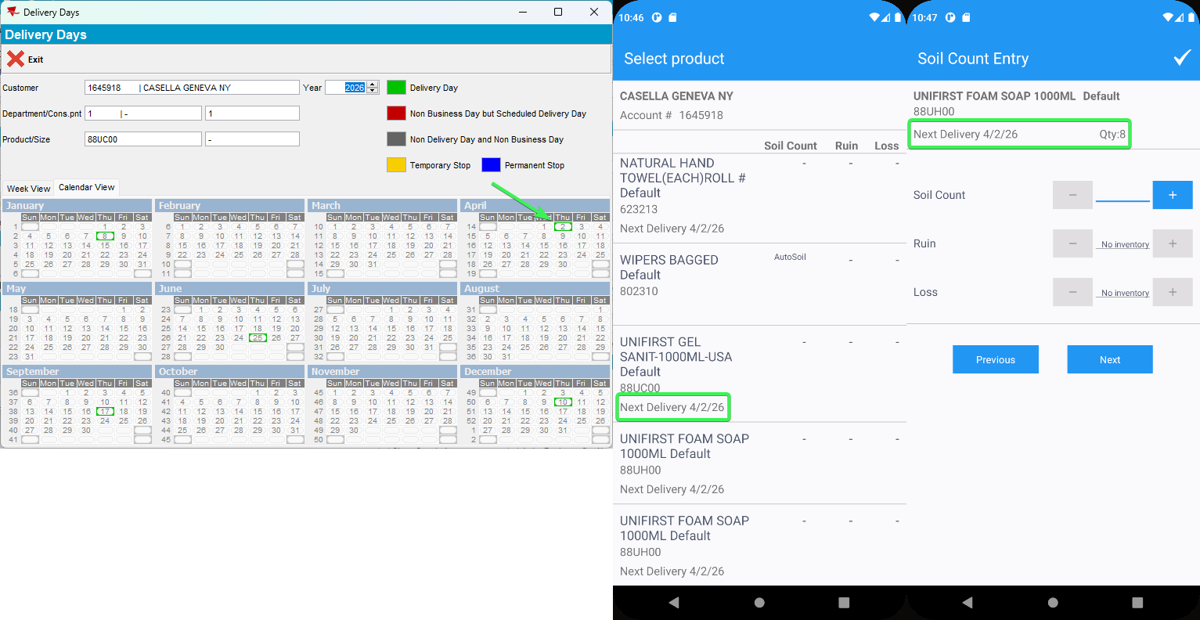
Tested OK

