ABSN-15735 Billing Method 4 and BM4BILLONBDAYONLY accumulating bill only for settled invoices on B day
Environment | Prerequisites
Version:9.07.00.UNF17.p21  DBServerName=abs-srv19.internal.abslbs.com  DBSID=CUST22  DBUser=UNFLIVE  Environment=Production | - Module:  - System setting

Contents
Retest after fix 1

Retest after fix
Version: 9.07.00.UNF17.p21 hash: 5aa1012fecd5

- Customer setup for delivery every day and billing on Friday
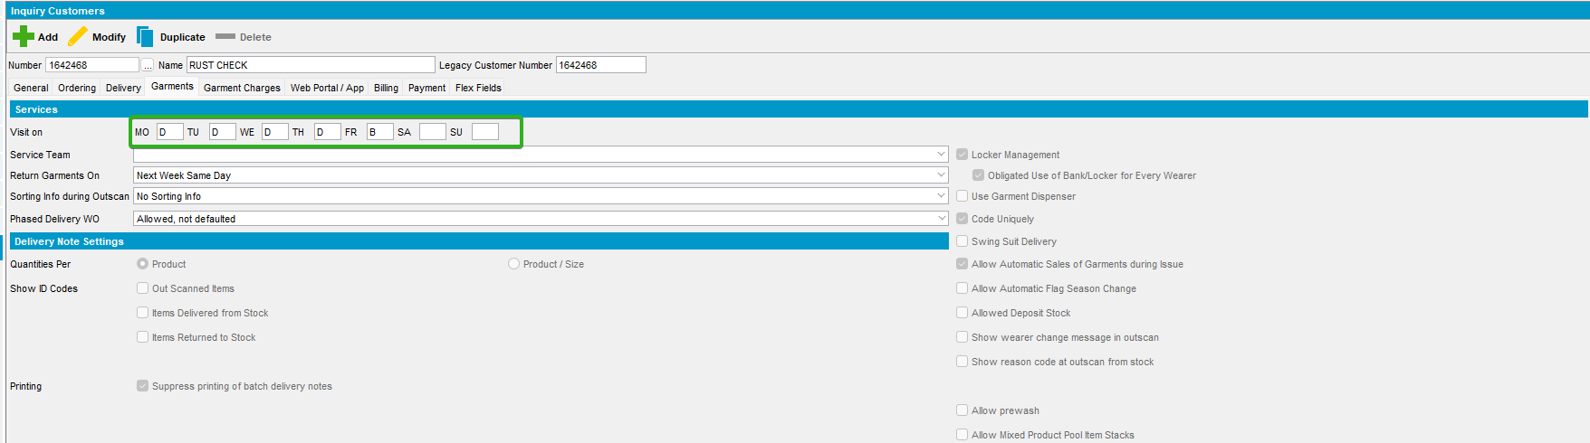

- PLPC set the same:
- PLPC setup with billing method 4
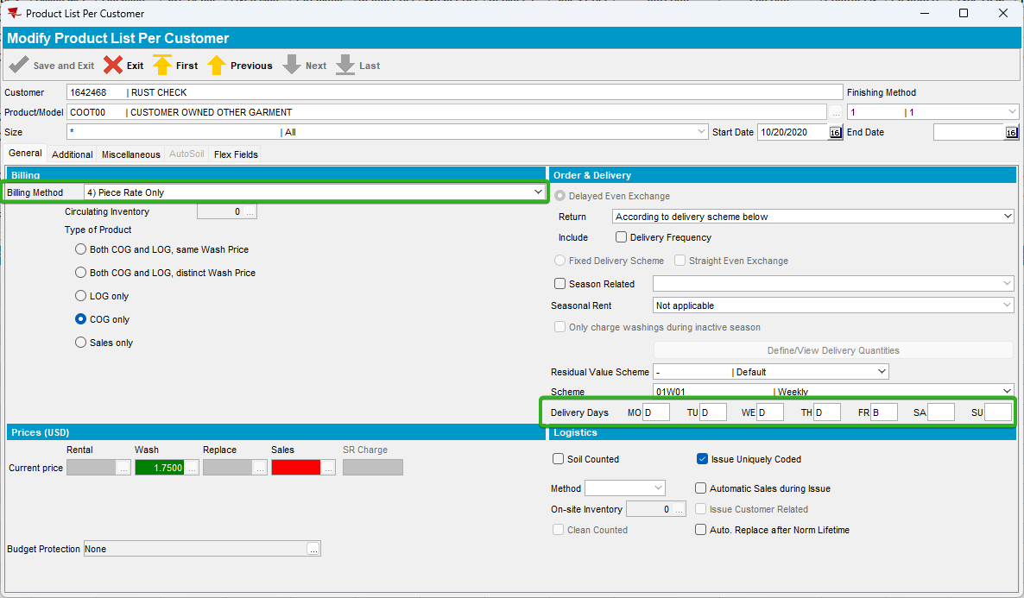

- System setting BM4BILLONBDAYONLY = 2
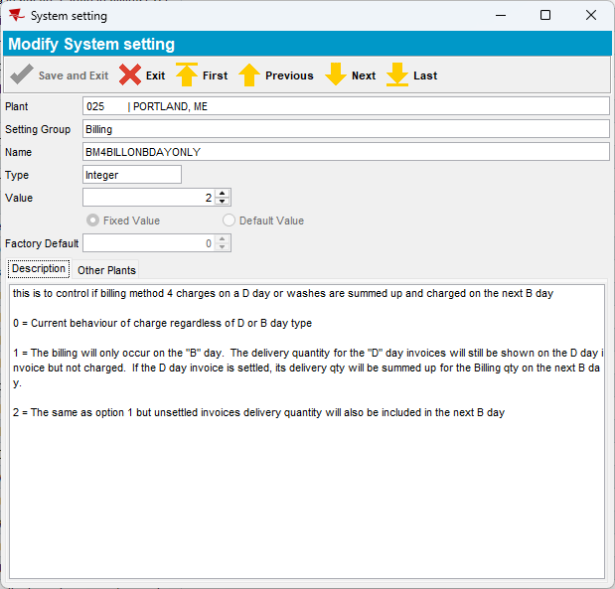
- Outscan an item for Thursday
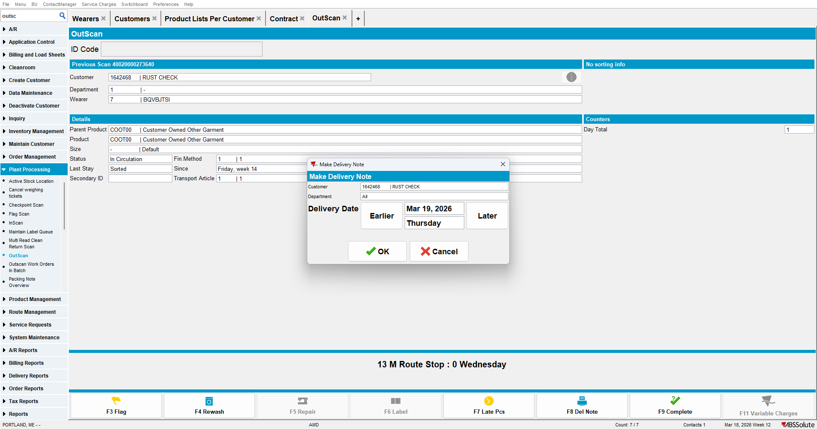

- Generate invoices for Thursday
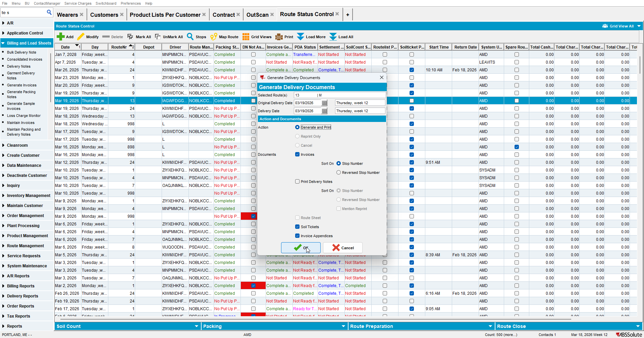

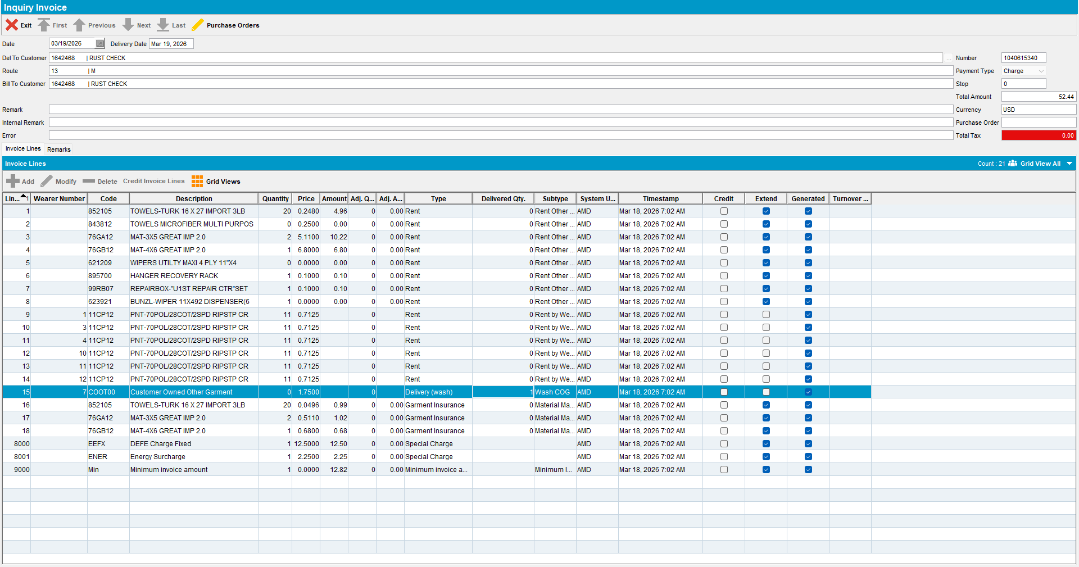
Expecting an invoice with qty = 0, amount = 0, delivered qty = 1 on wash line.

- Outscan an item for Friday.
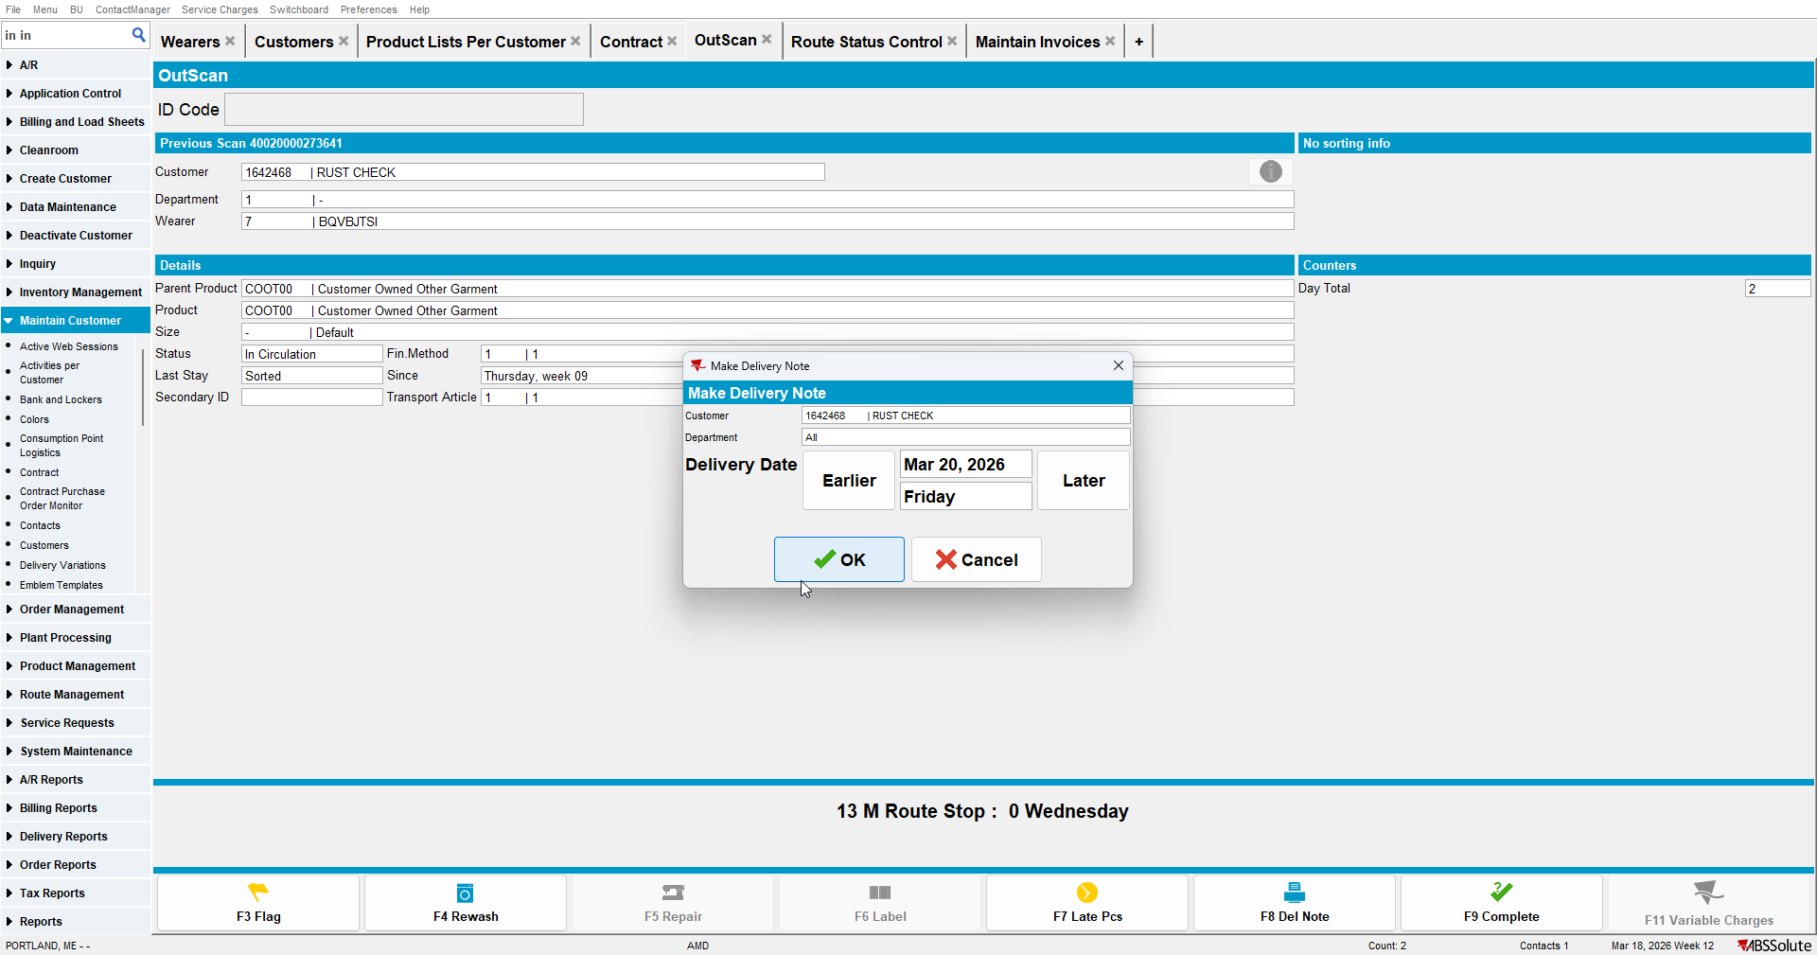

- Generate invoices for Friday.
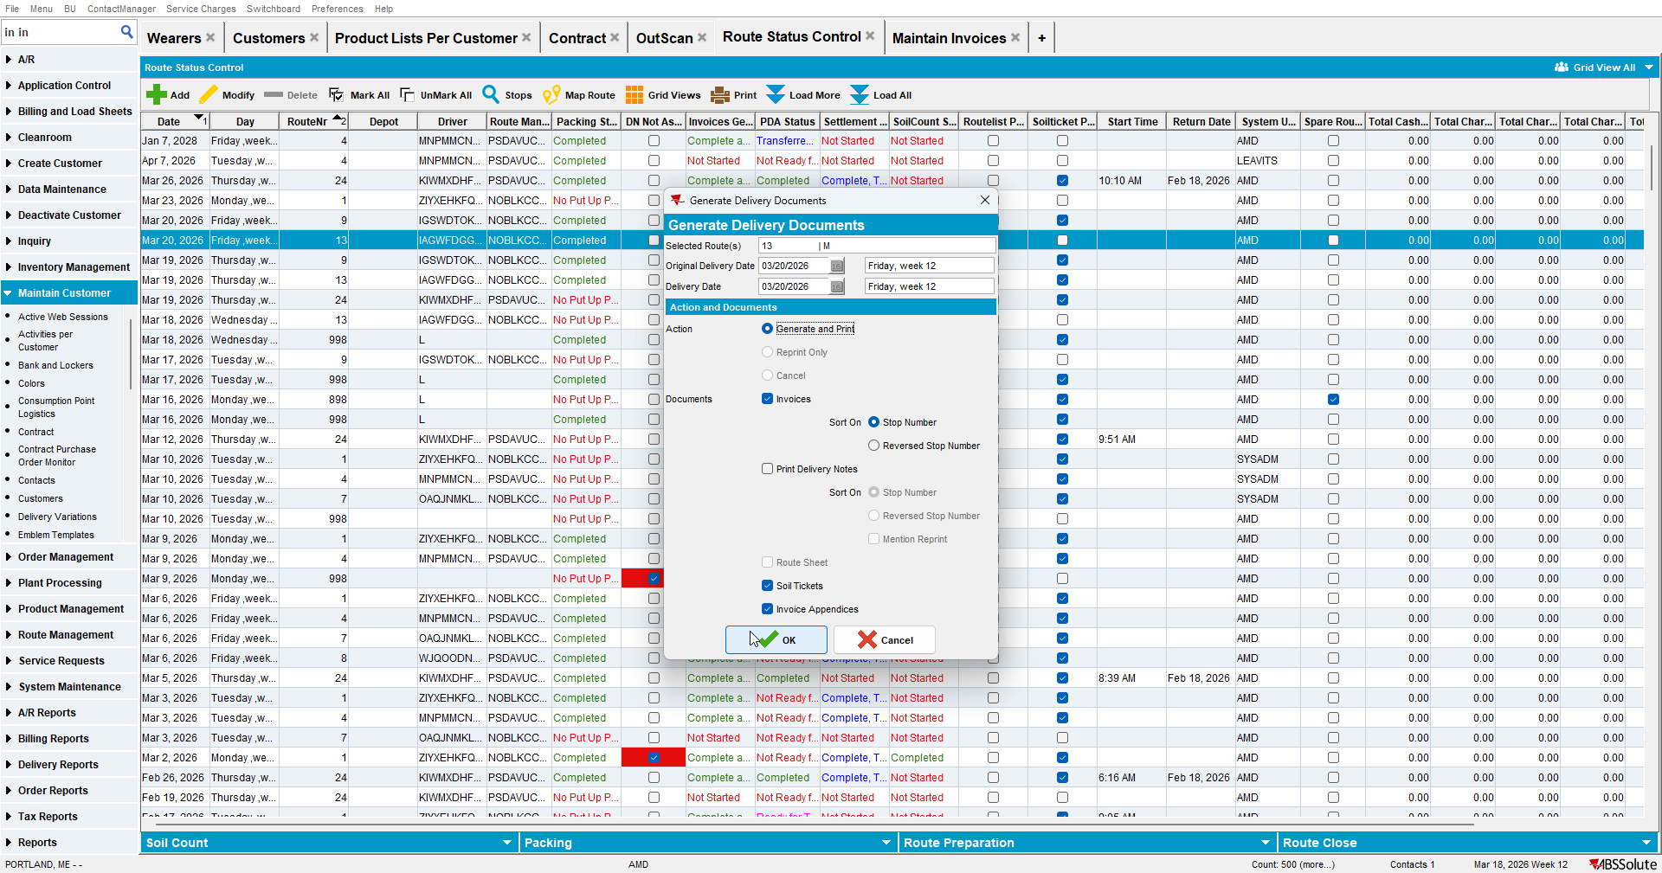
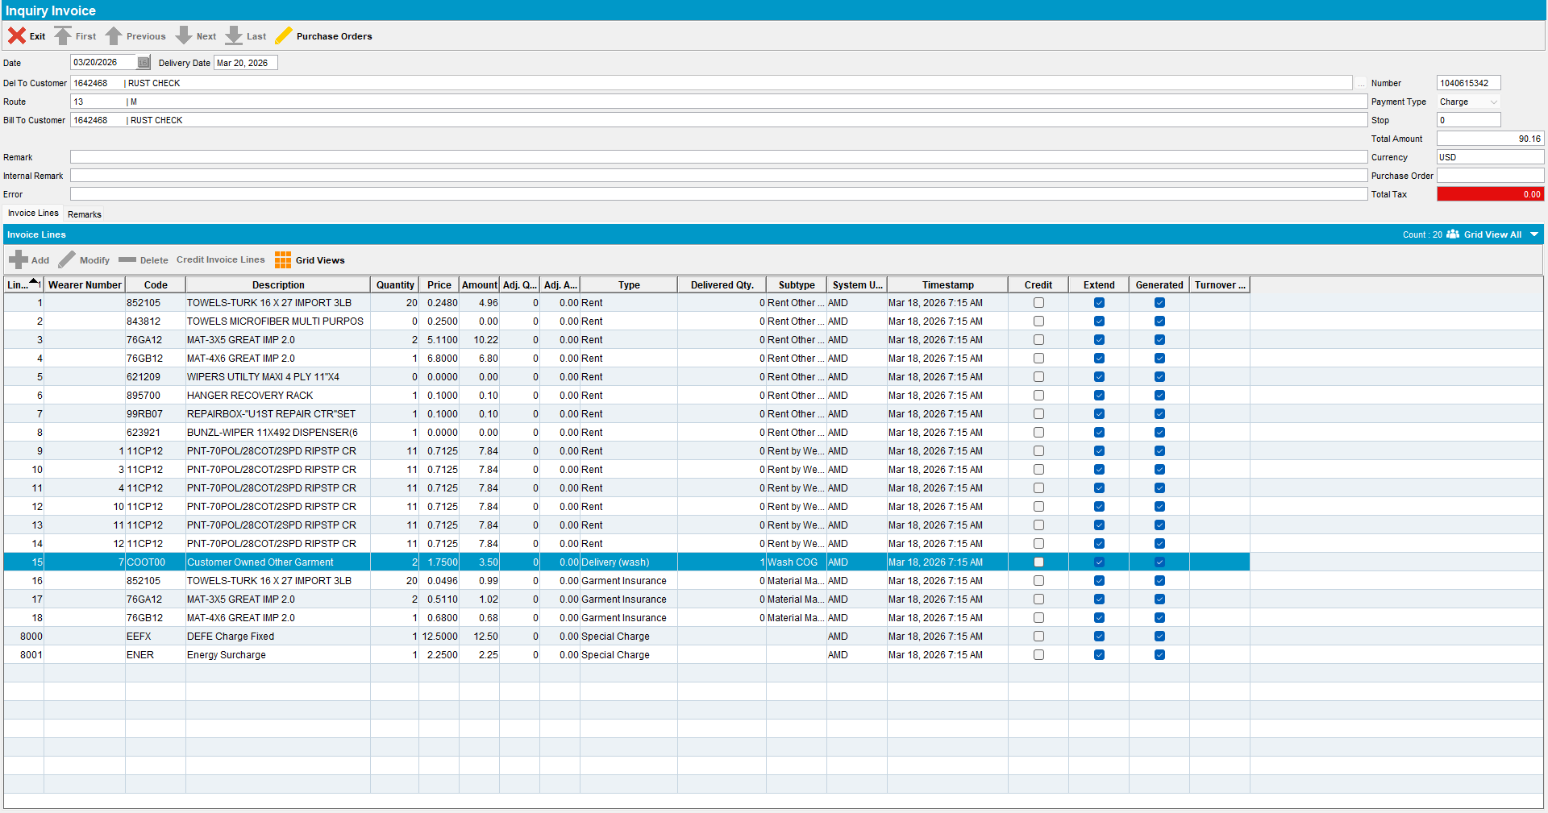
Invoice with qty = 2, amount = 2 * price, delivered qty = 1 (from Friday's outscan) on wash line.

TESTED OK.

