ASDN-8261 D_UBS_2837 Unable to view signatures in DBM post update
Environment | Prerequisites
DBServerName= abs-srv20.internal.abslbs.com  DBSID=CUST24  DBUser=UNFDEV  Environment=PRODUCTION | - Module:  - System setting

Contents
Reproduce before fix 1
Steps to reproduce: 1
Current behavior: 2
Expected behavior: 2
Retest after fix 2
Steps to reproduce: 2
Current behavior: 3

Reproduce before fix
Bu: 044 Nashua, NH
9.07.00.UNF17.p20 hash: e3b76fa77b22fdeef08c153ca3aa2cc991d7a647

Steps to reproduce:

- Update Chrome browser to the latest version available.
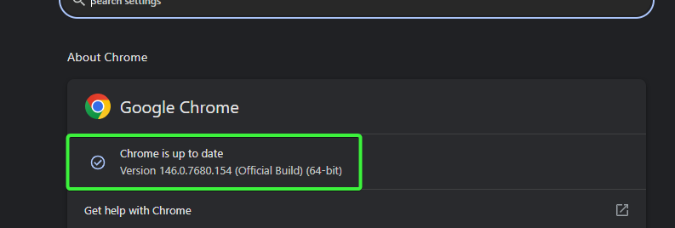
- WebX: Load a route that was uploaded from RA and had the invoices settled with signatures.
- WebX: Click on a stop and view the signature.
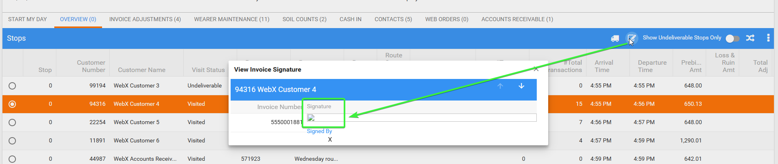

Current behavior:
The signature is not loaded / visible in WebClientX.

Expected behavior:
The signature should be displayed corectly.

Reproduced OK

Retest after fix
Bu: 044 Nashua, NH
9.07.00.UNF17.p21 hash: cd82019caf49

Steps to reproduce:
- Update Chrome browser to the latest version available.
- WebX: Load a route that was uploaded from RA and had the invoices settled with signatures, check one in database.
select p.code, rc.drivingdate, r.routenumber, INVSIG.* from invoiceheader ih
join INVOICESIGNATURE INVSIG on INVSIG.INVOICEHEADER_ID = IH.INVOICEHEADER_ID
join routecontrol rc on rc.routecontrol_id = ih.routecontrol_id
join ROUTE R on R.ROUTE_ID = RC.ROUTE_ID
join PLANT P on P.PLANT_ID = R.PLANT_ID
where rc.drivingdate > sysdate - 365
order by rc.drivingdate desc
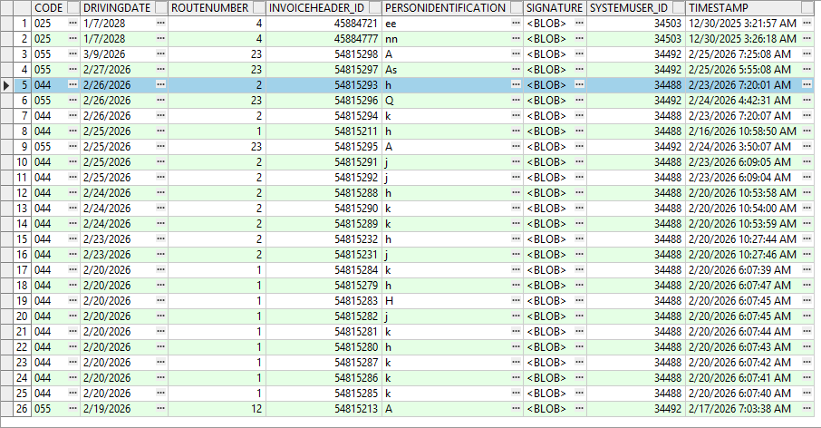
- WebX: Click on a stop and view the signature.
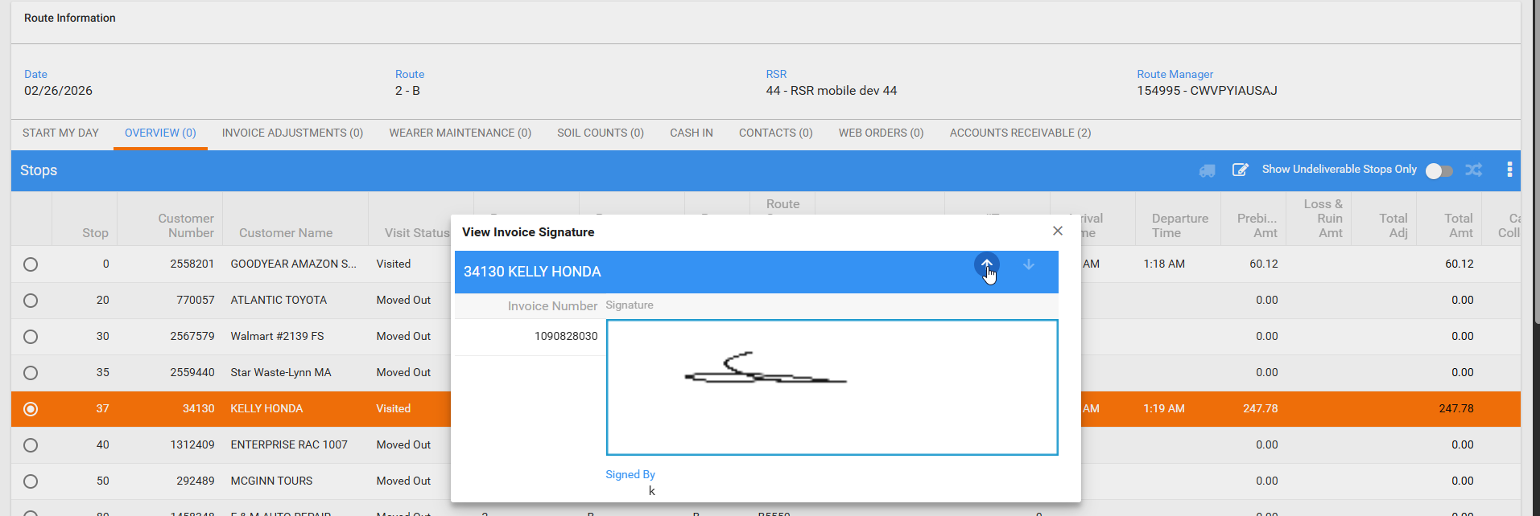

Current behavior:

Tested OK

