RASAN-451 - D_UBS_2822 Return only smart barcodes when only non-unique items are flagged for decrease
Environment | Prerequisites
Version: 9.07.00.UNF17.p20 + RouteAssistant_v12.40  DBServerName= abs-srv20.internal.abslbs.com  DBSID=CUST24  DBUser=UNFDEV  Environment=Test | - Module:  - System setting

Contents
Reproducing before fix 1
Steps to reproduce 1
Current Behavior 9
Retest after fix 9
Test Case 1 – WI with mixed inventory > Decrease only Non-unique items 9
Test Case 2 – WI with mixed inventory > Decrease Unique and Non-unique items 17
Test Case 3 – WI with mixed inventory > Decrease only Non-unique items and replace 1 non-Unique item 24
Test Case 4 –Quit WI with Unique and Non-Unique 31

Reproducing before fix

Steps to reproduce
- Wearers DLG: Add a wearer with all non-unique Items
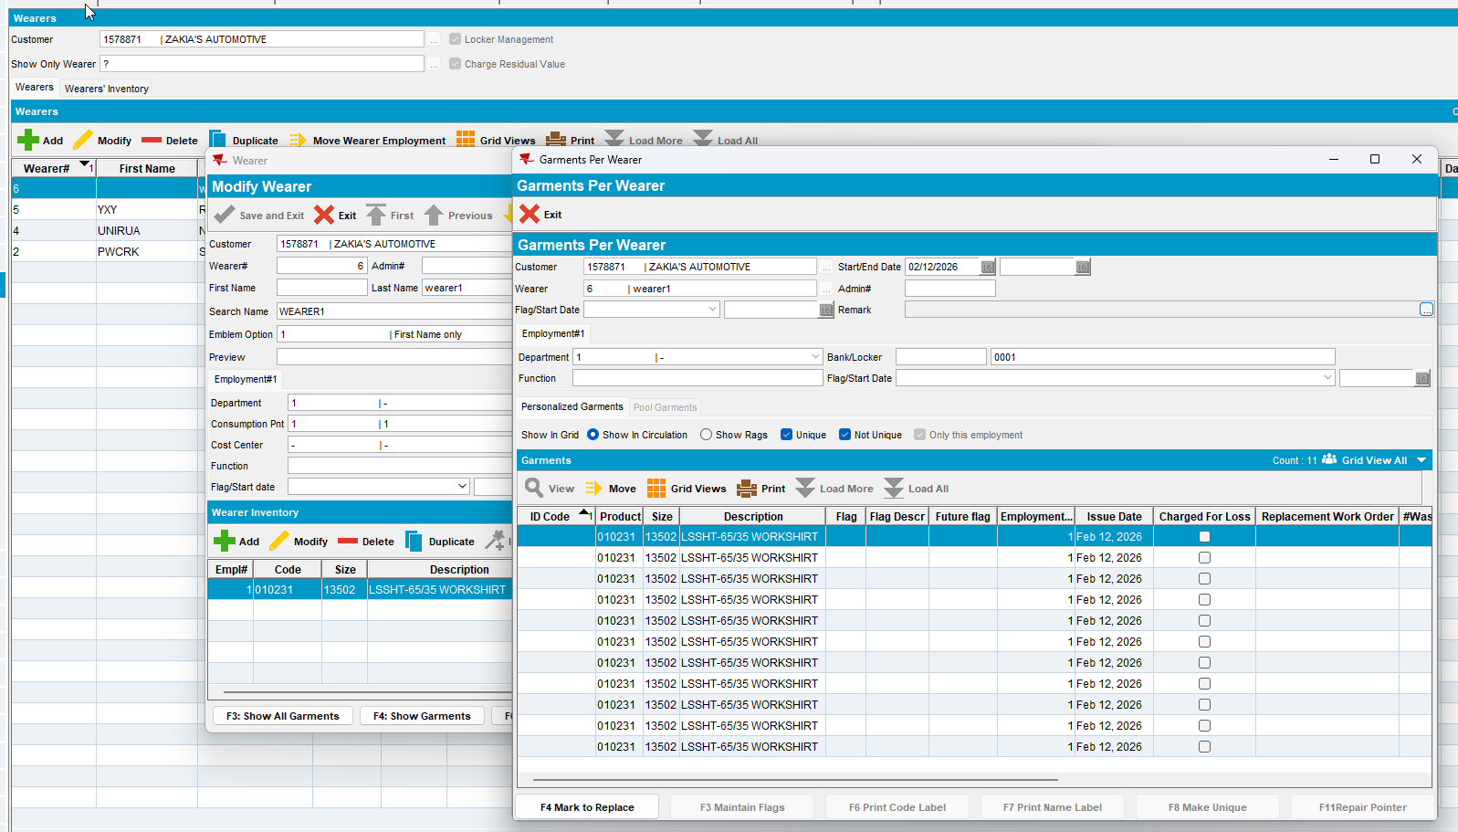
- Make 5 of the items Unique
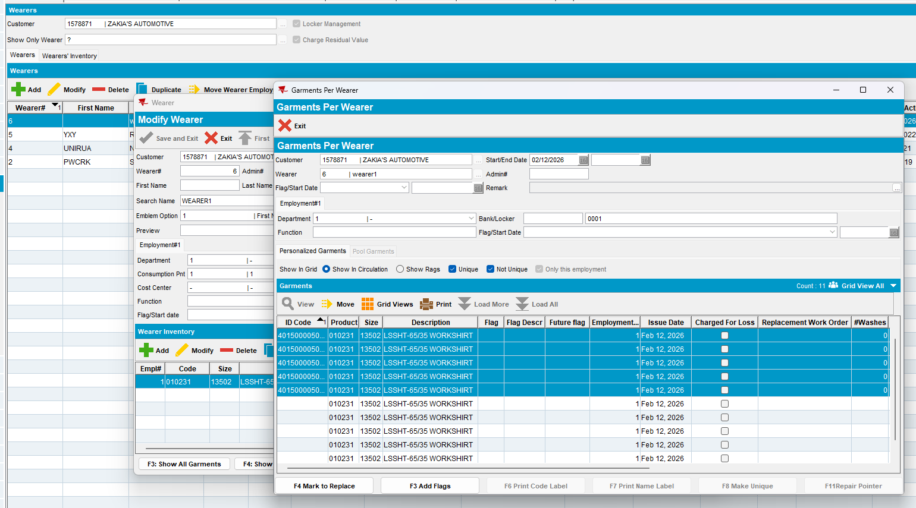
- Perform a decrease of Max inventory of 5 items
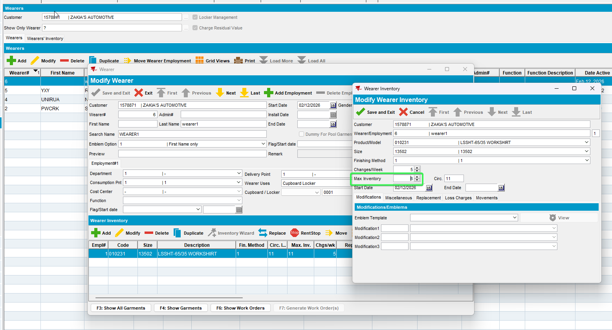
- Return the Oldest items so the non-uniques can be flagged
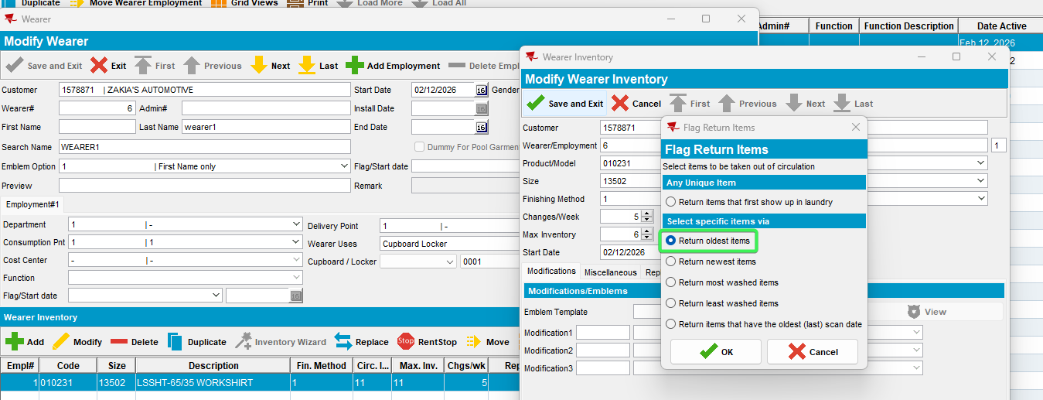
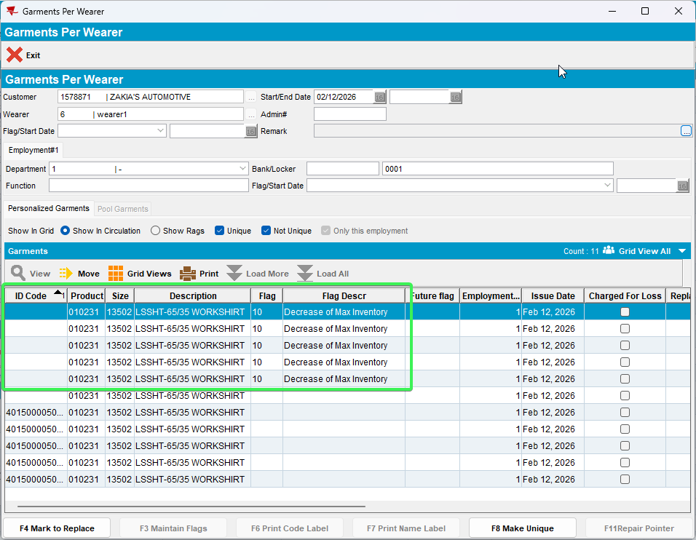
- RSC: Create a new route with the customer on it
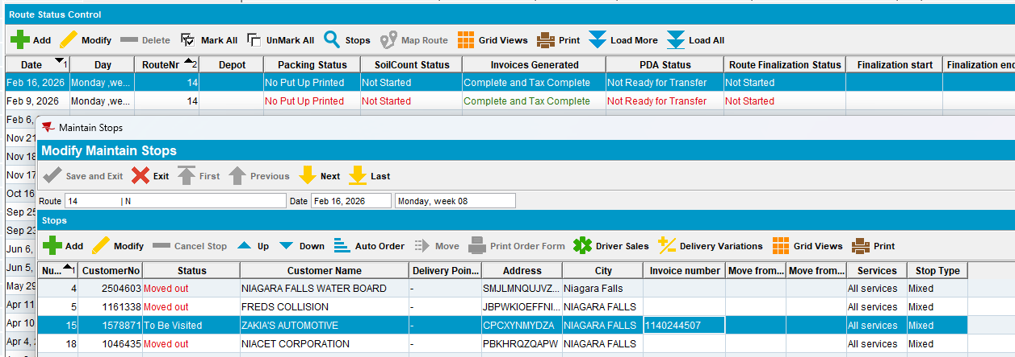
- Send the route to RA
- RA: Returned Items > Scan returns
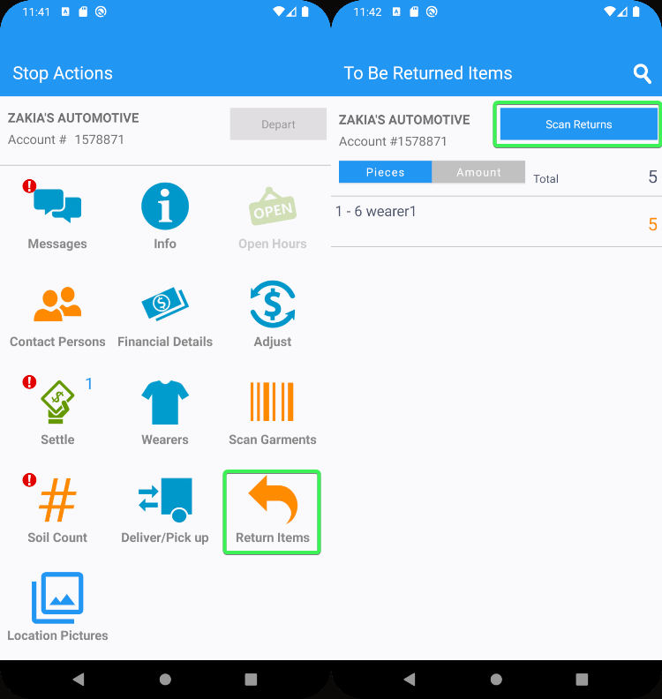
- On RA database check the wi.qtyToBeReturned before scanning any items
select wi.qtyToBeReturned, wi.* from WearerInventoryDTO wi
where wi.wearerInventoryId=8780693
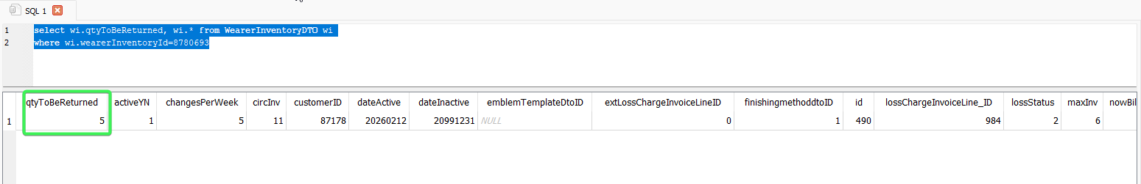
- Scan 1 unique item
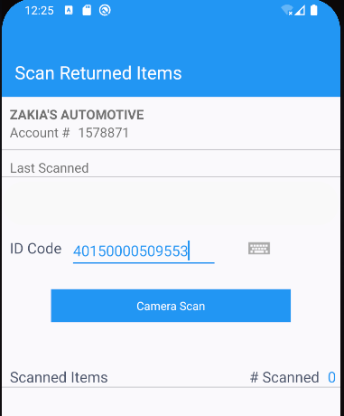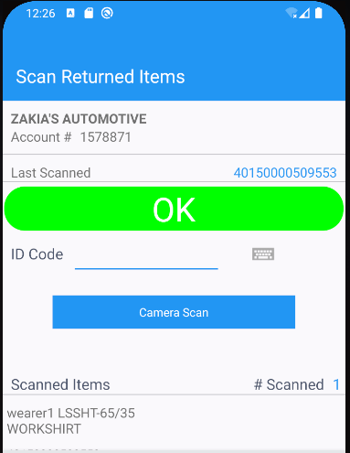
- Scan a Smart barcode
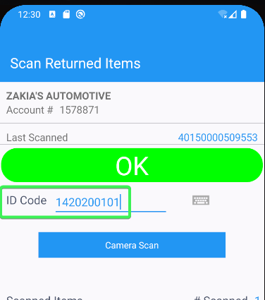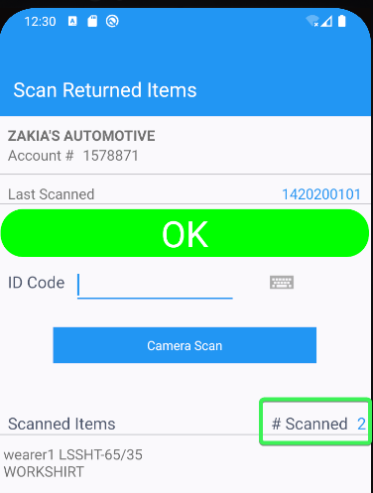
- Scan a different smart barcode
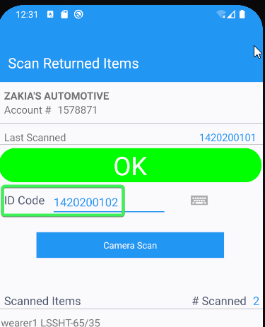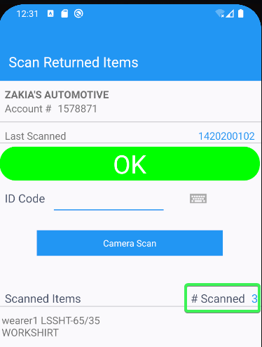
- Scan the same barcode as before: 1420200102 and click yes on the message
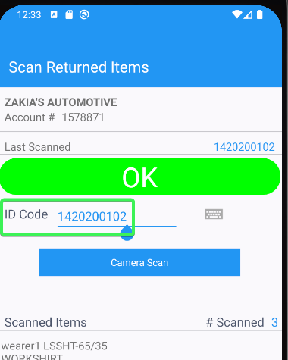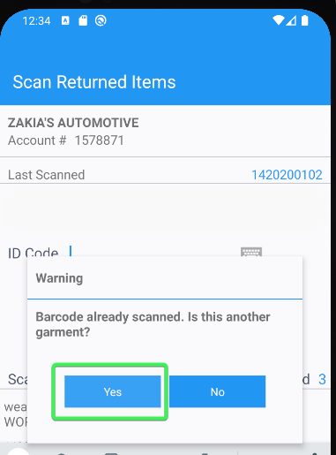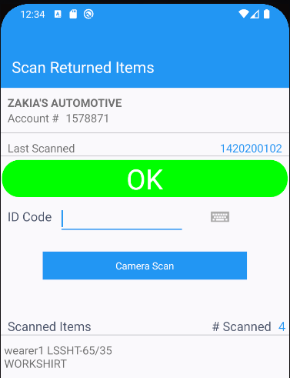
- Scan the last garment to be returned, this time an unique item
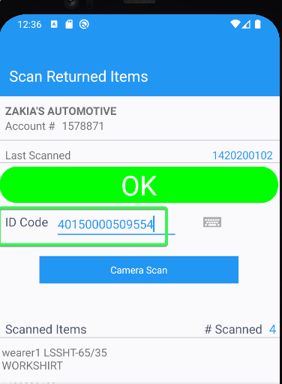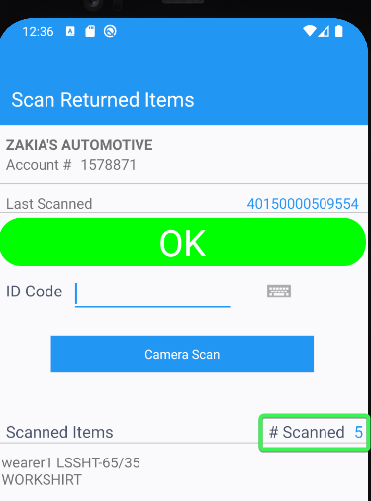
- Settle the route and depart
- Before upload check the wi.qtyToBeReturned again
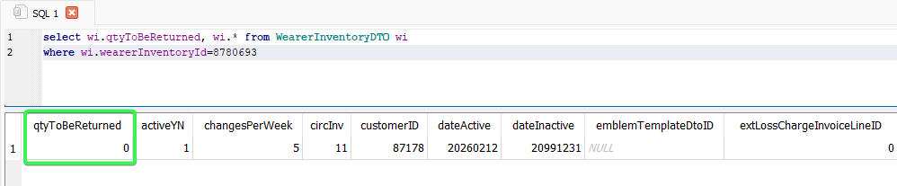
- Check the items that were returned from GarmentIDDTO
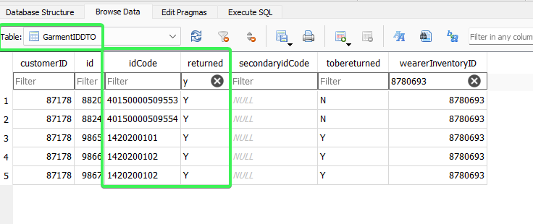
- Upload the route
- Wearers DLG: check the WI and see that only non-unique items have been returned
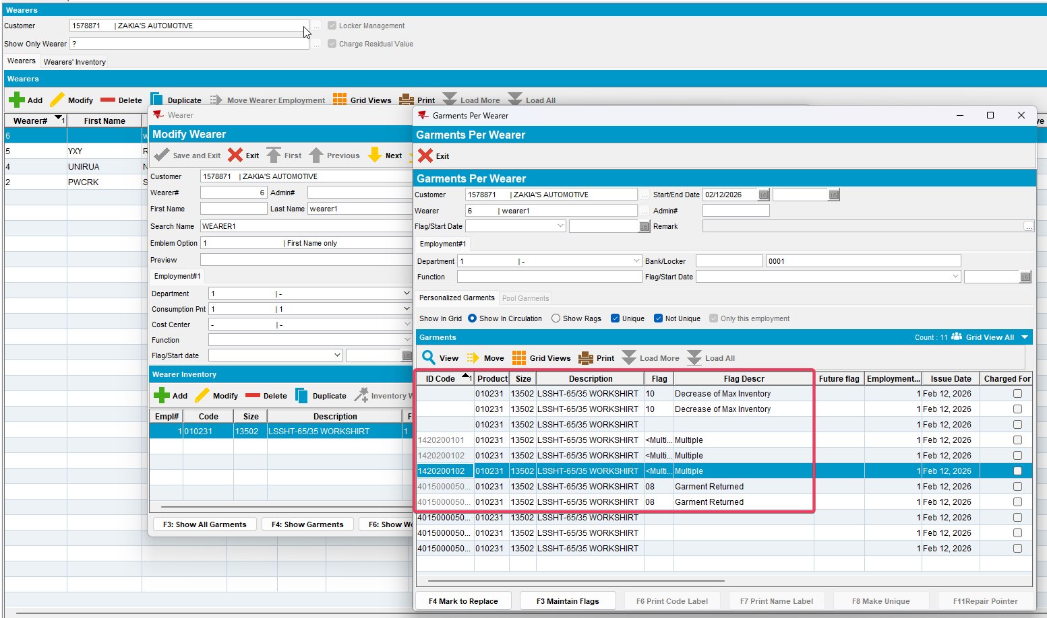
- Settle the route
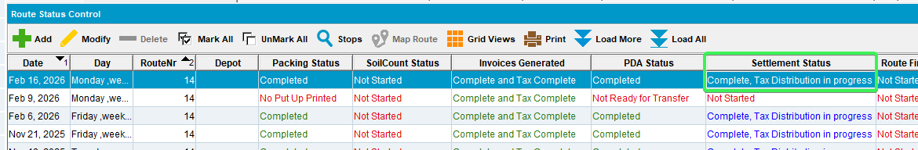
- Generate invoices for next week and check that there is no loss charge line for your wearer
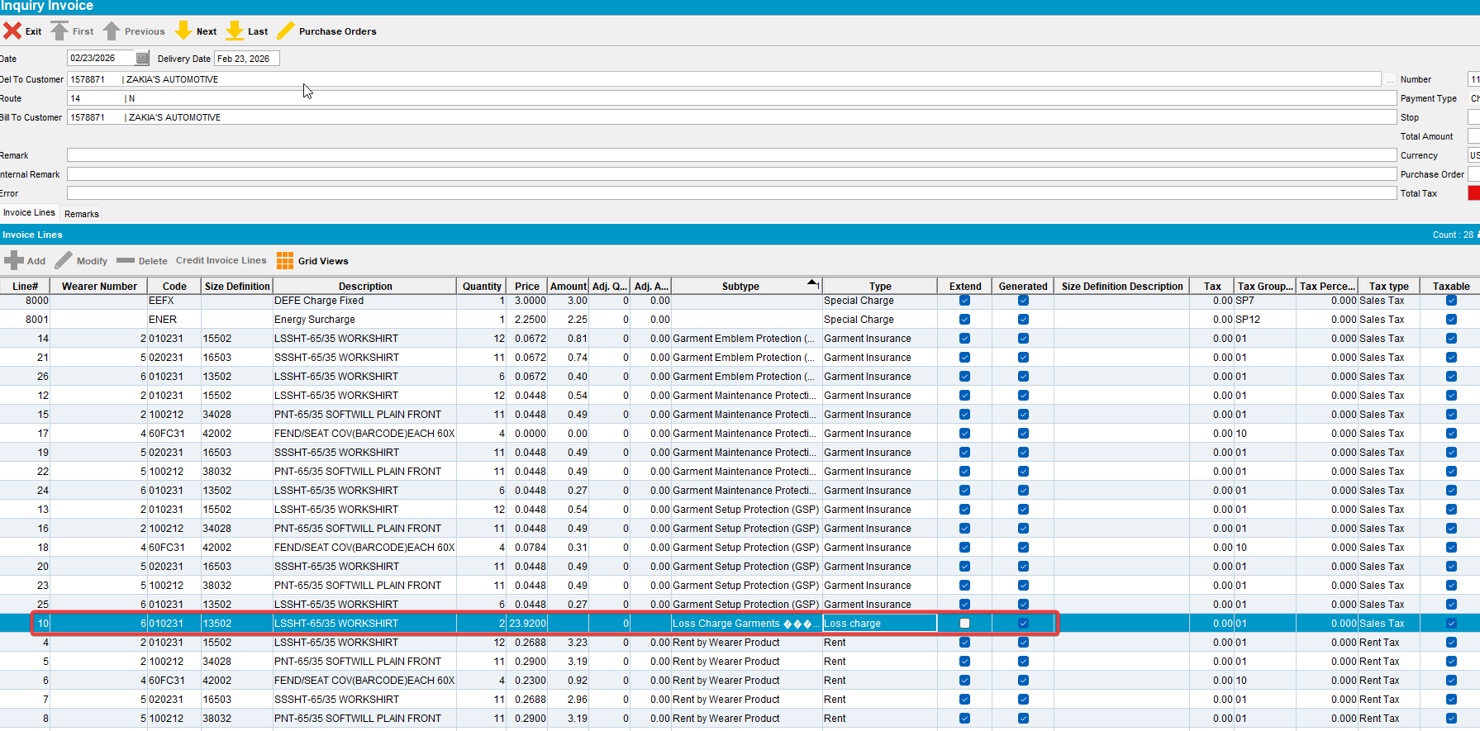

REPRODUCED OK.

Current Behavior
The user can scan a Unique item on RA
After Upload we still have non-unique items flagged with decrease of max inventory
After settlement and generating invoices for next week, a loss charge invoice in also generated for the items flagged with DOMI

Retest after fix

Test Case 1 – WI with mixed inventory > Decrease only Non-unique items
Expected:
The user cannot scan a Unique item on RA
After Upload non-unique items that were scanned should now have smart barcodes, and the unique IDs should not be flagged
After settlement and generating invoices for next week, we should not have a loss charge line.

Hash: 9.07.00.UNF17.p19 hash: 3930ae9c21a6 + RouteAssistant_v12.40.INTERNAL_TEST_ONLY.196e74a5f
- Wearers DLG: Add a wearer with all non-unique Items
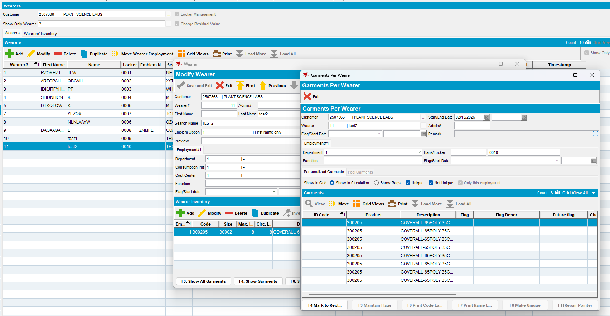
- Make 4 of the items Unique
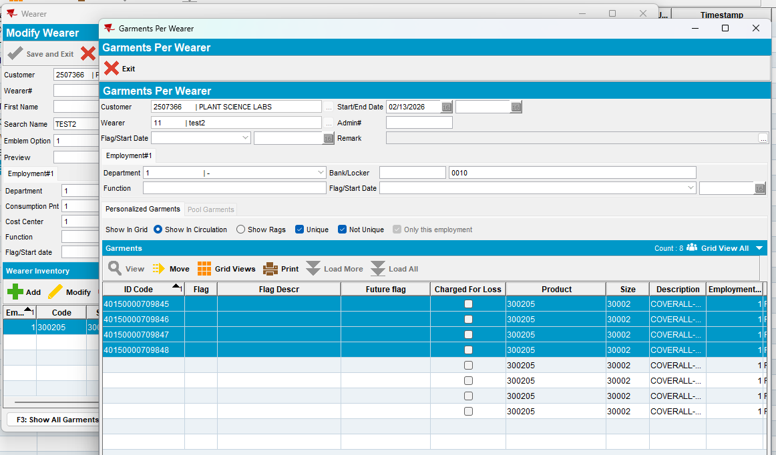
- Perform a decrease of Max inventory of 3 items
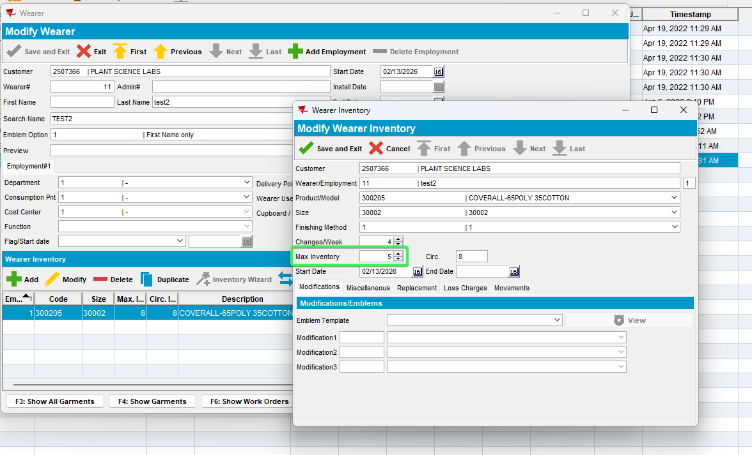
- Return the Oldest items so the non-unique can be flagged
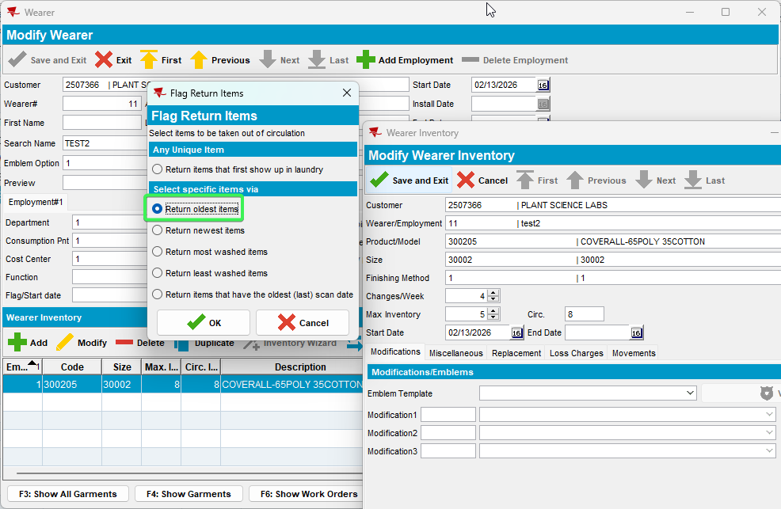
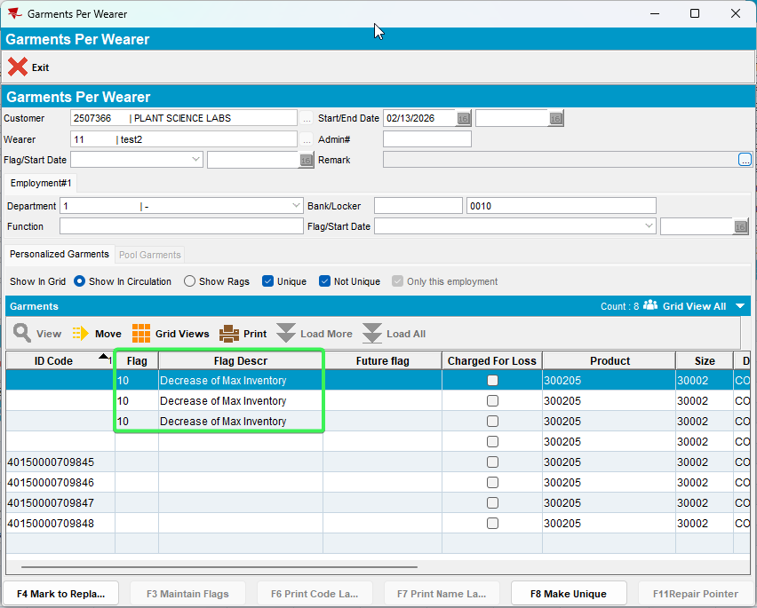
- RSC: Create a new route with the customer on it
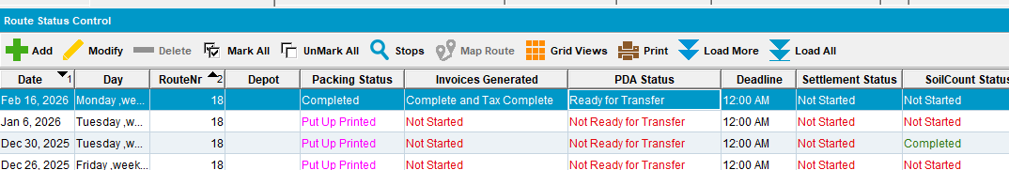
- Send the route to RA
- RA: Returned Items > Scan returns
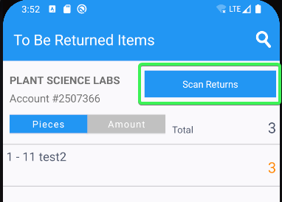
- On RA database check the wi.qtyToBeReturned before scanning any items
select wi.qtyToBeReturned, wi.* from WearerInventoryDTO wi
where wi.wearerInventoryId= 12190603
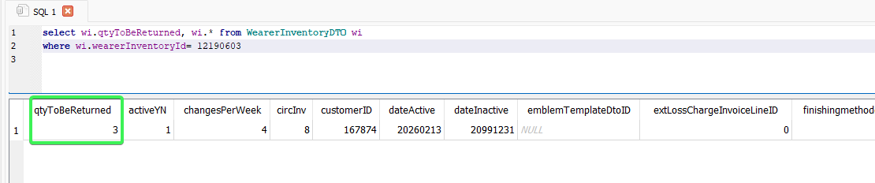
- Scan 1 unique item
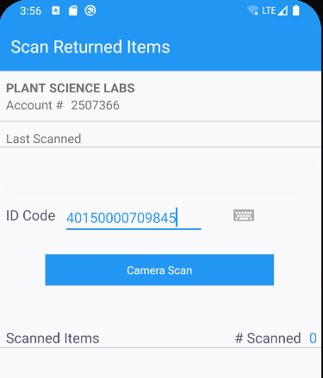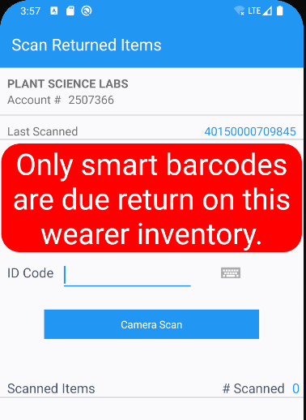
- Scan a Smart barcode
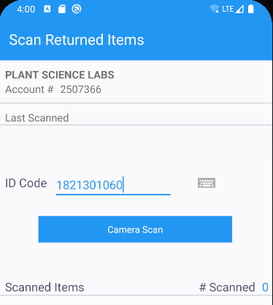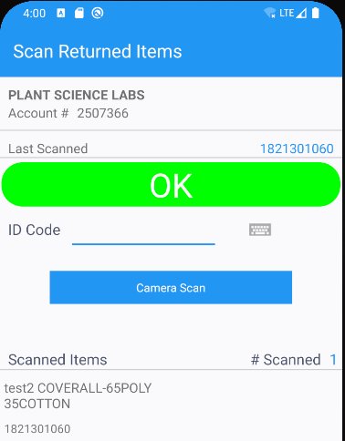
- Scan a different smart barcode
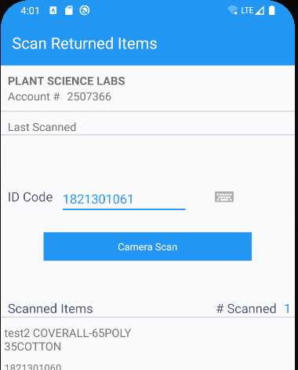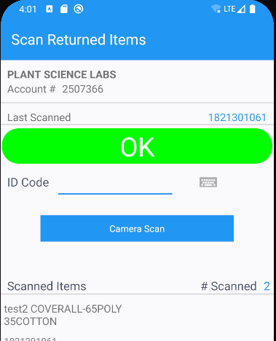
- Scan the same barcode as before: 1821301061 and click yes on the message
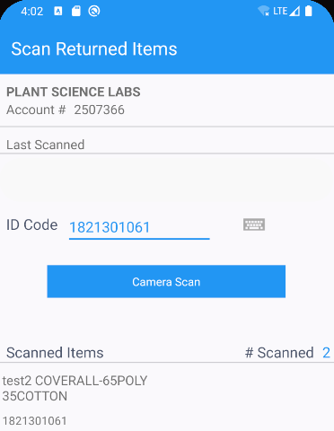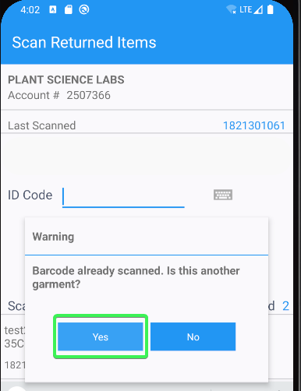
- Settle the route and depart
- Before upload check the wi.qtyToBeReturned again
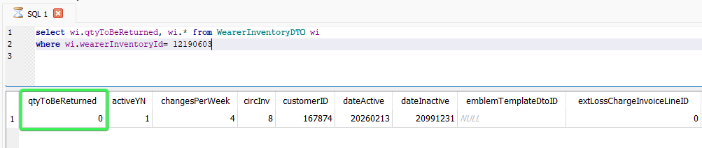
- Check the items that were returned from GarmentIDDTO
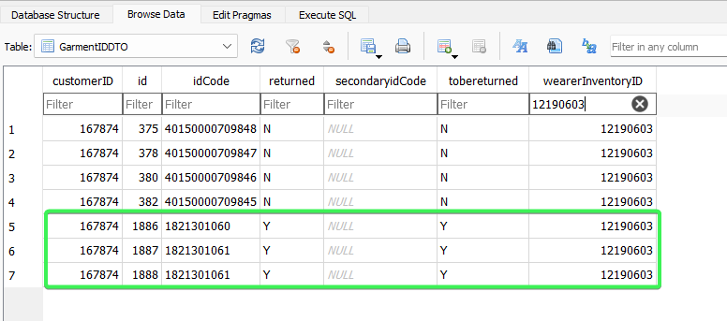
- Upload the route
- Wearers DLG: check the WI and see that only non-unique items scanned have been returned, 1 items that was not scanned is not flagged and the Unique ID are also not flagged
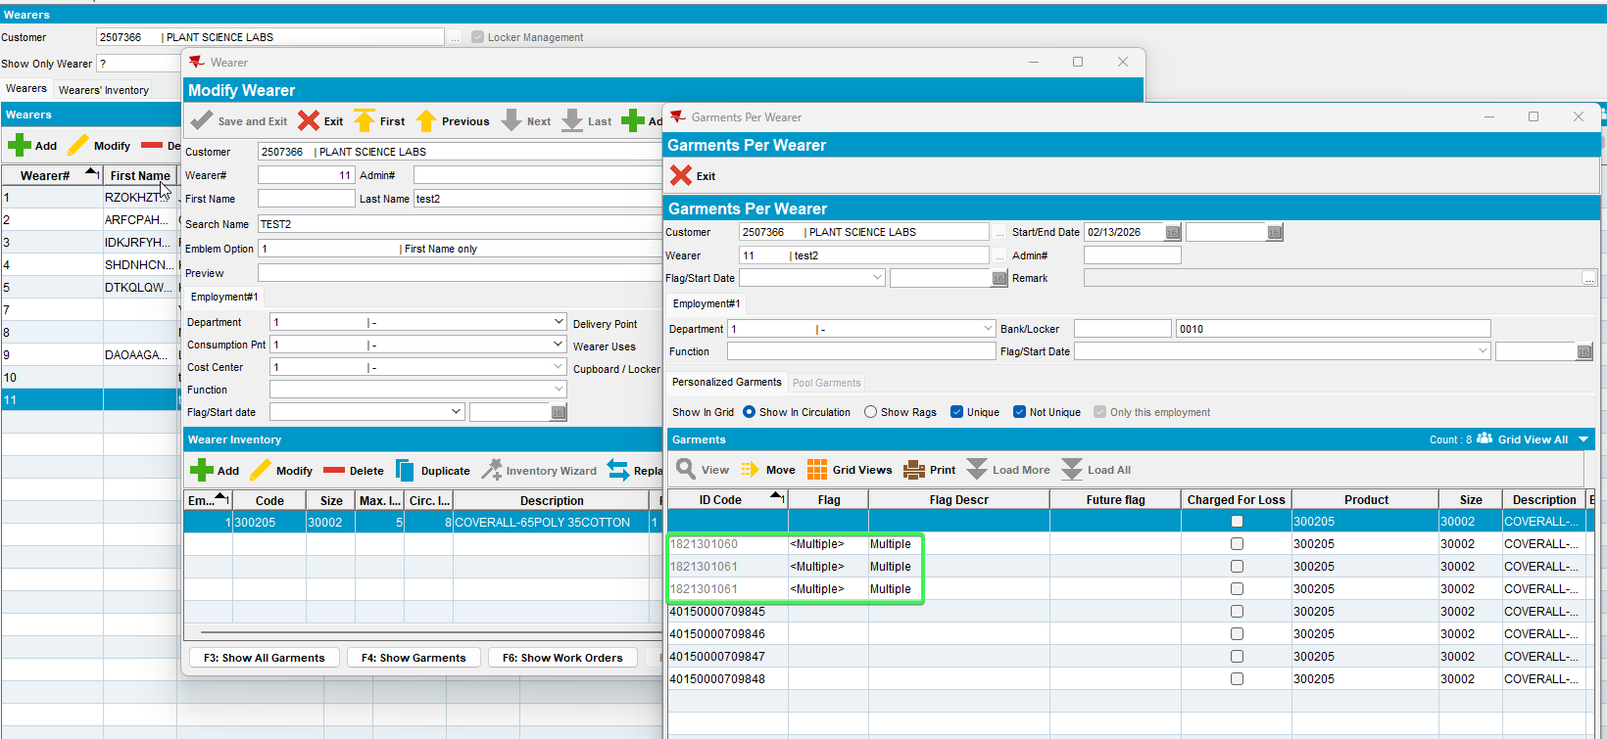

- Settle the route
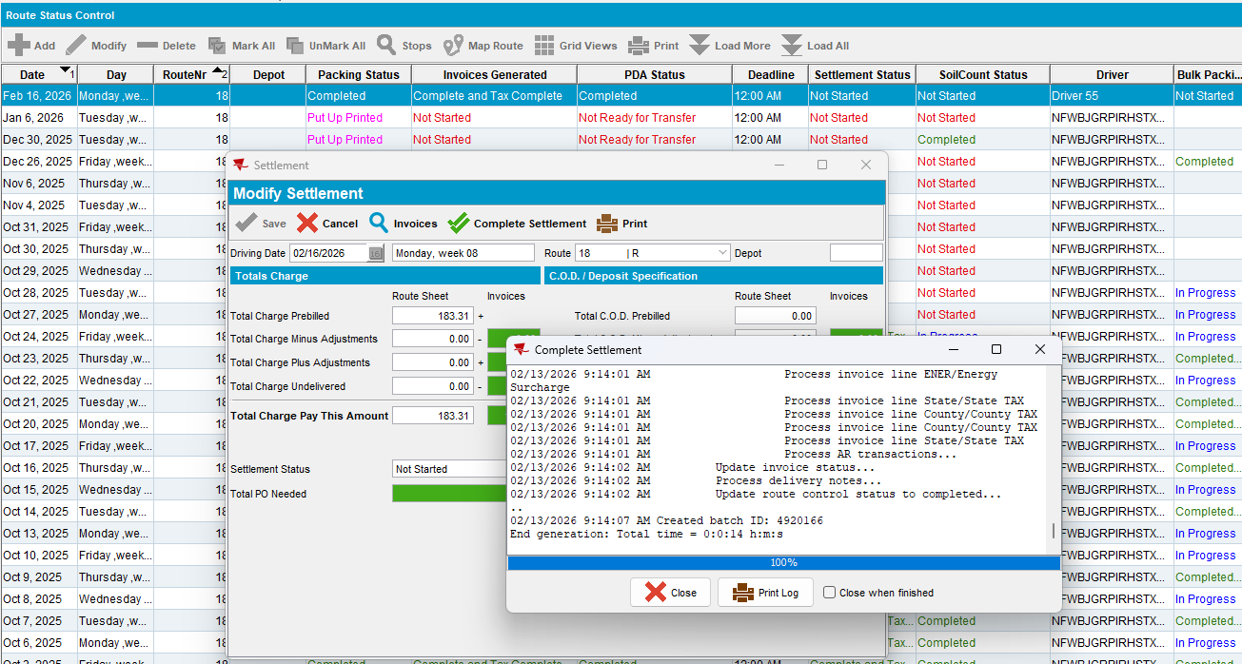
- Generate invoices for next week and check that there is no loss charge line for your wearer
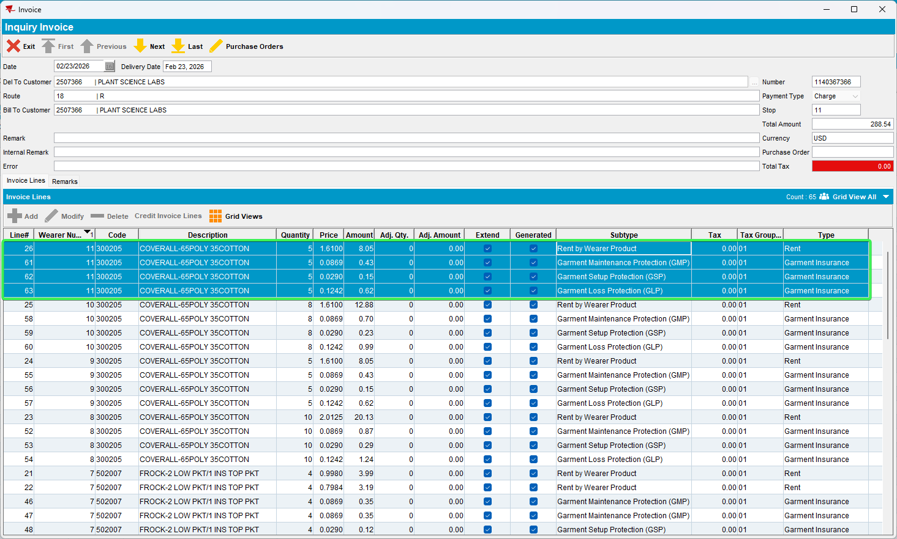

Test Case 2 – WI with mixed inventory > Decrease Unique and Non-unique items
Expected:
The user can scan unique items that are marked for decrease
After Upload non-unique items that were scanned for return should have smart barcodes, the ones that were not scanned should not have. The unique items should be marked as “Garment returned”

Hash: 9.07.00.UNF17.p19 hash: 3930ae9c21a6 + RouteAssistant_v12.40.INTERNAL_TEST_ONLY.196e74a5f
Steps

- Wearers DLG: Add a wearer with all non-unique Items
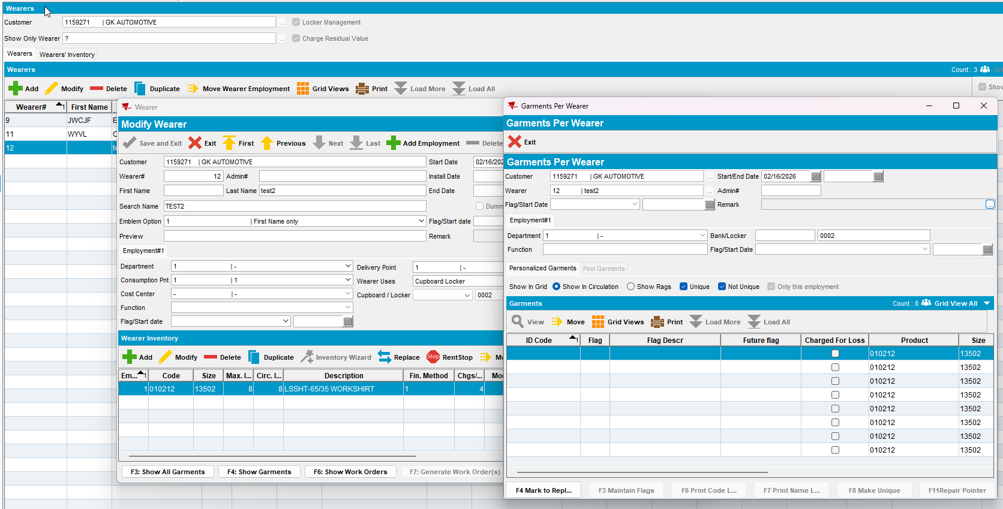
- Make 4 of the items Unique
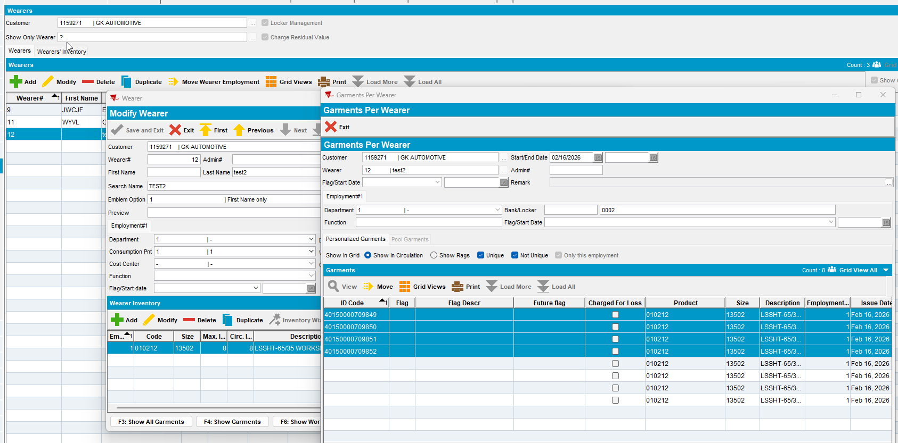
- Perform a decrease of Max inventory of 5 items which include 1 unique
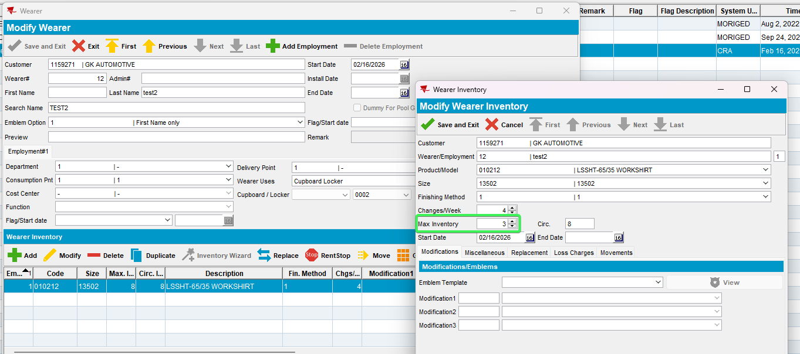
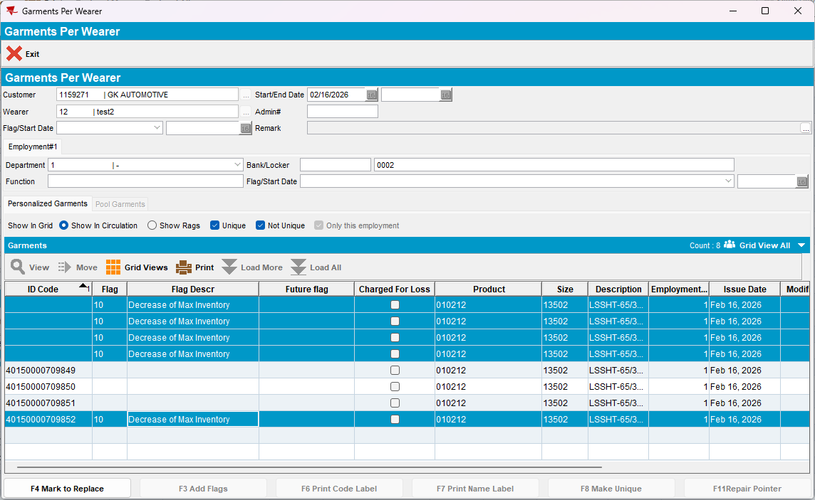
- RSC: Create a new route with the customer on it
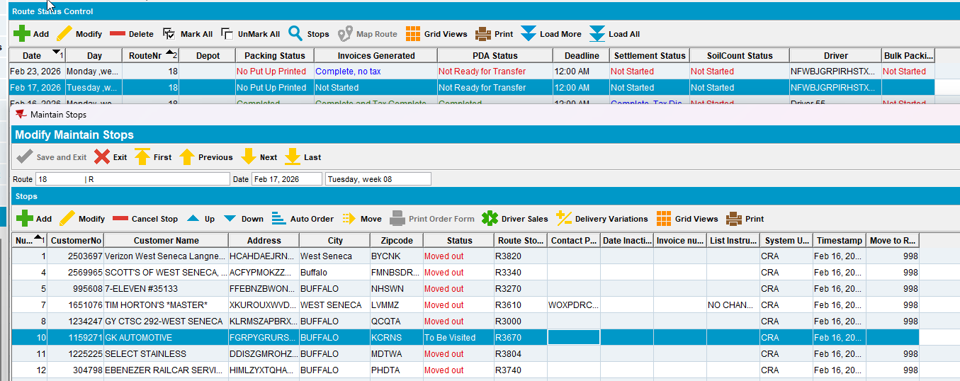
- Send the route to RA
- RA: Returned Items > Scan returns
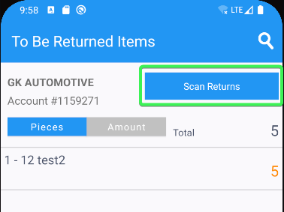
- Scan the Unique ID and see that no error is prompted
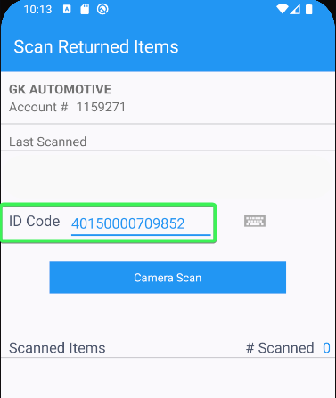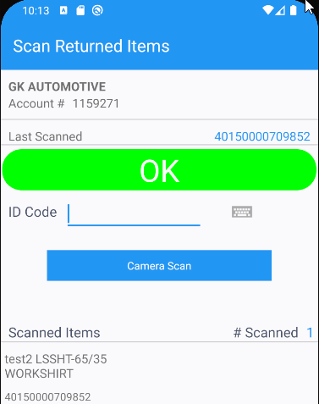
- Scan another Unique ID
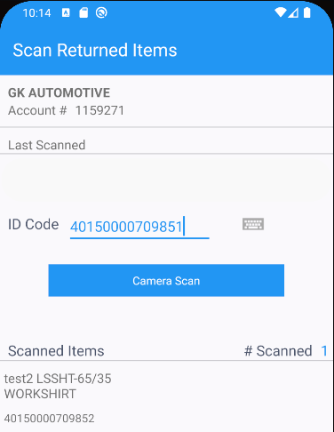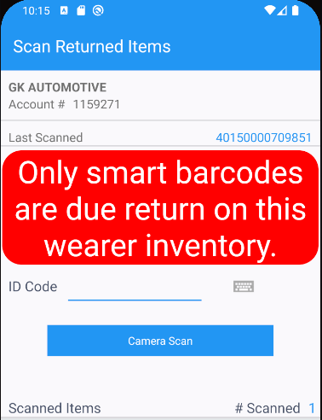
The error is prompted as only smart barcodes are left to be scanned
- Scan a Smart barcode
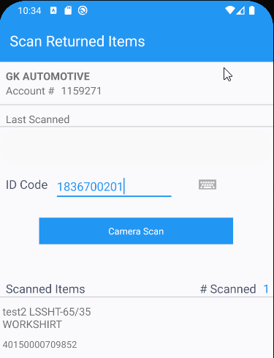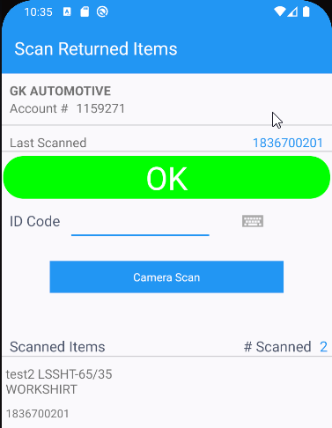
- Scan the remaining 3 smart barcodes
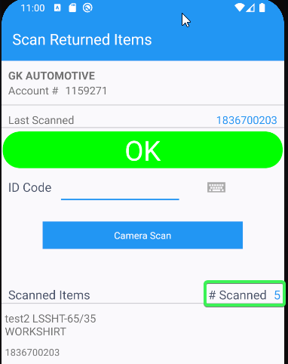
- Settle the route and upload the data
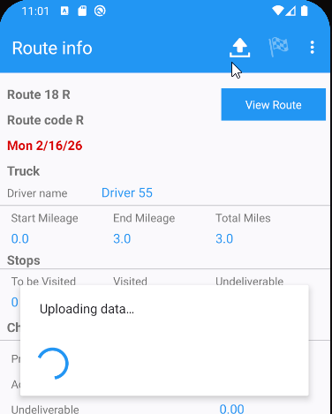
- Wearer DLG: See that the non-unique IDs now have a smart barcode and are flagged with Decrease of max inventory and Garment returned
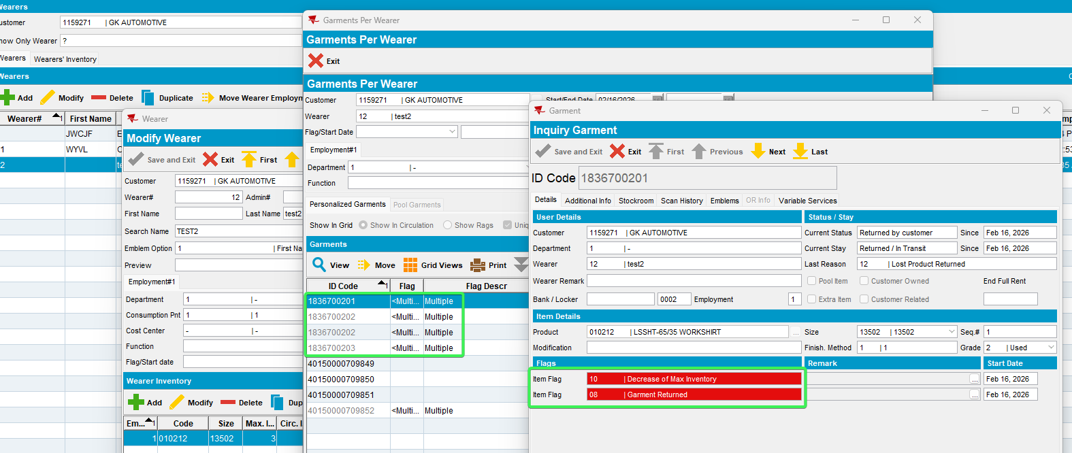
- The scanned Unique ID is also marked with Decrease of max inventory and Garment returned
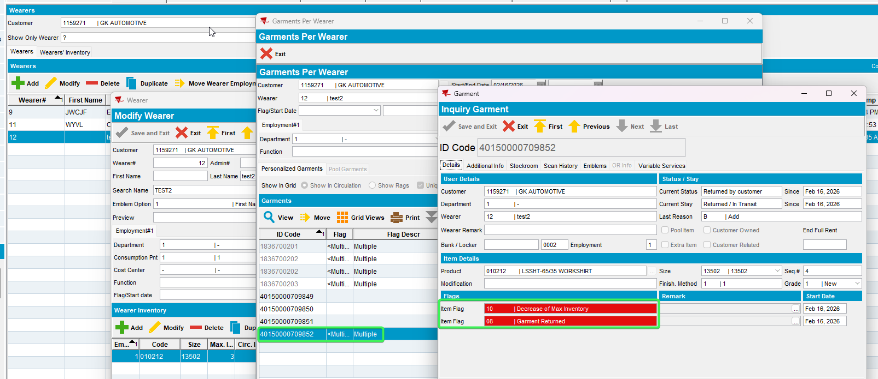
- The remaining Unique ID are not flagged
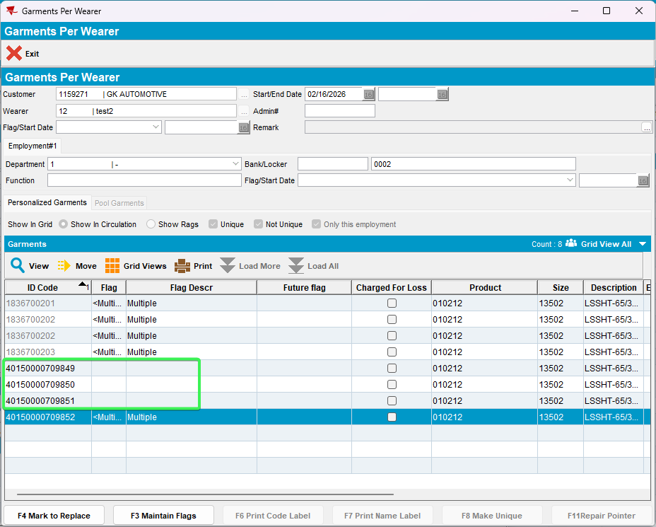
Tested OK

Test Case 3 – WI with mixed inventory > Decrease only Non-unique items and replace 1 non-Unique item
Expected:
The user can scan only the non-unique item that is replaced and decreased
After Upload items should have the non-unique with smart barcodes and the one returned replaces with a smart barcode

Hash: 9.07.00.UNF17.p19 hash: 3930ae9c21a6 + RouteAssistant_v12.40.INTERNAL_TEST_ONLY.08706083b
- Wearers DLG: Add a wearer with all non-unique Items
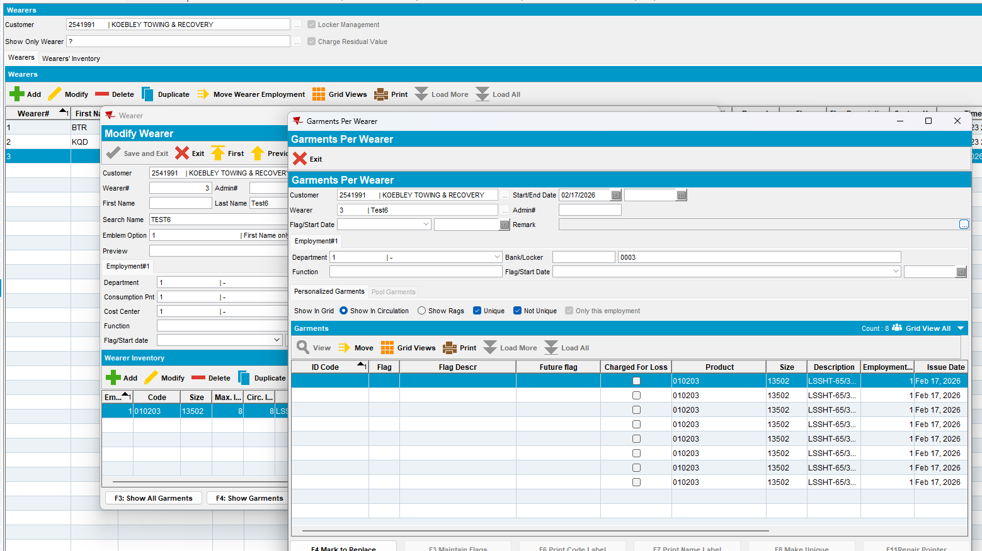
- Make 4 of the items Unique
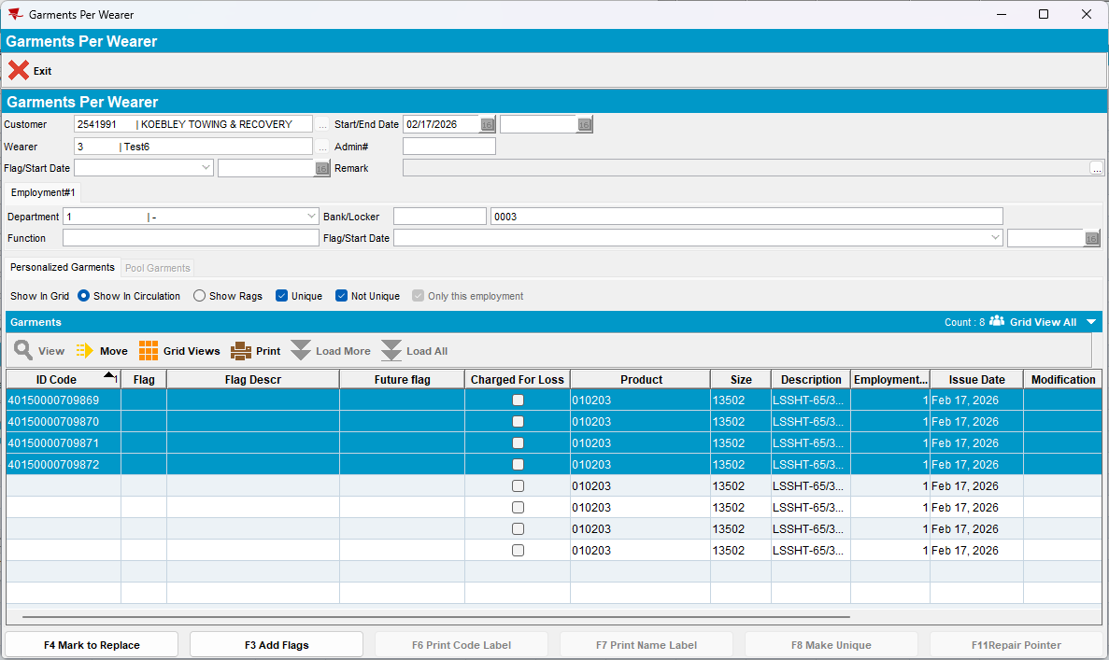
- Perform a decrease of Max inventory of 3 items returning the oldest so that the non-unique are selected to be flagged
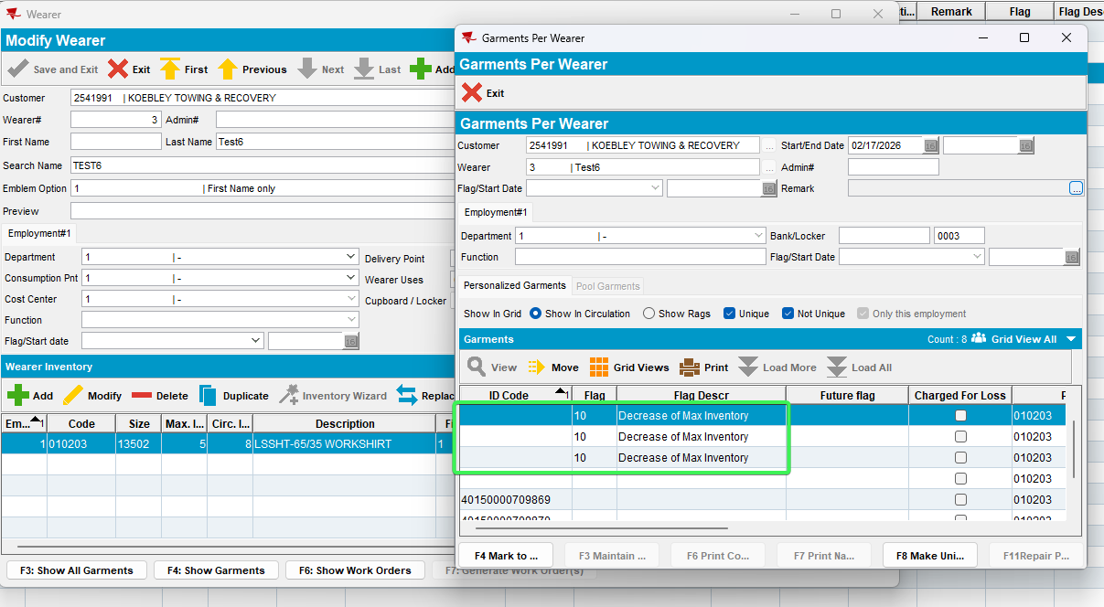

- The one non-unique that is not marked for decrease, mark it for replacement
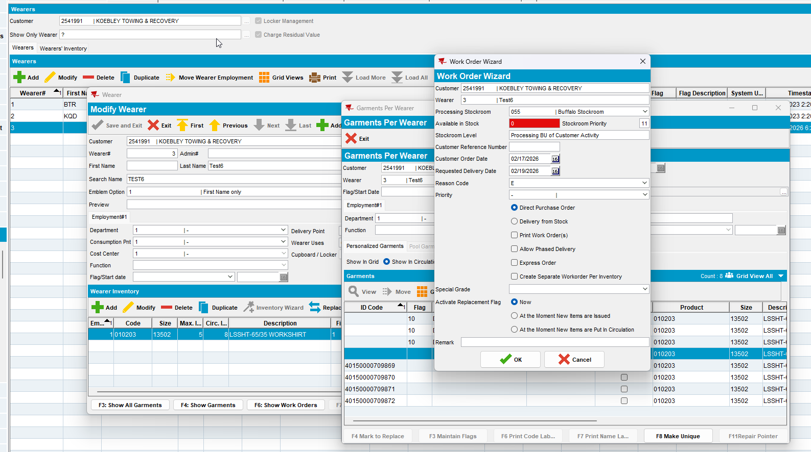
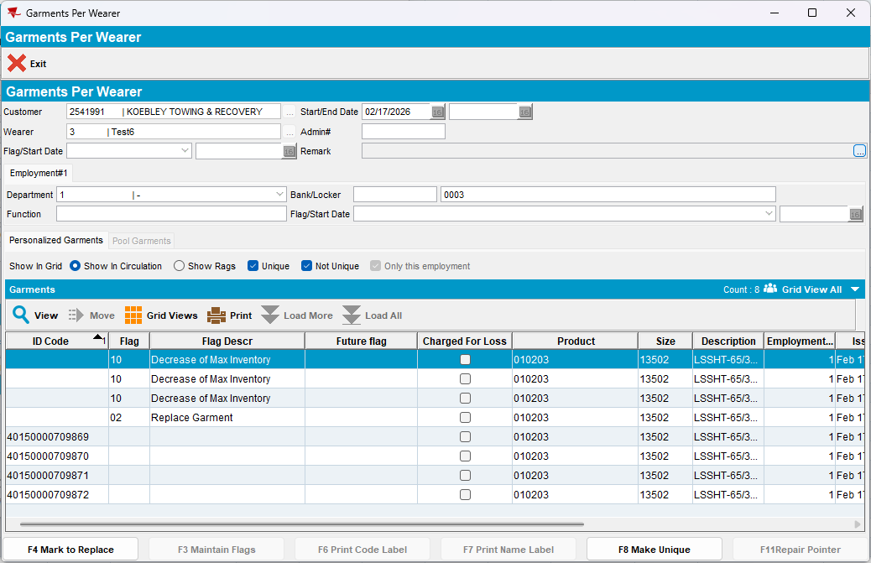
- Create a new route with the customer on it and send it to RA
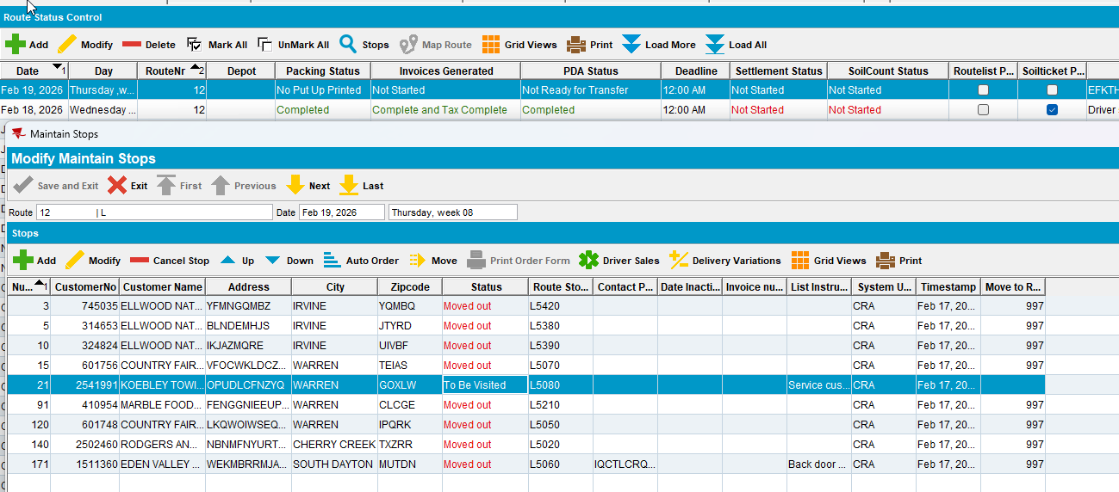
- Arrive at the customer and scan a Unique ID in the Return Items tab
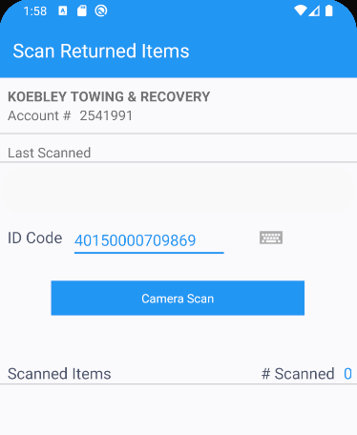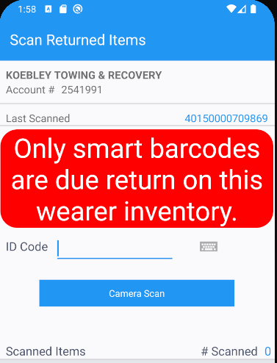
- Scan return more than 3 items which were decreased in the client
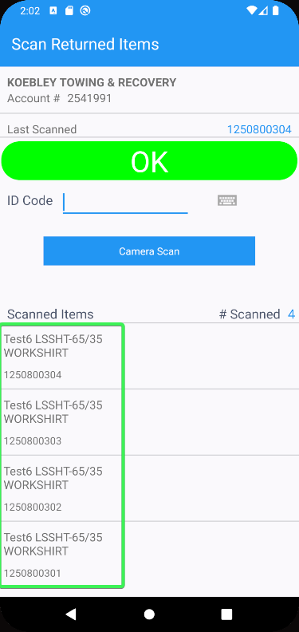
- Settle and upload the route
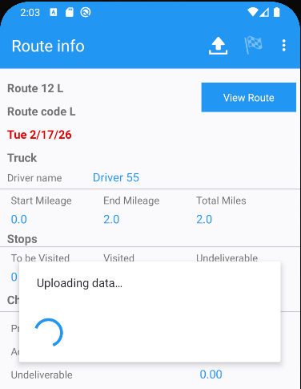
- Wearers DLG: Check that the 4 unique codes don’t have any flags on them and the 4 non-unique items noew have the scanned smart barcodes
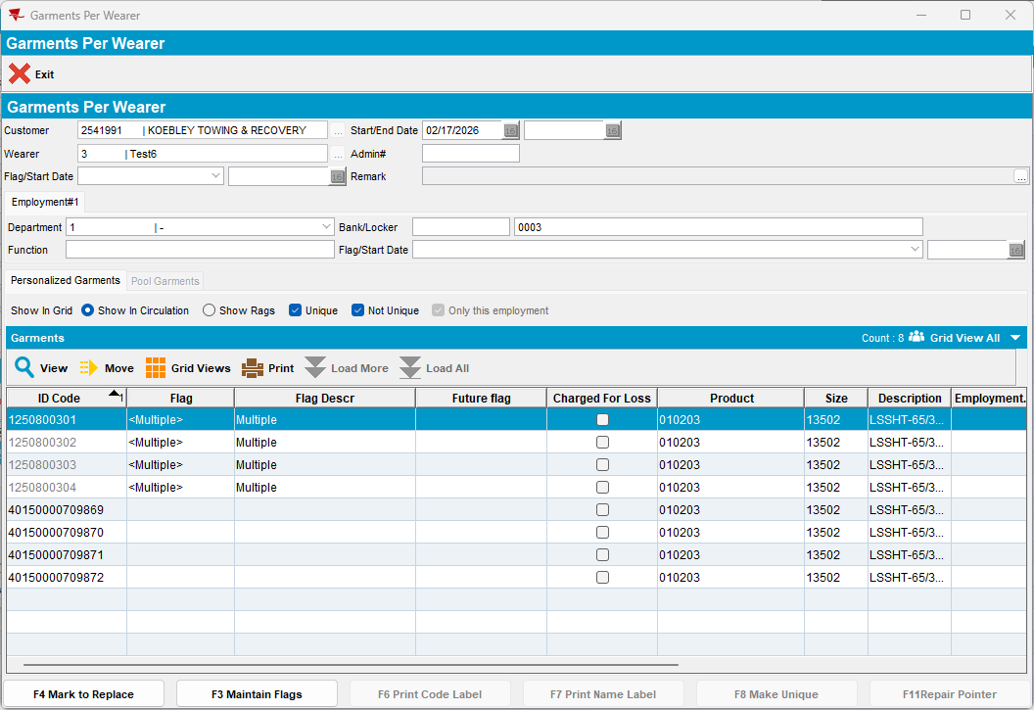
- Check that one of the smart barcode is also marked as Replace Garment + Garment Returned
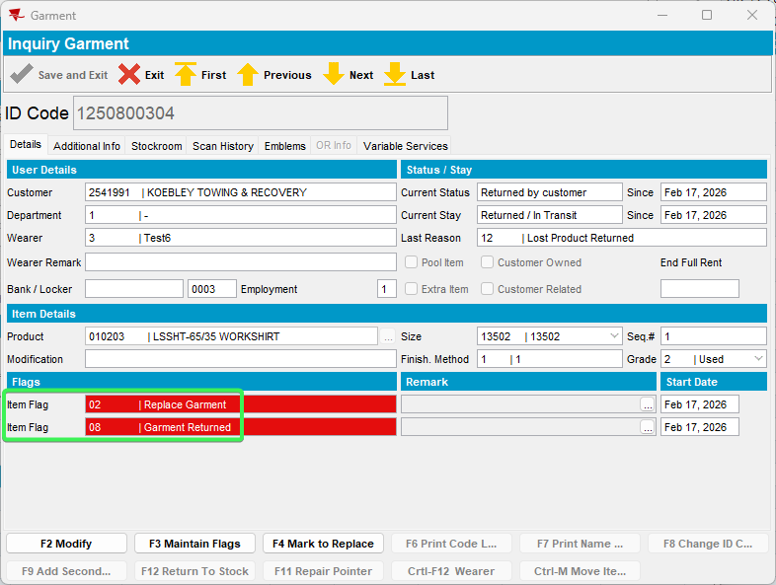
Tested OK

Test Case 4 –Quit WI with Unique and Non-Unique
Expected:
The user can scan unique and non-unique items for the quit wearer inventory
After Upload items Non-unique Items should have a smart barcode assigned to them and all items should be flagged for returned garment

Hash: 9.07.00.UNF17.p19 hash: 3930ae9c21a6 + RouteAssistant_v12.40.INTERNAL_TEST_ONLY.08706083b

- Wearers DLG: Add a wearer with all non-unique Items
- Make 4 of the items Unique
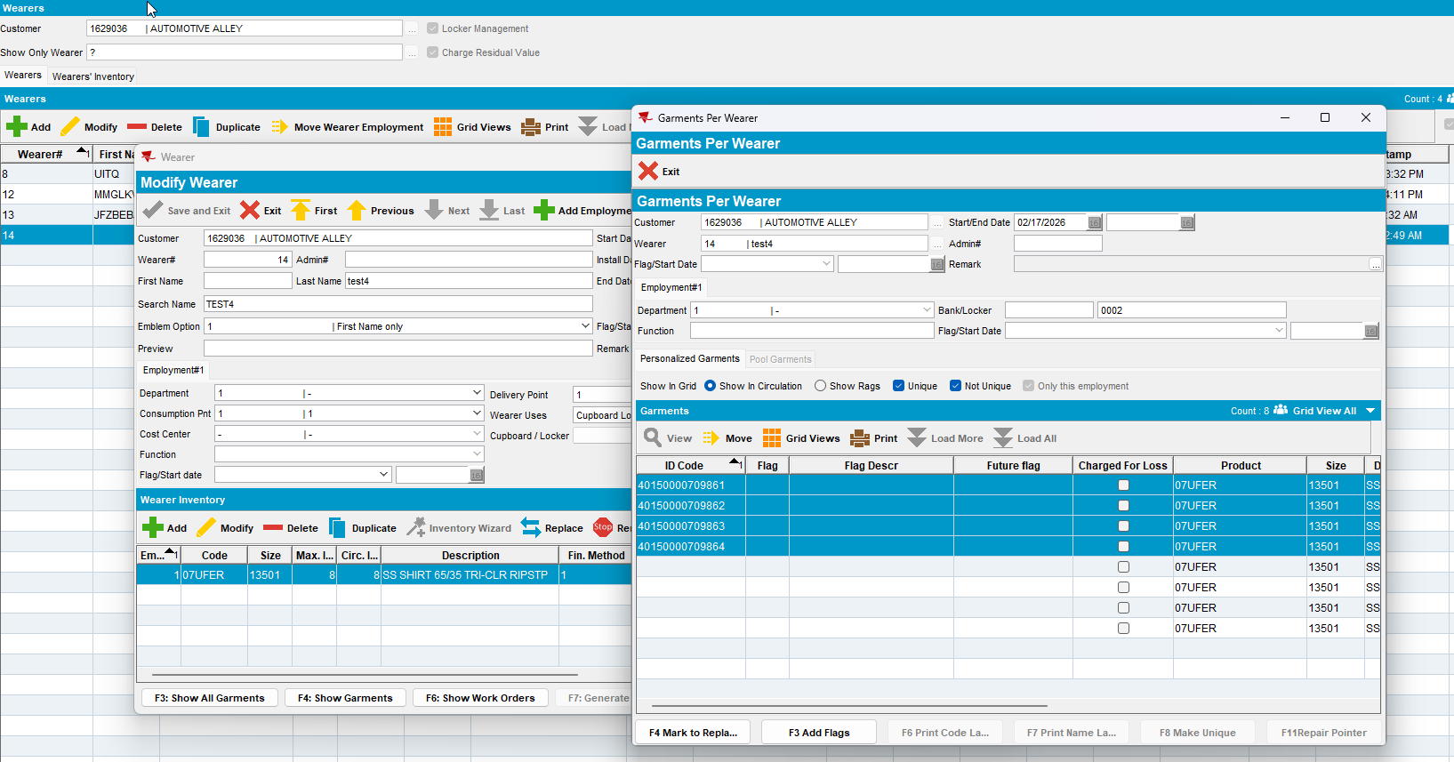
- Quit the wearer inventory
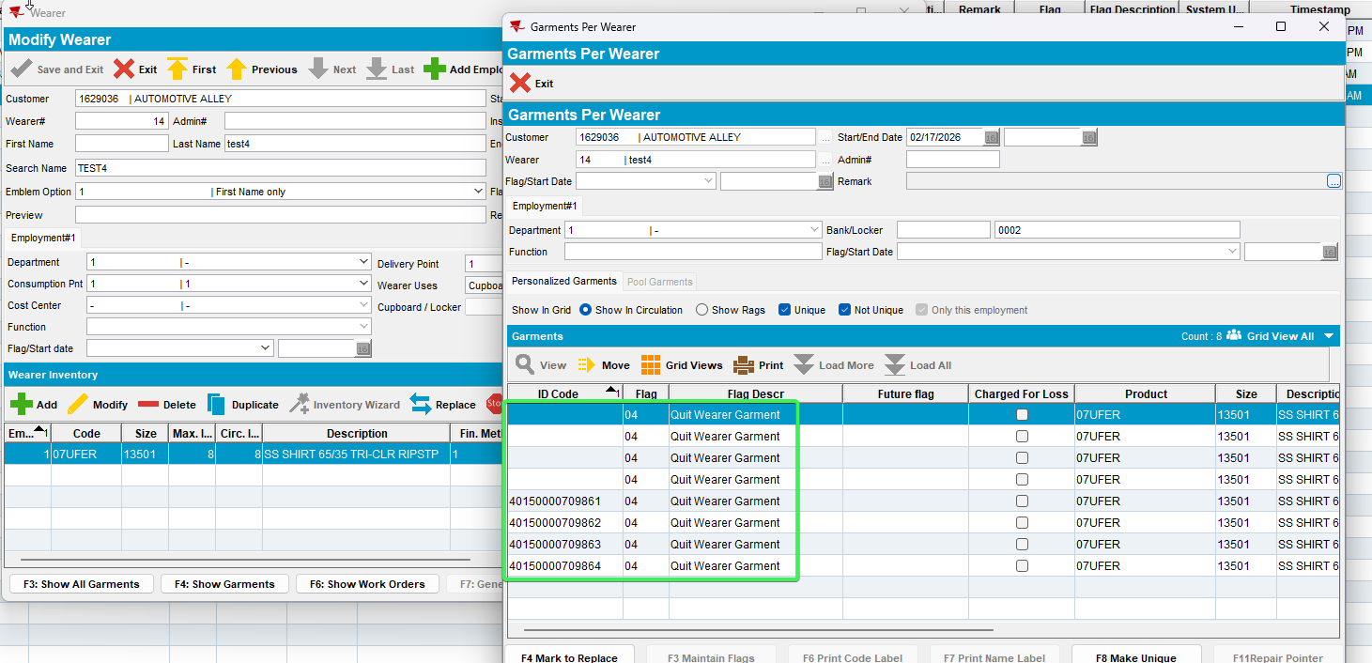
- RSC: Create a new route with the customer on it and send it to RA
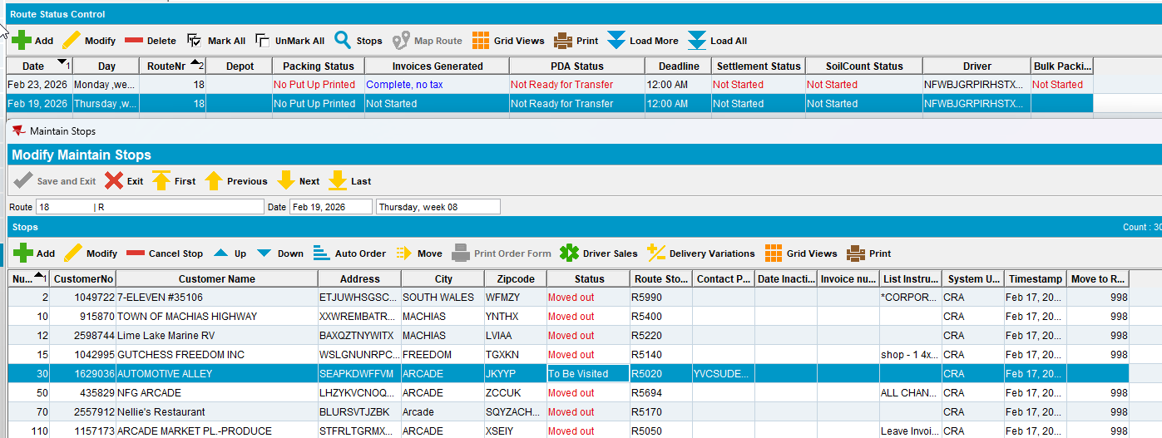
- Arrive at the customer and go to Returned Items tab > Scan Returns
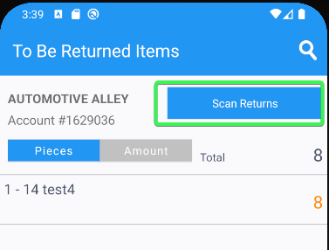
- Scan the 4 Unique items from the WI that was quit
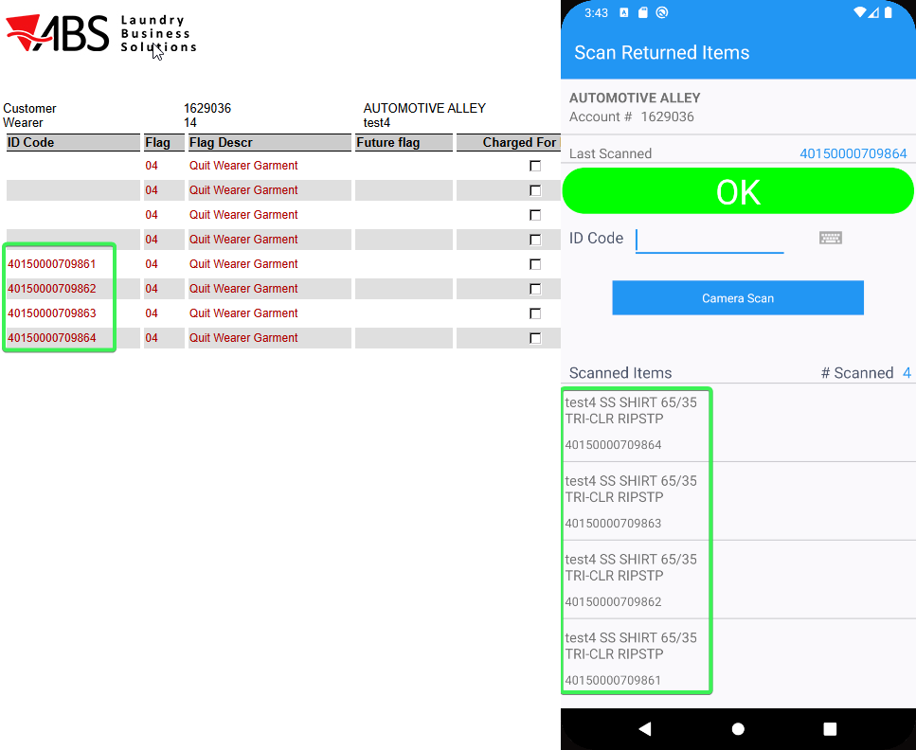
- Scan 4 Smart Barcodes for the 4 non-unique items from the same WI
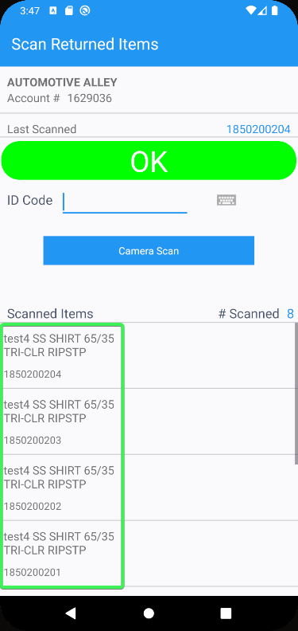
- Settle and upload the route
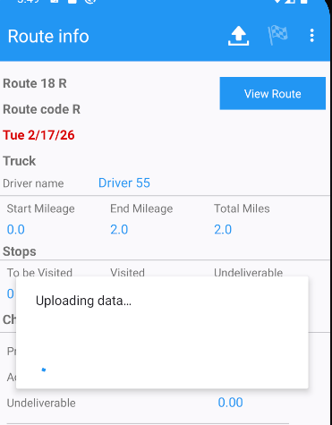
- Wearer: Check the WI and see that non-unique items now have smart barcodes assigned to them and all items are flagged as returned
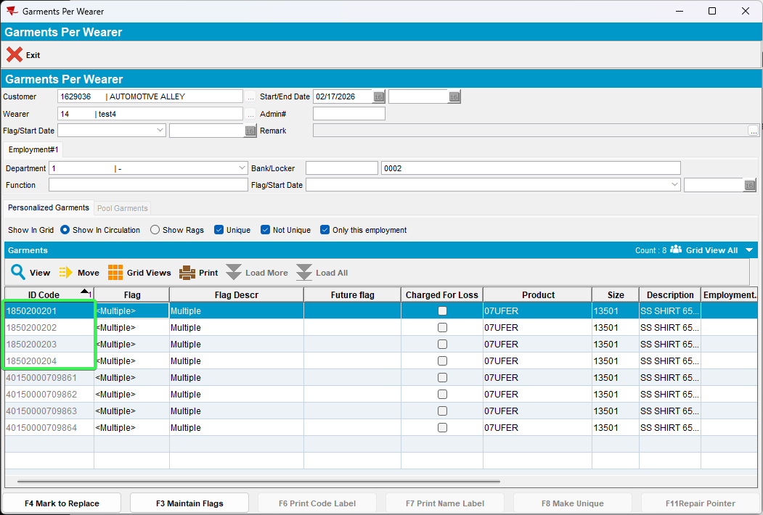
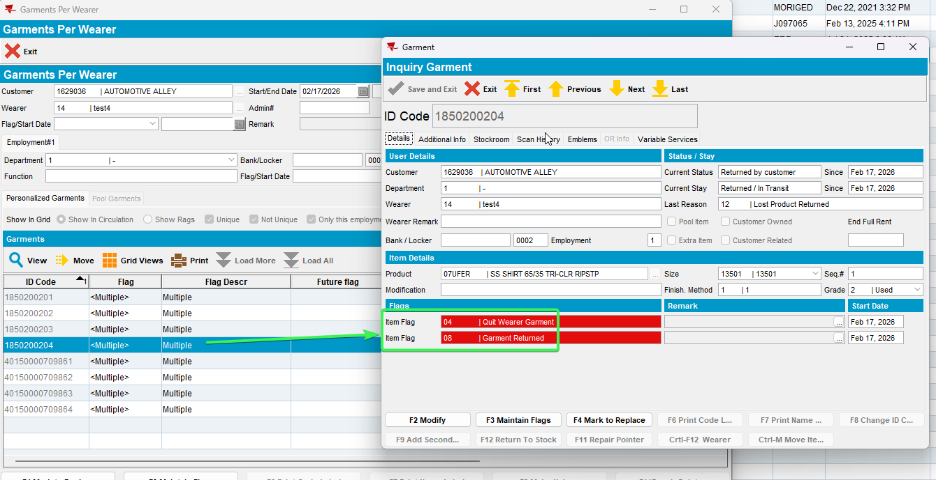
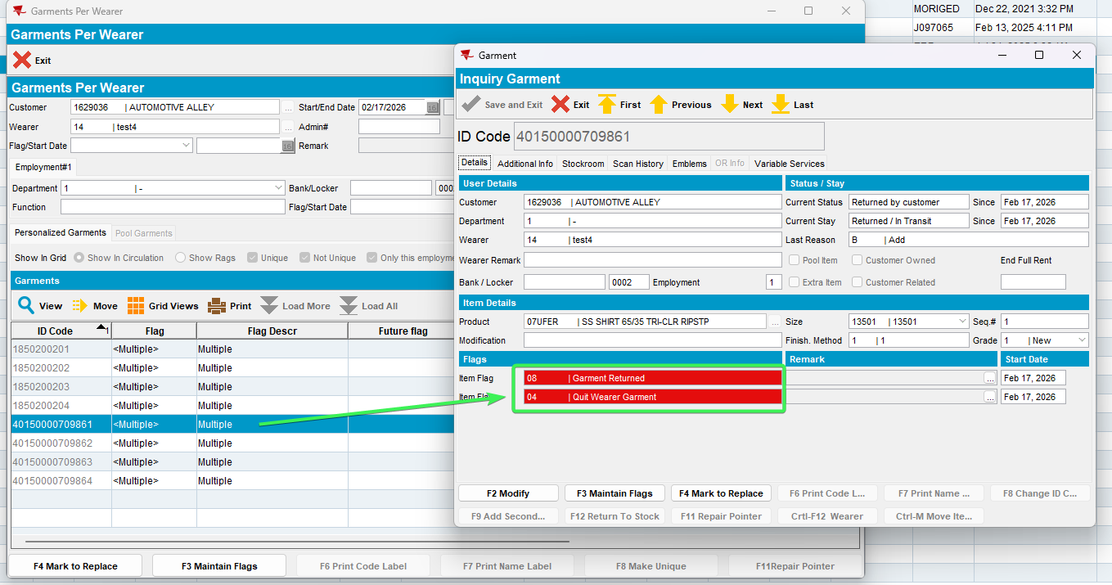
Tested OK

