RASAN-448 Multiple uploads issue
Environment | Prerequisites
DBServerName= abs-srv20.internal.abslbs.com  DBSID=CUST24  DBUser=UNFDEV  Environment=PRODUCTION | - Module:  - System setting

Contents
Reproduce before fix 1
Steps to reproduce: 1
Expected behavior: 7
Retest after fix 8
Steps to reproduce: 8

Reproduce before fix
Bu: 044 Nashua, NH
9.07.00.UNF17.p12 hash: 774a1e8fc893 + RA 12.39

Steps to reproduce:

- RSC dlg: Create a new route, keep a few customers. Generate packing notes and invoices.
- RSC dlg: Send the route to PDA.
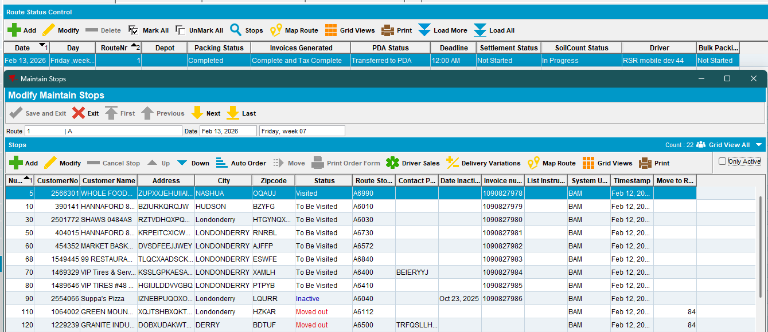
- RA: Download the route. From Android emulator, set the phone to mobile data only.
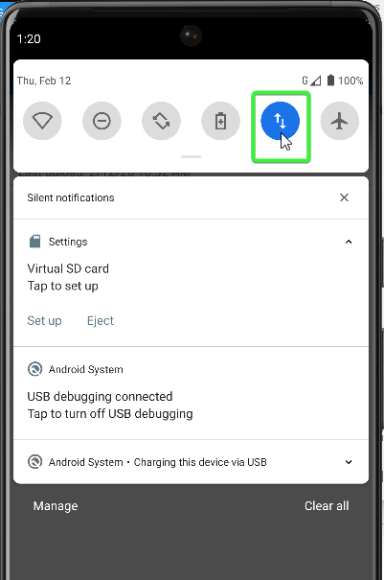
- RA: Set the cellular network type GPRS and signal strength poor to simulate a slow internet mobile connection.
Common Speed Settings (in kbps):
- GPRS: 28.8 down / 57.6 up
- EDGE/EGPRS: 473.6 down / 473.6 up
- UMTS/3G: 384.0 down / 384.0 up
- HSDPA: 5760.0 down / 13,980.0 up

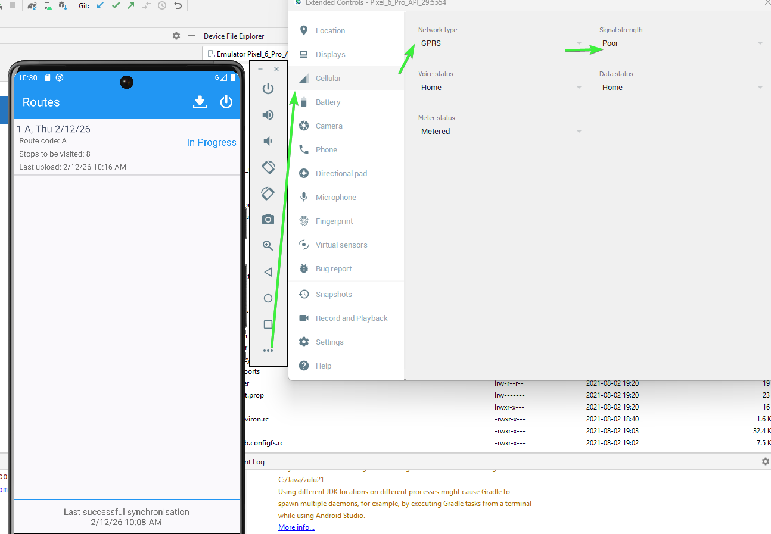

- RA: enter a customer and make some transactions, don’t depart from customer just yet. (example: I’ve added some wearers).
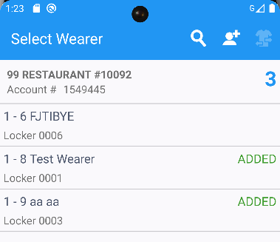
- RA: Go back to the download route screen where you have the download button.
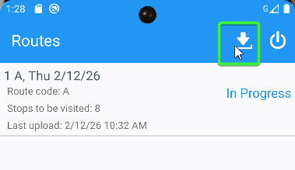
- RA: Spam the download button as many times you can get. The download also do an upload at the finish
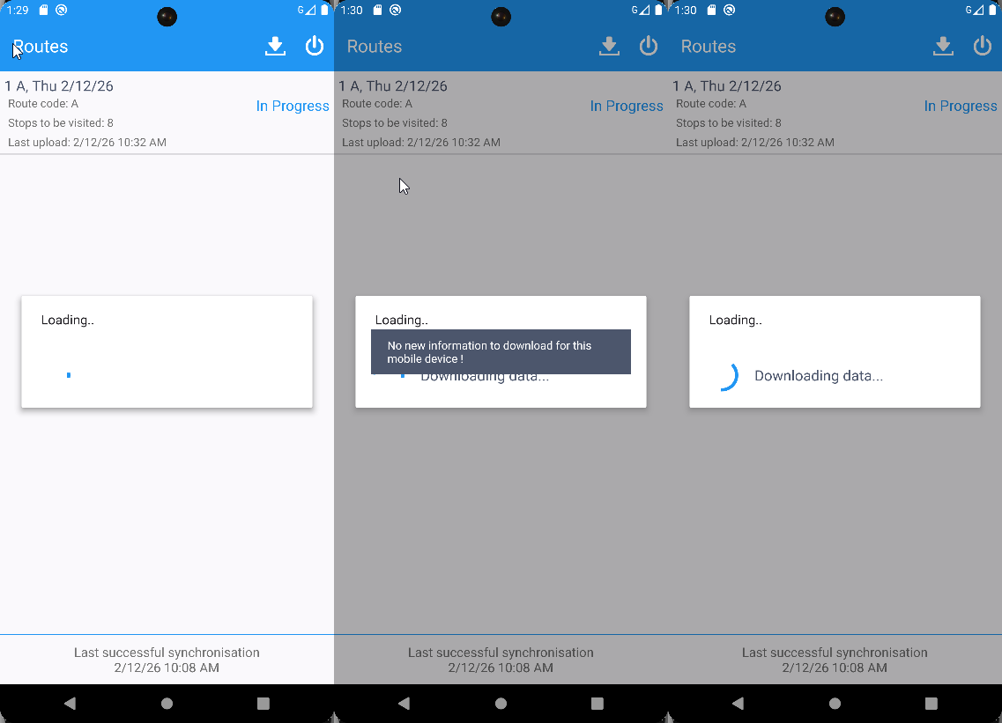

- Check in database for multiple uploads
select PJ.MOBILEDEVICE_ID,
TO_CHAR(PJ.STARTTIMESTAMP, 'mm/dd/yyyy HH24:mi'),
count(1)
from abslogprocessjob PJ
JOIN ABSLOGPROCESSJOBPART PJP
ON PJP.ABSLOGPROCESSJOB_ID = PJ.ABSLOGPROCESSJOB_ID
WHERE PJP.PROCESSNAME = 'uploadRouteData'
AND PJ.STARTTIMESTAMP > TRUNC(sysdate - 30)
group by TO_CHAR(PJ.STARTTIMESTAMP, 'mm/dd/yyyy HH24:mi'),
PJ.MOBILEDEVICE_ID
HAVING COUNT(1) > 1;

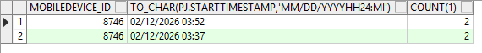

- For another customer decrease wearer inventory, scan replace garments.
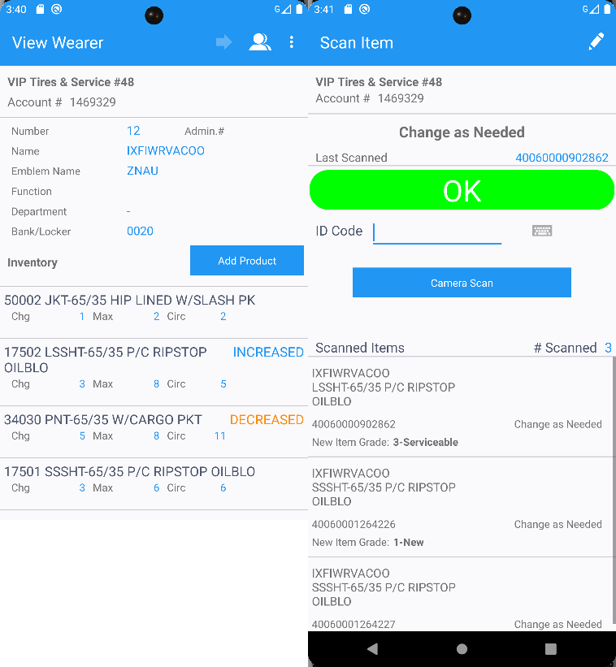
- Scan return some items
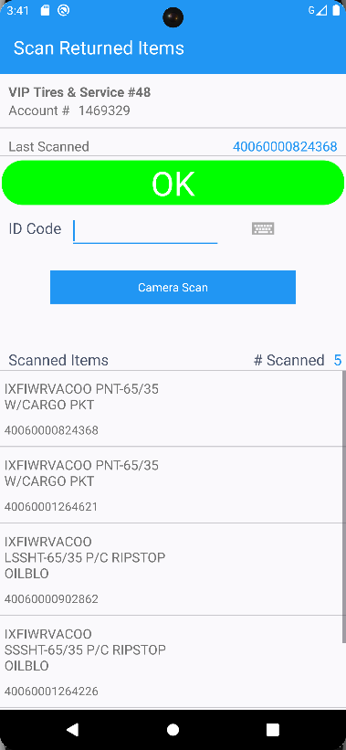
- RA: Settle, depart from this customer. Settle and depart from all customers.
- RA: Spam the download button as many times you can get. The download, also do an upload at the finish

- Check in database for multiple uploads
select PJ.MOBILEDEVICE_ID,
TO_CHAR(PJ.STARTTIMESTAMP, 'mm/dd/yyyy HH24:mi'),
count(1)
from abslogprocessjob PJ
JOIN ABSLOGPROCESSJOBPART PJP
ON PJP.ABSLOGPROCESSJOB_ID = PJ.ABSLOGPROCESSJOB_ID
WHERE PJP.PROCESSNAME = 'uploadRouteData'
AND PJ.STARTTIMESTAMP > TRUNC(sysdate - 30)
group by TO_CHAR(PJ.STARTTIMESTAMP, 'mm/dd/yyyy HH24:mi'),
PJ.MOBILEDEVICE_ID
HAVING COUNT(1) > 1;
There are multiple uploads present
- Route Check In dlg: Check what was uploaded from the route.
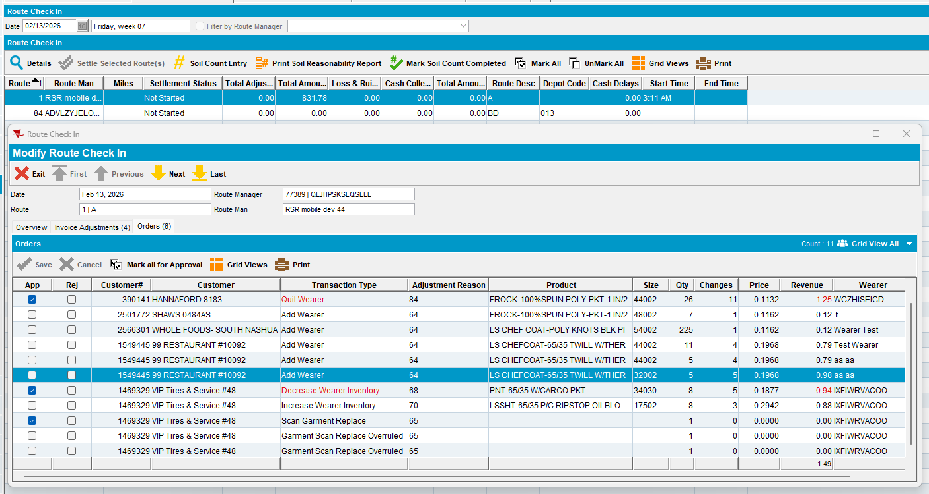

- RA: Arrive at the other customers settle the invoices, make some transactions like adjustments, soil count and depart. Depart from all customers.

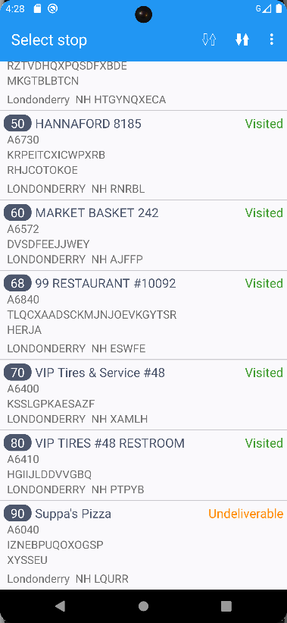
- RA: Finish the route.
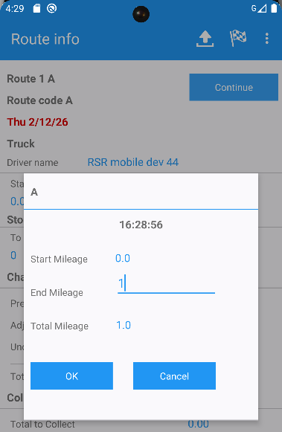

- RA: Click on the download button multiple times.
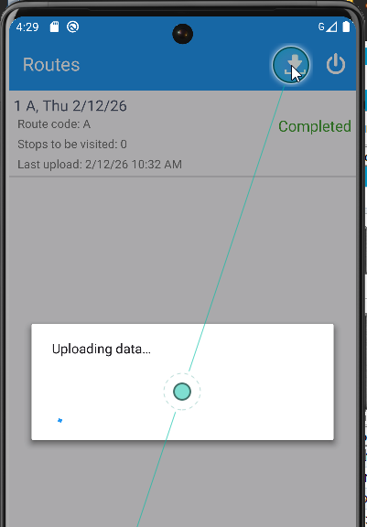
- Check in database for multiple uploads
-- How many duplicate uploads from RA
select PJ.MOBILEDEVICE_ID,
TO_CHAR(PJ.STARTTIMESTAMP, 'mm/dd/yyyy HH24:mi'),
count(1)
from abslogprocessjob PJ
JOIN ABSLOGPROCESSJOBPART PJP
ON PJP.ABSLOGPROCESSJOB_ID = PJ.ABSLOGPROCESSJOB_ID
WHERE PJP.PROCESSNAME = 'uploadRouteData'
AND PJ.STARTTIMESTAMP > TRUNC(sysdate - 30)
group by TO_CHAR(PJ.STARTTIMESTAMP, 'mm/dd/yyyy HH24:mi'),
PJ.MOBILEDEVICE_ID
HAVING COUNT(1) > 1;
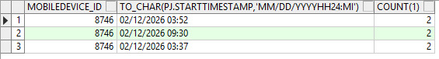

Expected behavior:
There shouldn’t be duplicate mobile uploads

Reproduced OK

Retest after fix
Bu: 044 Nashua, NH
9.07.00.UNF17.p20 hash: 58c5bf0d7ea0 + RouteAssistant_v12.40.INTERNAL_TEST_ONLY.f0b01c385

Steps to reproduce:

- RSC dlg: Create a new route, keep a few customers. Generate packing notes and invoices.
- RSC dlg: Send the route to PDA.
- Add another RSR with a different mobile device from reproduction step.
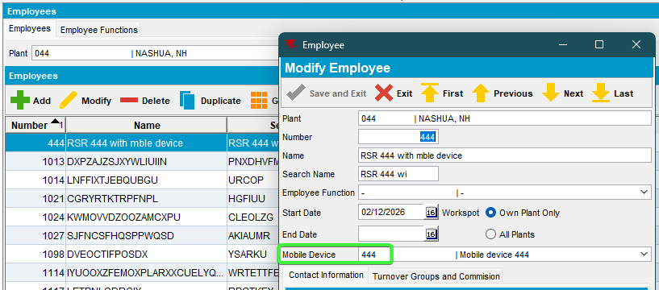
- RA: Download the route. From Android emulator, set the phone to mobile data only.
- RA: Set the cellular network type GPRS and signal strength poor, to simulate a slow internet mobile connection.
Common Speed Settings (in kbps):
- GPRS: 28.8 down / 57.6 up
- EDGE/EGPRS: 473.6 down / 473.6 up
- UMTS/3G: 384.0 down / 384.0 up
- HSDPA: 5760.0 down / 13,980.0 up

- RA: Enter a customer and make some transactions, don’t depart from customer just yet. (example: I’ve added some wearers).
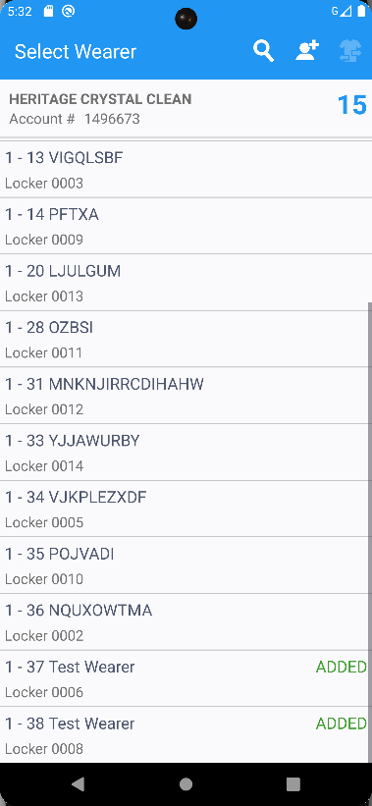
- RA: Go back to the download route screen where you have the download button.
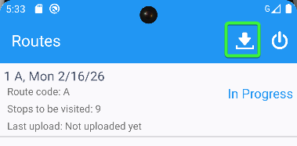
- RA: Click on the download button. The download also is doing an upload before downloading if there is something to upload.
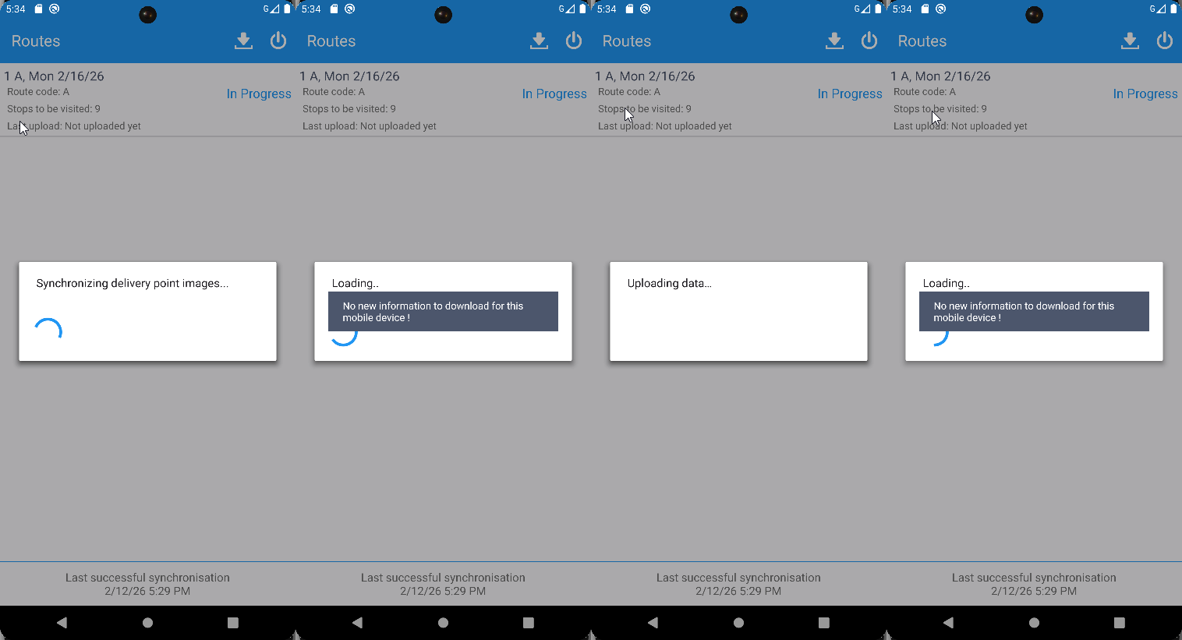
You get a message that no new information to download

- For another customer decrease wearer inventory, scan replace garments.
- RA: Arrive at the other customers settle the invoices, make some transactions like adjustments, soil count and depart. Depart from all customers.
- Ra: Upload the route.
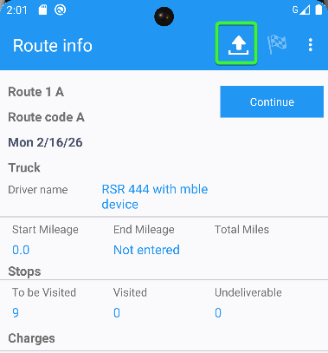
- RA: Click on the button, a warning is displayed and the upload button cannot be pressed / doesn’t accept any input.
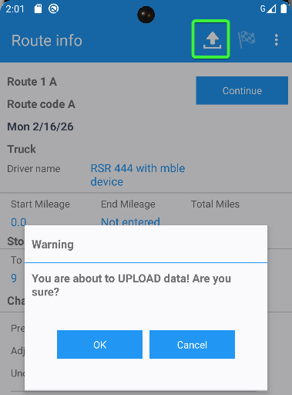

- RA: The upload process is displayed. upload button still cannot be pressed / doesn’t accept any input.
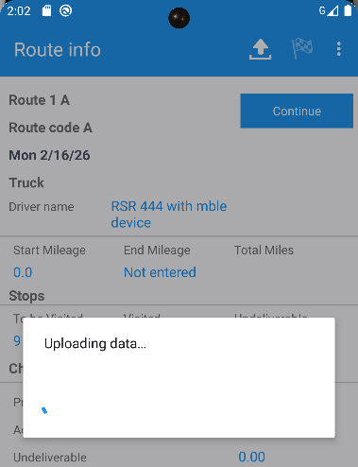
- RA: After the upload was finished, the upload button is not disabled as there aren’t anything left to upload.
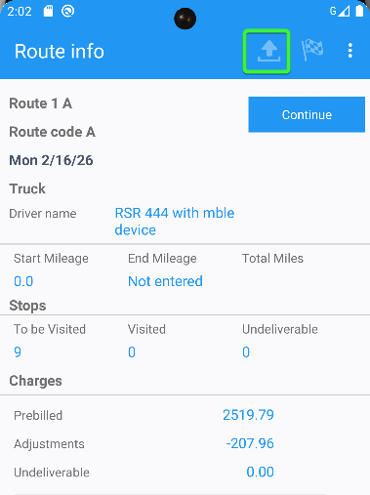

- RA: Settle, depart from this customer. Settle and depart from all customers.
- Route Check In dlg: Check what was uploaded from the route.

- RA: Arrive at the other customers settle the invoices, make some transactions like adjustments, soil count and depart. Depart from all customers.

- RA: Finish the route.
- RA: Upload the route.
- Route Check-In dlg: check the transactions.
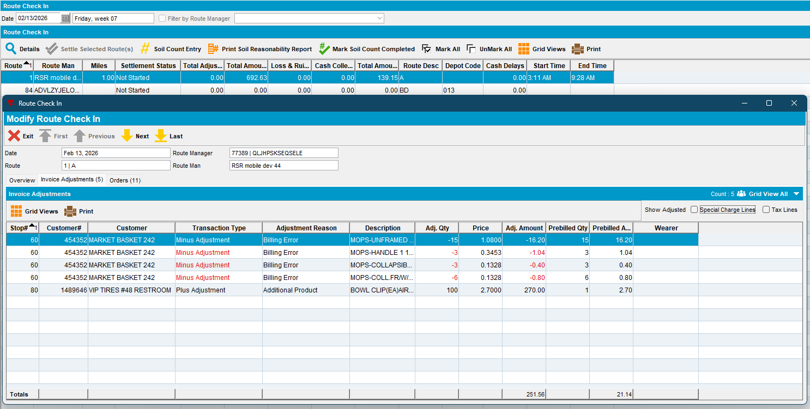
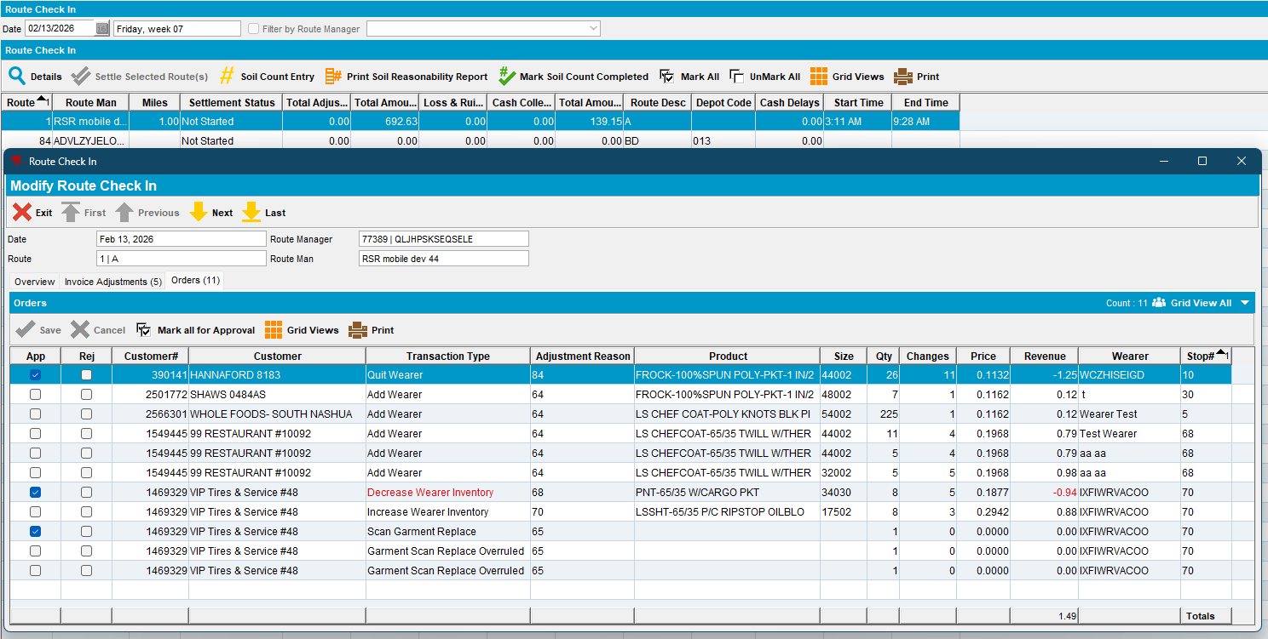
No duplicate adjustments or orders

Tested OK
The upload button cannot be pressed multiple times. The upload button is re-enabled after other RA transactions are made (settle, depart, increase wearer inventory …)

