ABSN-12794 Hot delivery definition for assign not linked needs to check future packing note on different routes
Environment | Prerequisites
DBServerName= abs-srv20.internal.abslbs.com  DBSID=CUST24  DBUser=UNFA  Environment=PRODUCTION | - Module:  - System setting

Contents
Reproduce before fix 1
Steps to reproduce: 2
Retest after fix 6
Expected behavior: 6
Test Case 1 – Route finalization correctly attaches delivery notes, delivery notes for garments (workorders) / non garments, delivery notes/ bulk put up and delivery notes for sales notes – Tested OK 6
Delivery notes with garments and non-garments 6
Steps to reproduce: 6
Bulk put up/delivery variations creation 11
Steps to reproduce: 11
Dv’s for workorders of new wearer inventories on different delivery dates than route day 16
Steps to reproduce: 16
Delivery notes for Sales Notes 23
Steps to reproduce: 23
Test Case 2 – Moved invoice from Maintain Invoices (incidental stop) to a different route but same driving date – Tested OK 31
Steps to reproduce: 31
Test Case 3 – Moved invoice from Maintain Invoices (incidental stop) to a different route and different route day – Tested OK 35
Steps to reproduce: 35
Test Case 4 - Moved stop along with invoice from RSC to a different route but same delivery day – Tested OK 44
Steps to reproduce: 45
Test Case 5 – Moved customer on a day of week where is already visited but on a different route number – Tested OK 51
Steps to reproduce: 51

Reproduce before fix
Bu: 841 HARLINGEN, TX
hash: 9.07.00.UNF17.p19 hash: 864d9c5faad9

Steps to reproduce:
- Create a new route, choose a customer for which we will create 2 different delivery variations.
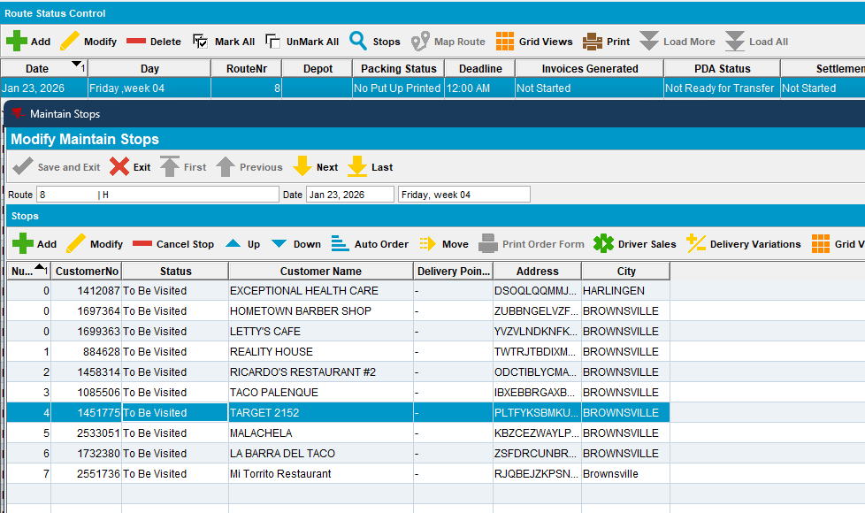
- RSC dlg: Generate packing notes and invoices. Script the taxes and run process Import Vertex BCI.
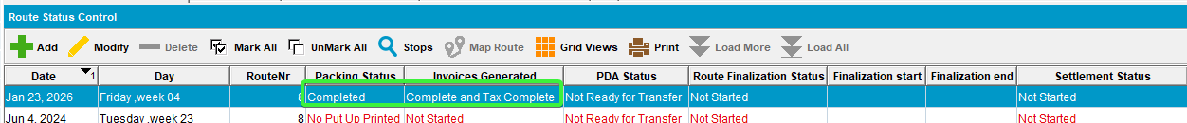
- RSC dlg: Check the assign not linked. Nothing unassigned for standard packing
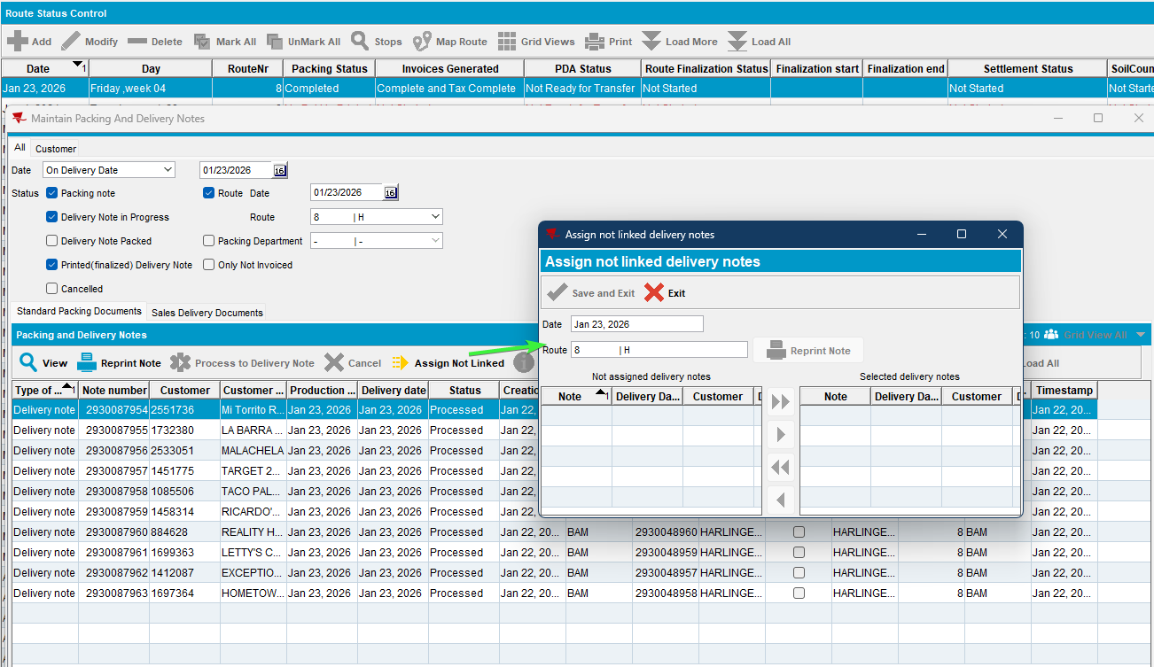

Same for sales delivery documents.
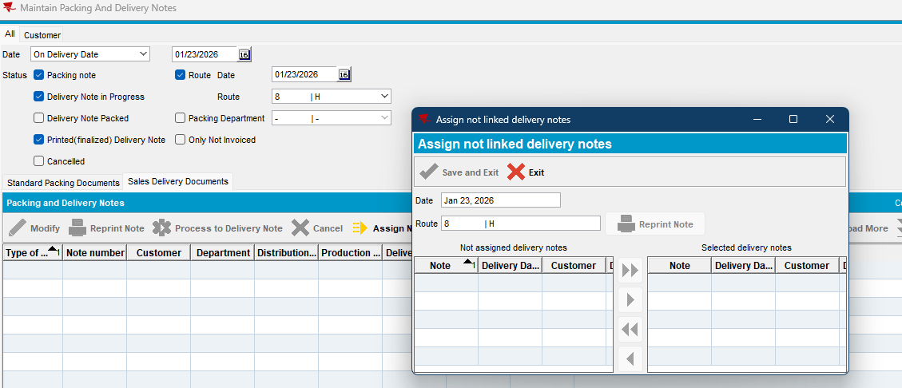
- Delivery notes dlg: Create a delivery variation on the date 22nd ( 1 day in the past from route day)
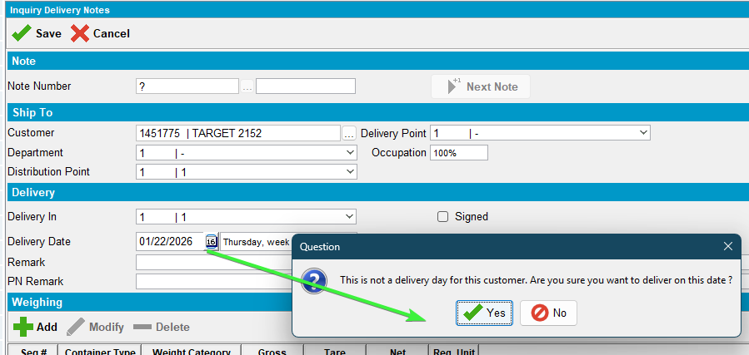
Add any product
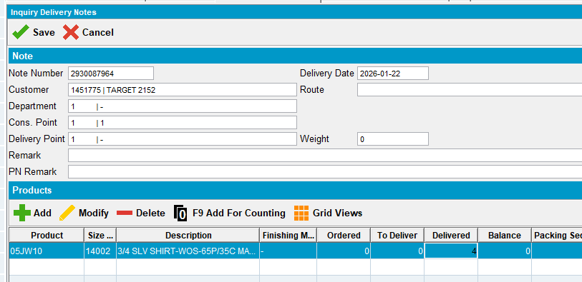
- Delivery notes dlg: Create a delivery variation on the date 24th ( 1 day in the future from route day)
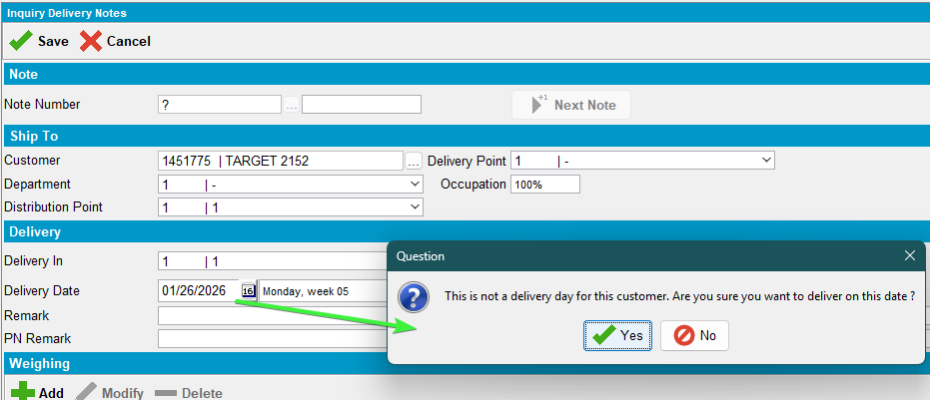
Add any product
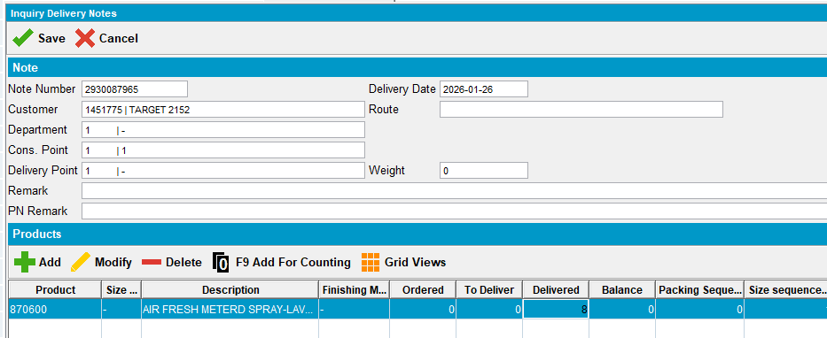

- RSC dlg: Re-check the route for unassigned deliveries.
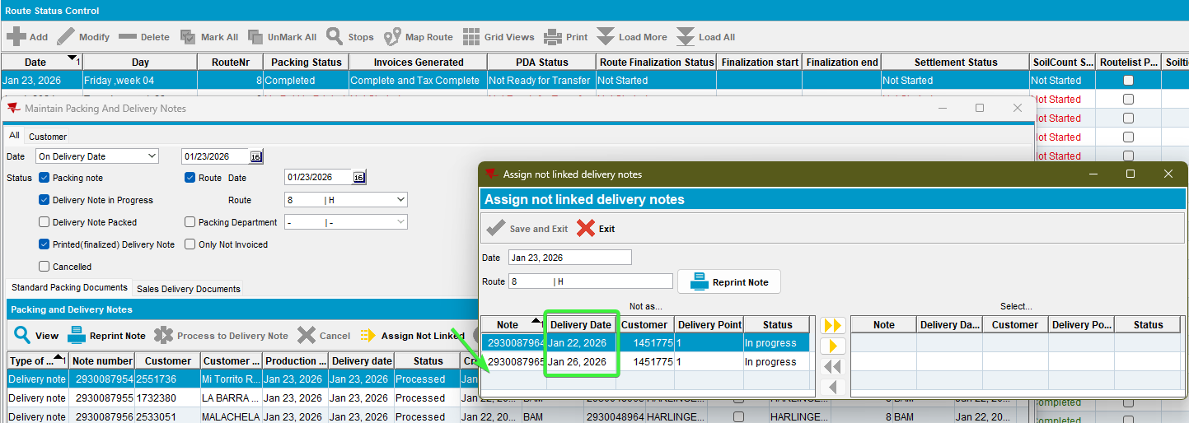
The 2 deliveries notes appear, one with delivery date 22nd and the other with delivery date 26th
- Process Scheduler dlg: Run process “Cancel and regenerate US direct invoices for late delivery notes”
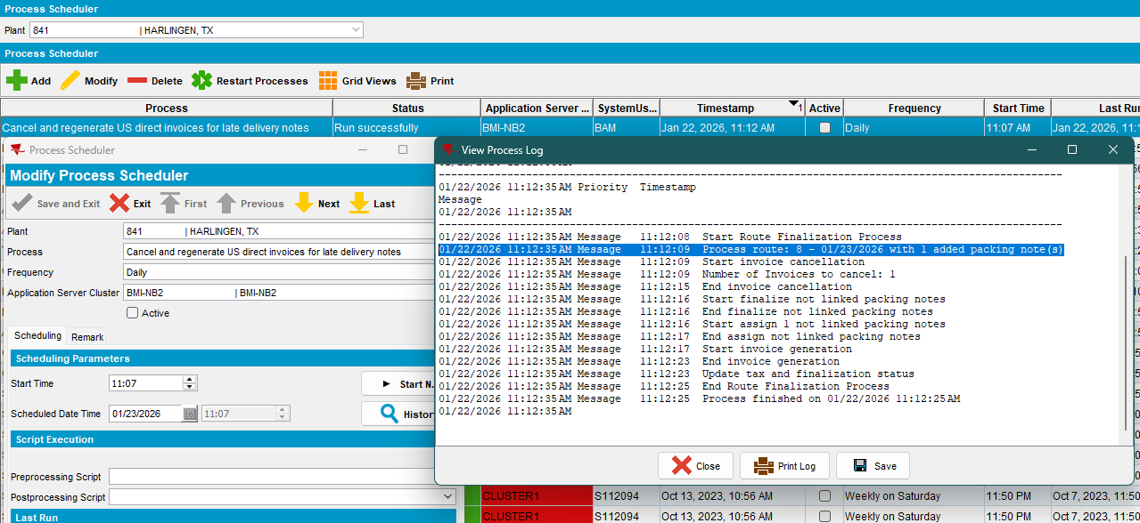

- RSC dlg: Check the delivery dates for the newly assigned notes.
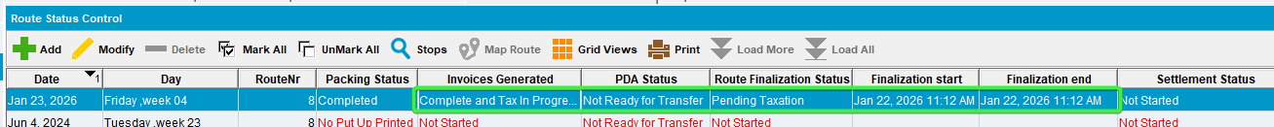
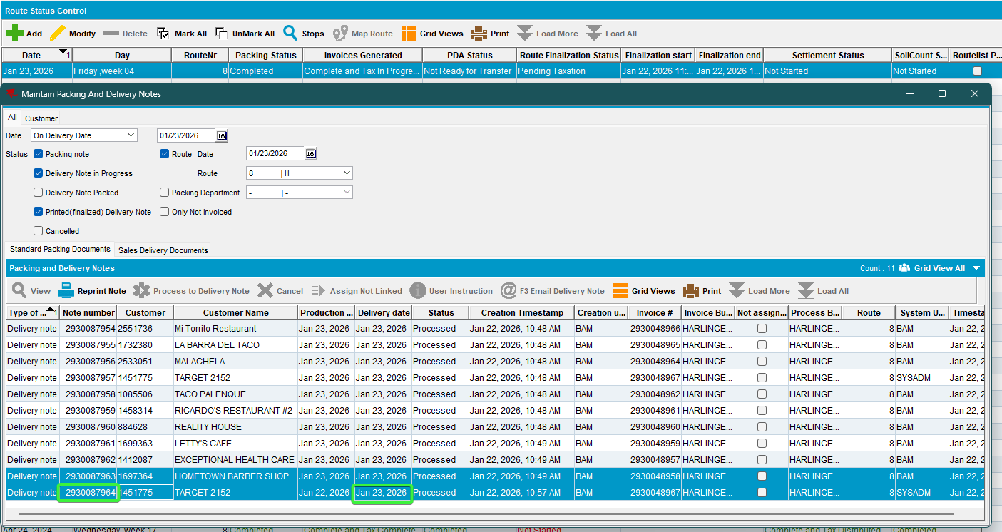
The other delivery note 2930087965 was not attached
- Maintain Packing and delivery notes dlg: Load the customer for which the deliveries were done
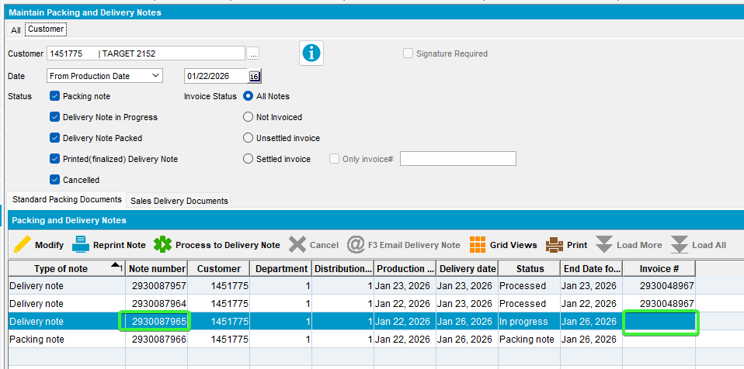
The delivery note 2930087965 doesn’t have invoice linked to, it remained unlinked

Reproduced OK

Retest after fix

Expected behavior:

Delivery notes for garments / non garments / bulk putup or sales notes that are dated after the route control driving date (PN.DeliveryDate > RC.OriginalDrivingDate) and no more than 6 days ahead (< RC.OriginalDrivingDate + 7) that are for customers with active stops (so moved in or to be visited) on this route control where the day and date of the future delivery note is NOT an active delivery day and date for the customer (RouteStop), will be attached and invoiced on the new route.
NOTE: During the assignment process, if any delivery notes being assigned have a date ahead of the route, then the delivery date of these delivery notes should be adjusted to the route date

9.07.00.UNF17.p20 hash: 58c5bf0d7ea0

Test Case 1 – Route finalization correctly attaches delivery notes, delivery notes for garments (workorders) / non garments, delivery notes/ bulk put up and delivery notes for sales notes – Tested OK

Delivery notes with garments and non-garments

Steps to reproduce:
- Create a new route, choose a customer for which we will be doing the actions. Move out the other customers.
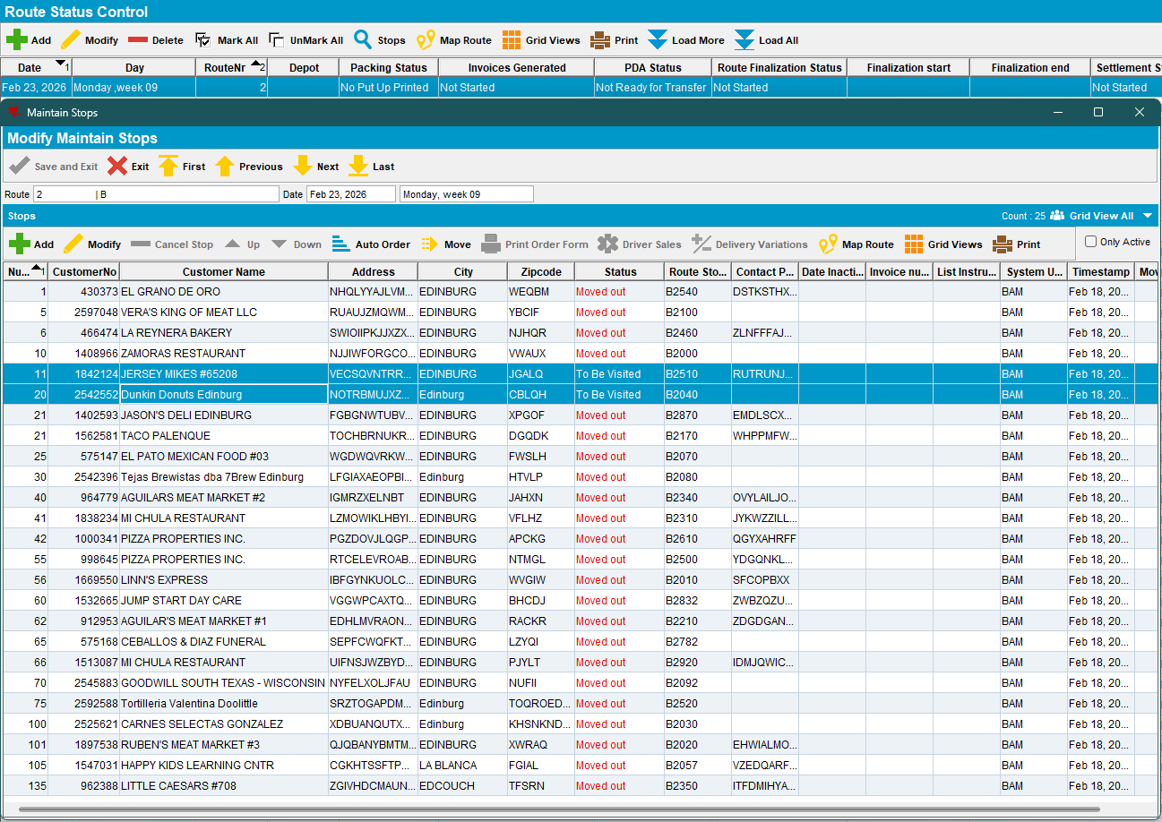
- RSC dlg: Generate packing notes and invoices. Script the taxes and run process Import Vertex BCI.
- RSC dlg: Check the assign not linked. Nothing unassigned for standard packing
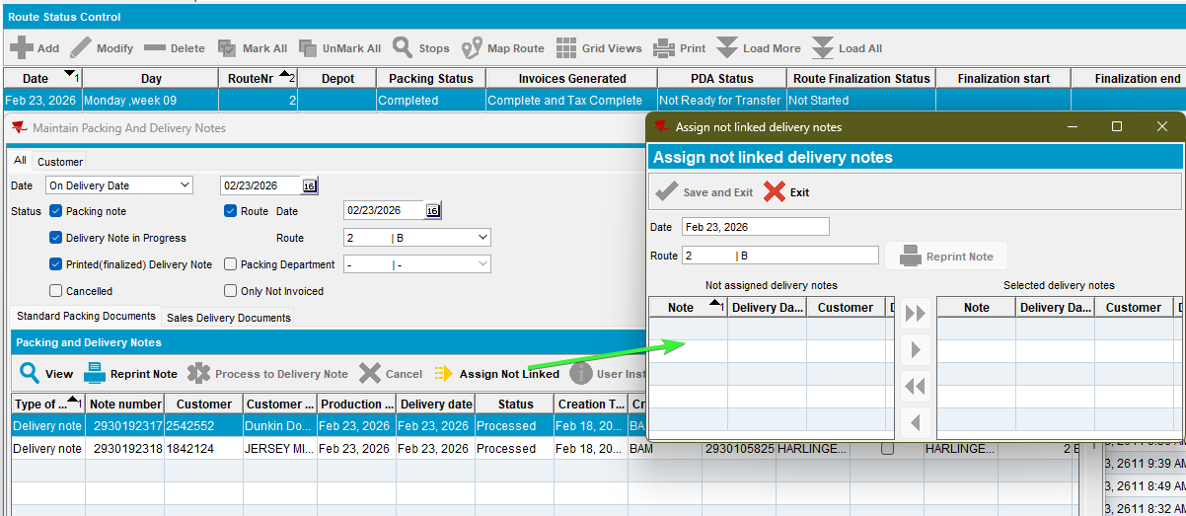

Same for sales delivery documents.
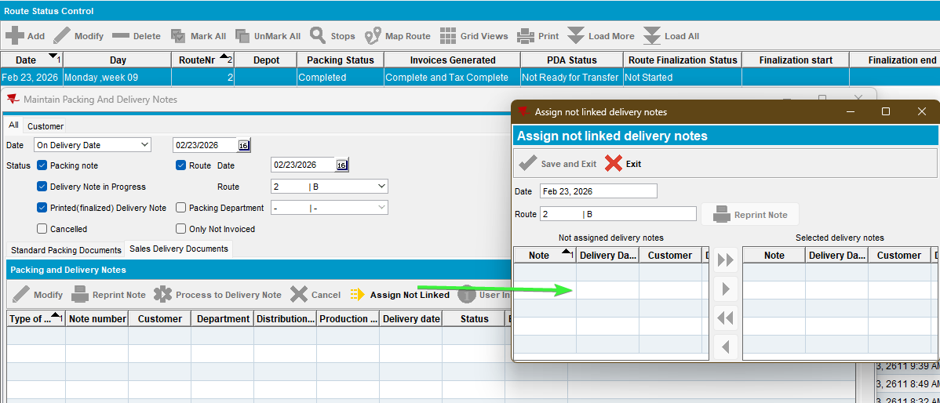

- Delivery notes dlg: Create a delivery variation on the date 20th ( Friday, the route day is on Monday)
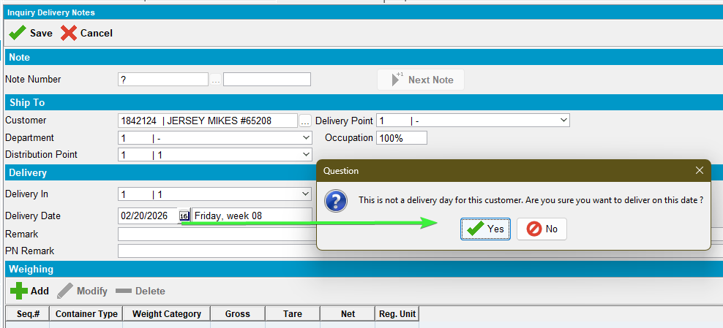
Add any garment
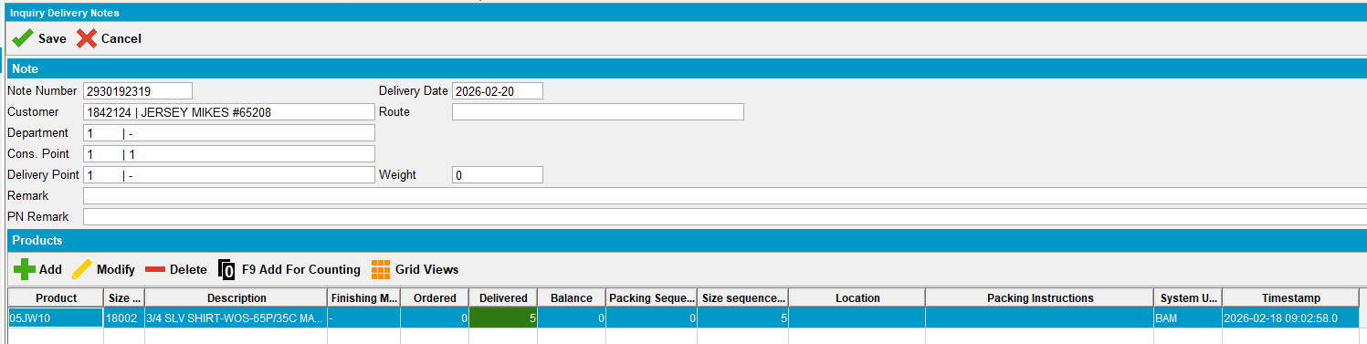
Add another delivery note including a non-garment
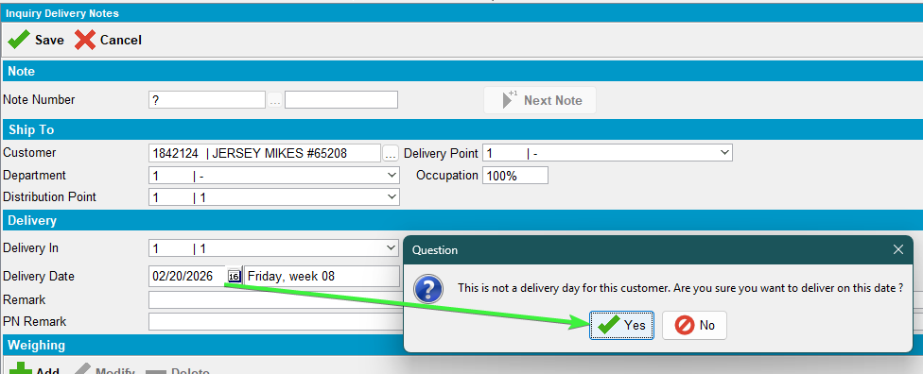
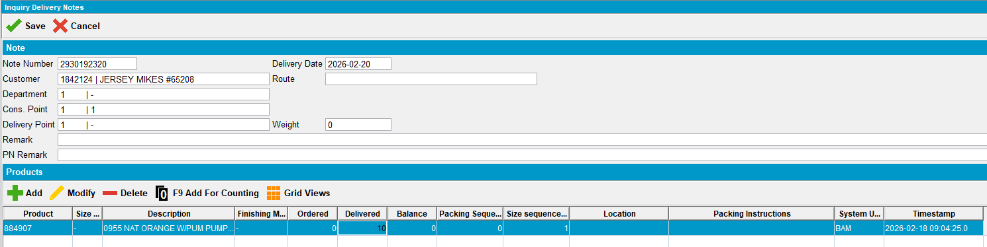

- Delivery variations dlg: Create a delivery variation on the date 27th ( 5 day in the future from route day)
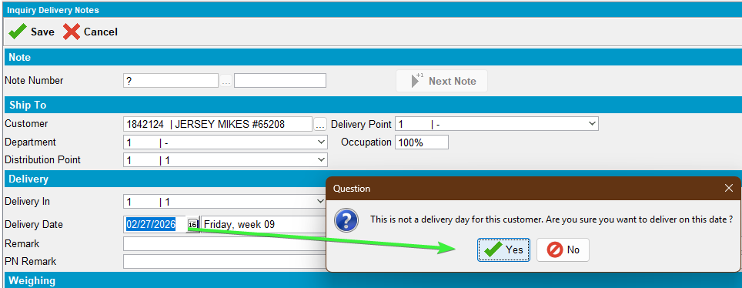
Add any product
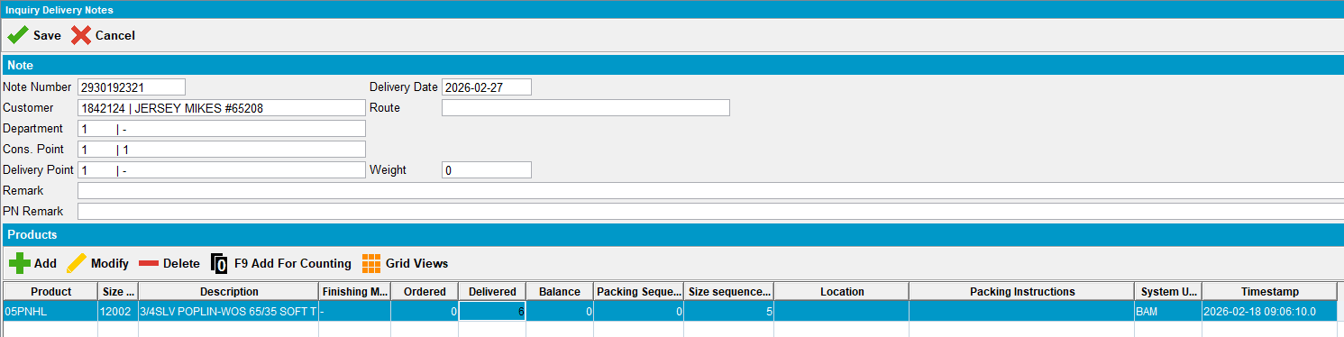
Add another on 7days+ in the future from route (2nd March, route is from 23rd February)
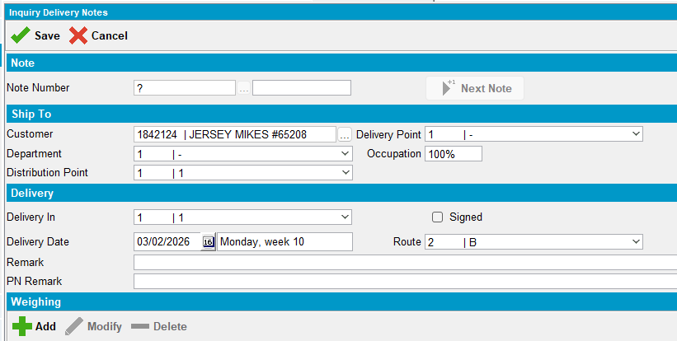
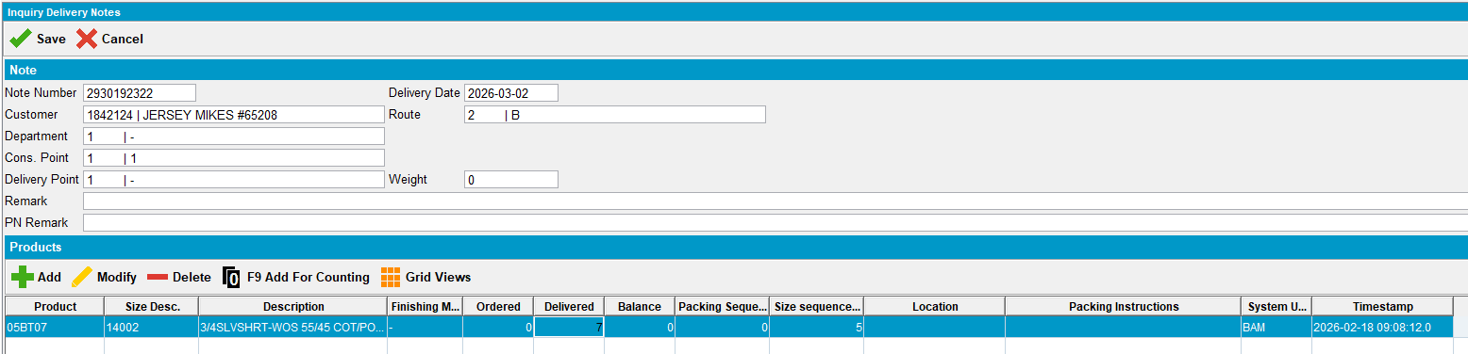

- RSC dlg: Re-check the route for unassigned deliveries.
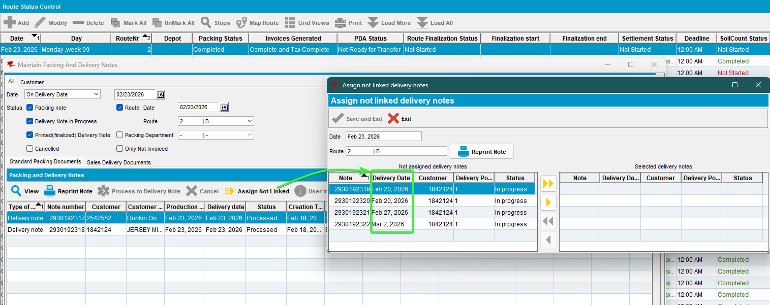
The 4 deliveries notes appear, two with delivery date 20th , one with 27th and the last one with delivery date 2nd
- Process Scheduler dlg: Run process “Cancel and regenerate US direct invoices for late delivery notes”
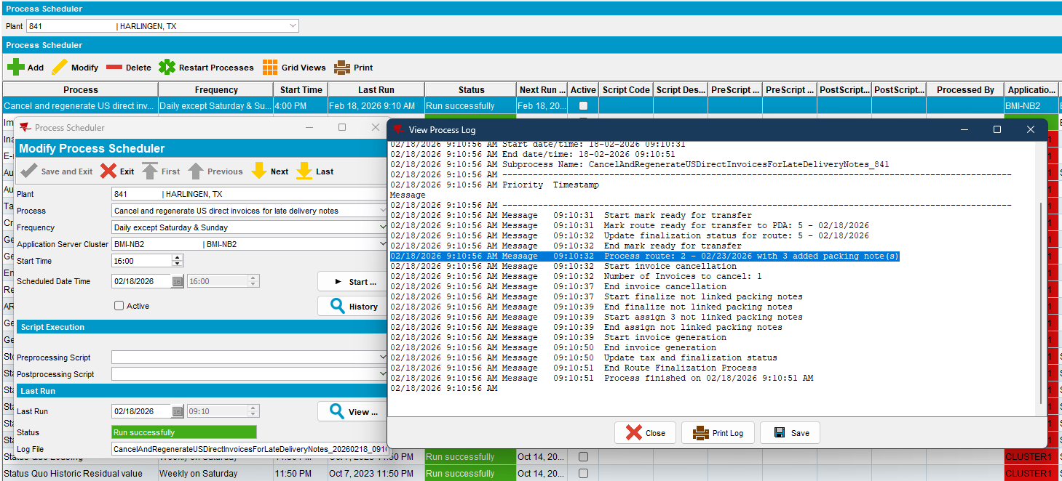

- RSC dlg: Check the delivery dates for the newly assigned notes.

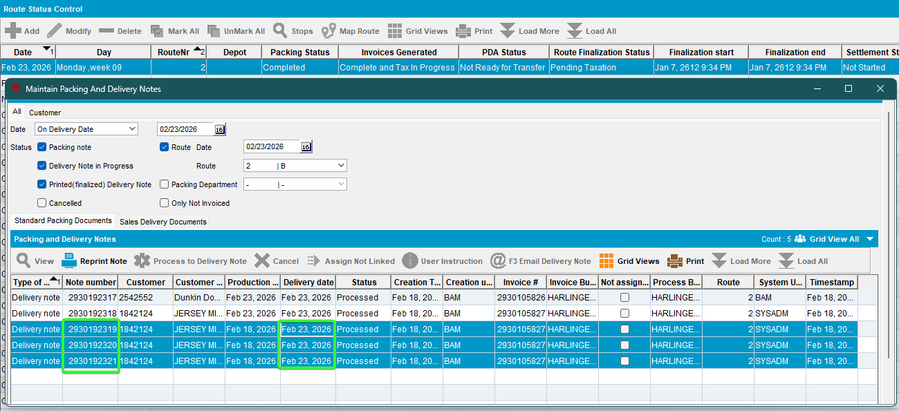
All the delivery notes were assigned to the route except the one that was 6 days more in the future, the one from 2nd March
- Maintain Packing and delivery notes dlg: Load the customer for which the deliveries were done
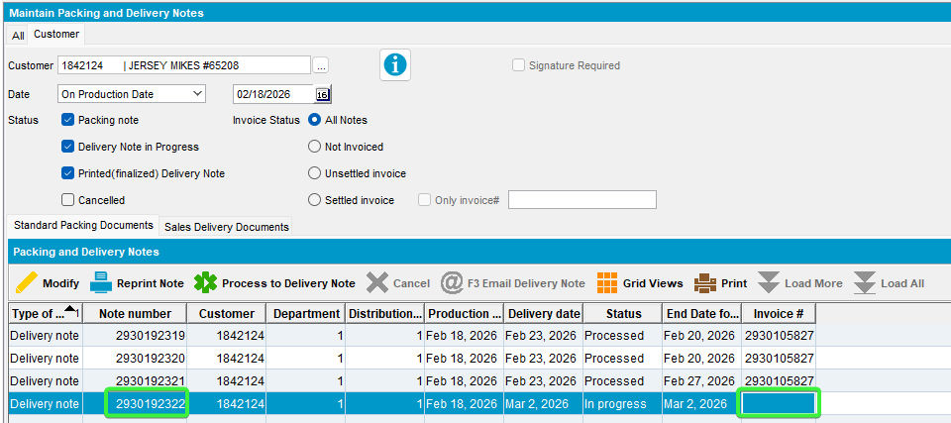
The delivery note 2930192322 doesn’t have invoice linked to, it remained unlinked because the delivery data was 6 days+ in the future. It will be picked up by the process in the future

Bulk put up/delivery variations creation

Steps to reproduce:
- RSC dlg: For another route, another customer, generate packing notes and invoices, script the taxes and complete the taxes on invoice.
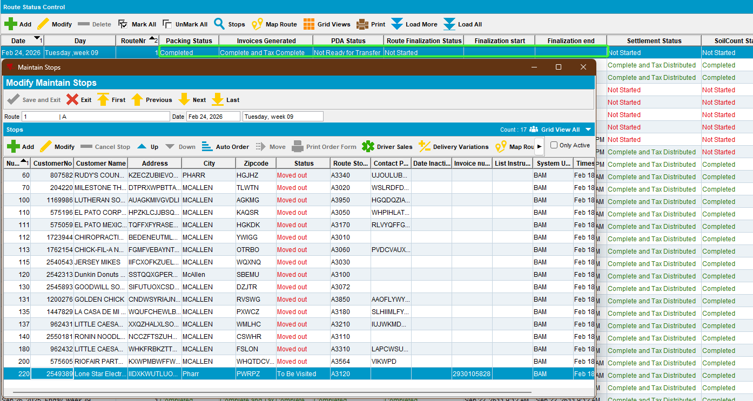
- RSC dlg: Check the delivery variations.
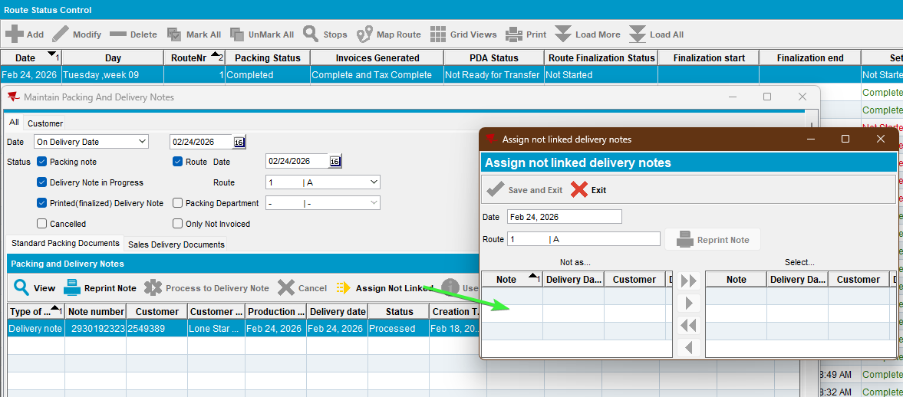
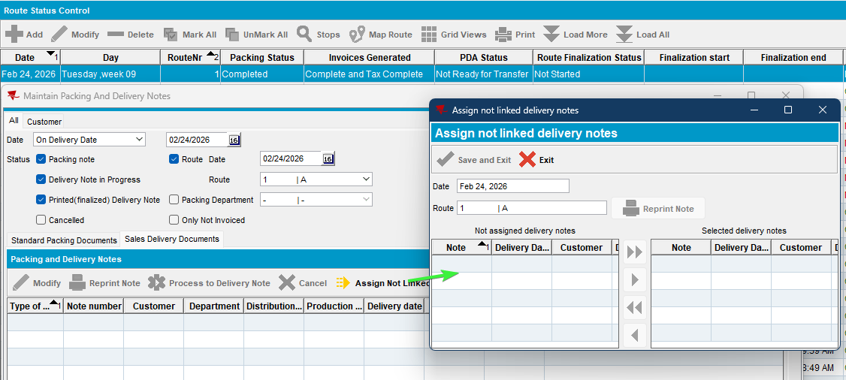

- Delivery variations dlg: Add a new delivery variation with a delivery date in the future, but one day older than delivery date and save it.
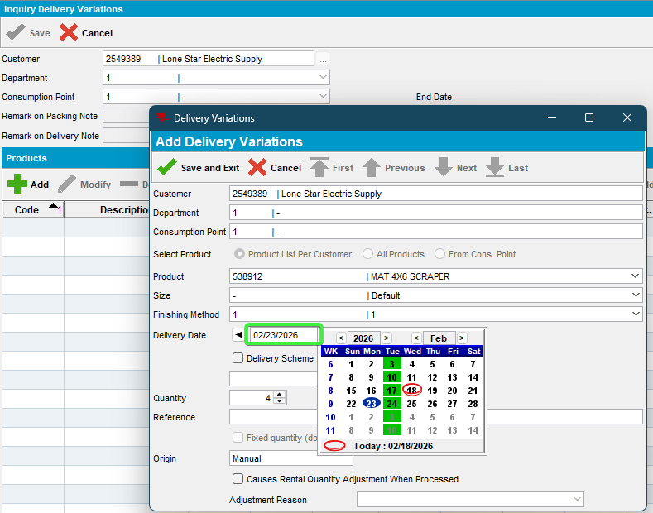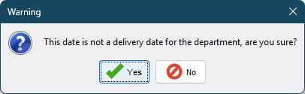
- Delivery variations dlg: Generate packing notes and change the date again the date to the one above (the date is automatically set on the customer delivery date).
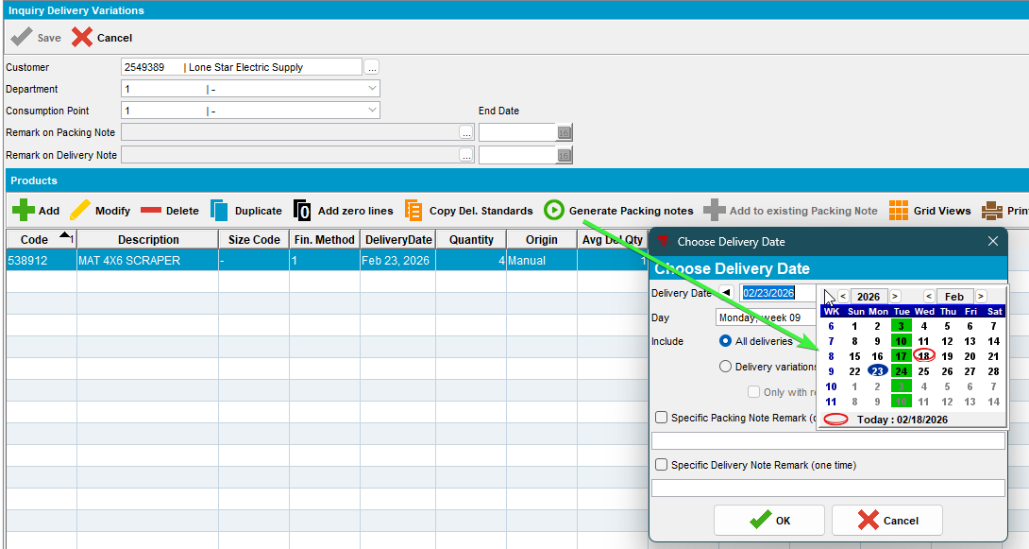
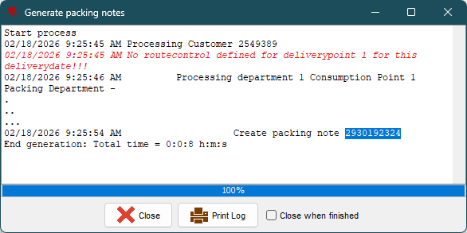
- Delivery variations dlg: Add another dv in the future 6 days from the route day.
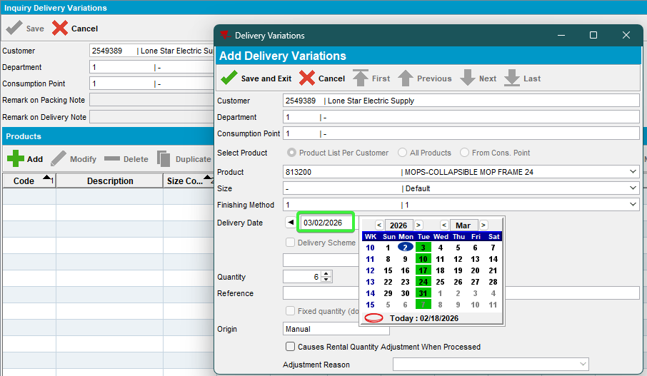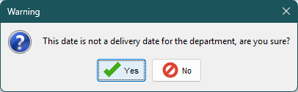
- Delivery variations dlg: Generate packing notes for the same day, 2nd March.
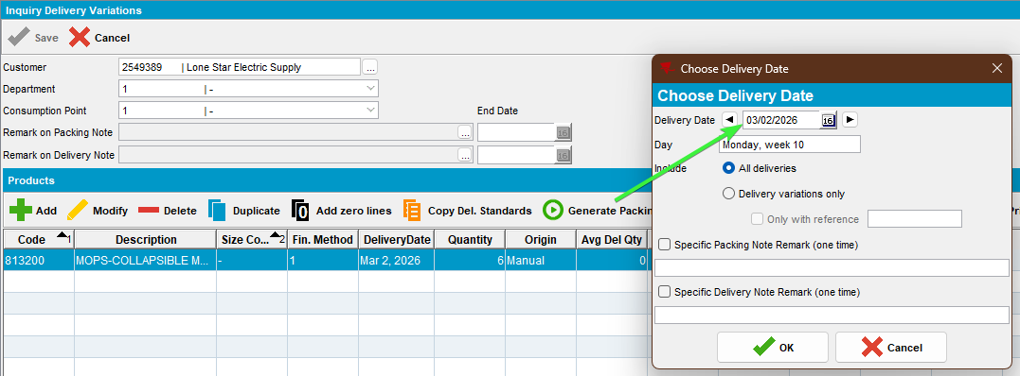
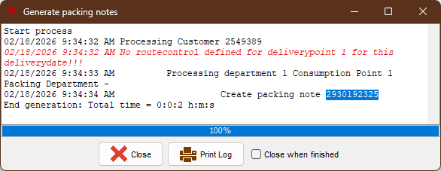
- Delivery variations dlg: Create another dv 7days+ in the future from the route day, on the 8th day.
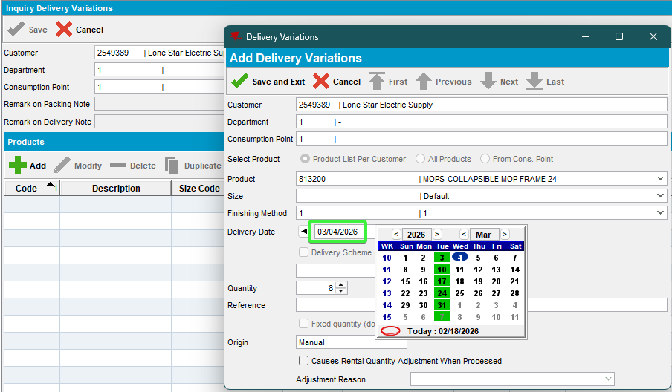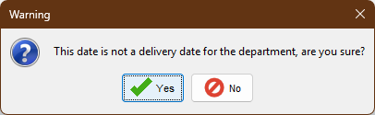

- Delivery variations dlg: Make sure you’re generating packing notes for the same day, 4th March
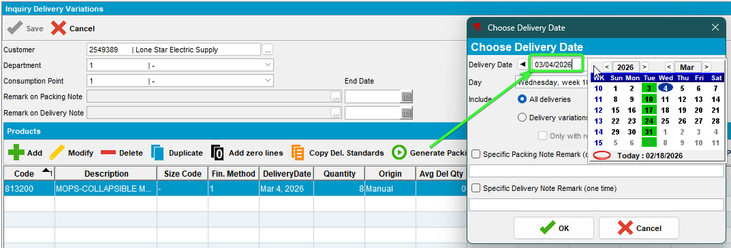
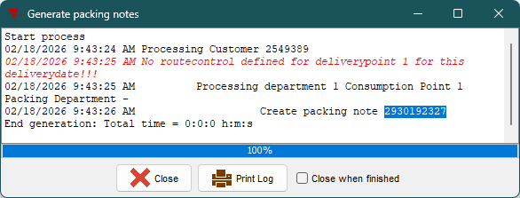
- Maintain Packing and Delivery Notes dlg: Check the dv’s
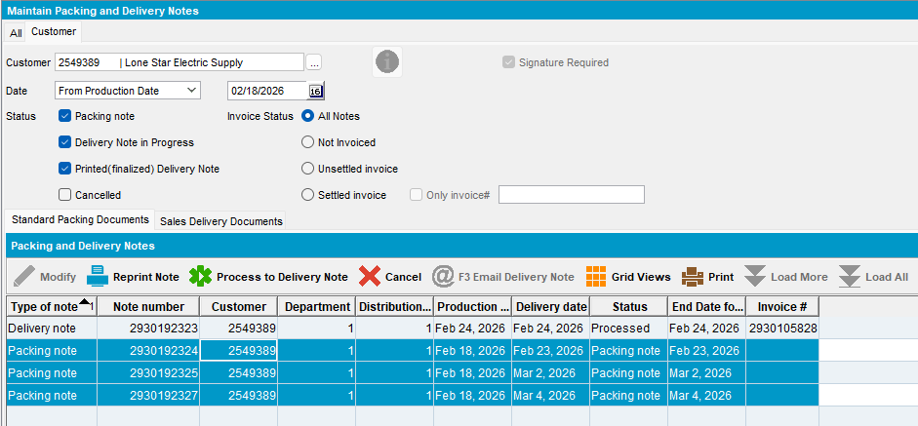
- RSC dlg: Check the assign not linked dv’s
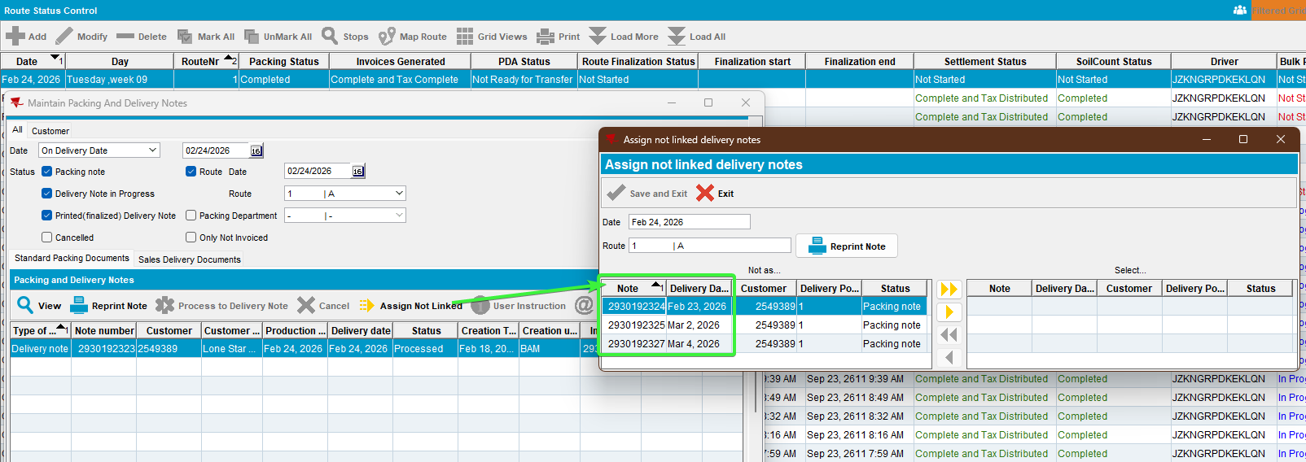

- Process Scheduler dlg: Run process “Cancel and regenerate US direct invoices for late delivery notes”
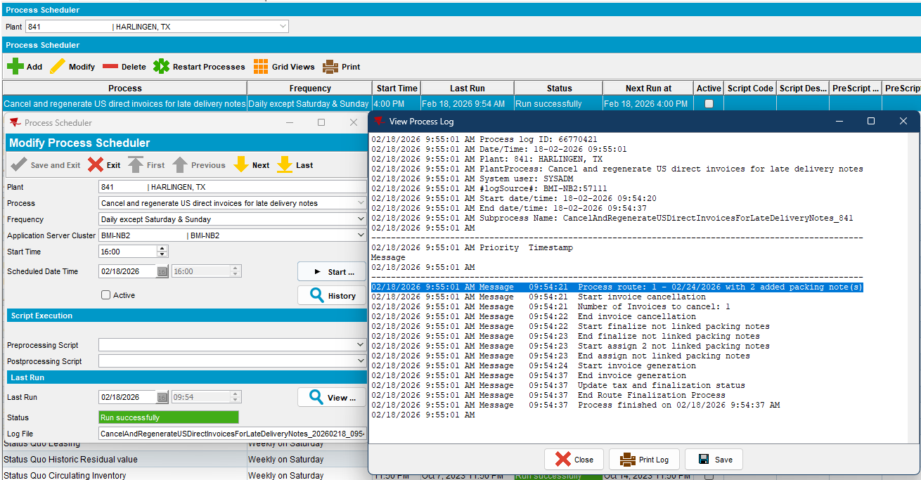
- RSC dlg: Check the assigned dv’s
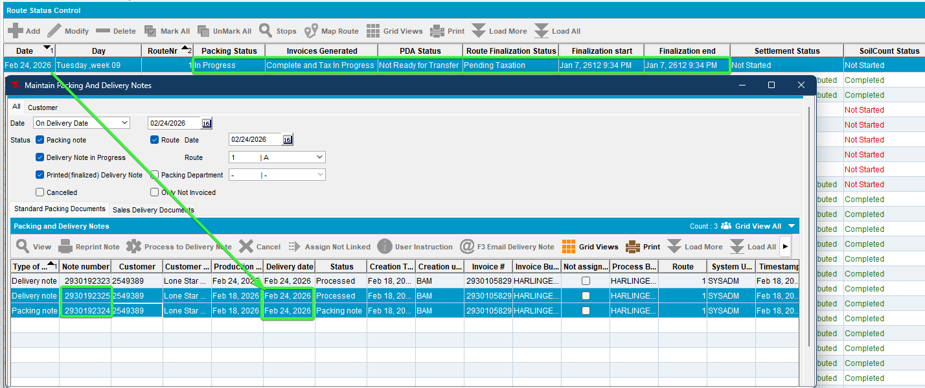

The 2 dv’s were assigned and delivery date changed with the one from route day.
The dv that was 8 days in the future from route day was not assigned.

- Maintain Packing and delivery note dlg: Check the unassigned dv.
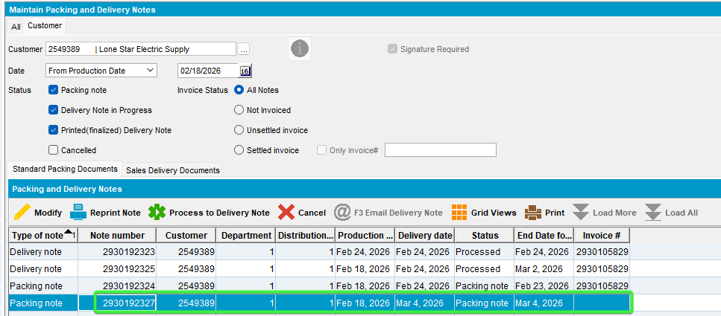

Dv’s for workorders of new wearer inventories on different delivery dates than route day

Steps to reproduce:
- Prepare another route with a customer that has wearers. Generate packing notes, complete invoices.
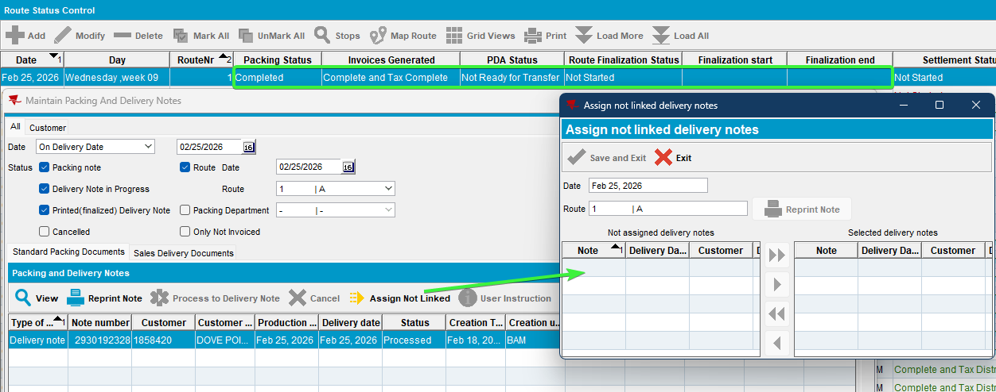
- Wearers dlg: Add a new wearer inventory with date -1 day from route day and generate workorder with the same date.
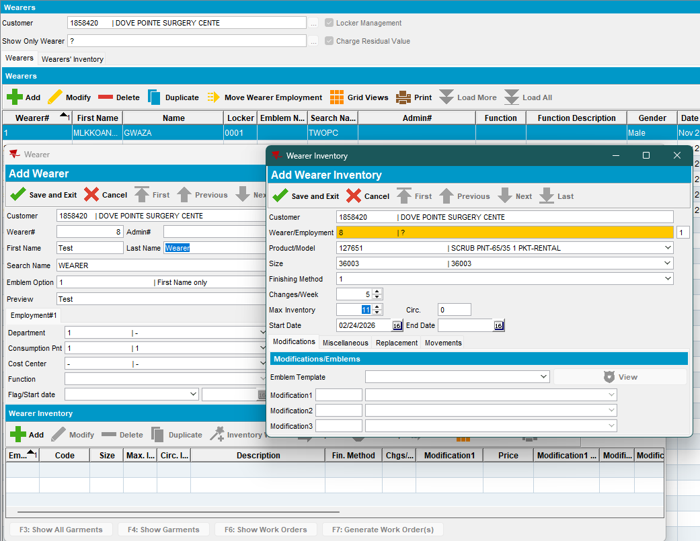
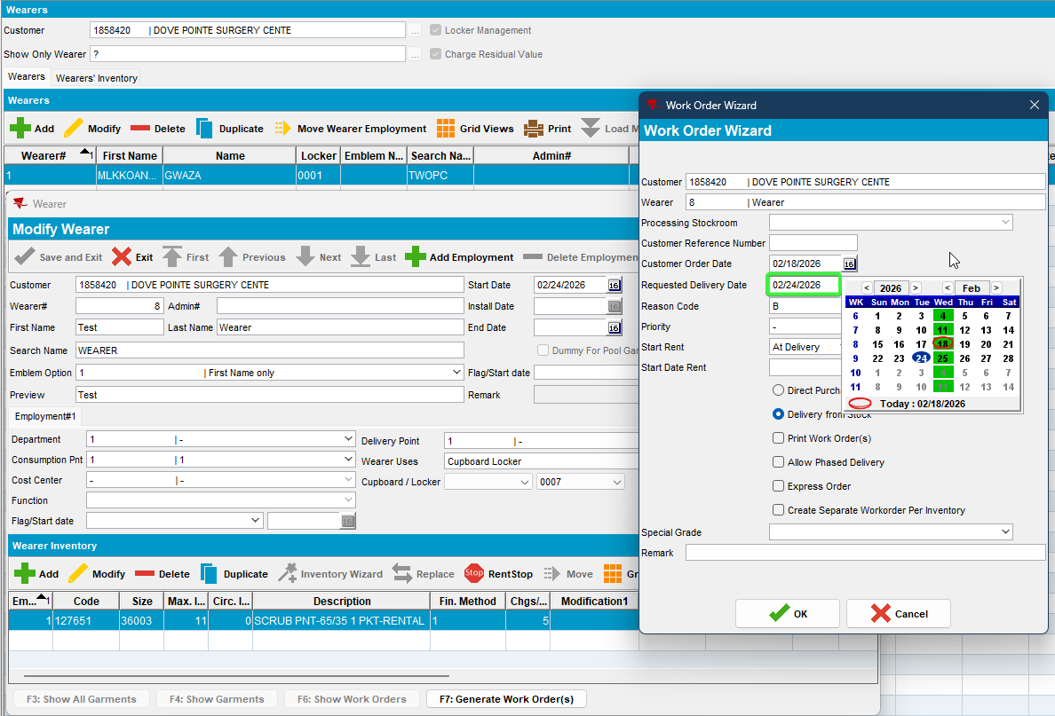
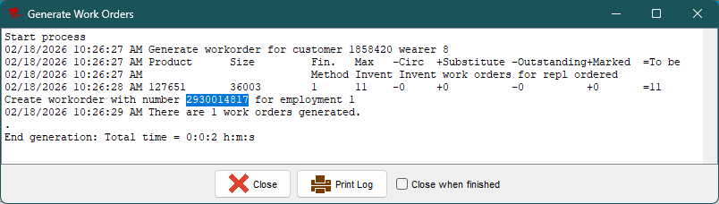
2930014817
- Issue Work Order dlg: Generate delivery notes for garments on a day that the customer is not visited, one day in the past from the driving date, same date as before
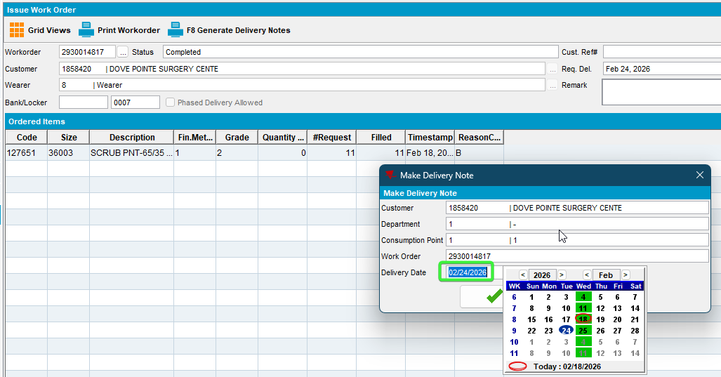
- Wearers dlg: For the same wearer add a new wearer inventory 6 days after the route day, 3rd March.
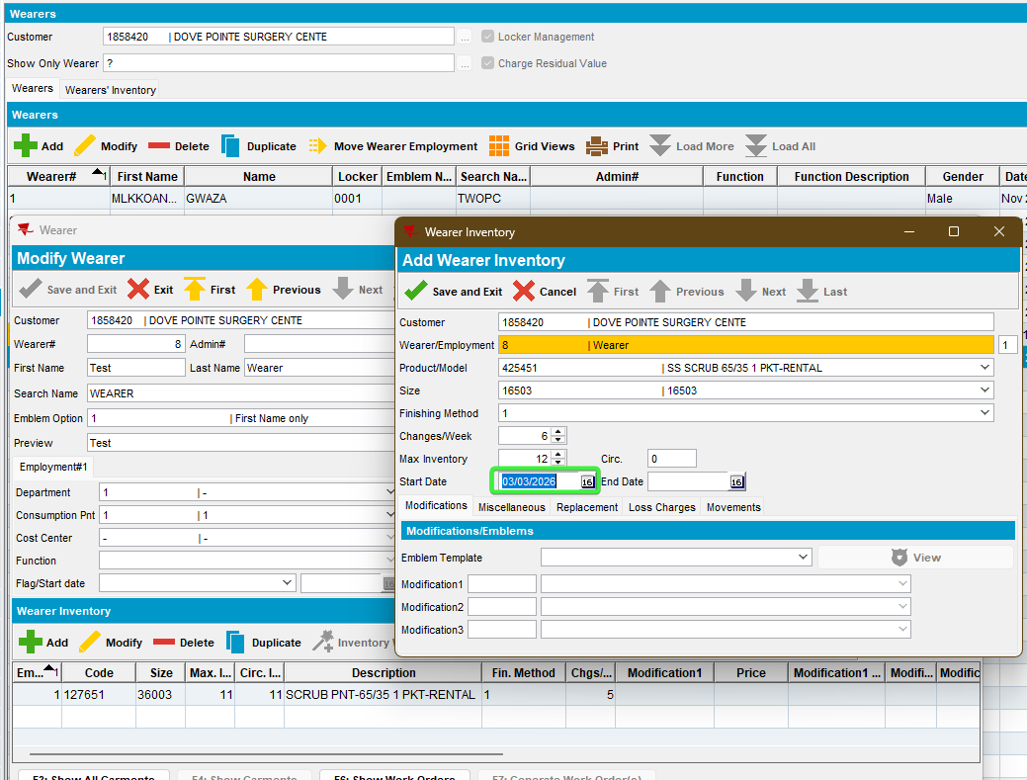
- Wearers dlg: Generate workorder with the same date for delivery date.
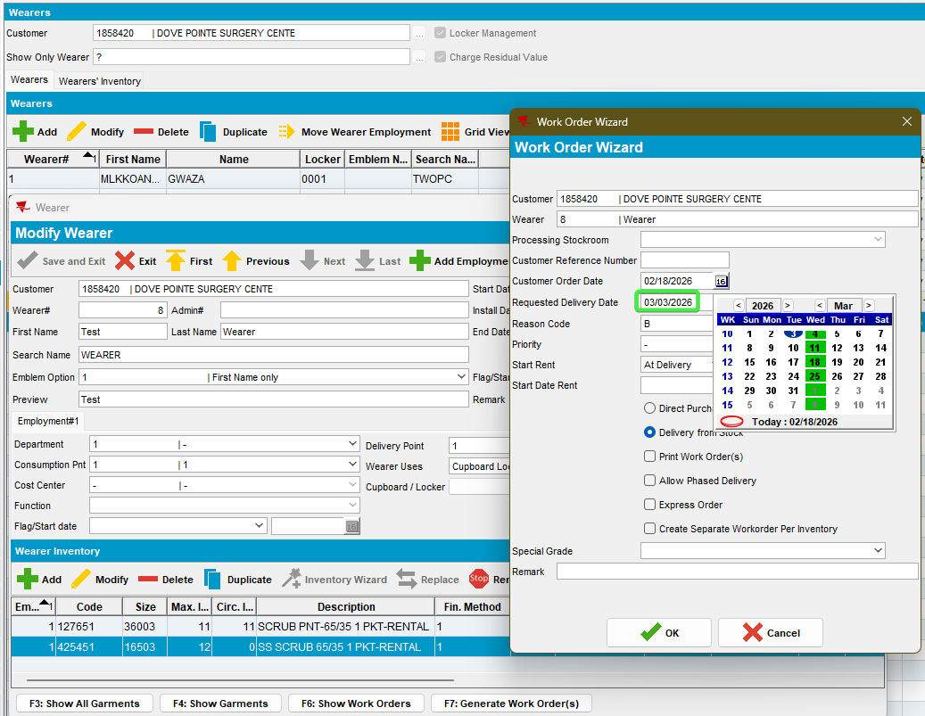
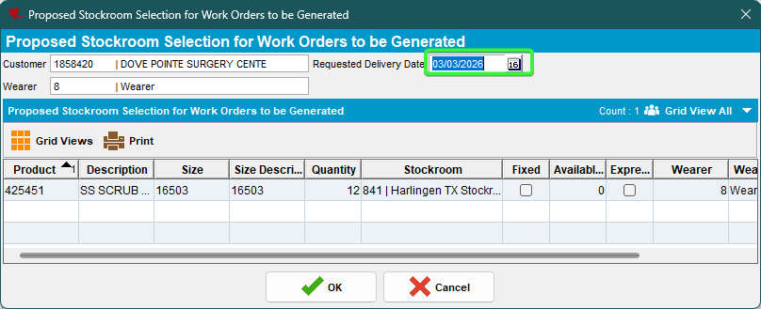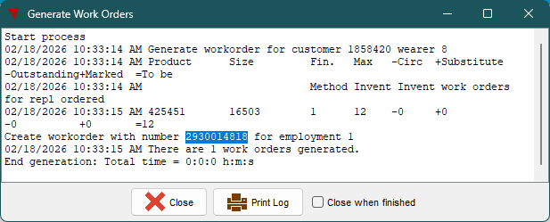
- Issue Work Order dlg: Issue the work order and generate delivery note for the same day 3rd March.
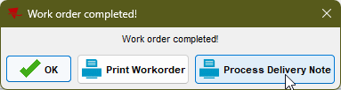
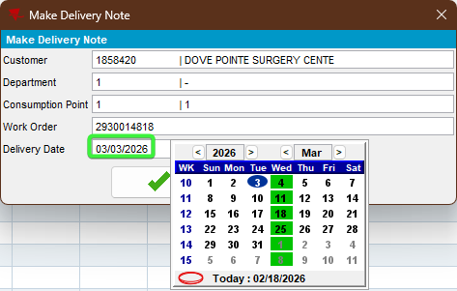
- Wearers dlg: For the same wearer add a third new wearer inventory 7 days after the route day.
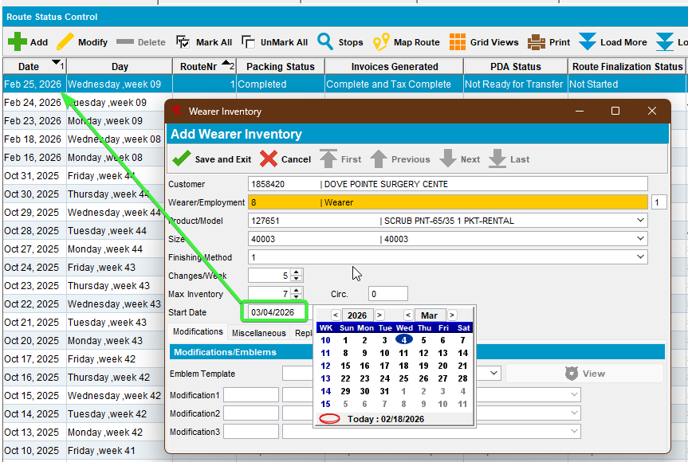
- Wearers dlg: Generate workorder with the same date for delivery date.
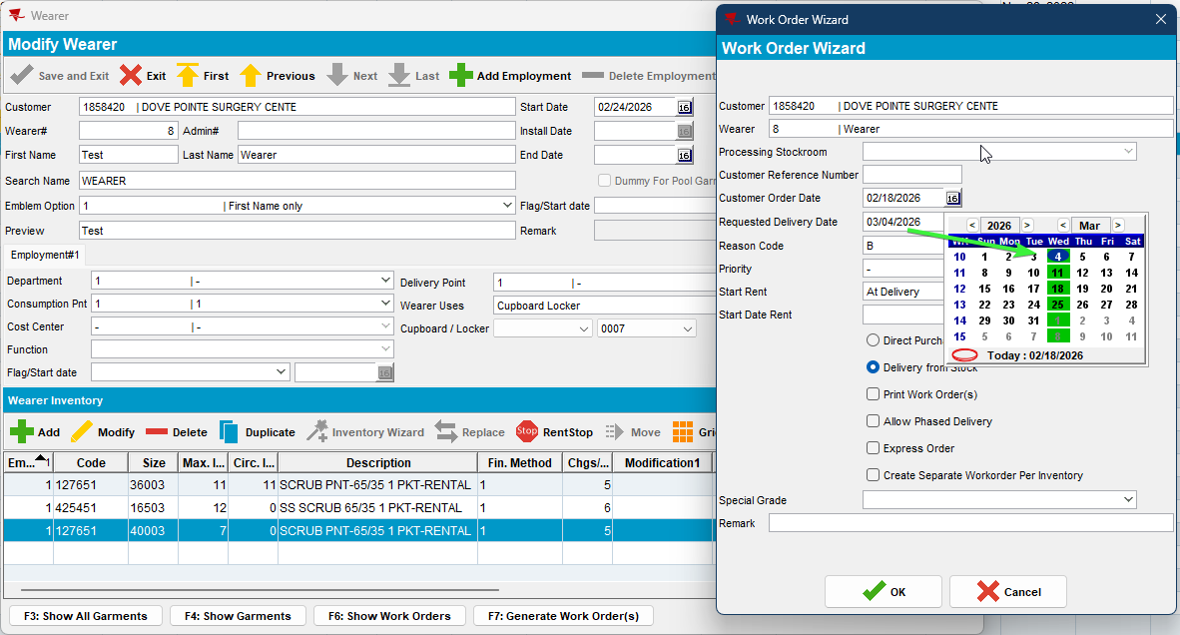
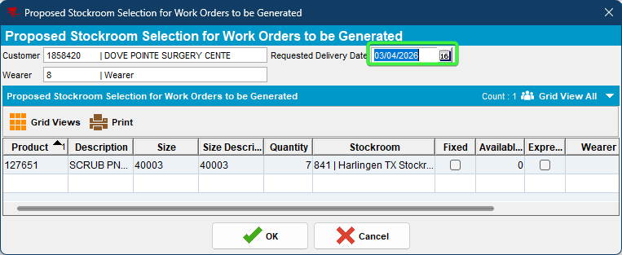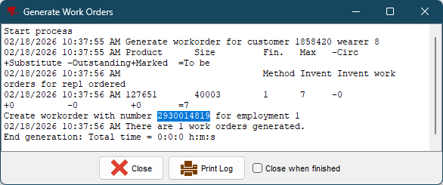
- Issue Work Order dlg: Issue the work order and generate delivery note for the same day 4th March.
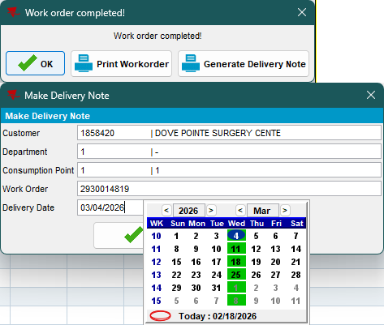

- RSC dlg: Check the unassigned dv’s
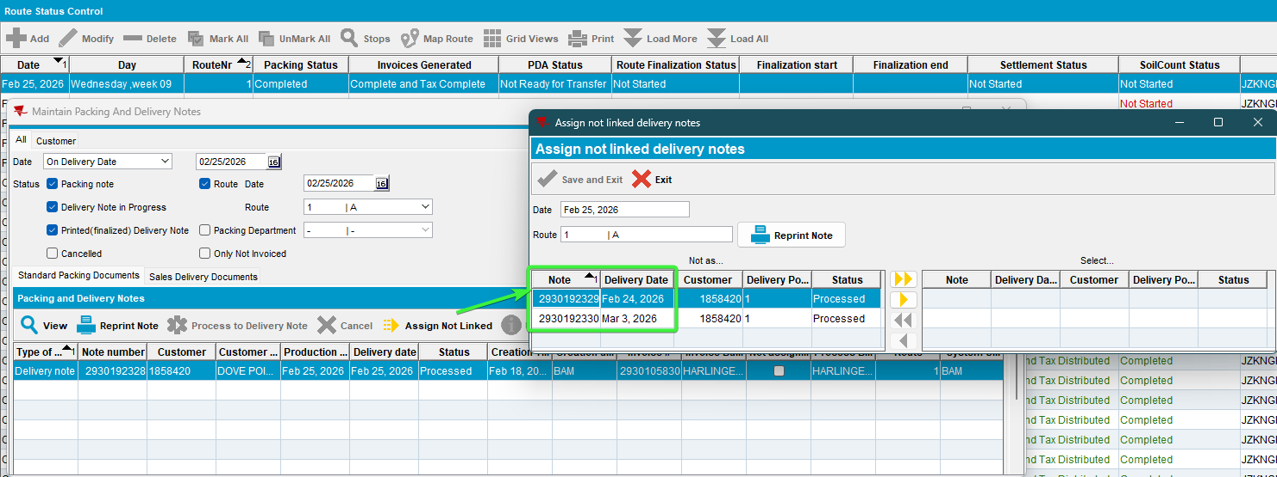
The delivery note for 4th was linked to the next week customer visit day
- RSC dlg: Check also the newly created route when the customer is visited, which was created after doing the dv’s for the last wo 7 days in the future from route day.
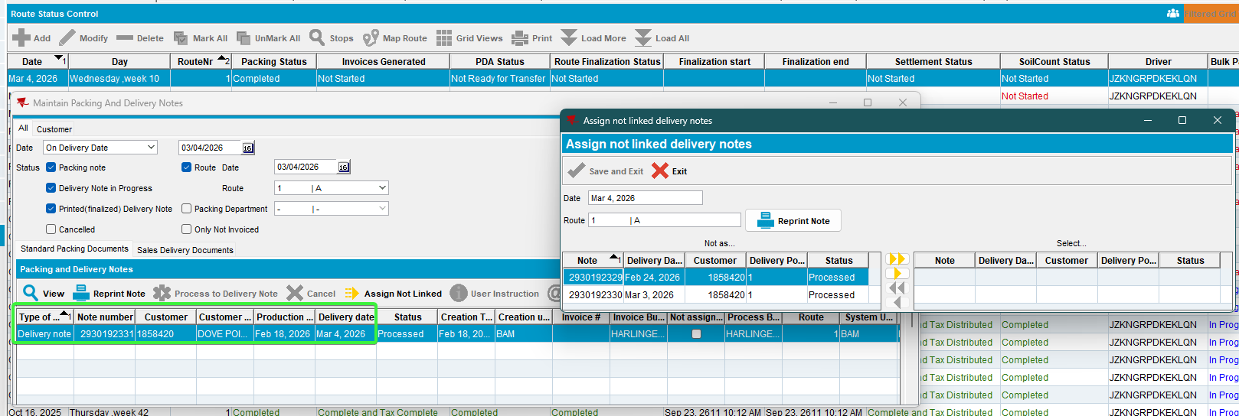
Correctly contains the (7 days future) dv assigned to the route because the customer is visited then.
- Process Scheduler dlg: Run process “Cancel and regenerate US direct invoices for late delivery notes”
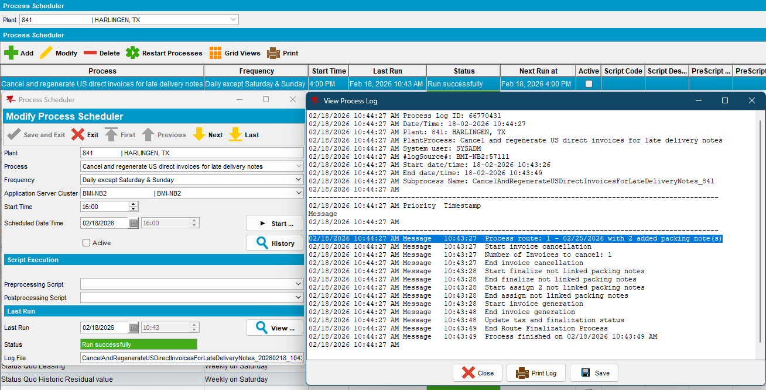
- View Process Log dlg: Check the log.
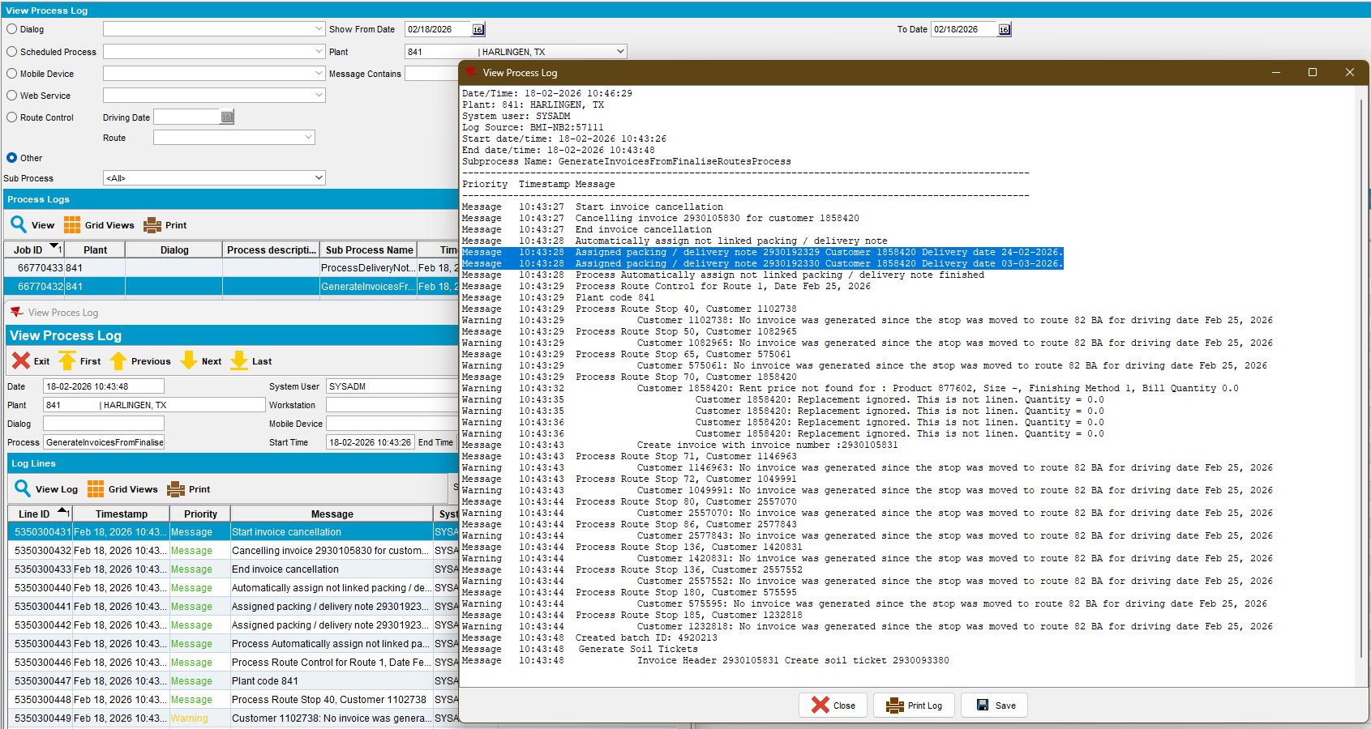
- RSC dlg: Check the route again for the dv’s.
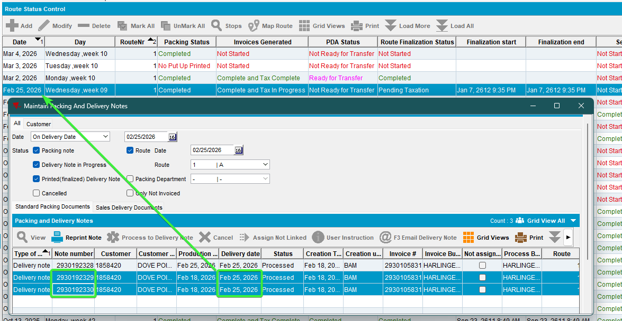
- Maintain Packing Notes dlg: Check the dv’s that was 7 days in the future.
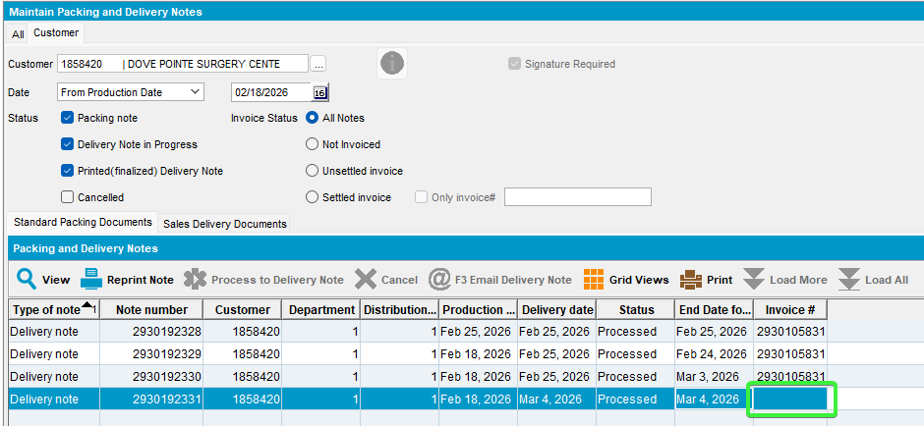

Delivery notes for Sales Notes

Steps to reproduce:

      - RSC dlg: Create a new route next week and keep one customer.
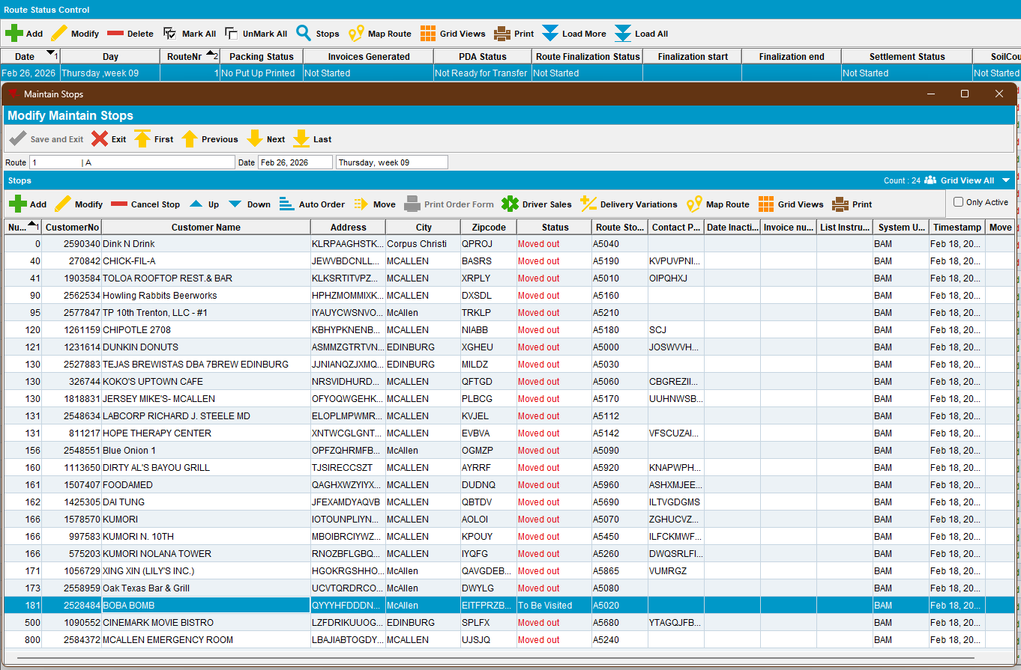
      - RSC dlg: Generate packing notes, complete invoices for the route.
      - Maintain Sales Notes dlg: add a sales note. choose a day that the customer is not visited, one day in the past from the driving date
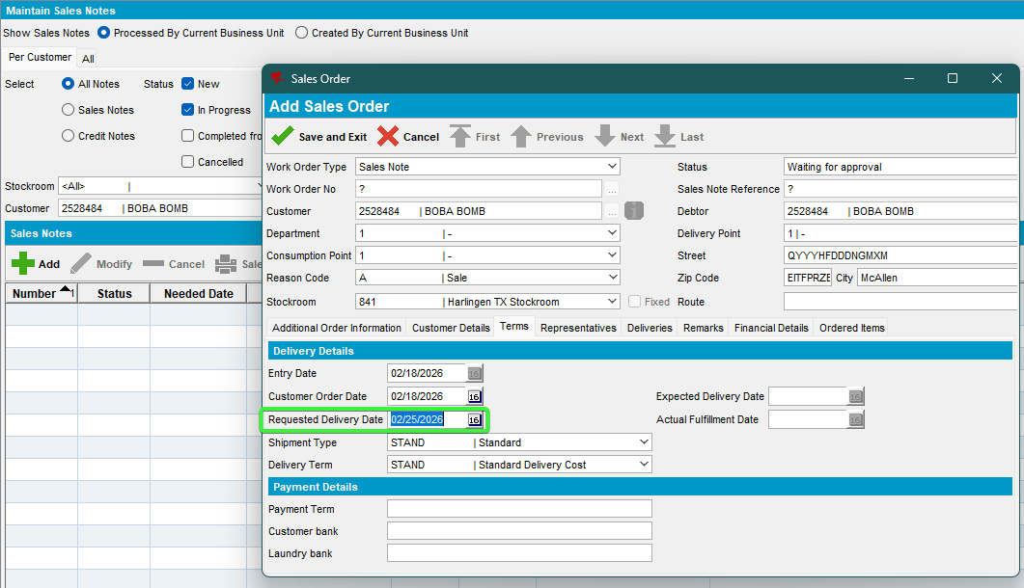
- Work Orders waiting for approval dlg: Approve the sales note.
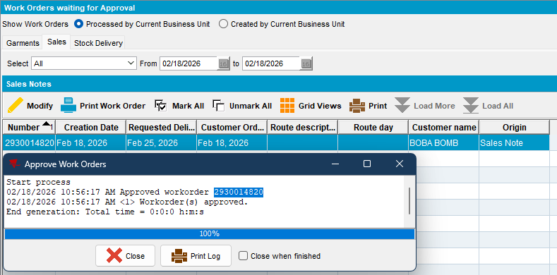
- Maintain Sales Notes dlg: issue the sales note > Generate a sales delivery note
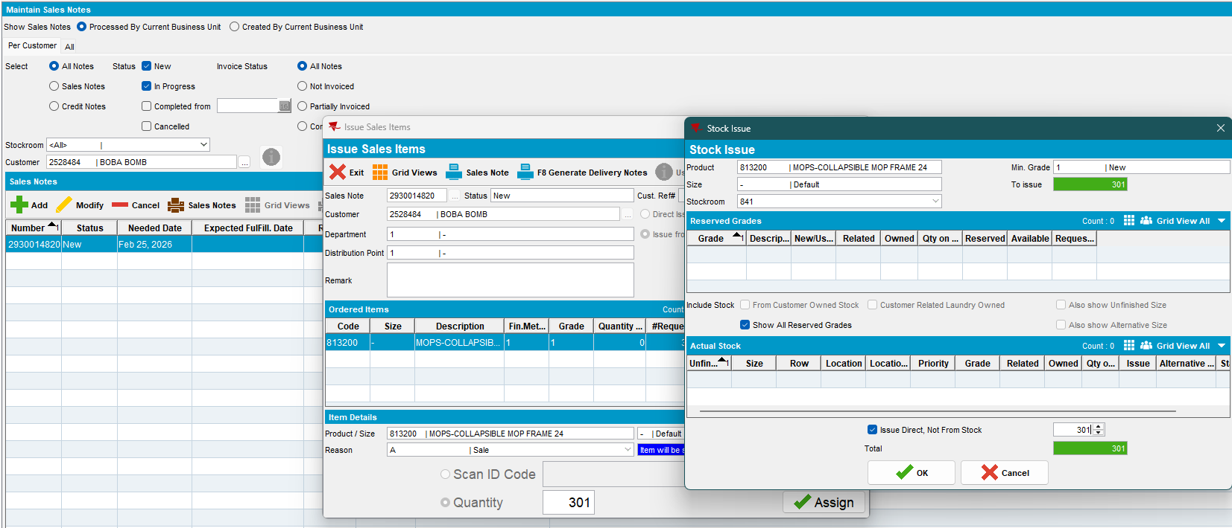
choose a day that the customer is not visited, one day in the past from the driving date
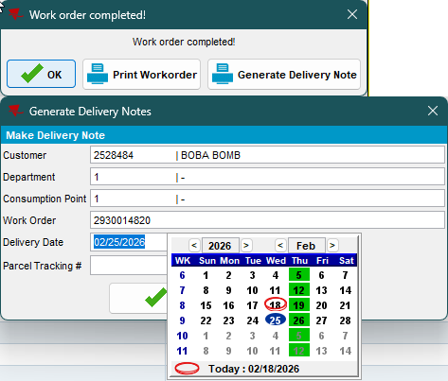
- Maintain Sales Note dlg: Add another sale note on the 6th day in the future from the route day
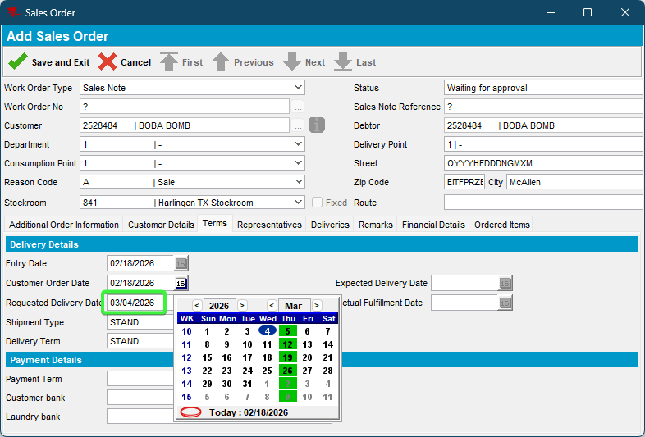
- Work Orders waiting for approval dlg: Approve the sales note.
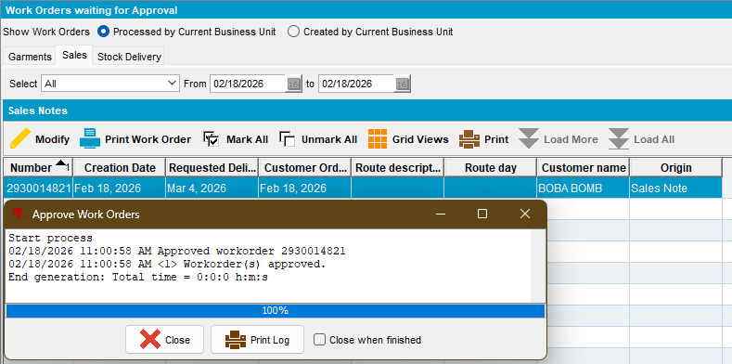
- Maintain Sales Notes dlg: issue the sales note > Generate a sales delivery note
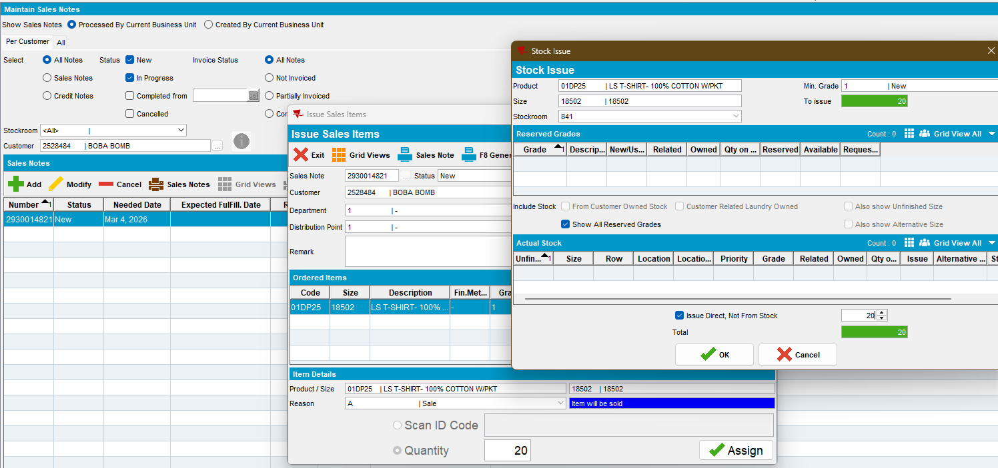
choose a day that the customer is not visited, 6th day in the future from the driving date same date as before
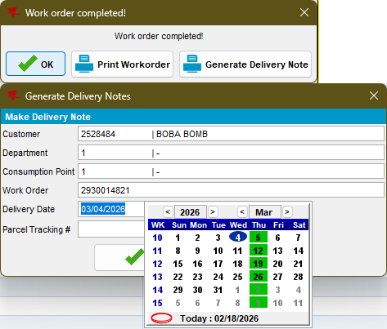
- Maintain Sales Note dlg: Add another sale note on the 7th day in the future from the route day
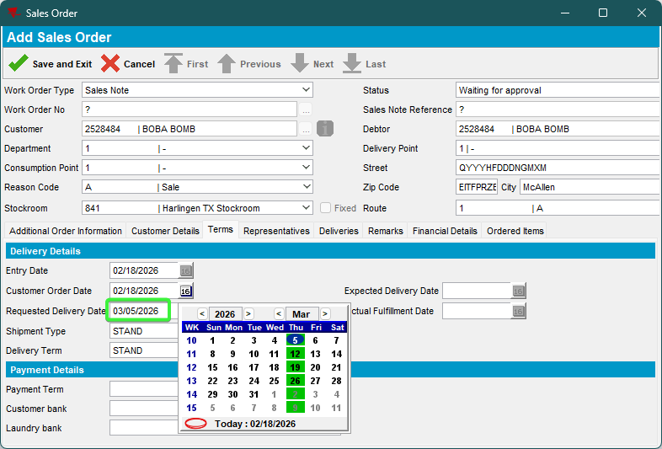
- Work Orders waiting for approval dlg: Approve the sales note.
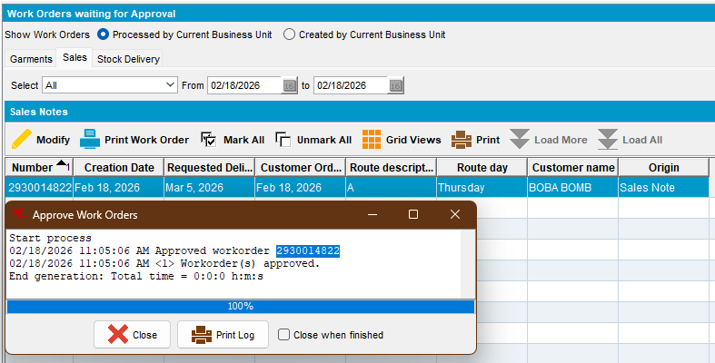
- Maintain Sales Notes dlg: issue the sales note > Generate a sales delivery note
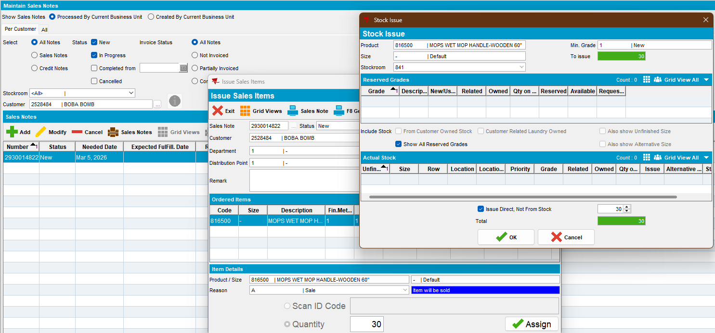
choose 7th day in the future from the driving date
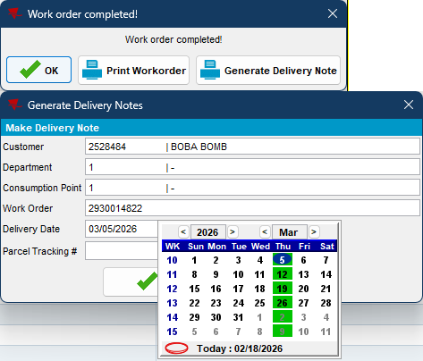

- RSC dlg: View packing and delivery notes assigned not linked, on the sales delivery documents tab.
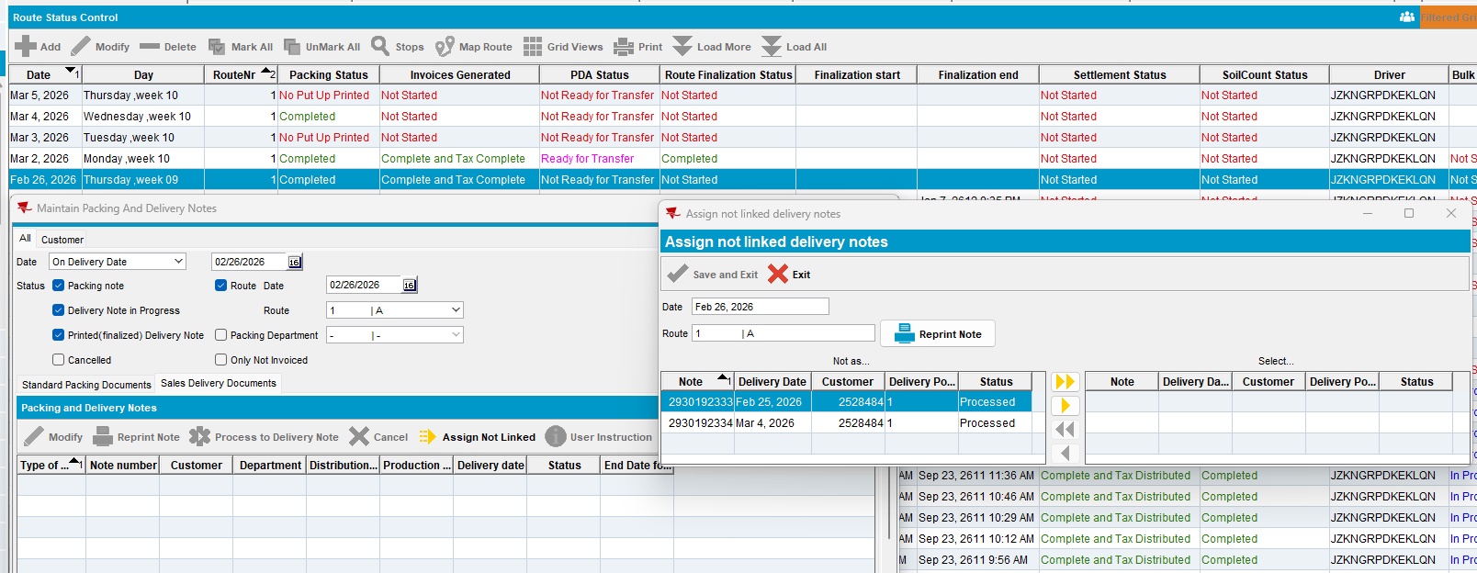
2 of them appear here, the one from 7th day in the future was assigned on the new future route
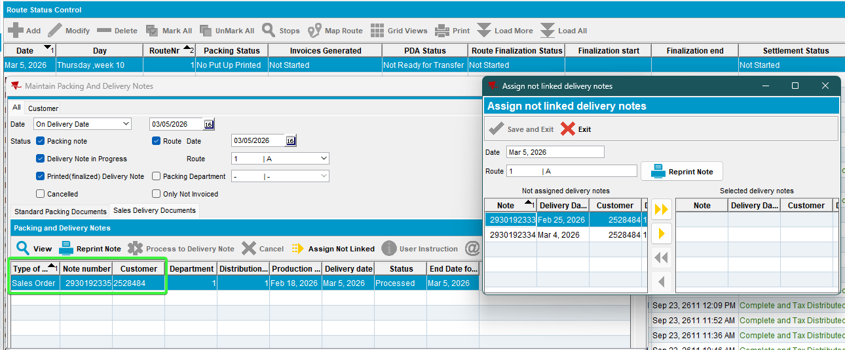
- Process Scheduler dlg: Run process “Cancel and regenerate US direct invoices for late delivery notes”
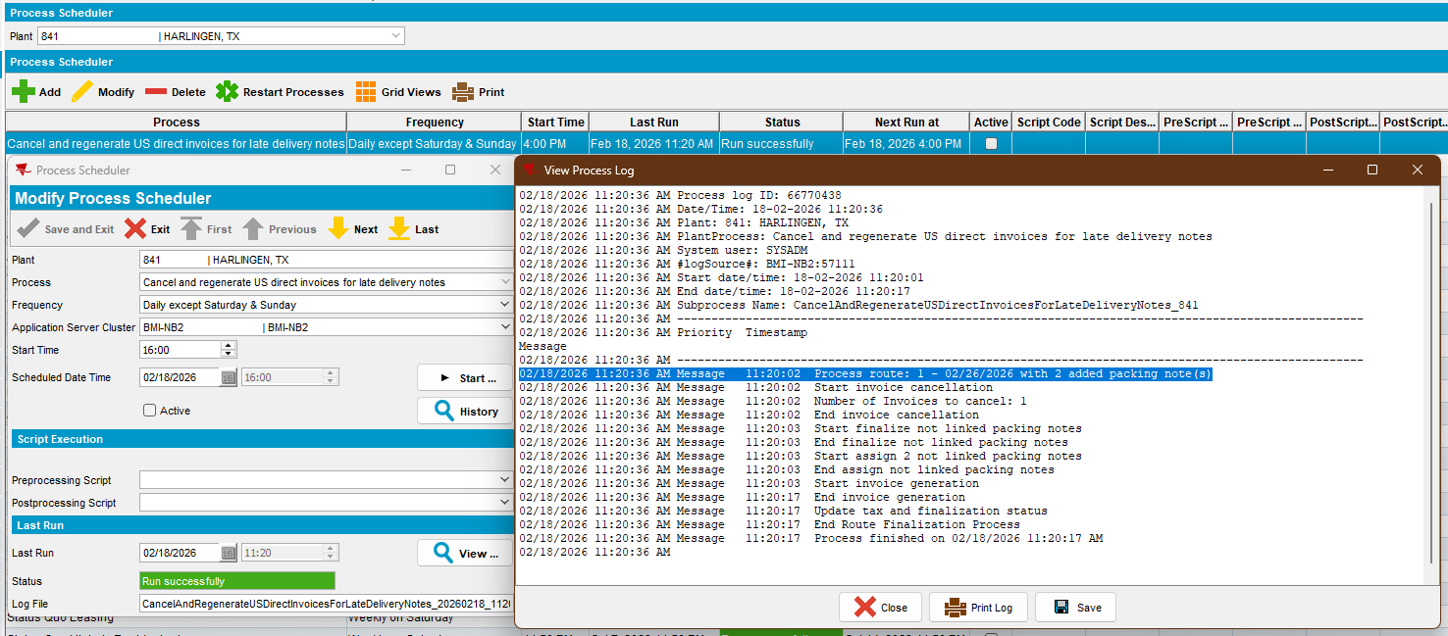
- View Process Log dlg: Check what the logs are stating
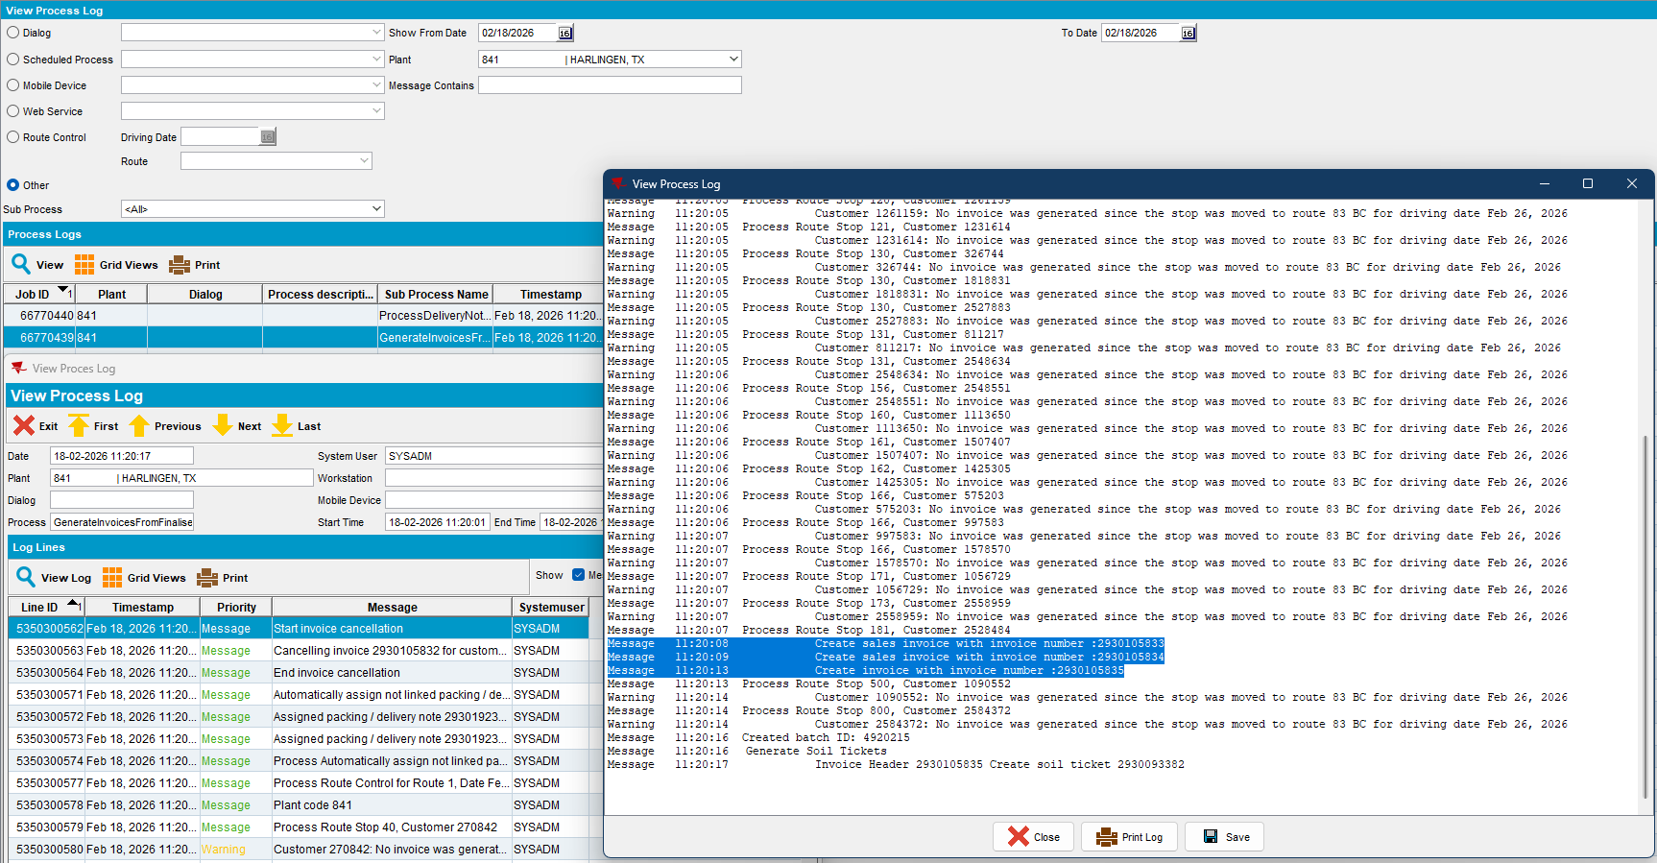
- RSC dlg: Check the assigned sales notes.
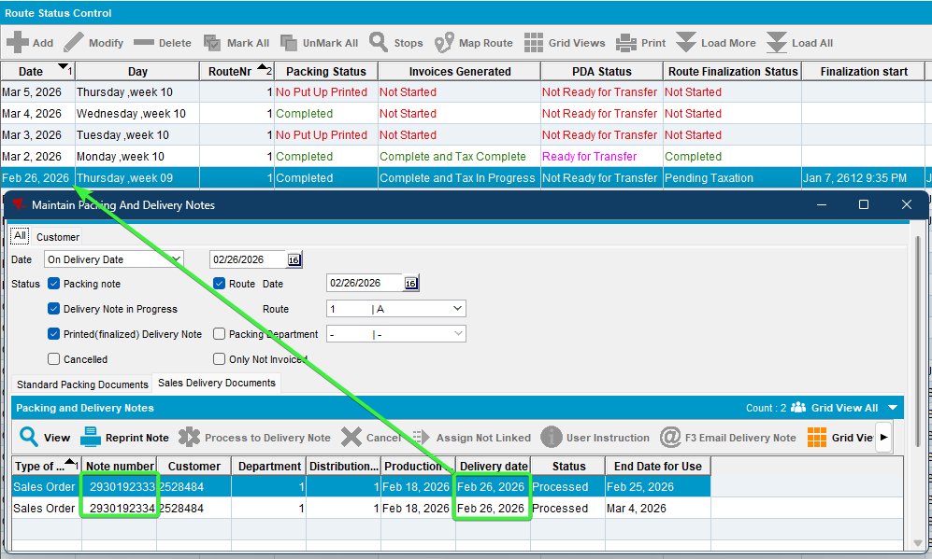
2 of the sales notes were assigned, the one that was 6+ days in the future was ignored

- Maintain Packing and Delivery Notes dlg: See that the last sales note wasn’t attached to any invoice.
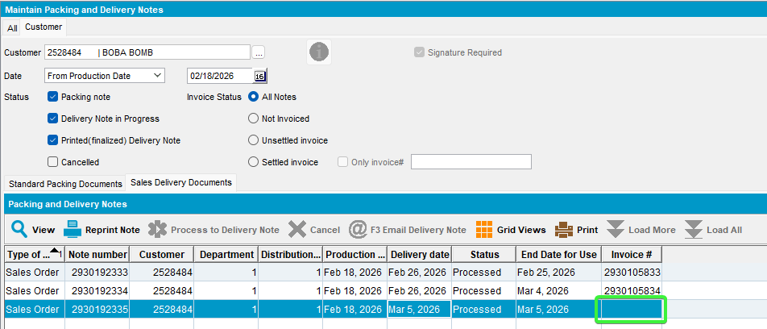

Test Case 2 – Moved invoice from Maintain Invoices (incidental stop) to a different route but same driving date – Tested OK
Expected behavior:
- The invoice that was moved in is cancelled and regenerated
- The manual packing note IS attached to the route control

Steps to reproduce:
- Customer 1 has a billing day on Route A
- RSC DLG: Generate packing notes and invoice for Customer 1 on Route A.
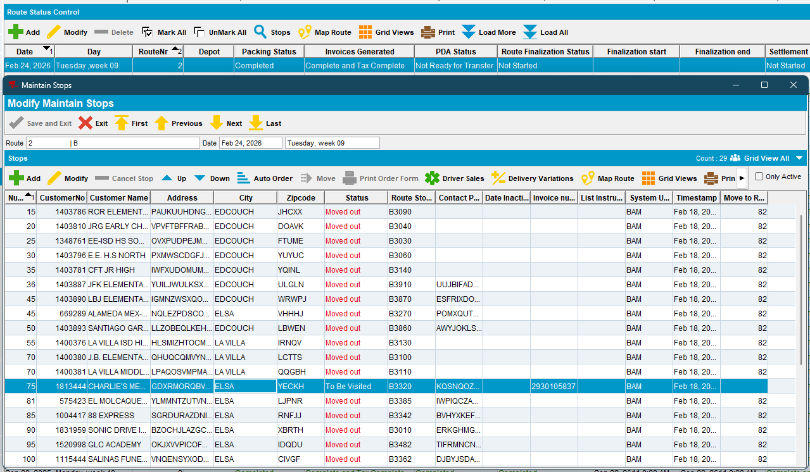
- RSC DLG: Add Route Control for Route B
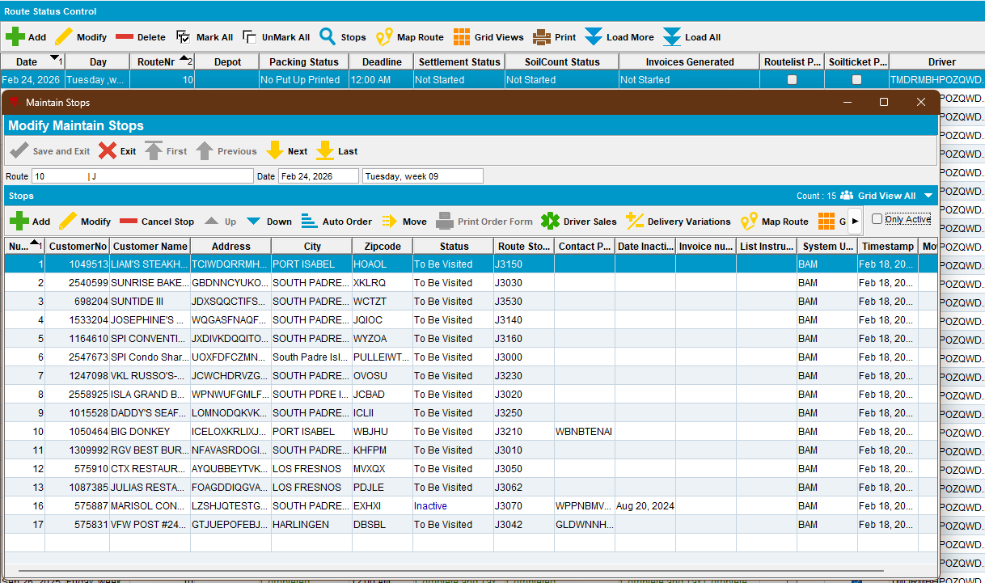
- Maintain Invoices DLG: Move the invoice of customer 1 from route A to the Route B
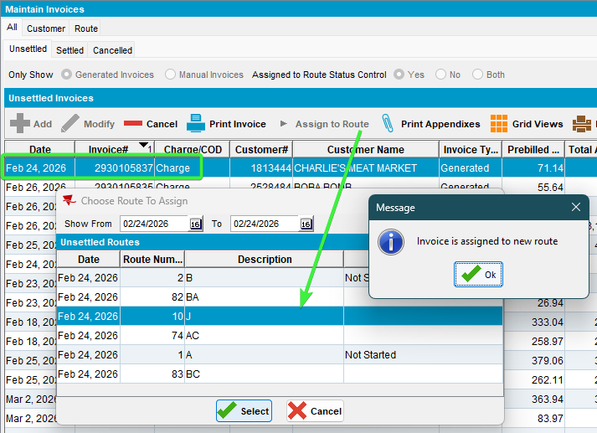
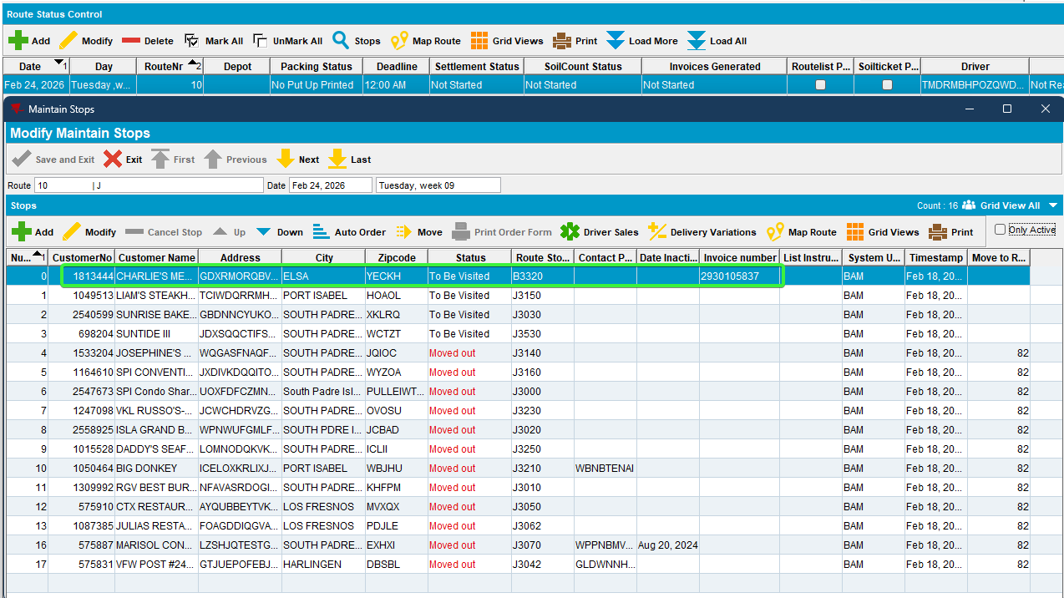
- RSC DLG: Keep a few customers, generate packing notes and generate invoices for Route B and tax them
- Delivery note DLG: add a manual packing note for that customer with no routecontrol (the customer A that was moved) and a delivery date < driving date of the new route.
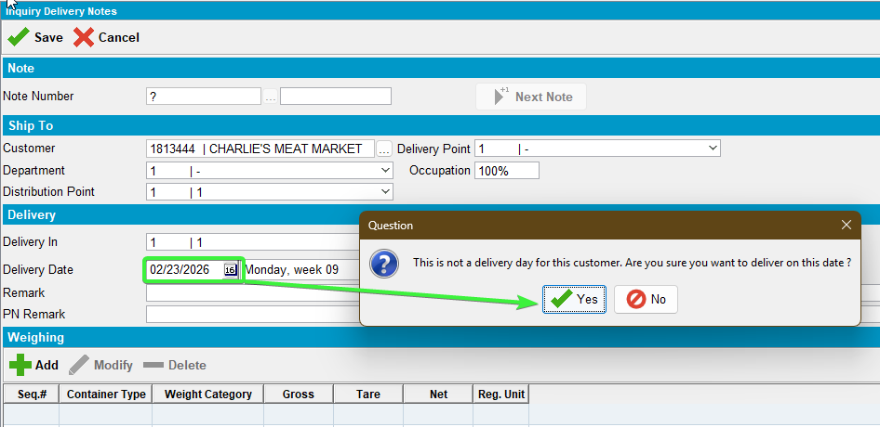
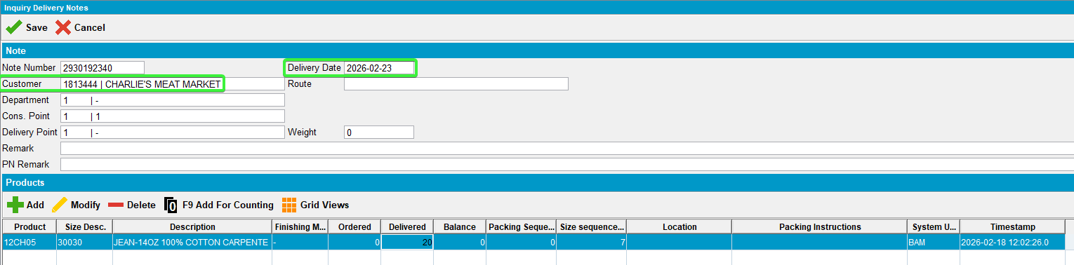
- Postman: Send a finalization request for Route B
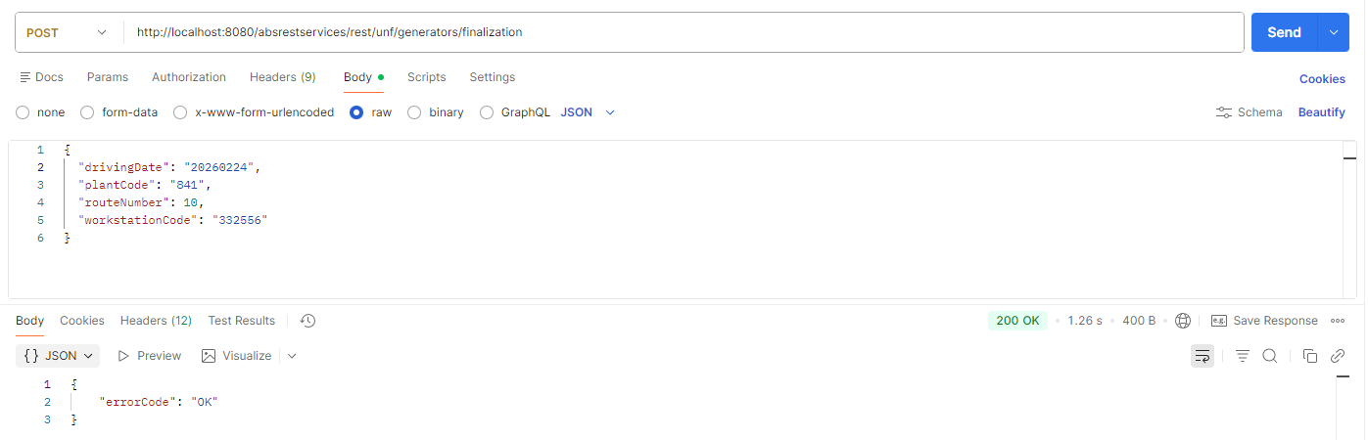

- The invoice that was moved in was cancelled and regenerated. The delivery wash is present on the new invoice
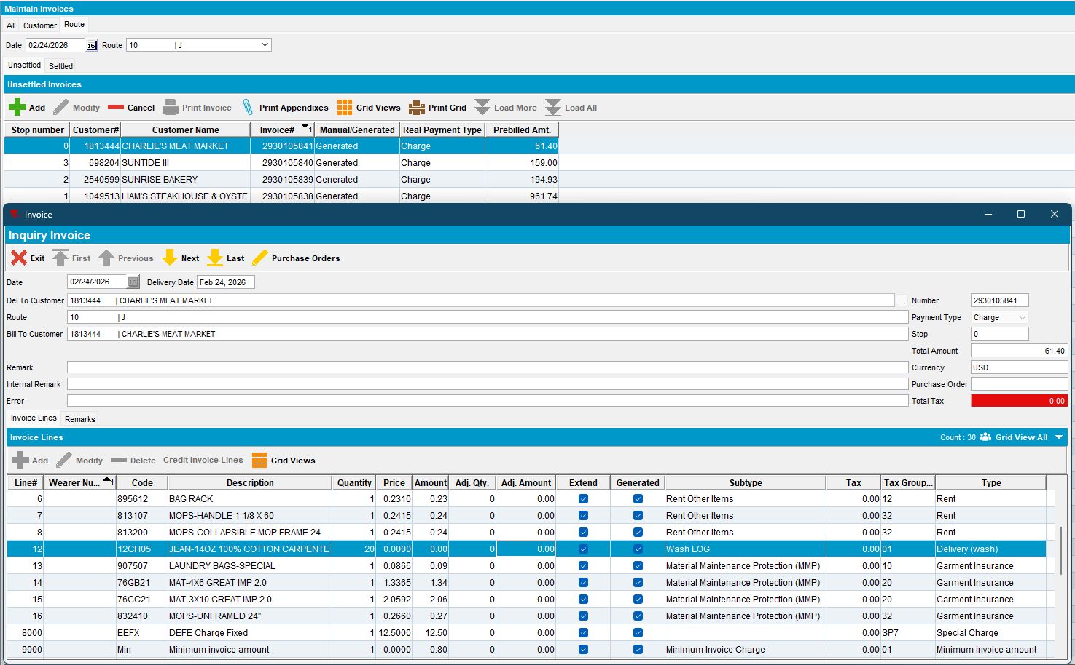

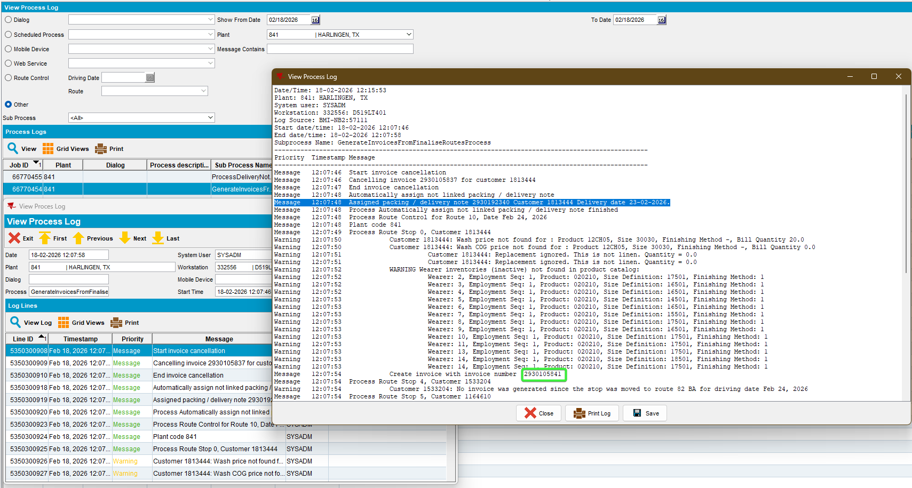
- The manual packing note is attached to the route control
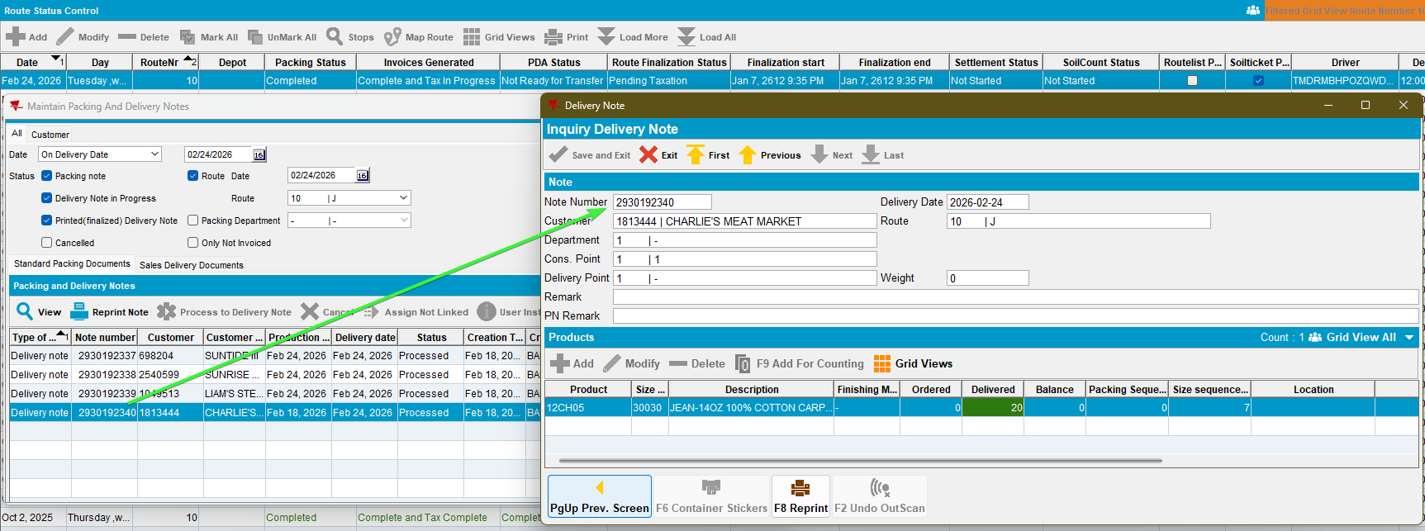

Test Case 3 – Moved invoice from Maintain Invoices (incidental stop) to a different route and different route day – Tested OK
Expected behavior:
- The invoice that was moved in is NOT cancelled and not regenerated.
- The manual packing note IS attached to the route control but not invoiced
- No new invoice is generated
- The Finalization Status is updated to 2

Steps to reproduce:
- Customer 1 has a billing day on Route A
- RSC DLG: Generate an invoice for Customer 1 on Route A

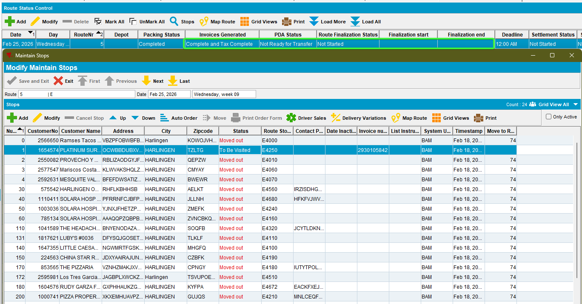
- Maintain invoices dlg: Check the invoice.
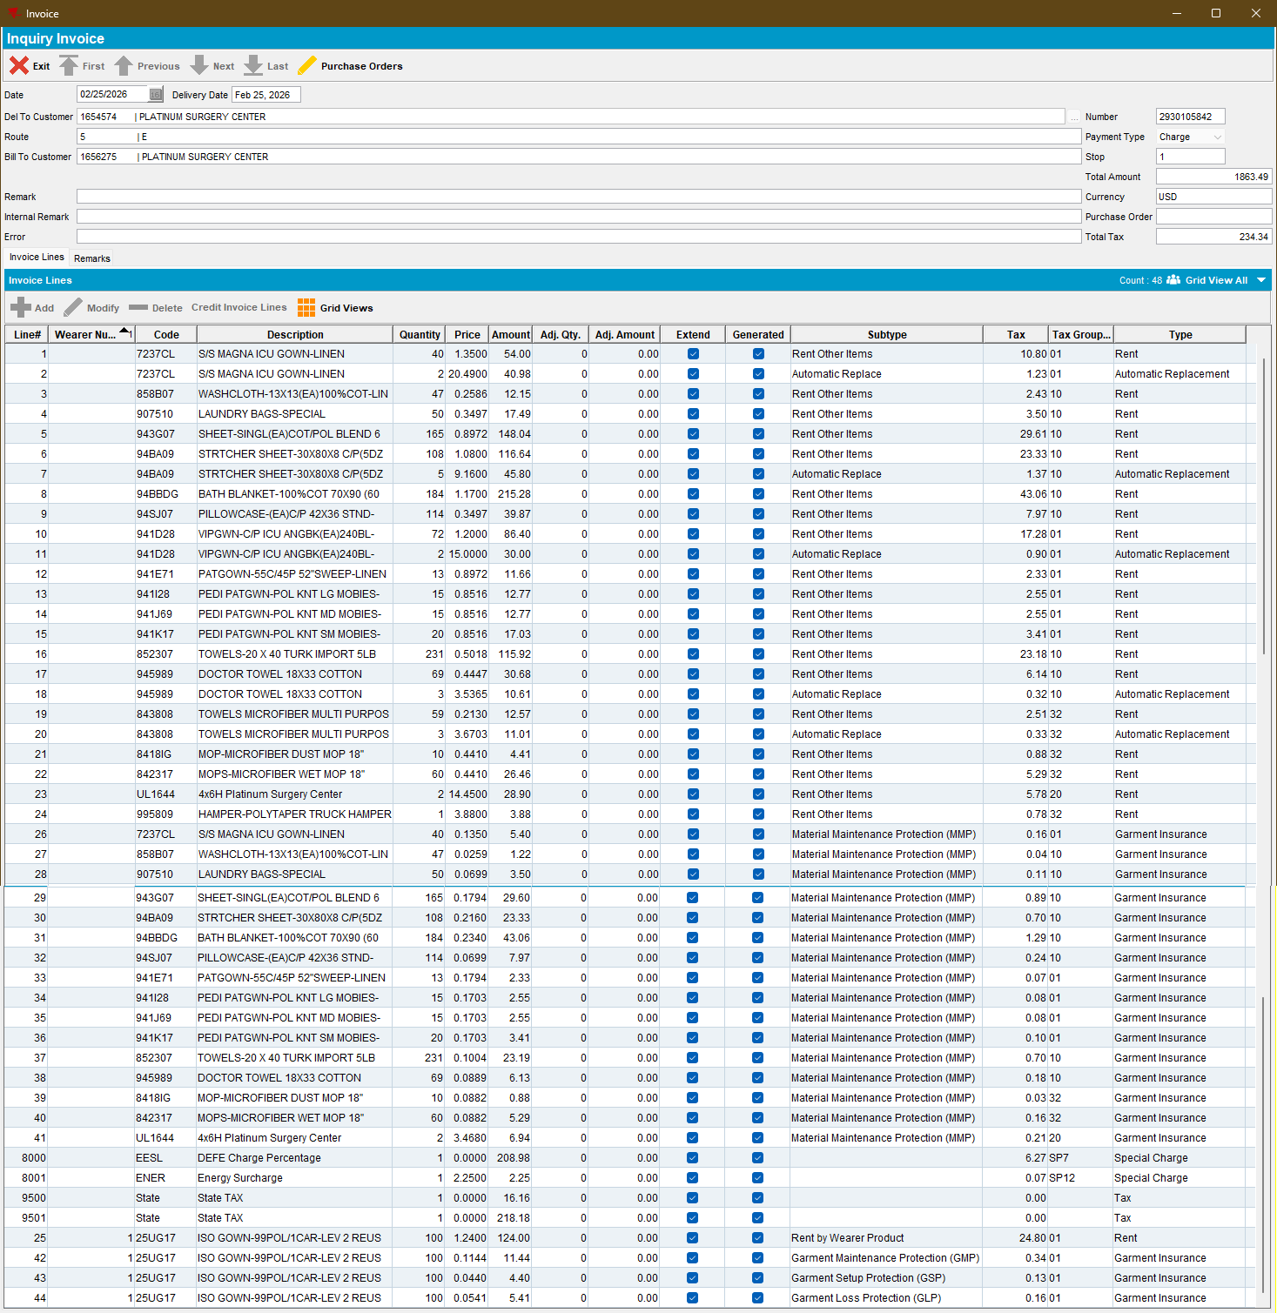
- RSC DLG: Add Route Control for Route B one day in the future from route A.
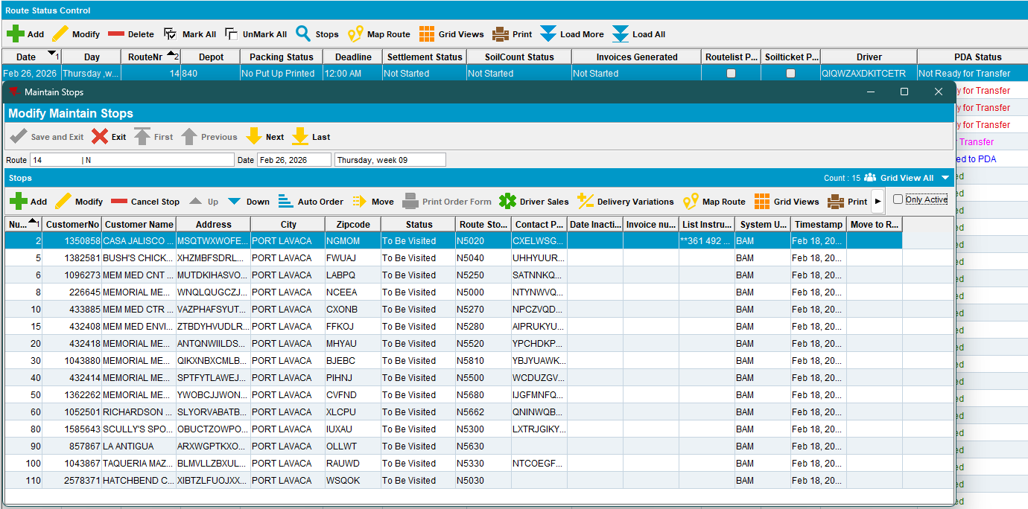
- Maintain Invoices DLG: Move the invoice of customer 1 from route A to the Route B
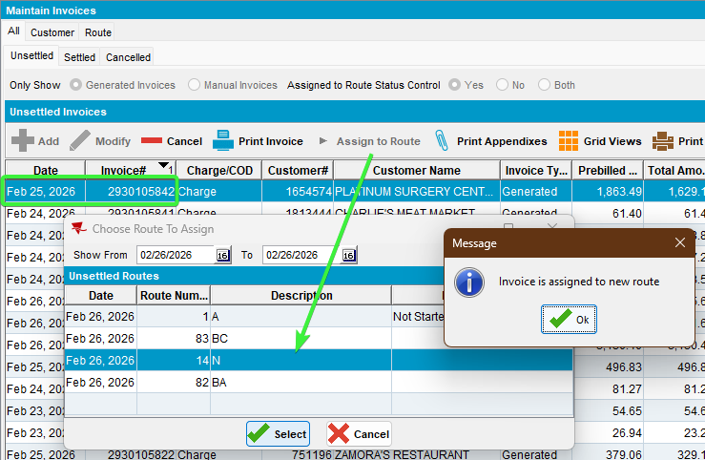
- RSC dlg: Move out the customers from route B, keep at least 2 + the new moved customer/invoice.

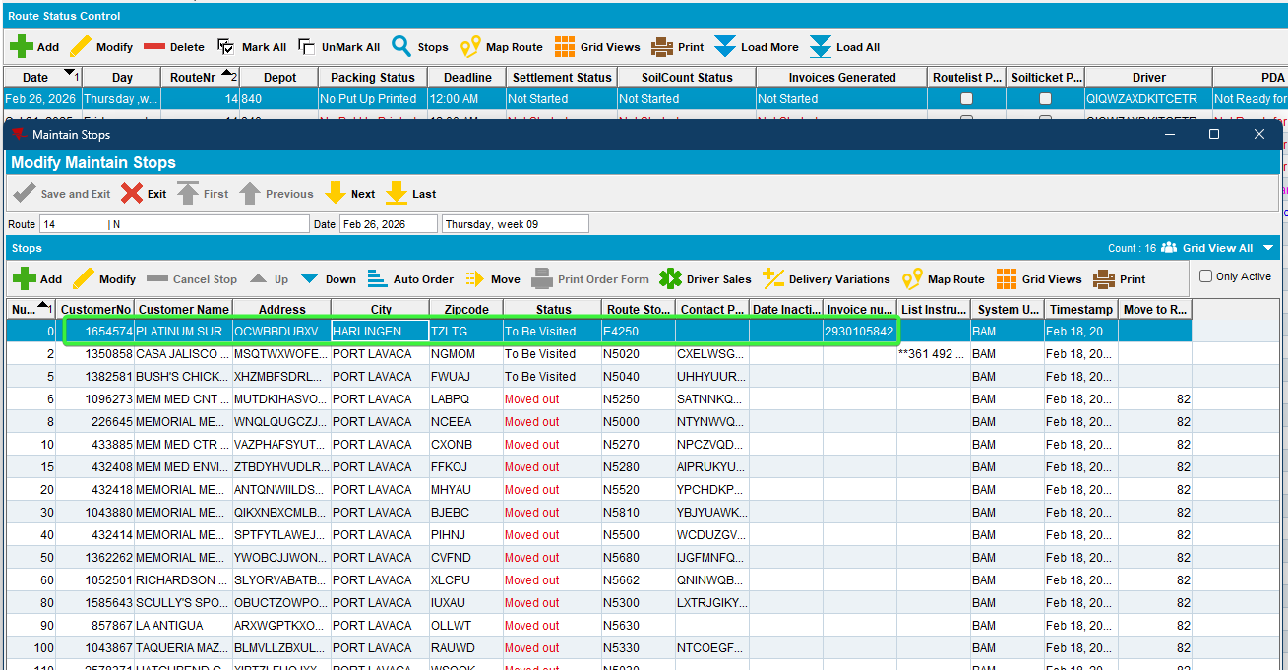
- RSC DLG: Generate packing notes and generate invoices for Route B and tax them. Check the assign not linked
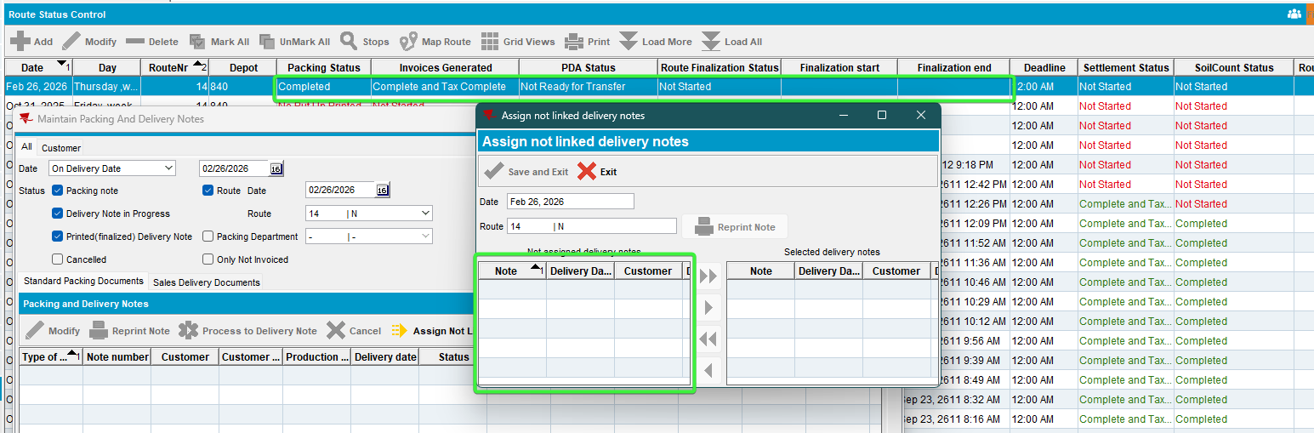
- Delivery note DLG: add a manual packing note for that customer with no routecontrol and a delivery date < driving date, the customer A which invoice was moved.
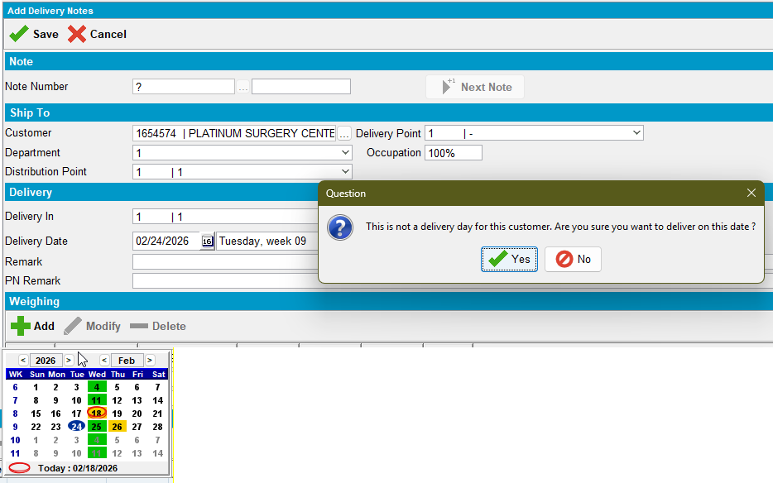
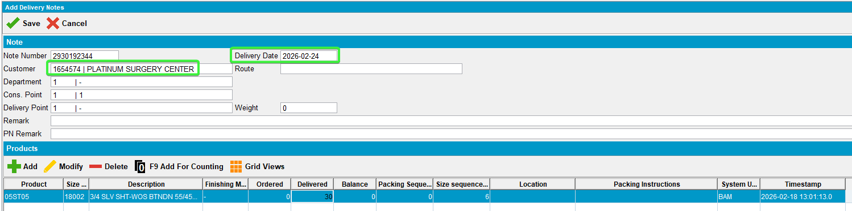
- RSC dlg: Check route B for delivery notes not assigned.
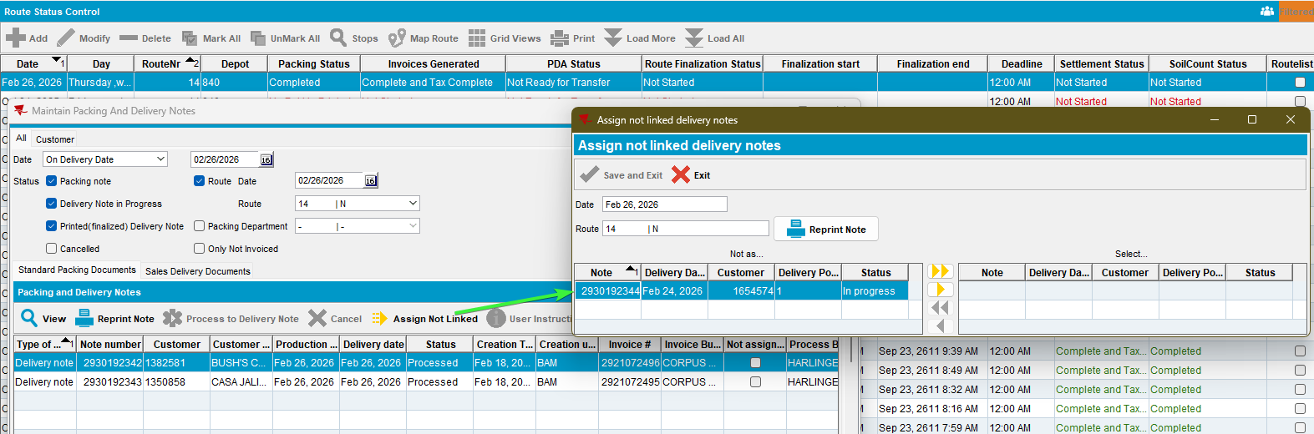
- Postman: Send a finalization request for Route B
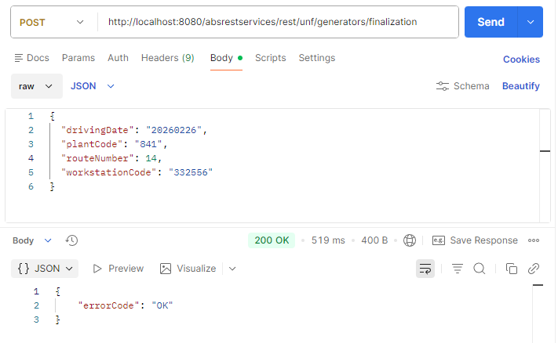

- The invoice that was moved in is NOT cancelled.
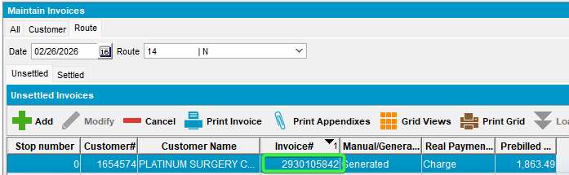
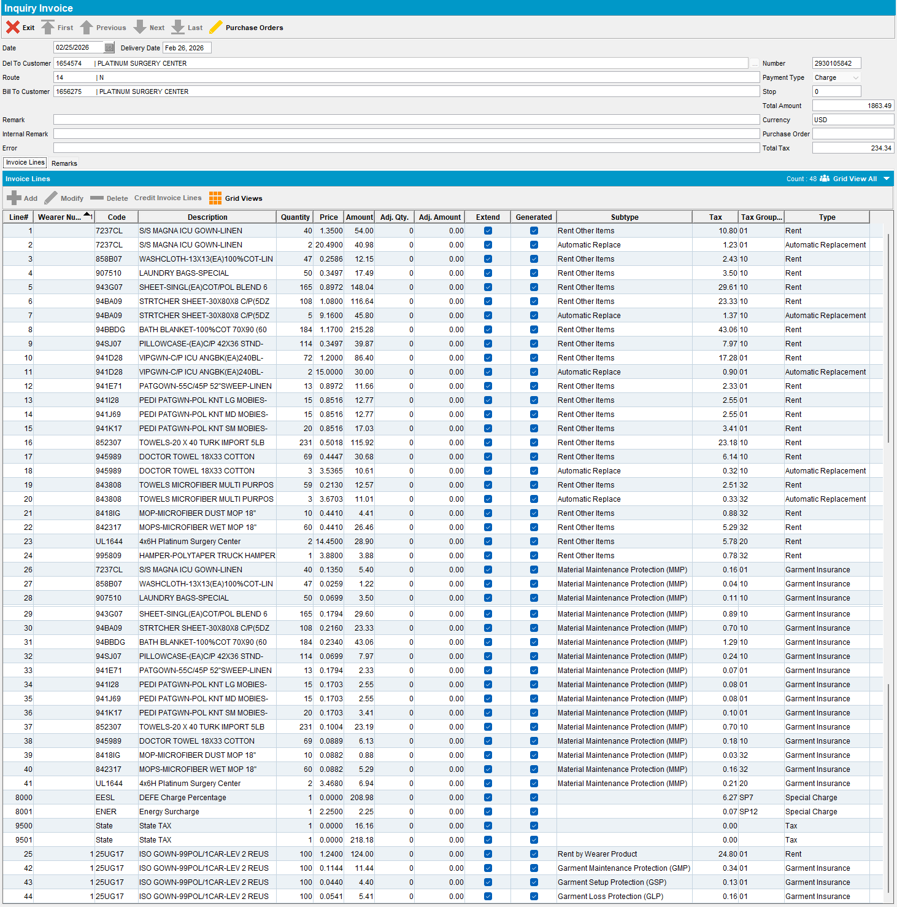
- View Process log dlg:
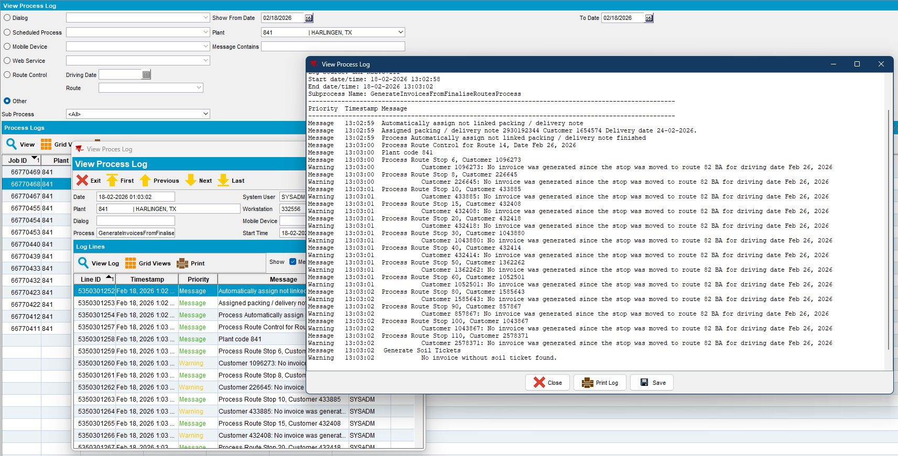
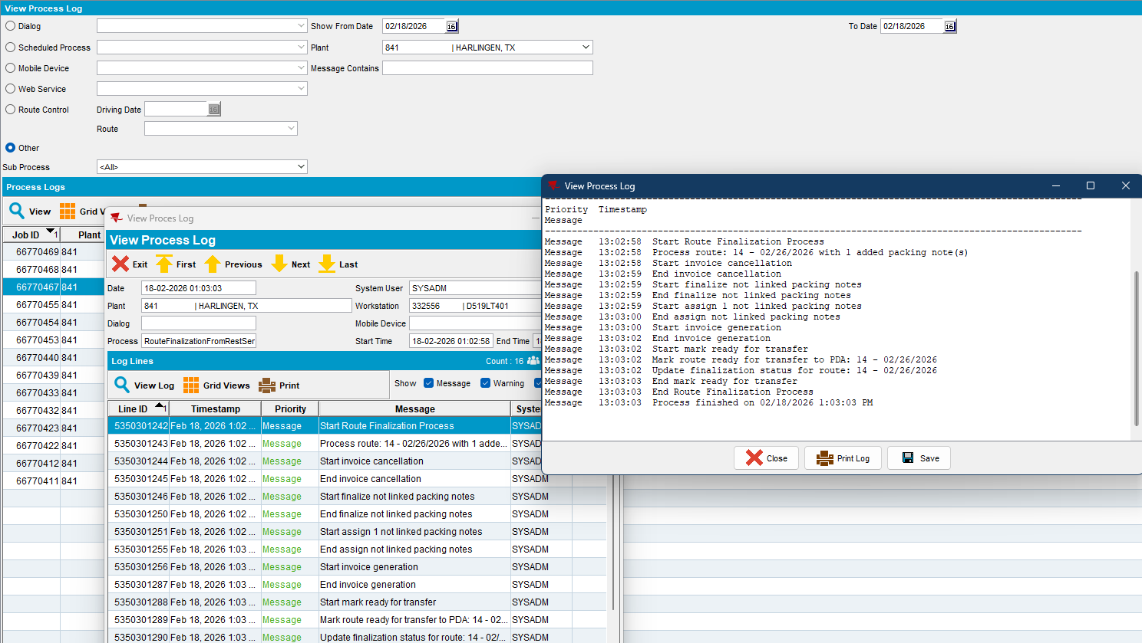
- The manual packing note is attached to the route but not invoiced
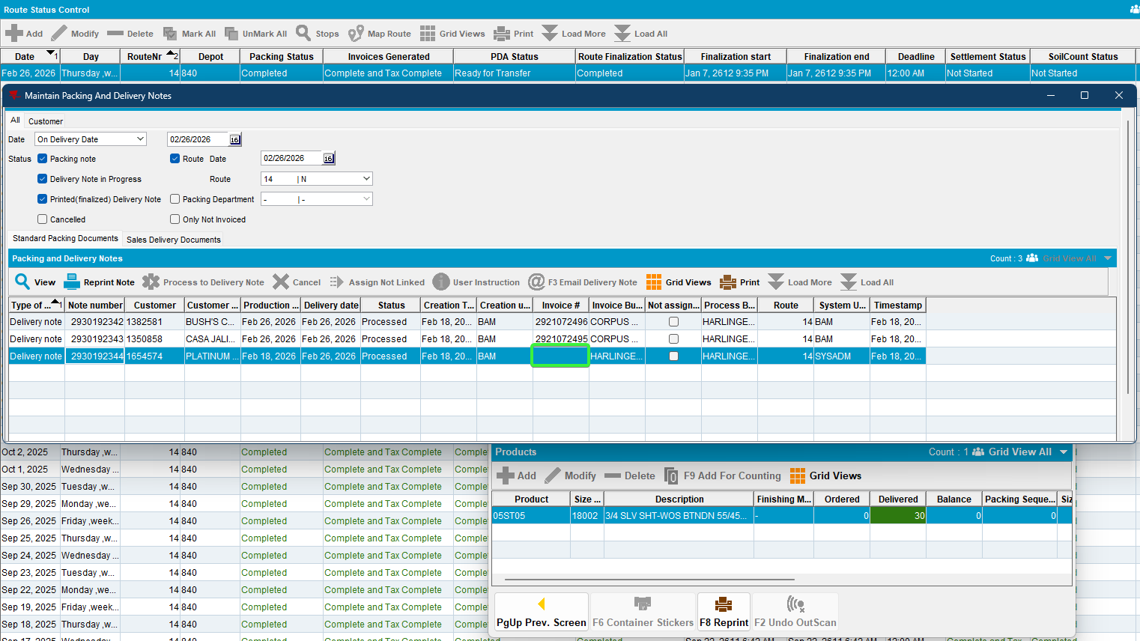
- No new invoice is generated
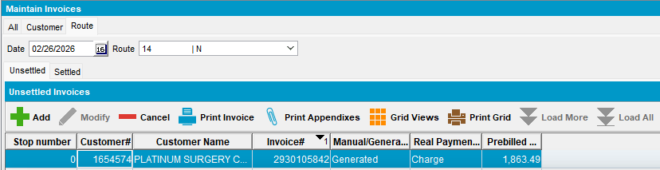
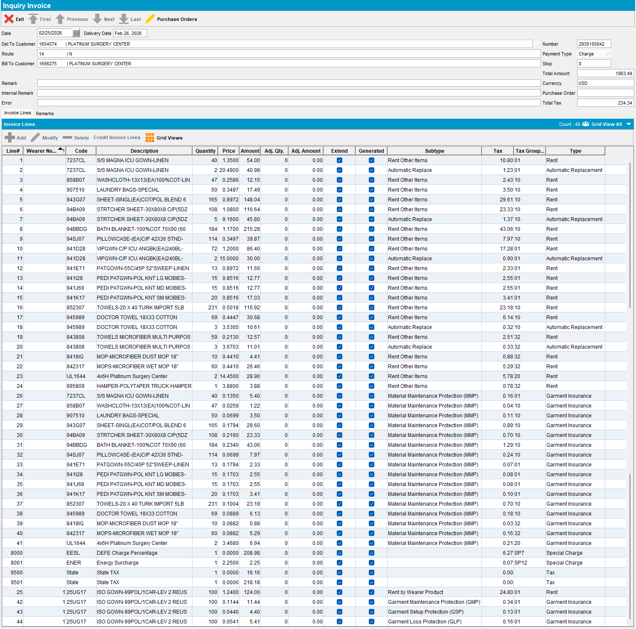
- The Finalization Status is updated to 2

Test Case 4 - Moved stop along with invoice from RSC to a different route but same delivery day – Tested OK

Expected behavior:
- The invoice that was moved in is NOT cancelled and not regenerated.
- Create 2 delivery notes, first with 5 days in the future and the second same delivery date
- The manual packing notes are attached to the route control and invoiced
- A new invoice is generated
- The Finalization Status is updated to 2

Steps to reproduce:
      - RSC dlg: Create route A and route B.
      - RSC dlg: Move a customer 1 from route A to route B
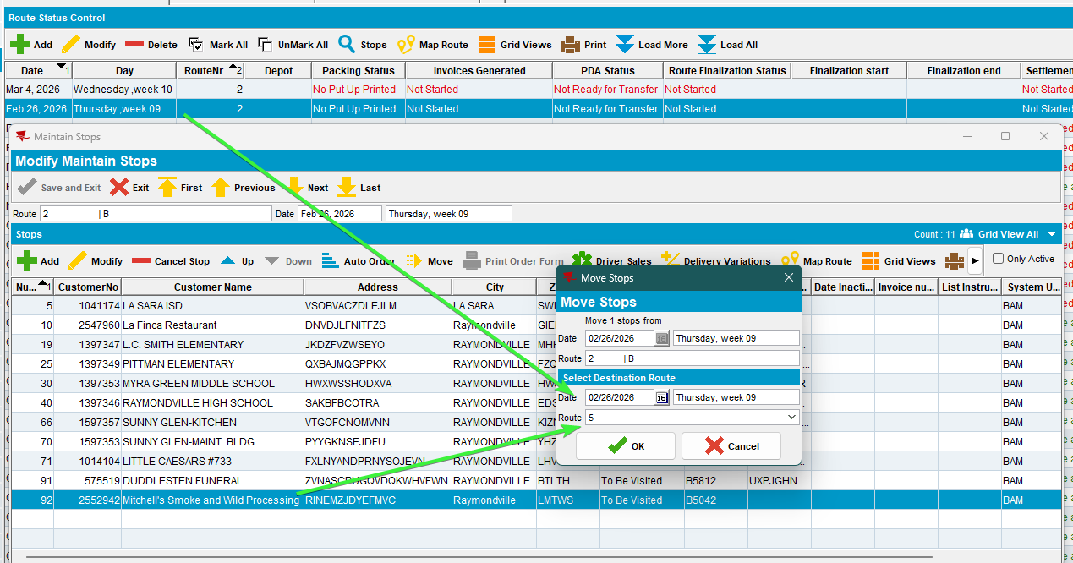
      - RSC dlg: Keep at least another 2 customers on route B (route 5). Generate packing notes, invoices and script the taxes for route B.
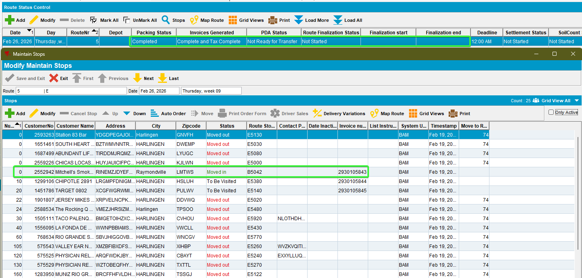
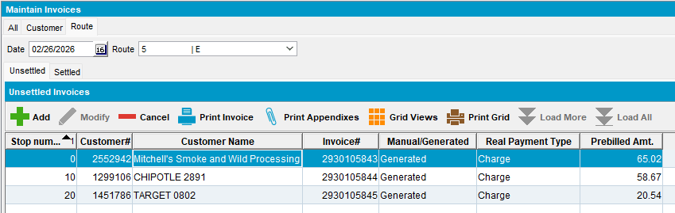
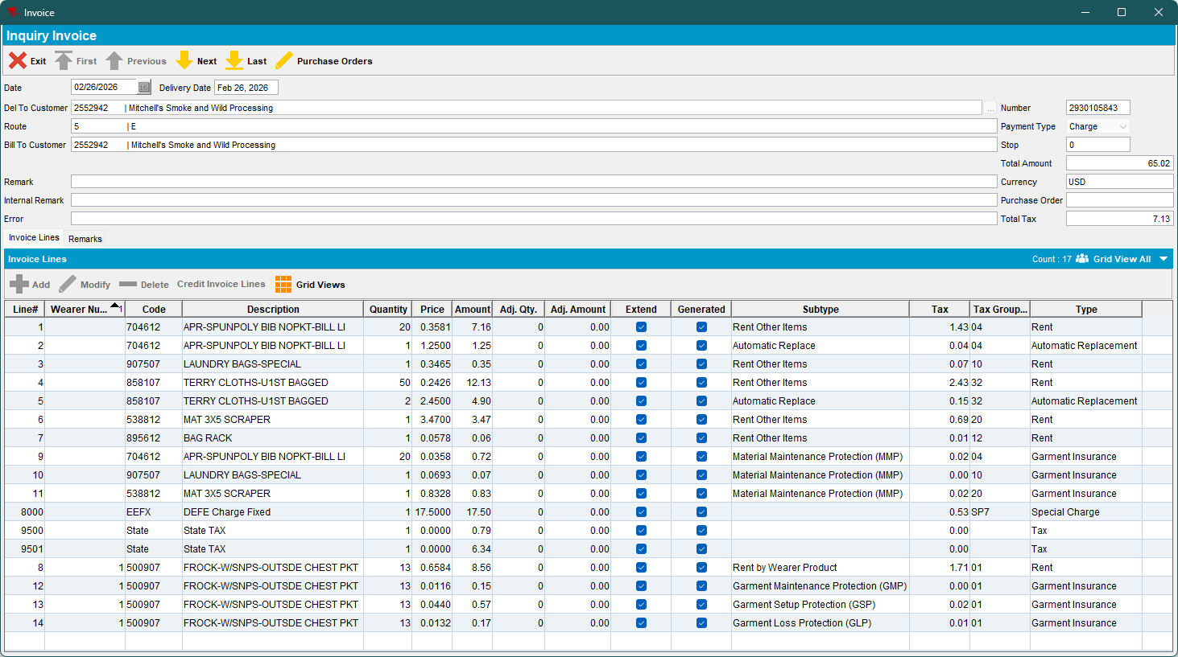
- Delivery note DLG: add a manual packing note for that customer with no routecontrol (Customer A) and a delivery date 5 days in the future (including the weekend days) from driving date
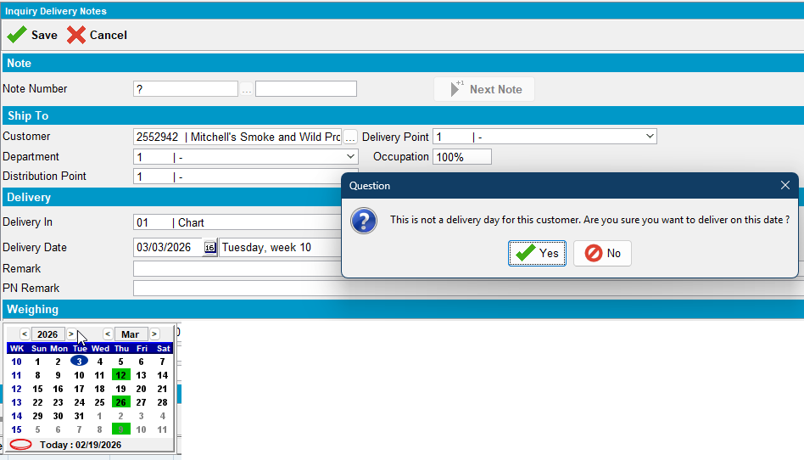
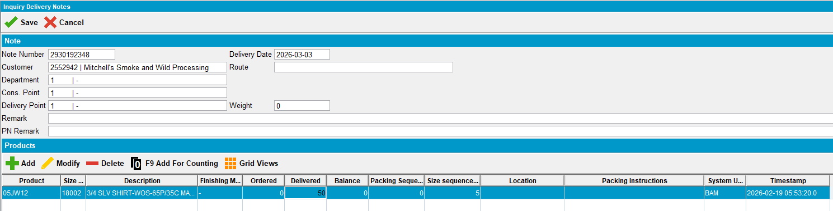
- Delivery note DLG: add another manual packing note for that customer with no routecontrol (Customer A) with same delivery date = driving date
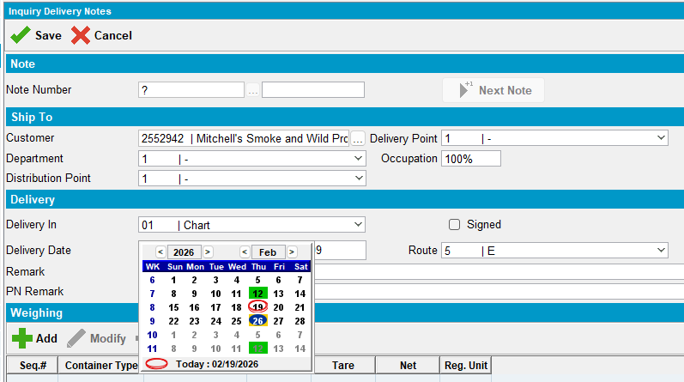
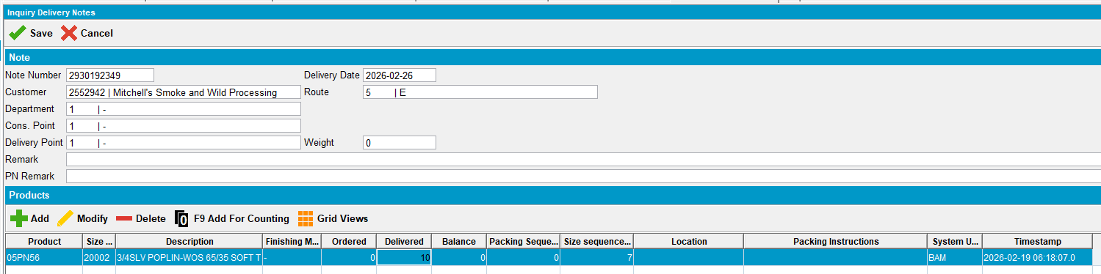
- RSC dlg: Check the delivery notes. One from the same delivery day was already assigned and the other was not.
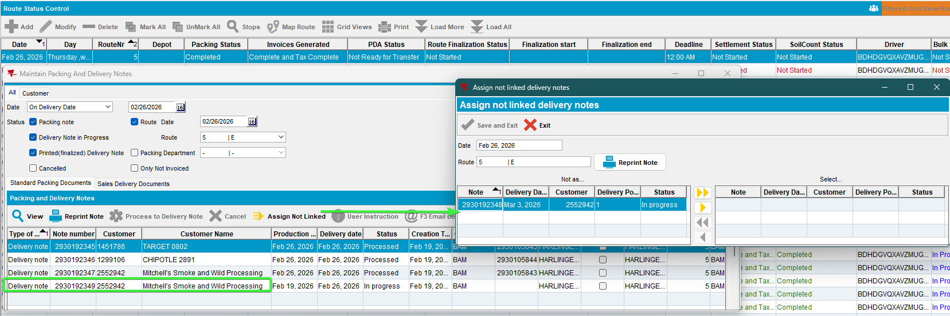
- Postman: Send a finalization request for Route B
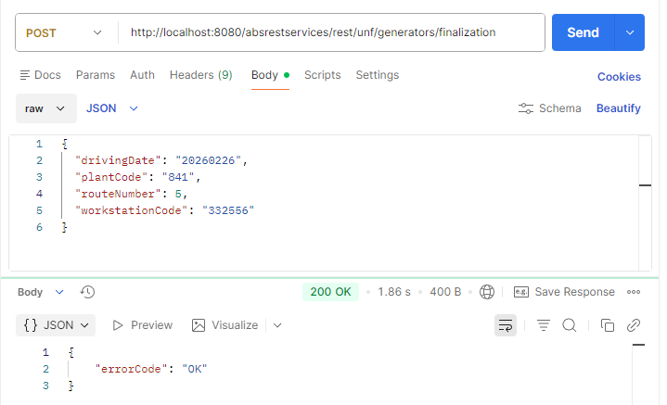

- Maintain Invoices dlg: Check the invoices
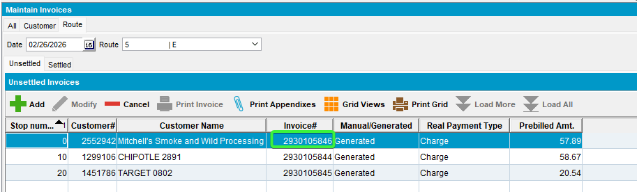
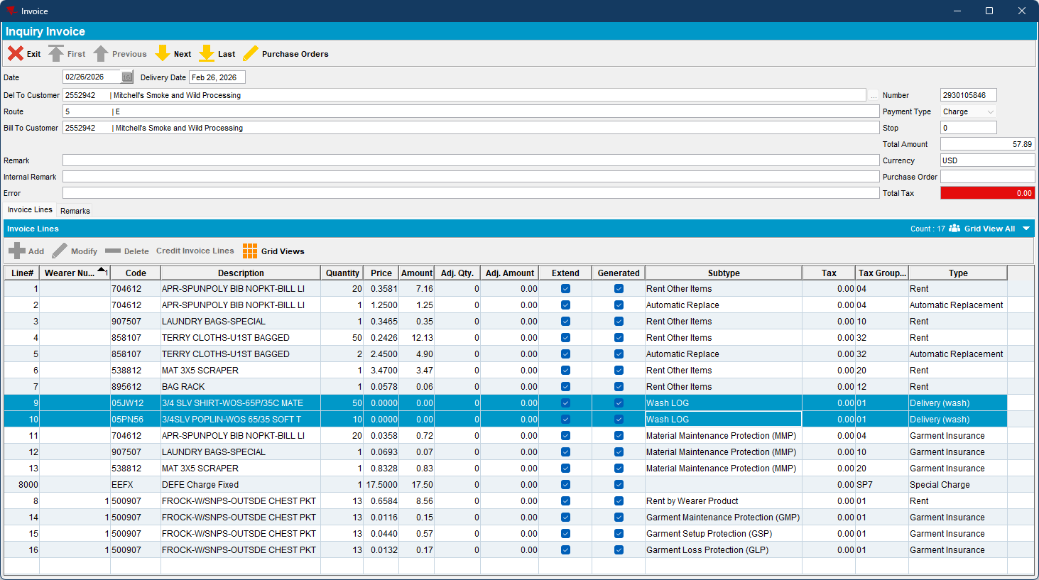
- RSC dlg: Both packing notes were attached and invoiced.
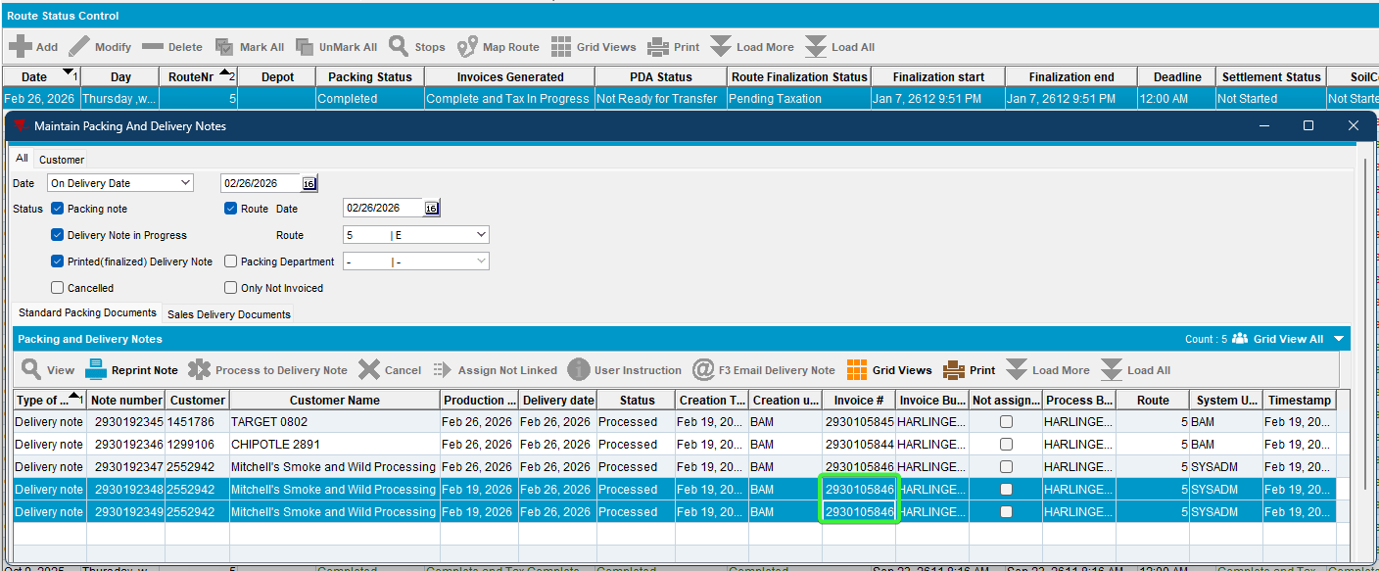
- View Process Log: Check the logs.
- Both of the delivery notes were processed.
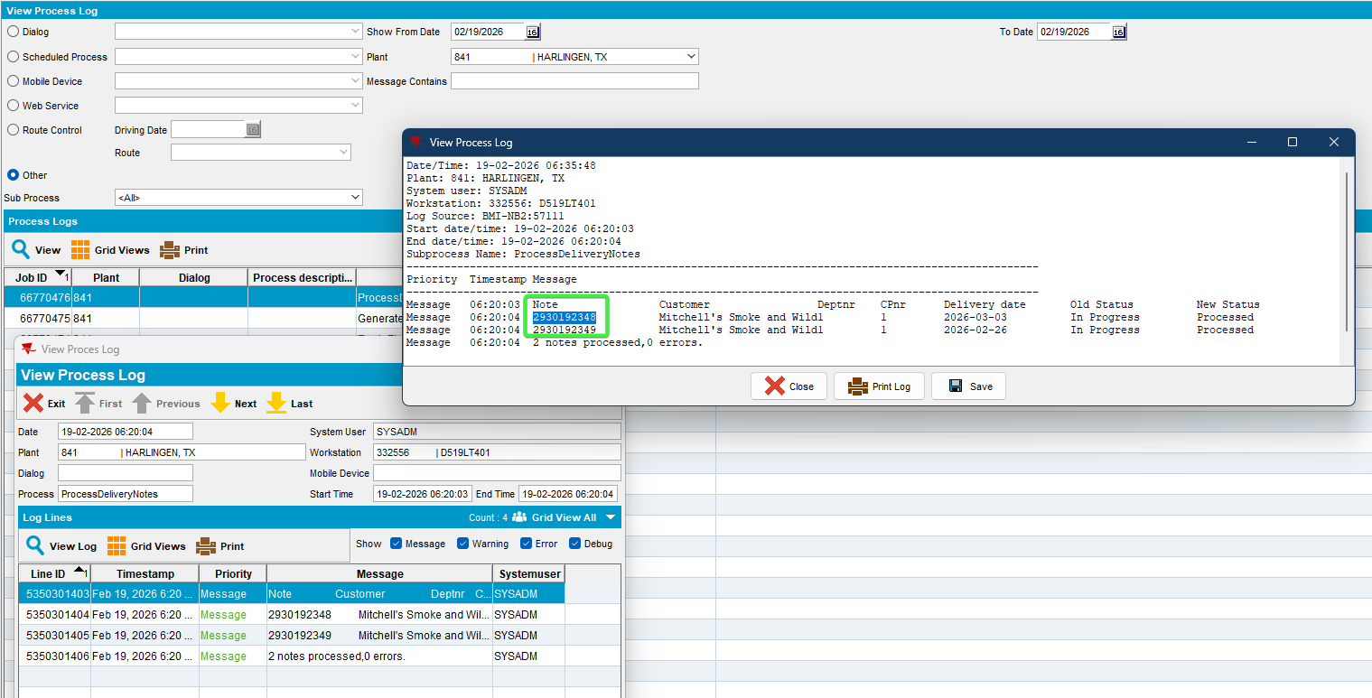
- The invoice was cancelled for the customer which had the new delivery notes and regenerated
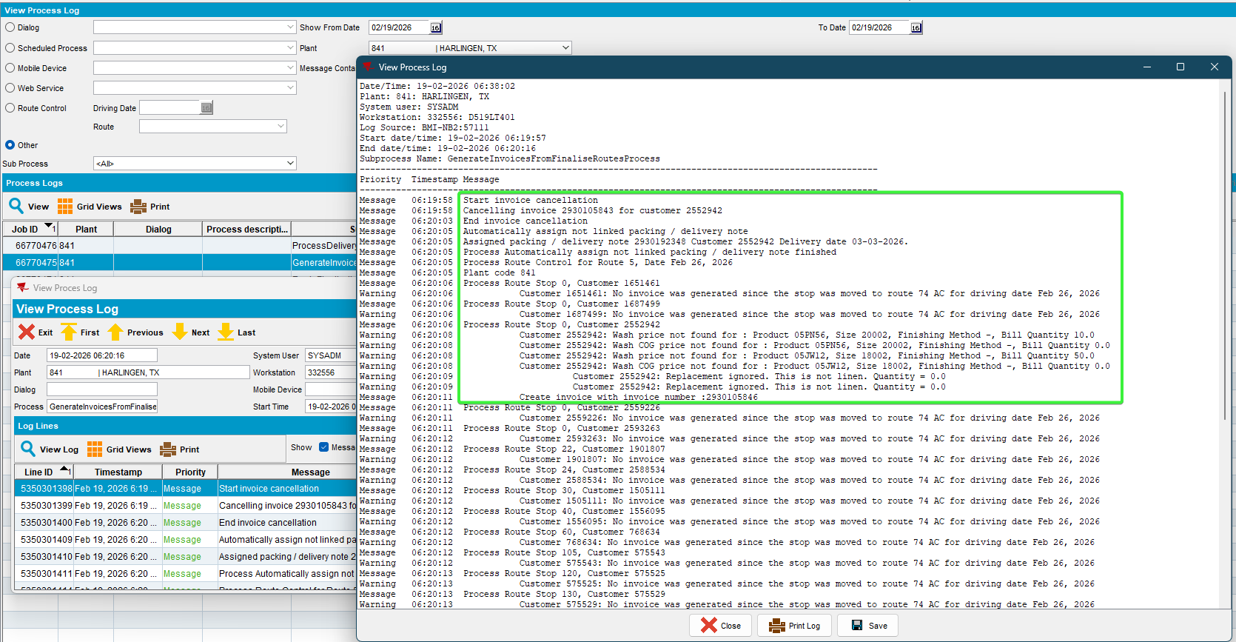
It shows the first delivery note to the route. The second one we’ve created on the same day so it wasn’t needed to assign it, just to invoice it.
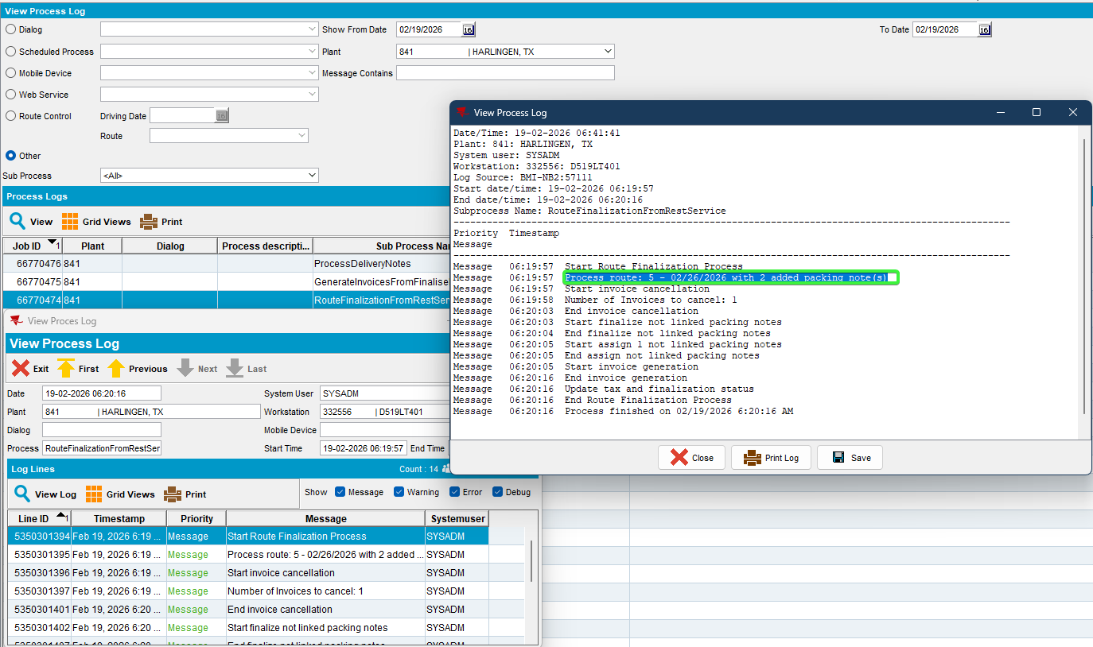

- Script the taxes and run process Vertex. The Finalization Status is updated to 2 for route finalization.

Test Case 5 – Moved customer on a day of week where is already visited but on a different route number – Tested OK

1 customer also visited on route B driving day of week
Route B driving day of week on a different route number
Route A containing customer A generate packing notes, invoices.
Move invoice customer A to route B from Maintain Invoices
Generate invoice for route B
Create sales note for customer A on second route day of driving date B

Expected behavior:
- The invoice that was moved in is NOT cancelled and not regenerated.
- Create 2 delivery notes, first with 5 days in the future and the second same delivery date
- The manual packing notes are attached to the route control and invoiced
- A new invoice is generated
- The Finalization Status is updated to 2

Steps to reproduce:
      - RSC dlg: Create a route A. Choose a customer from route A.
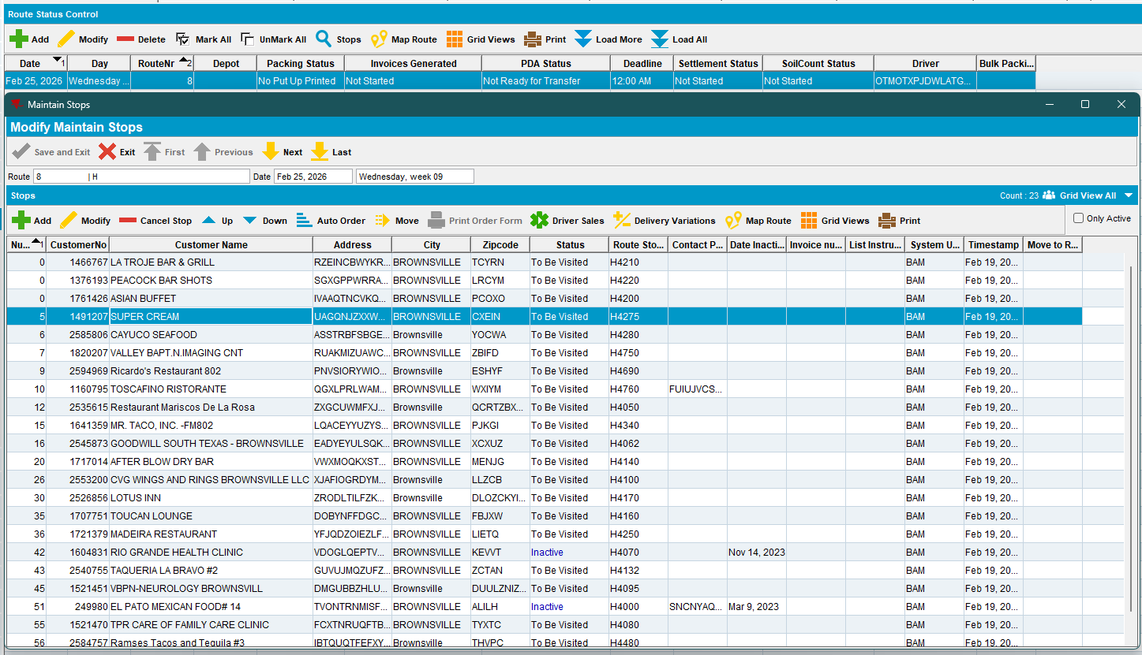
      - Customers dlg: Load the customer and add another route day.
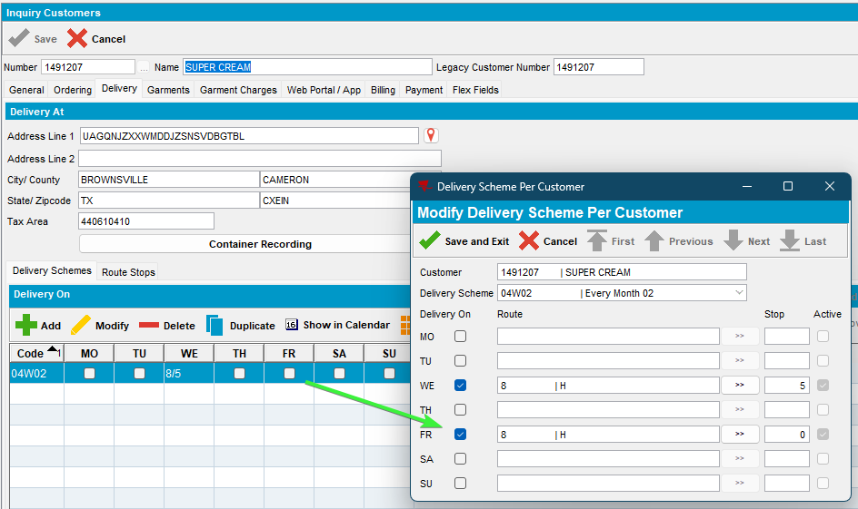
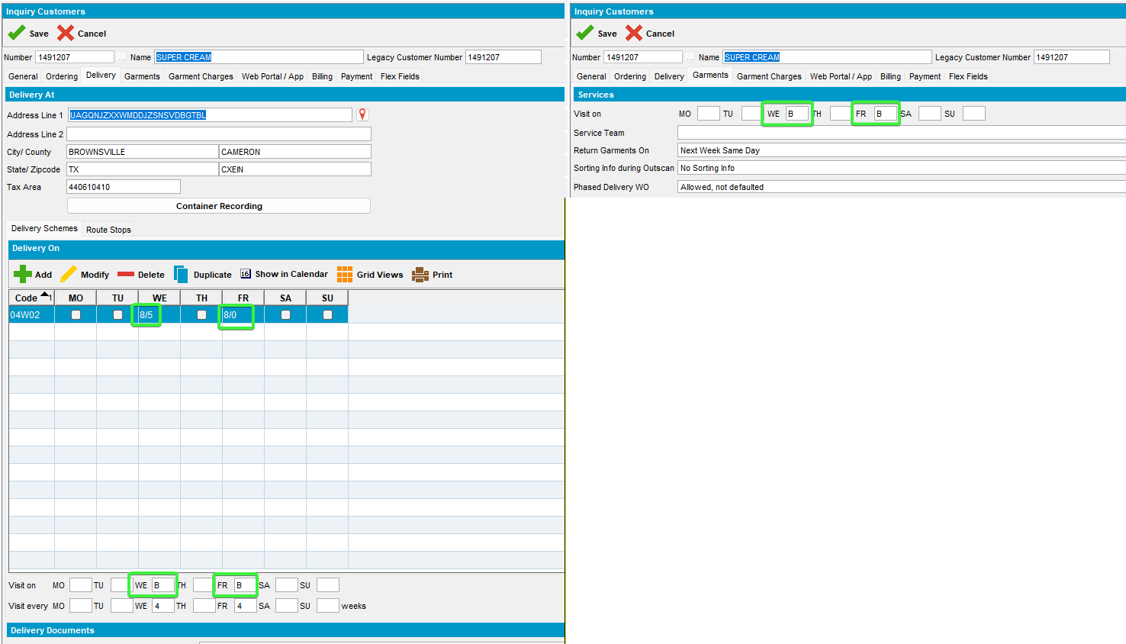
      - RSC dlg: Generate packing notes and invoices for route A, for our customer.
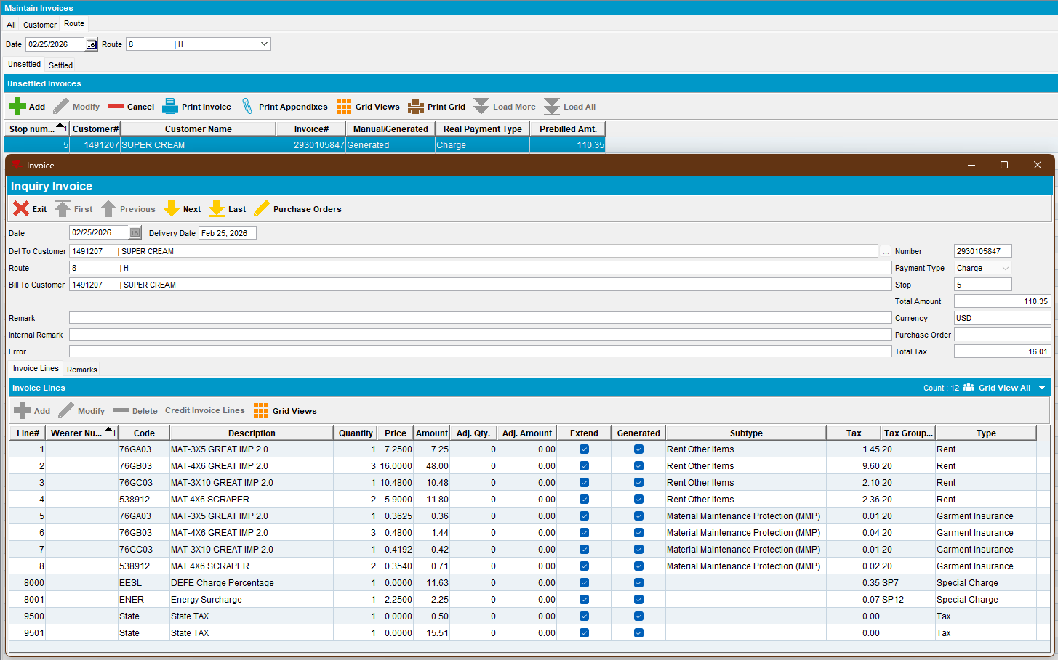
      - RSC dlg: Create route B that will be on Friday with the same route number.
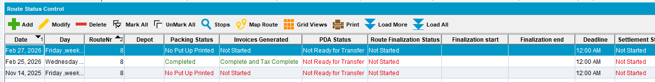
      - Maintain invoices dlg: Move invoice of customer 1 from route A Wednesday to route B Friday ( on Friday is also visited on the new route we’ve added)
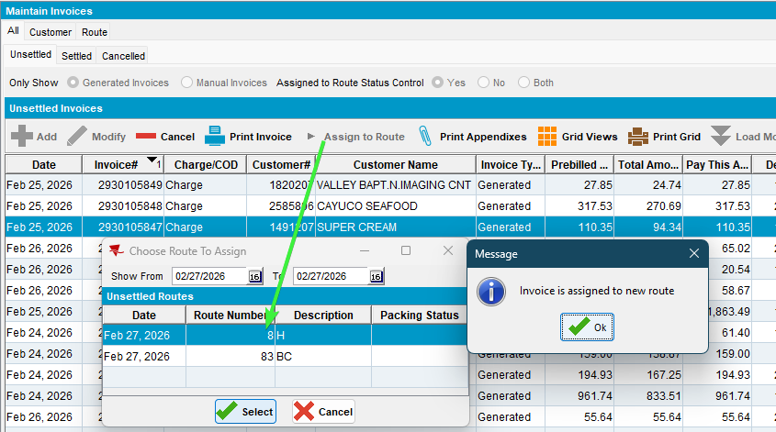

      - RSC dlg: Generate packing notes and invoices for route B, complete with tax.
      - Maintain Sales Notes dlg: Create a sales note for customer A on second route day of driving date B (Friday).
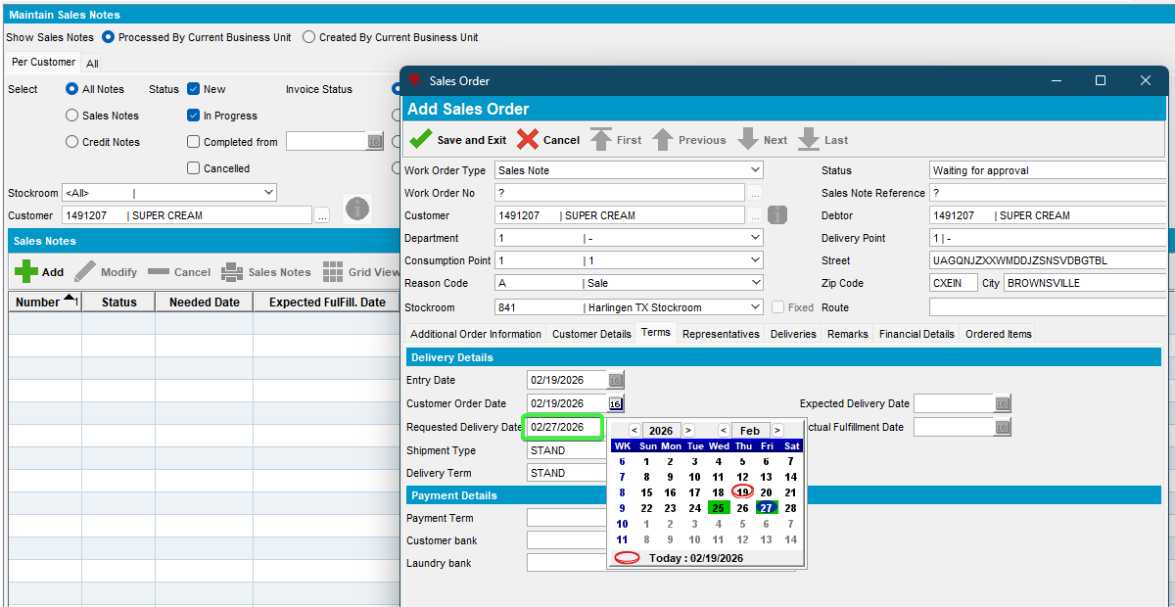
      - Work Orders waiting for approval dlg: Approve the wo.
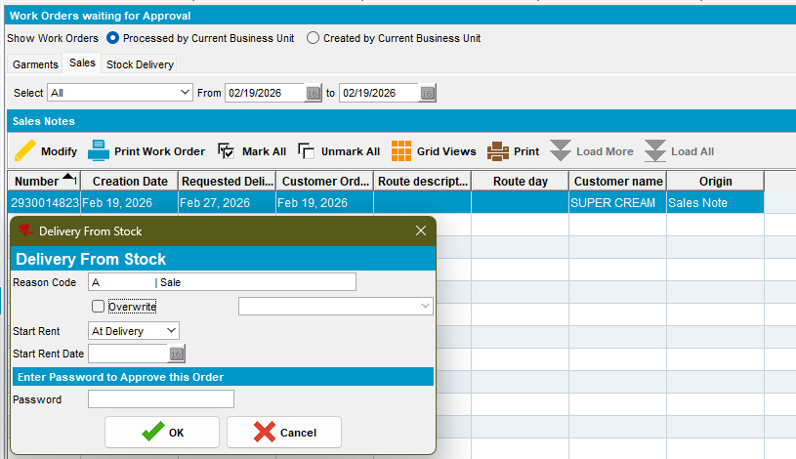
      - Maintain Sales Notes dlg: Issue the sale note with delivery date on Friday (the new delivery date)
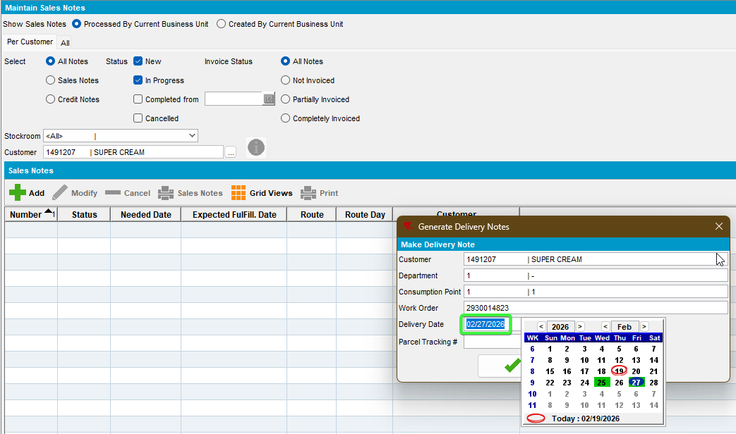
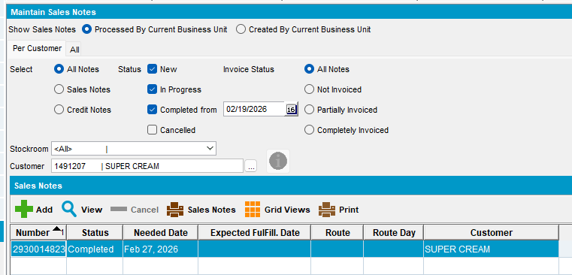
      - Run finalization on route B
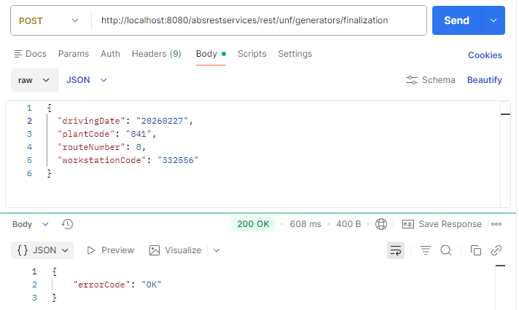
      - RSC dlg: Check the packing notes, the sales note was assigned to the new route day.
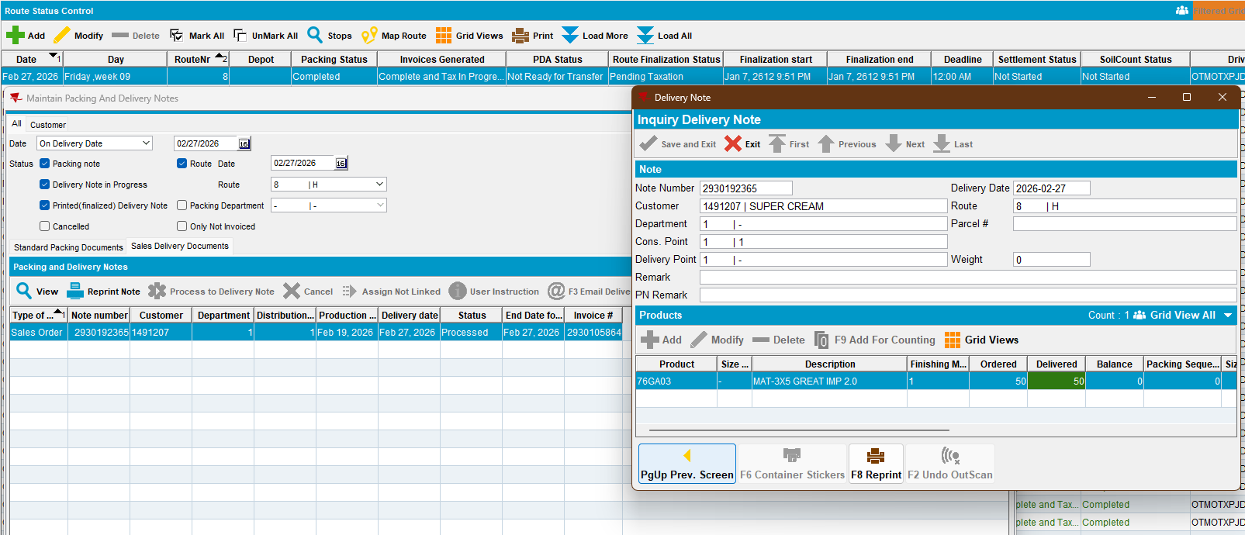
The invoice that was moved was not regenerated.
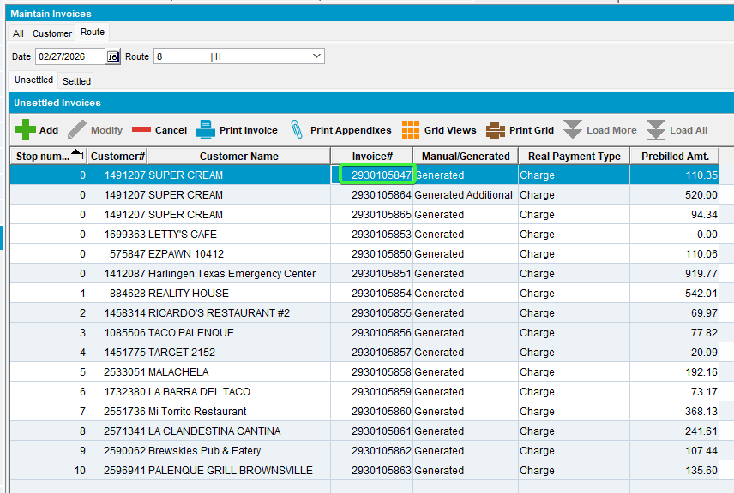
      - Maintain Packing and delivery notes dlg: The sales note was linked to the Friday route and invoiced.
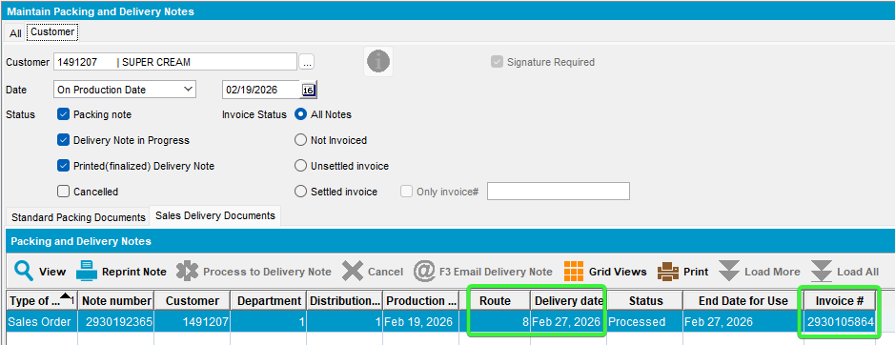
      - View Process Log dlg: Check the log for route finalization.
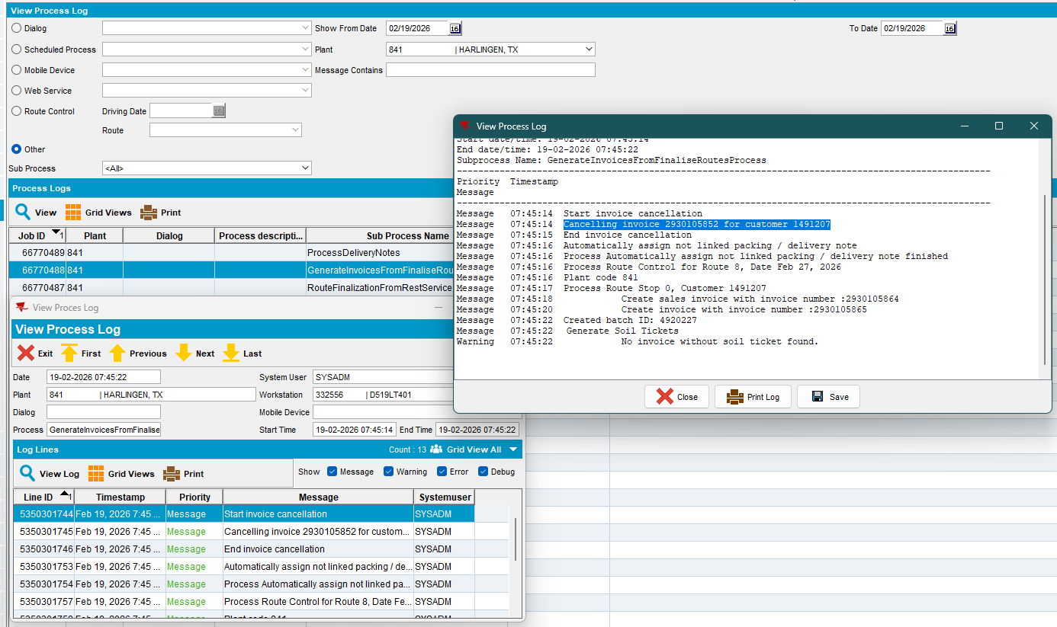
It recreated the second invoice and attached the sales note to the Friday route.

