ABSN-14208 FreedomPay amounts for negative adjustments
DataBase | Preconditions
Version:9.07.00.UNF17.p19  DBServerName= abs-srv20.internal.abslbs.com  DBSID=CUST22  DBUser=UNFLIVE | - Module:  - System setting:
Contents
Summary: Retest after fix 1
Test case #1 – Full negative adjustment 1
Test case #2 – Partial negative adjustment 3
Test case #3 – Positive adjustment 5
Test case #4 – Rounding 6

Summary: Retest after fix
Preconditions: Hash: 9.07.00.UNF17.p19 hash: d3bc6c10145b

Test case #1 – Full negative adjustment

- Have a settled invoice with a line having a full negative adjustment.
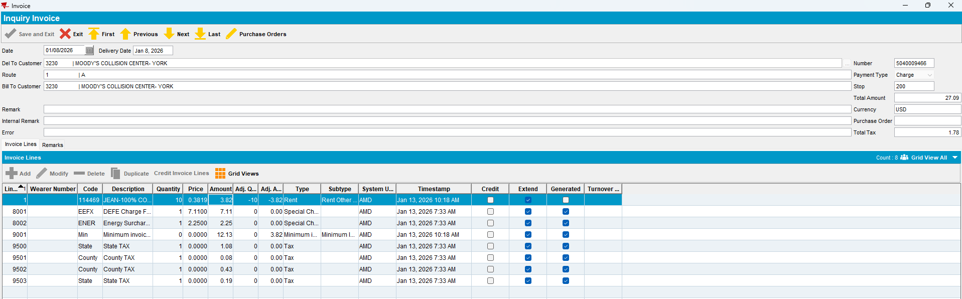

- Generate Credit Card Transactions.
- Process Credit Card Transaction.
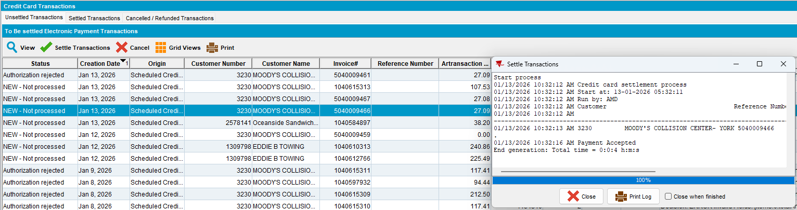
The transaction was processed successfully.

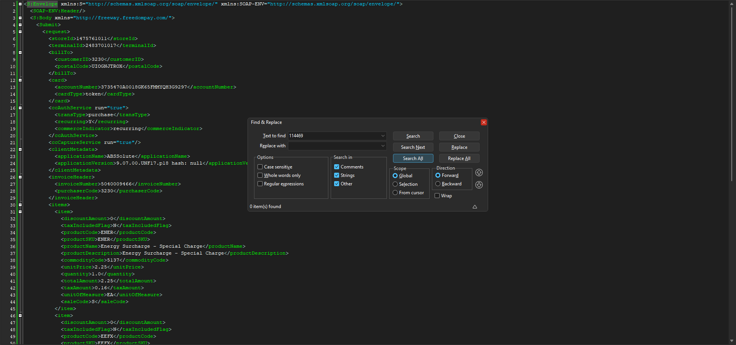
The product is not included in the request.

Test case #2 – Partial negative adjustment

- Have a settled invoice with a line having a partial negative adjustment.
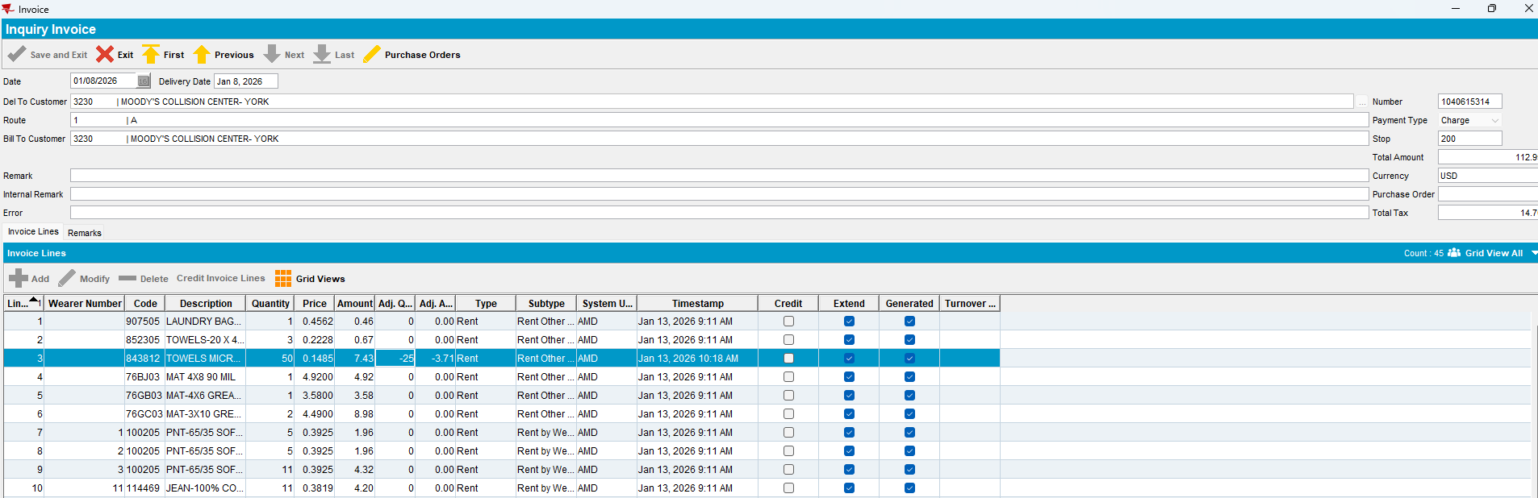

- Generate Credit Card Transactions.
- Process Credit Card Transaction.
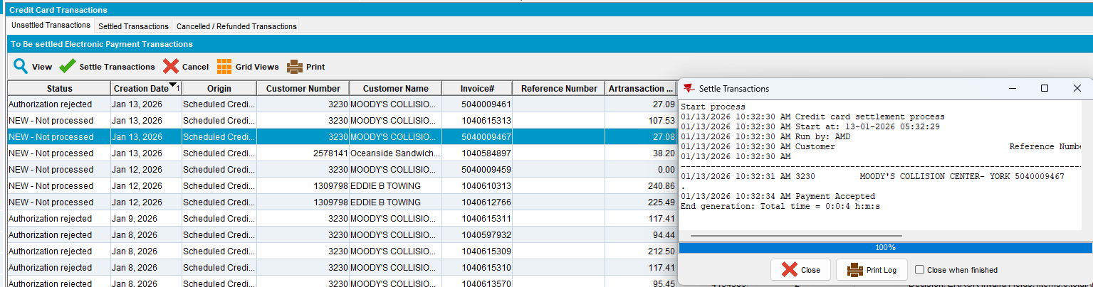
The transaction was processed successfully.

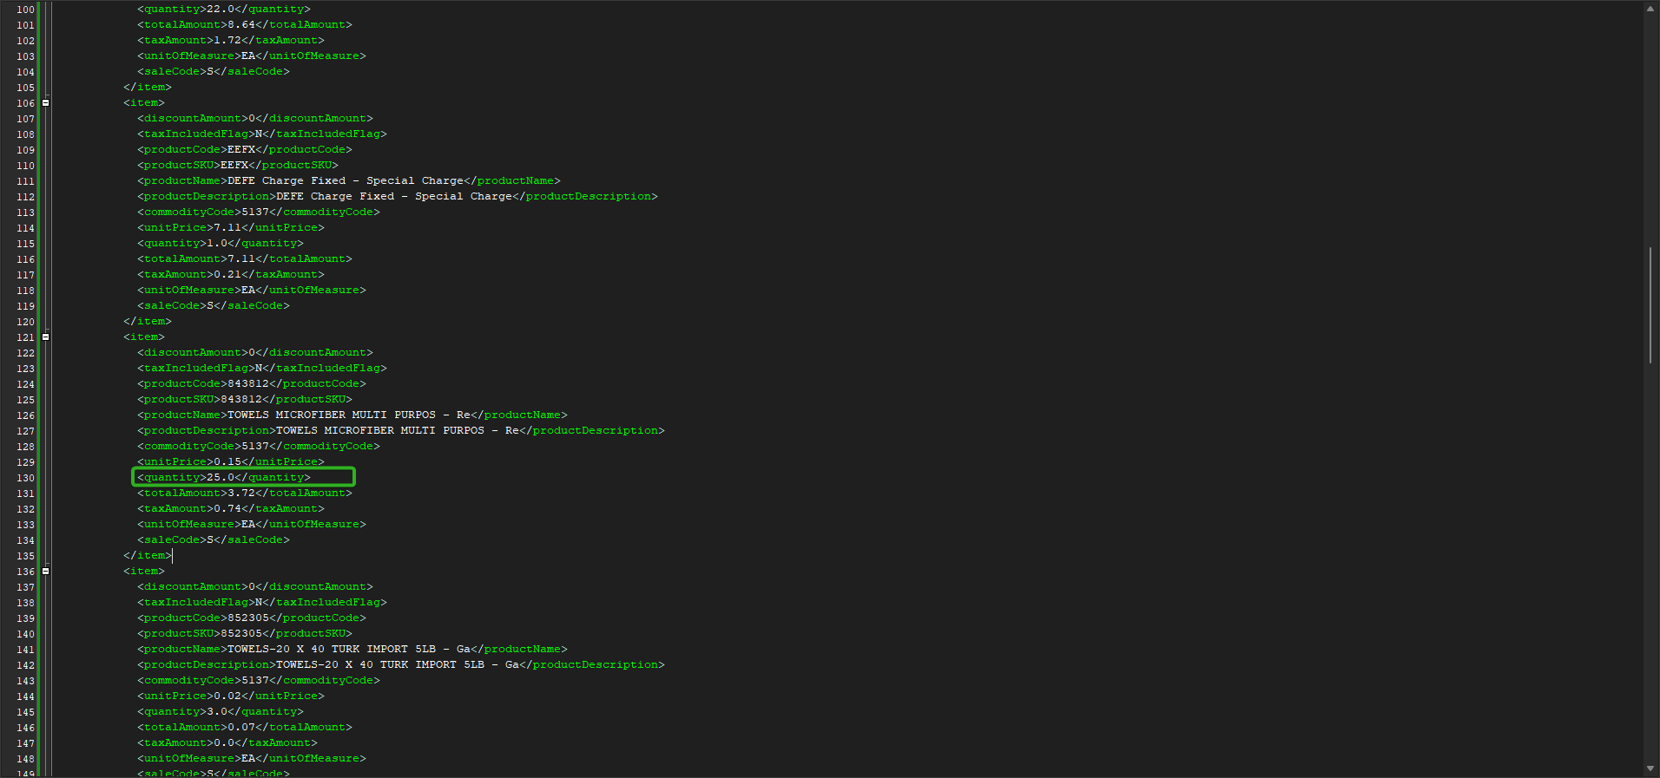
The quantity for the product is correct in the request.

Test case #3 – Positive adjustment

- Have a settled invoice with a line having a positive adjustment.
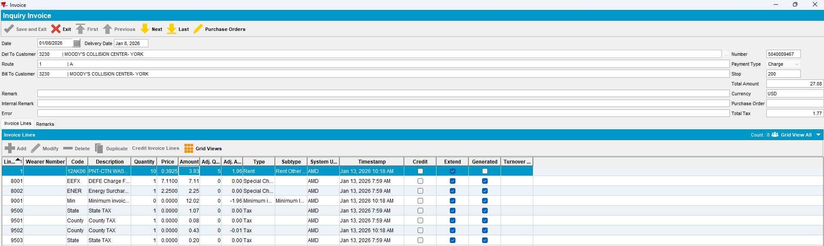

- Generate Credit Card Transactions.
- Process Credit Card Transaction.
The transaction was processed successfully.

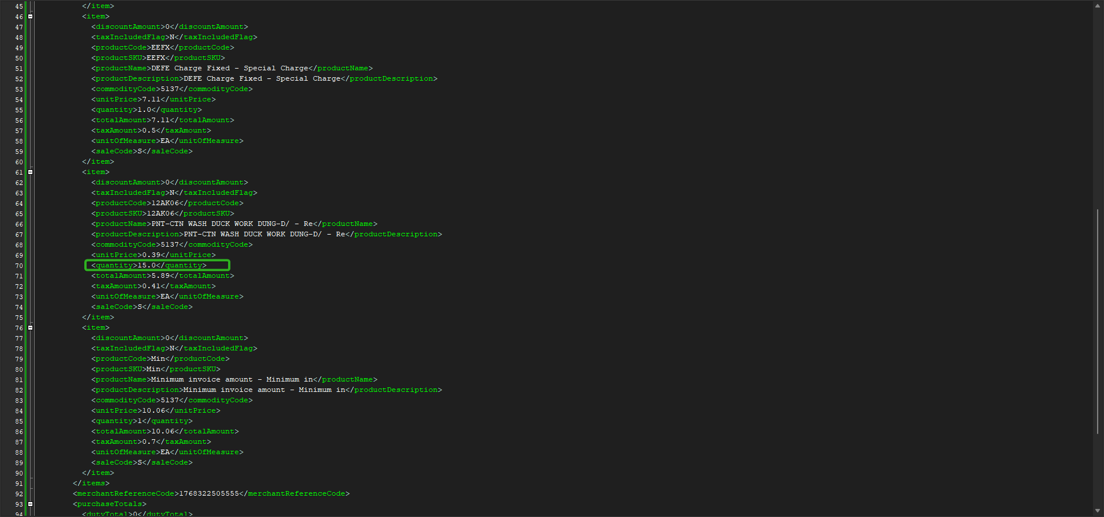
The quantity for the product is correct in the request.

Test case #4 – Rounding

The rounding should be applied to the first line that has a value greater than the rounding value.

- Have a settled invoice.
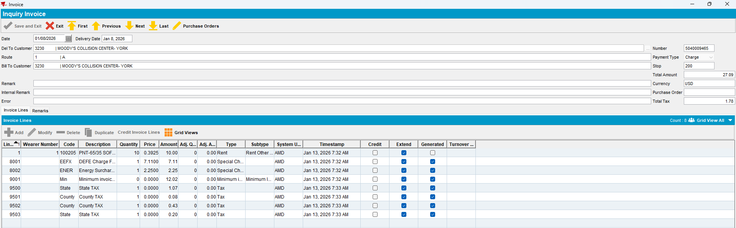

- Generate Credit Card Transactions.
- Modify the amount value of an invoice line in the database to allow the rounding to be applied.
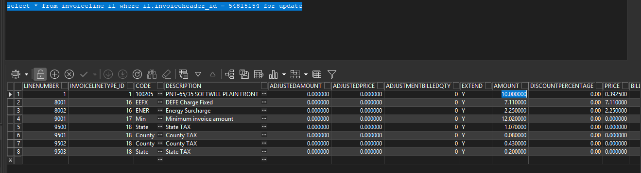

- Process Credit Card Transaction.
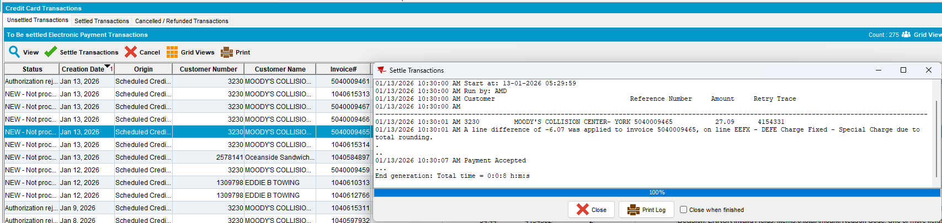
The transaction was processed successfully, and the rounding was applied to the first line with an amount greater than the rounding value.

