ABSN-7227 D_UBS_2234 General price lists with usage contract not reactivated when reactivating a contract customer
Environment | Prerequisites
Version:9.07.00  DBServerName=abs-SRV20.internal.abslbs.com  DBSID=CUST24  DBUser=UNFDEV  Environment=Test | - Module:  - System setting

Contents
Reproducing before fix 1
Steps to reproduce 1
Current Behavior 4
Expected behavior 5
Retest after fix 5
Test Case 1 – Add the customer again to the inactive contract – Tested OK 5

Reproducing before fix

Steps to reproduce
- Have a customer that is active on a contract(C1) and inactive on another contract(C2)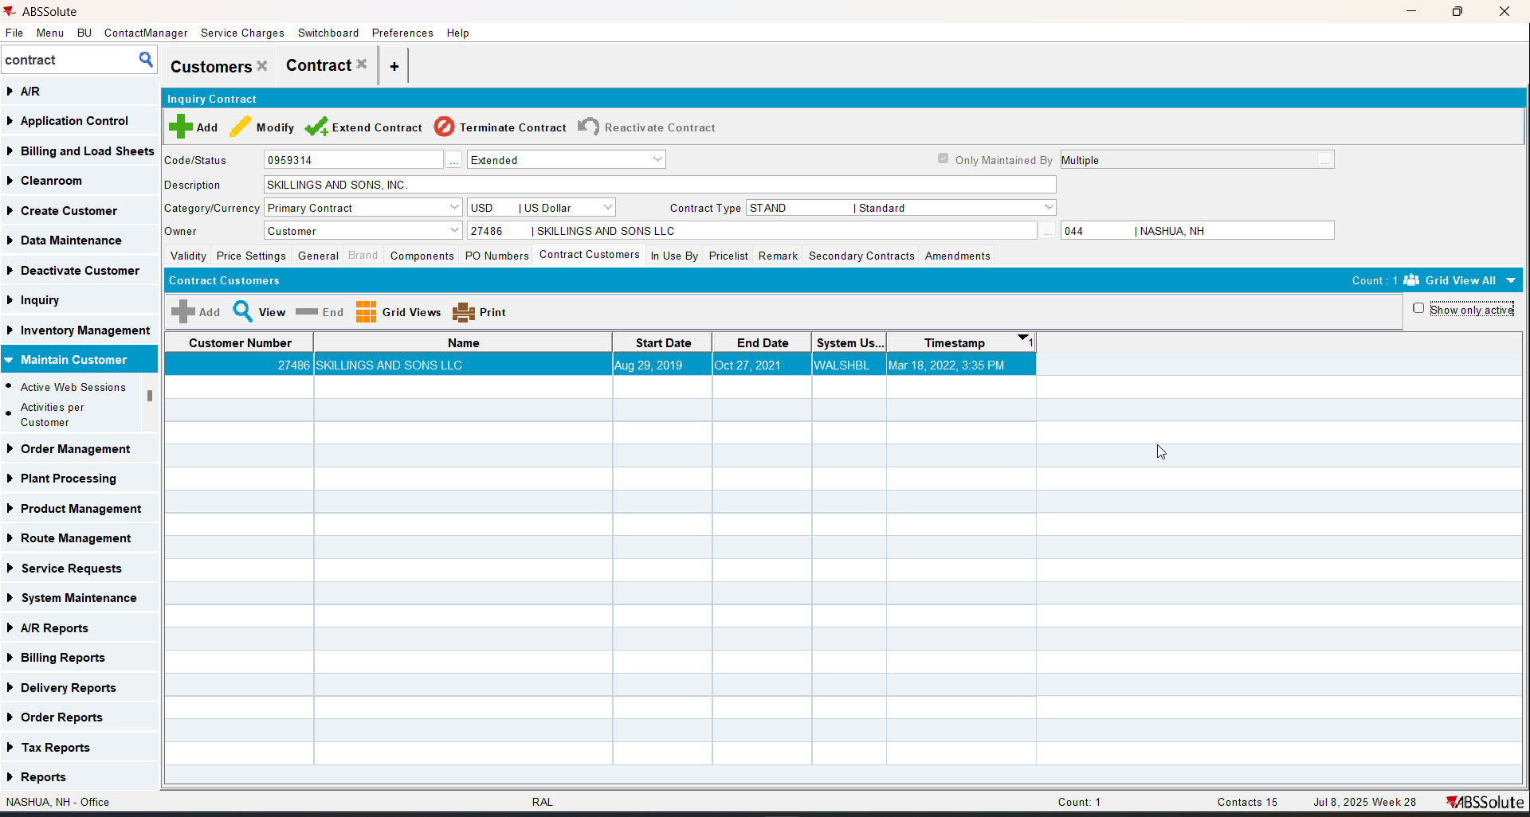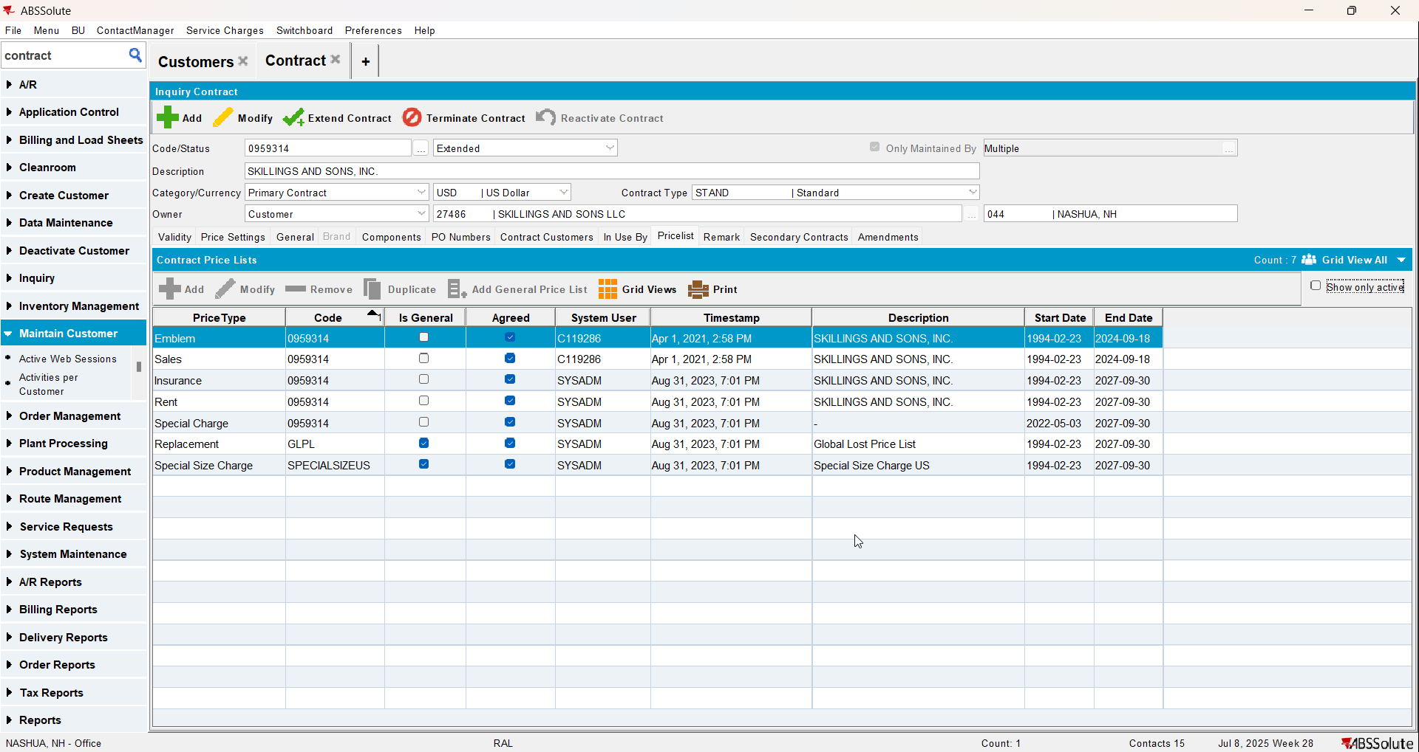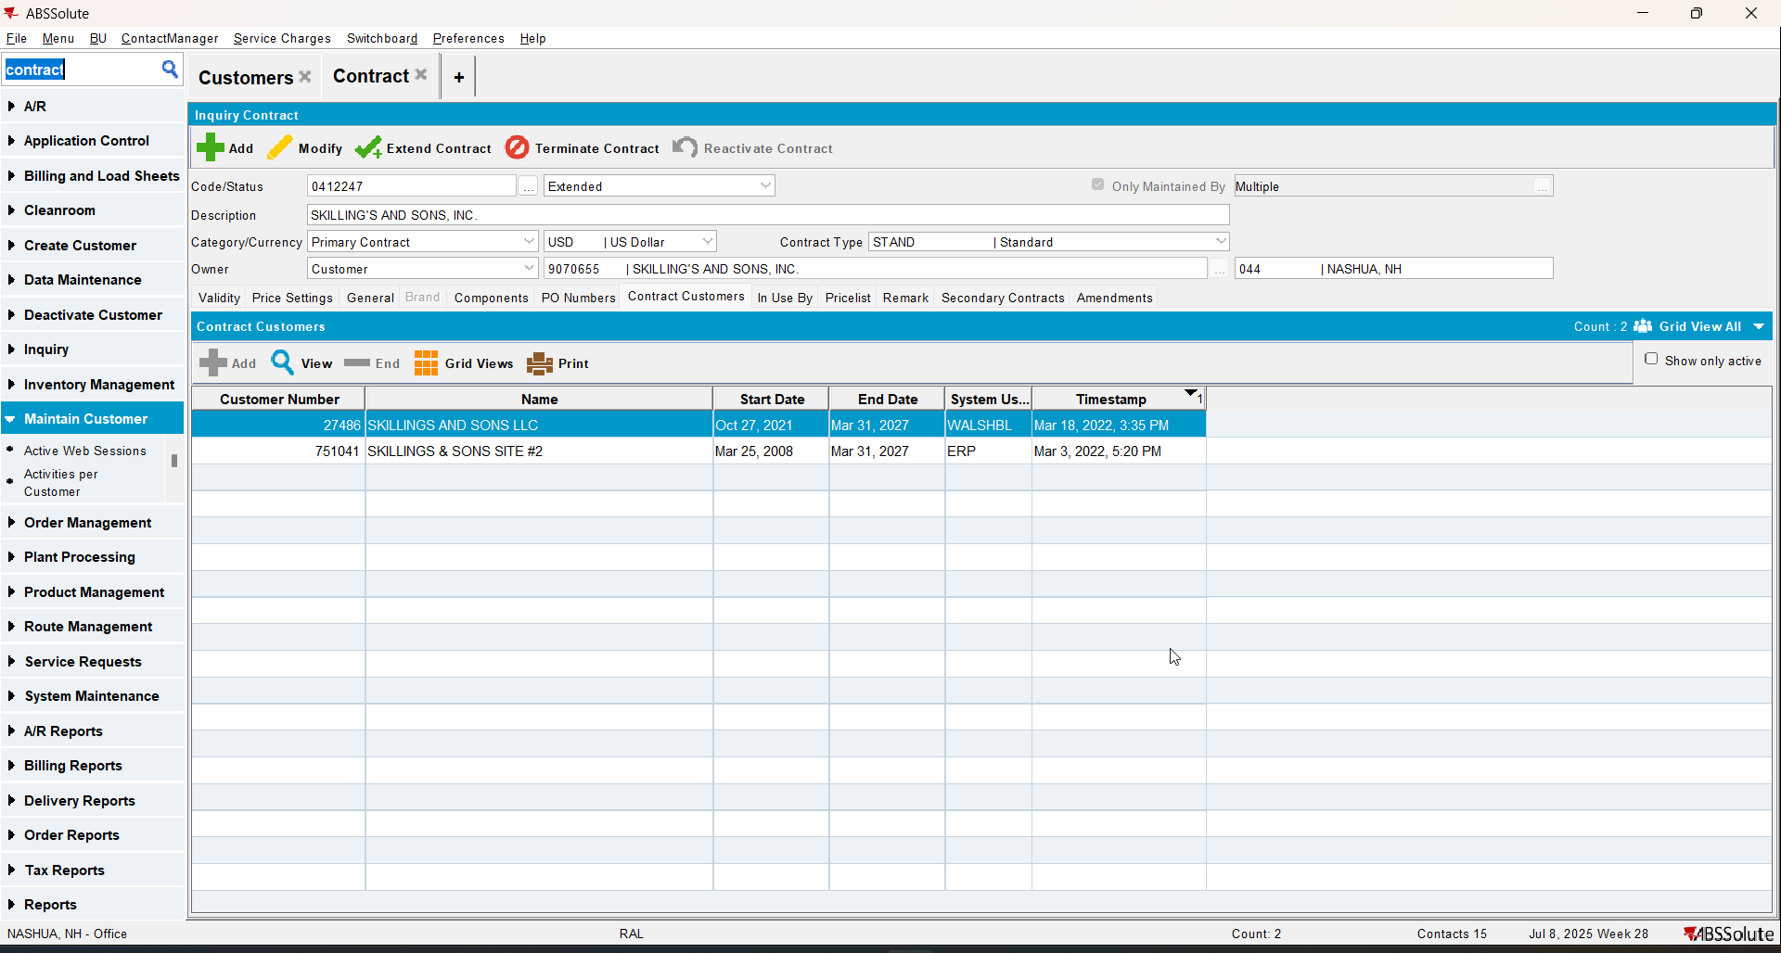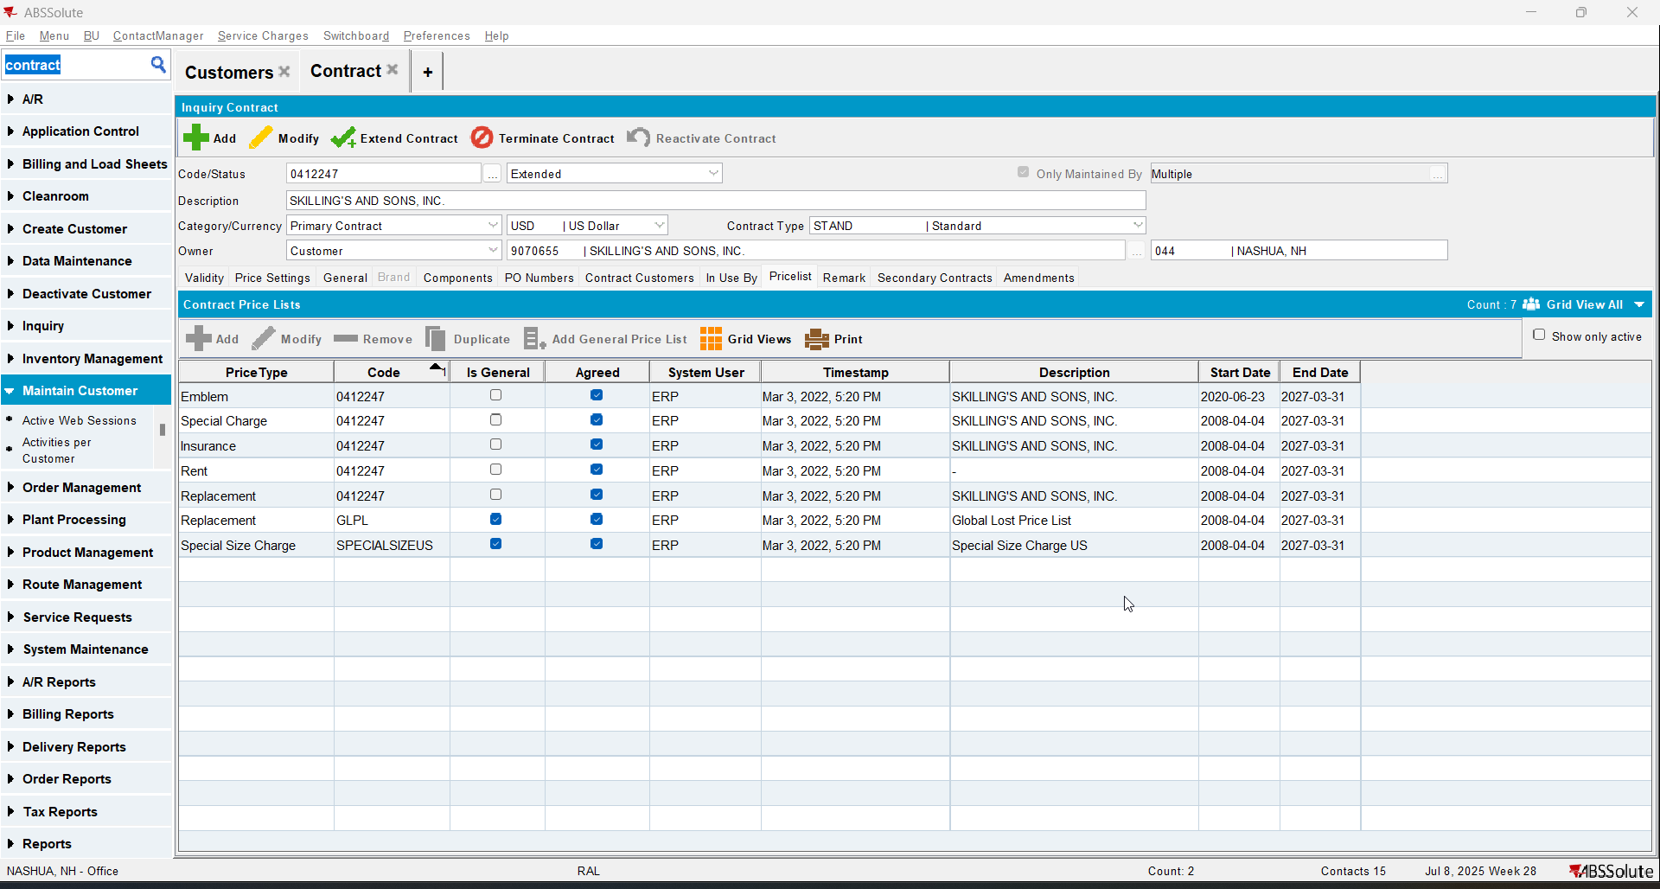
- Go to Price Lists Per Customer dlg and check the price lists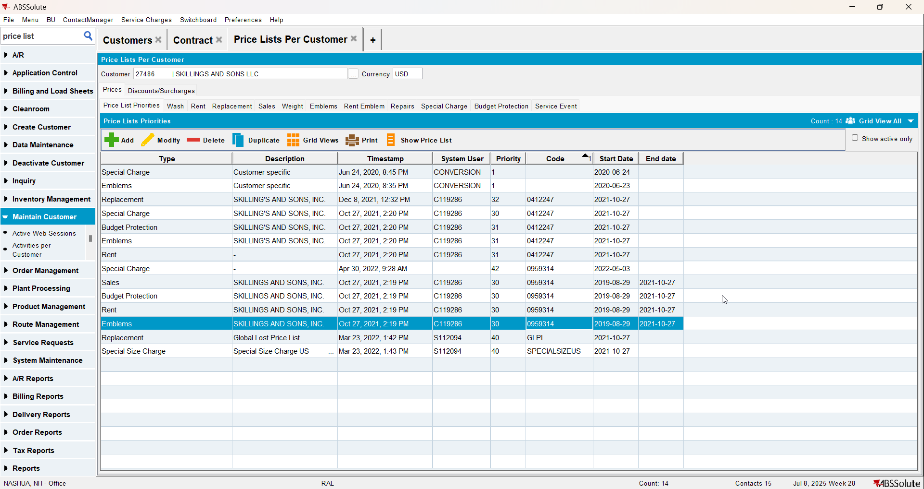
- Go to the active contract(C1) and end date that customer on the contract with a date in the past(D1)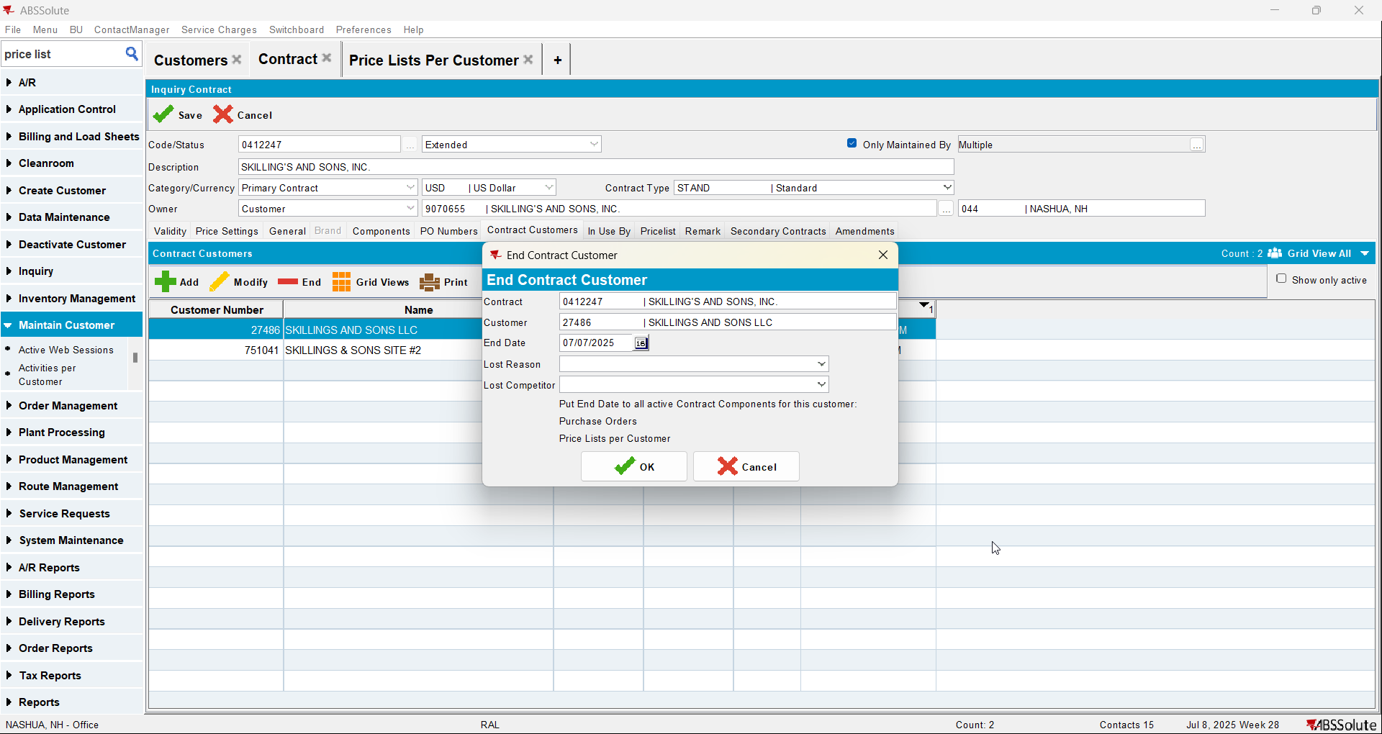
- Go to the contract C2 and add that customer again to the contract with a date D2=D1+1 day
- Go to Price Lists Per Customer dlg and check the price lists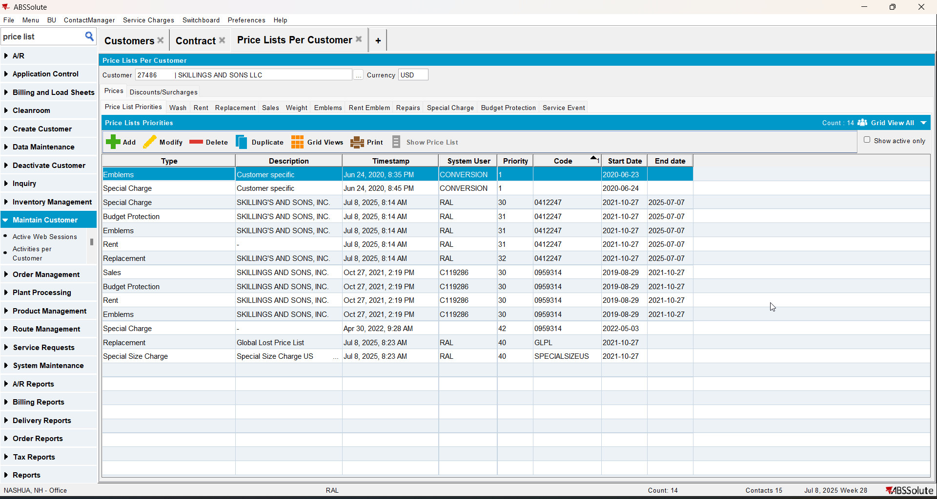
REPRODUCED OK.

Current Behavior
The price lists corresponding to C1 and C2 are both inactive (no change on the end date for C1)

Expected behavior
The price lists corresponding to C1 should be active (same start date as they had initially, no end date)

Retest after fix

Test Case 1 – Add the customer again to the inactive contract – Tested OK
Expected behavior: The price lists corresponding to CONTR1 should be active (same start date as they had initially, no end date)
Hash: 51a2556
- Have a customer that is active on a contract(C1) and inactive on another contract(C2)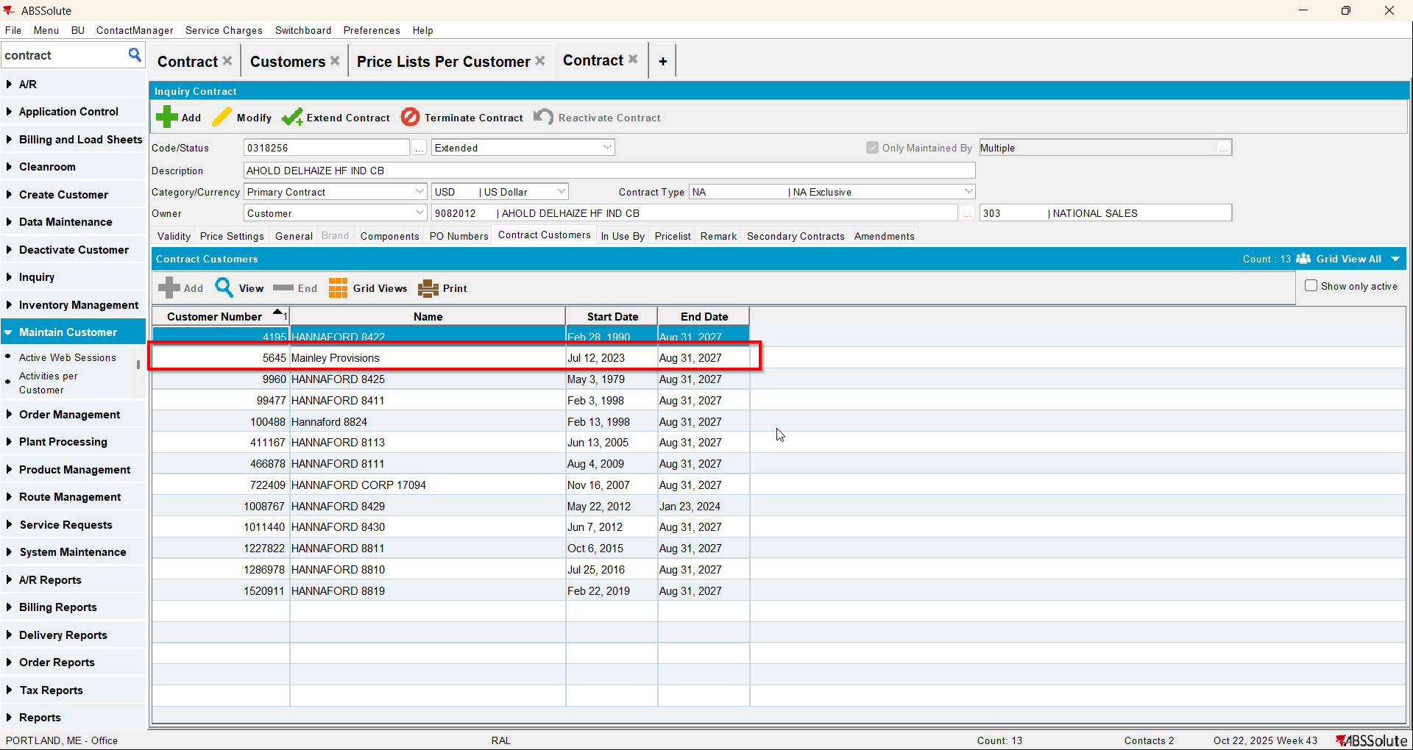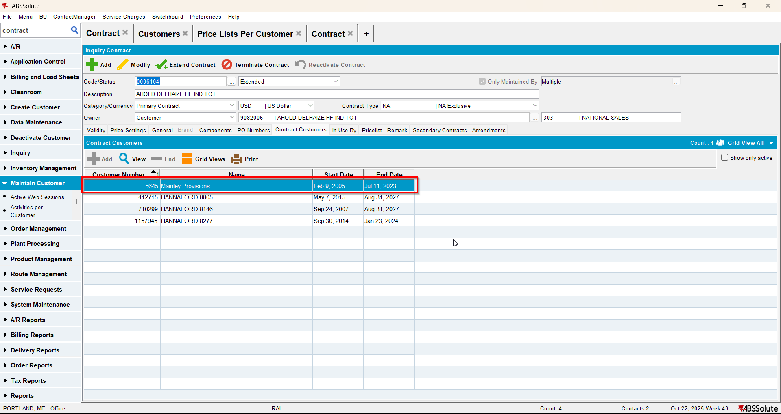
- Check that on the inactive contract one of the price lists is end dated in the past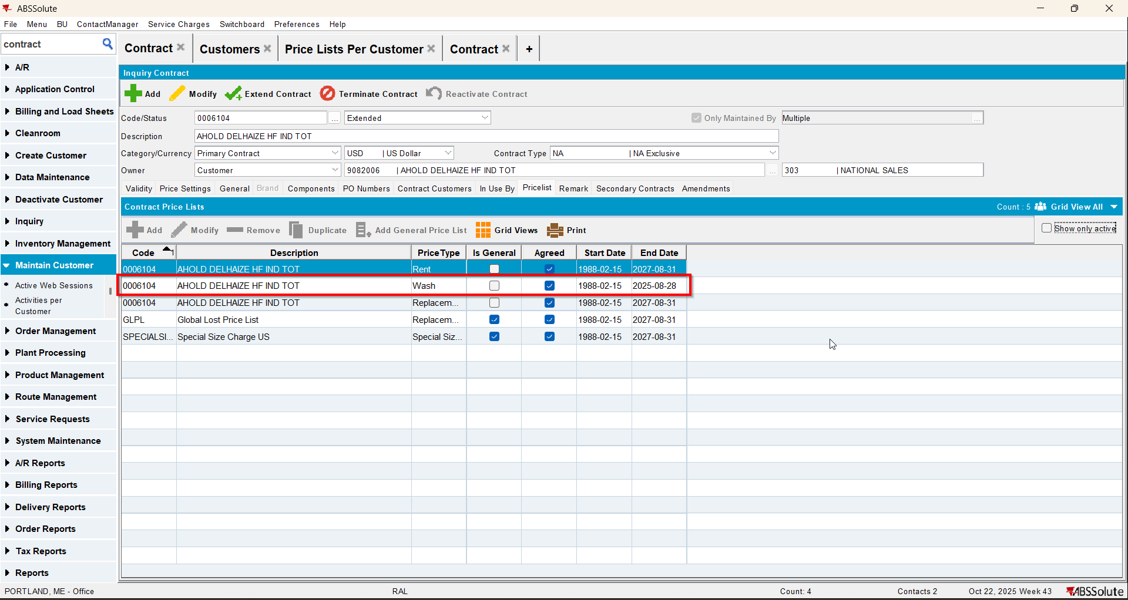
- Go to Price Lists Per Customer dlg and check the price lists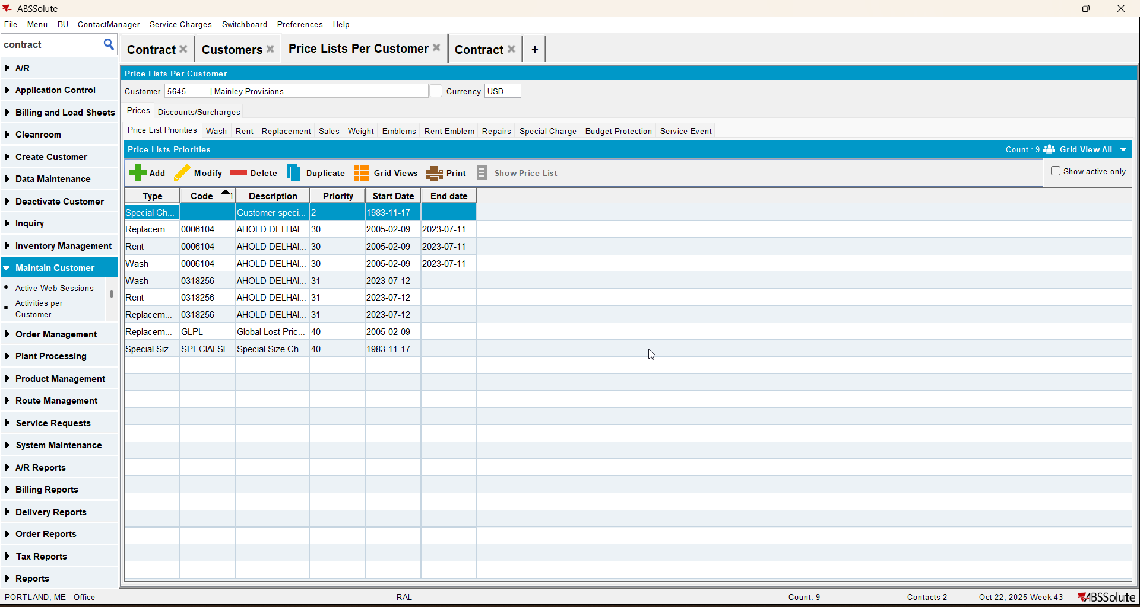
- Go to the active contract(C1) and end date that customer on the contract with a date in the past(D1)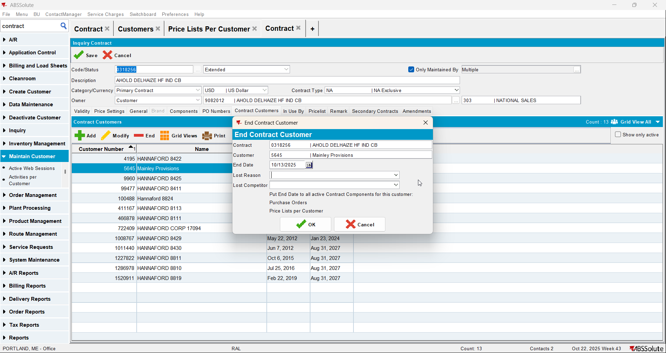
- Go to the contract C2 and add that customer again to the contract with a date D2=D1+1 day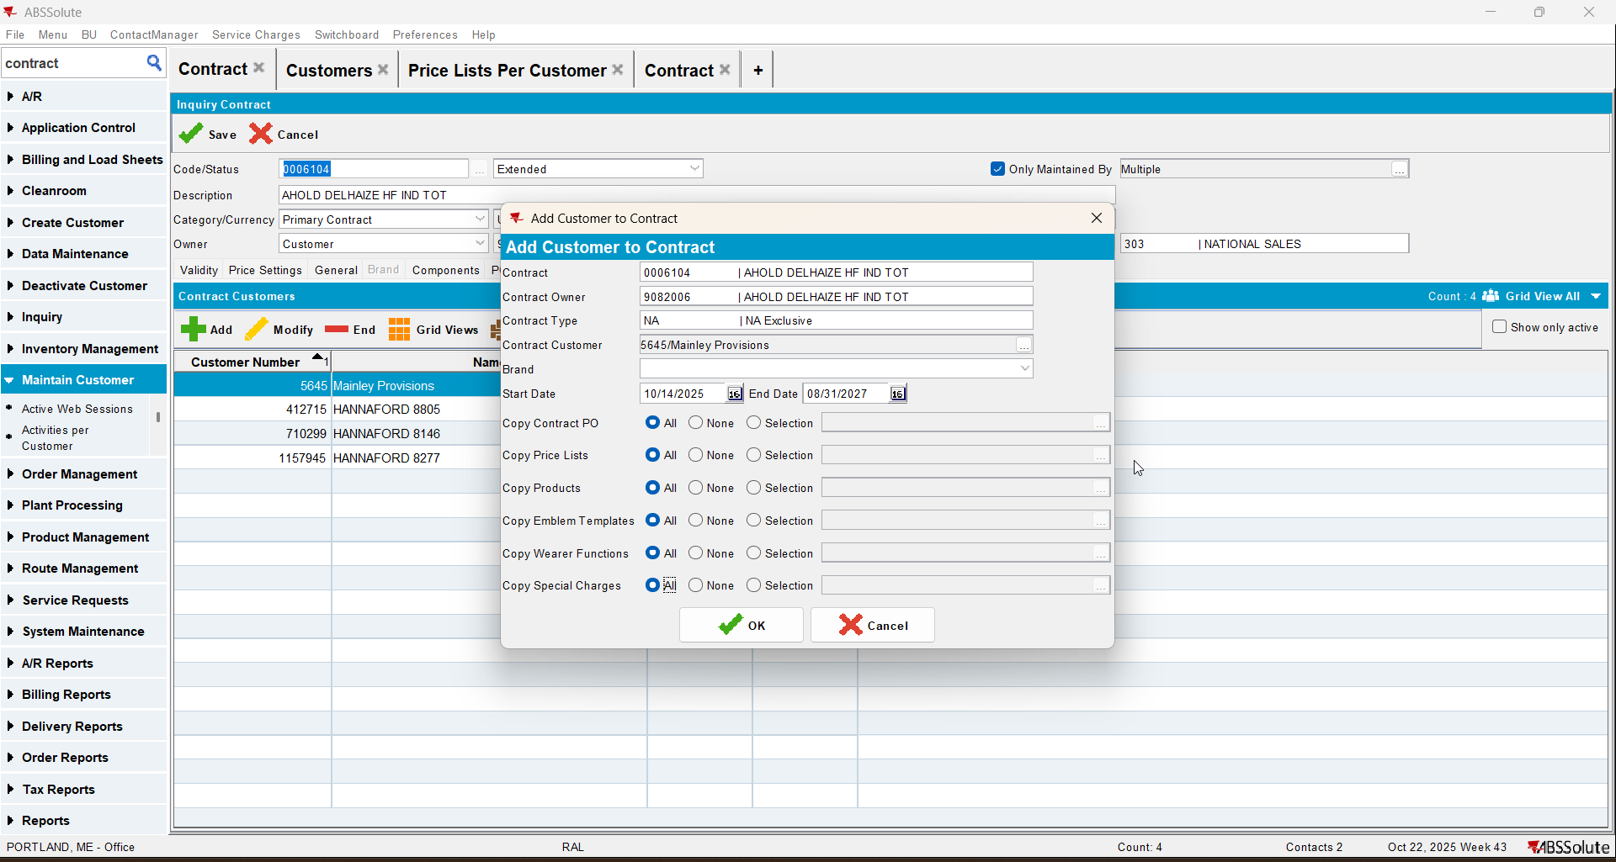
- Go to Price Lists Per Customer dlg and check the price lists