ABSN-4778 Extend FlexField to dlg. National Accounts
Environment | Prerequisites
Version: 9.07.00.UNF17.p17  DBServerName= abs-srv20.internal.abslbs.com  DBSID= CUST24  DBUser= UNFDEV  Environment=Test | - Module: FLEXFIELDS  - System setting: EXTENDEDNATIONALACCOUNT

Contents
National Account dlg 2
Data preparation 2
Steps to test 4
Test Case #1 SS EXTENDEDNATIONALACCOUNT = 0 and module FLEXFIELDS active for the current plant 4
Test Case #2 SS EXTENDEDNATIONALACCOUNT = 0 and module FLEXFIELDS inactive for the current plant 9
Test Case #3 SS EXTENDEDNATIONALACCOUNT = 1 and module FLEXFIELDS active for the current plant 11
Test Case #4 SS EXTENDEDNATIONALACCOUNT = 1 and module FLEXFIELDS inactive for the current plant 16

National Account dlg
9.07.00.UNF17.p17 hash: 86e97a86b7c3

Data preparation

- Module FLEXFIELDS in license for the current plant
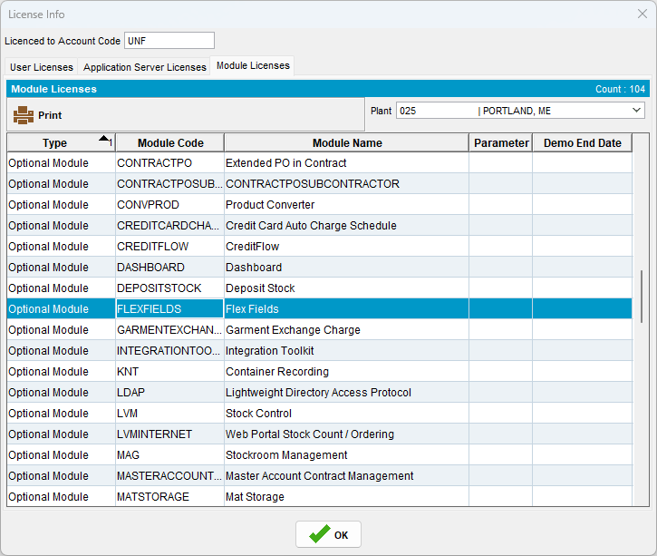

- System Setting EXTENDEDNATIONALACCOUNT = 0 and 1 (see Test Cases below)
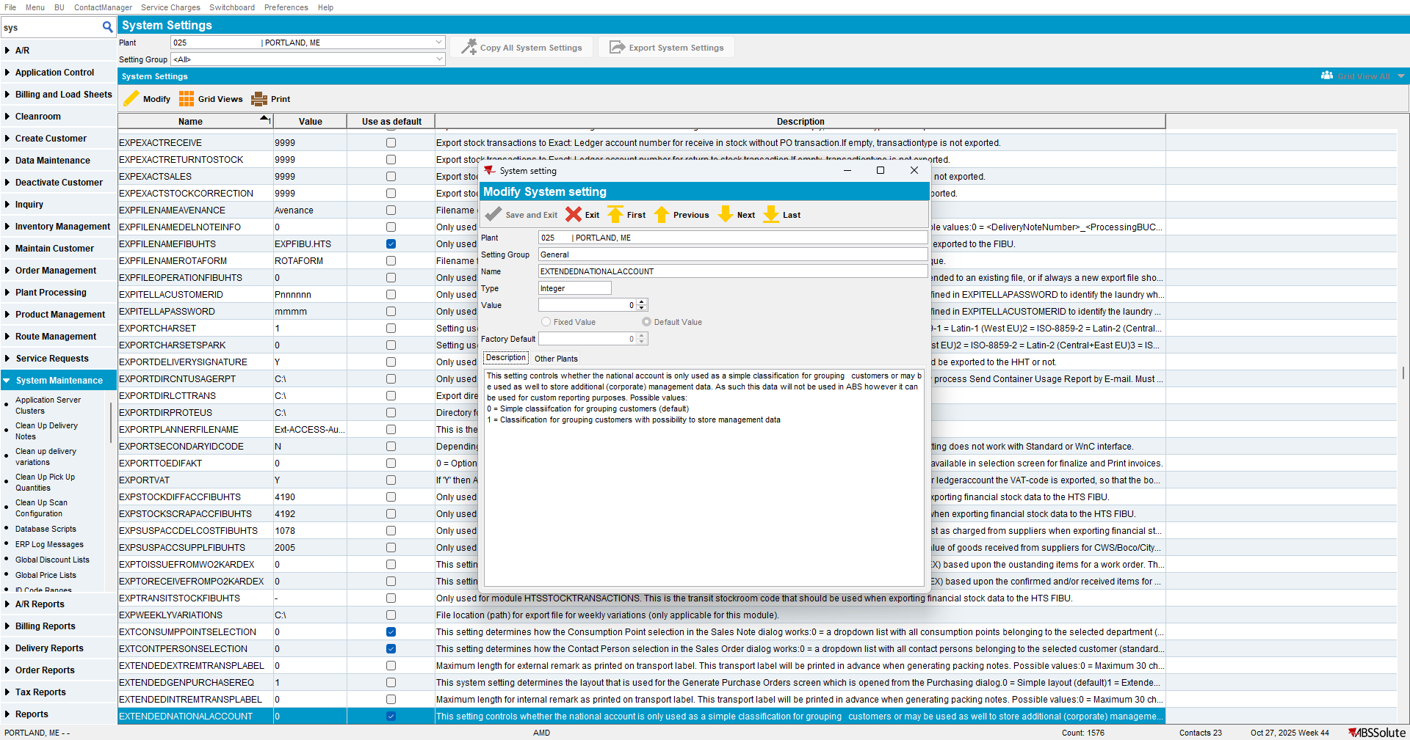
- FlexFields is set to Yes for the dialog “National Account”
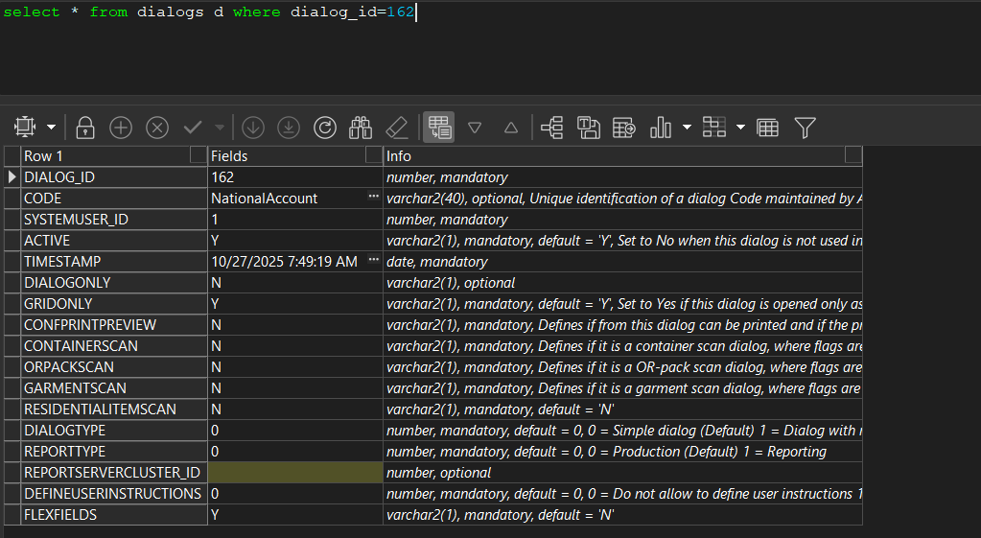

- “Flex Field Groups” defined for “National Account” dlg in “Flex Field Definition” dlg
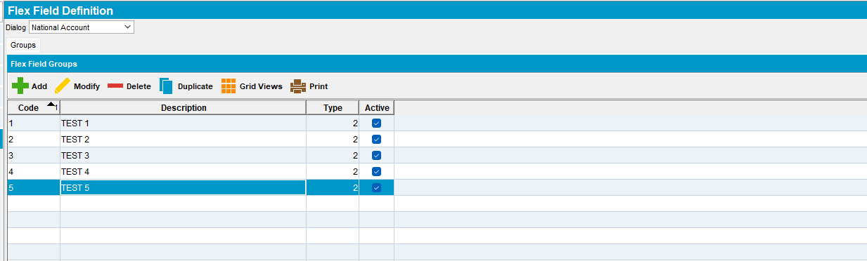

Steps to test

Test Case #1 SS EXTENDEDNATIONALACCOUNT = 0 and module FLEXFIELDS active for the current plant

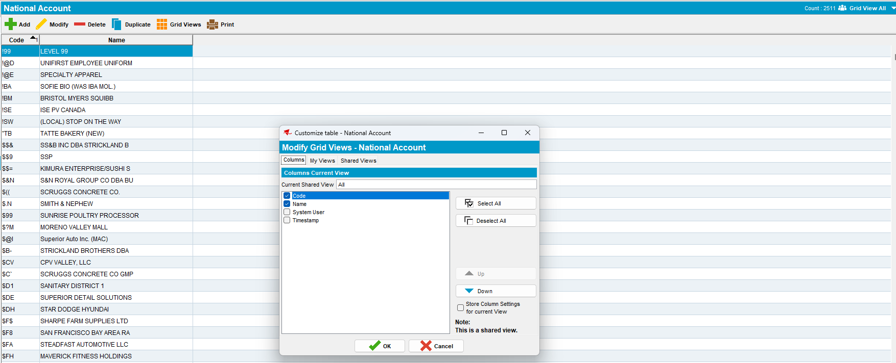
Step 1) Open “National Account” dlg , add a new National Account. Only tab ‘Flex Field” is available. The Flex Fields are displayed according to ‘Flex Field Definition’ dlg.
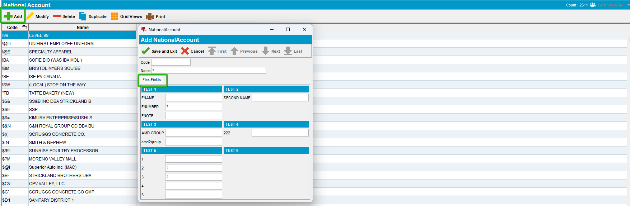
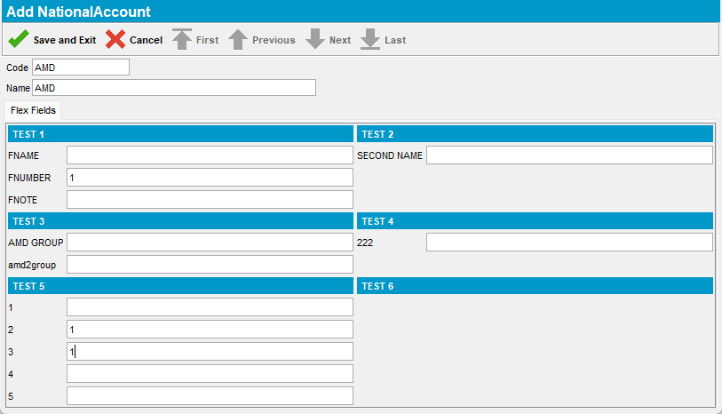
Step 2) Modify the National Account
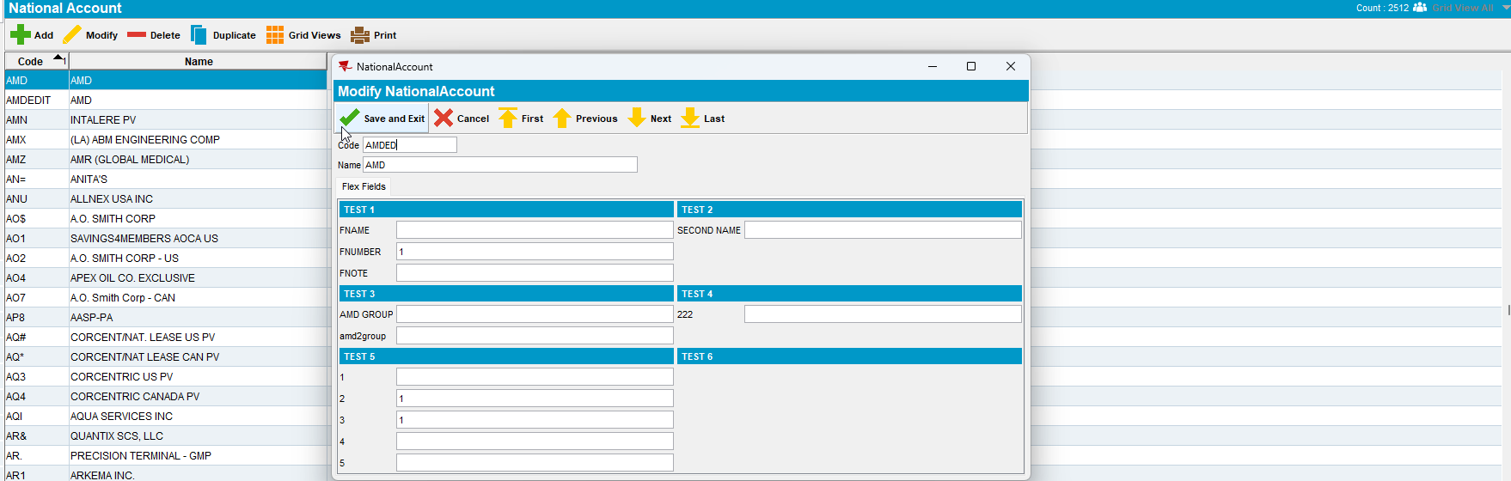
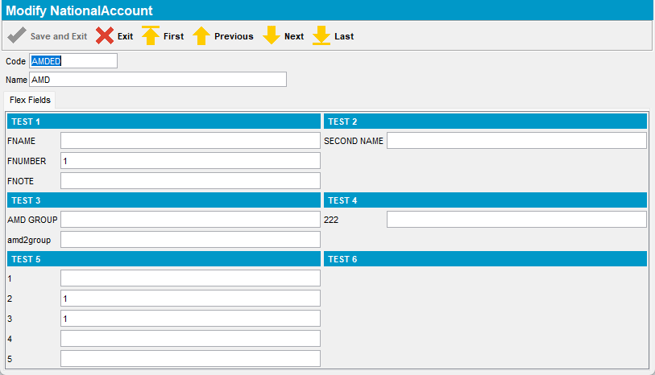

Step 3) Duplicate the National Account.
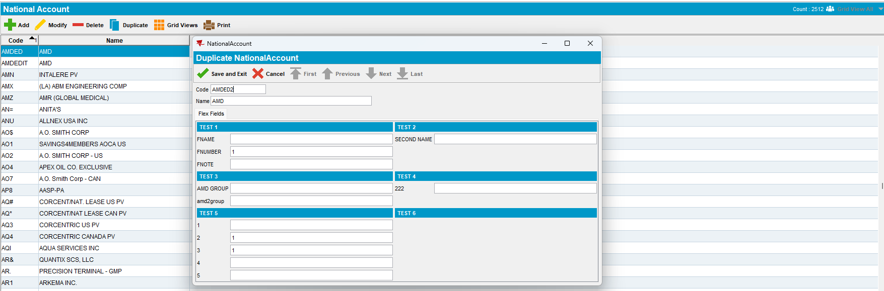
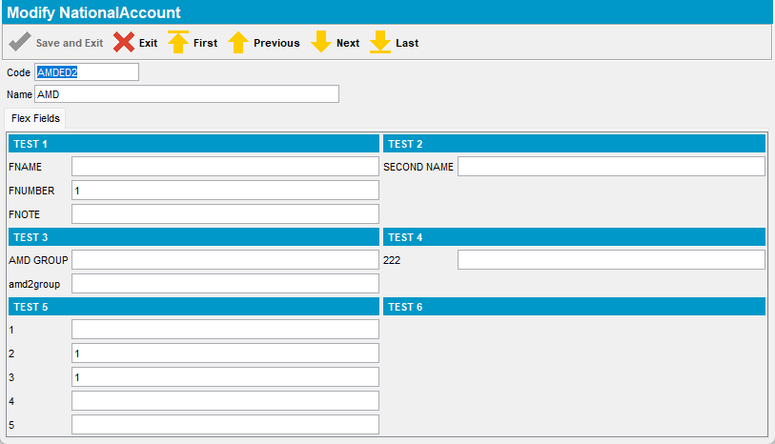

Step 3) Delete the National Account
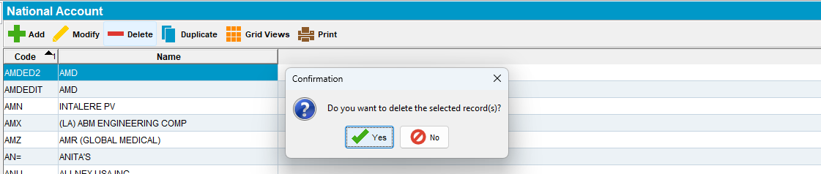
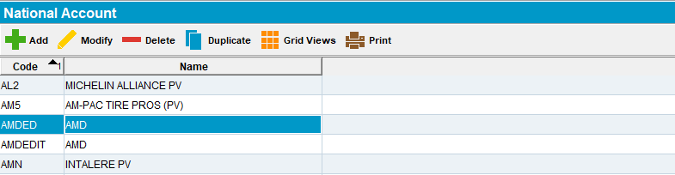

Test Case #2 SS EXTENDEDNATIONALACCOUNT = 0 and module FLEXFIELDS inactive for the current plant

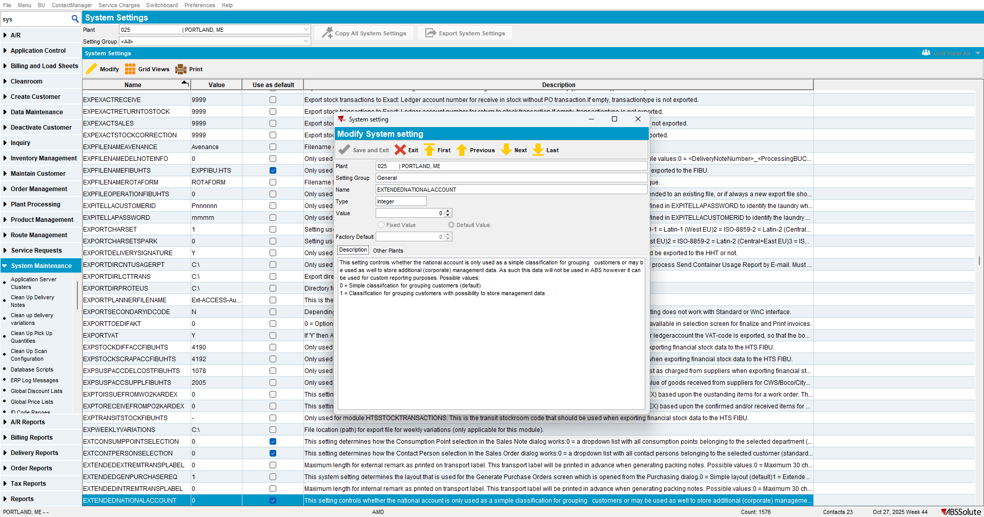
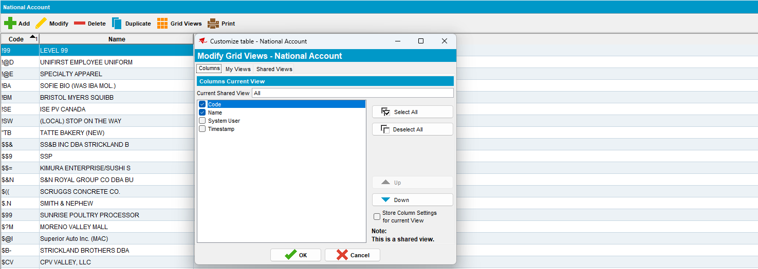
Step 1) Open “National Account” dlg , add a new National Account. No Flex Field tab available.
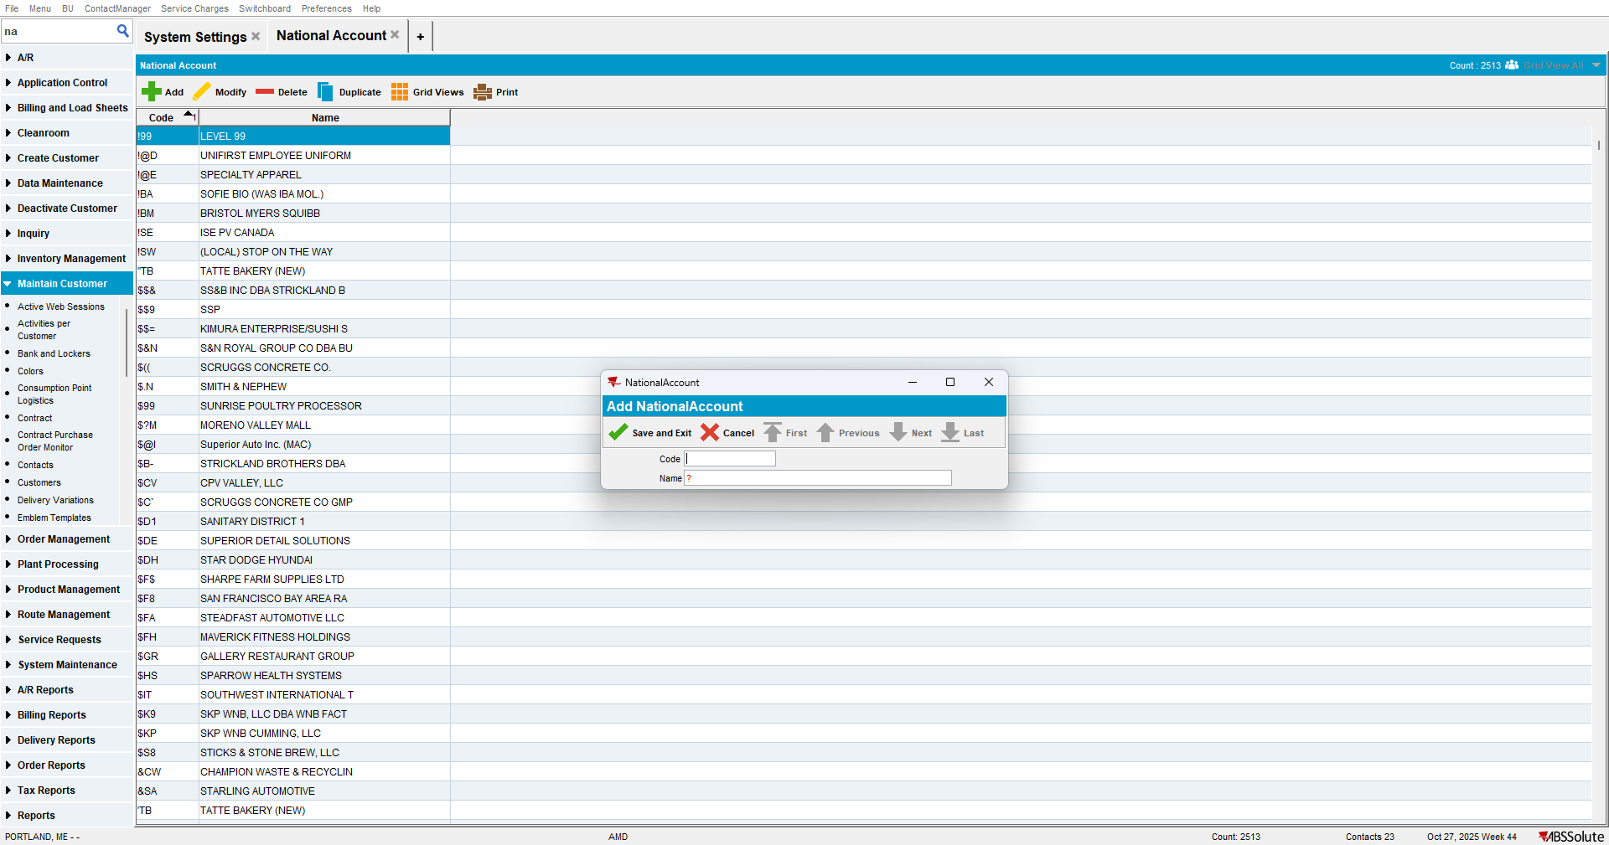

Test Case #3 SS EXTENDEDNATIONALACCOUNT = 1 and module FLEXFIELDS active for the current plant

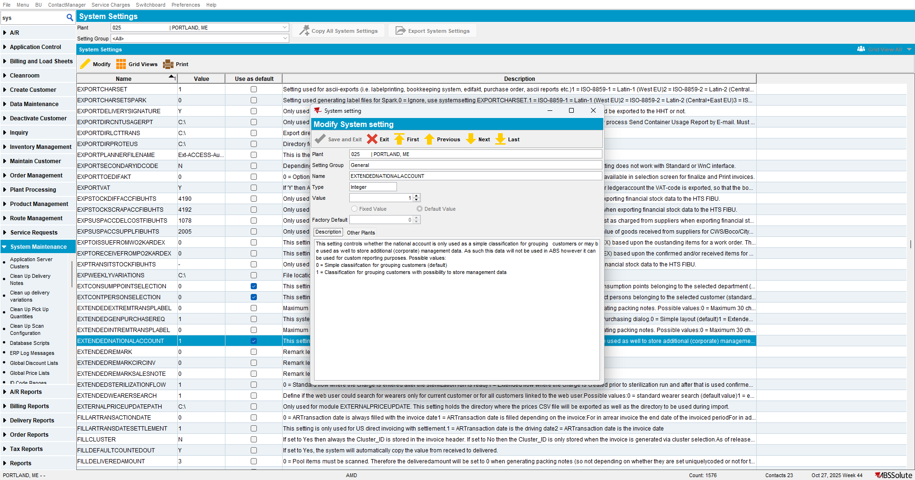
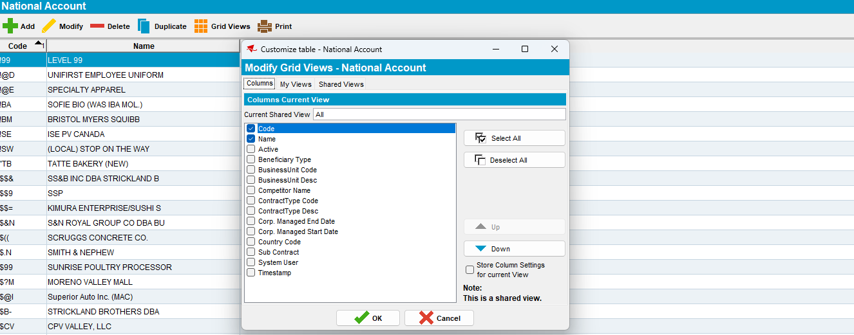

Step 1) Open “National Account” dlg , add a new National Account. Two tabs are available: “Extended National Account” and “Flex Fields” . The Flex Fields are displayed according to ‘Flex Field Definition’ dlg.
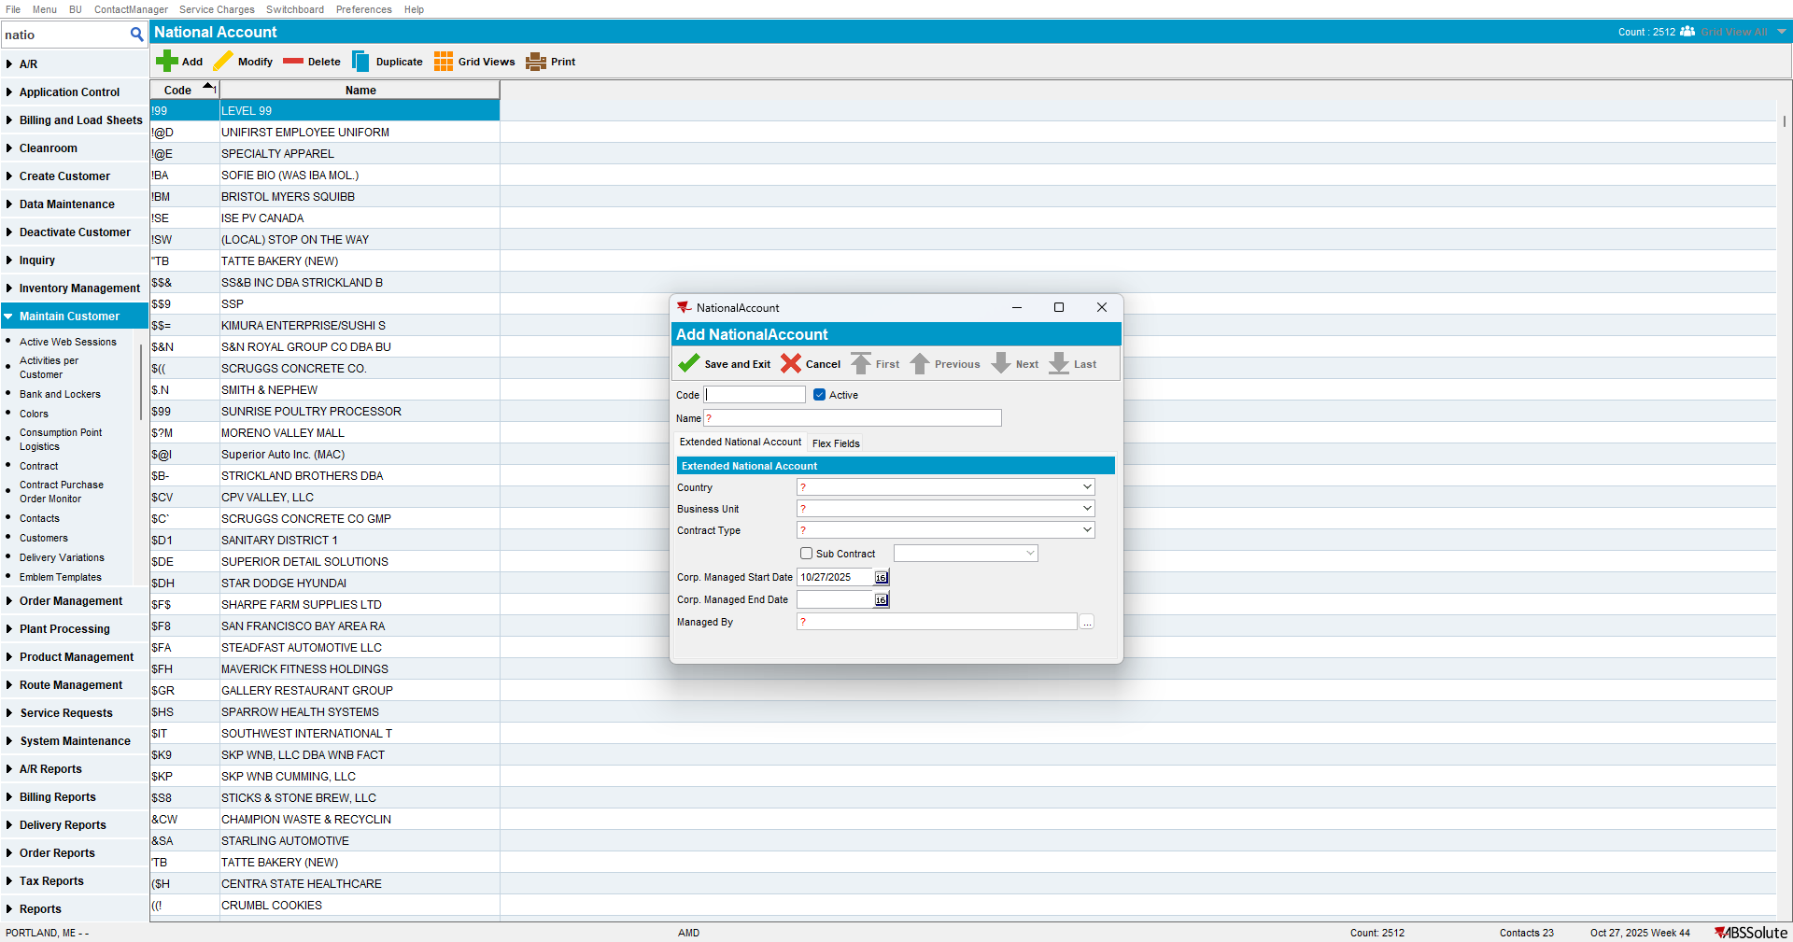
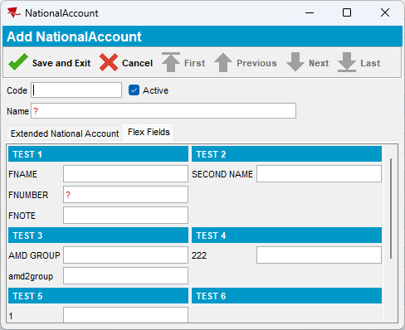
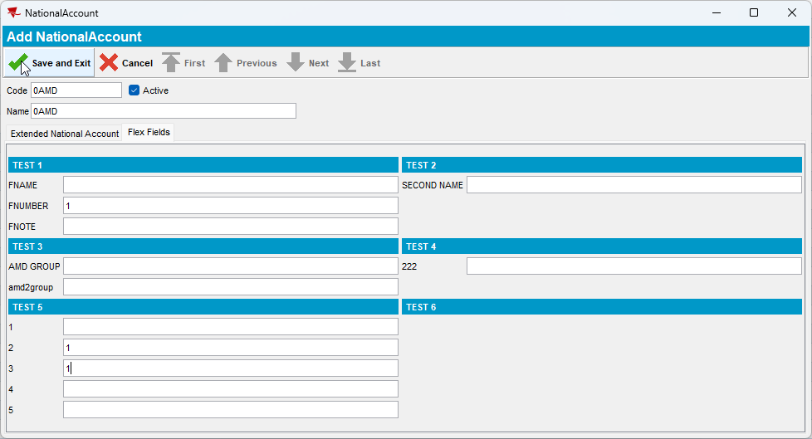
Step 2) Modify the National Account
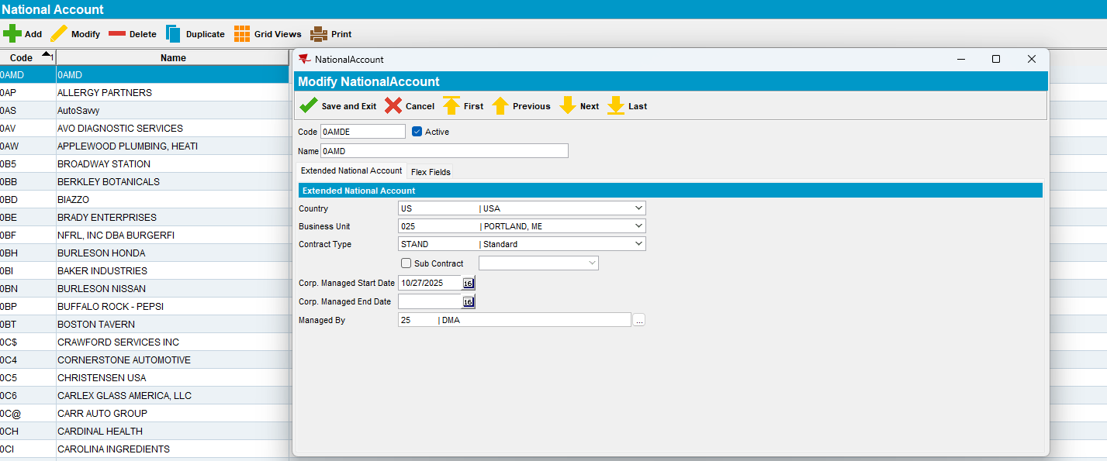
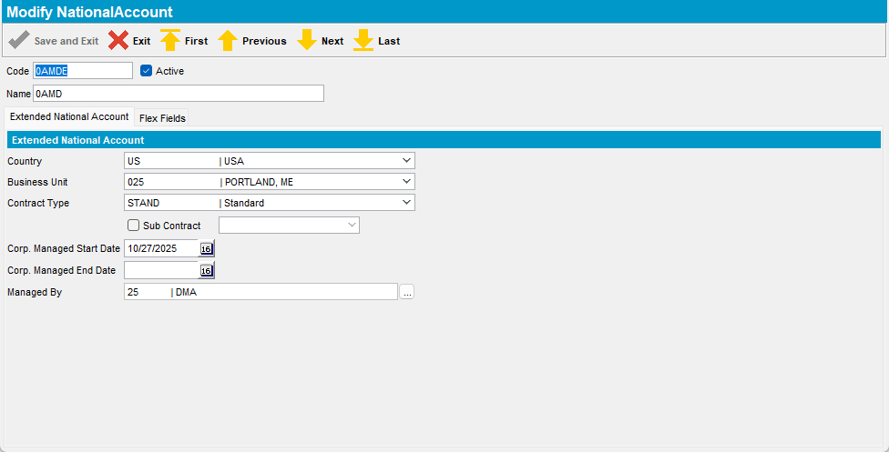

Step 3) Duplicate the National Account.
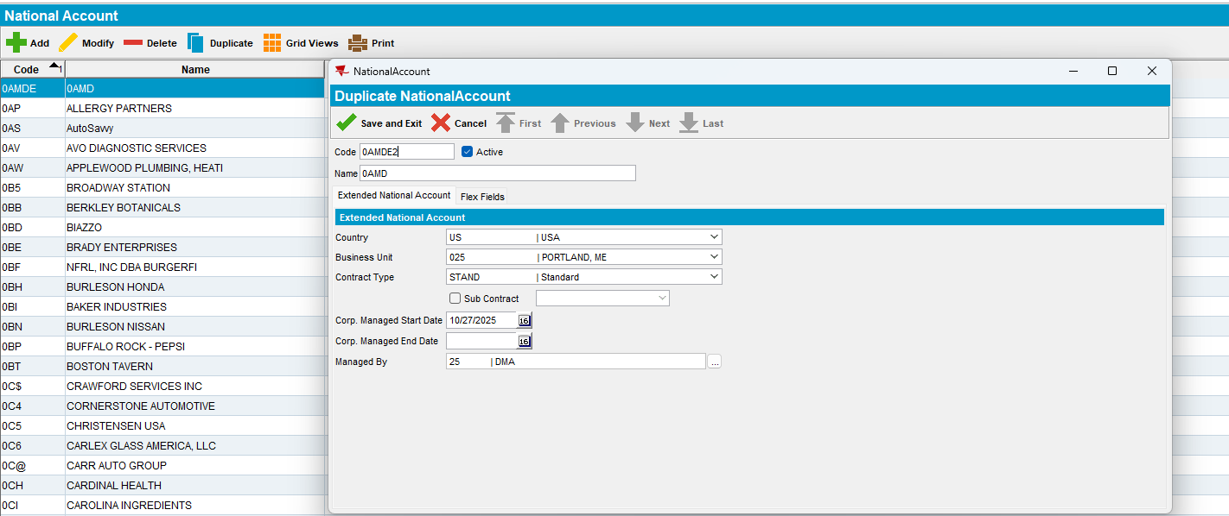
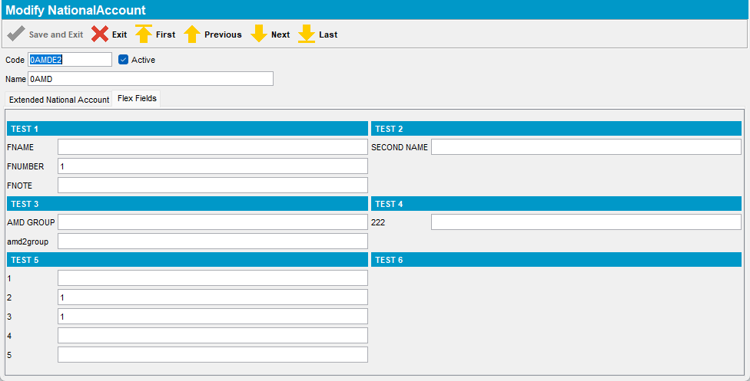

Step 3) Delete the National Account
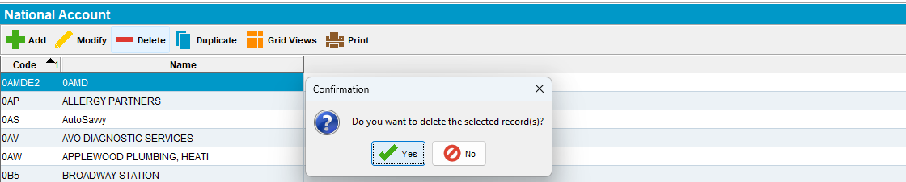
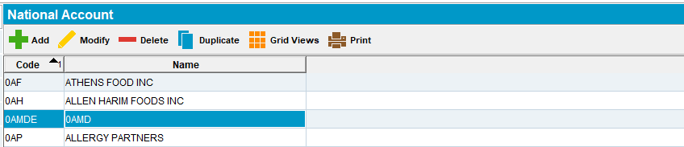

Test Case #4 SS EXTENDEDNATIONALACCOUNT = 1 and module FLEXFIELDS inactive for the current plant

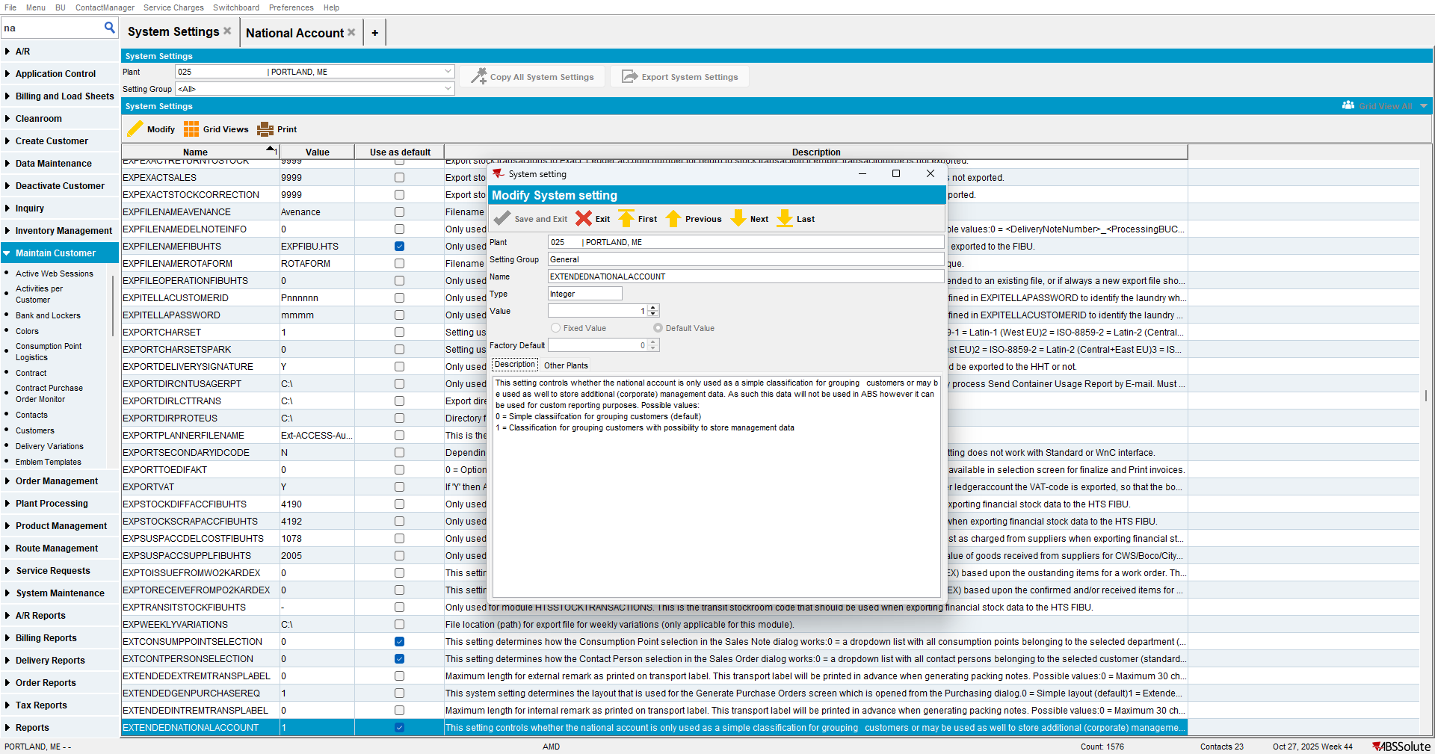
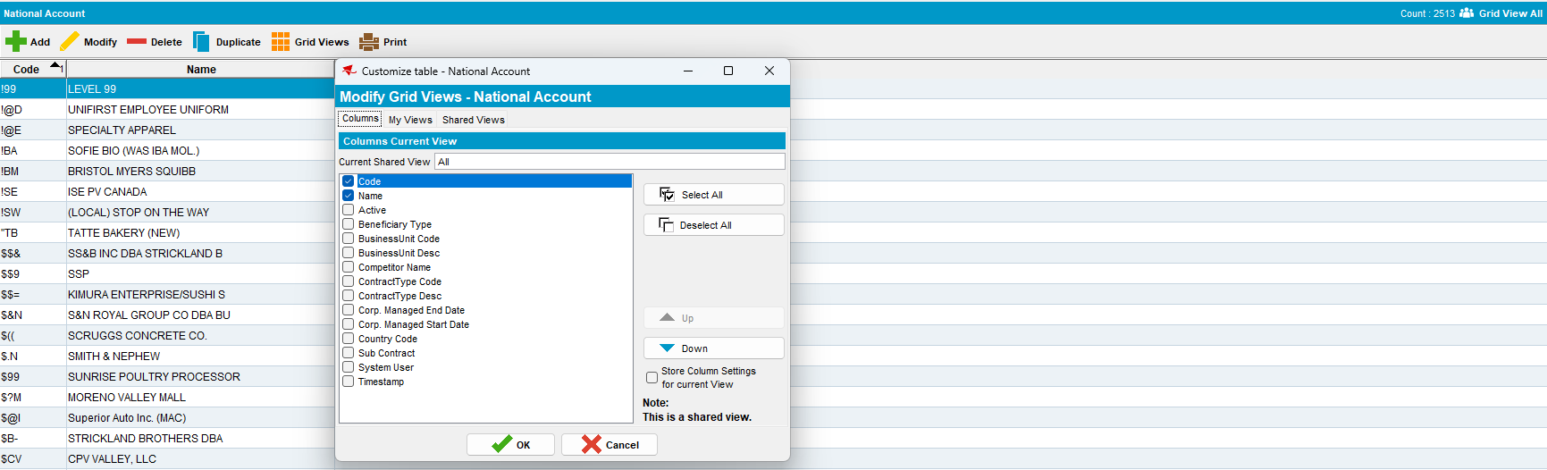

Step 1) Open “National Account” dlg , add a new National Account. No Flex Field tab available, only Extended National Account
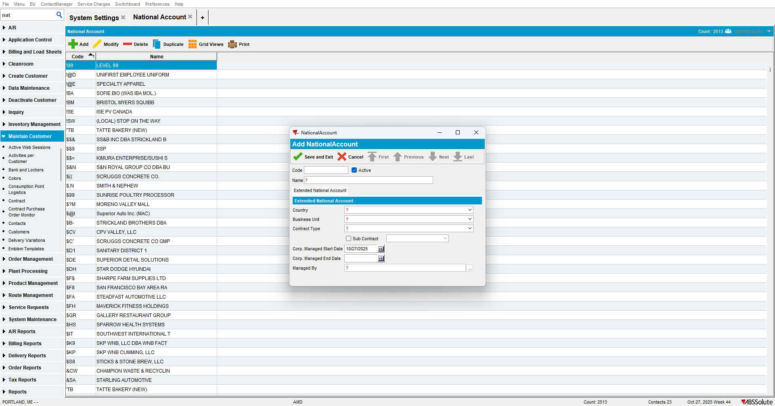

Expected Results:
FlexFields must be set to Yes for the dialog National Account.
The following controls will only be available when the system setting EXTENDEDNATIONALACCOUNT is set to 1.
If this is combined with Flex fields (see below) then add these attributes on a tab page “Extended National Account”.
NationalAccount.Active, NationalAccount.Country_ID, NationalAccount.BusinessUnit_ID, NationalAccount.ContractType_ID, NationalAccount.SubContract, NationalAccount.CorpManStartDate, NationalAccount.CorpManEndDate, NationalAccount.ManagedBy
Flex Fields

Business Rules Flex fields only visible if the module FLEXFIELDS is defined in the license of the current plant and there are flex fields defined for the NationalAccount dialog. Usage and details from flex fields are described in the document FlexFieldsDlg.doc.
In case both extended NA and flex fields are used then create a separate tab page for the flex fields.

Actual Results: As expected

