ABSN-11399 Adding a customer to a predefined contract where its already on the contract but end dated
Environment | Prerequisites
Version:9.07.00  DBServerName=abs-SRV20.internal.abslbs.com  DBSID=CUST24  DBUser=UNFDEV  Environment=Test | - Module:  - System setting

Contents
Retest after fix 1
Test Case 1 – Add the customer again to a contract where it is inactive – Tested OK 1

Retest after fix

Test Case 1 – Add the customer again to a contract where it is inactive – Tested OK
Expected behavior: If the customer is inactive (end dated) on a contract and wants to re-join the predefined contract, you can add it again, but the Contract Customer end date should be reset (CO.StartDate + CO.Duration).
Hash: 51a2556
- Open the "Contract" dialog. Select customer contract with the default end date (CO.StartDate + CO.Duration) and press Modify.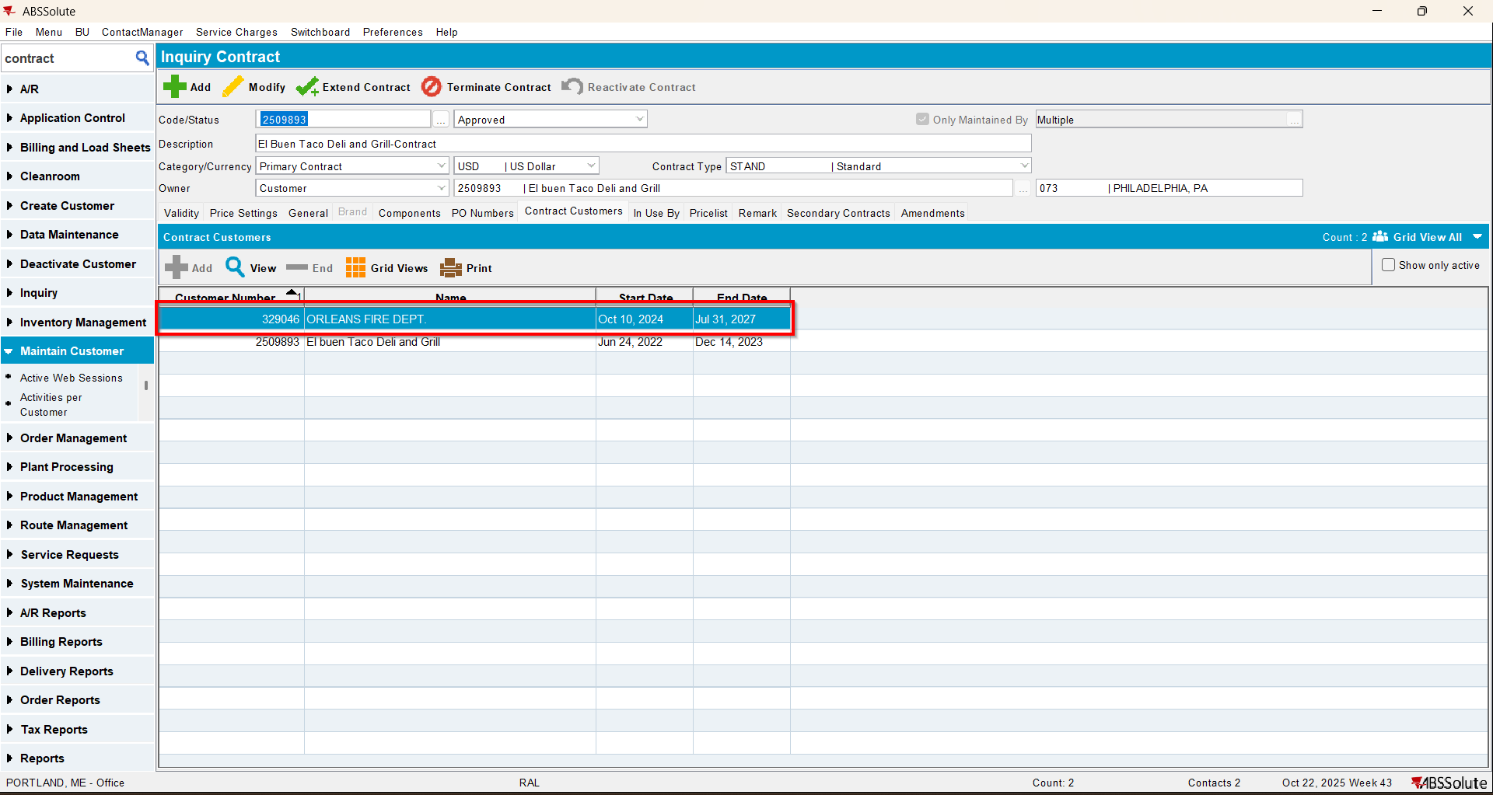
- Press End for the selected contract customer and select a new end date (from the past). Press OK.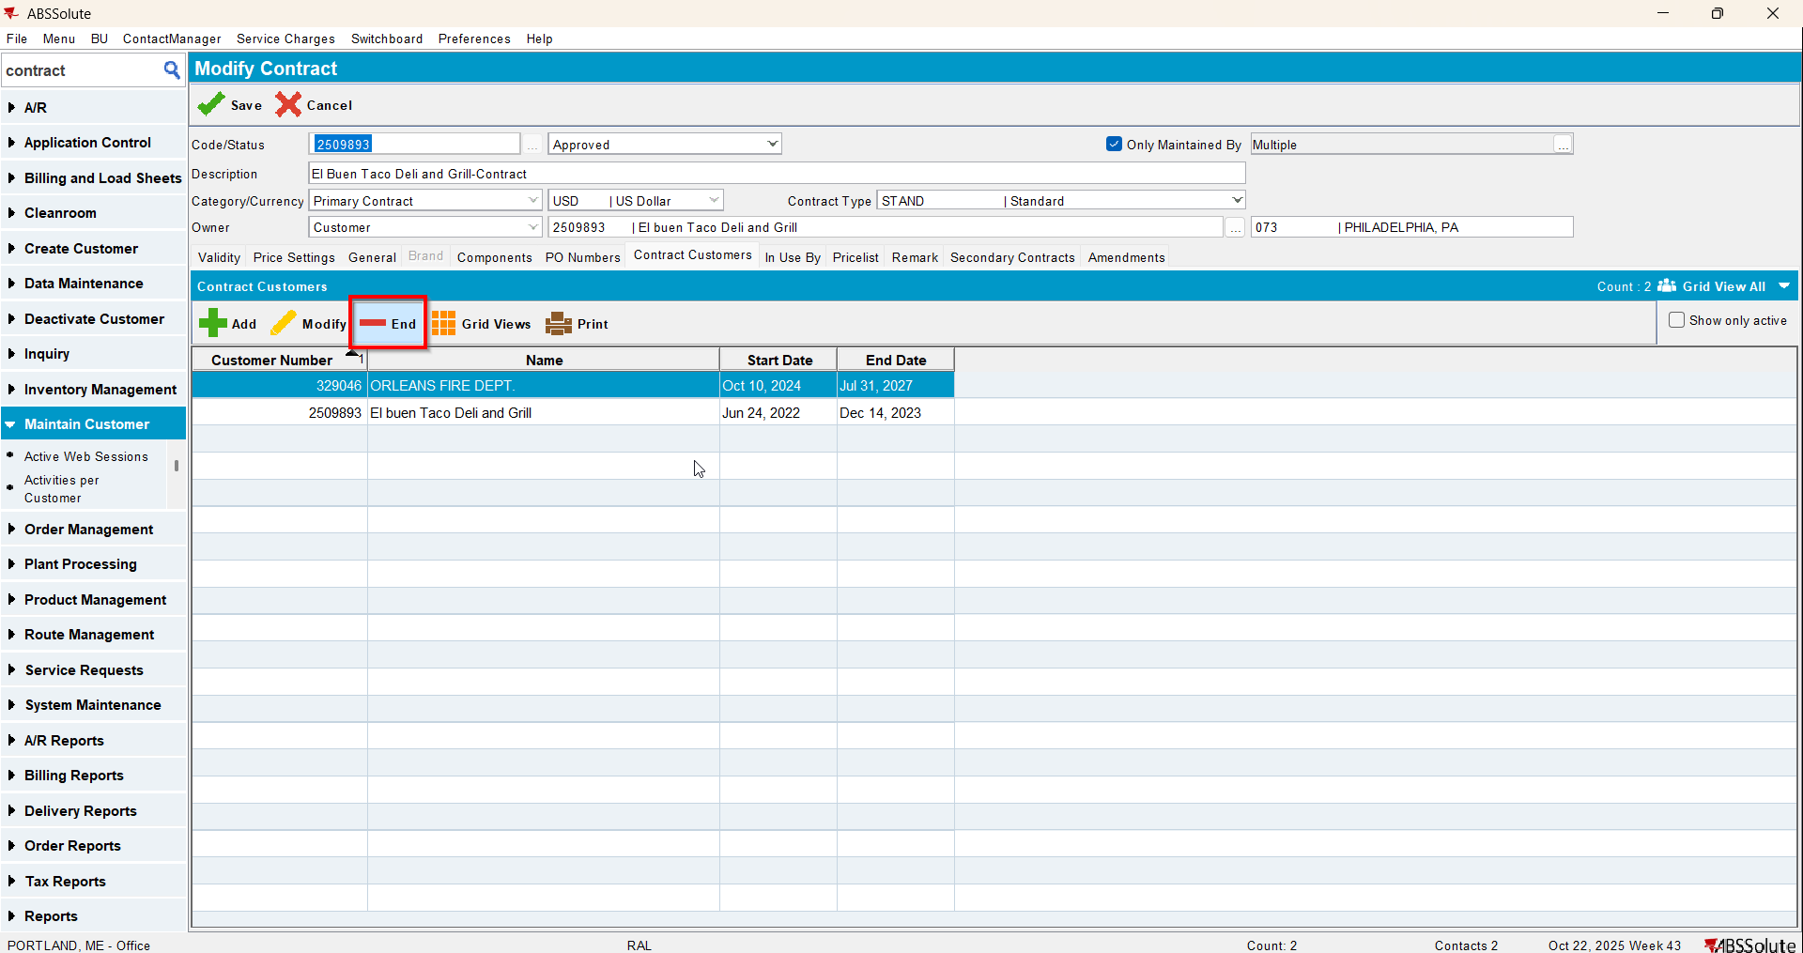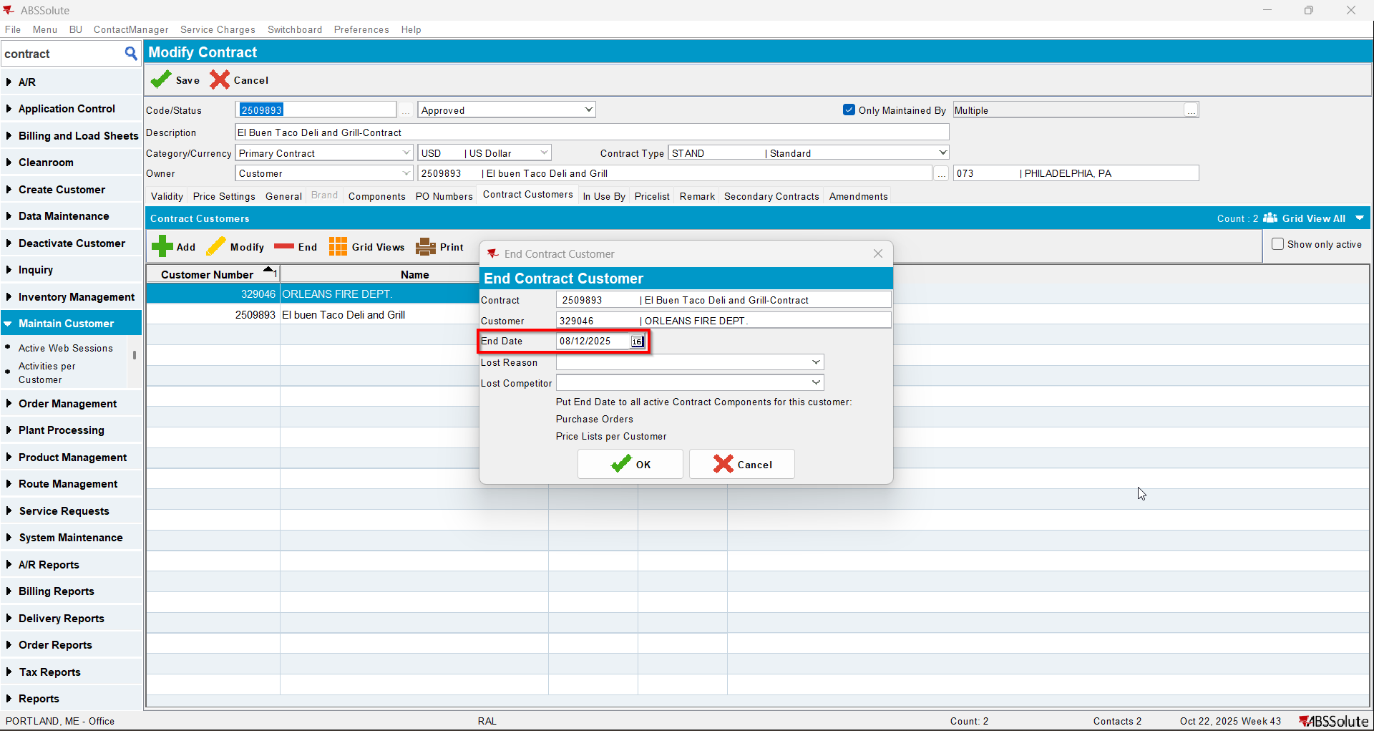
- Save and load the contract again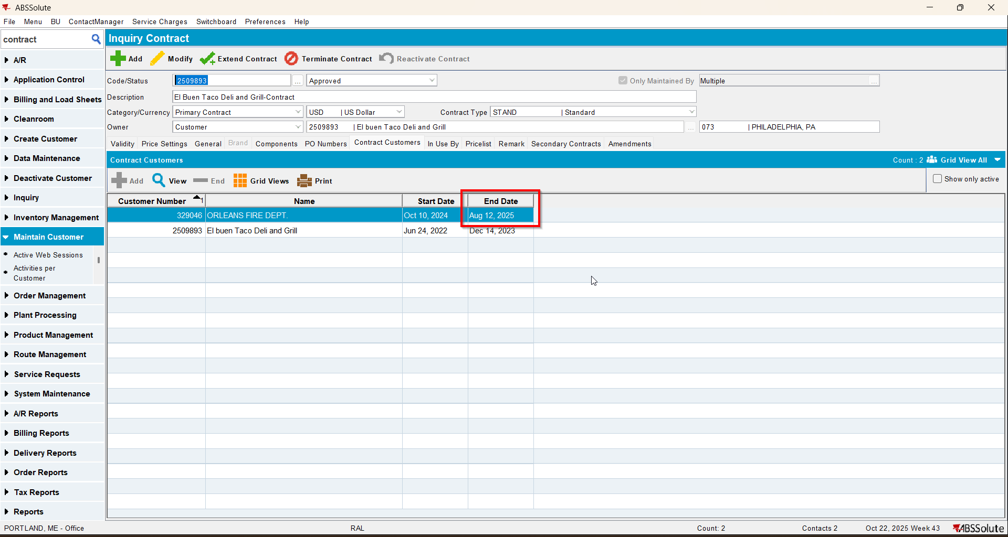
- Add the contract customer again (re-join the predefined contract).