ABSN-8112 VertexTax - Import BCI data Process Scheduler should use currency not country
Environment | Prerequisites
Version:9.07.00  DBServerName=abs-SRV20.internal.abslbs.com  DBSID=CUST24  DBUser=UNFDEV  Environment=Test | - Module:  - System setting

Contents
Test after fix 1
Test Case 1 – Customer with same bill-to from US but CA currency and taxareaID– Tested OK 1
Test Case 2 – Customer with different bill-to from US but CA currency and taxareaID– Tested OK 12
Test Case 3 – Customer with same bill-to from US and US currency but CA taxareaID– Tested OK 25

Test after fix

Test Case 1 – Customer with same bill-to from US but CA currency and taxareaID– Tested OK
Expected behavior: When running the Vertex Import BCI process scheduler there is no error and the tax lines get turnovergroups associated with the correct CANADA regions/states.
Hash: 94deccf
- Check that your BU has legal Entity UNC01 (you can use BU 710)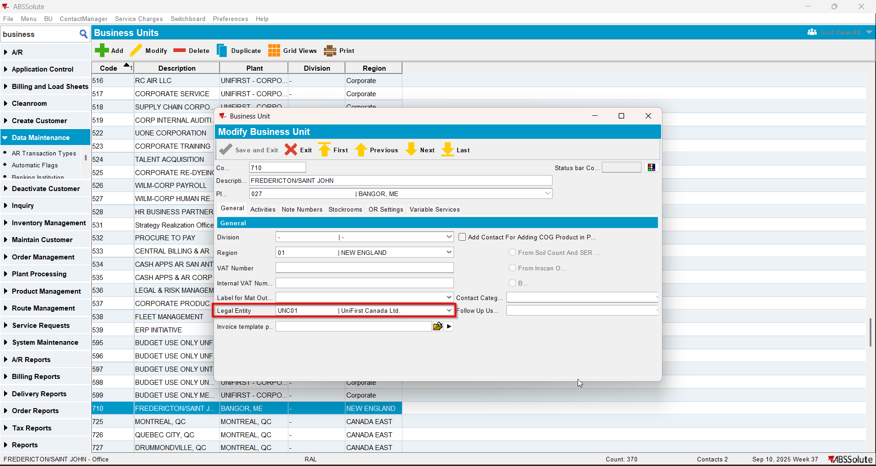
- Have a customer with Country US, Currency CAD and Tax Area CA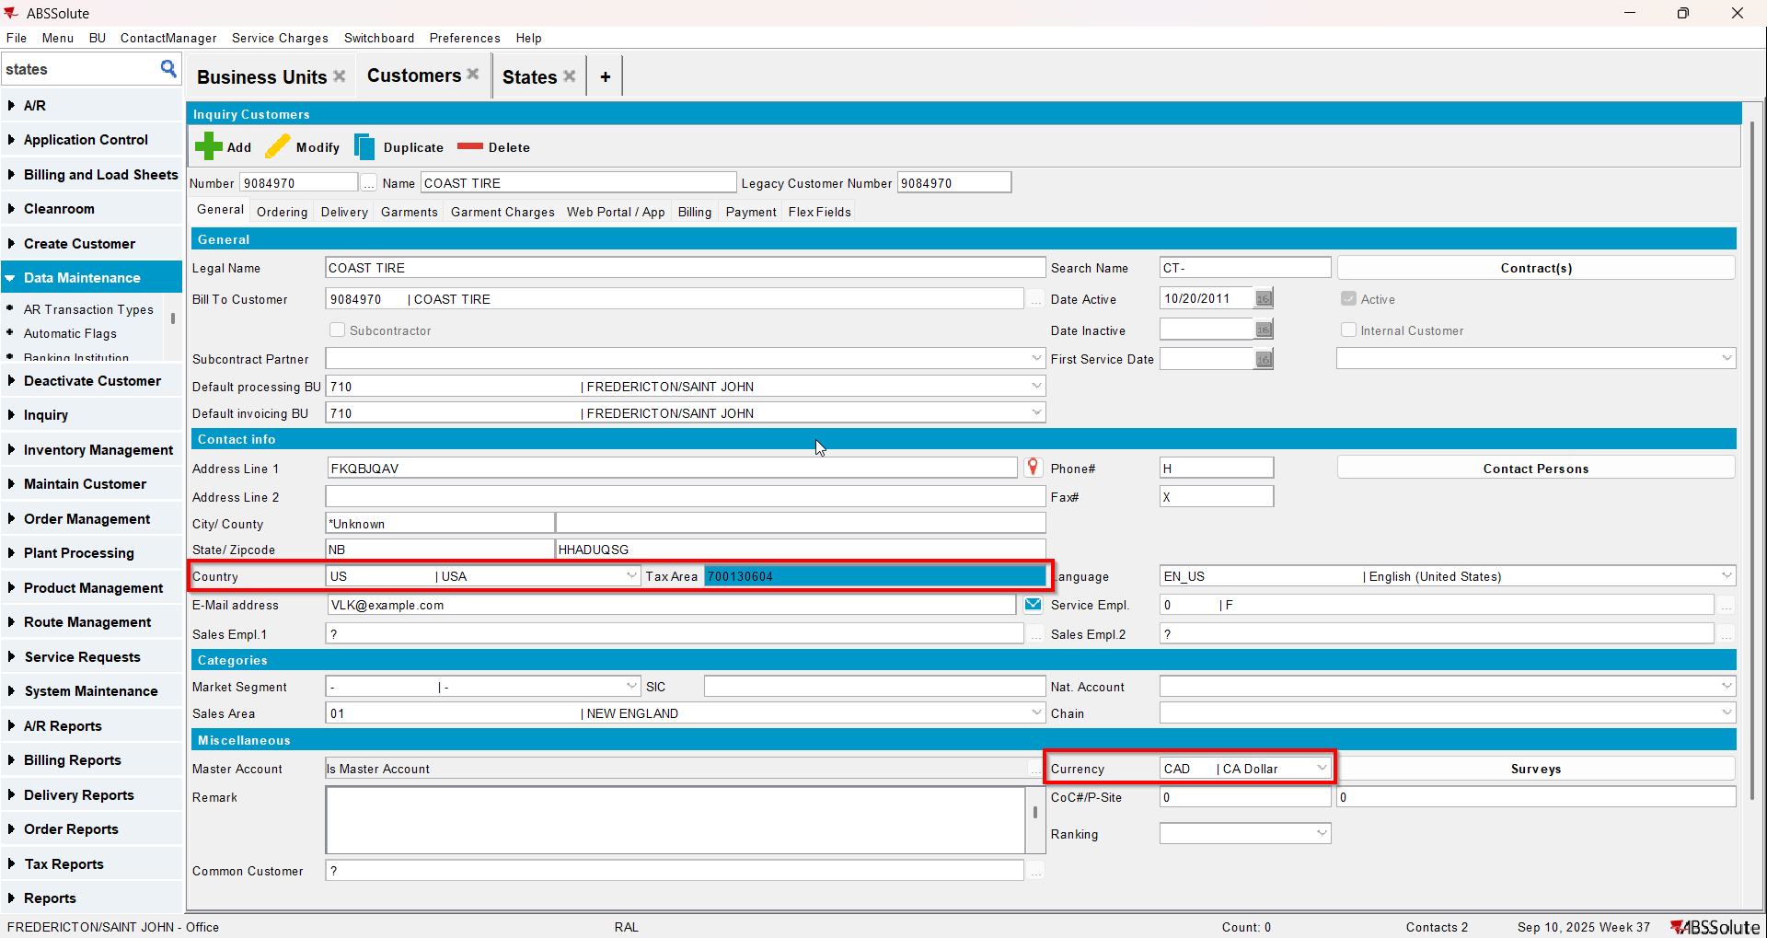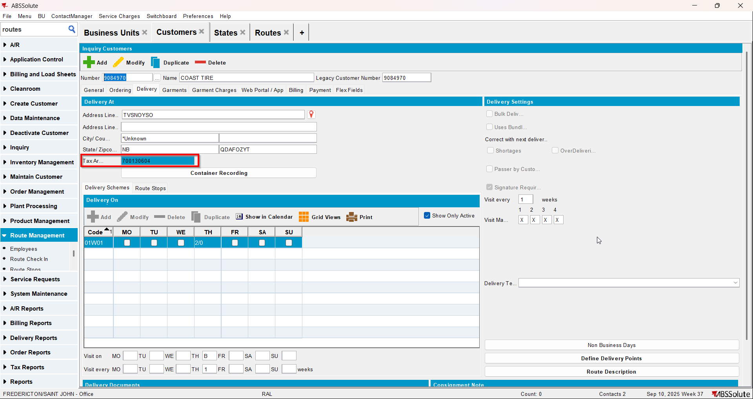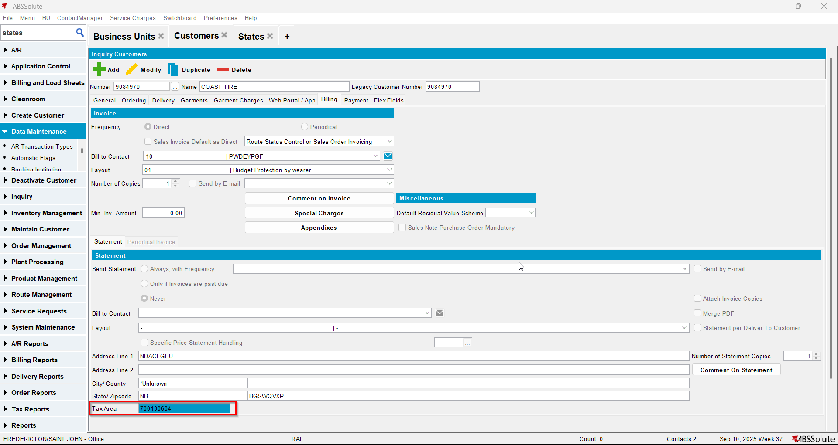
- Maintain Invoices dlg: create a manual invoice for your customer and add it to the route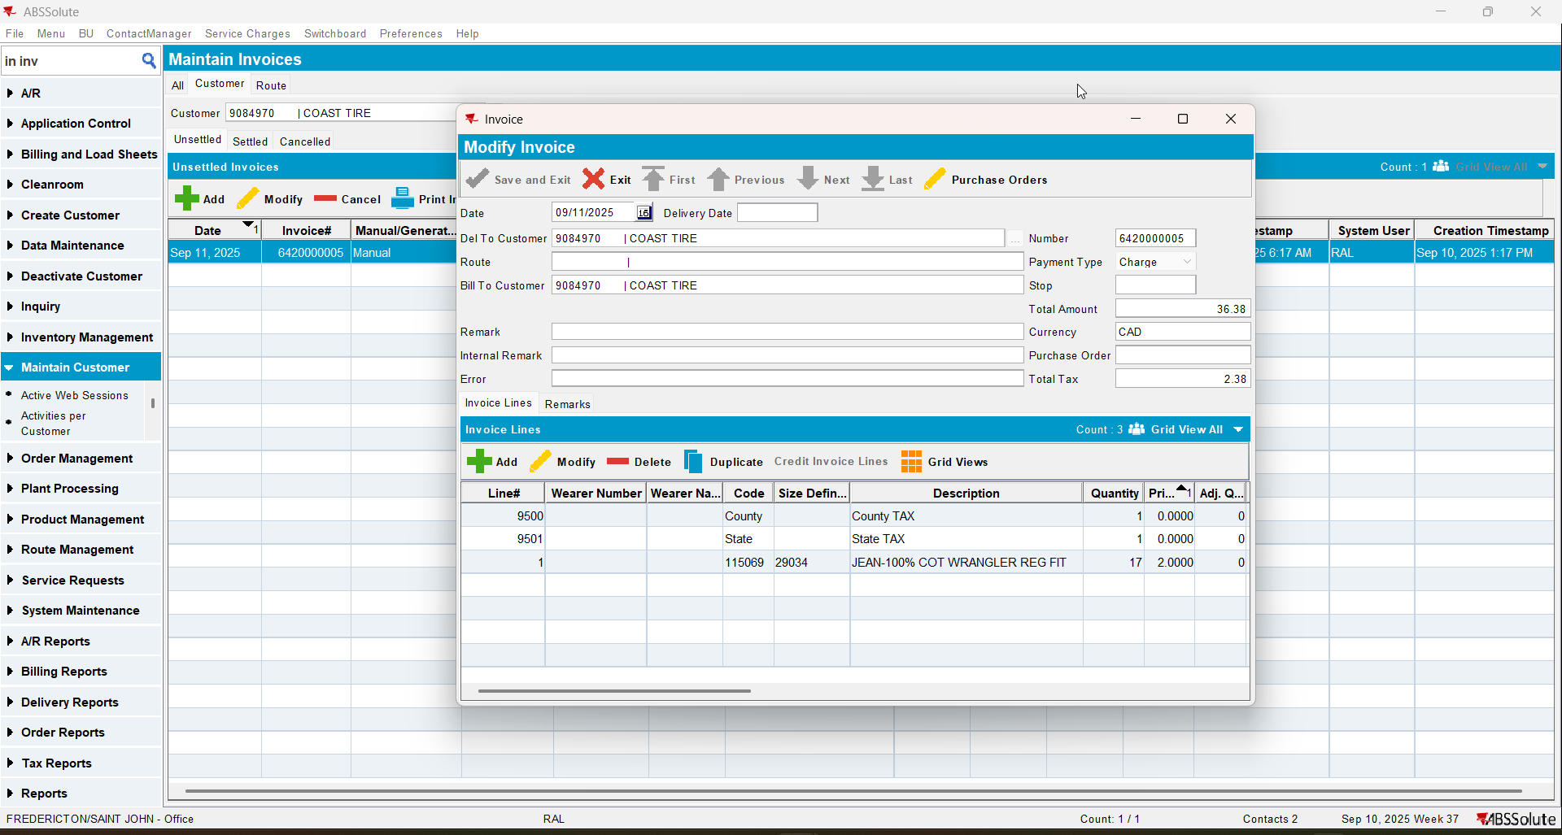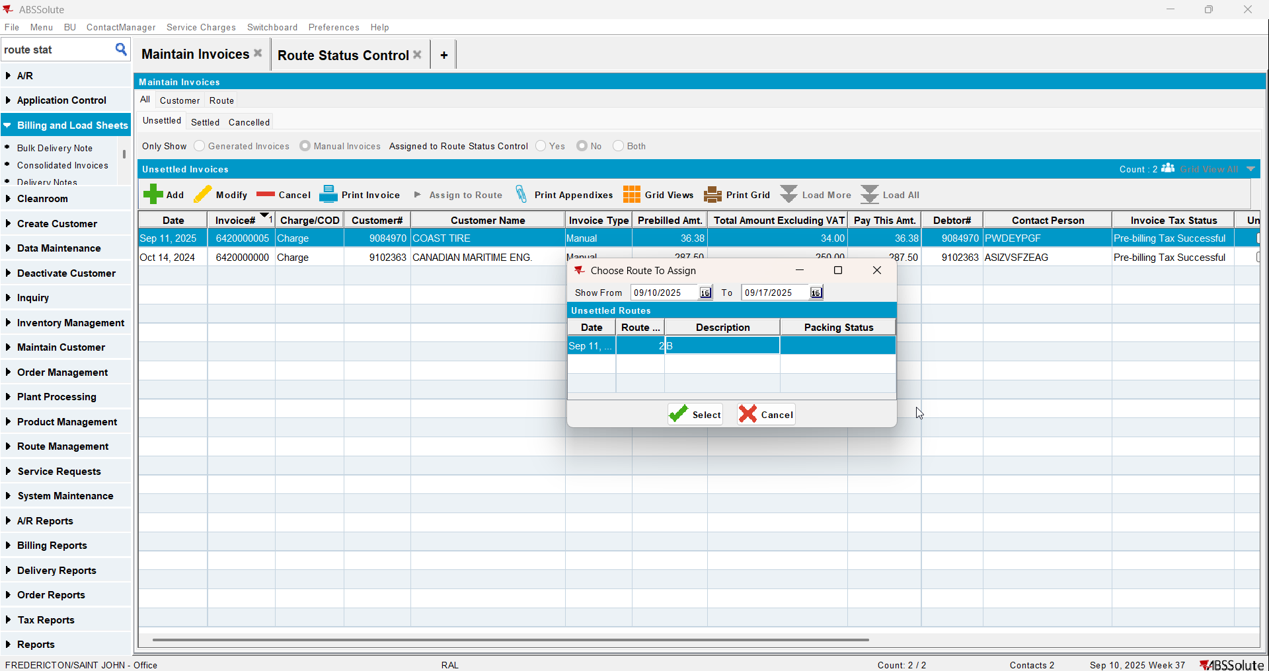
- Maintain Sales Notes dlg: create a sales note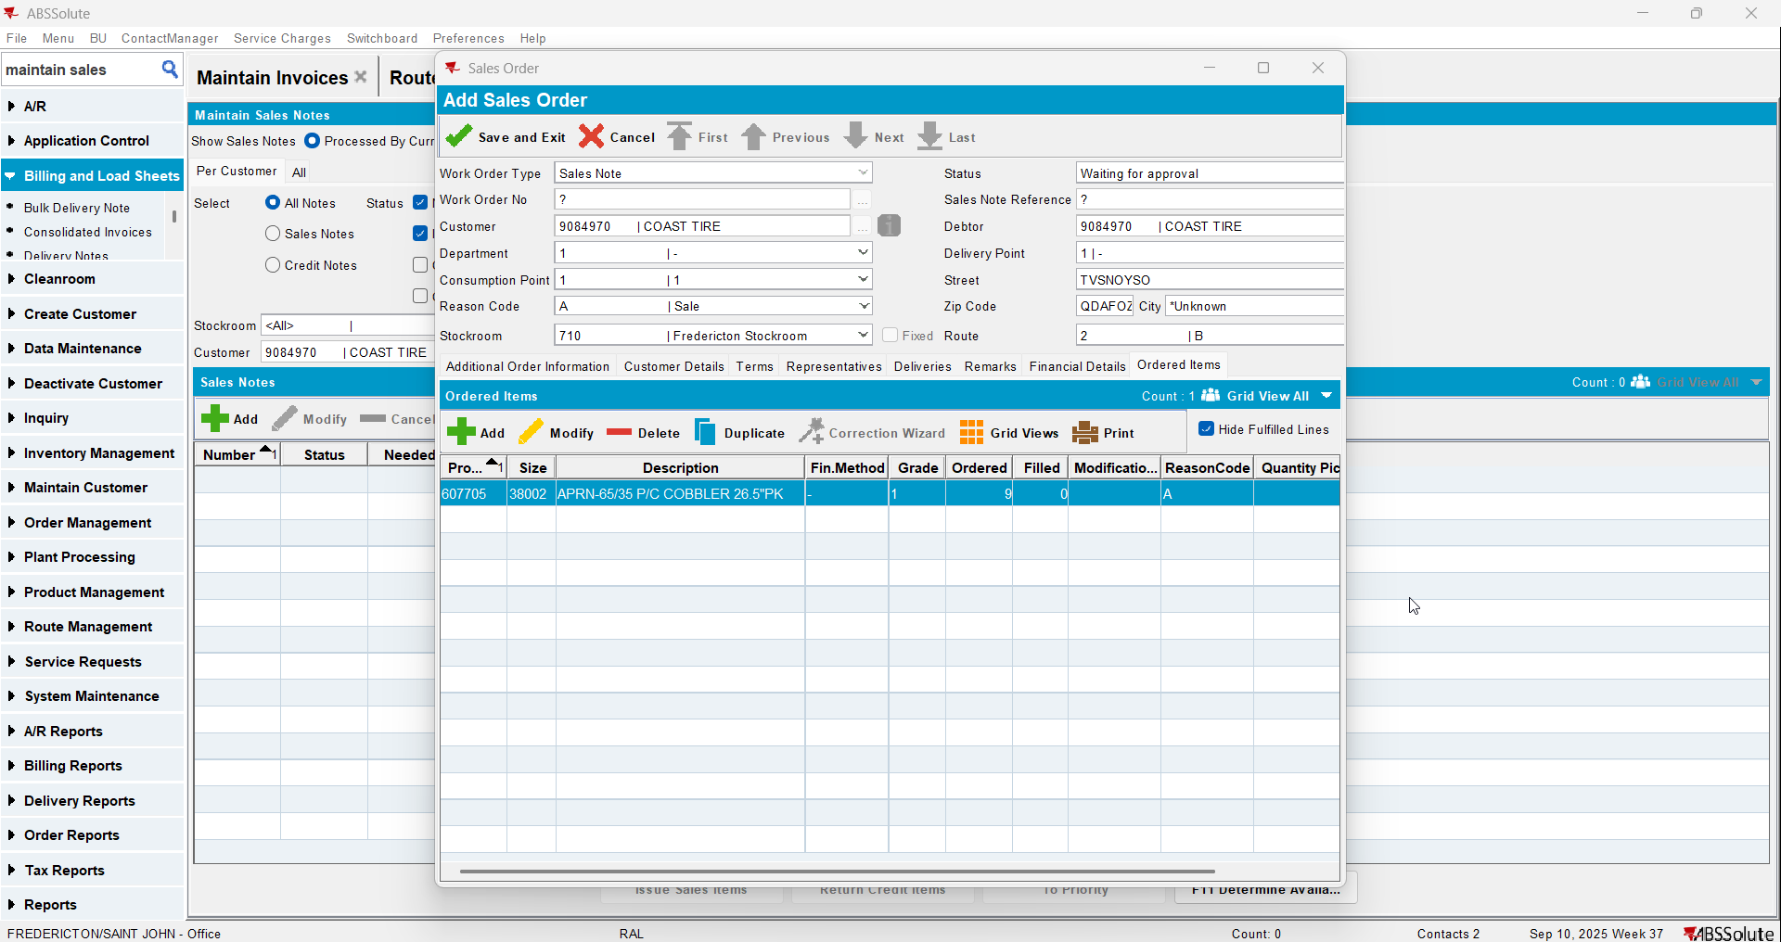
- Work Orders waiting for Approval dlg: approve your sales note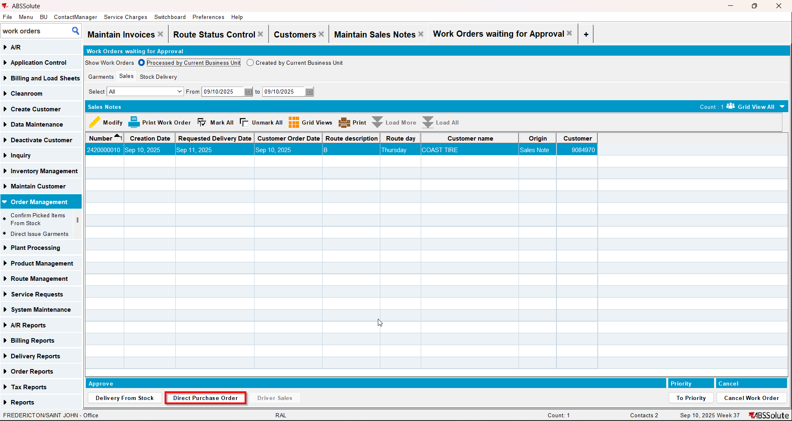
- Maintain Sales Notes dlg: issue the items and generate delivery notes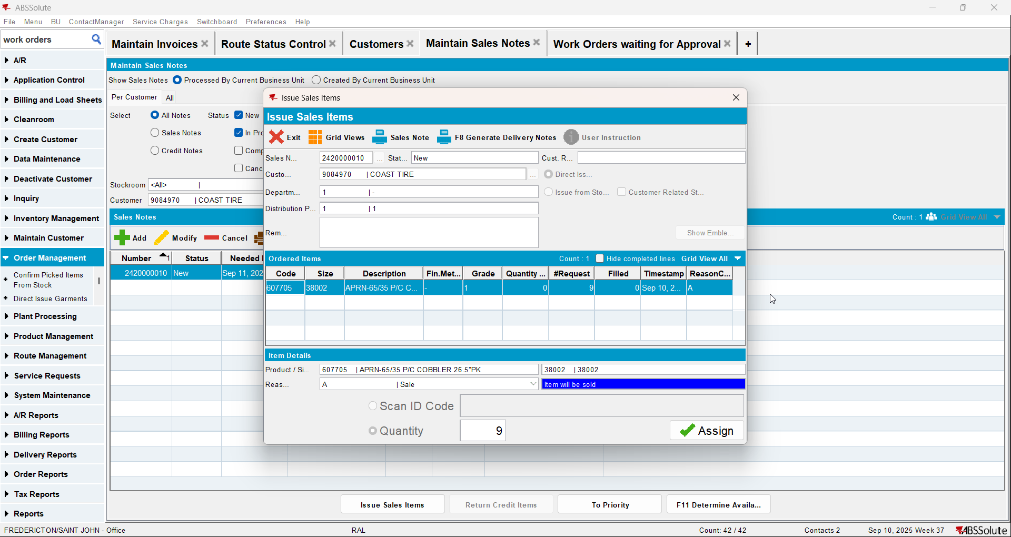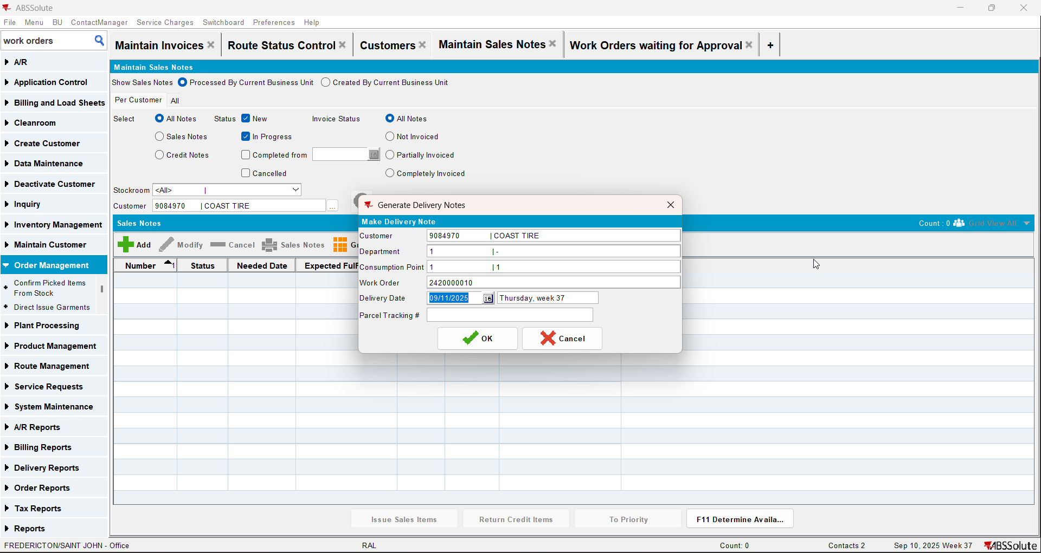
- Route Status Control dlg: generate invoices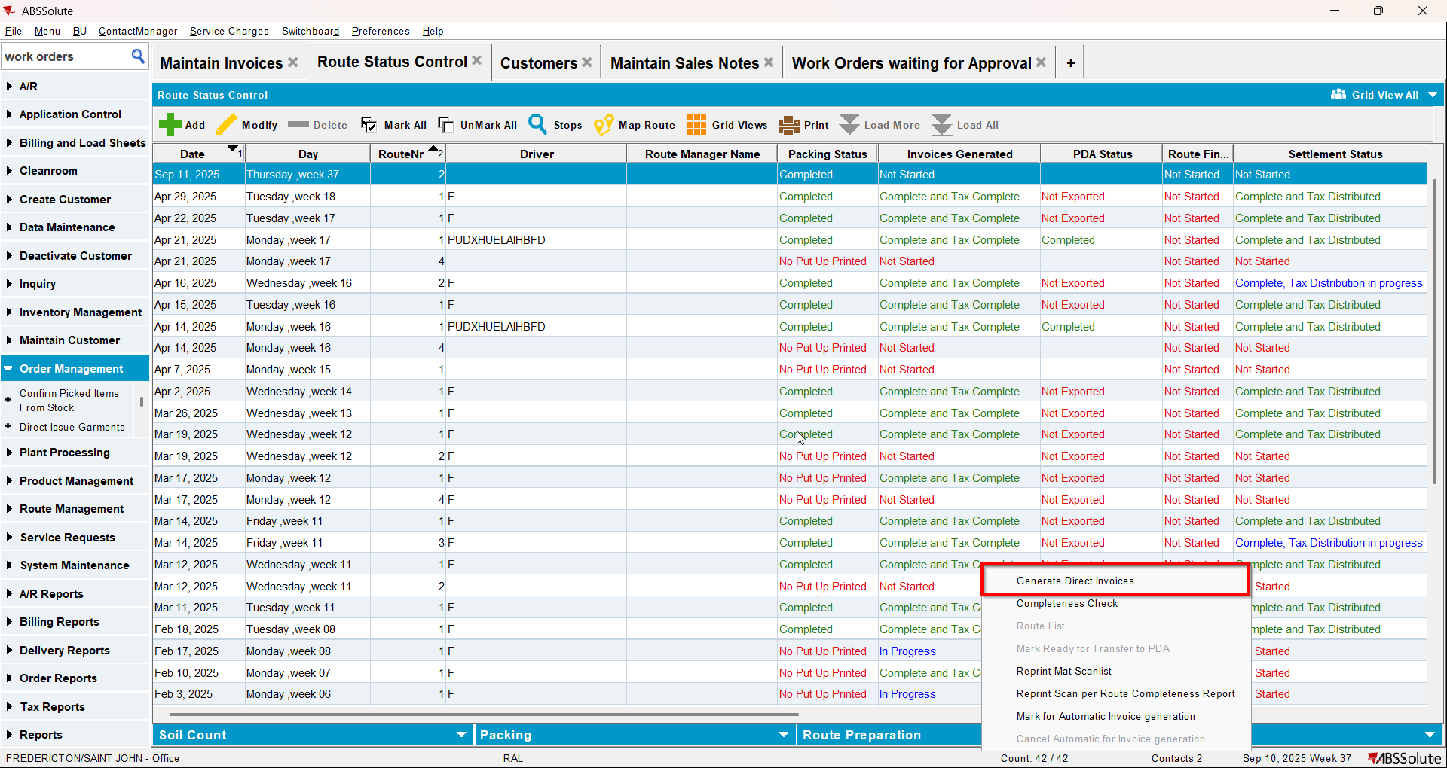
- Script the taxes and run the Vertex Import BCI process
- Route Status Control dlg: settle the route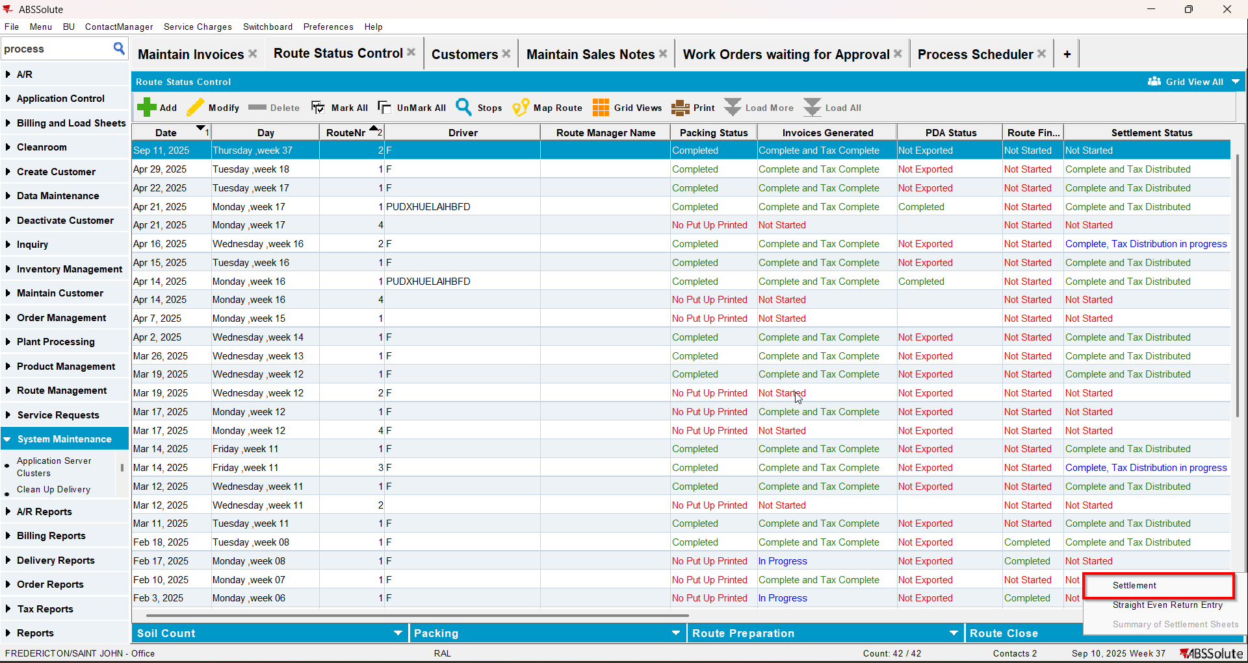
- Script the taxes and run the Vertex Import BCI process
- View Process Log dlg: check if there is an error(ignore the error with the tax amount)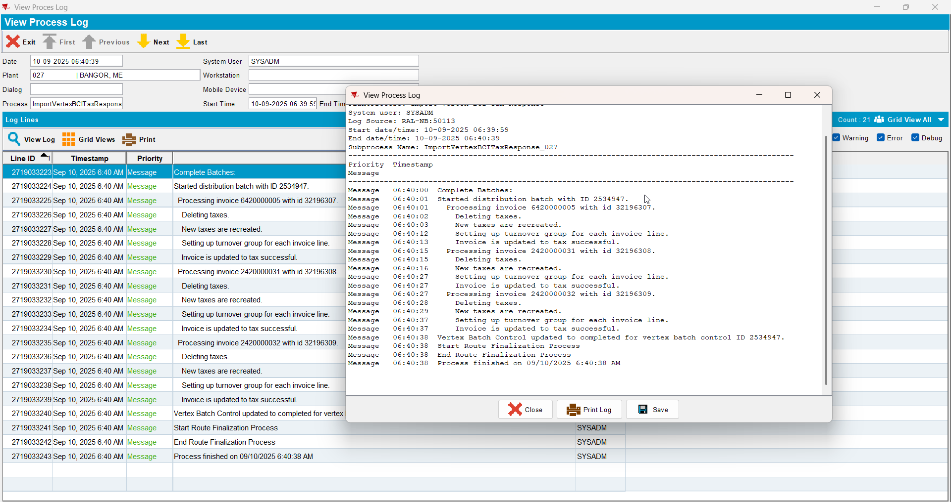
- Maintain Invoices dlg: check that the tax lines have the turnover group associated with the correct CANADA regions/states.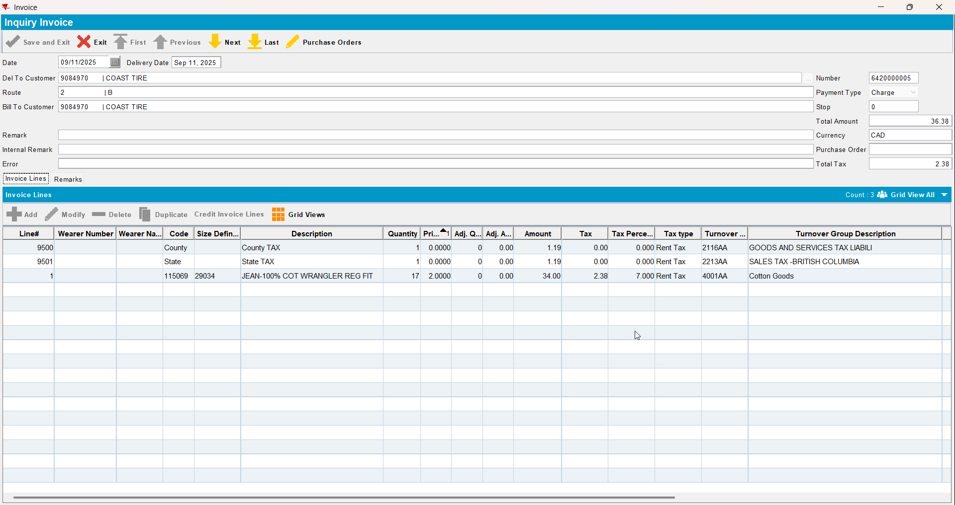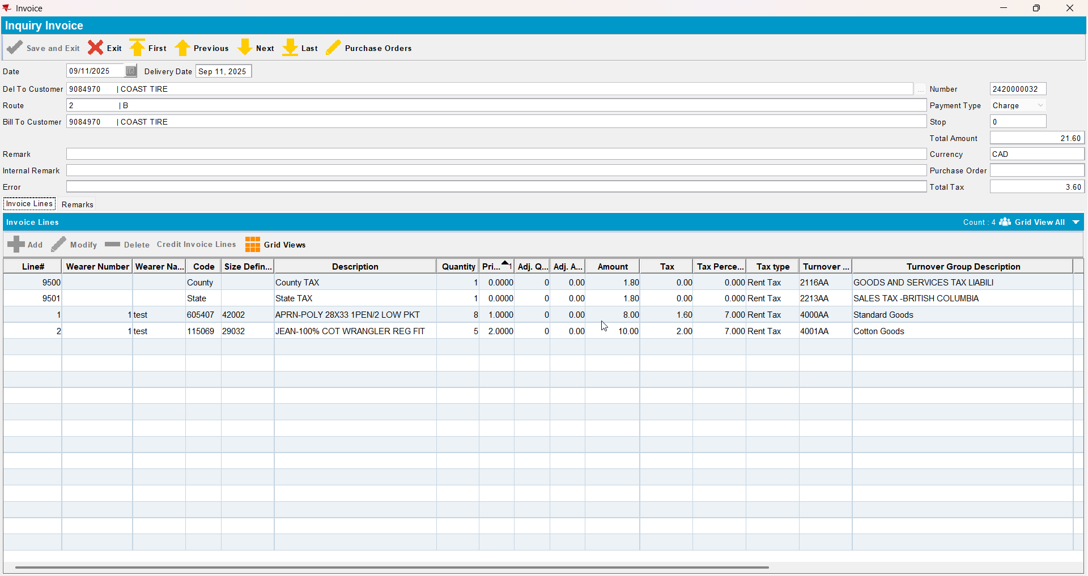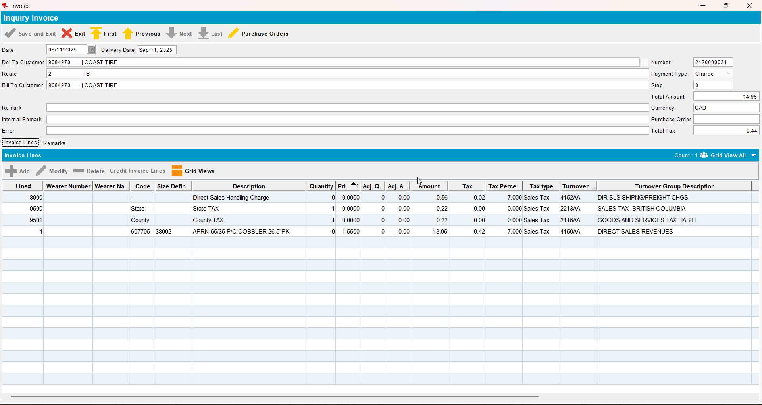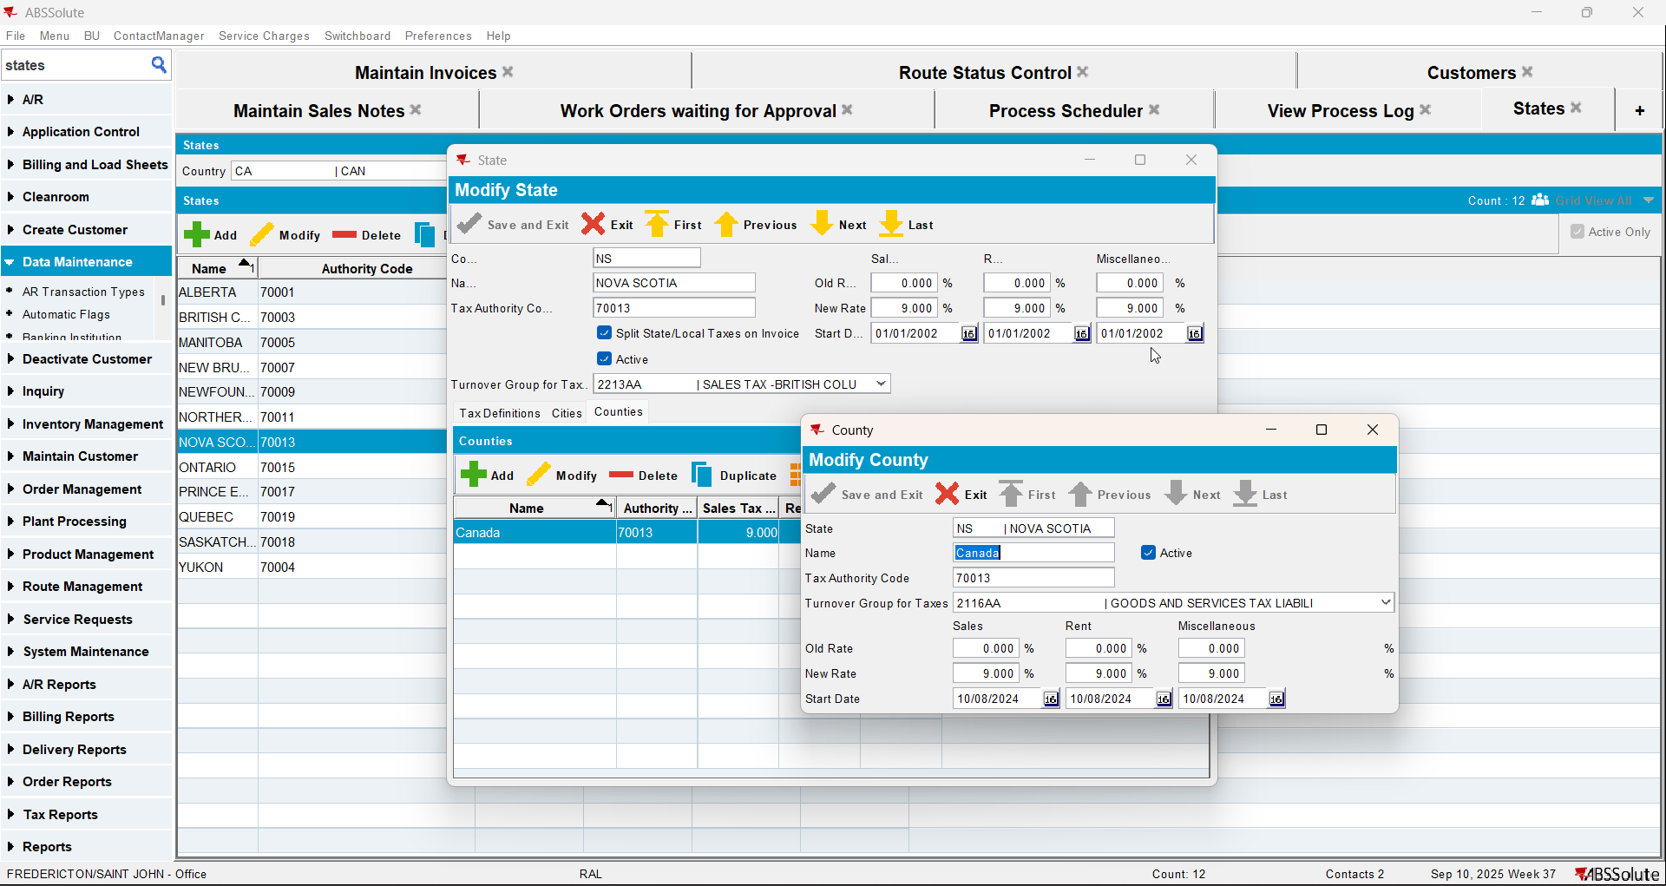
- Credit a settled invoices with settle now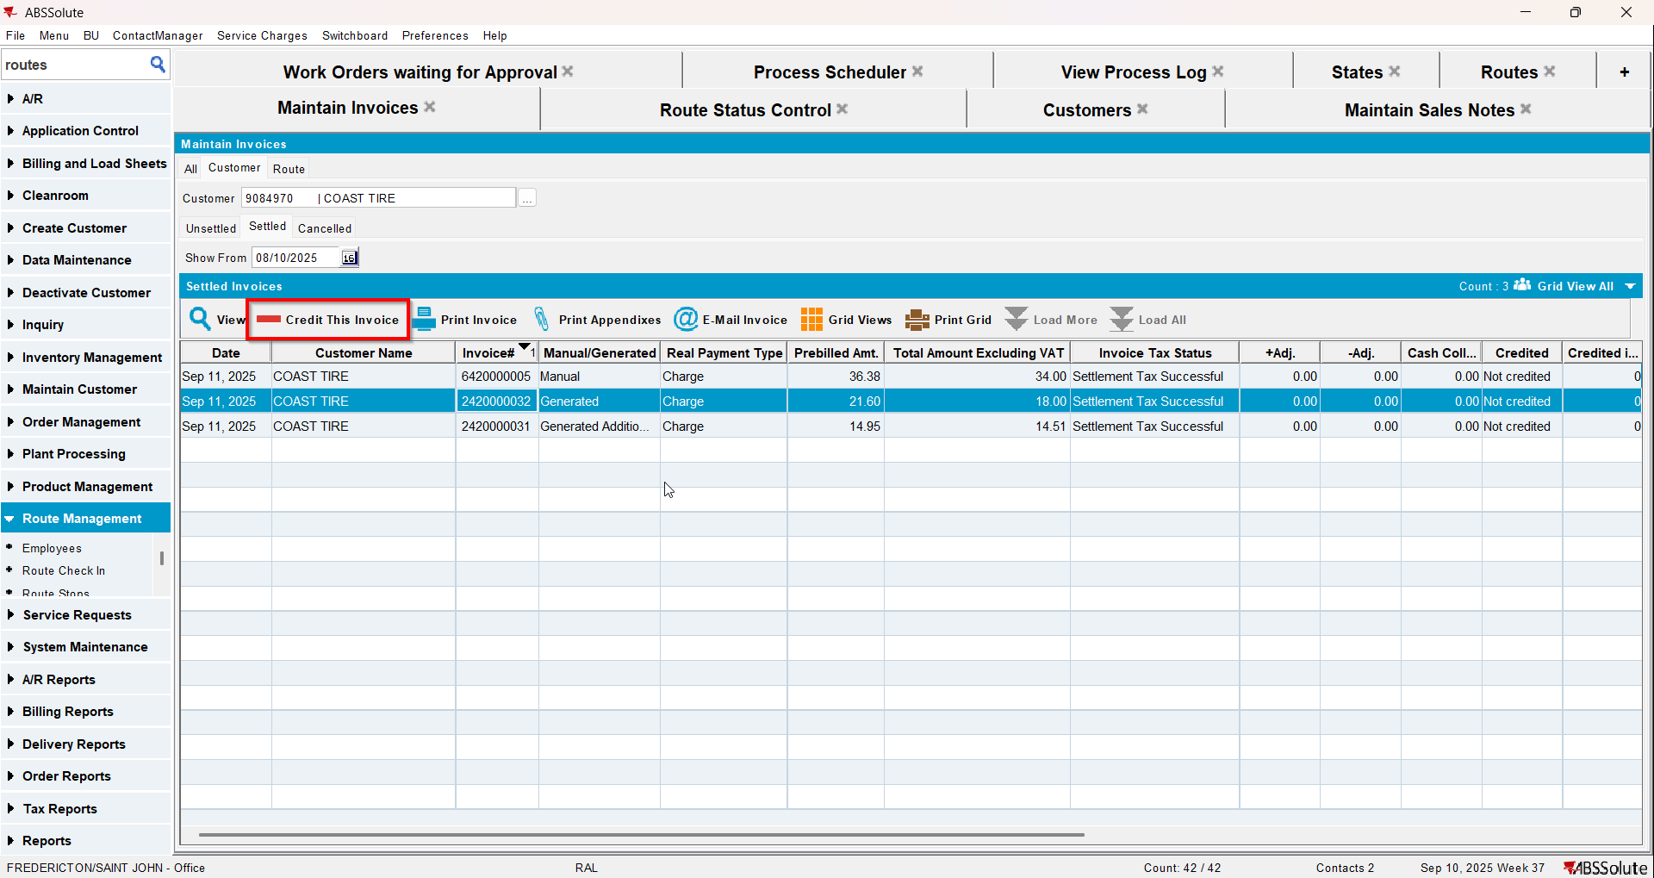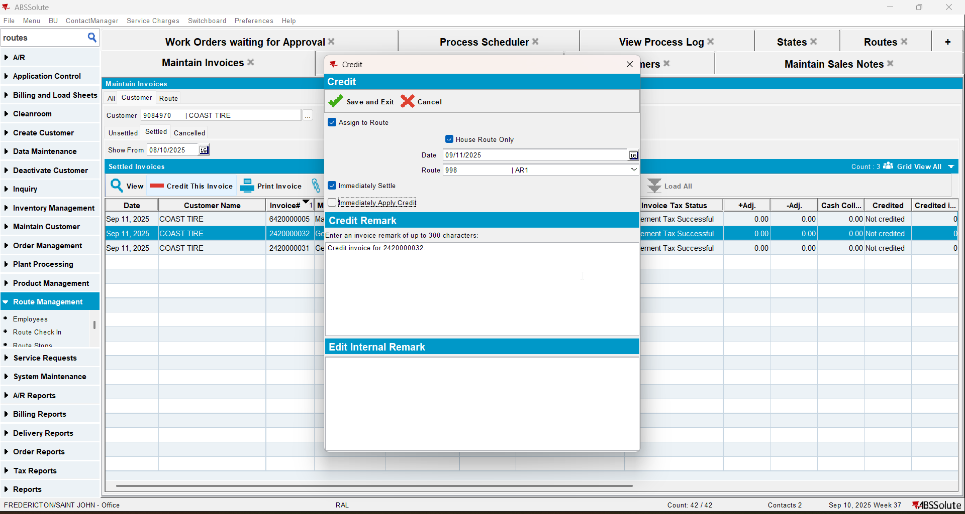
- Check that the tax lines have the turnover group associated with the correct CANADA regions/states.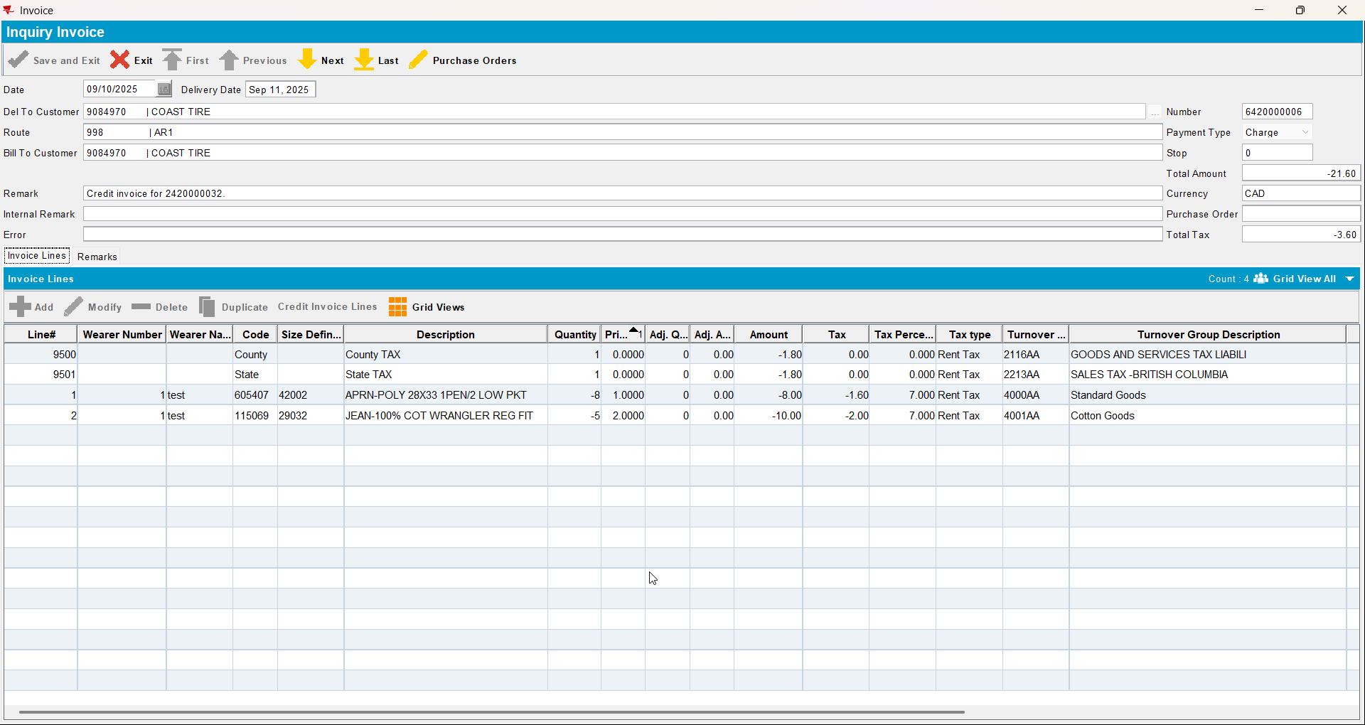

Test Case 2 – Customer with different bill-to from US but CA currency and taxareaID– Tested OK
Expected behavior: When running the Vertex Import BCI process scheduler there is no error and the tax lines get turnovergroups associated with the correct CANADA regions/states.
Hash: 94deccf
- Check that your BU has legal Entity UNC01 (you can use BU 710)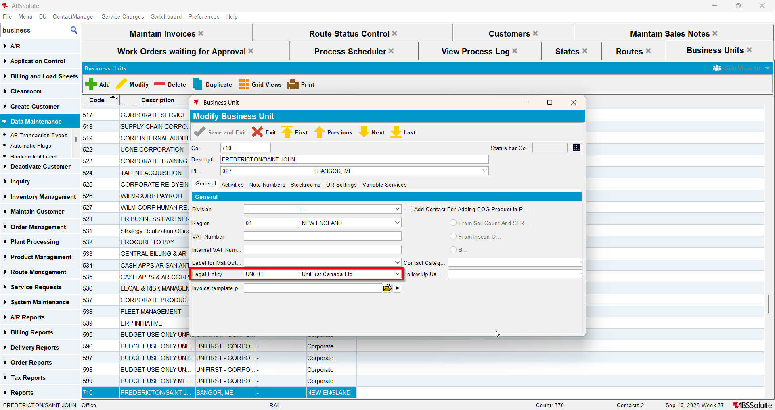
- Have a customer with Country CA, Currency CAD and Tax Area CA (Customer 1)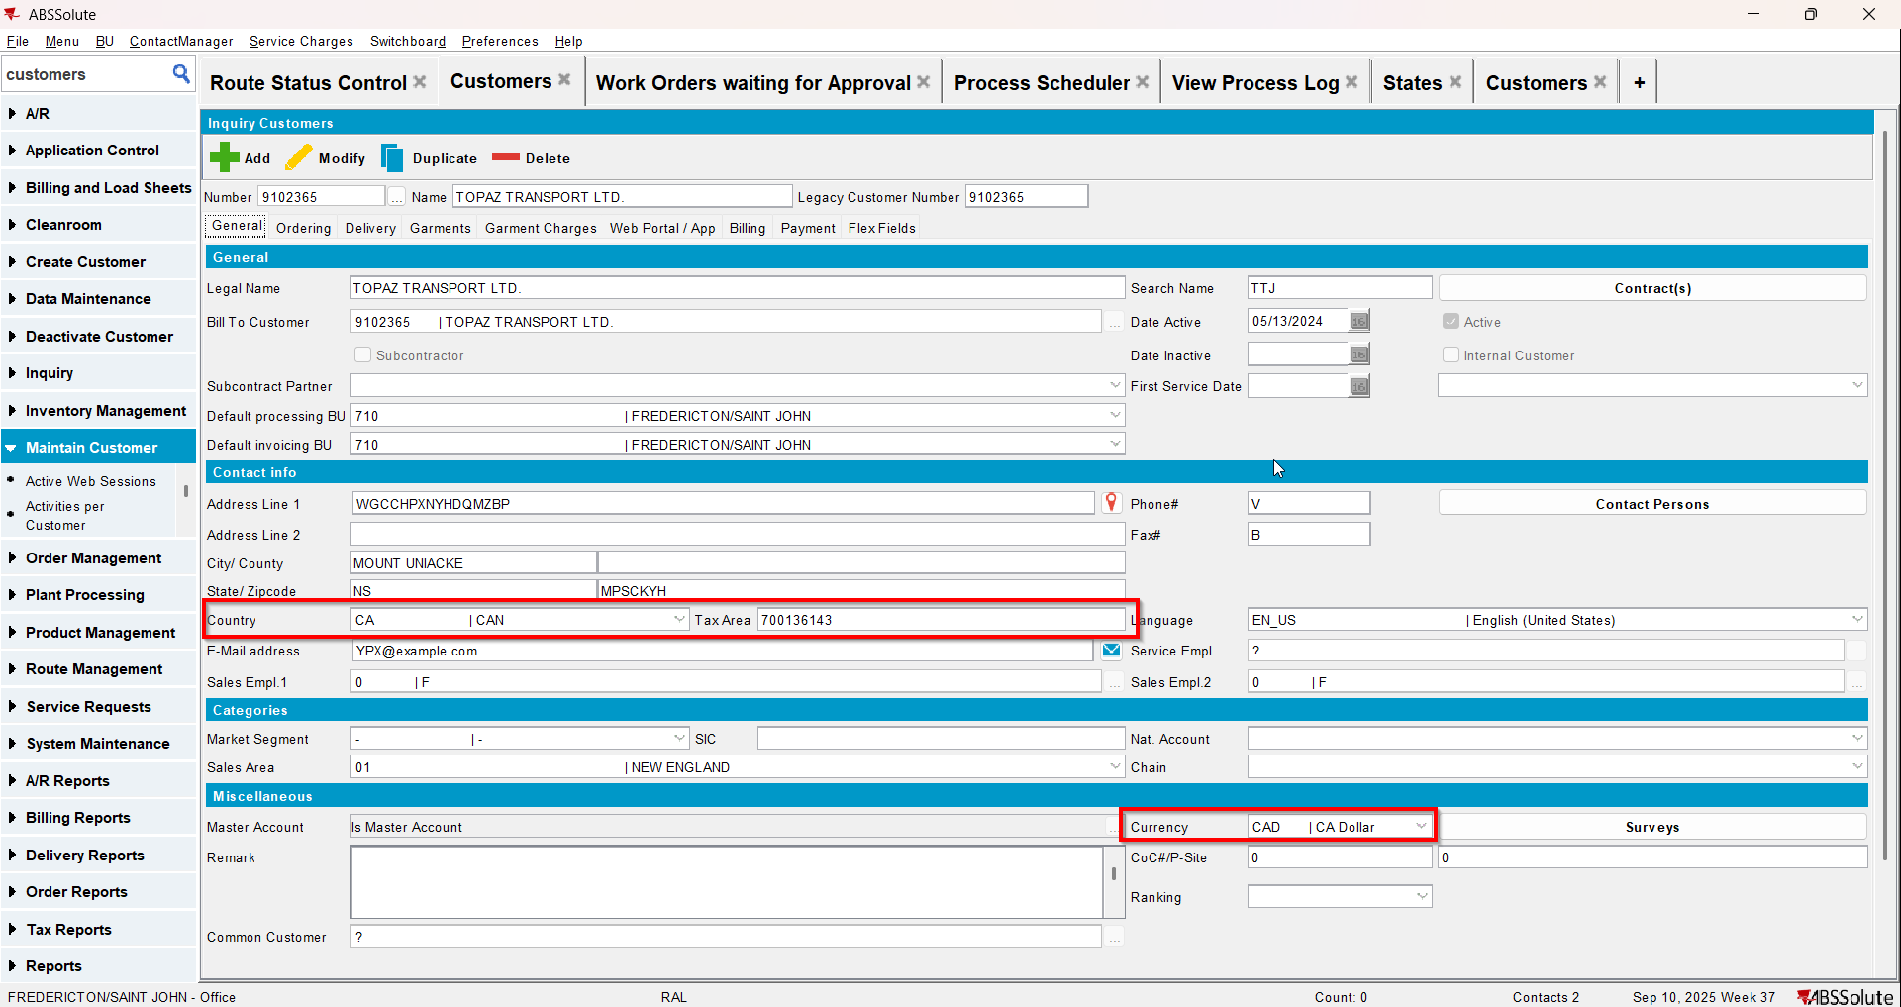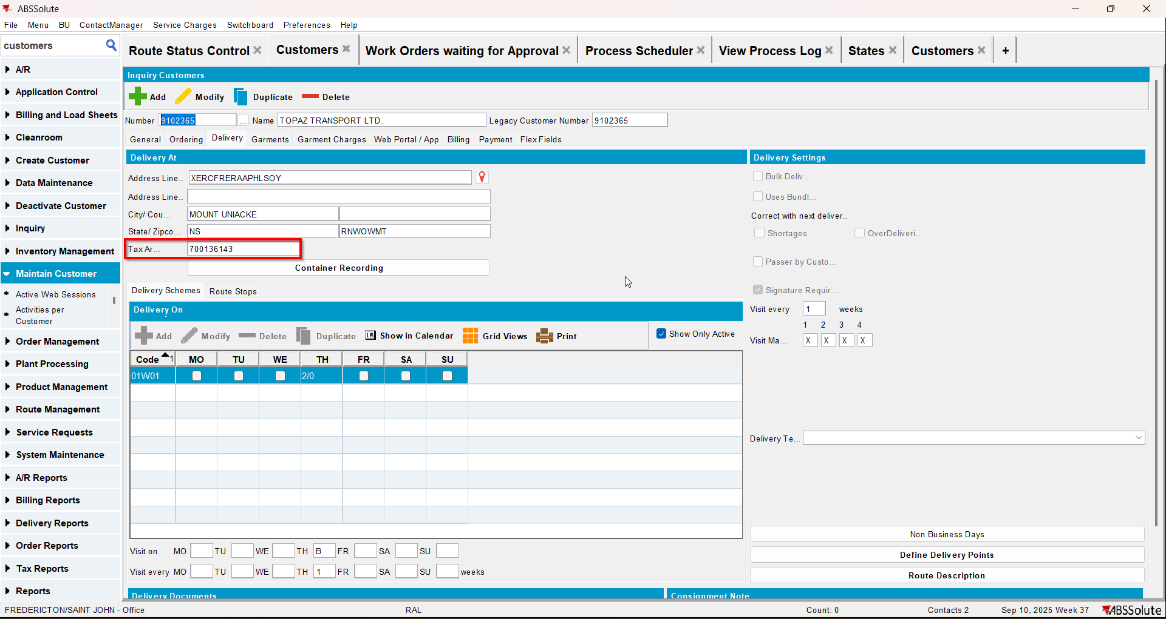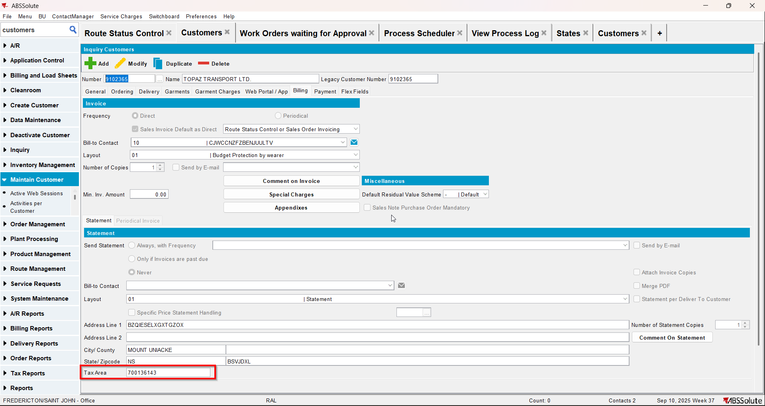
- Have a customer with Country US, Currency CAD and Tax Area CA (Customer 2)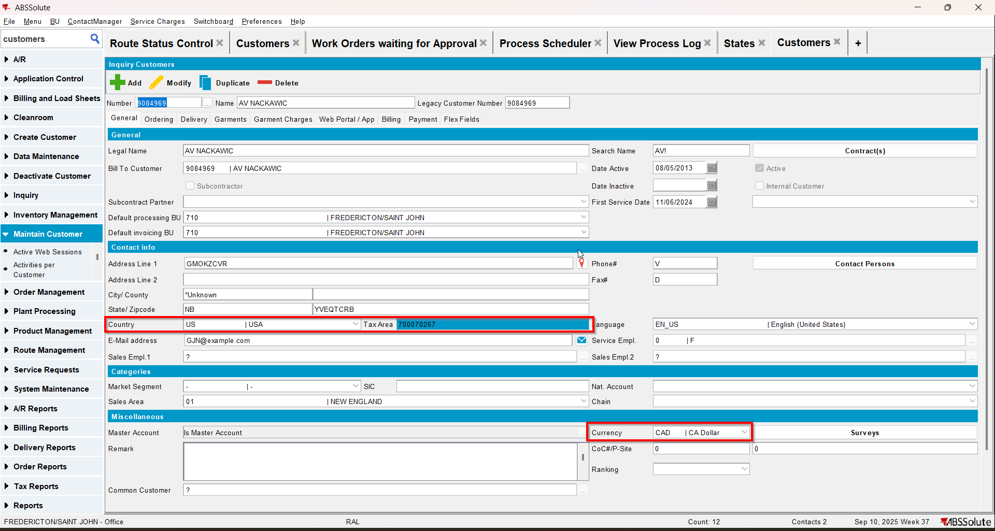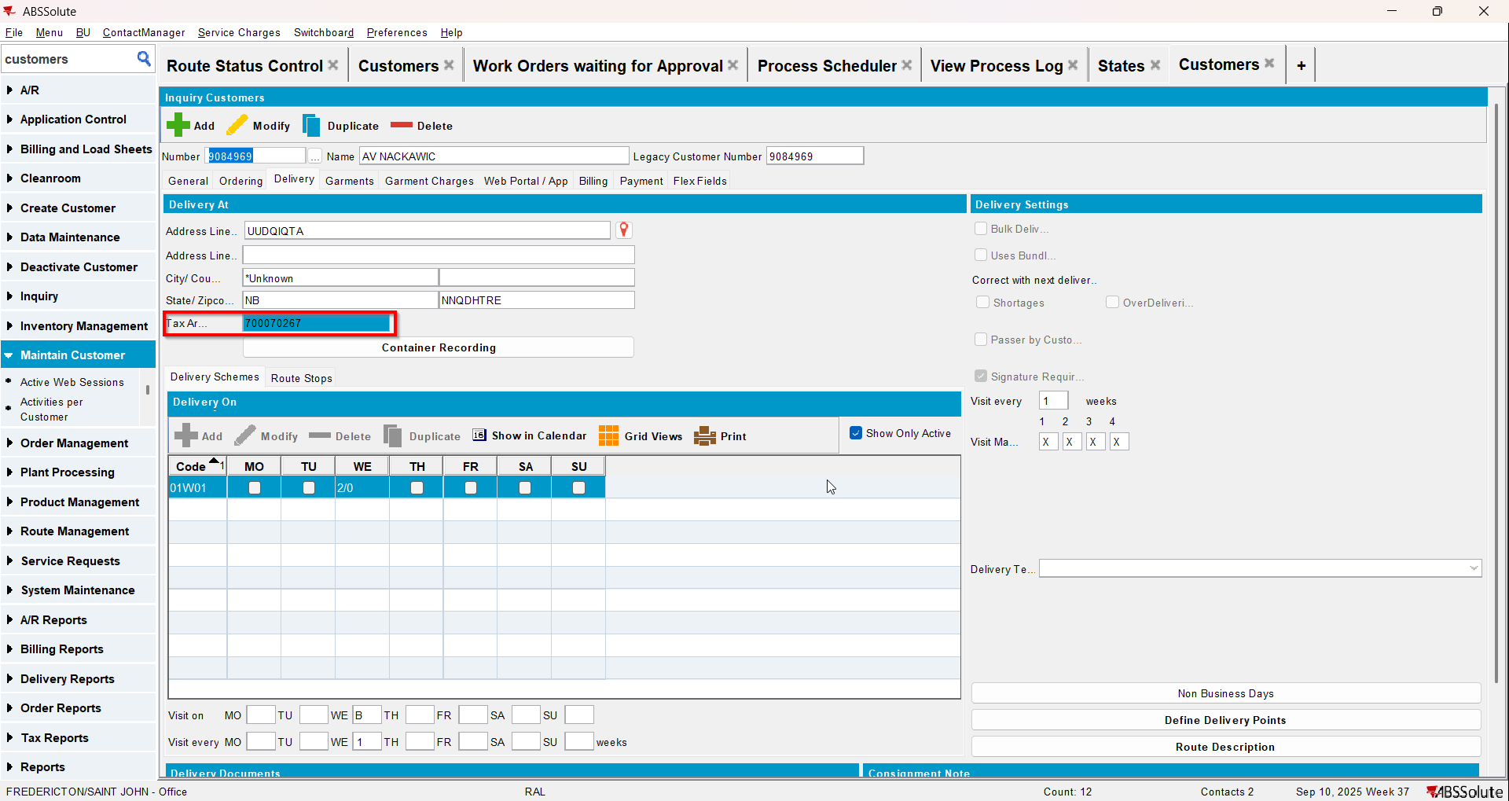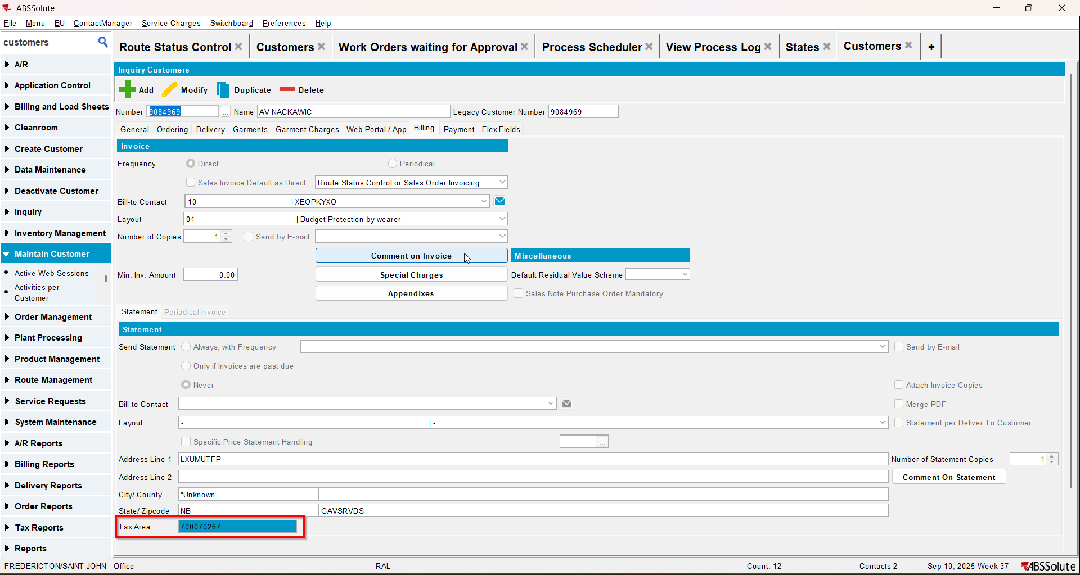
- Assign the Customer 2 as bill to for Customer 1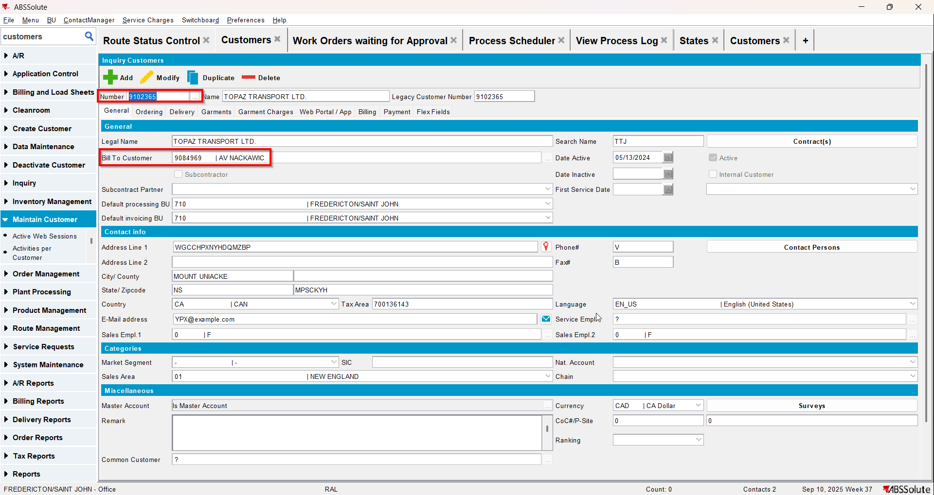
- Maintain Invoices dlg: create a manual invoice for your customer and add it to the route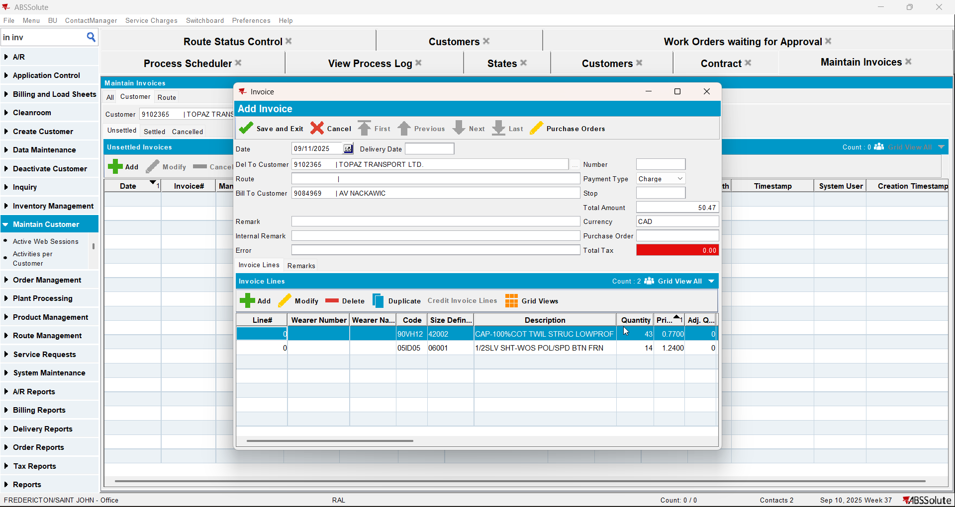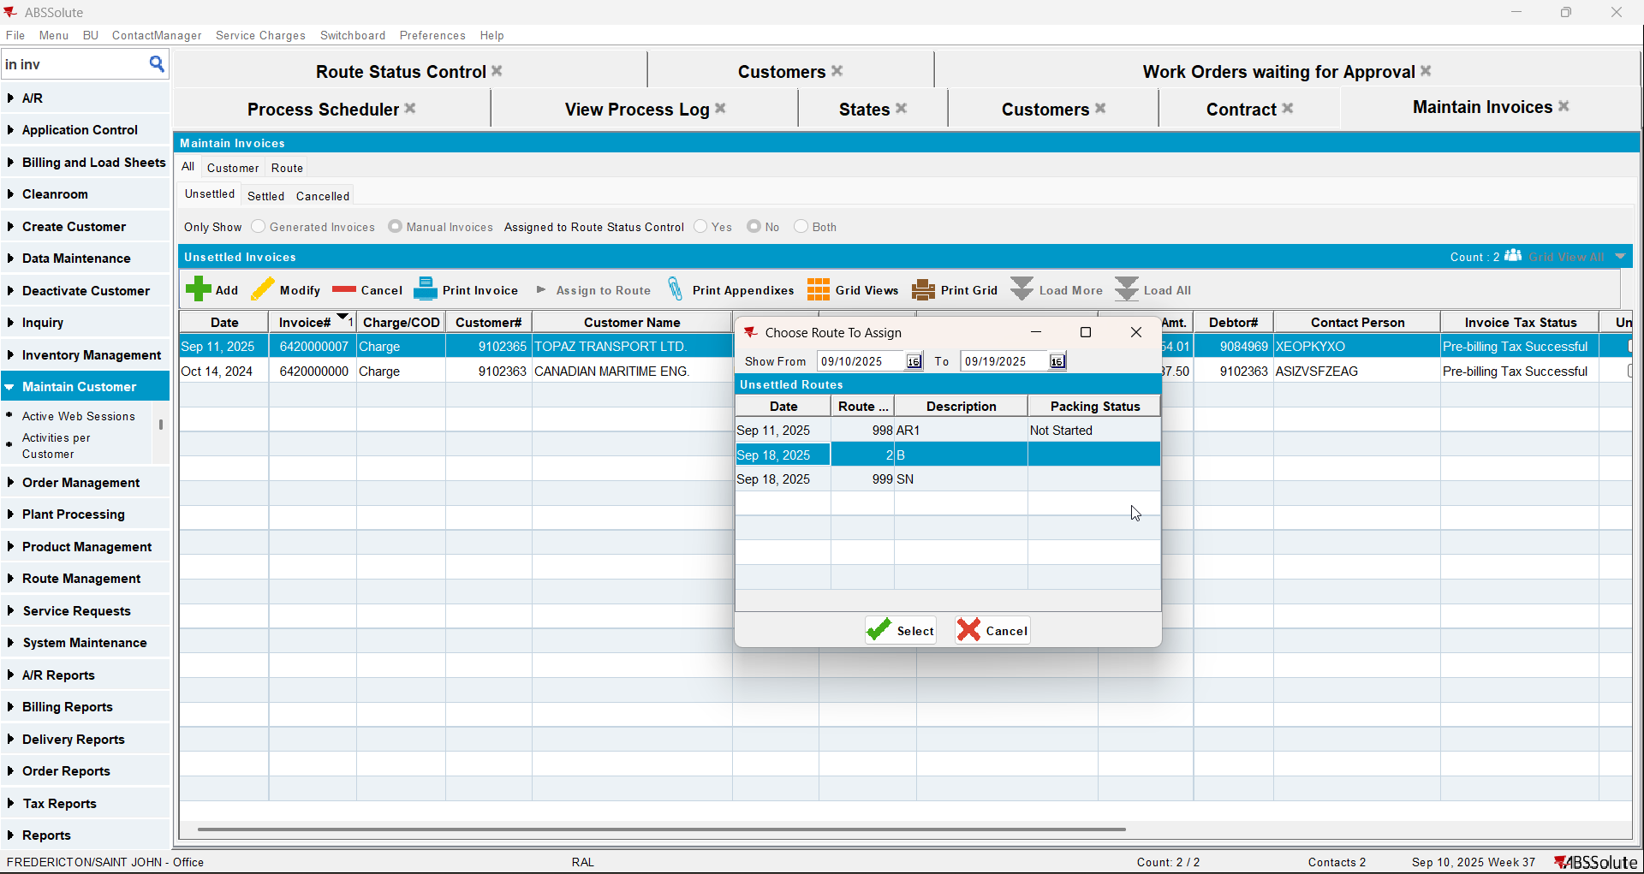
- Maintain Sales Notes dlg: create a sales note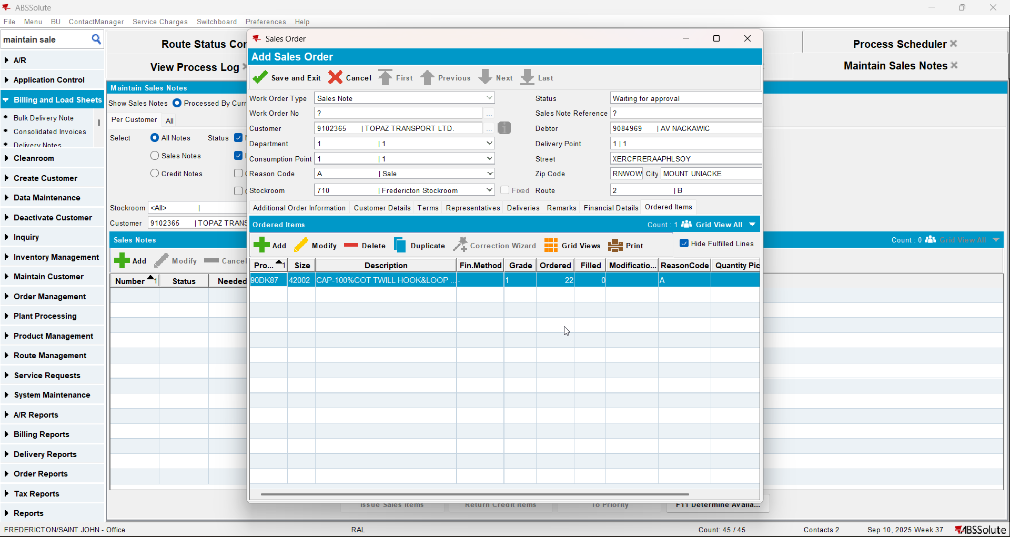
- Work Orders waiting for Approval dlg: approve your sales note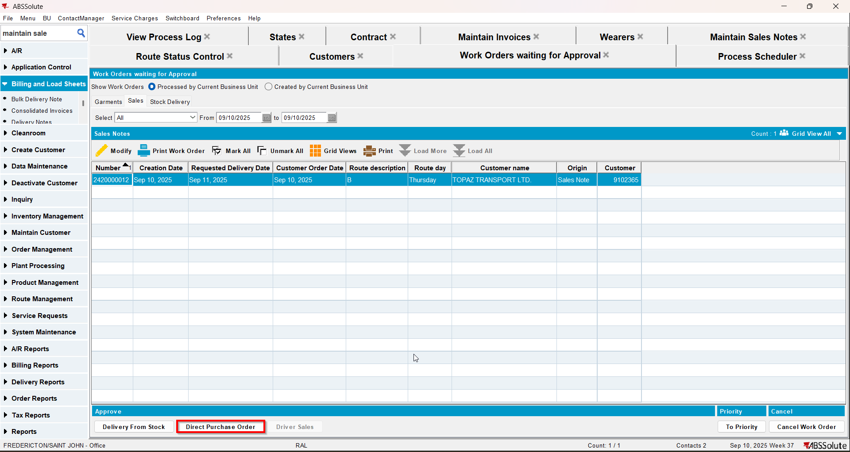
- Maintain Sales Notes dlg: issue the items and generate delivery notes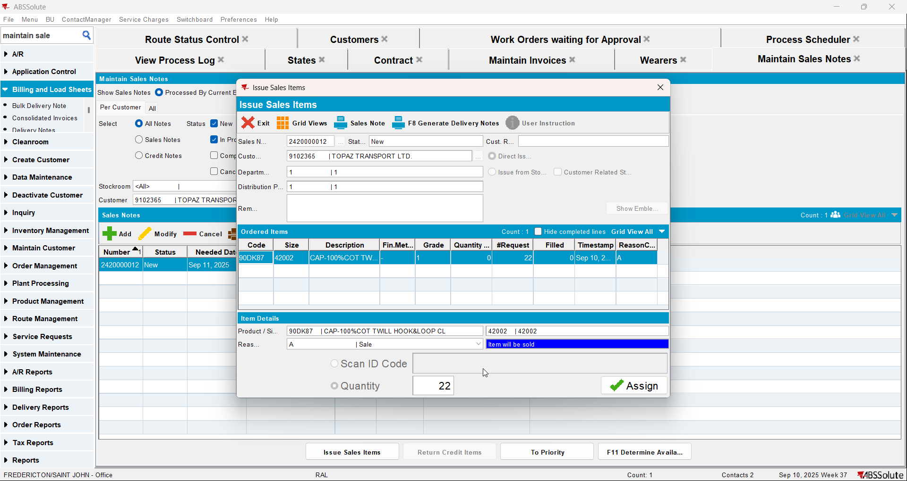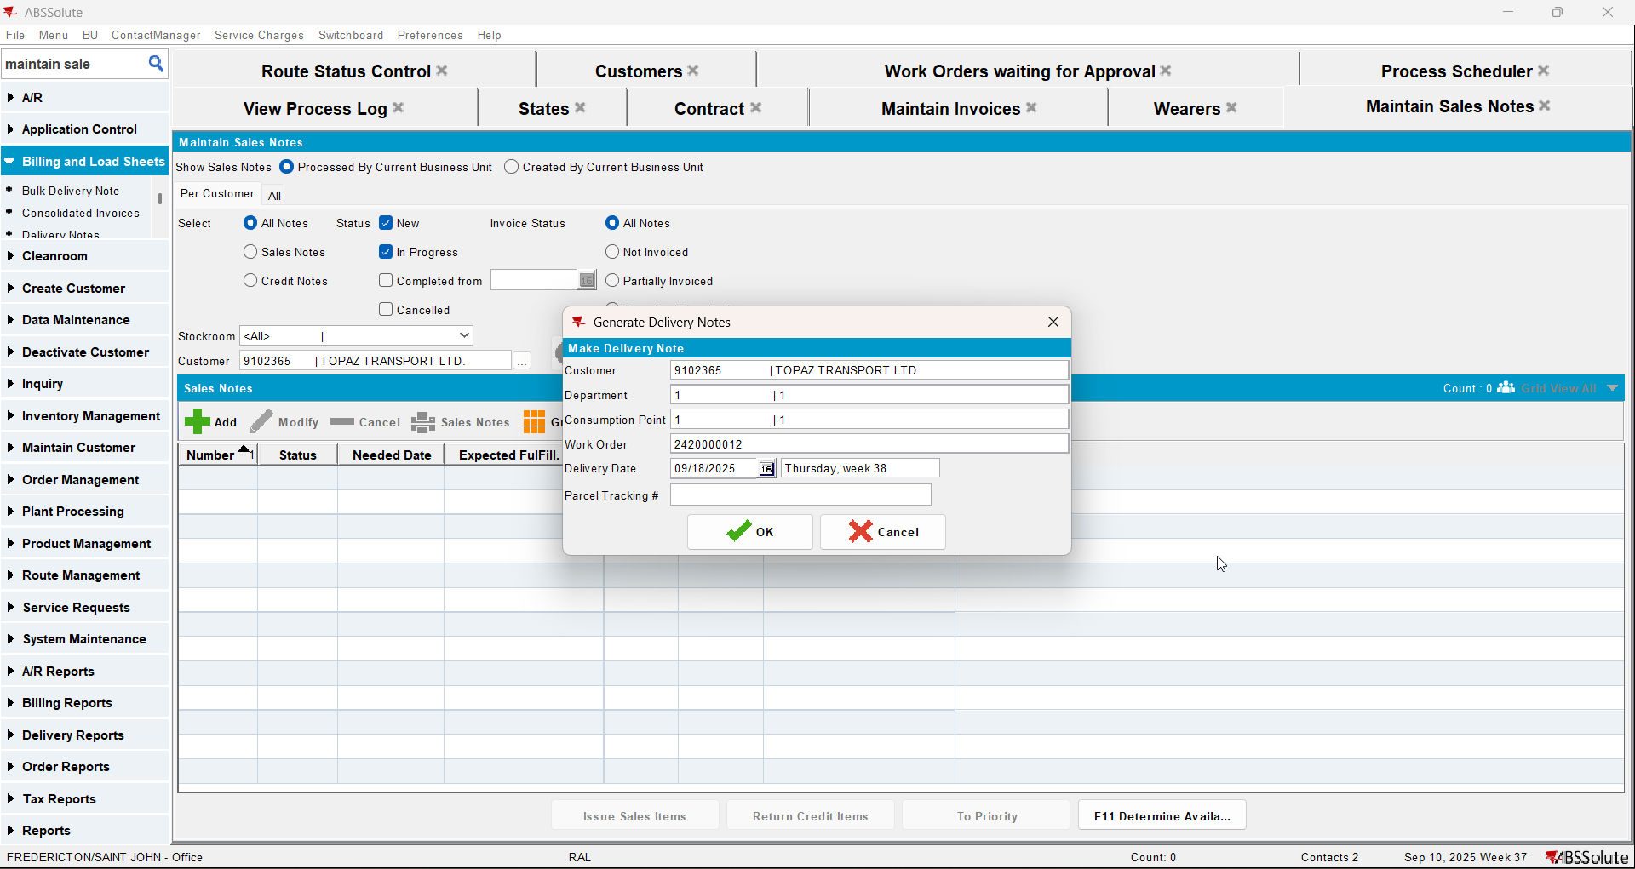
- Route Status Control dlg: generate invoices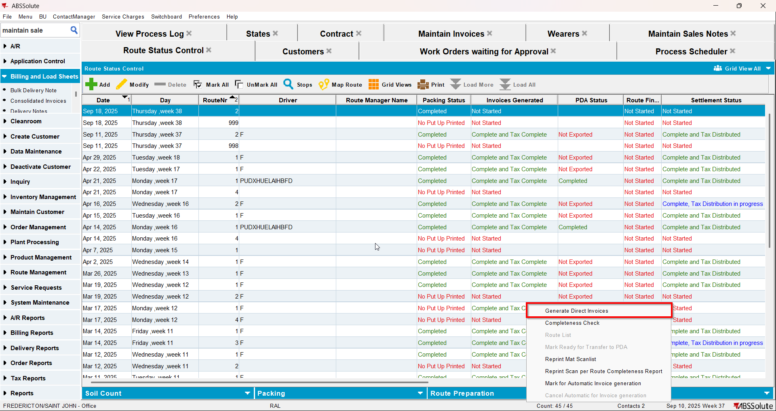
- Script the taxes and run the Vertex Import BCI process
- Route Status Control dlg: settle the route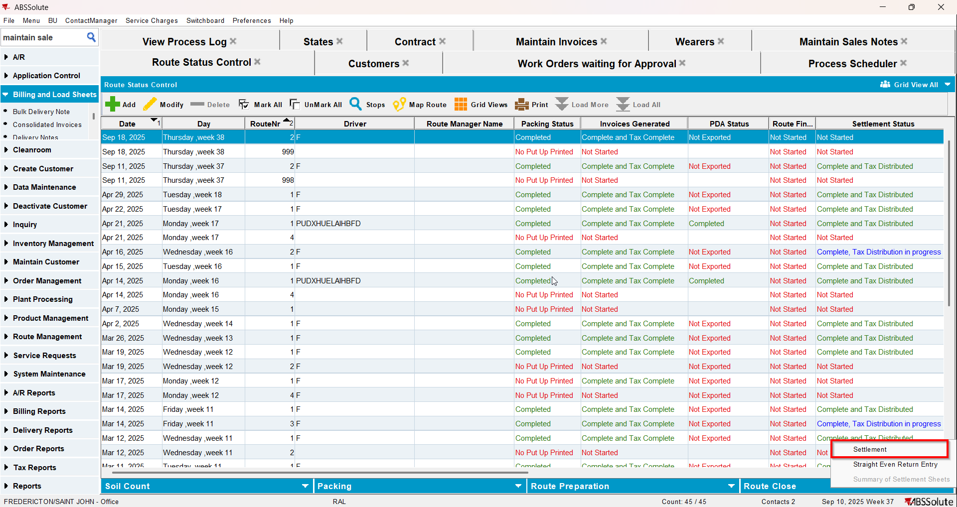
- Script the taxes and run the Vertex Import BCI process
- View Process Log dlg: check if there is an error(ignore the error with the tax amount)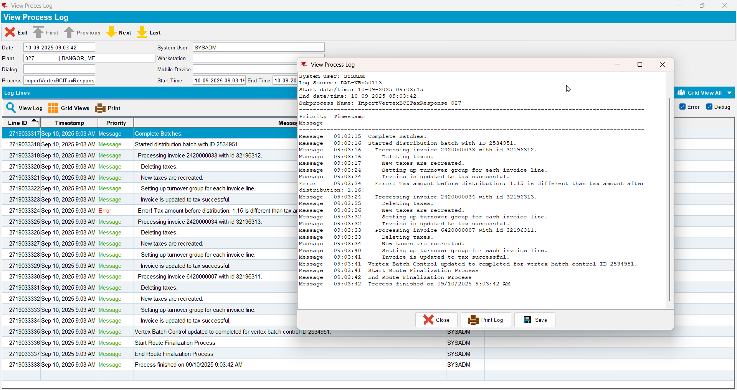
- Maintain Invoices dlg: check that the tax lines have the turnover group associated with the correct CANADA regions/states.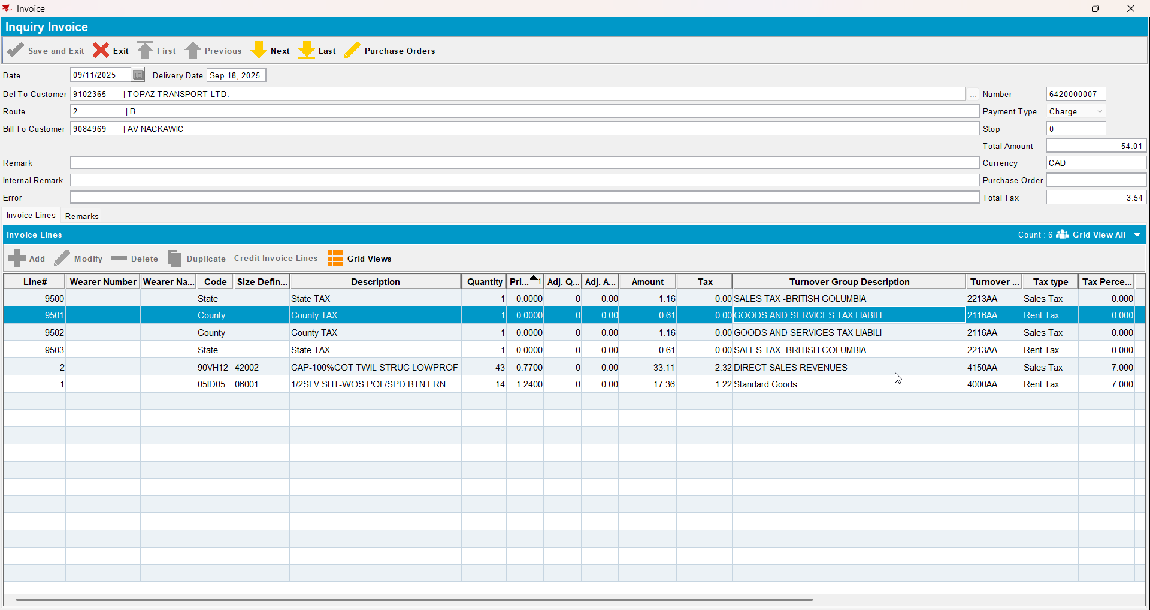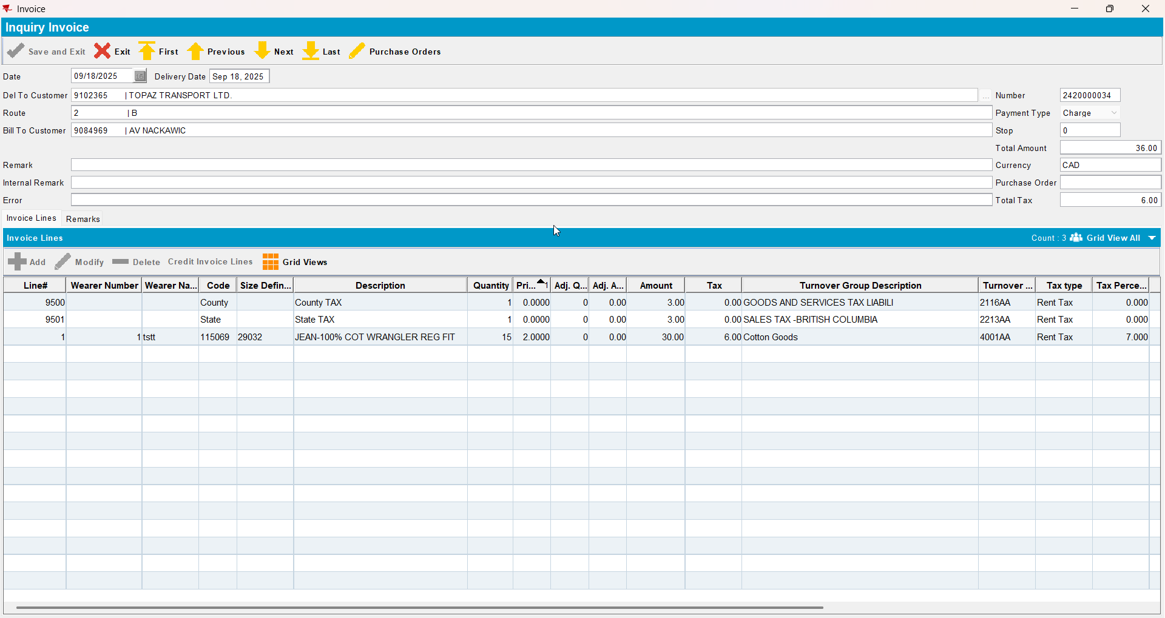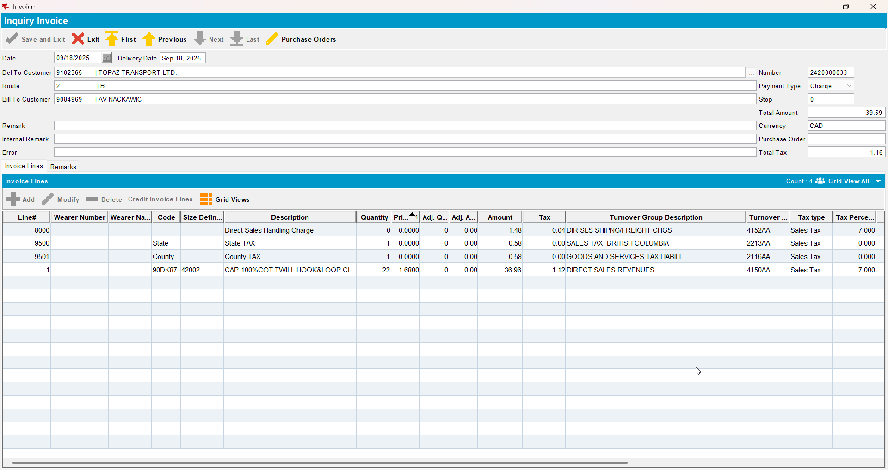
- Credit a settled invoices with settle now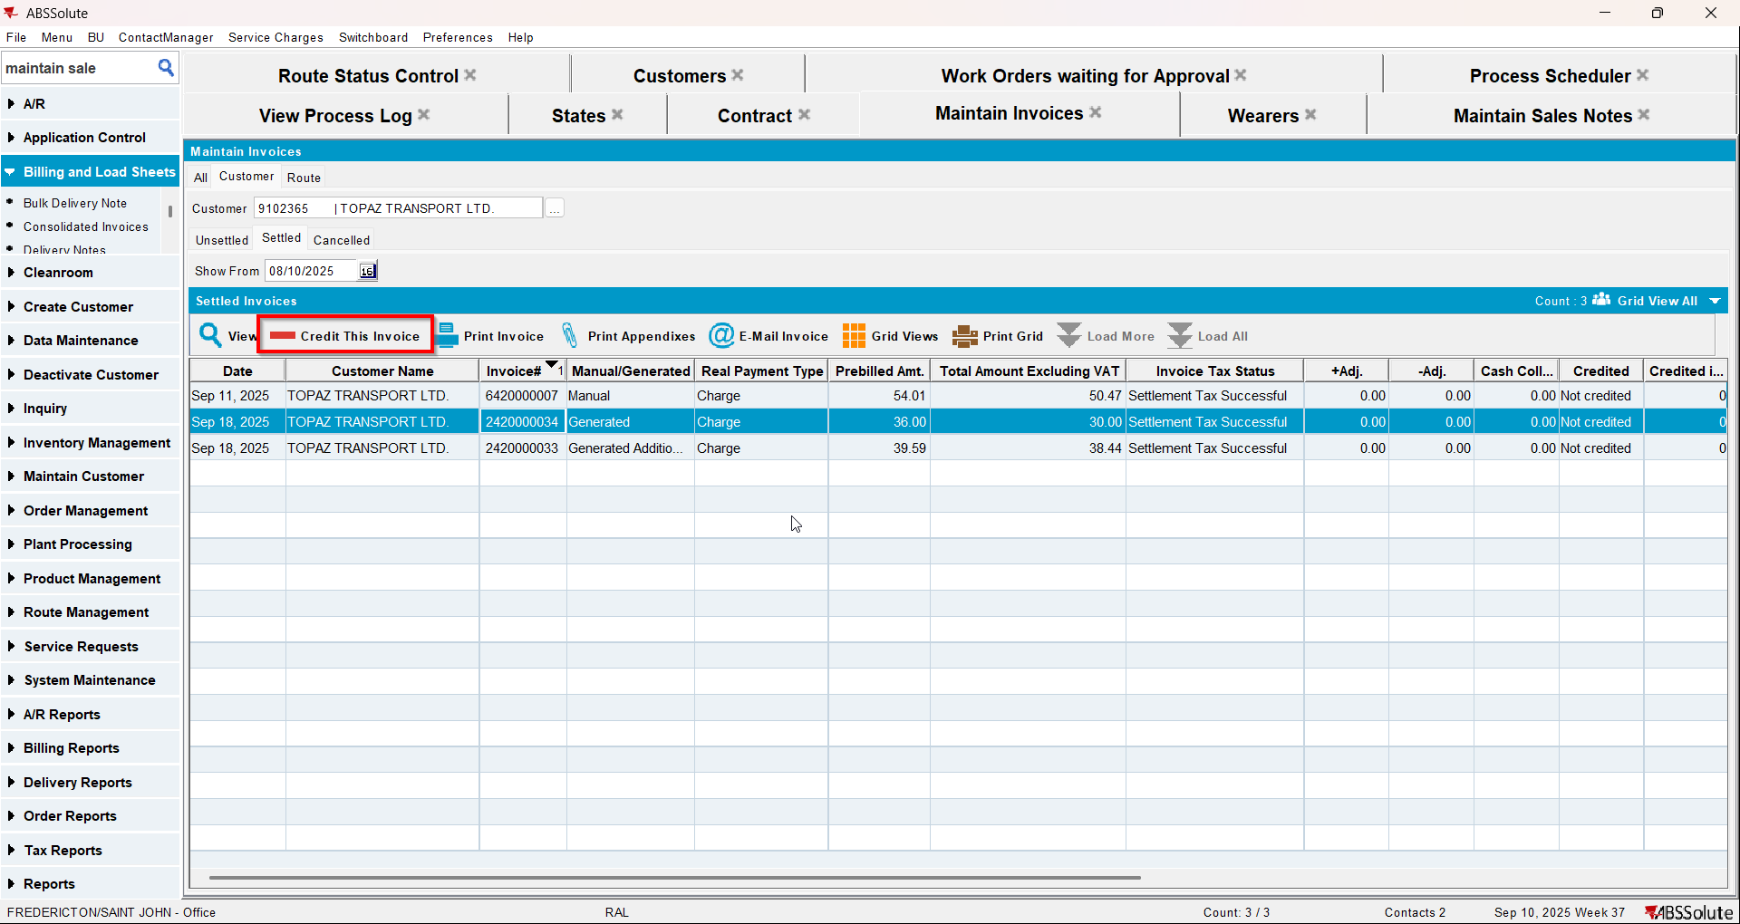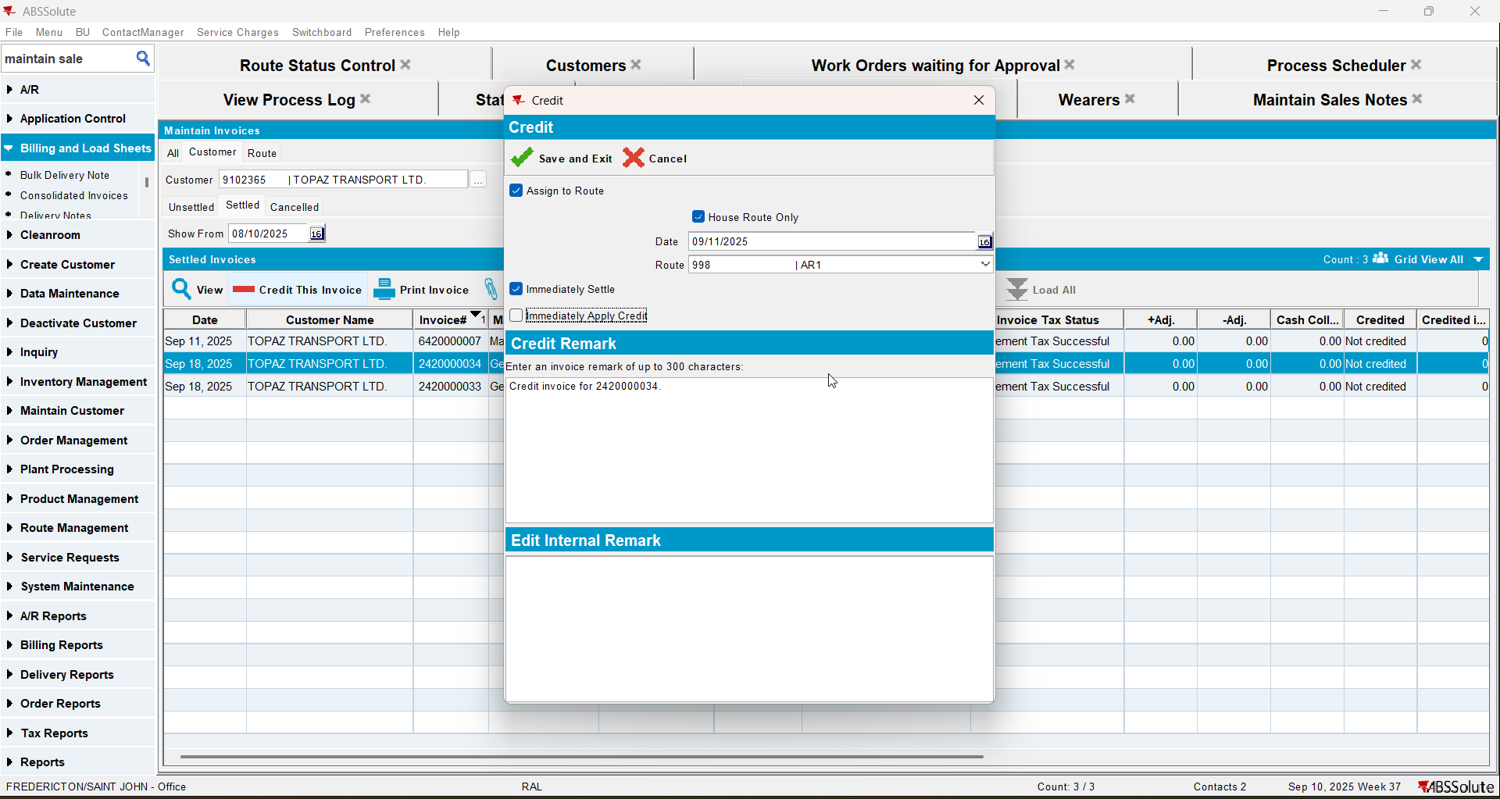
- Check that the tax lines have the turnover group associated with the correct CANADA regions/states.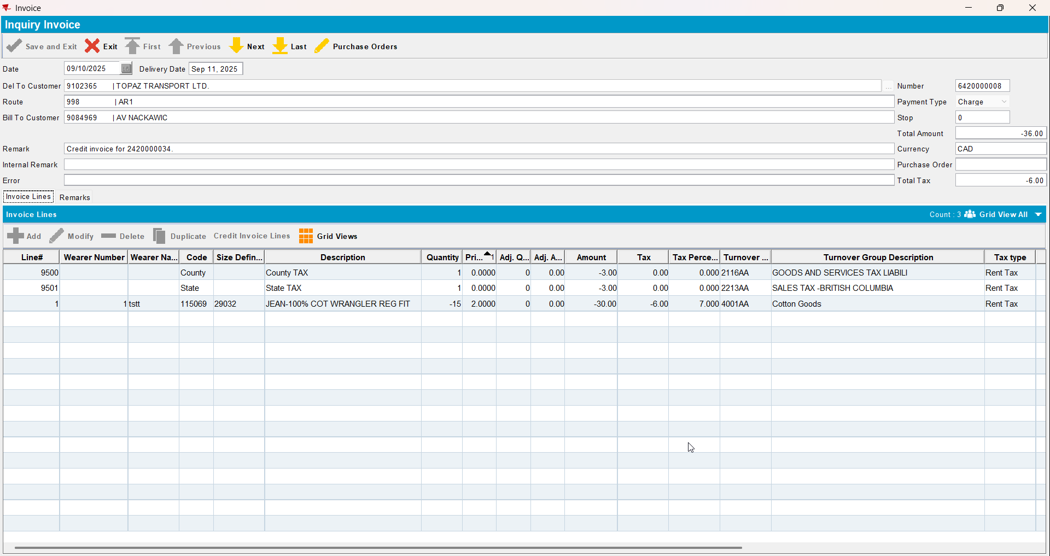

Test Case 3 – Customer with same bill-to from US and US currency but CA taxareaID– Tested OK
Expected behavior: When running the Vertex Import BCI process scheduler there an error and the tax lines do not get turnovergroups associated with the correct CANADA regions/states.
Hash: 94deccf
- Check that your BU has legal Entity UNC01 (you can use BU 710)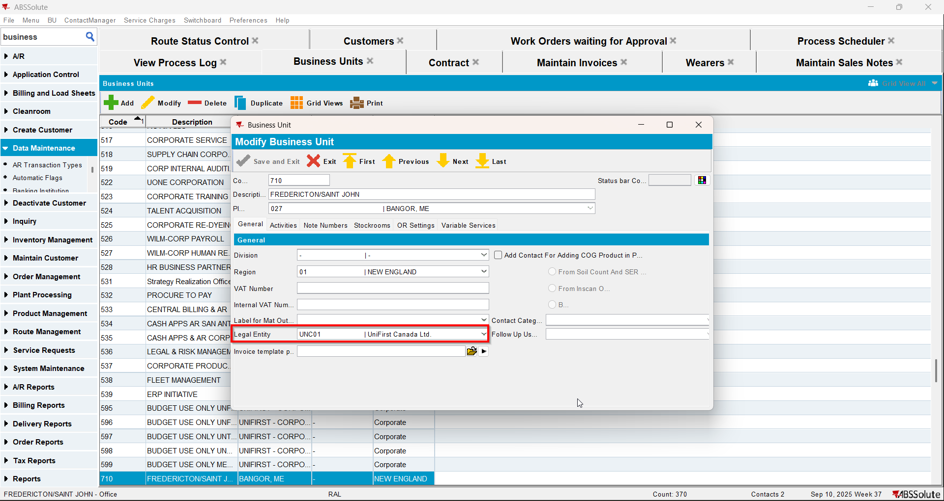
- Have a customer with Country US, Currency USD and Tax Area CA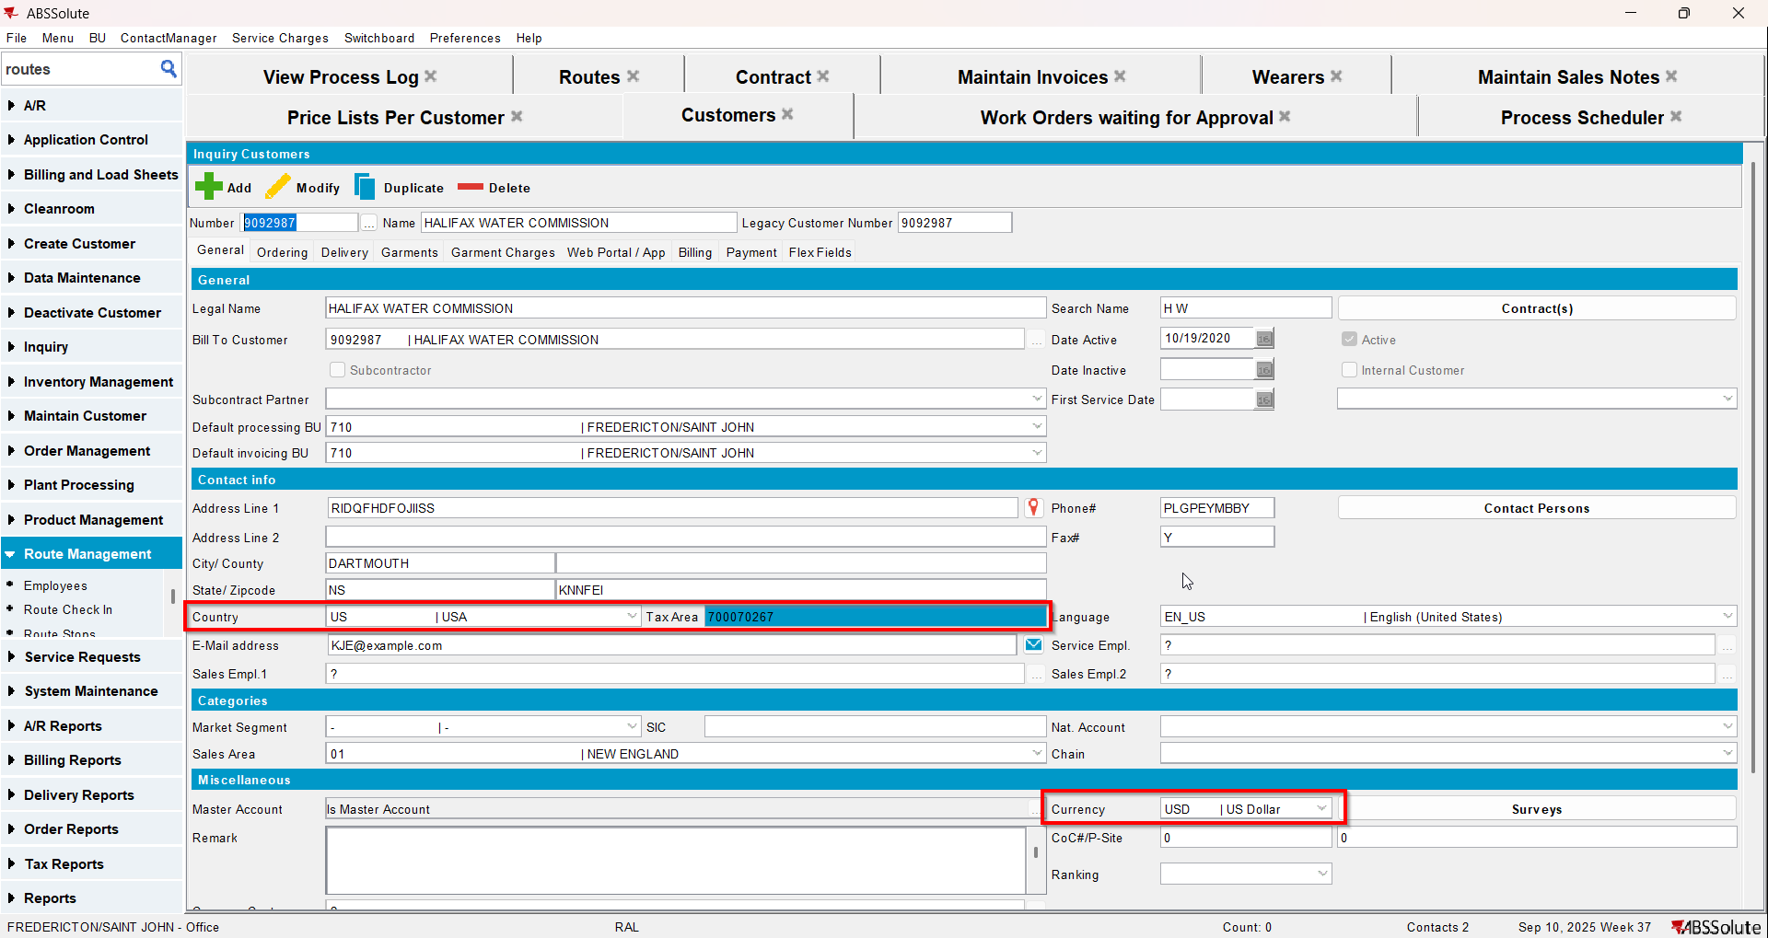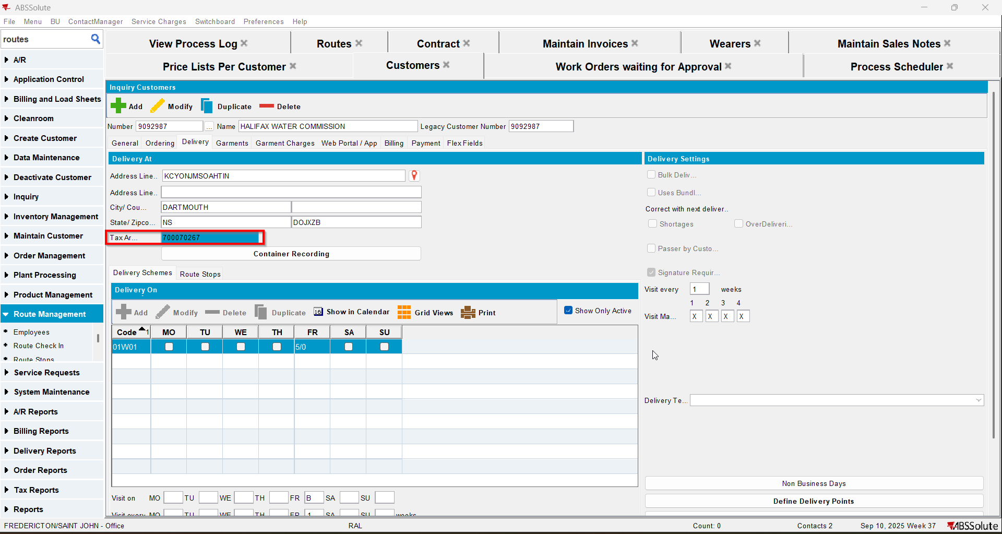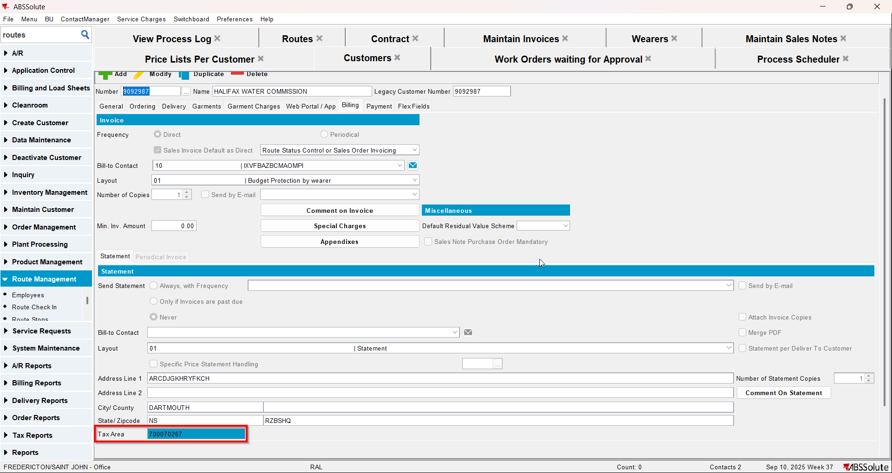
- Maintain Invoices dlg: create a manual invoice for your customer and add it to the route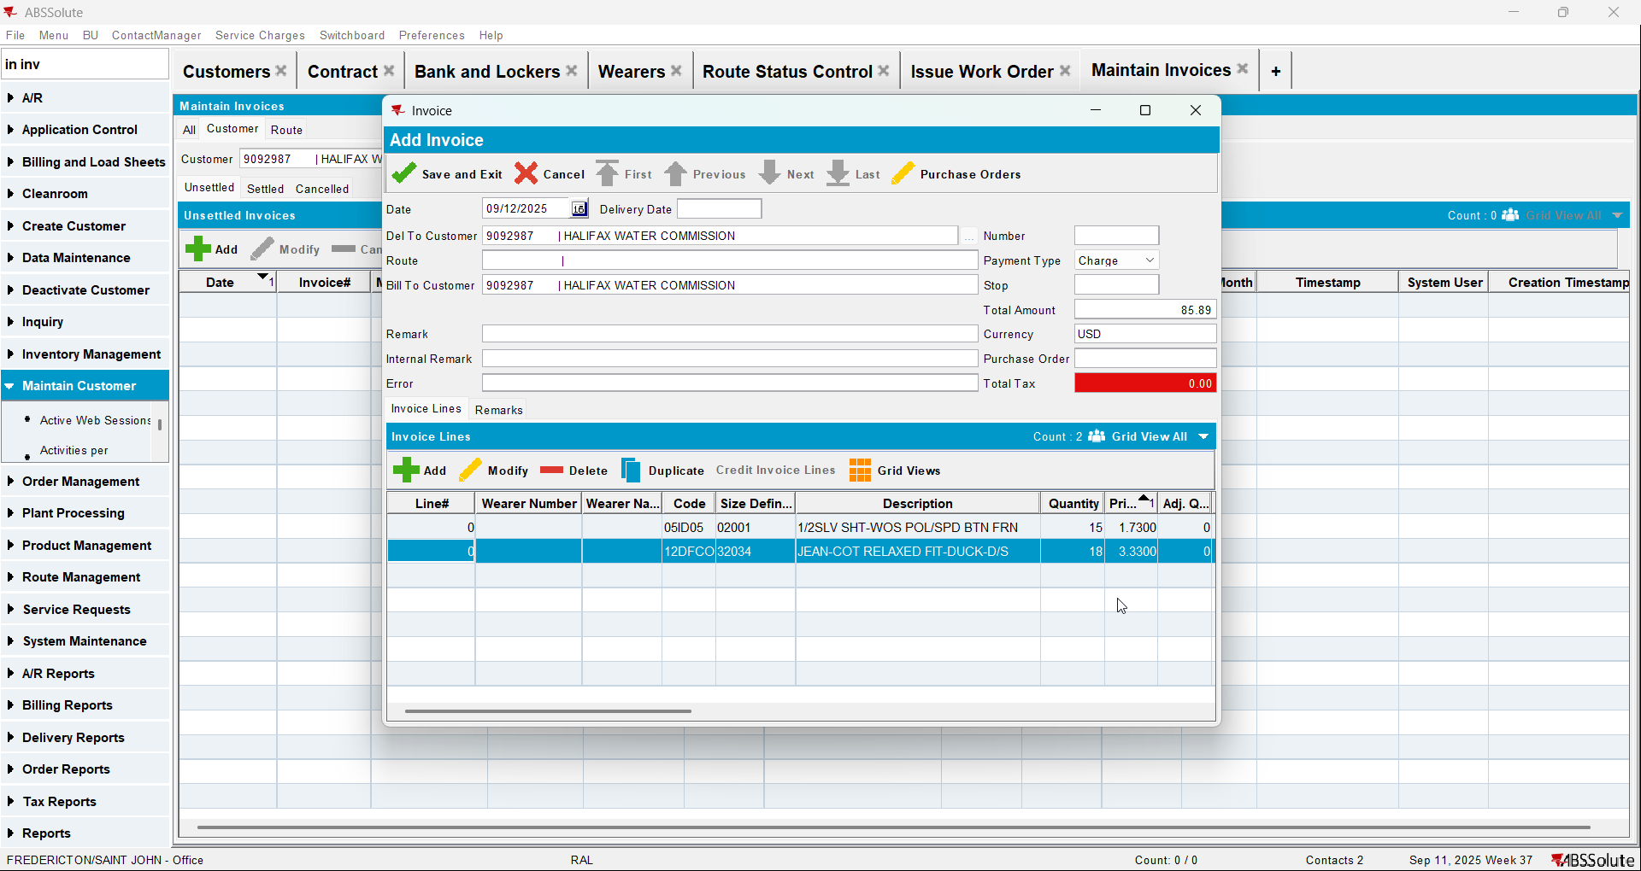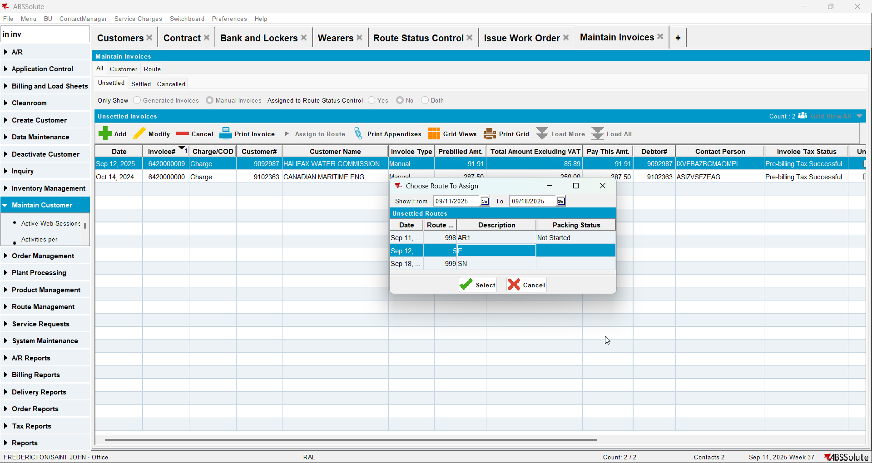
- Maintain Sales Notes dlg: create a sales note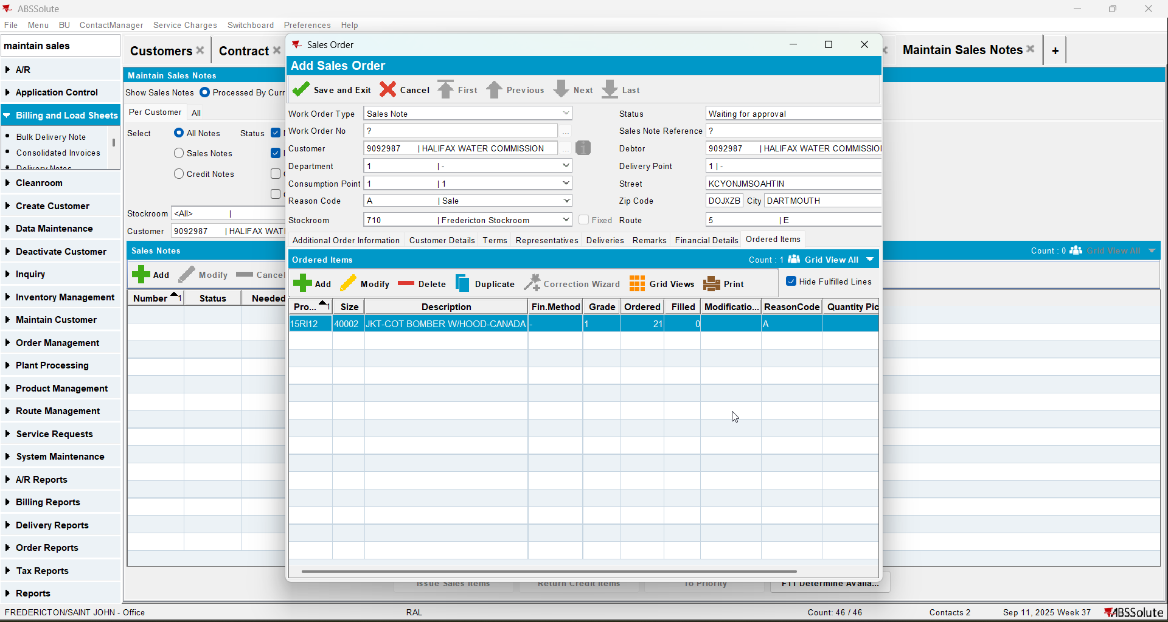
- Work Orders waiting for Approval dlg: approve your sales note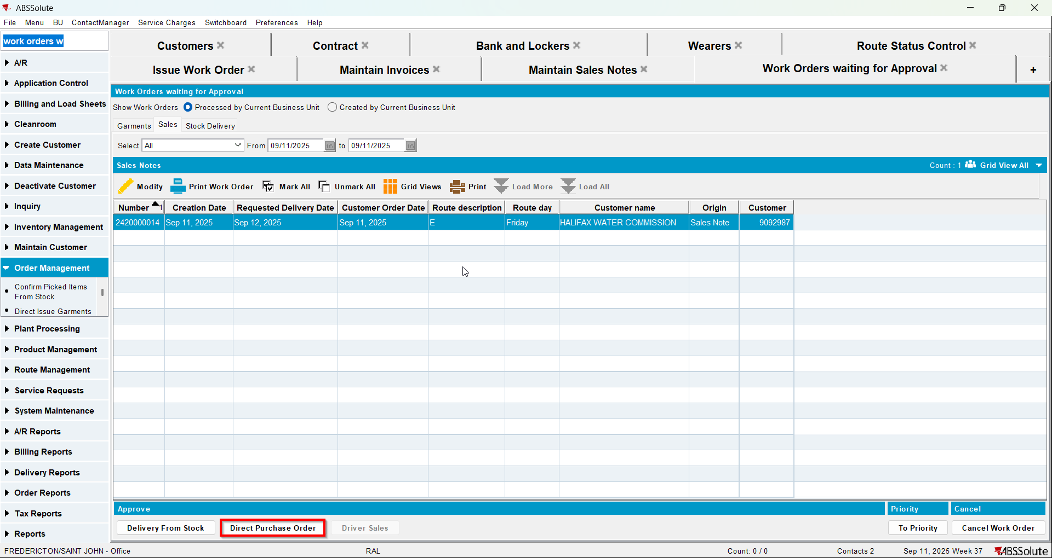
- Maintain Sales Notes dlg: issue the items and generate delivery notes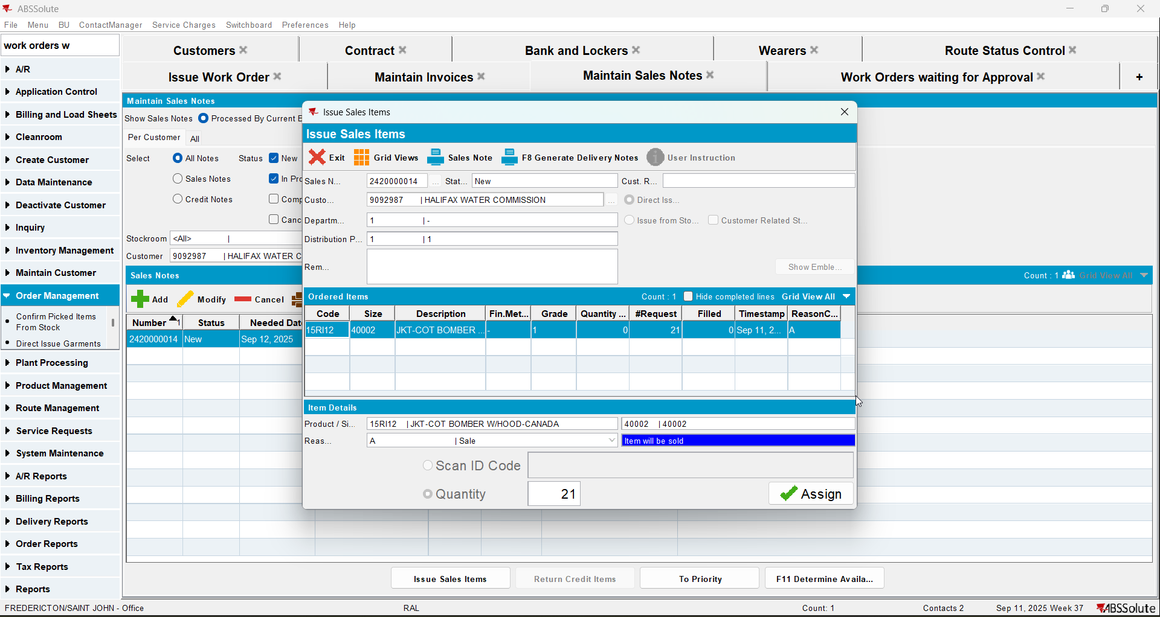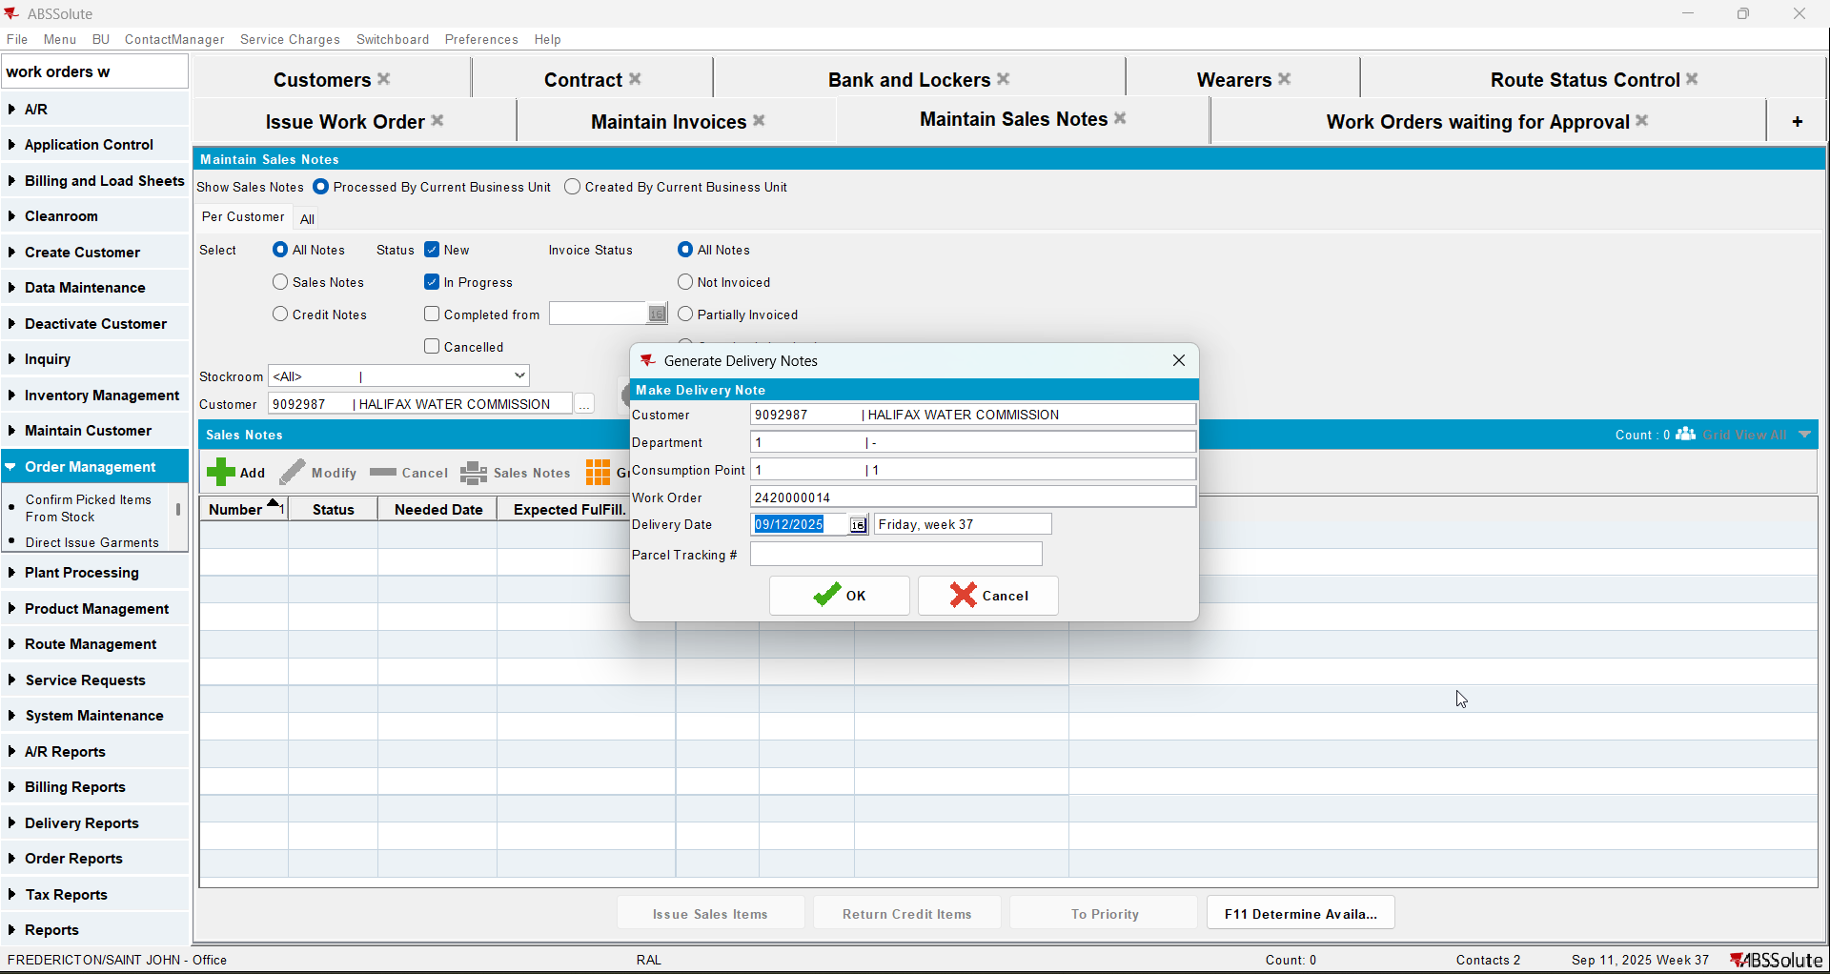
- Route Status Control dlg: generate invoices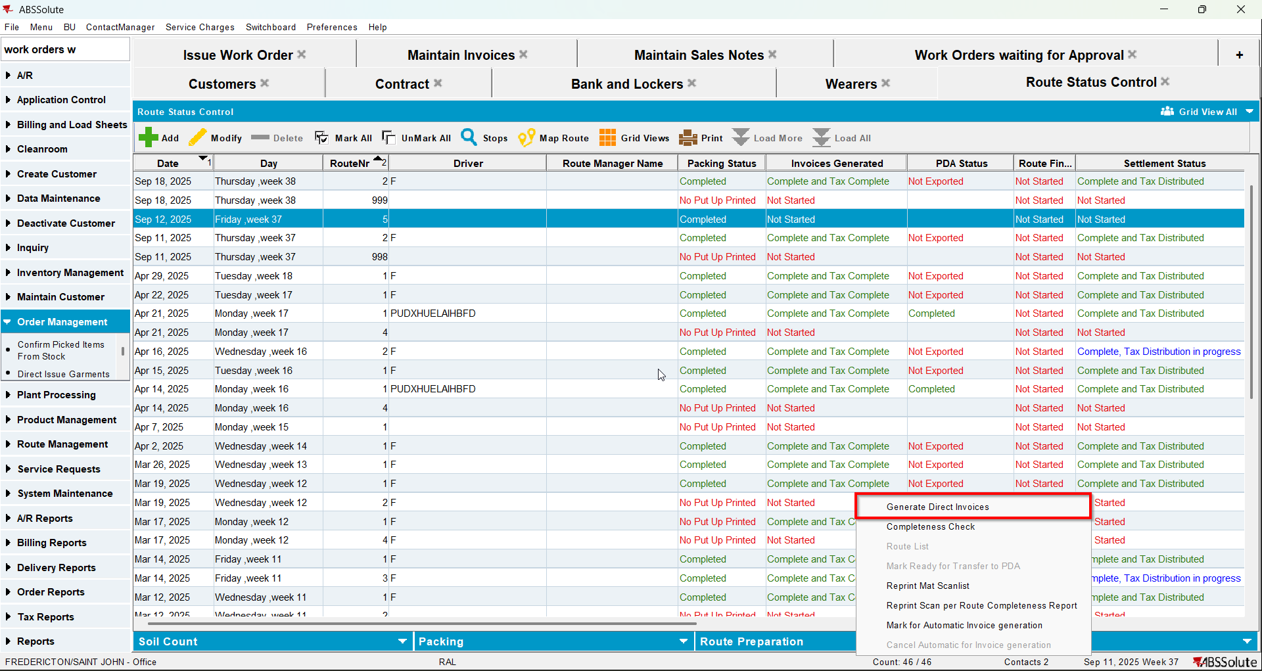
- Script the taxes and run the Vertex Import BCI process
- Route Status Control dlg: settle the route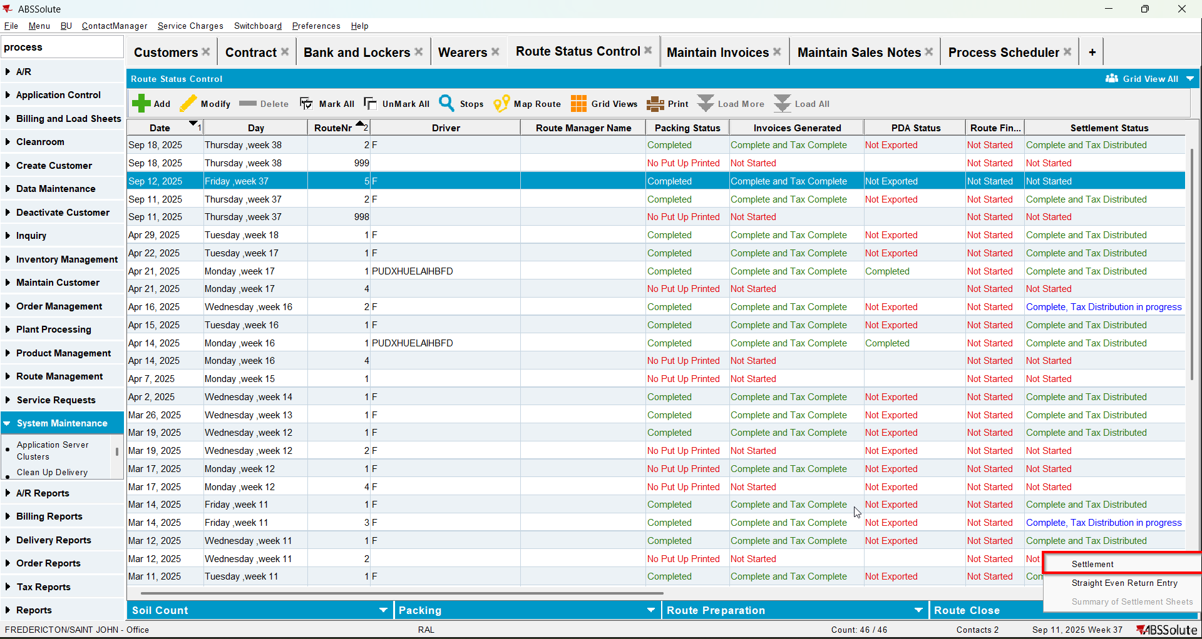
- Script the taxes and run the Vertex Import BCI process
- View Process Log dlg: check if there is an error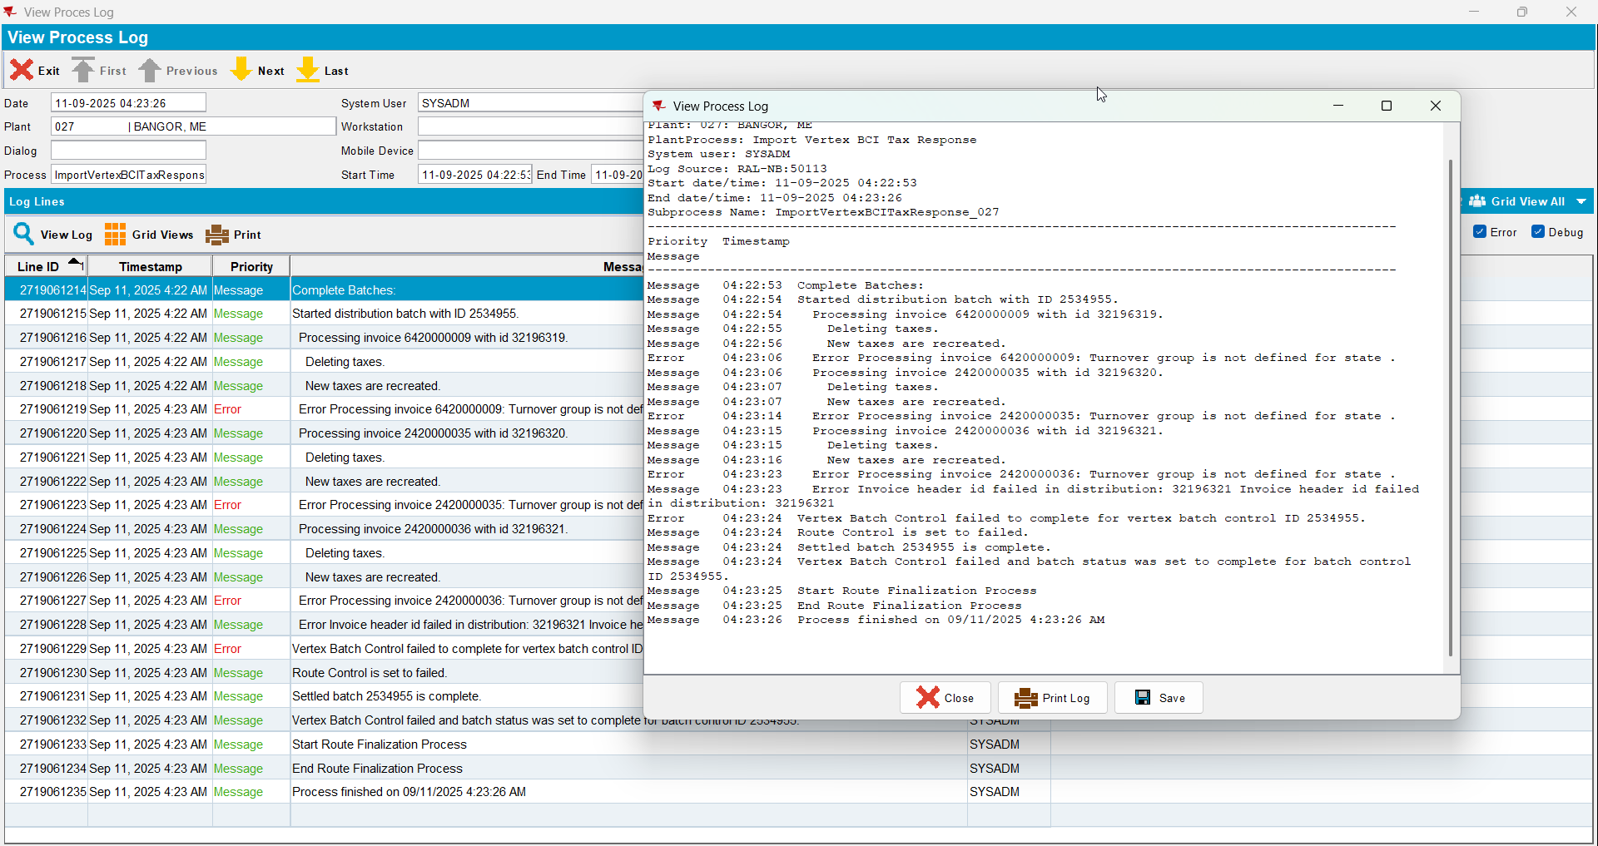
- Maintain Invoices dlg: check that the tax lines do not have the turnover group associated with the correct CANADA regions/states.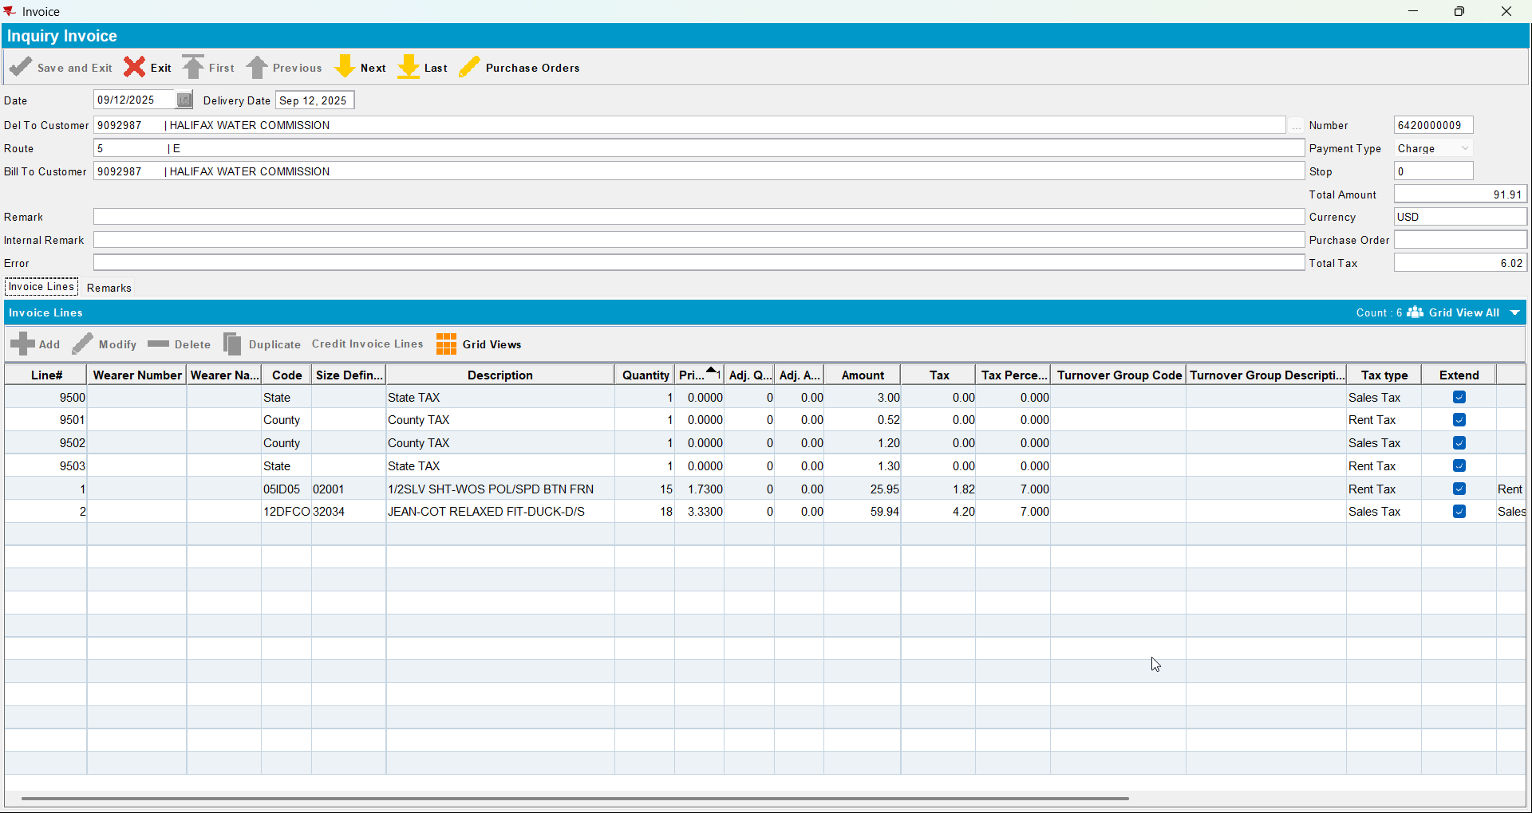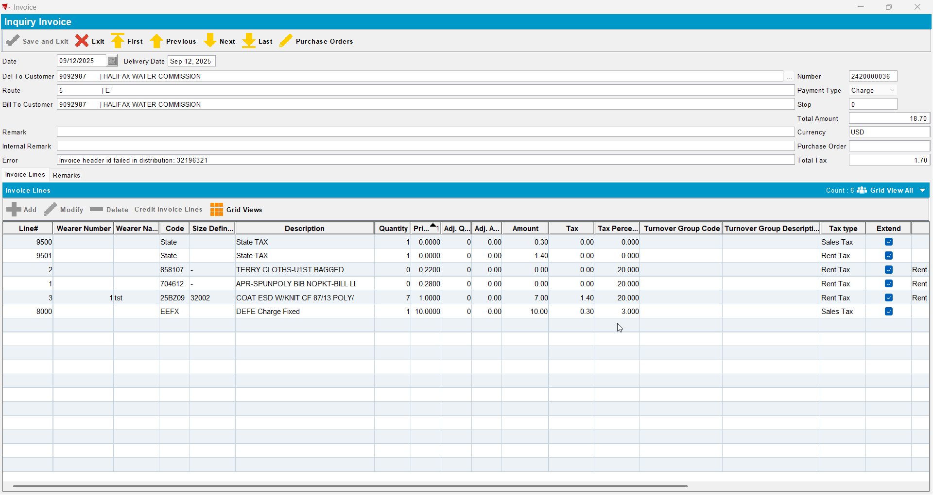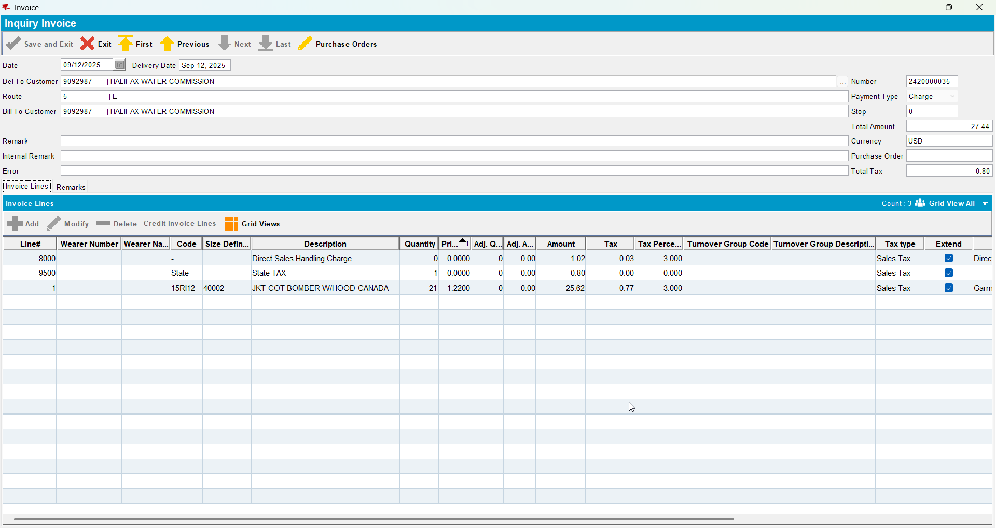
- For your customer change the tax area from CA to US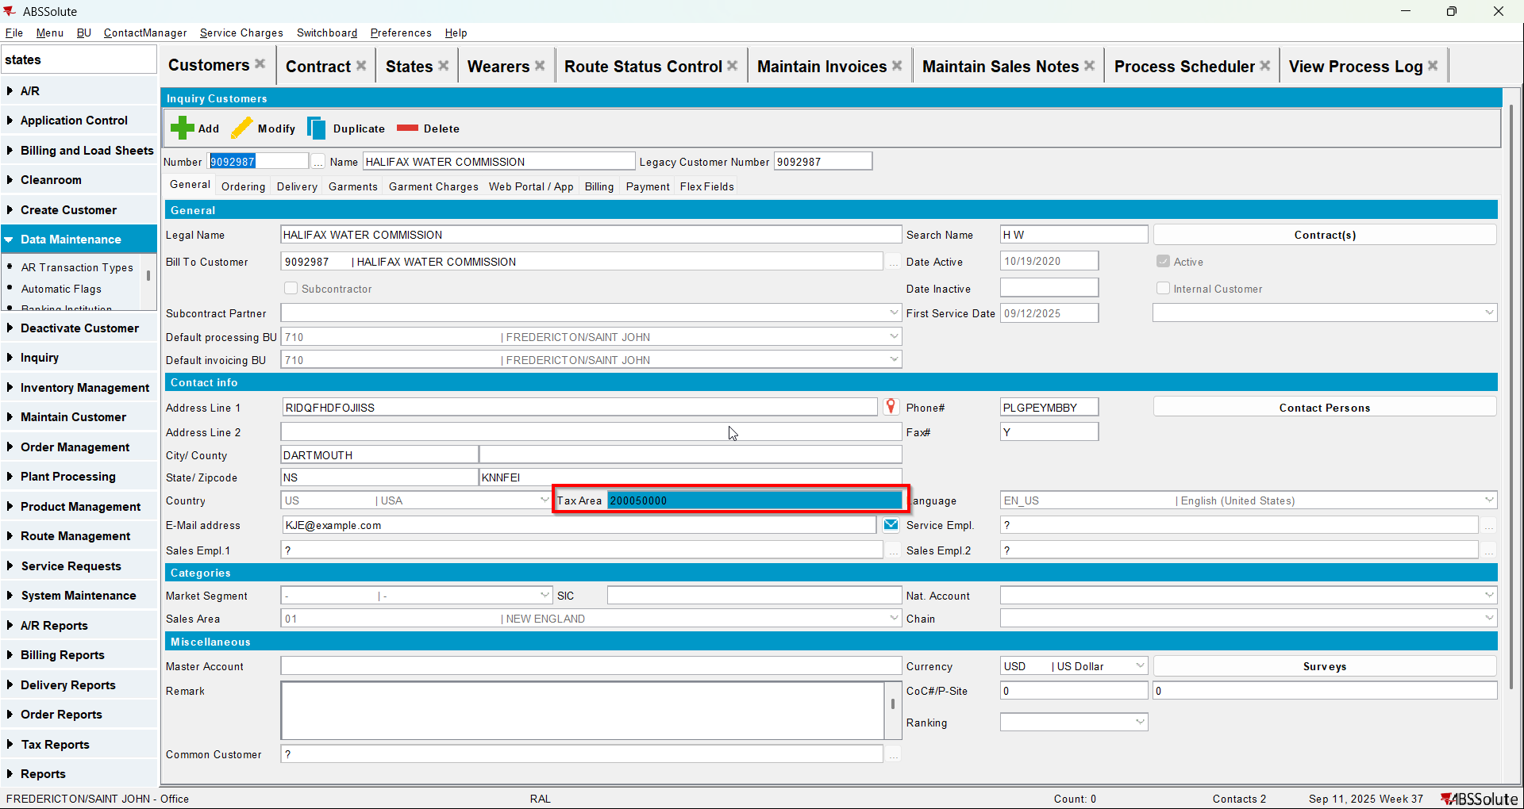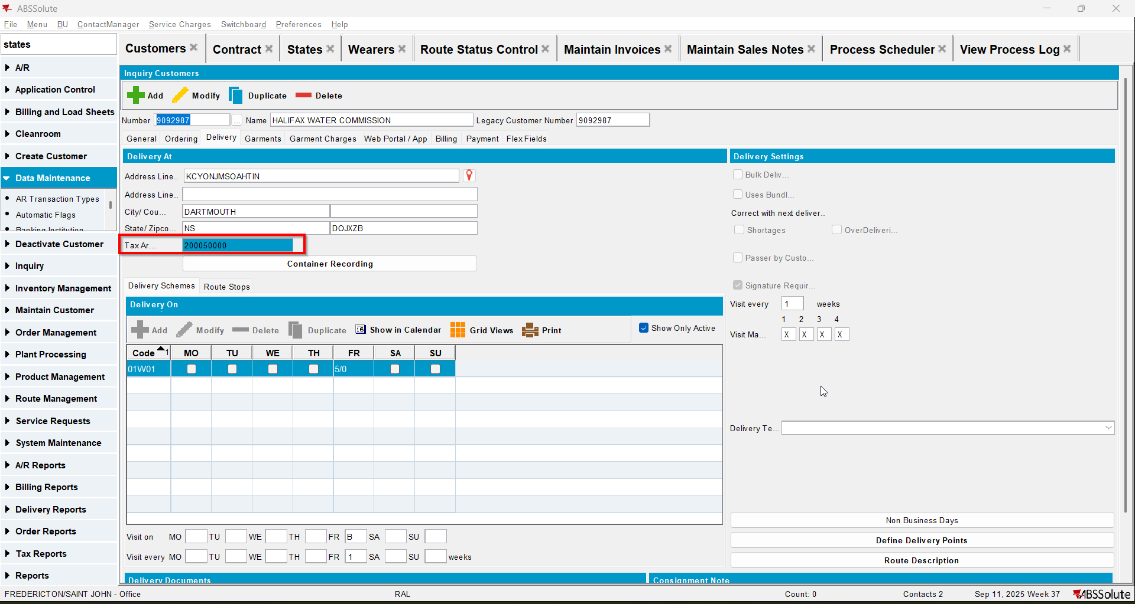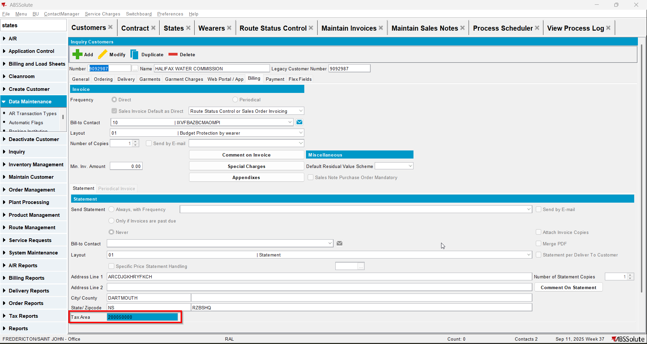
- Generate invoices for the next route and settle it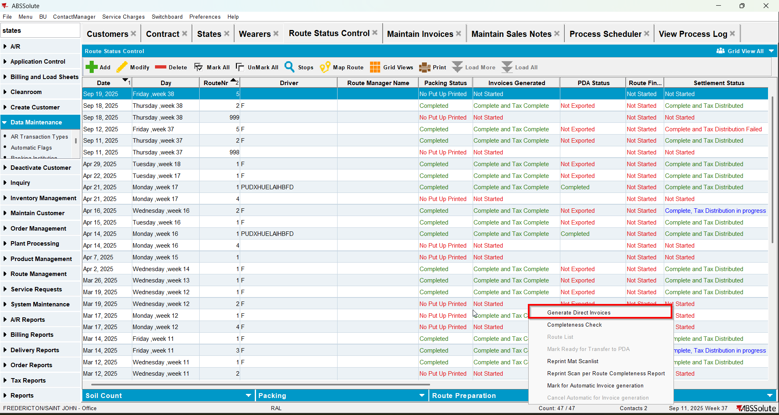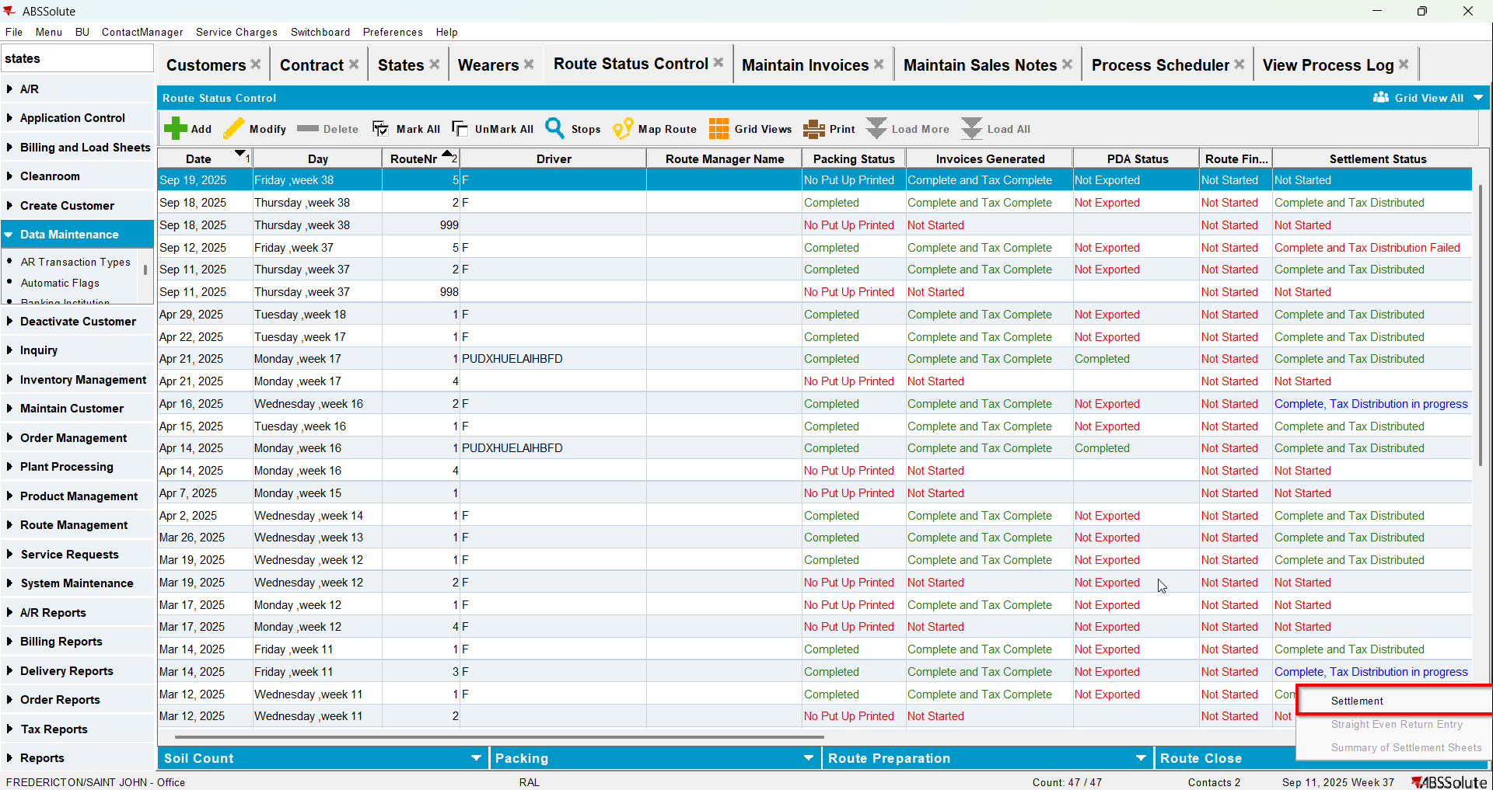
- Change back from US tax area to CA tax area
- Credit a settled invoices with settle now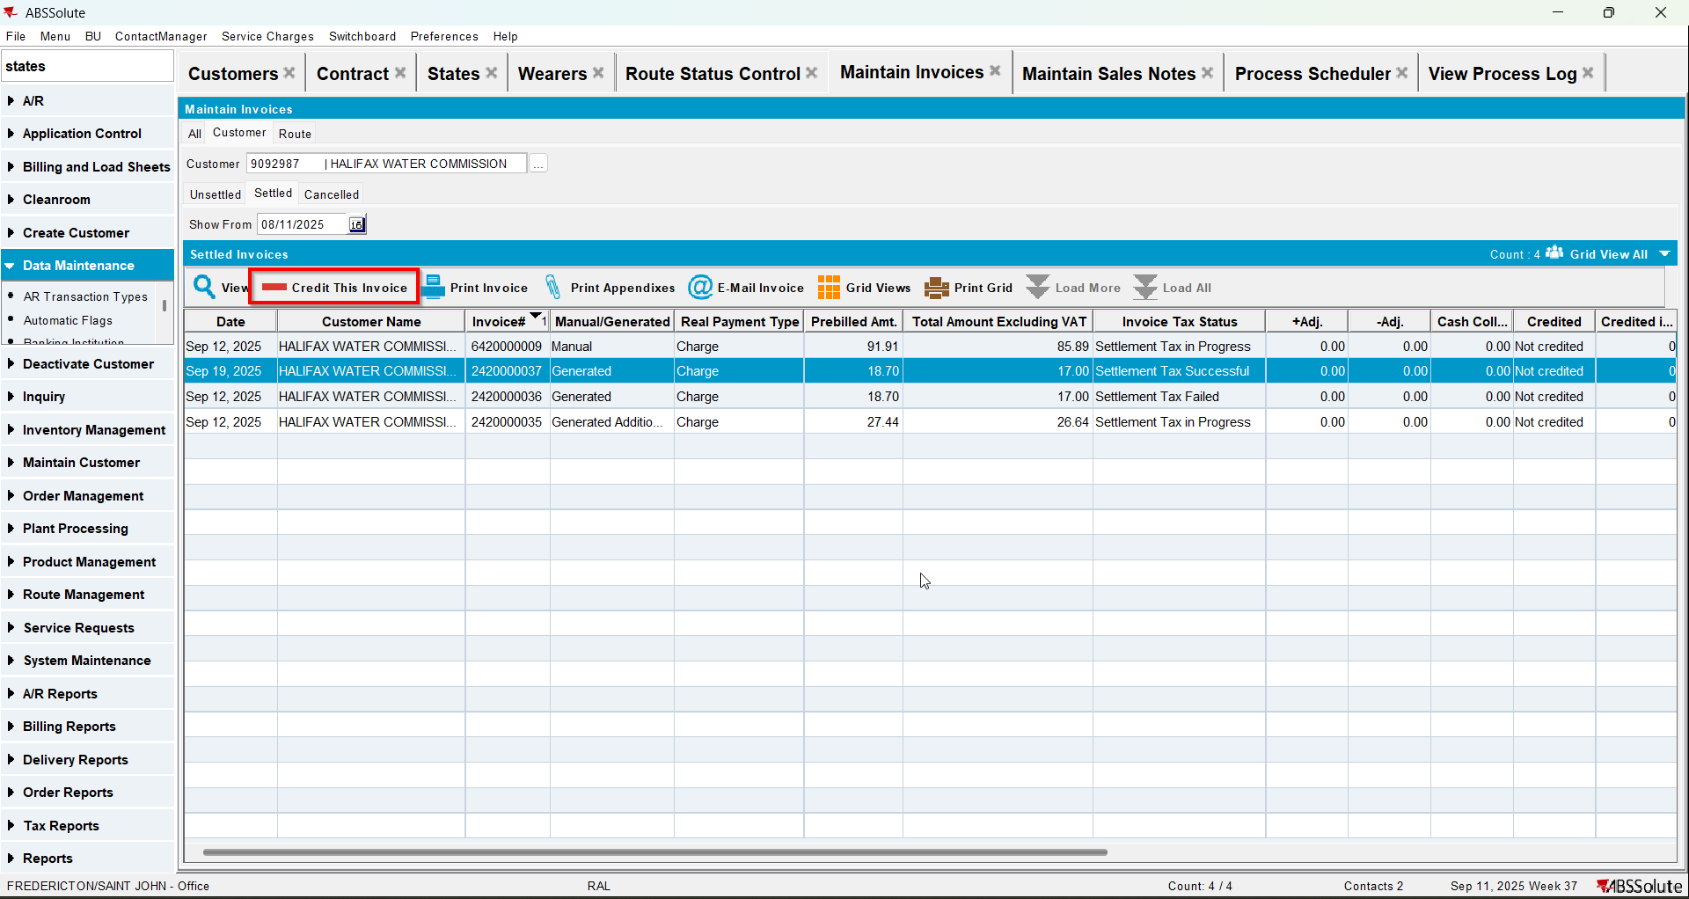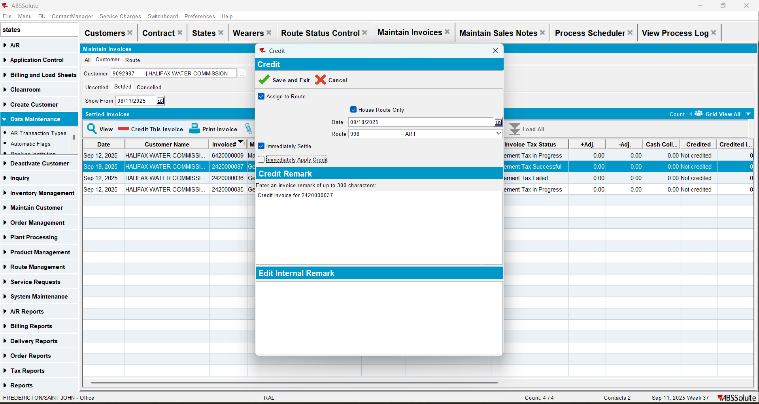
- Check that the tax lines have the turnover group associated with the US regions/states.