ABSN-9063 D_UBS_2742 User receives error Record cannot be saved WearerInventory1 Database error code 12899 when attempting to End Date a wearer or remove an End Date on
Environment | Prerequisites
Version: 9.07.00.UNF17.p13  DBServerName= abs-srv20.internal.abslbs.com  DBSID=CUST24  DBUser=UNFDEV  DBPassword=UNFDEV  Environment=Production | - Module:  - System setting

Contents
Retest after fix 1

Retest after fix

Test Case #1 – Quit a wearer with REPL_STILLTOBECHARGED not null

- Find a wearer that has a wearer inventory with REPL_STILLTOBECHARGED not null
Use this SQL to find any:
select C.CUSTOMERNUMBER, W.WEARERNUMBER, WI.REPL_STILLTOBECHARGED
from WEARERINVENTORY WI
join WEAREREMPLOYMENT WE
on WE.WEAREREMPLOYMENT_ID = WI.WEAREREMPLOYMENT_ID
join WEARER W
on W.WEARER_ID = WE.WEARER_ID
join CUSTOMER C
on C.CUSTOMER_ID = W.CUSTOMER_ID
where WI.REPL_STILLTOBECHARGED is not null

- Quit the wearer and save
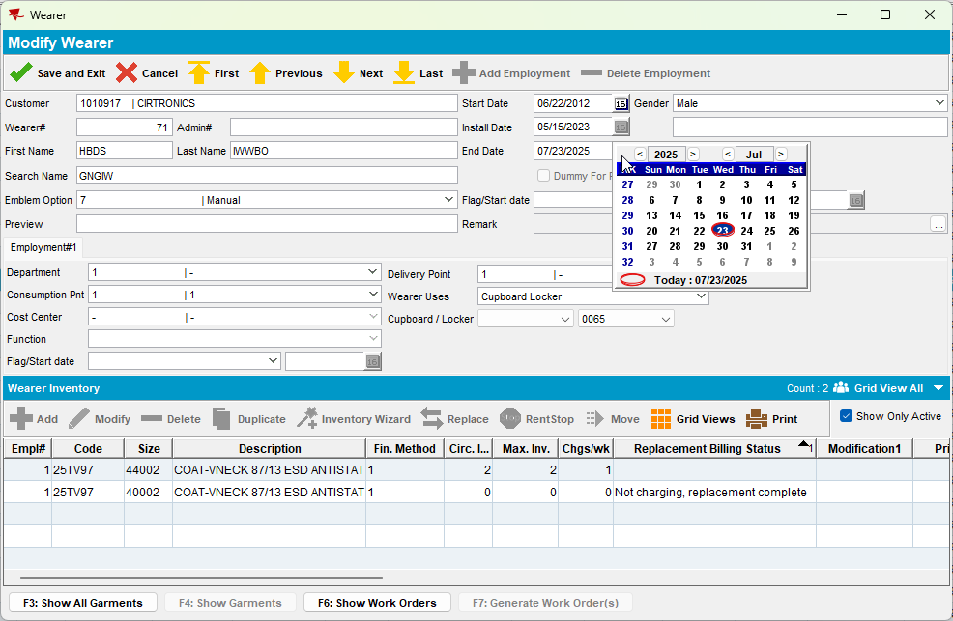
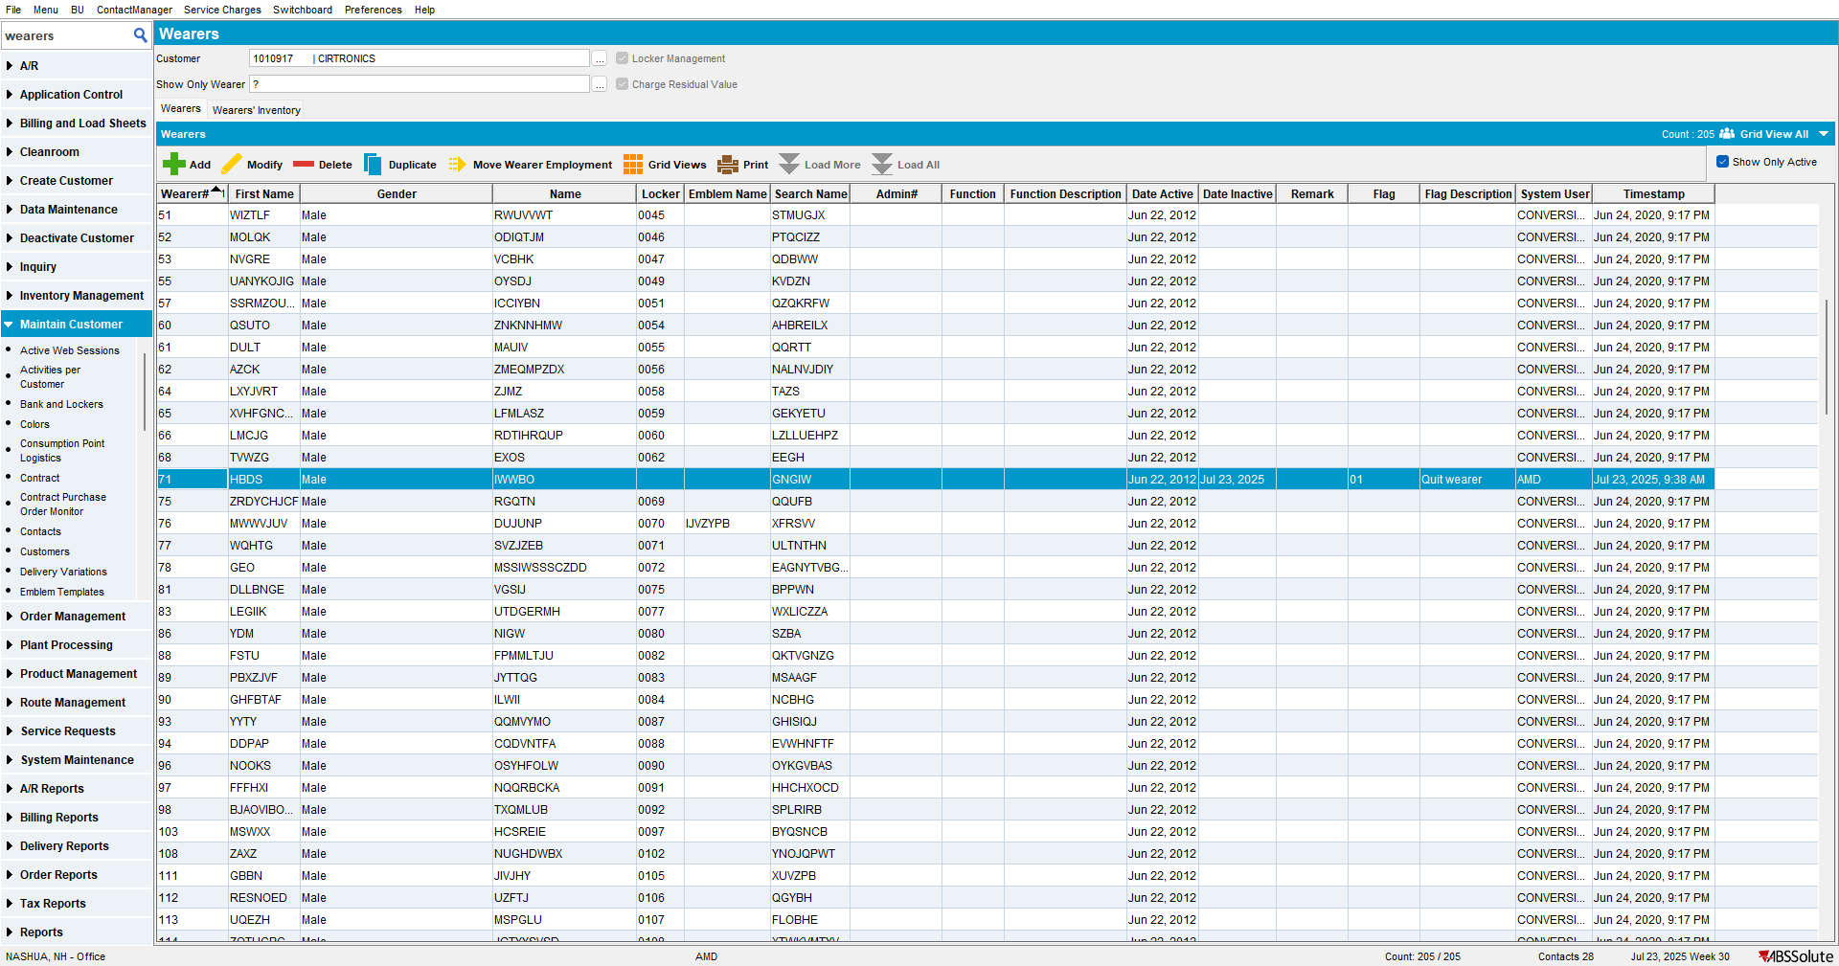

Expected behavior: The user must be able to save the wearer.
Actual behavior: The user can save the wearer.

Test Case #2 – Check that the column "Replacement Billing Status" is displayed

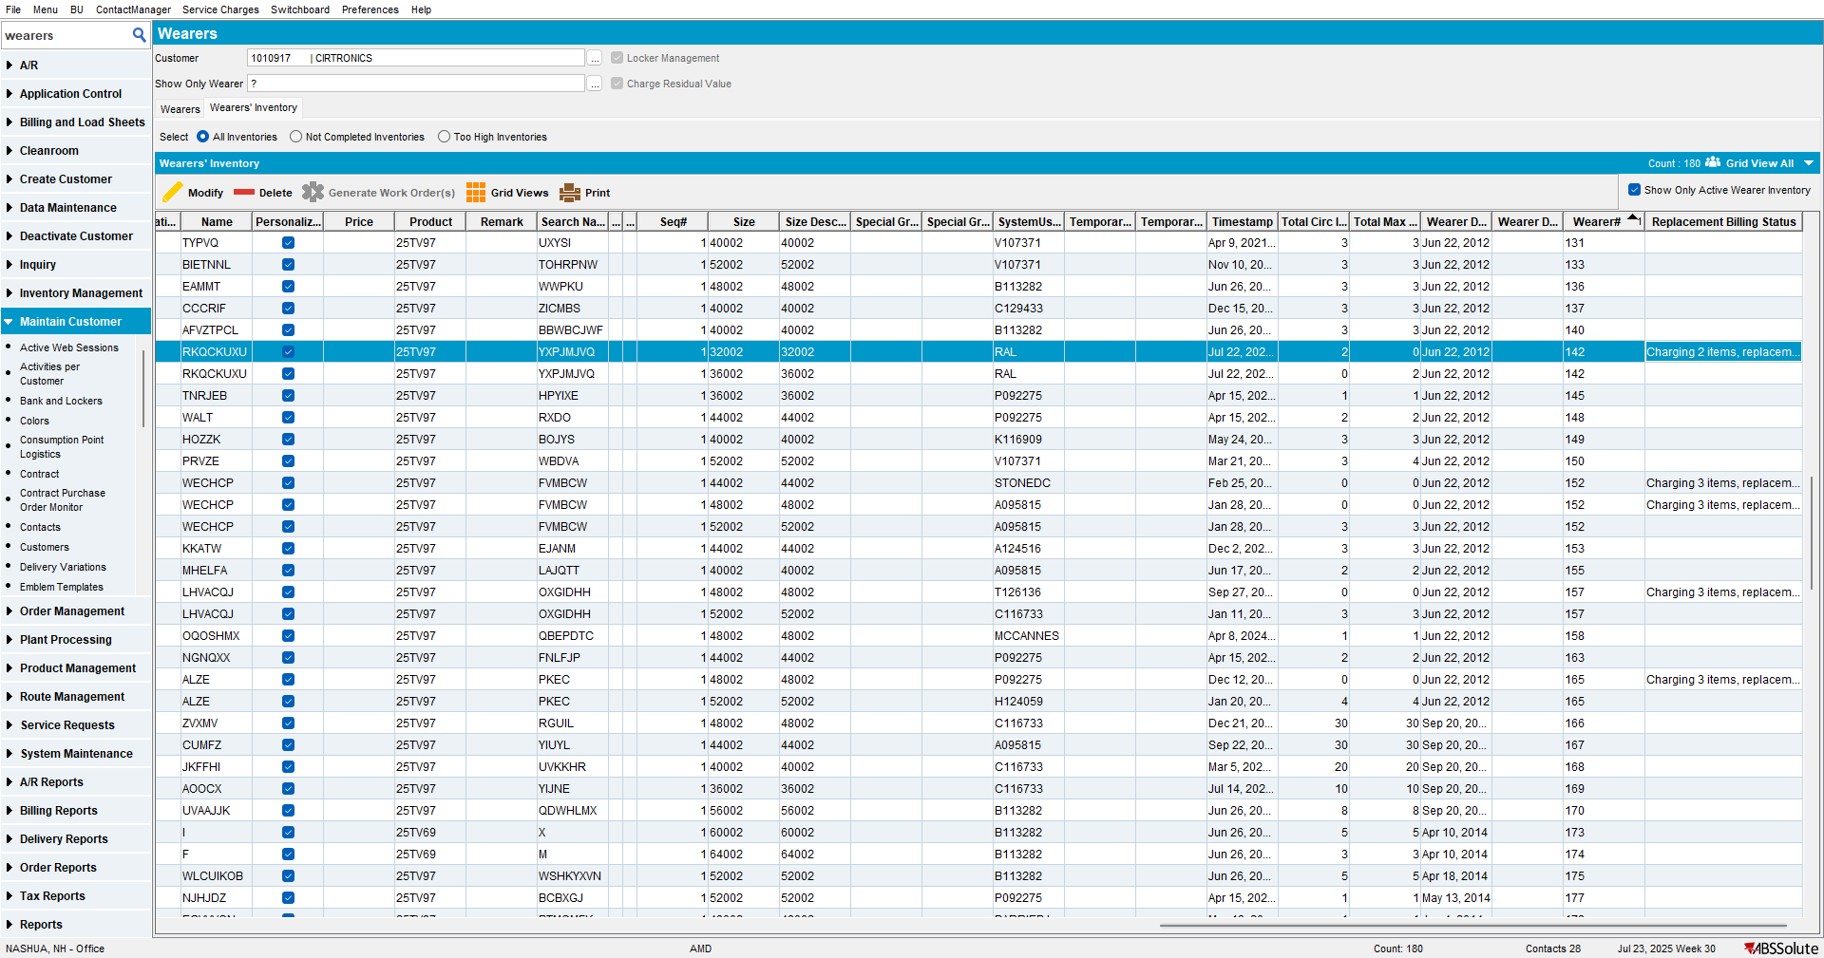
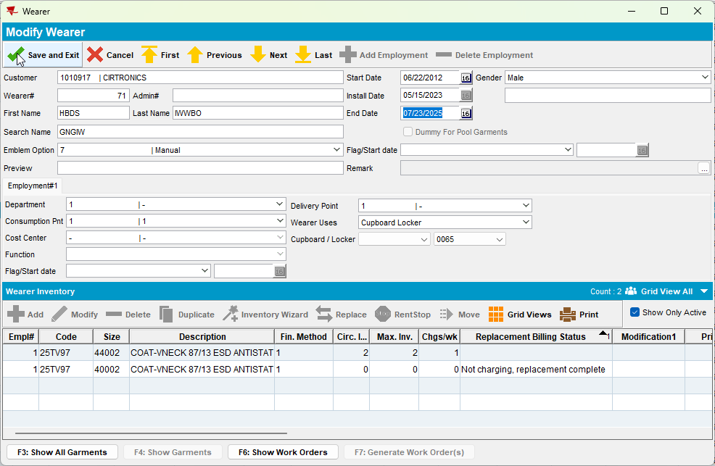
TESTED OK.

