ABSN-1656 - View Process Log - Redesign for performance
Environment | Prerequisites
Version: 9.07.00.UNF17.p12  DBServerName= abs-srv20.internal.abslbs.com  DBSID=CUST24  DBUser=UNFDEV  Environment=Test | - Module:  - System setting

Contents
Retest after fix 1
Test Case 1 – Check loading times for logs from Dialogs, Scheduled Process, Mobile Devices, Web Services, Route Control 1
Test Case 2 – Check that when accessing View Process Log DLG the default chosen radio button is set to Route Control 9
Test Case 3 – Check that the old select is used in executiontransaction log 10

Retest after fix

Test Case 1 – Check loading times for logs from Dialogs, Scheduled Process, Mobile Devices, Web Services, Route Control
Hash: 3fc3dc82efdc
Expected: Information in the grid should appear in under 10 seconds
- View Process log DLG: Select a time frame of 1+ month
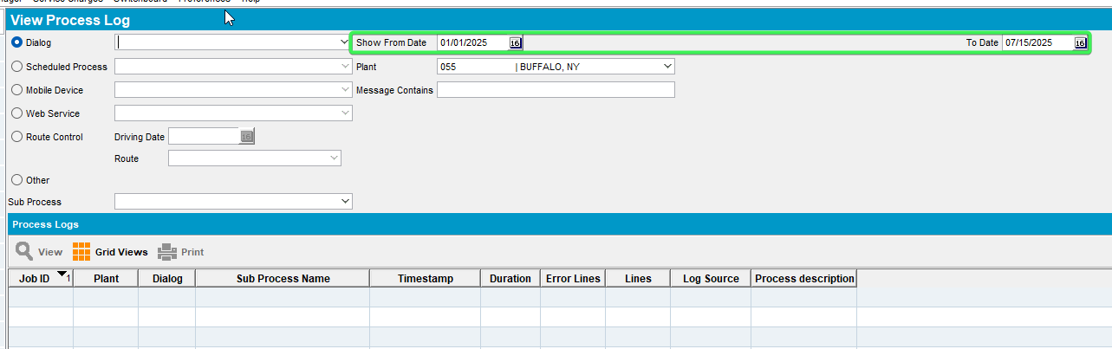
- Select Dialog Option press on the dropdown button and select logs which contain data
Credit Card Transactions
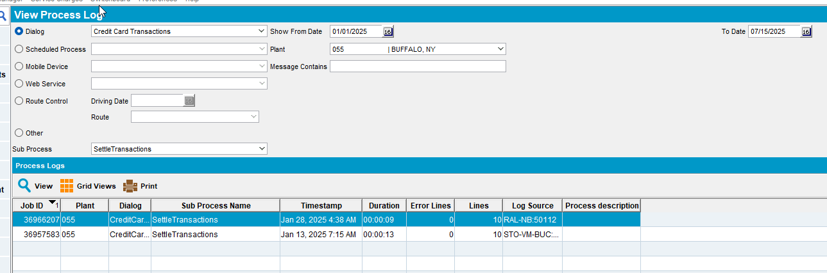
Delivery Notes
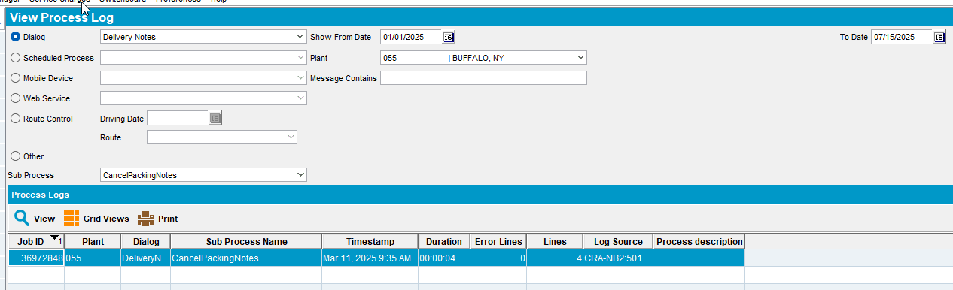
Garments per wearer
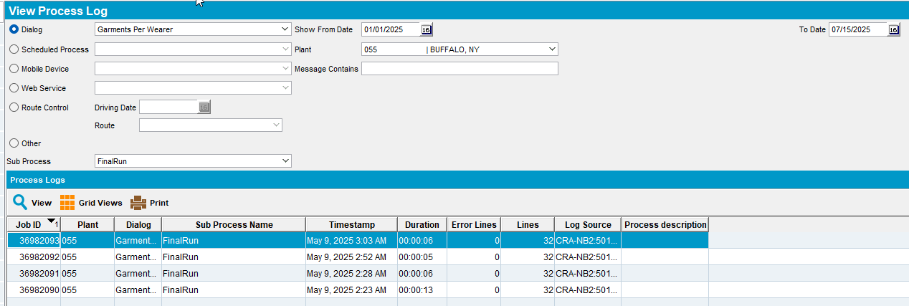
Route Status Control
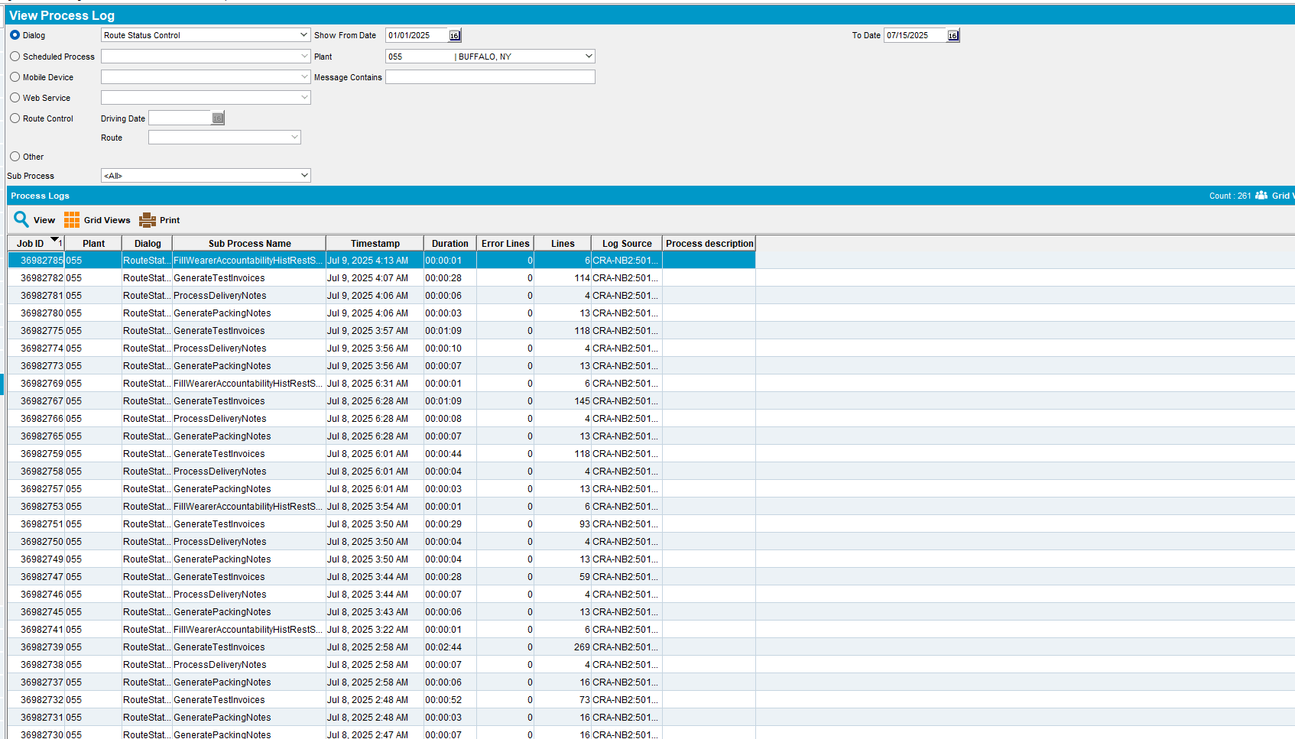
Settlement
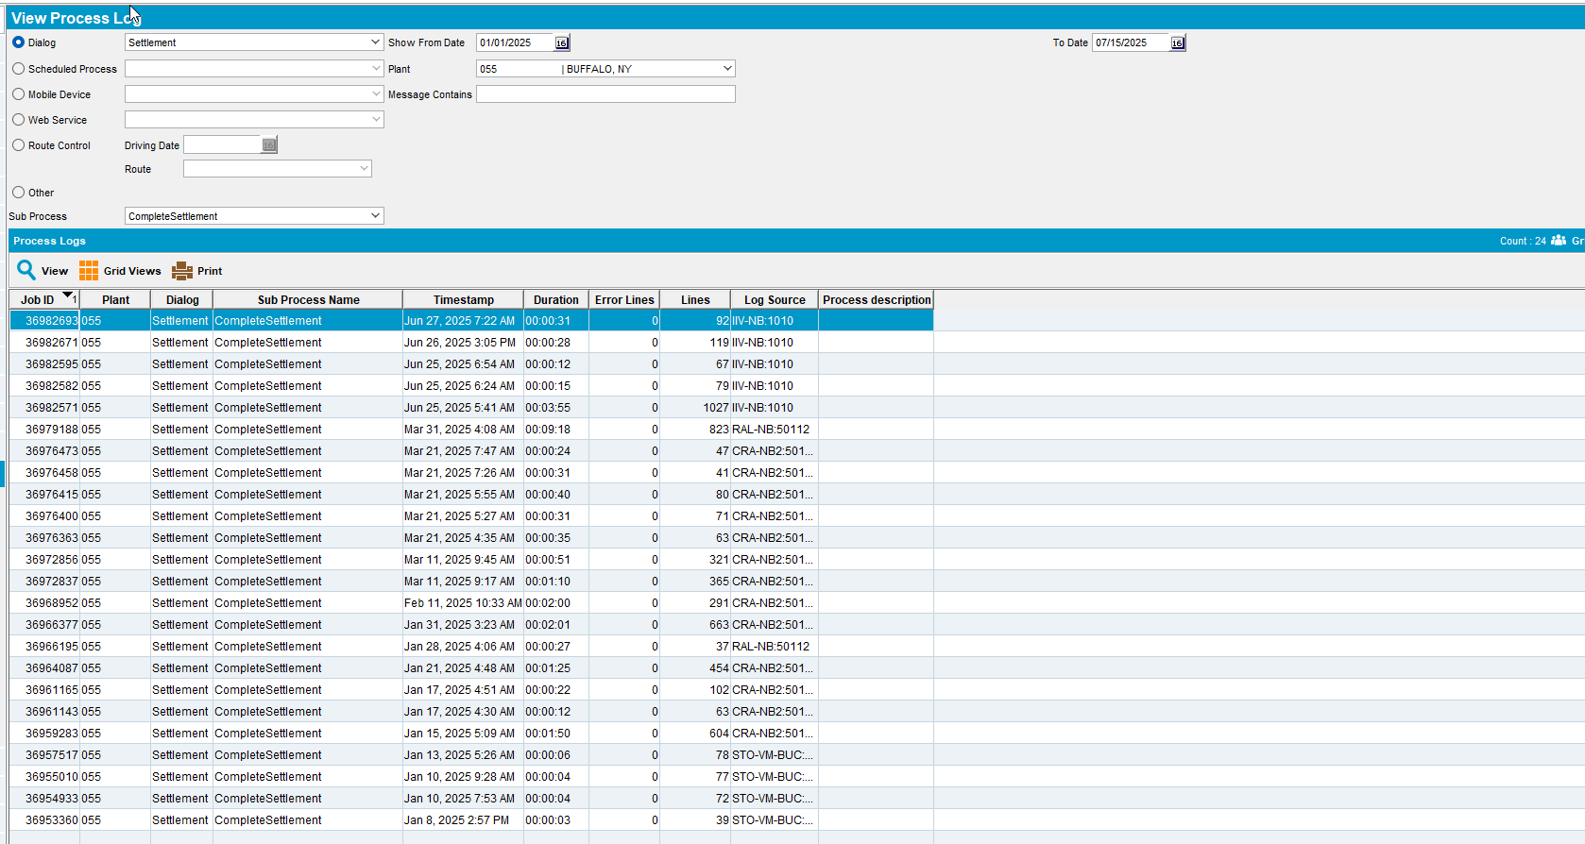
Wearers
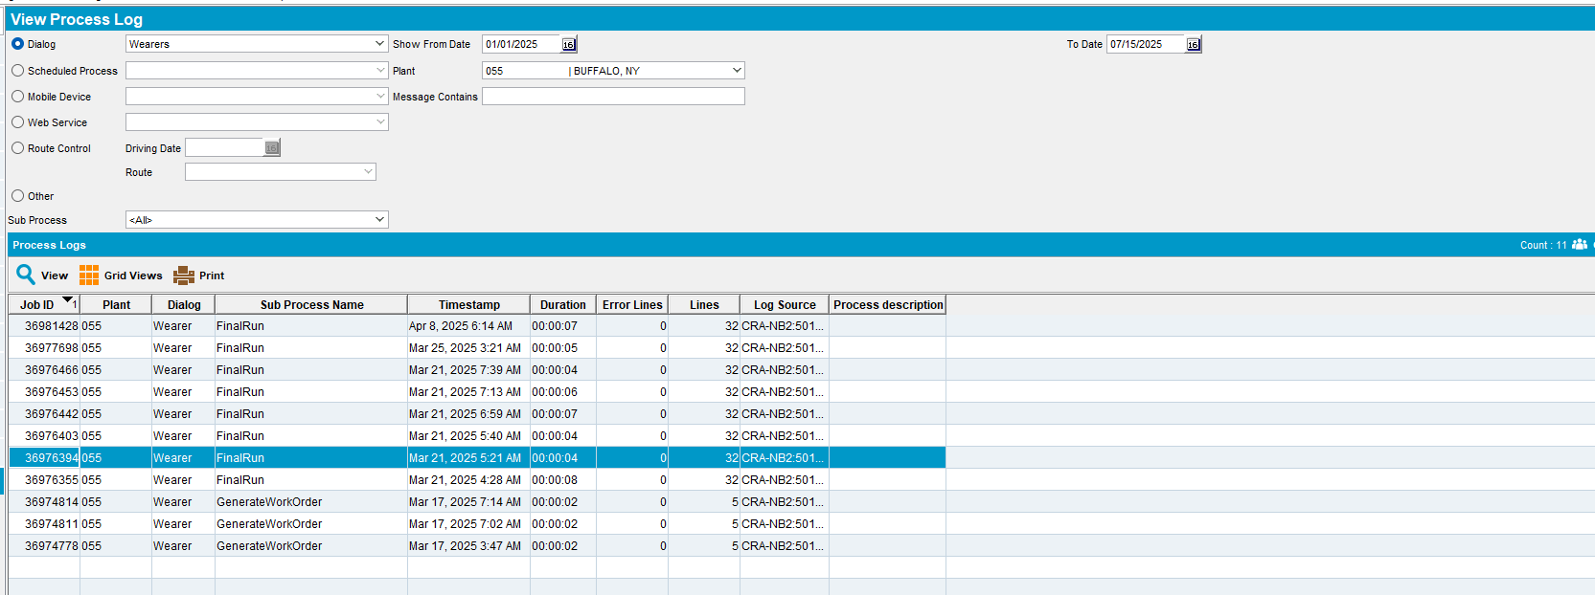
- Select Scheduled Process press on the dropdown button and select logs which contain data
Cancel and regenerate US direct invoices for late delivery notes
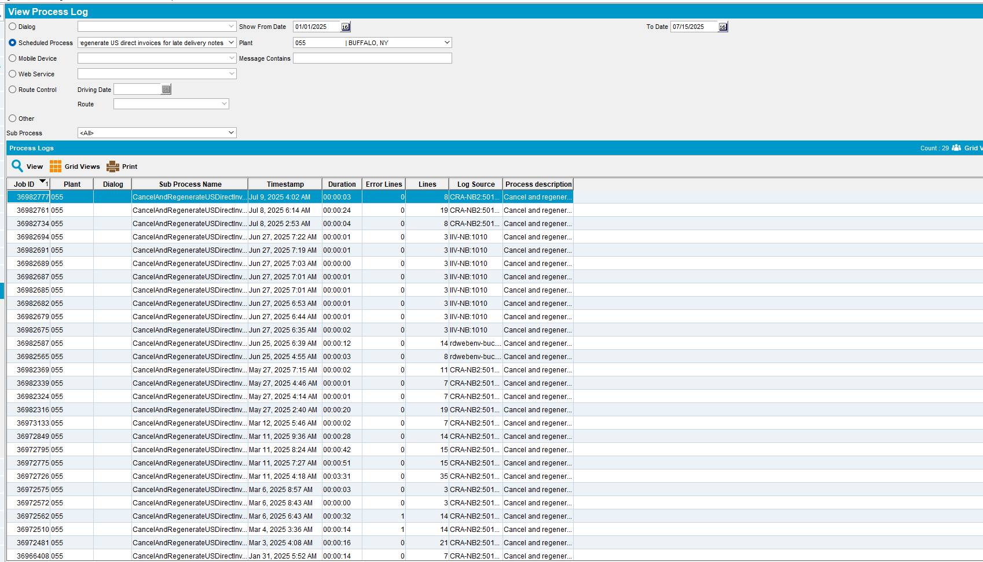
Create Credit Card transactions from payment schedule
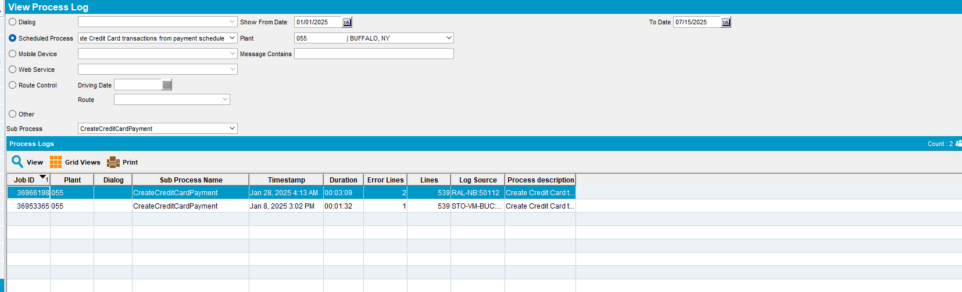
Import Vertex BCI Tax Response
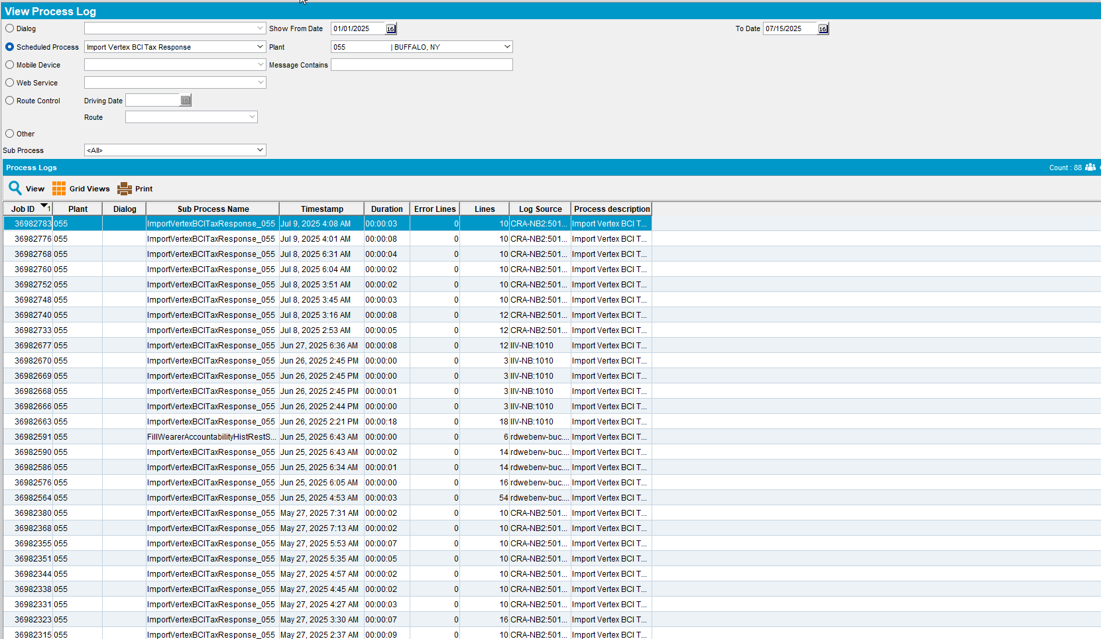

- Select Web Services press on the dropdown button and select logs which contain data
Generate Direct Invoices
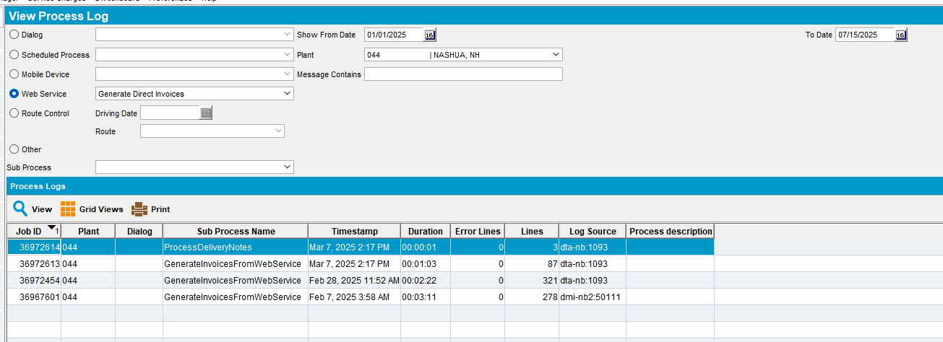
Product Size Change - DTA test
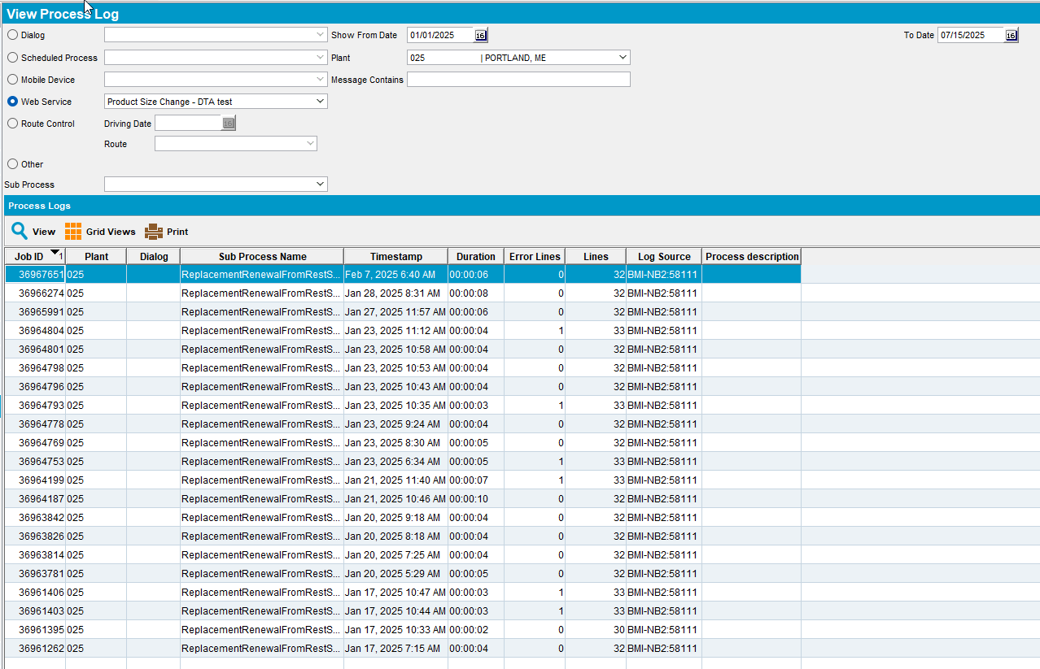
- Route Control select a date and route
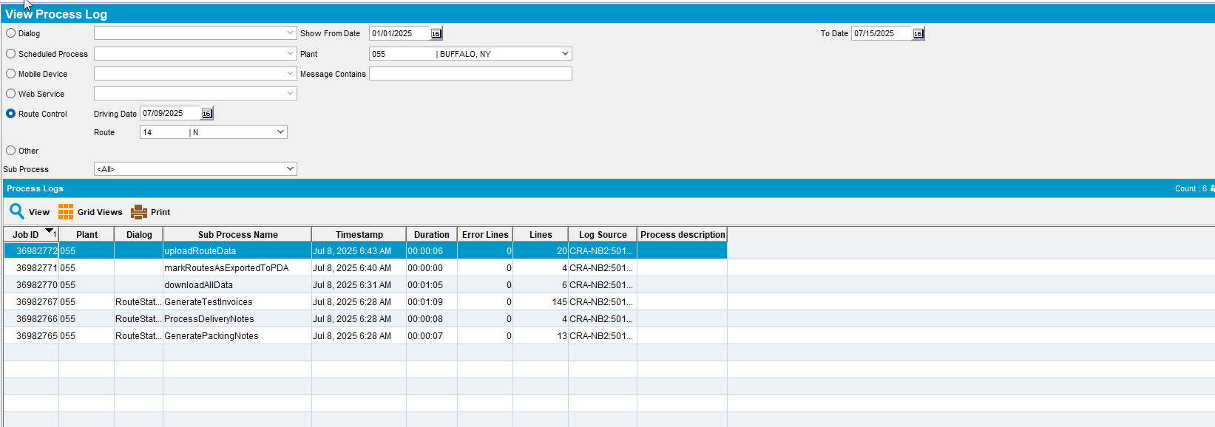
- Other press on the dropdown button and select logs which contain data
FillWearerAccountabilityHistRestService
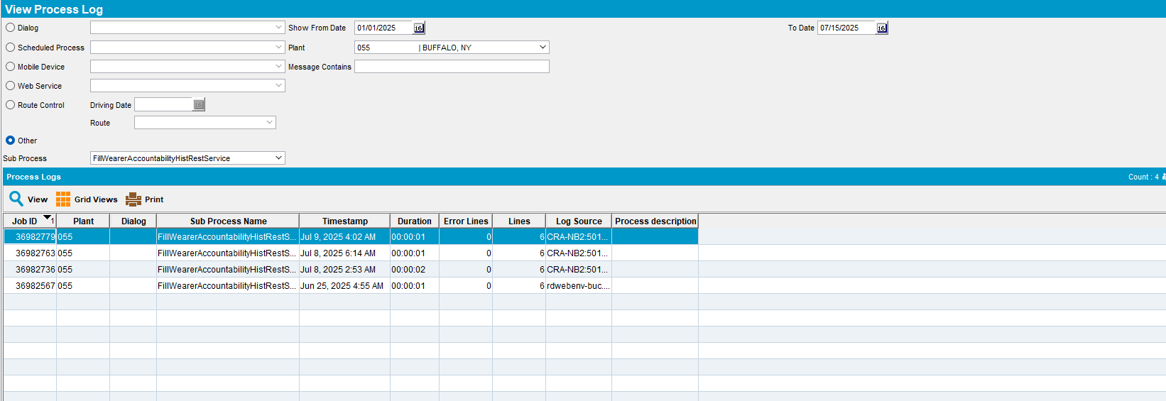
GenerateDirectInvoices
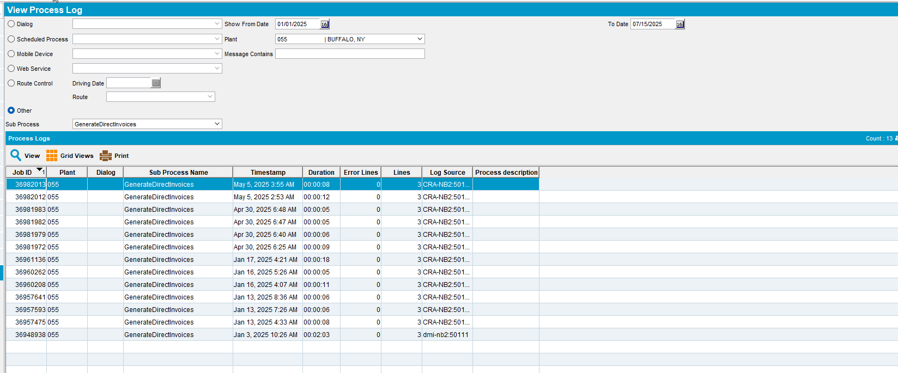
GenerateInvoicesFromFinaliseRoutesProcess
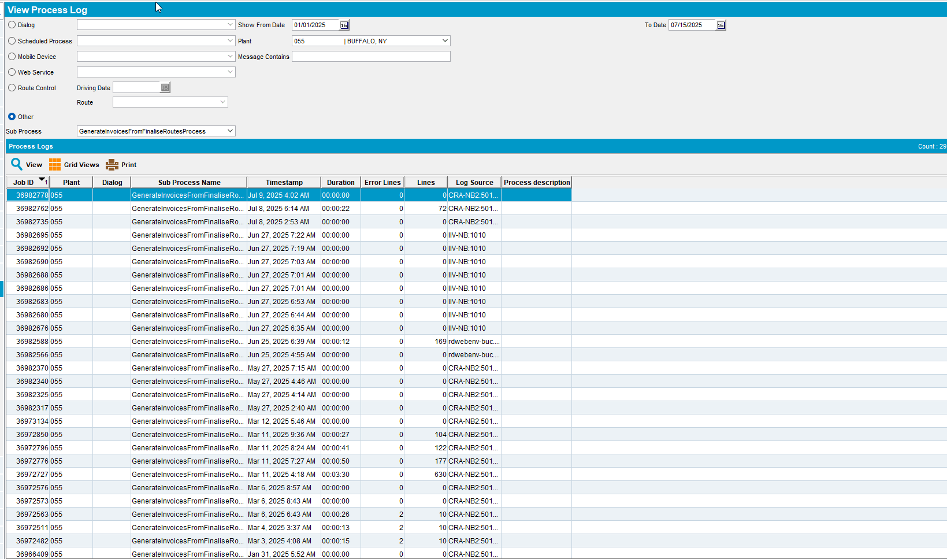
MissingPricesOnDirectInvoice
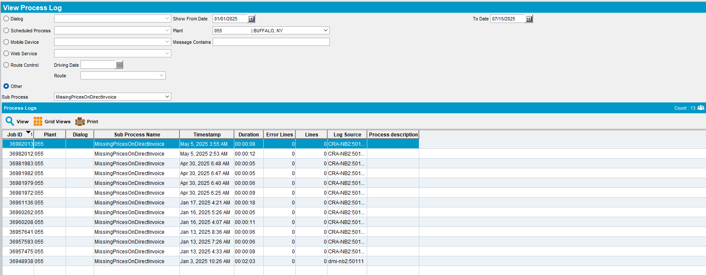
NotProcessedNotesOnDirectInvoice
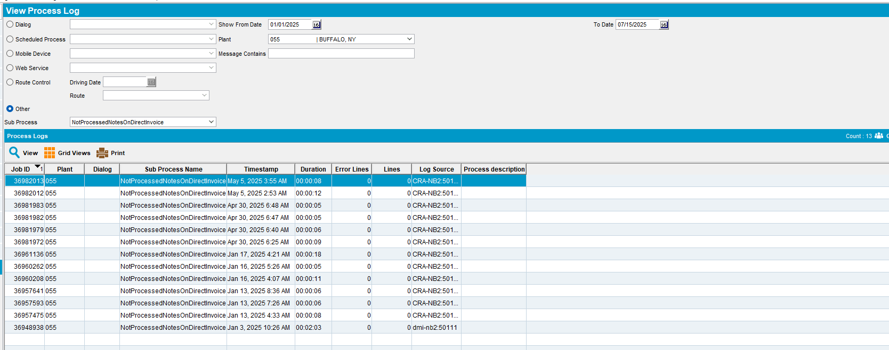
ProcessDeliveryNotes
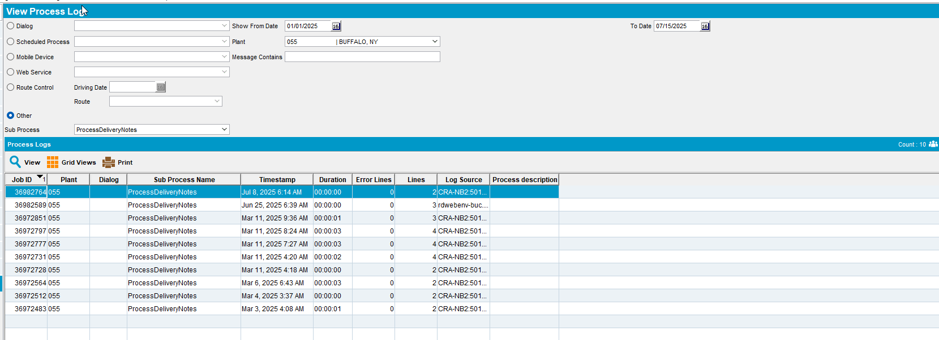
All Log were loaded in due time, under 10 seconds
Tested OK

Test Case 2 – Check that when accessing View Process Log DLG the default chosen radio button is set to Route Control
Hash: 3fc3dc82efdc
- Go to View Process Log DLG
- See that upon opening the screen the default selected process is Route Control
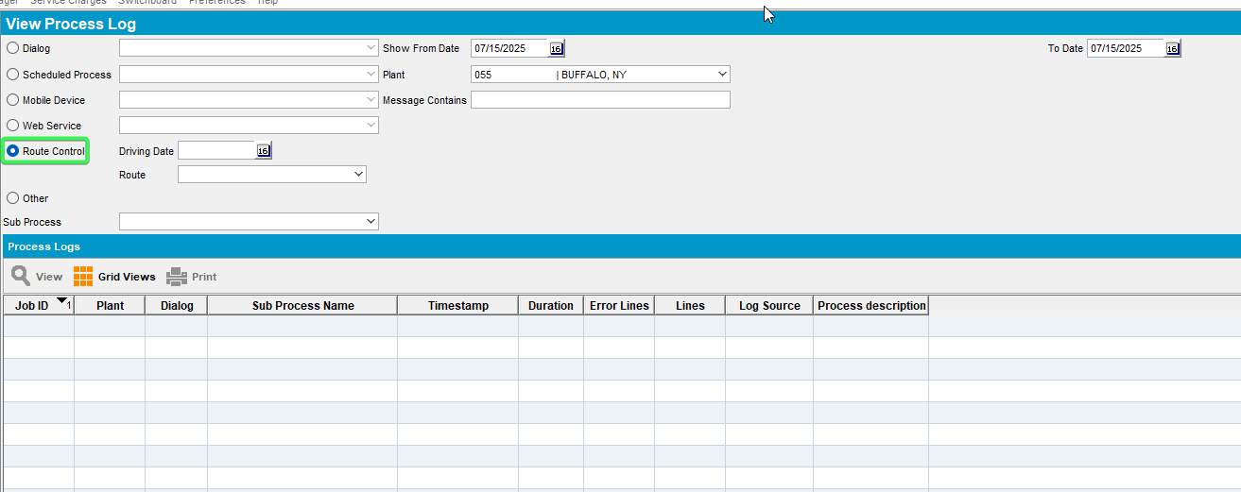
Tested OK

Test Case 3 – Check that the old select is used in executiontransaction log
Hash: 3fc3dc82efdc
Expected: new select that populates the dialogs dropdown list should be significantly faster than the old one
- Start the server with version new patch (12).
- Start diagnostics with executedtransactions.
- Open View Process Log DLG.
- Select Dialog process
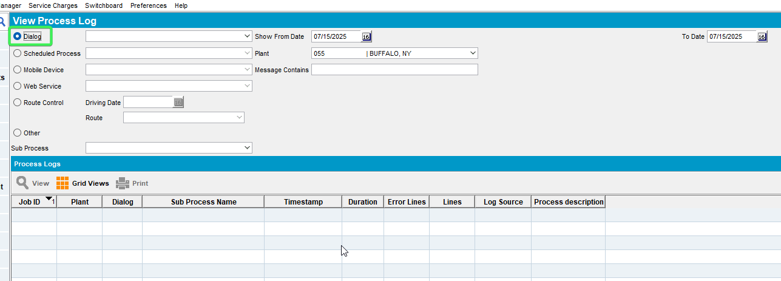
- Stop diagnostics recording.
- Find the executed transaction log in the server zip file.
- Open ExecutedTransactionLog and find the transaction containing: the old select
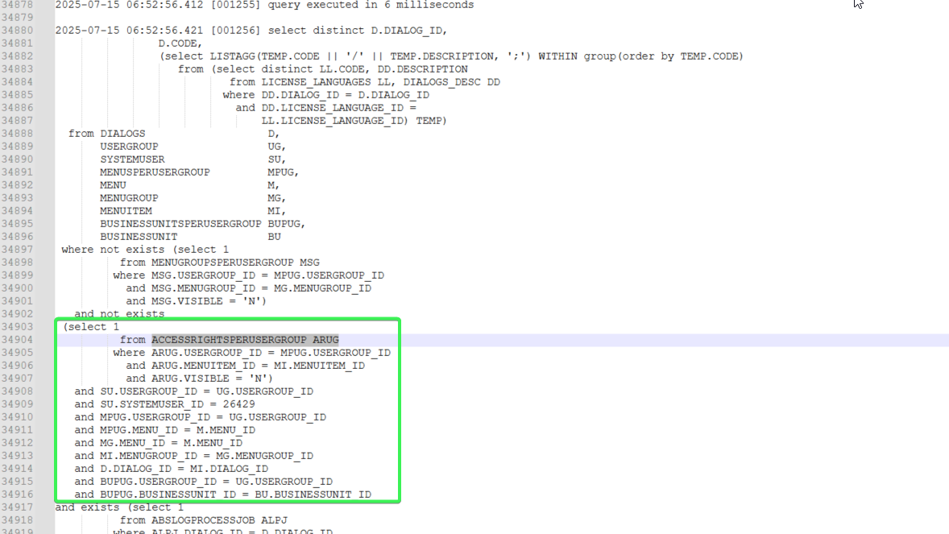
Tested OK

