ABSN-8325 Improve loading Credit Cards transactions dialog
Environment | Prerequisites
Version:9.07.00.UNF17.p11  DBServerName= abs-srv16.internal.abslbs.com  DBSID=CUST24  DBUser=UNFDEV  Environment=PRODUCTION | - Module:  - System setting

Contents
Reproduction before fix 1
Steps to reproduce 1
Retest after fix 8
Steps to reproduce 8

Reproduction before fix
Bu: 012 BOSTON, MA
9.07.00.UNF17.p10 hash: 12e536224d5d

Steps to reproduce
- With the database server freshly restarted.
- Credit Card Transaction dlg: Unsettled Transactions tab, load the screen and time how much it takes to load the records.
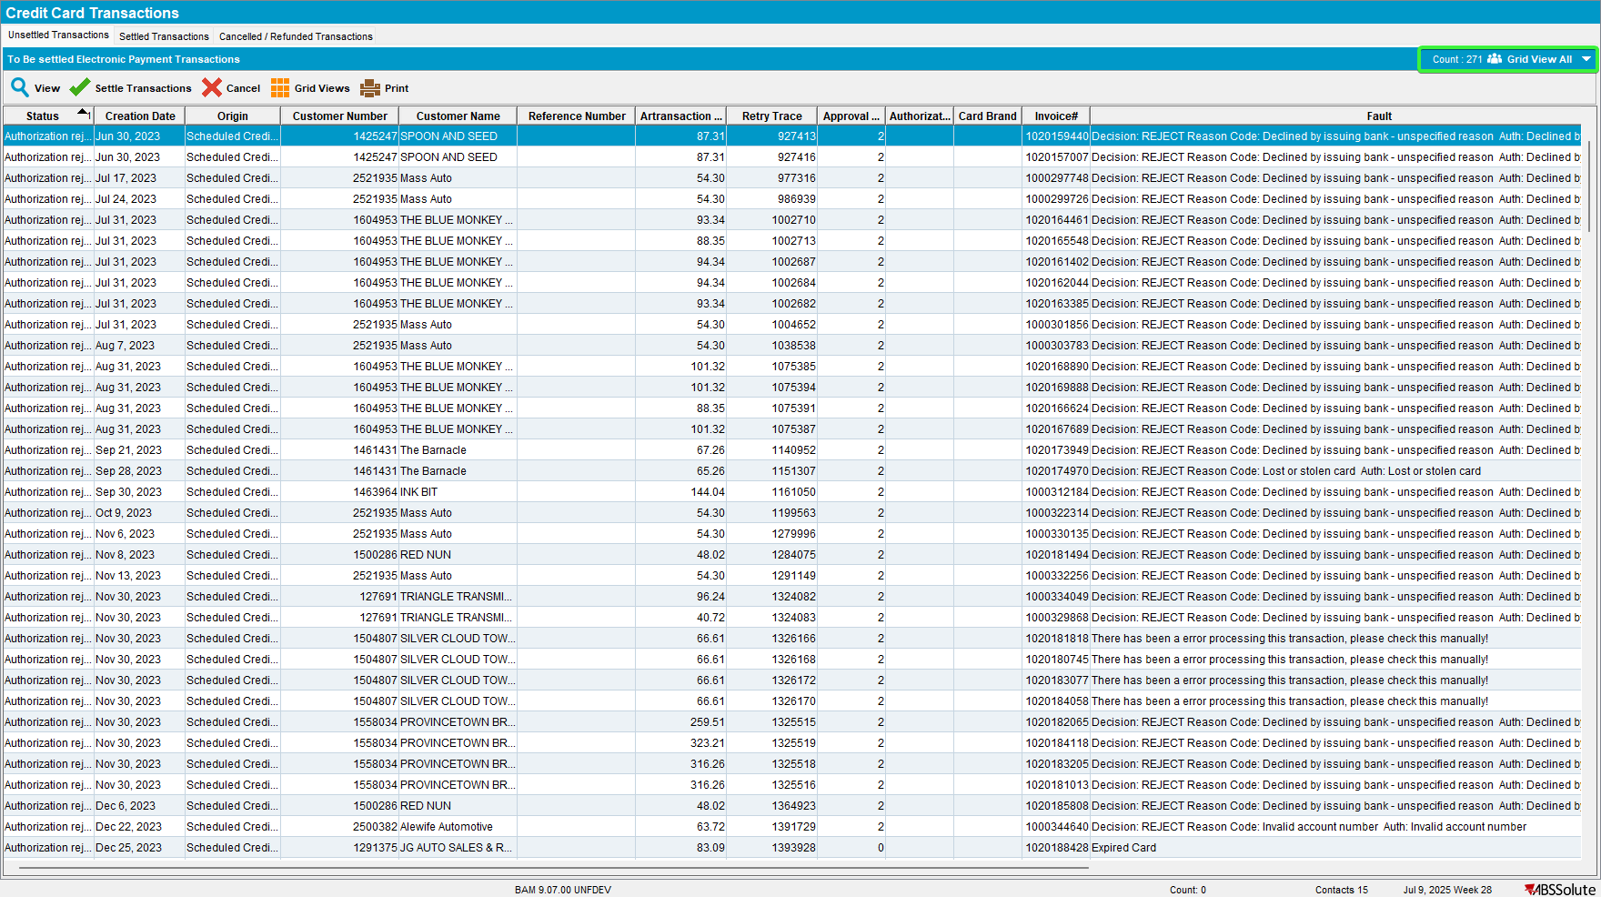
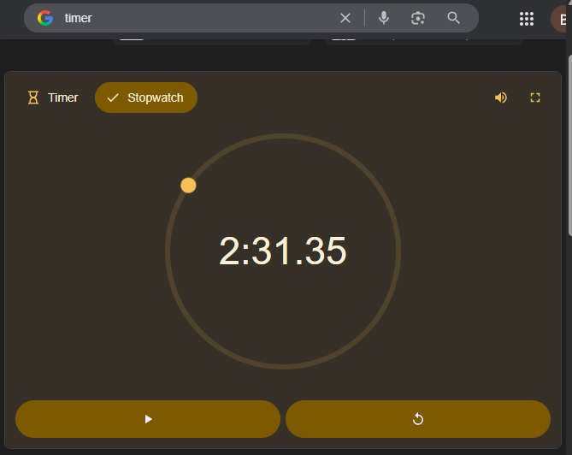

- Load all grids and save the column settings.
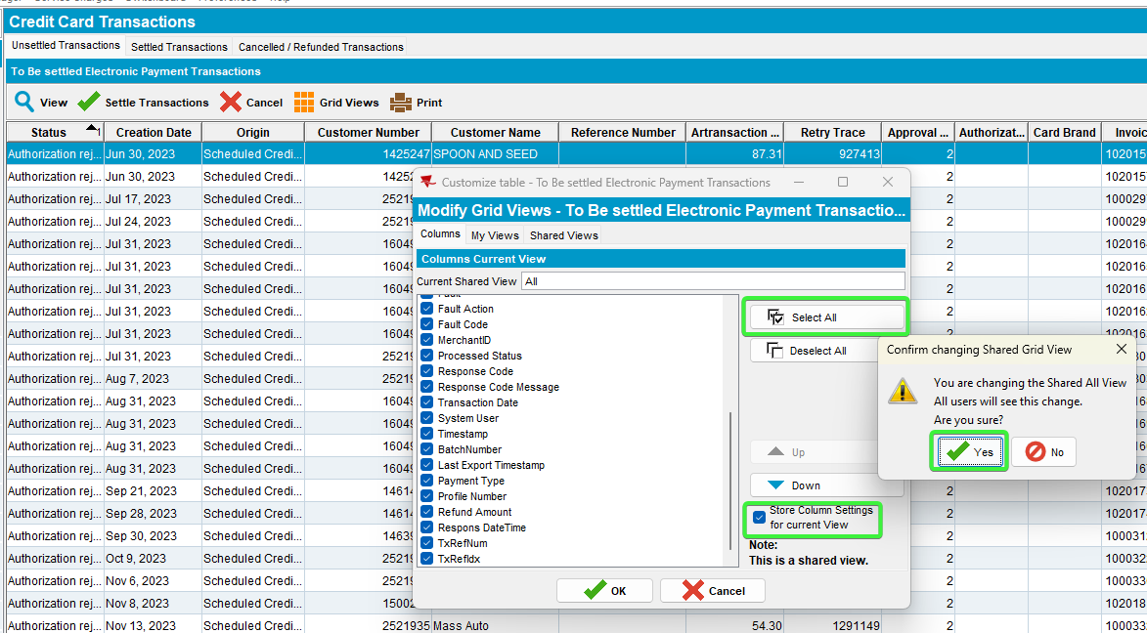
- Close the server. Restart everything.
- Credit Card Transaction dlg: Unsettled Transactions tab, load the screen and time how much it takes to load the records, now with all the columns saved.
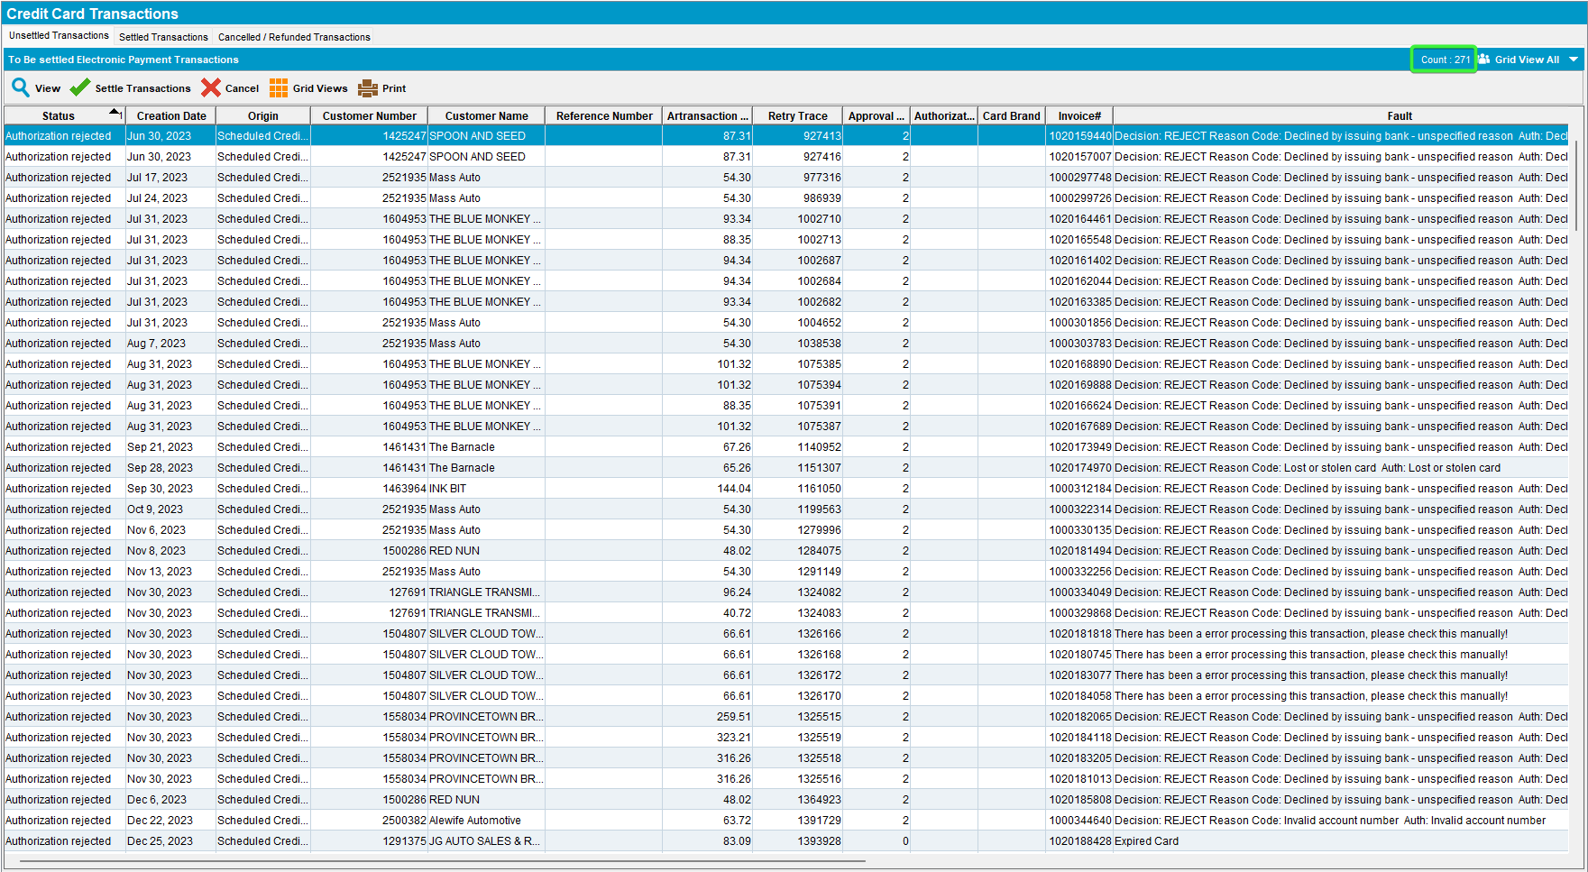
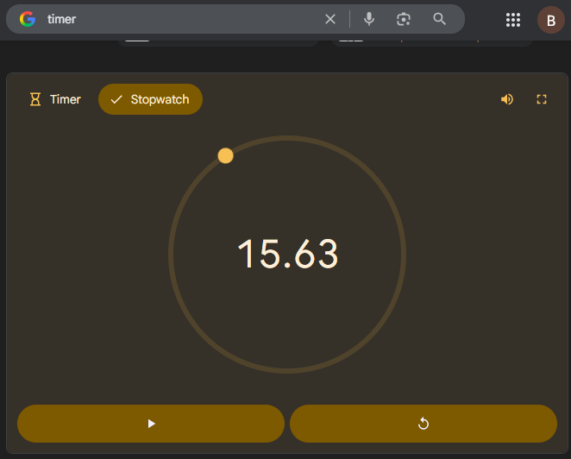

- Check the ServerError.log for any errors.
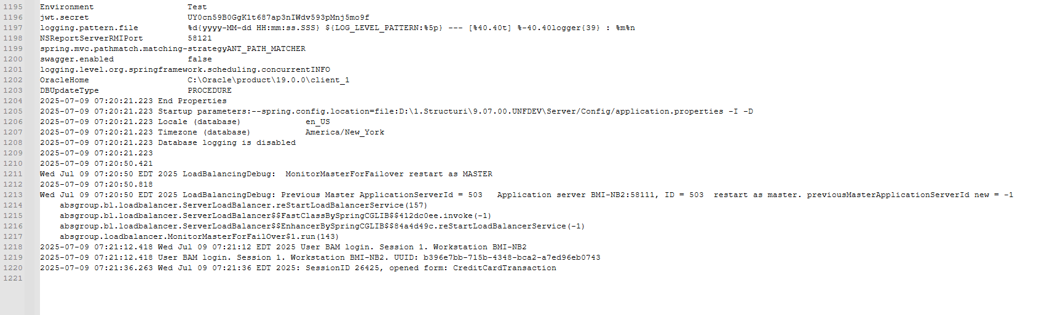
No errors were present.
- Credit Card Transactions dlg: Open Settled Transactions tab, Save all the grid columns.
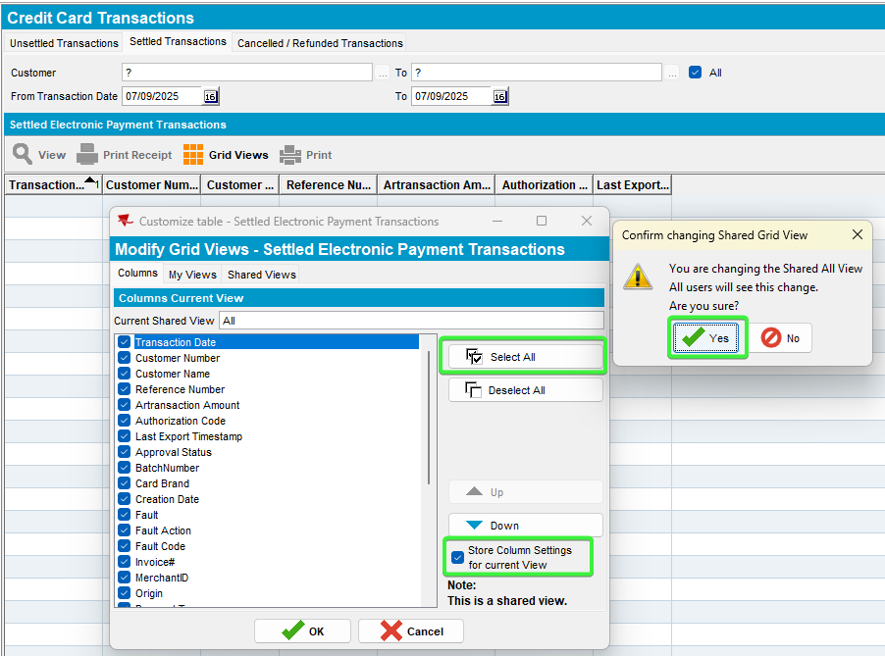
- Credit Card Transactions dlg: Load the records from settled invoices for 2+years. Wait for the data to load.
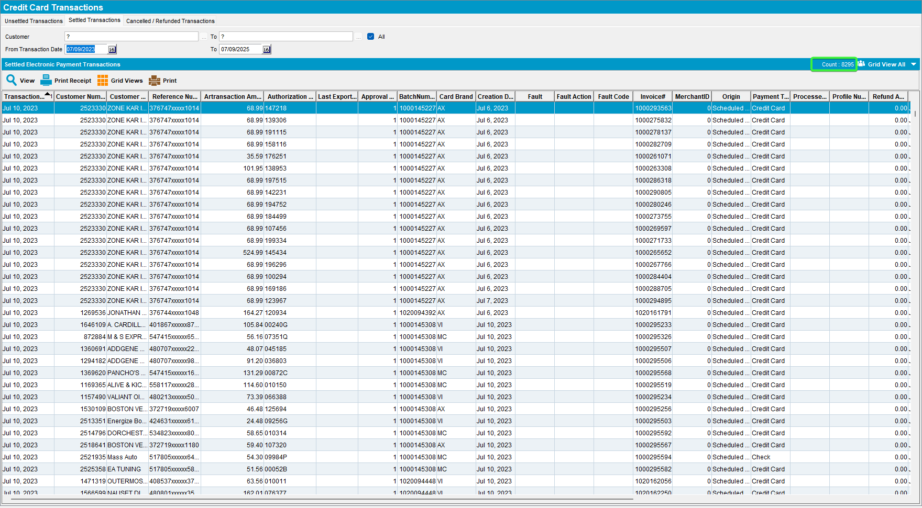
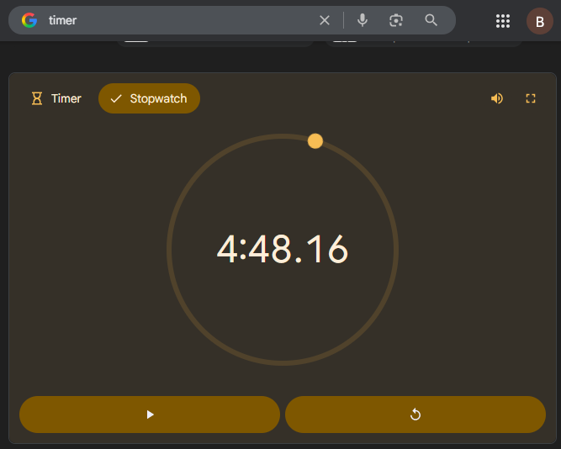
- Check the ServerError.log for any errors.
No errors were present.
- Credit Card Transactions dlg: Open Cancelled/Refunded Transactions tab, Save all the grid columns.
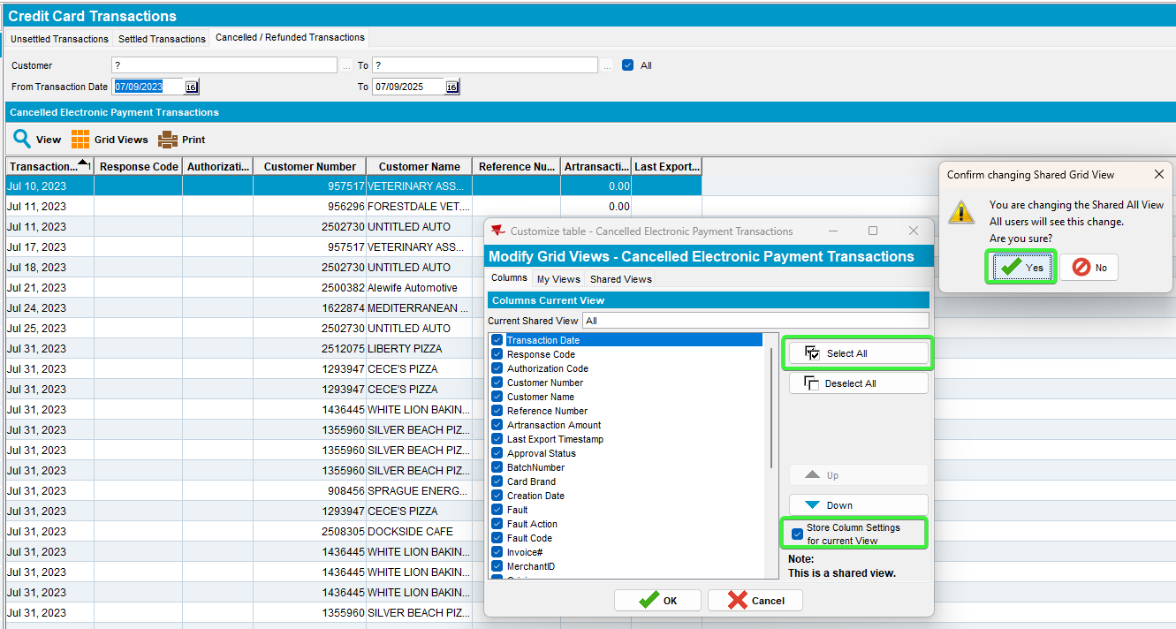
- Credit Card Transactions dlg: Load the records from settled invoices for 2+years. Wait for the data to load.
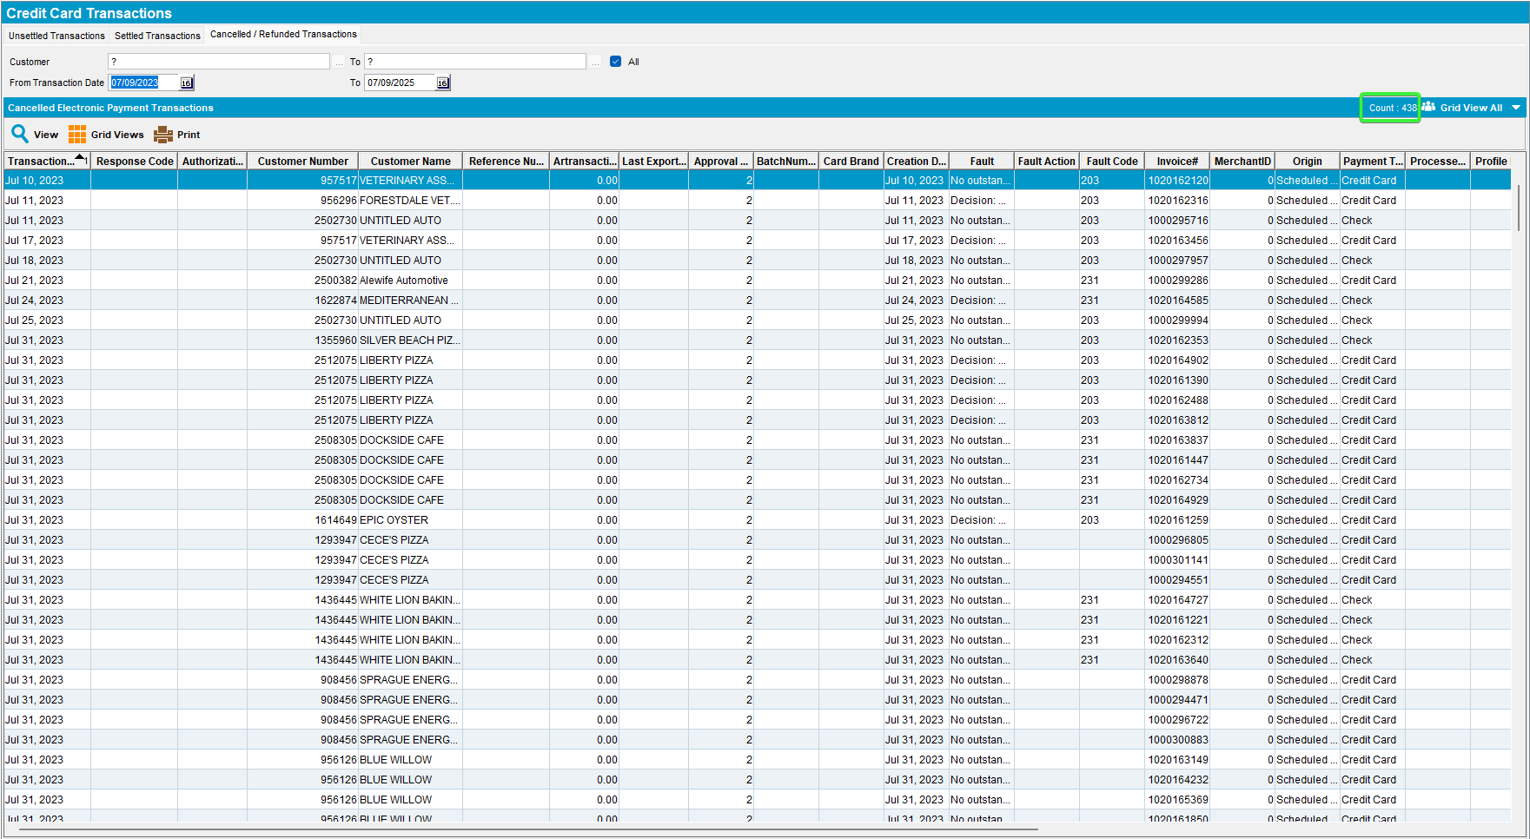
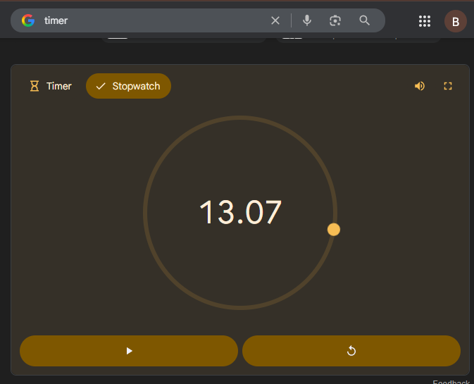

- Check the ServerError.log for any errors.
No errors were present.
- Credit Card Transaction dlg: Choose a customer from the list for which we will settle a transaction.
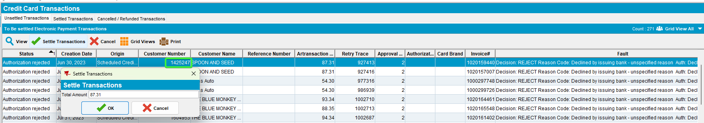

- Customers dlg: Load that customer and put a valid credit card in the Payment section.
Use a dummy valid card, eg:

02A600C0170018008292;5120********6802=2712?*CFE9CD4D4EA44DB29522CF84DF675D91FB9667069BF69F49000000000000000000000000000000000000000038333054393633393730FFFF987654001B0001411F8503

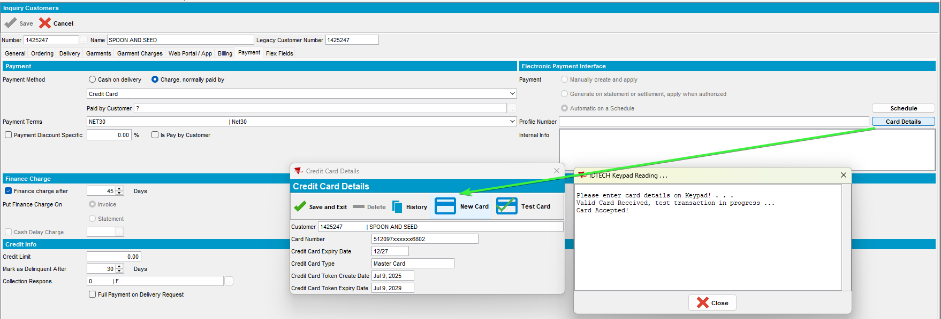

- Credit Card Transaction dlg: Settle an invoice from unsettled transaction tab, time how much it takes to get settled. Choose a customer from the list
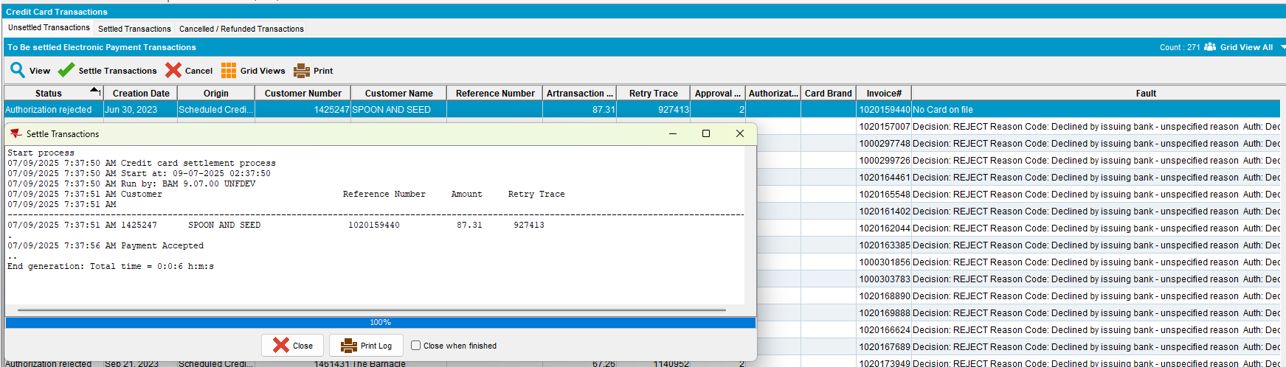
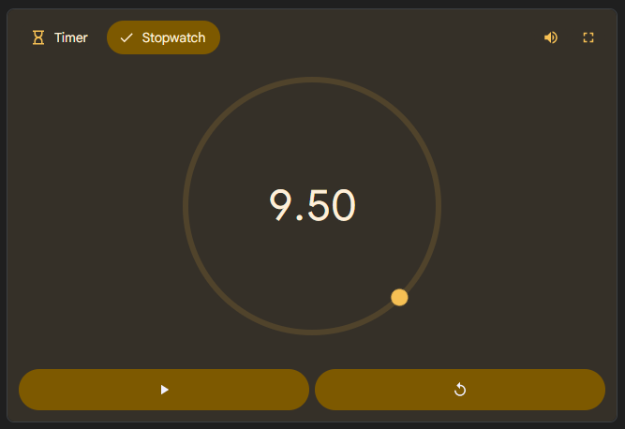
- Credit Card Transactions dlg: Go to the Settled Transactions tab and load the above customer.
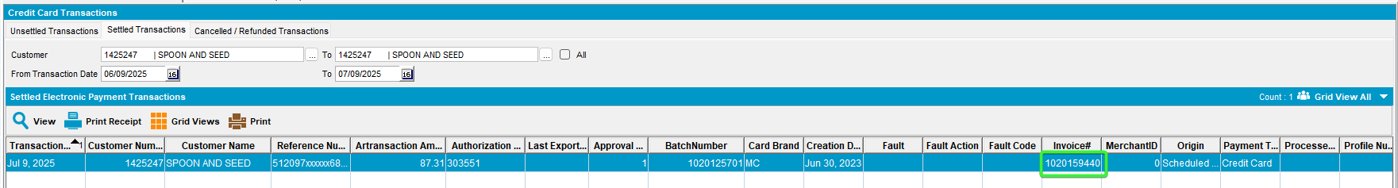
- Check the ServerError.log for any errors.
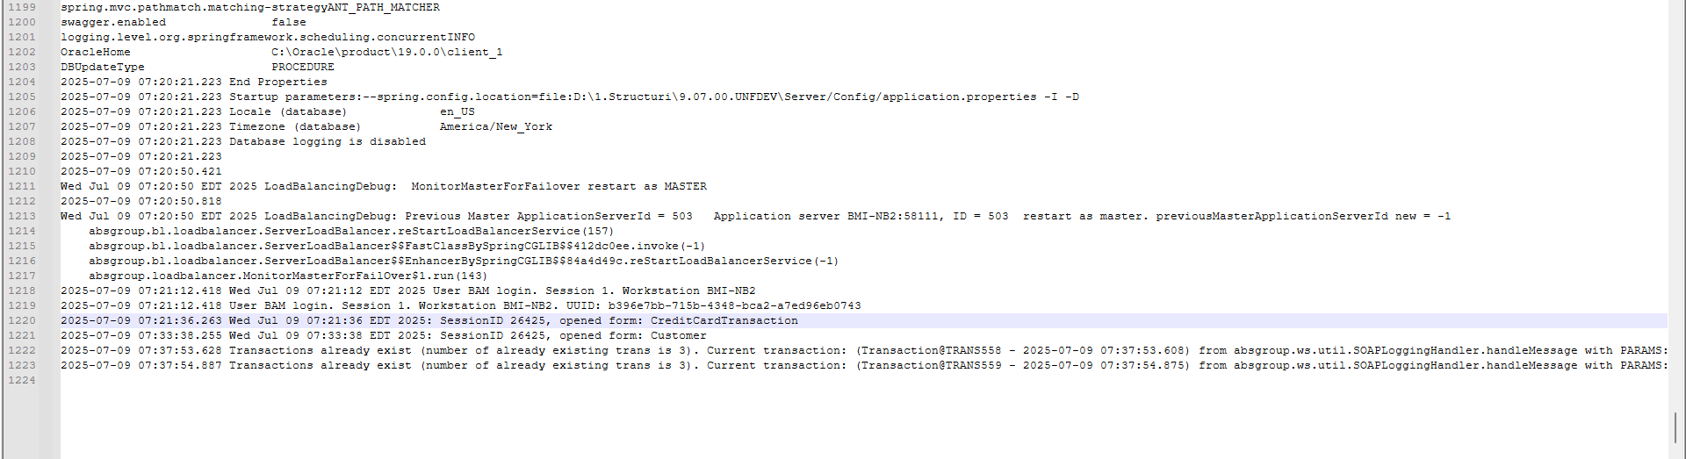
No errors were present.

Retest after fix
Bu: 012 BOSTON, MA
9.07.00.UNF17.p11 hash: 5bfff6dba95b

Steps to reproduce

!!! All the column grids were already saved from previous run !!! If there are not present, please add them
Close the server. Restart everything.

- Credit Card Transaction dlg: Unsettled Transactions tab, load the screen and time how much it takes to load the records.
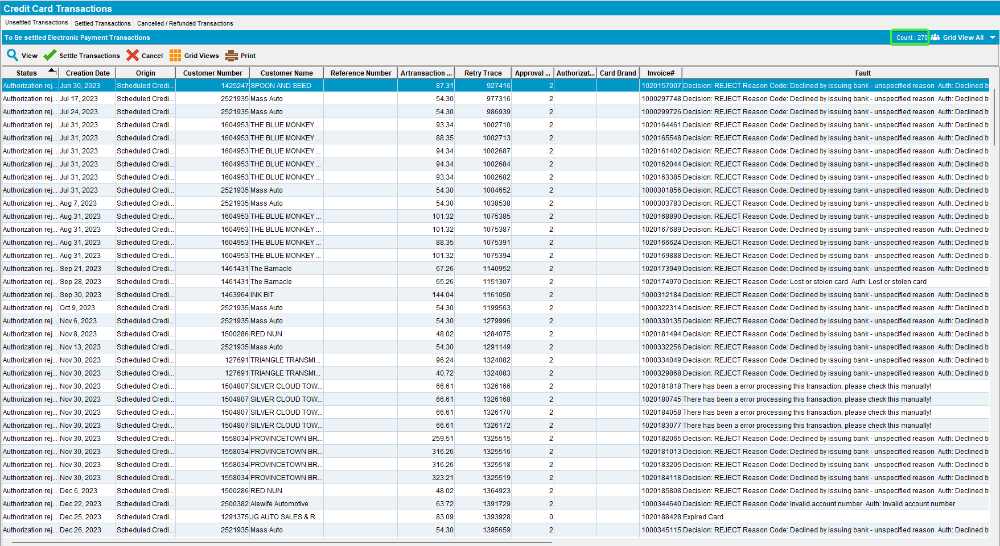

Before the improvement After the improvement
-> 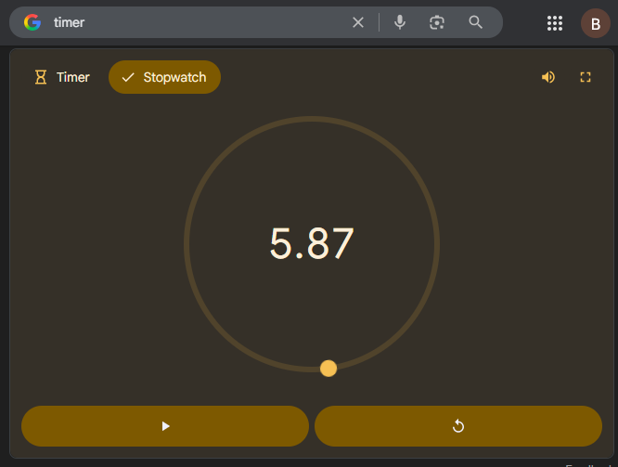

- Check the ServerError.log for any errors.
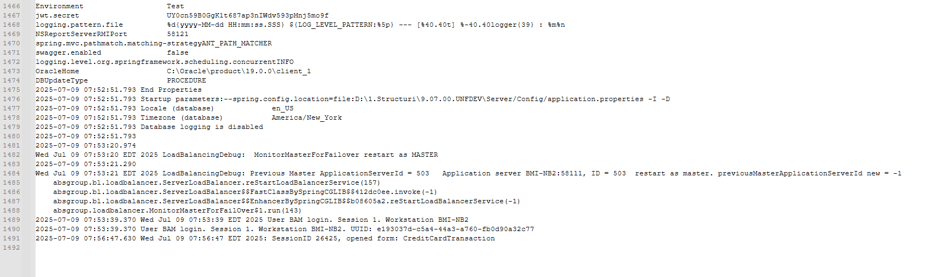
No errors were present.
- Credit Card Transactions dlg: Open Settled Transactions tab, Save all the grid columns (if were not already saved before)
- Credit Card Transactions dlg: Load the records from settled invoices for 2+years. Wait for the data to load.
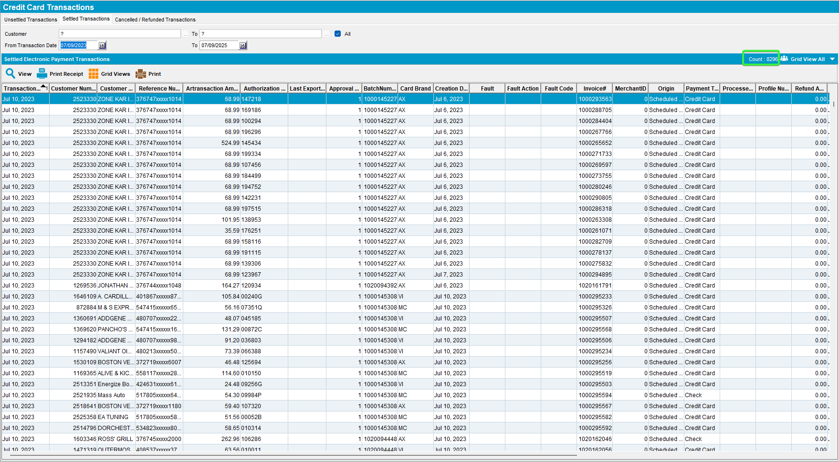
Before the improvement After the improvement
-> 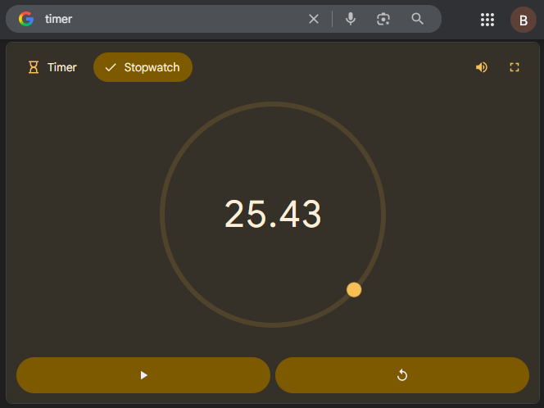
- Check the ServerError.log for any errors.
No errors were present.
- Credit Card Transactions dlg: Open Cancelled/Refunded Transactions tab, Save all the grid columns (if were not already saved before)
- Credit Card Transactions dlg: Load the records from settled invoices for 2+years. Wait for the data to load.

Before the improvement After the improvement
-> 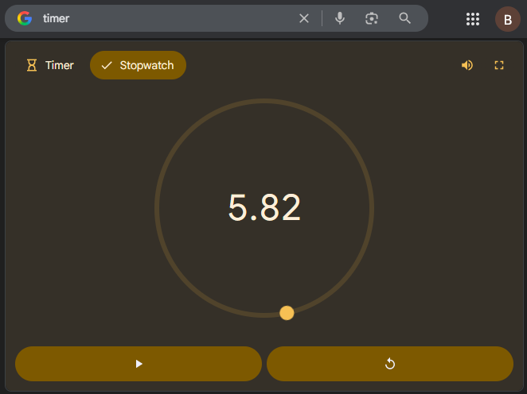

- Check the ServerError.log for any errors.
No errors were present.
- Credit Card Transaction dlg: Choose a customer from the list for which we will settle a transaction.

- Customers dlg: Load that customer and put a valid credit card in the Payment section.
Use a dummy valid card, eg:

02A600C0170018008292;5120********6802=2712?*CFE9CD4D4EA44DB29522CF84DF675D91FB9667069BF69F49000000000000000000000000000000000000000038333054393633393730FFFF987654001B0001411F8503

- Credit Card Transaction dlg: Settle an invoice from unsettled transaction tab, time how much it takes to get settled.
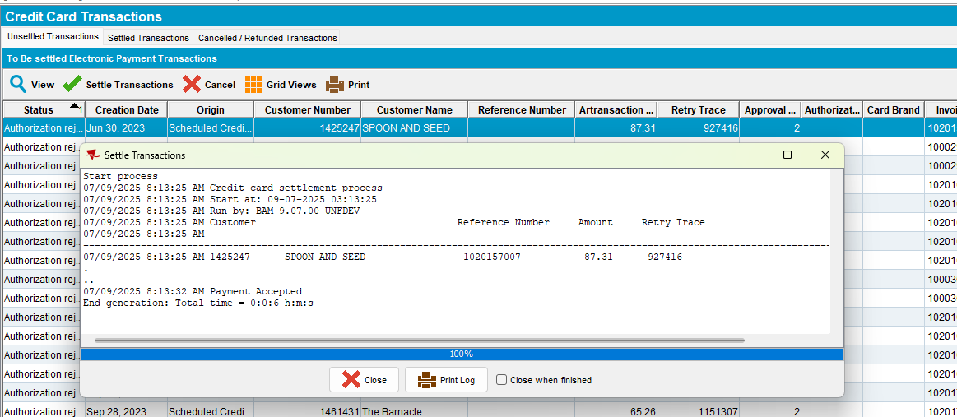

Before the improvement After the improvement
-> 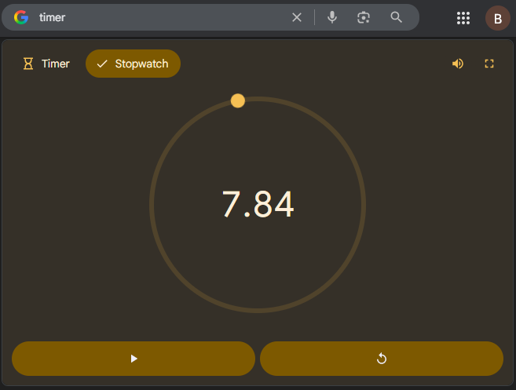
- Credit Card Transactions dlg: Go to the Settled Transactions tab and load the above customer.
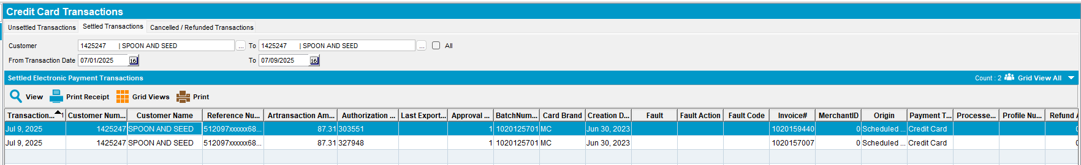
- Check the ServerError.log for any errors.
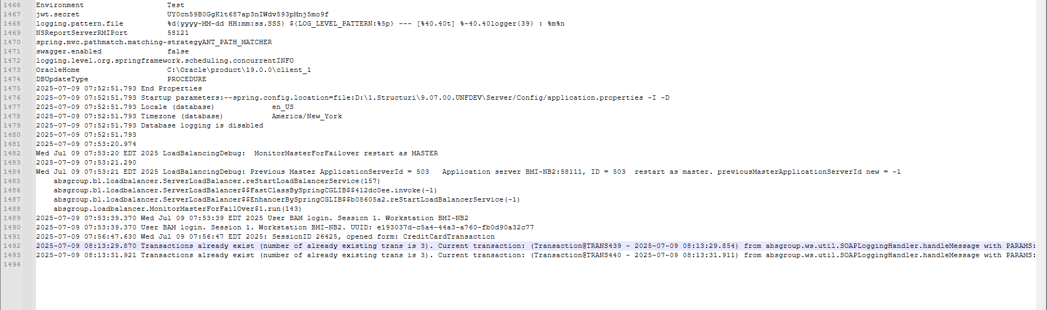
No errors were present.
- Credit Card Transactions dlg: Cancel an unsettled transaction.
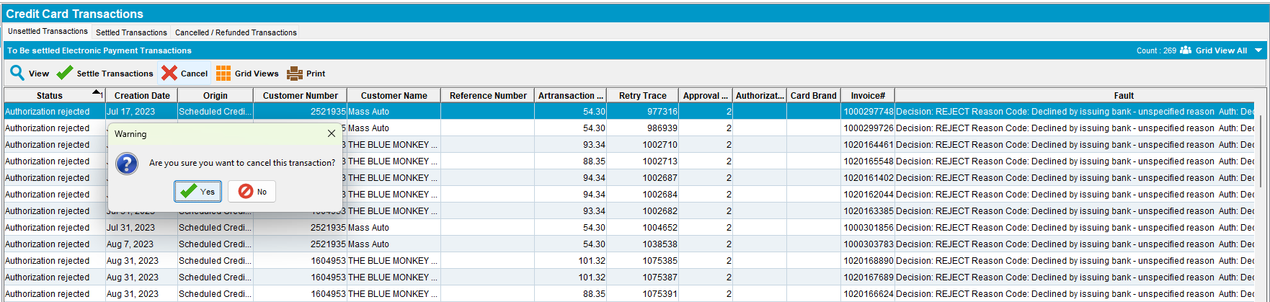
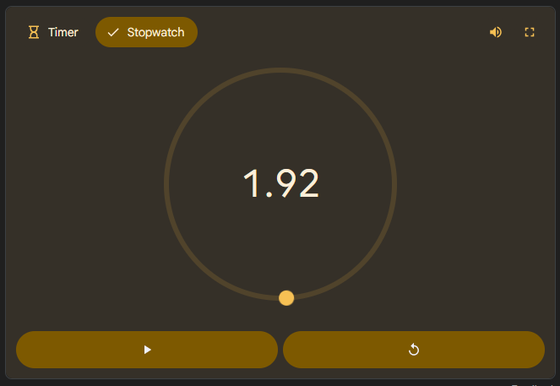
- Credit Card Transactions dlg: Go to the Cancelled / Refunded Transactions tab and check for the cancelled transaction.
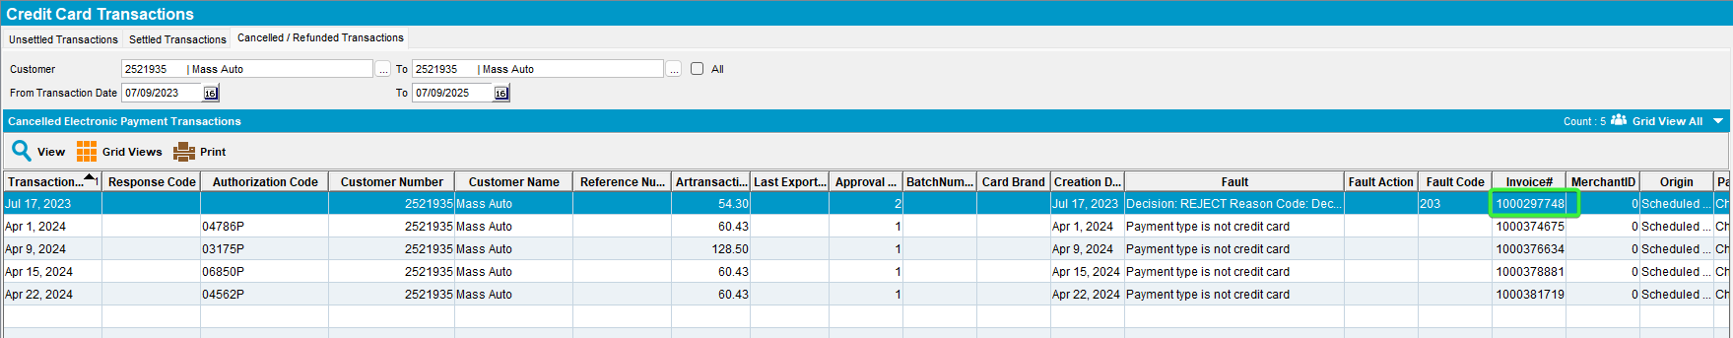
- Check the ServerError.log for any errors.
No errors were present.

