ABSN-1656 - View Process Log - Redesign for performance
Environment | Prerequisites
Version: 9.07.00.UNF17.p10  DBServerName= abs-srv20.internal.abslbs.com  DBSID=CUST24  DBUser=UNFDEV  Environment=Test | - Module:  - System setting

Contents
Retest after fix 1
Test Case 1 – Check loading times for logs from Dialogs, Scheduled Process, Mobile Devices, Web Services, Route Control 1

Retest after fix

Test Case 1 – Check loading times for logs from Dialogs, Scheduled Process, Mobile Devices, Web Services, Route Control
Hash: 4321af859559
Expected: Information in the grid should appear in under 10 seconds
- View Process log DLG: Select a time frame of 1+ month
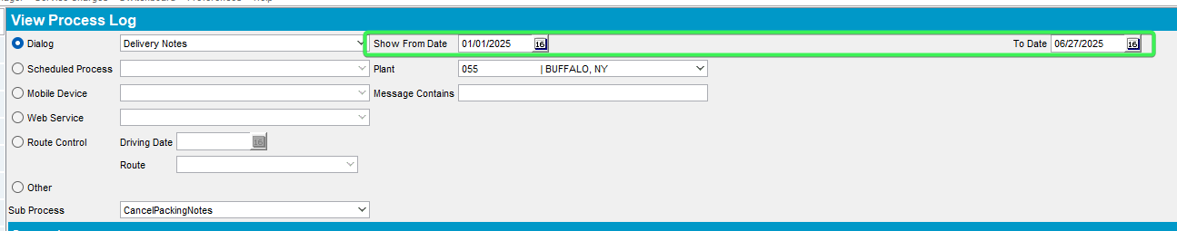
- Select Dialog Option press on the dropdown button and select logs which contain data
Credit Card Transactions
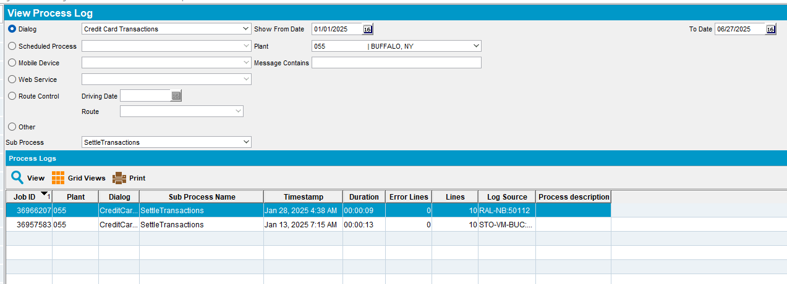
Delivery Notes
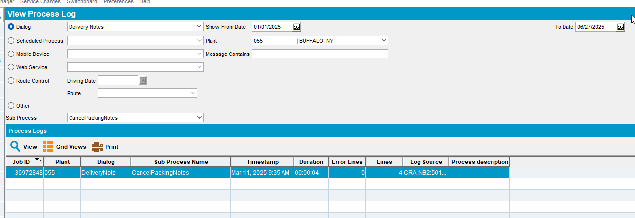
Garments per wearer
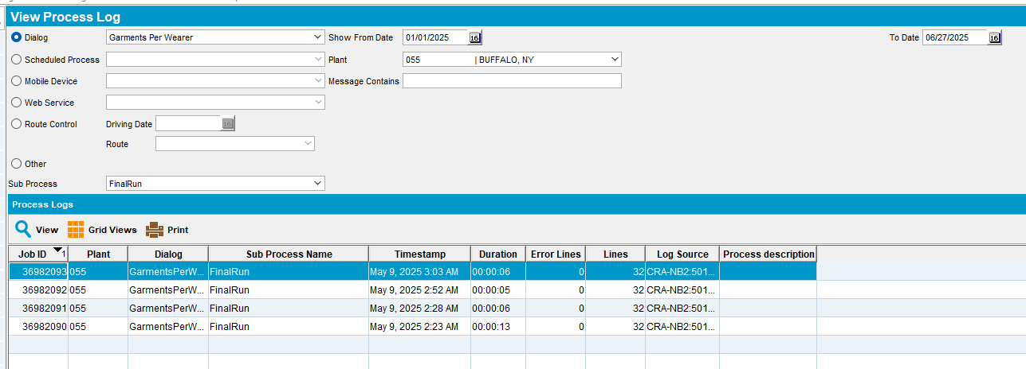
Route Status Control
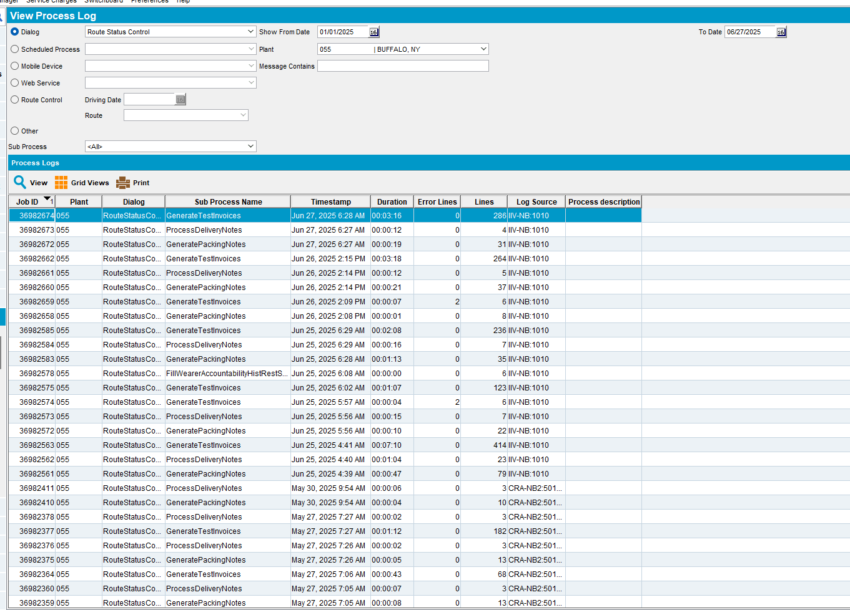
Settlement
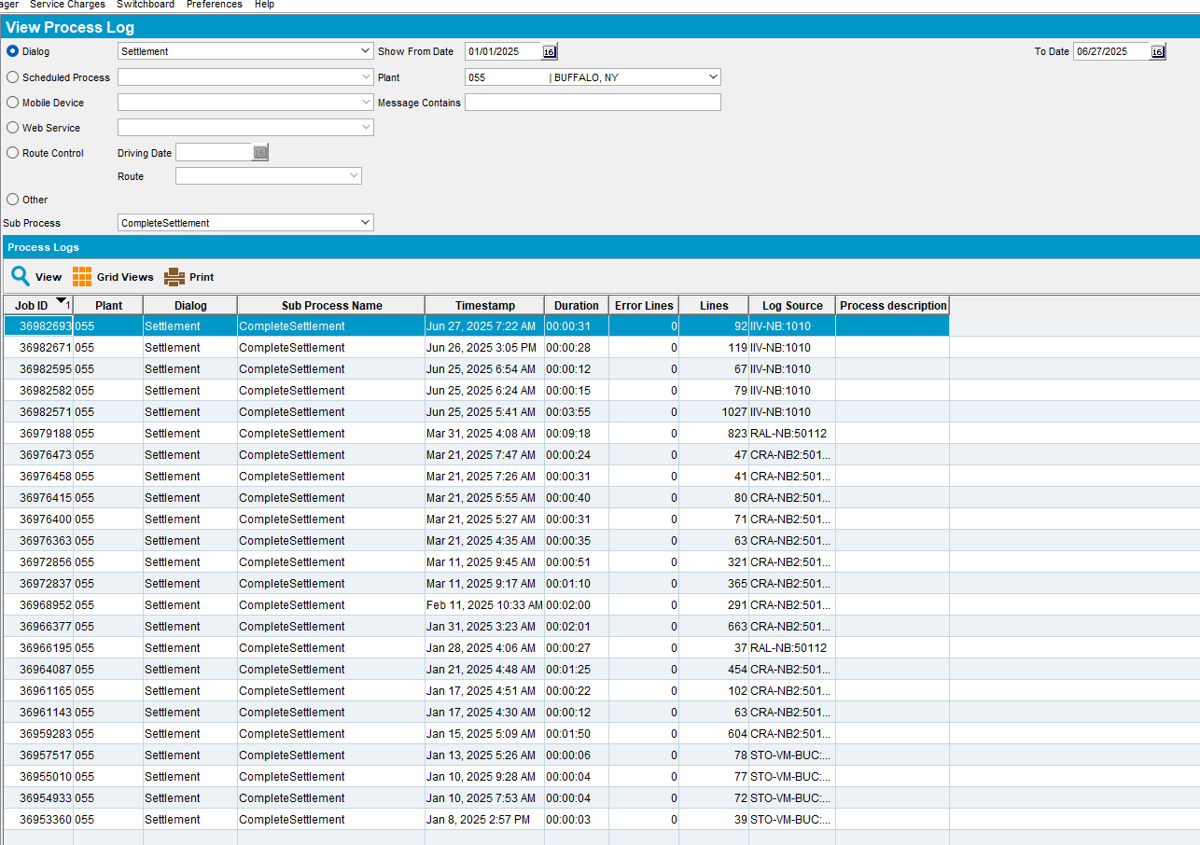
Wearers
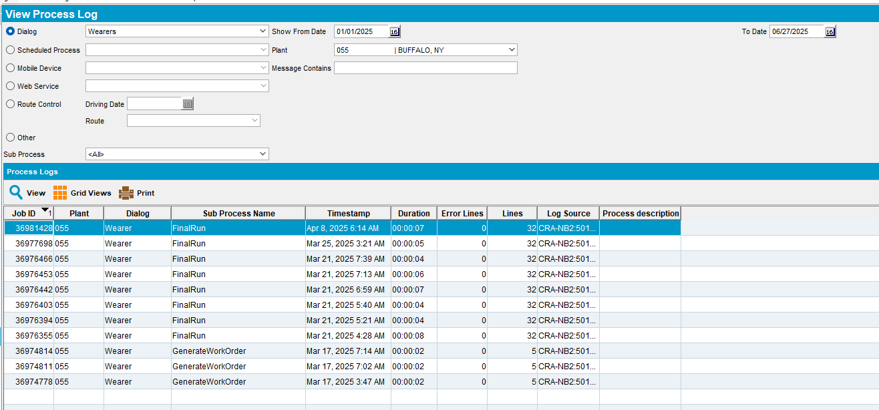
- Select Scheduled Process press on the dropdown button and select logs which contain data
Cancel and regenerate US direct invoices for late delivery notes
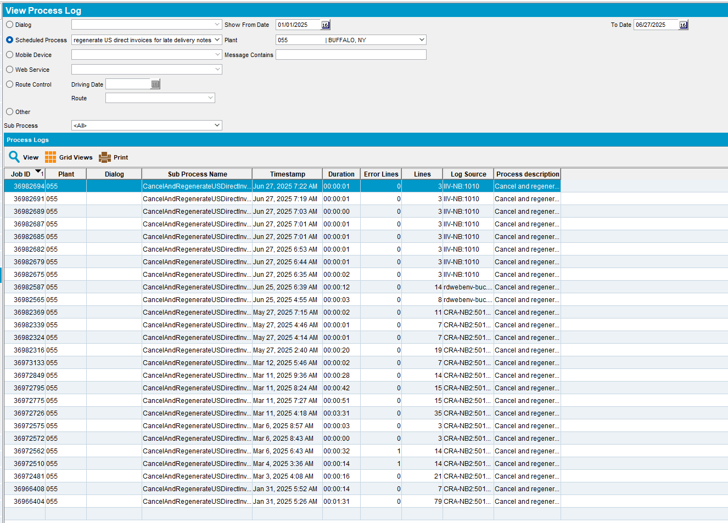
Create Credit Card transactions from payment schedule
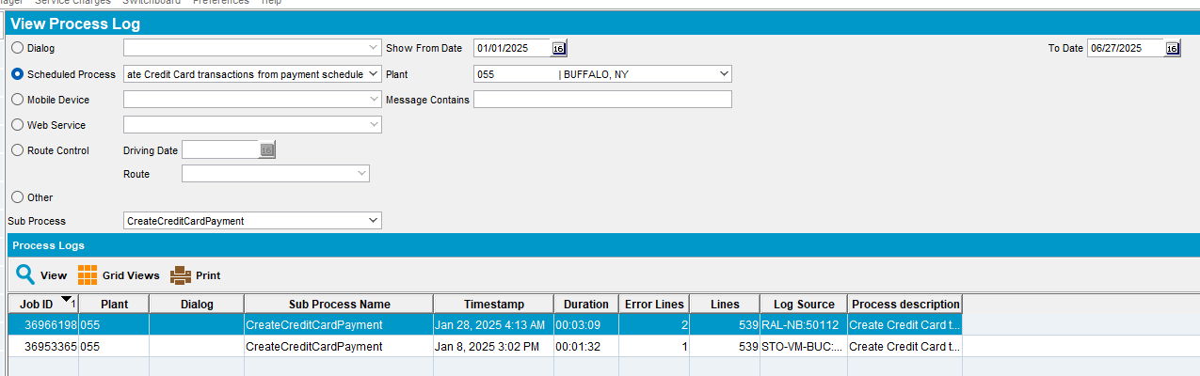
Import Vertex BCI Tax Response
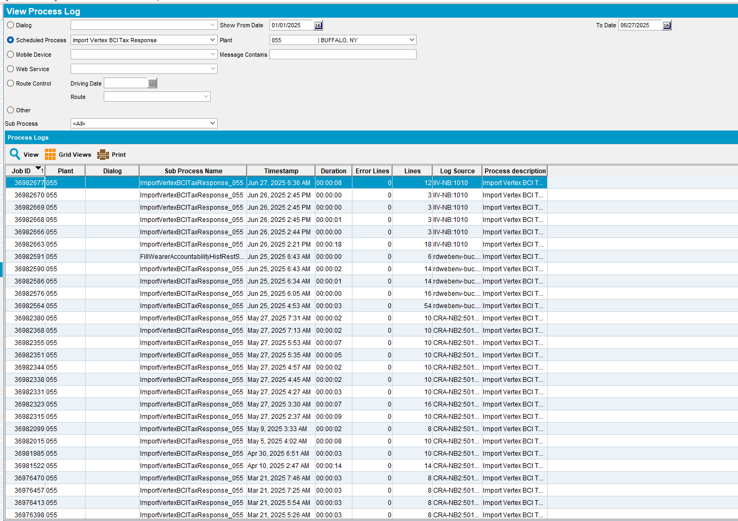
- Select Mobile Devices press on the dropdown button and select logs which contain data
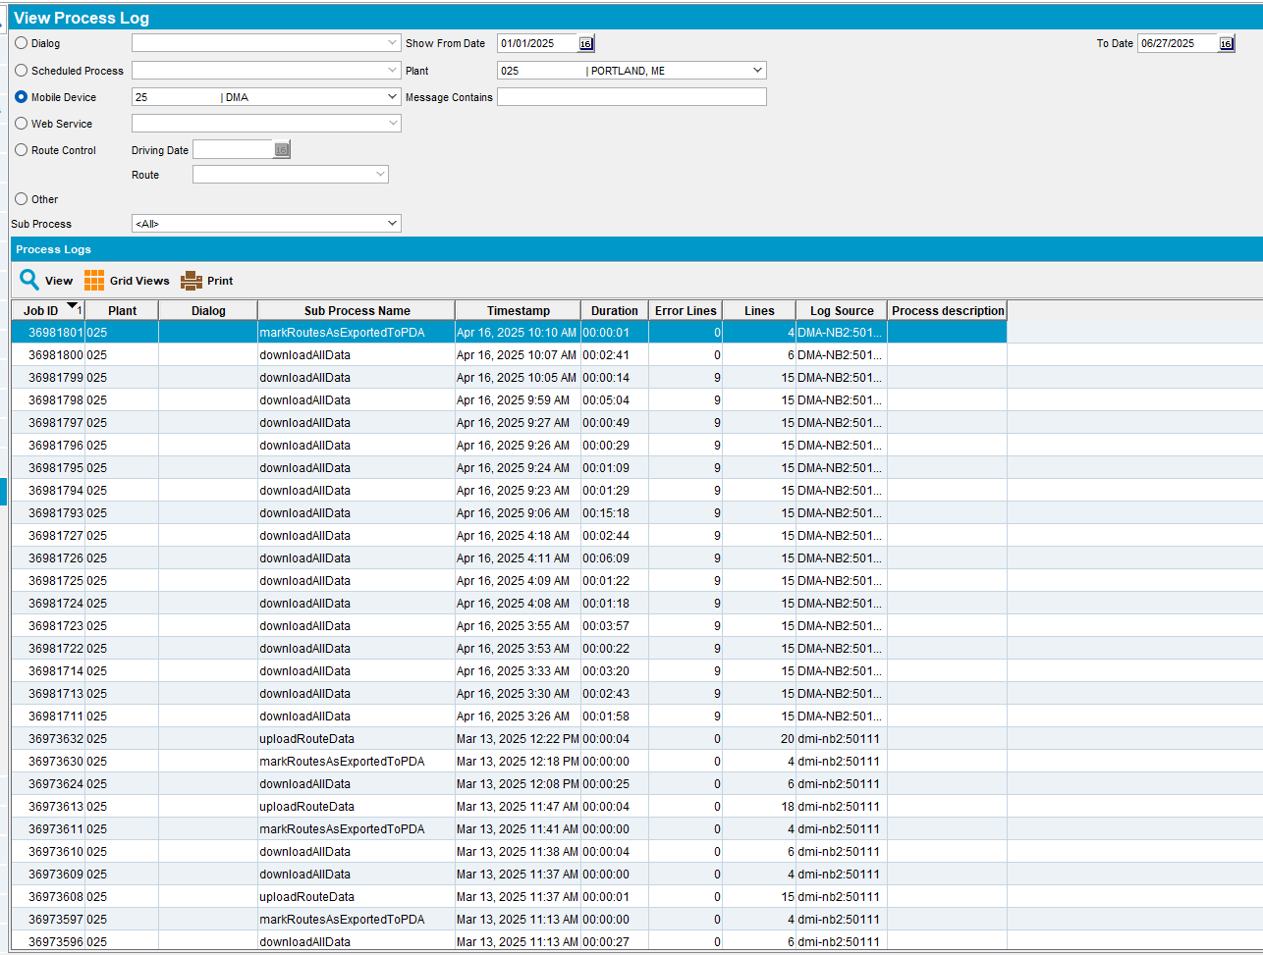
- Select Web Services press on the dropdown button and select logs which contain data
Generate Direct Invoices
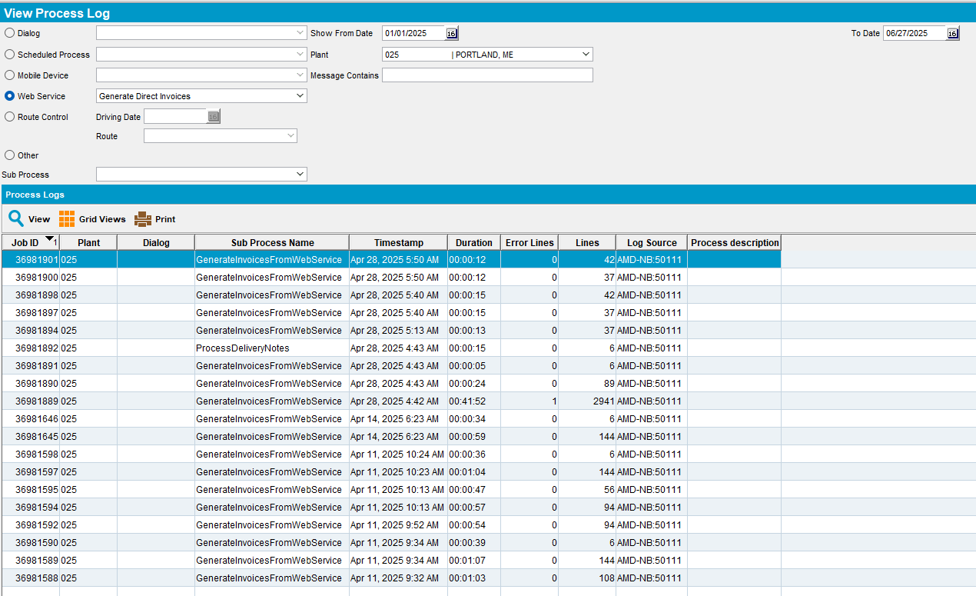
Product Size Change - DTA test
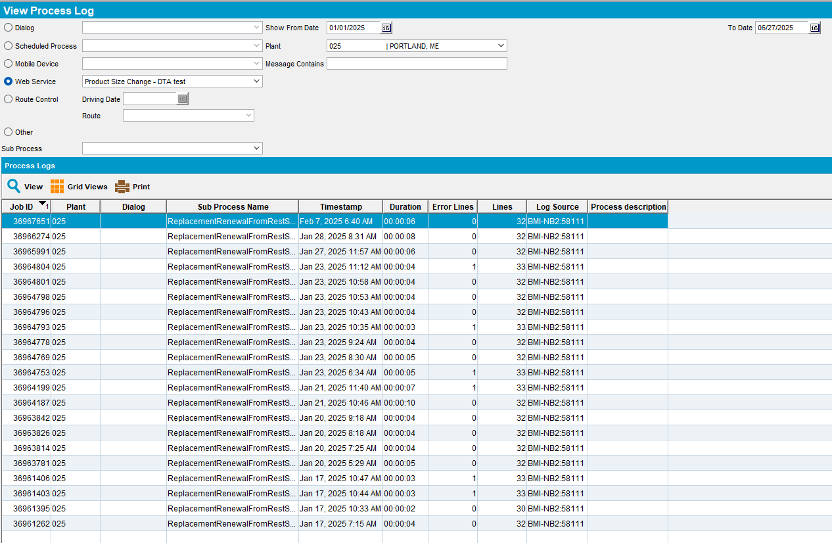
- Select Route Control select a date and route
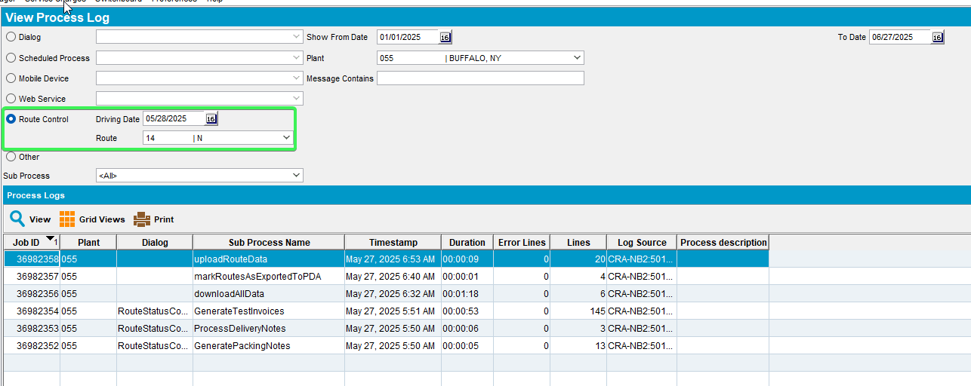
- Select Other press on the dropdown button and select logs which contain data
FillWearerAccountabilityHistRestService
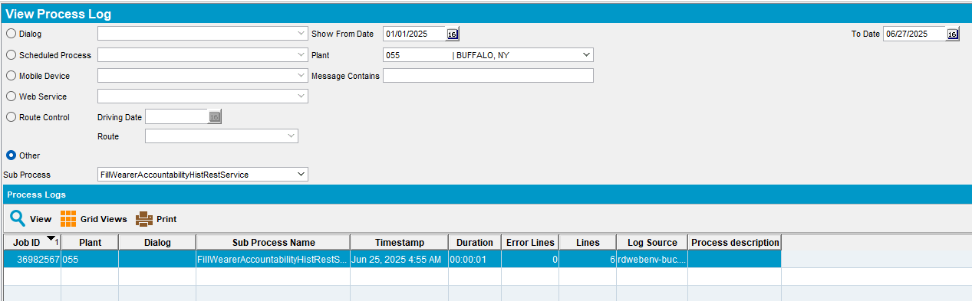
GenerateDirectInvoices
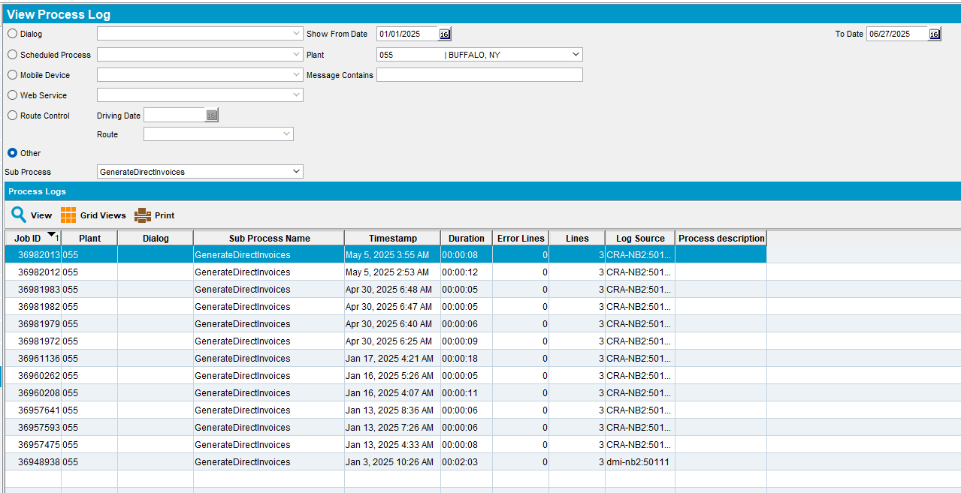
GenerateInvoicesFromFinaliseRoutesProcess
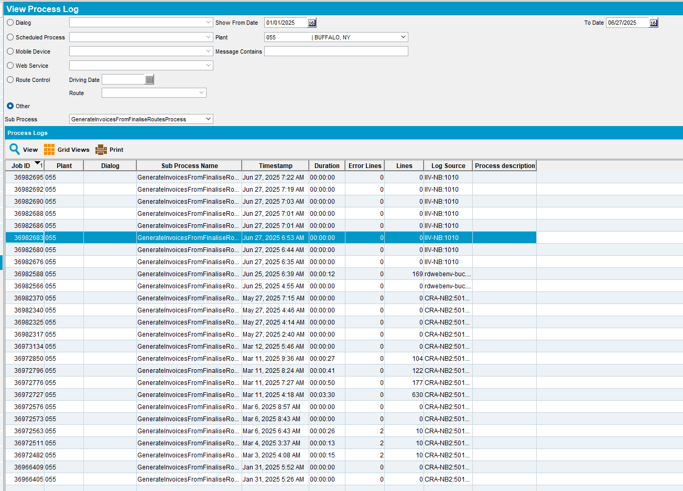
MissingPricesOnDirectInvoice
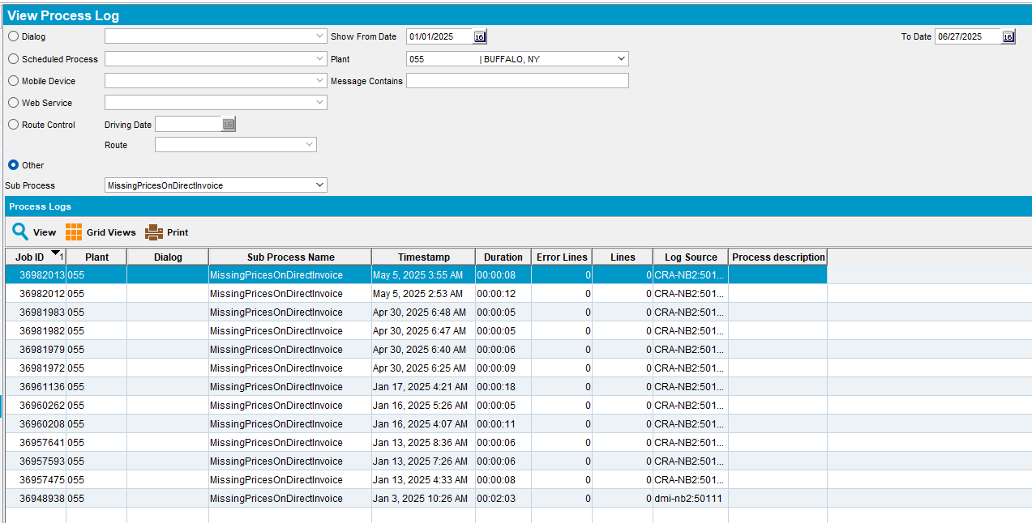
NotProcessedNotesOnDirectInvoice
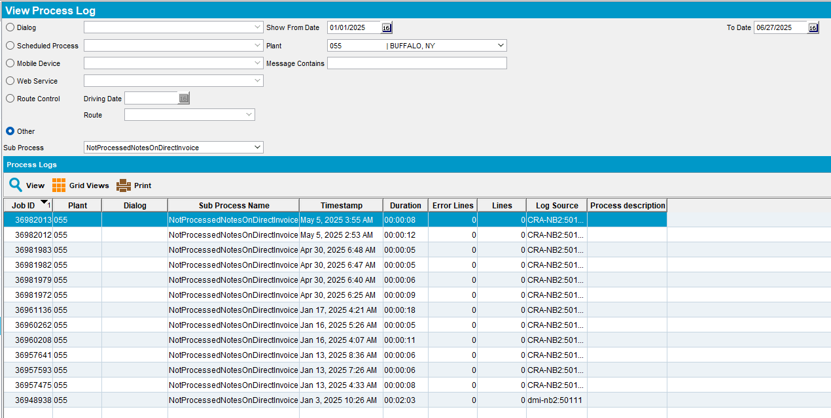
ProcessDeliveryNotes
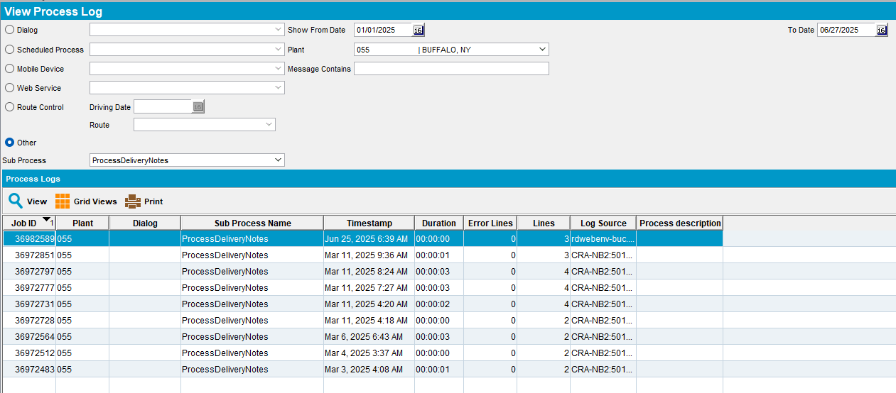
All Log were loaded in due time, under 10 seconds
Tested OK

Test Case 2 – Check performance of new select vs old select
Hash: 4321af859559
Expected: new select that populates the dialogs dropdown list should be significantly faster than the old one
- Start the server with the previous patch.
- Start diagnostics with executedtransactions.
- Open View Process Log DLG.
- Stop diagnostics recording.
- Find the executed transaction log in the server zip file.
- Open ExecutedTransactionLog and find the transaction containing: select distinct D.DIALOG_ID,
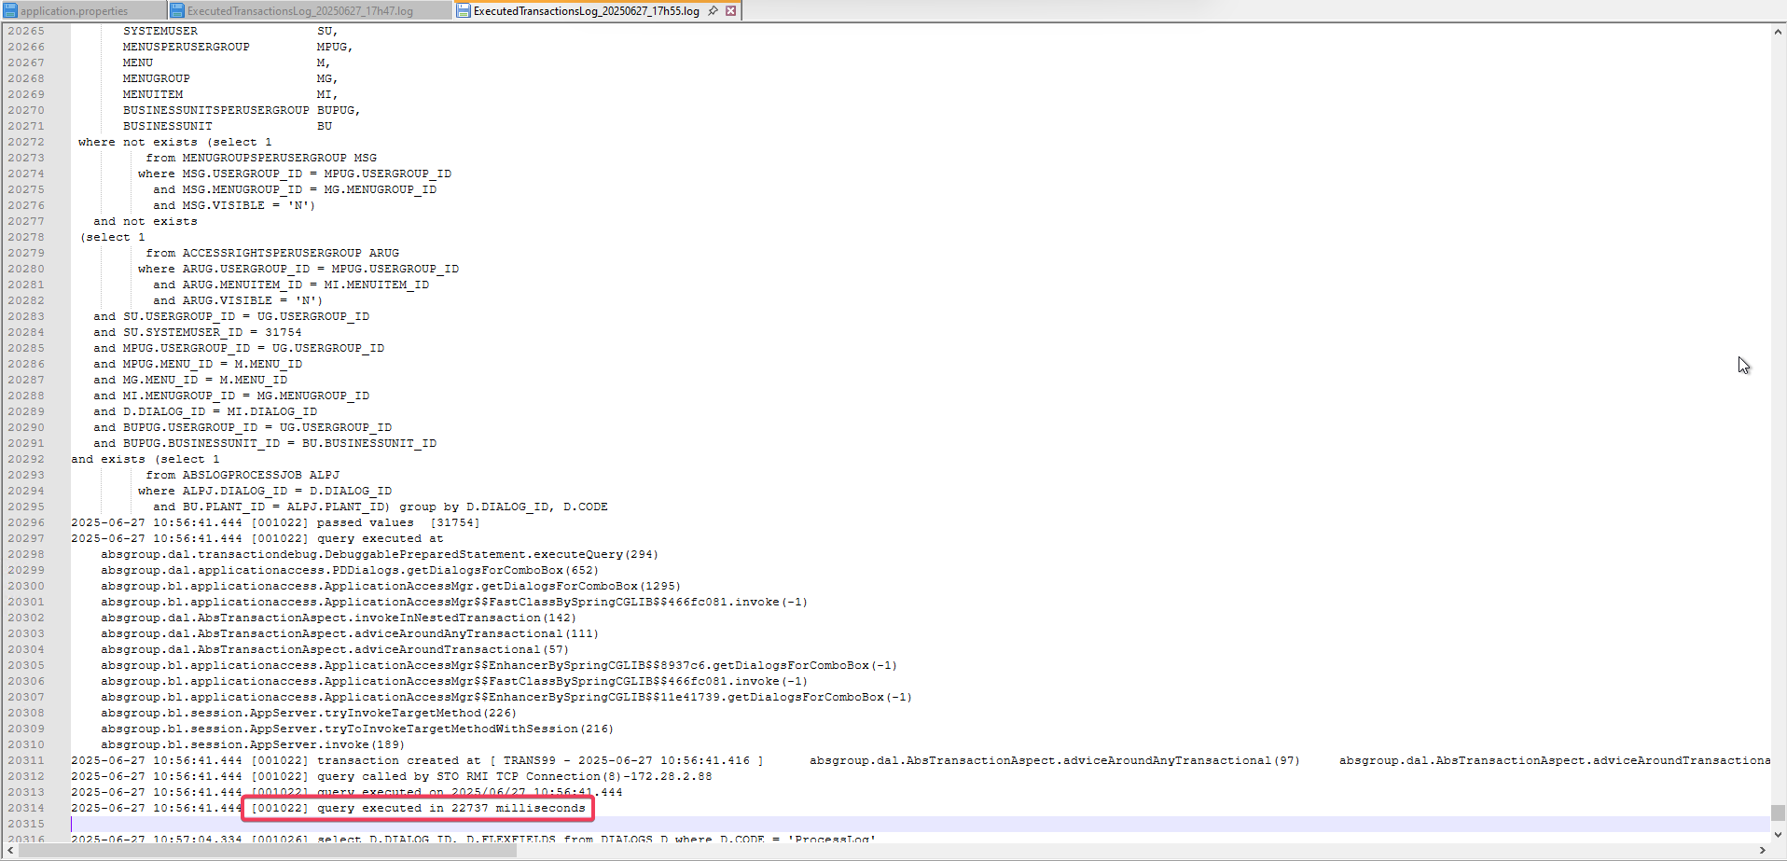
- Start the server with the new patch.
- Start diagnostics with executedtransactions.
- Open View Process Log DLG.
- Stop diagnostics recording.
- Find the executed transaction log in the server zip file.
- Open ExecutedTransactionLog and find the transaction containing: select distinct D.DIALOG_ID,
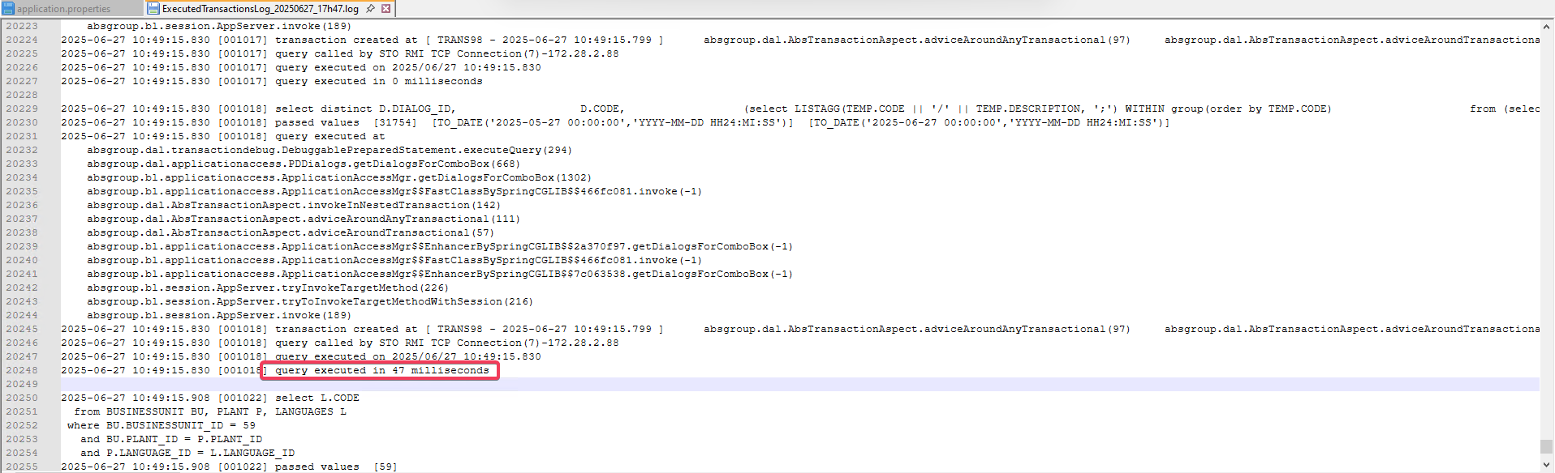
Old patch: query executed in 22737 milliseconds vs new patch: 47 milliseconds
Tested OK

