BPAN-21 - Create folders for French resources
Environment | Prerequisites
Version: 9.07.00.UNF20 + BulkPackingAssistant_v2.16  DBServerName= abs-srv20.internal.abslbs.com  DBSID=CUST24  DBUser=UNFDEV  Environment=Test | - Module:  - System setting

Contents
Test Implementation 1
Data preparation 1
Log in Screen and system information 2
Pack menu 3
Store menu 5
Return menu 8
Checking loading messages 10

Test Implementation

Data preparation
Hash: BulkPackingAssistant_v2.16.INTERNAL_TEST_ONLY.38379d7

- Have the latest resources_fr_FR .jar file placed in your Webserver: C:\WebServers\apache-tomee-plume-8.0.13\webapps\absmobilerestservices_9.07.00.UNF19\WEB-INF\lib
- Once you emulate the version change the language of your device to French
French must be first in the list
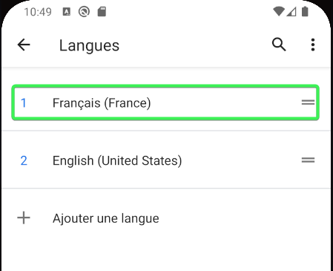

Log in Screen and system information
Log in
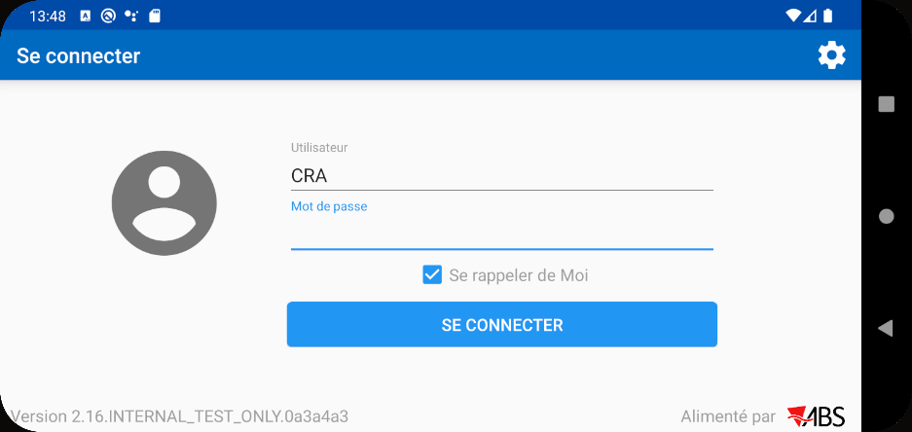
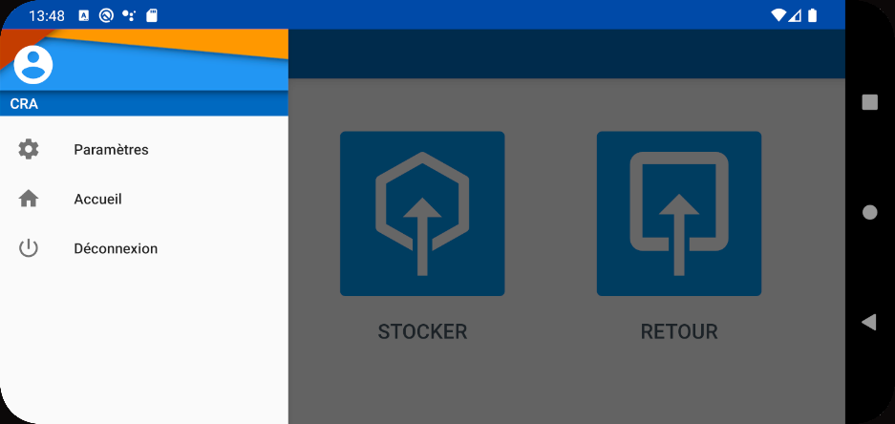
Settings
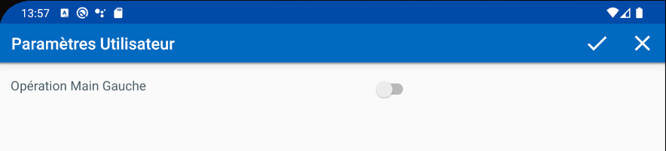

Pack menu
Select days
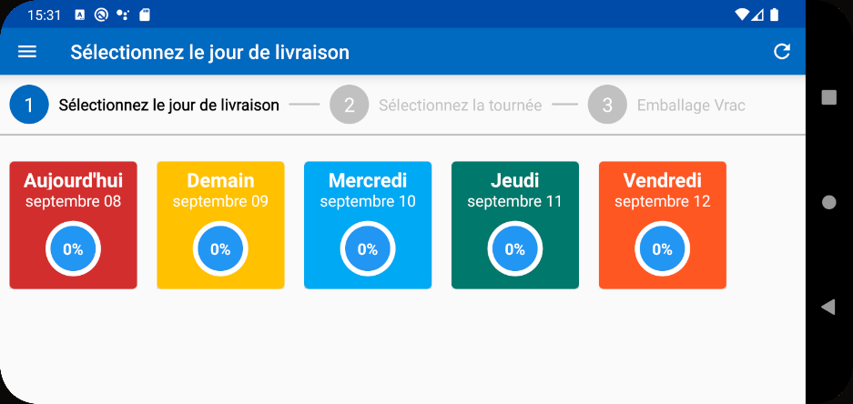
Selecting a day
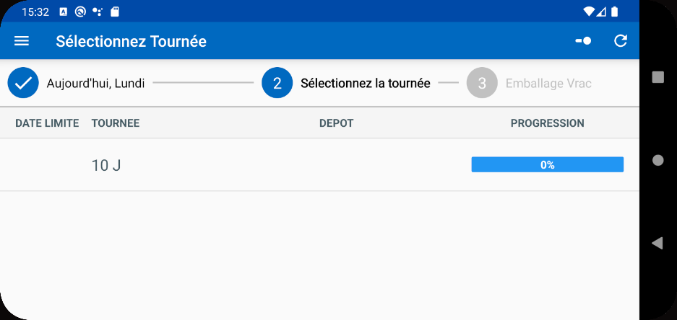
Route content
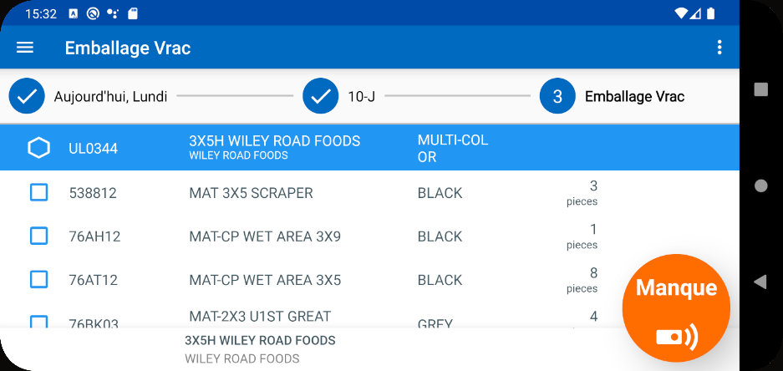
Scan an item
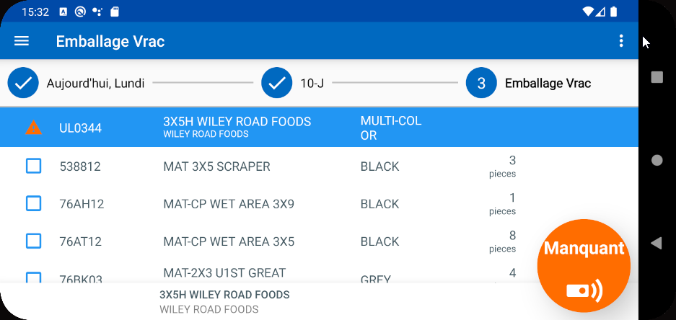
Sort button
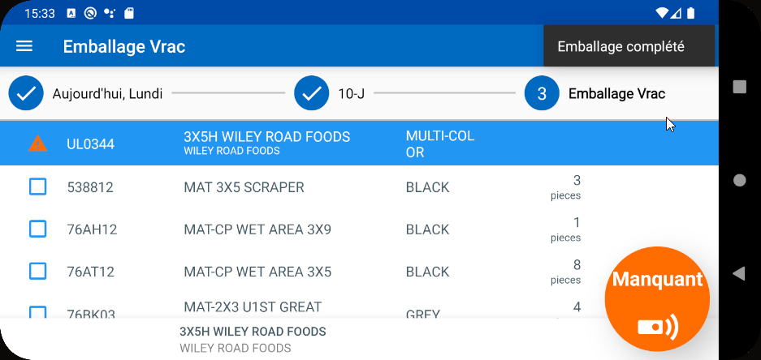

Store menu
Main page
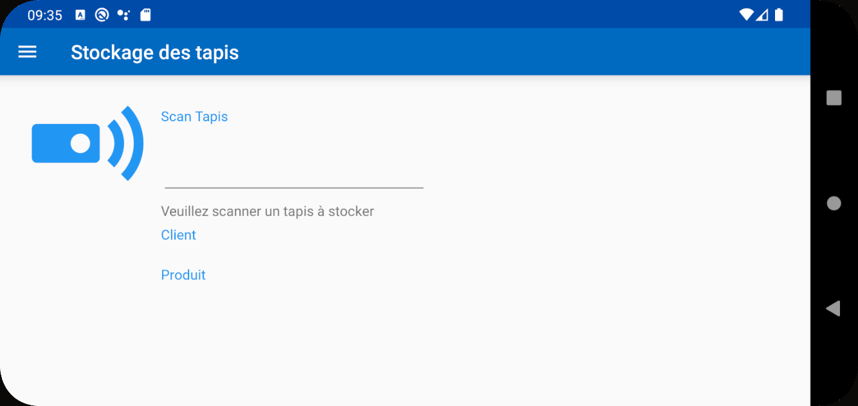
Scan a code
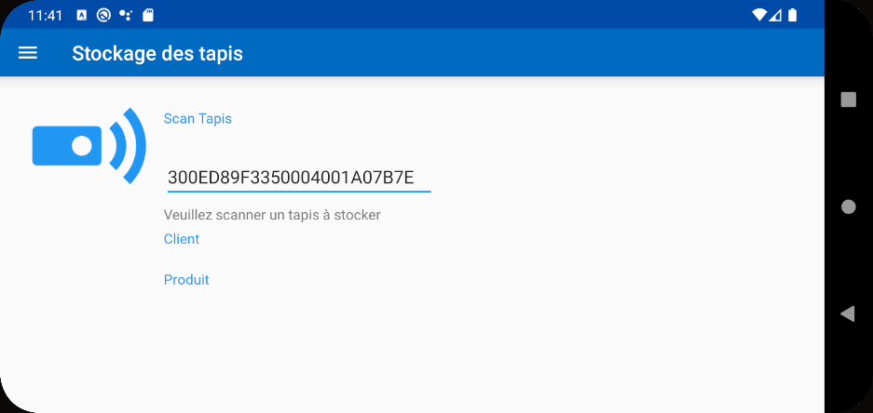
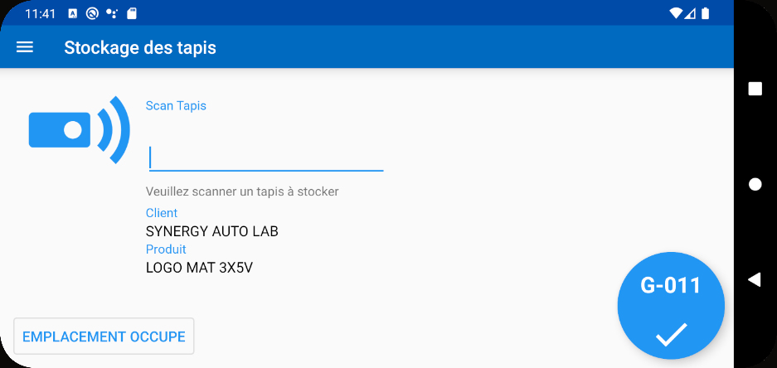
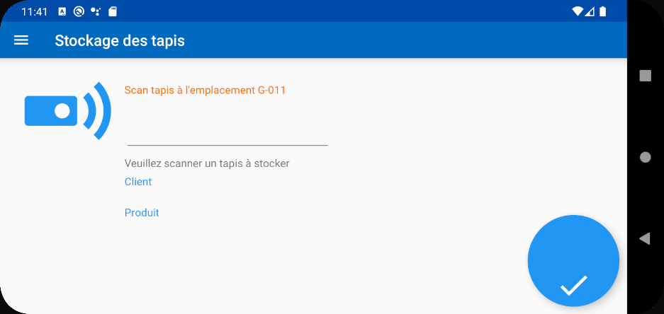
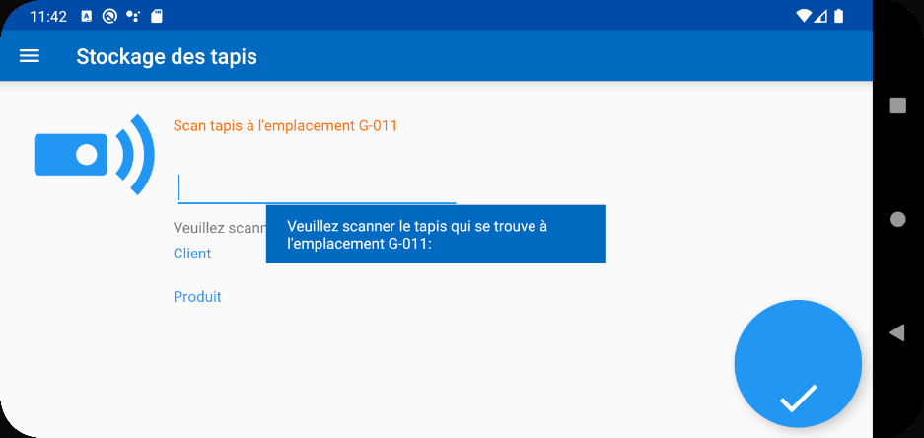
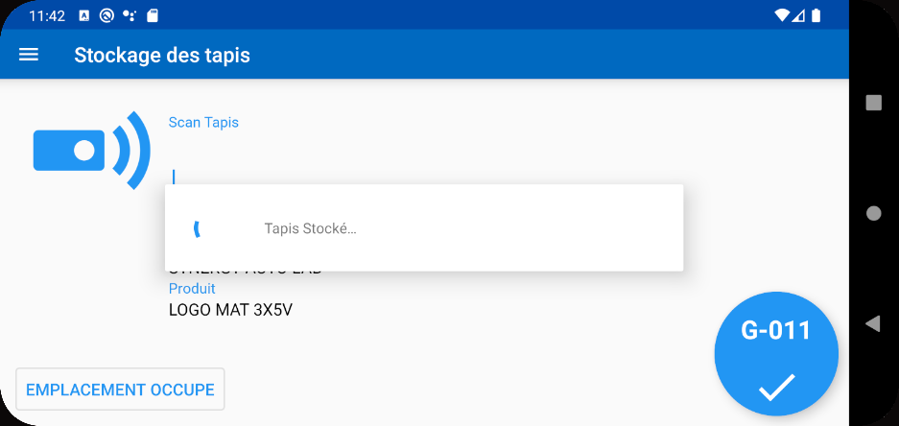

Return menu
Main page
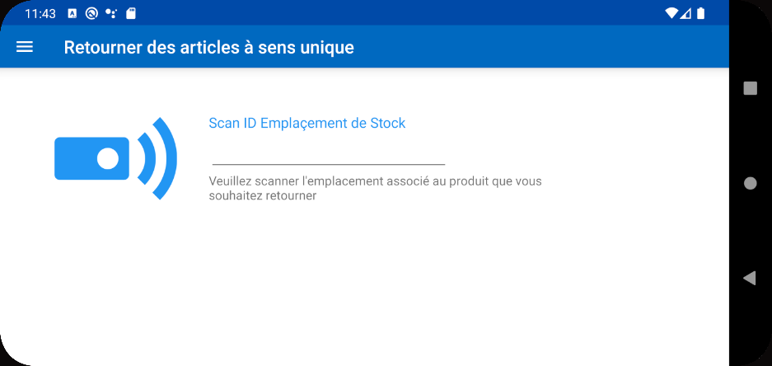
Scan a code: A124
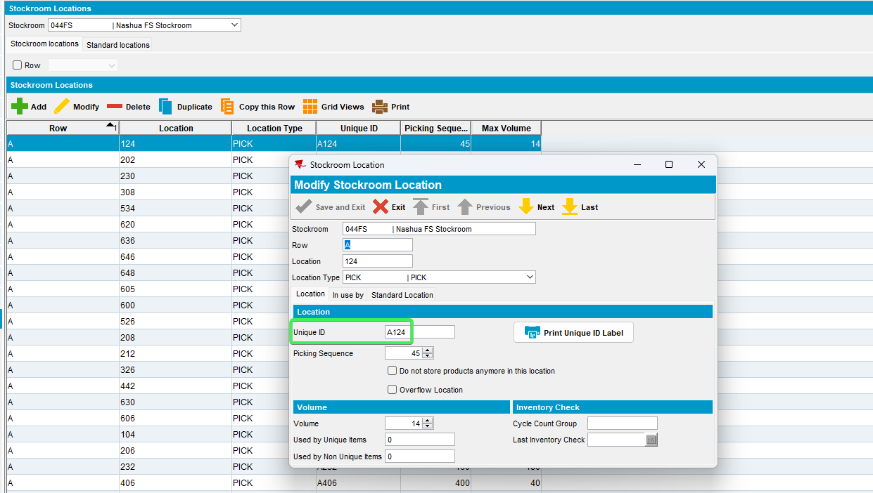
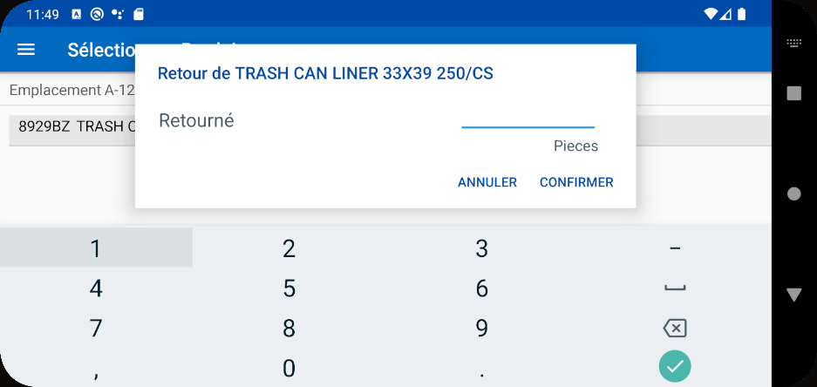
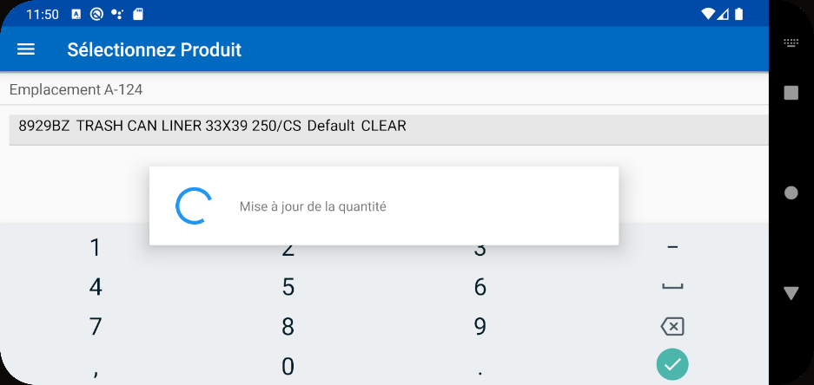

Checking loading messages
Pressing Pack button
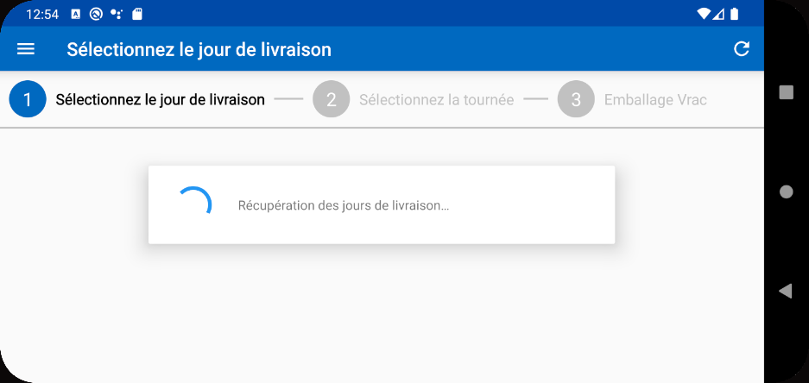
Pressing on a Day / Route inside the Packing menu
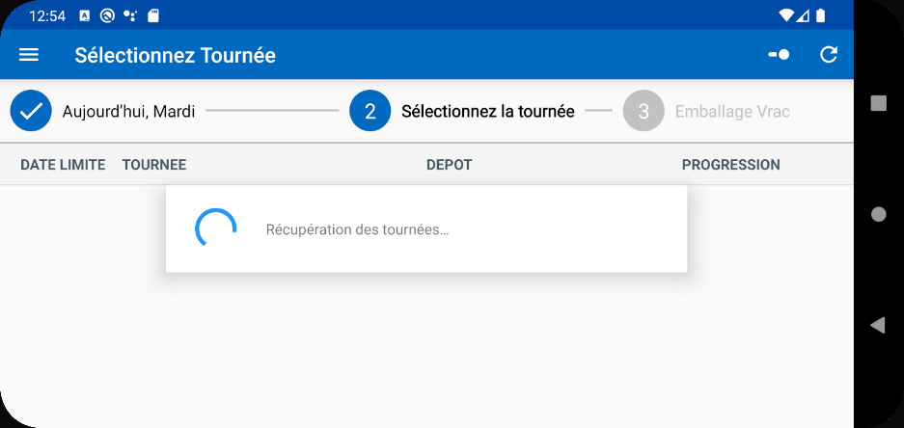
Selecting a route from that day
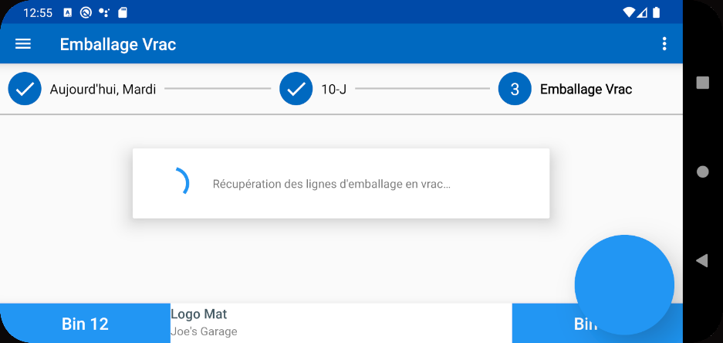
Scanning a mat
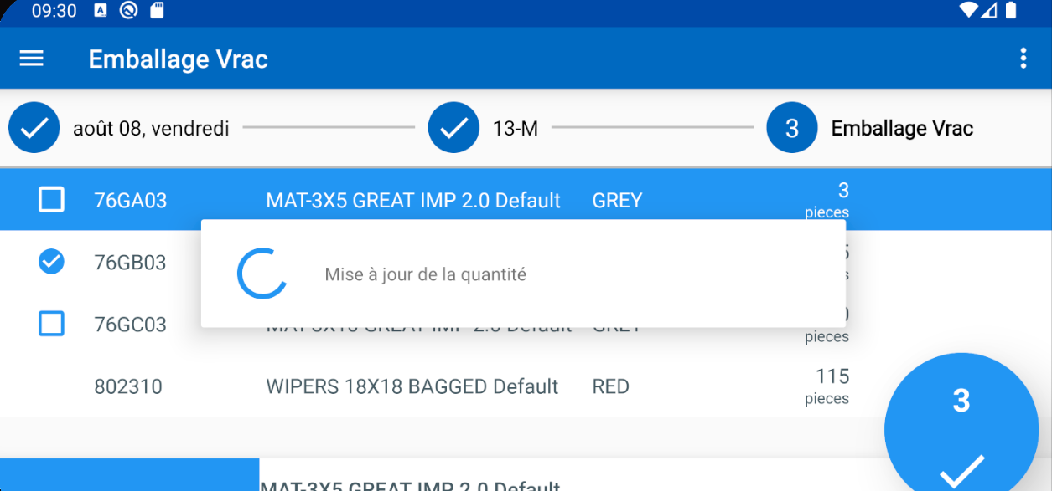
Scanning an ID
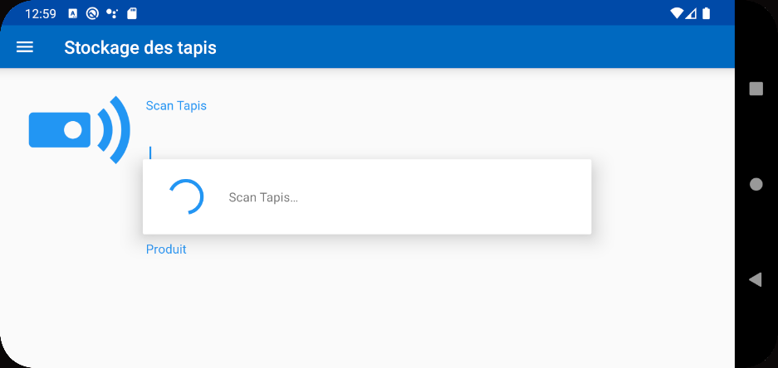
Refresh Button
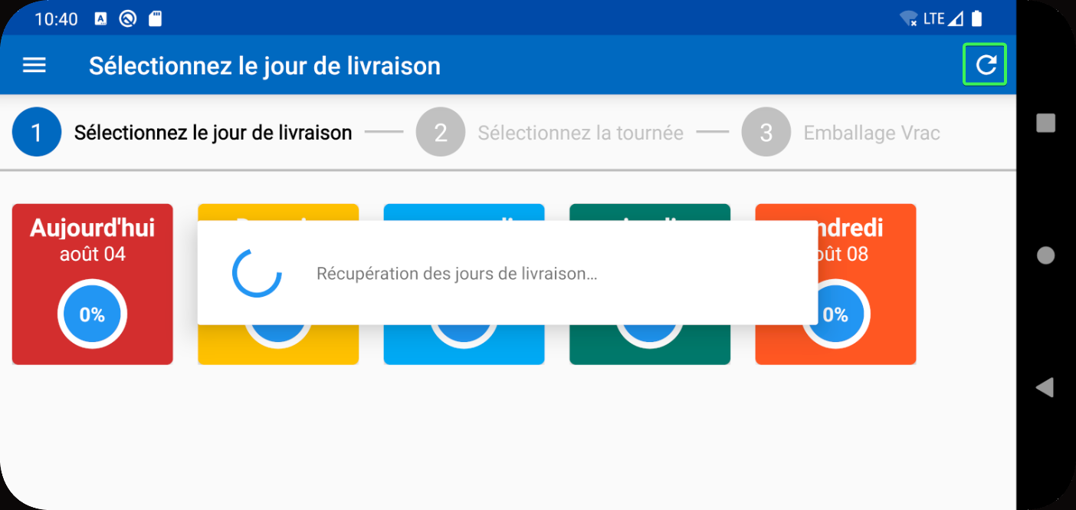
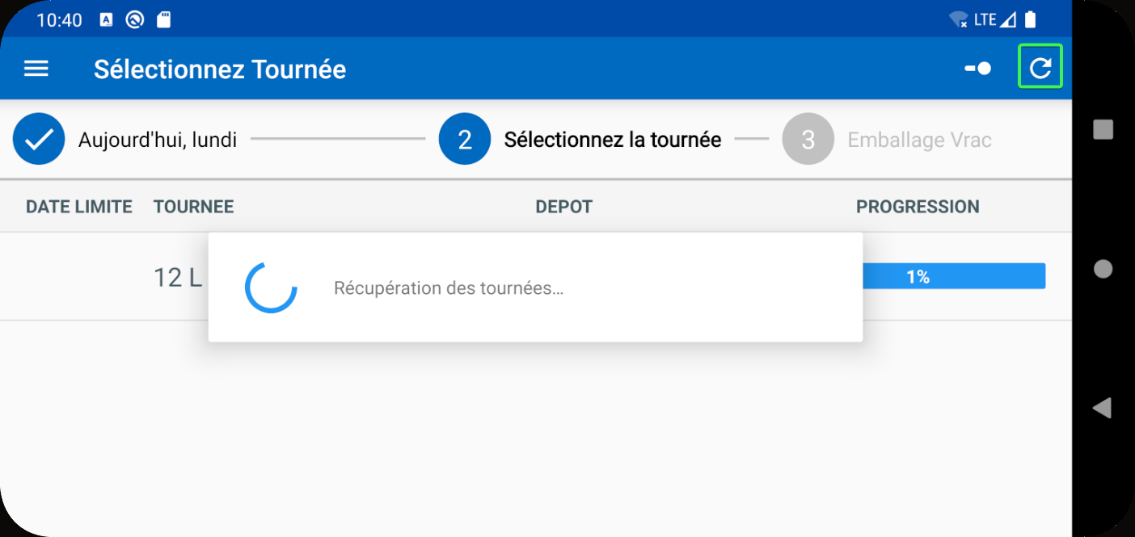
Tested OK

