BPA-196 Null pointer in BPA Store process when PACK_DELIVERYBASICS.DETERMINEDELDATEROUTESOIL does not return a route
Environment | Prerequisites
Version:9.07.00  DBServerName= abs-srv20.internal.abslbs.com  DBSID=CUST24  DBUser=UNFDEV  DBPassword=UNFDEV  Environment=PRODUCTION | - Module:  - System setting

Contents
Reproduction before fix 1
Expected behavior: 1
Data preparation: 1
Steps to reproduce 2
Retest after fix 8
Expected behavior: 8
Data preparation: 8
Steps to reproduce 9

Reproduction before fix
Bu: 052
9.07.00.UNF17 hash: 132b2be0cf4e + BulkPackingAssistant_v1.10.apk

Data preparation:
Load absrestservices.war, rename the file and delete any incrementation such as _9.07.00.RC1
In the BPA app enable the mobile rest services
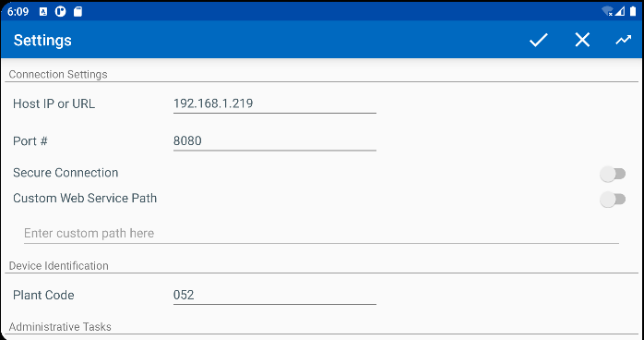

Steps to reproduce
- PLSQL – find mat products associated with customers
SELECT BU.CODE, C.CUSTOMERNUMBER, P.CODE AS PRODUCTCODE, FM.CODE AS FMCODE, UI.PRIMARYID, (SELECT S.FACTORYDESCRIPTION FROM STAY S WHERE S.STAY_ID = UI.STAY_ID) AS STAY
FROM CUSTOMER C
JOIN PRODUCTLISTPERCUSTOMER PLPC
ON PLPC.CUSTOMER_ID = C.CUSTOMER_ID
JOIN PLPCEXTRAINFO PLPCE
ON PLPCE.PRODUCTLISTPERCUSTOMER_ID = PLPC.PRODUCTLISTPERCUSTOMER_ID
JOIN PRODUCT P
ON P.PRODUCT_ID = PLPC.PRODUCT_ID
JOIN FINISHINGMETHOD FM
ON FM.FINISHINGMETHOD_ID = PLPC.FINISHINGMETHOD_ID
JOIN UNIQUEITEM UI
ON UI.PRODUCT_ID = PLPC.PRODUCT_ID
AND UI.FINISHINGMETHOD_ID = PLPC.FINISHINGMETHOD_ID
AND UI.SIZEDEFINITION_ID = PLPC.SIZEDEFINITION_ID
AND PLPC.CUSTOMER_ID = UI.RELATEDCUSTOMER_ID
JOIN BUSINESSUNIT BU
ON BU.BUSINESSUNIT_ID = C.DEFAULTBUSINESSUNIT_ID
WHERE PLPC.DATEINACTIVE > SYSDATE
AND P.TYPEOFMERCHANDISE = 1
AND P.STOREACTIVESTOCKLOCATION = 'Y'
AND P.BULKPACKINGACTIVESTOCKTYPE = 1
AND BU.CODE = '052'
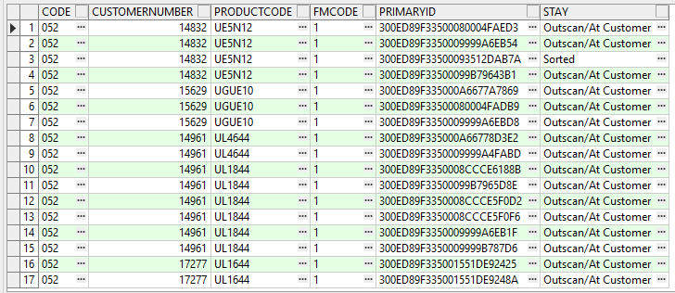
- Customers dlg: Take one of the customers from the list above and inactivate the routestop. Save and exit.
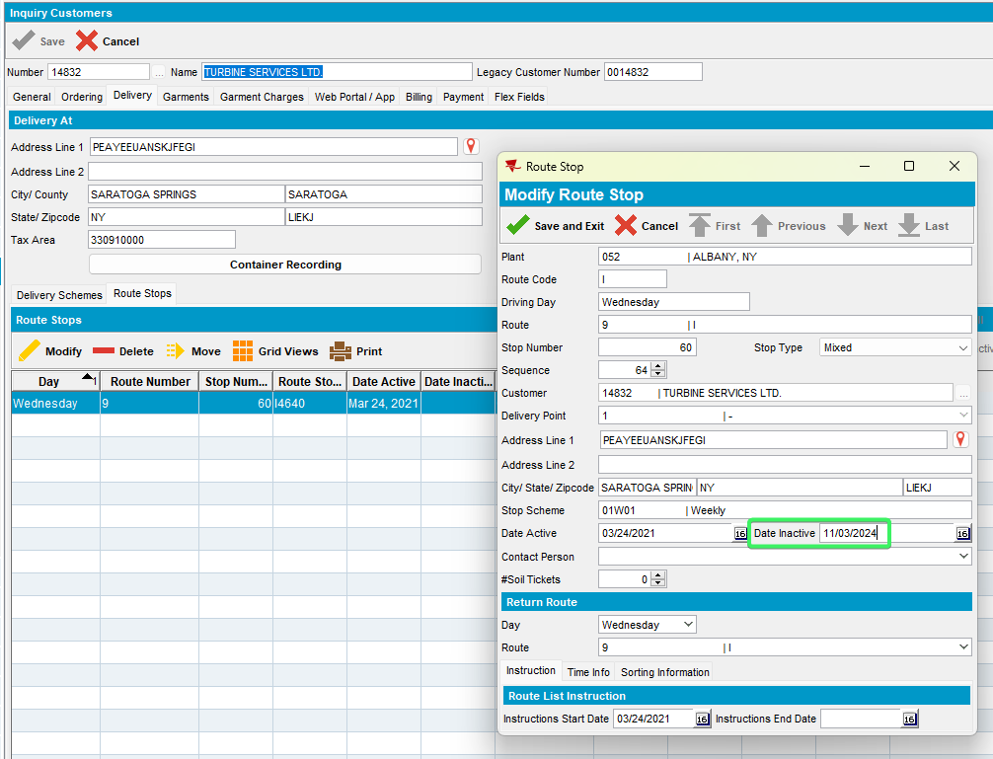
- BPA: Scan one of the garments to store them.
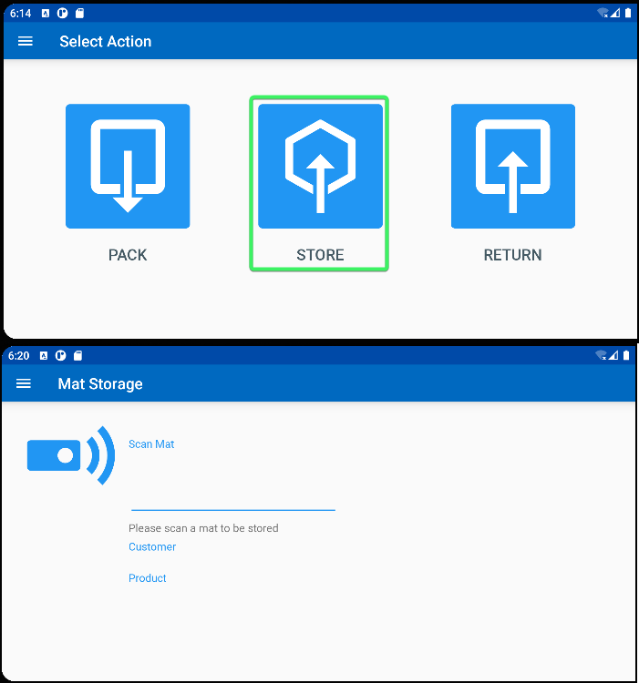
There is not a message informing the user that customer don’t have an active route

Expected behavior:
The BPA should have a check on active routes
REPRODUCED OK

Retest after fix
Bu: 052
9.07.00.UNF17 hash: 132b2be0cf4e + BulkPackingAssistant_v2.13.INTERNAL_TEST_ONLY.9f42064.apk

Data preparation:
Load absrestservices.war, rename the file and delete any incrementation such as _9.07.00.RC1
In the BPA app enable the mobile rest services

Steps to reproduce
- PLSQL – find mat products associated with customers
SELECT BU.CODE, C.CUSTOMERNUMBER, P.CODE AS PRODUCTCODE, FM.CODE AS FMCODE, UI.PRIMARYID, (SELECT S.FACTORYDESCRIPTION FROM STAY S WHERE S.STAY_ID = UI.STAY_ID) AS STAY
FROM CUSTOMER C
JOIN PRODUCTLISTPERCUSTOMER PLPC
ON PLPC.CUSTOMER_ID = C.CUSTOMER_ID
JOIN PLPCEXTRAINFO PLPCE
ON PLPCE.PRODUCTLISTPERCUSTOMER_ID = PLPC.PRODUCTLISTPERCUSTOMER_ID
JOIN PRODUCT P
ON P.PRODUCT_ID = PLPC.PRODUCT_ID
JOIN FINISHINGMETHOD FM
ON FM.FINISHINGMETHOD_ID = PLPC.FINISHINGMETHOD_ID
JOIN UNIQUEITEM UI
ON UI.PRODUCT_ID = PLPC.PRODUCT_ID
AND UI.FINISHINGMETHOD_ID = PLPC.FINISHINGMETHOD_ID
AND UI.SIZEDEFINITION_ID = PLPC.SIZEDEFINITION_ID
AND PLPC.CUSTOMER_ID = UI.RELATEDCUSTOMER_ID
JOIN BUSINESSUNIT BU
ON BU.BUSINESSUNIT_ID = C.DEFAULTBUSINESSUNIT_ID
WHERE PLPC.DATEINACTIVE > SYSDATE
AND P.TYPEOFMERCHANDISE = 1
AND P.STOREACTIVESTOCKLOCATION = 'Y'
AND P.BULKPACKINGACTIVESTOCKTYPE = 1
AND BU.CODE = '052'
- Customers dlg: Take one of the customers from the list above and inactivate the routestop. Save and exit.
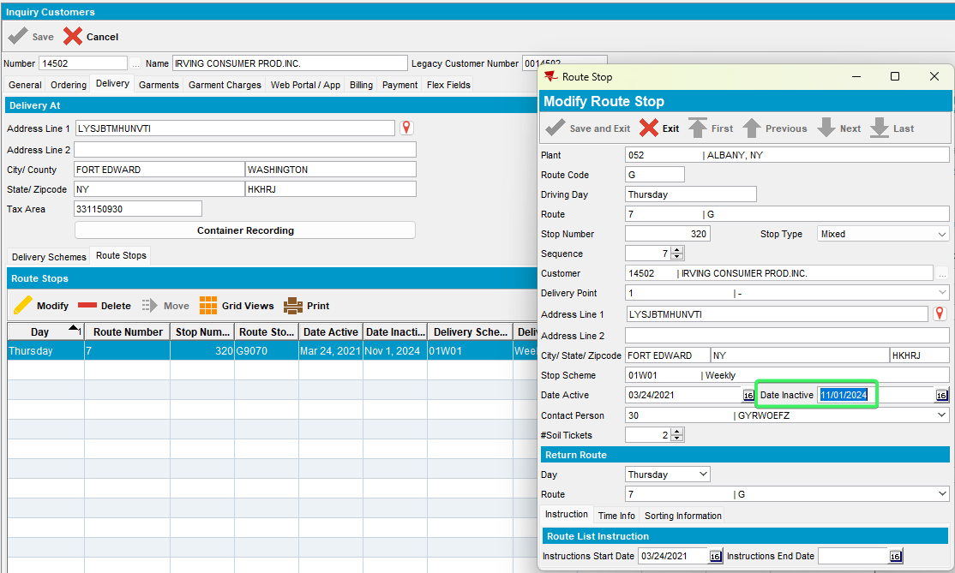
- BPA: Scan one of the garments to store them.
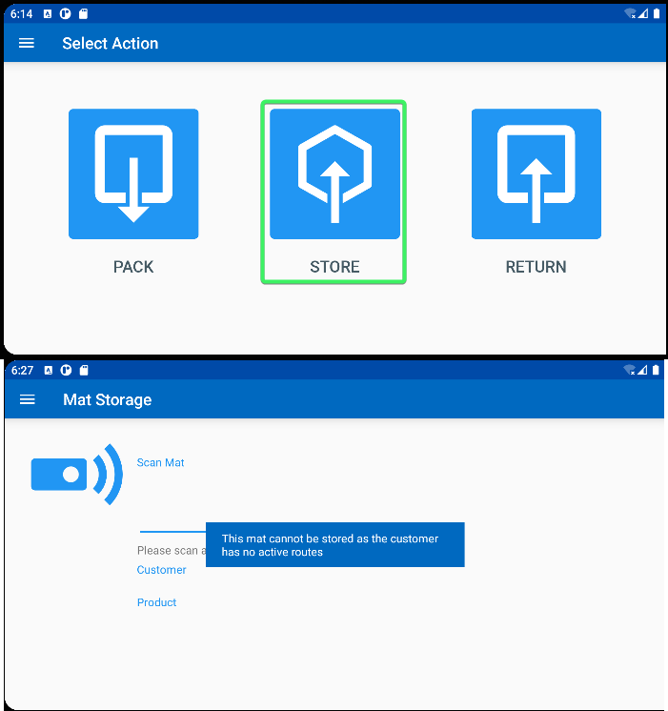
There is a message informing the user
This mat cannot be stored as the customer has no active routes
RETEST OK

