BPAN-26 Store text field not capturing data correctly from Zebra RFID scanner
Environment | Prerequisites
Version: 9.07.00.UNF17  DBServerName= abs-srv20.internal.abslbs.com  DBSID=CUST24  DBUser=UNFDEV  Environment=Test | - Module:  - System setting

Contents
Retest after fix 1
Steps to reproduce 1

Retest after fix
9.07.00.UNF17.p06 hash: 197909b1da44 + BulkPackingAssistant_v2.15.INTERNAL_TEST_ONLY.e9650d7.apk

Steps to reproduce
- Start the ABSMobileGateway.
- Configure the latest version of BPA.
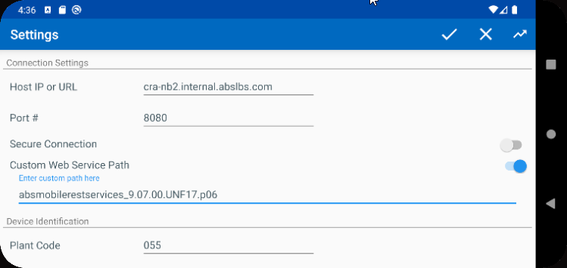
- Find a customer with logo mats.
SELECT BU.CODE, C.CUSTOMERNUMBER, P.CODE AS PRODUCTCODE, FM.CODE AS FMCODE, UI.PRIMARYID, (SELECT S.FACTORYDESCRIPTION FROM STAY S WHERE S.STAY_ID = UI.STAY_ID) AS STAY
FROM CUSTOMER C
JOIN PRODUCTLISTPERCUSTOMER PLPC
ON PLPC.CUSTOMER_ID = C.CUSTOMER_ID
JOIN PLPCEXTRAINFO PLPCE
ON PLPCE.PRODUCTLISTPERCUSTOMER_ID = PLPC.PRODUCTLISTPERCUSTOMER_ID
JOIN PRODUCT P
ON P.PRODUCT_ID = PLPC.PRODUCT_ID
JOIN FINISHINGMETHOD FM
ON FM.FINISHINGMETHOD_ID = PLPC.FINISHINGMETHOD_ID
JOIN UNIQUEITEM UI
ON UI.PRODUCT_ID = PLPC.PRODUCT_ID
AND UI.FINISHINGMETHOD_ID = PLPC.FINISHINGMETHOD_ID
AND UI.SIZEDEFINITION_ID = PLPC.SIZEDEFINITION_ID
AND PLPC.CUSTOMER_ID = UI.RELATEDCUSTOMER_ID
JOIN BUSINESSUNIT BU
ON BU.BUSINESSUNIT_ID = C.DEFAULTBUSINESSUNIT_ID
WHERE PLPC.DATEINACTIVE > SYSDATE
AND P.TYPEOFMERCHANDISE = 1
AND P.STOREACTIVESTOCKLOCATION = 'Y'
AND P.BULKPACKINGACTIVESTOCKTYPE = 1
AND BU.CODE = '055'
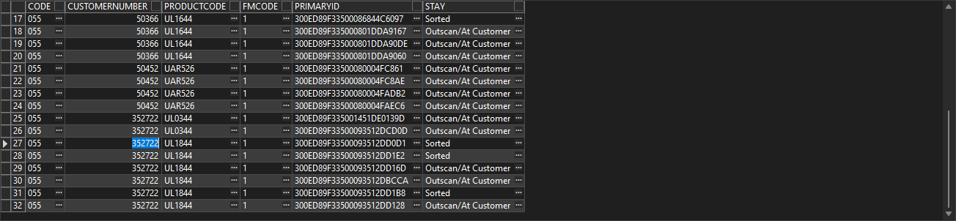
- Find a customer with logo mats, eg: 352722. Check the unique codes.
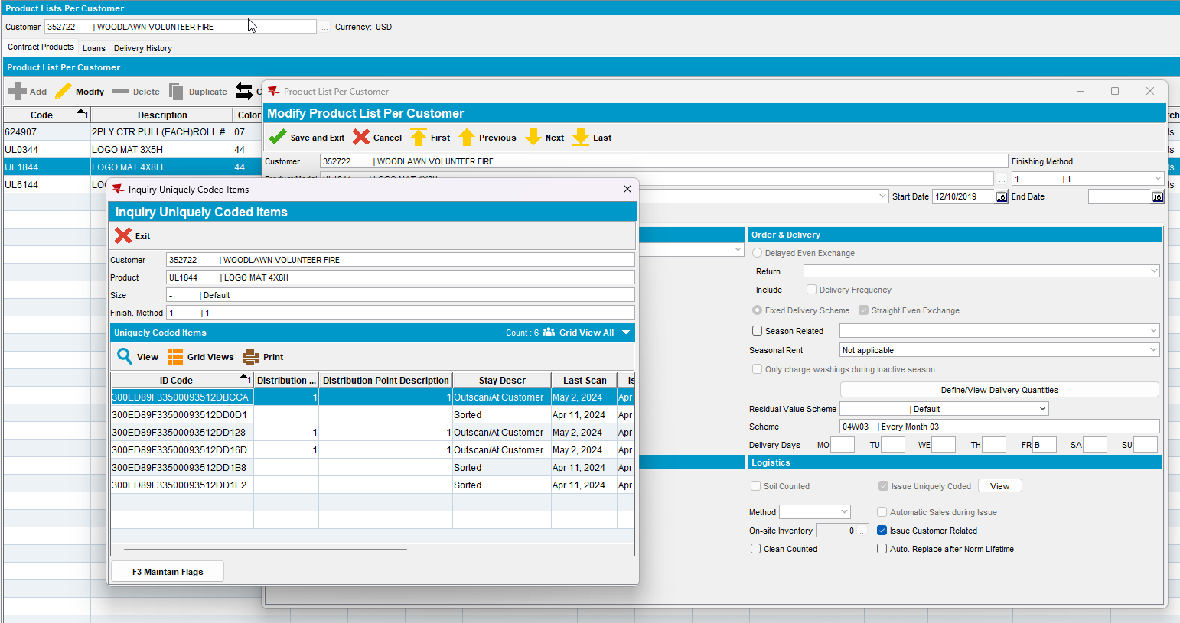
- RSC dlg: Add a new route for when the customer is visited. Generate packing notes.
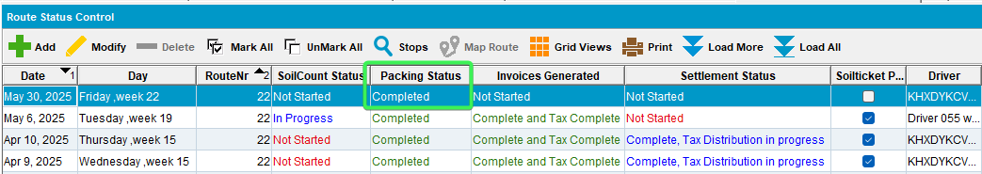
- BPA: Go to Pack, select the day of the route and route.
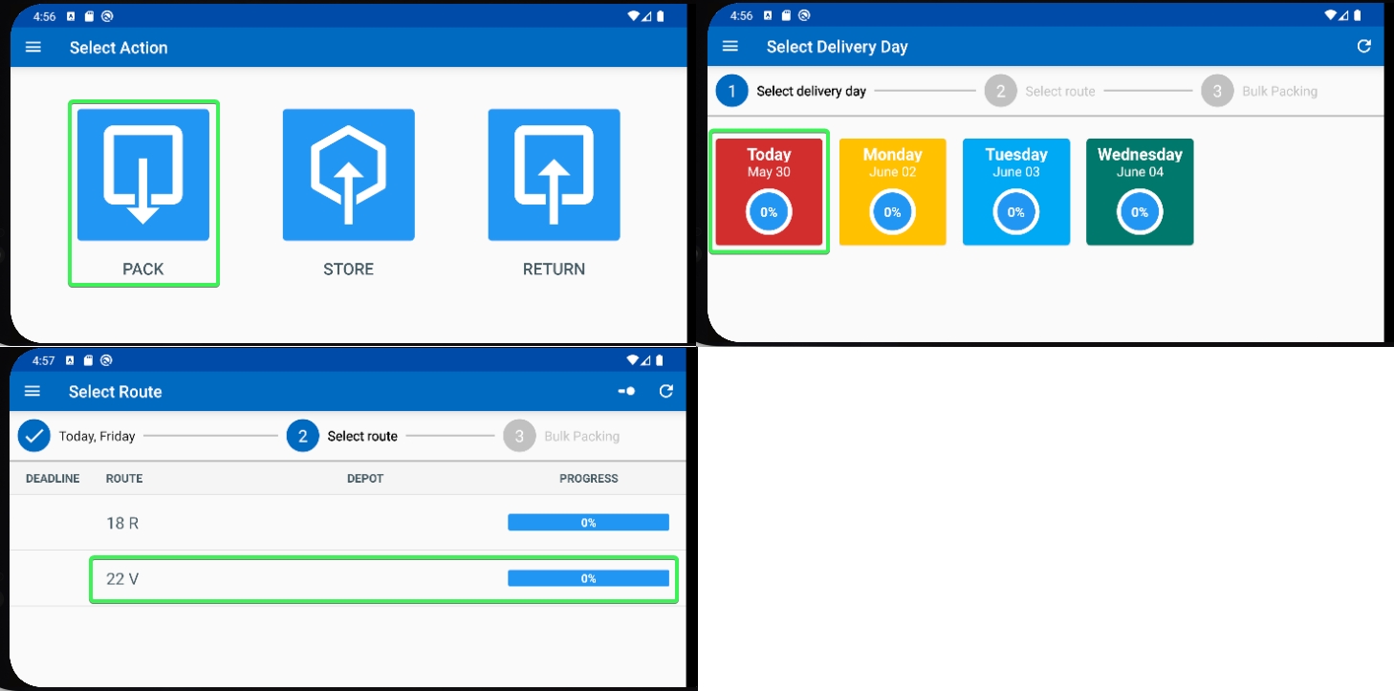
- BPA: Swipe left for a mat
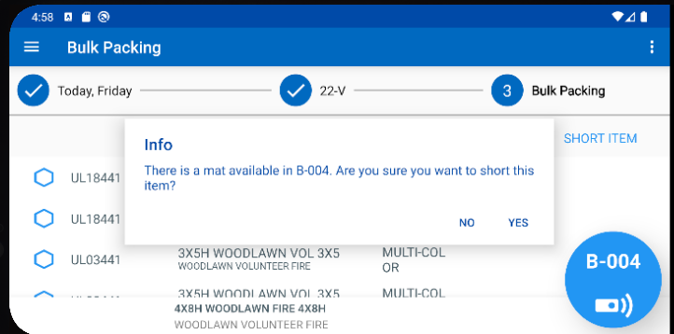

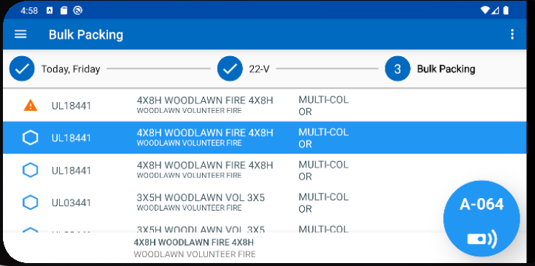
- PLPC
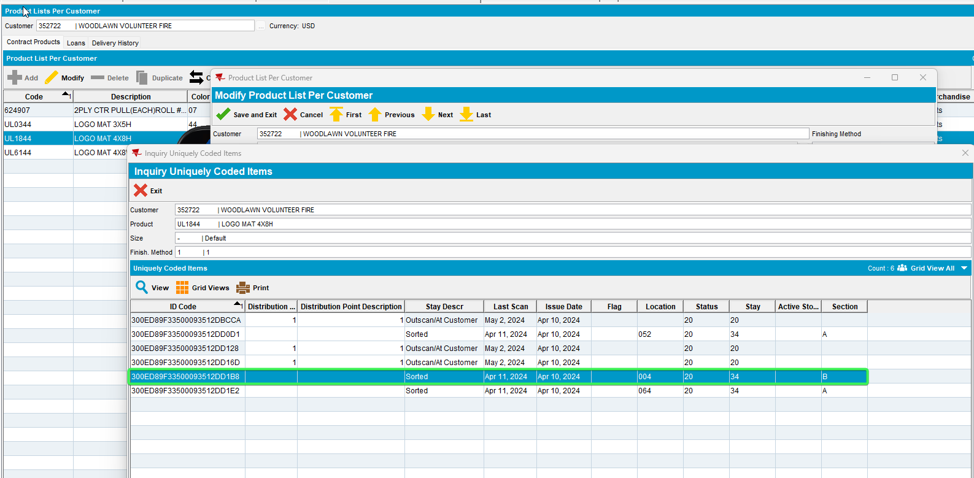
- BPA: Pack/Scan another code using the button with no scanner.
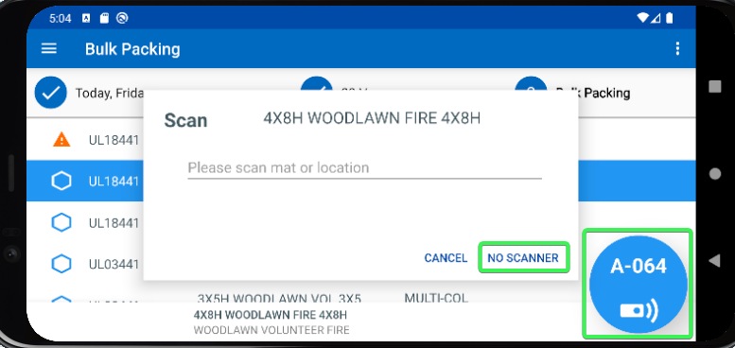

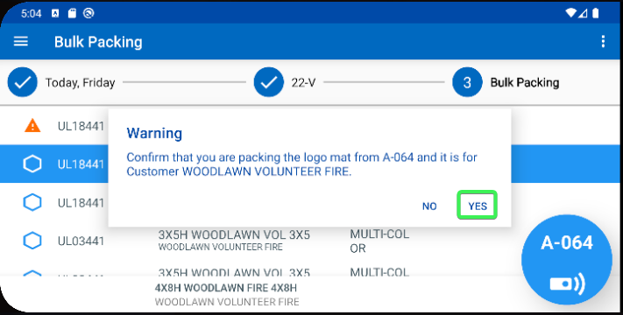

- PLPC:
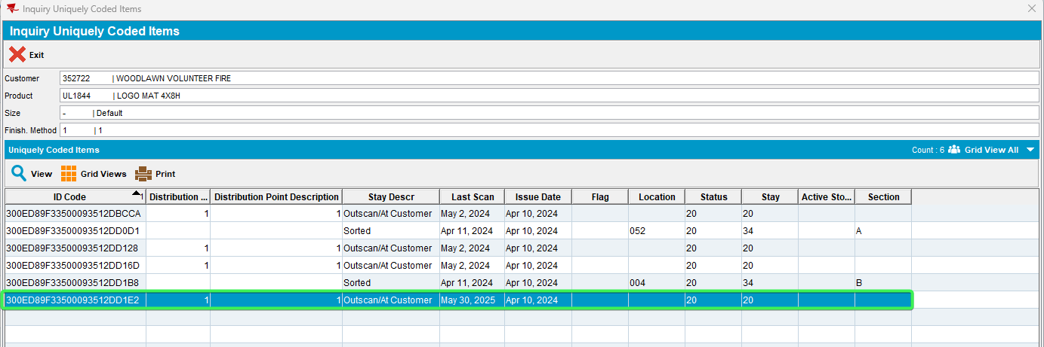
- BPA: Enter Store and scan another mat to store it.
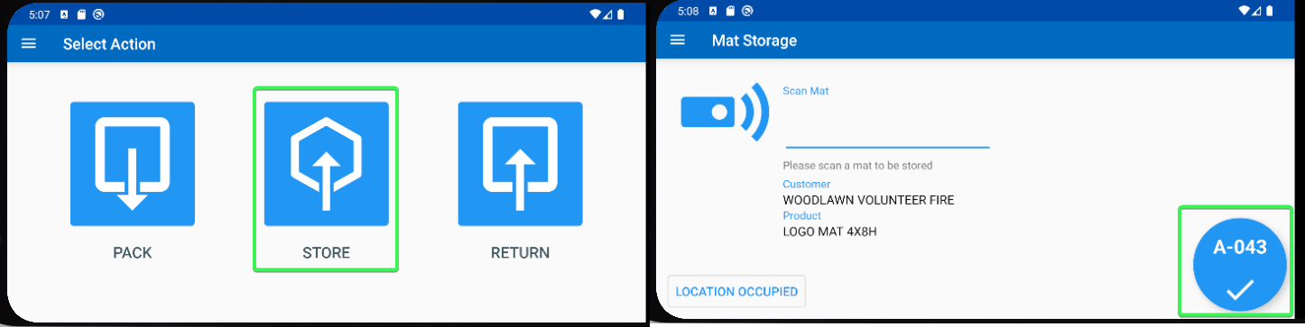
- PLPC:
Before
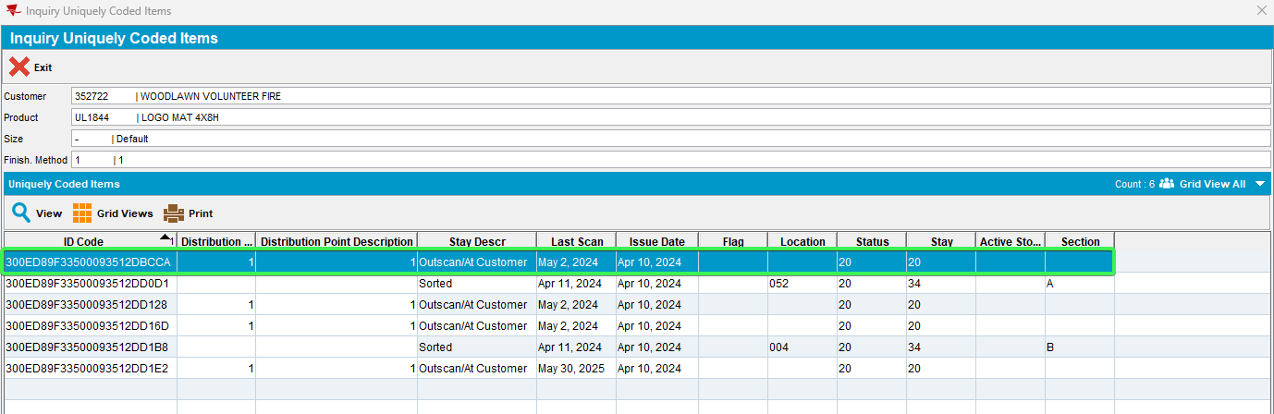
After
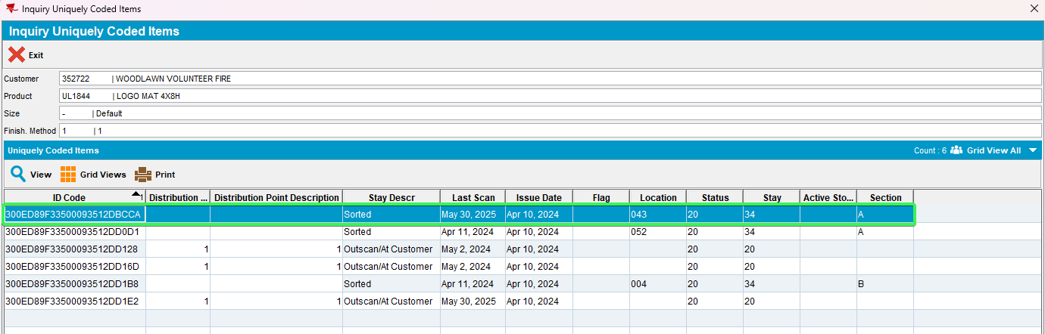
- Stockroom Locations: Load the dlg and choose a location that will be scanned, eg: A421
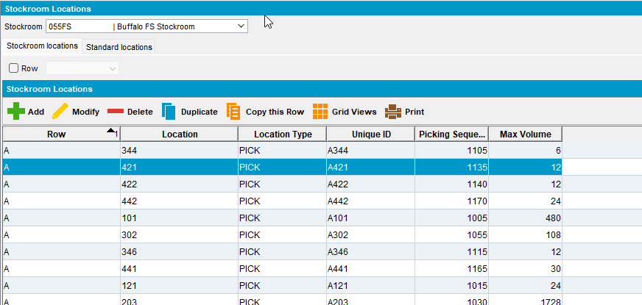
- BPA: Enter B328 code Copy the product code, don’t hit confirm yet.
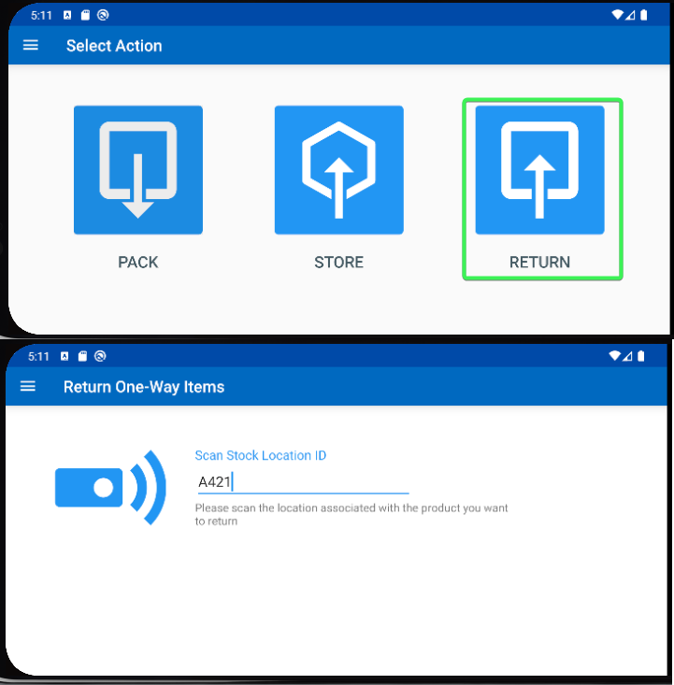
- Inquiry stock quantities dlg: Find that product 62AI07 and open it. Check the stock quantities
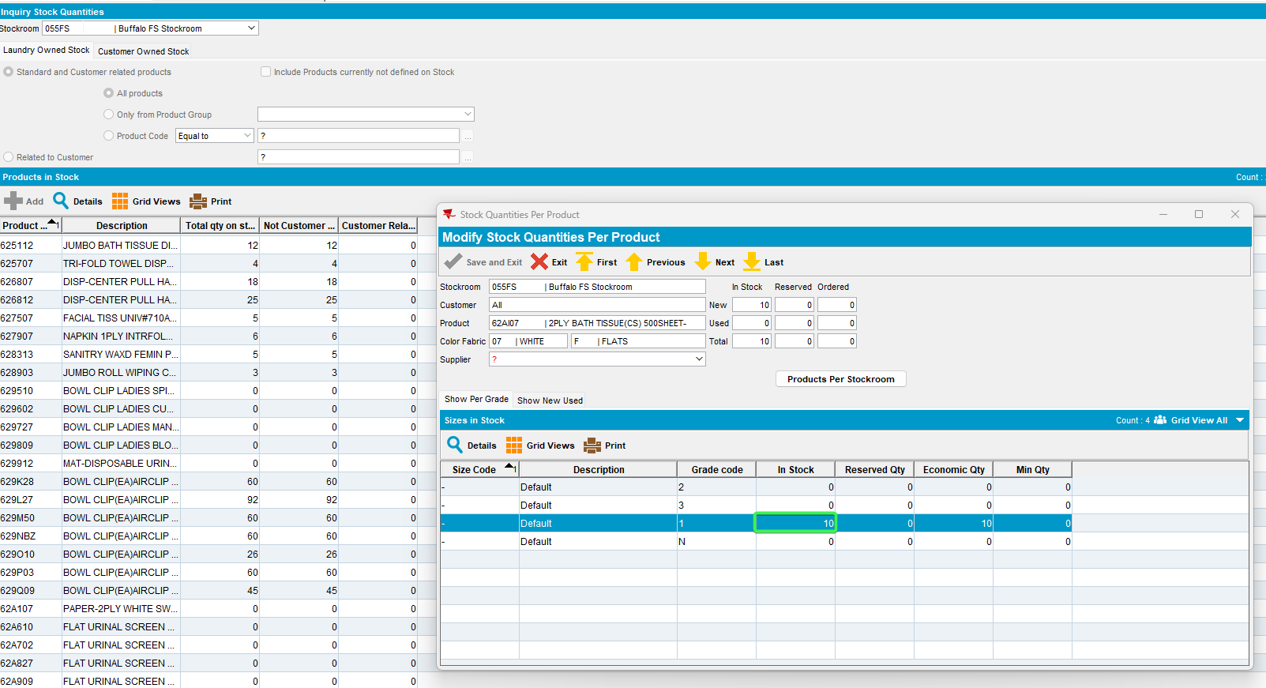
- BPA: Go back and hit confirm.
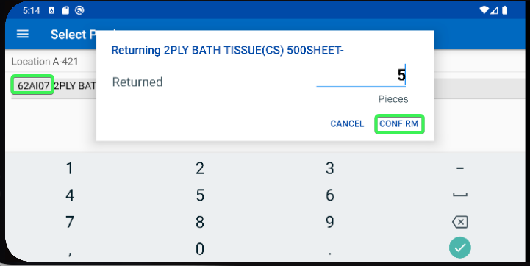
- Inquiry stock quantities dlg: Refresh the product 62AI07 and re-check the stock quantities
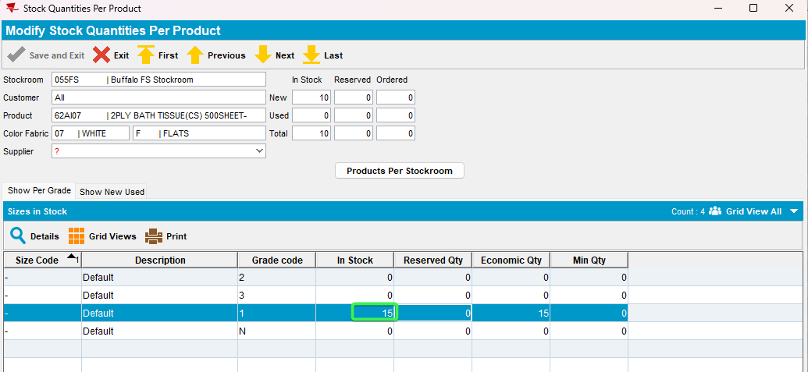

TESTED OK

