BPAN-1 - Add the 5th and 6th days to the Pack select delivery day screen
Environment | Prerequisites
Version: BulkPackingAssistant_v2.14  DBServerName= abs-srv20.internal.abslbs.com  DBSID=CUST24  DBUser=UNFDEV  DBPassword= UNFDEV  Environment=Test | - Module:  - System setting

Contents
Reproducing before fix 1
Retest after fix 1
Test Case 1 – Check that there are 6 days being displayed and you can scroll from 1st to 6th day 1

Reproducing before fix

Retest after fix

Test Case 1 – Check that there are 6 days being displayed and you can scroll from 1st to 6th day
Hash: dab1574

- Route status Controll DLG: ADD 5 RC on different days for the same route starting with current date
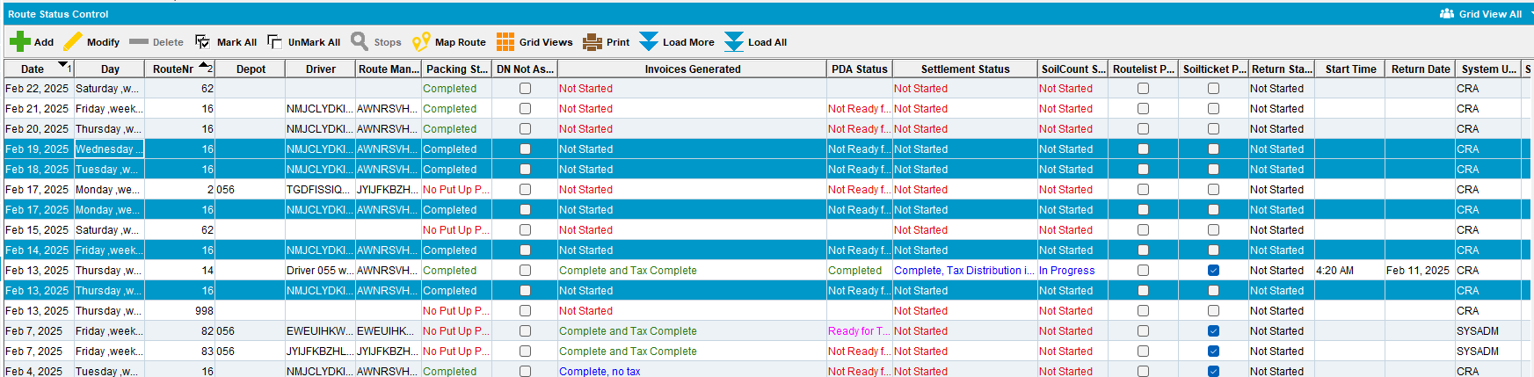
- Select all 5 RC and Generate Put-up docs for them
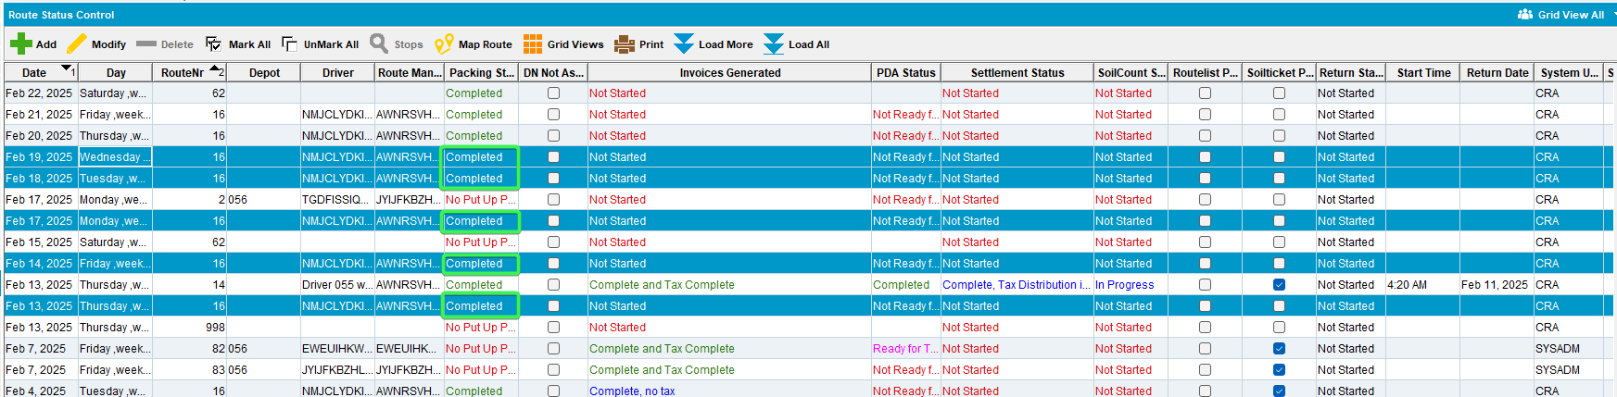

- Routes DLG: Create a new Route for Saturday
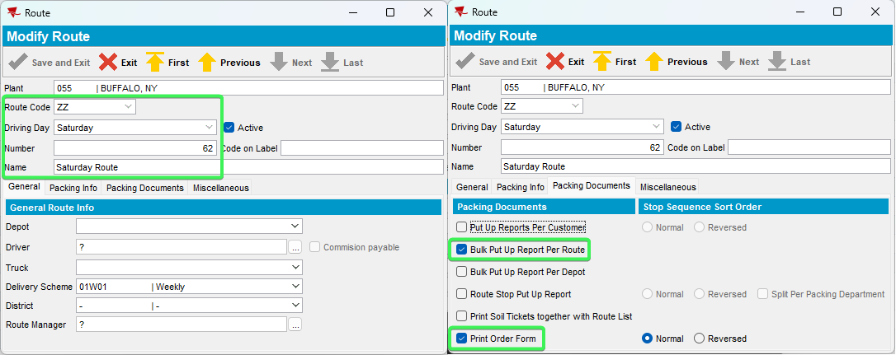

- Find a customer with Logo Mats
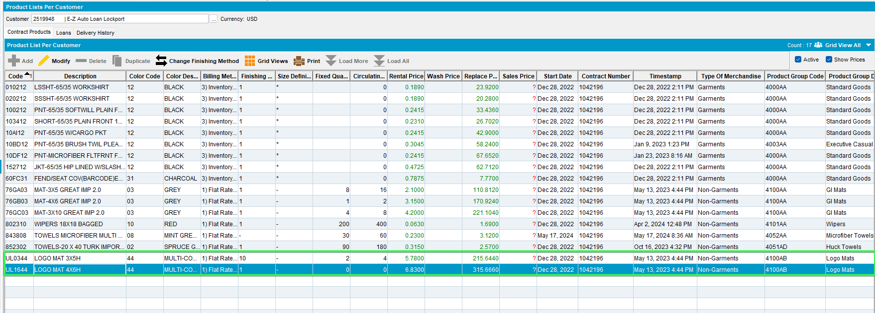
- Customers DLG: Add a delivery date on the Route you just created on Saturday
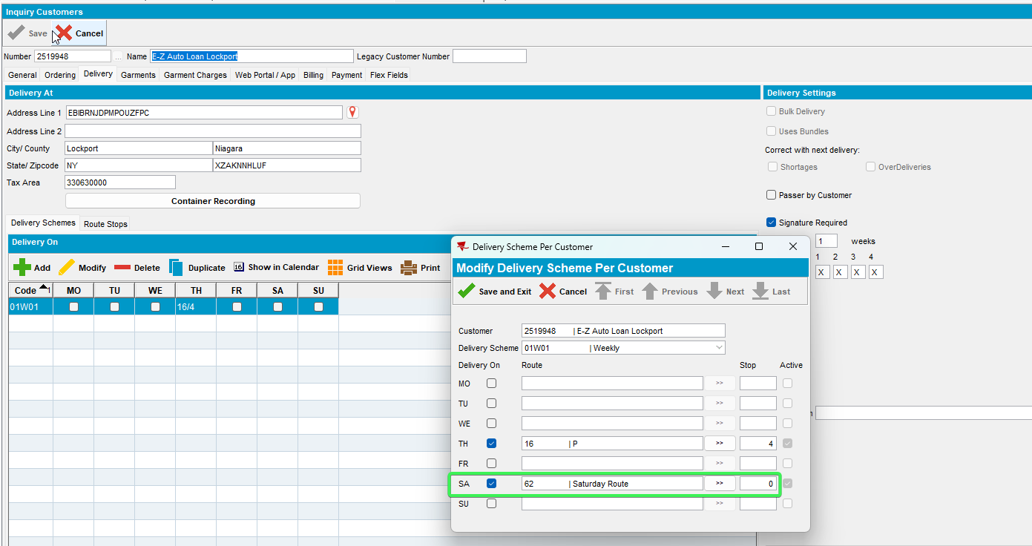
- PLPC: Go to your logo mat and have the check on Issue Uniquely Coded and Issue Customer Related
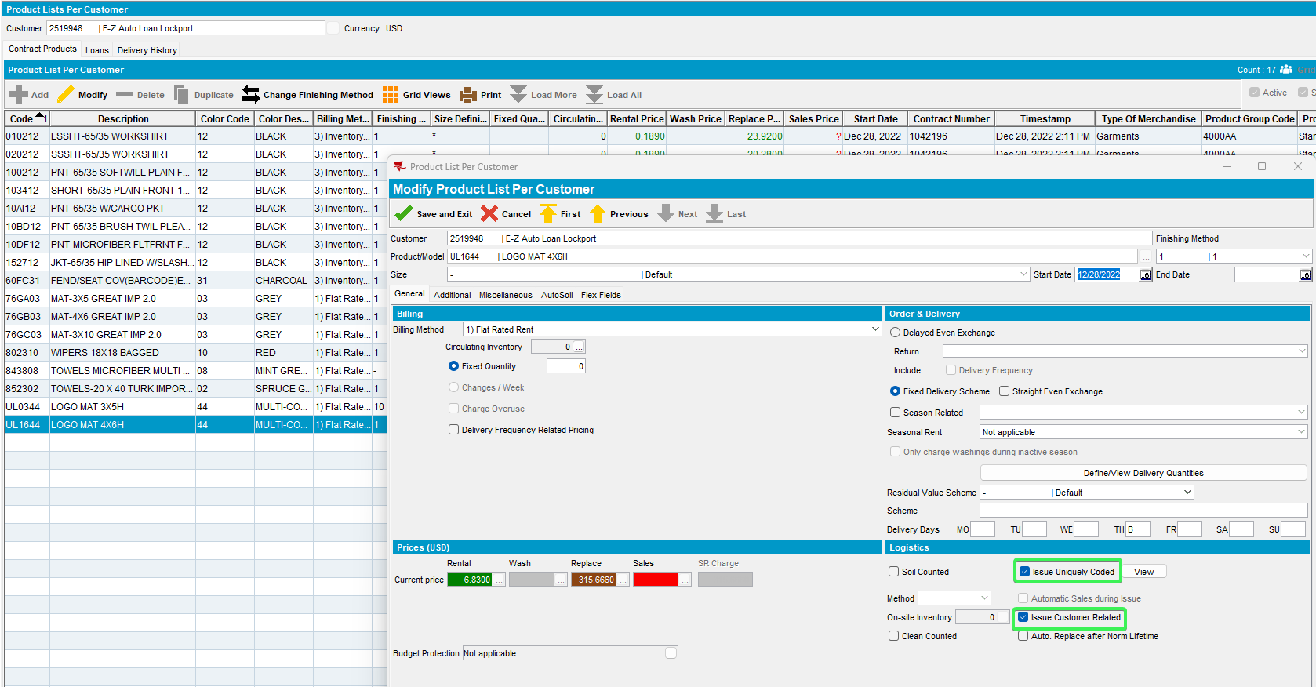
- Set Delivery Day Billing for Saturday as well
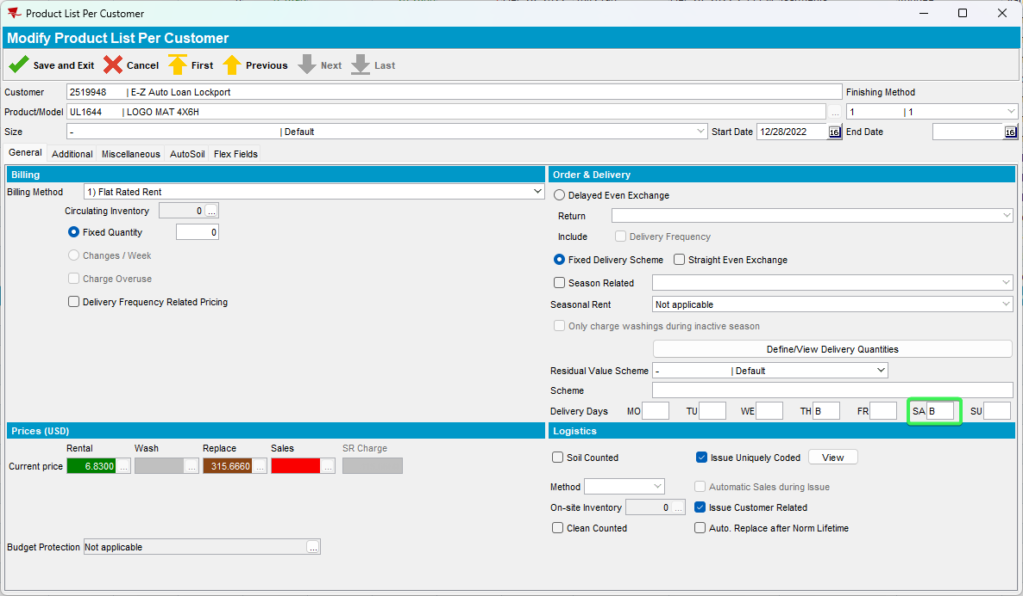
- Devine / View Delivery Quantities > Check Saturday and set a quantity
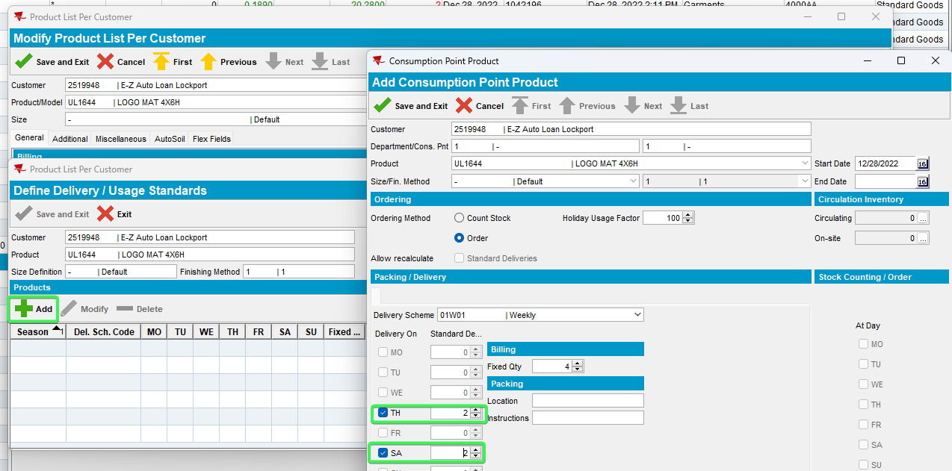
- Go to Additional tab and for “Show Put Up Qty On” select “Bulk Put UP”
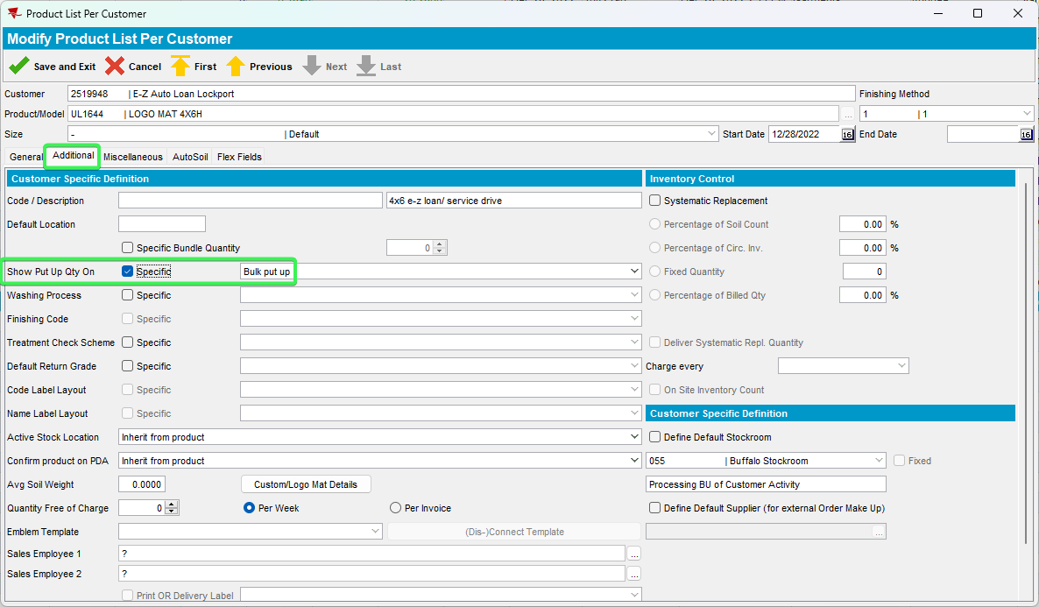
- Maintain Sales Notes DLG: Create a new Sales Note for this customer with the Logo mat you just set up
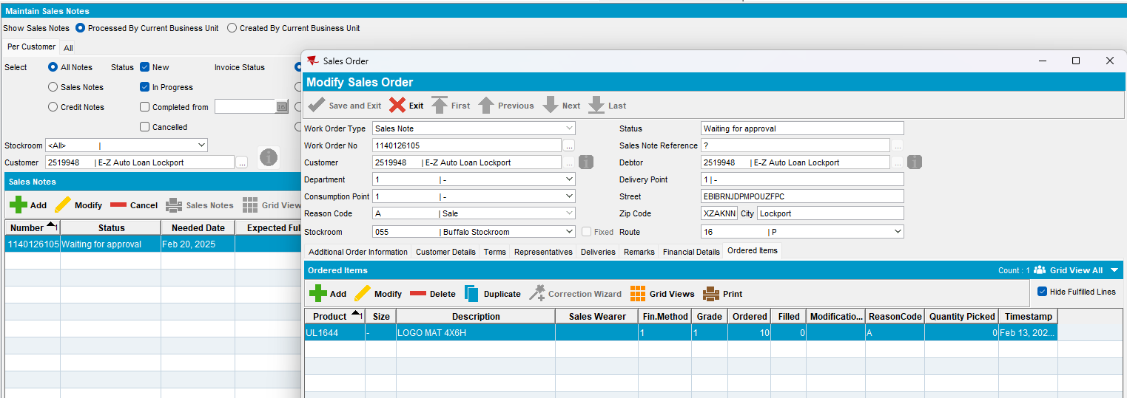
- Work Order Waiting for approval Approve the WO
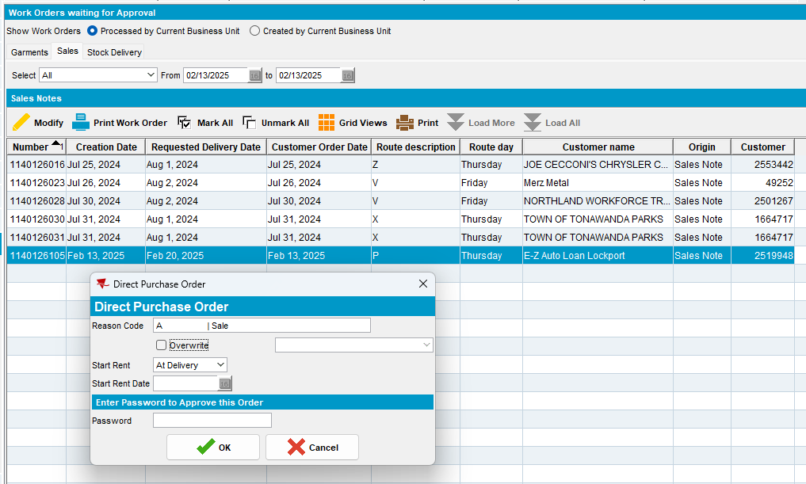
- Maintain Sales Notes DLG: Issue Sales Item and set the delivery date for the Saturday route we set up earlier
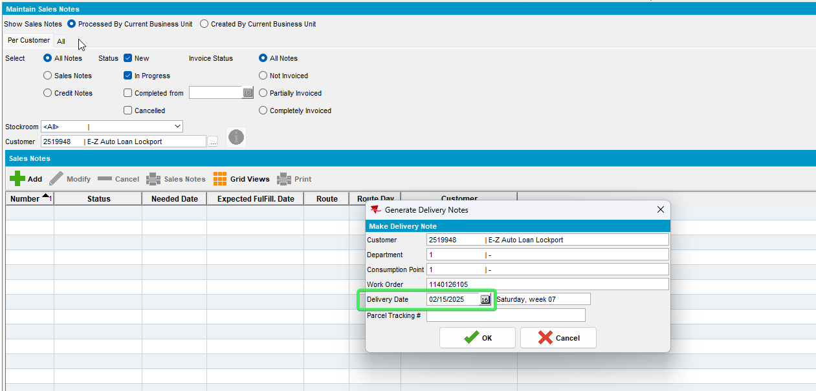
- RSC: Generate Put UP docs for the route on Saturday
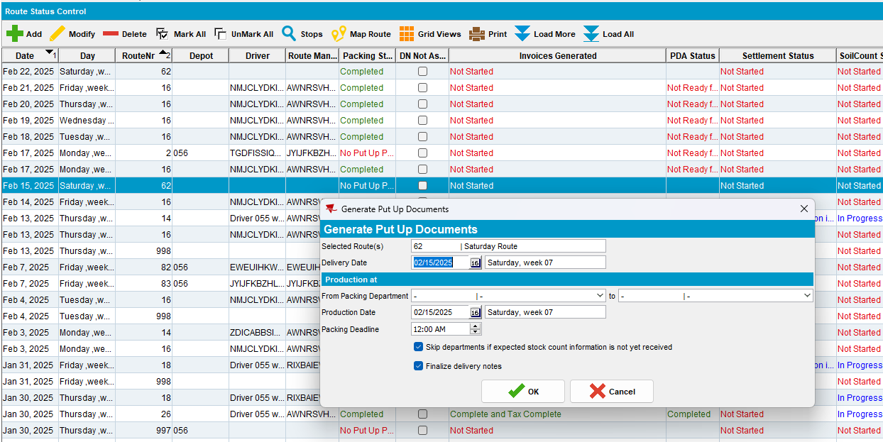
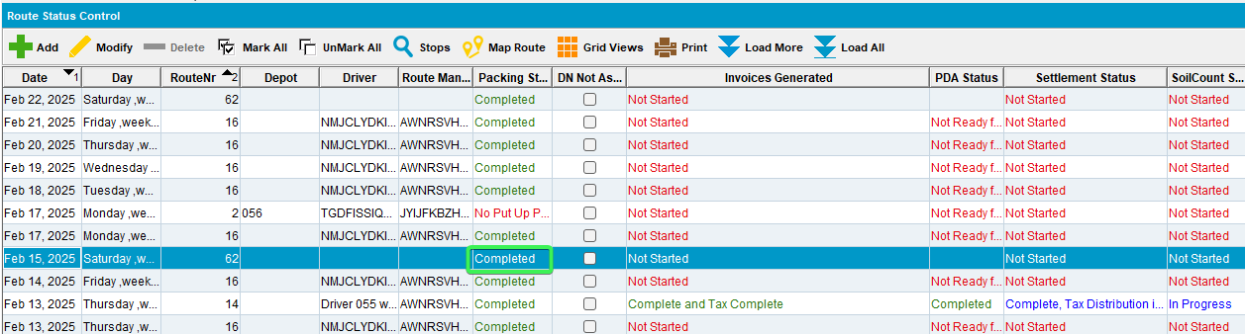
- BPA: Select Pack and see the 6 days present on your screen
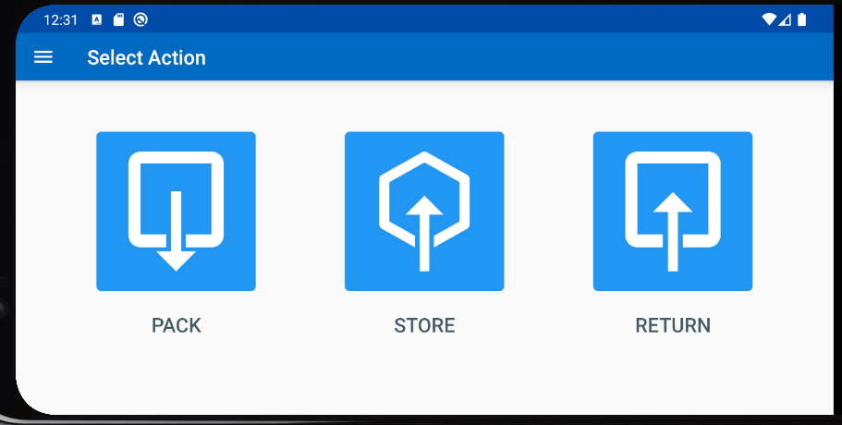
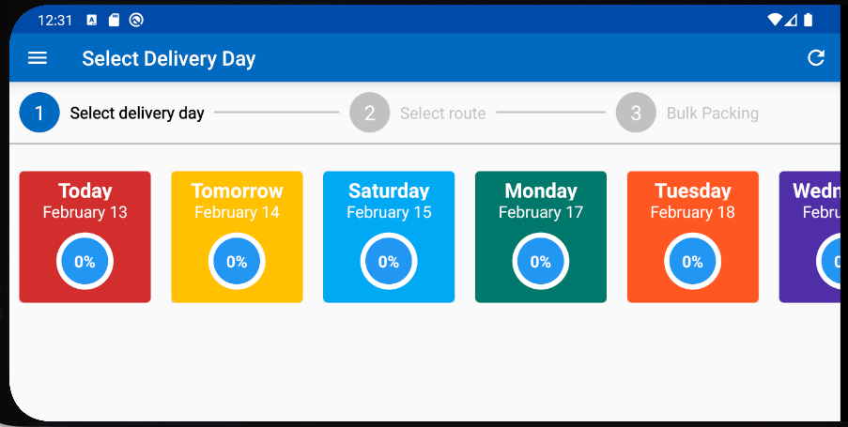
- You can scroll through the dates by clicking and holding onto the screen and dragging left and right
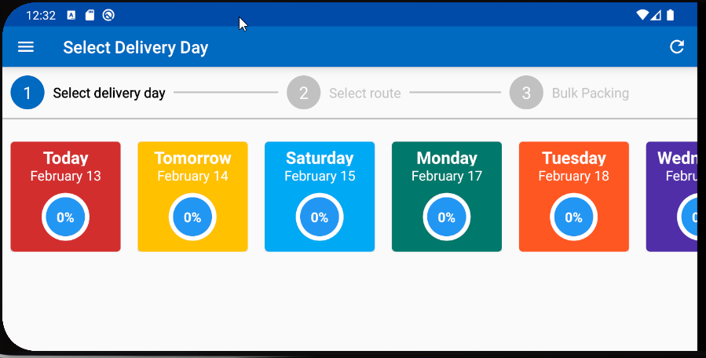
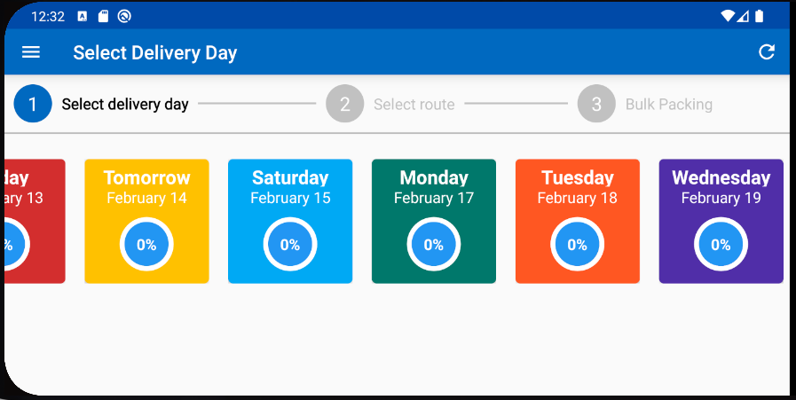
Tested OK

