
.
.
.
.
.
..
.
.
.

ABS Laundry Business Solutions
Parkweg 24a
5282 SM Boxtel
tel: +31-(0)411 612 761
fax: +31-(0)411 674236
e-mail:
info@ABSLBS.COM
ABSSolute
Multi Tier Laundry Information System

Oracle OAS Installation Manual
Linux/Windows (64-bit)

ABS, February 2024 Version 1.6
Update list:
-v1.0 19 July 2023 CVI
-v1.1 17 August 2023 ABE
-v1.3 02 November 2023 ABE
- v1.4 20 January 2024 ABE
- v1.5 26 January 2024 ABE
- v1.6 27 February 2024 CVI

Oracle OAS Installation Manual 1
1. Download Installer files 3
2. Install 64 bits JDK on the server 4
3. Install Fusion Middleware 4
4. Installing OAS 2023 14
5. Patching WLS and OAS 22
6. Creating the Repository 25
7. Configuring & Starting OAS 35
8. OAS Snapshot 51
9. OAS Start and Stop services 53
10. Automatic startup 54
11. TNSNames update for OAS 57
12. OAS configuration files 58
13. Migrating an existing customer 59
14. Enterprise edition features 72
15. Change the logo 73
16. Modify Log Off URL 74
17. System Settings 75
18. Installing the RPD file 76
19. Install V10 reports 78
20. Mail Server Settings used by Oracle BI Agents 78
21. Modify Catalog Permissions 81
22. Deploy new filters 85
23. Usage Tracking 87
24. Scheduled tasks 89
25. OAS Backup and recovery 90

Use the FTP OracleDB/BI_ABS_Lin_19cr1_v1.dbt template for Linux.
Very Important: please make sure that the hostname number of characters is maximum 64 characters, check with command: hostname -l on Linux. If hostname has more than 64 characters BI certificates cannot be deployed during the installation.
This manual will describe how to install and configure Oracle WLS 12.2.1.4 and OAS 2023 with the ABSSolute system.

Download Installer files
Download the following five files for the installation of OAS 2023. These files can be found on the ABS ftp server under the directory BI_OAS/
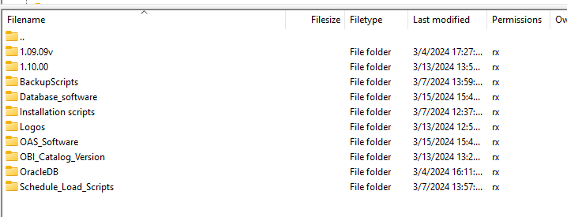
In folder OAS_Software you find OAS software and Patches Q1-2024 and latest JDK

Install 64 bits JDK on the server

The first step is to install the JDK on the OS. In Windows this can be done by running the file jdk-8u381-windows-x64.exe as an administrator. In Linux the following command must be performed as a root user.

Cd /u02/abs.install/ - this is location where you are placing the following JDK
Then run
dnf install jdk-8u401-linux-x64.rpm

After the installation the environment variable JAVA_HOME must be set to the following values:

For linux is not mandatory to setup this path
Linux JAVA_HOME=/usr/java/jdk1.8.0-x64/

Install Fusion Middleware

Install dependencies if needed for Linux:
dnf -y install binutils gcc gcc-c++ glibc glibc-devel libaio libaio-devel libgcc libstdc++ libstdc++-devel libnsl sysstat motif motif-devel openssl make xorg-x11-utils compat-libgfortran-48

The first step to install the Fusion Middleware software is to extract the zip file fmw_12.2.1.4.0_infrastructure_Disk1_1of1.zip. After extraction the file fmw_12.2.1.4.0_infrastructure.jar remains which can be installed with the following Java command:

Windows
C:\Program Files\Java\jdk1.8.0_381\bin\java.exe -d64 -jar fmw_12.2.1.4.0_infrastructure.jar
Linux
$JAVA_HOME/bin/java -d64 -jar fmw_12.2.1.4.0_infrastructure.jar
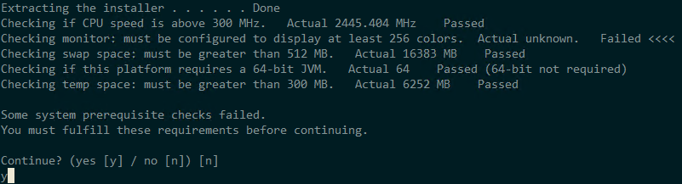
After a few seconds the splash screen will appear, followed by page 1 of the install wizard.

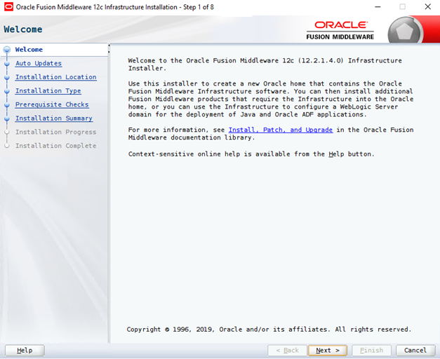
Just click next to continue.
The next screen asks if you want auto-updates. Leave ‘Skip Auto Updates’ selected and carry on.

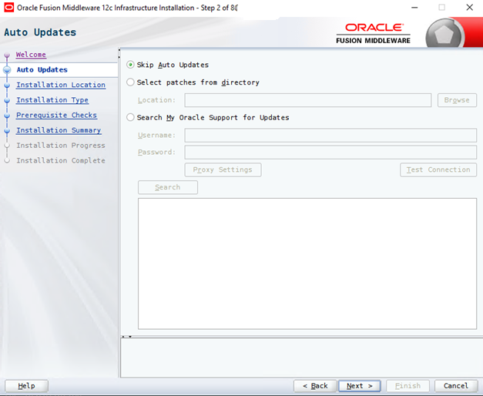
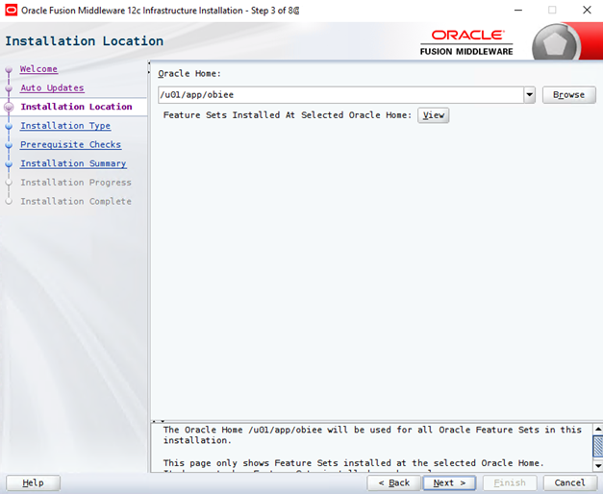
Next you need to specify the home location for Fusion Middleware.

Windows C:\Oracle\Middleware\Oracle_Home
Linux /u01/app/obiee

The next screen basically asks if you want Middleware installed with examples.

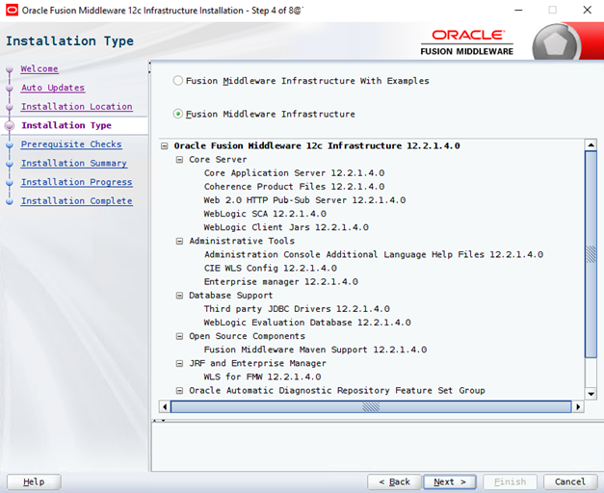

The installer will then perform prerequisite checks, essentially checking that the OS is recognized and that JDK 8 is installed before starting.

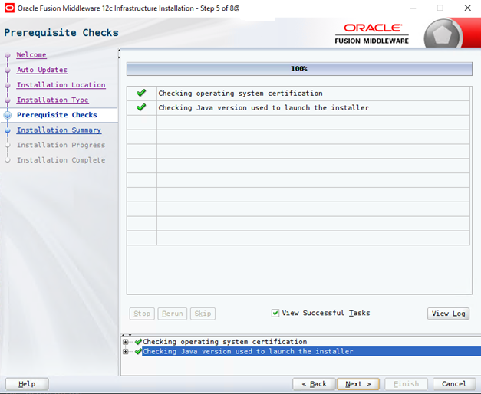

The final screen asks if the user wants to receive security mailing from Oracle. By default, this can be ignored. After which the installation will begin. This will be skipped.
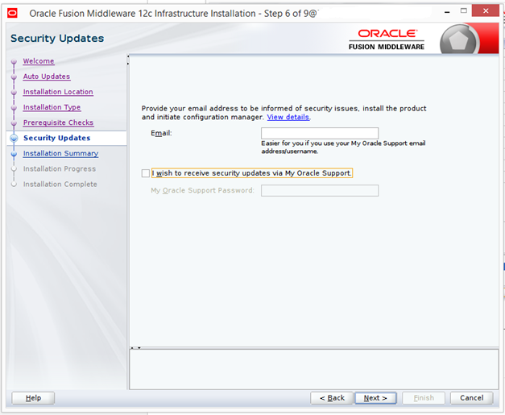

Start the installation.
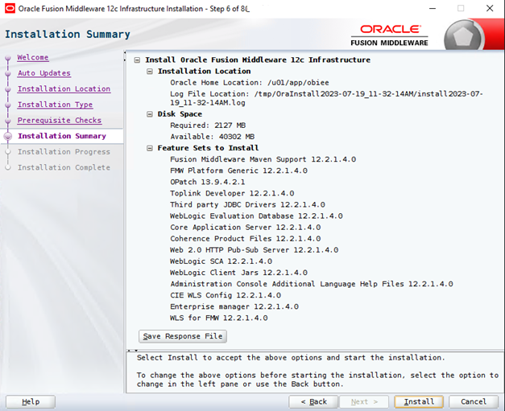

The installation should finish without issues and the installation can be continued.
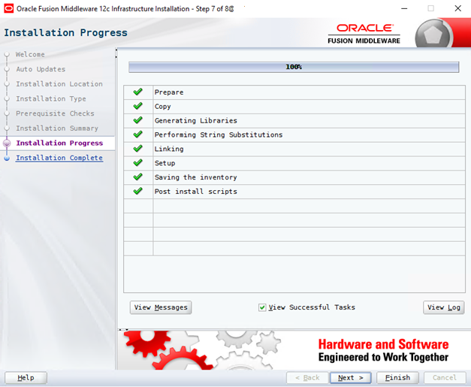

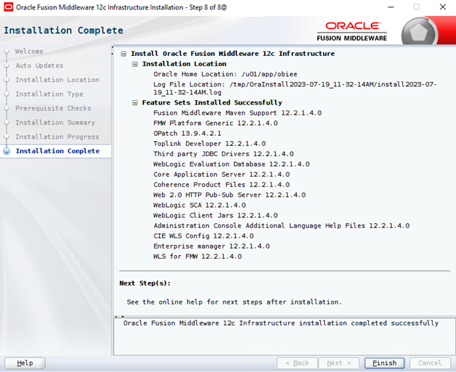

Installing OAS 2023

To install OAS 2023 on top of Fusion Middleware the files Oracle_Analytics_Server_2023 zip files need to be extracted with the following commands run from the zip file location:

Windows unzip Oracle_Analytics_Server_2023_Win64.zip -d bi
unzip Oracle_Analytics_Server_2023_Win64_Client.zip -d bi
Linux unzip Oracle_Analytics_Server_2023_Linux64.zip -d bi
The installer can be started with the following actions:

Windows
C:\Program Files\Java\jdk1.8.0_381\bin\java.exe -d64 -jar Oracle_Analytics_Server_2023Update_Win64.jar
Linux
$JAVA_HOME/bin/java -d64 -jar Oracle_Analytics_Server_2023_Linux64.jar

This then starts the standard Oracle installer. Click next to pass the first screen.

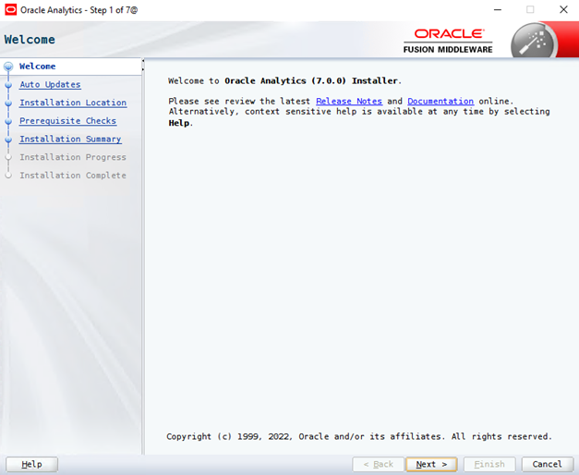

The next screen asks about auto updating, patches. Just leave the default ‘Skip Auto Updates’
selected:

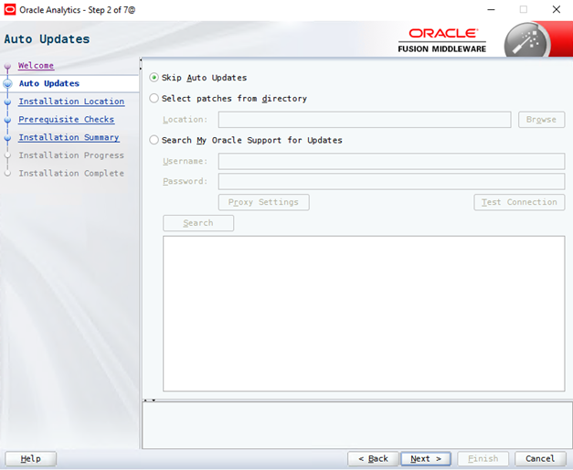

Next the home directory for the installation needs to be selected:

Windows C:\Oracle\Middleware\Oracle_Home
Linux /u01/app/obiee

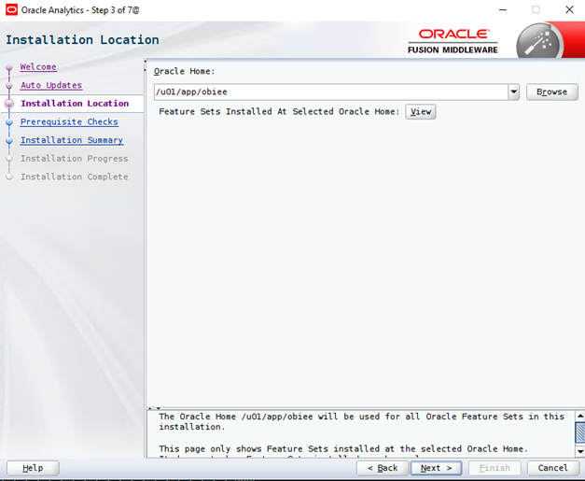

Then the prerequisite checks are carried out. This can fail if dependencies are missing. Please install the dependencies to work around the errors.

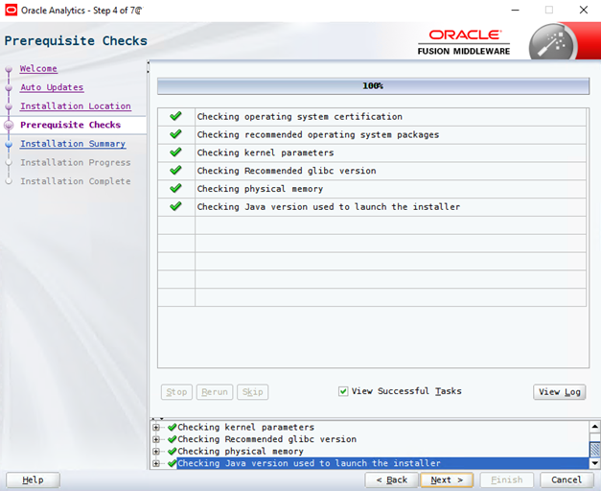

Finally, we get the installation summary.
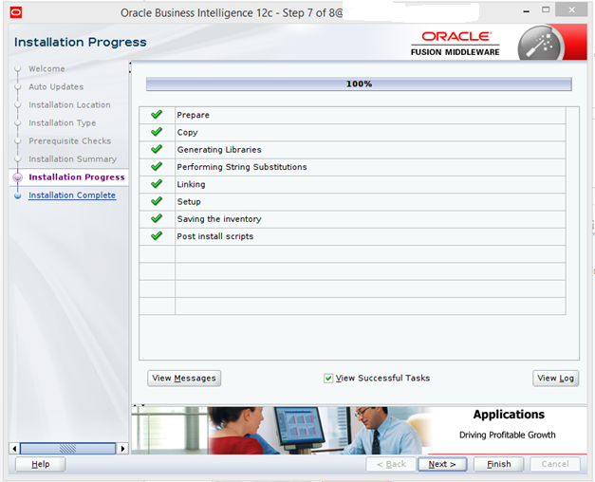

Then click install.

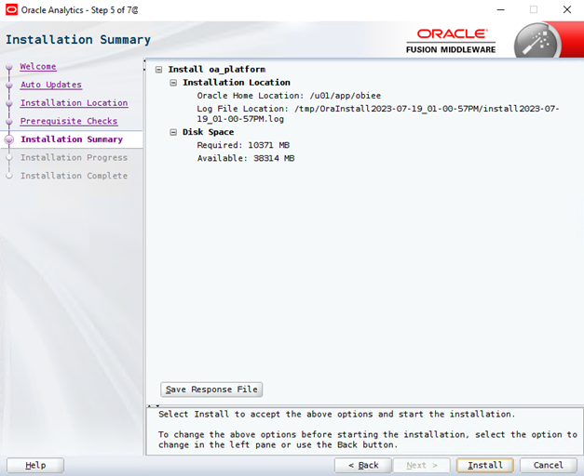

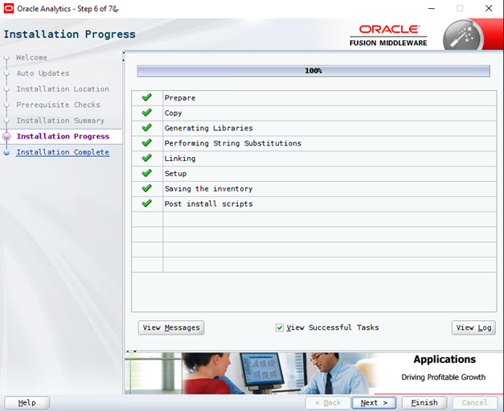
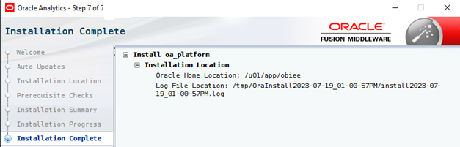

Patching WLS and OAS

For Installing Latest OAS with latest Java Patches need to be applied as follows:
Download from FTP latest Qx-202x patches Linux or Windows directory:
ftp/Oracle/OAS/Linux64/2023/Q1-2024/
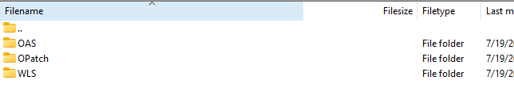
Copy and unzip the files on the OAS server.
There are 2 methods of installing the patches:

1.Applying the SPB Patches with SPBAT Recommended by Oracle

For Linux:
cd <patch_home>/Qx-202x/OAS/OAS_SPB_<VERSION>/tools/spbat/generic/SPBAT
./spbat.sh -phase apply -oracle_home /u01/app/obiee
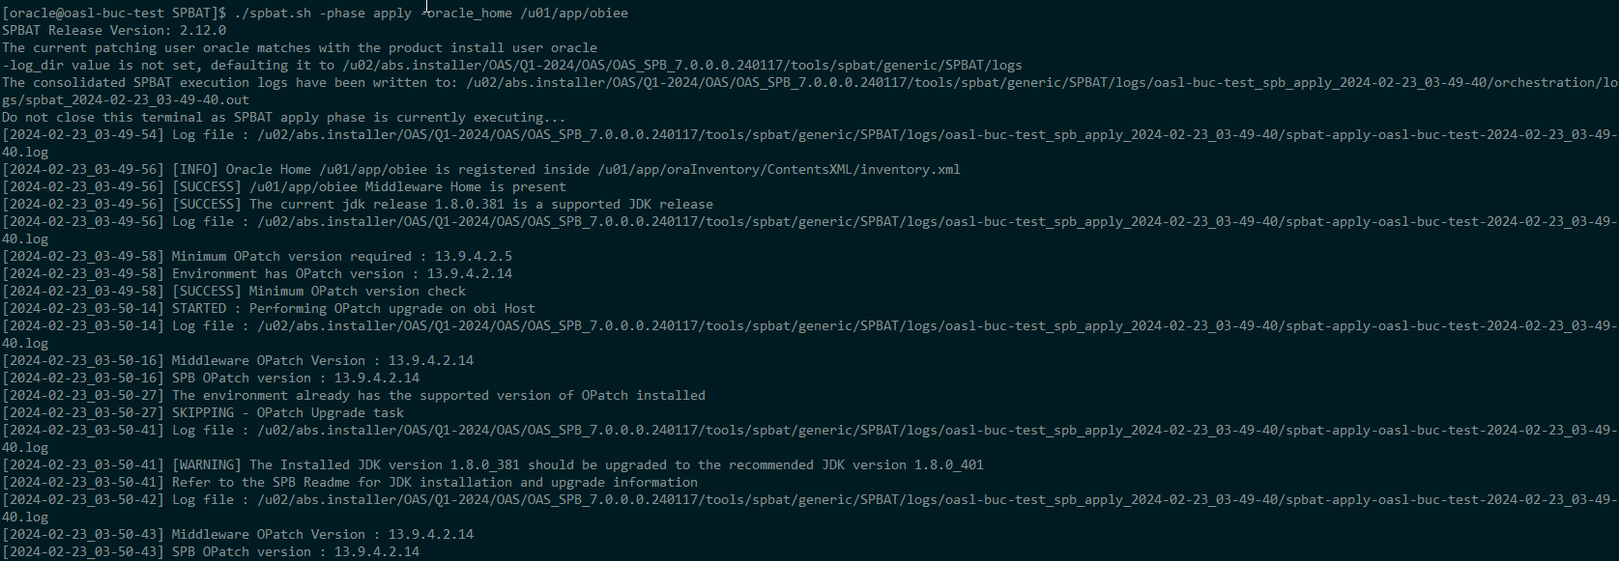
For Windows
Make sure that all java processes are stopped.
CMD as admin:
cd <patch_home>\Qx-202x\OAS\OAS_SPB_<version>\tools\spbat\generic\SPBAT
spbat.bat -phase apply -oracle_home C:\oracle\Middleware\Oracle_Home
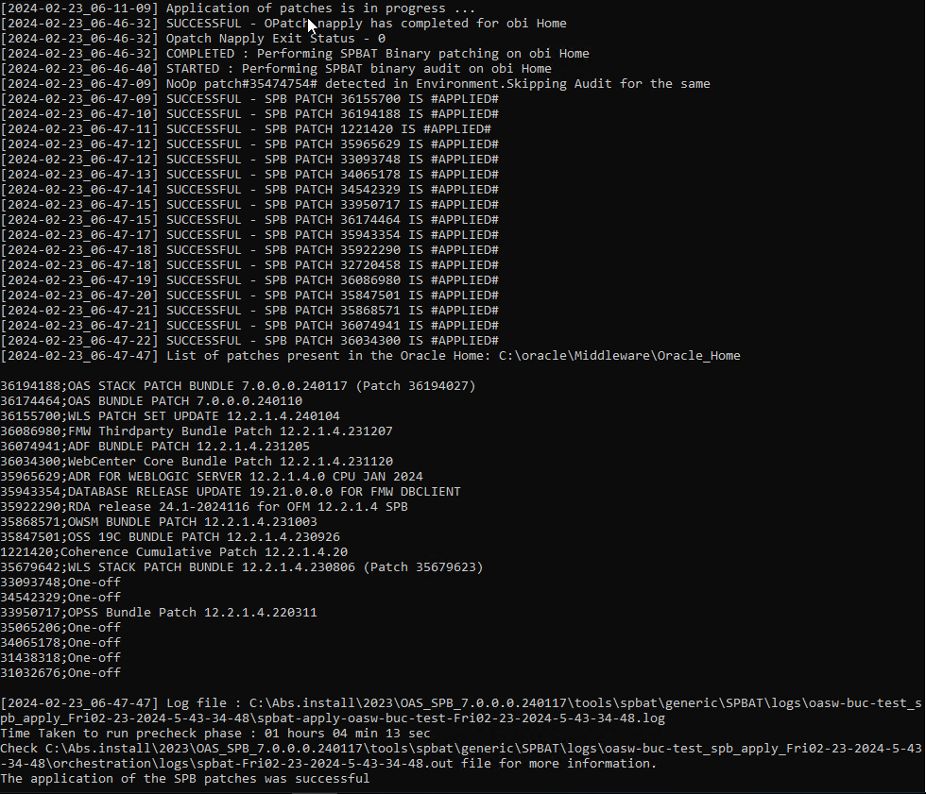
Set OAS variables:
Linux:
ORACLE_HOME=/u01/app/obiee; export ORACLE_HOME
PATH=$ORACLE_HOME/OPatch:$PATH; export PATH
Windows:
set ORACLE_HOME=C:\oracle\Middleware\Oracle_Home
set PATH=%ORACLE_HOME%\OPatch;%PATH%re
For Both Linux and Windows run the opatch apply after getting into patch unzipped folder. Set OAS HOME variables and add the OAS additional patches.
- Java Patching
Java can be patched only if the root installation directory structure is not changed while doing the Java update.
For the current installation of the java made by Oracle the Java can be patched keeping the same structure.
!!! Important is to have the BI services stopped and all java processes stopped while doing java update. In other case the OAS will not properly start and it will require an Java version rollback.
Check logs if issues appear during the running of spbat. Alternatively, the napply patch procedure can be used.

2. Applying the SPB Patches with napply <alternative>

- Install OPatch:
For Linux:
java -jar /u02/abs.installer/OAS/Q1-2024/OPatch/<patchnumber>//opatch_generic.jar -silent oracle_home=/u01/app/obiee/
For Windows
java -jar <PATCH_HOME>\6880880\opatch_generic.jar -silent oracle_home=<ORACLE_HOME_LOC>
- Install WebLogic Server patch:
Set OAS variables:
Linux:
ORACLE_HOME=/u01/app/obiee; export ORACLE_HOME
PATH=$ORACLE_HOME/OPatch:$PATH; export PATH
Windows:
set ORACLE_HOME=%MW_HOME%\OHS
set PATH=%ORACLE_HOME%\OPatch;%PATH%re

Patching the WLS_SPB to latest release:
For Linux:
$ORACLE_HOME/OPatch/opatch napply -oh /u01/app/obiee -phBaseFile linux64_patchlist.txt
For Windows
%ORACLE_HOME%\OPatch\opatch napply -oh =/u01/app/obiee/ -phBaseFile windows64_patchlist.txt
Additional Patching the WLS server to latest release:
For Both Linux and Windows run the opatch apply after getting into patch unzipped folder. Set OAS HOME variables and add the WLS additional patches.

Patching the OAS_SPB to latest release:
For Linux:
$ORACLE_HOME/OPatch/opatch napply -oh /u01/app/obiee -phBaseFile linux64_patchlist.txt
For Windows
%ORACLE_HOME%\OPatch\opatch napply -oh <ORACLE_HOME> -phBaseFile windows64_patchlist.txt
Additional Patching the OAS server to latest release:
For Both Linux and Windows run the opatch apply after getting into patch unzipped folder. Set OAS HOME variables and add the OAS additional patches.

Creating the Repository

In this chapter the BI repository will be created with the Repository Creation Utility. This utility will create ten BI schemes in the database:
- DEV_STB
- DEV_MDS
- DEV_WLS
- DEV_WLS_RUNTIME
- DEV_IAU_APPEND
- DEV_IAU_VIEWER
- DEV_UMS
- DEV_IAU
- DEV_OPSS
- DEV_BIPLATFORM
This password is defined in scripts provided by ABS as <pleaseuseDEV_MDS_PASSWORD> or <pleaseuseDEV_BIPLATFORM_PASSWORD>
!!!!!! This password is defined at page 31
To start the RCU the following command must be executed:

Windows C:\oracle\Middleware\Oracle_Home\oracle_common\bin\rcu.bat
Linux /u01/app/obiee/oracle_common/bin/rcu
The welcome screen can be skipped.
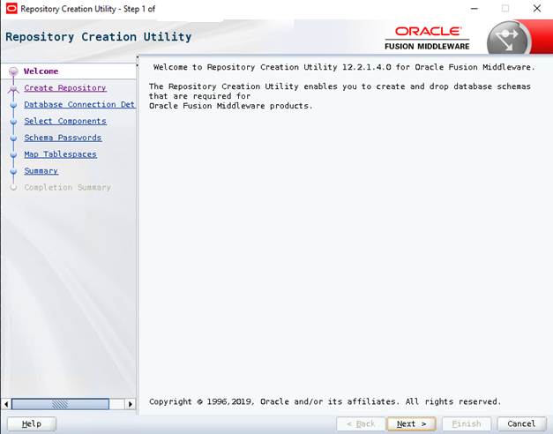

In the following screen select the create repository option System Load and Product Load and continue

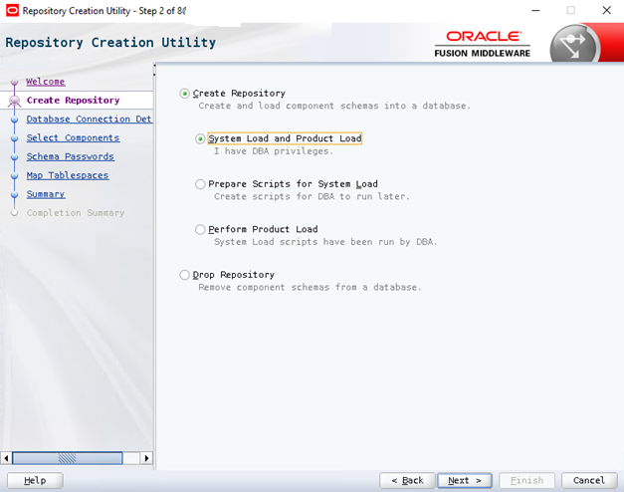

Enter the appropriate connection details. Please note the SYSDBA user should be given. This password is mentioned in backup scripts (dpexpimpset.sh) as : <pleaseuseDBOASSYSpassword> This password is used when Installing Oracle Database for BI.

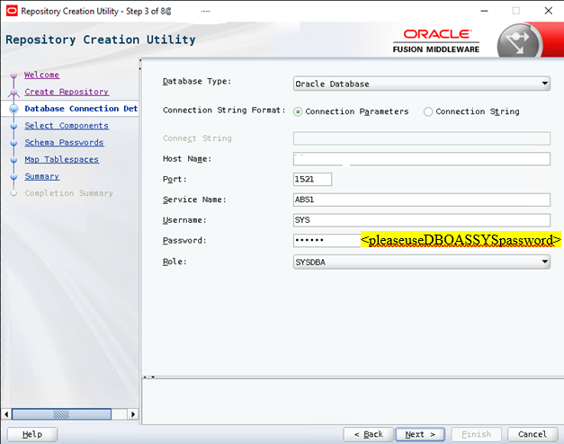

Some prerequisite checks will then be performed, essentially just checking that the database can connect to correctly.
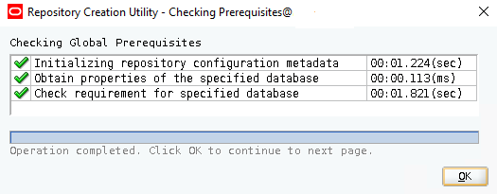

Select the all the available components in the installed.

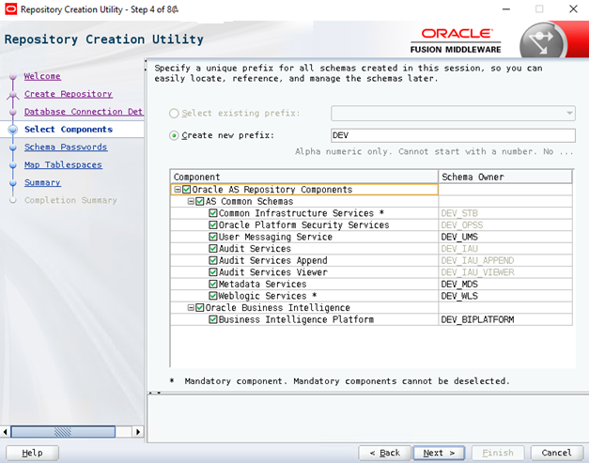

The RCU will then perform some more prerequisite checks to ensure it can continue.

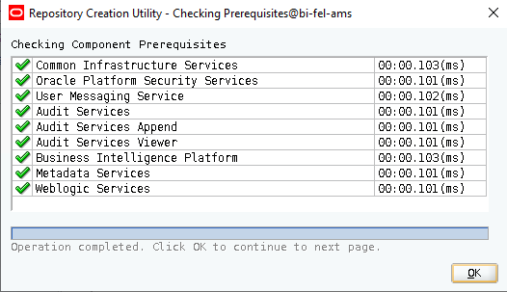

Specify the value OF <pleaseuseDEV_MDS_PASSWORD> as password form all schemas (ABS_DEV/ABS_DEV_BIPLATFORM) and continue the installation.
This is found in daily_backup.sh where you need to replace <pleaseuseDEV_MDS_PASSWORD> and <pleaseuseDEV_BIPLATFORM_PASSWORD> with the password you are setting up in step 5of 8 as in picture below:

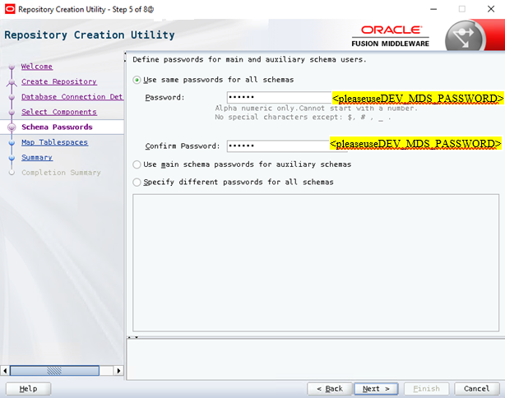
Change the values Default Tablespace and Temp tablespace to the appropriate values and continue the installation.

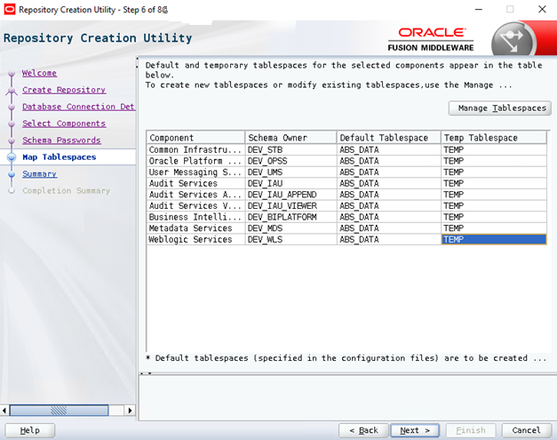

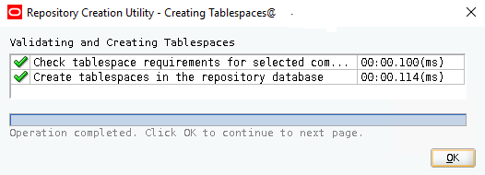
The next screen presents a summary confirming which schemas are about to be created along with their chosen details. Presse Create to start the creation of the schemas.

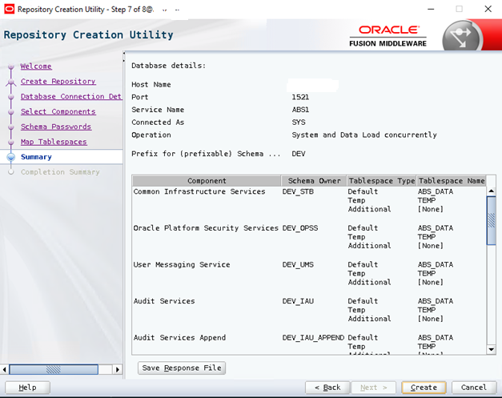

The final screen presents an installation summary.

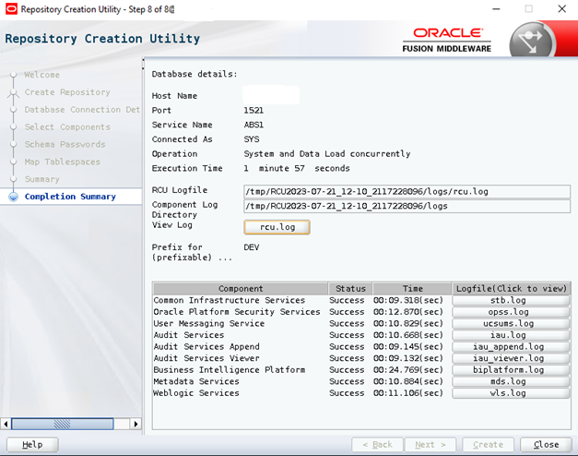

Configuring & Starting OAS

This final part will perform the configuration of the OBI domain of the Fusion middleware. The configuration can be started with the following command:

Windows C:\oracle\Middleware\Oracle_Home\bi\bin\config.cmd
Linux /u01/app/obiee/bi/bin/config.sh
Startup screen
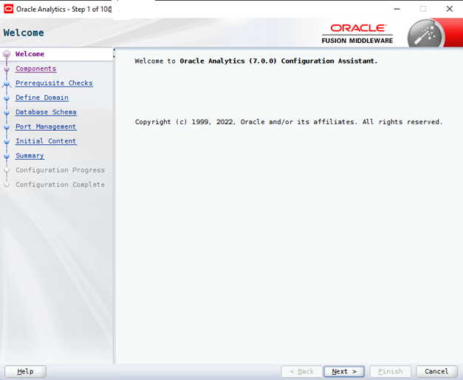

Select the following options and continue.
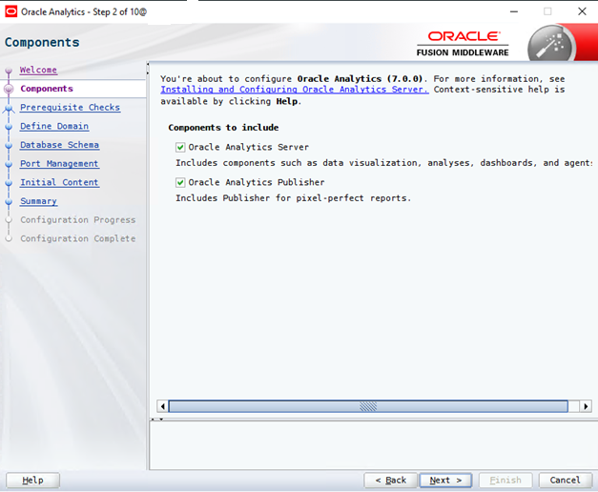

Then the standard prerequisite checks are performed to ensure the server is configured correctly.

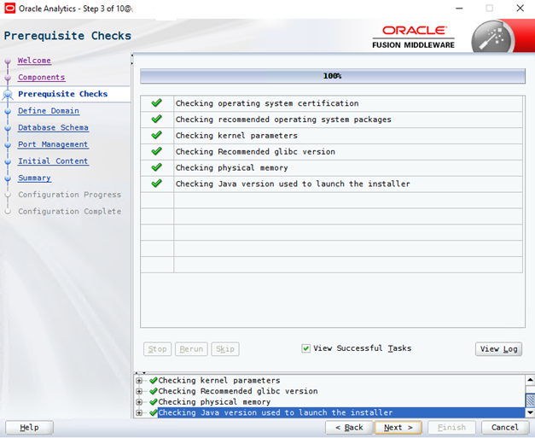

In the following dialog the system asks for the details of the BI domain. The default username and password is:
Username: SYS
Password: Create a generated password this will be referred as <pleaseuseBIOASSYSpassword> in all backup scripts, abspurgebicache_oas,
Please replace inside scripts <pleaseuseBIOASSYSpassword> with the password you are setting up as in picture below:

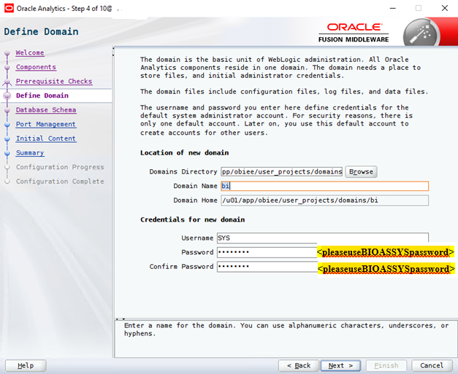

In the following screen the login credentials for the database schemas must be given, that are as followed:
Prefix: DEV
Password: <pleaseuseDEV_MDS_PASSWORD> and you should use the same password for schema DEV_BIPLATFORM <pleaseuseDEV_BIPLATFORM_PASSWORD>

This password is setup at page 25

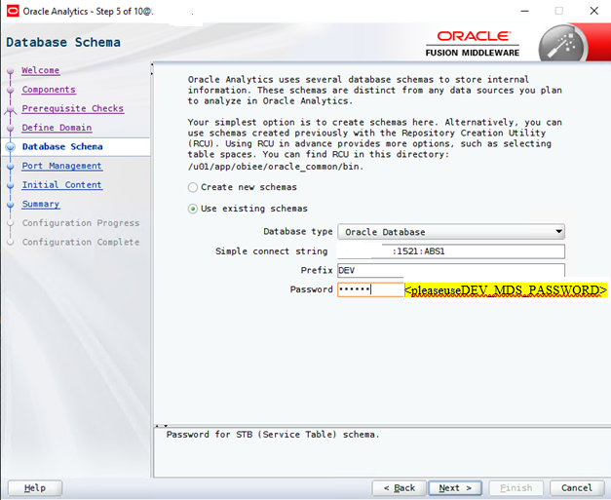

Next the TCP ports for BI are specified. By default, the range 9500 to 9999 are used.

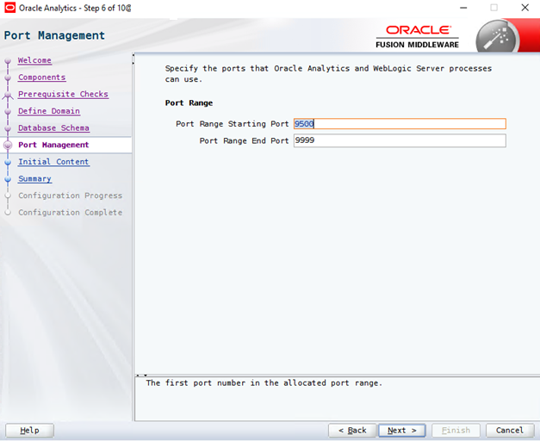

You’re then asked if you want the sample application installed or your own BI application. This samples can be disabled.

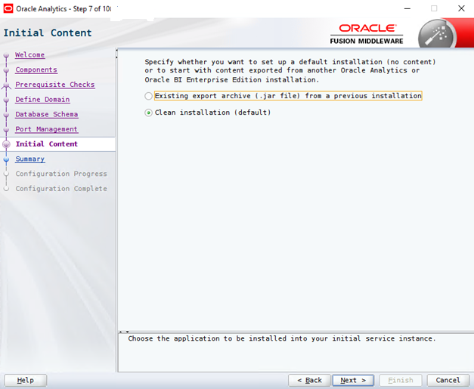

The summary screen then displays the settings you’ve selected and main URLS for accessing the WebLogic console, enterprise manager, OAS and BI Publisher.
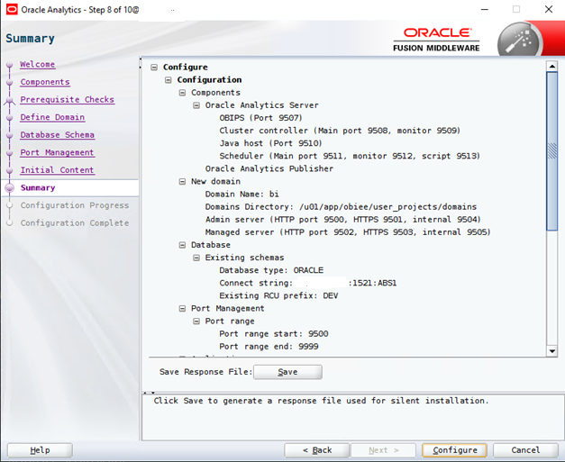

Clicking Configure then begins the process.
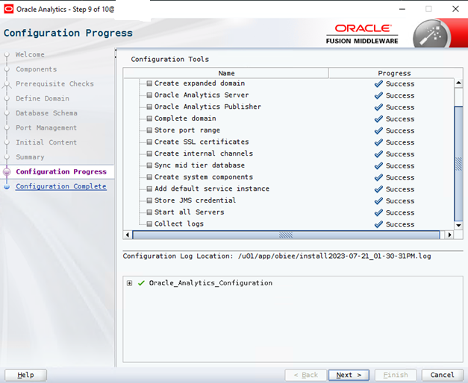
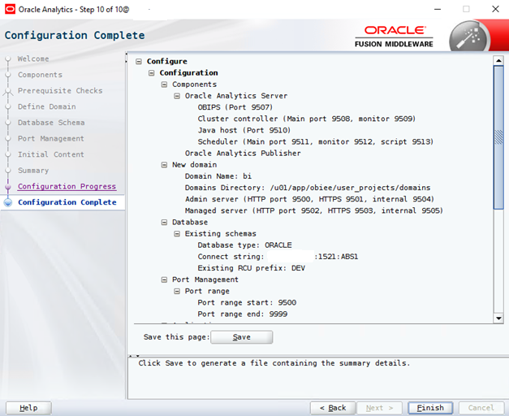
Click finish to close the configuration wizard.

Oracle Analytics should now be available on the following URL:
http://localhost:9502/analytics
http://localhost:9502/dv
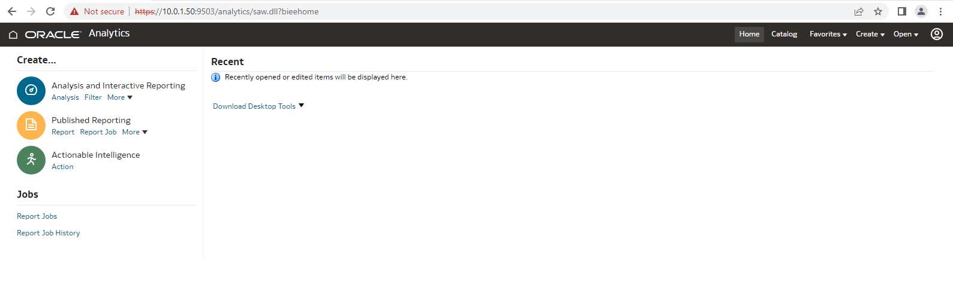
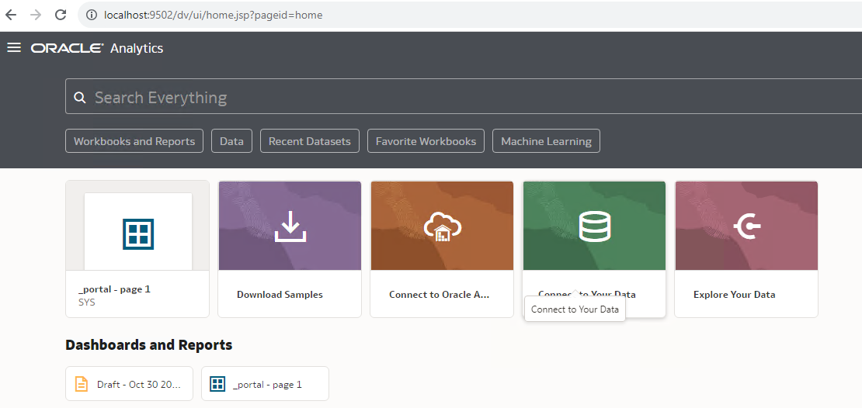
Tune Java heap Size
Modify for Linux: /u01/app/obiee/oracle_common/common/bin:
cp /u01/app/obiee/oracle_common/common/bin/commBaseEnv.sh /u01/app/obiee/oracle_common/common/bin/commBaseEnv.sh_bk
commBaseEnv.sh

Modify for Windows: <OAS HOME>\ oracle_common/common/bin:
Backup commBaseEnv.cmd
commBaseEnv.cmd
from:
MEM_ARGS="-Xms32m -Xmx200m"
UTILS_MEM_ARGS="-Xms32m -Xmx1024m"
To
MEM_ARGS="-Xms512m -Xmx1024m"
UTILS_MEM_ARGS="-Xms32m -Xmx1024m"

For Linux:
/u01/app/obiee/user_projects/domains/bi/bin
cp /u01/app/obiee/user_projects/domains/bi/bin/setStartupEnv.sh /u01/app/obiee/user_projects/domains/bi/bin/setStartupEnv.sh_bk
setStartupEnv.sh

For Windows:
<OAS Home>/user_projects\domains\bi\bin
setStartupEnv.cmd
backup setStartupEnv.cmd
# Startup parameters for STARTUP_GROUP AdminServerStartupGroup
From:
# 64 bit JVM memory settings
SERVER_MEM_ARGS_64="-Xms512m -Xmx1024m"
export SERVER_MEM_ARGS_64
SERVER_MEM_ARGS_64HotSpot="-Xms512m -Xmx1024m"
export SERVER_MEM_ARGS_64HotSpot
SERVER_MEM_ARGS_64JRockit="-Xms512m -Xmx1024m"
export SERVER_MEM_ARGS_64JRockit
to
# 64 bit JVM memory settings
SERVER_MEM_ARGS_64="-Xms1024m -Xmx4096m"
export SERVER_MEM_ARGS_64
SERVER_MEM_ARGS_64HotSpot="-Xms1024m -Xmx4096m"
export SERVER_MEM_ARGS_64HotSpot
SERVER_MEM_ARGS_64JRockit="-Xms1024m -Xmx4096m"
export SERVER_MEM_ARGS_64JRockit
and
# Startup parameters for STARTUP_GROUP BISUITE-MAN-SVR
From:
# 64 bit JVM memory settings
SERVER_MEM_ARGS_64="-Xms256m -Xmx4096m"
export SERVER_MEM_ARGS_64
SERVER_MEM_ARGS_64HotSpot="-Xms256m -Xmx4096m"
export SERVER_MEM_ARGS_64HotSpot
SERVER_MEM_ARGS_64JRockit="-Xms256m -Xmx4096m"
export SERVER_MEM_ARGS_64JRockit
to:
# 64 bit JVM memory settings
SERVER_MEM_ARGS_64="-Xms8g -Xmx8g"
export SERVER_MEM_ARGS_64
SERVER_MEM_ARGS_64HotSpot="-Xms8g -Xmx8g"
export SERVER_MEM_ARGS_64HotSpot
SERVER_MEM_ARGS_64JRockit="-Xms8g -Xmx8g"
export SERVER_MEM_ARGS_64JRockit

Enable Discovery Cache
If there is a long delay in logging in to EM, it is recommended to enable discovery cache.
A similar message appears: “Login is taking more time than usual. Total login time is 324943 ms, discovery time is 322634 ms. Consider enabling discovery cache and/or improving application server performance.”
The solution consists of setting the proper value to the System mBean property “oracle.sysman.emas.discovery.wls.FMW_DISCOVERY_USE_CACHED_RESULTS“.
Login to EM – WebLogic Domain – System MBean Browser – Application Defined MBeans – emmos.props – Server: AdminServer – Application: em – Properties – emmos.properties.
Click the Operations tab and select SetProperty.
The property key used to enable the discovery cache is “oracle.sysman.emas.discovery.wls.FMW_DISCOVERY_USE_CACHED_RESULTS” and the value must be set to “true“. Click “Invoke” button to execute the operation.
After the confirmation is received that the operation has been executed successfully, click Return button to return to the previous screen.
Log out from EM and login again to check the login is faster and that the information message doesn’t appear.
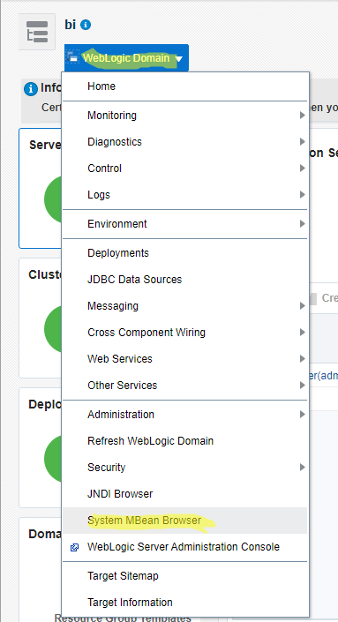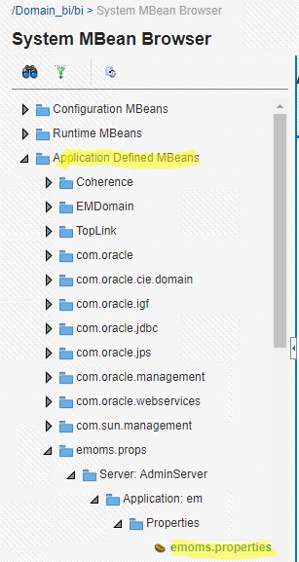
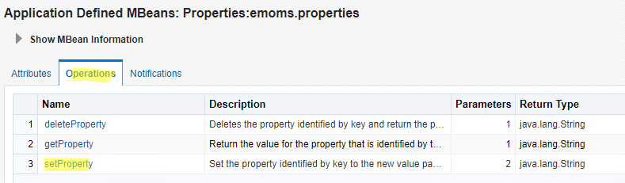
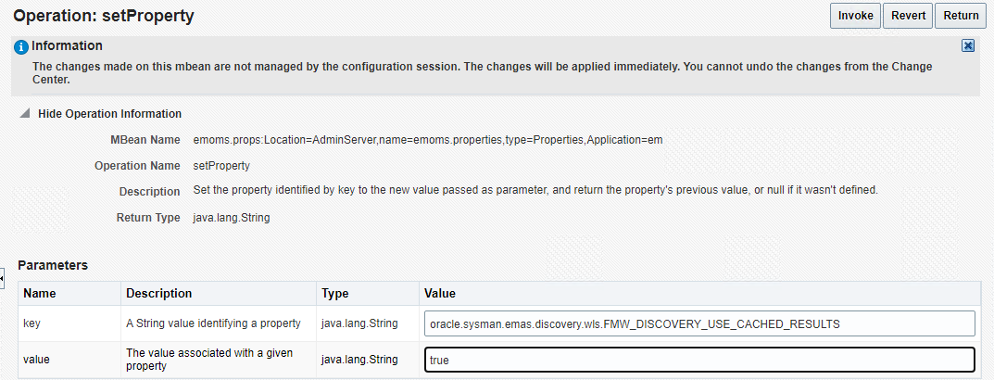

Enable HTTPS port 9503 for analytics
Make sure the firewall enables traffic on port 9502 and 9503 so remote users can access the web interface.
Go to console Domain Structure (expend Environment) Servers bi_server1 Configuration General
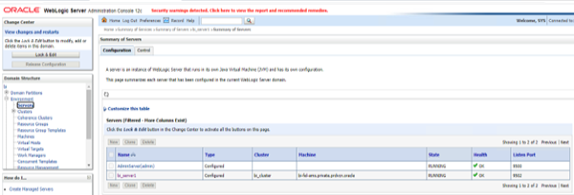
Lock & Edit then check SSL Listen Port Enabled (port 9503)
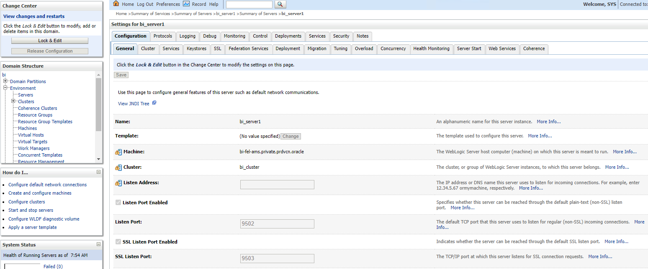
Save settings then Activate Changes:
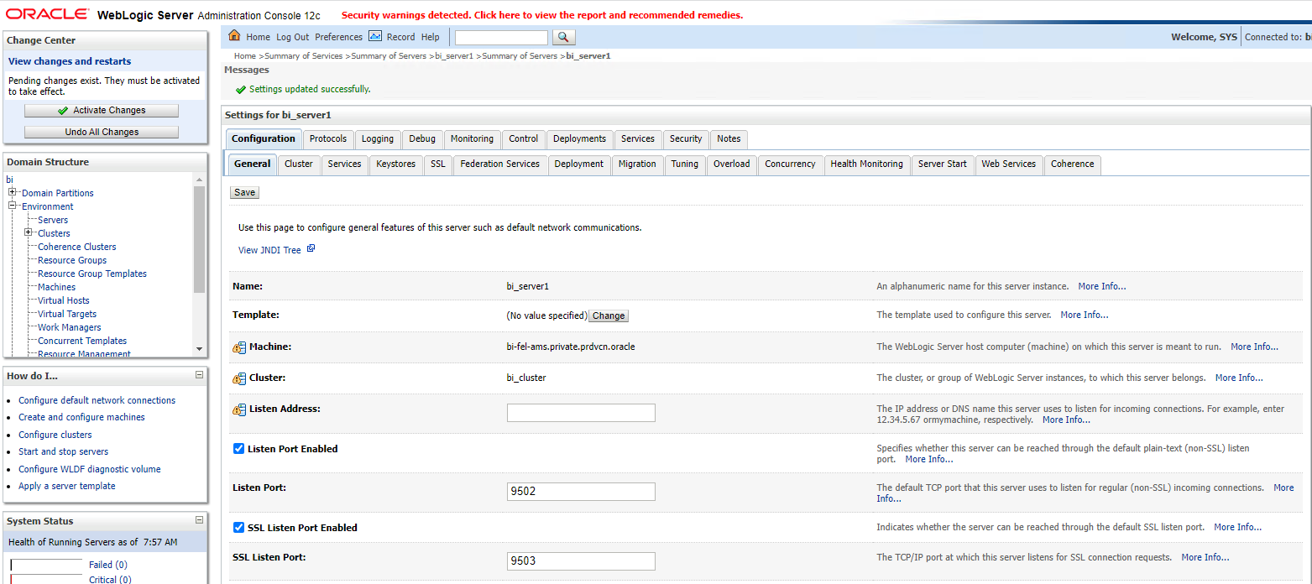

OAS Snapshot
Take a snapshot with the out of the box OAS settings after the installation is done. In case of issues further on, this snapshot can be restored to the original settings.
Navigate to http://localhost:9502/dv - Login as SYS and <pleaseuseBIOASSYSpassword> and click on Navigator (3 dots on upper left corner) - Console – Snapshots.
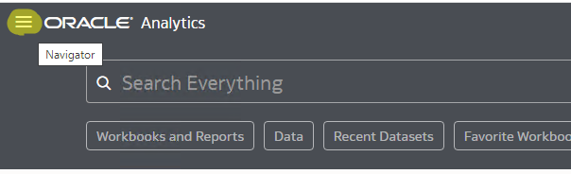
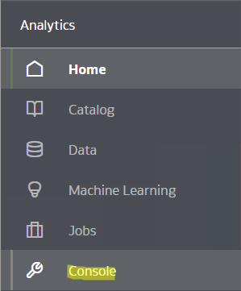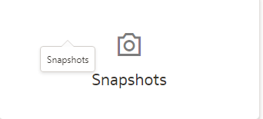
Click Create Snapshot and choose Content = Everything, click Create.
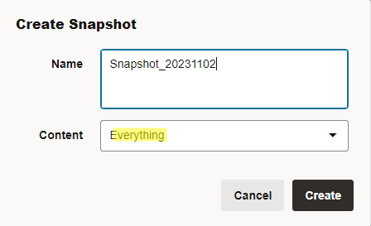
A new snapshot is created for the settings to be reverted in case of issues.
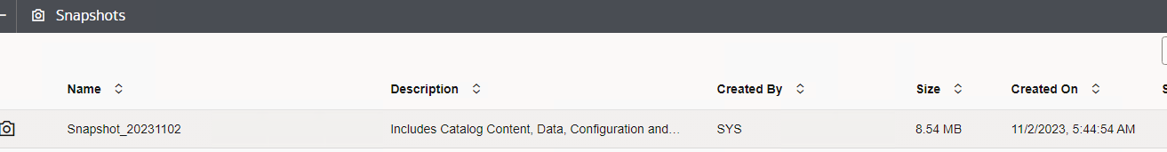

OAS Start and Stop services

Windows
In Windows OAS is registered as a Windows server with the name Oracle Analytics Server[bi] and can be managed as any other Windows service.
Linux
In Linux the following scripts can be used to manage OAS services entire stack (NodeManager, AdminServer, bi_server1, BI Services)
/u01/app/obiee/user_projects/domains/bi/bitools/bin/start.sh
/u01/app/obiee/user_projects/domains/bi/bitools/bin/stop.sh
/u01/app/obiee/user_projects/domains/bi/bitools/bin/status.sh
Restart BI services (BI Presentation Services, BI Servers, BI Schedulers, BI Cluster Controllers, BI Java Hosts)
/u01/app/obiee/user_projects/domains/bi/bitools/bin/stop.sh -i obis1,obips1,obijh1,obiccs1,obisch1
/u01/app/obiee/user_projects/domains/bi/bitools/bin/start.sh -i obis1,obips1,obijh1,obiccs1,obisch1
An alternative way to restart just the BI services is from http://localhost:9500/em -> bi instance -> Availability –> Restart All
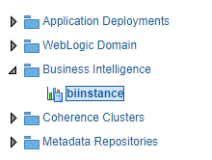
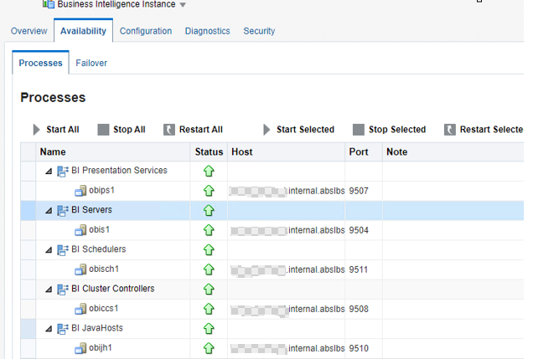

Automatic startup

Windows
To configure the automatic startup of BI on Windows a scheduled task must be created with the following details:
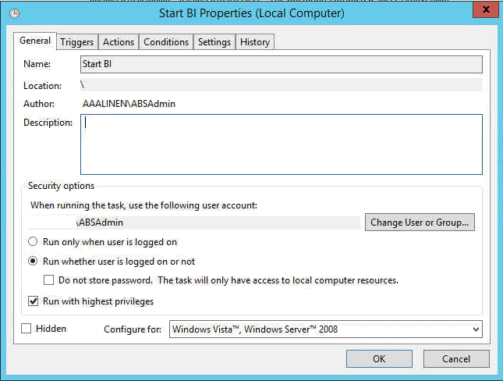

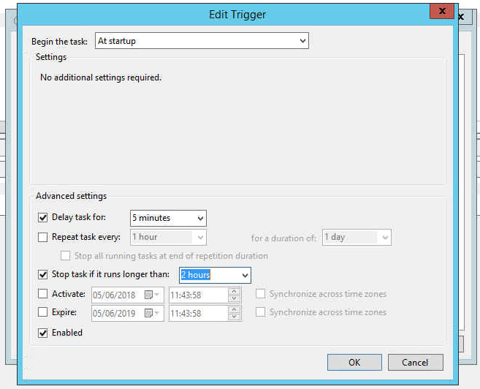

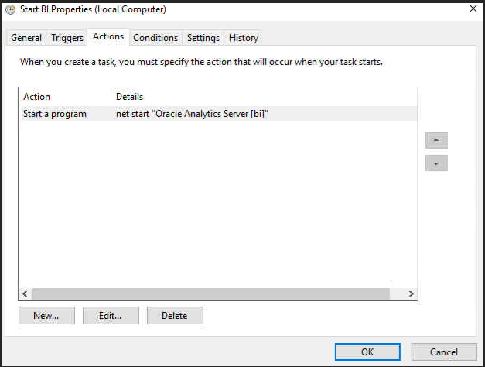
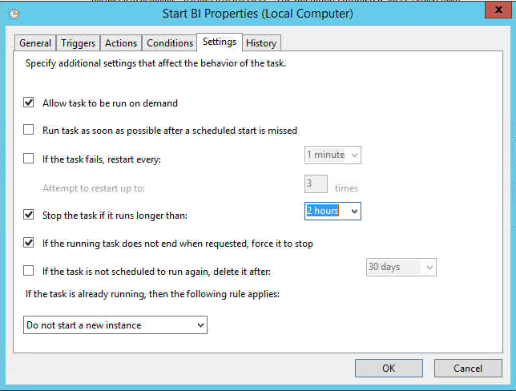

Linux
To configure the automatic startup of BI on Linux the following cation must be performed.
- Download the autostart script biora from BI_OAS/Installation scripts/.

- Make sure the automatic startup of Oracle database is already configured.
In RHEL 6 and earlier: Please make sure the startup priority for biora is set after the Oracle DB startup. This can be changed by making the middle number in the line ' chkconfig: 2345 99 11' of biora higher than the one in the Oracle database startup script.

- Move the script biora to the directory /etc/init.d/ and run the following commands:
dos2unix /etc/init.d/biora
chmod 770 /etc/init.d/biora
chkconfig --add biora
In RHTL/CentOS 7+ the OS will use the systemctl mechanism to start/stop the biora file. Unfortunately this mechanism has a timeout of 5 minutes which is not sufficient for biora. This causes systemctl to register biora startup as failed (even though it start just fine). As a result the stop function will not be called on shutdown. To increase the timeout and prevent this issue create the following directories and file /etc/systemd/system/biora.service.d/reduce-timeout.conf with content:
[Service]
TimeoutStartSec=900
After creating the file the following command must be run:
systemctl daemon-reload

TNSNames update for OAS
Copy the tnsnames.ora file from the database folder to the following 2 BI folders. If the folder on the BI path does not exist, create it.

Windows
- C:\oracle\Middleware\Oracle_Home\bi\modules\oracle.bi.servicelcm\oracledb
- C:\oracle\Middleware\Oracle_Home\user_projects\domains\bi\bidata\components\core\oracledb

Linux
- /u01/app/obiee/bi/modules/oracle.bi.servicelcm/oracledb/tnsnames.ora
- /u01/app/obiee/user_projects/domains/bi/bidata/components/core/serviceinstances/ssi/oracledb/tnsnames.ora

It is important that the OAS installation contains a tnsnames.ora file holding an ABS1 entry that point to the database containing the ETL schema. The easiest way to create this is to copy the tnsnames.ora file from the database to the OAS folders with the following commands:

Windows

copy tnsnames.ora
C:\oracle\Middleware\Oracle_Home\bi\modules\oracle.bi.servicelcm\oracledb

md C:\oracle\Middleware\Oracle_Home\user_projects\domains\bi\bidata\components\core\oracledb
copy tnsnames.ora
C:\oracle\Middleware\Oracle_Home\user_projects\domains\bi\bidata\components\core\oracledb

Linux
cp tnsnames.ora /u01/app/obiee/bi/modules/oracle.bi.servicelcm/oracledb

mkdir -r /u01/app/obiee/user_projects/domains/bi/bidata/components/core/serviceinstances/ssi/oracledb
cp tnsnames.ora /u01/app/obiee/user_projects/domains/bi/bidata/components/core/serviceinstances/ssi/oracledb
Restart entire OAS stack.

OAS configuration files

Two configuration files must be changed:
- instanceconfig.xml
- config.xml

instanceconfig.xml
The settings from ABS standard instanceconfig.xml are recommended settings. Should you have custom settings for instanceconfig.xml you should compare both files and apply the necessary ones.
MaxVisibleRows in Table/Pivot View can only be changed from System Settings with a limit on 5000 introduced by OAS. This applies to Content Paging.
Some additional configuration changes are required for the OAS installation. These changes should be made by altering the file:

Windows C:\oracle\Middleware\Oracle_Home\user_projects\domains\bi\config\
fmwconfig\biconfig\OBIPS\instanceconfig.xml

Linux /u01/app/obiee/user_projects/domains/bi/config/fmwconfig/biconfig/
OBIPS/instanceconfig.xml

backup instanceconfig.xml and replace with the one from
FTP: BI_OAS/OBI_Catalog_Version/bkp_files/oas_standard_settings

For Linux run command: dos2unix /u01/app/obiee/user_projects/domains/bi/config/fmwconfig/biconfig/OBIPS/instanceconfig.xml
Java Host Configuration – config.xml
- In config.xml, modify InputStreamLimitInKB, this is used for exporting.
Linux /u01/app/obiee/user_projects/domains/bi/config/fmwconfig/biconfig/OBIJH/config.xml
Winodws
C:\oracle\Middleware\Oracle_Home\user_projects\domains\bi\config\
fmwconfig\biconfig\OBIJH\config.xml
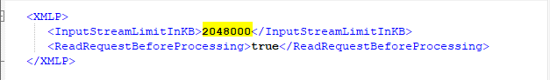
Please be aware these changes will be effective after a restart of the BI services.
Check if you have other changes in other config files:
- /u01/app/obiee/user_projects/domains/bi/config/fmwconfig/biconfig/OBIS/NQSConfig.ini
- config.xml: /u01/app/obiee/user_projects/domains/bi/config/fmwconfig/biconfig/OBIJH/config.xml

Migrating an existing customer

Migrate WebLogic users and groups

Should you be using AD integration, you have to setup OAS with AD to retrieve your users/groups. In this case the steps below are no longer required.
Export the weblogic users and groups from current OBIEE12c customer machine and import them into future OAS machine.
- Create a new directory /abs/bi_user_export/ on OBIEE12c server with correct permissions.
- Navigate to OBIEE12c WebLogic Console – Security Realms – myrealm.
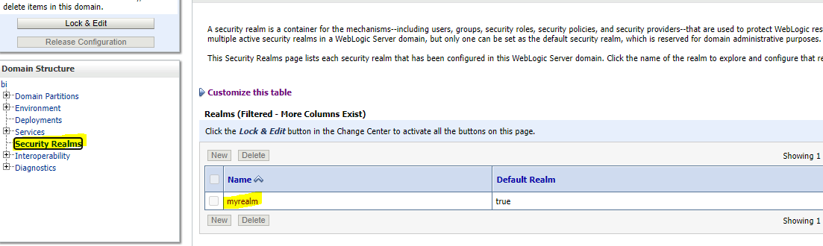
- Users and Groups -> Migration -> Export and write the directory name.
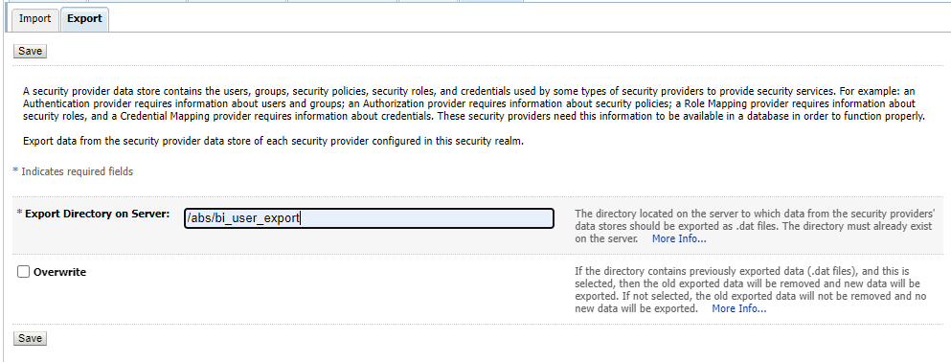
- Click Save
- 5 files will appear in the export folder.
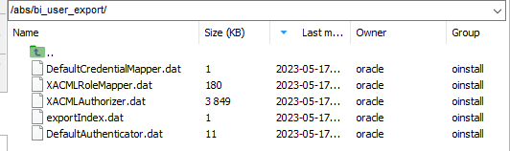
- Copy the folder on OAS server and check permissions for existing files.
- Navigate to OAS WebLogic Console – Security Realms – myrealm and make a back-up export as per step1.
- Navigate to Groups -> Migration -> Import and write the directory name you copied from OBIEE12c to OAS.
- Check that you see the same users and groups both in OBIEE12c and OAS. Verify that ABSBIConsumer and ABSBIAuthor groups exist and that users are correctly assigned to groups.

Assign groups to application roles in OAS

OAS Enterprise Manager: http://localhost:9500/em
New application roles are introduced: DVConsumer and DVContentAuthor. Should you have custom application roles, they will have to be recreated on OAS and assigned to weblogic/AD groups.
- Assign ABSBIConsumer group to BIConsumer and DVConsumer application roles.
- Assign ABSBIAuthor group to BIContentAuthor and DVContentAuthor application roles.
- Assign authenticated-role to BIConsumer application role.
For AD integration test if you need to Assign authenticated-role to BIConsumer application role.
- Navigate to OAS EM – Business Intelligence – biinstance – right click – Security – Application Roles.
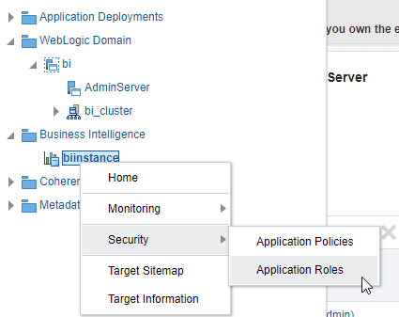
- Choose Application Stripe = obi
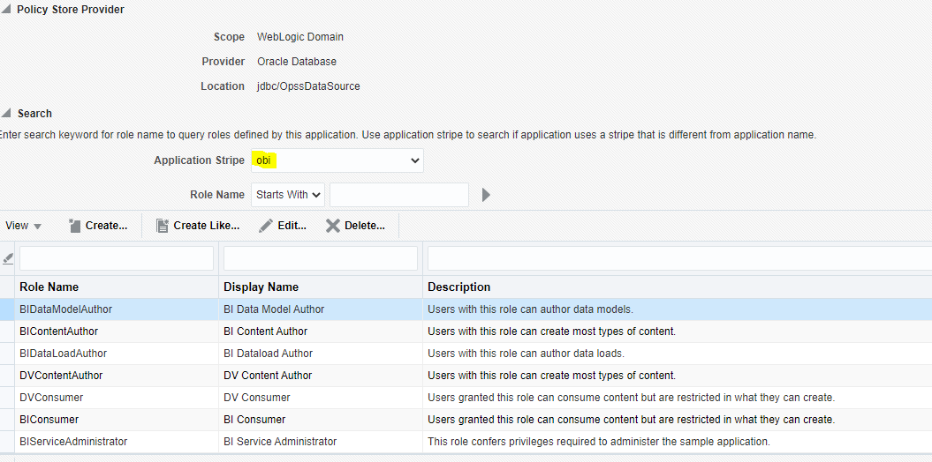

- Assign ABSBIAuthor group to BIContentAuthor application role and DVContentAuthor application role.
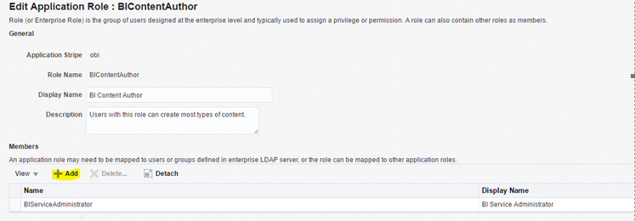
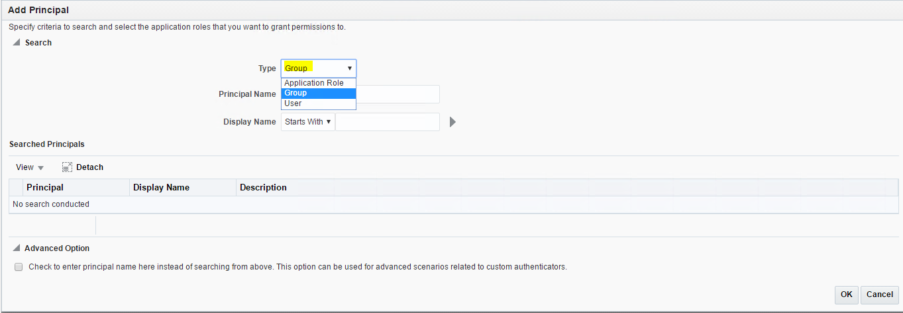

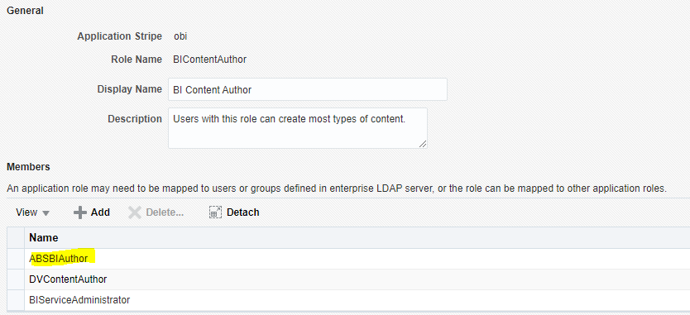
- Assign ABSBIConsumer group to BIConsumer application role and DVConsumer application role.
- Assign authenticated-role to BIConsumer application role.
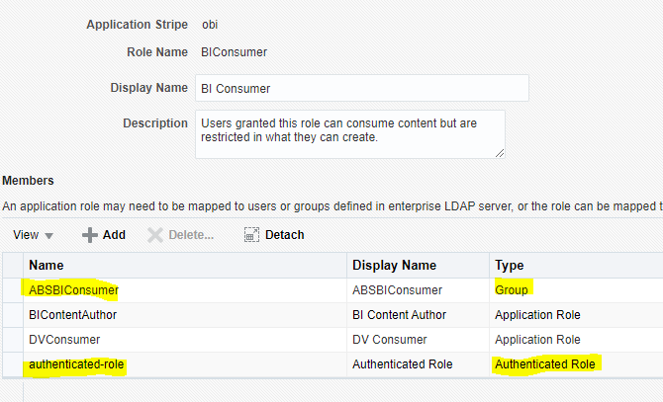
No need to restart BI Services.

The result should look like this:
BIConsumer
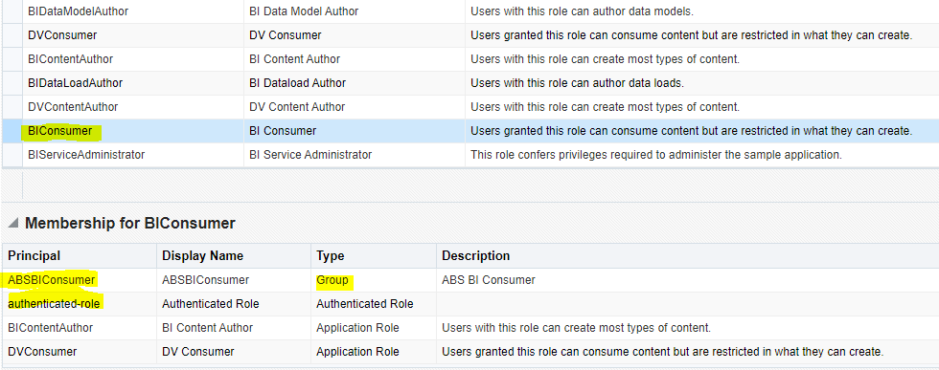

DVConsumer
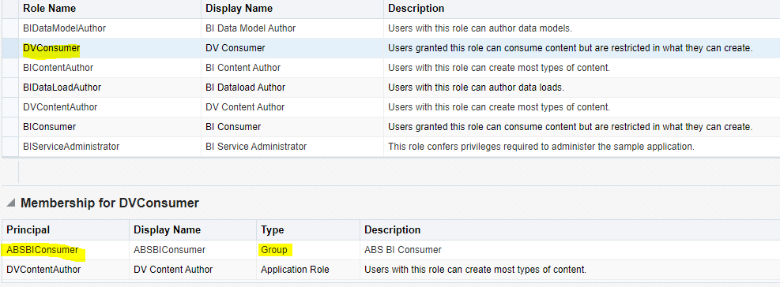
BIContentAuthor
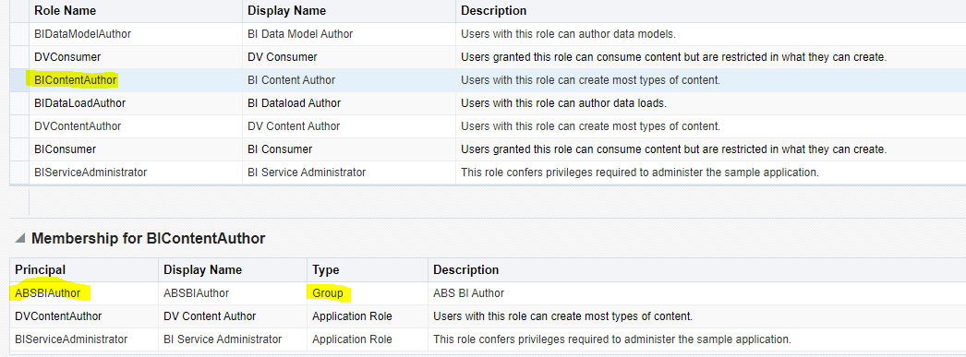
DVContentAuthor
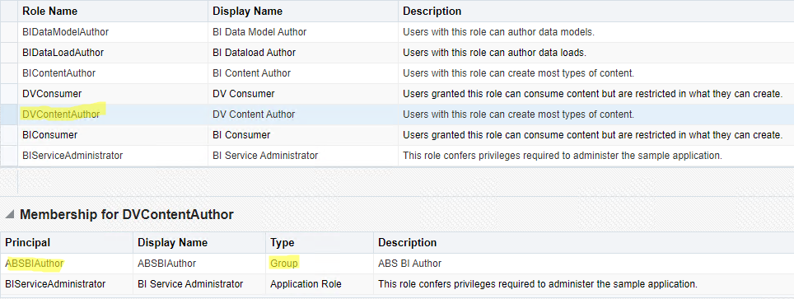

Migration – Import the snapshot

Inform your power users to stop any changes to the catalog (new reports/dashboards/modify existing objects, etc).
Go to the OBIEE server and take the latest working daily backup. Unarchive it and copy ssi.bar to OAS server (win) or the machine with access to OAS server (Linux).
Should the ssi.bar not being present in the daily backup, create it manually.
[LINUX]
# Make BAR file
export ORACLE_BI_HOME=/u01/app/obiee
export BACKUPLOCATION=/u02/oracle/dumpfiles
export BARDIR=$BACKUPLOCATION/bardir
mkdir $BARDIR
if [ -f $ORACLE_BI_HOME/user_projects/domains/bi/bitools/bin/exportarchive.sh ]
then
sh $ORACLE_BI_HOME/user_projects/domains/bi/bitools/bin/exportarchive.sh ssi $BARDIR encryptionpassword=abssys01
else
echo "exportServiceInstance ('$ORACLE_BI_HOME/user_projects/domains/bi','ssi','$BARDIR/workdir','$BARDIR/exportdir','','','',true,'ABSDATAWAREHOUSE')" > $SCRIPTDIR/createBAR.py
$ORACLE_BI_HOME/oracle_common/common/bin/wlst.sh $SCRIPTDIR/createBAR.py
rm $SCRIPTDIR/createBAR.py
fi
[WINDOWS]
@REM ** Set variables**
SET BACKUPLOCATION=D:\oracle\dumpfiles
SET ORACLE_BI_HOME=C:\Oracle\Middleware\Oracle_Home
@REM ** Run BAR export **
SET BARDIR=%BACKUPLOCATION%\bardir
mkdir %BARDIR%
if exist %ORACLE_BI_HOME%\user_projects\domains\bi\bitools\bin\exportarchive.cmd (
call %ORACLE_BI_HOME%\user_projects\domains\bi\bitools\bin\exportarchive.cmd ssi %BARDIR% encryptionpassword=abssys01
) else (
echo exportServiceInstance('%ORACLE_BI_HOME:\=\\%\\user_projects\\domains\\bi','ssi','%BARDIR:\=\\%\\workdir','%BARDIR:\=\\%\\exportdir','','','',true,'ABSDATAWAREHOUSE'^) > createBAR.py
call %ORACLE_BI_HOME%\oracle_common\common\bin\wlst.cmd createBAR.py
del createBAR.py
)

Once you have the snapshot from OBI server, import it into OAS:
- OAS server – navigate to http://localhost:9502/dv
- Click Navigator (upper left corner) – Console – Snapshots
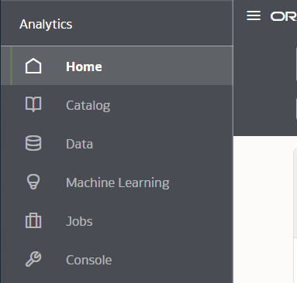
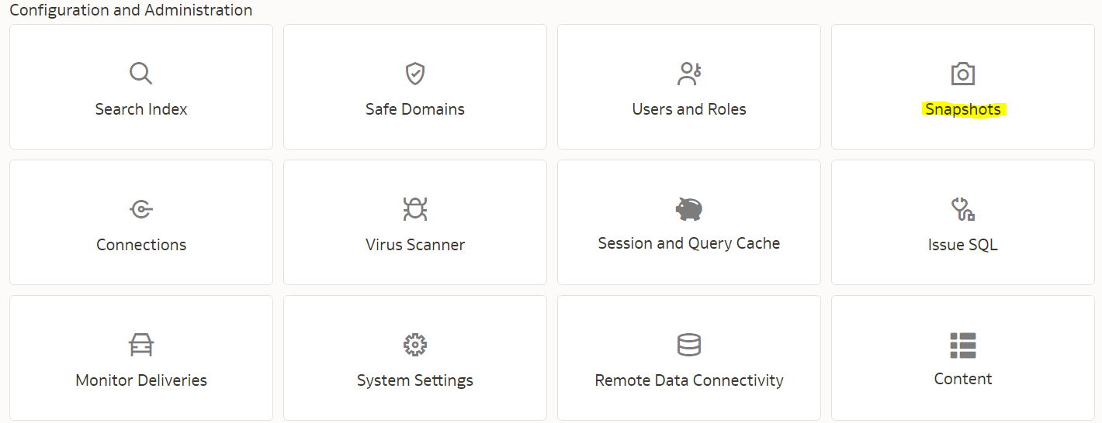

- Click the Page menu Page menu (upper right corner) and click Import Snapshot.
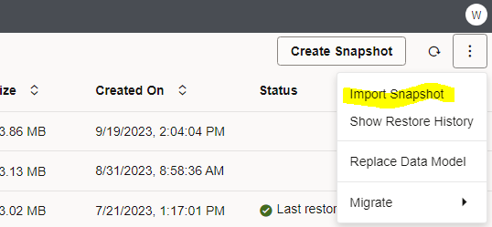

- Click the Page menu Page menu and click Import Snapshot.
- Click Select to locate the export bundle that you want to upload.
- Select the snapshot file (.bar) contains the metadata from your source system.
- Enter the snapshot password: abssys01
- Click Import.

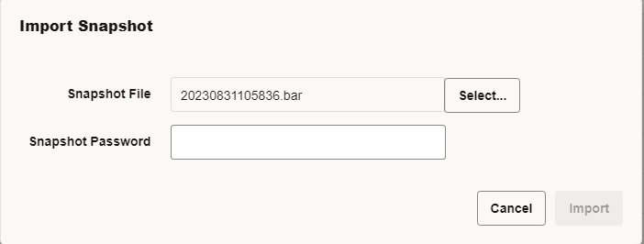

Migration – Restore the snapshot
On restoring the snapshot, the rpd file, catalog and configurations will be imported into OAS.
- click the three dot button on the right of the snapshot and select the “Restore” menu to restore the metadata contained in the file.
- Choose Custom and unselect Credentials and Application Roles.
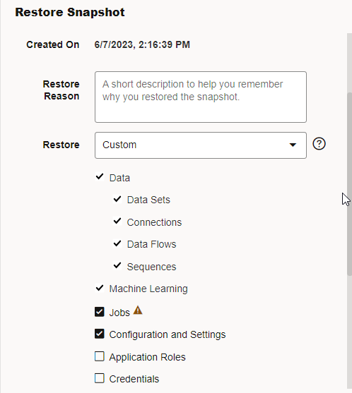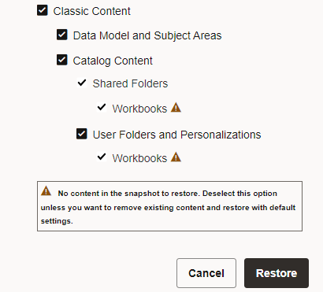
Selecting the Application Role will make OBIEE application roles to overwrite OAS application roles, hence DVConsumer and DVContentAuthor will be lost and BIConsumer and BIContentAuthor will be incorrect.
After this step, all the reports/objects/configurations should appear in OAS.

ETL Schema and database links

Oracle Analytics system requires ABSDATAWAREHOUSE_V10 database schema to function and a database link to ABSSOLUTE schema for V10 of the ETL.
The current customer OBI12c uses the following version 9 ETL schemas: ABSDWHSTAGING, ABSDATAWAREHOUSE, PIMS (even if the table contents is empty, this schema is needed).
Export ABSDWHSTAGING, ABSDATAWAREHOUSE, PIMS schemas from OBI12c machine and import them into the OAS server.
ABSDATAWAREHOUSE_V10 will be created by converting data from local imported ABSDWHSTAGING, ABSDATAWAREHOUSE schemas. There should be enough space on the OAS server. Additional steps will be sent on how to convert the data and create ABSDATAWAREHOUSE_V10 schema.

Import ABSDWHSTAGING and ABSDATAWAREHOUSE schemas:
When the ABSDWHSTAGING schema is imported into the database the following command needs to be run to configure the database links. Please note the bold sections could vary based on the installation:

drop database link ABSDATAWAREHOUSE_LOCATION;
drop database link ABSSOLUTE_LOCATION;
drop database link PIMS_LOCATION;

CREATE DATABASE LINK ABSDATAWAREHOUSE_LOCATION
CONNECT TO ABSDATAWAREHOUSE IDENTIFIED BY ABSDATAWAREHOUSE
USING '(DESCRIPTION=(ADDRESS_LIST=(ADDRESS=(PROTOCOL=TCP)
(HOST=OAS_DBHOST)(PORT=1521)))
(CONNECT_DATA=(SERVICE_NAME=ABS1))
)';

CREATE DATABASE LINK ABSSOLUTE_LOCATION
CONNECT TO ABSSOLUTE IDENTIFIED BY ABSSOLUTE
USING '(DESCRIPTION =
(ADDRESS = (PROTOCOL = TCP)(HOST = ABSSOLUTE_DBHOST)(PORT = 1521))
(CONNECT_DATA =
(SERVER = DEDICATED)
(SERVICE_NAME = ABS1)
)
)';

CREATE DATABASE LINK PIMS_LOCATION
CONNECT TO PIMS IDENTIFIED BY PIMS
USING '(DESCRIPTION =
(ADDRESS = (PROTOCOL = TCP)(HOST = OAS_DBHOST)(PORT = 1521))
(CONNECT_DATA =
(SERVER = DEDICATED)
(SERVICE_NAME = ABS1)
)
)';

When the ABSDATAWAREHOUSE schema is imported into the database the following command needs to be run to configure the database links. Please note the bold sections could vary based on the installation:

drop database link ABSDWHSTAGING_LOCATION;
drop database link ABSSOLUTE_LOCATION ;
drop database link PIMS_LOCATION ;

CREATE DATABASE LINK ABSDWHSTAGING_LOCATION
CONNECT TO ABSDWHSTAGING IDENTIFIED BY ABSDWHSTAGING
USING '(DESCRIPTION=(ADDRESS_LIST=(ADDRESS=(PROTOCOL=TCP)
(HOST= OAS_DBHOST)(PORT=1521)))
(CONNECT_DATA=(SERVICE_NAME=ABS1))
)';

CREATE DATABASE LINK ABSSOLUTE_LOCATION
CONNECT TO ABSSOLUTE IDENTIFIED BY ABSSOLUTE
USING '(DESCRIPTION =
(ADDRESS = (PROTOCOL = TCP)(HOST = ABSSOLUTE_DBHOST)(PORT = 1521))
(CONNECT_DATA =
(SERVER = DEDICATED)
(SERVICE_NAME = ABS1)
)
)';

CREATE DATABASE LINK PIMS_LOCATION
CONNECT TO PIMS IDENTIFIED BY PIMS
USING '(DESCRIPTION =
(ADDRESS = (PROTOCOL = TCP)(HOST = OAS_DBHOST)(PORT = 1521))
(CONNECT_DATA =
(SERVER = DEDICATED)
(SERVICE_NAME = ABS1)
)
)';

Check external directory ABSEXTERNALDATASOURCEDIR is physically present on the OAS machine and oracle user has all read and write access on the directory.
- install ABS_DIR_UTILS under SYS. Take ABS_DIR_UTILS package from current OBI server as SYS - Packages.
- give the following grants as SYS user:
  - GRANT EXECUTE ON ABS_DIR_UTILS TO ABSDWHSTAGING;
  - grant execute, read, write on directory ABSEXTERNALDATASOURCEDIR to ABSDATAWAREHOUSE with grant option;
  - grant execute, read, write on directory ABSEXTERNALDATASOURCEDIR to ABSDWHSTAGING with grant option;
After importing the schemas and changing the database links, Compile Invalid Objects on all the 3 schemas.
Additional steps will be sent on how to convert the data and create ABSDATAWAREHOUSE_V10 schema. Always upgrade to base version 1.10.00 and run the ETL and then go to the next minor versions.

Enterprise edition features

Login to http://localhost:9502/analytics and go to Administration – Manage Privileges.
After the snapshot is restored, the privileges are imported from OBI12c to OAS. Check that the enterprise edition features are disabled (following privileges are denied).
In this menu the following options must be set to Denied disabling them from the BI installation:
- Access to BI Composer
- Access to Delivers
- Access to Mobile
- Access to Segments
- Access to Segment Tress
- Access to List Formats
- Access to Oracle Analytics for Microsoft Office
- Access to Oracle Analytics Client Installer
- Create Invoke Actions
- Save Actions containing embedded HTML
- Diagnose BI Server Query
- Access Administration Menu
- Access Modeler
- Impersonate as system user
- Write Back to Database

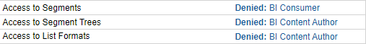

Change for the following entries:
- Save Content with HTML Markup
- New Meniu
- Create Navigate Actions
No restart is required.

Change the logo

Take the logo from BI_OAS/Logos – oraclelogo.png
Click top right corner – Administration – Manage Themes – Create New Theme
Theme Name ‘ABS’ and Select Logo and press Browse to select logo file.
Note: The logo png should not contain an underscore.
Check the Active box and then press Save.
If the following error appears in the jh.log, do the changes:
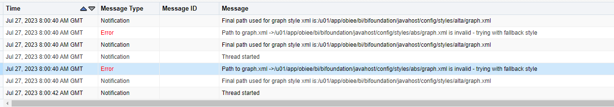
- Create a folder called abs in /u01/app/obiee/bi/bifoundation/javahost/config/styles/
- Copy graph.xml from alta to abs

Modify Log Off URL

Configure this way only if you’d like this logging out behavior.
When logging out of analytics, the redirect for login is automatically to DV. To change this behavior and redirect to analytics make the following changes:

Login Enterprise Manager > Business Intelligence > biinstance > Security

Click "Lock & Edit" on right top

Update "The SSO Provider Logoff URL" from

/bi-security-login/logout?redirect=/dv
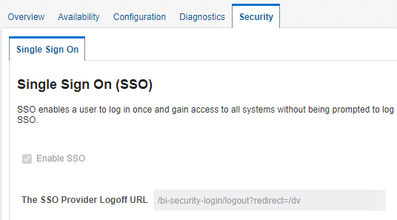

To

/bi-security-login/logout?redirect=/analytics
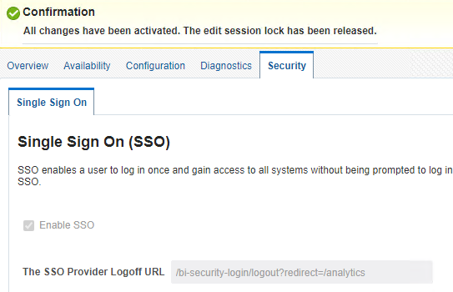

Click Apply and then Activate Changes and restart the entire stack to verify.

System Settings
Login to DV – Console – System settings and make the following changes:
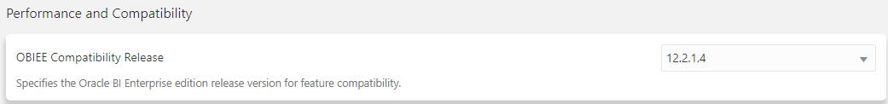
Choose your current OBI version.

Login to DV – Console – System settings and make the following changes:
- Allow HTML/JavaScript/CSS Content
- Answers Editor Start Tab
- Enable Immediate Dashboard Rendering
- Prompt section – Show Null Value when Column is Nullable
- Prompt Auto Complete Matching Level
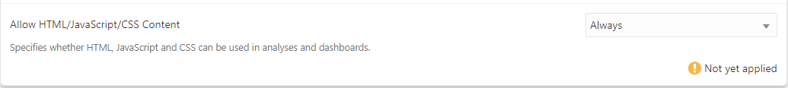
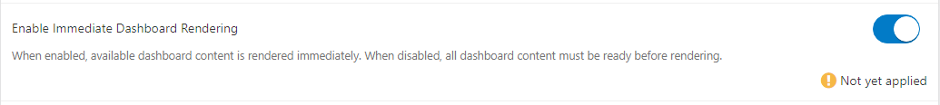
Restart BI Services to apply changes in system settings.

Installing the RPD file

Install the RPD file
Download ABS_BI_1.10.03.rpd version of the rpd from. You may apply the patch ABS_BI_1.10.03_restrict_access_patch.xml if it’s needed.
ftp - BI_OAS/OBI_Catalog_Version and deploy it:
- Navigate to DV – Console – Snapshots - Right click on the 3 dots (Navigator) and choose Replace Data Model
- 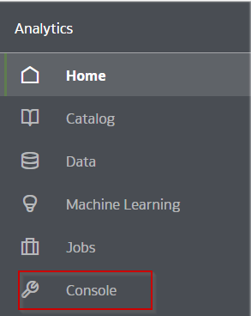
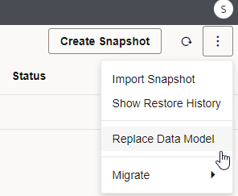

- Click on Proceed without a virus scanner
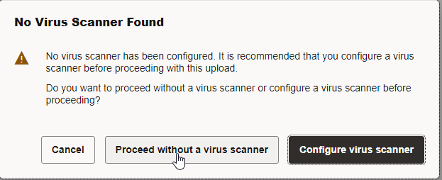
- Select ABS_BI_1.10.03.rpd (or the latest version), type in the password abssys01 and click Replace

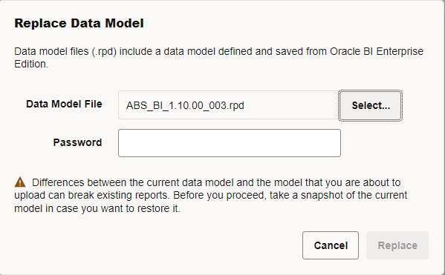
Restart is not required.

Install V10 reports

Modified and new reports: BI_OAS/OBI_Catalog_Version/catalog
- New Reports,filters,dashboards for BI Usage
- modified reports: Version Overview and ETL Log Last 7 Days. Version Overview will show the modified version after one ETL V10 run
- Check that the subject area BI Usage is visible in Answers.
Unarchive each report under the correct folder and choose Replace = All, ACL = Inherit.
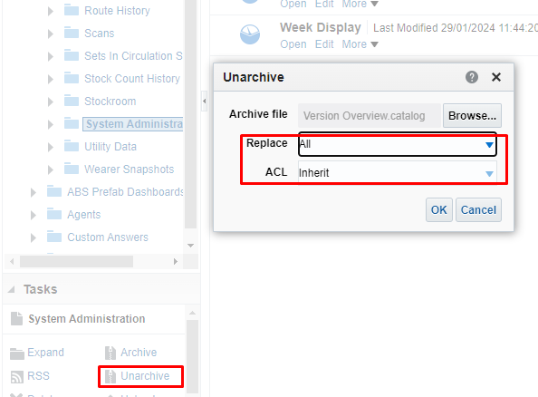

Mail Server Settings used by Oracle BI Agents

Only do this setup if you use Agents.
Navigate to EM – business intelligence – biinstance – configuration – Mail and update the settings and add the information for the specific customer.
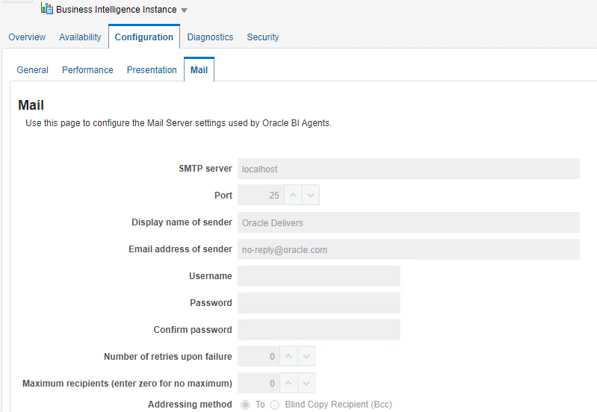
Should the customer use agents, modify the following in Administration - Manage Priviledges:
- Access to Delivers
- Deliver Agents to Specific or Dynamically Determined Users
- Modify Current Subscriptions for Agents
Restart BI services.

Check your existing agents schedule:
select lower(s.job_param) as agent_path, t.job_id, t.name, t.user_id, t.next_runtime_ts, t.last_runtime_ts
from dev_biplatform.s_nq_job t,
dev_biplatform.s_nq_job_param s
where t.job_id = s.job_id
and s.relative_order = 1
order by lower(s.job_param);

Enable agents - only do this after the Go-Live when the old server is not used.
There are some post-migration steps that need to be followed to enable agents when you restore or migrate content - After Migrating A Snapshot To Oracle Analytics, The Agents Are Disabled (Doc ID 2627357.1)

Restore and Enable Delivery Schedules
When you restore content (or migrate content) from a snapshot, delivery information is restored but it isn’t activated right away. Initially, restored deliveries are disabled. Click the Edit Delivery option to re-activate them.

- Click Console.
- Click Monitor Deliveries.
- To restore deliveries, click the Action menu for the page and select Restore Deliveries.
- Click OK to confirm. Recently restored deliveries display Disabled.
- To activate a delivery, click the Action menu for the delivery, and select Edit Delivery.
Enable, and if necessary, redefine the delivery schedule.
To prevent clutter, delete any history or deliveries you don't want anymore. Click the Action menu for the delivery:
Delete History — Removes historical information that you don't want to see any more.
Delete Delivery — Deletes the delivery and all its history.
After you restore, you will see the following message popup:
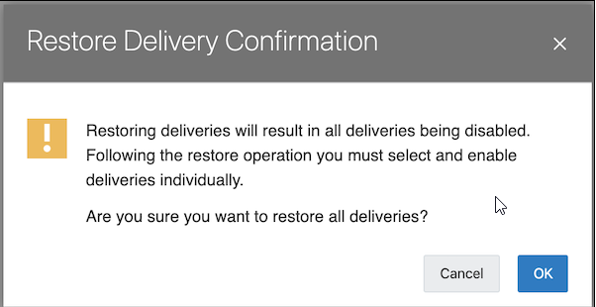
You will then be required to individual reset to each Agent, this step takes about 20 seconds for each Agent.
This review step is so you can evaluate if you want all Agents enabled or keep stale agents disabled on the new system.

Modify Catalog Permissions

Login to OAS – Catalog - Admin View – Shared Folders – Permissions and check if permissions are as in the picture below.
If not and the customer has default permissions, modify to:

BI Service Administrator – Full Control
Click Owner and Apply Permissions to sub-folders, Apply Permissions to items within folder
Replace options = Replace All
Click ok
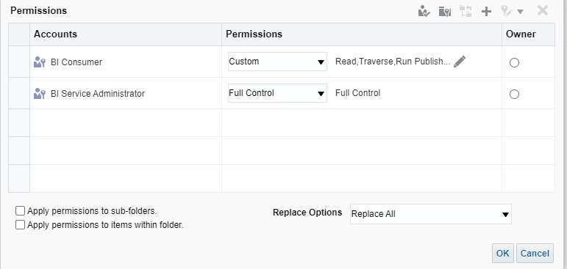
Check obiee12c for other type of permissions, some customers have BI Consumer full control, other customers have authenticated-user full control (which is probably after a migration).
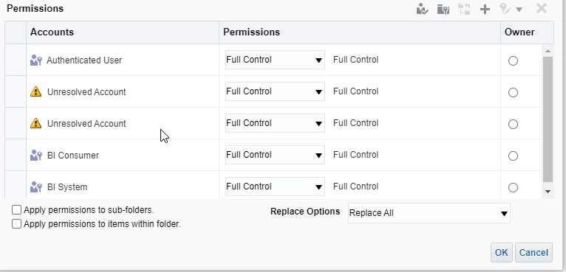

For ABS Prefab Answers, ABS Prefab Dashboards, Custom Answers, Custom Dashboards, Agents:
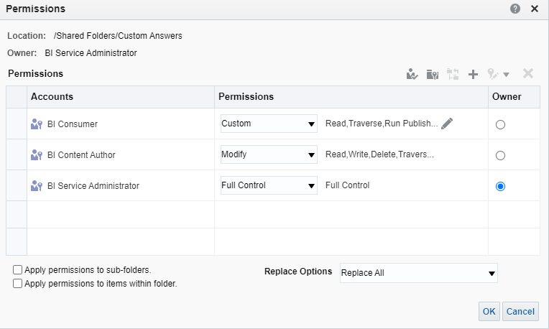

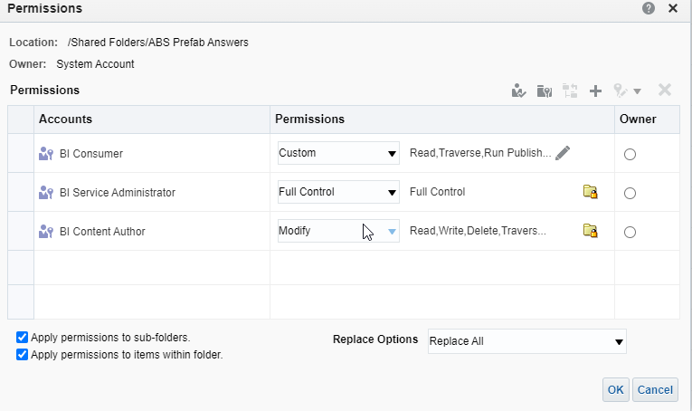

BIConsumer application role
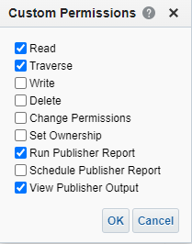

User folders
OBIEE: Weblogic User Does Not Have Access To Other User Folders Using "Admin View" (Doc ID 2234422.1)
Take a backup of the catalog.
Login to analytics as the administrator (weblogic) user.
Switch to Admin View.
Click on Catalog Root, on the right hand pane "User Folders" is listed.
Click on More option on "User Folders"->Permissions.
Make sure options "Apply Permission to sub-folders" and "Apply permission to items within folder" are checked. Choose "Replace Options" as "Replace Listed Accounts".
Click on OK button.
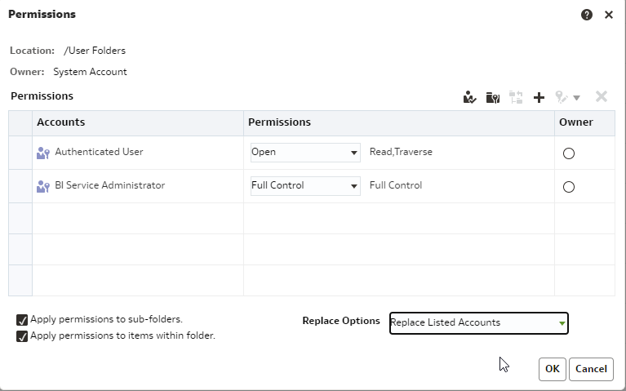

Deploy new filters

New filters improve performance by filtering on session rpd variables, instead of columns in the data warehouse tables.
Old style filters
New style filters
Take a snapshot before applying the new filters. Do this step after you check the permissions of the folders are correct.
New filters: BI_OAS/OBI_Catalog_Version/_filters_ALL_newstyle_10909.catalog
- Unarchive _filters_ALL_newstyle_10909.catalog directly under ABS Prefab Answers; it will overwrite the contents of the _filters (Subject Area Contents). If some other filters folders are present under ABS Prefab Answers - Subject Area Contents and they are not in the _filters_ALL_newstyle_10909.catalog archive, they will remain there.
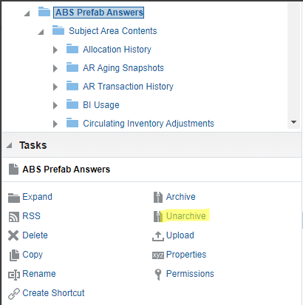
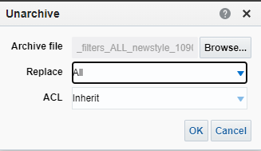
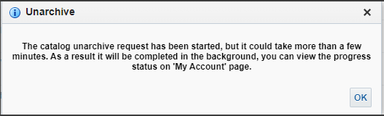
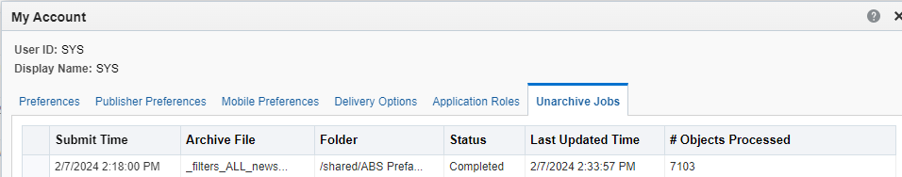
Should you have special permissions, you need to re-apply them as the permissions are inherited from Subject Area Contents folder.

Usage Tracking
- schema ABSDATAWAREHOUSE_V10 must exist.
- Login to DV, navigate to Console – System Settings – Usage Tracking and fill in the required information.
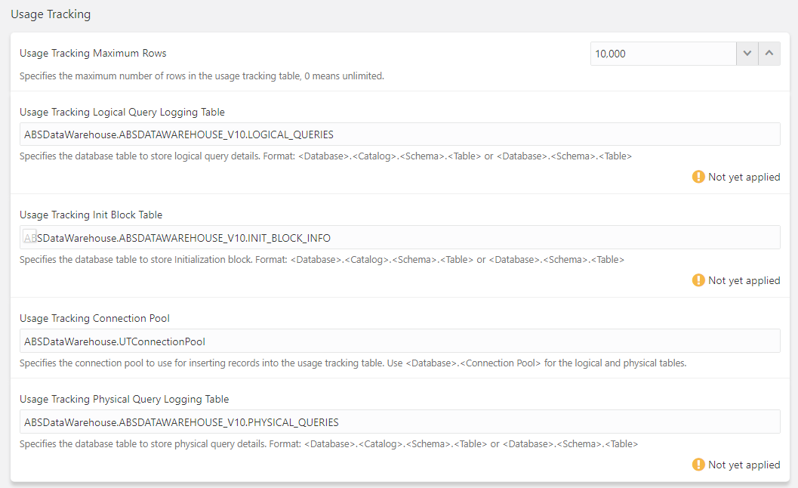

For Usage Tracking Maximum Rows. OAS has a automatic purging mechanism based on the data volume defined.
- 10.000 for small customers (few users)
- 100.000 for bigger customers (more users)
The info must match the rpd V10 which also has to be deployed at the customer.
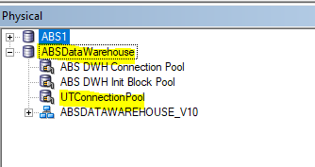
Usage Tracking Query Logging Table = ABSDataWarehouse.ABSDATAWAREHOUSE_V10.LOGICAL_QUERIES

Usage Tracking Init Block Info = ABSDataWarehouse.ABSDATAWAREHOUSE_V10.INIT_BLOCK_INFO

Usage Tracking Connection Pool = ABSDataWarehouse.UTConnectionPool

Usage Tracking Physical Query Logging Table = ABSDataWarehouse.ABSDATAWAREHOUSE_V10.PHYSICAL_QUERIES

Click Apply the and the BI Services will automatically be restarted.
After the restart the following tables will be automatically created in the database by the OAS UI. Check the tables exist in the db.
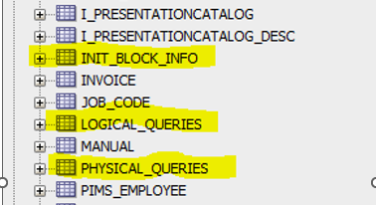
In case the 3 tables are not created automatically by the BI server, create them manually in ABSDATAWAREHOUSE_V10 schema with scripts from the ftp: BI_OAS/1.10.00/ABSDATAWAREHOUSE:
- create_usage_tracking_logical_queries.sql
- create_usage_tracking_physical_queries.sql
- create_usage_tracking_init_block_info.sql

Scheduled tasks

For the OAS installation three tasks should be scheduled in the Windows task scheduler or Linux crontab. The scripts for these tasks are on FTP location and should by default be placed on the following location of the OBI server:
- BI_OAS/Schedule_Load_Scripts/V10 – schedule daily ETL process and gather statistics
- BI_OAS/Schedule_Load_Scripts/OAS – purge cache

Windows C:\Oracle\Middleware\Scripts\ScheduleLoadScripts

Linux /u01/app/obiee/Scripts/ScheduleLoadScripts

Note: Make sure to run the dos2unix and chmod command on Linux

Set OAS Automatic Purging Cache
FTP: BI_OAS/Schedule_Load_Scripts/OAS/
- abspurgebicache_oas.bat / abspurgebicache_oas.sh
- abspurgebicache.sql
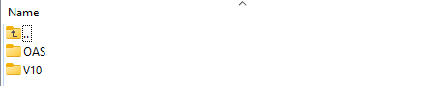
To purge the cache of OAS overnight the following script must be scheduled:
Windows abspurgebicache_oas.bat

Linux abspurgebicache_oas.sh
Note: Make sure to run the dos2unix and chmod command on Linux

Schedule the daily BI ETL process
Note 1: For this script SQL plus should be available containing the tnsnames entry mentioned in the script.
Note 2: The initial ETL should be performed first. After the initial ETL load it should be scheduled daily.
FTP: BI_OAS/Schedule_Load_Scripts/V10/
- execute_BI_warehouse_load_v10.bat / execute_BI_warehouse_load_v10.sh
- execute_BI_warehouse_load_v10.sql

To schedule the daily ETL load the following script must be scheduled:
Windows execute_BI_warehouse_load_v10.bat

Linux execute_BI_warehouse_load_v10.sh

Note: Make sure to run the dos2unix and chmod command on Linux

Schedule weekly gathering statistics on ABSDATAWAREHOUSE_V10

FTP: BI_OAS/Schedule_Load_Scripts/V10/
- gather_schema_stats_degree_v10.sql
- gather_schema_stats_degree_v10.sh

The stats should be scheduled weekly). Should not overlap with daily backup, daily ETL schedule. Choose your own schedule for statistics.

OAS Backup and recovery

On the FTP server BI_OAS/BackupScripts/OAS-Backup-Linux/scripts/. Backup scripts for Linux can be found. These scripts should be overviewed to assure all directory paths and retention times are correct for the specific installation. The scripts should be scheduled nightly to create the following items of the BI installation that can be used later for recovery/migration purposes:
- Export of the ABSDATAWEHOUSE_V10, DEV_MDS and DEV_BIPLATFORM schema’s
- Password for DEV_MDS and DEV_BIPLATFORM is defined at page 31 as <pleaseuseDEV_MDS_PASSWORD>
- Export of all security setting as an LDIF file
- BAR export file of the complete OAS installation. A BAR file is a compressed archive file that contains a cohesive set of BI metadata artifacts (data model, content model, and authorization model). A BAR file can be imported into a BI Service Instance.

