
Transport Linen

Linen is sometimes transferred to a different facility from which it was delivered during a patient transport. This procedure discusses the process to deliver empty carts to a facility for the pick-up of soiled linen that was transported from another facility and how it is scanned back into soil upon being received by the soil department.

Shipping Empty Carts

Create a TRNSPRT – Transport Linen delivery order
- Office Manager > Requirements
  - Enter start/end dates for delivery.
  - Select ‘Allentown Plant Internal Processing’ Customer/Group and select options.
  - Select ‘Create Delivery’/ ‘Regular’.
  - Select the ‘Transport Linen’ Order and the date to be delivered to the customer and select options.

Enter Customer in the Pick Form Instructions
- Double click on the delivery order and select ‘PO/Instructions’.
  - In the Purchase Order field, enter the customer where the carts are being delivered.
  - In the Instructions field enter the customer / Transport Linen
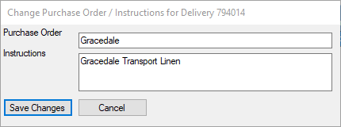
  - Save Changes.
- Double click on the delivery order to view and print the pick form(s).
Note: The instructions will be displayed on the pick form.
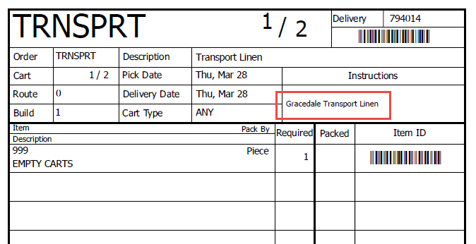

- Manually write and highlight on each tag, “DO NOT REMOVE THIS TAG FROM THIS CART”, this will alert the facility to leave the pick form on the cart.
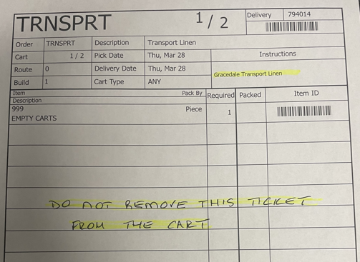
- Attach the pick form(s) to the cart(s). The pick form(s) should not be removed from the cart(s) so they will be easily identified upon return to soil.

Enter Office Manager Note
- Select ‘Notes’ from the left navigation panel.
  - Select ‘Allentown Plant Internal Processing’ customer.
  - Select ‘Add Note’ from the top toolbar.
  - Select ‘Customer Service’ note type.
  - Enter the Customer/Transport Linen in the text box and select ‘OK’.
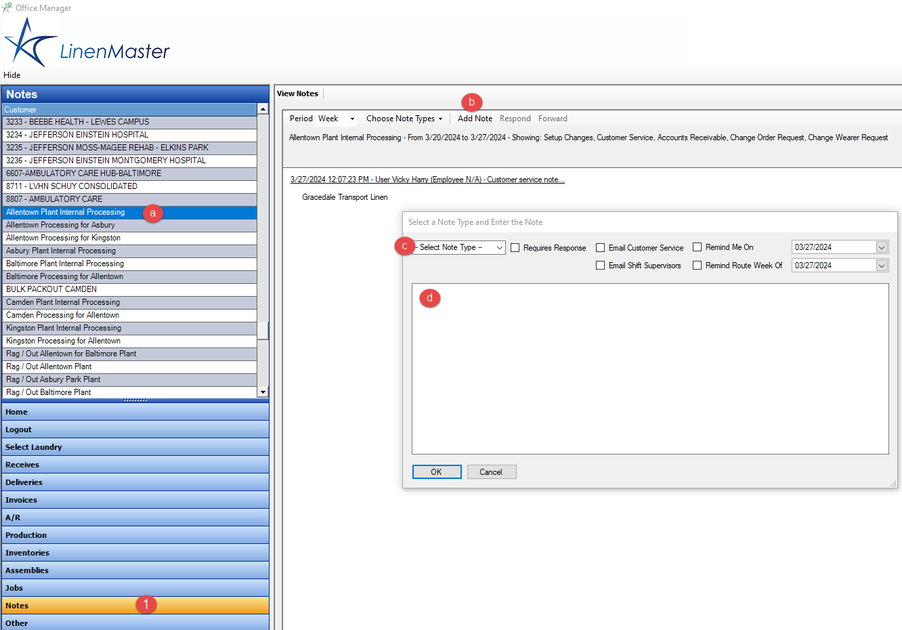

Deliver the Empty Carts
- Scan the delivery for the empty carts in Floor Manager.
- Print the shipping receipts and forward them to the plant office.
- The plant office will settle the delivery to close the order.

Receiving Soiled Transport Linen Carts
- The soil department will be able to identify incoming transport linen using the pick form attached to the cart.
- Use the TRNSPRT Master Soil barcode to scan the account and cart into soil and save the data.

