
Rewash Process_Soil Scale

This process provides instructions for tracking linen sent back to the Soil Department for rewash. Rewash weight is not added to Soil weight and will not calculate a charge or credit. Rewash can be displayed on reports to show how many pounds have been washed an additional time without generating revenue.

Floor Manager > Rewash Process
- Open/log into Floor Manager (‘Receiving Scale’ should be displayed in the upper left corner of the display screen).
- Select the ‘Rewash’ button.
- Scan the Master Soil barcode for the plant’s rewash order.
- Scan the cart barcode.
  - If no barcode, select the “Cart Has No Barcode” button.
  - Adjust the tare weight, if needed.
  - Follow plant’s process for getting a barcode placed on the cart.
- Review/verify the information on the display screen is correct.
- Select ‘Save’.
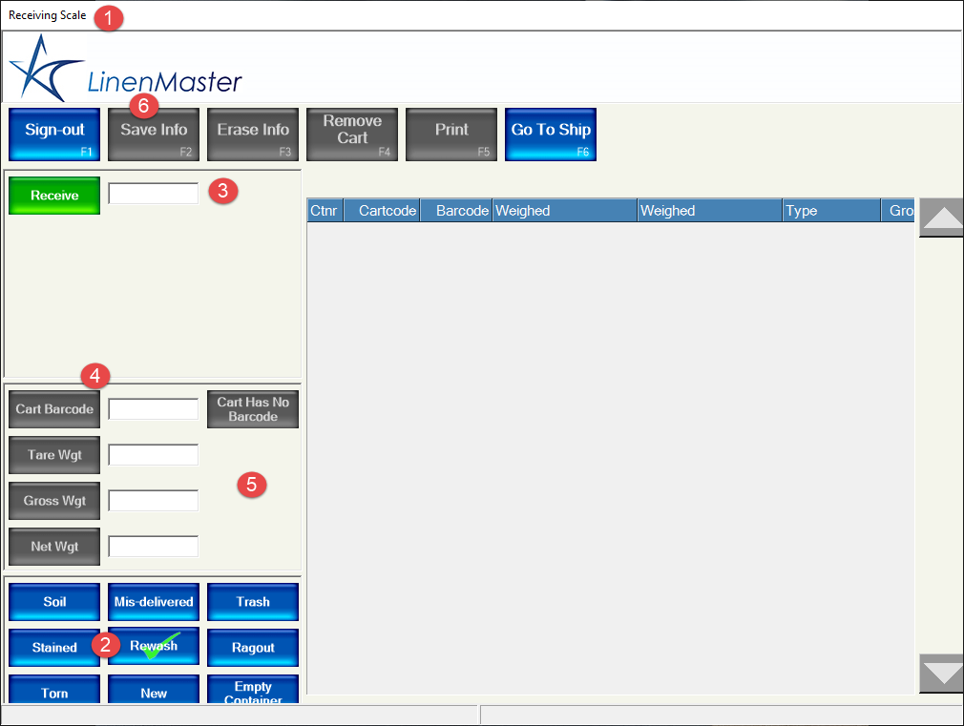

Reporting
Report Path: Reports > Receives > Weights > By Period
Report Options:
- Select receives where: Received From Customer Date
- Is in period start: Date range for report
- Inventory Flow: All>>Plant
- Customer/Group: Plant Internal Processing
- Organize columns by: Select preferred time interval

- Under the ‘Weight captured at Laundry’ heading, “Soil (Laundry)” and “Rewash (Laundry) should be ‘Yes’. All other fields should be marked ‘No’.
- Select options.

Troubleshooting
- Refer to “Soil Scale Instructions” procedure for troubleshooting common issues.

